1️⃣ What is an IP Address?
An IP (Internet Protocol) Address is a unique identifier assigned to each device in a network to communicate with other devices.
📌 Example of an IP Address: 192.168.1.1
📌 Types of IP Addresses:
🔹 IPv4 (Internet Protocol Version 4) – 32-bit address (e.g., 192.168.1.1)
🔹 IPv6 (Internet Protocol Version 6) – 128-bit address (e.g., 2001:db8::1)

Addressing
It has two main sections:
- Network Portion: Identifies the network the device belongs to.
- Host Portion: Uniquely identifies a device within the network.
IPv4 addresses are divided into classes based on the length of the network and host portions:
- Class A: 8-bit network ID, 24-bit host ID.
- Class B: 16-bit network ID, 16-bit host ID.
- Class C: 24-bit network ID, 8-bit host ID.

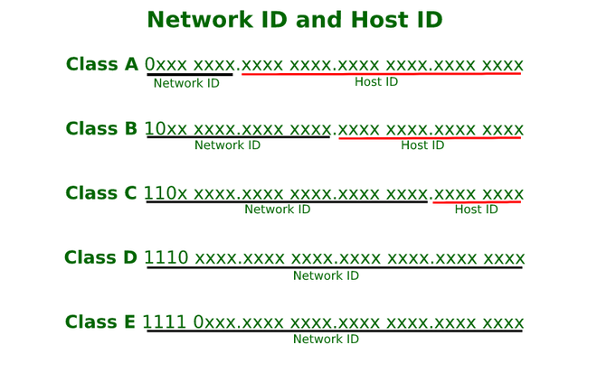
What is a Subnet?
A subnet (subnetwork) is a smaller network within a larger network.
Subnetting divides a large network into smaller, manageable parts to improve efficiency and security.
IPv4 addresses are categorized into five classes based on their range.
Class | Starting IP Range | Ending IP Range | Default Subnet Mask | Usage
A | 1.0.0.0 | 126.255.255.255 | 255.0.0.0 (/8) | Large Networks (e.g., ISPs)
B | 128.0.0.0 | 191.255.255.255 | 255.255.0.0 (/16) | Medium Networks (e.g., Universities)
C | 192.0.0.0 | 223.255.255.255 | 255.255.255.0 (/24) | Small Networks (e.g., Offices)
D | 224.0.0.0 | 239.255.255.255 | N/A | Multicasting
E | 240.0.0.0 | 255.255.255.255 | N/A | Research

✅ Classes A, B, and C are used for normal networking
✅ Class D is used for multicast (e.g., video streaming)
✅ Class E is reserved for research purposes
4️⃣ Subnet Calculations (Step by Step)
Now, let's learn how subnet masks work and how we calculate subnets.
🔹 Step 1: Understanding the Default Subnet Mask
A Subnet Mask is used to separate the network and host portions of an IP address.
CIDR | Subnet Mask | Usable Hosts
/8 | 255.0.0.0 | 16,777,214
/16 | 255.255.0.0 | 65,534
/24 | 255.255.255.0 | 254

Each bit in the subnet mask that is '1' represents the network portion and each bit that is '0' represents the host portion.

CIDR | Subnet Mask | Total IPs | Usable Hosts | Block Size | Binary Representation of Last Octet
/24 | 255.255.255.0 | 256 | 254 | 256 | 11111111.00000000
/25 | 255.255.255.128 | 128 | 126 | 128 | 10000000 (128)
/26 | 255.255.255.192 | 64 | 62 | 64 | 11000000 (192)
/27 | 255.255.255.224 | 32 | 30 | 32 | 11100000 (224)
/28 | 255.255.255.240 | 16 | 14 | 16 | 11110000 (240)
/29 | 255.255.255.248 | 8 | 6 | 8 | 11111000 (248)
/30 | 255.255.255.252 | 4 | 2 | 4 | 11111100 (252)

256 | 128 | 64 | 32 | 16 | 8 | 4 | 2
1 | 1 | 1 | 1 | 0 | 0 | 0 | 0

192.168.1.0/26
192.168.1.64/26
192.168.1.128/26
192.168.1.192/26
For /26 We can get 64 IP Address (32-26=6) So it could be 11000000 So it 64
Subnet range will be 255.255.255.192. this one we can Split like below

192.168.1.0/26
192.168.1.64/26
192.168.1.128/26
192.168.1.192/26

Summary :
IP Address 32 Bits
Subnet mask Contain Host Block(0) and Network Block(1)
CIDR | Binary Notation | Network Bits | Host Bits | Available Addresses
255.255.255.255 | /32 | 11111111.11111111.11111111.11111111 | 32 | 0 | 1
255.255.255.254 | /31 | 11111111.11111111.11111111.11111110 | 31 | 1 | 2
255.255.255.252 | /30 | 11111111.11111111.11111111.11111100 | 30 | 2 | 4
255.255.255.248 | /29 | 11111111.11111111.11111111.11111000 | 29 | 3 | 8
255.255.255.240 | /28 | 11111111.11111111.11111111.11110000 | 28 | 4 | 16
255.255.255.224 | /27 | 11111111.11111111.11111111.11100000 | 27 | 5 | 32
255.255.255.192 | /26 | 11111111.11111111.11111111.11000000 | 26 | 6 | 64
255.255.255.128 | /25 | 11111111.11111111.11111111.10000000 | 25 | 7 | 128
255.255.255.0 | /24 | 11111111.11111111.11111111.00000000 | 24 | 8 | 256

255.255.254.0 | /23 | 11111111.11111111.11111110.00000000 | 23 | 9 | 512
255.255.252.0 | /22 | 11111111.11111111.11111100.00000000 | 22 | 10 | 1024

Total IPs = 2^(32 − CIDR)

📘 CIDR – VALID vs INVALID (Quick Recall Notes)

1️⃣ What CIDR /n means
- IPv4 = 32 bits
- /n = n bits are NETWORK
- Remaining bits = HOST
Example:
- /8 → Network = 8 bits, Host = 24 bits
- /16 → Network = 16 bits, Host = 16 bits
- /29 → Network = 29 bits, Host = 3 bits

2️⃣ GOLDEN RULE (MOST IMPORTANT)
A CIDR is VALID only if the given IP is the FIRST IP of that subnet.
(i.e., all host bits must be ZERO)
If host bits ≠ 0 → ❌ INVALID CIDR

6️⃣ Why Azure Reserves 5 IP Addresses ❓ (VERY IMPORTANT)
For every subnet, Azure reserves the first 4 + last 1 IP.
Example: 10.0.0.0/24
IP | Reserved For
10.0.0.0 | Network address
10.0.0.1 | Default gateway
10.0.0.2 | Azure DNS
10.0.0.3 | Azure infrastructure
10.0.0.255 | Reserved (no broadcast)

