when i click on character relationship map it is showing a same global map for every character but it shouldnt do like that right? it should have an individual map for each character showing only thier realtions and then a seperate global map where there is a complete chracter relationship map of the film and also they are not properly organised, see how chaos they are make them organised like a tree or something easy to processs

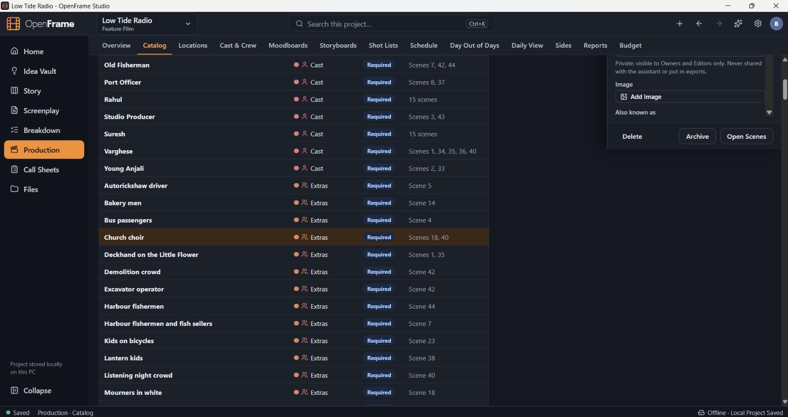
when i click on lower catalgoue it is opening its menu bar in the top corner so to see it i should scroll to top but it should open right beside the item we have seelcted right?
the same with location, cast & crew tabs also
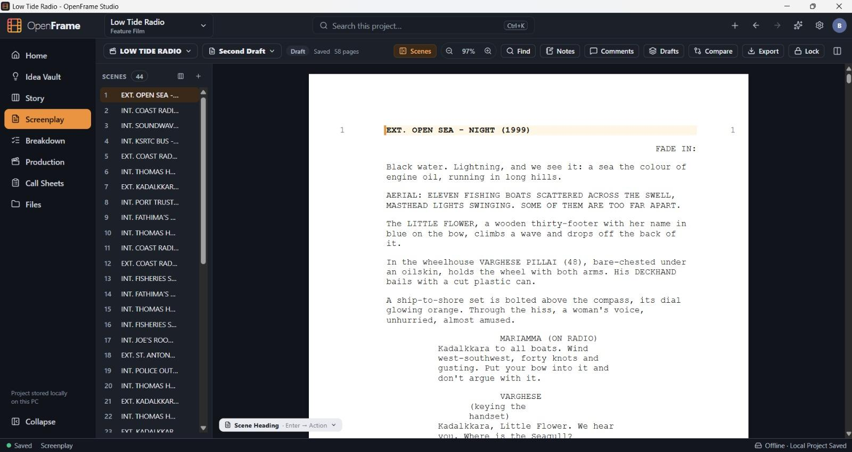
the screenplay paper is white even in the dark mode of the app...add a small toggle to manually change the screenplay appearence to light or dark based on user prefernce and put that toggle without disturbing existing ui
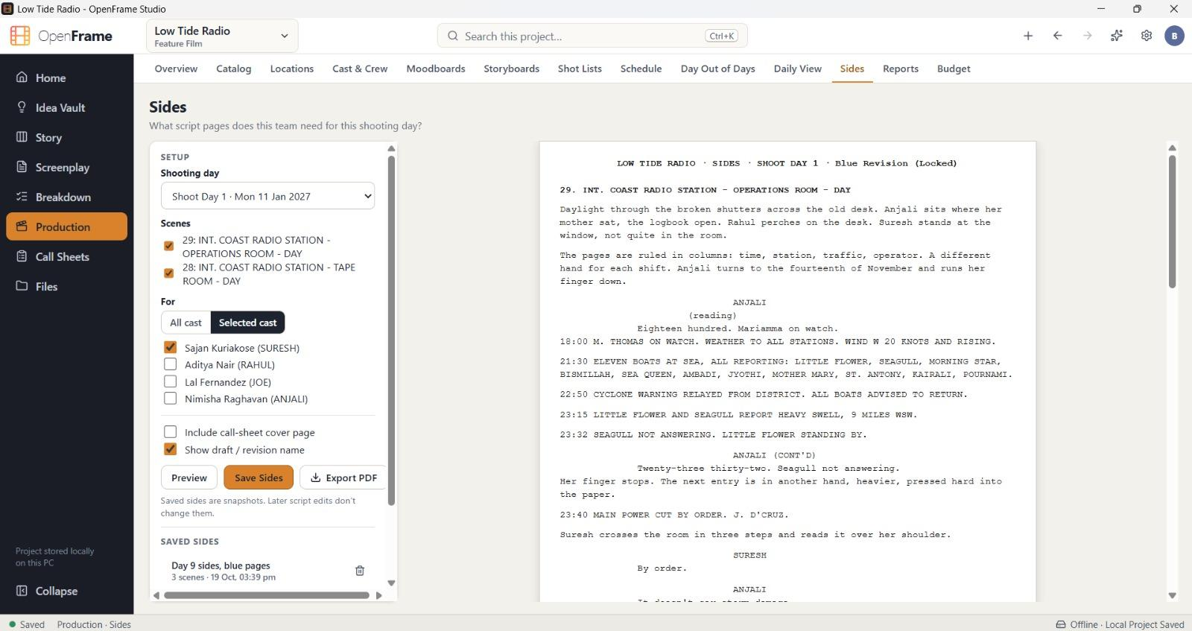
the selected cast option is not working as intendedyou can see here
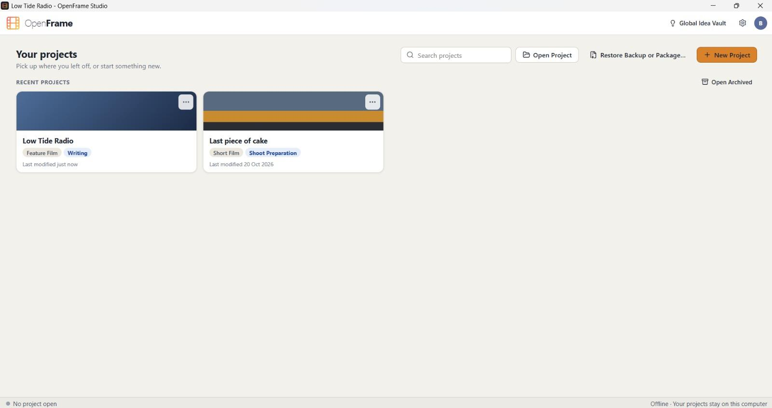
why havent we added a cover photo upload option for projects instead of that random colors? if posssible add that option and if none is uploaded then you can keep that random cover like as of now

