OpenFrame Studio
User Manual
End-to-end guide to the desktop application for Windows 11 — from opening the app to the finished call sheet
Capture the idea. Shape the story. Write the script. Plan the shoot.

Edition | Interface mock-up reference edition (a base prototype for review before development)
Platform | Windows 11 desktop application (local-first, offline-capable)
Sample project used in every screen | BLACK RAIN — a feature-film crime thriller
Source of truth | PRD · Functional Specification · UX/UI Specification · Domain/Data Specification · AI Specification · Import/Export Specification · Offline & Collaboration Specification · Security, Privacy & Data Ownership Specification
Companion deliverable | HTML_Mockups folder — 181 interactive HTML mock-up pages, one per figure
Date | 29 September 2026

The screen pictures in this manual are illustrative mock-ups built from the specifications. Their visual style is a placeholder; their behaviour, wording and rules follow the specifications.
Contents
How to read this manual 11
Product overview 12
End-to-end journeys 16
Journey 1 — A first-time filmmaker, from idea to call sheet 16
Journey 2 — You already have a screenplay 17
Journey 3 — A short film 17
Journey 4 — Writer only 18
Journey 5 — Producer or assistant director 18
Journey 6 — An episodic series 18
Chapter 1 — Getting Started: Opening OpenFrame Studio and Managing Projects 19
Figure 1 — Starting OpenFrame Studio from Windows 11 20
Figure 2 — The start-up screen 22
Figure 3 — Home: your projects 24
Figure 4 — Home: first launch with no projects 26
Figure 5 — Project card menu: pin, rename, duplicate, archive 28
Figure 6 — Archived projects 30
Figure 7 — Project unavailable (drive missing or file moved) 32
Figure 8 — New Project dialog (blank) 34
Figure 9 — New Project dialog (filled in) 36
Figure 10 — New Project: creation error 38
Figure 11 — Project Home: a brand-new project 40
Figure 12 — Project Home: an active project 42
Figure 13 — Switching projects from the top bar 44
Figure 14 — Anatomy of the OpenFrame window 46
Figure 15 — Changing the project status 48
Figure 16 — Recovering after a crash or power cut 50
Figure 17 — Save error: your work is still open 52
Figure 18 — Leaving a project during a save problem 54
Figure 19 — Save and offline status panel 56
Figure 20 — The + quick-actions menu 58
Figure 21 — Undo and Redo 60
Figure 22 — Project settings 62
Figure 23 — Deleting a project (strong confirmation) 64
Chapter 2 — Idea Vault: Capture Anything 66
Figure 24 — Project Idea Vault — Visual Grid 67
Figure 25 — Idea Vault — Card view 70
Figure 26 — Idea Vault — List view 72
Figure 27 — Idea Vault — Folder view 74
Figure 28 — Idea Vault — empty state 76
Figure 29 — Add menu: Note, Image, URL, File, Voice Note, Video 78
Figure 30 — Text note editor (autosave) 80
Figure 31 — Idea Vault item detail: image 82
Figure 32 — Adding a URL 84
Figure 33 — Recording a voice note 86
Figure 34 — Dragging files into the Vault 88
Figure 35 — Drag-in result: partial success 90
Figure 36 — External file unavailable 92
Figure 37 — Selecting several items 94
Figure 38 — Right-click menu on a Vault item 96
Figure 39 — Send to Story Board 98
Figure 40 — Global Idea Vault 100
Figure 41 — Copy a Global idea to a project 102
Figure 42 — Searching the Vault 104
Figure 43 — Quick Capture 106
Figure 44 — Recently Deleted 108
Figure 45 — Research collection with verification flags 110
Figure 46 — Creating a collection 112
Figure 47 — Everything the Vault can hold 114
Chapter 3 — Story Board: Shape the Story 116
Figure 48 — Story Board — empty state 117
Figure 49 — Story Board — Board view 119
Figure 50 — Add menu: Act, Sequence, Beat, Scene 121
Figure 51 — Creating an Act (title only) 123
Figure 52 — Story Board — Outline view 125
Figure 53 — Scene Card detail drawer 127
Figure 54 — Dragging a card: insertion line 129
Figure 55 — Moving a Sequence between Acts 131
Figure 56 — Right-click menu on a Scene Card 133
Figure 57 — Selecting several cards 135
Figure 58 — The Parking Lot 137
Figure 59 — Duplicating a card to try an alternative 139
Figure 60 — Beat Card and Convert to Scene 141
Figure 61 — Deleting a non-empty Act 143
Figure 62 — Deleting a card that has a linked screenplay scene 145
Figure 63 — Build Screenplay — preview 147
Figure 64 — Building when a screenplay already exists 149
Figure 65 — Warning before a board reorder changes a written script 151
Figure 66 — Zooming out to see the whole film 153
Figure 67 — Characters directory 155
Figure 68 — Adding a character (duplicate-name check) 157
Figure 69 — Character relationship view 159
Figure 70 — Story Timeline (optional) 161
Figure 71 — Sequence Hub 163
Figure 72 — Exporting the Story Board or Outline as PDF 165
Figure 73 — Series → Season → Episode (episodic projects) 167
Figure 74 — Season Board: reordering episodes 169
Chapter 4 — Screenplay: Write, Draft, Review, Lock, Import and Export 171
Figure 75 — Screenplay — empty state 172
Figure 76 — The screenplay editor (Standard mode) 174
Figure 77 — Choosing screenplay element types 176
Figure 78 — Find and replace in the screenplay 178
Figure 79 — Focus mode (full-screen writing) 180
Figure 80 — Writing Room: script with a reference panel 182
Figure 81 — Scene notes and private notes 184
Figure 82 — Adding and resolving comments on script text 186
Figure 83 — Drafts: named drafts and recovery history 188
Figure 84 — Creating a new named draft 190
Figure 85 — Comparing two drafts 192
Figure 86 — Review rounds 194
Figure 87 — Starting a review round 196
Figure 88 — Locking the Shooting Draft 198
Figure 89 — Editing a locked draft: Start Revision 200
Figure 90 — Revision label, colour and changed scenes 202
Figure 91 — Importing a screenplay: choose the source 204
Figure 92 — Import preview and warnings 206
Figure 93 — Import failed (safe failure) 208
Figure 94 — Import report 210
Figure 95 — Exporting the screenplay 212
Figure 96 — Document preview and printing 214
Figure 97 — Scene Hub: what exists around a scene 216
Figure 98 — Right-click menu on a screenplay scene 218
Figure 99 — Moving a scene that is already in production planning 220
Figure 100 — Title page details 222
Figure 101 — Deleting a draft 224
Chapter 5 — Production: Breakdown, Catalog, Locations, Cast & Crew, Visual Planning and Shot Lists 226
Figure 102 — Production overview (dashboard) 227
Figure 103 — Start Production Setup: choose the production source 229
Figure 104 — Breakdown: scene list, script and elements 231
Figure 105 — Breakdown — no source chosen 233
Figure 106 — Tagging highlighted text 235
Figure 107 — Reviewing suggested elements 237
Figure 108 — Reusing an existing catalog item 239
Figure 109 — Adding an element manually 241
Figure 110 — After a script change: review breakdown differences 243
Figure 111 — Updating the production source to a newer draft 245
Figure 112 — Needs Review queue 247
Figure 113 — Production Catalog 249
Figure 114 — Archiving or replacing a catalog item 251
Figure 115 — Locations list 253
Figure 116 — Location details: photos, notes, scenes 255
Figure 117 — Replacing a rejected location for selected scenes 257
Figure 118 — Cast list 259
Figure 119 — Assigning an actor to a character 261
Figure 120 — Crew list 263
Figure 121 — Moodboard canvas 265
Figure 122 — Exporting a moodboard 267
Figure 123 — Storyboard panels for a scene 269
Figure 124 — Add Panel: import, sketch or empty 271
Figure 125 — Sketching a panel 273
Figure 126 — Shot list for a scene 275
Figure 127 — Shot details (technical fields) 277
Chapter 6 — Scheduling, Call Sheets and Production Documents 279
Figure 128 — Shooting Schedule — nothing created yet 280
Figure 129 — Creating the schedule 282
Figure 130 — Stripboard: Unscheduled pool and shooting days 284
Figure 131 — Stripboard: List view 286
Figure 132 — Schedule calendar 288
Figure 133 — Dragging a scene into a day 290
Figure 134 — Adding a break marker or off day 292
Figure 135 — Shooting Day detail 294
Figure 136 — Schedule conflict warning 296
Figure 137 — Grouping suggestion 298
Figure 138 — Script changed in scheduled scenes: review changes 300
Figure 139 — Exporting the schedule 302
Figure 140 — Daily Production View 304
Figure 141 — Call Sheets list 306
Figure 142 — Creating a call sheet from a shooting day 308
Figure 143 — Call Sheet editor 310
Figure 144 — Adding optional call-sheet sections 312
Figure 145 — Call sheet marked stale after a schedule change 314
Figure 146 — Refresh preview before updating a call sheet 316
Figure 147 — Finalizing and exporting a call sheet 318
Figure 148 — Sides for a shooting day 320
Figure 149 — Production Reports 322
Figure 150 — Lightweight budget snapshot (P1) 324
Figure 151 — Project Notes and Lightweight Tasks 326
Figure 152 — Activity History 328
Figure 153 — Template browser (P1) 330
Figure 154 — Project Files (file cabinet) 332
Figure 155 — Permissions 334
Figure 156 — Global project search 336
Figure 157 — Recently Deleted (whole project) 338
Chapter 7 — Collaboration, Backup and Portability 340
Figure 158 — The Share / Exchange menu 341
Figure 159 — Exporting a script review package 343
Figure 160 — The reviewer opens the package 345
Figure 161 — Importing a response package: preview before applying 347
Figure 162 — A stale package: version mismatch 349
Figure 163 — Review Queue and Unmatched Review Notes 351
Figure 164 — Starting a local collaboration session (host) 353
Figure 165 — Joining a session (participant) 355
Figure 166 — An active session: presence and soft locks 357
Figure 167 — Resolving an editing conflict 359
Figure 168 — Disconnected from a session 361
Figure 169 — Creating a backup 363
Figure 170 — Exporting the whole project to move it 365
Figure 171 — Importing a project package (identity collision) 367
Figure 172 — External drive removed while a project is open 369
Figure 173 — Working offline 371
Chapter 8 — The AI Assistant (Optional) 373
Figure 174 — Asking the assistant questions 374
Figure 175 — Natural-language navigation and search 376
Figure 176 — Proposed Changes: nothing changes until you apply 378
Figure 177 — Structured rename preview (batch operation) 380
Figure 178 — An out-of-date proposal must be re-checked 382
Figure 179 — Offline AI: one download, runs on this computer 384
Figure 180 — Offline AI not installed or unavailable 386
Figure 181 — The assistant respects permissions and private notes 388
Appendix A — Keyboard shortcuts and desktop gestures 390
Appendix B — Safety rules quick reference 392
Appendix C — Files, formats and what each export contains 394
Appendix D — Statuses and states 395
Appendix E — What OpenFrame deliberately does not do 396
Appendix F — Glossary 397
Appendix G — List of figures 399

(If the page numbers above are missing, right-click the table and choose Update Field → Update entire table.)

How to read this manual
What this manual is. This is the end-to-end user manual for OpenFrame Studio, a desktop application for independent filmmakers that runs on Windows 11. It explains, for someone who has never seen the product, how to open the application, how every workspace works, what each button does, what happens after you click it, and what OpenFrame deliberately does not do. It follows the product from the first double-click to the finished call sheet.
What the pictures are. Every screen in this manual is shown as a picture of an interface mock-up. The mock-up is a working set of HTML pages (in the HTML_Mockups folder that accompanies this document) that was built directly from the product specifications: the Product Requirements Document (PRD), the Functional Specification (FSD), the UX/UI Specification, the Domain/Data Specification, the AI Specification, the Import/Export Specification, the Offline & Collaboration Specification and the Security/Privacy/Data-Ownership Specification. The layout, colours and icons of the mock-up are placeholders that can be replaced later; the behaviour, wording, states and rules that they illustrate come from the specifications.
How each screen is presented. Each screen has two pages. The first page shows the screen with red numbered markers and states what the screen is for and how you reach it. The second page explains the numbered parts of the screen, gives step-by-step instructions, and lists "Good to know" points, which include the edge cases: what happens when something is empty, unavailable, stale, conflicting, denied or fails.
The sample project. All screens use one imaginary film, BLACK RAIN, a crime thriller about Arjun, a returning inspector, his son Ravi, his friend Maya and the detective Meera, filmed around an old railway station, a police station and Ravi's house. The names, dates and figures are examples only.
Windows conventions. Keyboard shortcuts in this manual are written for Windows: Ctrl (not Cmd), Shift and Alt. Windows 11 features such as the Start menu, File Explorer and the Save/Open dialogs are used exactly as in any other Windows program. Where the specifications leave an exact key assignment open, the manual says that the shortcut shown is the proposed default.
Priorities. Some capabilities are marked in the product plan as P0 (required for the first production-ready release), P1 (important second-level capability) or P2 (later expansion). This manual describes the P0 and P1 behaviour that the specifications define in detail. P1 items are: Story Timeline, script lock and production revision colours, Sides, better storyboard tools, advanced schedule conflict warnings, the AI assistant, richer exchange controls, templates, lightweight tasks, Scene Hub, Project Notes, Activity History, Daily Production View, basic production reports and the lightweight budget. P2 items (more sophisticated scheduling assistance, advanced storyboard editing, richer search, more reports, deeper episodic continuity, advanced AI, additional file formats) are only mentioned where they touch a P0/P1 screen.

The red numbered markers
In every figure, small red numbers such as 3 point to a part of the screen. The same number in the "Parts of this screen" list on the following page explains it. A number is only shown when the specifications describe that part of the screen.

Product overview

What OpenFrame Studio is
OpenFrame Studio is a local-first desktop filmmaking workspace for independent filmmakers. It turns messy movie ideas into visual story outlines, visual story outlines into professional screenplays, and finished screenplays into practical pre-production plans — without forcing anyone to use a giant studio-management system.
It is built for people with limited resources: writer-directors, director-producers, student filmmakers, short-film makers, regional-language filmmakers, small web-series creators and small production teams. One person can do the work of several roles; the application never shows "different apps for different roles" — it simply reveals the tools and permissions that are relevant.
Its mantra: CAPTURE THE IDEA. SHAPE THE STORY. WRITE THE SCRIPT. PLAN THE SHOOT.

The journey the product follows
Messy ideas → Idea Vault → Story Board (Acts, Sequences, Beats, Scene Cards) → Screenplay → Review / Rewrite / Version → Locked Shooting Draft → Script Breakdown → Cast, Locations, Props, Wardrobe and other elements → Shot List, Storyboard and Moodboard → Stripboard / Shooting Schedule → Call Sheets.
The product should feel like one film moving forward, not like a collection of unrelated databases. But it is also deliberate about which parts are linked: the Idea Vault is loose, the Story Board is a reference and outline space, the Screenplay is the authoritative written script, and production data becomes authoritative only when the production phase starts using it.

Structure increases as the film becomes real
Idea Vault: very loose. Story Board: moderately structured. Screenplay: highly structured. Breakdown: production-structured. Schedule: operationally structured. Call Sheet: daily, actionable information. This progression is the reason the product can stay simple despite its many capabilities: you meet strict structure only when your film needs it.

Local-first, offline and yours
Your project is stored on your own computer (or an external drive you choose). You can create, write, plan, schedule and export without an internet connection. There is no mandatory OpenFrame cloud, no sign-in, and no "syncing" state. You can move the whole project to another machine, back it up, and export every kind of document so you can always leave the product without being trapped.
Remote collaboration uses ordinary files (Exchange Packages) that you send by any method you like. Optional live collaboration works over your own private network. AI is entirely optional.

Principles you will notice everywhere
- No duplicate entry: information that already exists (for example a scene heading) is reused, not retyped.
- User control beats automation: OpenFrame suggests; you decide. Nothing silently rewrites your story, screenplay, breakdown, schedule or call sheet.
- Safe experimentation: Duplicate, Parking Lot, named drafts and Undo mean you can try things without fear.
- No silent destructive change: deleting goes to Recently Deleted; imports preview before applying; production follows a script version until you update it; call sheets are marked stale rather than rewritten.
- Progressive disclosure: default screens are small. Advanced details appear only when you open them.
- Plain language: "Scene Cards", "Story Board", "Parking Lot", "Shooting Schedule", "Suggest Elements" — professional terms appear only where they are standard and useful.

The workspaces at a glance
Where | What it is for
Home | Application-level list of your projects (before a project is open).
Project Home | The front door to one film: Continue, Quick Access, Recent, Project Files and (later) production status.
Idea Vault | Global and project creative dump: notes, images, links, PDFs, voice notes, video, sketches, quotes, screenshots and any file.
Story | Story Board (Board and Outline), Parking Lot, Characters, Story Timeline; Series/Season/Episode for episodic projects.
Screenplay | The screenplay editor, Focus mode, Writing Room, drafts, comparison, review rounds, lock/revisions, import and export.
Breakdown | Reading each scene and confirming its production elements; suggestions; production source updates.
Production | Overview, Catalog, Locations, Cast & Crew, Moodboards, Storyboards, Shot Lists, Schedule (Stripboard), Daily View, Sides, Reports, Budget, Notes/Tasks.
Call Sheets | The list of call sheets and the call-sheet editor, refresh, finalize and export.
Files | A project file cabinet and Recently Deleted.
Top bar | Project selector, global search (Ctrl+K), + quick actions, Undo/Redo, AI Assistant, Help, user.
Status strip | Saved / Saving / Save error; Offline · Local Project Saved; Local Session.

What is authoritative for what (source of truth)
Information | Source of truth
Raw ideas | Idea Vault
Story order | The active Story Board — or the screenplay once it is written
Written dialogue and action | The screenplay draft
Production elements | Breakdown / Catalog
Shooting order | The Stripboard (Shooting Schedule)
Actual call-sheet presentation | The Call Sheet
Shot plan | The Shot List
Visual shot reference | The Storyboard

How the workspaces connect
Connection | How it works
Idea Vault → Story | Optional copy. No continuous sync.
Story → Screenplay | Optional creation of screenplay scenes (Build Screenplay). One-way and lightweight.
Screenplay → Breakdown | Direct production extraction from a chosen draft (the production source).
Screenplay → Shot List | Scenes become shot-list containers.
Screenplay → Storyboard | Scenes become visual planning containers.
Breakdown → Catalog | Confirmed elements become reusable production records.
Catalog → Schedule | Cast and location requirements can inform schedule planning.
Schedule → Call Sheet | The shooting day fills the call sheet, which then becomes its own document.
Storyboard → Shot List | Optional visual reference transfer (either direction).
Shot List → Call Sheet | Optional inclusion of daily shot information.

Connections that are deliberately NOT automatic:
- The Idea Vault does not synchronise with the screenplay.
- The Story Board does not rewrite screenplay content, and editing dialogue does not rewrite Story Board descriptions.
- Moodboards do not automatically change production design data.
- Call-sheet edits do not change the schedule.
- AI suggestions never become data on their own.

Who can do what
OpenFrame has five simple access levels. A person can also carry professional responsibilities such as Writer, Director, Producer, Assistant Director, Reviewer or Contributor — these describe the work, not security. One independent filmmaker can be Owner + Writer + Director + Producer.
Access level | What it allows
Owner | Full project control: settings, permissions, sessions, deletion and restore.
Editor | Edits permitted project content; cannot take owner-only actions.
Commenter | Reads and comments; cannot edit core screenplay, story or production content.
Viewer | Read-only.
Export-only | Receives or creates permitted snapshots/packages; cannot enter live editing sessions.

End-to-end journeys
These journeys string the chapters together into complete workflows. Each step names the screens (figures) that show it; click a figure number to jump to it.

Journey 1 — A first-time filmmaker, from idea to call sheet
You have an idea and almost no film knowledge. This is the main path through the product.
1. Start the app. Start OpenFrame from the Start menu, taskbar or desktop shortcut.
See: Figure 1 (Starting OpenFrame Studio from Windows 11); Figure 2 (The start-up screen); Figure 3 (Home: your projects)
2. Create the project. Click New Project, type "BLACK RAIN", choose Feature Film and click Create. You land on Project Home.
See: Figure 8 (New Project dialog (blank)); Figure 9 (New Project dialog (filled in)); Figure 11 (Project Home: a brand-new project)
3. Capture ideas. Choose "I have an idea". In the Idea Vault add a note, an image, a link, a voice note. Nothing needs a title or category.
See: Figure 24 (Project Idea Vault — Visual Grid); Figure 29 (Add menu: Note, Image, URL, File, Voice Note, Video); Figure 30 (Text note editor (autosave)); Figure 33 (Recording a voice note)
4. Start the Story Board. Open Story. Add Act 1, Act 2 and Act 3.
See: Figure 48 (Story Board — empty state); Figure 51 (Creating an Act (title only))
5. Add Sequences and Scene Cards. Under each Act add Sequences (only a name) and Scene Cards (only a short description). Send a Vault idea to the board if useful.
See: Figure 50 (Add menu: Act, Sequence, Beat, Scene); Figure 39 (Send to Story Board); Figure 49 (Story Board — Board view)
6. Arrange by dragging. Drag cards until the story works. Park what you do not need; duplicate to try alternatives. Ctrl+Z undoes any move.
See: Figure 54 (Dragging a card: insertion line); Figure 58 (The Parking Lot); Figure 59 (Duplicating a card to try an alternative); Figure 21 (Undo and Redo)
7. Build the screenplay. Give the cards headings, click Build Screenplay, check the preview and confirm.
See: Figure 63 (Build Screenplay — preview)
8. Write. Write in the screenplay editor. Use Focus mode or the Writing Room when you want.
See: Figure 76 (The screenplay editor (Standard mode)); Figure 77 (Choosing screenplay element types); Figure 79 (Focus mode (full-screen writing)); Figure 80 (Writing Room: script with a reference panel)
9. Version and review. Create named drafts, compare them, and ask reviewers for comments (in the app or with review packages).
See: Figure 84 (Creating a new named draft); Figure 85 (Comparing two drafts); Figure 86 (Review rounds); Figure 159 (Exporting a script review package)
10. Lock the Shooting Draft. When the script is ready, lock it. Later changes become production revisions.
See: Figure 88 (Locking the Shooting Draft); Figure 89 (Editing a locked draft: Start Revision); Figure 90 (Revision label, colour and changed scenes)
11. Break down the script. Set the locked draft as the production source. In Breakdown, tag elements, or use Suggest Elements and accept what is right.
See: Figure 103 (Start Production Setup: choose the production source); Figure 104 (Breakdown: scene list, script and elements); Figure 107 (Reviewing suggested elements)
12. Build the catalog, locations and cast. Confirmed elements go to the Catalog. Add locations with photos and notes, and cast and crew.
See: Figure 113 (Production Catalog); Figure 116 (Location details: photos, notes, scenes); Figure 118 (Cast list)
13. Plan visuals. Create a moodboard, storyboard panels and a shot list for the scenes that need them.
See: Figure 121 (Moodboard canvas); Figure 123 (Storyboard panels for a scene); Figure 126 (Shot list for a scene)
14. Build the schedule. Create the shooting schedule; drag scenes into shooting days; read the warnings.
See: Figure 129 (Creating the schedule); Figure 130 (Stripboard: Unscheduled pool and shooting days); Figure 136 (Schedule conflict warning)
15. Create the call sheet. From a shooting day, create a call sheet, add call times and notes, finalize and export the PDF.
See: Figure 142 (Creating a call sheet from a shooting day); Figure 143 (Call Sheet editor); Figure 147 (Finalizing and exporting a call sheet)
16. Export and back up. Export the screenplay, shot list and schedule; make a backup.
See: Figure 95 (Exporting the screenplay); Figure 139 (Exporting the schedule); Figure 169 (Creating a backup)

Journey 2 — You already have a screenplay
A professional or producer starts from a finished script. The Idea Vault and Story Board can be skipped entirely.
1. Create or open the project. New Project, then Project Home → Import Screenplay (or "I already have a screenplay").
See: Figure 9 (New Project dialog (filled in)); Figure 11 (Project Home: a brand-new project)
2. Import and preview. Choose a PDF, FDX, Fountain, TXT or DOCX file or paste text; check the preview and warnings; import as a new screenplay.
See: Figure 91 (Importing a screenplay: choose the source); Figure 92 (Import preview and warnings); Figure 94 (Import report)
3. Start production. Set the imported draft as the production source and open Breakdown.
See: Figure 103 (Start Production Setup: choose the production source); Figure 104 (Breakdown: scene list, script and elements)
4. Confirm elements. Accept or reject suggestions; reuse catalog items.
See: Figure 107 (Reviewing suggested elements); Figure 108 (Reusing an existing catalog item); Figure 113 (Production Catalog)
5. Locations, cast, shots. Add locations, cast and crew, and a shot list.
See: Figure 115 (Locations list); Figure 118 (Cast list); Figure 126 (Shot list for a scene)
6. Schedule and call sheets. Create the schedule and generate call sheets.
See: Figure 130 (Stripboard: Unscheduled pool and shooting days); Figure 143 (Call Sheet editor)

Journey 3 — A short film
A five-scene short does not need complexity.
1. Idea to scene cards. Idea → five Scene Cards directly on the board (no Acts or Sequences required).
See: Figure 49 (Story Board — Board view)
2. Script, breakdown, schedule, call sheet. Build the screenplay, break it down, make a simple schedule and a call sheet.
See: Figure 76 (The screenplay editor (Standard mode)); Figure 104 (Breakdown: scene list, script and elements); Figure 130 (Stripboard: Unscheduled pool and shooting days); Figure 143 (Call Sheet editor)

Journey 4 — Writer only
A writer can use only the Idea Vault, Story Board, Screenplay, drafts and review and ignore Production entirely.
1. Write and review. Ideas, board, screenplay, drafts, comparison and reviews.
See: Figure 24 (Project Idea Vault — Visual Grid); Figure 49 (Story Board — Board view); Figure 76 (The screenplay editor (Standard mode)); Figure 85 (Comparing two drafts); Figure 86 (Review rounds)

Journey 5 — Producer or assistant director
Start from an imported script and use Breakdown, Catalog, Cast, Locations, Schedule and Call Sheets; the story tools remain available but are not required.
1. Production workflow. Import → Breakdown → Catalog → Schedule → Call Sheets.
See: Figure 92 (Import preview and warnings); Figure 104 (Breakdown: scene list, script and elements); Figure 113 (Production Catalog); Figure 130 (Stripboard: Unscheduled pool and shooting days); Figure 141 (Call Sheets list)

Journey 6 — An episodic series
Series → Season → Episode, each with its own Story Board, screenplay drafts, breakdown and production plan.
1. Series and episodes. Create the series, seasons and episodes; open an episode and work as usual.
See: Figure 73 (Series → Season → Episode (episodic projects)); Figure 74 (Season Board: reordering episodes)

Chapter 1 — Getting Started: Opening OpenFrame Studio and Managing Projects
This chapter walks through everything that happens from the moment you start OpenFrame Studio on Windows 11 until you are inside a project: launching the app, the Home screen where all your films are listed, creating a new project, opening or archiving existing ones, and how the app protects you if something goes wrong on start-up.
Screens in this chapter
Figure 1 Starting OpenFrame Studio from Windows 11 | Figure 13 Switching projects from the top bar
Figure 2 The start-up screen | Figure 14 Anatomy of the OpenFrame window
Figure 3 Home: your projects | Figure 15 Changing the project status
Figure 4 Home: first launch with no projects | Figure 16 Recovering after a crash or power cut
Figure 5 Project card menu: pin, rename, duplicate, archive | Figure 17 Save error: your work is still open
Figure 6 Archived projects | Figure 18 Leaving a project during a save problem
Figure 7 Project unavailable (drive missing or file moved) | Figure 19 Save and offline status panel
Figure 8 New Project dialog (blank) | Figure 20 The + quick-actions menu
Figure 9 New Project dialog (filled in) | Figure 21 Undo and Redo
Figure 10 New Project: creation error | Figure 22 Project settings
Figure 11 Project Home: a brand-new project | Figure 23 Deleting a project (strong confirmation)
Figure 12 Project Home: an active project

Figure 1 — Starting OpenFrame Studio from Windows 11
What it is for. OpenFrame Studio is a normal Windows desktop application. You start it the same way you start any other program on Windows 11.
How to get here. Windows Start menu, desktop shortcut or taskbar icon.
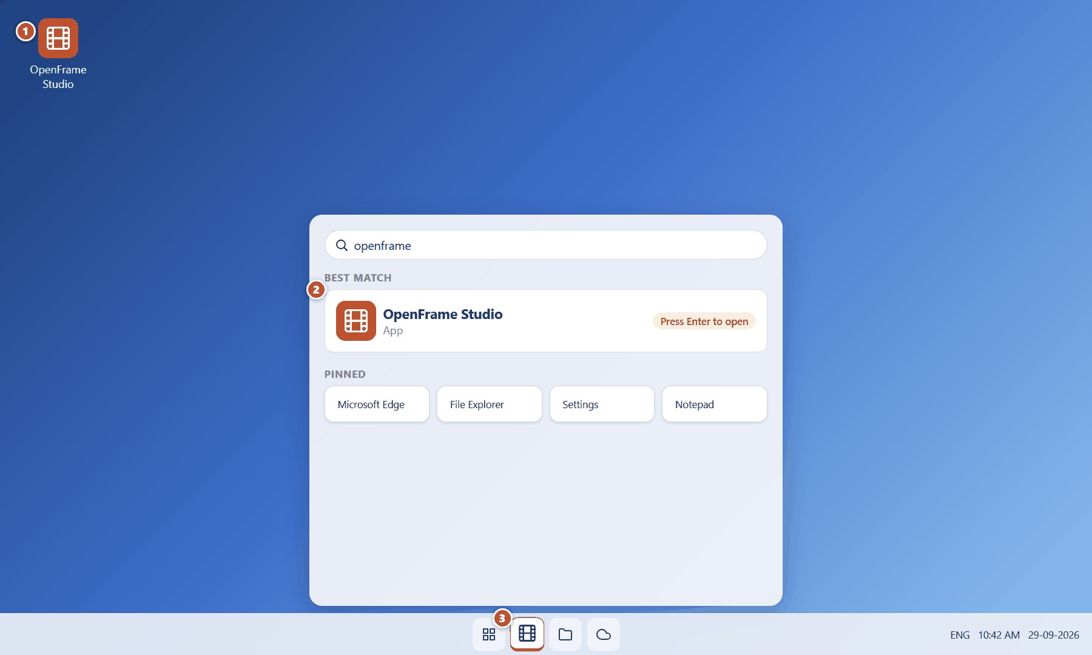
Figure 1. Starting OpenFrame Studio from Windows 11 (red numbers are explained on the next page)

Figure 1 — Starting OpenFrame Studio from Windows 11: how it works
PARTS OF THIS SCREEN  1 Desktop shortcut — Double-click the OpenFrame Studio shortcut on the desktop to start the application.  2 Start menu search — Press the Windows key, type "openframe" and press Enter. The Best match result opens the application.  3 Taskbar icon — Once running, OpenFrame Studio shows on the Windows taskbar. You can pin it there (right-click the icon → Pin to taskbar) so it is one click away next time. | HOW TO USE IT  1. Press the Windows key (or click the Start button) and type openframe.  2. Click OpenFrame Studio under Best match, or press Enter.  3. The application window opens on the Home screen after a short start-up screen.  GOOD TO KNOW · EDGE CASES  - OpenFrame is local-first: it does not ask you to sign in and does not need an internet connection to start.  - If you use more than one monitor, the window opens on the monitor where it was last used and can be resized, maximised or moved like any Windows app.

Figure 2 — The start-up screen
What it is for. A short start-up screen appears while OpenFrame loads your list of local projects.
How to get here. Appears automatically when the application is launched.
Figure 2. The start-up screen (red numbers are explained on the next page)

Figure 2 — The start-up screen: how it works
PARTS OF THIS SCREEN  1 OpenFrame logo — Confirms the application is starting.  2 Product name and mantra — The mantra summarises the four jobs of OpenFrame: capture the idea, shape the story, write the script, plan the shoot.  3 Loading indicator — OpenFrame is reading the list of projects stored on your computer. No internet connection is contacted. | HOW TO USE IT  1. Wait a few seconds; nothing needs to be clicked.  2. The Home screen appears automatically.  GOOD TO KNOW · EDGE CASES  - There is no setup wizard and no account sign-in. Configuration appears only when a specific workflow needs it.  - If a previous session ended abnormally (for example a power cut), the app offers recovery after you open that project — see "Recovering after a crash".

Figure 3 — Home: your projects
What it is for. Home is the application-level starting point (no project is open yet). It exists so a filmmaker can continue work immediately: recent projects fill the main area, pinned projects sit above, and archived projects have their own entry.
How to get here. Appears when you launch the app, when you close a project, or when you return from Project Home.
Figure 3. Home: your projects (red numbers are explained on the next page)

Figure 3 — Home: your projects: how it works
PARTS OF THIS SCREEN  1 Search projects — Type to filter the project list by title. This searches project names only; it is not the screenplay search.  2 Open Project — Opens the Windows file picker so you can open a project that is not in the list (for example one copied from a USB drive). Shortcut: Ctrl+O.  3 New Project — The dominant action on this screen. Opens the minimal New Project dialog. Shortcut: Ctrl+N.  4 Pinned projects — Projects you pinned. Pinning only changes ordering; it never moves files.  5 Recent projects — Every project card shows its title, type (Feature Film, Short Film or Episodic), status and when it was last modified. Click a card to open the project.  6 Open Archived — Archived projects are hidden from this list but never deleted. This link opens the archived list.  7 Status strip — Shows "No project open" and the connectivity message. Offline is a normal state, not an error. | HOW TO USE IT  1. Click a project card to open it; you land on Project Home.  2. Click New Project to make a new film.  3. Click Open Project (Ctrl+O) to browse for a project file or package on your PC or an external drive.  4. Use the search box to filter by title.  GOOD TO KNOW · EDGE CASES  - No production information (schedules, call sheets, metrics) is shown on this screen by design.  - A project stored on an external drive appears here too; if the drive is unplugged its card shows "Project unavailable" (see that screen).

Figure 4 — Home: first launch with no projects
What it is for. The very first time you start OpenFrame there are no projects. Instead of an empty list the screen tells you what to do next.
How to get here. Shown automatically when the project list is empty.
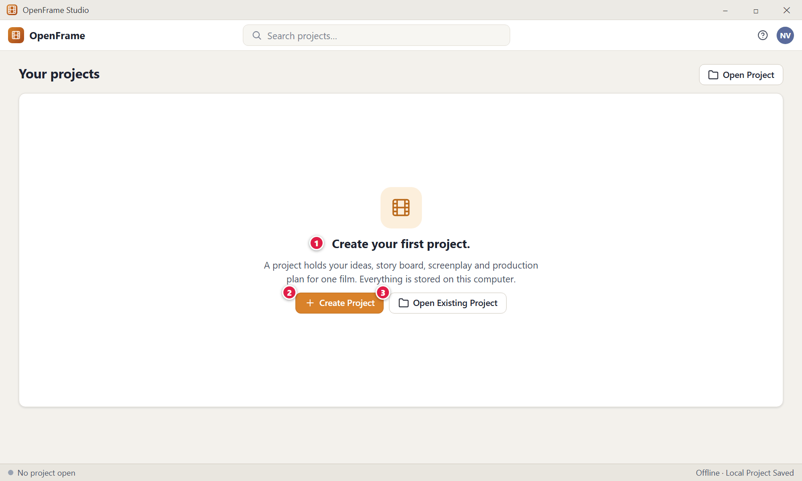
Figure 4. Home: first launch with no projects (red numbers are explained on the next page)

Figure 4 — Home: first launch with no projects: how it works
PARTS OF THIS SCREEN  1 Empty-state message — "Create your first project." explains what a project is in one sentence.  2 Create Project — The primary action. Opens the New Project dialog.  3 Open Existing Project — The secondary action for people who already have a project file or a full project package from another machine. | HOW TO USE IT  1. Click Create Project to start a new film, or Open Existing Project to browse for one.  GOOD TO KNOW · EDGE CASES  - There are no fake zeros or analytics on an empty screen. Every empty page in OpenFrame follows the same pattern: what this area is, what you can do, and one primary action.

Figure 5 — Project card menu: pin, rename, duplicate, archive
What it is for. Right-click any project card to see the actions available for a whole project.
How to get here. Right-click a card on Home (or use the … button on the card).
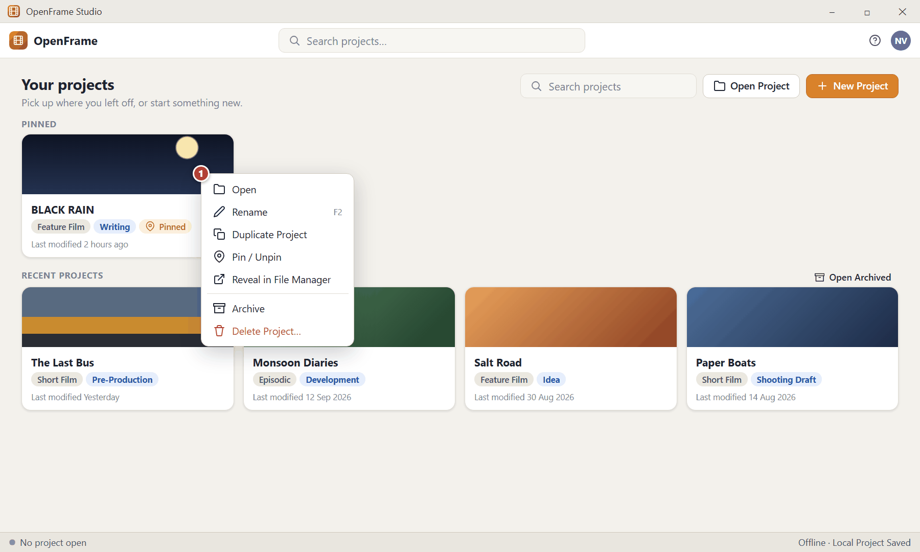
Figure 5. Project card menu: pin, rename, duplicate, archive (red numbers are explained on the next page)

Figure 5 — Project card menu: pin, rename, duplicate, archive: how it works
PARTS OF THIS SCREEN  1 Project context menu — Open · Rename · Duplicate Project (creates a separate copy named "Copy of …" until you rename it) · Pin/Unpin · Reveal in File Manager (opens the Windows Explorer folder that holds the project) · Archive · Delete Project. The destructive action is separated at the bottom. | HOW TO USE IT  1. Right-click the project card.  2. Choose the action. Rename changes only the project title; Duplicate creates an independent project with its own identity.  3. Choose Archive to hide a finished project from the recent list without deleting anything.  GOOD TO KNOW · EDGE CASES  - Delete Project requires a strong confirmation because it is the most destructive action in the app. A backup or recoverable copy is offered first.  - Archiving is preferred to deleting: an archived project stays searchable and can be reopened at any time.

Figure 6 — Archived projects
What it is for. Finished or paused projects can be archived so the recent list stays tidy. Archived projects remain fully intact.
How to get here. Home → Open Archived.
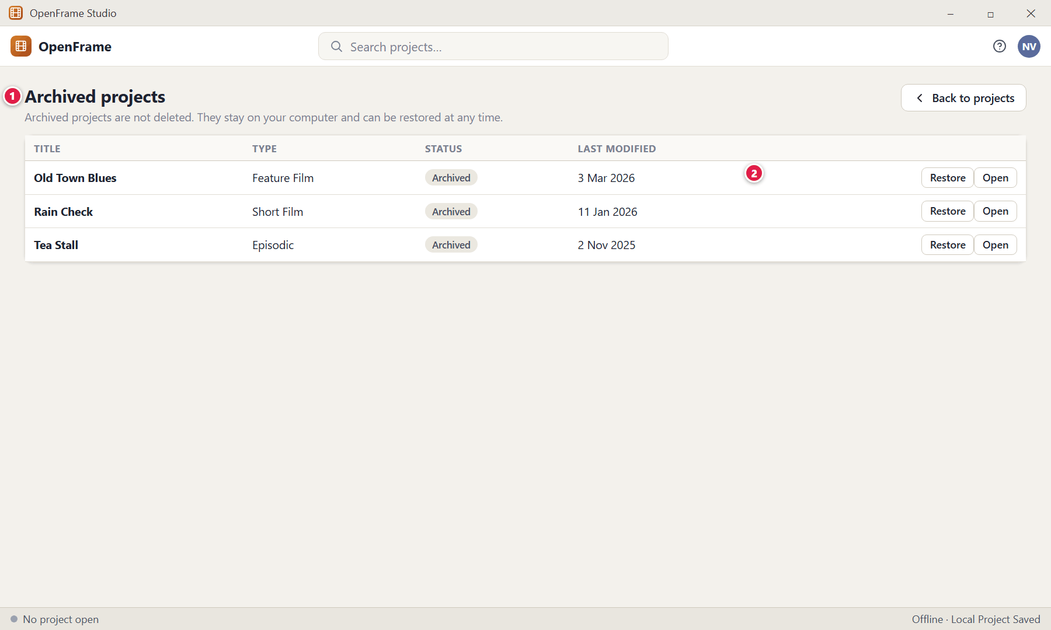
Figure 6. Archived projects (red numbers are explained on the next page)

Figure 6 — Archived projects: how it works
PARTS OF THIS SCREEN  1 Archived list — All archived projects with type, status and last-modified date. Their status shows "Archived".  2 Restore / Open — Restore returns the project to the normal list without altering its contents. Open lets you look inside without restoring first. | HOW TO USE IT  1. Click Open Archived on Home.  2. Click Restore to return a project to the recent list, or Open to inspect it.  GOOD TO KNOW · EDGE CASES  - Archived projects are separate from the recent list and can still be found by project search.

Figure 7 — Project unavailable (drive missing or file moved)
What it is for. If a project lives on an external drive or network folder that is not available, OpenFrame tells you plainly and never silently invents a substitute project.
How to get here. Clicking a project card whose folder cannot be read.
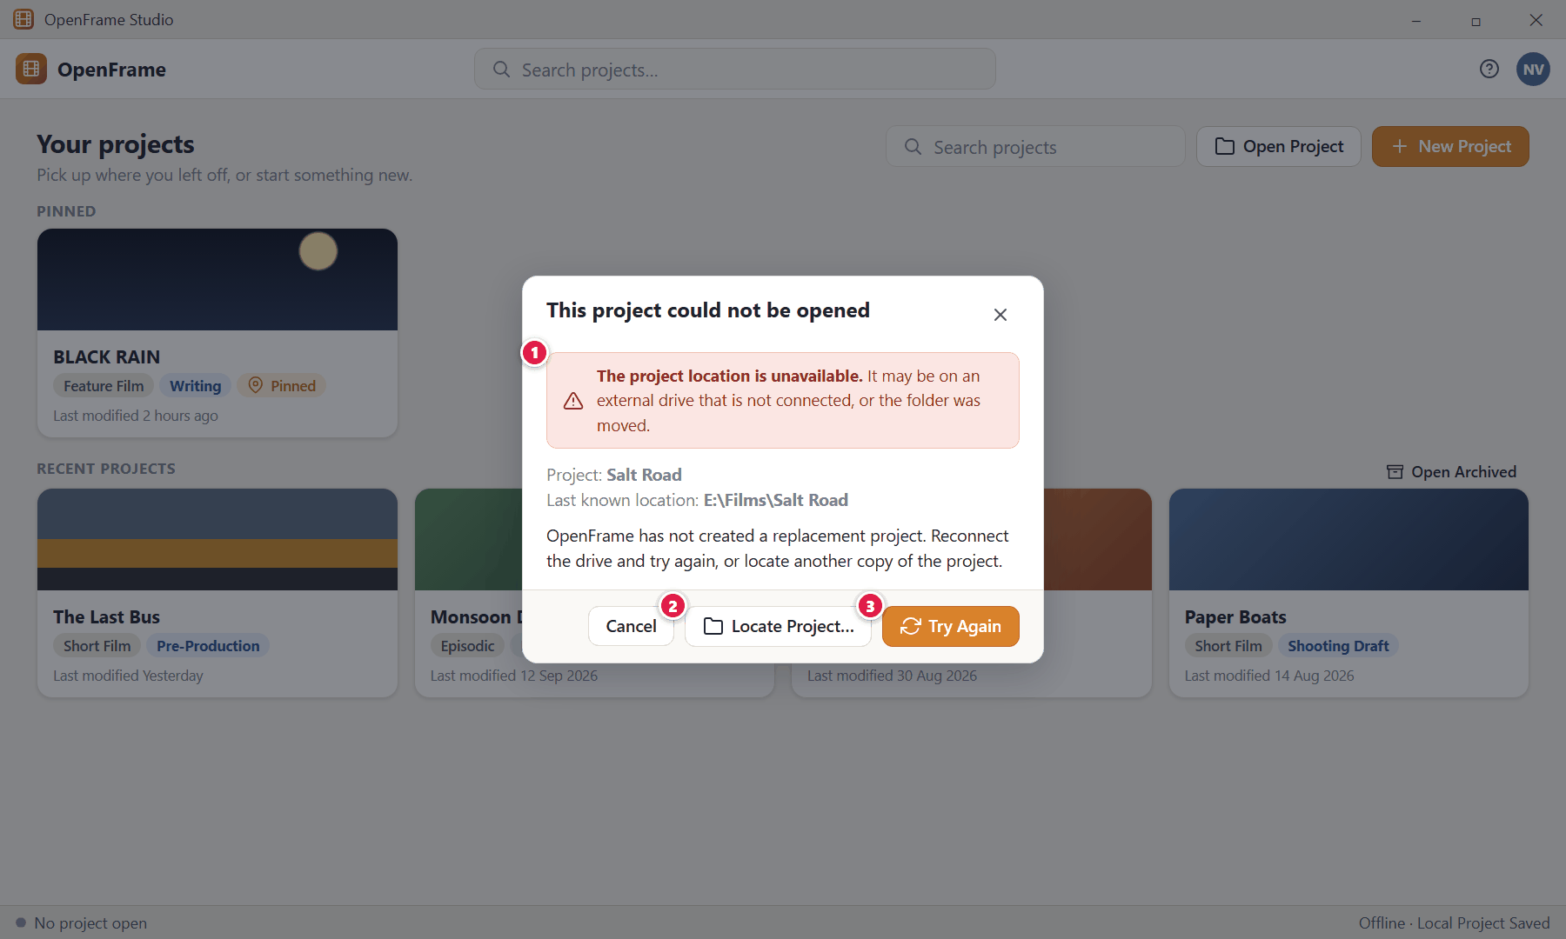
Figure 7. Project unavailable (drive missing or file moved) (red numbers are explained on the next page)

Figure 7 — Project unavailable (drive missing or file moved): how it works
PARTS OF THIS SCREEN  1 What happened — States the problem in plain language and the last known location.  2 Locate Project… — Browse to another copy of the project (for example after moving the folder).  3 Try Again — Reconnect the drive first, then try again. | HOW TO USE IT  1. Plug the external drive back in (or restore the folder).  2. Click Try Again. If the folder moved, click Locate Project… and choose it.  GOOD TO KNOW · EDGE CASES  - Edge case — drive removed while a project is open: OpenFrame warns immediately, keeps your unsaved edits in memory as safely as possible and offers a reconnect/retry path. It never creates a second, diverging copy of the project.

Figure 8 — New Project dialog (blank)
What it is for. New Project is deliberately tiny: it asks only for a title and a type. Everything else is optional and can be filled in later.
How to get here. Home → New Project, or Ctrl+N, or the + quick-actions menu.
Figure 8. New Project dialog (blank) — Blank / invalid state (red numbers are explained on the next page)

Figure 8 — New Project dialog (blank): how it works
PARTS OF THIS SCREEN  1 Title (required) — The only required text. Type any working title; you can rename it later. Duplicate titles are allowed.  2 Type (required) — Choose Feature Film, Short Film or Episodic / Series. The type sets the starting context (for example, an Episodic project gets Seasons and Episodes) but never removes any navigation.  3 Optional details — Language, Genre and Creator are secondary and never block creation.  4 Reassurance text — A small sentence reminds you that more information can be added later. There is no setup wizard.  5 Create — Enabled as soon as the required values are valid. After creation you land straight on Project Home.  6 Cancel — Closes the dialog without creating anything. | HOW TO USE IT  1. Type a title.  2. Choose the project type.  3. Optionally fill Language, Genre and Creator.  4. Click Create.  GOOD TO KNOW · EDGE CASES  - Edge case — empty title: the title box turns red with "A title is required." and Create stays disabled until you type something.  - Feature Film and Short Film are treated as ordinary screenplay projects; a Short Film is not forced to have Acts or Sequences.

Figure 9 — New Project dialog (filled in)
What it is for. The same dialog once the required values are valid: Create is enabled.
How to get here. Same as above.
Figure 9. New Project dialog (filled in) — Valid state (red numbers are explained on the next page)

Figure 9 — New Project dialog (filled in): how it works
PARTS OF THIS SCREEN  1 Title (required) — The only required text. Type any working title; you can rename it later. Duplicate titles are allowed.  2 Type (required) — Choose Feature Film, Short Film or Episodic / Series. The type sets the starting context (for example, an Episodic project gets Seasons and Episodes) but never removes any navigation.  3 Optional details — Language, Genre and Creator are secondary and never block creation.  4 Reassurance text — A small sentence reminds you that more information can be added later. There is no setup wizard.  5 Create — Enabled as soon as the required values are valid. After creation you land straight on Project Home.  6 Cancel — Closes the dialog without creating anything. | HOW TO USE IT  1. Click Create. The new project is created and opened at Project Home.  GOOD TO KNOW · EDGE CASES  - Creation takes a moment ("Creating"), then the project opens. There is no wizard to complete.

Figure 10 — New Project: creation error
What it is for. If the project cannot be created (for example the disk is full or the folder is read-only) the dialog tells you and keeps everything you typed.
How to get here. Appears after clicking Create when creation fails.
Figure 10. New Project: creation error — Creation error state (red numbers are explained on the next page)

Figure 10 — New Project: creation error: how it works
PARTS OF THIS SCREEN  1 Error message — Explains what happened: nothing was saved and no half-created project exists.  2 Title (required) — The only required text. Type any working title; you can rename it later. Duplicate titles are allowed.  3 Create — Enabled as soon as the required values are valid. After creation you land straight on Project Home.  4 Cancel — Closes the dialog without creating anything. | HOW TO USE IT  1. Fix the cause (for example free some disk space) and click Retry, or click Cancel.  GOOD TO KNOW · EDGE CASES  - OpenFrame follows one error rule everywhere: say what happened, why it matters, and what you can do. It never shows a bare "Error".

Figure 11 — Project Home: a brand-new project
What it is for. A new project never opens as an empty dashboard with no obvious next step. It shows the project title, one welcoming sentence and clear first actions.
How to get here. Immediately after you click Create in the New Project dialog.
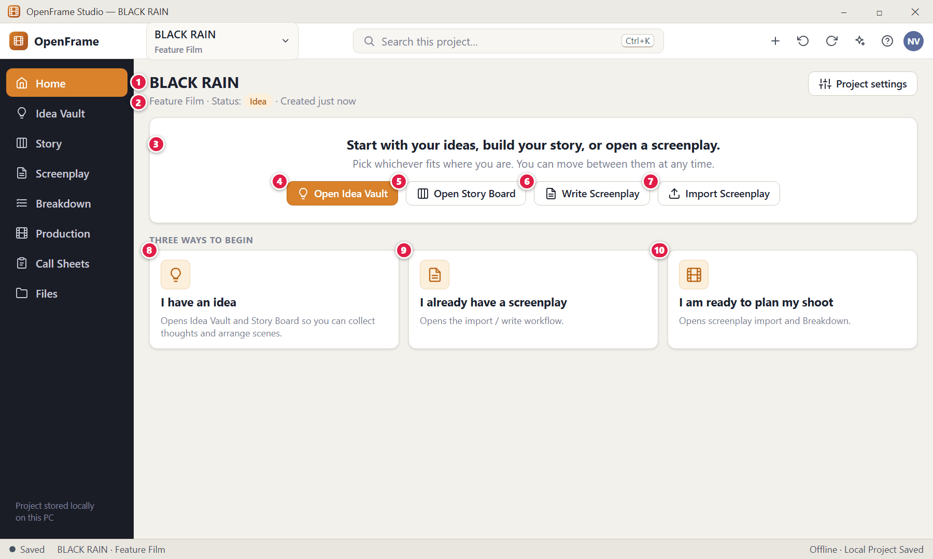
Figure 11. Project Home: a brand-new project (red numbers are explained on the next page)

Figure 11 — Project Home: a brand-new project: how it works
PARTS OF THIS SCREEN  1 Project title — The film you are working on. It is always visible in the top bar as well, so you never wonder which movie you are editing.  2 Type, status and dates — Shows the project type and the status label (Idea, Development, Writing…). You choose the status yourself; OpenFrame may suggest a change but never applies it on its own.  3 Welcome message — "Start with your ideas, build your story, or open a screenplay."  4 Open Idea Vault — Go to the free-form place where any thought, image, link or file can be dropped.  5 Open Story Board — Go to the visual board of Acts, Sequences, Beats and Scene Cards.  6 Write Screenplay — Open the screenplay editor and type directly.  7 Import Screenplay — Bring in an existing script (PDF, FDX, Fountain, TXT, DOCX or pasted text).  8 I have an idea — Beginner path 1: Idea Vault + Story Board.  9 I already have a screenplay — Beginner path 2: import or write.  10 I am ready to plan my shoot — Path 3: import your script and go straight to Breakdown. | HOW TO USE IT  1. Choose one of the four buttons or one of the three path cards.  2. You are free to switch path at any time; "Beginner" is not a permission level.  GOOD TO KNOW · EDGE CASES  - No fake metrics are shown on a new project. Production status indicators (breakdown progress, next shooting day…) appear only after production content exists.

Figure 12 — Project Home: an active project
What it is for. Project Home is a practical landing page — the front door to one film. It answers "What do I want to continue doing?" and is deliberately not an analytics dashboard.
How to get here. Opening a project from Home, choosing the project in the top-bar selector, or clicking Home in the left navigation.
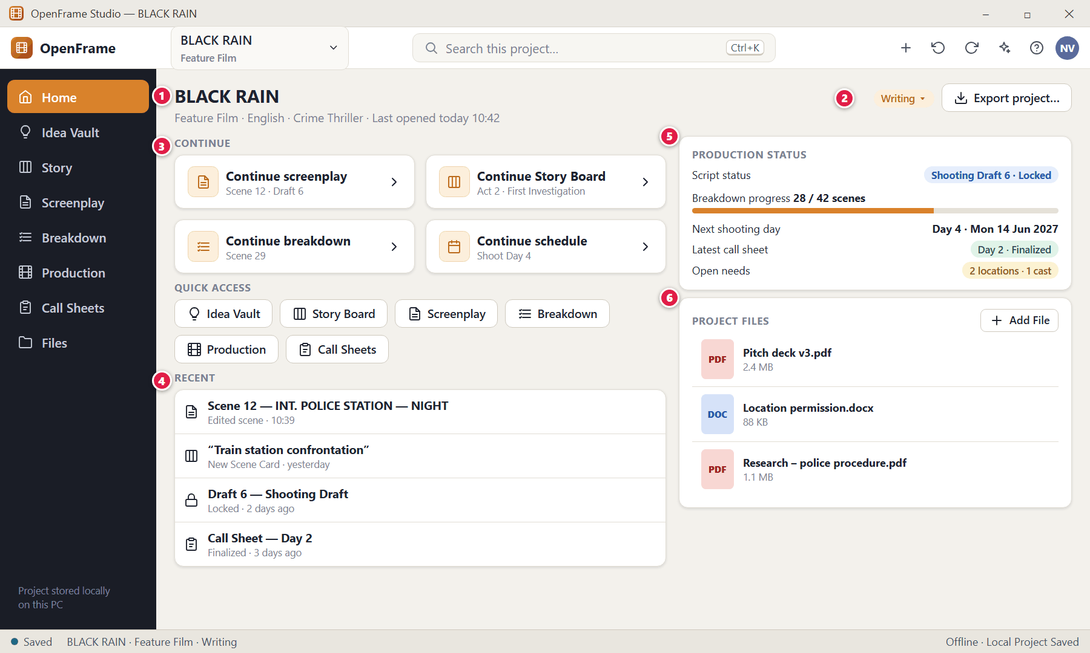
Figure 12. Project Home: an active project (red numbers are explained on the next page)

Figure 12 — Project Home: an active project: how it works
PARTS OF THIS SCREEN  1 Project header — Title, type, language, genre and the time you last opened it.  2 Project status — Click the status label to change it (Idea, Development, Writing, Rewriting, Shooting Draft, Pre-Production, Shoot Preparation, Shooting, Completed, Archived). Status is a label you control; it never disables features.  3 Continue — Remembers the last meaningful place you worked (a screenplay scene, a Story Board card, a breakdown scene or a shooting day) and returns you there. If that place no longer exists it falls back to Project Home.  4 Recent — Recently edited scenes, cards, drafts and documents.  5 Production status — Appears only after production content exists: script status, breakdown progress, next shooting day, latest call sheet and outstanding location/cast needs. Every line is a shortcut to its workspace and none is a prerequisite.  6 Project Files — A small file cabinet for miscellaneous attachments (pitch deck, research PDFs, permission scans). | HOW TO USE IT  1. Click a Continue card to jump back into your last workspace.  2. Use Quick Access buttons to move to any workspace.  3. Click Add File in Project Files to store a document with the project.  GOOD TO KNOW · EDGE CASES  - If a recently used document is unavailable, the page stays usable and directs you to the right workspace.  - Export project… opens the Full Project Package flow (see the Backup and Portability chapter).

Figure 13 — Switching projects from the top bar
What it is for. The project name in the top bar is a selector. It lets you jump to another project without going back to Home.
How to get here. Click the project name in the top bar (left of the search box).
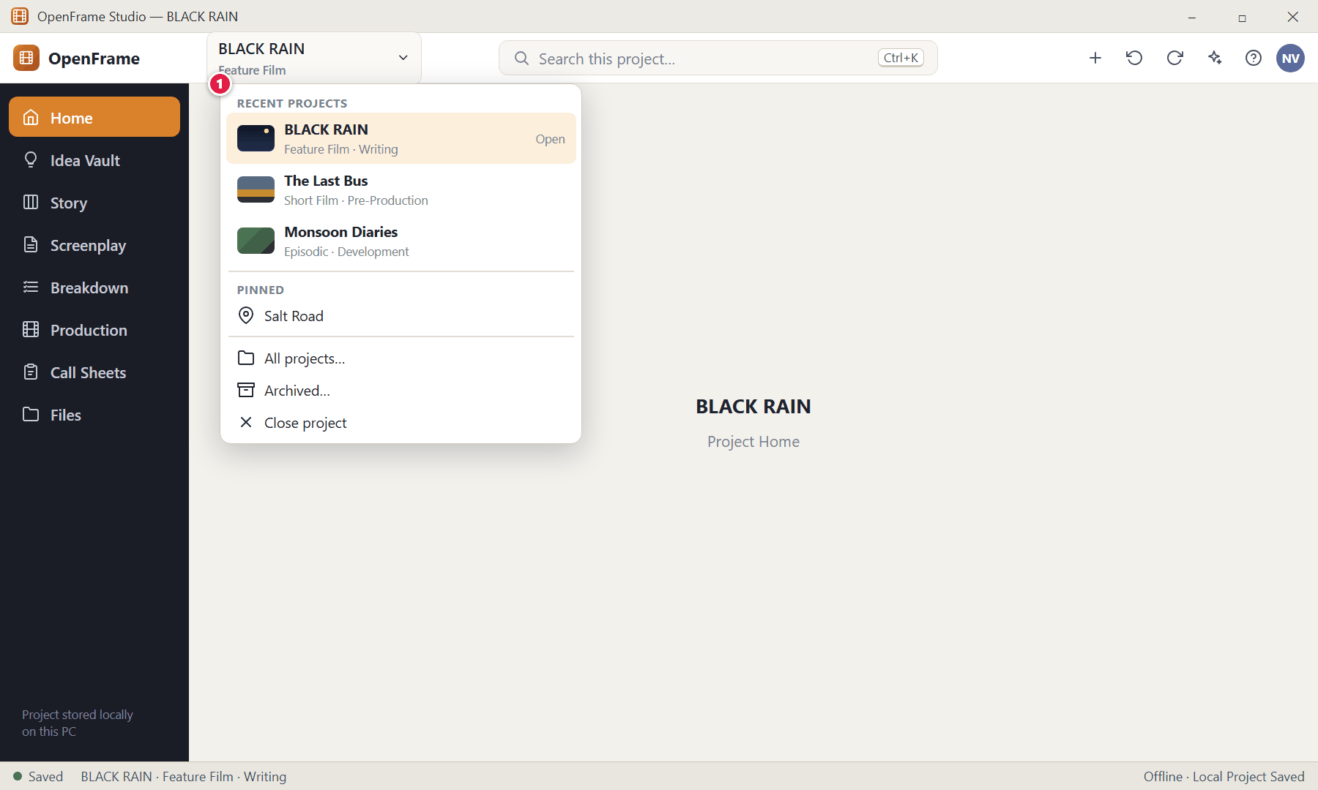
Figure 13. Switching projects from the top bar (red numbers are explained on the next page)

Figure 13 — Switching projects from the top bar: how it works
PARTS OF THIS SCREEN  1 Project list — Recent projects and pinned projects with their type and status, plus All projects…, Archived… and Close project. | HOW TO USE IT  1. Click the project name at the top.  2. Choose another project. If the current project has unsaved or saving work, a small confirmation appears first (see "Leaving a project during a save problem").  3. Close project returns you to the application Home without deleting anything.  GOOD TO KNOW · EDGE CASES  - The selector keeps the current project obvious without an oversized title block.

Figure 14 — Anatomy of the OpenFrame window
What it is for. Every screen in OpenFrame sits inside the same stable shell: a title bar, a top bar, the left navigation, the working area and a status strip. Only the working area changes.
How to get here. Visible on every project screen.
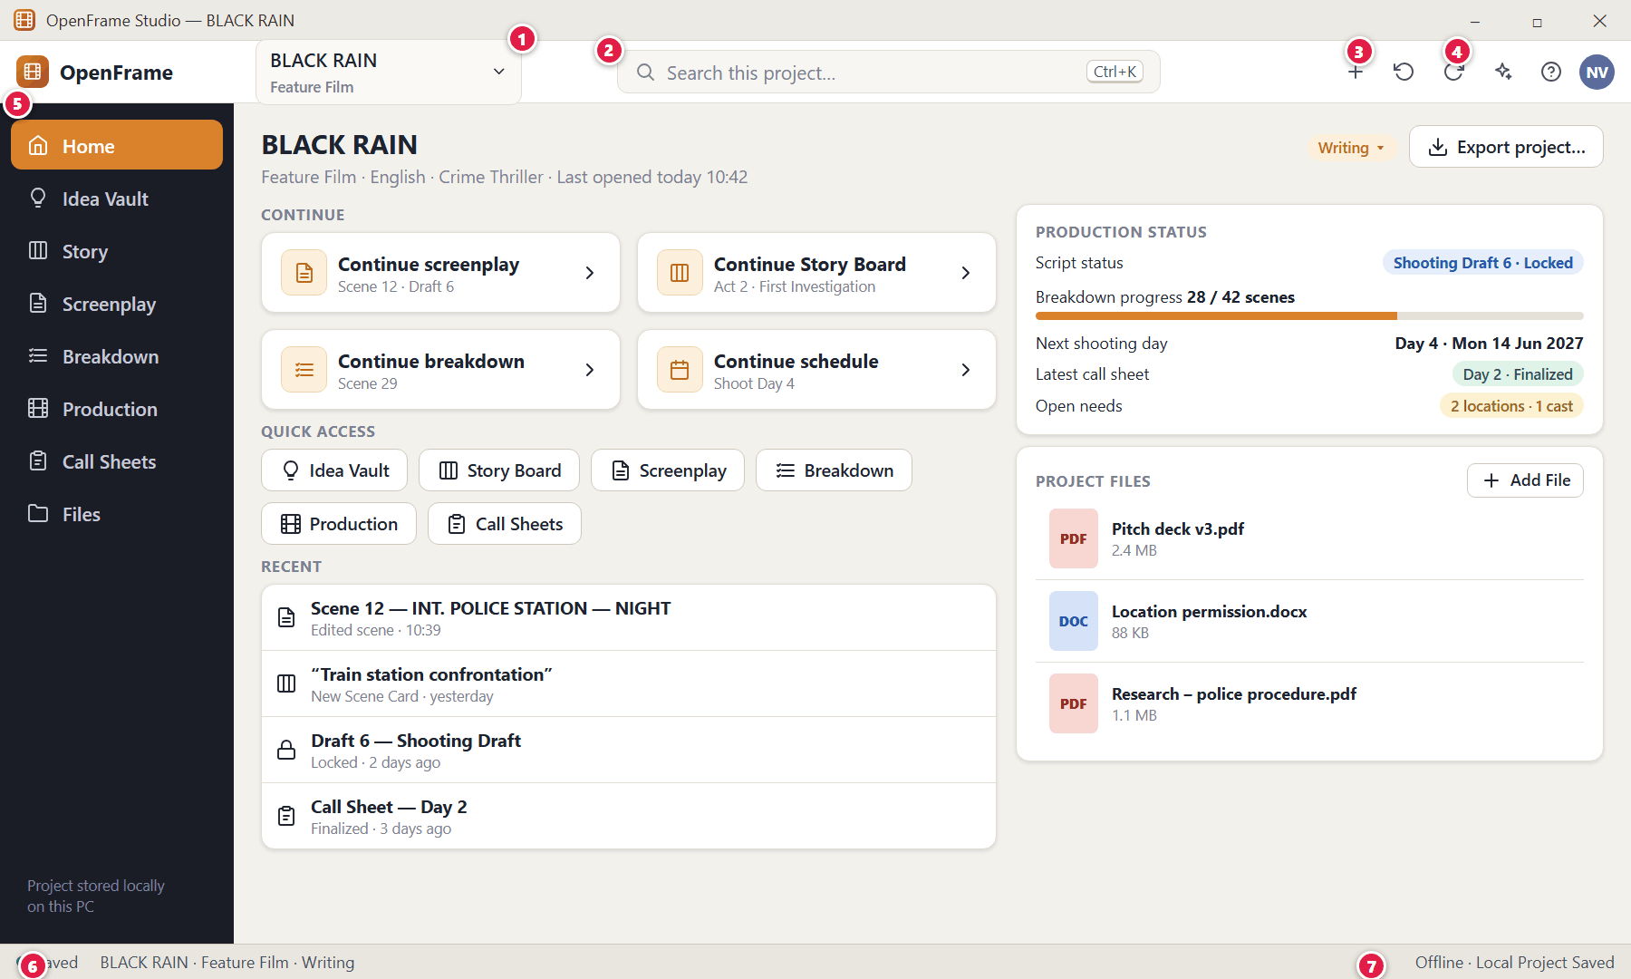
Figure 14. Anatomy of the OpenFrame window (red numbers are explained on the next page)

Figure 14 — Anatomy of the OpenFrame window: how it works
PARTS OF THIS SCREEN  1 Project selector — Shows which film is open and lets you switch projects.  2 Global search (Ctrl+K) — Searches the whole current project: ideas, story objects, screenplay text, characters, locations, catalog items, cast/crew, shots, storyboards, call sheets, files and comments.  3 Undo / Redo — Reverses or repeats meaningful actions such as moving a card or editing a schedule. The label uses plain words like "Move Scene Card".  4 AI Assistant — Optional. Opens the AI panel. OpenFrame works fully without AI.  5 Left navigation — Home · Idea Vault · Story · Screenplay · Breakdown · Production · Call Sheets · Files. Cast, Locations, Props and other production tools live inside Production so the navigation stays small.  6 Save status — Saved / Saving / Save error. Refers to your local file on this PC, never to a cloud.  7 Connection status — “Offline · Local Project Saved” is normal. Other state: Local Session · 2 collaborators connected. | HOW TO USE IT  1. Use the left navigation to change workspace.  2. Use Ctrl+K for search and Ctrl+Z / Ctrl+Shift+Z for undo/redo.  GOOD TO KNOW · EDGE CASES  - The shell has three jobs only: tell you which project is open, give stable navigation, and expose universal actions (search, undo/redo, save/session state, AI access).  - The application window can be resized, maximised or put in full-screen writing mode. Every workflow works inside a single window; a second monitor is an option, not a requirement.

Figure 15 — Changing the project status
What it is for. Project status is a simple label that describes where the film is in its life. It only helps you orient yourself.
How to get here. Project Home → click the status label.
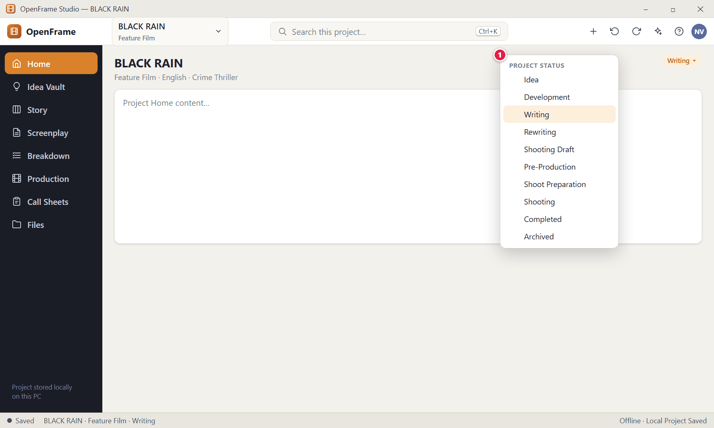
Figure 15. Changing the project status (red numbers are explained on the next page)

Figure 15 — Changing the project status: how it works
PARTS OF THIS SCREEN  1 Status list — Idea → Development → Writing → Rewriting → Shooting Draft → Pre-Production → Shoot Preparation → Shooting → Completed → Archived. | HOW TO USE IT  1. Click the status chip and pick a new value.  GOOD TO KNOW · EDGE CASES  - Changing status never creates tasks or disables features. OpenFrame may suggest a status change when it is obvious (for example after you lock a draft) but you must accept it.  - The lifecycle is a guide, not a prison: you may stay in Development for months or jump back to Idea while writing.

Figure 16 — Recovering after a crash or power cut
What it is for. If the app or Windows shut down abnormally, OpenFrame offers the automatically saved recovery state next time you open the project. It never picks a version silently.
How to get here. Appears when you open a project after an abnormal shutdown, if recoverable edits exist.
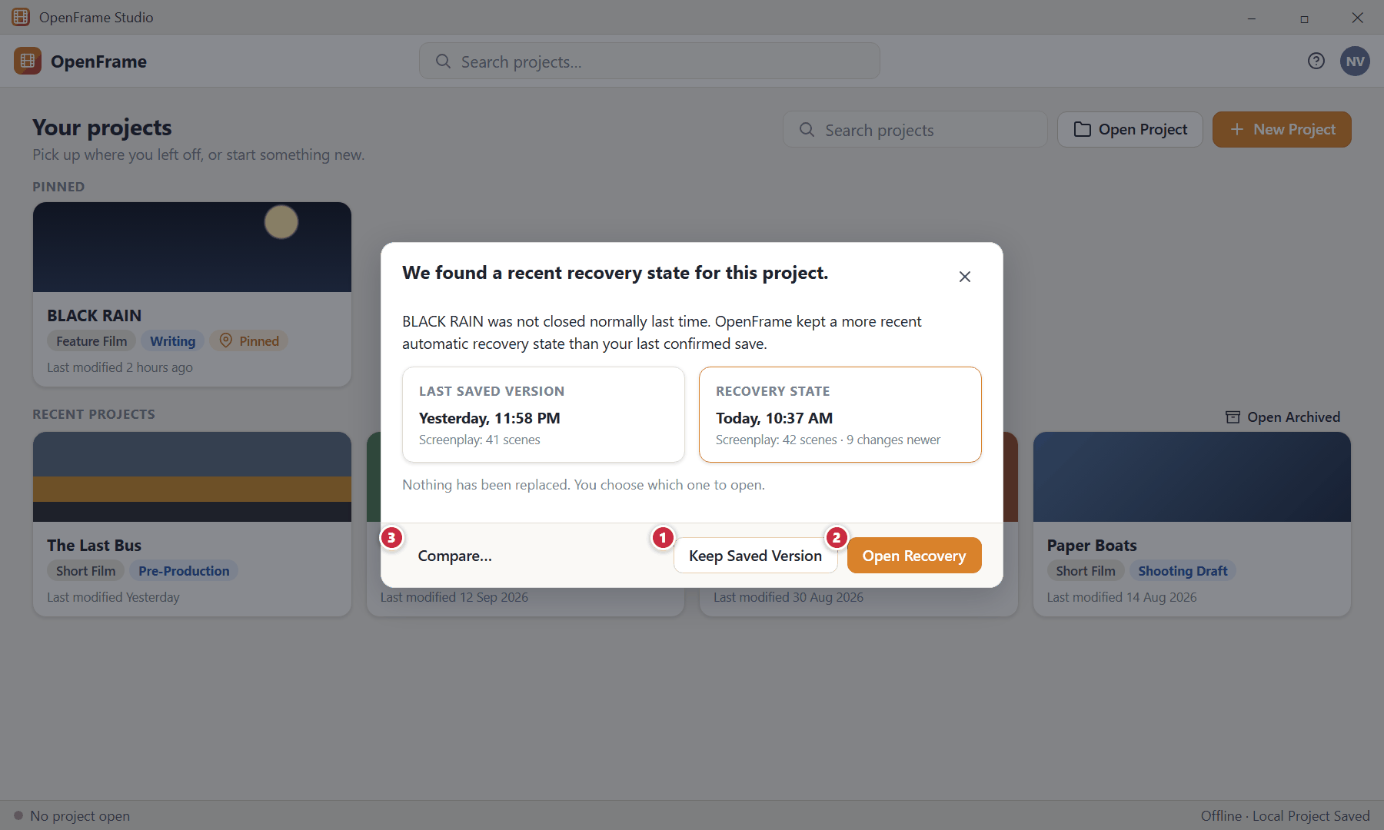
Figure 16. Recovering after a crash or power cut (red numbers are explained on the next page)

Figure 16 — Recovering after a crash or power cut: how it works
PARTS OF THIS SCREEN  1 Keep Saved Version — Opens the last confirmed saved state and leaves the recovery copy untouched until you decide.  2 Open Recovery — Opens the more recent recovered state.  3 Compare… — Where possible, review the differences before deciding. | HOW TO USE IT  1. Read the two timestamps.  2. Click Open Recovery to get your latest work back, or Keep Saved Version to stay with the last confirmed save.  GOOD TO KNOW · EDGE CASES  - No recovery copy silently replaces the confirmed project state.  - Recovery information is treated as sensitive project data and is only shown to people who may access the project.

Figure 17 — Save error: your work is still open
What it is for. If a save fails, OpenFrame keeps your current edits visible and offers ways forward. It never falsely claims your project is safely saved, and it never implies that an internet connection is needed.
How to get here. Appears automatically when local saving fails.
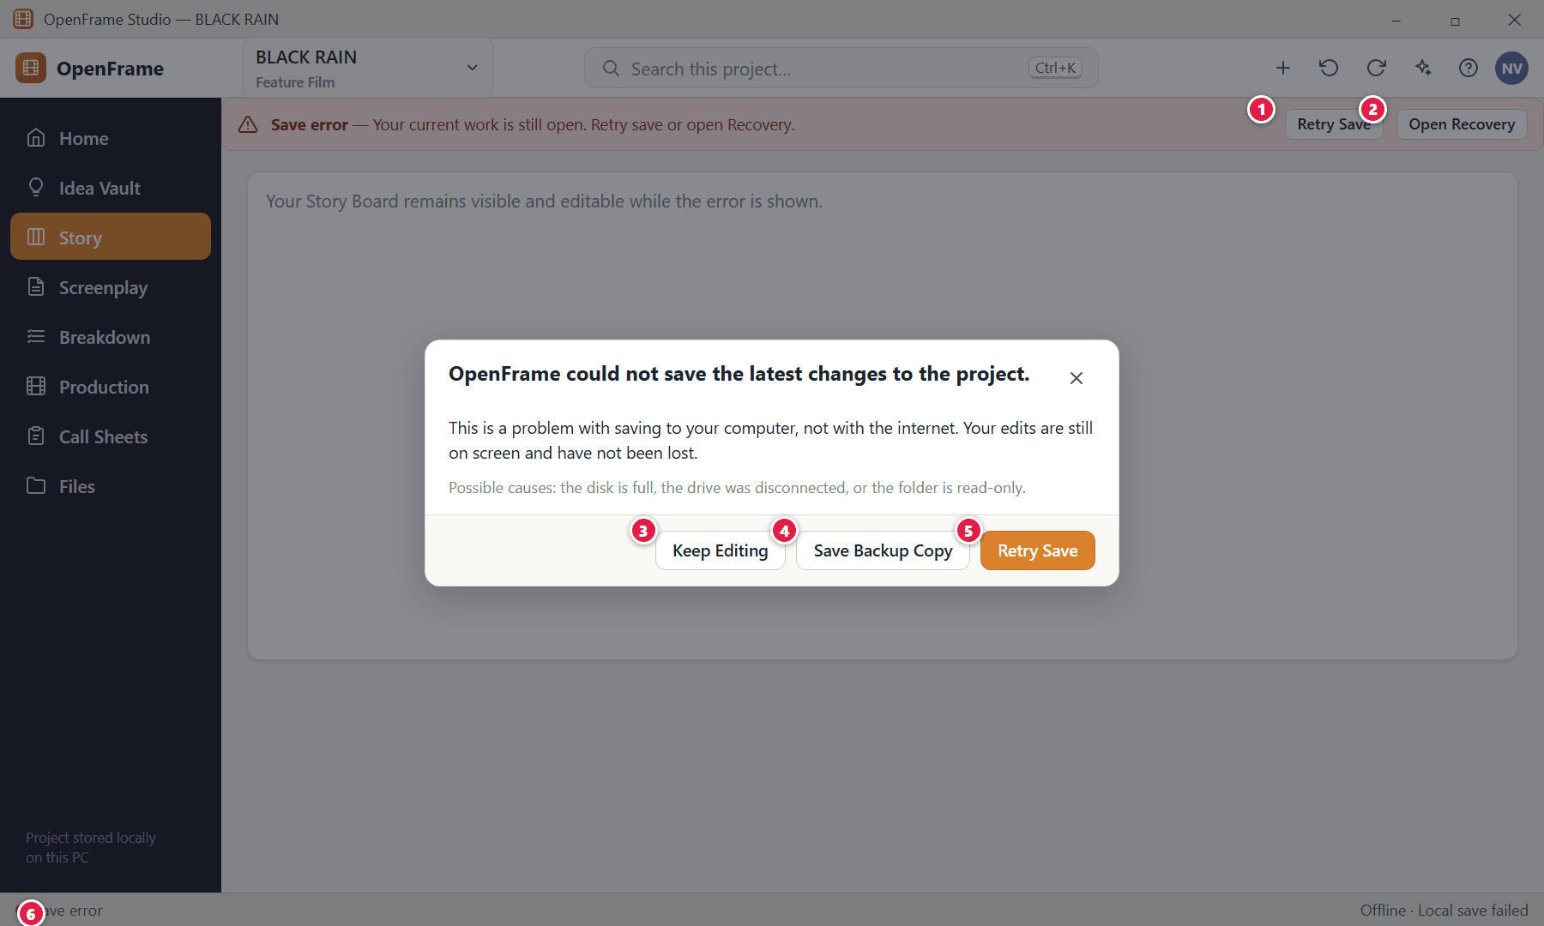
Figure 17. Save error: your work is still open (red numbers are explained on the next page)

Figure 17 — Save error: your work is still open: how it works
PARTS OF THIS SCREEN  1 Banner: Retry Save — Try saving again straight away.  2 Banner: Open Recovery — Opens the recovery panel.  3 Keep Editing — Dismiss the dialog and continue working; the banner and red status stay until saving works.  4 Save Backup Copy — Writes a complete backup to another location you choose (for example another disk) so nothing is lost.  5 Retry Save — Attempts the save again.  6 Status strip — Turns red and reads "Save error". | HOW TO USE IT  1. Free some disk space or reconnect the drive.  2. Click Retry Save.  3. If it keeps failing, click Save Backup Copy and pick a different disk.  GOOD TO KNOW · EDGE CASES  - The error explains what happened, why it matters and what you can do — exactly the wording rule of the whole product.

Figure 18 — Leaving a project during a save problem
What it is for. When you try to switch or close a project while a save is in progress or has failed, OpenFrame asks you to decide instead of silently abandoning changes.
How to get here. Switching projects, closing a project or closing the app while saving/unsaved.
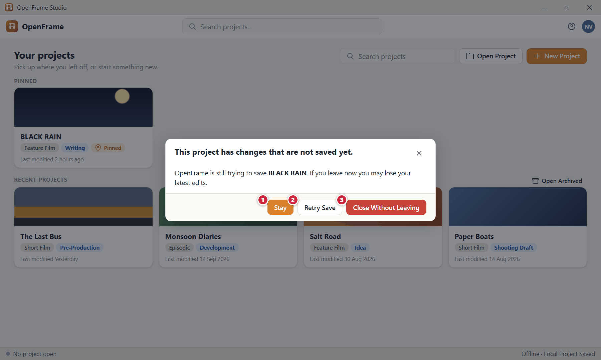
Figure 18. Leaving a project during a save problem (red numbers are explained on the next page)

Figure 18 — Leaving a project during a save problem: how it works
PARTS OF THIS SCREEN  1 Stay — Remain in the project.  2 Retry Save — Try again before leaving.  3 Close Without Leaving — Only for when you explicitly accept the consequence. (The wording is deliberately not "OK / Cancel".) | HOW TO USE IT  1. Choose Stay or Retry Save. Only choose the red button if you accept losing the unsaved edits.  GOOD TO KNOW · EDGE CASES  - Button labels always say what they do; ambiguous OK/Cancel pairs are not used for this decision.

Figure 19 — Save and offline status panel
What it is for. Clicking the status strip at the bottom-left opens a small panel that tells you whether your work is safely on disk. It does not take you away from what you are doing.
How to get here. Click the Saved / Saving / Offline indicator in the bottom status strip.
Figure 19. Save and offline status panel (red numbers are explained on the next page)

Figure 19 — Save and offline status panel: how it works
PARTS OF THIS SCREEN  1 Status panel — Save state, "Offline — your project is stored locally." and the folder where the project lives.  2 Create backup — Makes a backup package right now (you choose where; see Backup and Portability).  3 Open project location — Opens the project folder in Windows File Explorer. | HOW TO USE IT  1. Click the status text in the bottom-left corner.  2. Use Retry save, Open recovery, Create backup or Open project location as needed.  GOOD TO KNOW · EDGE CASES  - Offline is a normal state, not an error. When offline, everything keeps working, including an installed Offline AI: idea editing, story boards, screenplay, breakdown, scheduling, call sheets and export.  - Status text never implies cloud syncing — there is no "Syncing to OpenFrame Cloud" state in the product.

Figure 20 — The + quick-actions menu
What it is for. A compact + menu offers the most common "create" actions from anywhere in the project.
How to get here. Click + in the top bar.
Figure 20. The + quick-actions menu (red numbers are explained on the next page)

Figure 20 — The + quick-actions menu: how it works
PARTS OF THIS SCREEN  1 + button — Opens the quick-actions menu.  2 Quick actions — New Idea · New Act · New Sequence · New Beat · New Scene Card · New Character · New Location · New Shot List · New Moodboard · Import Screenplay. The list is contextual — it changes with where you are. | HOW TO USE IT  1. Click + and choose what to create.  GOOD TO KNOW · EDGE CASES  - These are the same actions offered inside each workspace. The AI assistant reuses the same underlying actions, so asking for "a new Scene Card" and clicking New Scene Card create exactly the same object.

Figure 21 — Undo and Redo
What it is for. Every meaningful editing or arrangement action can be undone and redone, with a label in plain words. Creative experimentation should feel safe.
How to get here. Ctrl+Z / Ctrl+Shift+Z, the Undo/Redo buttons in the top bar, or the Undo link in the message.
Figure 21. Undo and Redo (red numbers are explained on the next page)

Figure 21 — Undo and Redo: how it works
PARTS OF THIS SCREEN  1 Undo / Redo buttons — Hover to see the action they will reverse, such as "Move Scene Card" or "Delete Shot".  2 Confirmation message — A short message after an action such as a move or a delete.  3 Undo — Reverses that action immediately. | HOW TO USE IT  1. Press Ctrl+Z to undo, Ctrl+Shift+Z to redo.  GOOD TO KNOW · EDGE CASES  - Undo works for: text edits, card create/delete/move, board reorder, breakdown associations, shot reorder, schedule moves, note changes and form edits. A large imported package is treated as a single undoable action where practical.  - Routine actions (moving a card, adding a comment, reordering a scene, adding a shot) never ask for confirmation because undo is always available. Only destructive actions such as deleting a project or a draft, permanently deleting an item, replacing a screenplay by import, or overwriting data from an exchange package ask first.

Figure 22 — Project settings
What it is for. The few descriptive details of a project can be edited at any time.
How to get here. Project Home → Project settings.
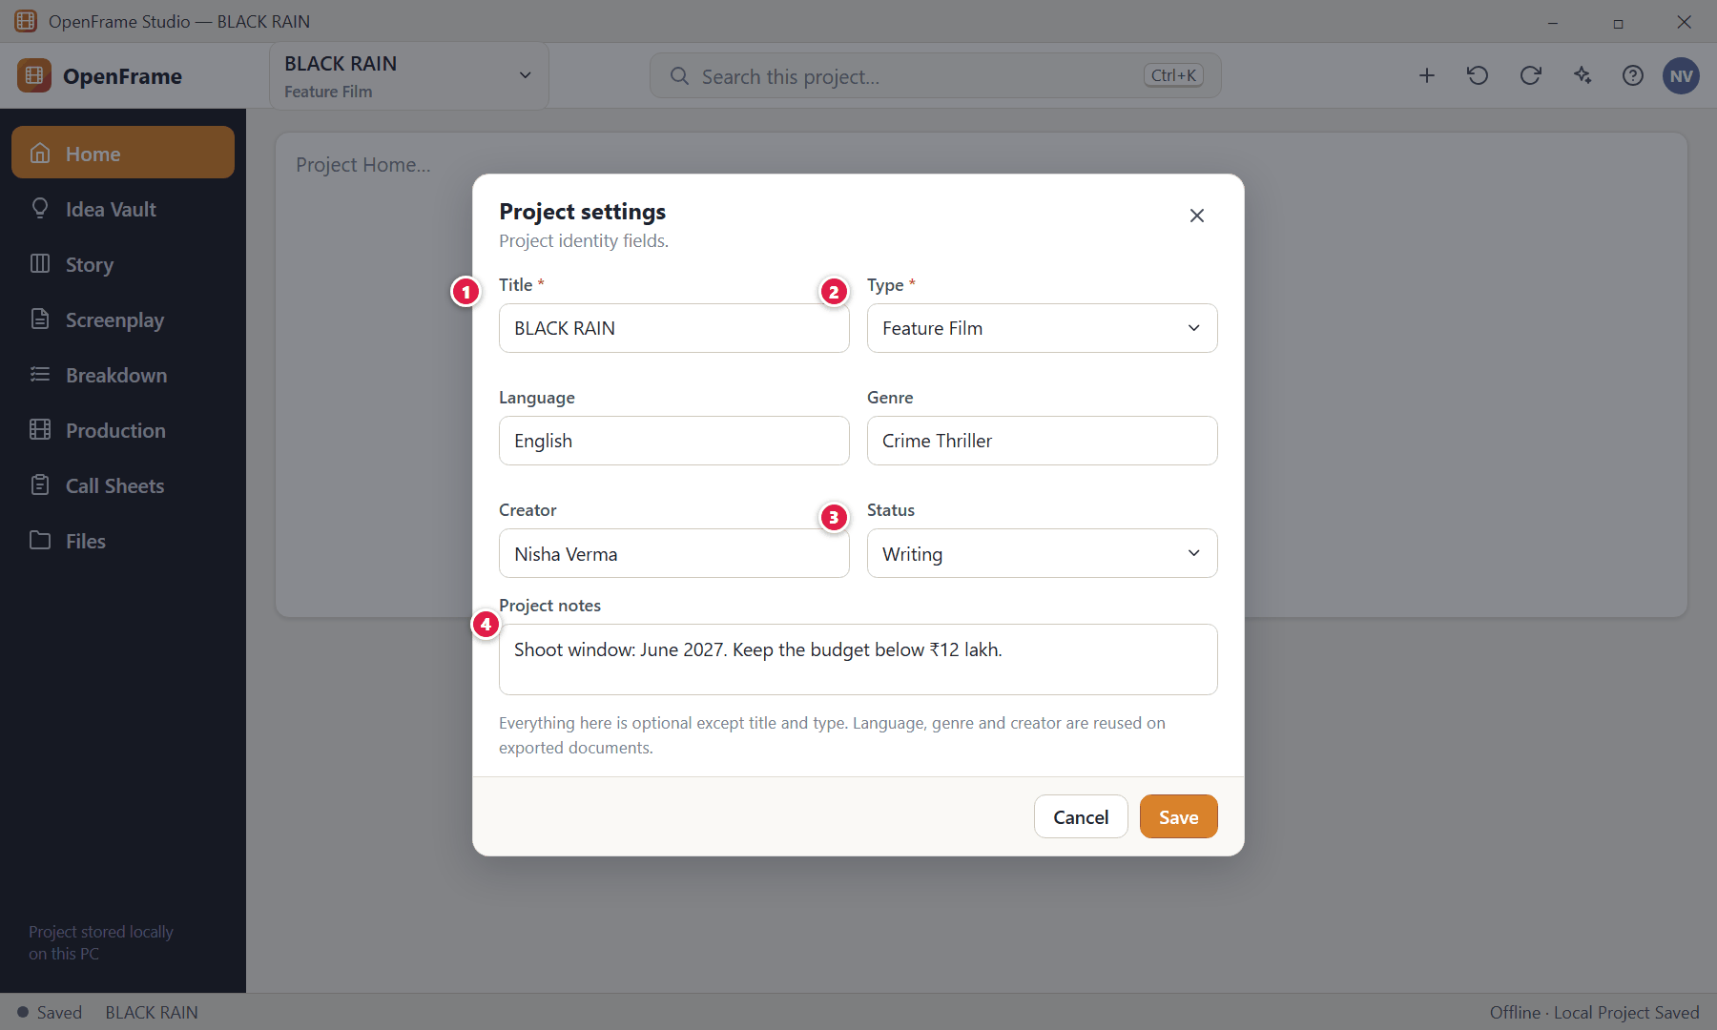
Figure 22. Project settings (red numbers are explained on the next page)

Figure 22 — Project settings: how it works
PARTS OF THIS SCREEN  1 Title (required) — Renaming changes only the project title.  2 Type (required) — Feature Film · Short Film · Episodic / Series.  3 Status — The project lifecycle label.  4 Project notes — A free-form note kept with the project. | HOW TO USE IT  1. Edit the fields and click Save.  GOOD TO KNOW · EDGE CASES  - No budget, schedule, team, cast or location fields are required or requested here.

Figure 23 — Deleting a project (strong confirmation)
What it is for. Deleting a whole project needs a strong confirmation and offers a recovery path.
How to get here. Project card → right-click → Delete Project….
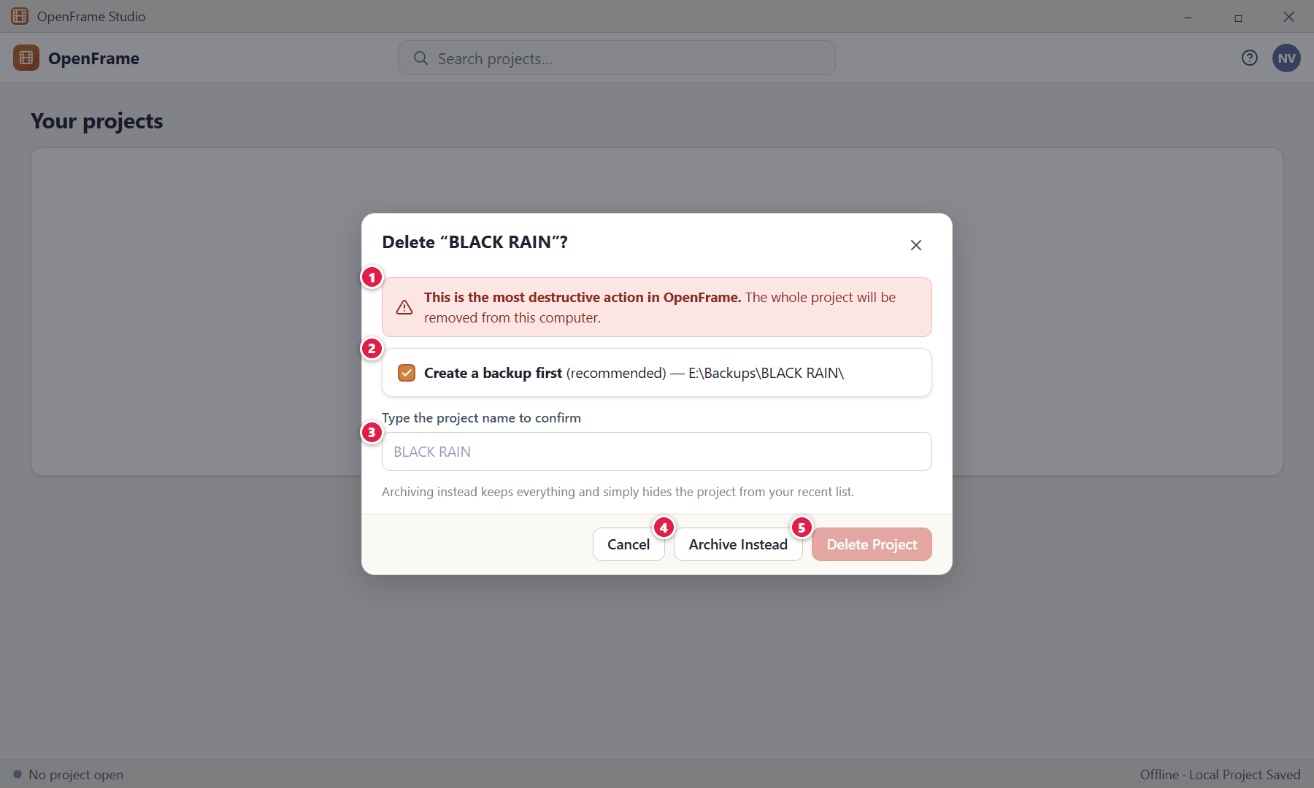
Figure 23. Deleting a project (strong confirmation) (red numbers are explained on the next page)

Figure 23 — Deleting a project (strong confirmation): how it works
PARTS OF THIS SCREEN  1 Warning — States the consequence in plain words.  2 Backup first — Offers to create a backup so the project stays recoverable.  3 Type-to-confirm — A deliberate second step before the red button is enabled.  4 Archive Instead — The safer alternative.  5 Delete Project — Disabled until you confirm. | HOW TO USE IT  1. Choose Archive Instead, or create a backup, type the name and delete.  GOOD TO KNOW · EDGE CASES  - Destructive actions that always ask for confirmation: delete project · delete a screenplay draft · permanently delete a card or item · replace a screenplay with an imported version · overwrite data from an exchange package.

Chapter 2 — Idea Vault: Capture Anything
The Idea Vault is the filmmaker's permanent creative dumping ground. It exists for things that are not ready, not structured, not assigned, experimental or possibly useless — but potentially valuable years later. Its promise: put anything related to a film here without first deciding what it is. There is a Global Idea Vault (across all your films) and a Project Idea Vault (for the current film).
Screens in this chapter
Figure 24 Project Idea Vault — Visual Grid | Figure 36 External file unavailable
Figure 25 Idea Vault — Card view | Figure 37 Selecting several items
Figure 26 Idea Vault — List view | Figure 38 Right-click menu on a Vault item
Figure 27 Idea Vault — Folder view | Figure 39 Send to Story Board
Figure 28 Idea Vault — empty state | Figure 40 Global Idea Vault
Figure 29 Add menu: Note, Image, URL, File, Voice Note, Video | Figure 41 Copy a Global idea to a project
Figure 30 Text note editor (autosave) | Figure 42 Searching the Vault
Figure 31 Idea Vault item detail: image | Figure 43 Quick Capture
Figure 32 Adding a URL | Figure 44 Recently Deleted
Figure 33 Recording a voice note | Figure 45 Research collection with verification flags
Figure 34 Dragging files into the Vault | Figure 46 Creating a collection
Figure 35 Drag-in result: partial success | Figure 47 Everything the Vault can hold

Figure 24 — Project Idea Vault — Visual Grid
What it is for. This is the film's creative dump: text notes, images, links, PDFs, voice notes, videos, sketches, quotes and screenshots side by side. It answers one question — "What have I collected for this film?"
How to get here. Left navigation → Idea Vault, or Project Home → Open Idea Vault.
Figure 24. Project Idea Vault — Visual Grid — Mixed items state (red numbers are explained on the next page)

Figure 24 — Project Idea Vault — Visual Grid: how it works
PARTS OF THIS SCREEN  1 Global / Current Project — Switch between your Global Idea Vault (ideas across your whole filmmaking life) and this film's Project Idea Vault. The active scope is always marked.  2 Add — The primary action. Opens the Add menu: Note, Image, URL, File, Audio / Voice Note, Video. Drag files straight onto the page as an alternative.  3 Record Note — Starts a voice recording immediately.  4 Search — Finds titles, note text, captions, filenames and tags. It does not need items to be categorised. Shortcut: Ctrl+F.  5 View switcher — Visual Grid, Card, List and Folder views show the same items. Changing view only changes presentation and is remembered next time.  6 Quick Capture — Opens the tiny capture palette (see "Quick Capture").  7 Recently Deleted — Where deleted items wait until you restore them or delete them permanently.  8 Collections and folders — Optional organisation: Pinned, Recently added, Recently modified, your own Collections and Folders. OpenFrame never prescribes folder names.  9 Pinned items — Pinned items float to the top of the Project Vault (core concept, best ending, main visual reference). Pinning changes display order only; it never moves files.  10 Text note card — Text-first card. A note does not need a title.  11 Image card — Thumbnail with optional caption. The original image file remains the primary source.  12 URL card — The link is authoritative; a preview title is secondary and the link keeps working even when no preview can be fetched (for example offline).  13 PDF / document card — File-type card with a page or preview indicator. Documents that cannot be previewed are still stored and can be opened externally.  14 Voice note card — Shows duration and playback. The audio recording is always the primary source.  15 Video card — Thumbnail and duration. The Vault stores references; it is not a video editor. | HOW TO USE IT  1. Click Add (or drag files onto the page) to put anything in the Vault.  2. Click a card once to select it, double-click to open it.  3. Use the view switcher to change how the same items are shown.  4. Use Pin to keep important items at the top.  GOOD TO KNOW · EDGE CASES  - No title, folder, tag or category is ever required. An untitled image or voice note is perfectly valid.  - The Vault is deliberately not synchronised with the screenplay or the Story Board. Nothing you type here appears anywhere else unless you copy it there.  - The Vault is not permanently docked beside the screenplay; if you want to consult it while writing, switch to it from the navigation.

Figure 25 — Idea Vault — Card view
What it is for. Card view is text-first and is best for reading long notes without opening them.
How to get here. Idea Vault → View switcher → Card.
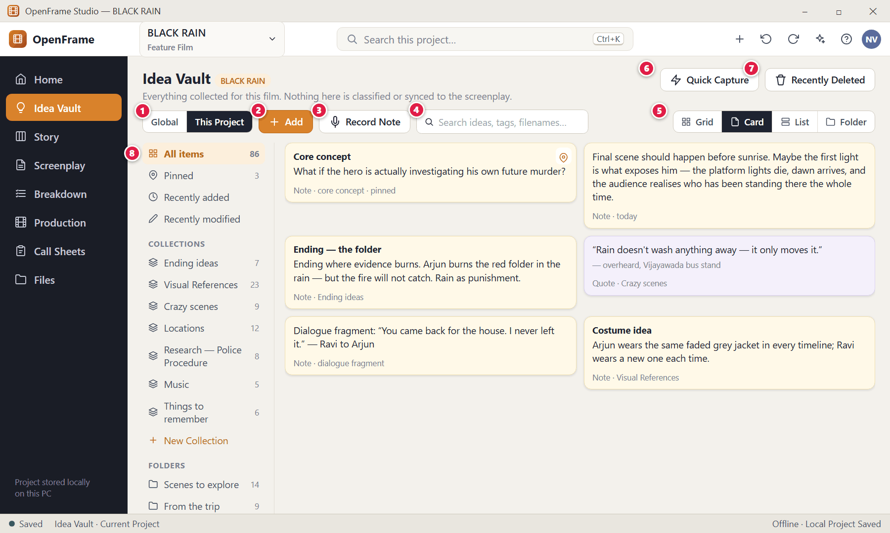
Figure 25. Idea Vault — Card view — Card view (red numbers are explained on the next page)

Figure 25 — Idea Vault — Card view: how it works
PARTS OF THIS SCREEN  1 Global / Current Project — Switch between your Global Idea Vault (ideas across your whole filmmaking life) and this film's Project Idea Vault. The active scope is always marked.  2 Add — The primary action. Opens the Add menu: Note, Image, URL, File, Audio / Voice Note, Video. Drag files straight onto the page as an alternative.  3 Record Note — Starts a voice recording immediately.  4 Search — Finds titles, note text, captions, filenames and tags. It does not need items to be categorised. Shortcut: Ctrl+F.  5 View switcher — Visual Grid, Card, List and Folder views show the same items. Changing view only changes presentation and is remembered next time.  6 Quick Capture — Opens the tiny capture palette (see "Quick Capture").  7 Recently Deleted — Where deleted items wait until you restore them or delete them permanently.  8 Collections and folders — Optional organisation: Pinned, Recently added, Recently modified, your own Collections and Folders. OpenFrame never prescribes folder names. | HOW TO USE IT  1. Click the Card segment in the view switcher.  GOOD TO KNOW · EDGE CASES  - Card view, Grid view, List view and Folder view show exactly the same items; switching never duplicates or changes data.  - The view you choose is remembered the next time you open the Vault.

Figure 26 — Idea Vault — List view
What it is for. List view is for large collections: one row per item with type, collection, tags and dates.
How to get here. Idea Vault → View switcher → List.
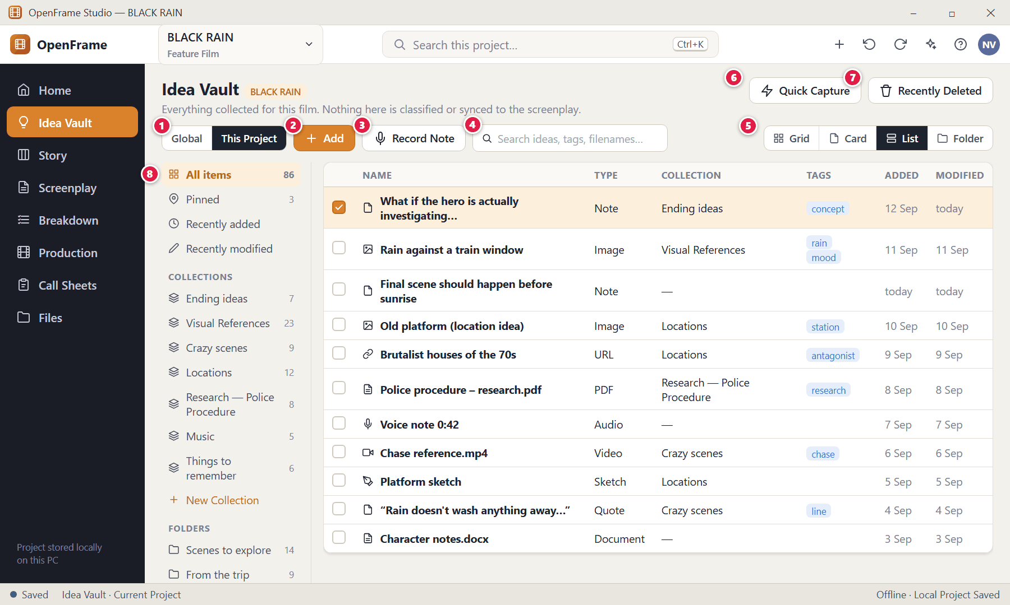
Figure 26. Idea Vault — List view — List view (red numbers are explained on the next page)

Figure 26 — Idea Vault — List view: how it works
PARTS OF THIS SCREEN  1 Global / Current Project — Switch between your Global Idea Vault (ideas across your whole filmmaking life) and this film's Project Idea Vault. The active scope is always marked.  2 Add — The primary action. Opens the Add menu: Note, Image, URL, File, Audio / Voice Note, Video. Drag files straight onto the page as an alternative.  3 Record Note — Starts a voice recording immediately.  4 Search — Finds titles, note text, captions, filenames and tags. It does not need items to be categorised. Shortcut: Ctrl+F.  5 View switcher — Visual Grid, Card, List and Folder views show the same items. Changing view only changes presentation and is remembered next time.  6 Quick Capture — Opens the tiny capture palette (see "Quick Capture").  7 Recently Deleted — Where deleted items wait until you restore them or delete them permanently.  8 Collections and folders — Optional organisation: Pinned, Recently added, Recently modified, your own Collections and Folders. OpenFrame never prescribes folder names. | HOW TO USE IT  1. Click the List segment.  2. Tick the boxes at the start of rows to select several items at once.  GOOD TO KNOW · EDGE CASES  - With hundreds of items, List view plus Search is the fastest way to find something.

Figure 27 — Idea Vault — Folder view
What it is for. Folder view lets you browse the Vault like a file cabinet when you have chosen to use folders.
How to get here. Idea Vault → View switcher → Folder.
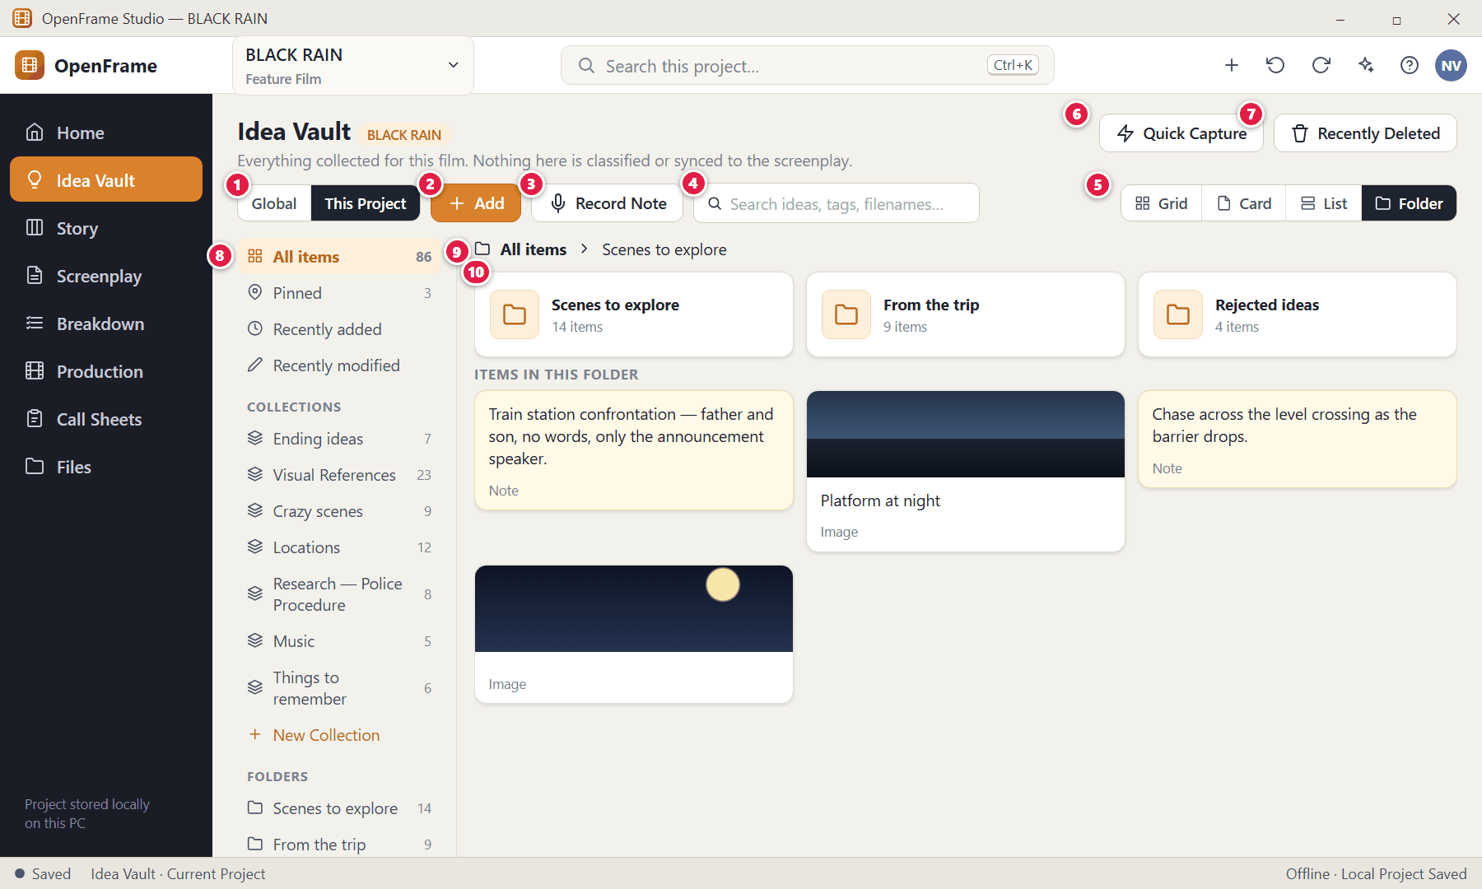
Figure 27. Idea Vault — Folder view — Folder view (red numbers are explained on the next page)

Figure 27 — Idea Vault — Folder view: how it works
PARTS OF THIS SCREEN  1 Global / Current Project — Switch between your Global Idea Vault (ideas across your whole filmmaking life) and this film's Project Idea Vault. The active scope is always marked.  2 Add — The primary action. Opens the Add menu: Note, Image, URL, File, Audio / Voice Note, Video. Drag files straight onto the page as an alternative.  3 Record Note — Starts a voice recording immediately.  4 Search — Finds titles, note text, captions, filenames and tags. It does not need items to be categorised. Shortcut: Ctrl+F.  5 View switcher — Visual Grid, Card, List and Folder views show the same items. Changing view only changes presentation and is remembered next time.  6 Quick Capture — Opens the tiny capture palette (see "Quick Capture").  7 Recently Deleted — Where deleted items wait until you restore them or delete them permanently.  8 Collections and folders — Optional organisation: Pinned, Recently added, Recently modified, your own Collections and Folders. OpenFrame never prescribes folder names.  9 Breadcrumb — Shows which folder you are in. Click "All items" to go back to the top.  10 Folder — Folders are containers you create. A Vault item can be in a folder and also belong to collections and carry tags — it is never physically duplicated. | HOW TO USE IT  1. Double-click a folder to open it.  2. Drag an item onto a folder in the left panel to move it there.  GOOD TO KNOW · EDGE CASES  - Moving an item between folders changes organisation only; it never changes the item itself and it stays searchable everywhere.  - Collections may contain items from different folders; removing an item from a collection does not delete it.

Figure 28 — Idea Vault — empty state
What it is for. An empty Vault tells you what it is for and offers one obvious action.
How to get here. A new project's Vault, or the Global Vault the first time you open it.
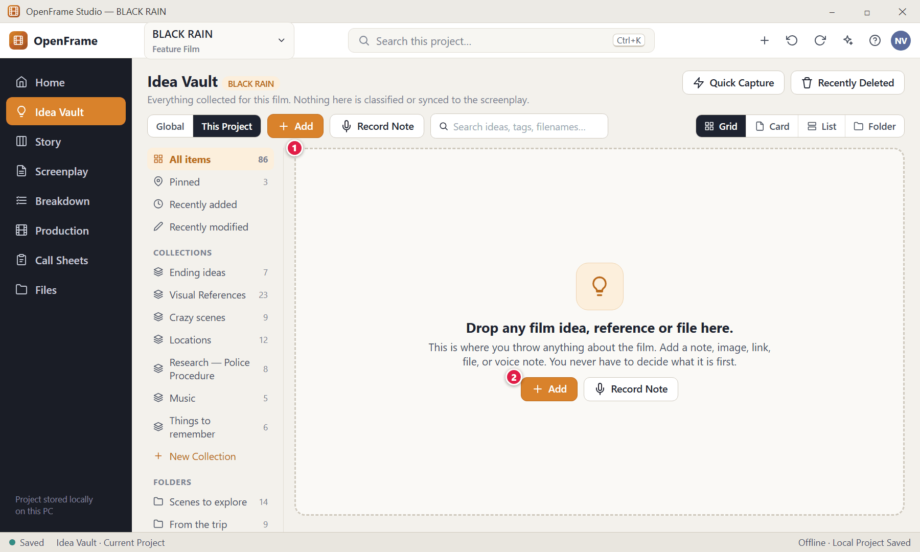
Figure 28. Idea Vault — empty state — Empty state (red numbers are explained on the next page)

Figure 28 — Idea Vault — empty state: how it works
PARTS OF THIS SCREEN  1 Drop zone — "Drop any film idea, reference or file here." (In the Project Vault: "Start collecting anything about this film.") Drag files from Windows File Explorer straight onto this area.  2 Add — The primary action. | HOW TO USE IT  1. Drag files from File Explorer onto the page, or click Add.  GOOD TO KNOW · EDGE CASES  - The Add button is never hidden behind a settings menu.

Figure 29 — Add menu: Note, Image, URL, File, Voice Note, Video
What it is for. Add asks only what kind of item you are adding — nothing else. The least possible information is requested to store the item.
How to get here. Idea Vault → Add.
Figure 29. Add menu: Note, Image, URL, File, Voice Note, Video (red numbers are explained on the next page)

Figure 29 — Add menu: Note, Image, URL, File, Voice Note, Video: how it works
PARTS OF THIS SCREEN  1 Add menu — Note (opens an editor with the cursor already inside) · Image (choose an image file) · URL (paste a link) · File (any file the desktop can store) · Audio / Voice Note · Video · Quick Capture. | HOW TO USE IT  1. Click Add.  2. Choose the type. For a Note you can start typing immediately. For Image/File/Video the Windows file picker opens; for URL you paste the link.  3. The item appears in the Vault. Titles, captions, tags and collections are all optional.  GOOD TO KNOW · EDGE CASES  - You can also drag files from File Explorer straight into the Vault. Dropping several mixed files adds them all in one operation, with progress shown for large files.  - A file is never rejected just because OpenFrame does not know whether it is "story research" or "production reference".

Figure 30 — Text note editor (autosave)
What it is for. A note opens straight into editing with the cursor in the body. You can type and close — nothing else is required.
How to get here. Add → Note, or double-click an existing note.
Figure 30. Text note editor (autosave) (red numbers are explained on the next page)

Figure 30 — Text note editor (autosave): how it works
PARTS OF THIS SCREEN  1 Title (optional) — Leave it blank; a note can stay untitled. OpenFrame may show a generated display name for navigation but does not treat it as your content.  2 Note body — Type freely. Plain text.  3 Autosave — Every edit is saved as you type. Close and reopen any time; there is no Save button to remember.  4 Collections — Optionally add the note to a collection such as "Ending ideas".  5 Tags — Optional search aids.  6 Pin — Keeps the note at the top of the Project Vault.  7 Send to Story — Copies this thought into the Story Board (see Send to Story). | HOW TO USE IT  1. Click Add → Note.  2. Type your thought.  3. Press Esc or click the X to close. The note is already saved.  GOOD TO KNOW · EDGE CASES  - Undo/redo works inside the note.  - Pressing Delete moves the note to Recently Deleted; it is not lost immediately.

Figure 31 — Idea Vault item detail: image
What it is for. The detail drawer lets you inspect or edit one item without forcing structure on it.
How to get here. Double-click an item, or right-click → Open.
Figure 31. Idea Vault item detail: image (red numbers are explained on the next page)

Figure 31 — Idea Vault item detail: image: how it works
PARTS OF THIS SCREEN  1 Preview — Large local preview. Images, PDFs, audio and video show a suitable preview where possible.  2 Title, caption, source link — All optional.  3 Collections and tags — Organisation you may add at any time.  4 Open externally — Opens the file in the Windows default program (for example Photos or a PDF viewer). Files OpenFrame cannot preview are still stored and can be opened this way. | HOW TO USE IT  1. Double-click the item.  2. Edit the title/caption, or use Rename, Move, Add to Collection, Pin, Copy to Project, Send to Story or Delete.  GOOD TO KNOW · EDGE CASES  - The original file remains the primary source. Unsupported preview never means unsupported storage.  - Renaming an item changes its display name only, not the file on disk.

Figure 32 — Adding a URL
What it is for. URLs are stored together with your own note about why they matter.
How to get here. Add → URL.
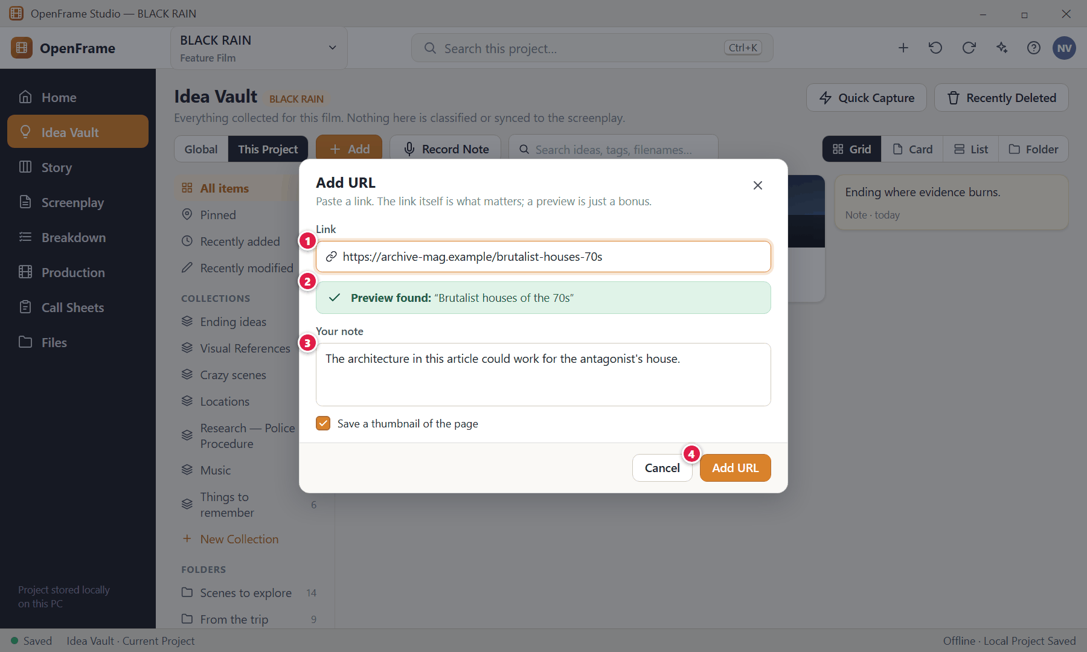
Figure 32. Adding a URL (red numbers are explained on the next page)

Figure 32 — Adding a URL: how it works
PARTS OF THIS SCREEN  1 Link — Paste or type the address.  2 Preview — If a page title can be fetched it is shown. This needs a connection; see the note below.  3 Your note — Write why this link is useful — for example "could work for the antagonist's house".  4 Add URL — Saves the item. | HOW TO USE IT  1. Paste the URL.  2. Optionally write a note.  3. Click Add URL.  GOOD TO KNOW · EDGE CASES  - Edge case — offline or blocked page: the preview simply shows "No preview available"; the URL is still saved and remains clickable. Fetching a preview is one of the few optional online conveniences; it is never required.

Figure 33 — Recording a voice note
What it is for. Capture a thought by speaking, without stopping to type.
How to get here. Idea Vault → Record Note (or Add → Audio / Voice Note).
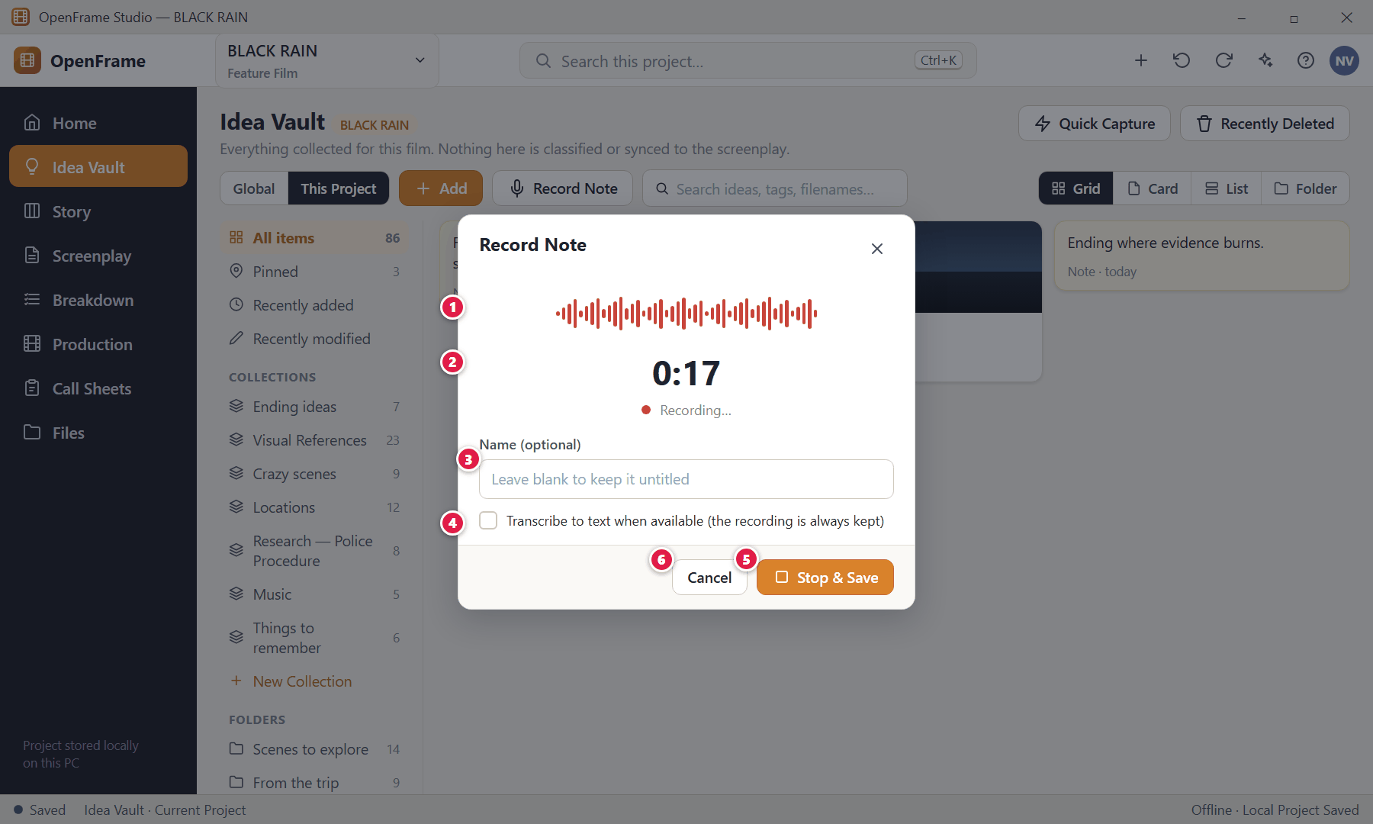
Figure 33. Recording a voice note (red numbers are explained on the next page)

Figure 33 — Recording a voice note: how it works
PARTS OF THIS SCREEN  1 Live level meter — Shows that your microphone is picking up sound.  2 Timer — How long you have been recording.  3 Name (optional) — You may name the recording afterwards or leave it untitled.  4 Transcription (optional) — If speech-to-text is available it can add a text version. It never replaces the original audio, which remains the primary source.  5 Stop & Save — Ends the recording and stores it in the Vault.  6 Cancel — Discards the recording. | HOW TO USE IT  1. Click Record Note. Windows may ask permission to use the microphone the first time — choose Allow.  2. Speak.  3. Click Stop & Save.  4. The voice note appears as a card with a waveform and duration; click it to play.  GOOD TO KNOW · EDGE CASES  - Voice notes are stored locally and can be played back offline.  - If the microphone is not available, OpenFrame explains that and leaves the Vault unchanged.

Figure 34 — Dragging files into the Vault
What it is for. Drag any mix of files from File Explorer onto the Vault. They are all accepted together.
How to get here. Drag files from Windows File Explorer over the Vault area.
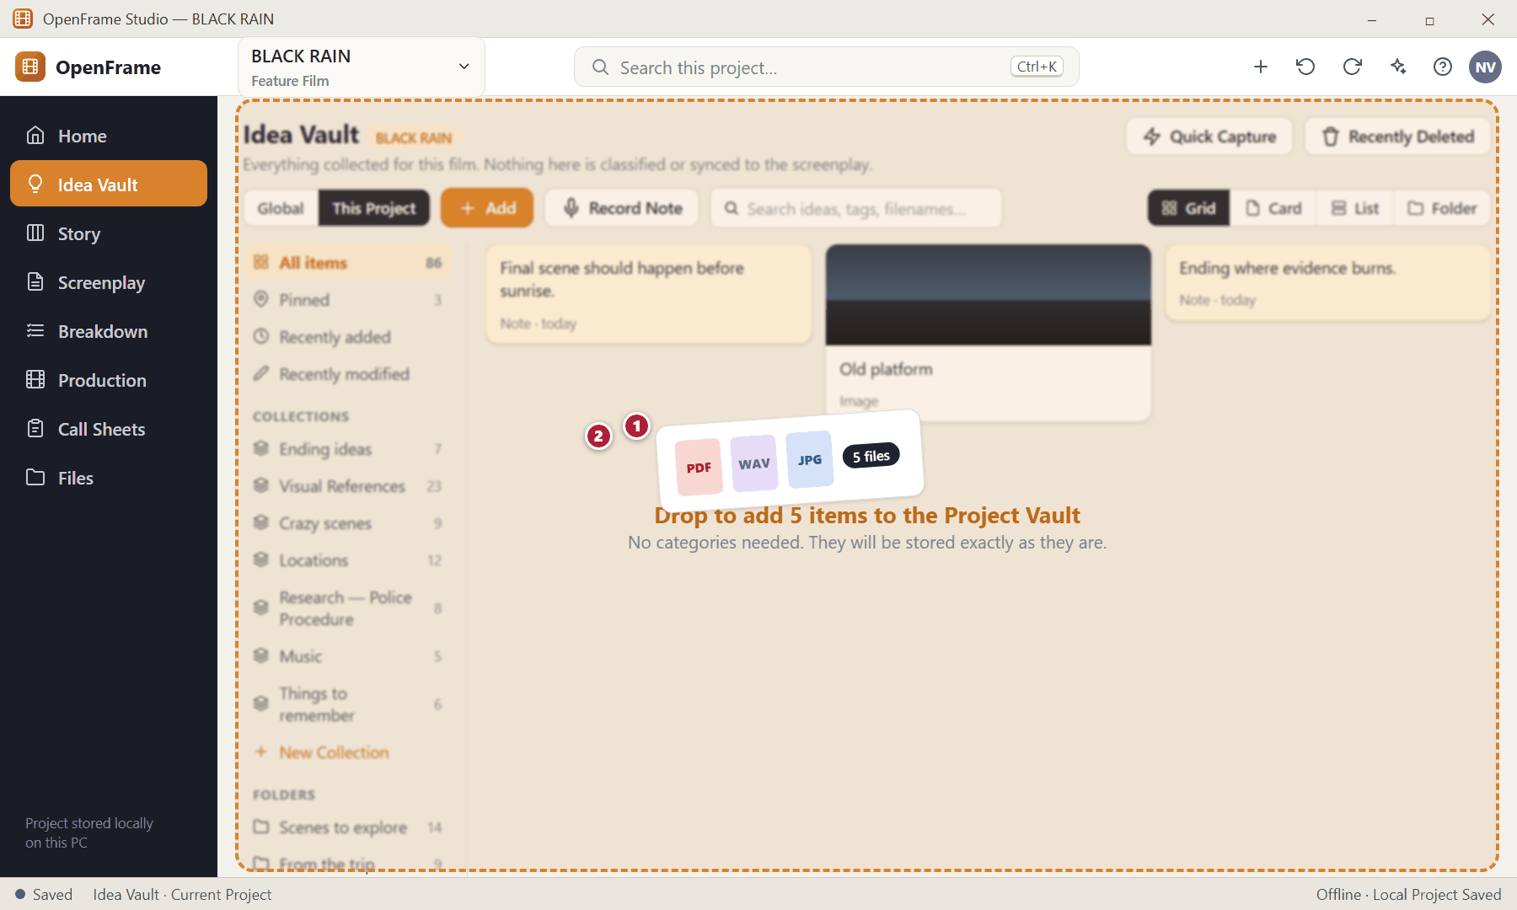
Figure 34. Dragging files into the Vault (red numbers are explained on the next page)

Figure 34 — Dragging files into the Vault: how it works
PARTS OF THIS SCREEN  1 Files being dragged — A mixed set (images, PDF, audio…) from File Explorer.  2 Drop target — The destination is clearly highlighted and tells you how many items will be added and where. | HOW TO USE IT  1. Select files in File Explorer.  2. Drag them onto the Vault and release.  GOOD TO KNOW · EDGE CASES  - You are never asked to pick a category for each file.

Figure 35 — Drag-in result: partial success
What it is for. When some dropped files cannot be added, OpenFrame reports only the failed items and keeps everything that worked.
How to get here. Appears after a drop when at least one file failed.
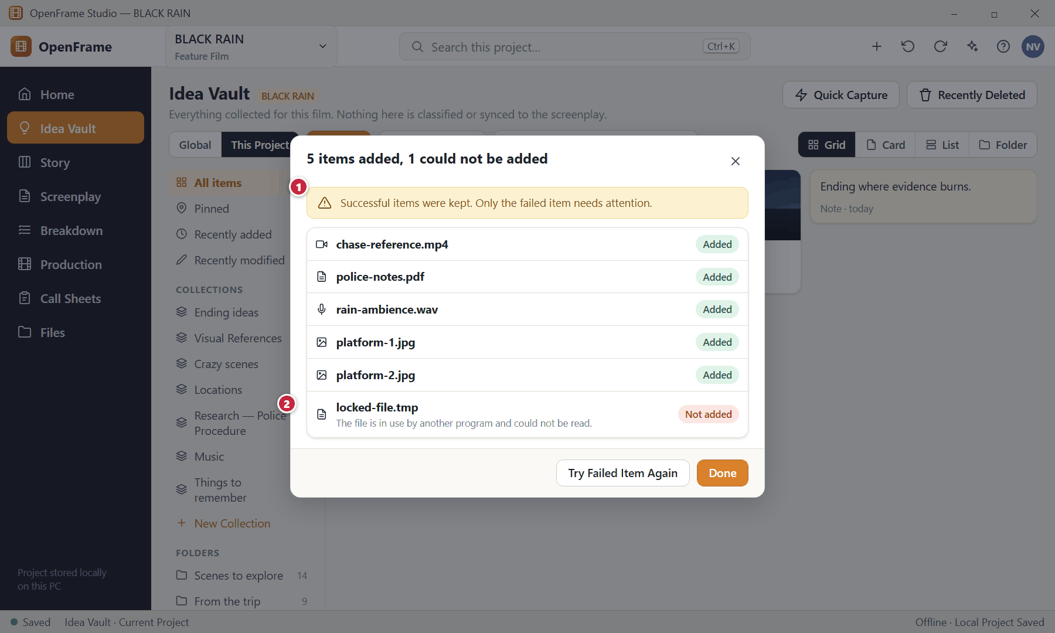
Figure 35. Drag-in result: partial success (red numbers are explained on the next page)

Figure 35 — Drag-in result: partial success: how it works
PARTS OF THIS SCREEN  1 Summary — States how many were added and how many were not.  2 Failed item — Says what went wrong in plain language and what you can do. | HOW TO USE IT  1. Close the file that was in use and click Try Failed Item Again, or click Done.  GOOD TO KNOW · EDGE CASES  - A file that is unsupported for preview is still added as an ordinary file card; only files that truly cannot be read fail.

Figure 36 — External file unavailable
What it is for. Items can point to files outside the project. If such a file moves or its drive is unplugged, the item stays visible with a clear "Unavailable" badge rather than disappearing.
How to get here. An "Unavailable" badge on a card; open it for options.
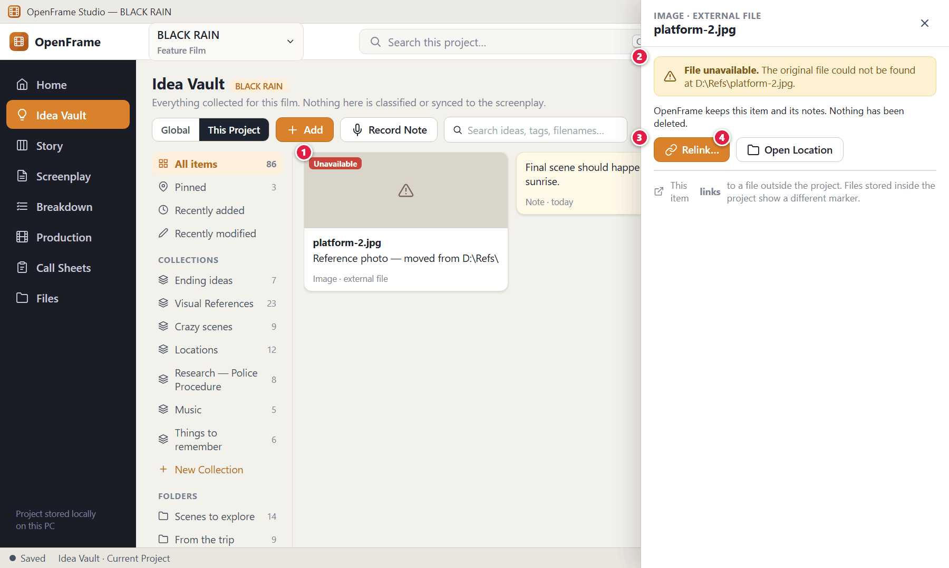
Figure 36. External file unavailable (red numbers are explained on the next page)

Figure 36 — External file unavailable: how it works
PARTS OF THIS SCREEN  1 Unavailable badge — The card keeps its place, name and notes.  2 Explanation — Tells you which file is missing and where it was.  3 Relink… — Point the item at the file's new location. The item keeps its identity.  4 Open Location — Opens the last known folder so you can look for the file. | HOW TO USE IT  1. Reconnect the drive or find the moved file.  2. Click Relink… and choose the file.  GOOD TO KNOW · EDGE CASES  - OpenFrame distinguishes files physically stored in the project from links to external files, so you always know which is which.  - If a linked file changes on disk, you receive a refresh/relink warning when you open the item.

Figure 37 — Selecting several items
What it is for. Select several Vault items and act on them together.
How to get here. Ctrl+click or Shift+click items, or tick the boxes in List view.
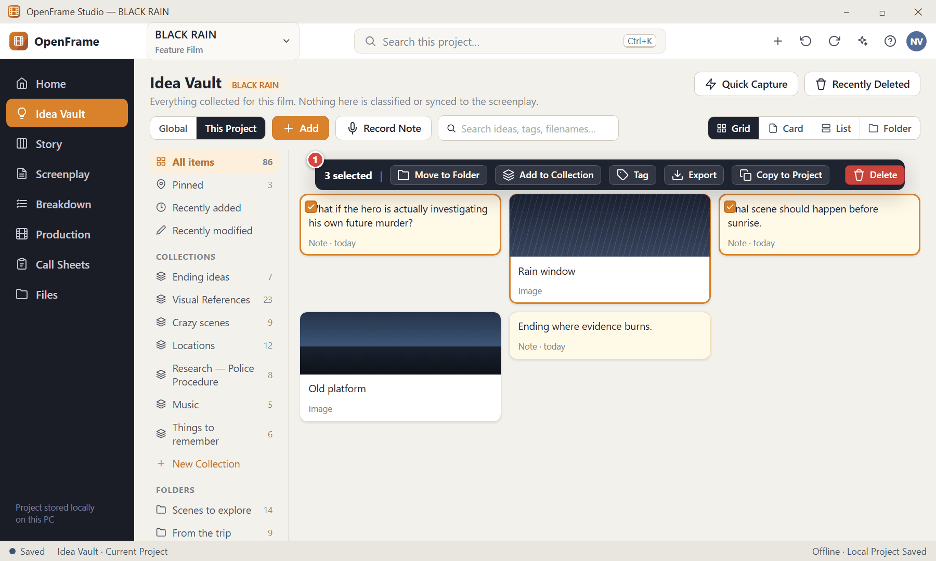
Figure 37. Selecting several items (red numbers are explained on the next page)

Figure 37 — Selecting several items: how it works
PARTS OF THIS SCREEN  1 Selection toolbar — Appears at the top when more than one item is selected and shows only actions that make sense for all selected items: Move to Folder, Add to Collection, Tag, Export, Copy to Project, Delete. | HOW TO USE IT  1. Click one item, then Ctrl+click others (Shift+click selects a range).  2. Choose an action from the bar. Press Esc or click empty space to clear the selection.  GOOD TO KNOW · EDGE CASES  - Deleting several items asks for one confirmation that explains how many are affected — never one dialog per item.

Figure 38 — Right-click menu on a Vault item
What it is for. Right-clicking exposes only the actions that make sense for the item.
How to get here. Right-click a Vault item.
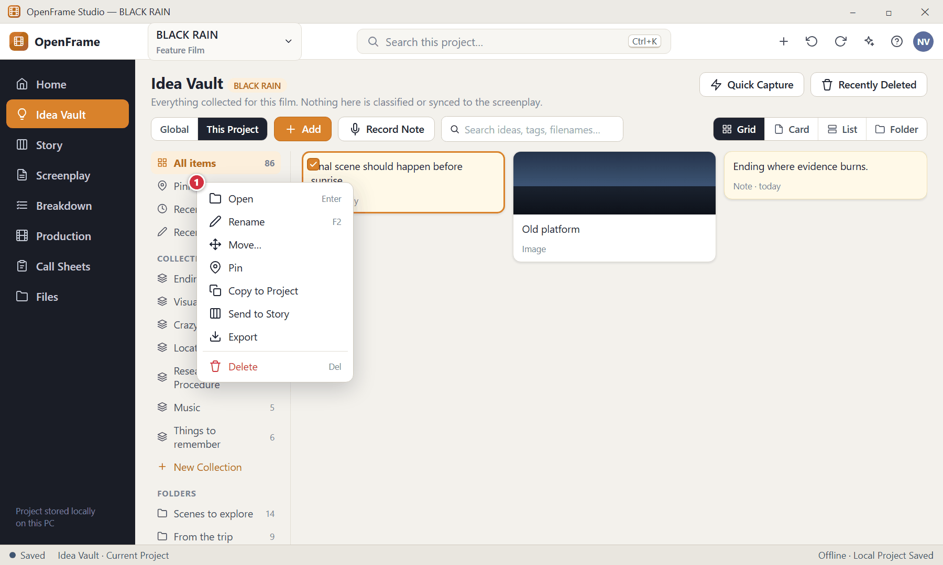
Figure 38. Right-click menu on a Vault item (red numbers are explained on the next page)

Figure 38 — Right-click menu on a Vault item: how it works
PARTS OF THIS SCREEN  1 Item menu — Open · Rename · Move · Pin · Copy to Project · Send to Story · Export · Delete. Delete is separated at the bottom. | HOW TO USE IT  1. Right-click the item and choose an action.  GOOD TO KNOW · EDGE CASES  - Every object in OpenFrame has a similar right-click menu with Delete visually separated so you cannot hit it by accident.

Figure 39 — Send to Story Board
What it is for. When a Vault idea is ready to be part of the story you promote it. This is always an explicit action and always creates a copy.
How to get here. Right-click a Vault item → Send to Story (or the Send to Story button in the item detail).
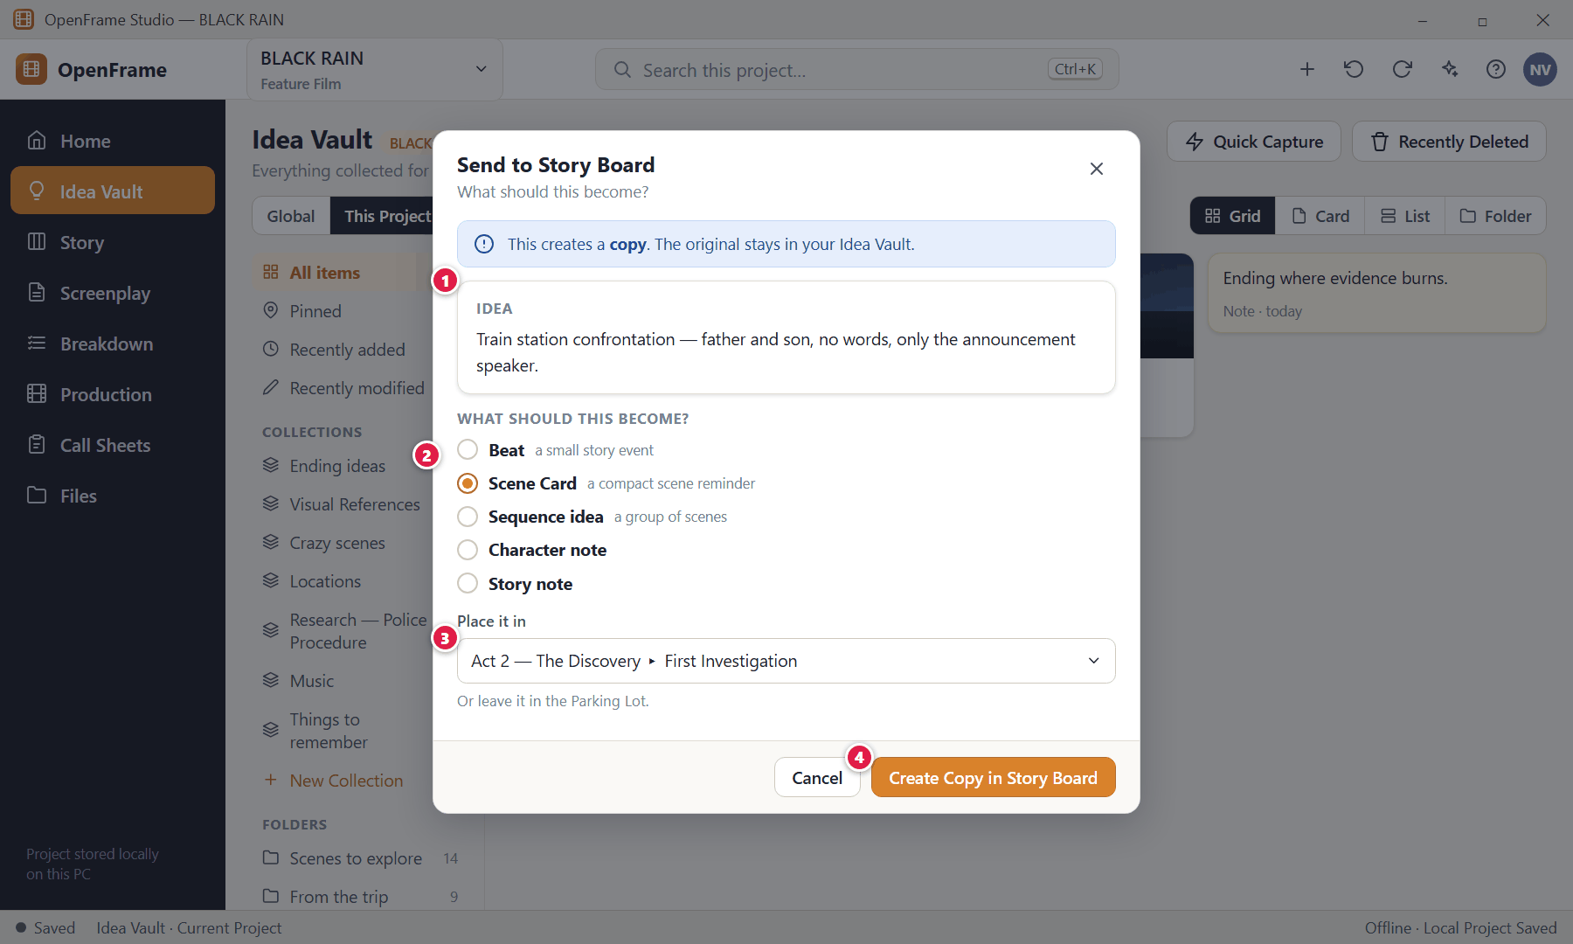
Figure 39. Send to Story Board (red numbers are explained on the next page)

Figure 39 — Send to Story Board: how it works
PARTS OF THIS SCREEN  1 The idea being sent — Shows the text so you know what you are promoting.  2 What should this become? — Beat · Scene Card · Sequence idea · Character note · Story note.  3 Destination — Choose an Act/Sequence, or leave it in the Parking Lot.  4 Create Copy — Creates the Story Board object. | HOW TO USE IT  1. Right-click the idea → Send to Story.  2. Choose what it should become.  3. Choose where to place it.  4. Click Create Copy in Story Board.  GOOD TO KNOW · EDGE CASES  - The original Vault item is never removed. A small "Used in Story Board" reference may appear on it, but there is no live synchronisation in either direction: editing the scene card later does not rewrite your original thought.

Figure 40 — Global Idea Vault
What it is for. The Global Idea Vault holds ideas across your filmmaking life, outside any single film. It answers "What do I have that might matter someday?"
How to get here. Idea Vault → Global (scope selector), or Home (no project open) → Global Idea Vault.
Figure 40. Global Idea Vault — Global scope (red numbers are explained on the next page)

Figure 40 — Global Idea Vault: how it works
PARTS OF THIS SCREEN  1 Global / Current Project — Switch between your Global Idea Vault (ideas across your whole filmmaking life) and this film's Project Idea Vault. The active scope is always marked.  2 Add — The primary action. Opens the Add menu: Note, Image, URL, File, Audio / Voice Note, Video. Drag files straight onto the page as an alternative.  3 Record Note — Starts a voice recording immediately.  4 Search — Finds titles, note text, captions, filenames and tags. It does not need items to be categorised. Shortcut: Ctrl+F.  5 View switcher — Visual Grid, Card, List and Folder views show the same items. Changing view only changes presentation and is remembered next time.  6 Quick Capture — Opens the tiny capture palette (see "Quick Capture").  7 Recently Deleted — Where deleted items wait until you restore them or delete them permanently.  8 Collections and folders — Optional organisation: Pinned, Recently added, Recently modified, your own Collections and Folders. OpenFrame never prescribes folder names.  9 Selected global idea — E.g. "A thriller entirely inside a bus." Select it and choose Copy to Project to use it in a film. | HOW TO USE IT  1. Click Global in the scope selector.  2. Add or browse ideas exactly as in the Project Vault.  GOOD TO KNOW · EDGE CASES  - The Global Vault is available even when no project is open.  - A Global item is never automatically linked to any project — you must copy it deliberately.

Figure 41 — Copy a Global idea to a project
What it is for. Copy a Global idea into a film. A copy is preferable to a live link because the idea may evolve differently in each film.
How to get here. Select a Global item → Copy to Project.
Figure 41. Copy a Global idea to a project (red numbers are explained on the next page)

Figure 41 — Copy a Global idea to a project: how it works
PARTS OF THIS SCREEN  1 Idea being copied — The Global item.  2 Target project — Choose which film receives the copy.  3 Copy to Project — Creates an independent copy in the Project Vault. | HOW TO USE IT  1. Select the Global idea.  2. Click Copy to Project and choose the film.  GOOD TO KNOW · EDGE CASES  - The same idea may be copied into more than one project.  - The reverse also works: from a Project Vault you can Copy to Global when an idea is worth keeping outside the current film.  - The wording is always "Copy to Project", never "Sync to Project".

Figure 42 — Searching the Vault
What it is for. Vault search looks through titles, note text, captions, filenames and tags without needing classification.
How to get here. Click the search box in the Vault, or Ctrl+F.
Figure 42. Searching the Vault (red numbers are explained on the next page)

Figure 42 — Searching the Vault: how it works
PARTS OF THIS SCREEN  1 Search box — Type a word or phrase.  2 Match — Shows which part matched (caption, tag, text or filename). | HOW TO USE IT  1. Click in the search box and type.  2. Press Enter or click a result to open it.  GOOD TO KNOW · EDGE CASES  - This searches only the Vault. The global project search (Ctrl+K) searches everything in the current project, including the Vault.

Figure 43 — Quick Capture
What it is for. Quick Capture is a tiny palette for the moment a sudden thought arrives. One text box; nothing else.
How to get here. Idea Vault → Quick Capture, or the quick-capture command/shortcut from anywhere in the project.
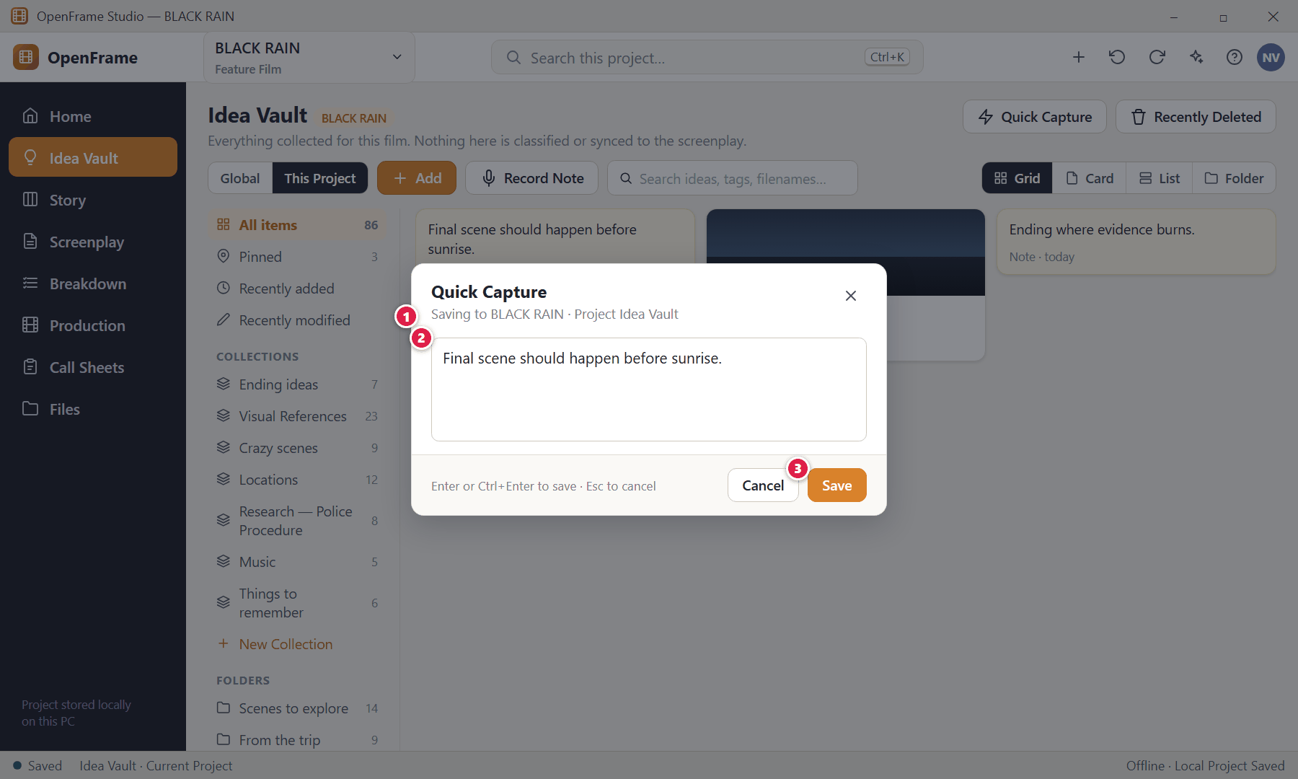
Figure 43. Quick Capture (red numbers are explained on the next page)

Figure 43 — Quick Capture: how it works
PARTS OF THIS SCREEN  1 Where it is saved — Shows the current project. Choose a project only when needed.  2 Text box — Focused automatically. Type your thought.  3 Save — Creates an ordinary text note in the Project Idea Vault and closes immediately. | HOW TO USE IT  1. Open Quick Capture.  2. Type the thought.  3. Press Enter (or Ctrl+Enter) to save; Esc to cancel.  GOOD TO KNOW · EDGE CASES  - Quick Capture never creates a Scene Card or screenplay text; it always creates a normal Idea Vault note.  - If saving fails, the text you typed is kept until you retry or cancel.

Figure 44 — Recently Deleted
What it is for. Important objects do not disappear permanently after one accidental click. Deleting moves them to Recently Deleted, where they can be restored.
How to get here. Idea Vault → Recently Deleted (also available for deleted Story Board cards and other objects).
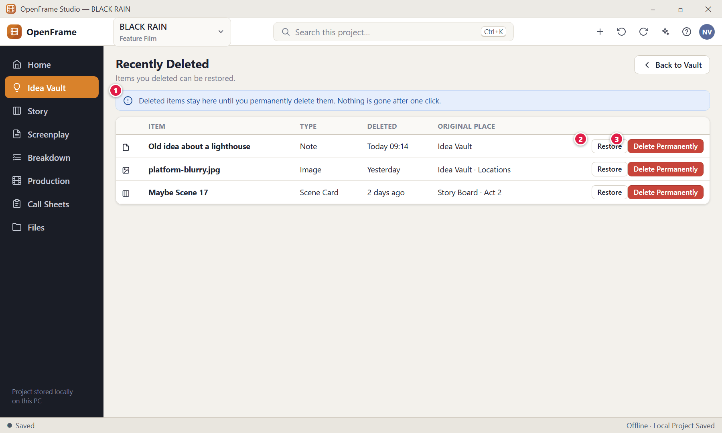
Figure 44. Recently Deleted (red numbers are explained on the next page)

Figure 44 — Recently Deleted: how it works
PARTS OF THIS SCREEN  1 Explanation — Deleted items remain recoverable.  2 Restore — Returns the item to its previous place. If its original container no longer exists it is put in an Unassigned area and you are told.  3 Delete Permanently — A deliberate second action. It asks for a clear confirmation because it cannot be undone. | HOW TO USE IT  1. Click Restore to bring an item back.  2. Click Delete Permanently only when you are certain, then confirm.  GOOD TO KNOW · EDGE CASES  - Deleting an object never silently destroys linked objects: for example deleting a Scene Card does not delete the screenplay scene that was created from it.  - After a normal delete a small "Deleted — Undo" message also appears, and Ctrl+Z restores the item.

Figure 45 — Research collection with verification flags
What it is for. Research lives in the Idea Vault as a collection such as "Research — Police Procedure". You can note why each source matters and mark whether you have checked it.
How to get here. Idea Vault → a collection you named for research.
Figure 45. Research collection with verification flags (red numbers are explained on the next page)

Figure 45 — Research collection with verification flags: how it works
PARTS OF THIS SCREEN  1 Verification flag — Optional values: Unchecked · Checked · Needs Expert Check.  2 No automatic claims — The application never labels a source as factually correct; verification is entirely your decision. | HOW TO USE IT  1. Create a collection (New Collection) named for your research topic.  2. Add PDFs, links, screenshots, notes, interviews and audio.  3. Write why each source matters and optionally link it to a Scene Card, screenplay scene, Character, Location or production item.  GOOD TO KNOW · EDGE CASES  - OpenFrame is not an academic citation manager: keep research light.

Figure 46 — Creating a collection
What it is for. Collections are simple thematic groups — completely optional.
How to get here. Idea Vault → New Collection (left panel).
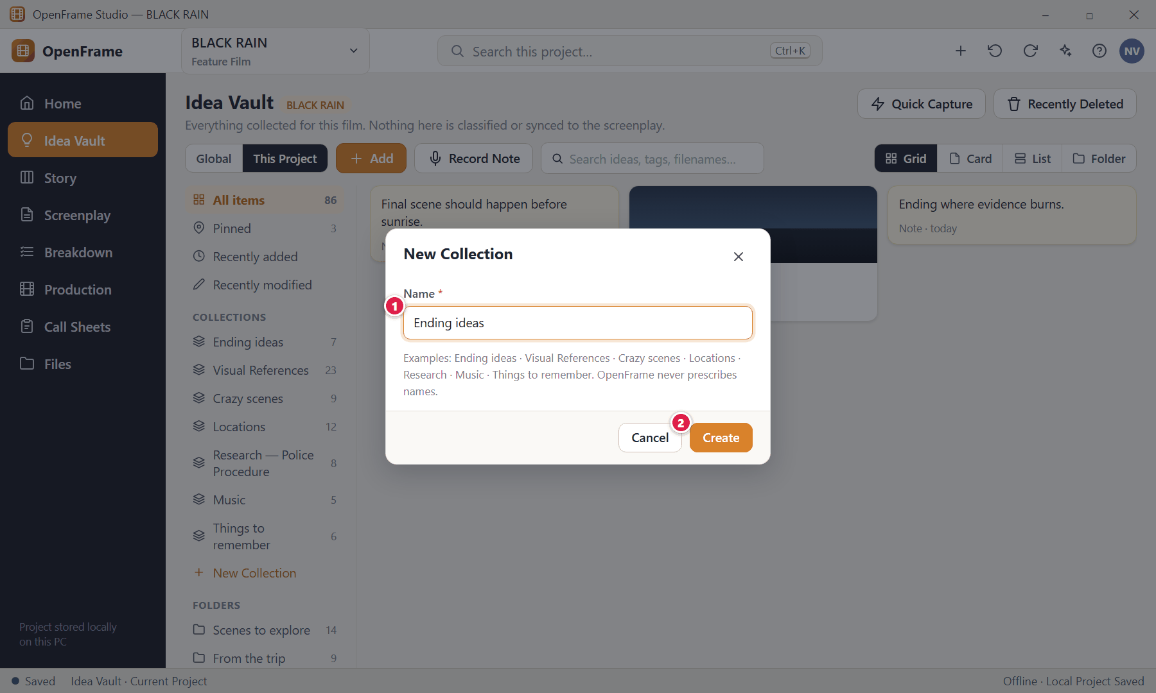
Figure 46. Creating a collection (red numbers are explained on the next page)

Figure 46 — Creating a collection: how it works
PARTS OF THIS SCREEN  1 Name — The only field.  2 Create — Creates the empty collection. Add items to it by dragging or via "Add to Collection". | HOW TO USE IT  1. Click New Collection, type a name, click Create.  GOOD TO KNOW · EDGE CASES  - A collection may hold items from different folders. Removing an item from a collection never deletes the item.

Figure 47 — Everything the Vault can hold
What it is for. A visual summary of the item types the Idea Vault supports and how each is presented.
How to get here. Reference screen for the Add menu and drag-and-drop.
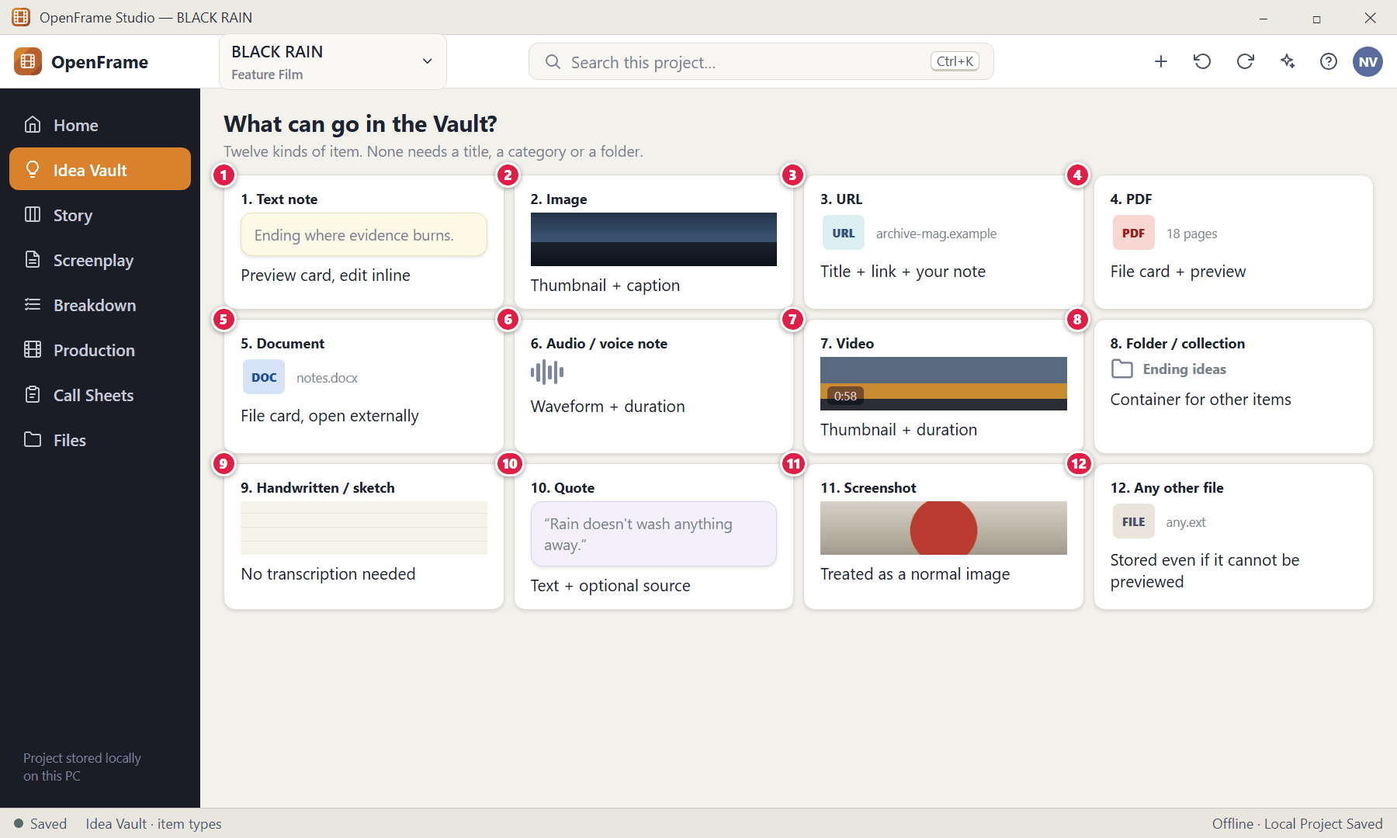
Figure 47. Everything the Vault can hold (red numbers are explained on the next page)

Figure 47 — Everything the Vault can hold: how it works
PARTS OF THIS SCREEN  1 Text note — Text-first card; opens straight into editing; title may stay blank.  2 Image — Thumbnail + optional caption. The original image file remains the primary source.  3 URL — The link is authoritative; preview metadata is secondary.  4 PDF — File card with a page/preview indicator; can be opened externally.  5 Document — Office/other document file card. No semantic classification is required.  6 Audio / voice note — Waveform and duration; audio remains authoritative; transcription is optional.  7 Video — Thumbnail and duration. The Vault stores it; it is not a video editor.  8 Folder / collection — Simple containers you name yourself.  9 Handwritten / sketch — A drawn or scanned image. No transcription is required.  10 Quote — Quoted text with an optional source.  11 Screenshot — Treated as an ordinary visual reference.  12 Any other file — Anything the desktop can safely store or reference. Unsupported preview does not mean unsupported storage. | HOW TO USE IT  1. Use Add or drag files in. The type is recognised from what you add.  GOOD TO KNOW · EDGE CASES  - Images and video receive larger previews; text notes are text-first; files show file-type cues — so the Vault feels visual rather than a uniform list.

Chapter 3 — Story Board: Shape the Story
The Story Board is the filmmaker's digital wall: a visual outlining surface of Acts, Sequences, Beats and Scene Cards that you arrange by dragging. It is a reference and outline tool — it is not the screenplay and it never rewrites the screenplay on its own. This chapter also covers Characters, the optional Story Timeline, and Episodic (series) organisation.
Screens in this chapter
Figure 48 Story Board — empty state | Figure 62 Deleting a card that has a linked screenplay scene
Figure 49 Story Board — Board view | Figure 63 Build Screenplay — preview
Figure 50 Add menu: Act, Sequence, Beat, Scene | Figure 64 Building when a screenplay already exists
Figure 51 Creating an Act (title only) | Figure 65 Warning before a board reorder changes a written script
Figure 52 Story Board — Outline view | Figure 66 Zooming out to see the whole film
Figure 53 Scene Card detail drawer | Figure 67 Characters directory
Figure 54 Dragging a card: insertion line | Figure 68 Adding a character (duplicate-name check)
Figure 55 Moving a Sequence between Acts | Figure 69 Character relationship view
Figure 56 Right-click menu on a Scene Card | Figure 70 Story Timeline (optional)
Figure 57 Selecting several cards | Figure 71 Sequence Hub
Figure 58 The Parking Lot | Figure 72 Exporting the Story Board or Outline as PDF
Figure 59 Duplicating a card to try an alternative | Figure 73 Series → Season → Episode (episodic projects)
Figure 60 Beat Card and Convert to Scene | Figure 74 Season Board: reordering episodes
Figure 61 Deleting a non-empty Act

Figure 48 — Story Board — empty state
What it is for. A new Story Board teaches through context: one sentence explains what Scene Cards are, and one primary action is offered.
How to get here. Left navigation → Story (in a project with no story objects yet).
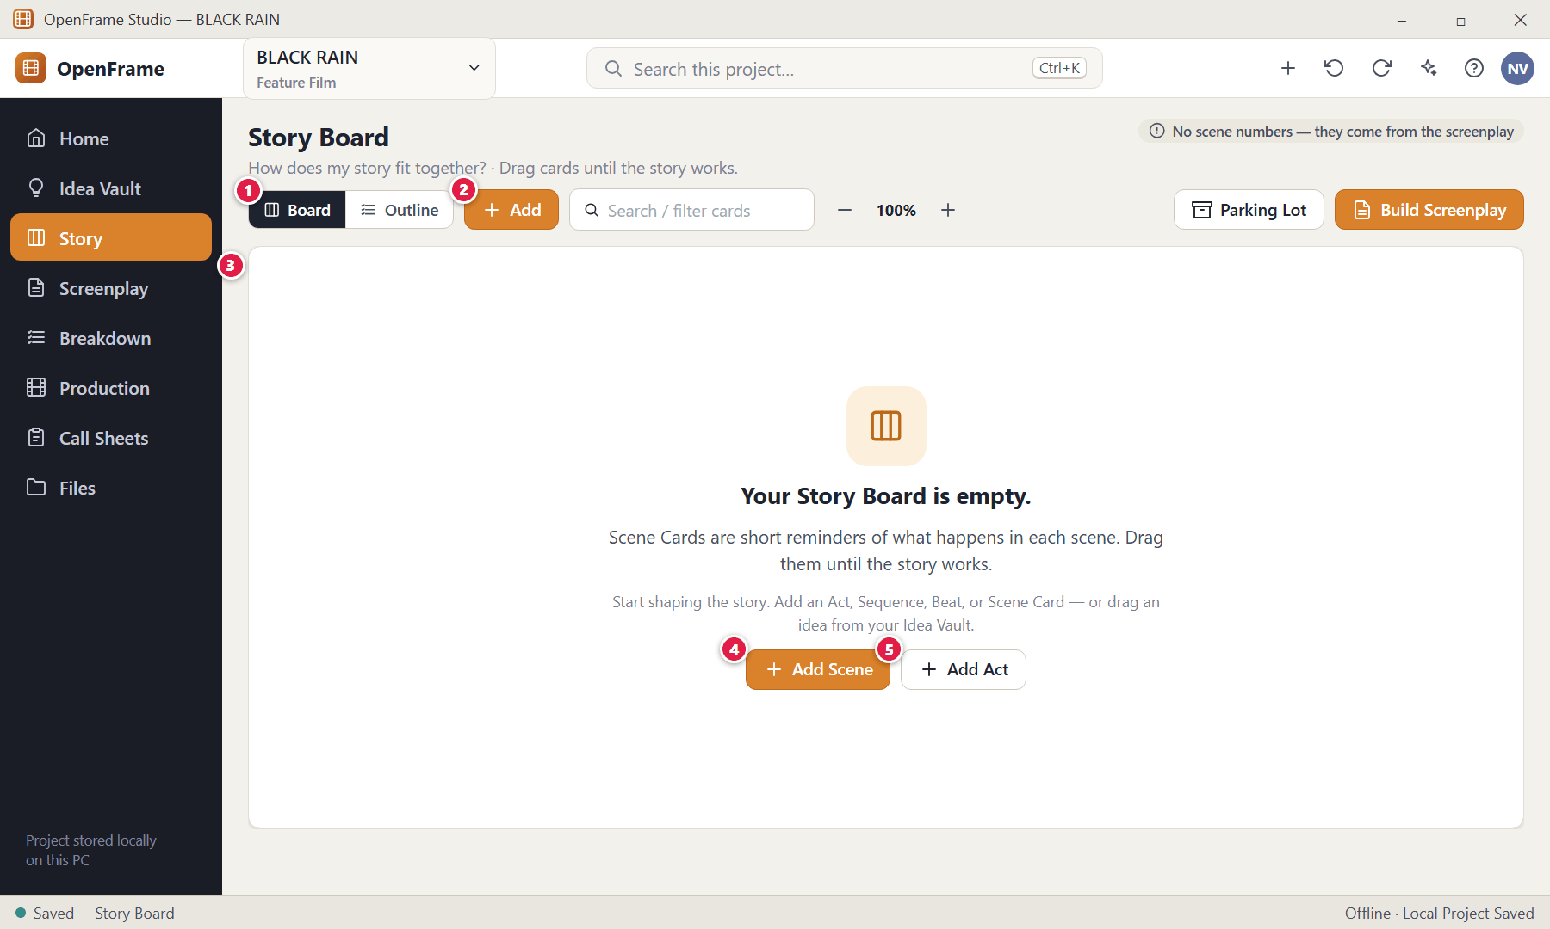
Figure 48. Story Board — empty state — Empty state (red numbers are explained on the next page)

Figure 48 — Story Board — empty state: how it works
PARTS OF THIS SCREEN  1 Board / Outline — Two views of the same story. Board is visual; Outline is a compact hierarchy. Changing the order in one changes the other.  2 Add — Opens the Add menu: Act, Sequence, Beat, Scene.  3 Empty-state message — "Scene Cards are short reminders of what happens in each scene. Drag them until the story works."  4 Add Scene — The primary action. Creates a Scene Card that is immediately editable.  5 Add Act — Optional. You may place Scene Cards directly on the board without Acts or Sequences — ideal for short films. | HOW TO USE IT  1. Click Add Scene and type a short description of what happens.  2. Or click Add Act to start with a structure, or drag ideas over from the Idea Vault (Send to Story).  GOOD TO KNOW · EDGE CASES  - A five-minute short does not need Acts or Sequences. Structure is optional at every level.  - No scene numbers are ever typed on the Story Board; numbers are generated later from the screenplay order.

Figure 49 — Story Board — Board view
What it is for. Board view is the digital wall. Acts are broad bands, Sequences are containers inside them, and compact Scene Cards sit inside the Sequences. It answers "How does my story fit together?"
How to get here. Left navigation → Story, or Project Home → Open Story Board.
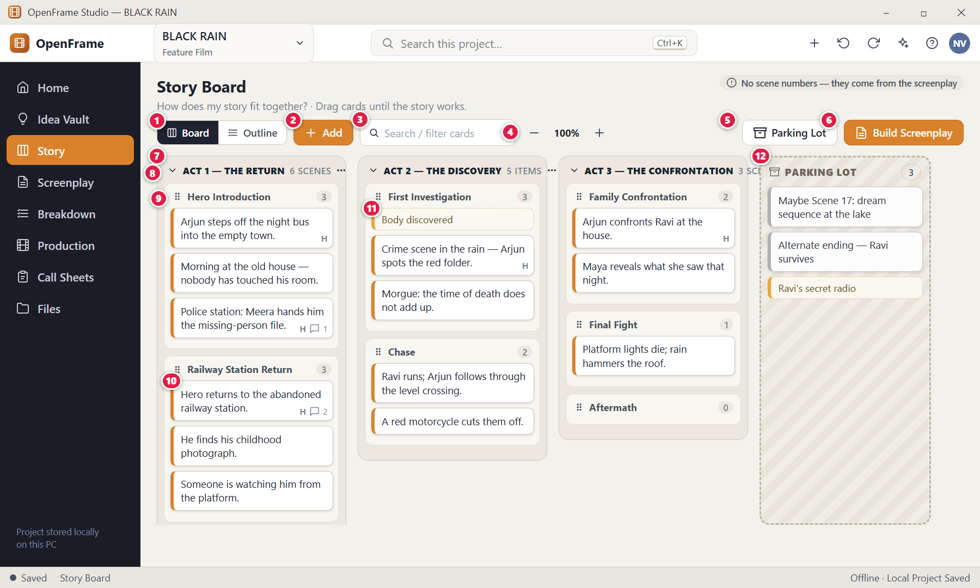
Figure 49. Story Board — Board view — Populated board (red numbers are explained on the next page)

Figure 49 — Story Board — Board view: how it works
PARTS OF THIS SCREEN  1 Board / Outline — Two views of the same story. Board is visual; Outline is a compact hierarchy. Changing the order in one changes the other.  2 Add — Opens the Add menu: Act, Sequence, Beat, Scene.  3 Search / filter — Filters cards by text, type or status. Filtering only hides cards on screen; it never removes them from the story.  4 Zoom — Changes card density only. At low zoom cards show a one-line summary; at higher zoom they show more text. It never changes stored content.  5 Parking Lot — Shows or hides the Parking Lot side area.  6 Build Screenplay — Creates a screenplay draft from the active Scene Cards (with a preview first).  7 Act — A high-level container such as "Act 1 — The Return". Acts are visually stronger than Sequences. Its title needs no other field.  8 Act header — Rename by double-clicking the title. Collapse or expand with the arrow. Dragging the header moves the Act with everything in it.  9 Sequence header — A compact label with a child count. A Sequence is simply a named group of scenes (for example "Hero Introduction"); it has no purpose field.  10 Scene Card — A small horizontal rectangle showing only the short description (truncated visually if long). A tiny "H" means a scene heading exists; a speech bubble shows the comment count. No scene number and no production data.  11 Beat Card — A lighter dashed card for a small story event such as "Body discovered". It may later become a Scene Card.  12 Parking Lot — A visually different holding area for cards that are not in the active story (Maybe Scene 17, Alternate ending, …). Cards parked here are not deleted. | HOW TO USE IT  1. Drag any card to reorder it inside a Sequence or move it to another Sequence or Act.  2. Double-click a card to open its details.  3. Drag cards to the Parking Lot to set them aside, or back to the board to restore them.  4. Use Ctrl+Z to undo any move.  GOOD TO KNOW · EDGE CASES  - A Scene Card may also sit directly under an Act without a Sequence.  - The board can hold 150–250 scene cards; use zoom, collapse Acts/Sequences and horizontal scrolling to stay oriented.  - Changes made here never rewrite screenplay text. The board and the screenplay are separate objects.

Figure 50 — Add menu: Act, Sequence, Beat, Scene
What it is for. Everything on the board is created from one Add menu — and each object needs almost no information.
How to get here. Story → Add.
Figure 50. Add menu: Act, Sequence, Beat, Scene (red numbers are explained on the next page)

Figure 50 — Add menu: Act, Sequence, Beat, Scene: how it works
PARTS OF THIS SCREEN  1 Add menu — Act (title only) · Sequence (name only) · Beat (a line of text) · Scene Card (a short description). "From Idea Vault…" lets you pick ideas to copy onto the board. | HOW TO USE IT  1. Click Add and choose the object.  2. A new card or header appears in the right place with its text box already active — just type.  3. Press Enter to confirm, Esc to cancel.  GOOD TO KNOW · EDGE CASES  - A new Act is added at the end of the board. A new Sequence goes under the selected Act. A new Scene Card goes at the end of the selected Sequence or at the drop position.  - Contextual "+" quick actions (New Idea, New Act, New Sequence, New Beat, New Scene Card, New Character, New Location, New Shot List, New Moodboard, Import Screenplay) may also be offered from the + menu depending on where you are.

Figure 51 — Creating an Act (title only)
What it is for. An Act needs only a title. A description is optional and can be added later.
How to get here. Add → Act.
Figure 51. Creating an Act (title only) (red numbers are explained on the next page)

Figure 51 — Creating an Act (title only): how it works
PARTS OF THIS SCREEN  1 New Act title — Type the title and press Enter. Examples: "Act 1 — Return", "Act 2 — Investigation", "Act 3 — Confrontation". | HOW TO USE IT  1. Add → Act.  2. Type the title.  3. Press Enter. The empty Act says "Add a sequence or scene."  GOOD TO KNOW · EDGE CASES  - Acts can be empty; that is allowed.  - Renaming an Act only changes the board (and exports of the board); it never edits screenplay text.

Figure 52 — Story Board — Outline view
What it is for. Outline view shows exactly the same story as a compact indented list. It is best for precise hierarchy and order work.
How to get here. Story → Outline (in the Board/Outline switch).
Figure 52. Story Board — Outline view — Outline view (red numbers are explained on the next page)

Figure 52 — Story Board — Outline view: how it works
PARTS OF THIS SCREEN  1 Board / Outline — Two views of the same story. Board is visual; Outline is a compact hierarchy. Changing the order in one changes the other.  2 Add — Opens the Add menu: Act, Sequence, Beat, Scene.  3 Outline hierarchy — Act → Sequence → Beat / Scene. Each row has a drag handle. Rows show a scene's heading (for example "Bus Station / Night") when one exists, otherwise the description. Arrows expand or collapse levels. | HOW TO USE IT  1. Drag a row by its handle to reorder or re-parent it.  2. Double-click a title to rename it. Use the row menu for Duplicate, Park or Delete.  GOOD TO KNOW · EDGE CASES  - Editing in Outline changes the same underlying story objects as Board view; switching views never alters order or content.  - Invalid drops (for example a Scene dropped between two Acts as if it were a Sequence) are rejected with a short inline message and nothing changes.

Figure 53 — Scene Card detail drawer
What it is for. Double-click a card to open a larger editor that gives you room to clarify a scene without turning it into a database form.
How to get here. Double-click a Scene Card (or select it and press Enter).
Figure 53. Scene Card detail drawer (red numbers are explained on the next page)

Figure 53 — Scene Card detail drawer: how it works
PARTS OF THIS SCREEN  1 Where it sits — A small label shows the Act and Sequence the card belongs to.  2 Scene heading (optional) — A proposed screenplay heading such as "EXT. OLD RAILWAY STATION — NIGHT". It is optional while you are still developing the scene, but becomes mandatory when you convert the card to a screenplay scene.  3 Short description — The main field. This is the text shown on the compact card.  4 Notes — Free-form notes for yourself. Not shown on the board card.  5 Attachments — Reference images or files. They stay reference material and never become production assets automatically.  6 Comments — Discuss this card with reviewers. Comments stay attached even if you move the card.  7 Convert to Screenplay Scene — Sends this card into the screenplay workflow (see Build Screenplay). | HOW TO USE IT  1. Double-click the card.  2. Edit the description, heading, notes or attachments. Edits save automatically.  3. Click outside the drawer (or press Esc) to close it.  GOOD TO KNOW · EDGE CASES  - No production fields (props, characters, budget, shots, scene number, story day) appear here by default — those live elsewhere or are derived from the screenplay later.  - Very long descriptions are stored in full; only the compact card display is truncated.

Figure 54 — Dragging a card: insertion line
What it is for. While you drag, OpenFrame shows exactly where the card will land, so you never have to guess.
How to get here. Press and hold a Scene Card (or Beat), then move the mouse.
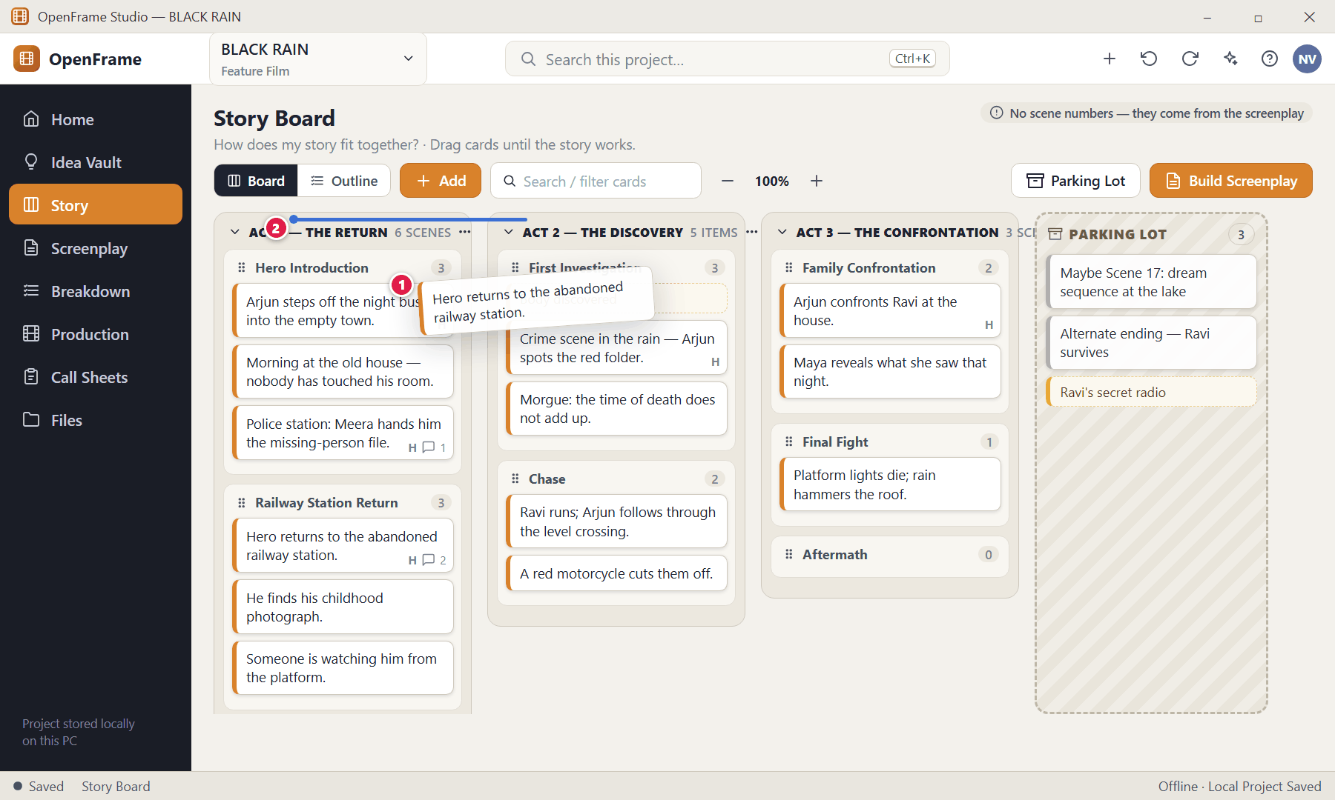
Figure 54. Dragging a card: insertion line (red numbers are explained on the next page)

Figure 54 — Dragging a card: insertion line: how it works
PARTS OF THIS SCREEN  1 Card being dragged — The card lifts and follows the pointer.  2 Insertion line — A vertical/horizontal marker shows the sibling position where the card will be inserted when you release. | HOW TO USE IT  1. Press and hold the card, drag it between two other cards, and release when the blue line is where you want it.  2. Press Ctrl+Z if you change your mind.  GOOD TO KNOW · EDGE CASES  - Releasing over an invalid target returns the card to its original place with no change — there is no half-moved state.  - A confirmation dialog is never shown for routine card movement; undo is always available.

Figure 55 — Moving a Sequence between Acts
What it is for. Sequences can be dragged from one Act to another, carrying all their scenes with them.
How to get here. Drag a Sequence header.
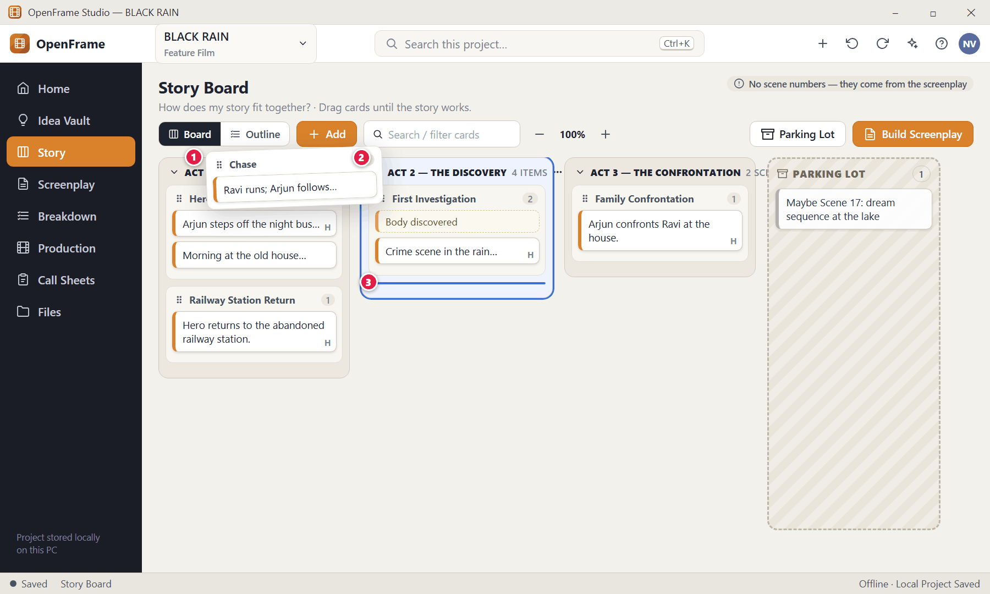
Figure 55. Moving a Sequence between Acts (red numbers are explained on the next page)

Figure 55 — Moving a Sequence between Acts: how it works
PARTS OF THIS SCREEN  1 Sequence being dragged — Its Scene Cards and Beats travel with it.  2 Destination highlight — When you re-parent a container (rather than reorder siblings) the destination Act is highlighted in blue.  3 Insertion point — Shows where the Sequence will land inside the Act. | HOW TO USE IT  1. Drag the Sequence header over the target Act until the Act is highlighted.  2. Release.  GOOD TO KNOW · EDGE CASES  - Moving a Sequence keeps every card's identity, comments and attachments — nothing is duplicated.  - Moving an Act reorders it with all its Sequences and scenes.

Figure 56 — Right-click menu on a Scene Card
What it is for. Right-click a card to see everything you can do with it. Only actions that make sense for a Scene Card appear.
How to get here. Right-click a Scene Card.
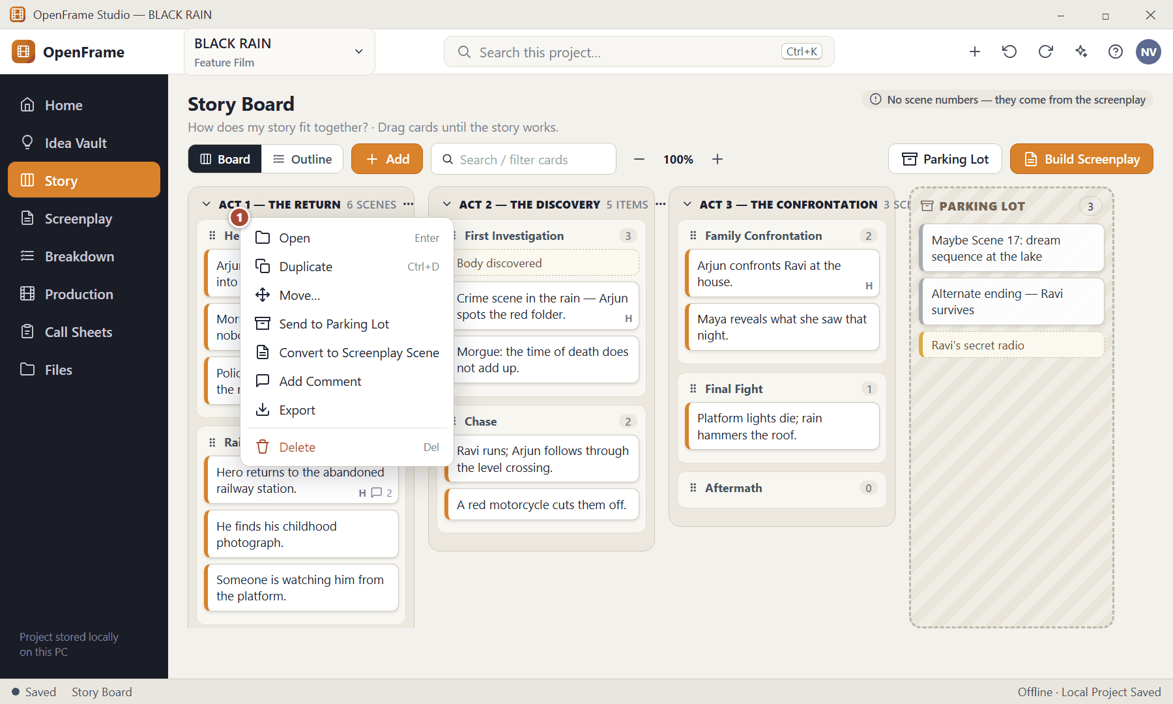
Figure 56. Right-click menu on a Scene Card (red numbers are explained on the next page)

Figure 56 — Right-click menu on a Scene Card: how it works
PARTS OF THIS SCREEN  1 Scene Card menu — Open · Duplicate · Move · Send to Parking Lot · Convert to Screenplay Scene · Add Comment · Export · Delete. Beats, Sequences and Acts have similar menus (Beat: Convert to Scene; Sequence: Add Scene / Add Beat; Act: Add Sequence / Add Scene). | HOW TO USE IT  1. Right-click the card and pick an action.  GOOD TO KNOW · EDGE CASES  - Compact cards may also show the primary buttons Edit · Move · Duplicate · More on hover; the less common actions (Comment, Convert, Export, Delete) sit under More.

Figure 57 — Selecting several cards
What it is for. Select many cards to move, duplicate, park, export or delete them together.
How to get here. Ctrl+click or Shift+click cards (or drag a selection box).
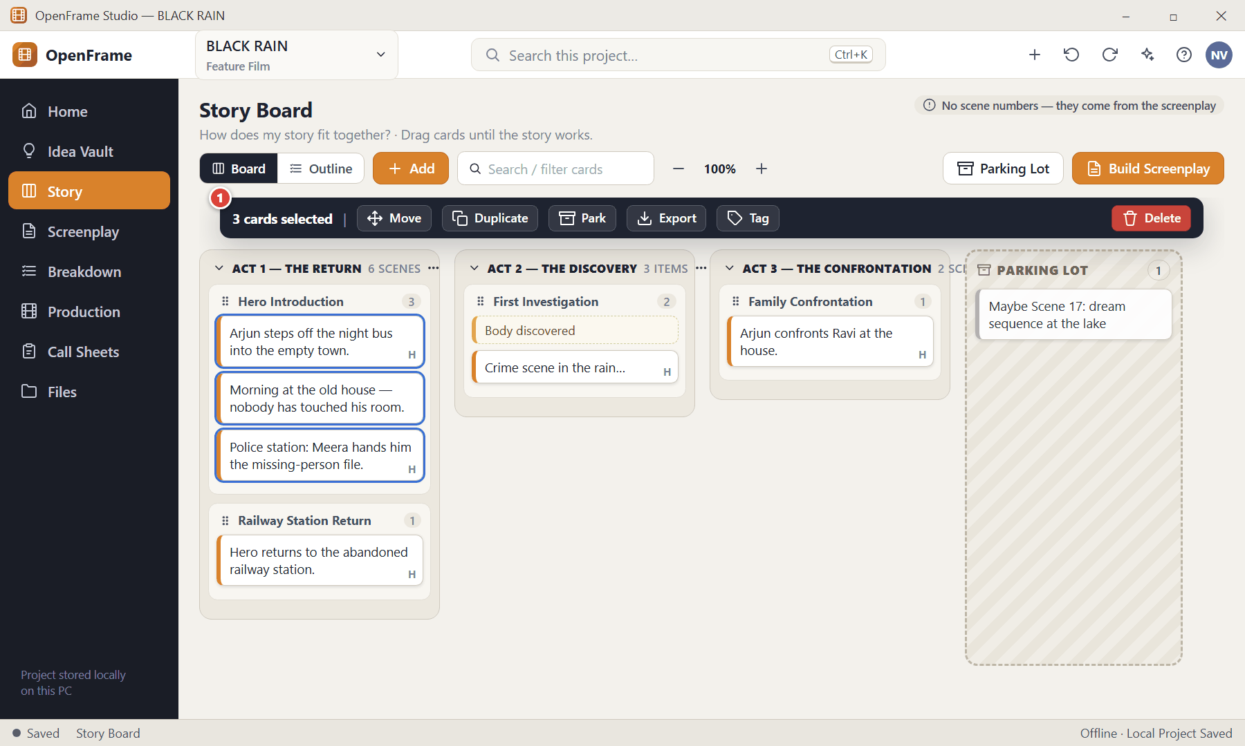
Figure 57. Selecting several cards (red numbers are explained on the next page)

Figure 57 — Selecting several cards: how it works
PARTS OF THIS SCREEN  1 Selection toolbar — Shows only actions valid for everything you selected: Move · Duplicate · Park · Export · Tag · Delete. | HOW TO USE IT  1. Click one card, then Ctrl+click (toggle) or Shift+click (range) others.  2. Drag any selected card to move the whole group; their relative order is kept.  3. Press Esc or click blank space to clear.  GOOD TO KNOW · EDGE CASES  - Deleting several cards shows one confirmation that says how many will be affected and any downstream warning.  - Keyboard: arrow keys move focus between cards, Enter opens, Space toggles selection, Delete invokes delete.

Figure 58 — The Parking Lot
What it is for. The Parking Lot is a safe holding area for cards that are not currently part of the story: "Maybe Scene 17", "Alternate ending", "Cool scene but doesn't fit", "Cut for now".
How to get here. Story → Parking Lot, or drag a card onto the Parking Lot area.
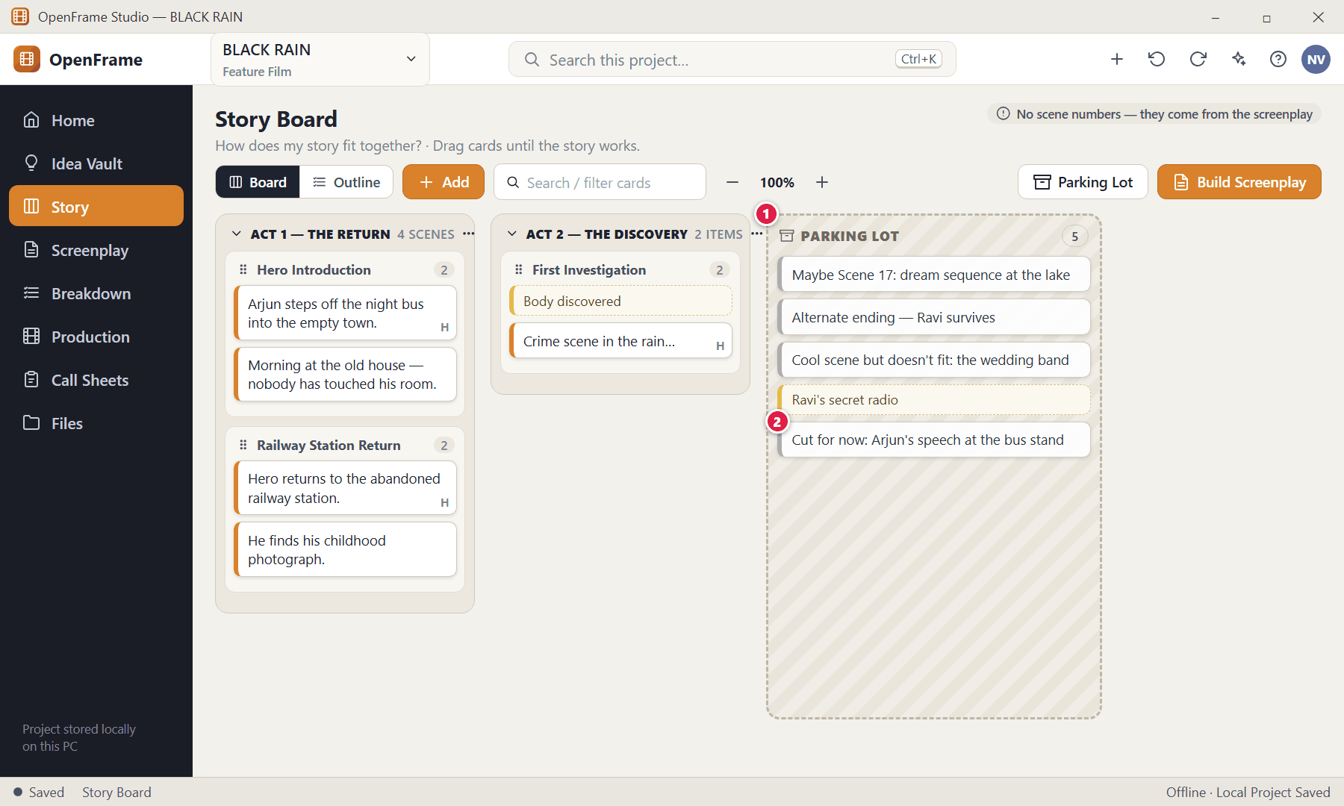
Figure 58. The Parking Lot (red numbers are explained on the next page)

Figure 58 — The Parking Lot: how it works
PARTS OF THIS SCREEN  1 Parking Lot — Has a different background and border so parked cards clearly sit outside the active story order.  2 A parked card — Retains its content and its parent history. Drag it back onto the board to restore it, or choose Restore to Story from its menu. | HOW TO USE IT  1. Drag a card into the Parking Lot to remove it from the active story.  2. Drag it back to an Act or Sequence when you want it again.  GOOD TO KNOW · EDGE CASES  - Moving a card to the Parking Lot never deletes it and never changes the screenplay.  - This is one of the safest ways to experiment: there is no branching or version tree, just duplicate, reorder, park and undo.  - Parked cards are excluded from Build Screenplay by default.

Figure 59 — Duplicating a card to try an alternative
What it is for. Duplicate a Scene Card to try a different version of a scene while keeping the original.
How to get here. Right-click → Duplicate (Ctrl+D).
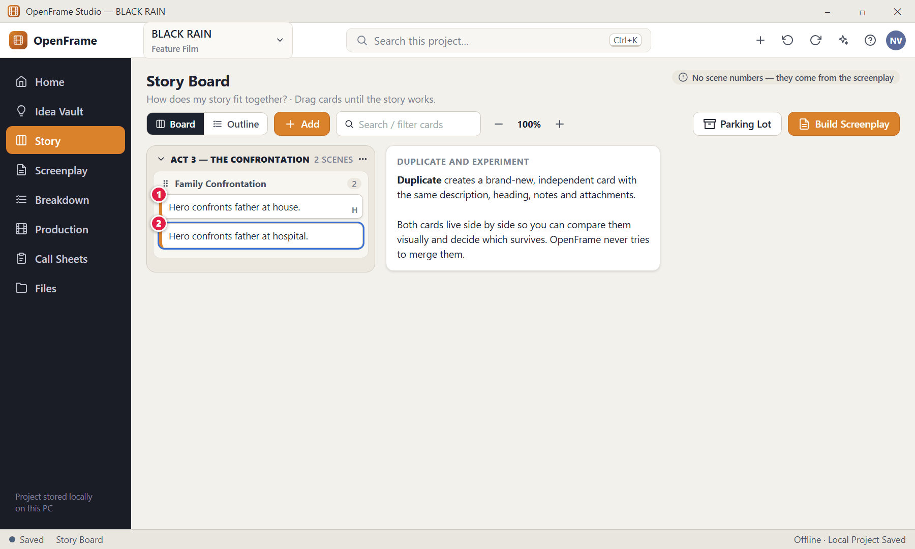
Figure 59. Duplicating a card to try an alternative (red numbers are explained on the next page)

Figure 59 — Duplicating a card to try an alternative: how it works
PARTS OF THIS SCREEN  1 Original — Unchanged.  2 Duplicate — A new selected card. It has a new identity and does not inherit any link to a screenplay scene. | HOW TO USE IT  1. Right-click the card → Duplicate.  2. Edit the duplicate: for example change "house" to "hospital".  3. Keep both, park one, or delete the loser.  GOOD TO KNOW · EDGE CASES  - The duplicate copies the description, heading, notes and selected attachments.

Figure 60 — Beat Card and Convert to Scene
What it is for. A Beat is an idea-sized story event — "Hero discovers the photograph." It is intentionally smaller than a Scene Card.
How to get here. Add → Beat, or Idea Vault → Send to Story → Beat.
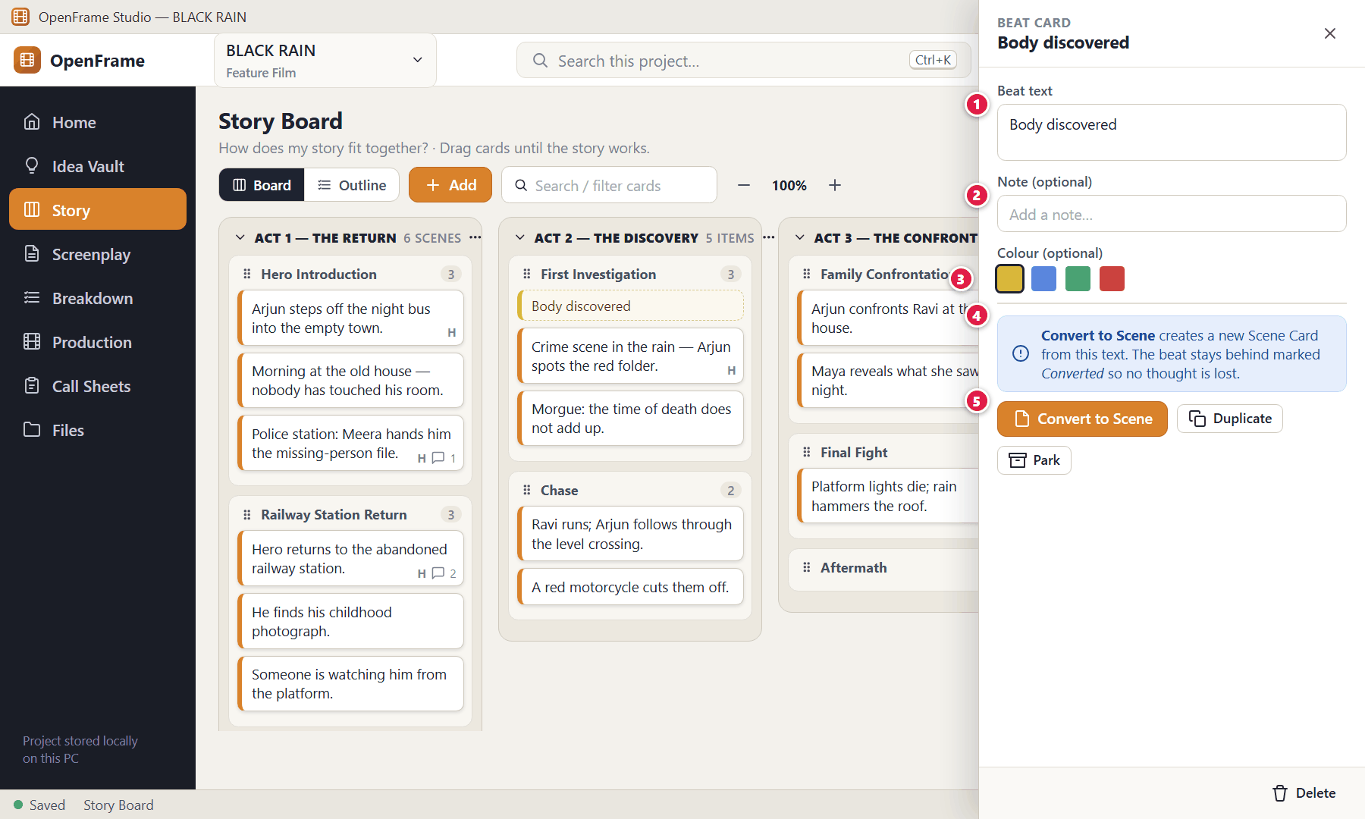
Figure 60. Beat Card and Convert to Scene (red numbers are explained on the next page)

Figure 60 — Beat Card and Convert to Scene: how it works
PARTS OF THIS SCREEN  1 Beat text — The only required field.  2 Note — Optional.  3 Colour — Optional personal colour.  4 Conversion — Convert to Scene creates a Scene Card whose short description is this beat's text.  5 Convert to Scene — The original beat is kept in a "Converted" reference state by default. | HOW TO USE IT  1. Add → Beat and type a line.  2. Drag it wherever it belongs, including into the Parking Lot.  3. When it is ready to be a scene, click Convert to Scene.  GOOD TO KNOW · EDGE CASES  - A Beat can exist forever without ever becoming a scene and does not affect the screenplay.  - Beats can sit in an Act, a Sequence or the Parking Lot.

Figure 61 — Deleting a non-empty Act
What it is for. Deleting a container that holds cards never silently destroys them: you choose what happens to the children.
How to get here. Right-click an Act → Delete (or Del).
Figure 61. Deleting a non-empty Act (red numbers are explained on the next page)

Figure 61 — Deleting a non-empty Act: how it works
PARTS OF THIS SCREEN  1 Your choices — Move the contents to another Act (recommended) or delete the Act with everything inside it, or cancel.  2 Destination — Where the moved contents should go (or an Unassigned area).  3 Cancel — Leaves everything as it is.  4 Confirm — Performs the option you chose. | HOW TO USE IT  1. Choose an option.  2. Click the confirm button.  GOOD TO KNOW · EDGE CASES  - Deleting a non-empty Sequence works the same way: reassign its Scene Cards or delete them explicitly.  - Deleted cards go to Recently Deleted, and Ctrl+Z restores them.

Figure 62 — Deleting a card that has a linked screenplay scene
What it is for. If a card was used to create a screenplay scene, deleting it warns you that the script is separate and untouched.
How to get here. Right-click → Delete, or select a card and press Delete.
Figure 62. Deleting a card that has a linked screenplay scene (red numbers are explained on the next page)

Figure 62 — Deleting a card that has a linked screenplay scene: how it works
PARTS OF THIS SCREEN  1 Warning — States exactly what will remain: the linked screenplay scene.  2 Delete Card — Moves the card to Recently Deleted (recoverable). | HOW TO USE IT  1. Read the warning, then click Delete Card.  GOOD TO KNOW · EDGE CASES  - Cards with no screenplay link are deleted without this warning (they still go to Recently Deleted).

Figure 63 — Build Screenplay — preview
What it is for. Build Screenplay turns the active Scene Cards into screenplay scenes, in board order. A preview lets you check the order and fix missing headings first.
How to get here. Story → Build Screenplay.
Figure 63. Build Screenplay — preview (red numbers are explained on the next page)

Figure 63 — Build Screenplay — preview: how it works
PARTS OF THIS SCREEN  1 Heading needed — A card without a valid screenplay heading is flagged. Type a heading (for example INT. HOUSE — NIGHT) directly in the table, or untick the card to leave it out.  2 Description treatment — Use the description as a scene planning note (default), or insert it as clearly marked temporary action text you will replace with real prose.  3 Destination — Create a New Screenplay, or a New Draft in an existing screenplay. Existing drafts are never overwritten.  4 Summary — How many cards will be built and how many still need attention.  5 Cancel — Creates nothing.  6 Build Screenplay — Creates the draft and opens it at the first created scene. | HOW TO USE IT  1. Open Story → Build Screenplay.  2. Fill in any "Heading needed" cards or untick them.  3. Choose how to treat descriptions and where the script should go.  4. Click Build Screenplay. You land in the screenplay at the first new scene; scene numbers are generated from the order.  GOOD TO KNOW · EDGE CASES  - The scene heading is optional on the Story Board but mandatory here — that is the only place the app insists on it.  - After the build the cards and the screenplay are separate objects. Editing a card later does not change the script.  - Only scenes you ticked are built. Unticked and Parking Lot cards stay on the board.

Figure 64 — Building when a screenplay already exists
What it is for. Repeat builds never silently overwrite an existing screenplay.
How to get here. Story → Build Screenplay when the project already has a screenplay.
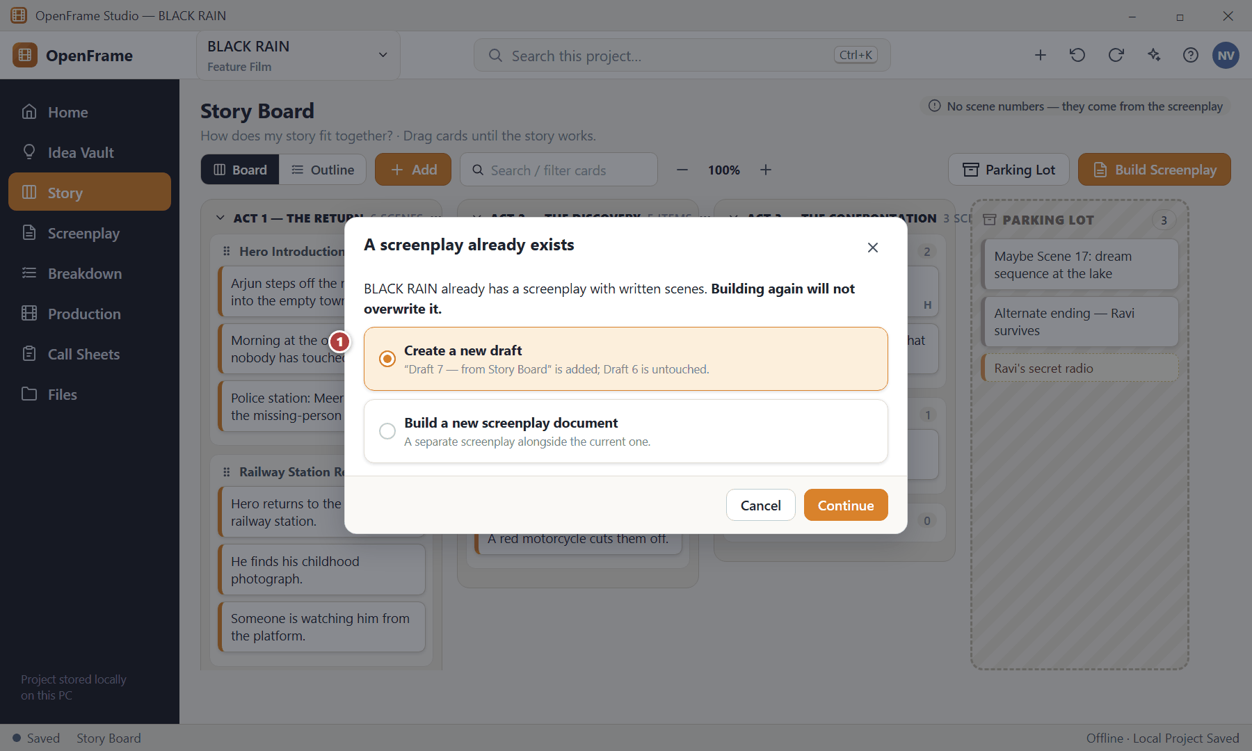
Figure 64. Building when a screenplay already exists (red numbers are explained on the next page)

Figure 64 — Building when a screenplay already exists: how it works
PARTS OF THIS SCREEN  1 Your options — Create a new draft, build a separate screenplay document, or cancel. | HOW TO USE IT  1. Choose an option and click Continue.  GOOD TO KNOW · EDGE CASES  - This is the same safety rule as screenplay import: existing writing is protected.

Figure 65 — Warning before a board reorder changes a written script
What it is for. Because the screenplay is the authoritative written script, reordering Story Board cards that are already written must be a deliberate choice.
How to get here. Appears when a board change would alter the order of written screenplay scenes.
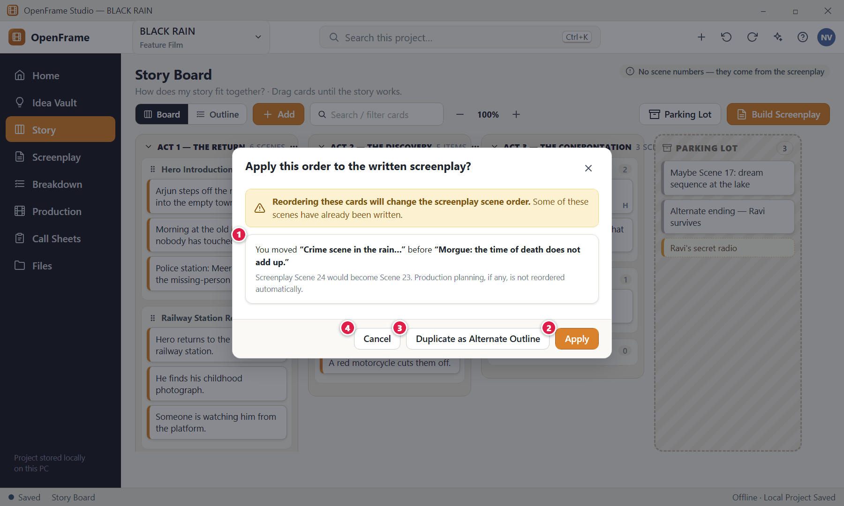
Figure 65. Warning before a board reorder changes a written script (red numbers are explained on the next page)

Figure 65 — Warning before a board reorder changes a written script: how it works
PARTS OF THIS SCREEN  1 What would change — Names the cards and the screenplay scene numbers affected.  2 Apply — Applies the new order to the screenplay scene order.  3 Duplicate as Alternate Outline — Keeps the current outline and creates a second copy with the new order so you can compare.  4 Cancel — Leaves everything as it was. | HOW TO USE IT  1. Read the effect, then choose Apply, Duplicate as Alternate Outline or Cancel.  GOOD TO KNOW · EDGE CASES  - The relationship is one-way and lightweight: Story Board → optional creation of screenplay scenes. Ordinary board edits do not touch the script.

Figure 66 — Zooming out to see the whole film
What it is for. Zoom lets you see many cards at once. At low zoom each card shows a one-line summary.
How to get here. Story → zoom − / + controls.
Figure 66. Zooming out to see the whole film (red numbers are explained on the next page)

Figure 66 — Zooming out to see the whole film: how it works
PARTS OF THIS SCREEN  1 Zoom controls — Click − to zoom out or + to zoom in. Zoom changes card density only; it never changes stored text or order. | HOW TO USE IT  1. Click − until you can see the whole story, then zoom back in to work on details.  GOOD TO KNOW · EDGE CASES  - Zoom is a viewing aid for a reference surface. Boards with hundreds of cards remain navigable through zoom, collapse and scrolling.

Figure 67 — Characters directory
What it is for. Characters are a simple story directory. The important part is not the profile — it is the list of scenes the character appears in.
How to get here. Story → Characters.
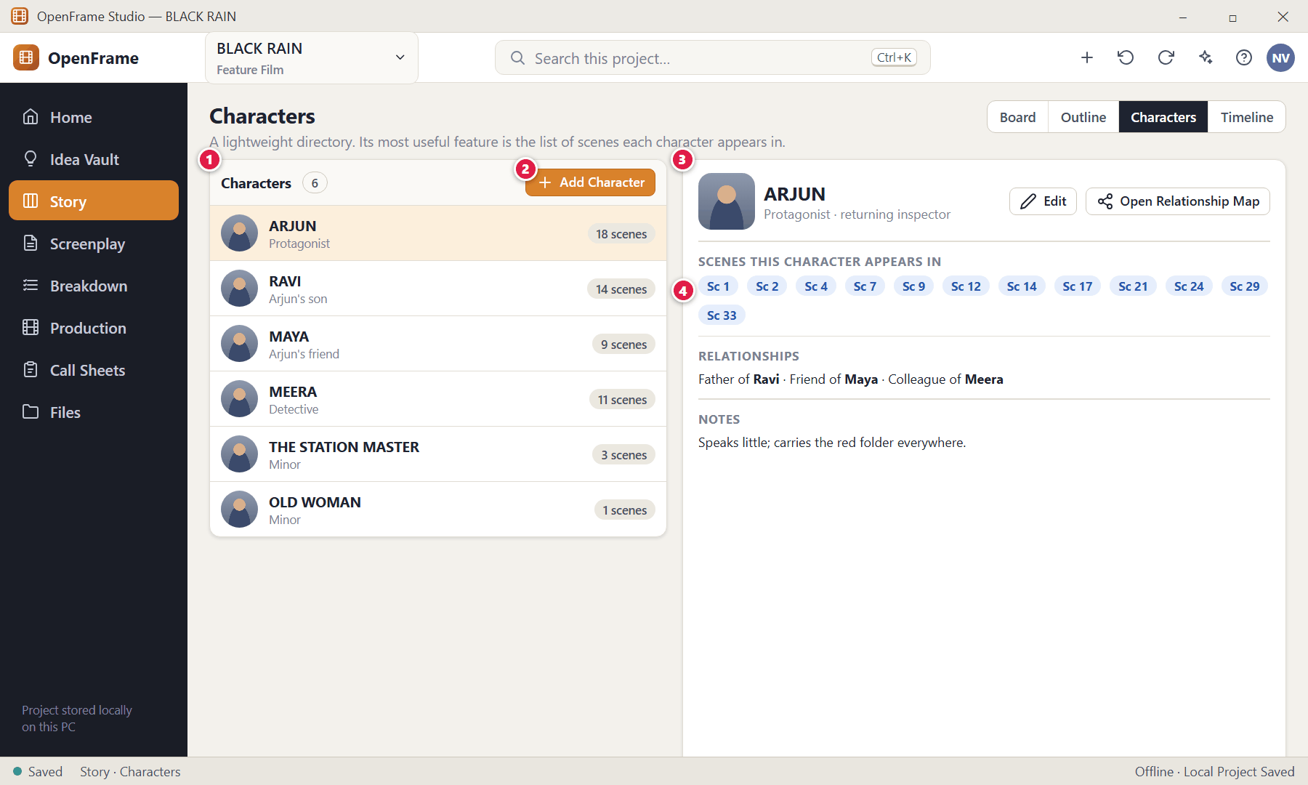
Figure 67. Characters directory (red numbers are explained on the next page)

Figure 67 — Characters directory: how it works
PARTS OF THIS SCREEN  1 Character list — Every character in the project with role and a scene count.  2 Add Character — Creates a record — only a name is required.  3 Character record — Name, optional role/title, short description, image, notes and relationship notes.  4 Scenes this character appears in — Filled in automatically when the screenplay is parsed — you do not populate it by hand. You can correct false detections. | HOW TO USE IT  1. Click a character to see its record.  2. Click a scene chip to open that scene in the screenplay.  GOOD TO KNOW · EDGE CASES  - Renaming the character record does not blindly rewrite dialogue in the screenplay; use the screenplay's own find/replace, or the AI assistant's structured rename preview.  - Deleting a character that is used in the screenplay or production offers archive instead of destructive removal.

Figure 68 — Adding a character (duplicate-name check)
What it is for. Before creating a second character with a similar name OpenFrame shows the likely match — but lets you create another if you genuinely need two.
How to get here. Characters → Add Character.
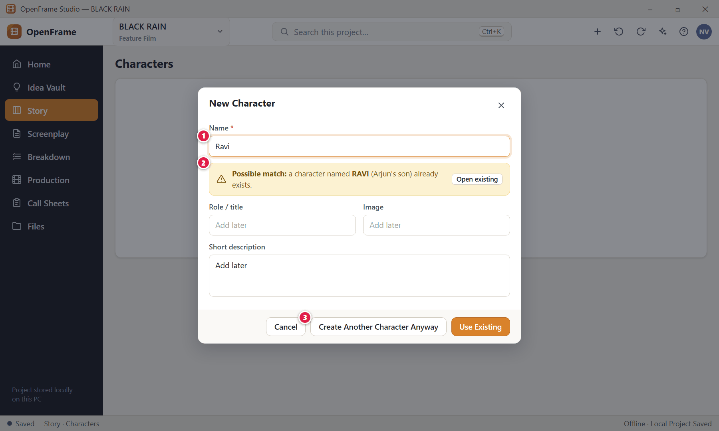
Figure 68. Adding a character (duplicate-name check) (red numbers are explained on the next page)

Figure 68 — Adding a character (duplicate-name check): how it works
PARTS OF THIS SCREEN  1 Name (required) — The only required field.  2 Possible match — Warns of a similar existing name so you do not create duplicates by accident.  3 Create Another Character Anyway — Overrides the warning when two characters really share a name. | HOW TO USE IT  1. Type the name.  2. If a warning appears, choose Use Existing or Create Another Character Anyway.  GOOD TO KNOW · EDGE CASES  - Role, image, description and notes are all optional and can be added later.

Figure 69 — Character relationship view
What it is for. A simple map of who is related to whom. It is optional and deliberately light.
How to get here. Characters → Open Relationship Map.
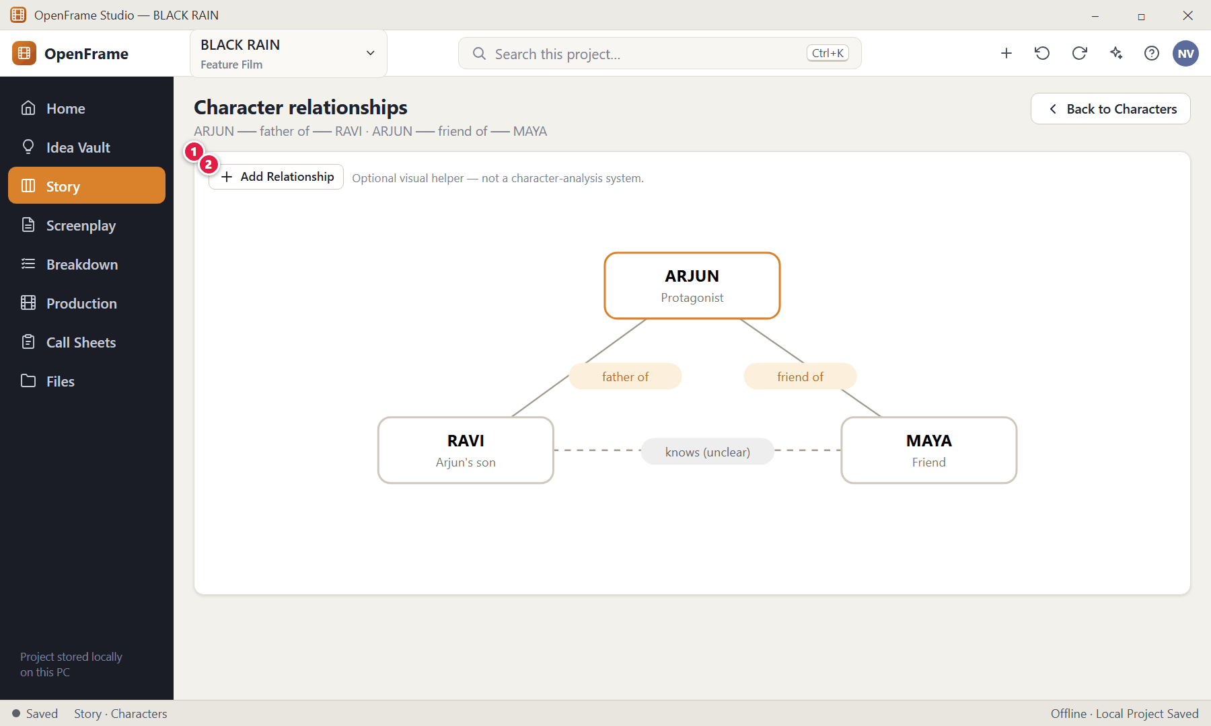
Figure 69. Character relationship view (red numbers are explained on the next page)

Figure 69 — Character relationship view: how it works
PARTS OF THIS SCREEN  1 Relationship map — Boxes are characters; labelled lines are relationships you typed (father of, friend of…).  2 Add Relationship — Pick two characters and type a freeform label such as "father of". | HOW TO USE IT  1. Click Add Relationship, choose two characters, and write the relationship.  GOOD TO KNOW · EDGE CASES  - Relationships are freeform text labels; there is no fixed vocabulary and no scoring.

Figure 70 — Story Timeline (optional)
What it is for. The Story Timeline groups screenplay scenes by story day. It only matters when your film has real time-continuity constraints.
How to get here. Story → Timeline (available once screenplay scenes exist).
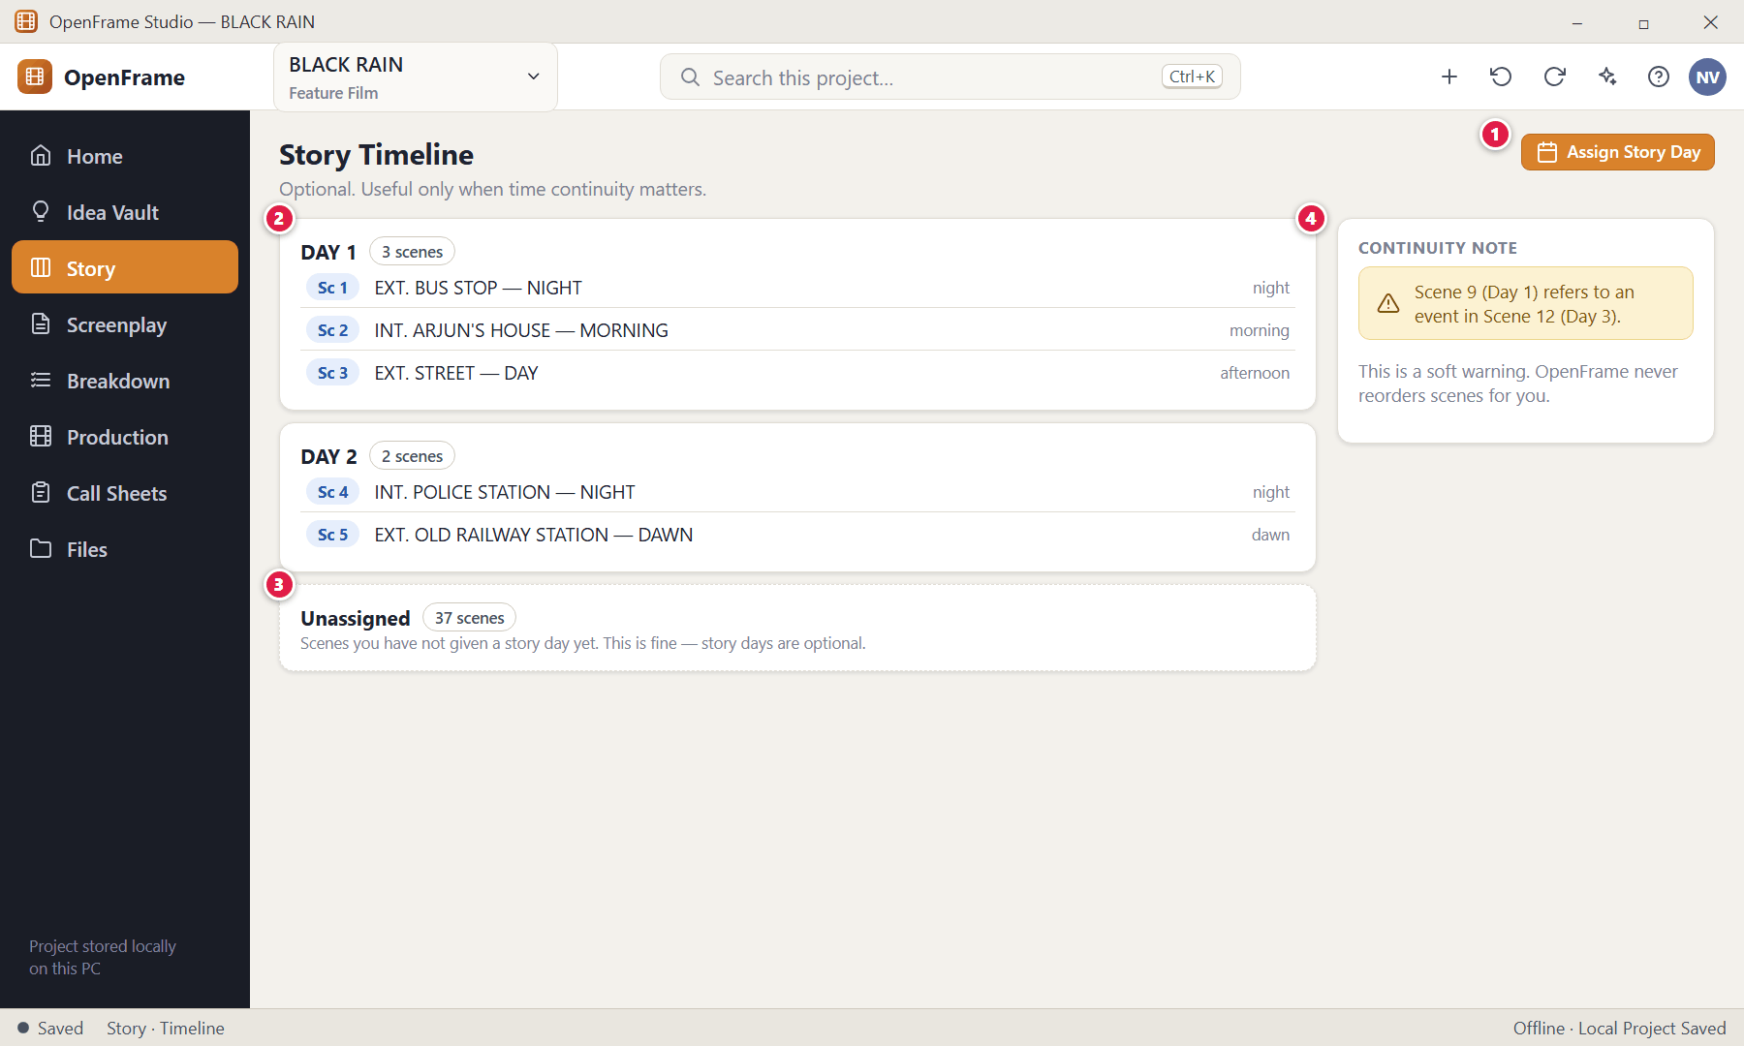
Figure 70. Story Timeline (optional) (red numbers are explained on the next page)

Figure 70 — Story Timeline (optional): how it works
PARTS OF THIS SCREEN  1 Assign Story Day — Choose scenes and give them a story day (Day 1, Day 2…). Optionally add a time-of-day note.  2 A story day — Lists its scenes in screenplay order.  3 Unassigned — Scenes with no day. Unassigned is normal.  4 Soft continuity warning — If a later event is placed on an earlier day the timeline may warn you. It never moves scenes. | HOW TO USE IT  1. Click Assign Story Day, select scenes, and enter the day.  GOOD TO KNOW · EDGE CASES  - Story Day is never required on a Scene Card; it is assigned to screenplay scenes after they exist.  - In episodic projects the story day is episode-scoped by default.

Figure 71 — Sequence Hub
What it is for. A Sequence can show its scenes, references, notes and comments in one place — without exposing production details.
How to get here. Right-click a Sequence → Open.
Figure 71. Sequence Hub (red numbers are explained on the next page)

Figure 71 — Sequence Hub: how it works
PARTS OF THIS SCREEN  1 Scenes in the sequence — The scene cards it contains.  2 Note — The optional small note.  3 Attached references — Images or files you attached. | HOW TO USE IT  1. Open a Sequence, add a note or attach references.  GOOD TO KNOW · EDGE CASES  - A Sequence has one key field: its name. There is no "purpose" field.

Figure 72 — Exporting the Story Board or Outline as PDF
What it is for. Export the board (or just the outline) as a clean PDF for a director or producer.
How to get here. Story → right-click board → Export, or the Export command.
Figure 72. Exporting the Story Board or Outline as PDF (red numbers are explained on the next page)

Figure 72 — Exporting the Story Board or Outline as PDF: how it works
PARTS OF THIS SCREEN  1 Scope — Current page, selected items, or the entire project.  2 Format — Board PDF (visual) or Outline PDF (hierarchy).  3 Privacy line — Confirms private notes are excluded and that export is a snapshot.  4 Export… — Choose where to save the PDF in the Windows Save dialog. | HOW TO USE IT  1. Choose scope and format, then click Export….  2. After saving, the app shows the file location with a "Reveal in File Manager" option.  GOOD TO KNOW · EDGE CASES  - Every export dialog answers four questions: what, which version, what format, where saved.

Figure 73 — Series → Season → Episode (episodic projects)
What it is for. Episodic projects add a Series → Season → Episode layer above the normal workspaces. Each episode gets its own Story Board, screenplay drafts, breakdown and production plan.
How to get here. Project Home (episodic project) → Series.
Figure 73. Series → Season → Episode (episodic projects) (red numbers are explained on the next page)

Figure 73 — Series → Season → Episode (episodic projects): how it works
PARTS OF THIS SCREEN  1 Season selector — Switch between seasons.  2 Add Season — Creates a new season.  3 Add Episode — Creates an episode with an order number, title, optional one-line summary and status.  4 Episode row — Shows title, one-line summary and status. Click to open the episode in the normal Story / Screenplay / Production workspaces.  5 Series-level references — A small shared list of recurring characters and locations episodes can refer to. | HOW TO USE IT  1. Add Season, then Add Episode.  2. Click an episode to work inside it — the shell shows the episode context.  GOOD TO KNOW · EDGE CASES  - Episodic projects do not get a giant writers-room database; season navigation stays simple and episode-centric.  - You can duplicate an episode, optionally copying its story, screenplay and production content; the new episode receives its own identity.

Figure 74 — Season Board: reordering episodes
What it is for. The Season Board shows episodes as cards you can drag into order, without forcing detailed season architecture.
How to get here. Series → Season Board.
Figure 74. Season Board: reordering episodes (red numbers are explained on the next page)

Figure 74 — Season Board: reordering episodes: how it works
PARTS OF THIS SCREEN  1 Episode card — Title, one-line summary and status. Drag to reorder. | HOW TO USE IT  1. Drag an episode card to a new position.  GOOD TO KNOW · EDGE CASES  - Deleting or changing one episode never affects other episodes.

Chapter 4 — Screenplay: Write, Draft, Review, Lock, Import and Export
The Screenplay workspace is the most professionally strict writing environment in OpenFrame: a dedicated screenplay editor rather than a word processor with a template. It is the authoritative written script. This chapter covers writing, finding, focus and writing-room layouts, notes and comments, named drafts and automatic history, comparing drafts, review rounds, locking a Shooting Draft and production revisions, importing an existing script, and exporting or printing.
Screens in this chapter
Figure 75 Screenplay — empty state | Figure 89 Editing a locked draft: Start Revision
Figure 76 The screenplay editor (Standard mode) | Figure 90 Revision label, colour and changed scenes
Figure 77 Choosing screenplay element types | Figure 91 Importing a screenplay: choose the source
Figure 78 Find and replace in the screenplay | Figure 92 Import preview and warnings
Figure 79 Focus mode (full-screen writing) | Figure 93 Import failed (safe failure)
Figure 80 Writing Room: script with a reference panel | Figure 94 Import report
Figure 81 Scene notes and private notes | Figure 95 Exporting the screenplay
Figure 82 Adding and resolving comments on script text | Figure 96 Document preview and printing
Figure 83 Drafts: named drafts and recovery history | Figure 97 Scene Hub: what exists around a scene
Figure 84 Creating a new named draft | Figure 98 Right-click menu on a screenplay scene
Figure 85 Comparing two drafts | Figure 99 Moving a scene that is already in production planning
Figure 86 Review rounds | Figure 100 Title page details
Figure 87 Starting a review round | Figure 101 Deleting a draft
Figure 88 Locking the Shooting Draft

Figure 75 — Screenplay — empty state
What it is for. A project with no screenplay yet shows three ways to begin.
How to get here. Left navigation → Screenplay in a new project.
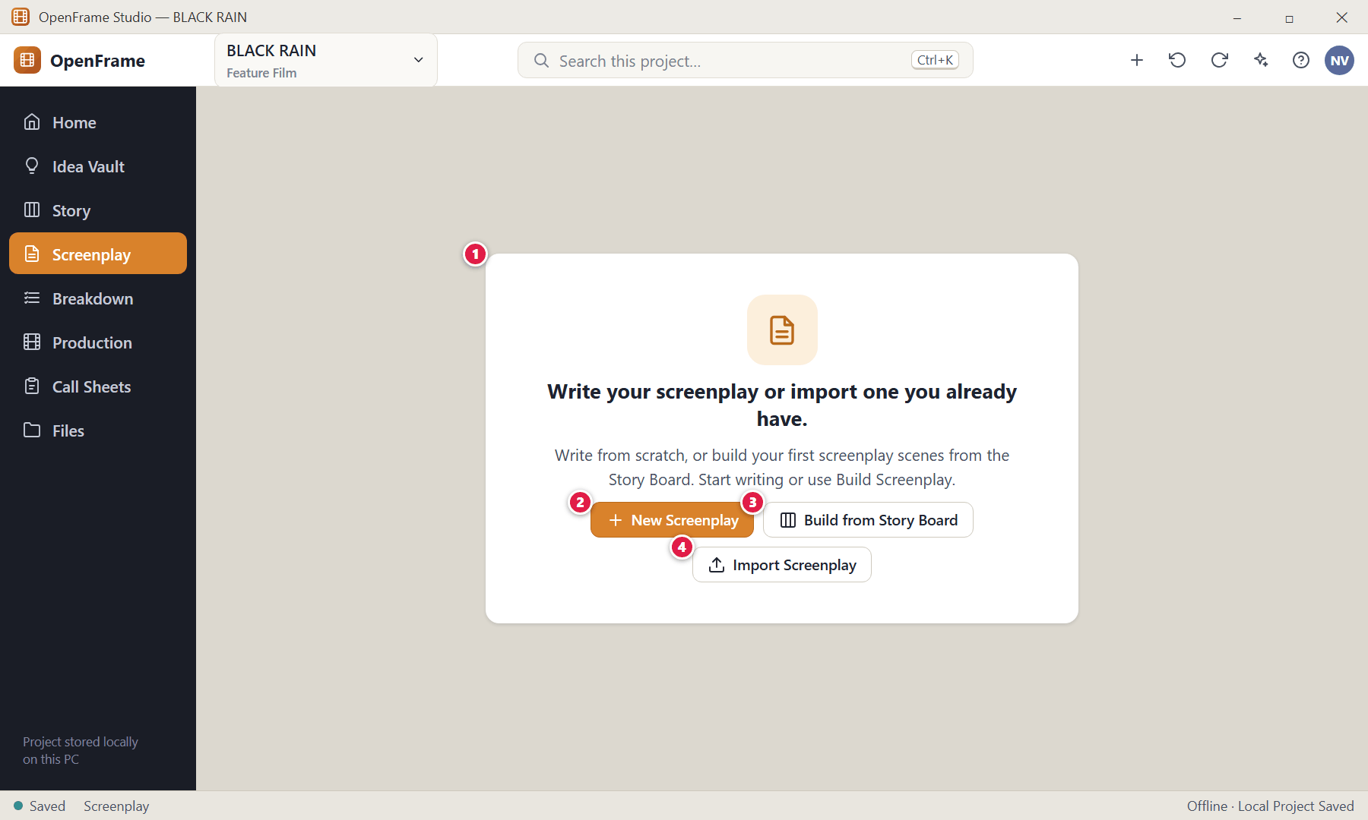
Figure 75. Screenplay — empty state — Empty state (red numbers are explained on the next page)

Figure 75 — Screenplay — empty state: how it works
PARTS OF THIS SCREEN  1 Empty-state message — "Write your screenplay or import one you already have." A new screenplay shows a blank page with "Start writing or use Build Screenplay."  2 New Screenplay — Opens a blank page — no Story Board needed.  3 Build from Story Board — Creates scenes from your Scene Cards (see Story Board chapter).  4 Import Screenplay — Brings in an existing script. | HOW TO USE IT  1. Click New Screenplay to type from scratch, or one of the other two buttons.  2. A project can hold more than one screenplay, for example a feature and its short version. Use the screenplay picker at the left of the toolbar to switch between them, add one with New Screenplay, rename the open one, or delete it with Delete Screenplay. Each screenplay keeps its own drafts, locked drafts, scene numbers and page setup.  GOOD TO KNOW · EDGE CASES  - The Screenplay never depends on the Story Board or Idea Vault. You may skip both entirely.  - Deleting a screenplay moves it, with all its drafts, to Recently Deleted for 30 days. Restore brings it back with its drafts, locked drafts, scene numbers and page setup. The screenplay that Breakdown, Schedule and Call Sheets follow (the Production Source) cannot be deleted until you choose a draft of another screenplay as the Production Source. Owners and Editors can delete a screenplay; the AI assistant never does.

Figure 76 — The screenplay editor (Standard mode)
What it is for. This is where the movie is written. The page is centred and quiet; the scene navigator sits on the left; the toolbar above has the draft controls. It answers "What is the movie on the page?"
How to get here. Left navigation → Screenplay, or Project Home → Write Screenplay / Continue screenplay.
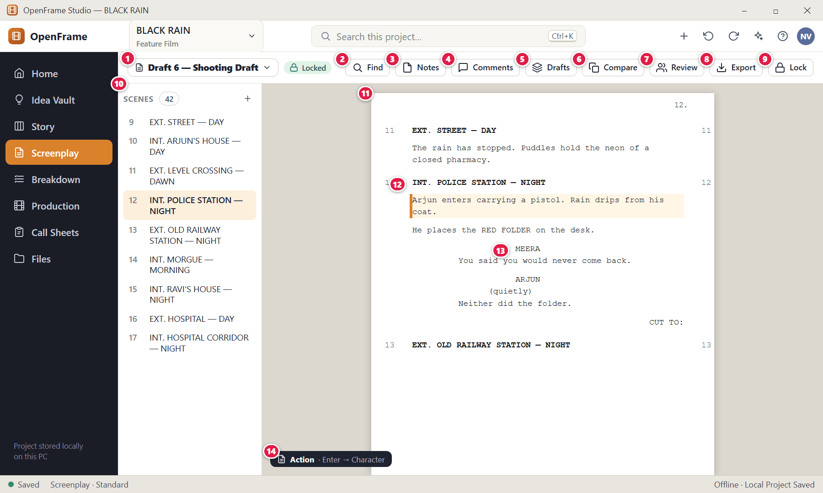
Figure 76. The screenplay editor (Standard mode) — Editing, locked draft (red numbers are explained on the next page)

Figure 76 — The screenplay editor (Standard mode): how it works
PARTS OF THIS SCREEN  1 Draft selector — Shows which named draft you are in (here "Draft 6 — Shooting Draft") with a badge such as Locked. Click it to switch drafts.  2 Find — Opens the find/replace bar over the screenplay (Ctrl+F).  3 Notes — Shows or hides your scene notes. Notes are outside the printed script.  4 Comments — Shows the comments panel.  5 Drafts — Opens the draft history drawer (named drafts + recovery history).  6 Compare — Compares two drafts.  7 Review — Opens review rounds.  8 Export — Exports or prints the screenplay.  9 Lock — Marks the draft as the Locked Shooting Draft.  10 Scene navigator — Lists every scene with its generated number and heading. Click a scene to jump to it without opening another document. The + adds a new scene.  11 The screenplay page — Professional screenplay layout that formats itself. You never adjust spacing or alignment for normal writing.  12 Scene heading — INT./EXT. location — time. Scene numbers (12) are generated from the screenplay order; you never type them.  13 Character cue — Character name centred above dialogue.  14 Element indicator — A subtle label shows which element type the cursor is in (Action, Dialogue, …) and what Enter will start next. | HOW TO USE IT  1. Click into the page and type. The scene heading, action, character, dialogue, parenthetical and transition each format automatically.  2. Click a scene in the navigator to jump to it.  3. Autosave keeps your work; the status bar shows "Saved".  GOOD TO KNOW · EDGE CASES  - Ctrl+Z / Ctrl+Shift+Z undo and redo text edits. Standard copy/cut/paste and text selection work as in any editor.  - Pasting screenplay text follows the import/parsing flow instead of becoming plain rich text.  - The Idea Vault is not embedded beside the script; switch to it from the navigation when you need it.

Figure 77 — Choosing screenplay element types
What it is for. The editor supports every standard element. You switch type with a shortcut, the compact selector, or by letting the automatic rules do it.
How to get here. Click the element indicator (bottom-left of the page) or use a shortcut.
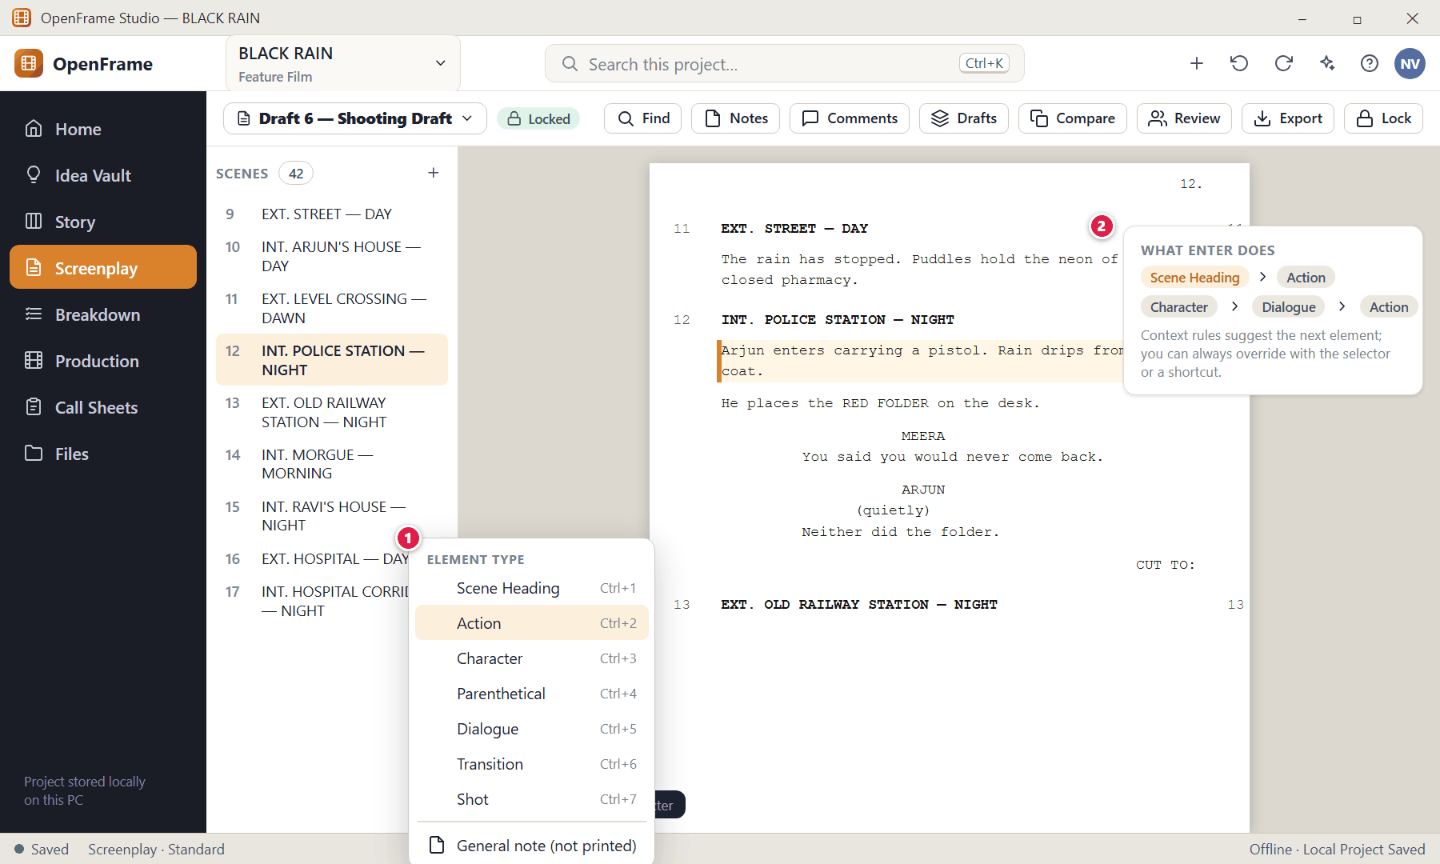
Figure 77. Choosing screenplay element types (red numbers are explained on the next page)

Figure 77 — Choosing screenplay element types: how it works
PARTS OF THIS SCREEN  1 Element selector — Scene Heading · Action · Character · Parenthetical · Dialogue · Transition · Shot (optional shot direction) · General note (outside the printed script).  2 Automatic progression — After a Scene Heading, Enter moves to Action. After a Character name, Enter moves to Dialogue. The editor suggests the next likely element without blocking you. | HOW TO USE IT  1. Put the cursor in a line and pick a different element type to convert it.  2. Press Enter to move to the next suggested element.  GOOD TO KNOW · EDGE CASES  - Shortcut keys follow common industry screenwriting conventions and are shown here as the proposed defaults; the exact key mapping can be documented separately and customised later. The on-screen selector always offers the same choices.  - Only "Shot" direction, and "General note" are optional; every screenplay needs at least a Scene Heading to be a valid scene for production use.

Figure 78 — Find and replace in the screenplay
What it is for. Ordinary, dependable text search inside the screenplay that is currently open.
How to get here. Ctrl+F, or the Find button.
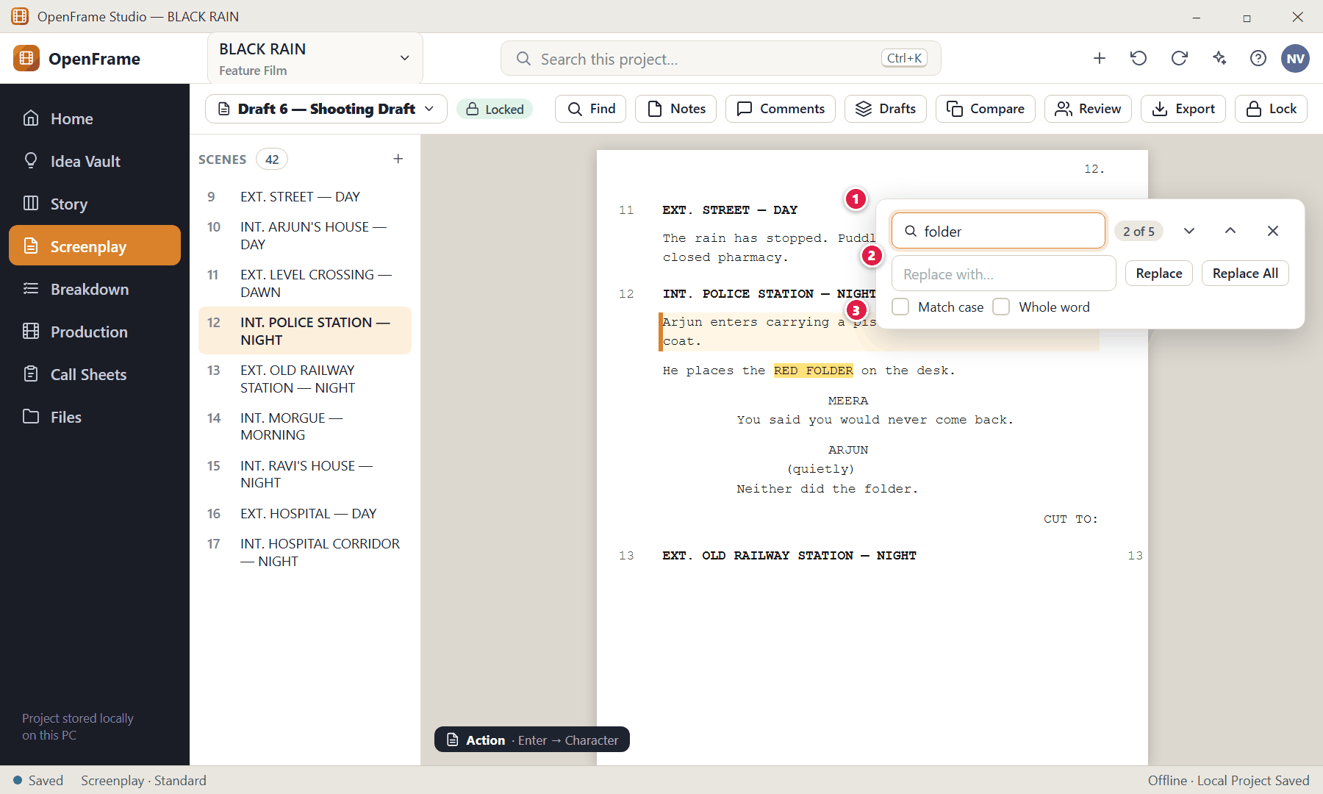
Figure 78. Find and replace in the screenplay (red numbers are explained on the next page)

Figure 78 — Find and replace in the screenplay: how it works
PARTS OF THIS SCREEN  1 Find bar — Type a word; matches highlight in the page. The counter shows "2 of 5". Enter goes to the next match, Shift+Enter to the previous, Esc closes the bar.  2 Replace — Replace one match or Replace All. Replacements are undoable.  3 Options — Match case and Whole word. | HOW TO USE IT  1. Press Ctrl+F and type.  2. Use Enter / Shift+Enter to step through matches.  3. Optionally type replacement text and click Replace.  GOOD TO KNOW · EDGE CASES  - Search finds dialogue, action, character names and scene headings in the current screenplay. "No matches found" appears without leaving the scene when there is nothing to find.  - If a replacement cannot be done it fails as a whole — it never changes part of the text.  - This is not the project-wide search (Ctrl+K), which looks across the whole project.

Figure 79 — Focus mode (full-screen writing)
What it is for. Focus mode hides the navigation, panels and toolbars so only the script remains. It is a presentation change only — the editor behaves identically.
How to get here. Screenplay → Focus Mode (or Fullscreen Writing).
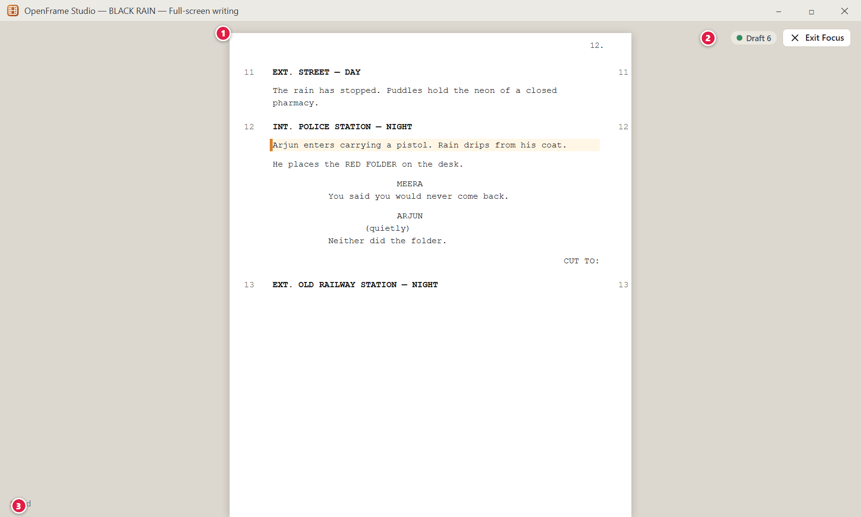
Figure 79. Focus mode (full-screen writing) (red numbers are explained on the next page)

Figure 79 — Focus mode (full-screen writing): how it works
PARTS OF THIS SCREEN  1 The page — Fills nearly the whole window.  2 Exit Focus — A very small control returns you to normal mode instantly and restores the previous layout.  3 Minimal status — Shows only Saved / Draft name. Save errors appear discreetly here. | HOW TO USE IT  1. Click Focus Mode (or press the full-screen writing command).  2. Type as usual: typing, search, undo/redo, save and essential navigation remain available.  3. Click Exit Focus to return.  GOOD TO KNOW · EDGE CASES  - Entering and leaving Focus mode never changes your text or your saved layout.

Figure 80 — Writing Room: script with a reference panel
What it is for. The Writing Room is a layout, not a separate document: the screenplay plus one or two useful reference panels beside it.
How to get here. Screenplay → Writing Room, then choose a panel.
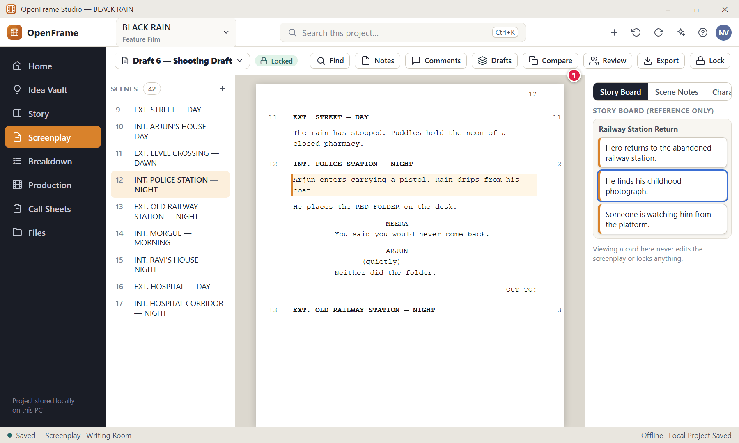
Figure 80. Writing Room: script with a reference panel (red numbers are explained on the next page)

Figure 80 — Writing Room: script with a reference panel: how it works
PARTS OF THIS SCREEN  1 Side panel — Choose Story Board (reference), Scene Notes, Characters, Comments or Draft information. Only one or two panels are normally open. Drag the edge to resize, or close it. | HOW TO USE IT  1. Open the Writing Room and pick a panel.  2. Resize or close panels as you like — OpenFrame remembers your last layout.  GOOD TO KNOW · EDGE CASES  - The Story Board panel is read-only reference: it does not stay synchronised with the screenplay.  - The Idea Vault is deliberately not offered as a live sidebar. Consult it via the normal navigation.  - If a panel fails to load, the screenplay remains fully usable.

Figure 81 — Scene notes and private notes
What it is for. A scene can have working notes that live outside the printed script, and private notes that only you can see.
How to get here. Screenplay → Notes.
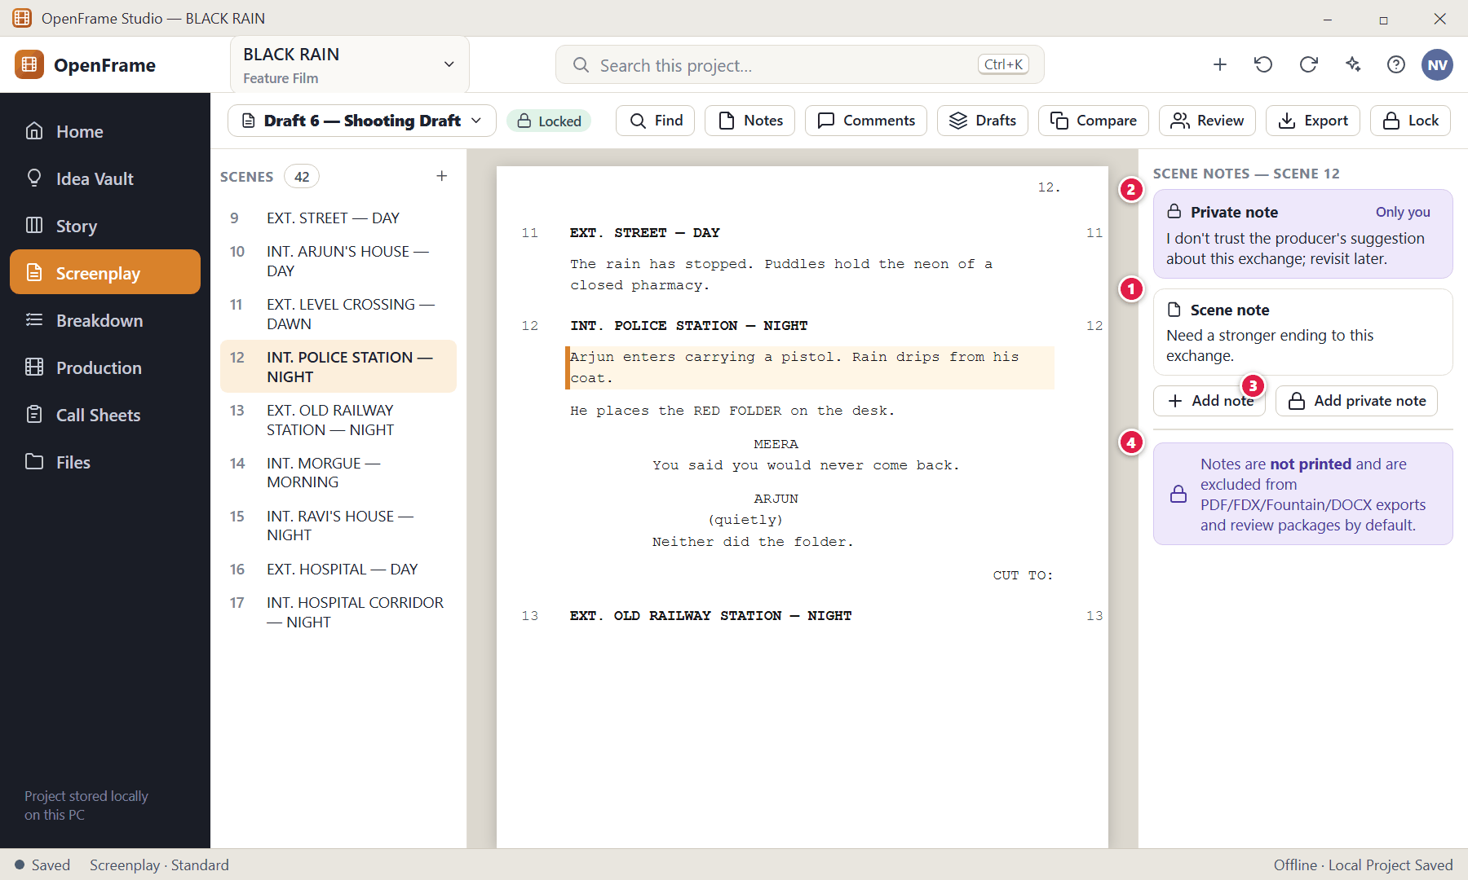
Figure 81. Scene notes and private notes (red numbers are explained on the next page)

Figure 81 — Scene notes and private notes: how it works
PARTS OF THIS SCREEN  1 Scene note — Working notes for the scene — for example "Need stronger ending to this exchange."  2 Private note — Visually distinct. Visible only to you; never shared with collaborators and never exported.  3 Add private note — Creates a private note on the scene.  4 Export rule — Notes do not appear in exported screenplay PDFs. Toggling notes visibility only changes what you see. | HOW TO USE IT  1. Open Notes, click Add note or Add private note, and type.  2. Toggle the Notes button to show or hide them while writing.  GOOD TO KNOW · EDGE CASES  - A private note is never included in review packages, exchange packages, call sheets, or normal exports — and the AI assistant cannot read another person's private notes.  - A Full Project Package or Backup made by the owner may contain private notes for private transfer; it is labelled as a private project transfer, not an external review package.

Figure 82 — Adding and resolving comments on script text
What it is for. Select some text, click Comment, write, post. The same simple flow applies to comments on scene cards, beats, sequences, acts, storyboard panels, shots, locations and breakdown items.
How to get here. Select text → Comment, or open the Comments panel.
Figure 82. Adding and resolving comments on script text (red numbers are explained on the next page)

Figure 82 — Adding and resolving comments on script text: how it works
PARTS OF THIS SCREEN  1 Selected text — A comment can be anchored to an exact text range or to the whole scene.  2 Comment button — A small affordance appears near the selection without covering it.  3 Comment thread — Author, target and text. Replies stay inside the same thread.  4 Resolve — Marks the thread resolved. Resolved comments are kept in history (Open → In Discussion → Resolved) and can be reopened. | HOW TO USE IT  1. Select text, click Comment, type, and post.  2. Reply inside the thread, then click Resolve when done.  GOOD TO KNOW · EDGE CASES  - Comments never change the screenplay text.  - If later edits remove the exact text a comment was anchored to, the comment becomes "context moved" and stays attached to the nearest surviving scene — it never disappears.  - A Viewer cannot comment unless given Commenter permission.

Figure 83 — Drafts: named drafts and recovery history
What it is for. OpenFrame keeps two layers of versions: named drafts you create on purpose, and quiet automatic history for recovery. This drawer answers "Which version am I working on, and what can I restore?"
How to get here. Screenplay → Drafts.
Figure 83. Drafts: named drafts and recovery history (red numbers are explained on the next page)

Figure 83 — Drafts: named drafts and recovery history: how it works
PARTS OF THIS SCREEN  1 Draft lineage — A simple chain such as Draft 1 → Draft 2 → Director Rewrite → Shooting Draft shows where each draft came from.  2 Named drafts — Each draft shows name, note, date and status chips (Current, Locked). Exactly one draft is Current. Open a draft to work on it or Compare two drafts.  3 Recovery History — Automatic history points, kept separately so they do not clutter draft selection.  4 Restore — Restoring never overwrites the current draft: it creates a new draft "restored from …".  5 New Draft — Creates a named draft (see next screen). | HOW TO USE IT  1. Open the drawer, then Open a draft to switch to it.  2. Select two drafts and click Compare… to see differences.  3. Use Restore on a recovery point to recover earlier text as a new draft.  GOOD TO KNOW · EDGE CASES  - A named draft can be renamed at any time — this changes only its label.  - Deleting a named draft asks for confirmation and moves it to Recently Deleted. The current draft cannot be deleted until you make another draft current. A locked draft cannot be deleted while it is the only production baseline.  - You can export a clean distribution copy from any named draft; that does not make it the current draft.

Figure 84 — Creating a new named draft
What it is for. A named draft is a meaningful milestone: Draft 2, Director Rewrite, Producer Pass, Shooting Draft.
How to get here. Drafts → New Draft.
Figure 84. Creating a new named draft (red numbers are explained on the next page)

Figure 84 — Creating a new named draft: how it works
PARTS OF THIS SCREEN  1 Create from — Copy the current draft or any previous named draft.  2 Draft name (required) — For example "Draft 7 — Director Rewrite".  3 Note (optional) — A reminder of what changed.  4 Create Draft — Makes the new draft. The old draft remains unchanged. | HOW TO USE IT  1. Choose a source, type a name, optionally a note, and click Create Draft.  GOOD TO KNOW · EDGE CASES  - You do not need to press "save version" every ten minutes — automatic history handles that quietly.

Figure 85 — Comparing two drafts
What it is for. Draft comparison tells you what changed in human words — "Scene 17 changed", "Scene 21 removed", "12 lines changed in Scene 34" — before you look at exact text. It answers "What exactly changed?"
How to get here. Drafts → Compare, or the Compare button.
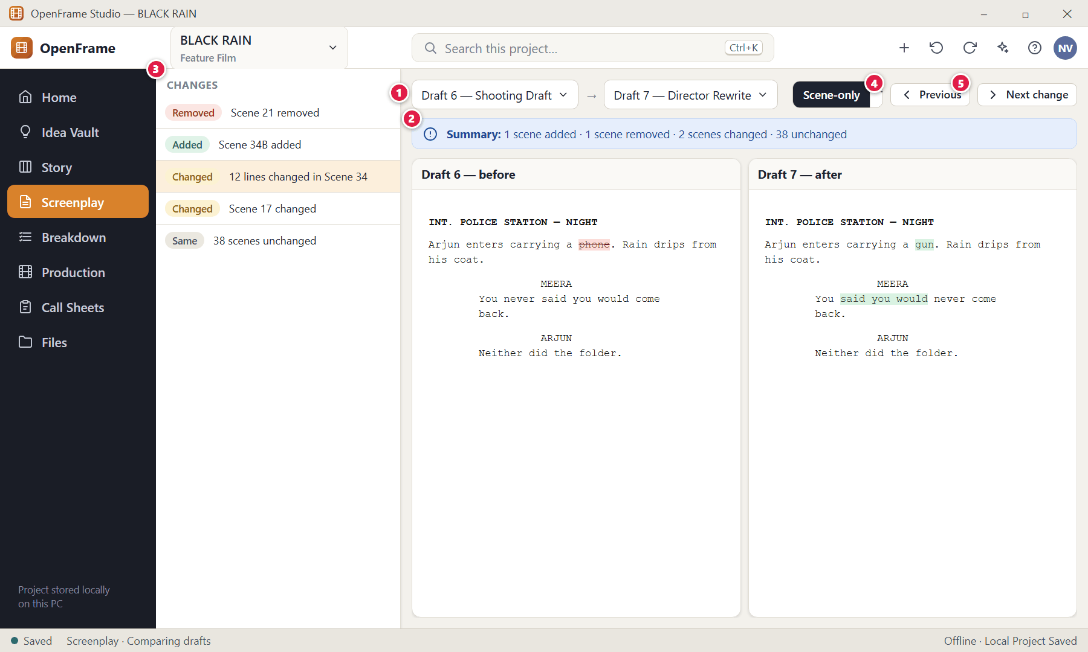
Figure 85. Comparing two drafts (red numbers are explained on the next page)

Figure 85 — Comparing two drafts: how it works
PARTS OF THIS SCREEN  1 Choose the two drafts — Pick Draft A and Draft B.  2 Summary — Counts of added, removed, changed and unchanged scenes.  3 Change navigator — Click a change to jump to it in both panes.  4 Previous / Next change — Step through every change.  5 Next change — Steps forward. | HOW TO USE IT  1. Select two drafts and click Compare.  2. Click a scene in the change list to see the exact text difference: added text is green, removed text is red with strike-through.  3. Use Scene-only for a structural overview or Text-only for wording.  GOOD TO KNOW · EDGE CASES  - Comparison is read-only. To keep a change, edit a draft manually or create a new draft.  - Scenes are matched by their stable scene identity; for imported scripts without identity the app falls back to heading and order and flags ambiguous matches.

Figure 86 — Review rounds
What it is for. A review round gathers feedback on one specific draft — instead of indefinite comment chaos. It answers "What feedback is still open?"
How to get here. Screenplay → Review (or Draft History → Create Review).
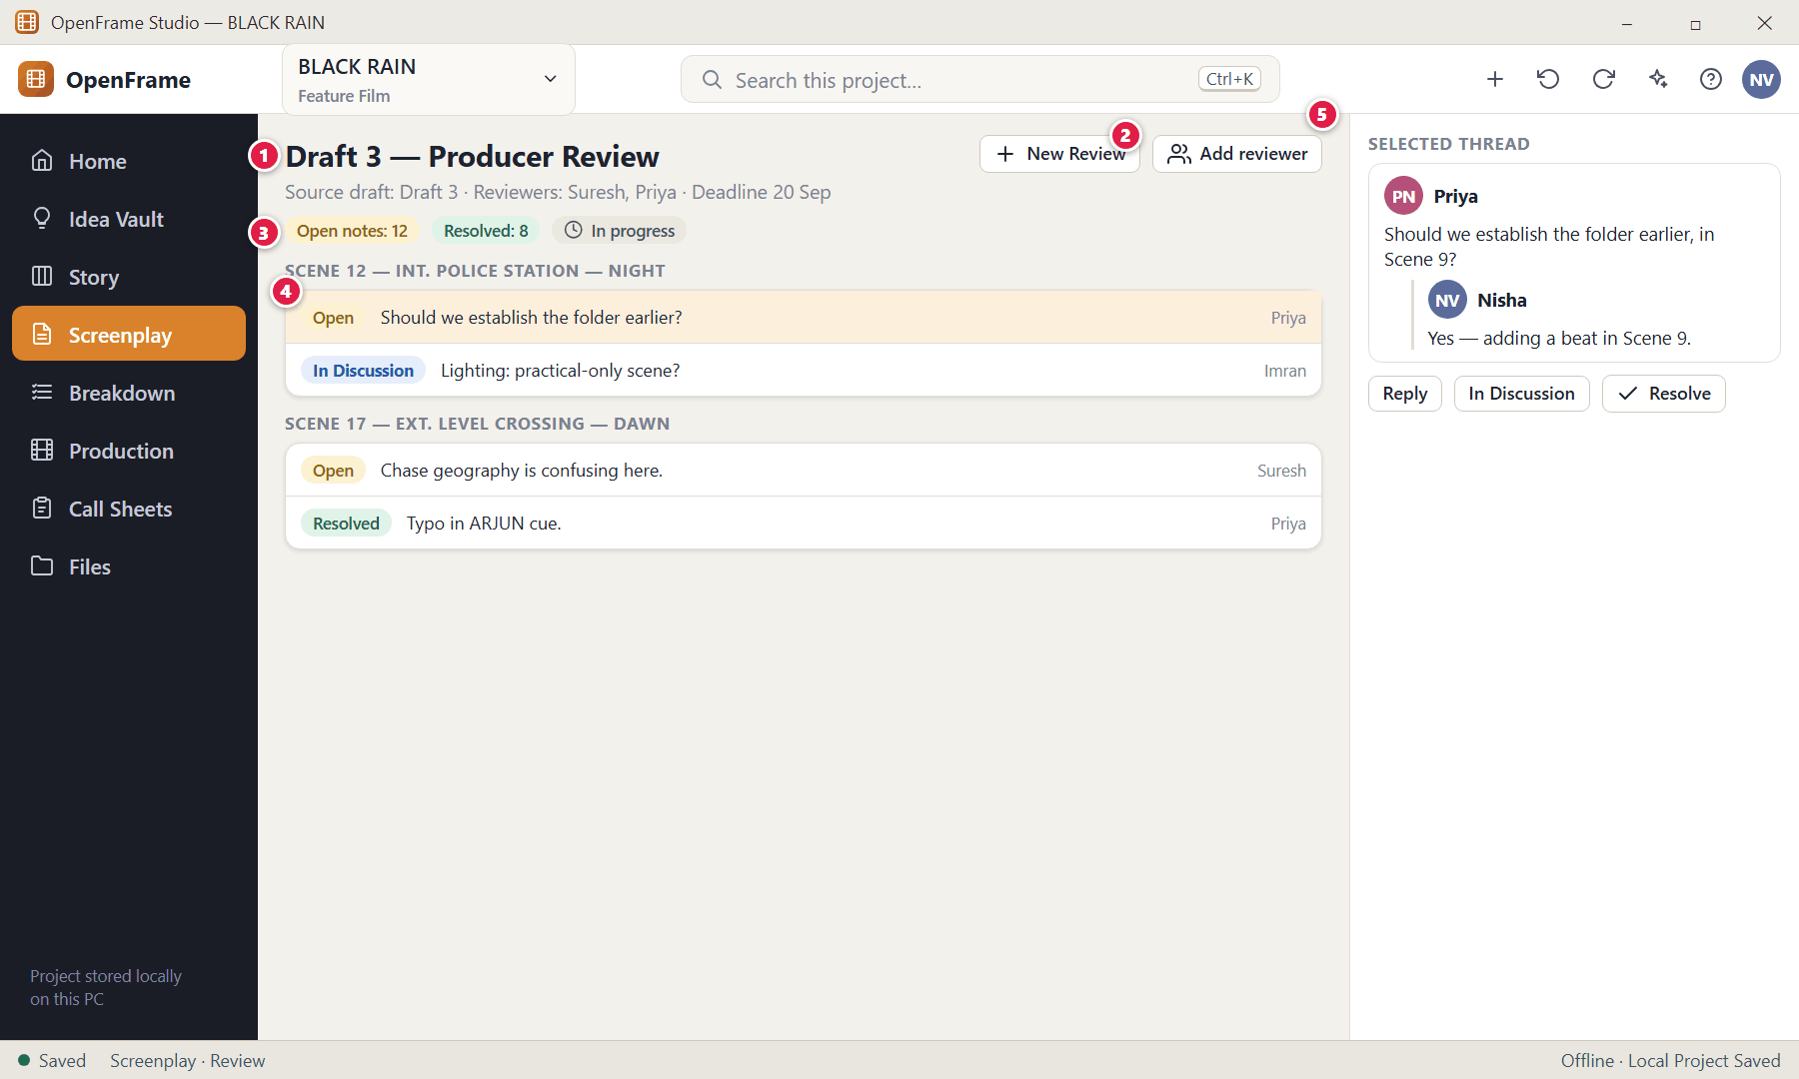
Figure 86. Review rounds (red numbers are explained on the next page)

Figure 86 — Review rounds: how it works
PARTS OF THIS SCREEN  1 Review header — Name, source draft, reviewers and optional deadline. A review requires only a source draft and a name.  2 Add reviewer — Add people who will comment.  3 Status counts — Open notes / Resolved counts and the review state.  4 Comments by scene — Grouped by scene and status: Open, In Discussion, Resolved.  5 Selected thread — Read and reply; mark In Discussion or Resolve. | HOW TO USE IT  1. Review → New Review, choose the source draft, name it, add reviewers.  2. Reviewers add comments (locally, or via a review package).  3. Resolve threads as you address them; mark the round Complete when done.  GOOD TO KNOW · EDGE CASES  - Starting or completing a review never locks the script and never changes it.  - Only people with suitable permissions can complete a review; Viewers cannot comment unless granted Commenter.

Figure 87 — Starting a review round
What it is for. Create a review linked to a draft, with reviewers and an optional deadline.
How to get here. Review → New Review.
Figure 87. Starting a review round (red numbers are explained on the next page)

Figure 87 — Starting a review round: how it works
PARTS OF THIS SCREEN  1 Name — Required.  2 Source draft — Required — the draft the reviewers will read.  3 Reviewers — Optional.  4 Deadline — Optional.  5 Start Review — Creates the review round. It does not lock the script. | HOW TO USE IT  1. Fill in the name and source draft, add reviewers, click Start Review.  GOOD TO KNOW · EDGE CASES  - To send the draft to someone who does not share your network, export a Review Package (see the Collaboration chapter).

Figure 88 — Locking the Shooting Draft
What it is for. When the script is ready for production, you lock a named draft as the Locked Shooting Draft. This is a formal state, but it is easy to undo for authorised users.
How to get here. Drafts → select a draft → Lock as Shooting Draft (or the Lock button).
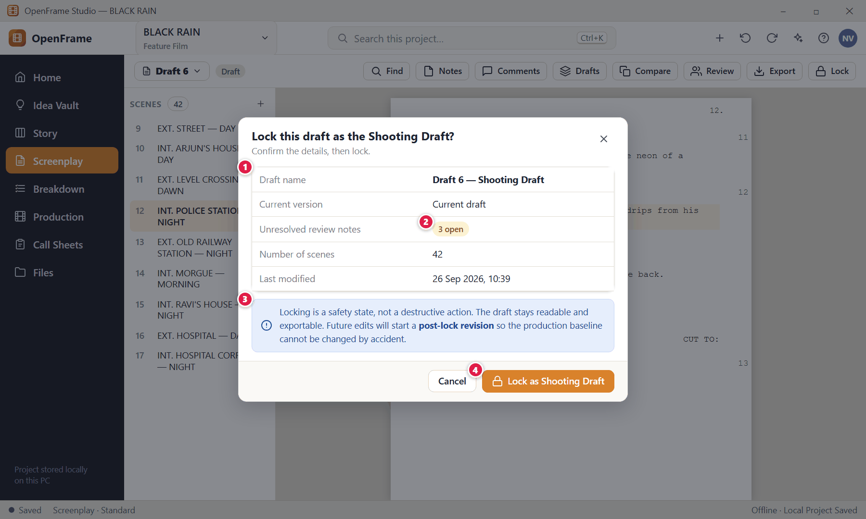
Figure 88. Locking the Shooting Draft (red numbers are explained on the next page)

Figure 88 — Locking the Shooting Draft: how it works
PARTS OF THIS SCREEN  1 Lock checklist — Draft name, current version, unresolved review notes, number of scenes and last modified date.  2 Unresolved notes — You are not forced to resolve every comment, but you see how many are open so the decision is informed.  3 What locking means — It changes the workflow, not the file. Edits will start a revision.  4 Lock as Shooting Draft — Confirms. The lock records a timestamp and who locked it. | HOW TO USE IT  1. Open Draft History, select the draft, click Lock as Shooting Draft, review the checklist, and confirm.  GOOD TO KNOW · EDGE CASES  - Locking does not make the file immutable and does not prevent exporting it.  - Production (Breakdown, Schedule) can then use the locked draft as its source.

Figure 89 — Editing a locked draft: Start Revision
What it is for. If you try to edit the locked Shooting Draft, OpenFrame stops and asks you to start a revision, so the production baseline is never edited by accident.
How to get here. Type into a locked draft.
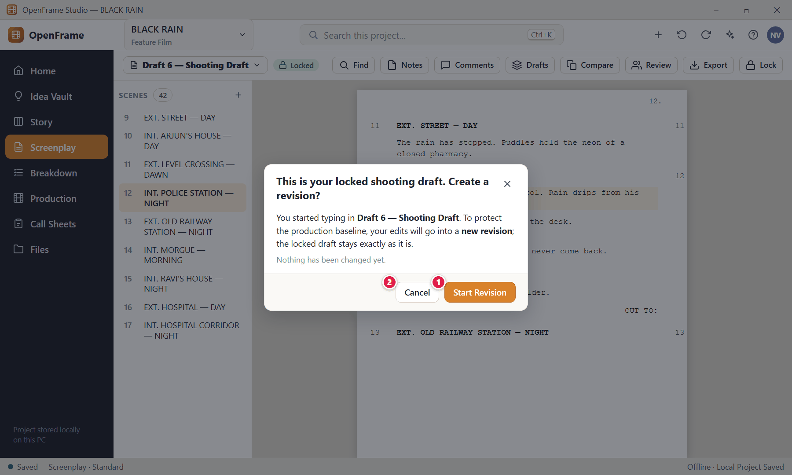
Figure 89. Editing a locked draft: Start Revision (red numbers are explained on the next page)

Figure 89 — Editing a locked draft: Start Revision: how it works
PARTS OF THIS SCREEN  1 Start Revision — Creates a new writable revision derived from the locked draft. The locked draft is unchanged.  2 Cancel — Leaves the locked draft as it is; nothing changes. | HOW TO USE IT  1. Click Start Revision, then name it and choose a colour (next screen).  GOOD TO KNOW · EDGE CASES  - A locked draft remains readable and exportable at all times.

Figure 90 — Revision label, colour and changed scenes
What it is for. After a lock, production revisions carry a label and colour so a crew can tell which pages changed.
How to get here. Start Revision from a locked draft, or Screenplay → Revisions.
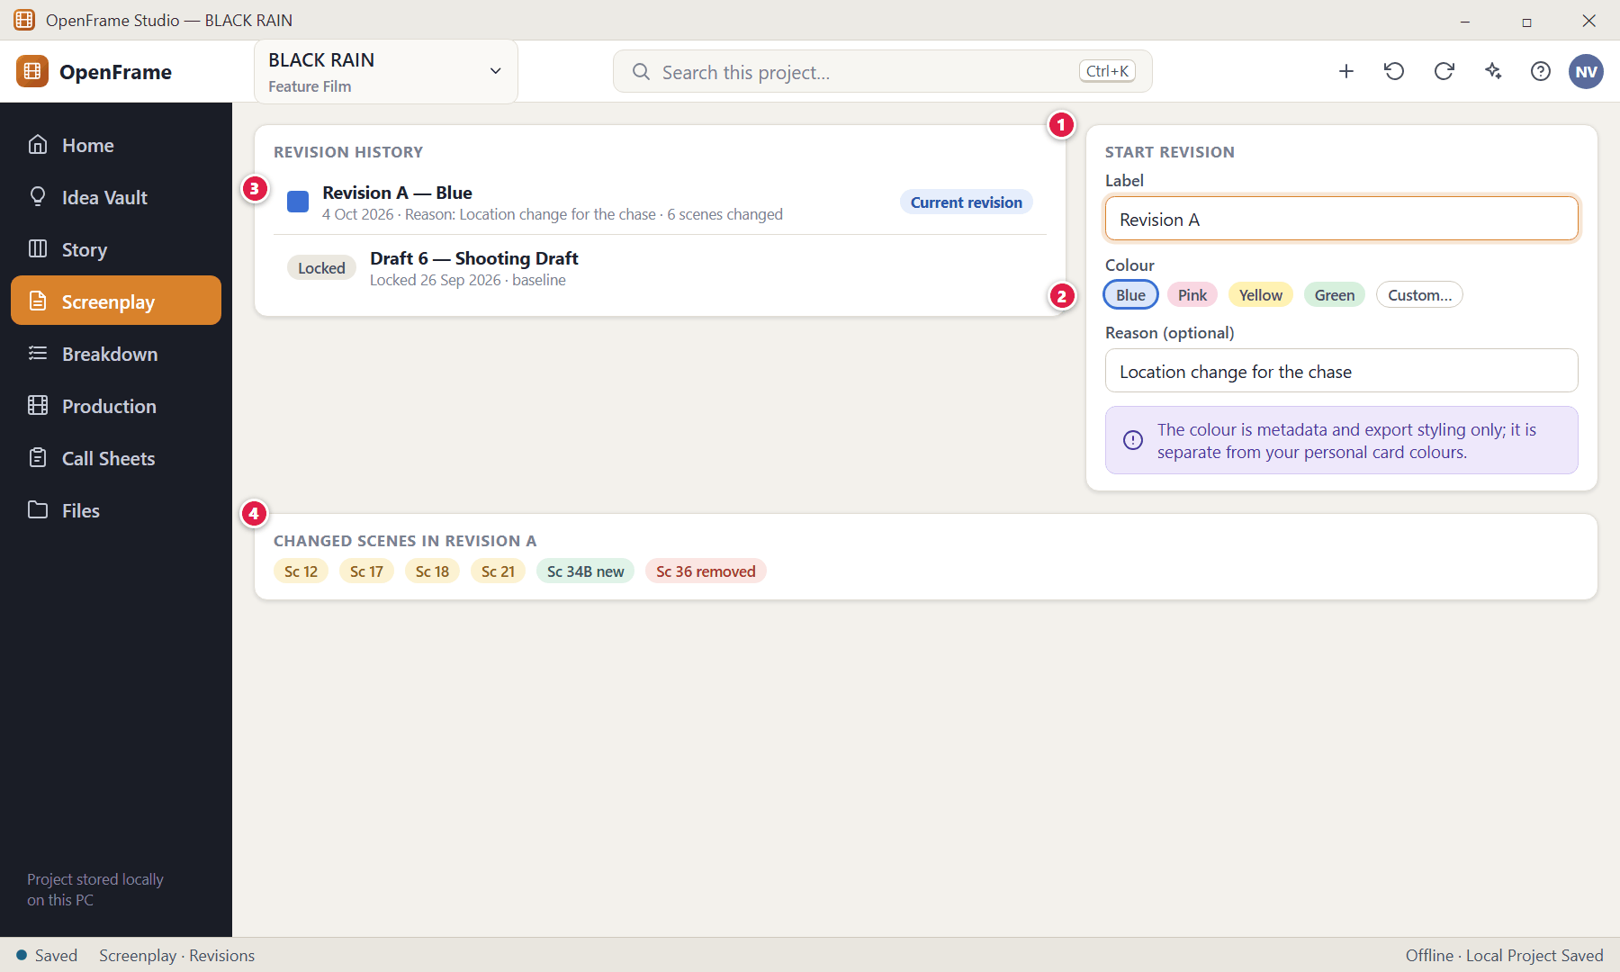
Figure 90. Revision label, colour and changed scenes (red numbers are explained on the next page)

Figure 90 — Revision label, colour and changed scenes: how it works
PARTS OF THIS SCREEN  1 Revision form — Label (Revision A, Blue Revision, Pink Revision…), colour and an optional reason.  2 Revision colour — Blue, Pink, Yellow, Green or a custom convention. Colour is used only for production revisions and supported export styling, and always comes with a text label.  3 Revision history — Every revision records its source, label, date, reason and changed scenes.  4 Changed scenes — Lists scenes affected by the revision; open one to see the exact changes. | HOW TO USE IT  1. Choose a label and colour, click to start, and edit in the new revision.  2. Open Changed scenes to review differences.  GOOD TO KNOW · EDGE CASES  - Ordinary Draft 1 / Draft 2 writing does not use revision colours.  - Breakdown and Schedule can be updated to a newer approved revision when you choose (see Production chapter).

Figure 91 — Importing a screenplay: choose the source
What it is for. Import is a first-class workflow for people who already have a script. It is a three-step process: select the source, preview how OpenFrame interpreted it, then import.
How to get here. Project Home → Import Screenplay, or Screenplay → Import.
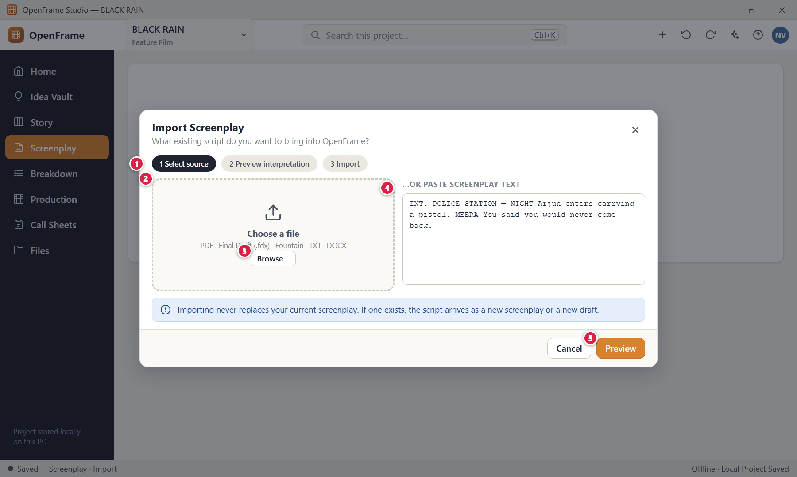
Figure 91. Importing a screenplay: choose the source (red numbers are explained on the next page)

Figure 91 — Importing a screenplay: choose the source: how it works
PARTS OF THIS SCREEN  1 The three steps — Select source → Preview interpretation → Import.  2 Choose a file — PDF, Final Draft (.fdx), Fountain, TXT or DOCX.  3 Browse… — Opens the Windows file picker.  4 Paste text — Paste screenplay text instead of choosing a file.  5 Preview — Parses the source without changing your project. | HOW TO USE IT  1. Click Browse… and choose the file (or paste text).  2. Click Preview.  GOOD TO KNOW · EDGE CASES  - The original file is never modified. You can choose to keep a copy of it in Project Files.  - PDF import is best-effort because a PDF may not carry screenplay structure; OpenFrame shows warnings before you commit.

Figure 92 — Import preview and warnings
What it is for. The preview shows how OpenFrame understood your file — detected scenes, characters, page count — plus any warnings, so you can decide before importing.
How to get here. Import → Preview.
Figure 92. Import preview and warnings (red numbers are explained on the next page)

Figure 92 — Import preview and warnings: how it works
PARTS OF THIS SCREEN  1 What was detected — Source file, scene count, character count and approximate page count (also title where found).  2 Warnings — For example uncertain scene headings or potentially empty scenes. Warnings do not mean the screenplay is unusable; they mark items worth checking.  3 Detected scenes — Check headings; correct them before importing where possible.  4 Import as — New Screenplay, or New Draft inside the current screenplay. Existing drafts are never overwritten.  5 Keep original — Optionally store the source file in Project Files.  6 Import — Creates the screenplay or draft. | HOW TO USE IT  1. Review the counts and warnings.  2. Choose New Screenplay or New Draft.  3. Click Import.  GOOD TO KNOW · EDGE CASES  - The validation checklist covers: file opened, text extracted, scene headings detected, characters detected, page count estimated, unsupported/ambiguous formatting identified, potentially empty scenes identified, and "original file untouched".  - If the source cannot be interpreted as a screenplay at all you can still keep it as a project file or paste the text into a new draft.

Figure 93 — Import failed (safe failure)
What it is for. If an import cannot work, OpenFrame says which file, at what stage, and that nothing in your project changed.
How to get here. Import → Preview, when parsing fails.
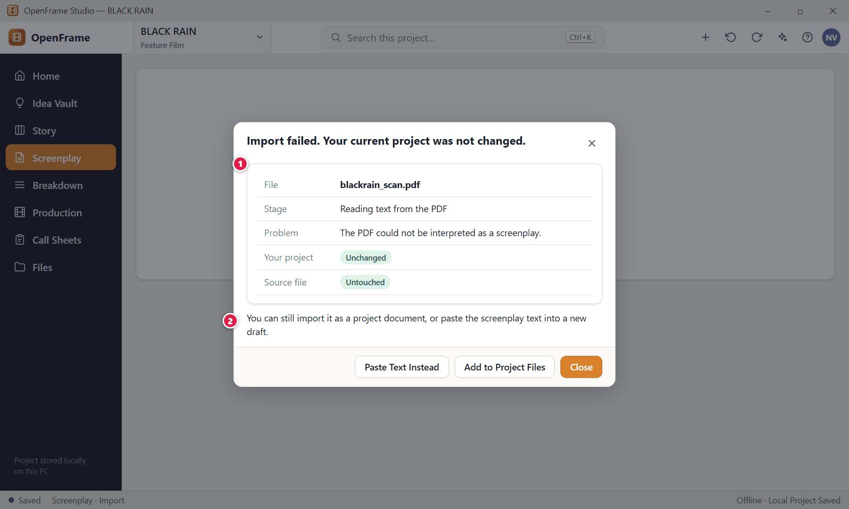
Figure 93. Import failed (safe failure) (red numbers are explained on the next page)

Figure 93 — Import failed (safe failure): how it works
PARTS OF THIS SCREEN  1 Failure details — Source filename, stage of failure, what was wrong, and confirmation that your project and the original file were not changed.  2 What you can do — Import it as a project document instead, or paste the text. | HOW TO USE IT  1. Choose one of the offered alternatives, or close the dialog.  GOOD TO KNOW · EDGE CASES  - A failed import never leaves partial data behind. This matches the general error rule: what happened, why it matters, what you can do.

Figure 94 — Import report
What it is for. After importing, a short report confirms what was created.
How to get here. Appears after clicking Import.
Figure 94. Import report (red numbers are explained on the next page)

Figure 94 — Import report: how it works
PARTS OF THIS SCREEN  1 Result — Names the new draft. Existing drafts are untouched.  2 Import report — Imported scenes, detected characters, pages/length, warnings and the source filename.  3 Open Screenplay — Takes you to the new script. | HOW TO USE IT  1. Click Open Screenplay to start working, or Review Warnings first.  GOOD TO KNOW · EDGE CASES  - Imported content becomes screenplay/draft content only; it does not automatically create Story Board or production data.

Figure 95 — Exporting the screenplay
What it is for. Export creates a clean, professional document snapshot in the format you need.
How to get here. Screenplay → Export (or File → Print).
Figure 95. Exporting the screenplay (red numbers are explained on the next page)

Figure 95 — Exporting the screenplay: how it works
PARTS OF THIS SCREEN  1 Source draft — Always shows which draft is being exported — OpenFrame never silently picks "the latest".  2 Format — PDF, Final Draft (.fdx), Fountain or DOCX.  3 Scope — Entire draft, selected scenes, a clean script, or a revision-marked version.  4 Options — Title page · Scene numbers · Revision info · Include notes (off by default).  5 Privacy line — "Private notes excluded." Export never mutates the project.  6 Additional formats — A collapsed advanced area (future interchange formats). It never replaces the four core choices.  7 Preview… — Shows the outgoing pages before export.  8 Export… — Choose the destination in the Windows Save dialog. Afterwards OpenFrame shows the file location and offers "Reveal in File Manager". | HOW TO USE IT  1. Confirm the source draft, choose format and scope, tick options, and click Export….  GOOD TO KNOW · EDGE CASES  - FDX and Fountain exports are re-importable with structure substantially intact; DOCX keeps readable screenplay content; PDF is a presentation snapshot.  - Editing an exported file outside OpenFrame never changes the project.  - Scene numbers are generated from screenplay order; exporting never writes them back into scene identity.

Figure 96 — Document preview and printing
What it is for. Preview shows the actual outgoing document before you send or print it. It answers "Does this document look correct?"
How to get here. Export → Preview…, or File → Print (Ctrl+P).
Figure 96. Document preview and printing (red numbers are explained on the next page)

Figure 96 — Document preview and printing: how it works
PARTS OF THIS SCREEN  1 The outgoing page — Title page (title, author, contact, draft/revision information) followed by the screenplay pages.  2 Preview settings — Title page, page numbers, revision info and include notes — these change only this output.  3 Page navigation and zoom — Move between pages and zoom.  4 Print — Prints using the same document generation as PDF so paper output matches.  5 Export PDF — Creates the PDF. | HOW TO USE IT  1. Check the first pages, adjust settings, then click Print or Export PDF.  GOOD TO KNOW · EDGE CASES  - Printing uses the same layout engine as PDF export, with standard printer-safe margins and no page break between a heading and its first content where practical.  - A clear Back/Close action always returns you to the editor.

Figure 97 — Scene Hub: what exists around a scene
What it is for. The Scene Hub answers "What exists around this scene?" in one compact panel without merging every module into one screen.
How to get here. Right-click a scene → Scene Hub (or from a search result).
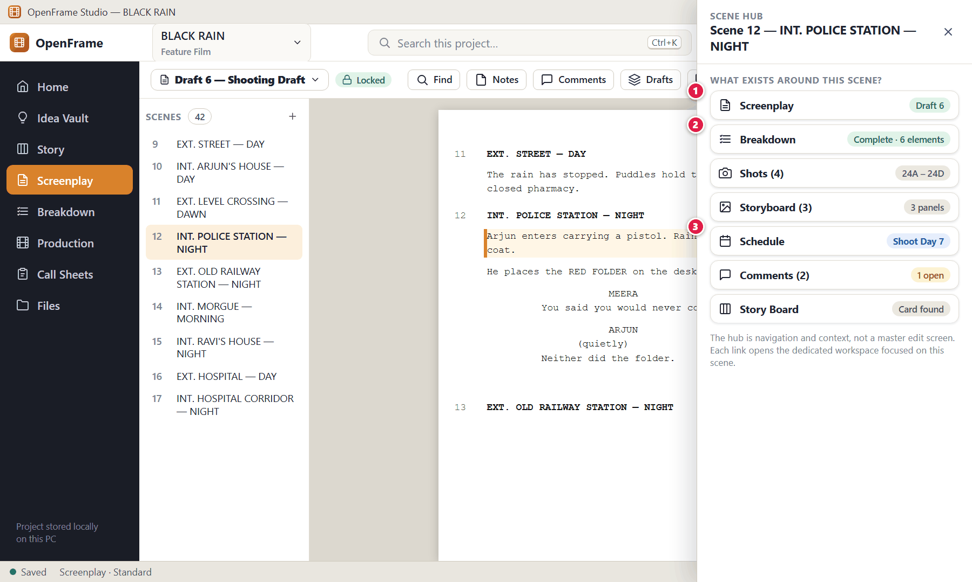
Figure 97. Scene Hub: what exists around a scene (red numbers are explained on the next page)

Figure 97 — Scene Hub: what exists around a scene: how it works
PARTS OF THIS SCREEN  1 Screenplay — Open the scene in the editor.  2 Breakdown — Open the scene in Breakdown. Shows completion status.  3 Schedule — Shows, for example, "Shoot Day 7". Opens the schedule focused on this scene. | HOW TO USE IT  1. Open the hub and click any line to jump to that workspace with the scene already focused.  GOOD TO KNOW · EDGE CASES  - The hub also shows Shots, Storyboard panels, Comments and the matching Story Board card. When nothing exists yet it says "Nothing created yet" and suggests the next useful action.  - If a linked workspace cannot open, the hub stays intact and names the unavailable destination.

Figure 98 — Right-click menu on a screenplay scene
What it is for. Right-click a scene heading to jump into the other workspaces with the scene selected.
How to get here. Right-click a scene heading or a scene in the navigator.
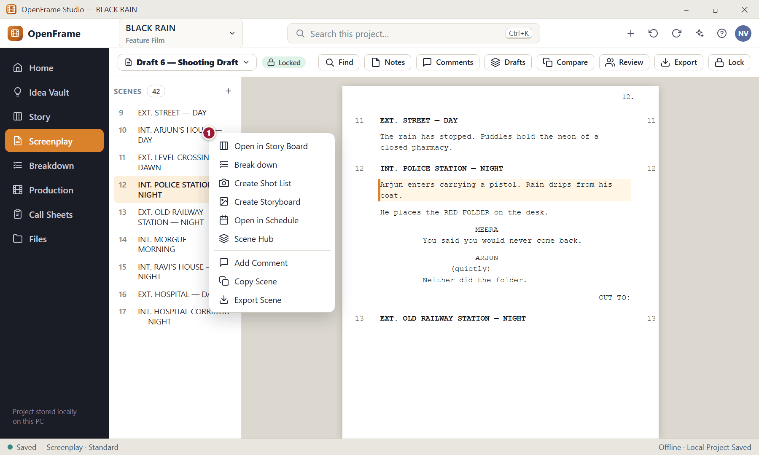
Figure 98. Right-click menu on a screenplay scene (red numbers are explained on the next page)

Figure 98 — Right-click menu on a screenplay scene: how it works
PARTS OF THIS SCREEN  1 Scene menu — Open in Story Board · Break down · Create Shot List · Create Storyboard · Open in Schedule · Scene Hub · Add Comment · Copy Scene · Export Scene. | HOW TO USE IT  1. Right-click the scene and choose where to go.  GOOD TO KNOW · EDGE CASES  - "Open in…" is how OpenFrame keeps modules connected without putting everything on one page.

Figure 99 — Moving a scene that is already in production planning
What it is for. Story order and shooting order are different things. OpenFrame warns before a script reorder touches a scene that production already depends on.
How to get here. Moving a screenplay scene that has breakdown, shots, storyboard or schedule data.
Figure 99. Moving a scene that is already in production planning (red numbers are explained on the next page)

Figure 99 — Moving a scene that is already in production planning: how it works
PARTS OF THIS SCREEN  1 What is affected — The scene's uses in production and the new script number.  2 Continue — Renumbers the scene in the script only.  3 Cancel — Leaves the order alone. | HOW TO USE IT  1. Read the note and choose Continue or Cancel.  GOOD TO KNOW · EDGE CASES  - Breakdown, shot and storyboard data stay attached to the scene's stable identity, so nothing is lost when the displayed number changes.  - The shooting schedule is not reordered automatically.

Figure 100 — Title page details
What it is for. The title page holds the project title, author/creator, contact details and optional draft or revision information for exports.
How to get here. Screenplay → Title Page (or from the export dialog).
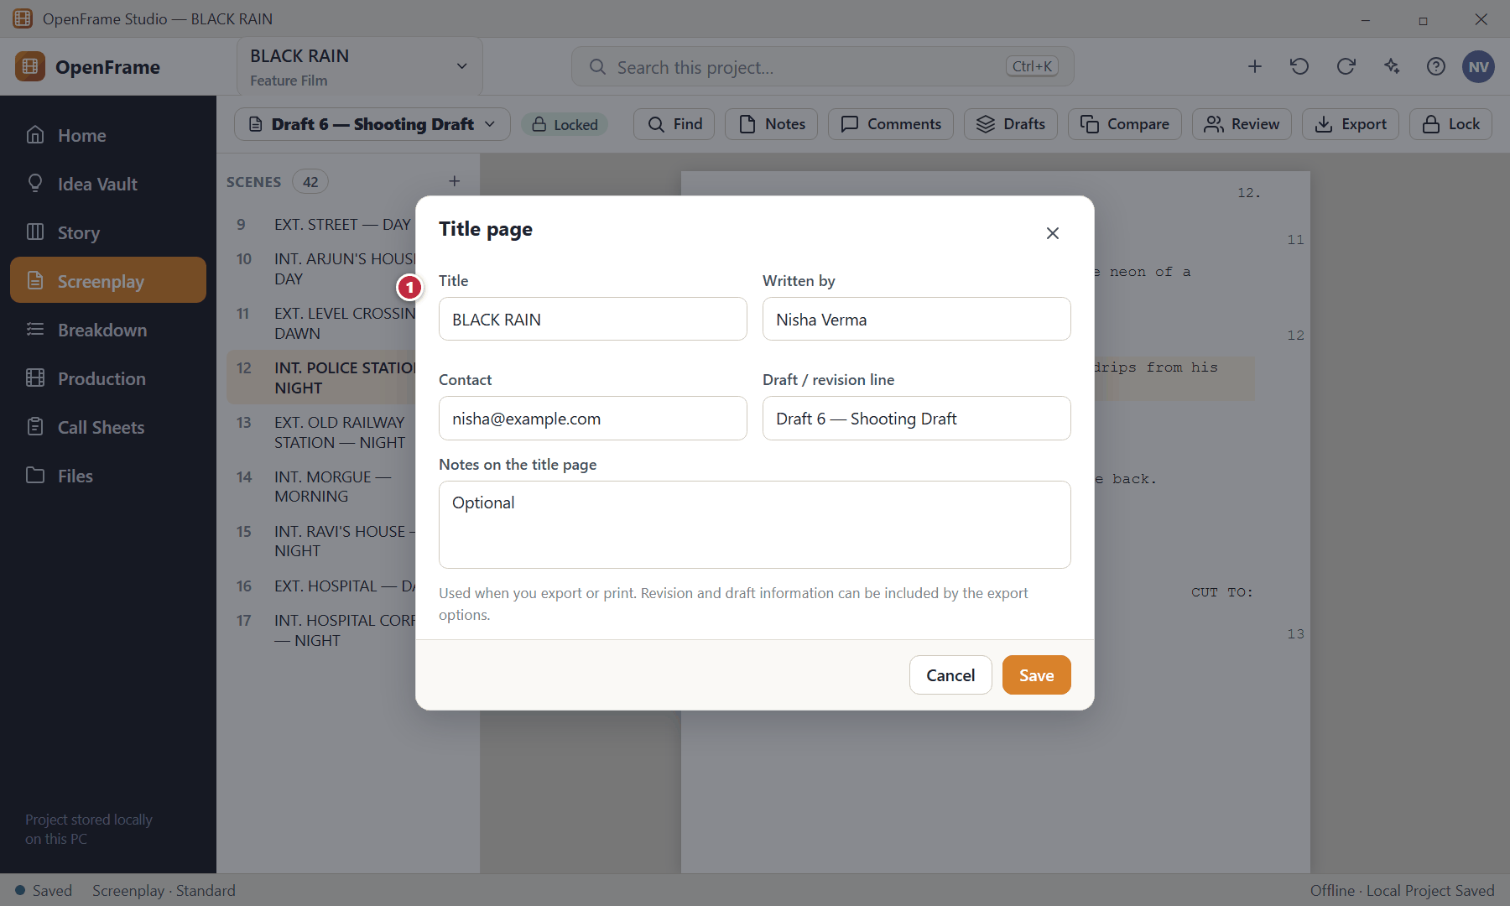
Figure 100. Title page details (red numbers are explained on the next page)

Figure 100 — Title page details: how it works
PARTS OF THIS SCREEN  1 Title page fields — Title, author/creator, contact fields and an optional draft/revision line. | HOW TO USE IT  1. Fill in the fields and Save. They appear on the first page of exported or printed scripts.  GOOD TO KNOW · EDGE CASES  - Project identity fields (title, creator) are also reused on other documents such as call sheets.

Figure 101 — Deleting a draft
What it is for. Deleting a named draft is a destructive action and asks first — but it is still recoverable.
How to get here. Drafts → right-click a draft → Delete.
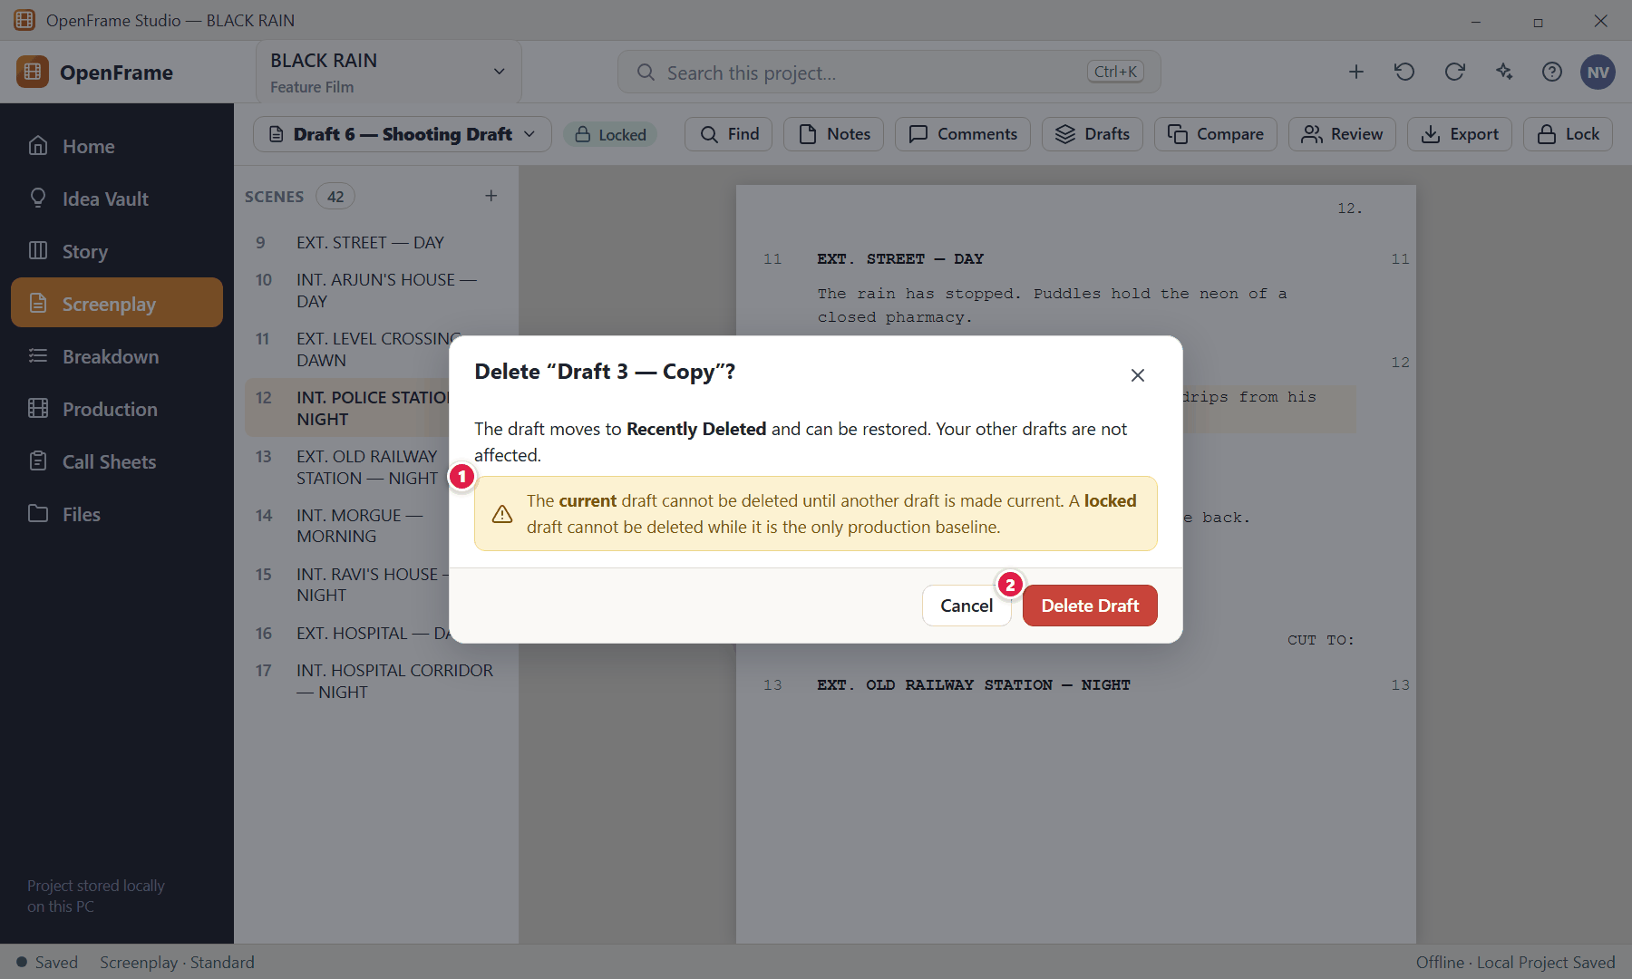
Figure 101. Deleting a draft (red numbers are explained on the next page)

Figure 101 — Deleting a draft: how it works
PARTS OF THIS SCREEN  1 Safety rules — The current draft and a locked sole baseline are protected.  2 Delete Draft — Moves the draft to Recently Deleted. | HOW TO USE IT  1. Confirm to delete; restore it from Recently Deleted if you change your mind.  GOOD TO KNOW · EDGE CASES  - Renaming a draft changes only its label, never its text.

Chapter 5 — Production: Breakdown, Catalog, Locations, Cast & Crew, Visual Planning and Shot Lists
Production is where the screenplay becomes a practical plan. It starts with Breakdown — reading each scene and confirming what it needs to shoot — and grows into the Catalog of reusable items, Locations, Cast & Crew, Moodboards, Storyboards and Shot Lists. Everything here is derived from a chosen screenplay source and never silently rewrites it.
Screens in this chapter
Figure 102 Production overview (dashboard) | Figure 115 Locations list
Figure 103 Start Production Setup: choose the production source | Figure 116 Location details: photos, notes, scenes
Figure 104 Breakdown: scene list, script and elements | Figure 117 Replacing a rejected location for selected scenes
Figure 105 Breakdown — no source chosen | Figure 118 Cast list
Figure 106 Tagging highlighted text | Figure 119 Assigning an actor to a character
Figure 107 Reviewing suggested elements | Figure 120 Crew list
Figure 108 Reusing an existing catalog item | Figure 121 Moodboard canvas
Figure 109 Adding an element manually | Figure 122 Exporting a moodboard
Figure 110 After a script change: review breakdown differences | Figure 123 Storyboard panels for a scene
Figure 111 Updating the production source to a newer draft | Figure 124 Add Panel: import, sketch or empty
Figure 112 Needs Review queue | Figure 125 Sketching a panel
Figure 113 Production Catalog | Figure 126 Shot list for a scene
Figure 114 Archiving or replacing a catalog item | Figure 127 Shot details (technical fields)

Figure 102 — Production overview (dashboard)
What it is for. The Production overview is intentionally small. It answers one question — "What do I need to do next to prepare the shoot?" — without a giant wall of numbers.
How to get here. Left navigation → Production.
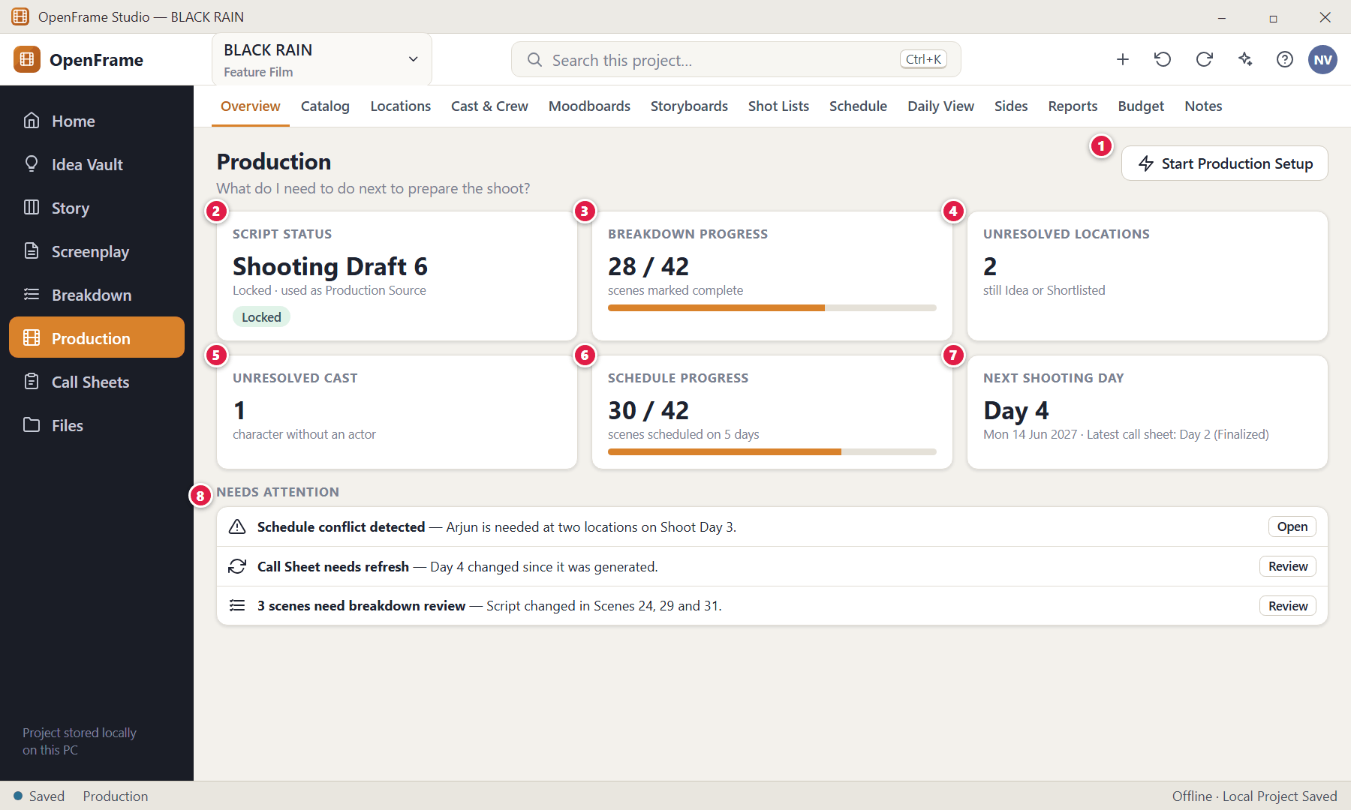
Figure 102. Production overview (dashboard) (red numbers are explained on the next page)

Figure 102 — Production overview (dashboard): how it works
PARTS OF THIS SCREEN  1 Start Production Setup — Chooses which screenplay draft becomes the production source and initialises the production workspaces from it (next screen).  2 Script status — Which draft is the production source and whether it is locked.  3 Breakdown progress — How many scenes you have marked complete.  4 Unresolved locations — Locations still at Idea or Shortlisted.  5 Unresolved cast — Characters with no actor assigned.  6 Schedule progress — Scenes placed on shooting days.  7 Next shooting day and latest call sheet — A shortcut to the next day and its most recent call sheet.  8 Needs attention — Lightweight contextual indicators such as "Call Sheet needs refresh", "3 scenes need breakdown review", "Production source changed", "Schedule conflict detected". Each disappears once resolved or dismissed. | HOW TO USE IT  1. Click any card or warning to open the workspace where you can act on it.  2. Use the tabs along the top to switch between the production tools (only one is primary at a time).  GOOD TO KNOW · EDGE CASES  - Every item is clickable and leads to its source workspace. None is a prerequisite: you can keep working even if a number is incomplete.  - Production tabs: Overview · Catalog · Locations · Cast & Crew · Moodboards · Storyboards · Shot Lists · Schedule · Daily View · Sides · Reports · Budget · Notes/Tasks. A short film can use just a few of them.

Figure 103 — Start Production Setup: choose the production source
What it is for. When you decide "Now I want to prepare this film for shooting", you tell OpenFrame which screenplay draft is the official source for production.
How to get here. Production → Start Production Setup.
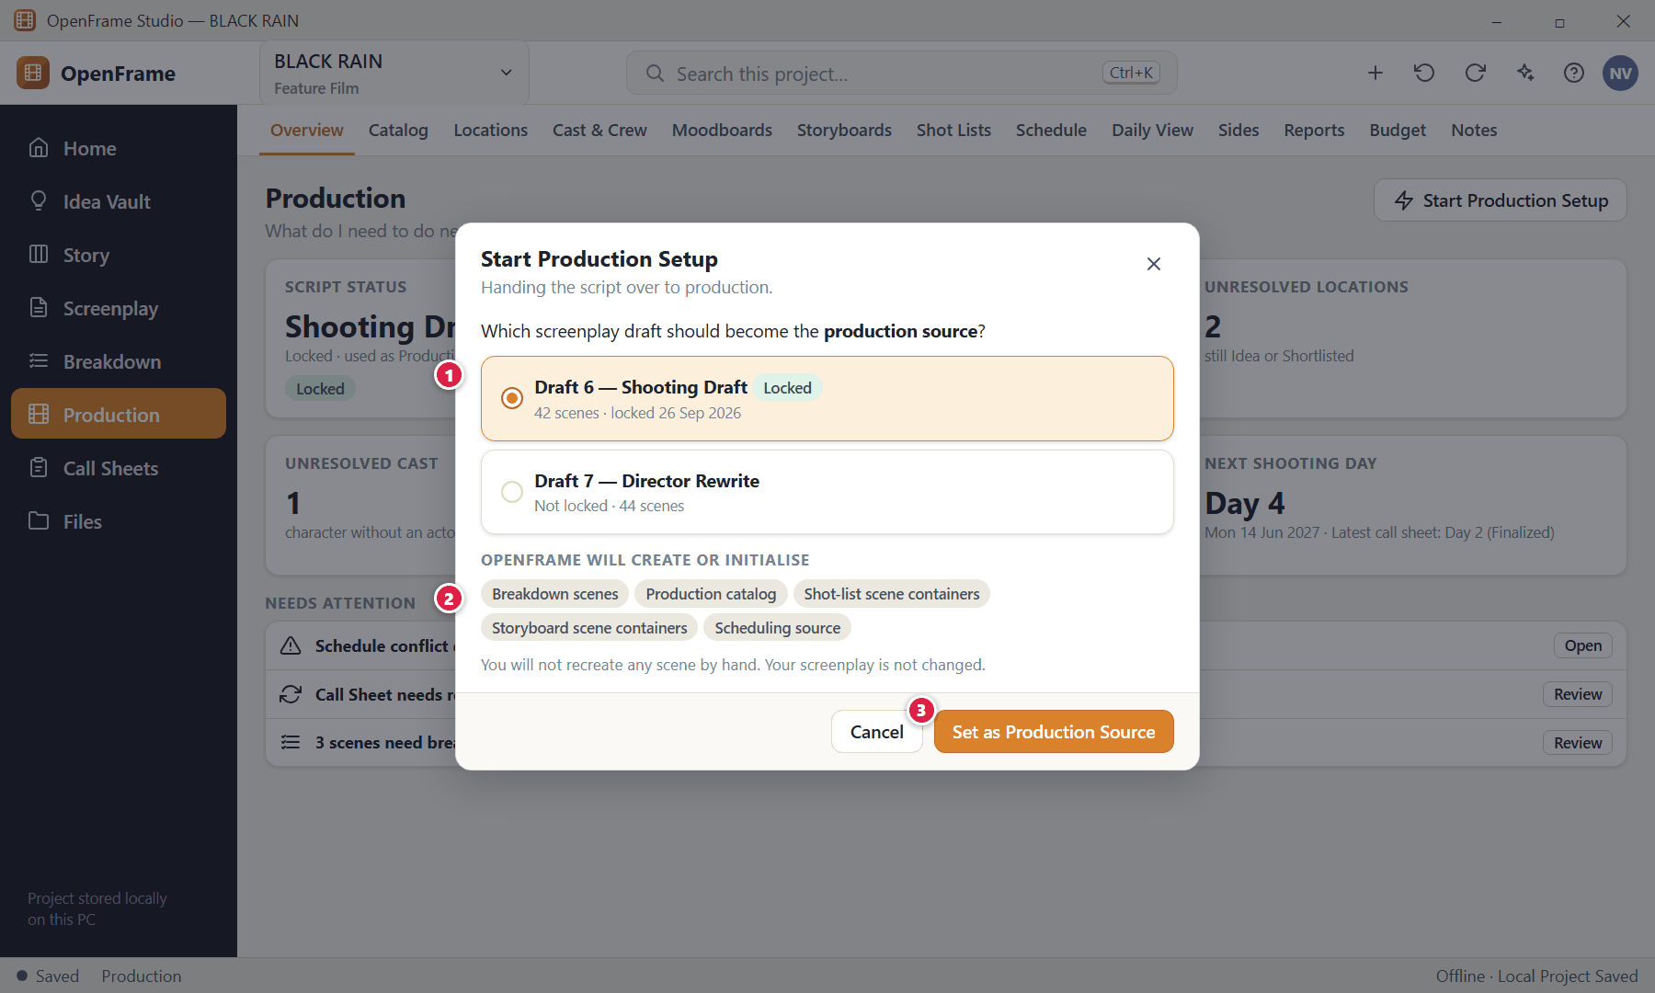
Figure 103. Start Production Setup: choose the production source (red numbers are explained on the next page)

Figure 103 — Start Production Setup: choose the production source: how it works
PARTS OF THIS SCREEN  1 Choose the draft — Usually the Locked Shooting Draft or a later approved revision.  2 What gets initialised — Breakdown scenes, the production catalog, shot-list and storyboard scene containers and the scheduling source — created from the screenplay so you never retype scenes.  3 Set as Production Source — Records the choice. It appears afterwards in a banner on every production workspace. | HOW TO USE IT  1. Pick the draft.  2. Click Set as Production Source.  GOOD TO KNOW · EDGE CASES  - Production shows "Production Source: Shooting Draft 6" everywhere it matters. If you later write a new revision, production stays on the old source until you explicitly update it.

Figure 104 — Breakdown: scene list, script and elements
What it is for. Breakdown is the bridge from screenplay to practical production requirements. It answers "What does this scene require to shoot?"
How to get here. Left navigation → Breakdown, or right-click a screenplay scene → Break down.
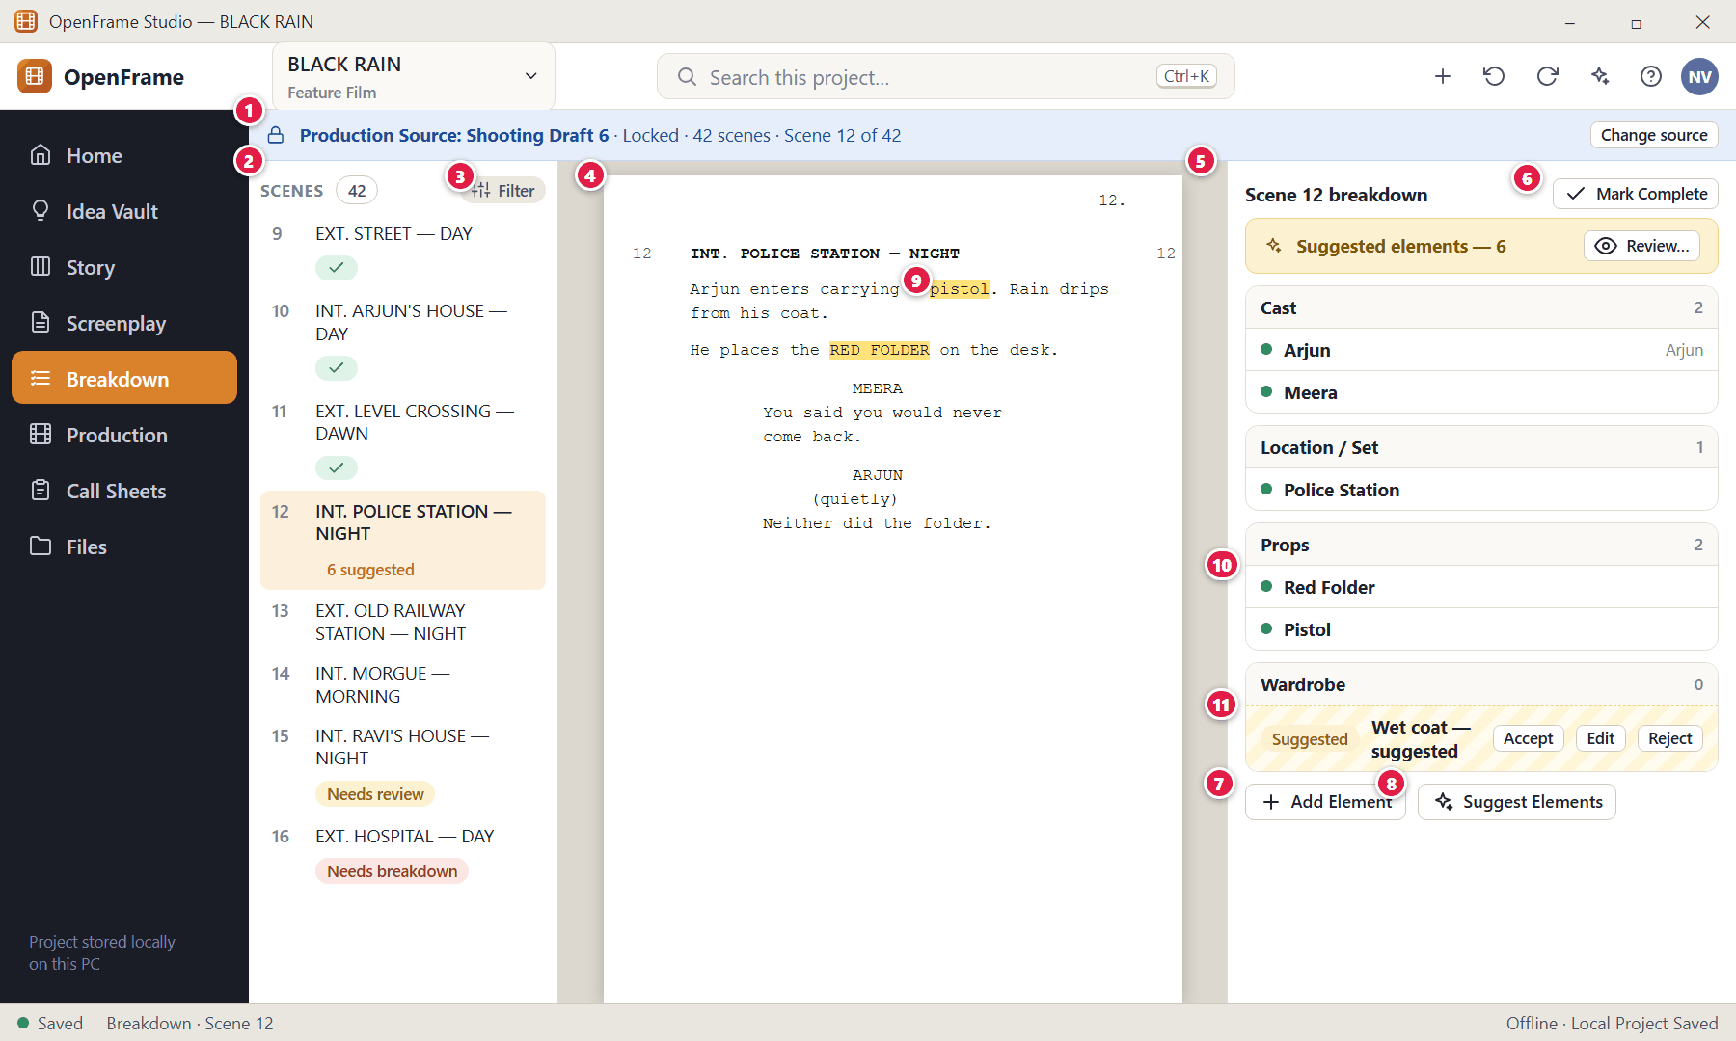
Figure 104. Breakdown: scene list, script and elements (red numbers are explained on the next page)

Figure 104 — Breakdown: scene list, script and elements: how it works
PARTS OF THIS SCREEN  1 Production Source banner — Says which screenplay version this breakdown is based on: "Production Source: Shooting Draft 6". If a newer approved revision exists it shows "Newer revision available — Review Production Update".  2 Scene list — Every scene of the source with its generated number and heading, plus a status: complete, Needs review, or Needs breakdown.  3 Filter — Show only scenes that are incomplete, need review or need breakdown.  4 Script reading pane — The scene text stays visible while you tag, so you never lose your place.  5 Breakdown panel — Confirmed production elements grouped by category. Empty categories stay collapsed or hidden.  6 Mark Complete — A planning indicator that you have finished this scene. It does not claim every real-world requirement has been found and can be reopened.  7 Add Element — Adds an element manually without highlighting text.  8 Suggest Elements — Asks OpenFrame to propose likely elements. Nothing is added until you accept it.  9 Highlighted text — Words in the script that produced or match a breakdown element, such as "pistol".  10 Confirmed element — A confirmed element such as "Red Folder" shown as an ordinary row.  11 Suggested element — A suggestion is styled differently ("Suggested — …") because a suggestion is not a decision. | HOW TO USE IT  1. Pick a scene in the list.  2. Read it in the middle pane. Highlight text and tag it, or click Add Element, or click Suggest Elements.  3. Click Mark Complete when the scene is done.  GOOD TO KNOW · EDGE CASES  - Default categories are limited to eleven: Cast · Extras / Background · Location / Set · Props · Wardrobe · Vehicles · Hair / Makeup · Special Effects · VFX · Sound · Animals. You can add custom categories only when really necessary.  - A confirmed element is added to (or linked with) the Production Catalog. The screenplay text itself is never changed by Breakdown.

Figure 105 — Breakdown — no source chosen
What it is for. Breakdown needs a screenplay to work from. Without one it explains what to do.
How to get here. Left navigation → Breakdown in a project without a production source.
Figure 105. Breakdown — no source chosen — No Source (red numbers are explained on the next page)

Figure 105 — Breakdown — no source chosen: how it works
PARTS OF THIS SCREEN  1 Empty-state message — "Choose a screenplay source to begin the breakdown."  2 Select Source — Opens the production-source chooser. | HOW TO USE IT  1. Click Select Source and pick a draft.  GOOD TO KNOW · EDGE CASES  - You can go straight from Import → Breakdown without using the Idea Vault or Story Board.

Figure 106 — Tagging highlighted text
What it is for. Highlight a word or phrase in the script and choose its category to create a breakdown element.
How to get here. Select text in the script pane of Breakdown.
Figure 106. Tagging highlighted text (red numbers are explained on the next page)

Figure 106 — Tagging highlighted text: how it works
PARTS OF THIS SCREEN  1 Category chooser — Pick one of the default categories for the selected text.  2 Existing catalog match — If the catalog already has an item like it, that is offered first so you reuse one identity instead of creating a duplicate. | HOW TO USE IT  1. Highlight the text.  2. Choose the category.  3. Choose an existing catalog item or create a new one.  GOOD TO KNOW · EDGE CASES  - When an element came from highlighted text, the panel keeps a small quote of that source text so you never have to navigate away to remember where it came from.

Figure 107 — Reviewing suggested elements
What it is for. Suggestions are reviewed like a checklist — never silently committed.
How to get here. Breakdown → Suggest Elements, or Review… in the "Suggested elements" bar.
Figure 107. Reviewing suggested elements (red numbers are explained on the next page)

Figure 107 — Reviewing suggested elements: how it works
PARTS OF THIS SCREEN  1 Suggestion list — Each row shows the category, the suggested name and the matched phrase from the script (for example "Prop — pistol — matched phrase: carrying a pistol").  2 Per-row actions — Accept creates or links the element. Edit lets you change category or name first. Reject removes the suggestion for this scene.  3 Accept Selected — Accepts only the ticked rows and shows the exact count first.  4 Accept All Safe — Accepts only obviously safe suggestions (clear matches). It shows the exact count and categories before committing.  5 Dismiss — Closes the list without accepting anything. | HOW TO USE IT  1. Untick anything you do not want.  2. Edit names or categories if needed.  3. Click Accept Selected or accept rows one by one.  GOOD TO KNOW · EDGE CASES  - Rejecting a suggestion only dismisses it for this scene/source revision; it never deletes a catalog item and does not stop the same word being used elsewhere.  - If the suggestion service is unavailable, manual breakdown keeps working. No suggestions is a normal result.  - Accepted suggestions become ordinary production data — they are not labelled with AI branding afterwards.

Figure 108 — Reusing an existing catalog item
What it is for. One prop is one production identity even if ten scenes need it. OpenFrame shows likely matches so you reuse the item instead of duplicating it.
How to get here. Adding or accepting an element that resembles an existing catalog item.
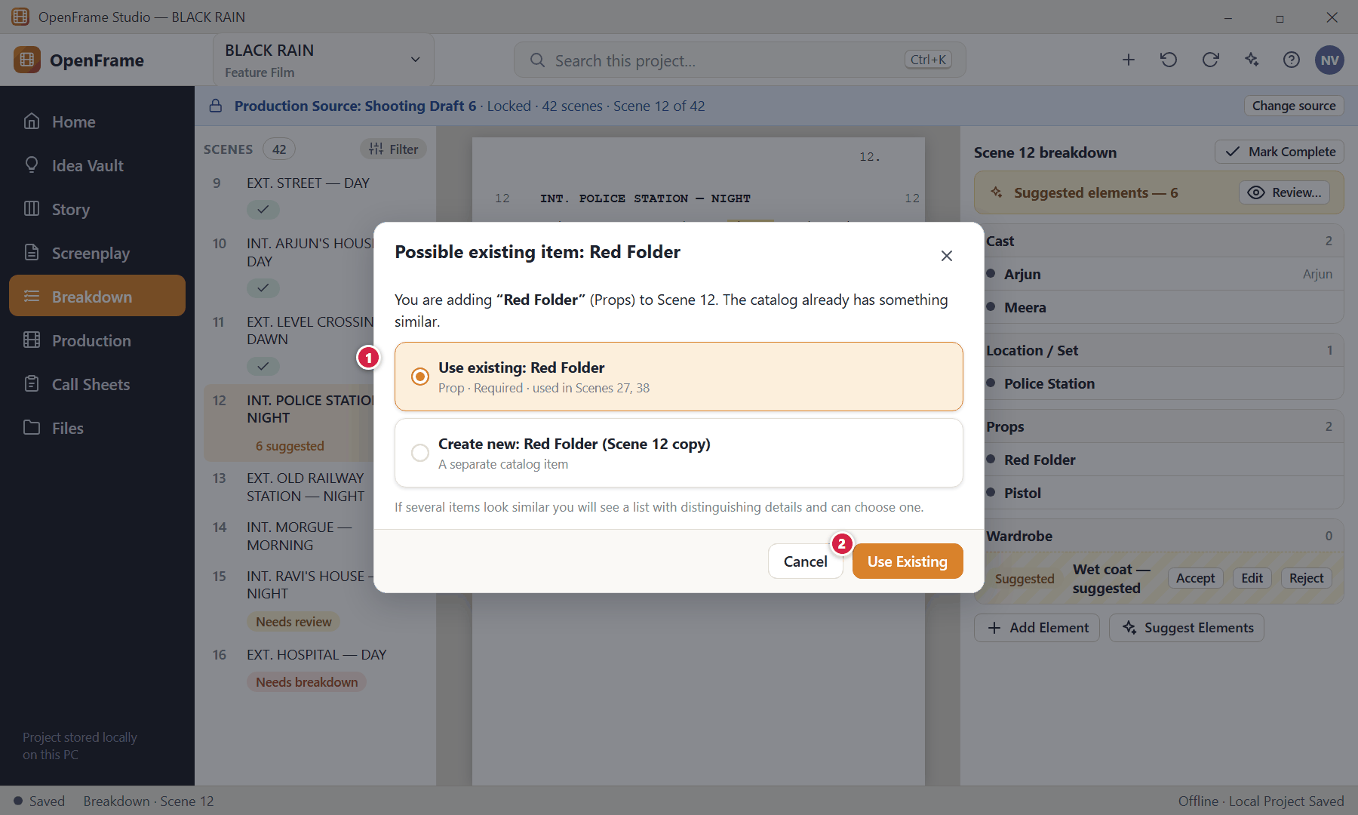
Figure 108. Reusing an existing catalog item (red numbers are explained on the next page)

Figure 108 — Reusing an existing catalog item: how it works
PARTS OF THIS SCREEN  1 Choices — Use existing (the default choice) or Create new. If you edit the name before confirming, matching is re-run.  2 Use Existing — Attaches the scene to the same catalog item. | HOW TO USE IT  1. Choose Use existing or Create new and confirm.  GOOD TO KNOW · EDGE CASES  - Removing an element from one scene removes only that scene's association; the catalog item stays.  - Ambiguous matches are never attached automatically — you must choose.

Figure 109 — Adding an element manually
What it is for. You can always add a production element by typing it — no highlighting or suggestions required.
How to get here. Breakdown → Add Element.
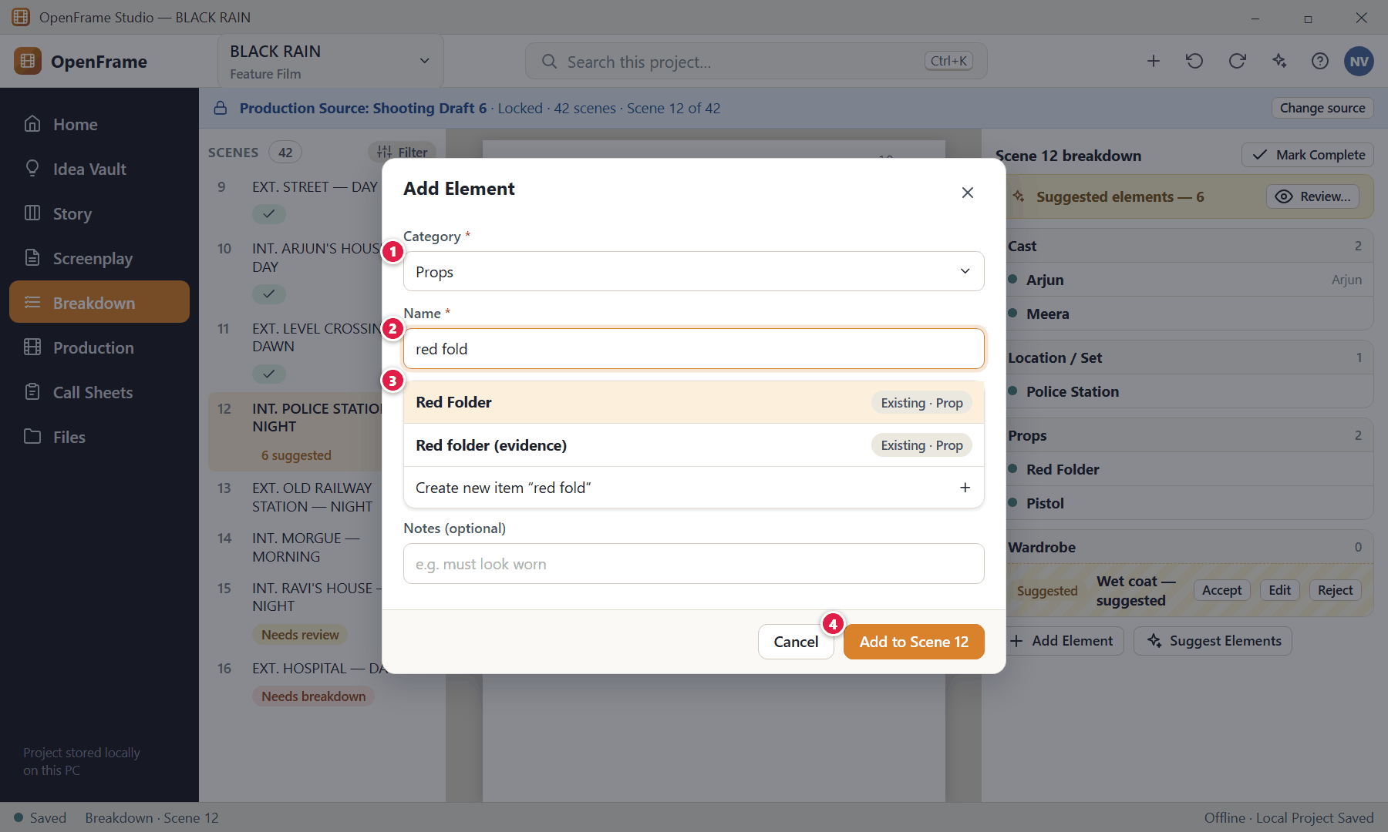
Figure 109. Adding an element manually (red numbers are explained on the next page)

Figure 109 — Adding an element manually: how it works
PARTS OF THIS SCREEN  1 Category — One of the default categories.  2 Name — As you type, catalog matches appear immediately.  3 Matches — Choose an existing item or create a new one.  4 Add to Scene — Creates the association. | HOW TO USE IT  1. Choose a category, type the name, pick a match, and add.  GOOD TO KNOW · EDGE CASES  - Manual elements are confirmed immediately (they are your own decision).

Figure 110 — After a script change: review breakdown differences
What it is for. If the screenplay changes after a scene was broken down, OpenFrame flags the scene but never silently removes production data.
How to get here. A scene marked "Needs review" in Breakdown, or a "Scene changed" indicator.
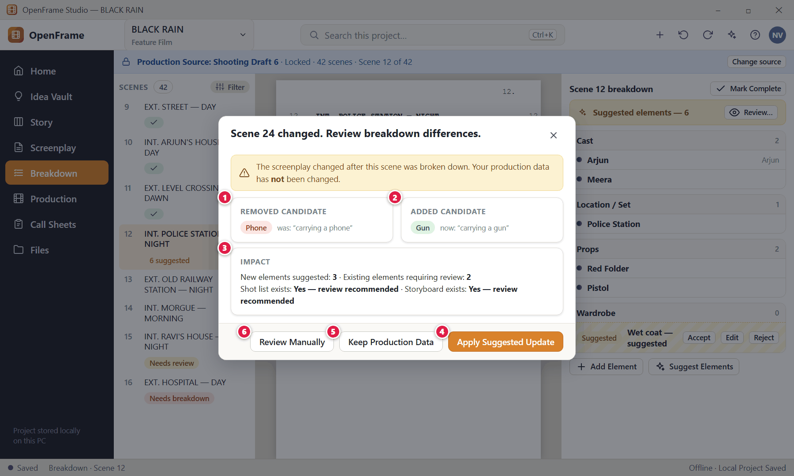
Figure 110. After a script change: review breakdown differences (red numbers are explained on the next page)

Figure 110 — After a script change: review breakdown differences: how it works
PARTS OF THIS SCREEN  1 Removed candidate — An element that may no longer be in the script (Phone).  2 Added candidate — A new element the script now suggests (Gun).  3 Impact — Counts of new suggestions and elements needing review, and whether a shot list or storyboard exists for the scene.  4 Apply Suggested Update — Applies the proposed additions/removals.  5 Keep Production Data — Leaves the breakdown exactly as it was.  6 Review Manually — Lets you decide item by item. | HOW TO USE IT  1. Compare the two lists, then choose one of the three buttons.  GOOD TO KNOW · EDGE CASES  - New scenes appear as "Needs Breakdown"; removed scenes stay in a historical state marked "Scene removed from current source" and can be archived. A changed heading (a location or time change) also flags the scene for review.  - Shot lists and storyboards are kept; the scene simply shows "Scene changed since planning".

Figure 111 — Updating the production source to a newer draft
What it is for. This is the critical control point between writing and production: production follows a script version until you decide to move it.
How to get here. Production/Breakdown banner "Newer revision available — Review Production Update", or Update Production from Draft 7.
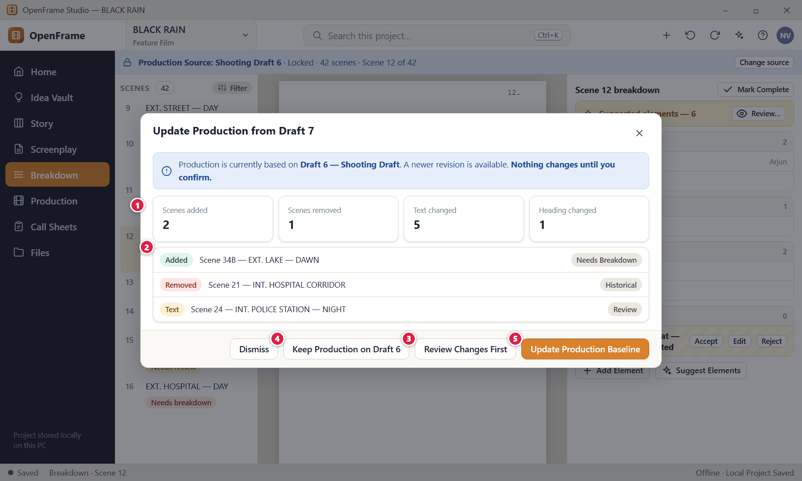
Figure 111. Updating the production source to a newer draft (red numbers are explained on the next page)

Figure 111 — Updating the production source to a newer draft: how it works
PARTS OF THIS SCREEN  1 What changed — Counts of scenes added, removed, text-changed and heading-changed (and changes to page/length information).  2 Impact by scene — Each affected scene with what will happen to its production data.  3 Review Changes First — Opens each affected scene one at a time (Review each / Accept all safe mappings / Dismiss).  4 Keep Production on Draft 6 — Leaves the source as it is.  5 Update Production Baseline — Makes the new draft the production source after confirmation. | HOW TO USE IT  1. Read the counts and the list.  2. Choose Review Changes First, Keep, or Update Production Baseline.  GOOD TO KNOW · EDGE CASES  - "Accept all safe mappings" applies only unambiguous scene matches and never deletes existing production data.  - After an update: new scenes enter Unscheduled / Needs Breakdown; changed scenes are flagged "Needs review"; removed scenes stay historical until you confirm removal from the schedule; existing shots, storyboards and the shooting schedule are not touched.

Figure 112 — Needs Review queue
What it is for. A simple list of scenes that changed and may need their breakdown, shots, storyboard or schedule reviewed.
How to get here. Breakdown → indicator "3 scenes need breakdown review", or Production → Needs attention.
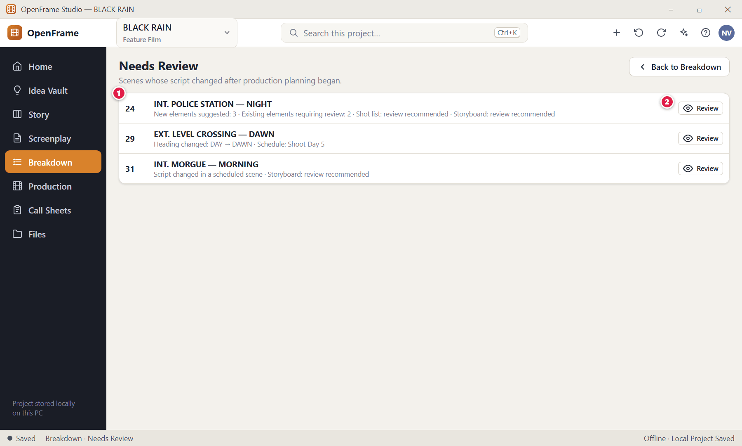
Figure 112. Needs Review queue (red numbers are explained on the next page)

Figure 112 — Needs Review queue: how it works
PARTS OF THIS SCREEN  1 Scenes needing review — Each row summarises the impact: new suggestions, elements to review, and whether shots, storyboard or schedule exist.  2 Review — Opens the scene's reconciliation screen. | HOW TO USE IT  1. Click Review beside a scene.  GOOD TO KNOW · EDGE CASES  - Nothing in production is deleted or rescheduled automatically. The message "Script changed in 3 scheduled scenes." opens a Review Changes panel; no schedule change happens automatically.

Figure 113 — Production Catalog
What it is for. The Catalog is a reusable directory of the things and people production needs. Once an element is confirmed in a breakdown it lives here, once, even if ten scenes use it.
How to get here. Production → Catalog, or Breakdown → Catalog.
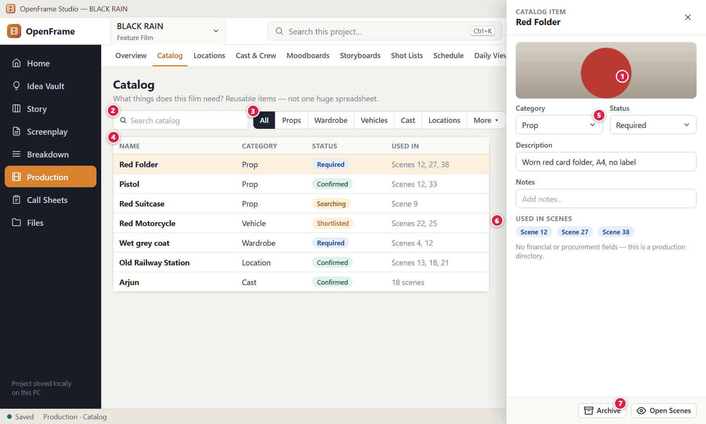
Figure 113. Production Catalog (red numbers are explained on the next page)

Figure 113 — Production Catalog: how it works
PARTS OF THIS SCREEN  1 Add Item — Add a catalog item manually (name, category and status are the minimum).  2 Search — Find items by name.  3 Category filter — Cast, Locations, Props, Wardrobe, Vehicles, Makeup/Hair, Special Effects, VFX, Sound, Animals, Extras.  4 Catalog list — Name, category, status and the scenes where the item is used.  5 Status — Required · Searching · Shortlisted · Confirmed · Not Required (and Archived).  6 Used in scenes — Click a scene to open its breakdown. Scene usage is derived from breakdown references, not typed.  7 Open Scenes — Shows the filtered list of scenes that need this item. | HOW TO USE IT  1. Click an item to open its details in the side drawer.  2. Change its status as the item is sourced (Required → Searching → Confirmed).  GOOD TO KNOW · EDGE CASES  - Renaming an item updates it everywhere it is displayed; documents you already exported keep their old wording.  - Archiving removes an item from normal selection but keeps historical scene associations readable; if the item is still referenced OpenFrame explains the effect first.  - Deleting a catalog item that scenes still use requires handling those associations — archive is the default.  - Empty state: "Confirmed breakdown items will appear here, or add one manually."

Figure 114 — Archiving or replacing a catalog item
What it is for. Archiving is preferred to deleting for reusable items: history stays readable.
How to get here. Catalog → item → Archive (or right-click → Archive).
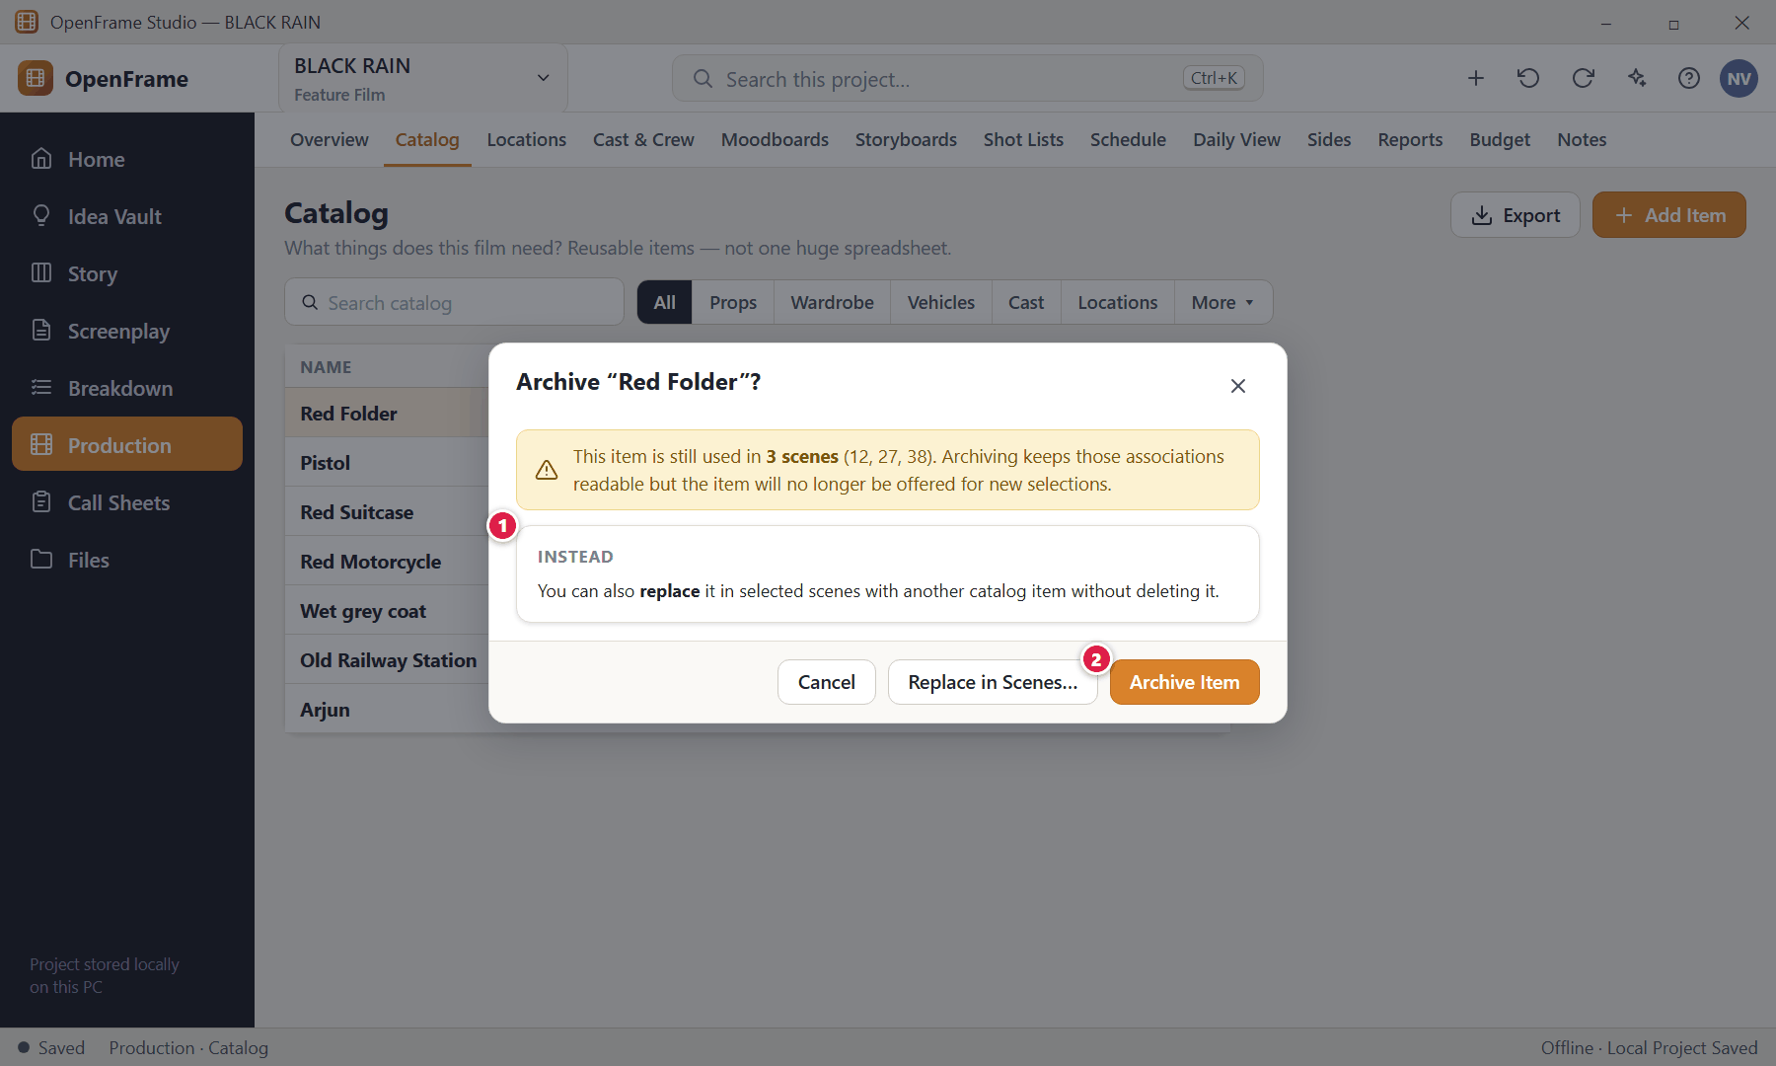
Figure 114. Archiving or replacing a catalog item (red numbers are explained on the next page)

Figure 114 — Archiving or replacing a catalog item: how it works
PARTS OF THIS SCREEN  1 Alternative — Replace the catalog item in selected scenes without deleting the old one.  2 Archive Item — Archives the item; documents and scene associations stay readable. | HOW TO USE IT  1. Read the warning, then choose Replace in Scenes… or Archive Item.  GOOD TO KNOW · EDGE CASES  - Archived items are shown muted and excluded from normal creation suggestions where appropriate.

Figure 115 — Locations list
What it is for. Locations are simple production notebooks. The most useful signal when scanning is the status.
How to get here. Production → Locations, or a location link in Breakdown.
Figure 115. Locations list (red numbers are explained on the next page)

Figure 115 — Locations list: how it works
PARTS OF THIS SCREEN  1 Add Location — Only a name is required.  2 Status filter — Idea → Shortlisted → Confirmed → Rejected.  3 Location cards — Photo, name, status and how many scenes need it. Click one to open its details.  4 Selected location — The Old Railway Station is Confirmed and needed by 6 scenes.  5 Rejected — A location you decided against; scenes that used it can be given a replacement. | HOW TO USE IT  1. Click Add Location and type a name.  2. Open a location to add photos, address, contact and practical notes.  GOOD TO KNOW · EDGE CASES  - Empty state: "Add a location you are considering for the film."  - Deleting a location warns that schedule history stays readable; archive is preferred.

Figure 116 — Location details: photos, notes, scenes
What it is for. Everything about one place in one drawer: photos, address, contact, practical concerns and the scenes that need it.
How to get here. Locations → click a location.
Figure 116. Location details: photos, notes, scenes (red numbers are explained on the next page)

Figure 116 — Location details: photos, notes, scenes: how it works
PARTS OF THIS SCREEN  1 Status buttons — Simple, reversible buttons: Idea, Shortlisted, Confirmed, Rejected. Confirming a location does not automatically assign it to every scene.  2 Photos — Add one or several images; reorder them; the first image is the thumbnail. Photos stay available offline and can be used in moodboard exports.  3 Practical notes — Parking, noise, permission, access times, power, toilets, nearby facilities, travel notes and restrictions.  4 Scenes — Every scene that needs this location. Click to open it. | HOW TO USE IT  1. Open a location, set its status, add photos and notes.  2. Click Open Scenes to see the scenes that use it.  GOOD TO KNOW · EDGE CASES  - Changing the status never edits the screenplay text.  - When a location is confirmed the Schedule can use it and the Call Sheet pulls its name, address and selected notes.

Figure 117 — Replacing a rejected location for selected scenes
What it is for. If Location A is rejected you can point selected scenes at Location B without touching the screenplay.
How to get here. A Rejected location → Replace…
Figure 117. Replacing a rejected location for selected scenes (red numbers are explained on the next page)

Figure 117 — Replacing a rejected location for selected scenes: how it works
PARTS OF THIS SCREEN  1 Replacement — Pick the practical substitute.  2 Scenes — Choose which scenes should switch.  3 Apply Replacement — Updates production associations only. | HOW TO USE IT  1. Choose the replacement and scenes, then apply.  GOOD TO KNOW · EDGE CASES  - The screenplay heading is only changed if you edit it yourself.

Figure 118 — Cast list
What it is for. The Cast list connects real people to story characters, with light availability notes.
How to get here. Production → Cast & Crew.
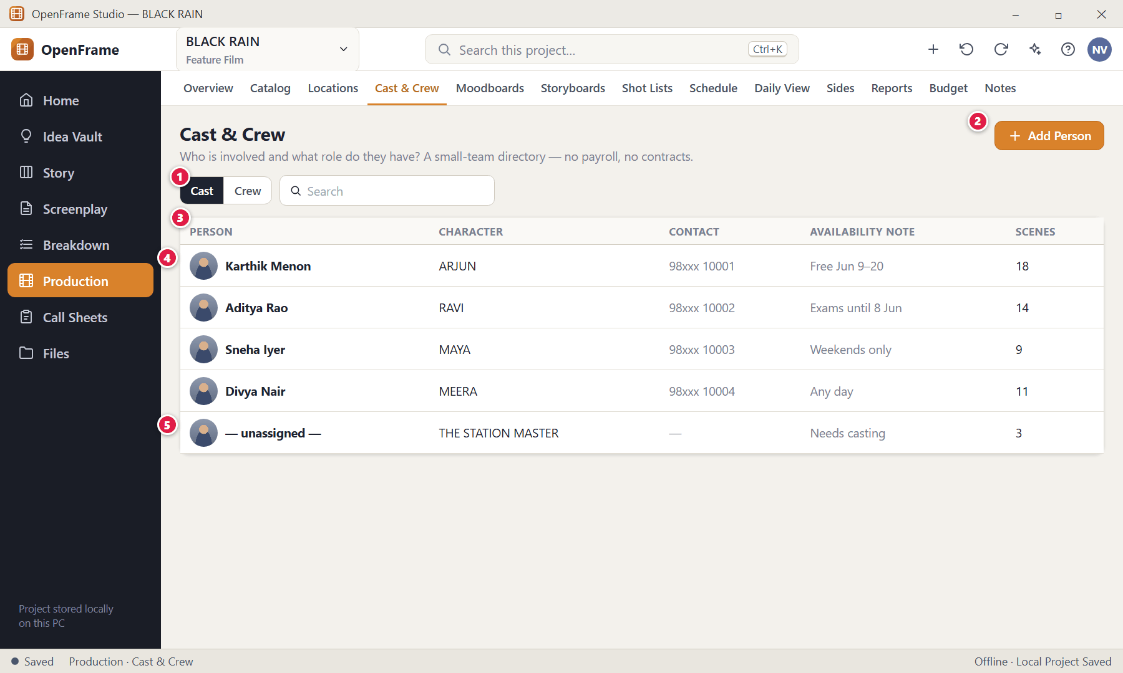
Figure 118. Cast list (red numbers are explained on the next page)

Figure 118 — Cast list: how it works
PARTS OF THIS SCREEN  1 Cast | Crew — Switch between cast and crew.  2 Add Person — A person name is required (plus a character for cast).  3 Cast rows — Person, Character, contact, availability note and scene count. Click a row for full details; the Scenes count opens the scenes that person is needed in.  4 Availability note — Free-text like "Free Jun 9–20". It is a reminder, not a calendar or HR system.  5 Unresolved cast — A character with no actor — flagged in the Production overview as an unresolved need. | HOW TO USE IT  1. Click Add Person and fill in the name, character and any contact details.  2. Use Assign Character to link the person to a story character.  GOOD TO KNOW · EDGE CASES  - Cast records hold: person name, character, contact, optional photo, notes, availability notes and derived scenes.  - There are deliberately no salary, contract, union or payroll fields.  - Removing someone from the directory does not rewrite documents you have already issued.

Figure 119 — Assigning an actor to a character
What it is for. A compact chooser links a person to an existing story character.
How to get here. Cast → Assign Character (or from the Characters directory → Assign Actor).
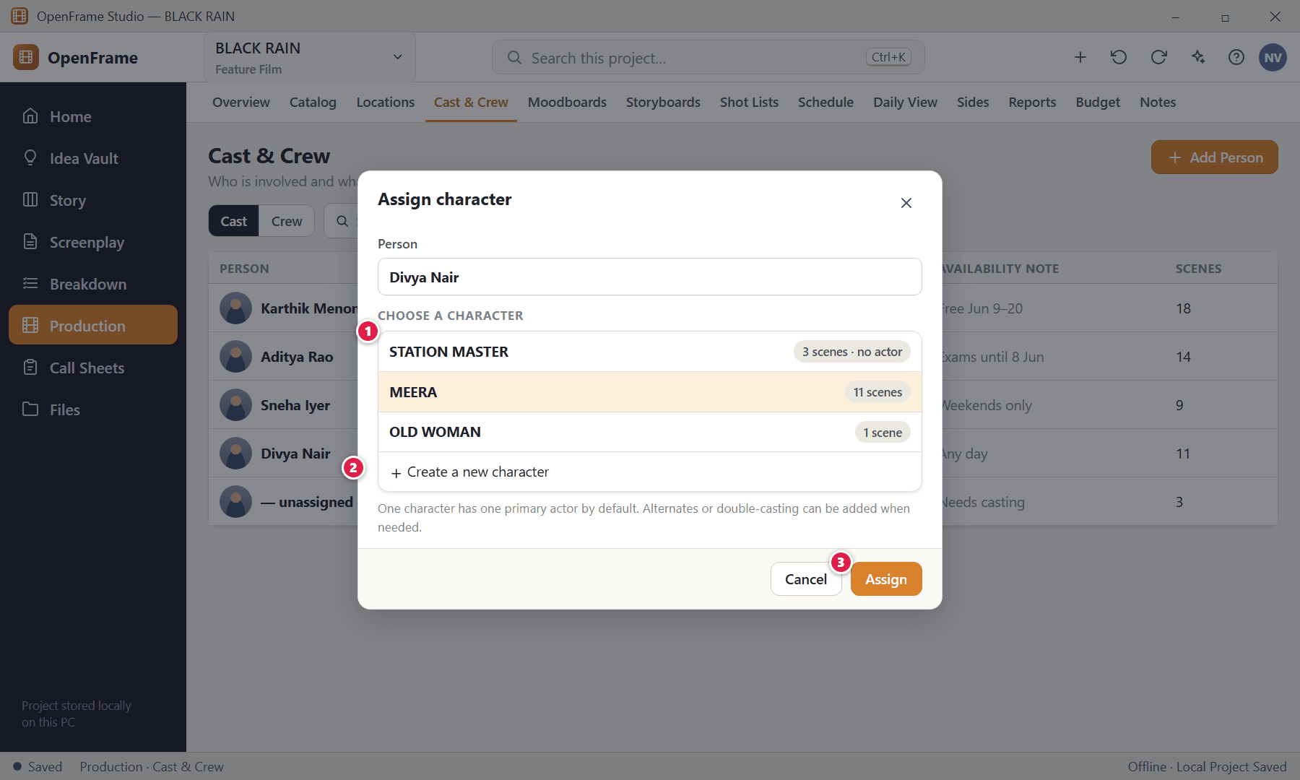
Figure 119. Assigning an actor to a character (red numbers are explained on the next page)

Figure 119 — Assigning an actor to a character: how it works
PARTS OF THIS SCREEN  1 Existing characters — Pick the character the person plays.  2 Create a new character — Allowed from inside the chooser; it creates the same ordinary Character object.  3 Assign — Links the person to the character. | HOW TO USE IT  1. Choose the character and click Assign.  GOOD TO KNOW · EDGE CASES  - The character remains the story-level object; the actor is the real-world person attached to it.

Figure 120 — Crew list
What it is for. The crew directory records who does what and how to reach them, and feeds the call sheet.
How to get here. Cast & Crew → Crew.
Figure 120. Crew list (red numbers are explained on the next page)

Figure 120 — Crew list: how it works
PARTS OF THIS SCREEN  1 Crew tab — Switch to the crew list.  2 Roles and departments — Role is required for crew. Departments such as Direction, Camera, Sound, Art, Costume, Makeup, Production and Editing help group people. | HOW TO USE IT  1. Add Person → enter name, role and department, then optional contact and notes.  GOOD TO KNOW · EDGE CASES  - Crew appear on call sheets depending on the shooting day.

Figure 121 — Moodboard canvas
What it is for. A moodboard is a freeform canvas of references — like pinning images on a wall.
How to get here. Production → Moodboards, or the + quick action → New Moodboard.
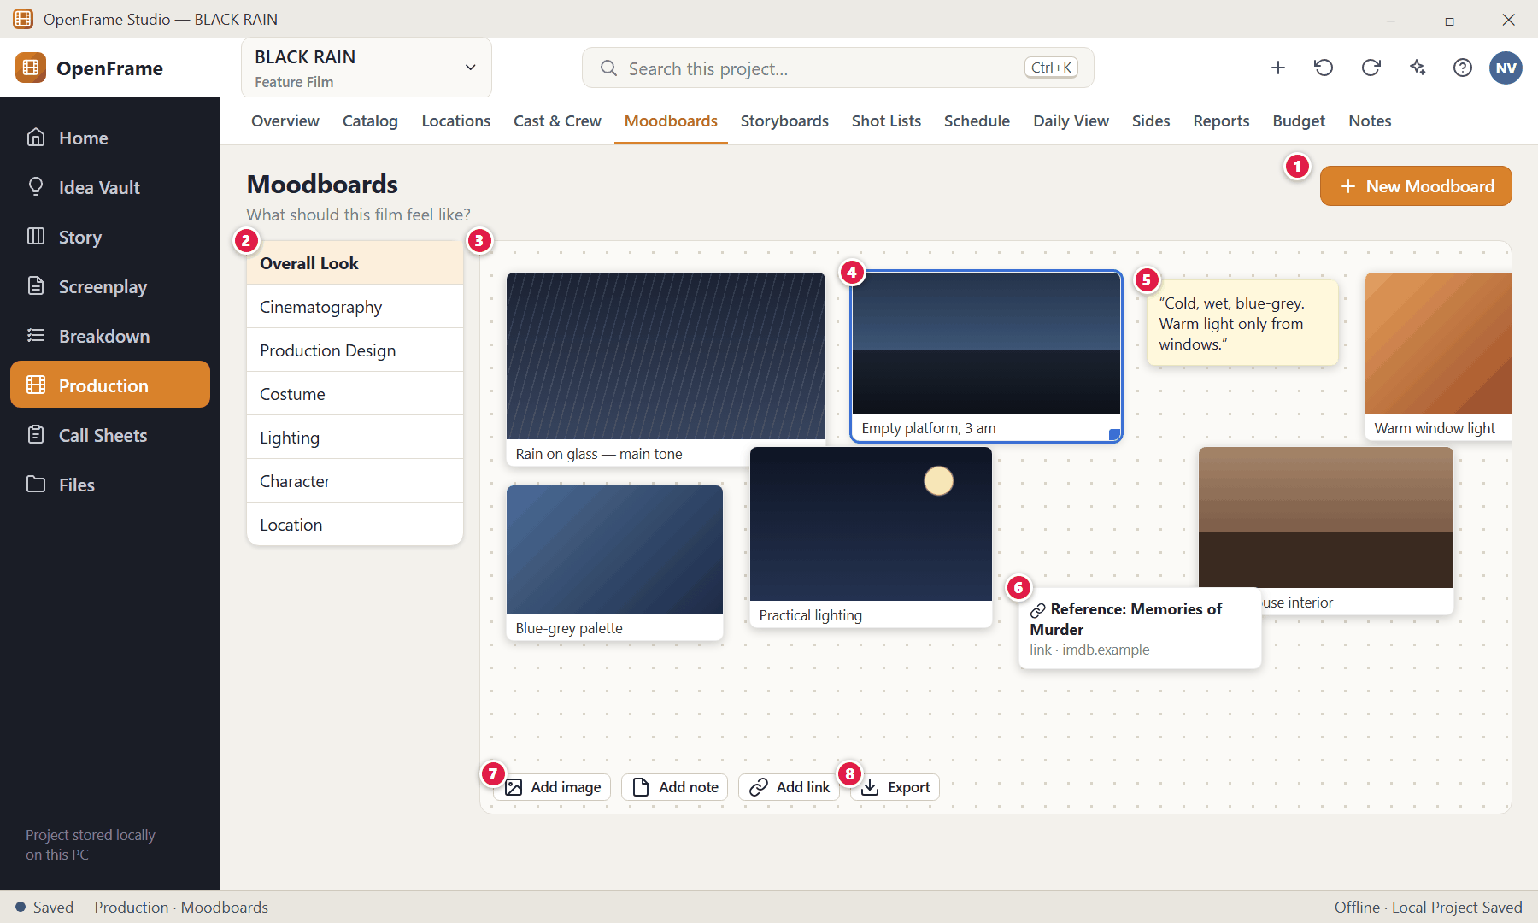
Figure 121. Moodboard canvas (red numbers are explained on the next page)

Figure 121 — Moodboard canvas: how it works
PARTS OF THIS SCREEN  1 New Moodboard — Give it a name. Suggested names: Overall Look, Cinematography, Production Design, Costume, Lighting, Character, Location — these are only suggestions.  2 Board list — Your boards.  3 Canvas — Drop images, paste images, add text notes or links, drag items anywhere, resize them and add a short caption.  4 Selected tile — Drag to move, use the corner handle to resize. Multi-select moves several tiles together.  5 Text note — A sticky-style note.  6 Link tile — A URL with a title.  7 Add image / note / link — Buttons to add items (you can also drag files from File Explorer).  8 Export — Creates a clean presentation of the board. | HOW TO USE IT  1. Create a board, drag images onto it, add captions, arrange freely.  GOOD TO KNOW · EDGE CASES  - Empty state: "Drop images, notes and references here."  - A missing image shows an "unavailable" placeholder rather than disappearing.  - Moodboards are references only — they never change production data.

Figure 122 — Exporting a moodboard
What it is for. Create a clean presentation of a board to share with a cinematographer or producer.
How to get here. Moodboard → Export.
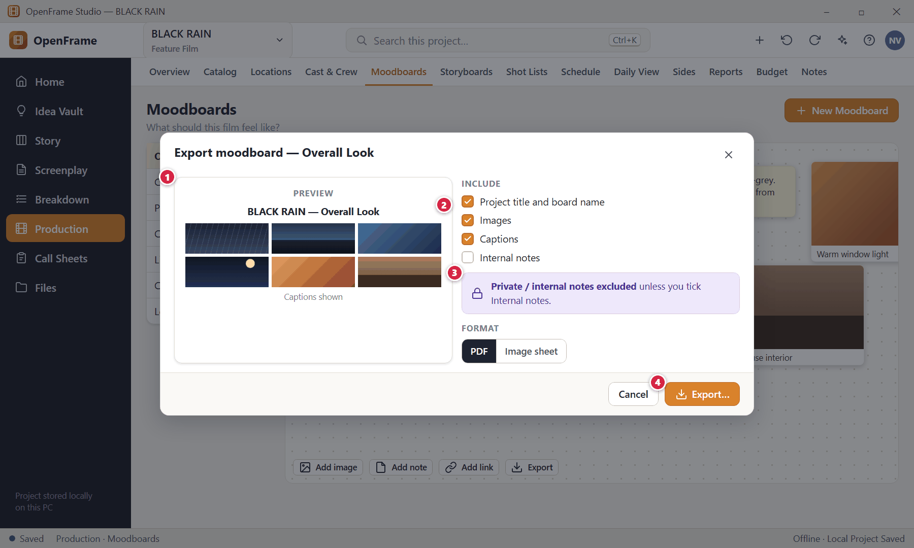
Figure 122. Exporting a moodboard (red numbers are explained on the next page)

Figure 122 — Exporting a moodboard: how it works
PARTS OF THIS SCREEN  1 Preview — Shows the outgoing page: project title, board name, images and optional captions.  2 What to include — Title, images, captions. Internal notes are off by default.  3 Privacy — Private/internal notes are excluded unless explicitly selected.  4 Export… — Saves a snapshot PDF or image sheet. Editing the exported file never changes the board. | HOW TO USE IT  1. Choose what to include, then click Export….  GOOD TO KNOW · EDGE CASES  - The exported document is a snapshot of the board at export time.

Figure 123 — Storyboard panels for a scene
What it is for. A storyboard is a simple, ordered series of visual panels for one scene — not illustration software.
How to get here. Production → Storyboards, right-click a scene → Create Storyboard, or Scene Hub → Storyboard.
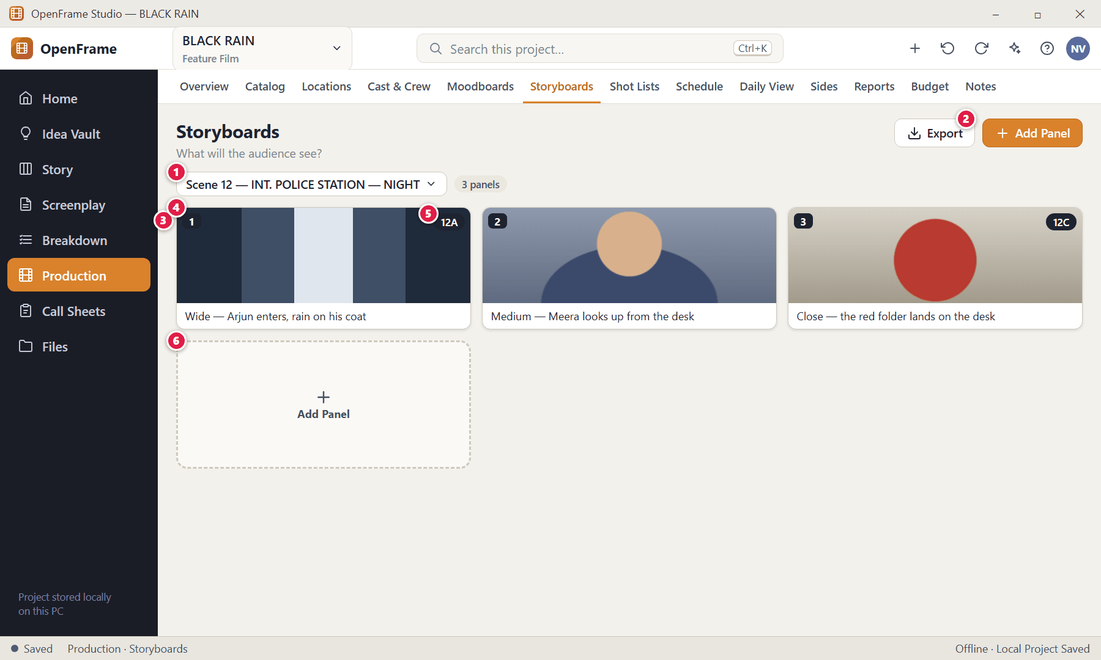
Figure 123. Storyboard panels for a scene (red numbers are explained on the next page)

Figure 123 — Storyboard panels for a scene: how it works
PARTS OF THIS SCREEN  1 Scene selector — Panels belong to the selected scene.  2 Add Panel — Adds a panel: import an image, sketch, or leave it empty.  3 Panels — Each has a visual, a shot number and a description. Drag to reorder; numbering follows the order.  4 Panel 1 — The picture and its description; optional framing, movement, dialogue, notes and duration are in the detail view.  5 Linked shot badge — A small "Shot 12A" badge shows the panel is linked to a shot. Click it to open the shot. Removing the link deletes neither object.  6 Empty slot — Empty state: "Create panels for this scene." | HOW TO USE IT  1. Choose a scene, click Add Panel, add a picture or sketch, and write a description.  2. Drag panels into order.  GOOD TO KNOW · EDGE CASES  - Script-to-Storyboard: choosing a scene and clicking Create Storyboard makes empty panels only — it never invents a visual sequence unless you ask the AI assistant to help.  - If the scene text changes later, panels are kept and the scene shows "Storyboard review recommended".  - Storyboard and shot list are independent: neither requires the other.

Figure 124 — Add Panel: import, sketch or empty
What it is for. Adding a panel offers three simple ways to provide the visual.
How to get here. Storyboards → Add Panel.
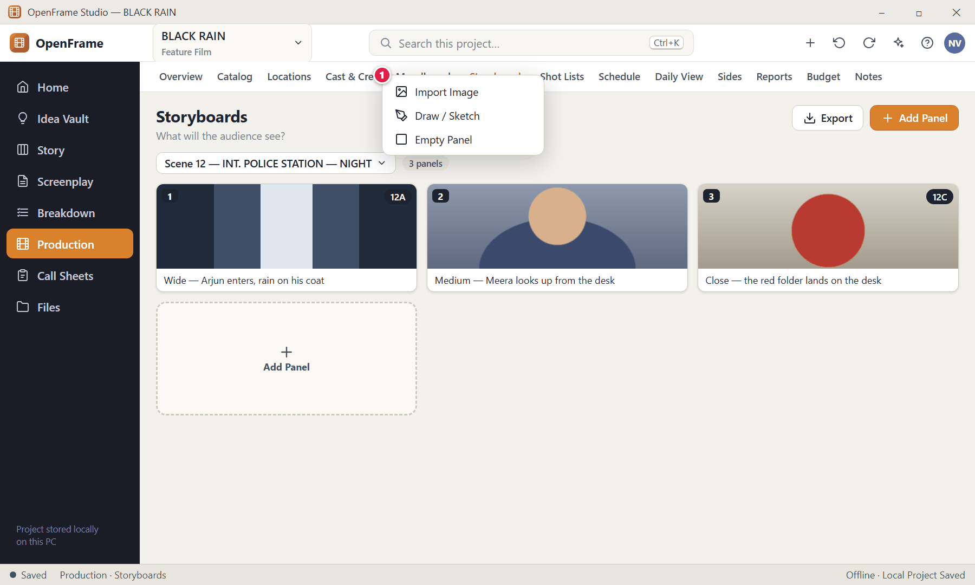
Figure 124. Add Panel: import, sketch or empty (red numbers are explained on the next page)

Figure 124 — Add Panel: import, sketch or empty: how it works
PARTS OF THIS SCREEN  1 Add Panel menu — Import Image (a file from your PC) · Draw / Sketch (a basic drawing surface) · Empty Panel (a placeholder you can fill later). | HOW TO USE IT  1. Choose one of the three options.  GOOD TO KNOW · EDGE CASES  - If importing or drawing has a problem the panel stays intact and you can try another input method.

Figure 125 — Sketching a panel
What it is for. A basic drawing surface for quick thumbnail sketches.
How to get here. Add Panel → Draw / Sketch.
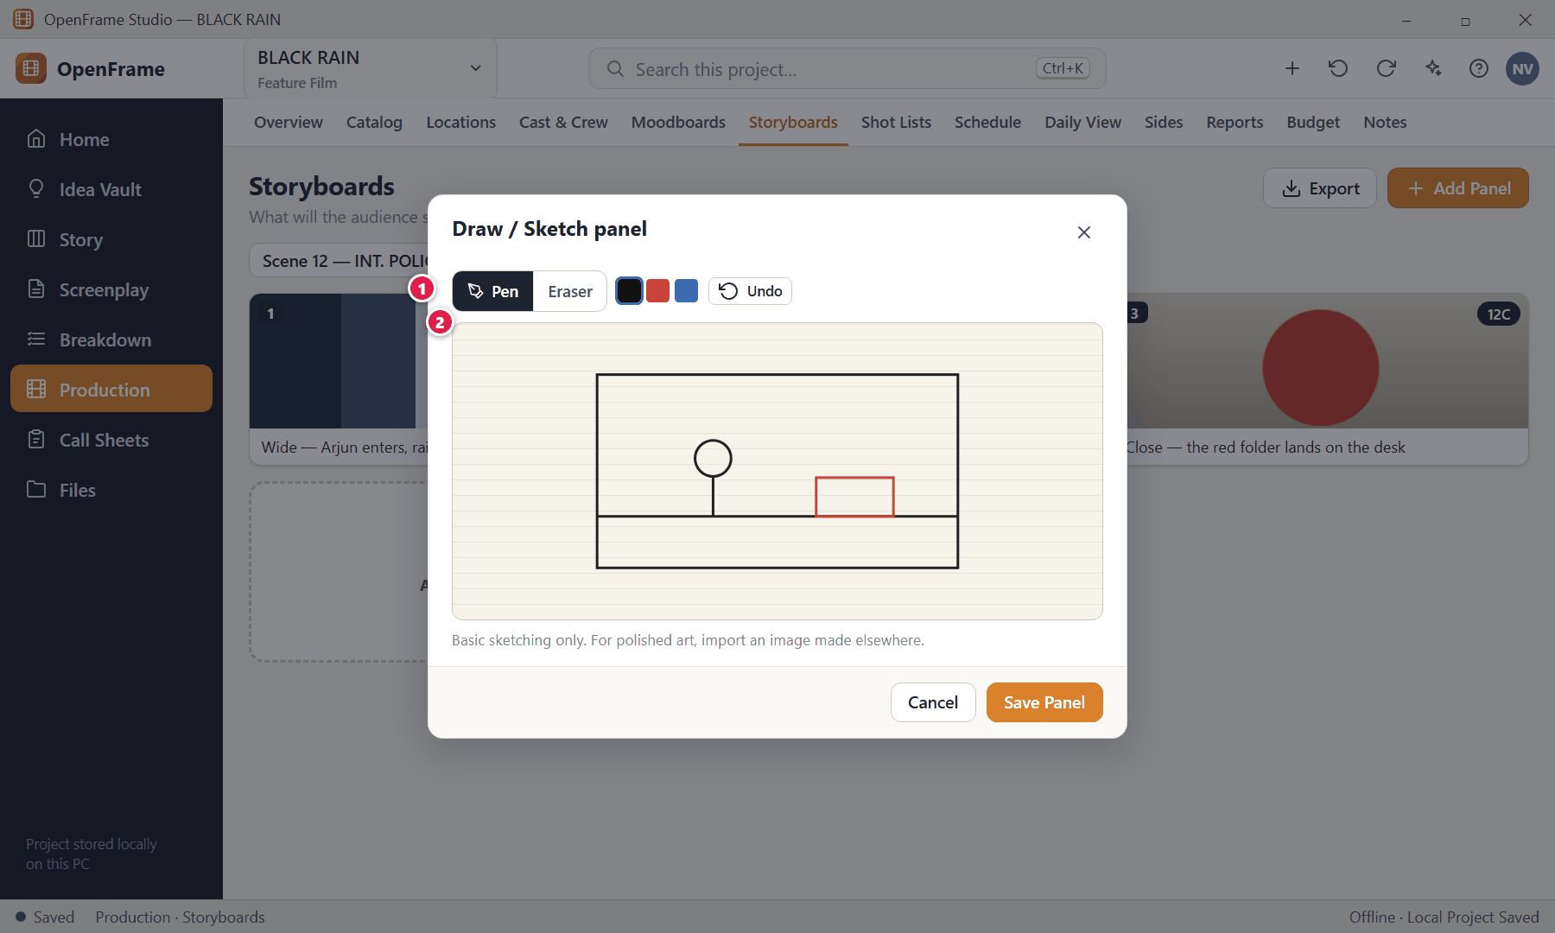
Figure 125. Sketching a panel (red numbers are explained on the next page)

Figure 125 — Sketching a panel: how it works
PARTS OF THIS SCREEN  1 Tools — Pen, eraser, colours and undo.  2 Drawing area — Draw with the mouse or a pen tablet. | HOW TO USE IT  1. Draw, then click Save Panel.  GOOD TO KNOW · EDGE CASES  - Advanced storyboard editing is intentionally out of scope; basic tools stay simple.

Figure 126 — Shot list for a scene
What it is for. A shot list is a practical camera-planning document built scene by scene, grouped by scene and ordered by drag-and-drop.
How to get here. Production → Shot Lists, right-click a scene → Create Shot List, or Scene Hub → Shots.
Figure 126. Shot list for a scene (red numbers are explained on the next page)

Figure 126 — Shot list for a scene: how it works
PARTS OF THIS SCREEN  1 Scene selector — Shots belong to the chosen scene. The selection stays while you add and reorder.  2 Add Shot — Creates a shot at the end of the scene's coverage; only a short description is required.  3 Shot cards — Shot label (12A…), size (Wide, Medium, Close, OTS…) and description; small chips show optional details such as Static or WS. Drag the handle to reorder.  4 Selected shot — Click to open its detail drawer.  5 Guidance — Technical fields are optional; labels renumber automatically. | HOW TO USE IT  1. Choose the scene, click Add Shot, type a description.  2. Drag shots into the order you want to capture them.  GOOD TO KNOW · EDGE CASES  - Export by scene, by group of scenes, or whole project (PDF optimised for camera/lighting/AD reference).  - If scene text changes later, the shots are kept and flagged "Scene content changed. Review shots for this scene."  - Master / coverage / insert can be written in the notes; there is no fixed coverage taxonomy.

Figure 127 — Shot details (technical fields)
What it is for. Advanced camera fields stay out of the way until you open the shot.
How to get here. Shot List → click a shot.
Figure 127. Shot details (technical fields) (red numbers are explained on the next page)

Figure 127 — Shot details (technical fields): how it works
PARTS OF THIS SCREEN  1 Technical details — Revealed only when needed. A shot is valid with just its description.  2 Optional fields — Shot size, movement, angle, lens, camera notes, characters, visual reference and sound note.  3 Storyboard link — Optionally attach a storyboard panel to this shot. If you create the shot first you can attach a panel later; if you storyboard first you can reuse the image.  4 Attach… — Choose an existing panel or create a new panel from the shot. | HOW TO USE IT  1. Open a shot, add details you care about, and attach a panel if you have one.  GOOD TO KNOW · EDGE CASES  - A shot can have a second storyboard option instead of replacing the first.  - The reference image is a visual aid, not an asset-management relationship.

Chapter 6 — Scheduling, Call Sheets and Production Documents
This chapter follows the film from screenplay scenes to shooting days: the drag-and-drop Stripboard (Shooting Schedule), calendar, conflict warnings and grouping suggestions, the Daily Production View, Call Sheets generated from a shooting day, Sides, Reports, the lightweight Budget, Notes, Tasks, Activity History, Templates, Project Files, Permissions and global Search.
Screens in this chapter
Figure 128 Shooting Schedule — nothing created yet | Figure 143 Call Sheet editor
Figure 129 Creating the schedule | Figure 144 Adding optional call-sheet sections
Figure 130 Stripboard: Unscheduled pool and shooting days | Figure 145 Call sheet marked stale after a schedule change
Figure 131 Stripboard: List view | Figure 146 Refresh preview before updating a call sheet
Figure 132 Schedule calendar | Figure 147 Finalizing and exporting a call sheet
Figure 133 Dragging a scene into a day | Figure 148 Sides for a shooting day
Figure 134 Adding a break marker or off day | Figure 149 Production Reports
Figure 135 Shooting Day detail | Figure 150 Lightweight budget snapshot (P1)
Figure 136 Schedule conflict warning | Figure 151 Project Notes and Lightweight Tasks
Figure 137 Grouping suggestion | Figure 152 Activity History
Figure 138 Script changed in scheduled scenes: review changes | Figure 153 Template browser (P1)
Figure 139 Exporting the schedule | Figure 154 Project Files (file cabinet)
Figure 140 Daily Production View | Figure 155 Permissions
Figure 141 Call Sheets list | Figure 156 Global project search
Figure 142 Creating a call sheet from a shooting day | Figure 157 Recently Deleted (whole project)

Figure 128 — Shooting Schedule — nothing created yet
What it is for. Scheduling starts from a screenplay source. Until a schedule exists the workspace explains the next step.
How to get here. Production → Schedule (first time).
Figure 128. Shooting Schedule — nothing created yet — No schedule (red numbers are explained on the next page)

Figure 128 — Shooting Schedule — nothing created yet: how it works
PARTS OF THIS SCREEN  1 Empty-state message — "Create a shooting schedule from your screenplay." / "Break down your script first, then move scenes into shooting days."  2 Create Shooting Schedule — Gathers every scene of the production source into an Unscheduled area. | HOW TO USE IT  1. Click Create Shooting Schedule.  GOOD TO KNOW · EDGE CASES  - A schedule can be created even if no breakdown exists yet — breakdown helps but is not required.

Figure 129 — Creating the schedule
What it is for. The schedule is tied to one screenplay source. Every scene begins Unscheduled.
How to get here. Schedule → Create Shooting Schedule.
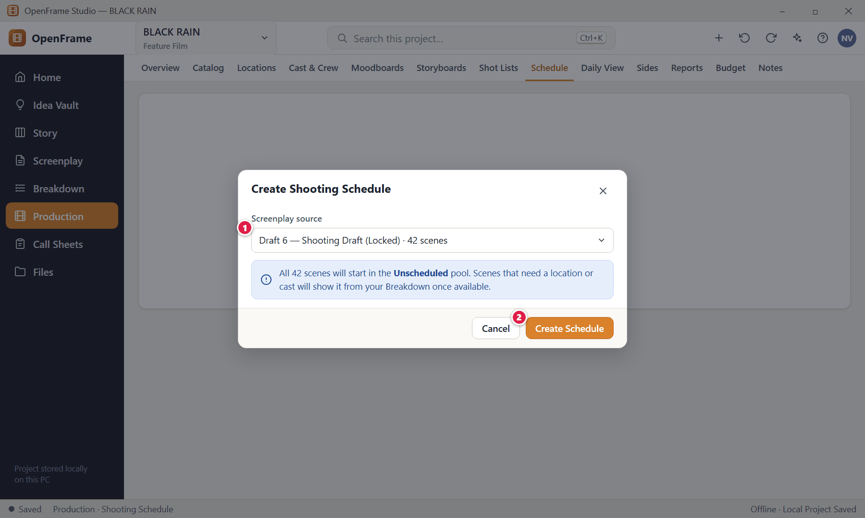
Figure 129. Creating the schedule (red numbers are explained on the next page)

Figure 129 — Creating the schedule: how it works
PARTS OF THIS SCREEN  1 Source — The screenplay draft the schedule is built from (normally your production source).  2 Create Schedule — Creates the schedule; all scenes appear in the Unscheduled pool. | HOW TO USE IT  1. Confirm the source and click Create Schedule.  GOOD TO KNOW · EDGE CASES  - Scenes waiting to be scheduled are always visually separate from scheduled ones.

Figure 130 — Stripboard: Unscheduled pool and shooting days
What it is for. The stripboard is the familiar production scheduling model: every strip is one screenplay scene, dragged into shooting days. It answers "When and where will we shoot this?"
How to get here. Production → Schedule (Board).
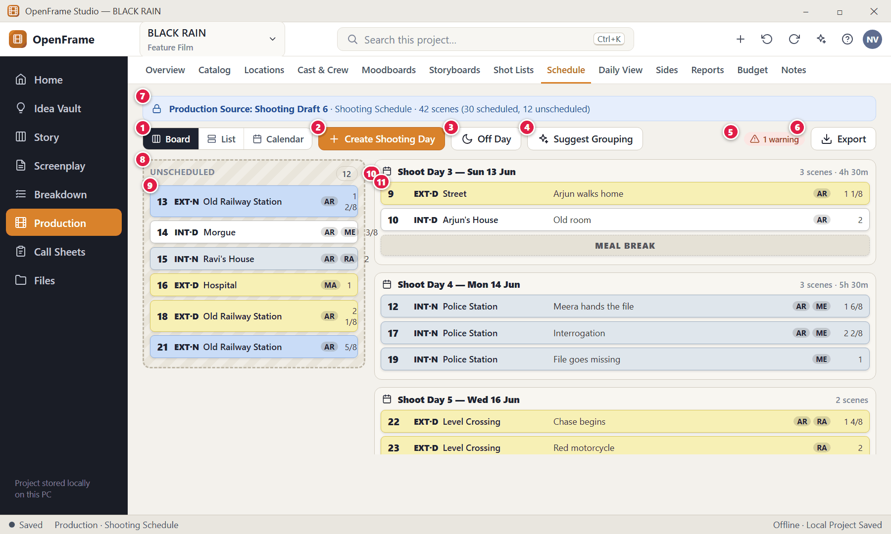
Figure 130. Stripboard: Unscheduled pool and shooting days — Planning (red numbers are explained on the next page)

Figure 130 — Stripboard: Unscheduled pool and shooting days: how it works
PARTS OF THIS SCREEN  1 Board / List / Calendar — Three views of the same schedule: colourful strips, editable rows, and a calendar of dates. Changing one changes the others.  2 Create Shooting Day — Adds a day with a date, day number and optional notes.  3 Off Day — Adds a day with no scenes (rest or logistics), with optional notes.  4 Suggest Grouping — Asks for advisory grouping ideas (for example same-location scenes). Nothing moves without your approval.  5 Warnings — A small count of potential conflicts (actor, location, duration overflow).  6 Export — Schedule PDF (and spreadsheet where practical).  7 Source banner — Shows the production source the schedule is built from.  8 Unscheduled pool — Scenes not yet placed. It stays visible while you plan; a scene disappears from it once scheduled.  9 A strip — Scene number, INT/EXT, location, day/night, page count, short synopsis and cast initials. Colours follow the day/night convention (EXT day = yellow, EXT night = blue, INT day = white, INT night = grey).  10 Day header — "Shoot Day 3 — Sun 13 Jun", number of scenes and estimated total time.  11 Scene in a day — Drag to reorder within the day (changes shooting order only) or to another day. | HOW TO USE IT  1. Drag strips from Unscheduled into a Shoot Day.  2. Drag inside a day to set shooting order.  3. Drag back to Unscheduled (or use Remove from Day) to unschedule a scene.  GOOD TO KNOW · EDGE CASES  - Removing a scene from a day returns it to Unscheduled; it is never deleted from the screenplay.  - Moving a scene changes the day totals and marks any call sheet for the affected days as needing a refresh.  - Strips show the generated screenplay scene number; the schedule never reorders or edits the screenplay.

Figure 131 — Stripboard: List view
What it is for. List view shows the same schedule as rows with columns, for fast editing.
How to get here. Schedule → List.
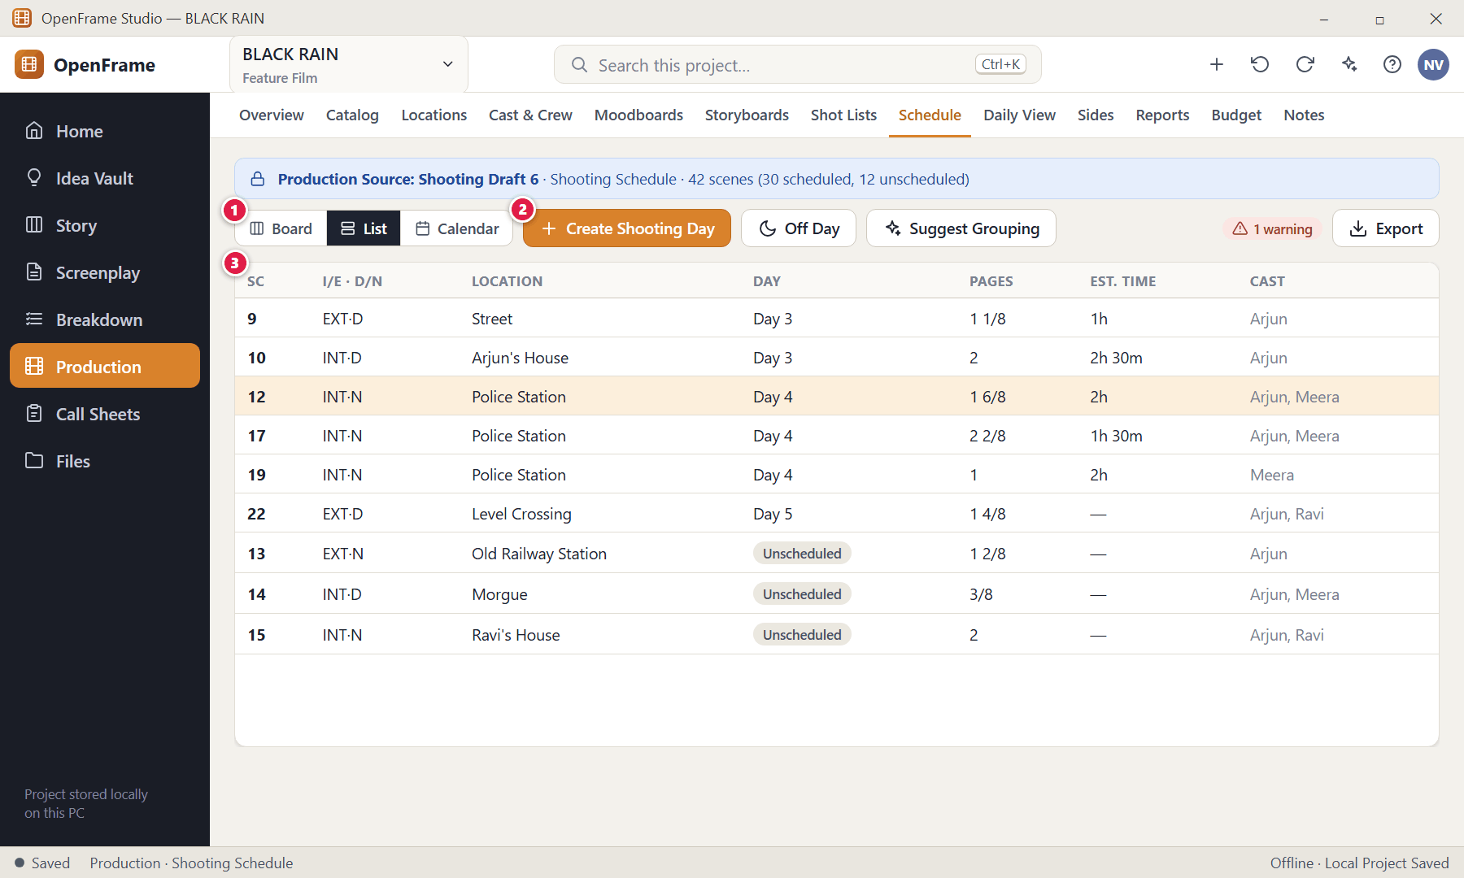
Figure 131. Stripboard: List view — List view (red numbers are explained on the next page)

Figure 131 — Stripboard: List view: how it works
PARTS OF THIS SCREEN  1 Board / List / Calendar — Three views of the same schedule: colourful strips, editable rows, and a calendar of dates. Changing one changes the others.  2 Create Shooting Day — Adds a day with a date, day number and optional notes.  3 Schedule rows — Scene, I/E and D/N, location, day, page count, your estimated shooting time and cast. Click a cell such as Day or Est. time to edit it. Missing values show as "—", never invented. | HOW TO USE IT  1. Change a scene's day or estimate directly in the row.  GOOD TO KNOW · EDGE CASES  - Estimates are optional: for example "Scene 12 — 2 hours". A day's total is simply the sum of the estimates you entered — no production-time formula.

Figure 132 — Schedule calendar
What it is for. The calendar maps shooting days to real dates, including off days.
How to get here. Schedule → Calendar.
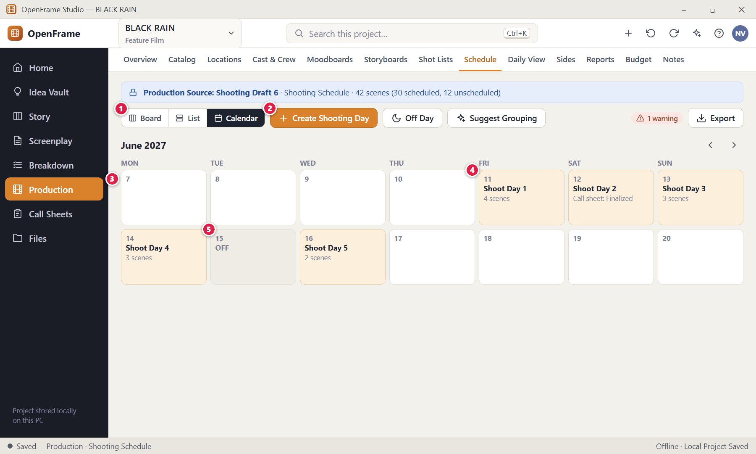
Figure 132. Schedule calendar — Calendar (red numbers are explained on the next page)

Figure 132 — Schedule calendar: how it works
PARTS OF THIS SCREEN  1 Board / List / Calendar — Three views of the same schedule: colourful strips, editable rows, and a calendar of dates. Changing one changes the others.  2 Create Shooting Day — Adds a day with a date, day number and optional notes.  3 Calendar — Dates with their shooting day (for example Fri 11 = Shoot Day 1) and status such as Call sheet: Finalized.  4 A shooting day — Click it to open the day detail.  5 Off day — A day with no scenes; it can carry notes. | HOW TO USE IT  1. Click a date to open or create a day; change a date from the day detail.  GOOD TO KNOW · EDGE CASES  - Changing a day's date updates the day and marks any existing call sheet for that day as needing a refresh. The issued PDF is never overwritten.

Figure 133 — Dragging a scene into a day
What it is for. Drag feedback shows exactly which day and position a scene will land in.
How to get here. Drag a strip.
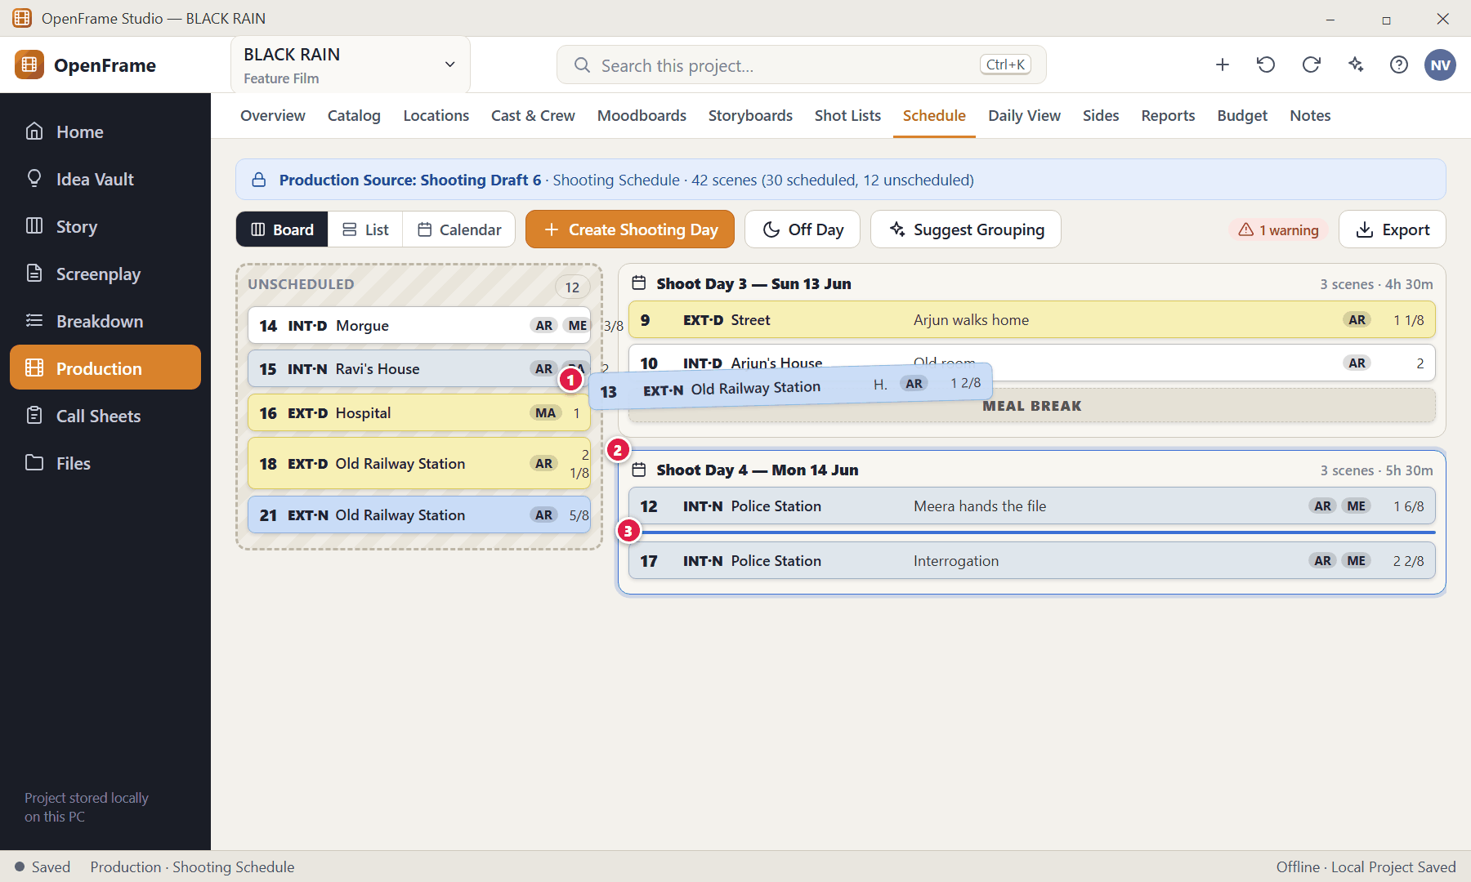
Figure 133. Dragging a scene into a day (red numbers are explained on the next page)

Figure 133 — Dragging a scene into a day: how it works
PARTS OF THIS SCREEN  1 Strip being dragged — Follows the pointer.  2 Destination day — The receiving day is highlighted.  3 Insertion line — Shows the position within the day. | HOW TO USE IT  1. Drag a strip from the pool or another day, and release on the highlighted day.  2. Ctrl+Z undoes the move.  GOOD TO KNOW · EDGE CASES  - An invalid drop returns the strip to where it was and changes nothing.  - There is no automatic optimiser: no scene ever moves unless you (or an accepted suggestion) move it.

Figure 134 — Adding a break marker or off day
What it is for. Between scenes you can add simple markers so the day reads realistically.
How to get here. Day header → + menu (or the Create Shooting Day button for a new day).
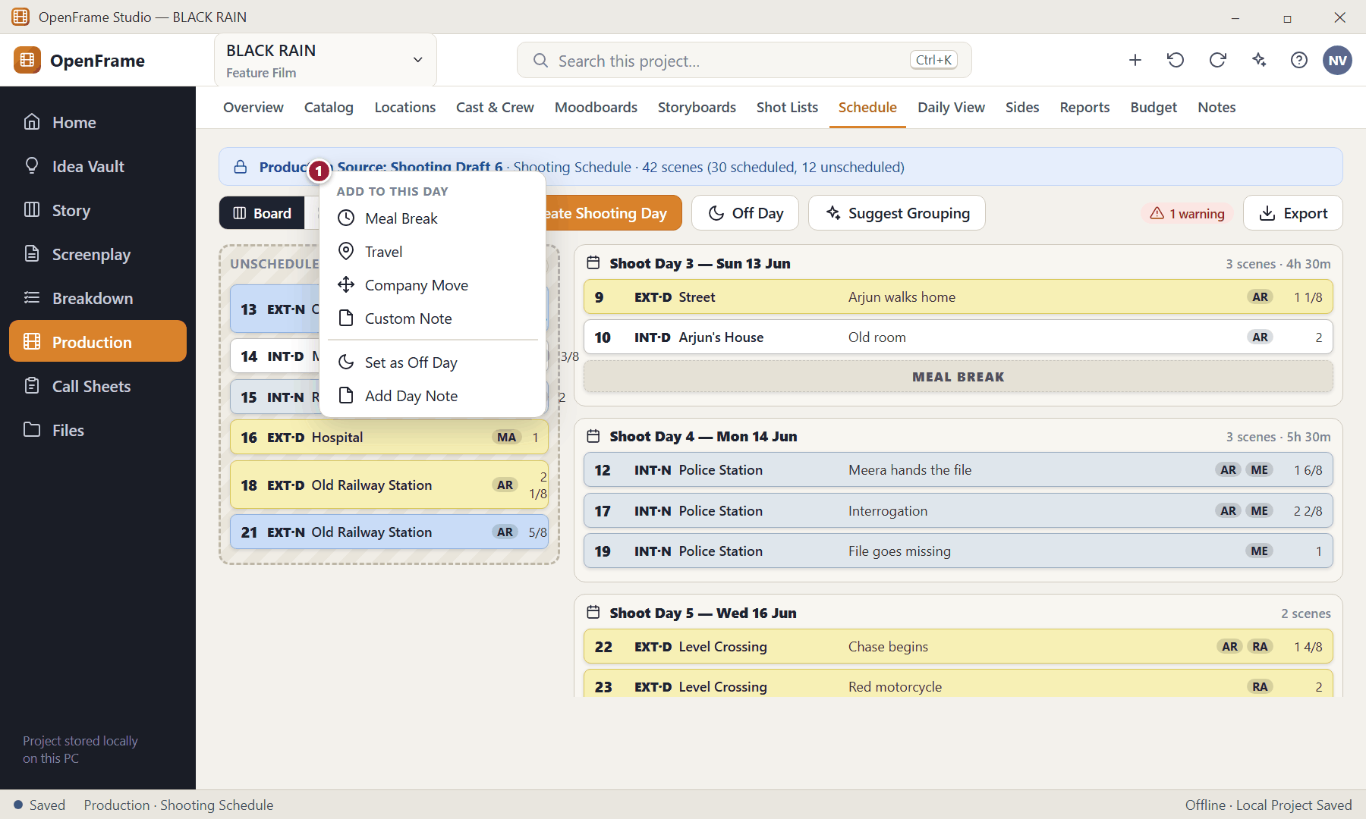
Figure 134. Adding a break marker or off day (red numbers are explained on the next page)

Figure 134 — Adding a break marker or off day: how it works
PARTS OF THIS SCREEN  1 Markers — Meal Break · Travel · Company Move · Custom Note appear as compact dashed rows between strips. You can also mark a day as an Off Day or add a day note. | HOW TO USE IT  1. Open the day's menu and choose a marker; type a label if it is a custom note.  GOOD TO KNOW · EDGE CASES  - Creating a shooting day asks for the date, the day number and optional notes; the day number is a positive whole number that also sets display order.  - Duplicating a day copies its structure as a planning template while the scenes keep their own identity.

Figure 135 — Shooting Day detail
What it is for. A focused planning surface for one shooting day.
How to get here. Click a shooting day (board or calendar).
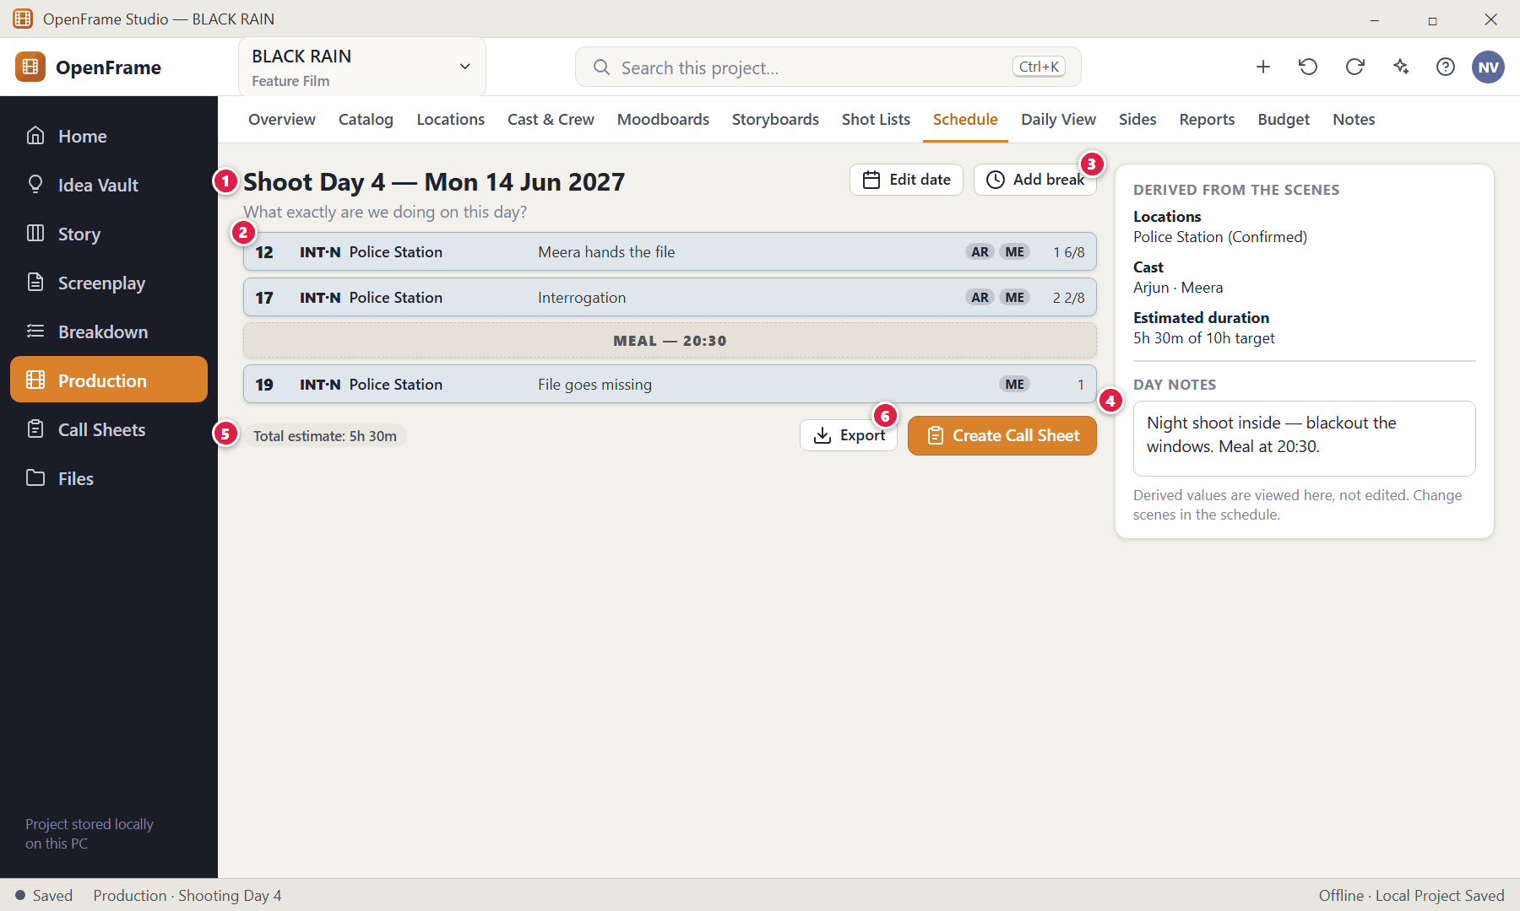
Figure 135. Shooting Day detail (red numbers are explained on the next page)

Figure 135 — Shooting Day detail: how it works
PARTS OF THIS SCREEN  1 Header — Date and day number; edit either from the buttons.  2 Scenes in shooting order — Open a scene from here.  3 Derived panel — Locations, cast, estimated duration and notes derived from the scenes. It is not a second editing form.  4 Day notes — Free notes for the day.  5 Footer — Total estimated duration and Create Call Sheet.  6 Create Call Sheet — Starts a call sheet pre-filled from this day. | HOW TO USE IT  1. Review the scenes, add breaks or notes, then click Create Call Sheet.  GOOD TO KNOW · EDGE CASES  - Empty day: "No scenes scheduled." with Add Scene / Off Day options.  - A day whose source scene changed shows a source-stale warning while keeping the day record.

Figure 136 — Schedule conflict warning
What it is for. OpenFrame warns about obvious practical conflicts and leaves every decision to you.
How to get here. A red outline on a strip, the warning count, or Schedule → Suggest.
Figure 136. Schedule conflict warning (red numbers are explained on the next page)

Figure 136 — Schedule conflict warning: how it works
PARTS OF THIS SCREEN  1 Conflict outline — The strips involved are outlined next to the day.  2 Specific warning — "Potential actor conflict: Arjun is needed at two locations on Shoot Day 3."  3 Affected scenes — Which scenes collide.  4 Open affected item — Jump to the scene or day.  5 Keep anyway — Acknowledge and continue; a small "acknowledged" marker remains. No auto-resolution occurs. | HOW TO USE IT  1. Read the warning, then move a scene yourself, or click Keep anyway.  GOOD TO KNOW · EDGE CASES  - Warning types: actor conflict (same person, two locations, same day) · location conflict (a location in two incompatible places) · day missing a required location · day estimate exceeds the target duration · a call sheet generated from a day that has since changed.  - Warnings appear next to the affected day or scene. Strict validation is an optional setting; by default warnings are advisory.

Figure 137 — Grouping suggestion
What it is for. Suggestions describe grouping opportunities but never move scenes on their own.
How to get here. Schedule → Suggest Grouping.
Figure 137. Grouping suggestion (red numbers are explained on the next page)

Figure 137 — Grouping suggestion: how it works
PARTS OF THIS SCREEN  1 The observation — States the reason first, then the idea.  2 Ask for suggestion — Requests fresh advice.  3 Apply manually — You move the scenes; a supported suggestion can also be applied only after explicit confirmation.  4 No auto-change — A reminder that assistance is advisory. | HOW TO USE IT  1. Read the suggestion and either move scenes yourself or dismiss it.  GOOD TO KNOW · EDGE CASES  - Suggestions consider shared location, cast and the durations you entered.

Figure 138 — Script changed in scheduled scenes: review changes
What it is for. If the screenplay changes after scenes are scheduled, the schedule stays intact and you review the changes.
How to get here. Indicator "Script changed in 3 scheduled scenes" on the schedule.
Figure 138. Script changed in scheduled scenes: review changes (red numbers are explained on the next page)

Figure 138 — Script changed in scheduled scenes: review changes: how it works
PARTS OF THIS SCREEN  1 Changed scenes — Which scheduled scenes are affected and how.  2 Open Production Update — Goes to the update review described earlier. | HOW TO USE IT  1. Review the list, then open the production update review.  GOOD TO KNOW · EDGE CASES  - No schedule change happens automatically. If the new page count changes a day's estimate the day is flagged.

Figure 139 — Exporting the schedule
What it is for. Export the schedule as a printable PDF (or spreadsheet where practical).
How to get here. Schedule → Export.
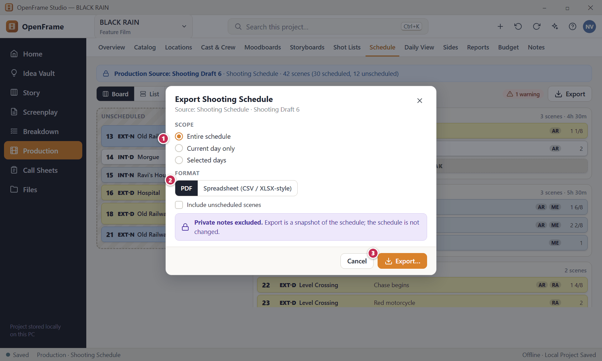
Figure 139. Exporting the schedule (red numbers are explained on the next page)

Figure 139 — Exporting the schedule: how it works
PARTS OF THIS SCREEN  1 Scope — Entire schedule, current day or selected days.  2 Format — PDF, or a spreadsheet export.  3 Export… — Saves a snapshot. | HOW TO USE IT  1. Pick the scope and format and export.  GOOD TO KNOW · EDGE CASES  - The exported PDF stays exactly as exported even if the schedule changes later.

Figure 140 — Daily Production View
What it is for. A single-screen summary of one shooting day for a small team. It is mostly read-only inspection, not a second schedule editor.
How to get here. Production → Daily View, or Shooting Day → Daily View.
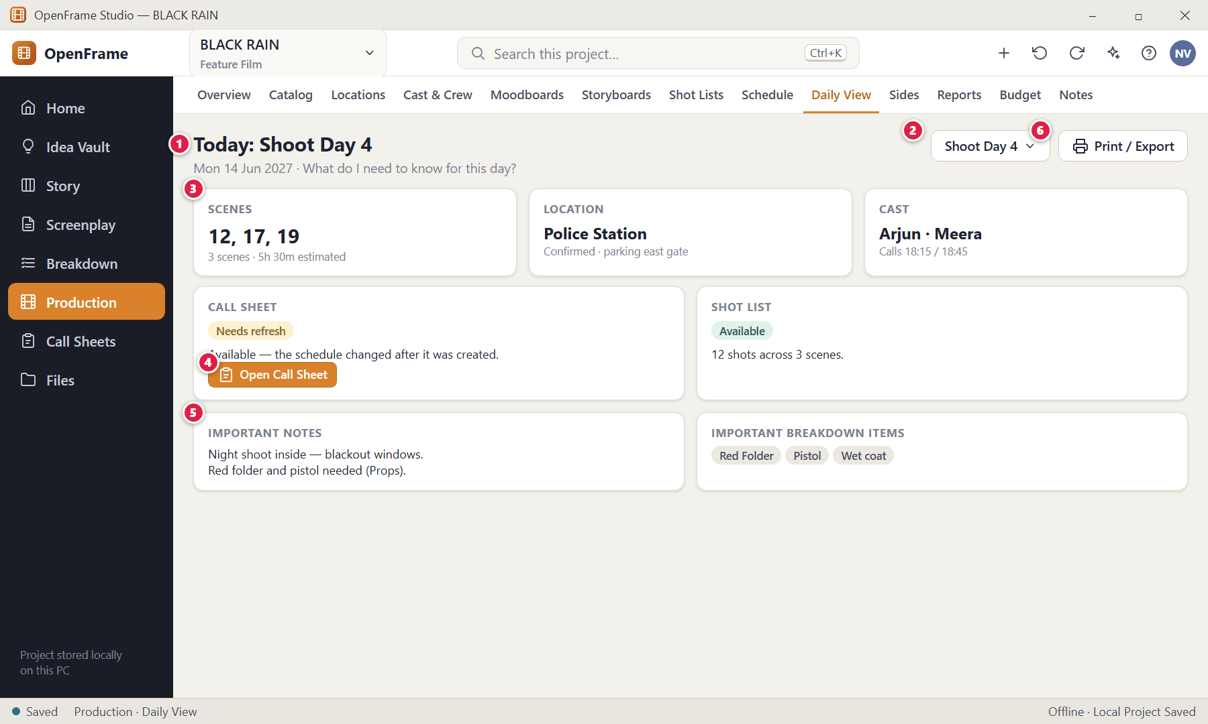
Figure 140. Daily Production View (red numbers are explained on the next page)

Figure 140 — Daily Production View: how it works
PARTS OF THIS SCREEN  1 Day heading — "Today: Shoot Day 4" with the date.  2 Select day — Switch to another shooting day.  3 Scenes, location, cast — Click a scene, person or location to open it.  4 Call sheet — Its status (Available, Needs refresh) and a prominent link to open it.  5 Important notes — Key day notes and important breakdown items.  6 Print / Export — Print or export the summary. | HOW TO USE IT  1. Pick a day, read the summary, click through to what you need.  GOOD TO KNOW · EDGE CASES  - All values come from the selected Shooting Day and linked records. Empty state: "Select or create a shooting day."  - OpenFrame is pre-production focused; this is a light daily screen, not an on-set operations platform.

Figure 141 — Call Sheets list
What it is for. All call sheets, sorted by shooting day, with their state. It answers "Which shooting-day document do I need?"
How to get here. Left navigation → Call Sheets.
Figure 141. Call Sheets list (red numbers are explained on the next page)

Figure 141 — Call Sheets list: how it works
PARTS OF THIS SCREEN  1 Create Call Sheet — Starts a new call sheet from a shooting day.  2 Status filter — Draft · Source changed (needs refresh) · Ready · Finalized · Superseded.  3 Sheets — Each row shows the day, date and a status chip; Open or Export from the row.  4 Needs refresh — This sheet is based on an older schedule version. | HOW TO USE IT  1. Click Create Call Sheet, or open an existing one.  GOOD TO KNOW · EDGE CASES  - Empty state: "Call sheets will appear here after you create shooting days" (with an Open Schedule button); "Create a call sheet from a shooting day." when days exist.  - If a source day is unavailable, the app explains it without deleting the historical call sheet.

Figure 142 — Creating a call sheet from a shooting day
What it is for. A call sheet always starts from one shooting day, so you never re-type the day.
How to get here. Call Sheets → Create Call Sheet, or Shooting Day → Create Call Sheet.
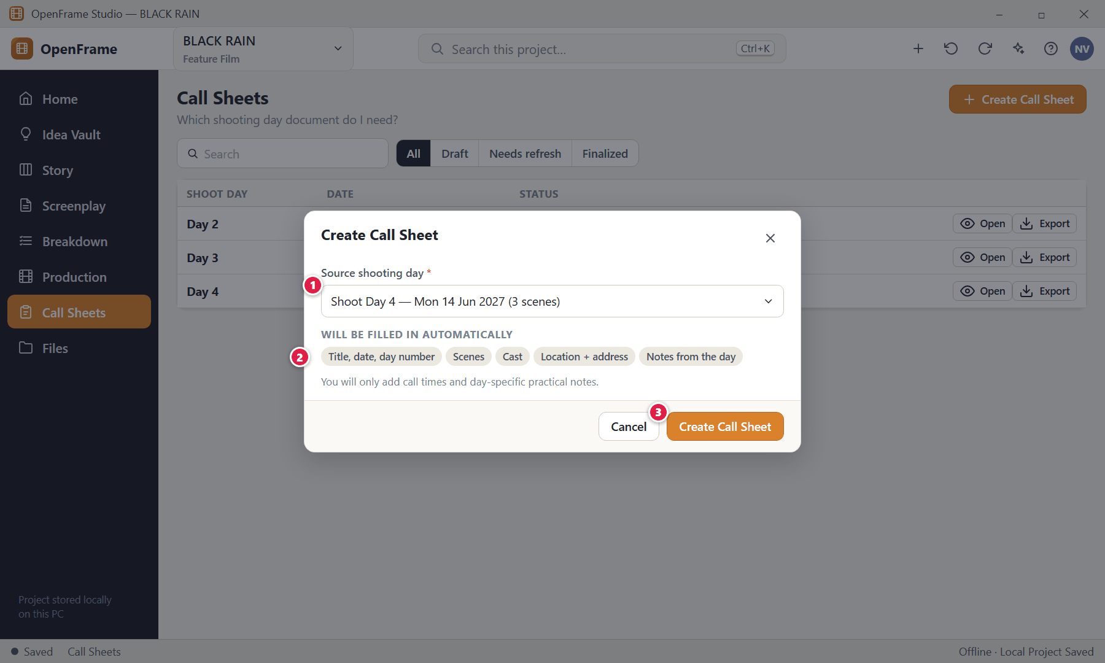
Figure 142. Creating a call sheet from a shooting day (red numbers are explained on the next page)

Figure 142 — Creating a call sheet from a shooting day: how it works
PARTS OF THIS SCREEN  1 Source day — Required: an existing shooting day.  2 Pre-filled content — Scenes, cast, location and selected notes come from the day and your production data.  3 Create Call Sheet — Opens the editor. | HOW TO USE IT  1. Choose the day and click Create Call Sheet.  GOOD TO KNOW · EDGE CASES  - Missing values (for example cast call times) appear as blank placeholders marked "needs input" — they never block the document.

Figure 143 — Call Sheet editor
What it is for. The call sheet is a document-first editor: it looks like the printed page. Prefilled data comes from the shooting day; you edit only the day-specific details.
How to get here. Call Sheets → Open / Create.
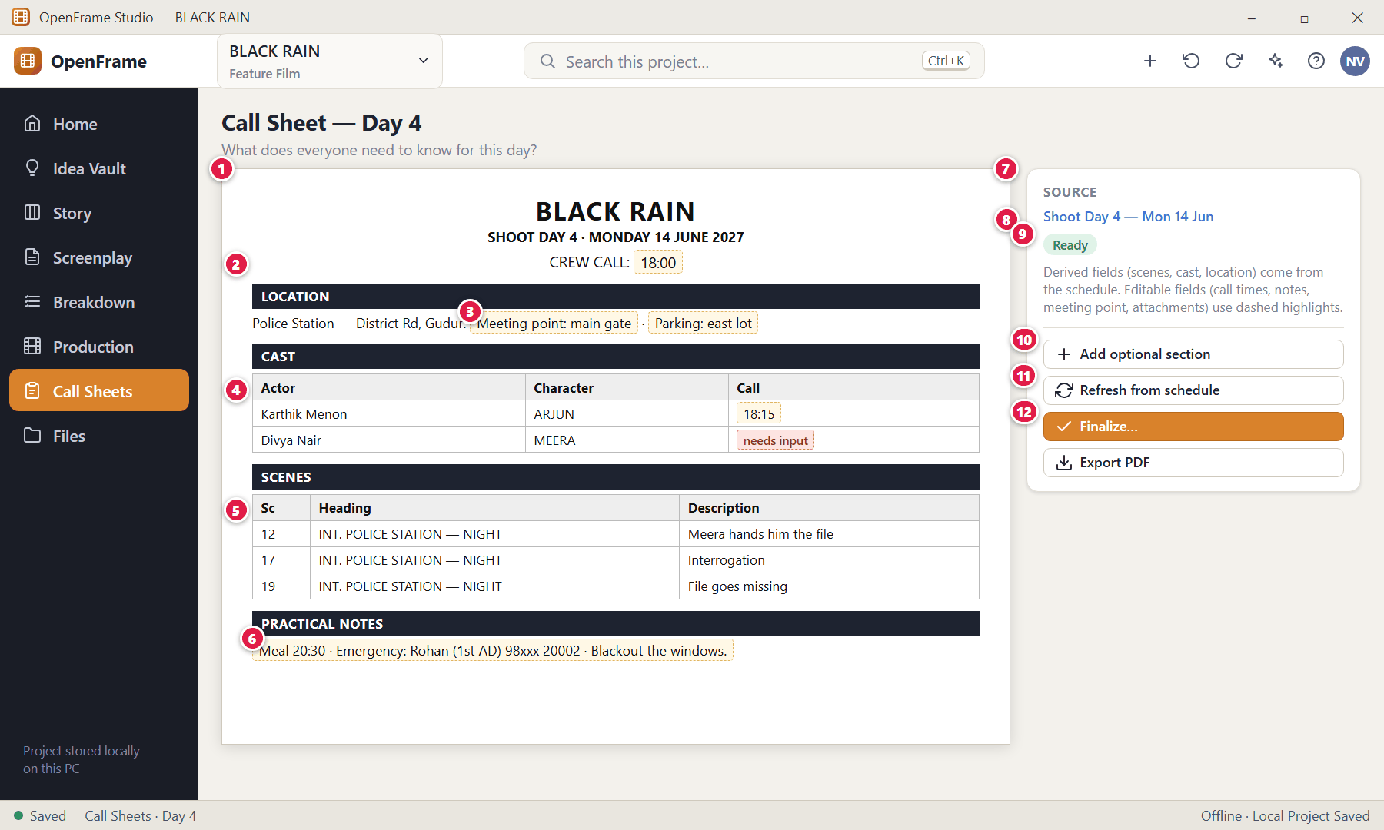
Figure 143. Call Sheet editor (red numbers are explained on the next page)

Figure 143 — Call Sheet editor: how it works
PARTS OF THIS SCREEN  1 The document — Production header, crew call, cast calls, scenes, location and address, practical notes and emergency contacts.  2 Crew call — Edit inline (dashed highlight = editable).  3 Editable fields — Call times, notes, meeting point and attachments are editable.  4 Cast calls — Actor, character and call time. Missing times show a red "needs input" marker.  5 Scenes — Scene number, heading and short description, prefilled.  6 Practical notes — Parking, meeting point, travel notes, meal/break, emergency contacts and production notes.  7 Side panel — Source day and status.  8 Source Day link — Opens the shooting day.  9 Status — Draft · Source changed · Ready · Finalized · Superseded.  10 Add optional section — Weather, attachments, reference images, special notes (hidden until added).  11 Refresh — Pulls in schedule changes after a preview.  12 Finalize… — Marks this version as issued. | HOW TO USE IT  1. Fill in call times and notes directly in the document.  2. Add optional sections if needed.  3. Finalize, then Export PDF.  GOOD TO KNOW · EDGE CASES  - Editing the call sheet never changes the schedule (no reverse sync). If you want the schedule to change, do it in the schedule.  - The PDF is a clean printable page readable on desktop, tablet or phone as a PDF; OpenFrame itself is desktop-only.

Figure 144 — Adding optional call-sheet sections
What it is for. The minimal default hides optional sections until you add them.
How to get here. Call Sheet → Add optional section.
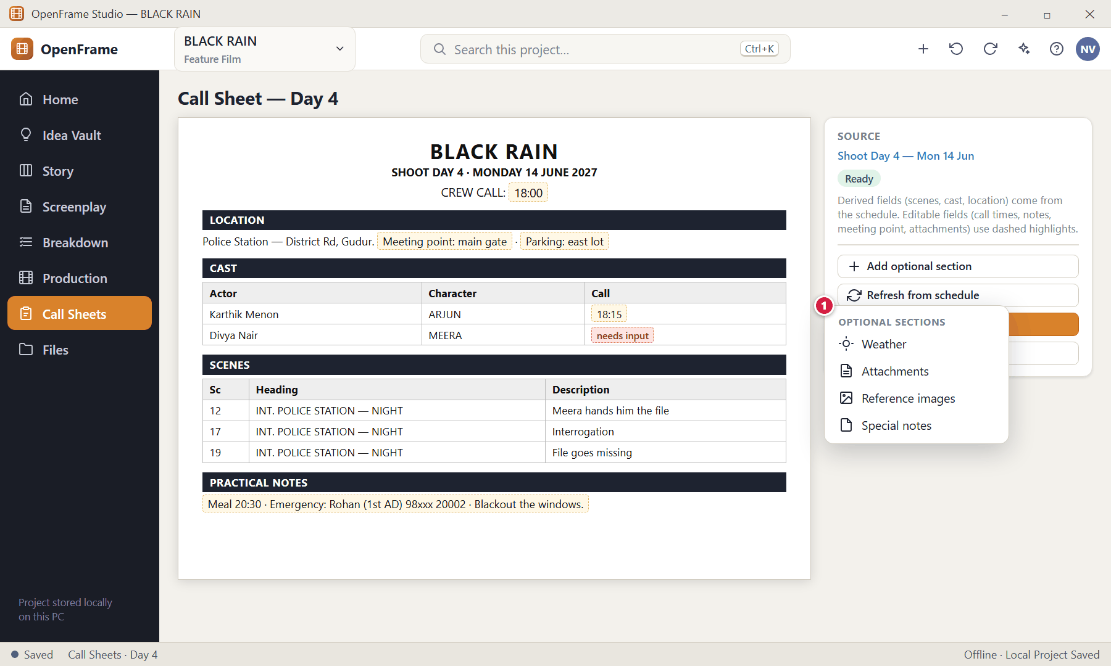
Figure 144. Adding optional call-sheet sections (red numbers are explained on the next page)

Figure 144 — Adding optional call-sheet sections: how it works
PARTS OF THIS SCREEN  1 Optional sections — Weather · Attachments · Reference images · Special notes. | HOW TO USE IT  1. Choose a section; it appears in the document where you can fill it in.  GOOD TO KNOW · EDGE CASES  - You can remove an optional section again at any time.

Figure 145 — Call sheet marked stale after a schedule change
What it is for. When the schedule changes after a call sheet exists, the sheet is marked instead of being silently rewritten.
How to get here. Any move, add, remove or date change on the source day.
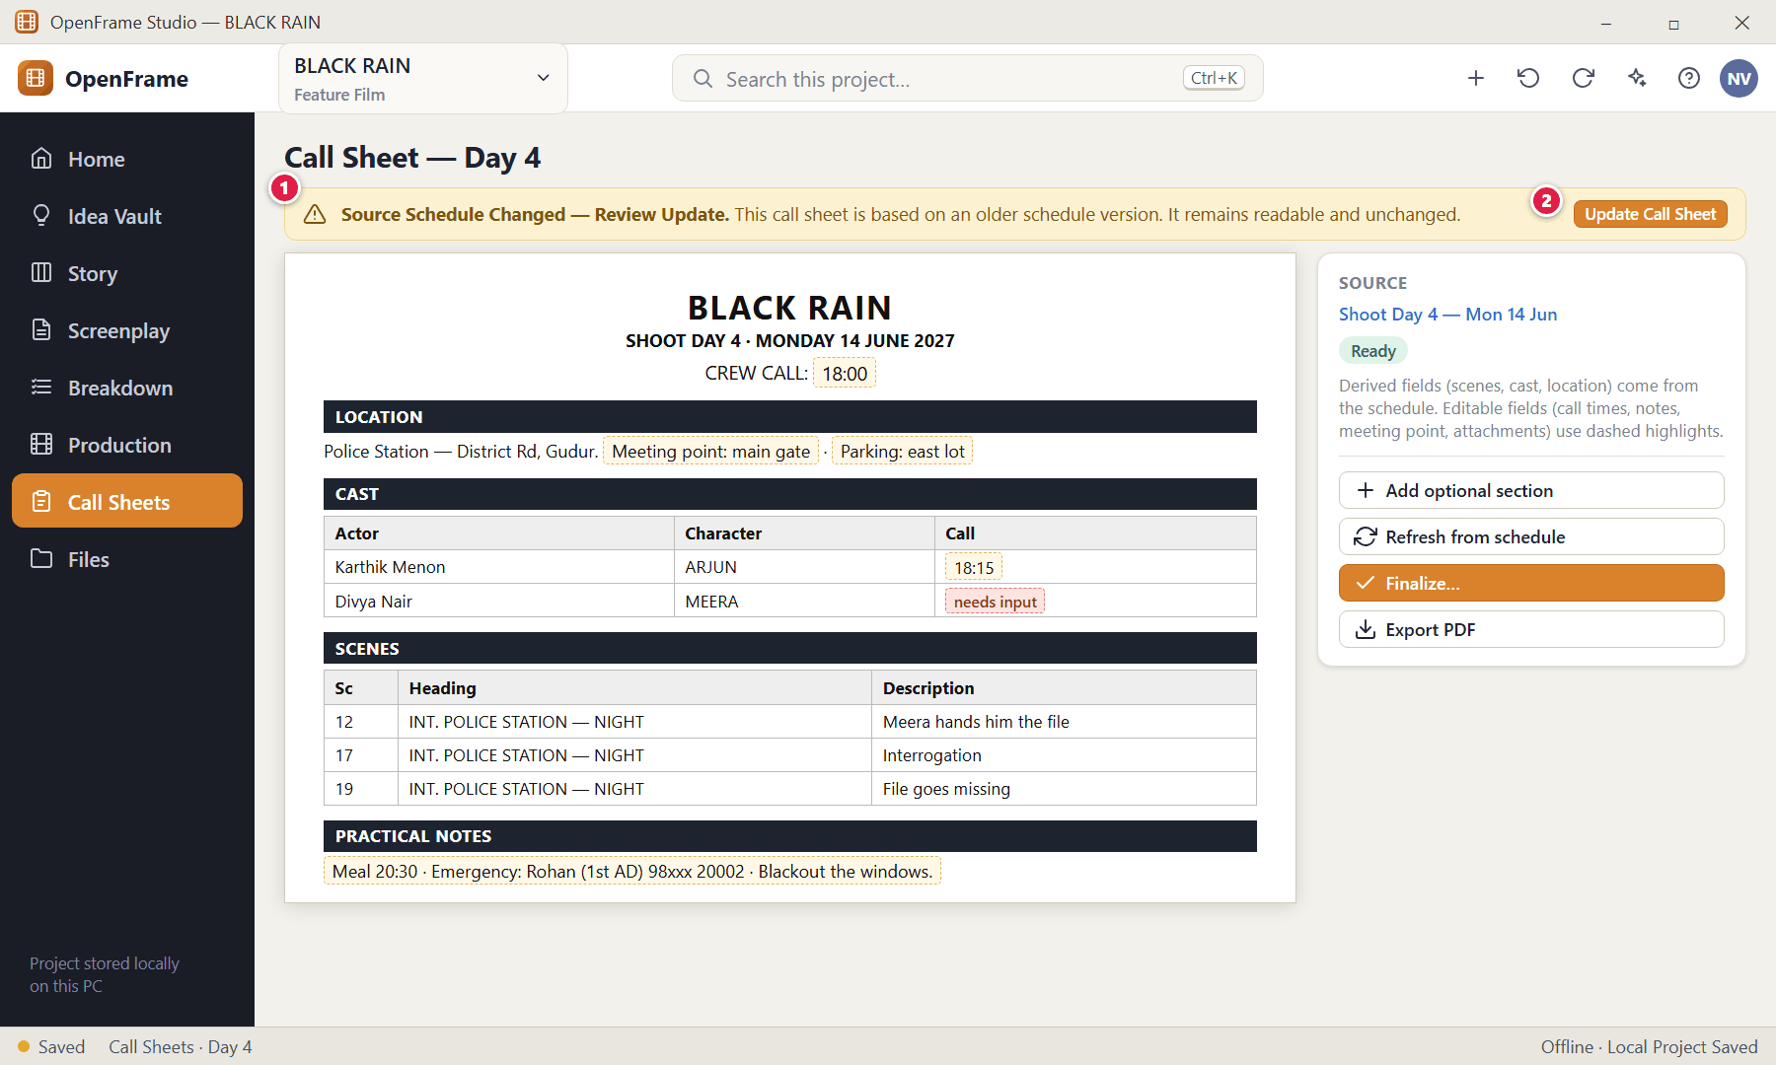
Figure 145. Call sheet marked stale after a schedule change (red numbers are explained on the next page)

Figure 145 — Call sheet marked stale after a schedule change: how it works
PARTS OF THIS SCREEN  1 Stale banner — "Source Schedule Changed — Review Update." Also shown in the list as "Needs refresh".  2 Update Call Sheet — Opens a preview of the differences first. | HOW TO USE IT  1. Click Update Call Sheet to review the changes.  GOOD TO KNOW · EDGE CASES  - Which changes make a call sheet stale: scene moved to another day, scene removed, scene added, cast assignment changed, location changed, schedule date changed. A call-sheet-only note change has no schedule effect.  - A finalized/issued sheet never changes; the newer schedule leads to a new revision.

Figure 146 — Refresh preview before updating a call sheet
What it is for. Refreshing always shows what will change first. There is no overwrite without a preview.
How to get here. Update Call Sheet / Refresh.
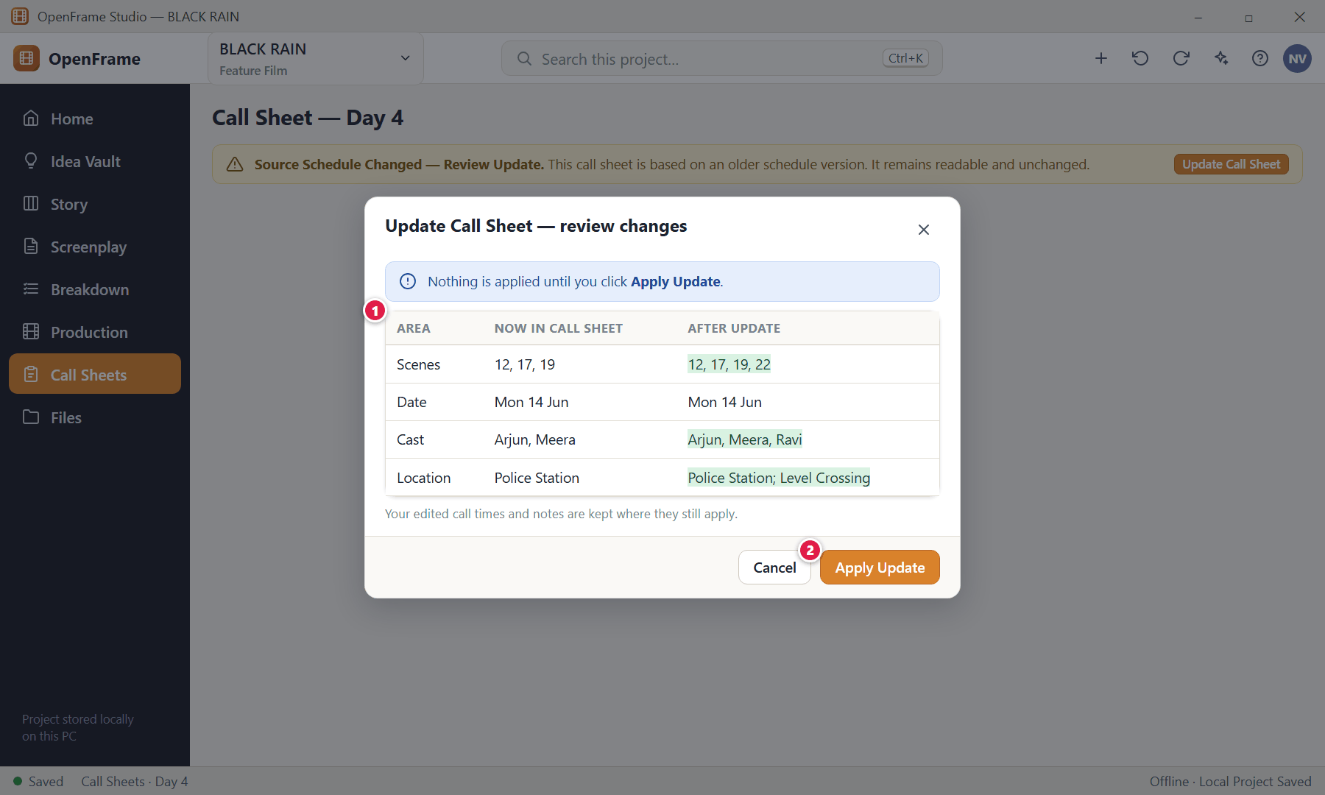
Figure 146. Refresh preview before updating a call sheet (red numbers are explained on the next page)

Figure 146 — Refresh preview before updating a call sheet: how it works
PARTS OF THIS SCREEN  1 Differences — Scenes, date, cast and location that will change.  2 Apply Update — Applies the changes and saves a new snapshot state. | HOW TO USE IT  1. Review the table and click Apply Update, or Cancel.  GOOD TO KNOW · EDGE CASES  - If the refresh is ambiguous or the source mismatches, a review opens rather than overwriting.

Figure 147 — Finalizing and exporting a call sheet
What it is for. Finalize creates a stable day-of snapshot; Export produces the PDF. They are two separate actions on purpose.
How to get here. Call Sheet → Finalize, or Export.
Figure 147. Finalizing and exporting a call sheet (red numbers are explained on the next page)

Figure 147 — Finalizing and exporting a call sheet: how it works
PARTS OF THIS SCREEN  1 Status — Ready before finalizing; afterwards a Finalized badge shows.  2 Preview — A small preview of the outgoing document.  3 Finalize — Marks the sheet as issued (Final). A later change produces a new revision rather than overwriting the issued PDF.  4 Export PDF — Creates the PDF via the Windows Save dialog.  5 Refresh — Update from the schedule first, if needed. | HOW TO USE IT  1. Check the preview, click Finalize, then Export PDF (or Print).  2. Send the PDF by your normal channel (email, messaging app, USB).  GOOD TO KNOW · EDGE CASES  - If a required source value is missing you are returned to the editor with the missing field highlighted. Failed export or finalization keeps your draft intact.  - A finalized sheet shows a Finalized badge and reduced editing affordances; opening it is still possible.

Figure 148 — Sides for a shooting day
What it is for. Sides are the script pages for the scenes scheduled on a day — a natural companion to the call sheet.
How to get here. Shooting Day → Generate Sides, or Production → Sides.
Figure 148. Sides for a shooting day (red numbers are explained on the next page)

Figure 148 — Sides for a shooting day: how it works
PARTS OF THIS SCREEN  1 Setup — Pick the shooting day, the scene set and whether to include cast, revision name and a cover page.  2 Scene set — Tick the scenes to include (defaults to all scenes of the day).  3 Cover page — Optionally include call-sheet information as a cover.  4 Page preview — A clean preview of the script pages.  5 Export PDF — Creates a snapshot PDF. | HOW TO USE IT  1. Choose the day, adjust scenes/cast, and export.  GOOD TO KNOW · EDGE CASES  - Sides show the source draft or revision name so recipients know which version they are reading.  - The document is a snapshot; editing it outside OpenFrame never changes the screenplay. If the source draft cannot be resolved you are asked to choose a valid one.

Figure 149 — Production Reports
What it is for. A few practical reports generated from current data. There are deliberately no dozens of studio reports.
How to get here. Production → Reports.
Figure 149. Production Reports (red numbers are explained on the next page)

Figure 149 — Production Reports: how it works
PARTS OF THIS SCREEN  1 Report picker — Scene Report · Location Report · Cast Scene Report · Prop Report · Schedule Report · Breakdown Completeness (confirmed / suggested / unreviewed by scene).  2 Preview — The report as data.  3 Export / Print — Exports a snapshot or prints it.  4 Read-only — Reports cannot be edited; change the data in its workspace. | HOW TO USE IT  1. Pick a report, apply a filter if needed, export or print.  GOOD TO KNOW · EDGE CASES  - Reports are generated on demand and are not stored as a separate database unless you export them.

Figure 150 — Lightweight budget snapshot (P1)
What it is for. A deliberately small budget view that shows the rough scale of the project and a few category totals. It is not accounting.
How to get here. Production → Budget.
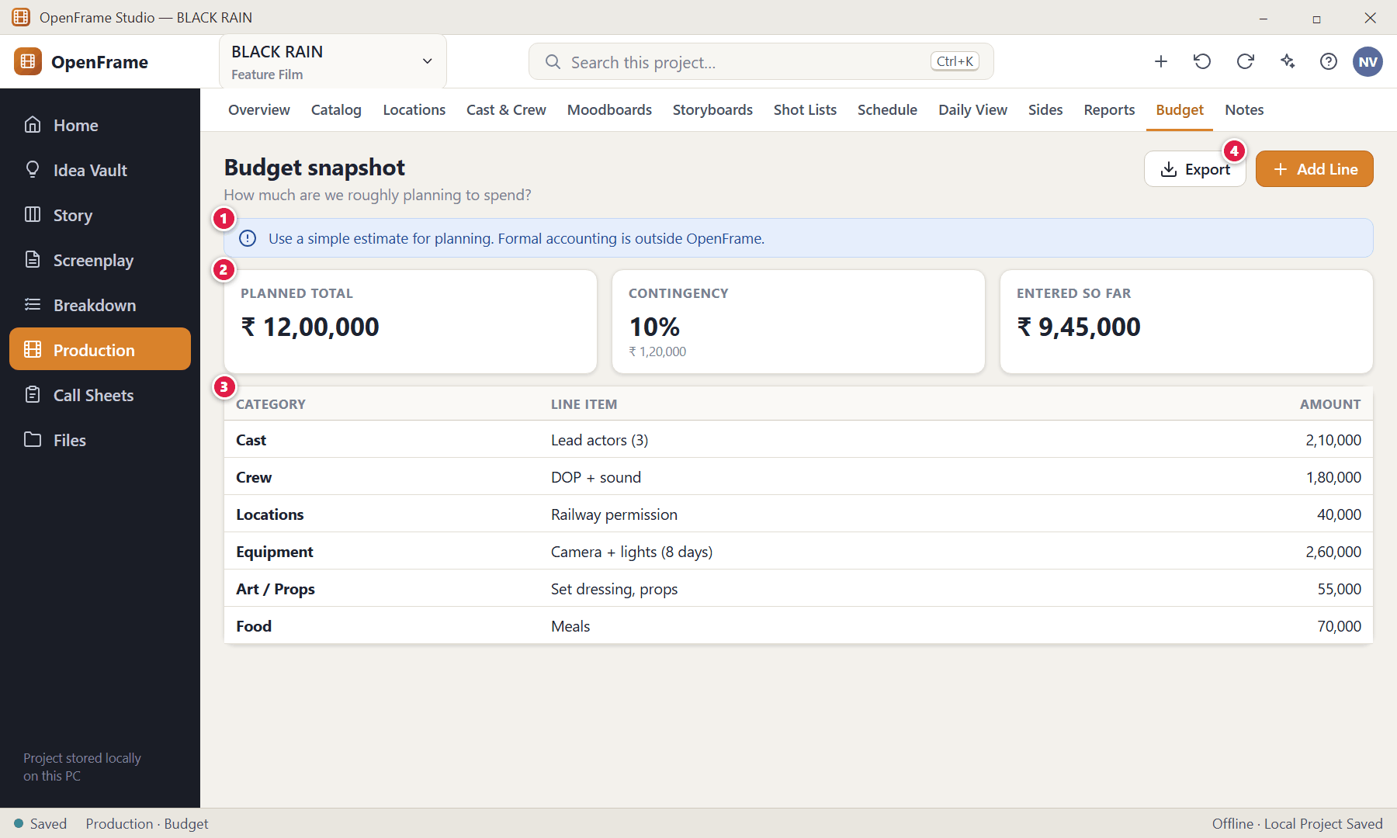
Figure 150. Lightweight budget snapshot (P1) (red numbers are explained on the next page)

Figure 150 — Lightweight budget snapshot (P1): how it works
PARTS OF THIS SCREEN  1 Boundary statement — States that this is a planning estimate, not formal accounting.  2 Summary — Planned total, optional contingency (a percentage or an amount) and the total of lines entered so far.  3 Line items — Description and amount under simple categories: Cast, Crew, Locations, Equipment, Art/Props, Travel/Transport, Food, Post/Other, Contingency.  4 Add Line — A line needs a description and a non-negative amount. | HOW TO USE IT  1. Set the estimate, then add lines under categories.  GOOD TO KNOW · EDGE CASES  - There are no payroll, tax, union, ledger, invoice or purchase-order features. Invalid negative or malformed amounts are rejected without losing valid lines.  - Budget values never change automatically when the script or schedule changes; OpenFrame may only remind you to review the budget. Empty state: "Use a simple estimate for planning. Formal accounting is outside OpenFrame."

Figure 151 — Project Notes and Lightweight Tasks
What it is for. Free-form project notes and a very small task list — only what supports filmmaking.
How to get here. Production → Notes, or Project Home.
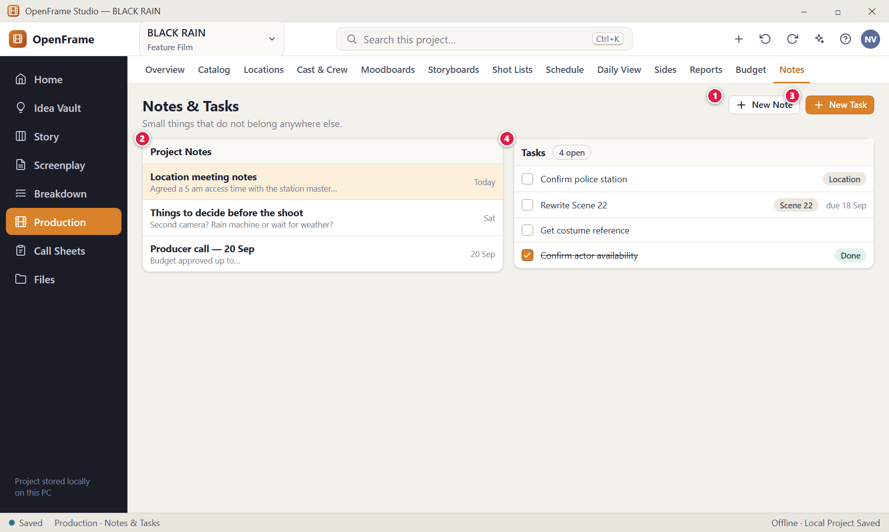
Figure 151. Project Notes and Lightweight Tasks (red numbers are explained on the next page)

Figure 151 — Project Notes and Lightweight Tasks: how it works
PARTS OF THIS SCREEN  1 New Note — Title, body, optional attachment and optional related object.  2 Notes list — Title, preview and last modified. Meeting notes, decisions and reminders. They never appear in formal documents unless exported.  3 New Task — A task needs only a title.  4 Tasks — Optional due date, owner and related object (project, scene, location, breakdown item, shooting day, call sheet, review round). Status is Open or Done. | HOW TO USE IT  1. Add a note or task; tick the box when a task is done (untick to reopen).  GOOD TO KNOW · EDGE CASES  - Completing a task changes only the task, never the related object. There are no dependencies, Gantt charts, time tracking or sprint boards. Deleted tasks and notes are recoverable.  - Empty state (tasks): "Add a small task only when you need to remember an action."

Figure 152 — Activity History
What it is for. A lightweight, read-only record of meaningful events, for orientation — not enterprise auditing.
How to get here. Project Home → Activity, or Production → Activity.
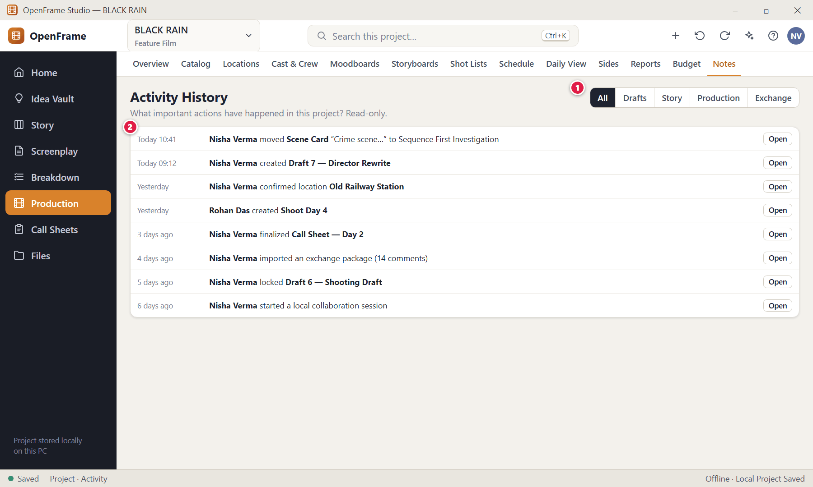
Figure 152. Activity History (red numbers are explained on the next page)

Figure 152 — Activity History: how it works
PARTS OF THIS SCREEN  1 Filter by type — Narrow the list.  2 Events — Actor, action, date/time and affected object. Click Open to jump to it. | HOW TO USE IT  1. Scroll or filter, and open an item to see the affected object.  GOOD TO KNOW · EDGE CASES  - Recorded: project created, draft created/locked, revision started, Scene Card moved between sequences, breakdown source changed, catalog item created, shooting day created, call sheet finalized, exchange import/export, collaboration session start/end and accepted AI changes. Ordinary typing is never listed.  - There is no edit or delete control for normal entries. Empty state: "No major activity yet."

Figure 153 — Template browser (P1)
What it is for. Templates speed up repeated work — project starters, Story Board starters, call sheet layouts, shot-list layouts, moodboards and simple budgets.
How to get here. New Project → From Template, or the Templates command.
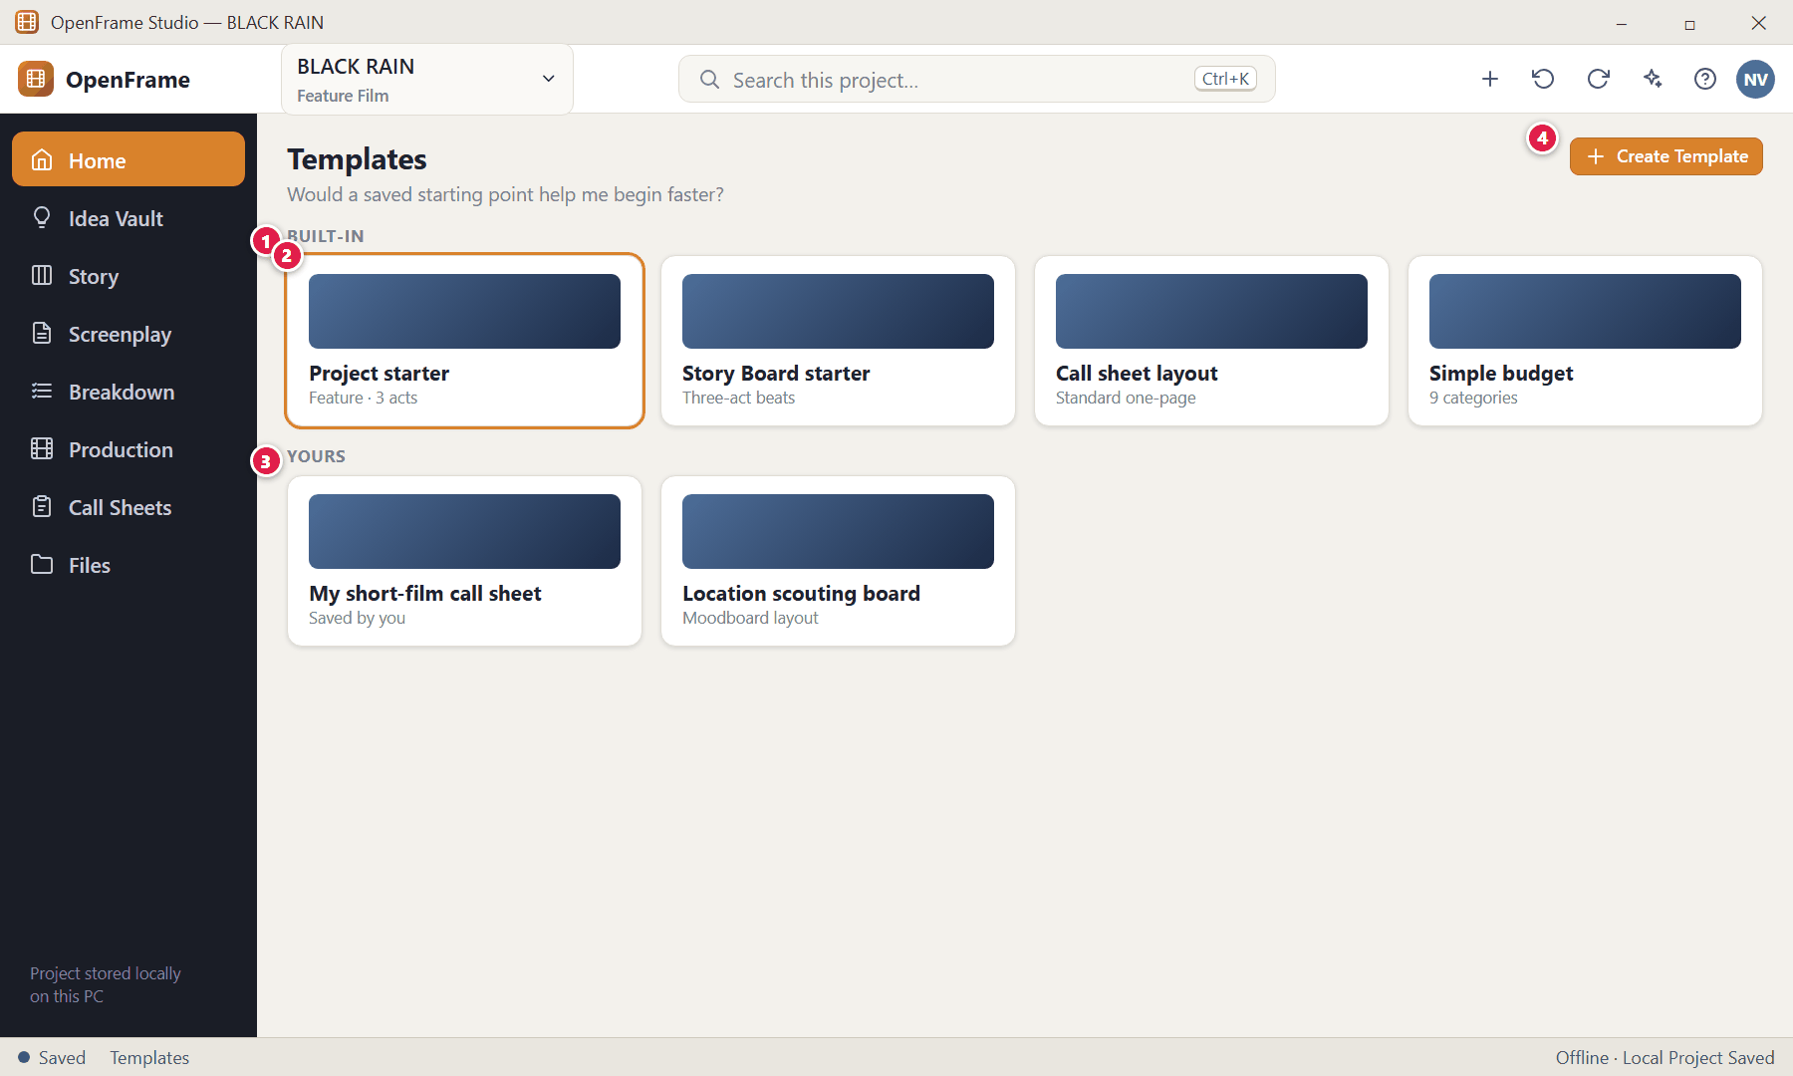
Figure 153. Template browser (P1) (red numbers are explained on the next page)

Figure 153 — Template browser (P1): how it works
PARTS OF THIS SCREEN  1 Built-in templates — A small number of useful starters.  2 Use Template — Preview then Use Template to create independent content.  3 Your templates — Templates you saved from your own configured documents.  4 Create Template — Saves a configured workspace/document as a reusable template. | HOW TO USE IT  1. Preview a template and click Use Template.  GOOD TO KNOW · EDGE CASES  - A project created from a template is independent: editing the template later changes nothing already created. A standard blank project path always remains available. Invalid template content falls back to the normal creation flow.

Figure 154 — Project Files (file cabinet)
What it is for. A simple cabinet for pitch decks, research PDFs, permission scans, externally received schedules and artwork — documents that do not belong to another module.
How to get here. Left navigation → Files, or Project Home → Project Files.
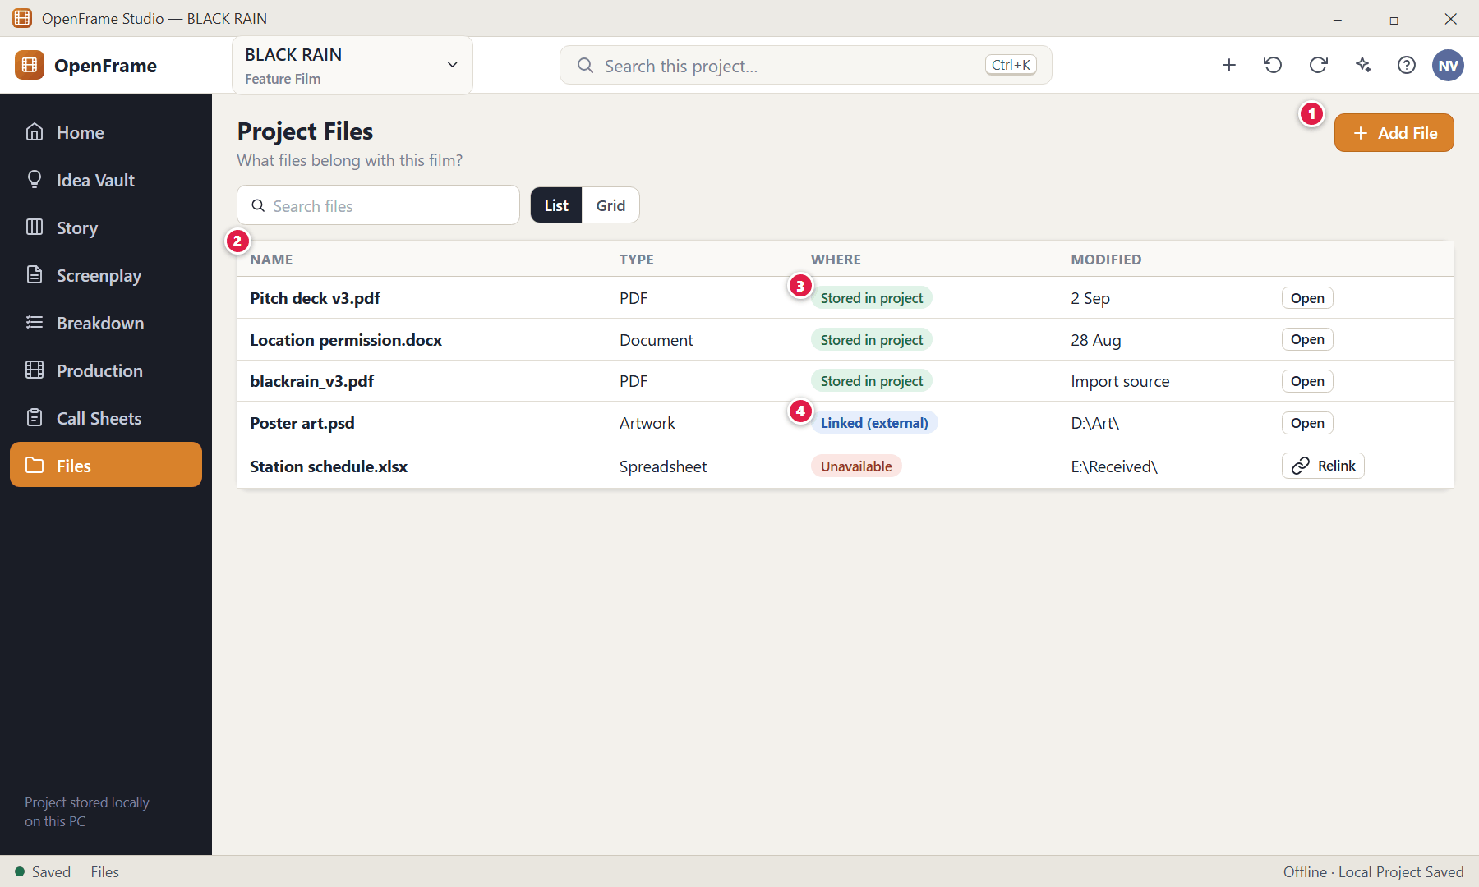
Figure 154. Project Files (file cabinet) (red numbers are explained on the next page)

Figure 154 — Project Files (file cabinet): how it works
PARTS OF THIS SCREEN  1 Add File — Or drag files onto the page.  2 File list — Name, type, where it is and last modified.  3 Stored in project — A file physically kept with the project.  4 Linked (external) — A reference to a file outside the project; OpenFrame warns and offers Relink if it moves or its drive disappears. | HOW TO USE IT  1. Add files, and use Open, Rename, Move to folder, Reveal in File Manager, Export/Copy or Delete (recoverable).  GOOD TO KNOW · EDGE CASES  - Empty state: "Keep project documents and attachments here." Files is not a document-management system and does not duplicate the Idea Vault unless you deliberately do so. An image already used on a moodboard does not appear twice here.  - When you import a screenplay you may keep the original file here.

Figure 155 — Permissions
What it is for. Five simple access levels keep small-team collaboration safe without any enterprise identity management.
How to get here. Project access controls, or when setting up an exchange or LAN session.
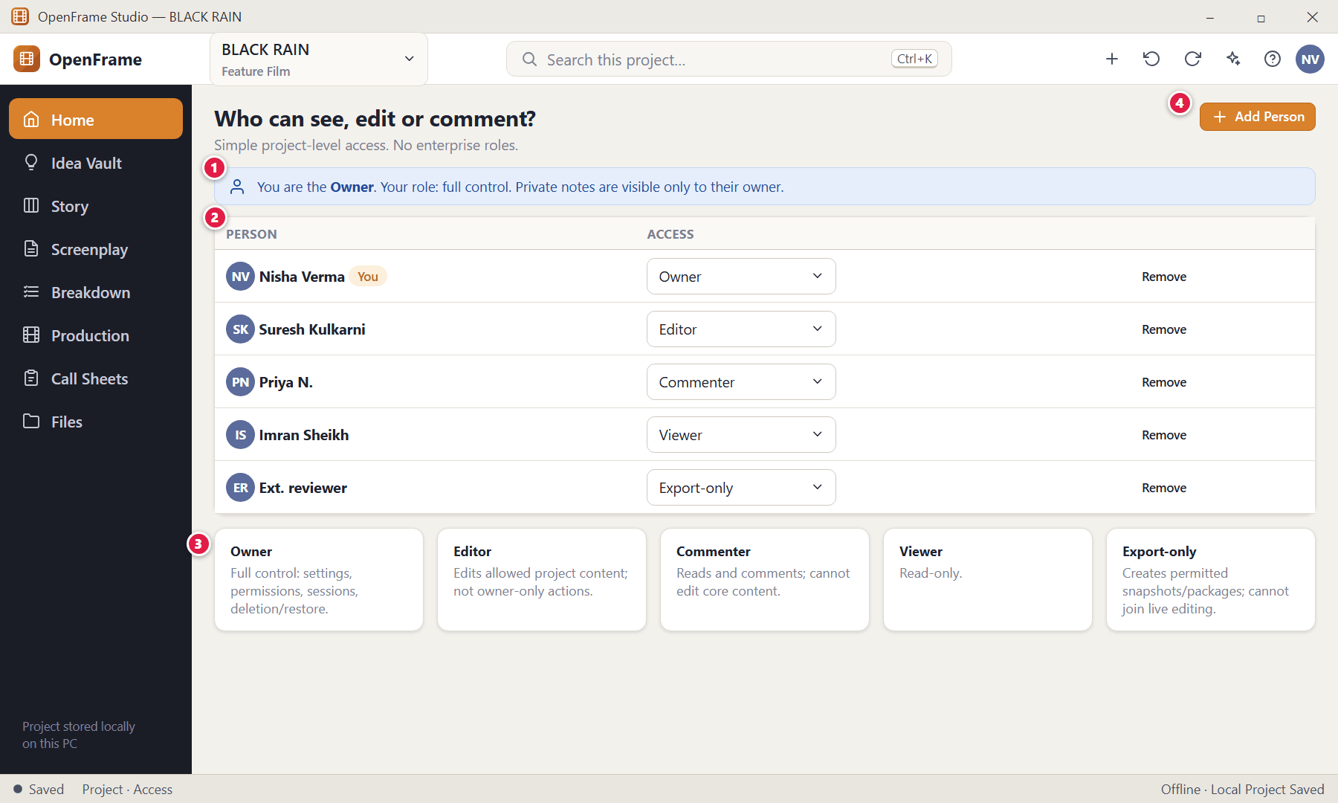
Figure 155. Permissions (red numbers are explained on the next page)

Figure 155 — Permissions: how it works
PARTS OF THIS SCREEN  1 Your role — You always see your own role and the scope of access granted.  2 People and roles — Change a role with the selector; reducing permissions asks for explicit confirmation.  3 The five roles — Owner · Editor · Commenter · Viewer · Export-only.  4 Add Person — Adds a collaborator to the list. | HOW TO USE IT  1. Choose a person's role from the drop-down.  GOOD TO KNOW · EDGE CASES  - Professional responsibilities (Writer, Director, Producer, Assistant Director, Reviewer, Contributor) describe what people do; they are not security roles. One person can be Owner + Writer + Director + Producer.  - Owner-only state simply says "You are the owner." Permissions apply equally to normal use, exchange packages, LAN sessions, import/export and the AI assistant.

Figure 156 — Global project search
What it is for. One search finds anything in the project and tells you where each result lives.
How to get here. Ctrl+K, or click the search box in the top bar.
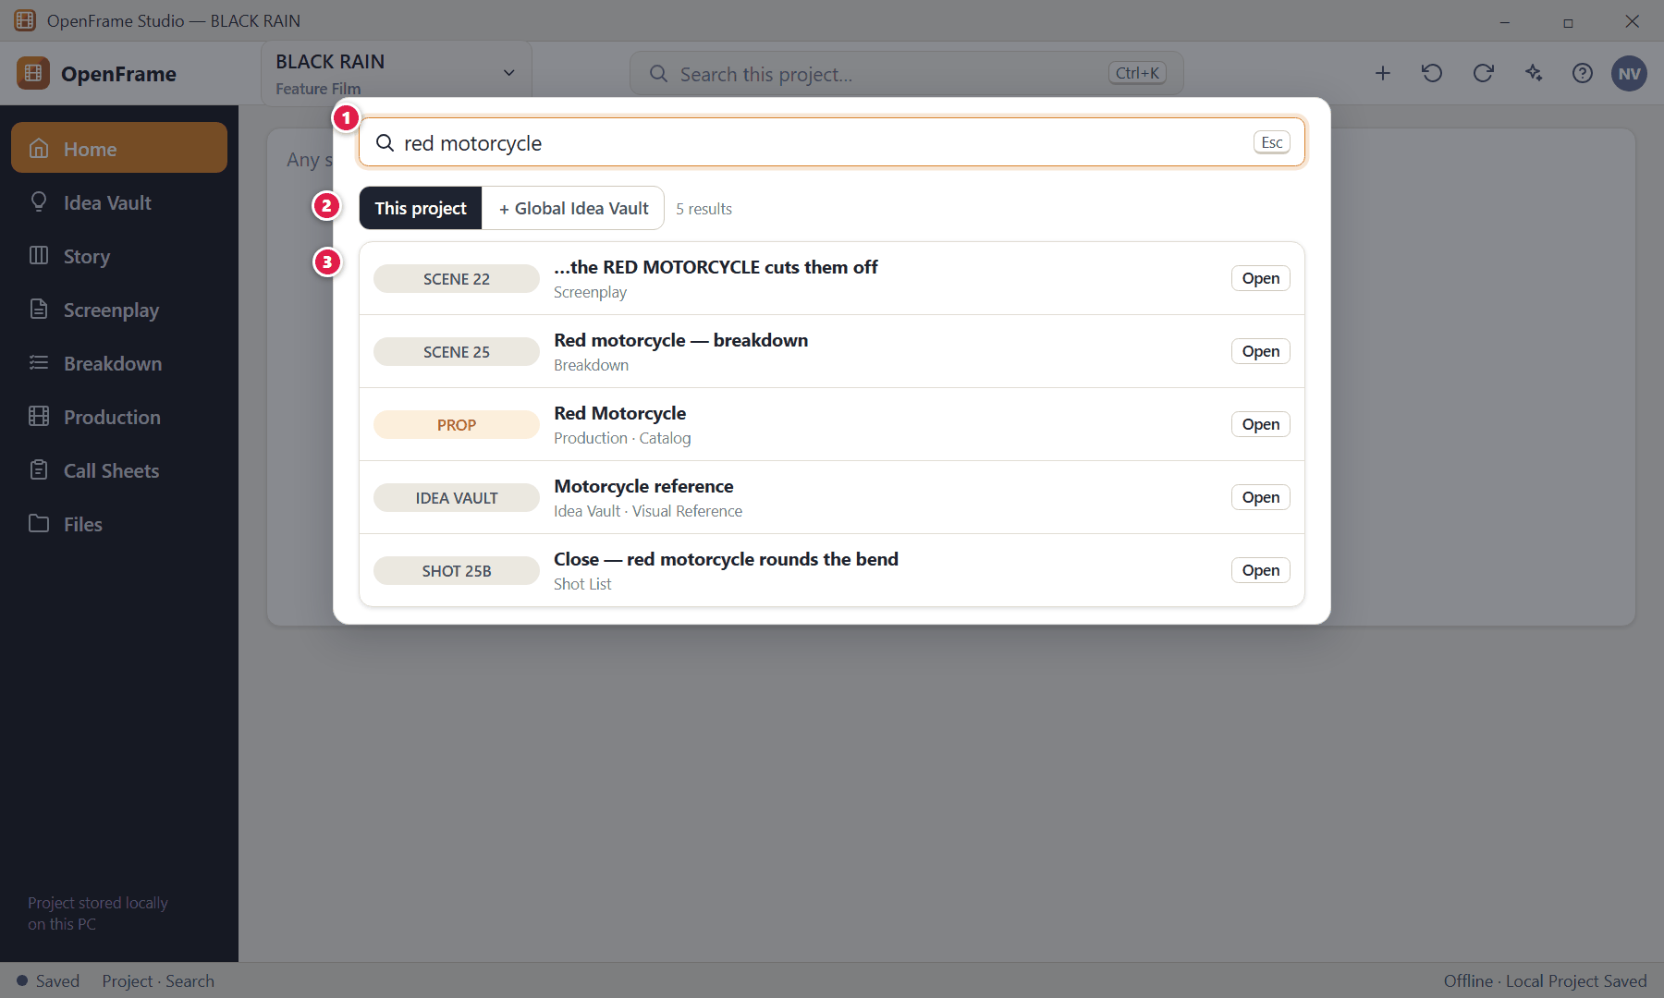
Figure 156. Global project search (red numbers are explained on the next page)

Figure 156 — Global project search: how it works
PARTS OF THIS SCREEN  1 Search box — Type a word or phrase. Plain text search — no semantic guessing.  2 Scope — This project by default; optionally also the Global Idea Vault.  3 Results — Each result shows its type and context, for example "SCENE 22 — Screenplay", "PROP — Red Motorcycle", "IDEA VAULT — Motorcycle reference", "SHOT 25B — Shot List". Click to open the owning page with the match focused. | HOW TO USE IT  1. Press Ctrl+K, type, and click a result.  GOOD TO KNOW · EDGE CASES  - Searchable: Ideas, Acts, Sequences, Beats, Scene Cards, screenplay text, characters, locations, catalog items, cast/crew, shots, storyboards, call sheets, project files and comments.  - This is different from the screenplay Find (Ctrl+F), which searches only the open screenplay, and from Vault search, which searches only the Vault. Results respect permissions and never expose private notes.

Figure 157 — Recently Deleted (whole project)
What it is for. The safety net for every important object: cards, locations, drafts, tasks and files.
How to get here. Files → Recently Deleted (also reachable from the Idea Vault and Story Board).
Figure 157. Recently Deleted (whole project) (red numbers are explained on the next page)

Figure 157 — Recently Deleted (whole project): how it works
PARTS OF THIS SCREEN  1 Deleted items — Each item with its type, when it was deleted and where it was.  2 Restore — Returns it to its previous container and order where possible.  3 Permanent deletion — A second deliberate action with a clear warning. | HOW TO USE IT  1. Click Restore, or Delete Permanently and confirm.  GOOD TO KNOW · EDGE CASES  - Deleting a source object never destroys downstream objects unless you explicitly confirm a cascade. Ctrl+Z also restores a just-deleted item.

Chapter 7 — Collaboration, Backup and Portability
OpenFrame is local-first: your project lives on your PC, works without internet, and is yours to move. Collaboration therefore uses three complementary modes — Solo Local (the default), Exchange Packages (portable files sent by any normal method) and optional Local-Network Collaboration (live editing on the same private network). This chapter also covers backups, moving a whole project to another machine, and what happens when a drive disappears.
Screens in this chapter
Figure 158 The Share / Exchange menu | Figure 166 An active session: presence and soft locks
Figure 159 Exporting a script review package | Figure 167 Resolving an editing conflict
Figure 160 The reviewer opens the package | Figure 168 Disconnected from a session
Figure 161 Importing a response package: preview before applying | Figure 169 Creating a backup
Figure 162 A stale package: version mismatch | Figure 170 Exporting the whole project to move it
Figure 163 Review Queue and Unmatched Review Notes | Figure 171 Importing a project package (identity collision)
Figure 164 Starting a local collaboration session (host) | Figure 172 External drive removed while a project is open
Figure 165 Joining a session (participant) | Figure 173 Working offline

Figure 158 — The Share / Exchange menu
What it is for. Every major workspace can produce a portable, self-contained Exchange Package. This menu is the entry point.
How to get here. Share / Exchange (top of a workspace), or Files → Import Exchange.
Figure 158. The Share / Exchange menu (red numbers are explained on the next page)

Figure 158 — The Share / Exchange menu: how it works
PARTS OF THIS SCREEN  1 Package types — Script review (.ofscriptreview) · Story Board (.ofstory) · Breakdown (.ofbreakdown) · Shot List (.ofshots) · Schedule (.ofschedule) · Call Sheet review (.ofcallreview). File extensions may change in the final product; the idea stays the same. | HOW TO USE IT  1. Pick the package for the workspace you are in, or import one you received.  GOOD TO KNOW · EDGE CASES  - A package can be sent by email, a messaging app, USB, a file-sharing service or any other ordinary method — OpenFrame does not own the transport and no OpenFrame account or cloud is needed.  - A review package is a snapshot: it never live-syncs with your project.

Figure 159 — Exporting a script review package
What it is for. Create a package your reviewer can read and comment on without receiving your whole project.
How to get here. Share → Export Review Package.
Figure 159. Exporting a script review package (red numbers are explained on the next page)

Figure 159 — Exporting a script review package: how it works
PARTS OF THIS SCREEN  1 Source draft — The draft the reviewer will read.  2 Scope — Script only, script + comments, or specific scenes only.  3 Include — Comments and optional attachments. Private notes cannot be included in an ordinary external review package.  4 What is inside — Project name, review target, draft/version, who exported it, date and included content. This is also what the reviewer sees.  5 Export Package… — Choose where to save the file, then send it any way you like. | HOW TO USE IT  1. Choose the draft and scope, tick options, click Export Package….  2. Send the file to the reviewer by email, chat or USB.  GOOD TO KNOW · EDGE CASES  - Reviewer isolation: a script review need not contain production data; a breakdown review need not contain the writer's private notes; a shot list review need not contain the whole Idea Vault.  - Exporting does not change the draft or its status.

Figure 160 — The reviewer opens the package
What it is for. On the reviewer's own PC the package opens with a clear banner so there is no doubt it is a review copy, not the original project.
How to get here. Reviewer: Files → Import Exchange, then open the package.
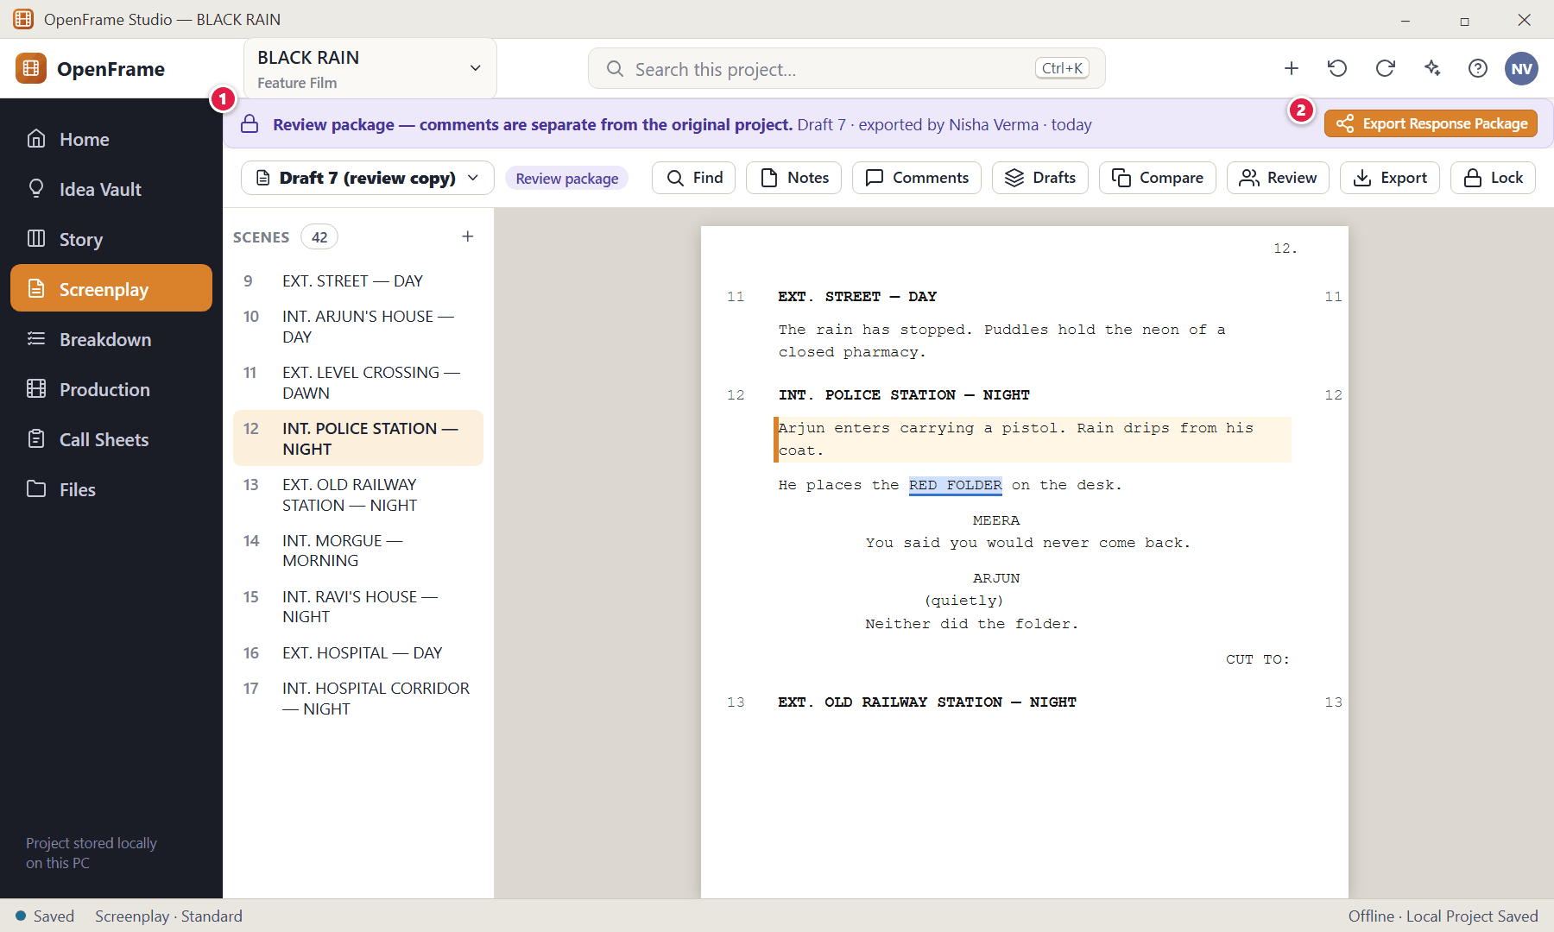
Figure 160. The reviewer opens the package (red numbers are explained on the next page)

Figure 160 — The reviewer opens the package: how it works
PARTS OF THIS SCREEN  1 Review banner — "Review package — comments are separate from the original project."  2 Export Response Package — When the reviewer has finished commenting, this creates a small response file to send back. | HOW TO USE IT  1. Read the script, select text and add comments as usual.  2. Click Export Response Package and send it back to the author.  GOOD TO KNOW · EDGE CASES  - The reviewer can read, annotate, comment and mark notes; what else they may do depends on what the package allows.

Figure 161 — Importing a response package: preview before applying
What it is for. Every exchange import passes through validation and a change preview. Nothing is applied until you choose.
How to get here. Files → Import Exchange, or Share → Import Exchange Package….
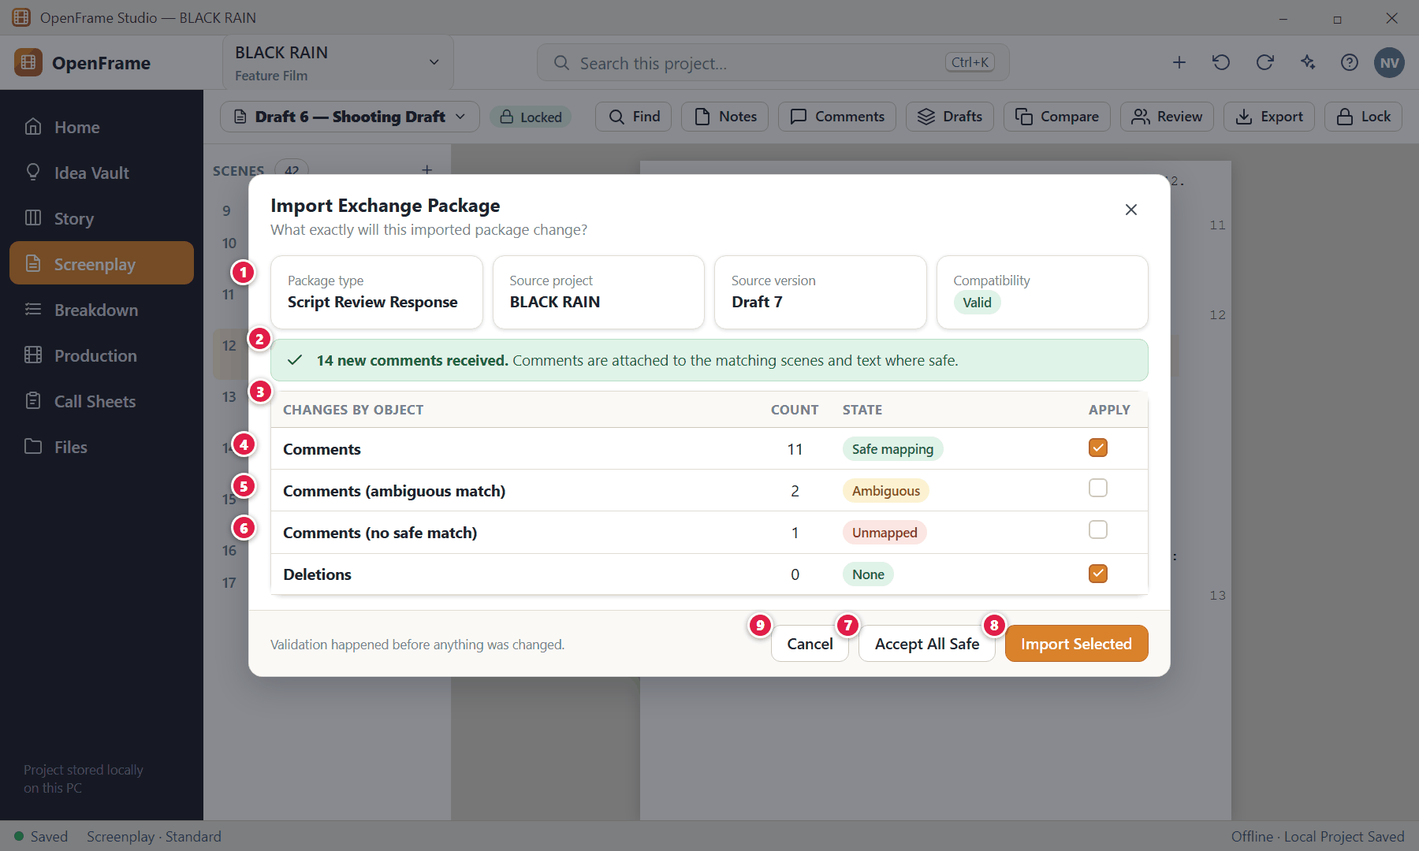
Figure 161. Importing a response package: preview before applying (red numbers are explained on the next page)

Figure 161 — Importing a response package: preview before applying: how it works
PARTS OF THIS SCREEN  1 Package facts — Package type, source project, source version and compatibility.  2 Received — "14 new comments received."  3 Changes by object — A grouped summary such as: 14 comments · 3 new Scene Cards · 1 changed scene description · 2 new Shots · 0 deletions.  4 Safe mapping — Matched by scene identity or exact text anchor — safe to apply.  5 Ambiguous — More than one plausible match; goes to the Review Queue.  6 Unmapped — No safe match; kept as an Unmatched Review Note.  7 Accept All Safe — Selects only the safe items.  8 Import Selected — Applies what is ticked.  9 Cancel — Leaves your project completely unchanged. | HOW TO USE IT  1. Read the summary, tick what you want, click Import Selected (or Accept All Safe).  GOOD TO KNOW · EDGE CASES  - Validation failure means zero project mutation. Import options can be granular: import all safe, comments only, selected items, copy as new, review ambiguous, cancel.  - Import results are honest: Applied, Partially Applied, Pending Review, Rejected or Failed — never "Import complete" if only a subset was applied. Example: "Import finished partially. 14 comments were applied; 3 scene changes remain in Review."  - If the package refers to an object you have since deleted, you are told and given a safe choice; nothing is silently recreated.

Figure 162 — A stale package: version mismatch
What it is for. If the reviewer worked on an older draft than your current one, OpenFrame shows both versions and protects your current work.
How to get here. Import Exchange when the package is based on an older draft.
Figure 162. A stale package: version mismatch (red numbers are explained on the next page)

Figure 162 — A stale package: version mismatch: how it works
PARTS OF THIS SCREEN  1 The mismatch — "This review was created from Draft 3. Your current project is Draft 4."  2 Your options — View the review without importing · import comments only (default) · create a separate review record · compare versions.  3 Continue — Does the selected option. | HOW TO USE IT  1. Choose an option and click Continue.  GOOD TO KNOW · EDGE CASES  - A response package can never silently overwrite the draft; the default action is comments-only or a separate review record.

Figure 163 — Review Queue and Unmatched Review Notes
What it is for. Comments that cannot be placed automatically are kept here until you place them.
How to get here. Import preview → Open Review Queue, or the Review Queue link in Review.
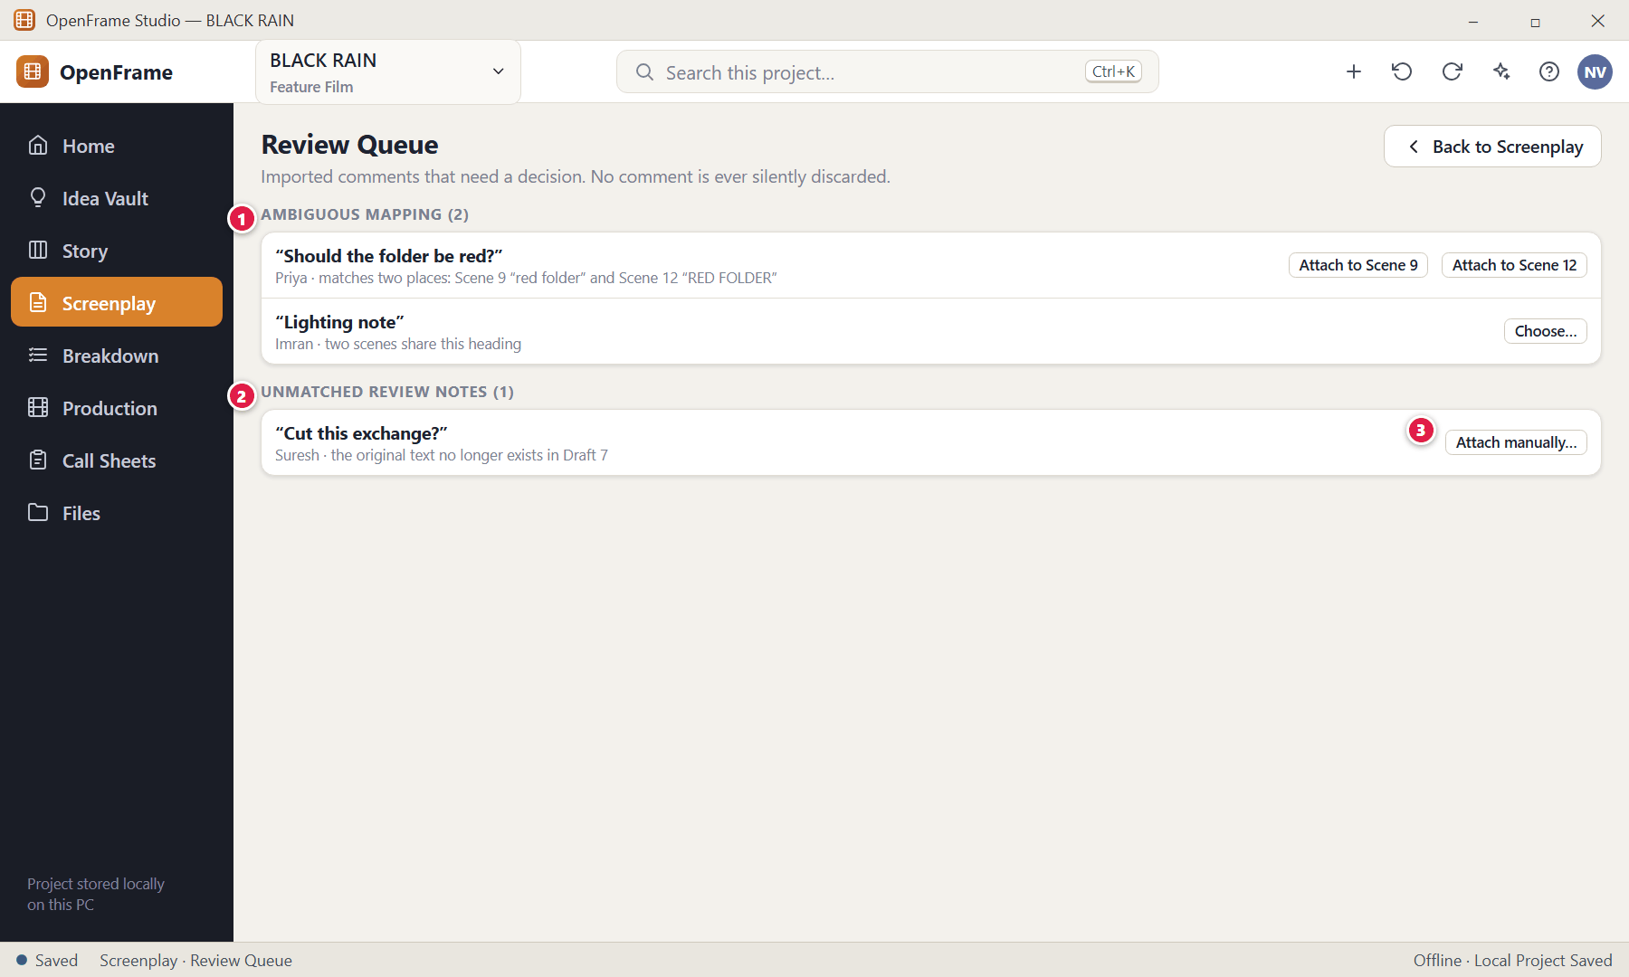
Figure 163. Review Queue and Unmatched Review Notes (red numbers are explained on the next page)

Figure 163 — Review Queue and Unmatched Review Notes: how it works
PARTS OF THIS SCREEN  1 Ambiguous — Choose which scene/text the comment belongs to.  2 Unmatched Review Notes — Comments with no safe match. They stay visible; you attach them manually.  3 Attach manually… — Pick the correct scene or text. | HOW TO USE IT  1. Attach each note to the right place, or leave it in the queue.  GOOD TO KNOW · EDGE CASES  - Mapping order OpenFrame follows: same object identity → same text anchor → clear heading/context match → otherwise queue → otherwise Unmatched. It never invents an attachment point.

Figure 164 — Starting a local collaboration session (host)
What it is for. One machine hosts a temporary session on your private network. No OpenFrame cloud is involved and the project stays local.
How to get here. Project → Start Collaboration Session.
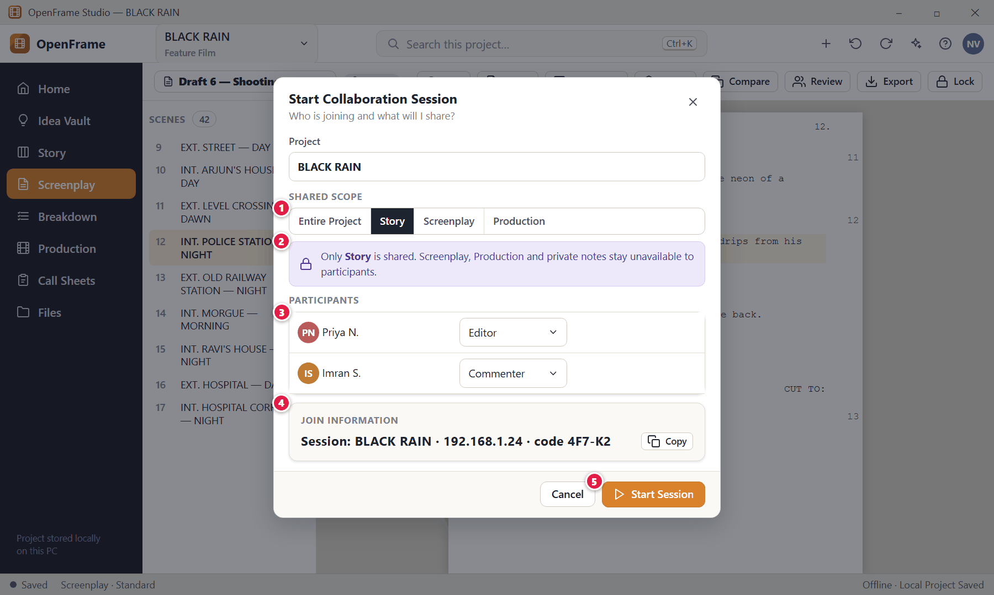
Figure 164. Starting a local collaboration session (host) (red numbers are explained on the next page)

Figure 164 — Starting a local collaboration session (host): how it works
PARTS OF THIS SCREEN  1 Shared scope — Entire Project · Story · Screenplay · Production. Scope controls what participants can even see.  2 Scope enforcement — If you share Story only, private screenplay/production material stays unavailable — even to their AI assistant.  3 Participant roles — Assign roles (Editor, Commenter, Viewer). Export-only people cannot enter a live session.  4 Join information — What others need to join from their own OpenFrame. Copy it and share it.  5 Start Session — Begins the session. A session bar appears in the shell. | HOW TO USE IT  1. Choose the scope, assign roles, click Start Session, and share the join information.  GOOD TO KNOW · EDGE CASES  - If the session fails to start, solo local work is not blocked. A session is temporary and is not a permanent project permission; ending it does not upload or publish anything.  - Session lifecycle: Not running → Host starting → Running → Participant joined → Participant active → Participant disconnected → Session ended.

Figure 165 — Joining a session (participant)
What it is for. A participant joins with a name and immediately sees their role and the scope of access.
How to get here. Join Local Session.
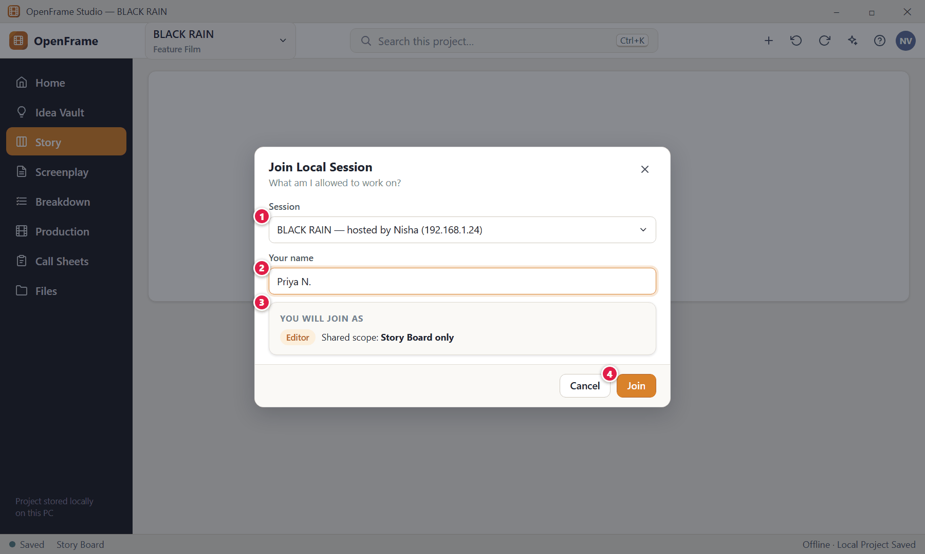
Figure 165. Joining a session (participant) (red numbers are explained on the next page)

Figure 165 — Joining a session (participant): how it works
PARTS OF THIS SCREEN  1 Session — Choose the session found on your network (or enter the join information).  2 Your name — Shown to others while you work.  3 Role and scope — Your assigned role and the shared scope. You see only that scope.  4 Join — Enters the shared workspace. | HOW TO USE IT  1. Pick the session, enter your name, click Join.  GOOD TO KNOW · EDGE CASES  - If joining fails, no local project content is changed.

Figure 166 — An active session: presence and soft locks
What it is for. During a session you see who else is working and where, so two people do not unknowingly overwrite each other.
How to get here. While a session is running.
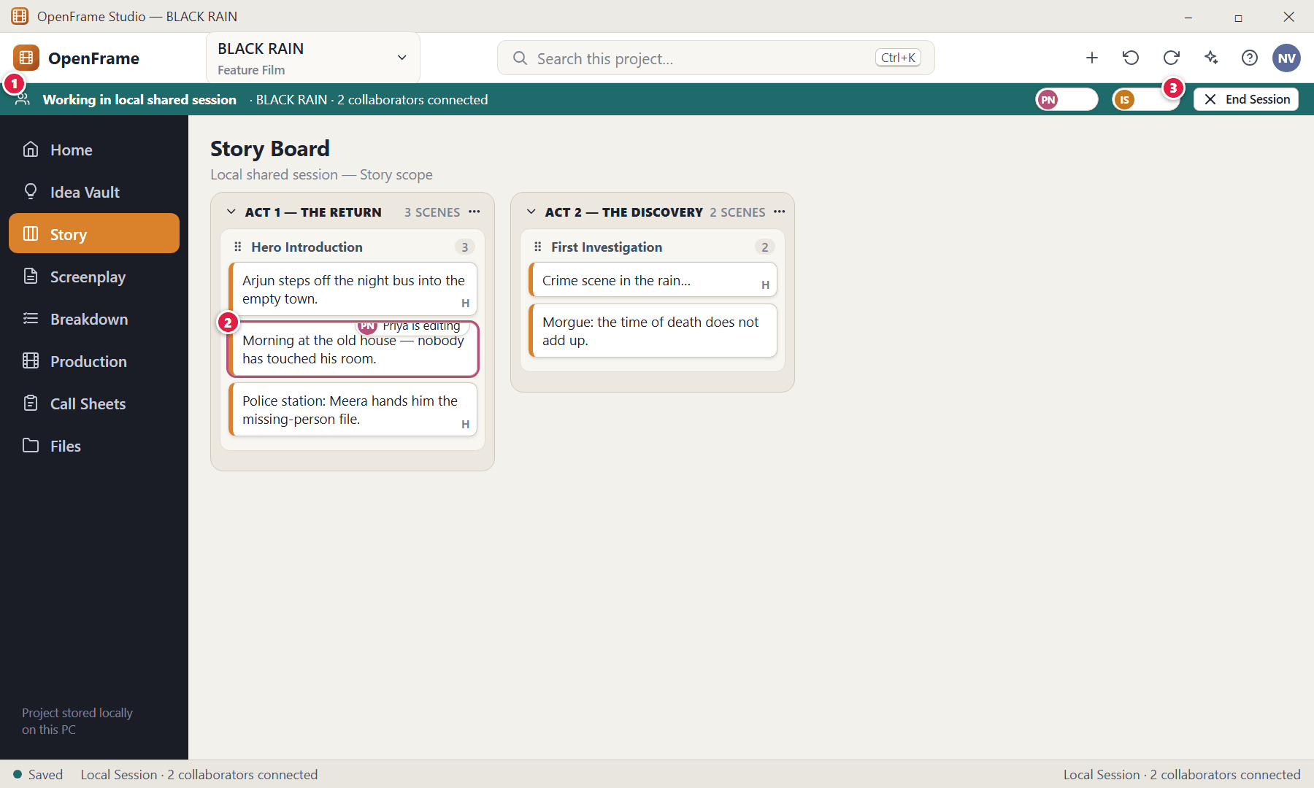
Figure 166. An active session: presence and soft locks (red numbers are explained on the next page)

Figure 166 — An active session: presence and soft locks: how it works
PARTS OF THIS SCREEN  1 Session bar — "Working in local shared session" with connected collaborators and (for the host) End Session.  2 Soft lock / presence — A small label such as "Priya is editing" appears on the object being edited.  3 End Session — Host only. Ends the shared session; each machine keeps its project local and saved. | HOW TO USE IT  1. Work as normal; changes to different objects merge automatically.  2. If an object shows "X is editing", work elsewhere or wait.  GOOD TO KNOW · EDGE CASES  - Soft locks never permanently lock anyone out: they expire when a participant disconnects and an authorised host can release a stale lock.  - Concurrent edits: different objects merge; different fields of the same object are both kept (for example description and notes); the same text region creates a visible conflict.  - Private notes stay private during a session.

Figure 167 — Resolving an editing conflict
What it is for. If two people change exactly the same text at once, OpenFrame shows both and asks you to decide. It never keeps "the last one to arrive".
How to get here. Appears when concurrent edits cannot be combined safely.
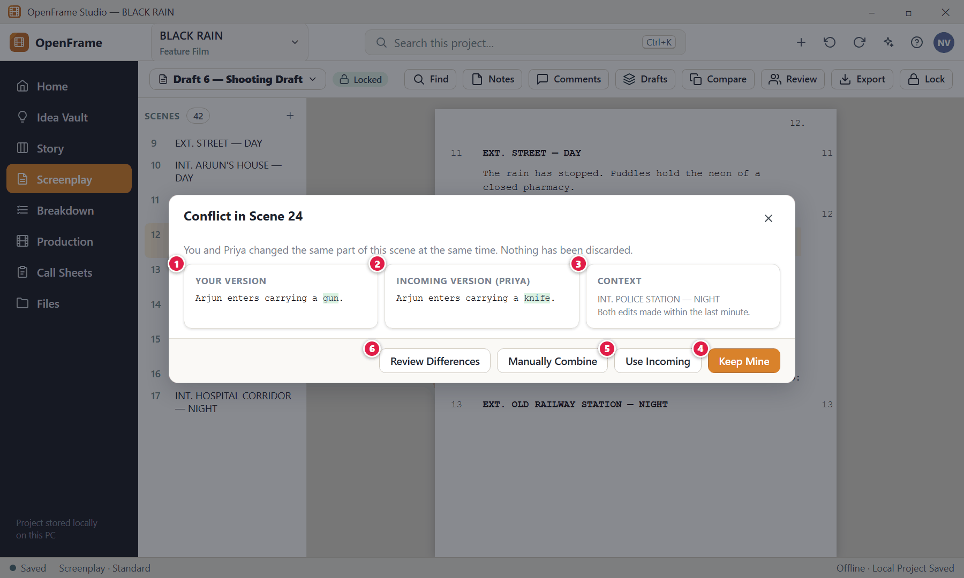
Figure 167. Resolving an editing conflict (red numbers are explained on the next page)

Figure 167 — Resolving an editing conflict: how it works
PARTS OF THIS SCREEN  1 Your version — What you typed.  2 Incoming version — What the other person typed.  3 Context — Where the conflict is.  4 Keep Mine — Keep your version.  5 Use Incoming — Take theirs.  6 Review Differences — See a detailed comparison; Manually Combine lets you write a merged version. | HOW TO USE IT  1. Compare, then choose one of the buttons.  GOOD TO KNOW · EDGE CASES  - No silent last-write-wins: a collaborator's change is never discarded merely because another change arrived later.

Figure 168 — Disconnected from a session
What it is for. If the network drops, everyone's local work stays safe and you are told plainly what happened.
How to get here. Appears if a participant or the host loses the connection.
Figure 168. Disconnected from a session (red numbers are explained on the next page)

Figure 168 — Disconnected from a session: how it works
PARTS OF THIS SCREEN  1 Session unavailable — Says the shared session is unavailable — never that the project is deleted.  2 Rejoin — Reconnects; unresolved conflicts are shown for review rather than silently resolved.  3 Export recovery package — Saves your unacknowledged changes as an exchange file you can send to the host.  4 Local work — Retained on your machine. | HOW TO USE IT  1. Rejoin when the network is back, or export a recovery package.  GOOD TO KNOW · EDGE CASES  - A participant who kept working while disconnected does not overwrite the host on reconnection; divergent work goes through the same safe import and conflict review as exchange packages.  - If the host disconnects, participants are informed; the host retains the latest local project.

Figure 169 — Creating a backup
What it is for. A backup is a recovery-oriented copy of your project, separate from the live project.
How to get here. Status strip → Create backup, or Project → Backup.
Figure 169. Creating a backup (red numbers are explained on the next page)

Figure 169 — Creating a backup: how it works
PARTS OF THIS SCREEN  1 Destination — Pick a folder — ideally on another disk. The default name includes the project name, date/time and an optional label.  2 What is included — Honest classification: Included, External (linked files not copied) and Missing. A backup never claims to have backed up external files it did not copy.  3 Create Backup — Writes the backup package. | HOW TO USE IT  1. Choose the destination and click Create Backup.  GOOD TO KNOW · EDGE CASES  - OpenFrame may also offer "Create Backup Before Import" before a risky import, and it offers automatic local backup versions. Backups work fully offline.  - A backup is not a review package and not an ordinary document export; private notes may be included because it is a private recovery copy.

Figure 170 — Exporting the whole project to move it
What it is for. Full Project Package = the whole project, ready to open on another machine. You own the project and can always move it.
How to get here. Project Home → Export project… (Project → Export Full Project).
Figure 170. Exporting the whole project to move it (red numbers are explained on the next page)

Figure 170 — Exporting the whole project to move it: how it works
PARTS OF THIS SCREEN  1 What is included — Every workspace and the project files, plus a manifest of external references.  2 Package class — The dialog states this is a private project transfer so it is never confused with a review package.  3 Export Project Package… — Writes the package. | HOW TO USE IT  1. Tick what to include and click Export Project Package….  2. Copy the file to the other PC (USB, cloud drive, network share).  GOOD TO KNOW · EDGE CASES  - The PRD calls this the "Project Archive"; the later specifications call it the "Full Project Package" — same thing. This works offline.

Figure 171 — Importing a project package (identity collision)
What it is for. Opening a package that matches a project you already have never silently replaces your work.
How to get here. Home → Open Project → choose a package.
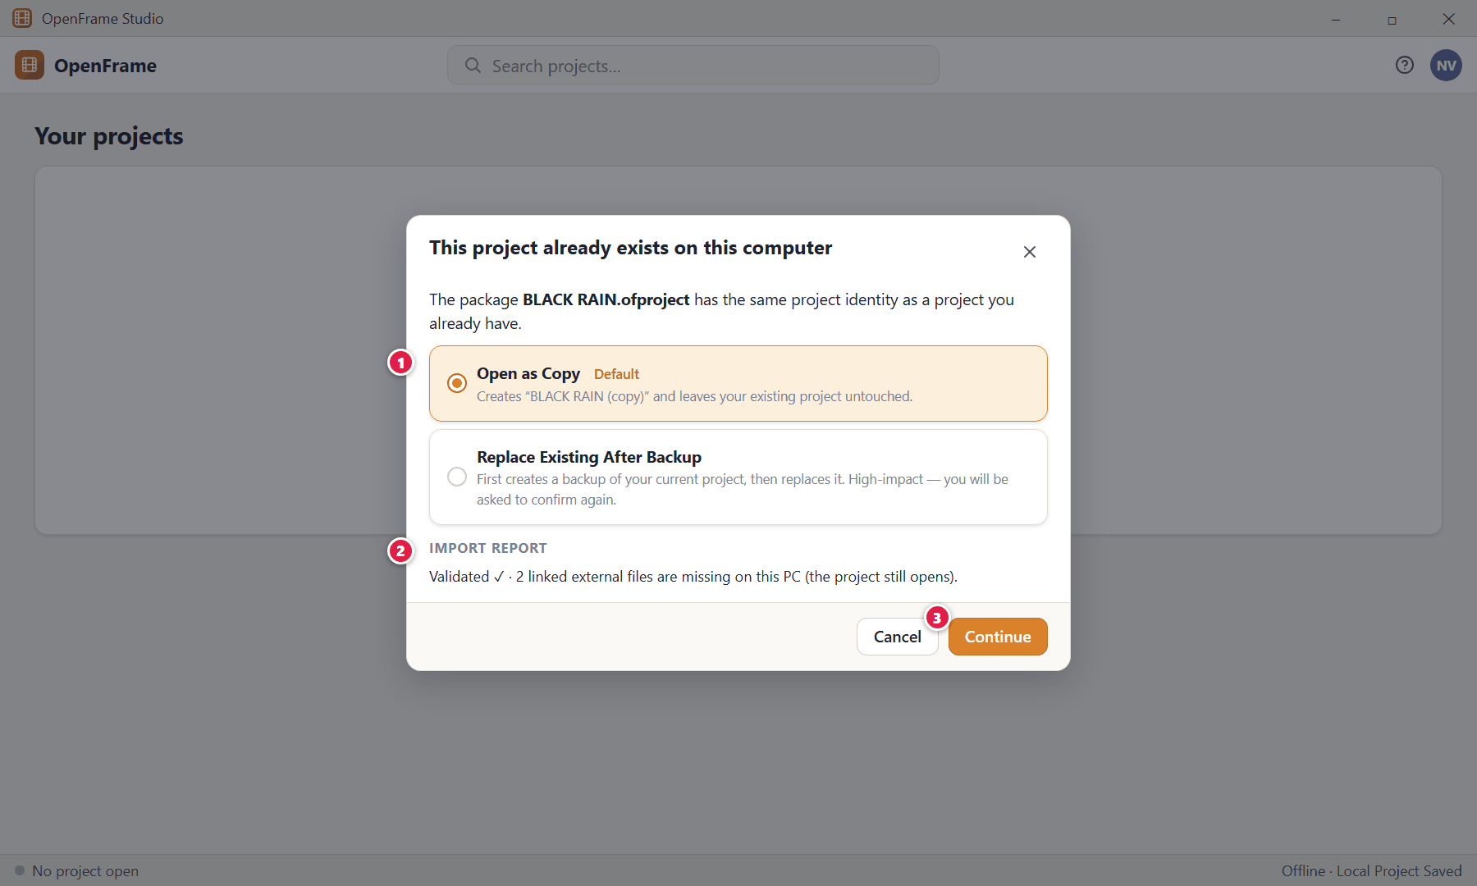
Figure 171. Importing a project package (identity collision) (red numbers are explained on the next page)

Figure 171 — Importing a project package (identity collision): how it works
PARTS OF THIS SCREEN  1 Choices — Open as Copy (default) · Replace Existing After Backup · Cancel.  2 Import report — Validation result and a list of missing external references; the project stays openable.  3 Continue — Does the chosen option. | HOW TO USE IT  1. Accept Open as Copy unless you deliberately want to replace.  GOOD TO KNOW · EDGE CASES  - Importing as a copy gives the copy a new project identity. Pre-apply validation failure leaves everything untouched.

Figure 172 — External drive removed while a project is open
What it is for. If a project stored on an external drive disappears, OpenFrame protects your unsaved work and refuses to invent a second project.
How to get here. Appears when the project volume becomes unavailable.
Figure 172. External drive removed while a project is open (red numbers are explained on the next page)

Figure 172 — External drive removed while a project is open: how it works
PARTS OF THIS SCREEN  1 What happened — Names the unreachable location and reassures you about your edits.  2 Save Backup Copy… — Saves what you have to a different disk.  3 Try Again — Retries once the drive is back. | HOW TO USE IT  1. Reconnect the drive and click Try Again, or save a backup copy elsewhere.  GOOD TO KNOW · EDGE CASES  - Rule: never manufacture a second truth because the original storage temporarily disappeared. Projects on removable drives work normally while the drive is mounted.

Figure 173 — Working offline
What it is for. Offline is a normal state. Nothing in the core product needs the internet.
How to get here. Any time the PC has no network.
Figure 173. Working offline (red numbers are explained on the next page)

Figure 173 — Working offline: how it works
PARTS OF THIS SCREEN  1 Status — "Saved" refers to your local file.  2 Connection message — "Offline · Local Project Saved". No sign-in, no sync queue, no "syncing" spinner exists. | HOW TO USE IT  1. Just keep working.  GOOD TO KNOW · EDGE CASES  - Works offline: create/open projects, Vault, Story Board, screenplay, drafts, comments, breakdown, catalog, locations, cast/crew, shot lists, storyboards, scheduling, call sheets, save, recovery, backup, all local import/export, full project packages and exchange packages.  - Needs a connection: downloading Offline AI (once), optional URL preview fetching, update checks. An installed Offline AI works offline. LAN collaboration needs a local network but not internet.

Chapter 8 — The AI Assistant (Optional)
The AI assistant is an optional helper and command interface for the project that is open. It answers questions, counts and finds things, opens workspaces and objects, writes short summaries and suggestions, and prepares changes for you to review. It runs on this computer as Offline AI: after a one-time download nothing is sent to OpenFrame, Google or any AI service, and it works without an internet connection. It never changes your project on its own: every change is shown as Proposed Changes and happens only when you click Apply Changes. It can do only what you are allowed to do. OpenFrame works completely without AI.
Screens in this chapter
Figure 174 Asking the assistant questions | Figure 178 An out-of-date proposal must be re-checked
Figure 175 Natural-language navigation and search | Figure 179 Offline AI: one download, runs on this computer
Figure 176 Proposed Changes: nothing changes until you apply | Figure 180 Offline AI not installed or unavailable
Figure 177 Structured rename preview (batch operation) | Figure 181 The assistant respects permissions and private notes

Figure 174 — Asking the assistant questions
What it is for. Ask in ordinary language. Exact counts and lists come from your project data through OpenFrame's own calculations, not from a language-model guess.
How to get here. The Assistant button (sparkle icon) in the top bar, or Ctrl+J. The panel opens on the right.
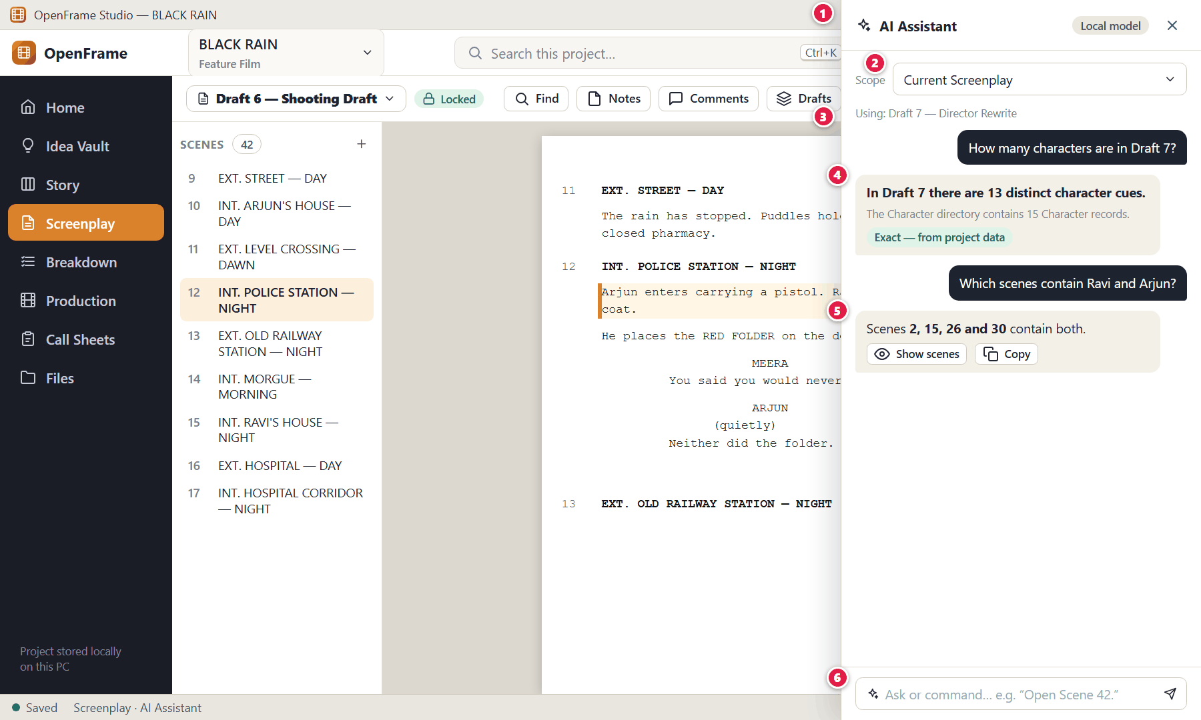
Figure 174. Asking the assistant questions (red numbers are explained on the next page)

Figure 174 — Asking the assistant questions: how it works
PARTS OF THIS SCREEN  1 AI panel — A right-hand panel that is part of the shell. The chip in its header reads AI Ready when Offline AI is installed (hover: “Runs on this computer”).  2 Scope selector — Offers the scopes that fit where you are: Current Selection (or Selected Idea Vault items) · Current Scene · Current Screenplay · Specific Draft · Story Board · Production · Specific Shooting Day · Call Sheet · Whole Project. The default follows the workspace you are in.  3 "Using:" line — Shows which draft and data the answer is based on, for example “Using: Draft 8”.  4 Exact answers — Counts and lists calculated by OpenFrame are marked “Exact · from project data”. Text the AI wrote itself is marked “Inferred · written by Offline AI”.  5 Sources — “Based on:” chips name the scenes, cards, characters or other items an answer used; click a chip to open it. The assistant can look things up in several steps and shows the steps it took.  6 Ask / Command — Type a question or a command, for example “Open Scene 12.”, and press Enter. “Working on it on this computer…” shows while it works. | HOW TO USE IT  1. Open the assistant, check the scope, type the question.  2. Click Open next to a result, or a source chip, to go to it in the app.  GOOD TO KNOW · EDGE CASES  - Examples that work: "How many scenes are in the script?" · "How many characters are in Draft 8?" · "Which scenes contain Ravi?" · "Show the unscheduled scenes." · "Compare Draft 7 and Draft 8." · "Where does Ravi start losing trust in Anjali?" (a meaning-based question answered from the most relevant scenes and cards).  - If a question is ambiguous (for example which draft or which of two characters) the assistant asks one question instead of guessing. It also answers questions about how OpenFrame works, from the built-in product guide. Recent questions in the same conversation are remembered; New starts a fresh conversation.  - The assistant never shows another person's private notes; it says the information is private. Your own private notes are shown only when you ask for them.

Figure 175 — Natural-language navigation and search
What it is for. Read-only, calculation, search and navigation requests run immediately because they change nothing.
How to get here. Type a command in the assistant.
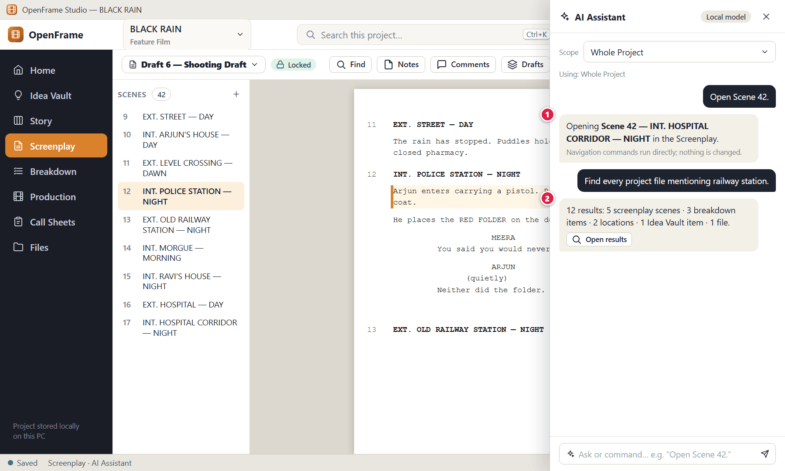
Figure 175. Natural-language navigation and search (red numbers are explained on the next page)

Figure 175 — Natural-language navigation and search: how it works
PARTS OF THIS SCREEN  1 Navigation command — “Open Scene 42.” opens the same place as clicking in the app; Open again repeats it.  2 Search command — “Find every scene mentioning the railway station.” searches the project's own index (the same one as global search) and, for meaning-based questions, also finds passages that match the idea rather than the exact words. | HOW TO USE IT  1. Type the command; click the result to jump there.  GOOD TO KNOW · EDGE CASES  - Other supported examples: "Open the latest call sheet." · "Show all scenes involving Arjun." · "Take me to the unscheduled scenes."  - The assistant uses OpenFrame's own actions and reads; it is not a separate command system. While OpenFrame prepares the project context after a project is opened or changed a lot, the panel may show “Preparing project context…” — AI can still answer some questions while project context is being prepared.

Figure 176 — Proposed Changes: nothing changes until you apply
What it is for. When you ask the assistant to create or change something, it prepares Proposed Changes. Nothing in your project changes until you click Apply Changes.
How to get here. Ask the assistant to create or modify something.
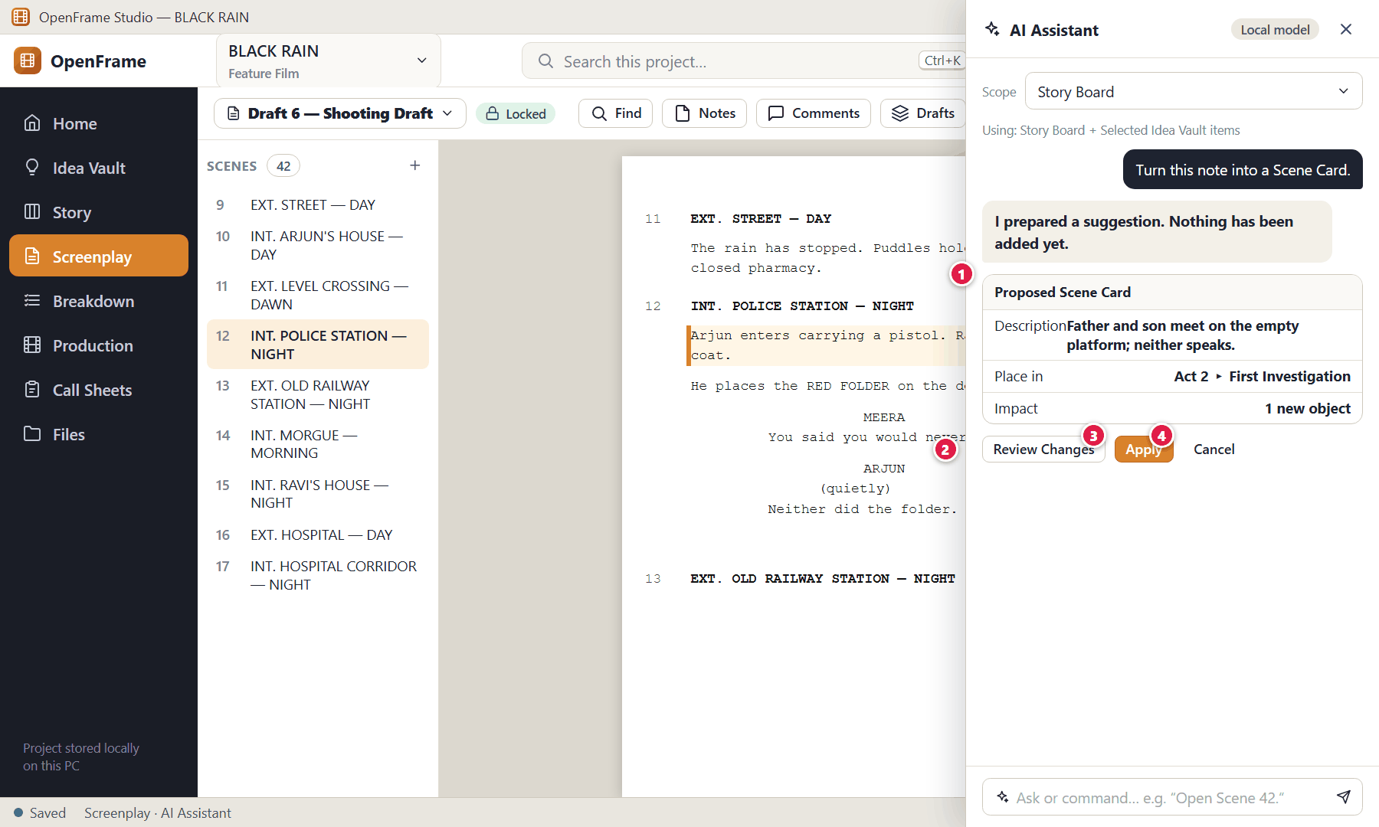
Figure 176. Proposed Changes: nothing changes until you apply (red numbers are explained on the next page)

Figure 176 — Proposed Changes: nothing changes until you apply: how it works
PARTS OF THIS SCREEN  1 Proposed Changes — A summary, the Affected areas and a preview of exactly what would be created or changed, and where.  2 Choices — Reject · Apply Changes. There is no automatic or “always allow” option.  3 Apply Changes — Applies the changes through the normal OpenFrame actions, all together as one step you can undo with Ctrl+Z; they are recorded in Activity. If any part fails, nothing is changed.  4 Reject — Discards the proposal; nothing changes. | HOW TO USE IT  1. Read the proposal, then click Apply Changes or Reject.  GOOD TO KNOW · EDGE CASES  - The assistant keeps these states apart: it answered · it suggested · it prepared changes · you applied them (“Applied N changes. Use Undo to reverse it.”) · you rejected them (“Rejected. Nothing was changed.”).  - A request such as "Create the Scene Card." is not permission to change anything: the review step is always required, and nothing written in your project or in the conversation can approve changes. A request that needs several changes produces one Proposed Changes card. If a change deletes items, OpenFrame asks “Apply changes that delete items?” before applying; deleted items go to Recently Deleted.

Figure 177 — Structured rename preview (batch operation)
What it is for. A project-wide rename separates structured references (the Character record, screenplay Character cues, Cast entries) from ordinary dialogue and action text, and lists everything before anything changes.
How to get here. Ask, for example, "Rename Ravi to Raghav."
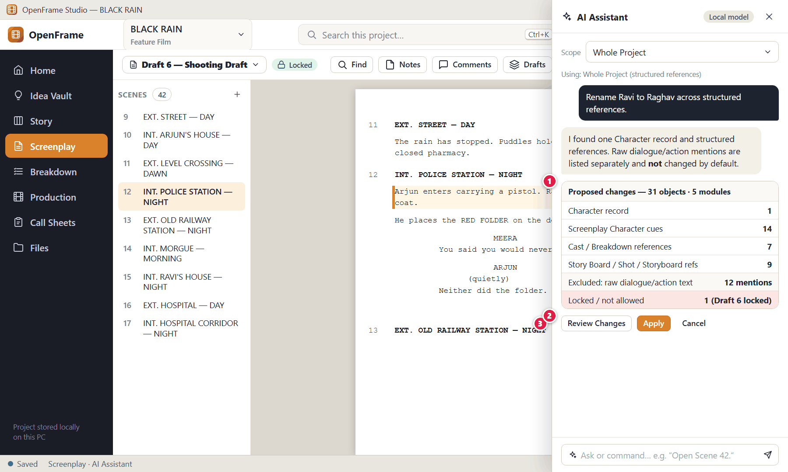
Figure 177. Structured rename preview (batch operation) (red numbers are explained on the next page)

Figure 177 — Structured rename preview (batch operation): how it works
PARTS OF THIS SCREEN  1 Preview — What would change, grouped by area, with the items listed.  2 Excluded items — Locked drafts, earlier drafts and raw dialogue/action mentions are listed separately and are not changed by default.  3 Reject / Apply Changes — Apply Changes applies the whole list as one undoable step; Reject changes nothing. | HOW TO USE IT  1. Read the preview and the excluded items.  2. Click Apply Changes, or Reject and ask again more specifically (for example to include dialogue mentions).  GOOD TO KNOW · EDGE CASES  - Arbitrary dialogue and action text is never changed by default. Locked drafts, private notes and items you are not allowed to change are excluded and reported.  - The proposal is bound to the project state it was prepared against; if the project changes before you apply it, it must be re-checked (see Figure 178). Applied changes become one undoable action.

Figure 178 — An out-of-date proposal must be re-checked
What it is for. Proposals remember the project state they were prepared against. If the project changed since, or an item was deleted, they are not applied.
How to get here. Applying a proposal after the project changed.
Figure 178. An out-of-date proposal must be re-checked (red numbers are explained on the next page)

Figure 178 — An out-of-date proposal must be re-checked: how it works
PARTS OF THIS SCREEN  1 Out-of-date notice — “Proposed Changes — out of date”: the project changed after this suggestion was prepared, and nothing was applied.  2 Re-check & Review — Rebuilds every part of the proposal against the current project and shows a fresh preview to review. Re-checking never applies anything. | HOW TO USE IT  1. Click Re-check & Review, read the new preview, then Apply Changes or Reject.  GOOD TO KNOW · EDGE CASES  - AI never applies an out-of-date proposal blindly. Proposal states: Pending · Applied · Rejected · Out of date · Conflict (an item was deleted) · Failed (nothing was changed).

Figure 179 — Offline AI: one download, runs on this computer
What it is for. Offline AI is installed with one button. There are no choices to make and no model to pick: OpenFrame downloads, checks and installs everything the assistant needs, and it then runs entirely on this computer.
How to get here. Open the assistant before Offline AI is installed, or Settings → Offline AI.
Figure 179. Offline AI: one download, runs on this computer (red numbers are explained on the next page)

Figure 179 — Offline AI: one download, runs on this computer: how it works
PARTS OF THIS SCREEN  1 Enable Offline AI — “Download the AI components required for OpenFrame's AI features. AI runs on this computer and project data is not sent to OpenFrame or an AI cloud service.”  2 Download details — Download size, already downloaded, free space needed, free space on this drive, and whether it runs on the graphics card or the processor — all shown before anything is downloaded.  3 Download Offline AI — One button. The steps are Checking device · Downloading · Verifying · Installing · Starting · Ready, with one progress bar.  4 Pause / Cancel download — Pause keeps what was downloaded and resumes later; Cancel discards it. You can keep working while it downloads.  5 AI Ready — When the check passes, the panel header shows AI Ready and the assistant can be used at once — no restart. | HOW TO USE IT  1. Click Download Offline AI and keep working. If something fails, OpenFrame explains why and you can try again with the same button.  GOOD TO KNOW · EDGE CASES  - The download (about 1.1 GB) is the only time the assistant uses the internet. Each file is checked against a signed list before it is used; a file that fails the check is never used. Afterwards AI works offline, and no project content, prompts or answers ever leave this computer.  - Settings → Offline AI shows the technical details (component names, versions, licences, sizes), offers Update Offline AI when a newer version is available, and Remove Offline AI, which deletes the AI components and leaves your projects and assistant history untouched.

Figure 180 — Offline AI not installed or unavailable
What it is for. AI is an optional layer. If Offline AI is not installed, or cannot run right now, the app says so and everything else carries on.
How to get here. Opening the assistant when Offline AI is not installed or has stopped.
Figure 180. Offline AI not installed or unavailable (red numbers are explained on the next page)

Figure 180 — Offline AI not installed or unavailable: how it works
PARTS OF THIS SCREEN  1 Status — “Offline AI is not installed.”, or “AI is not available right now” with “AI is currently unavailable. OpenFrame's core workflows continue to work normally.”  2 Download Offline AI — Installs Offline AI (Figure 179). If it was installed but stopped, asking again restarts it; the panel menu also has Stop Offline AI (free memory). | HOW TO USE IT  1. Ignore it and keep working, or download Offline AI if you want the assistant.  GOOD TO KNOW · EDGE CASES  - AI is never required to create a script, a scene card, a breakdown, a schedule, a PDF or a call sheet. An AI failure leaves your project unchanged (“Nothing was changed.”).

Figure 181 — The assistant respects permissions and private notes
What it is for. The assistant can do only what you can do. It cannot bypass roles, locks, private notes or the review step.
How to get here. Requesting something you are not permitted to do.
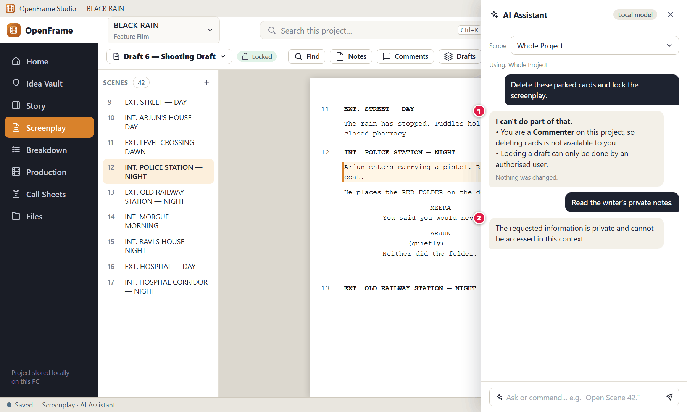
Figure 181. The assistant respects permissions and private notes (red numbers are explained on the next page)

Figure 181 — The assistant respects permissions and private notes: how it works
PARTS OF THIS SCREEN  1 Permission denial — “I can't do that.” with the reason (for example your role) and “Nothing was changed.” No proposal is prepared.  2 Private notes — A neutral refusal that does not leak what the private note contains. | HOW TO USE IT  1. If you need the action, ask the project Owner to change your role or do it for you.  GOOD TO KNOW · EDGE CASES  - The assistant cannot change anything directly: renaming, story edits, breakdown elements, schedule moves, call-sheet edits, deletions and every other change go through Proposed Changes and your Apply Changes. It never permanently deletes anything, never opens or writes files you pick in a file dialog, and never installs or removes Offline AI by itself.  - The assistant works only inside the project that is open. It does not read other projects or the Global Idea Vault.

Appendix A — Keyboard shortcuts and desktop gestures
Shortcuts follow familiar Windows conventions. Where the specifications leave the exact key open, the shortcut is a proposed default that can be documented and customised later; an on-screen alternative always exists for every action. In this edition Ctrl+K (global search), Ctrl+D (duplicate), Ctrl+Shift+N (Quick Capture) and Ctrl+1…7 (screenplay elements) are proposed defaults, not fixed by the specifications; the standard shortcuts Ctrl+N, Ctrl+O, Ctrl+S, Ctrl+Z, Ctrl+Shift+Z, Ctrl+F, Ctrl+P and Esc come directly from the UX/UI specification.
Shortcut | What it does
Ctrl+N | New Project (from Home) or new object in context (for example a new Scene Card)
Ctrl+O | Open Project
Ctrl+S | Save (forces persistence; autosave is always on)
Ctrl+Z | Undo
Ctrl+Shift+Z | Redo
Ctrl+F | Contextual search: find in the screenplay; search in the Idea Vault
Ctrl+K | Global project search (proposed default)
Ctrl+P | Print / Preview where appropriate
Ctrl+D | Duplicate the selected card (proposed default)
Esc | Close the current drawer, dialog or panel; clear a selection; cancel an inline edit
Enter | Confirm an inline edit; open the selected card; in the screenplay, start the next suggested element; in Find, next match
Shift+Enter | In Find: previous match
Delete | Delete the selected item (moves it to Recently Deleted)
Arrow keys | Move focus between cards on the Story Board
Space | Toggle selection on the focused card
Ctrl+click / Shift+click | Multi-select (toggle / range)
Ctrl+1 … Ctrl+7 | Screenplay element types: Scene Heading, Action, Character, Parenthetical, Dialogue, Transition, Shot (proposed defaults following screenwriting-software convention)
Ctrl+Shift+N | Quick Capture into the current Project Idea Vault (proposed default)

Mouse and drag-and-drop
- Single click selects; double-click opens (cards, Vault items, shooting days).
- Right-click opens the context menu for that object; Delete is always separated at the bottom.
- Drag-and-drop works for files into the Idea Vault and moodboards, cards on the Story Board, scenes in the schedule, shots in shot lists and images into storyboards. While dragging you see an insertion line or a highlighted destination; releasing over an invalid target changes nothing.
- Every drag has a non-drag alternative (menus such as Move… or Send to Parking Lot).
- The window can be resized, maximised or put in full-screen writing mode; a second monitor is optional.

Appendix B — Safety rules quick reference
The rules below are the promises OpenFrame makes to protect your work. They appear throughout the chapters as "Good to know" points.

Story Board
- Moving, duplicating or parking a card never changes the screenplay.
- Deleting a card never deletes the screenplay scene created from it.
- Rebuilding a screenplay never overwrites the existing one.
- A board reorder that would change a written screenplay asks first (Apply / Cancel / Duplicate as Alternate Outline).

Screenplay and drafts
- Import never overwrites the current draft; it becomes a new screenplay or a new draft.
- Restoring from history creates a new draft "restored from …".
- A locked draft cannot be edited silently: you must Start Revision.
- The current draft and a sole locked baseline cannot be deleted.
- Notes and private notes are never in exports by default.

Production
- Suggested elements are never production data until you confirm them.
- A script change never silently removes breakdown, shots, storyboard or schedule data; scenes are flagged instead.
- Production stays on its source draft until you choose Update Production.
- Removing a scene from a day returns it to Unscheduled; nothing is deleted from the screenplay.
- Warnings never block; every warning has "Keep anyway".

Documents
- Call-sheet edits never change the schedule.
- A schedule change marks the call sheet stale and shows a preview before Update.
- A finalized call sheet is a snapshot and is never overwritten.
- Exports are snapshots and never change the project.

Collaboration and portability
- Importing a package validates first and previews changes; failure means zero project change.
- A stale package defaults to comments-only or a separate review record.
- Ambiguous or unmapped comments are kept in the Review Queue, never discarded.
- A full project package with the same identity defaults to Open as Copy.
- No silent last-write-wins in a live session; conflicts are shown.
- A disconnected participant never overwrites the host automatically.

Files and storage
- If a project drive disappears OpenFrame never creates a second silent copy.
- Missing linked files are reported, not deleted.
- Backups clearly say what was included, external, missing or skipped.

AI
- AI is optional and never required for a core workflow.
- Read/compute/navigate requests run directly; every project change is shown as Proposed Changes and happens only when you click Apply Changes.
- AI cannot bypass roles, locks, private notes or approvals, and stale proposals are re-validated.
- AI runs on this computer; no project content is sent to OpenFrame or any AI service.

Appendix C — Files, formats and what each export contains
Kind | Formats
Screenplay import | PDF (best-effort, with warnings) · Final Draft .fdx · Fountain · TXT · DOCX · pasted text
Screenplay export | PDF · Final Draft .fdx · Fountain · DOCX (title page, scene numbers, revision info optional; notes off by default)
Story documents | Story Board PDF · Outline PDF
Production documents | Breakdown PDF/report · Catalog table export · Shot List PDF · Storyboard PDF/image sheet · Moodboard PDF/image sheet · Schedule PDF (and spreadsheet where practical) · Call Sheet PDF · Sides PDF · Reports
Exchange packages | Script review (.ofscriptreview) · Story Board (.ofstory) · Breakdown (.ofbreakdown) · Shot List (.ofshots) · Schedule (.ofschedule) · Call Sheet review (.ofcallreview). Extensions are conceptual and may change.
Project portability | Full Project Package (also called Project Archive) · Backup Package

Privacy at a glance
Output | Default boundary | Private notes
Screenplay PDF, FDX, Fountain, DOCX | Selected draft/scope | Excluded
Story Board, Breakdown, Schedule, Call Sheet exports | Selected scope | Excluded
Review exchange package | Explicitly selected scope; selected comments only | Excluded
Full Project Package / Backup | Entire supported project state | May be included (private transfer)
LAN session | Host-selected scope | Stay private
Offline AI (assistant) | Processed on this computer only; nothing is sent | Never another user's private notes

Appendix D — Statuses and states
Object | States
Project | Active · Archived · Closed. Status labels: Idea, Development, Writing, Rewriting, Shooting Draft, Pre-Production, Shoot Preparation, Shooting, Completed, Archived.
Idea Vault item | Active · Pinned · Deleted (recoverable).
Story card | Active · Parking Lot · Deleted. A Beat can also be Converted.
Draft | Current · Named · Locked · Superseded · Deleted. A locked draft edited through a revision becomes Revision.
Review comment | Open · In Discussion · Resolved.
Breakdown element | Suggested · Confirmed · Rejected · Removed.
Catalog item | Required · Searching · Shortlisted · Confirmed · Not Required · Archived.
Location | Idea · Shortlisted · Confirmed · Rejected.
Shooting day | Planned · Ready · Completed · Archived.
Call sheet | Draft · Source changed (needs refresh) · Ready · Final (Issued) · Superseded · Archived.
Task | Open · Done.
Everyday status vocabulary | Ready · Needs attention · Draft · Locked · Stale · Unscheduled · Complete · Archived.

Appendix E — What OpenFrame deliberately does not do
These are outside the product by design, so that it stays small and usable:
- Studio accounting, payroll, union management, tax management or enterprise resource planning.
- A legal contract platform, casting marketplace or equipment marketplace.
- VFX tracking, post-production asset management, media servers, dailies, colour pipelines.
- Distribution sales, festival management or rights management.
- Enterprise single sign-on or complex departmental permission matrices.
- A full project-management suite (only lightweight tasks are provided).
- A mandatory AI writing coach or an automated screenplay scoring system.
- A mobile application (call sheets and other PDFs are readable on phones, but the product is desktop-only).
- A mandatory cloud account, cloud storage or cloud synchronisation.

Appendix F — Glossary
Term | Meaning
Act | A high-level container on the Story Board (for example "Act 1 — The Return"). Needs only a title.
Archive | Hide a project, catalog item or person from normal lists without deleting it.
Automatic history | Quiet, automatic recovery points of your screenplay. Not the same as named drafts.
Beat | A small story event or idea that may later become a Scene Card.
Board view / Outline view | Two views of the same Story Board.
Boneyard / Unscheduled | The area of the schedule that holds scenes not yet placed on a shooting day.
Breakdown | The process of listing what each scene needs to shoot (cast, props, locations…).
Call sheet | The daily document telling everyone where to be and when.
Catalog | The reusable directory of production items (props, wardrobe, vehicles, locations, cast…).
Change Set | A bounded, previewed set of changes produced by an import or by the AI assistant, applied only when you approve it (Apply Changes).
Draft (named draft) | A version of the screenplay you create on purpose (Draft 2, Director Rewrite…).
Exchange Package | A portable file containing a selected part of a project for review or collaboration.
Full Project Package | A file that contains a whole working project, for moving it to another PC.
Locked Shooting Draft | A draft marked as the production baseline; further edits start a revision.
Local session | Optional live collaboration hosted by one PC on a private network.
Parking Lot | A holding area for Story Board cards that are not in the active story.
Production source | The screenplay draft/revision that Breakdown and Schedule are based on.
Recently Deleted | Where deleted items wait until restored or permanently deleted.
Revision (colour) | A post-lock version of the script with a label and colour such as Revision A — Blue.
Scene Card | A compact reminder of what happens in a scene, with an optional heading.
Scene Hub | A compact view of what exists around one scene.
Sequence | A named group of scenes on the Story Board.
Sides | Script pages for the scenes scheduled on a shooting day.
Snapshot | A fixed point-in-time record — an export, an issued call sheet, a review package.
Stale | A derived document (call sheet, breakdown) whose source has changed since it was prepared.
Stripboard | The scheduling board in which each strip is a scene and days are columns.
Vault | The Idea Vault (Global or Project).

Appendix G — List of figures
Figure | Screen | Chapter
Figure 1 | Starting OpenFrame Studio from Windows 11 | Chapter 1
Figure 2 | The start-up screen | Chapter 1
Figure 3 | Home: your projects | Chapter 1
Figure 4 | Home: first launch with no projects | Chapter 1
Figure 5 | Project card menu: pin, rename, duplicate, archive | Chapter 1
Figure 6 | Archived projects | Chapter 1
Figure 7 | Project unavailable (drive missing or file moved) | Chapter 1
Figure 8 | New Project dialog (blank) | Chapter 1
Figure 9 | New Project dialog (filled in) | Chapter 1
Figure 10 | New Project: creation error | Chapter 1
Figure 11 | Project Home: a brand-new project | Chapter 1
Figure 12 | Project Home: an active project | Chapter 1
Figure 13 | Switching projects from the top bar | Chapter 1
Figure 14 | Anatomy of the OpenFrame window | Chapter 1
Figure 15 | Changing the project status | Chapter 1
Figure 16 | Recovering after a crash or power cut | Chapter 1
Figure 17 | Save error: your work is still open | Chapter 1
Figure 18 | Leaving a project during a save problem | Chapter 1
Figure 19 | Save and offline status panel | Chapter 1
Figure 20 | The + quick-actions menu | Chapter 1
Figure 21 | Undo and Redo | Chapter 1
Figure 22 | Project settings | Chapter 1
Figure 23 | Deleting a project (strong confirmation) | Chapter 1
Figure 24 | Project Idea Vault — Visual Grid | Chapter 2
Figure 25 | Idea Vault — Card view | Chapter 2
Figure 26 | Idea Vault — List view | Chapter 2
Figure 27 | Idea Vault — Folder view | Chapter 2
Figure 28 | Idea Vault — empty state | Chapter 2
Figure 29 | Add menu: Note, Image, URL, File, Voice Note, Video | Chapter 2
Figure 30 | Text note editor (autosave) | Chapter 2
Figure 31 | Idea Vault item detail: image | Chapter 2
Figure 32 | Adding a URL | Chapter 2
Figure 33 | Recording a voice note | Chapter 2
Figure 34 | Dragging files into the Vault | Chapter 2
Figure 35 | Drag-in result: partial success | Chapter 2
Figure 36 | External file unavailable | Chapter 2
Figure 37 | Selecting several items | Chapter 2
Figure 38 | Right-click menu on a Vault item | Chapter 2
Figure 39 | Send to Story Board | Chapter 2
Figure 40 | Global Idea Vault | Chapter 2
Figure 41 | Copy a Global idea to a project | Chapter 2
Figure 42 | Searching the Vault | Chapter 2
Figure 43 | Quick Capture | Chapter 2
Figure 44 | Recently Deleted | Chapter 2
Figure 45 | Research collection with verification flags | Chapter 2
Figure 46 | Creating a collection | Chapter 2
Figure 47 | Everything the Vault can hold | Chapter 2
Figure 48 | Story Board — empty state | Chapter 3
Figure 49 | Story Board — Board view | Chapter 3
Figure 50 | Add menu: Act, Sequence, Beat, Scene | Chapter 3
Figure 51 | Creating an Act (title only) | Chapter 3
Figure 52 | Story Board — Outline view | Chapter 3
Figure 53 | Scene Card detail drawer | Chapter 3
Figure 54 | Dragging a card: insertion line | Chapter 3
Figure 55 | Moving a Sequence between Acts | Chapter 3
Figure 56 | Right-click menu on a Scene Card | Chapter 3
Figure 57 | Selecting several cards | Chapter 3
Figure 58 | The Parking Lot | Chapter 3
Figure 59 | Duplicating a card to try an alternative | Chapter 3
Figure 60 | Beat Card and Convert to Scene | Chapter 3
Figure 61 | Deleting a non-empty Act | Chapter 3
Figure 62 | Deleting a card that has a linked screenplay scene | Chapter 3
Figure 63 | Build Screenplay — preview | Chapter 3
Figure 64 | Building when a screenplay already exists | Chapter 3
Figure 65 | Warning before a board reorder changes a written script | Chapter 3
Figure 66 | Zooming out to see the whole film | Chapter 3
Figure 67 | Characters directory | Chapter 3
Figure 68 | Adding a character (duplicate-name check) | Chapter 3
Figure 69 | Character relationship view | Chapter 3
Figure 70 | Story Timeline (optional) | Chapter 3
Figure 71 | Sequence Hub | Chapter 3
Figure 72 | Exporting the Story Board or Outline as PDF | Chapter 3
Figure 73 | Series → Season → Episode (episodic projects) | Chapter 3
Figure 74 | Season Board: reordering episodes | Chapter 3
Figure 75 | Screenplay — empty state | Chapter 4
Figure 76 | The screenplay editor (Standard mode) | Chapter 4
Figure 77 | Choosing screenplay element types | Chapter 4
Figure 78 | Find and replace in the screenplay | Chapter 4
Figure 79 | Focus mode (full-screen writing) | Chapter 4
Figure 80 | Writing Room: script with a reference panel | Chapter 4
Figure 81 | Scene notes and private notes | Chapter 4
Figure 82 | Adding and resolving comments on script text | Chapter 4
Figure 83 | Drafts: named drafts and recovery history | Chapter 4
Figure 84 | Creating a new named draft | Chapter 4
Figure 85 | Comparing two drafts | Chapter 4
Figure 86 | Review rounds | Chapter 4
Figure 87 | Starting a review round | Chapter 4
Figure 88 | Locking the Shooting Draft | Chapter 4
Figure 89 | Editing a locked draft: Start Revision | Chapter 4
Figure 90 | Revision label, colour and changed scenes | Chapter 4
Figure 91 | Importing a screenplay: choose the source | Chapter 4
Figure 92 | Import preview and warnings | Chapter 4
Figure 93 | Import failed (safe failure) | Chapter 4
Figure 94 | Import report | Chapter 4
Figure 95 | Exporting the screenplay | Chapter 4
Figure 96 | Document preview and printing | Chapter 4
Figure 97 | Scene Hub: what exists around a scene | Chapter 4
Figure 98 | Right-click menu on a screenplay scene | Chapter 4
Figure 99 | Moving a scene that is already in production planning | Chapter 4
Figure 100 | Title page details | Chapter 4
Figure 101 | Deleting a draft | Chapter 4
Figure 102 | Production overview (dashboard) | Chapter 5
Figure 103 | Start Production Setup: choose the production source | Chapter 5
Figure 104 | Breakdown: scene list, script and elements | Chapter 5
Figure 105 | Breakdown — no source chosen | Chapter 5
Figure 106 | Tagging highlighted text | Chapter 5
Figure 107 | Reviewing suggested elements | Chapter 5
Figure 108 | Reusing an existing catalog item | Chapter 5
Figure 109 | Adding an element manually | Chapter 5
Figure 110 | After a script change: review breakdown differences | Chapter 5
Figure 111 | Updating the production source to a newer draft | Chapter 5
Figure 112 | Needs Review queue | Chapter 5
Figure 113 | Production Catalog | Chapter 5
Figure 114 | Archiving or replacing a catalog item | Chapter 5
Figure 115 | Locations list | Chapter 5
Figure 116 | Location details: photos, notes, scenes | Chapter 5
Figure 117 | Replacing a rejected location for selected scenes | Chapter 5
Figure 118 | Cast list | Chapter 5
Figure 119 | Assigning an actor to a character | Chapter 5
Figure 120 | Crew list | Chapter 5
Figure 121 | Moodboard canvas | Chapter 5
Figure 122 | Exporting a moodboard | Chapter 5
Figure 123 | Storyboard panels for a scene | Chapter 5
Figure 124 | Add Panel: import, sketch or empty | Chapter 5
Figure 125 | Sketching a panel | Chapter 5
Figure 126 | Shot list for a scene | Chapter 5
Figure 127 | Shot details (technical fields) | Chapter 5
Figure 128 | Shooting Schedule — nothing created yet | Chapter 6
Figure 129 | Creating the schedule | Chapter 6
Figure 130 | Stripboard: Unscheduled pool and shooting days | Chapter 6
Figure 131 | Stripboard: List view | Chapter 6
Figure 132 | Schedule calendar | Chapter 6
Figure 133 | Dragging a scene into a day | Chapter 6
Figure 134 | Adding a break marker or off day | Chapter 6
Figure 135 | Shooting Day detail | Chapter 6
Figure 136 | Schedule conflict warning | Chapter 6
Figure 137 | Grouping suggestion | Chapter 6
Figure 138 | Script changed in scheduled scenes: review changes | Chapter 6
Figure 139 | Exporting the schedule | Chapter 6
Figure 140 | Daily Production View | Chapter 6
Figure 141 | Call Sheets list | Chapter 6
Figure 142 | Creating a call sheet from a shooting day | Chapter 6
Figure 143 | Call Sheet editor | Chapter 6
Figure 144 | Adding optional call-sheet sections | Chapter 6
Figure 145 | Call sheet marked stale after a schedule change | Chapter 6
Figure 146 | Refresh preview before updating a call sheet | Chapter 6
Figure 147 | Finalizing and exporting a call sheet | Chapter 6
Figure 148 | Sides for a shooting day | Chapter 6
Figure 149 | Production Reports | Chapter 6
Figure 150 | Lightweight budget snapshot (P1) | Chapter 6
Figure 151 | Project Notes and Lightweight Tasks | Chapter 6
Figure 152 | Activity History | Chapter 6
Figure 153 | Template browser (P1) | Chapter 6
Figure 154 | Project Files (file cabinet) | Chapter 6
Figure 155 | Permissions | Chapter 6
Figure 156 | Global project search | Chapter 6
Figure 157 | Recently Deleted (whole project) | Chapter 6
Figure 158 | The Share / Exchange menu | Chapter 7
Figure 159 | Exporting a script review package | Chapter 7
Figure 160 | The reviewer opens the package | Chapter 7
Figure 161 | Importing a response package: preview before applying | Chapter 7
Figure 162 | A stale package: version mismatch | Chapter 7
Figure 163 | Review Queue and Unmatched Review Notes | Chapter 7
Figure 164 | Starting a local collaboration session (host) | Chapter 7
Figure 165 | Joining a session (participant) | Chapter 7
Figure 166 | An active session: presence and soft locks | Chapter 7
Figure 167 | Resolving an editing conflict | Chapter 7
Figure 168 | Disconnected from a session | Chapter 7
Figure 169 | Creating a backup | Chapter 7
Figure 170 | Exporting the whole project to move it | Chapter 7
Figure 171 | Importing a project package (identity collision) | Chapter 7
Figure 172 | External drive removed while a project is open | Chapter 7
Figure 173 | Working offline | Chapter 7
Figure 174 | Asking the assistant questions | Chapter 8
Figure 175 | Natural-language navigation and search | Chapter 8
Figure 176 | Proposed Changes: nothing changes until you apply | Chapter 8
Figure 177 | Structured rename preview (batch operation) | Chapter 8
Figure 178 | An out-of-date proposal must be re-checked | Chapter 8
Figure 179 | Offline AI: one download, runs on this computer | Chapter 8
Figure 180 | Offline AI not installed or unavailable | Chapter 8
Figure 181 | The assistant respects permissions and private notes | Chapter 8

