OpenFrame Studio
User Manual
Every feature of the Windows desktop application, screen by screen, from opening the app to the finished call sheet
Capture the idea. Shape the story. Write the script. Plan the shoot.
Edition | Windows 11 internal build 0.1.0 (installer OpenFrame-Studio-0.1.0-internal-028d8b6.exe)
Platform | Windows 11 desktop application. Local-first, works offline.
Sample project used in every screen | BLACK RAIN, an invented feature-film crime thriller
Source of truth | The product as built, the product specifications and the final screen designs
Companion deliverable | Manual Testing Guide (for the people who test the build)
Date | 18 October 2026
The pictures are the final screen designs, drawn with red numbered markers. Where the finished product differs from a picture, the text says so.
Contents
How to read this manual 7
What OpenFrame Studio is 8
Getting started 9
Typical journeys 10
Chapter 1: Getting Started: Opening OpenFrame Studio and Managing Projects 12
Figure 1: Starting OpenFrame Studio from Windows 11 14
Figure 2: The start-up screen 16
Figure 3: Home: your projects 18
Figure 4: Home: first launch with no projects 20
Figure 5: Project card menu: pin, rename, duplicate, archive 22
Figure 6: Archived projects 24
Figure 7: Project unavailable (drive missing or file moved) 26
Figure 8: New Project dialog (blank) 28
Figure 9: New Project dialog (filled in) 30
Figure 10: New Project: creation error 32
Figure 11: Project Home: a brand-new project 34
Figure 12: Project Home: an active project 36
Figure 13: Switching projects from the top bar 38
Figure 14: Anatomy of the OpenFrame window 40
Figure 15: Changing the project status 42
Figure 16: Recovering after a crash or power cut 44
Figure 17: Save error: your work is still open 46
Figure 18: Leaving a project during a save problem 48
Figure 19: Save and offline status panel 50
Figure 20: The + quick-actions menu 52
Figure 21: Undo and Redo 54
Figure 22: Project settings 56
Figure 23: Deleting a project (strong confirmation) 58
Chapter 2: Idea Vault: Capture Anything 60
Figure 24: Project Idea Vault: Visual Grid 62
Figure 25: Idea Vault: Card view 65
Figure 26: Idea Vault: List view 67
Figure 27: Idea Vault: Folder view 69
Figure 28: Idea Vault: empty state 71
Figure 29: Add menu: Note, Image, URL, File, Voice Note, Video 73
Figure 30: Text note editor (autosave) 75
Figure 31: Idea Vault item detail: image 77
Figure 32: Adding a URL 79
Figure 33: Recording a voice note 81
Figure 34: Dragging files into the Vault 83
Figure 35: Drag-in result: partial success 85
Figure 36: External file unavailable 87
Figure 37: Selecting several items 89
Figure 38: Right-click menu on a Vault item 91
Figure 39: Send to Story Board 93
Figure 40: Global Idea Vault 95
Figure 41: Copy a Global idea to a project 97
Figure 42: Searching the Vault 99
Figure 43: Quick Capture 101
Figure 44: Recently Deleted 103
Figure 45: Research collection with verification flags 105
Figure 46: Creating a collection 107
Figure 47: Everything the Vault can hold 109
Chapter 3: Story Board: Shape the Story 111
Figure 48: Story Board: empty state 113
Figure 49: Story Board: Board view 115
Figure 50: Add menu: Act, Sequence, Beat, Scene 118
Figure 51: Creating an Act (title only) 120
Figure 52: Story Board: Outline view 122
Figure 53: Scene Card detail drawer 124
Figure 54: Dragging a card: insertion line 126
Figure 55: Moving a Sequence between Acts 128
Figure 56: Right-click menu on a Scene Card 130
Figure 57: Selecting several cards 132
Figure 58: The Parking Lot 134
Figure 59: Duplicating a card to try an alternative 136
Figure 60: Beat Card and Convert to Scene 138
Figure 61: Deleting a non-empty Act 140
Figure 62: Deleting a card that has a linked screenplay scene 142
Figure 63: Build Screenplay: preview 144
Figure 64: Building when a screenplay already exists 146
Figure 65: Warning before a board reorder changes a written script 148
Figure 66: Zooming out to see the whole film 150
Figure 67: Characters directory 152
Figure 68: Adding a character (duplicate-name check) 154
Figure 69: Character relationship view 156
Figure 70: Story Timeline (optional) 158
Figure 71: Sequence Hub 160
Figure 72: Exporting the Story Board or Outline as PDF 162
Figure 73: Series → Season → Episode (episodic projects) 164
Figure 74: Season Board: reordering episodes 166
Chapter 4: Screenplay: Write, Draft, Review, Lock, Import and Export 168
Figure 75: Screenplay: empty state 170
Figure 76: The screenplay editor (Standard mode) 172
Figure 77: Choosing screenplay element types 175
Figure 78: Find and replace in the screenplay 177
Figure 79: Focus mode (full-screen writing) 179
Figure 80: Writing Room: script with a reference panel 181
Figure 81: Scene notes and private notes 183
Figure 82: Adding and resolving comments on script text 185
Figure 83: Drafts: named drafts and recovery history 187
Figure 84: Creating a new named draft 189
Figure 85: Comparing two drafts 191
Figure 86: Review rounds 193
Figure 87: Starting a review round 195
Figure 88: Locking the Shooting Draft 197
Figure 89: Editing a locked draft: Start Revision 199
Figure 90: Revision label, colour and changed scenes 201
Figure 91: Importing a screenplay: choose the source 203
Figure 92: Import preview and warnings 205
Figure 93: Import failed (safe failure) 207
Figure 94: Import report 209
Figure 95: Exporting the screenplay 211
Figure 96: Document preview and printing 213
Figure 97: Scene Hub: what exists around a scene 215
Figure 98: Right-click menu on a screenplay scene 217
Figure 99: Moving a scene that is already in production planning 219
Figure 100: Title page details 221
Figure 101: Deleting a draft 223
Chapter 5: Production: Breakdown, Catalog, Locations, Cast & Crew, Visual Planning and Shot Lists 225
Figure 102: Production overview (dashboard) 227
Figure 103: Start Production Setup: choose the production source 229
Figure 104: Breakdown: scene list, script and elements 231
Figure 105: Breakdown: no source chosen 233
Figure 106: Tagging highlighted text 235
Figure 107: Reviewing suggested elements 237
Figure 108: Reusing an existing catalog item 239
Figure 109: Adding an element manually 241
Figure 110: After a script change: review breakdown differences 243
Figure 111: Updating the production source to a newer draft 245
Figure 112: Needs Review queue 247
Figure 113: Production Catalog 249
Figure 114: Archiving or replacing a catalog item 251
Figure 115: Locations list 253
Figure 116: Location details: photos, notes, scenes 255
Figure 117: Replacing a rejected location for selected scenes 257
Figure 118: Cast list 259
Figure 119: Assigning an actor to a character 261
Figure 120: Crew list 263
Figure 121: Moodboard canvas 265
Figure 122: Exporting a moodboard 267
Figure 123: Storyboard panels for a scene 269
Figure 124: Add Panel: import, sketch or empty 271
Figure 125: Sketching a panel 273
Figure 126: Shot list for a scene 275
Figure 127: Shot details (technical fields) 277
Chapter 6: Scheduling, Call Sheets and Production Documents 279
Figure 128: Shooting Schedule: nothing created yet 281
Figure 129: Creating the schedule 283
Figure 130: Stripboard: Unscheduled pool and shooting days 285
Figure 131: Stripboard: List view 287
Figure 132: Schedule calendar 289
Figure 133: Dragging a scene into a day 291
Figure 134: Adding a break marker or off day 293
Figure 135: Shooting Day detail 295
Figure 136: Schedule conflict warning 297
Figure 137: Grouping suggestion 299
Figure 138: Script changed in scheduled scenes: review changes 301
Figure 139: Exporting the schedule 303
Figure 140: Daily Production View 305
Figure 141: Call Sheets list 307
Figure 142: Creating a call sheet from a shooting day 309
Figure 143: Call Sheet editor 311
Figure 144: Adding optional call-sheet sections 313
Figure 145: Call sheet marked stale after a schedule change 315
Figure 146: Refresh preview before updating a call sheet 317
Figure 147: Finalizing and exporting a call sheet 319
Figure 148: Sides for a shooting day 321
Figure 149: Production Reports 323
Figure 150: Lightweight budget snapshot (P1) 325
Figure 151: Project Notes and Lightweight Tasks 327
Figure 152: Activity History 329
Figure 153: Template browser (P1) 331
Figure 154: Project Files (file cabinet) 333
Figure 155: Permissions 335
Figure 156: Global project search 336
Figure 157: Recently Deleted (whole project) 338
Chapter 7: Collaboration, Backup and Portability 340
Figure 158: The Share / Exchange menu 341
Figure 159: Exporting a script review package 343
Figure 160: The reviewer opens the package 345
Figure 161: Importing a response package: preview before applying 347
Figure 162: A stale package: version mismatch 349
Figure 163: Review Queue and Unmatched Review Notes 351
Figure 164: Starting a local collaboration session (host) 353
Figure 165: Joining a session (participant) 354
Figure 166: An active session: presence and soft locks 355
Figure 167: Resolving an editing conflict 356
Figure 168: Disconnected from a session 357
Figure 169: Creating a backup 358
Figure 170: Exporting the whole project to move it 360
Figure 171: Importing a project package (identity collision) 362
Figure 172: External drive removed while a project is open 364
Figure 173: Working offline 366
Chapter 8: The AI Assistant (Optional) 368
Figure 174: Asking the assistant questions 369
Figure 175: Natural-language navigation and search 371
Figure 176: Proposed Changes: nothing changes until you apply 373
Figure 177: Structured rename preview (batch operation) 375
Figure 178: An out-of-date proposal must be re-checked 377
Figure 179: Offline AI: one download, runs on this computer 379
Figure 180: Offline AI not installed or unavailable 381
Figure 181: The assistant respects permissions and private notes 383
Appendix A. Keyboard shortcuts 385
Appendix B. Questions and problems 396
Appendix C. Glossary 397
Appendix D. List of figures 399

How to read this manual
This manual explains OpenFrame Studio for someone who has never seen it. It tells you how to open the app, what every screen is for, what each button does, what happens after you click it, and what OpenFrame deliberately does not do. It follows the product from the first double-click to the finished call sheet.

How each screen is presented
• Page 1 shows the screen as a picture with red numbered markers, what the screen is for and how you reach it.
• Page 2 lists the numbered parts of the screen on the left, and on the right the steps to use it and "Good to know" points. These include what happens when something is empty, locked, unavailable or offline.
• Click a figure number anywhere in the manual to jump to that screen.

The red numbered markers
A red number such as 3 points at a part of the screen. The same number in the list on the next page explains it. Names in bold are the labels you see on the buttons and menus.

The sample project
All pictures use one invented film, BLACK RAIN, a crime thriller about Arjun, a returning inspector, his son Ravi, his friend Maya and the detective Meera. Names, dates and numbers are examples only. Your own project will show your own content.

Windows keys and words
Keyboard shortcuts use Ctrl, Shift and Alt. Appendix A lists them all. A greater-than sign means a menu path: Settings > Offline AI means open Settings, then choose Offline AI.

If a picture and the app differ
The pictures are the final designs. A few details of the finished app differ, for example some button names. The text next to each picture describes the app. When the text and the picture differ, follow the text.

What OpenFrame Studio is
OpenFrame Studio is a desktop workspace for independent filmmakers, writers and small production teams. It turns loose ideas into a story board, the story board into a professional screenplay, and the screenplay into a practical pre-production plan: breakdown, schedule and call sheets. It is not a studio-management system. One person can do the work of several roles, and the app shows the tools you need.

The journey the product follows
Ideas, Idea Vault, Story Board (Acts, Sequences, Beats, Scene Cards), Screenplay, review and versions, Locked Shooting Draft, Breakdown, Catalog, Locations, Cast and Crew, Shot List, Storyboard and Moodboard, Schedule, Call Sheets. Structure grows as the film becomes real: the Idea Vault is loose, the Story Board is an outline, the Screenplay is the authoritative script, and production follows a script version until you update it.

Local-first, offline and yours
Your project is stored on your own computer. You can create, write, plan, schedule and export with no internet. There is no sign-in and nothing is uploaded. You can move a project to another computer, back it up, and export every kind of document, so you are never locked in. People work together by sending files (Exchange Packages and review packages). The AI is optional and runs on your computer.

Principles you will notice everywhere
• No duplicate entry: what already exists, such as a scene heading, is reused.
• You decide: OpenFrame suggests, and nothing silently rewrites your story, script, breakdown, schedule or call sheet.
• Safe experiments: duplicate, the Parking Lot, named drafts and Undo let you try things without fear.
• No silent destructive change: deleting moves things to Recently Deleted for 30 days, imports show a preview first, and a call sheet becomes "Needs refresh" instead of changing by itself.
• Small by default: advanced details appear only when you open them.

The workspaces at a glance
Workspace | What it is for
Home | Your list of projects, before a project is open.
Project Home | The front door of one film: continue where you left off, quick access, recent items, files.
Idea Vault | Capture notes, images, links, files, voice notes and video.
Story | Acts, Sequences, Beats and Scene Cards, characters, timeline, episodes.
Screenplay | Write, draft, review, lock, import and export the script.
Breakdown and Production | Find what each scene needs. Catalog, locations, cast and crew, moodboards, storyboards, shot lists.
Schedule | Plan the shooting days.
Call Sheets | Daily documents for cast and crew, plus sides, reports and budget.
Files | Documents and references attached to the project.

Getting started

Install
1. Your team lead sends you one file: OpenFrame-Studio-0.1.0-internal-028d8b6.exe.
2. Double-click it. If Windows shows Windows protected your PC, click More info, then Run anyway. This is normal for a team build that is not yet signed.
3. You do not need administrator rights. Finish the steps. OpenFrame Studio appears in the Start menu.

First start
1. Open OpenFrame Studio from the Start menu.
2. Type the team password you were given. The app asks for it every time it starts.
3. On the very first start a window asks "What should we call you?". Type your name and click Continue. There is no account.
4. You land on Home (Figure 3, or Figure 4 when you have no projects yet).

Download the AI helper (once, optional)
The AI model is not inside the installer. To use the assistant, open Settings > Offline AI and start the download. It is about 1 GB, needs internet for this step only, and can be paused. After it finishes, the AI works with no internet (Figures 179 and 180).

Where your work is stored
Projects are saved in Documents\OpenFrame\Projects. Uninstalling the app never removes your projects. This is a team test build, so keep a copy of anything important and use Create Backup before large changes (Figure 169).

Typical journeys
These journeys string the chapters together. Click a figure number to jump to its screen.

Journey 1: from an idea to a call sheet
You have an idea and almost no film knowledge. This is the main path.
1. Start the app and sign in with the team password. See: Figure 1, Figure 2, Figure 3
2. Create the project: click New Project, type BLACK RAIN, choose Feature Film, click Create. See: Figure 8, Figure 9, Figure 11
3. Capture ideas in the Idea Vault: a note, an image, a link, a voice note. See: Figure 24, Figure 29, Figure 30, Figure 33
4. Open Story and add Acts, Sequences and Scene Cards. Send a Vault idea to the board if useful. See: Figure 48, Figure 50, Figure 51, Figure 39
5. Drag cards into order. Park what you do not need, duplicate to try alternatives. Ctrl+Z undoes a move. See: Figure 54, Figure 58, Figure 59, Figure 21
6. Give the cards headings and click Build Screenplay. Check the preview. See: Figure 63
7. Write in the screenplay editor. Use Focus mode or the Writing Room when you want. See: Figure 76, Figure 77, Figure 79, Figure 80
8. Save named drafts, compare them, and run a review round. See: Figure 84, Figure 85, Figure 86
9. Lock the Shooting Draft. Later changes become revisions. See: Figure 88, Figure 89, Figure 90
10. Set the locked draft as the production source and break the script down. See: Figure 103, Figure 104, Figure 107
11. Build the catalog, locations, cast and crew. Plan visuals and shots. See: Figure 113, Figure 116, Figure 118, Figure 121, Figure 123, Figure 126
12. Create the shooting schedule. Drag scenes into shooting days and read the warnings. See: Figure 129, Figure 130, Figure 136
13. Create a call sheet from a shooting day, finalize it and export the PDF. See: Figure 142, Figure 143, Figure 147
14. Export the screenplay and make a backup. See: Figure 95, Figure 139, Figure 169

Journey 2: you already have a screenplay
Start from a finished script. You can skip the Idea Vault and the Story Board.
1. Create the project, then import the script (PDF, Final Draft, Fountain, TXT or DOCX). See: Figure 9, Figure 11, Figure 91
2. Check the preview and warnings, then import as a new screenplay. See: Figure 92, Figure 94
3. Set the imported draft as the production source and open Breakdown. See: Figure 103, Figure 104
4. Accept or reject suggested elements and reuse catalog items. See: Figure 107, Figure 108, Figure 113
5. Add locations, cast and a shot list, then schedule and make call sheets. See: Figure 115, Figure 118, Figure 126, Figure 130, Figure 143

Journey 3: a short film
A five-scene short needs no Acts or Sequences.
1. Add five Scene Cards straight on the board. See: Figure 49
2. Build the screenplay, break it down, make a one-day schedule and a call sheet. See: Figure 63, Figure 104, Figure 130, Figure 143

Journey 4: writer only
You can use only the Idea Vault, Story Board, Screenplay, drafts and review and ignore Production.
1. Write, keep named drafts, compare them and ask for review. See: Figure 24, Figure 49, Figure 76, Figure 85, Figure 86

Journey 5: producer or assistant director
Start from an imported script and use Breakdown, Catalog, Schedule and Call Sheets.
1. Import, break down, catalog, schedule, call sheets. See: Figure 92, Figure 104, Figure 113, Figure 130, Figure 141

Journey 6: an episodic series
Series, then Season, then Episode. Each episode has its own board, screenplay and plan.
1. Create the series, seasons and episodes, then work in one episode as usual. See: Figure 73, Figure 74

Chapter 1: Getting Started: Opening OpenFrame Studio and Managing Projects
Home, your projects and the application window. This is where you start: create, open, switch, archive, duplicate and delete projects, see and change the project status, and rely on autosave, crash recovery and undo. It also covers project settings.

Screens in this chapter
Figure | Screen | Page
Figure 1 | Starting OpenFrame Studio from Windows 11 | 14
Figure 2 | The start-up screen | 16
Figure 3 | Home: your projects | 18
Figure 4 | Home: first launch with no projects | 20
Figure 5 | Project card menu: pin, rename, duplicate, archive | 22
Figure 6 | Archived projects | 24
Figure 7 | Project unavailable (drive missing or file moved) | 26
Figure 8 | New Project dialog (blank) | 28
Figure 9 | New Project dialog (filled in) | 30
Figure 10 | New Project: creation error | 32
Figure 11 | Project Home: a brand-new project | 34
Figure 12 | Project Home: an active project | 36
Figure 13 | Switching projects from the top bar | 38
Figure 14 | Anatomy of the OpenFrame window | 40
Figure 15 | Changing the project status | 42
Figure 16 | Recovering after a crash or power cut | 44
Figure 17 | Save error: your work is still open | 46
Figure 18 | Leaving a project during a save problem | 48
Figure 19 | Save and offline status panel | 50
Figure 20 | The + quick-actions menu | 52
Figure 21 | Undo and Redo | 54
Figure 22 | Project settings | 56
Figure 23 | Deleting a project (strong confirmation) | 58

Figure 1: Starting OpenFrame Studio from Windows 11
What it is for. OpenFrame Studio is a normal Windows 11 desktop app. This picture shows the three ways to start it and how you know it has started.
How to get here. On the Windows 11 desktop. Press the Windows key, type "openframe" and press Enter. Or double-click the OpenFrame Studio icon on the desktop. Or click the OpenFrame Studio icon on the taskbar once you have pinned it.
Figure 1. Starting OpenFrame Studio from Windows 11. Red numbers are explained on the next page.

Figure 1: Starting OpenFrame Studio from Windows 11: how it works
PARTS OF THIS SCREEN  1 Desktop icon (OpenFrame Studio) Double-click the icon to start the app. If the app is already running, its window comes to the front. The installer adds a Start menu entry but does not say it adds a desktop icon, so create the shortcut yourself if it is missing.  2 OpenFrame Studio App, Press Enter to open Type "openframe" in the Windows Start menu search. The first row under Best match is OpenFrame Studio. Press Enter, or click the row, to start the app. This row exists only after the app is installed.  3 Taskbar icon While the app runs, its icon shows on the Windows taskbar. Right-click it and choose Pin to taskbar so that one click starts the app next time. Clicking the icon of a running app brings its window forward. | HOW TO USE IT  1. Press the Windows key and type "openframe".  2. Press Enter on the Best match row, OpenFrame Studio.  3. Wait for the short start-up screen.  4. Enter the team password when the app asks for it.  5. Home opens and shows your projects.  GOOD TO KNOW · EDGE CASES  • OpenFrame is local-first. It needs no account sign-in and starts without an internet connection.  • The team build asks for the team password on every start, before Home.  • Only one OpenFrame Studio window can run at a time. A second start brings the first window to the front.  • The window opens centered at 1440 by 900 pixels at most and cannot be made smaller than 1200 by 720. The app does not remember where you last put the window.  • Windows may show "Windows protected your PC" on the first install and first start. This is normal for a team build that is not signed.
See also: Figure 2 The start-up screen Figure 3 Home: your projects Figure 4 Home: first launch with no projects

Figure 2: The start-up screen
What it is for. The start-up screen shows for a moment while OpenFrame reads the list of projects stored on your computer. It tells you that the app has started and is working.
How to get here. It appears by itself after you start the app, and after the team password step in the team build. Nothing needs to be clicked.
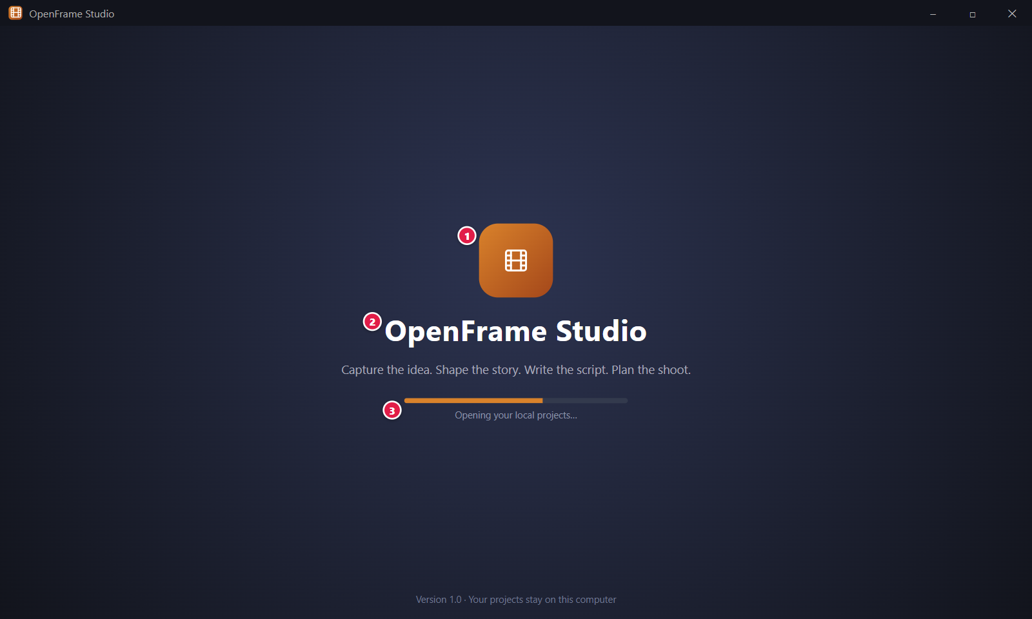
Figure 2. The start-up screen. Red numbers are explained on the next page.

Figure 2: The start-up screen: how it works
PARTS OF THIS SCREEN  1 OpenFrame logo The film-frame mark. It shows that the app has started. Its colors follow your chosen theme.  2 OpenFrame Studio The product name. In the app this is the wordmark "OpenFrame". The app does not show the line "Capture the idea. Shape the story. Write the script. Plan the shoot." on this screen.  3 Opening your local projects… The loading line. OpenFrame is reading the list of projects on this computer. No internet connection is used. | HOW TO USE IT  1. Start the app.  2. Wait a few seconds. Do not click anything.  3. Home appears with your project cards.  GOOD TO KNOW · EDGE CASES  • There is no setup wizard and no account sign-in.  • The screen shows only while the first project list loads. If a later wait happens, Home stays on screen.  • If a project did not close cleanly, for example after a power cut, the app offers recovery after you open that project.  • If the list cannot load, Home shows "Your project list couldn't be loaded." with a Try Again button.  • The team build shows the team password step before this screen.
See also: Figure 1 Starting OpenFrame Studio from Windows 11 Figure 3 Home: your projects Figure 4 Home: first launch with no projects Figure 7 Project unavailable (drive missing or file moved)

Figure 3: Home: your projects
What it is for. Home is where you start when no project is open. It lists your projects as cards so you can continue one, open another from disk, or start a new one. It answers the question: which project do I continue?
How to get here. Start the app and wait for the start-up screen. You also reach Home when you close a project, and from the project menu of an open project (All projects). Ctrl+N starts a new project and Ctrl+O opens one from disk.
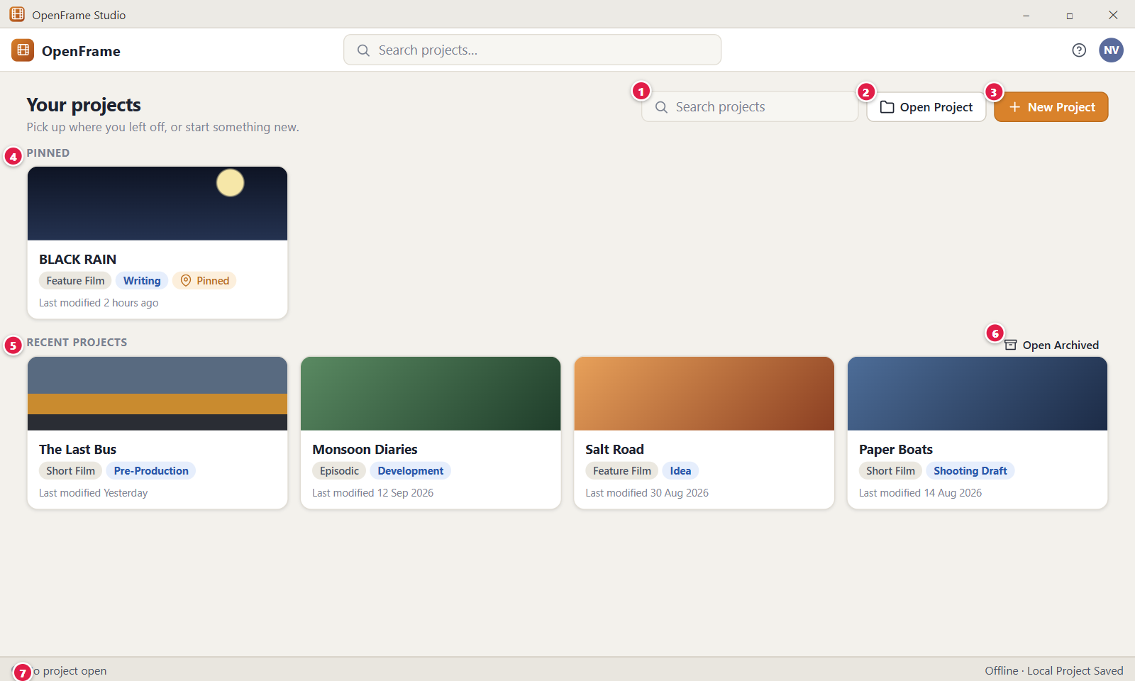
Figure 3. Home: your projects. Red numbers are explained on the next page.

Figure 3: Home: your projects: how it works
PARTS OF THIS SCREEN  1 Search projects Type to filter the cards by project title, type (for example "Short Film") or status (for example "Writing"). It does not search inside screenplays. Press Esc to clear it. Ctrl+F or Ctrl+K moves the cursor into the box.  2 Open Project Opens a Windows folder picker titled "Open an OpenFrame project folder". Use it for a project that is not on the list, such as one copied from a USB drive. A project folder ends in .openframe. Projects on a network share are refused. Shortcut: Ctrl+O.  3 New Project The main button. It opens the New Project dialog, which asks only for a title and a type. Cancel creates nothing. Shortcut: Ctrl+N.  4 Pinned Holds the projects you pinned, with a small "Pinned" chip on each card. This group shows only when at least one project is pinned and the search box is empty. Pinning changes only the order on Home. It never moves files. Use Pin or Unpin in the card menu to change it.  5 Recent projects Every project that is not pinned, newest opened first. A card shows the title, a type chip (Feature Film, Short Film, Episodic or Series), a status chip and "Last modified" (for example "2 hours ago", "Yesterday" or "12 Sep 2026"). You choose the type when you create the project. You set the status on Project Home: Idea, Development, Writing, Rewrite, Shooting Draft, Pre-Production, Shoot Preparation or Shooting. Click a card to open the project.  6 Open Archived Opens the list of archived projects. Archived projects are hidden from Home but never deleted. The label shows a count when you have any, for example "Open Archived (3)".  7 No project open The status strip. The left text says no project is open. The right text on Home reads "Offline · Your projects stay on this computer". Offline is a normal state, not an error. | HOW TO USE IT  1. Look through the cards, or type part of a name in Search projects, for example "black" for BLACK RAIN.  2. Click a card to open the project at Project Home.  3. To start a new film, click New Project (Ctrl+N), enter a title and choose a type.  4. To open a project from a USB drive, click Open Project (Ctrl+O) and pick its .openframe folder.  5. Click Open Archived to see projects you put away.  GOOD TO KNOW · EDGE CASES  • Home shows no production data such as schedules or call sheets. That is on purpose.  • The first time you start the app, it asks "What should we call you?" in a Welcome dialog. Enter a name and click Continue. There is no account.  • In the app the top bar has no search box. It has the Global Idea Vault, Help, Appearance and your name instead, and next to Open Project there is a Restore Backup or Package… button.  • Projects are saved in Documents\OpenFrame\Projects by default.  • A project on an external drive that is not connected shows the chip "Unavailable" instead of disappearing.  • The app needs no network to work. Only the one-time AI download uses the internet.
See also: Figure 4 Home: first launch with no projects Figure 5 Project card menu: pin, rename, duplicate, archive Figure 6 Archived projects Figure 7 Project unavailable (drive missing or file moved) Figure 8 New Project dialog (blank) Figure 12 Project Home: an active project

Figure 4: Home: first launch with no projects
What it is for. This is Home when you have no projects yet, for example on the first start. Instead of an empty list it tells you what a project is and offers the next step. It answers the question: what do I do first?
How to get here. Start the app on a computer with no projects. Home shows this state by itself whenever the list is empty. Ctrl+N opens the New Project dialog and Ctrl+O opens a project folder.
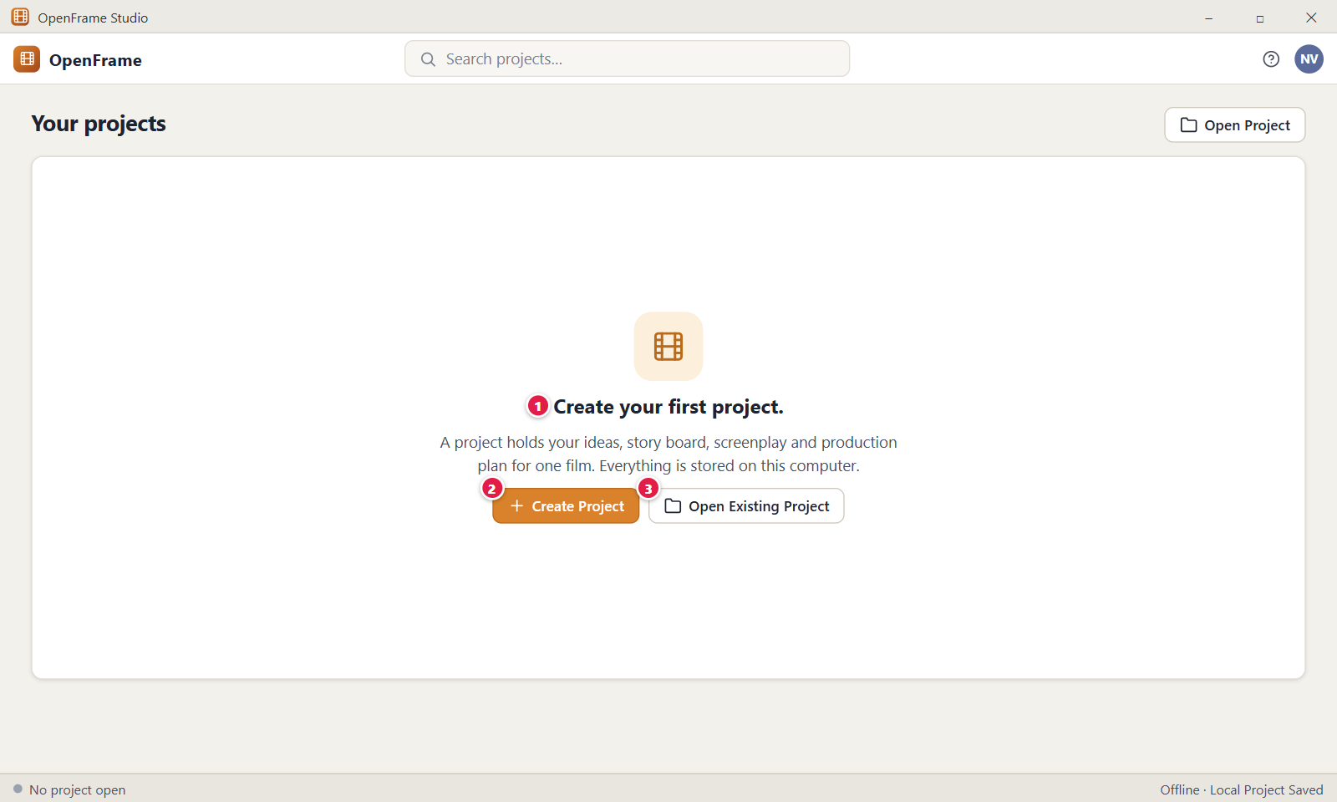
Figure 4. Home: first launch with no projects. Red numbers are explained on the next page.

Figure 4: Home: first launch with no projects: how it works
PARTS OF THIS SCREEN  1 Create your first project. The message. It says: "A project holds your ideas, story board, screenplay and production plan for one film. Everything is stored on this computer." It shows only when you have no projects at all. An archived project counts as a project.  2 Create Project The main button. It opens the New Project dialog, which needs a title and a type. Shortcut: Ctrl+N. After you create the project it opens at Project Home and this message is gone.  3 Open Existing Project For a project folder you already have, for example from another computer. It opens a Windows folder picker titled "Open an OpenFrame project folder". Shortcut: Ctrl+O. A project folder ends in .openframe. | HOW TO USE IT  1. Start the app. On the very first start, enter your name in the Welcome dialog and click Continue.  2. Click Create Project (Ctrl+N).  3. Type a title, for example BLACK RAIN, and choose a type.  4. Click Create. The project opens at Project Home.  5. To use an existing project instead, click Open Existing Project and pick its folder.  GOOD TO KNOW · EDGE CASES  • An empty screen shows no zeros or charts. It says what the area is and gives you one main action.  • There is no setup wizard and no account. The only first-start question is your name.  • In the app there is also a third button, Restore Backup or Package…. It restores a Backup Package or opens a Full Project Package, which is the way back in on a new computer.  • In the app the page header has no search box and no Open Project button on this screen.  • If you pick a folder that is not a project, the app says "This folder isn't an OpenFrame project (its project information file is missing)."  • The Global Idea Vault button in the top bar works even when no project is open.
See also: Figure 3 Home: your projects Figure 8 New Project dialog (blank) Figure 11 Project Home: a brand-new project

Figure 5: Project card menu: pin, rename, duplicate, archive
What it is for. The project card menu lists every action you can take on a whole project from Home: open it, rename it, copy it, pin it, find its folder, archive it or delete it. It answers the question: what can I do with this project without opening it?
How to get here. On Home, right-click a project card, or click the "…" button at the top right of the card. With the keyboard, press Tab to a card, then F2 to rename it.
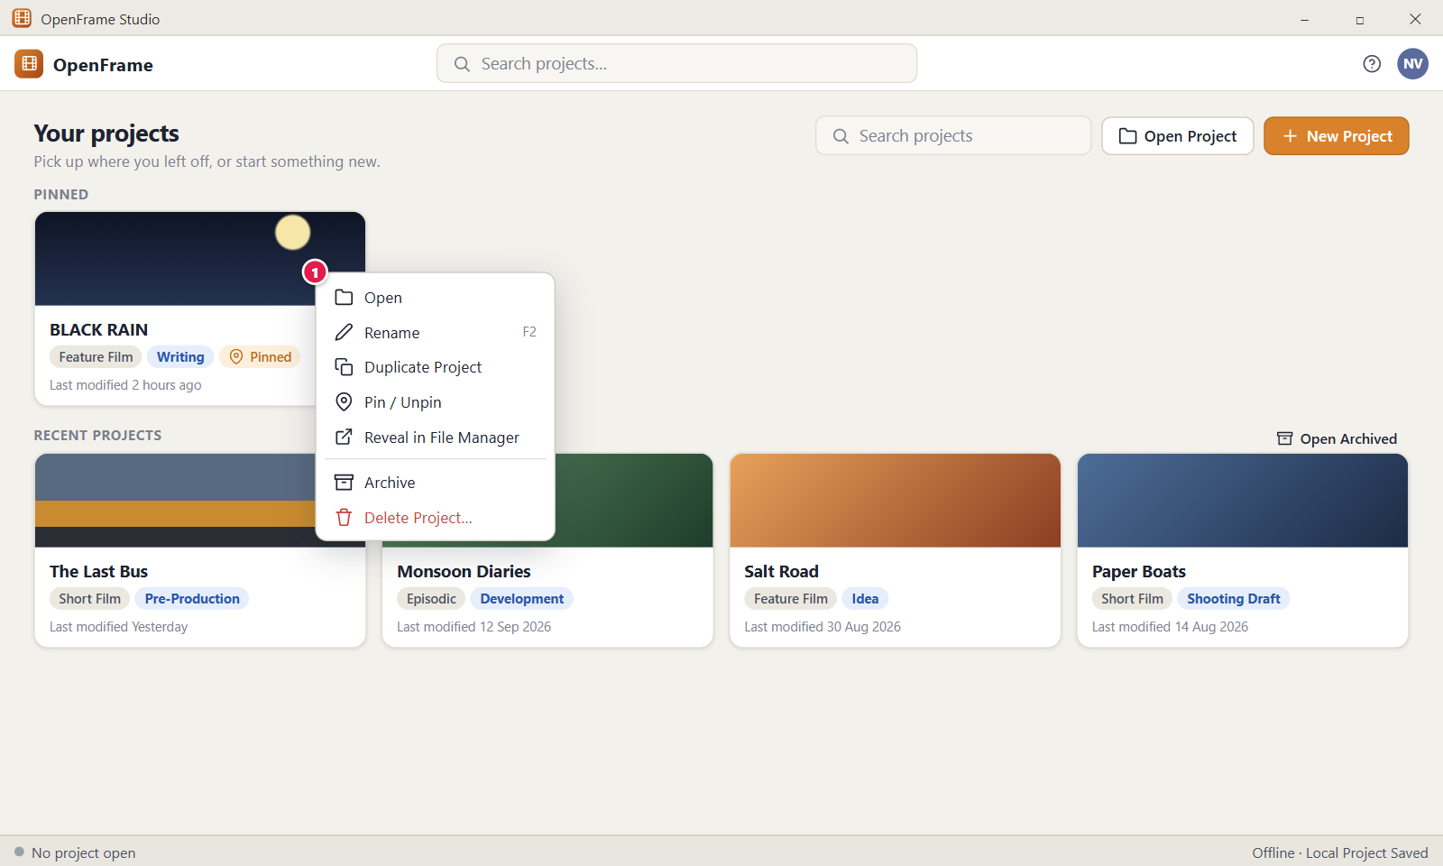
Figure 5. Project card menu: pin, rename, duplicate, archive. Red numbers are explained on the next page.

Figure 5: Project card menu: pin, rename, duplicate, archive: how it works
PARTS OF THIS SCREEN  1 Card menu The menu lists, in order: Open, Rename (F2), Duplicate Project, Pin or Unpin, Reveal in File Manager, a dividing line, Archive and Delete Project… in red. The app shows either Pin or Unpin depending on the card, not both. On an archived card Archive reads Restore from Archive. Rename, Duplicate Project and Reveal in File Manager are grey when the project is unavailable. Esc or a click outside closes the menu with no change. | HOW TO USE IT  1. On Home, right-click the card of BLACK RAIN.  2. Choose Rename (or press F2), type a new title and confirm.  3. Choose Duplicate Project to make a separate copy, titled "Copy of BLACK RAIN" until you rename it.  4. Choose Pin to move the card to the Pinned group, or Unpin to send it back to Recent projects.  5. Choose Archive to put the project away without deleting it.  GOOD TO KNOW · EDGE CASES  • Prefer Archive to Delete. An archived project stays on disk, can be found with Search projects and can be reopened at any time.  • Rename changes the title only. The project folder keeps its first name.  • Duplicate Project makes a separate project with its own identity. It is not a link to the original.  • Delete Project… moves the project folder to the Windows Recycle Bin. The app does not make a backup first. If you restore the folder from the Recycle Bin, open it again with Open Project.  • Pin and Unpin are settings of this computer. They are not saved inside the project and do not travel with a copied project.  • If the folder on disk no longer matches the project, the app says "The folder on disk no longer matches this project, so it was not deleted."
See also: Figure 3 Home: your projects Figure 6 Archived projects Figure 7 Project unavailable (drive missing or file moved) Figure 12 Project Home: an active project

Figure 6: Archived projects
What it is for. The archived list shows the projects you hid from Home. Archived projects are not deleted. This screen lets you bring one back or look inside it. It answers the question: where did my finished project go, and how do I get it back?
How to get here. On Home, click Open Archived (it shows a count when projects are archived, for example "Open Archived (3)"). To return, click Back to projects. A project gets here when you choose Archive in its card menu.
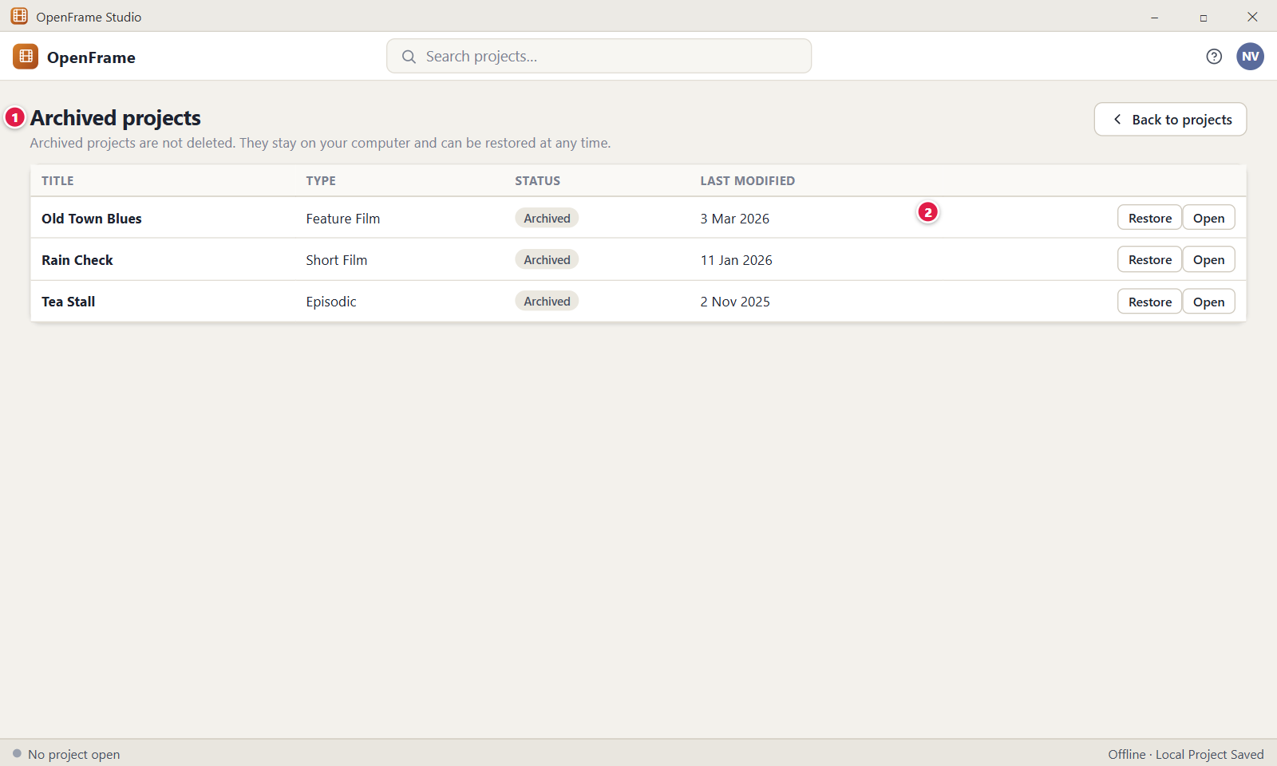
Figure 6. Archived projects. Red numbers are explained on the next page.

Figure 6: Archived projects: how it works
PARTS OF THIS SCREEN  1 Archived projects The page title, the sentence "Archived projects are not deleted. They stay on your computer and can be restored at any time.", and a table with the columns Title, Type, Status and Last modified. The Status column shows "Archived". A search box above the table filters by title, type or status. Right-click a row for the project menu. If nothing is archived, the page says "No archived projects. Archive a project from its menu to tidy your list without deleting anything."  2 Restore and Open Two buttons at the end of each row. Restore returns the project to Home with the status it had before. Open looks inside the project without restoring it: Project Home shows the banner "This project is archived. Nothing is deleted. It is only hidden from your recent projects." with a Restore to Active button. | HOW TO USE IT  1. On Home, click Open Archived.  2. Type part of a name in the search box, for example "rain", to find Rain Check.  3. Click Restore on the row to bring the project back to Home.  4. Or click Open to look inside it first. Click Restore to Active on the banner when you want it back.  5. Click Back to projects to return to Home.  GOOD TO KNOW · EDGE CASES  • Archived projects keep all their content. Nothing is removed from your computer.  • If only archived projects match a search on Home, Home offers a button such as "1 archived match: Open Archived".  • A project on a disconnected drive shows the chip "Unavailable" beside its title.  • If no archived project matches your search, the page says "No archived projects match" and shows your text.  • Ctrl+F or Ctrl+K moves the cursor into the search box, and Esc clears it.  • In the app the page has a search box and the right-click row menu. Rows are ordered by last opened, newest first.
See also: Figure 3 Home: your projects Figure 5 Project card menu: pin, rename, duplicate, archive Figure 7 Project unavailable (drive missing or file moved) Figure 12 Project Home: an active project

Figure 7: Project unavailable (drive missing or file moved)
What it is for. This dialog tells you that a project cannot be opened because its folder is missing, for example the external drive is unplugged or the folder was moved. OpenFrame never makes a substitute project. It answers the question: why does my project not open, and what can I do?
How to get here. On Home, click the card of a project that shows the chip "Unavailable", or right-click it and choose Open. From the archived list, click Open on such a project.
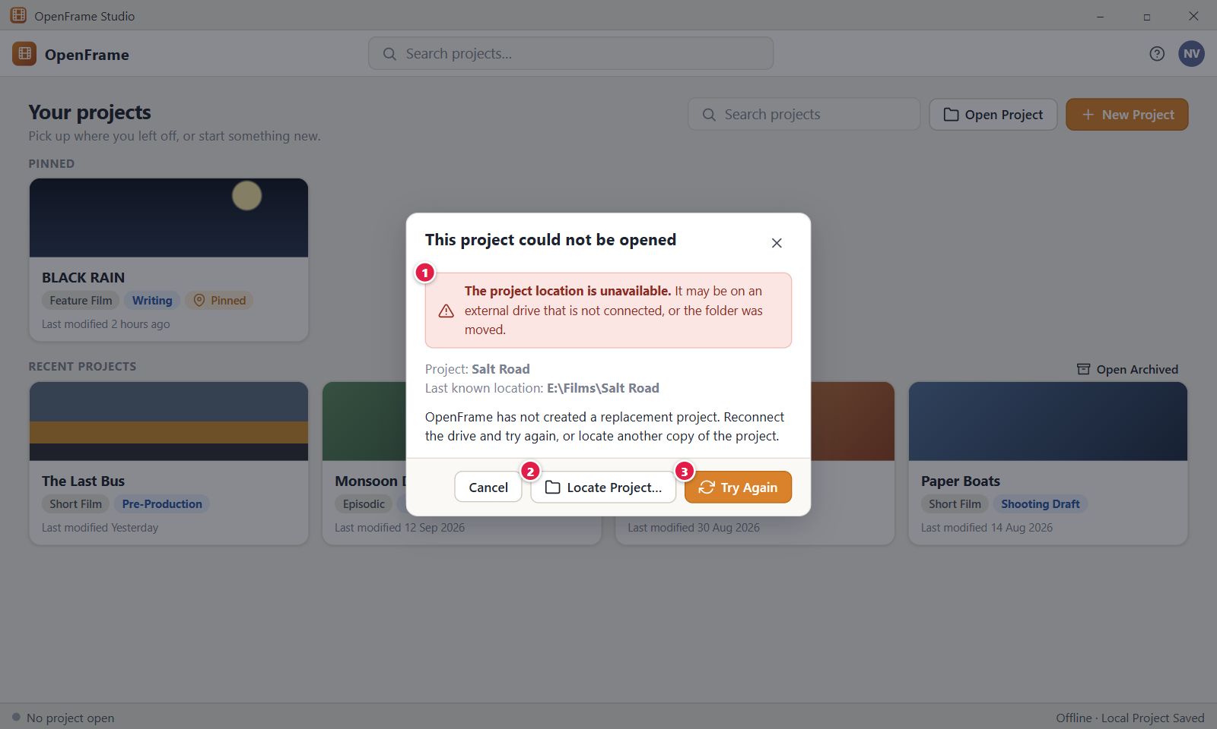
Figure 7. Project unavailable (drive missing or file moved). Red numbers are explained on the next page.

Figure 7: Project unavailable (drive missing or file moved): how it works
PARTS OF THIS SCREEN  1 The project location is unavailable. It may be on an external drive that is not connected, or the folder was moved. The red banner that names the problem. Under it the dialog shows "Project:" with the title, "Last known location:" with the folder path, and the line "OpenFrame has not created a replacement project. Reconnect the drive and try again, or locate another copy of the project." The dialog title is "This project could not be opened". You can select and copy the path. It ends in .openframe.  2 Locate Project… Opens a folder picker titled with the project name. Choose the folder of the same project, for example after you moved it. OpenFrame remembers the new place, opens the project and closes the dialog. A folder with a different project, a folder that is not a project, and a network folder are refused.  3 Try Again Tries the last known location again. Plug the drive back in first. On success Project Home opens. If the folder is still missing, the dialog stays and says "This project can't be found. If it's on an external drive, reconnect the drive and try again." | HOW TO USE IT  1. Plug the external drive back in, for example the one that holds Salt Road.  2. Click Try Again.  3. If you moved the folder instead, click Locate Project… and choose the new folder.  4. If you no longer want the card, click Remove from List. This forgets the card and deletes nothing.  5. Click Cancel to close the dialog without changes.  GOOD TO KNOW · EDGE CASES  • OpenFrame never creates a replacement project and never deletes anything because a drive is missing.  • Offline is not the same as unavailable. The app needs no network. Unavailable means the project folder cannot be read now.  • A project on an external drive works normally while the drive is plugged in.  • Locate Project… accepts only the same project. A copy made with Duplicate Project is a different project and is refused.  • In the app the dialog has one more button on the left, Remove from List, and Cancel closes the dialog. Esc does the same.  • If the drive is removed while a project is open, the app shows "OpenFrame could not save the latest changes to the project." after the next failed save.
See also: Figure 3 Home: your projects Figure 5 Project card menu: pin, rename, duplicate, archive Figure 6 Archived projects Figure 12 Project Home: an active project

Figure 8: New Project dialog (blank)
What it is for. The New Project dialog creates a project from only a title and a type. Everything else is optional and can be added later. It answers the question: what is this project called, and what type is it?
How to get here. On Home, click New Project or press Ctrl+N. On the empty Home, click Create Project. Inside an open project, use New Project… in the project menu, which returns to Home and opens this dialog.
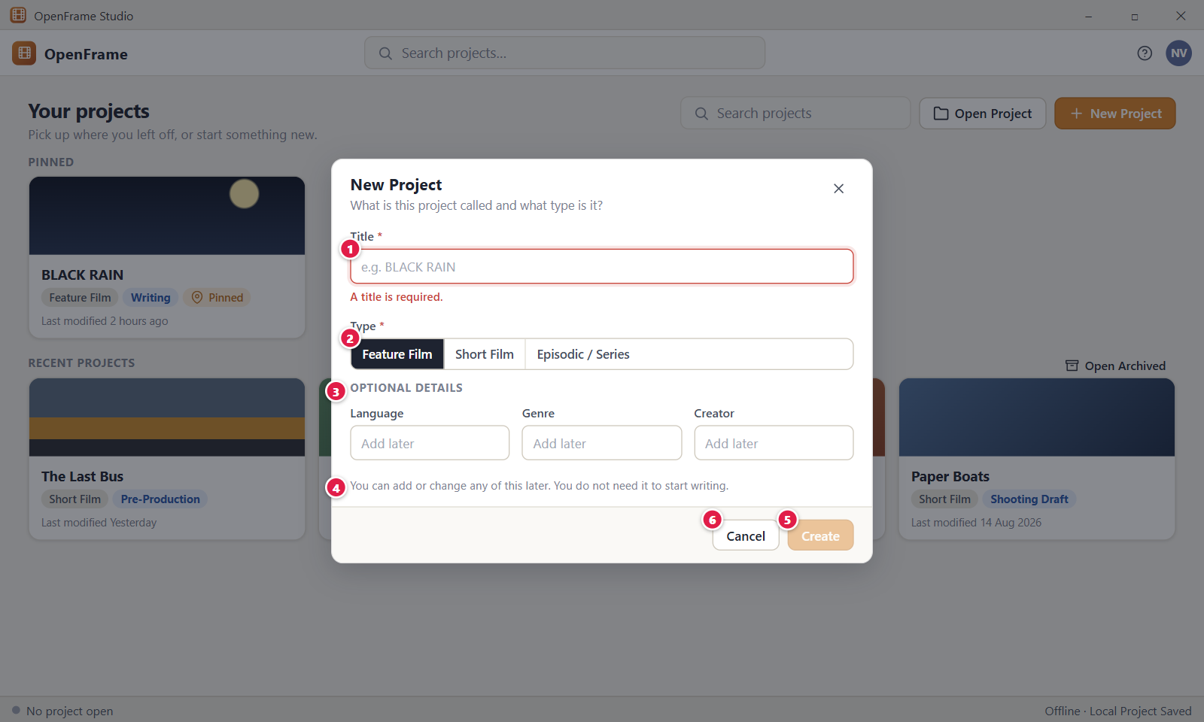
Figure 8. New Project dialog (blank). Red numbers are explained on the next page.

Figure 8: New Project dialog (blank): how it works
PARTS OF THIS SCREEN  1 e.g. BLACK RAIN The Title box. Type the working title of the film. It is required and holds up to 200 characters. Spaces at the start and end are removed, and spaces only count as empty. Duplicate titles are allowed. After you leave the box empty or press Enter on an empty title, it shows "A title is required."  2 Feature Film, Short Film, Episodic / Series The Type choice. One is always selected, and Feature Film is selected first. The type sets the starting context but never removes any menu entry. Episodic / Series shows a second choice, Structure: Episodic (episodes of one story) or Series (seasons of episodes).  3 OPTIONAL DETAILS A folded section. In the app it reads "Optional details" and is closed at first. Click it to open Language, Genre and Creator, and the row "Saved in" with a Change… button. The default folder is Documents\OpenFrame\Projects. Nothing here is needed to create the project.  4 You can add or change any of this later. You do not need it to start writing. A reminder under the fields. There is no setup wizard. The text stays visible while you type.  5 Create Creates the project and opens it at Project Home. It is greyed out until the title has 1 to 200 characters. While it works it reads "Creating…". The project gets the status Idea and you as its owner. OpenFrame makes a folder named after the title, for example BLACK RAIN.openframe, and adds (2), (3) and so on if the name exists.  6 Cancel Closes the dialog and creates nothing. Esc and the X button do the same. A click on the dimmed area outside the dialog also closes it, and the text you typed is lost. | HOW TO USE IT  1. On Home, click New Project (Ctrl+N).  2. Type the title, for example BLACK RAIN.  3. Choose the type, for example Feature Film.  4. Open Optional details only if you want to add Language, Genre or Creator, or change the folder.  5. Click Create. Project Home opens.  GOOD TO KNOW · EDGE CASES  • New Project is small on purpose: only a title and a type. Nothing else blocks creation.  • The title is stored as typed. The folder name replaces characters that Windows does not allow with an underscore.  • A new project always starts with the status Idea. You change the status on Project Home.  • If the folder you pick is inside a OneDrive, Dropbox, Google Drive or iCloud Drive folder, the dialog warns "This folder is synced by OneDrive."  • A network folder is refused: "OpenFrame projects can't be edited directly from a network folder. Copy the project to this computer, or share it with others using a review or project package."  • In the app the "A title is required." text shows only after you leave the empty box, and Create stays greyed out until you type.
See also: Figure 3 Home: your projects Figure 4 Home: first launch with no projects Figure 9 New Project dialog (filled in) Figure 10 New Project: creation error Figure 11 Project Home: a brand-new project

Figure 9: New Project dialog (filled in)
What it is for. This is the New Project dialog with valid values typed in. Create is on, and the optional details Language, Genre and Creator are filled in. It answers the question: what happens to the values I typed when I click Create?
How to get here. On Home, click New Project (Ctrl+N) and type a title. The dialog reaches this state as soon as the title has at least one character. Create then opens Project Home.
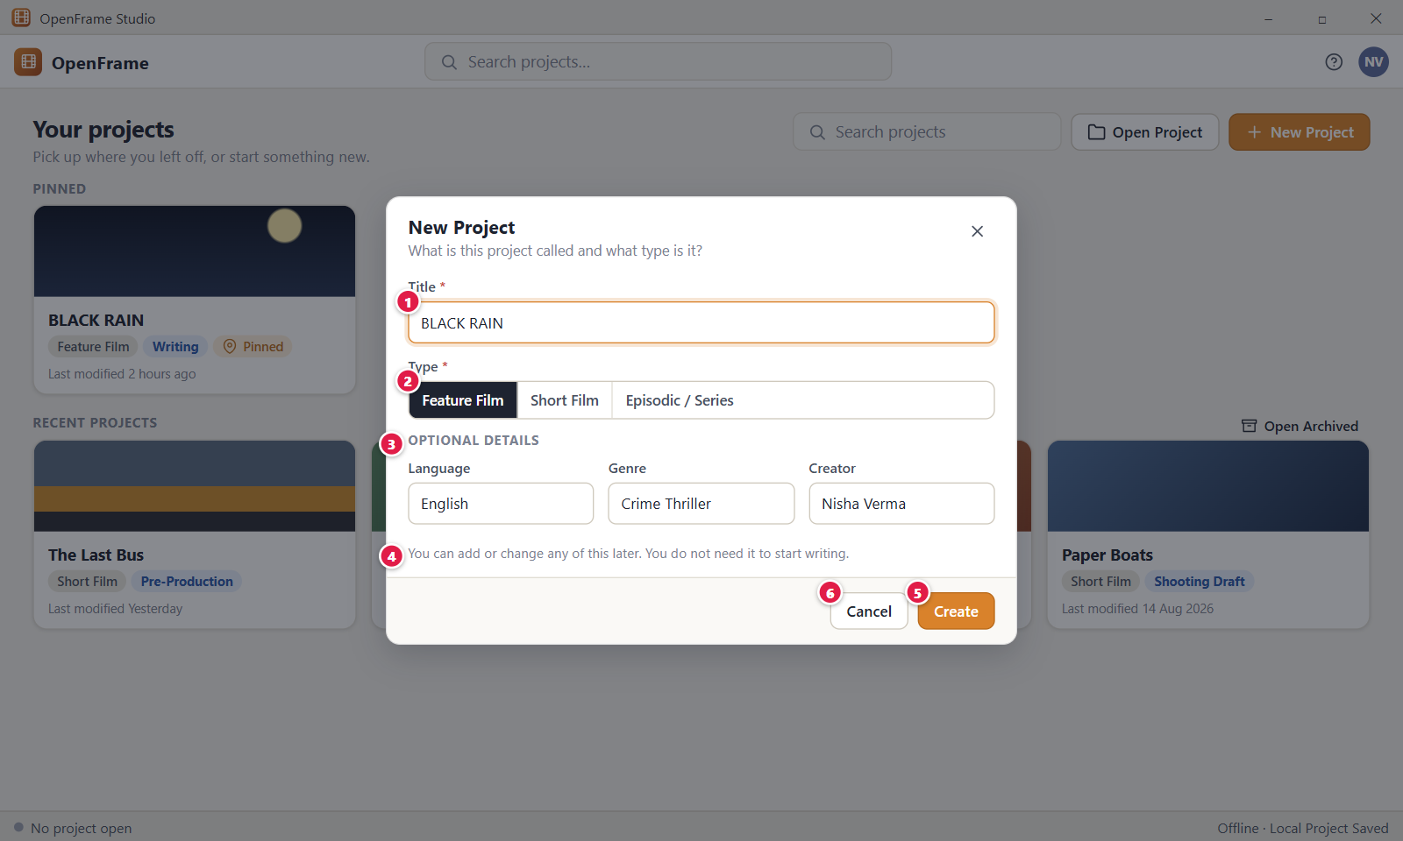
Figure 9. New Project dialog (filled in). Red numbers are explained on the next page.

Figure 9: New Project dialog (filled in): how it works
PARTS OF THIS SCREEN  1 BLACK RAIN The Title box with a valid title. The title becomes the project name on Home and in the top bar. It needs 1 to 200 characters. A title that already exists is accepted, and the new folder then reads "BLACK RAIN (2).openframe". A valid title shows no red border and no message.  2 Feature Film, Short Film, Episodic / Series The Type choice. One is always selected. The Right and Left arrow keys move the choice. Episodic / Series adds a Structure choice, Episodic or Series.  3 OPTIONAL DETAILS The section with Language, Genre and Creator, here filled with English, Crime Thriller and Nisha Verma. In the app it is closed at first. Click "Optional details" to open it. It also has "Saved in" with a Change… button. Language and Genre take up to 80 characters, Creator up to 200. The values are saved with the project and shown later in Project settings.  4 You can add or change any of this later. You do not need it to start writing. The reminder under the fields. You can create the project now and fill in details later in Project settings.  5 Create Creates the project from the typed values and opens Project Home. You can also press Enter in a text box. The label shows "Creating…" for a moment. The project gets the status Idea and you as its owner. There is no setup wizard.  6 Cancel Closes the dialog and throws away everything you typed. Esc, the X button and a click on the dimmed area do the same. No project, folder or card is made. | HOW TO USE IT  1. Type the title BLACK RAIN.  2. Leave the type on Feature Film, or choose another.  3. Click Optional details and enter a language, a genre and a creator if you want to.  4. Click Create, or press Enter.  5. Project Home opens with the line "Feature Film · Status: Idea · Created just now".  GOOD TO KNOW · EDGE CASES  • Create is on as soon as the title is valid. The optional details never block it.  • Duplicate titles are allowed. Each project has its own folder.  • Language, Genre and Creator can be changed later in Project settings, and they are reused on exported documents.  • If the save folder is inside OneDrive, Dropbox, Google Drive or iCloud Drive, the dialog warns "This folder is synced by OneDrive."  • If you cancel, the reopened dialog is blank.
See also: Figure 8 New Project dialog (blank) Figure 10 New Project: creation error Figure 11 Project Home: a brand-new project Figure 3 Home: your projects

Figure 10: New Project: creation error
What it is for. This is the New Project dialog after the project could not be created, for example because the folder cannot be written to or the disk is full. It says what happened, keeps everything you typed and lets you retry or cancel. It answers the question: did my project get made, and what can I do now?
How to get here. On Home, click New Project, fill in the dialog and click Create. If the save folder cannot be written to, the dialog stays open and shows a red banner.
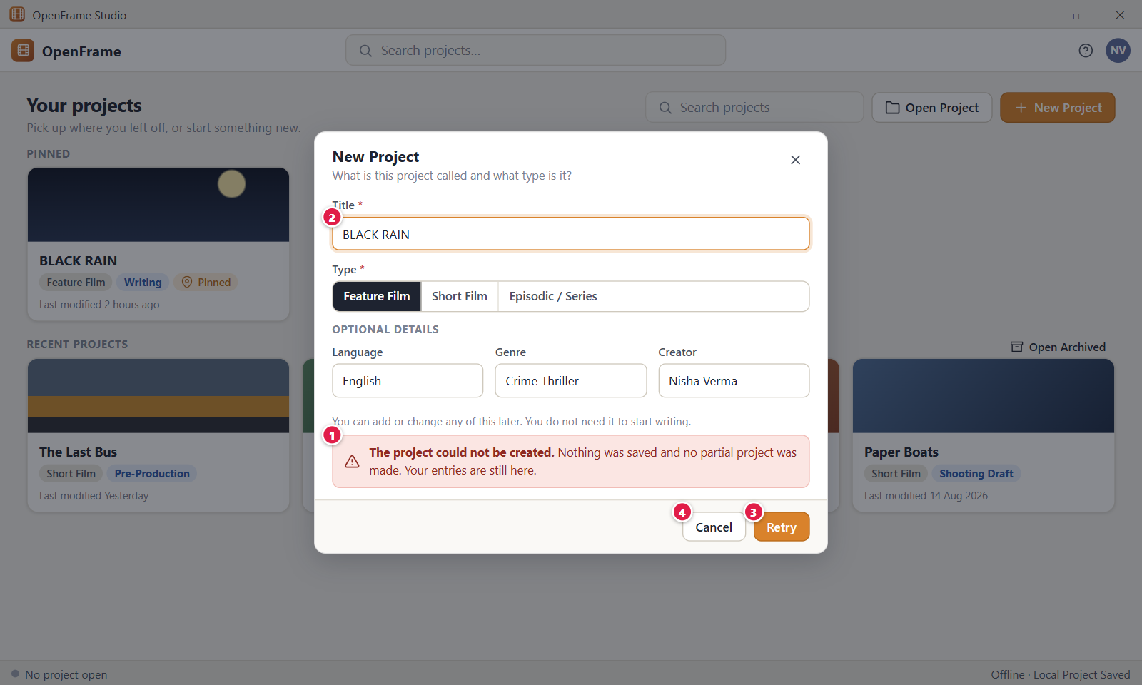
Figure 10. New Project: creation error. Red numbers are explained on the next page.

Figure 10: New Project: creation error: how it works
PARTS OF THIS SCREEN  1 The project could not be created. Nothing was saved and no partial project was made. Your entries are still here. The red banner. Under this line the app adds a second line with the reason, for example "OpenFrame doesn't have permission to write to this location. Choose a different folder or check its permissions." or "The drive is full, so OpenFrame could not save this change. Free up some space and try again. Your work is still open." The app removes any folder it made during the failed try.  2 BLACK RAIN The Title box. It keeps the title you typed. The type, Language, Genre, Creator and folder are kept too. When you edit the title, the banner goes away and the button reads Create again.  3 Retry Tries to create the same project again with the same entries. It replaces the label Create after a failure. While it works it reads "Creating…". If it fails again the banner shows the new reason. If it works, Project Home opens.  4 Cancel Closes the dialog. Nothing is created and your entries are dropped. Esc, the X button and a click on the dimmed area do the same. | HOW TO USE IT  1. Read the second line of the banner to see the reason.  2. Fix the cause. For example free some disk space, or click Optional details and Change… to pick another folder.  3. Click Retry.  4. Project Home of BLACK RAIN opens when it works.  5. Click Cancel if you want to stop.  GOOD TO KNOW · EDGE CASES  • A failed Create leaves nothing behind. No half-made project that looks complete can appear.  • Your entries are kept so you do not have to type them again.  • A network folder gives this message: "OpenFrame projects can't be edited directly from a network folder. Copy the project to this computer, or share it with others using a review or project package."  • A folder inside the OpenFrame app folder gives this message: "OpenFrame keeps its own files in that folder. Choose a different folder."  • If the drive was removed, the reason reads "The drive holding this project is no longer available. Reconnect it to keep saving. OpenFrame will not create a separate copy."  • A failed Create is not a crash. The dialog stays and the rest of the app works.
See also: Figure 8 New Project dialog (blank) Figure 9 New Project dialog (filled in) Figure 11 Project Home: a brand-new project Figure 7 Project unavailable (drive missing or file moved)

Figure 11: Project Home: a brand-new project
What it is for. Project Home of a brand-new project shows the title, type, status and age of the project and offers first steps instead of an empty dashboard. It answers the question: what do I want to do first in this film?
How to get here. On Home, click New Project, type a title and click Create. The project opens at Project Home by itself. Later, click Home in the left navigation. This welcome layout shows only while the project has no content.
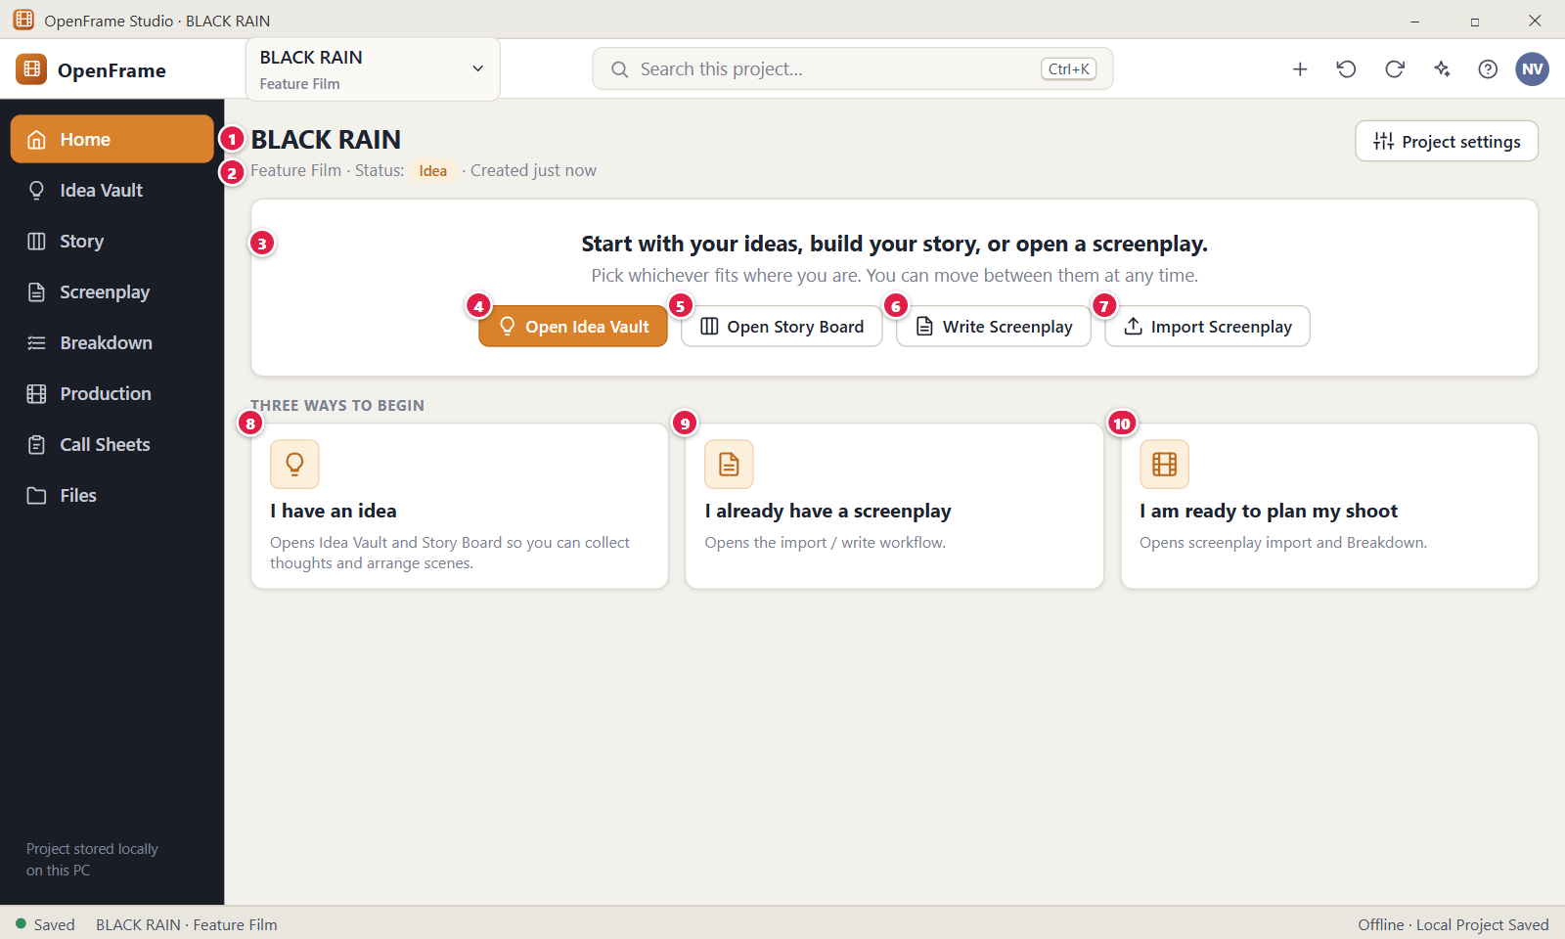
Figure 11. Project Home: a brand-new project. Red numbers are explained on the next page.

Figure 11: Project Home: a brand-new project: how it works
PARTS OF THIS SCREEN  1 BLACK RAIN The project title at the top of the page. You change it in Project settings (button at the top right) or with Rename in the card menu on Home. The title also shows in the project selector in the top bar and in the window title.  2 Feature Film · Status: Idea · Created just now One line with the type, the status and the age of the project. The status chip is a button. Click it to open the "Project status" menu with Idea, Development, Writing, Rewrite, Shooting Draft, Pre-Production, Shoot Preparation, Shooting and Archived. After a change the app says "Changed project status to Writing" and offers Undo. The app never changes the status by itself.  3 Start with your ideas, build your story, or open a screenplay. The welcome card. Under the line it says "Pick whichever fits where you are. You can move between them at any time." and holds three cards: Open Idea Vault, Build Story and Write/Import Screenplay. It disappears once the project has content, and Project Home then shows Continue, Quick Access and Recent.  4 Open Idea Vault Opens the Idea Vault, the free place where you drop thoughts, images, links and notes. The card says "Collect thoughts, images, links and notes about the film. Nothing needs to be organised yet." It does the same as Idea Vault in the left navigation.  5 Open Story Board In the app this card is called "Build Story". It says "Arrange acts, beats and scene cards on the Story Board until the story works." and opens the Story workspace. There is no button called "Open Story Board".  6 Write Screenplay In the app one card, "Write/Import Screenplay", does this job. It says "Start writing, or import a screenplay you already have." and opens the Screenplay workspace.  7 Import Screenplay This button is not on Project Home in the app. Start an import from the Screenplay workspace, or from the plus menu in the top bar with the entry "Import Screenplay…".  8 I have an idea This card is not in the app. The card Open Idea Vault does the same first step.  9 I already have a screenplay This card is not in the app. The card Write/Import Screenplay opens the Screenplay workspace, where you can import.  10 I am ready to plan my shoot This card is not in the app. Click Breakdown in the left navigation to open the Breakdown workspace. | HOW TO USE IT  1. Create a project, for example BLACK RAIN. Project Home opens.  2. Click the status chip if you want to set a status such as Writing.  3. Click Open Idea Vault to start collecting ideas, or Build Story to arrange acts and beats.  4. Or click Write/Import Screenplay to write or import a script.  5. Use the left navigation at any time to move to another workspace.  GOOD TO KNOW · EDGE CASES  • A new project never opens as an empty dashboard. It shows no numbers or charts.  • The three starting cards are not a wizard and not permission levels. You can use any workspace at any time.  • The project counts as empty until it has any idea, scene card, character, scene, location, shot, shooting day, call sheet, act, beat, file, note or task. A screenplay draft alone does not count.  • The left navigation is the same on every project screen: Home, Idea Vault, Story, Screenplay, Breakdown, Production, Call Sheets and Files. The project type never removes an entry.  • Ctrl+K opens project search.  • If Project Home cannot be read, the app says "Project Home couldn't be displayed." and offers Try Again.
See also: Figure 9 New Project dialog (filled in) Figure 12 Project Home: an active project Figure 24 Project Idea Vault: Visual Grid Figure 49 Story Board: Board view Figure 76 The screenplay editor (Standard mode) Figure 91 Importing a screenplay: choose the source

Figure 12: Project Home: an active project
What it is for. Project Home is the front door of one open film. It answers the question: what do I want to continue doing in this film? It offers Continue cards, Quick Access buttons, recent changes, a Production status card and a small Project Files list. It is not an analytics dashboard.
How to get here. On Home, click a project card. Or click Home in the left navigation, or choose the project name in the top bar. A brand-new project with no content shows a different welcome layout.
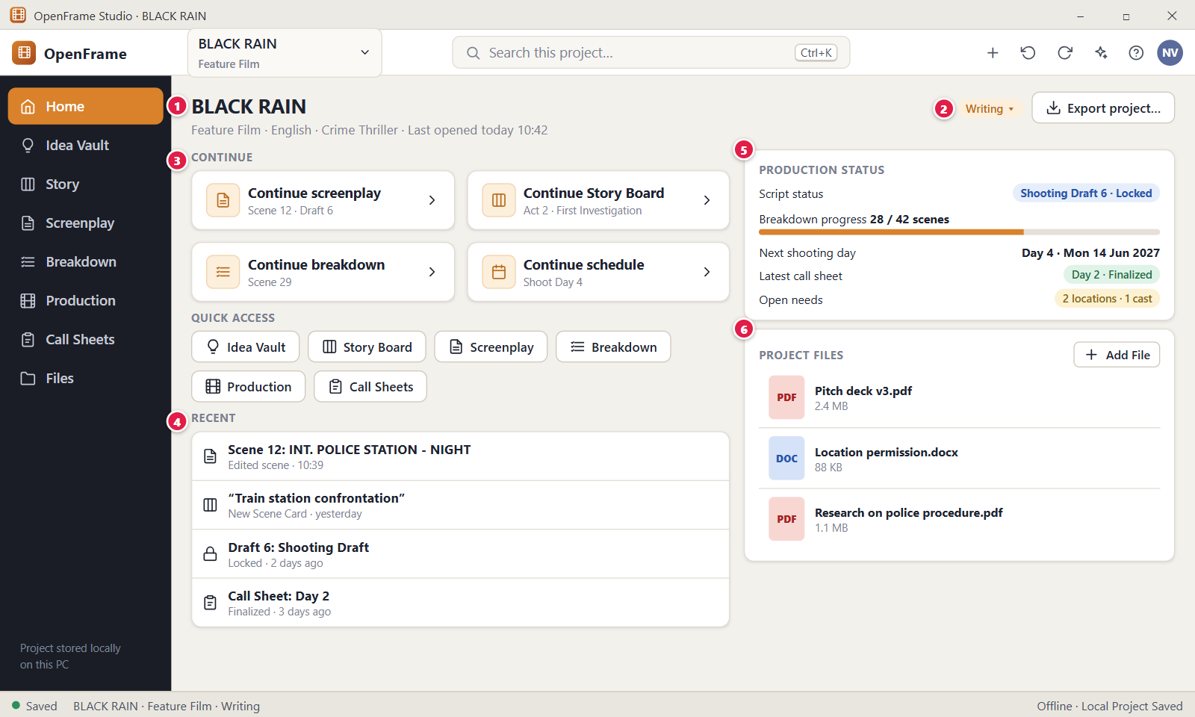
Figure 12. Project Home: an active project. Red numbers are explained on the next page.

Figure 12: Project Home: an active project: how it works
PARTS OF THIS SCREEN  1 BLACK RAIN The project header. It shows the title as a large heading and under it one line such as "Feature Film · English · Crime Thriller · Last opened Today 10:42". Language and genre are left out when empty. Change the title in Project settings, the button at the top right. In the app that button replaces the picture's Export project… button.  2 Writing ▾ The status chip. Click it to open the status menu: Idea, Development, Writing, Rewrite, Shooting Draft, Pre-Production, Shoot Preparation and Shooting, then a separate Archived item. A tick marks the current status. The app has "Rewrite", not "Rewriting", and no "Completed". After a change the app says "Changed project status to Shooting Draft" with an Undo link. The status is only a label. It creates no tasks and disables no screen.  3 CONTINUE Up to four cards that take you back to the last place you worked, such as "Continue screenplay". Each card opens that workspace at that place. The group is hidden when the app remembers no place yet. The app remembers places in the Screenplay, Files and Notes. A screenplay card may show no scene line under its title.  4 RECENT The latest changes to scenes, cards, drafts and documents, up to six rows, newest first. Each row shows what changed, and under it the person and the time, such as "5 minutes ago" or "Yesterday". Click a row to open the changed object. A row is clickable only while the object still exists. When there is nothing yet, it says "Recent changes to scenes, cards, drafts and documents will appear here."  5 PRODUCTION STATUS A card that appears only after the project has at least one breakdown item, location, shot, shooting day or call sheet. In the app it lists counts above zero (screenplay drafts, screenplay scenes, breakdown items, locations, shots, shooting days, call sheets) and the button Open Production. It does not show Script status, Breakdown progress, Next shooting day or Latest call sheet.  6 PROJECT FILES A small card for loose documents such as a pitch deck or research PDFs. It lists up to 5 files with a type badge, name and size. Add File opens a Windows file picker titled "Add files to this project" and copies the files into the project. Click a row to open Files with that file selected. A link reads "Open Files", or "All 7 files" when more than 5 exist. When empty it says "Keep project documents and attachments here." | HOW TO USE IT  1. Open BLACK RAIN from Home.  2. Click a Continue card, for example "Continue screenplay", to return to where you stopped.  3. Click the status chip and choose Shooting Draft when the script is ready for the shoot.  4. Click a row under Recent to jump to the scene or document you changed.  5. Click Add File and choose a file to keep it with the project.  GOOD TO KNOW · EDGE CASES  • Archived is not a status. It is a separate flag. The chip then reads "Writing · Archived", a banner offers Restore to Active, and nothing is deleted.  • Quick Access has six buttons: Idea Vault, Story Board, Screenplay, Breakdown, Production and Call Sheets. The app also has small links to Notes & Tasks, Activity, Recently Deleted and Templates.  • When the project has open tasks, a Tasks card with a count "N open" shows under Project Files.  • Counts and rows are read live from the project, so a very recent edit can take a few seconds to show.  • Offline is normal. The status strip reads "Offline · Local Project Saved" and does not mean an error.  • If Home cannot load, the app says "Project Home couldn't be displayed." and "Your project is safe." with a Try Again button.
See also: Figure 11 Project Home: a brand-new project Figure 13 Switching projects from the top bar Figure 15 Changing the project status Figure 22 Project settings Figure 154 Project Files (file cabinet)

Figure 13: Switching projects from the top bar
What it is for. The project name in the top bar is a menu. It lets you jump to another project, open project tools such as settings and backup, or leave the project, without going back to Home first. It answers the question: how do I switch films safely?
How to get here. On any project screen, click the project name box at the top left of the top bar. It shows the project title and type, for example "BLACK RAIN" and "Feature Film".
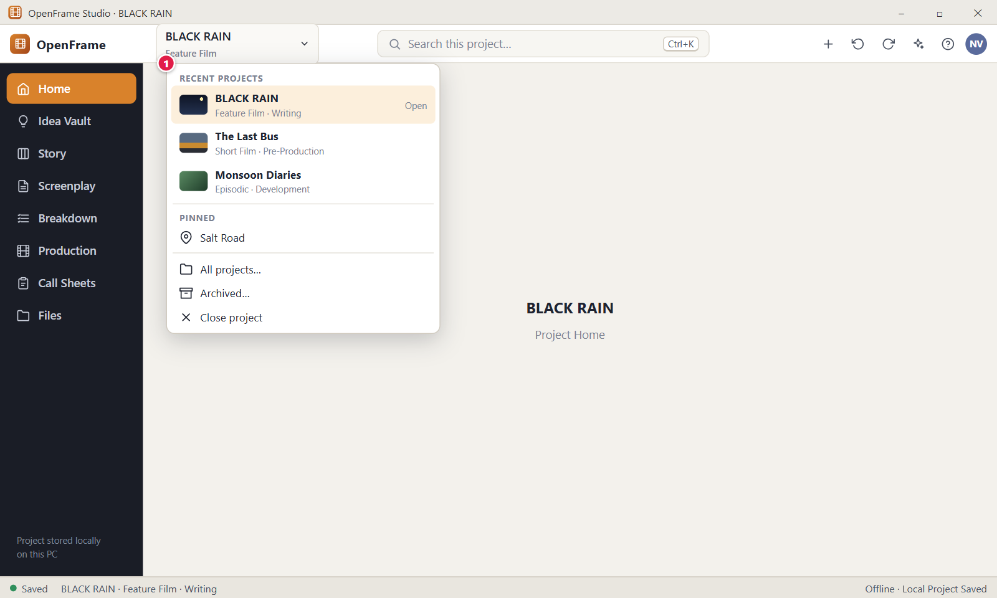
Figure 13. Switching projects from the top bar. Red numbers are explained on the next page.

Figure 13: Switching projects from the top bar: how it works
PARTS OF THIS SCREEN  1 RECENT PROJECTS The project menu. Under the heading "Recent projects" it lists the open project (with a tick and the text "Open"), up to 5 other recent projects with their type and status, and a Pinned group with up to 5 pinned projects. Then come Project settings, Notes & Tasks, Activity, Recently Deleted, Templates, Appearance, a Share / Exchange group and a Backup & Portability group (Create Backup…, Export Full Project…, Open Project Package…). The exits are All projects…, Archived… and Close project. A project whose folder cannot be found shows "Unavailable" and is disabled. Archived projects are not listed. | HOW TO USE IT  1. Click the project name box at the top left.  2. Click another project, for example The Last Bus, to switch to it.  3. Or click All projects… or Close project to return to Home.  4. Or click Archived… to see the archived list.  5. Press Esc to close the menu without changes.  GOOD TO KNOW · EDGE CASES  • Switching or closing never deletes a project. Close project and All projects… do the same thing.  • If a save is failing, or text is still waiting to be stored, the app says "This project has changes that are not saved yet." and asks Stay, Retry Save or Close Without Saving. It never drops your edits silently.  • The menu is longer than a plain project list on purpose. It also holds project tools such as settings, backup and export.  • The open project is always the first row, even when it is pinned.  • The box stays small so it is always clear which project is open.
See also: Figure 12 Project Home: an active project Figure 3 Home: your projects Figure 5 Project card menu: pin, rename, duplicate, archive Figure 6 Archived projects Figure 7 Project unavailable (drive missing or file moved) Figure 18 Leaving a project during a save problem

Figure 14: Anatomy of the OpenFrame window
What it is for. This picture names the parts of the OpenFrame window that stay the same on every project screen: the top bar, the left navigation, the working area and the status strip. Only the working area changes. It answers the question: what is each fixed control for?
How to get here. These parts are visible on every project screen. Open any project from Home.
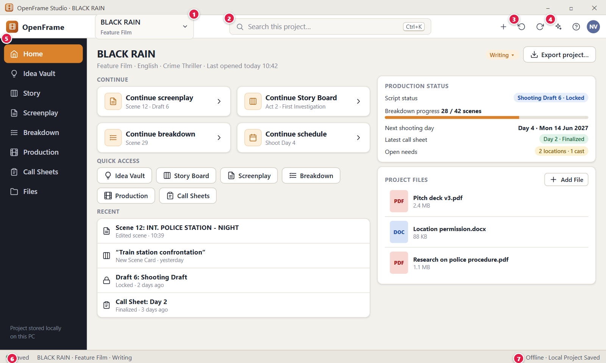
Figure 14. Anatomy of the OpenFrame window. Red numbers are explained on the next page.

Figure 14: Anatomy of the OpenFrame window: how it works
PARTS OF THIS SCREEN  1 BLACK RAIN Feature Film The project selector. It shows which film is open and its type. Click it to open the project menu, where you switch projects or leave the project. Esc closes the menu.  2 Search this project… Ctrl+K Opens the search window for the whole open project: ideas, story objects, screenplay text, characters, locations, shots, call sheets, files and comments. Click the box or press Ctrl+K. Results start about a moment after you stop typing, up to 60 results. Arrow Up and Down move the highlight and Enter opens the result. Esc closes the window.  3 Undo and Redo Two round-arrow buttons at the top right of the top bar. Undo reverses the last project action (Ctrl+Z). Redo repeats it (Ctrl+Y or Ctrl+Shift+Z). They are grey when there is nothing to undo or redo. The tooltip names the action, and a message such as "Undid: Changed project status to Shooting Draft" confirms it.  4 AI Assistant The sparkle button. It opens and closes the AI Assistant panel on the right (Ctrl+J). The panel narrows the page instead of covering it. The AI model is not in the installer. Until you download it, about 1.2 GB, the panel shows the card "Download OpenFrame AI". OpenFrame works fully without the AI.  5 Left navigation The eight workspaces: Home, Idea Vault, Story, Screenplay, Breakdown, Production, Call Sheets and Files. The selected one is highlighted. The order never changes. Cast, Locations, Props, Moodboards, Shots, Schedule, Reports and Budget are inside Production. A note at the bottom reads "Project stored locally on this PC".  6 Saved The save indicator at the bottom left. A green dot and "Saved" mean your file on this computer is safe. Other states are "Saving" (amber), "Saved · finishing export" (amber) and "Save error" (red). OpenFrame saves as you work. Ctrl+S saves now and shows "Saved. Everything is stored on this computer." Click the indicator to open the project status panel.  7 Offline · Local Project Saved The connection text at the bottom right. Offline is normal, not a problem. It says your project lives on this computer. It turns to "Offline · Local save failed" when the save state is Save error. There is no cloud sync. | HOW TO USE IT  1. Open BLACK RAIN from Home.  2. Press Ctrl+K and type a word from the film to search the project.  3. Click a workspace in the left navigation to move to it. The top bar and status strip stay where they are.  4. Press Ctrl+Z to undo your last project action, or click the Undo button.  5. Look at the bottom left to confirm the project shows "Saved".  GOOD TO KNOW · EDGE CASES  • Besides the controls in the picture, the top bar has a Create (+) button, a Help (?) button and a round button with your initials. The initials button opens a dialog to change your display name.  • Help shows the shortcuts: Ctrl+K search, Ctrl+S save, Ctrl+Z undo, Ctrl+Y redo, Ctrl+J assistant.  • Ctrl+Z inside a text box undoes your typing in that box. The Undo button and Ctrl+Z outside text boxes undo project actions.  • The window opens at 1440 by 900 pixels at most and cannot be made smaller than 1200 by 720. Only one OpenFrame window runs at a time.  • There is no live collaboration and no "connected" state in the status strip.  • If a search finds nothing, the app says "No matches. Search looks at titles, text, notes, file names and tags."
See also: Figure 12 Project Home: an active project Figure 13 Switching projects from the top bar Figure 19 Save and offline status panel Figure 20 The + quick-actions menu Figure 21 Undo and Redo Figure 156 Global project search

Figure 15: Changing the project status
What it is for. Project status is a simple label that says where the film is in its life. This menu lets the project owner change that label. It answers the question: how do I mark that BLACK RAIN moved from Writing to Shooting Draft?
How to get here. On Project Home, click the status chip at the top right of the page, next to the Project settings button. The same statuses are in the Status drop-down in Project settings.
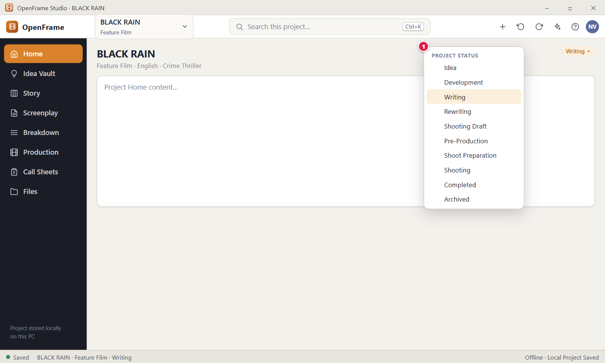
Figure 15. Changing the project status. Red numbers are explained on the next page.

Figure 15: Changing the project status: how it works
PARTS OF THIS SCREEN  1 PROJECT STATUS The status menu. It has the heading "Project status" and eight statuses in life-cycle order: Idea, Development, Writing, Rewrite, Shooting Draft, Pre-Production, Shoot Preparation and Shooting. A tick marks the current one. Pick any status from any other, there is no forced order. In the app it reads "Rewrite" and there is no "Completed". "Archived" is not a status. It is a separate item under a line at the bottom that archives the project. | HOW TO USE IT  1. On Project Home, click the status chip, for example "Writing ▾".  2. Choose Shooting Draft.  3. Read the message "Changed project status to Shooting Draft". Click Undo within about 5 seconds if you chose by mistake.  4. Check that the chip and the status strip at the bottom show the new status.  5. To put the project away, choose Archived.  GOOD TO KNOW · EDGE CASES  • Status is a label you control. It never creates tasks and never turns off a feature.  • Only the project owner can change the status. Choosing the current status does nothing.  • The app never changes the status by itself, and it shows no status suggestions.  • Archived keeps the status label. Choose Restore to Active to return the project as it was.  • The status also shows in the Project Home header, in the bottom strip and on the project cards on Home.  • Ctrl+Z outside a text box undoes the status change, and Esc closes the menu.
See also: Figure 12 Project Home: an active project Figure 22 Project settings Figure 6 Archived projects Figure 3 Home: your projects

Figure 16: Recovering after a crash or power cut
What it is for. After the app or Windows stopped in a wrong way, such as a crash, a power cut or a forced quit, OpenFrame offers the automatic recovery state the next time you open the project. It never picks a version silently. It answers the question: which version of my work do I want back?
How to get here. It appears by itself over the project when you open a project that was not closed normally and a recovery state exists.
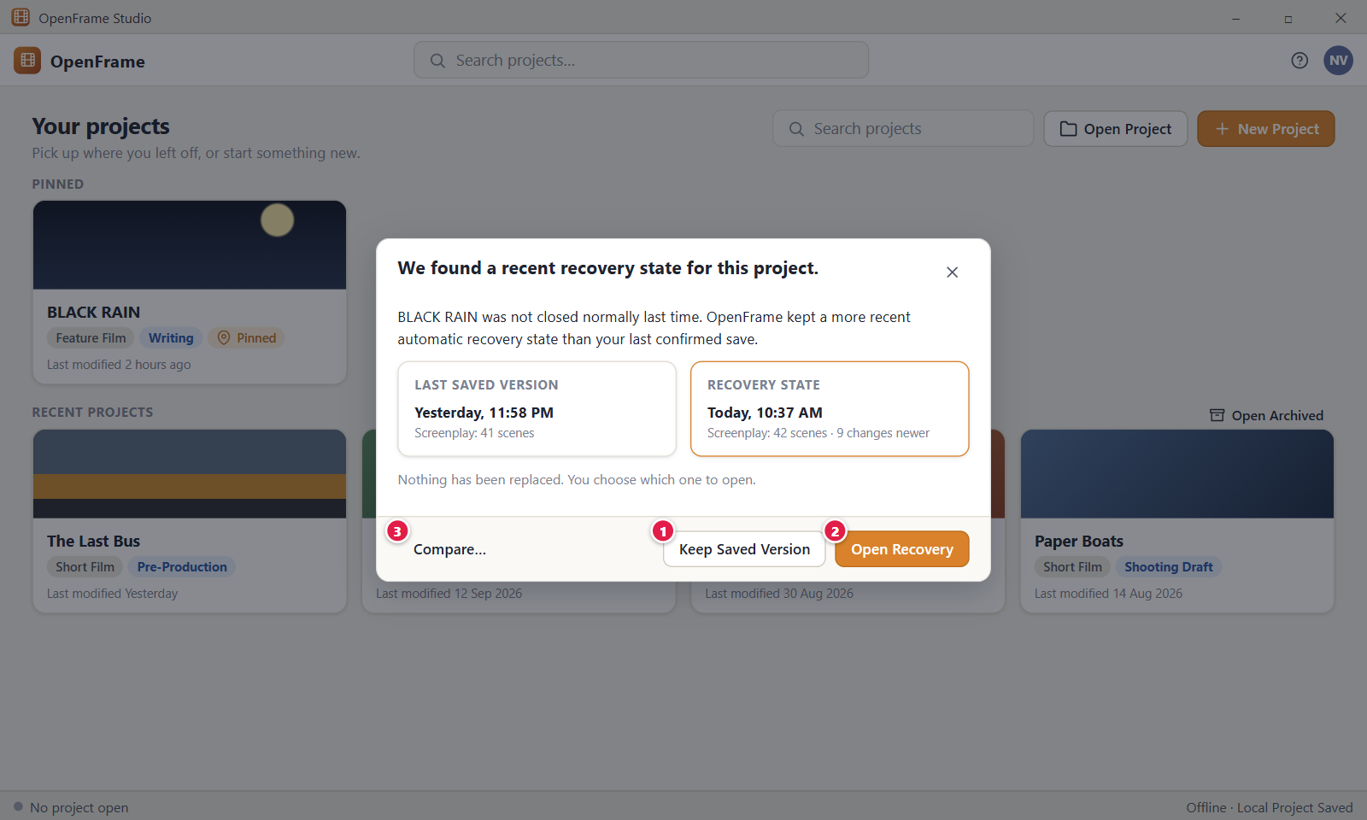
Figure 16. Recovering after a crash or power cut. Red numbers are explained on the next page.

Figure 16: Recovering after a crash or power cut: how it works
PARTS OF THIS SCREEN  1 Keep Saved Version Goes back to the last confirmed saved state. A confirmed save comes from Ctrl+S, Save now or a clean close. The newer recovery state is not lost: OpenFrame first copies it to the project's backups folder as a safety copy. The button is grey, with the tooltip "There is no confirmed saved version to return to.", when no confirmed save exists. Afterwards you see "Opened the last saved version. The newer recovery state was kept as a safety copy in the project's backups folder."  2 Open Recovery Keeps the project exactly as it was at the moment of the crash, with every change that was stored before it. Nothing is replaced. It is the main button. Afterwards you see "Opened the recovery state. Your latest work is here."  3 Compare… This button is not in the current version. The dialog shows a card "Recovery state" with a time and a line such as "3 changes newer", or "Latest automatic save". It does not show scene counts. | HOW TO USE IT  1. Start the app and open the project that was open when it stopped.  2. Read the dialog "We found a recovery state for this project." and look at the time and the "changes newer" line.  3. Click Open Recovery to keep all work stored before the stop.  4. Or click Keep Saved Version to go back to your last confirmed save.  5. Wait for the confirming message.  GOOD TO KNOW · EDGE CASES  • No recovery copy replaces your project silently. The dialog says "Nothing has been replaced. You choose which one to open."  • Both choices keep your data. Open Recovery keeps everything stored before the stop. Keep Saved Version saves the newer state to the backups folder first.  • In the app the dialog shows over the project after you open it, not over Home. It has no close (X) button.  • If the recovery state matches your last save, the text reads "The automatic recovery state OpenFrame kept matches your last confirmed save."  • While a choice works, the label reads "Opening…" and both buttons are disabled.  • Recovery information belongs to the project and is shown only to someone who can open it.
See also: Figure 17 Save error: your work is still open Figure 19 Save and offline status panel Figure 18 Leaving a project during a save problem Figure 12 Project Home: an active project

Figure 17: Save error: your work is still open
What it is for. When OpenFrame cannot write your project to disk, it keeps your edits on screen, turns the save indicator red and offers ways forward. It never says the project is safe when it is not, and it never blames the internet. It answers the question: what do I do right now?
How to get here. It appears by itself on any project screen when saving to the local file fails. A red banner shows at the top of the page, a dialog opens once for each new failure, and the indicator at the bottom left turns red.
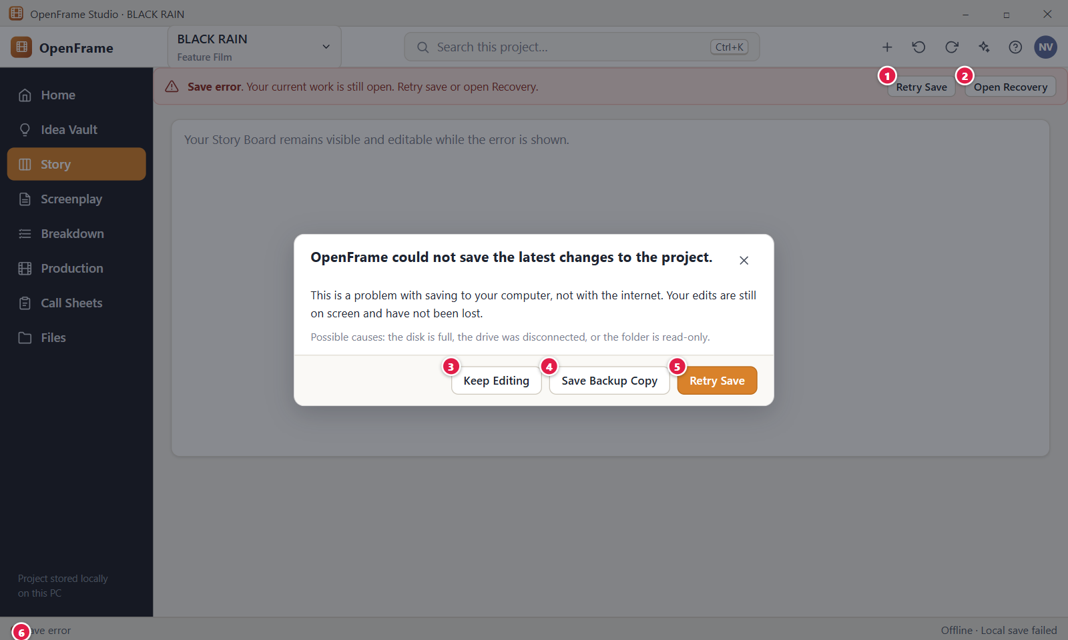
Figure 17. Save error: your work is still open. Red numbers are explained on the next page.

Figure 17: Save error: your work is still open: how it works
PARTS OF THIS SCREEN  1 Retry Save The button in the red banner. The banner reads "Save error. Your current work is still open. Retry save or open Recovery." The button tries the save again at once, like Ctrl+S. On success the banner goes away and you see "Saved. Everything is stored on this computer." On failure an error message gives the reason.  2 Open Recovery The second banner button. It opens the dialog "Open recovery" with the cards "Last saved version" and "Current state". Keep Current Work closes it and changes nothing. Open Saved Version goes back to your last confirmed save, after copying the current state to the project's backups folder. With no confirmed save, Open Saved Version is grey.  3 Keep Editing Closes the dialog and lets you continue working. The red banner and the red indicator stay until saving works again. The dialog does not come back for the same failure.  4 Save Backup Copy This button is not in the app. To make a backup copy, use Create Backup… in the project selector menu, in the group Backup & Portability.  5 Retry Save The main button in the dialog. It tries the save again and shows "Saving…" while it works. If it works, the dialog closes by itself. If not, the dialog stays and an error message gives the reason.  6 Save error The red save indicator at the bottom left. The right side reads "Offline · Local save failed". It turns red only for storage problems such as a full disk, a missing drive or a locked file. Click it to open the project status panel, which shows the error message and a Retry Save button. | HOW TO USE IT  1. Read the dialog. It says "OpenFrame could not save the latest changes to the project."  2. Click Keep Editing if you want to keep working. Your edits stay on screen.  3. Fix the cause. Free disk space, reconnect the drive or make the folder writable.  4. Click Retry Save, in the banner or in the dialog.  5. Check that the indicator at the bottom left is green and reads "Saved".  GOOD TO KNOW · EDGE CASES  • The dialog says "This is a problem with saving to your computer, not with the internet. Your edits are still on screen and have not been lost."  • It lists possible causes: the disk is full, the drive was disconnected, or the folder is read-only.  • Save error never blocks editing. The failed change is rolled back safely and earlier work stays intact.  • The dialog appears once for each new failure. The banner and the red indicator stay until saving works.  • If the drive was removed, the message reads "The drive holding this project is no longer available. Reconnect it to keep saving. OpenFrame will not create a separate copy."  • The dialog in the app has two buttons, Keep Editing and Retry Save.
See also: Figure 18 Leaving a project during a save problem Figure 19 Save and offline status panel Figure 16 Recovering after a crash or power cut Figure 169 Creating a backup Figure 49 Story Board: Board view

Figure 18: Leaving a project during a save problem
What it is for. When you switch to another project, close the project or close the app while your latest changes are not stored, OpenFrame asks you to decide instead of silently dropping them. It answers the question: do I stay and fix the save, or leave and accept losing the newest edits?
How to get here. It appears over the project when the save state is Save error, or some editor text could not be stored, and you pick another project in the top bar, choose All projects…, Archived…, Close project or New Project…, or close the window with the X or Alt+F4.
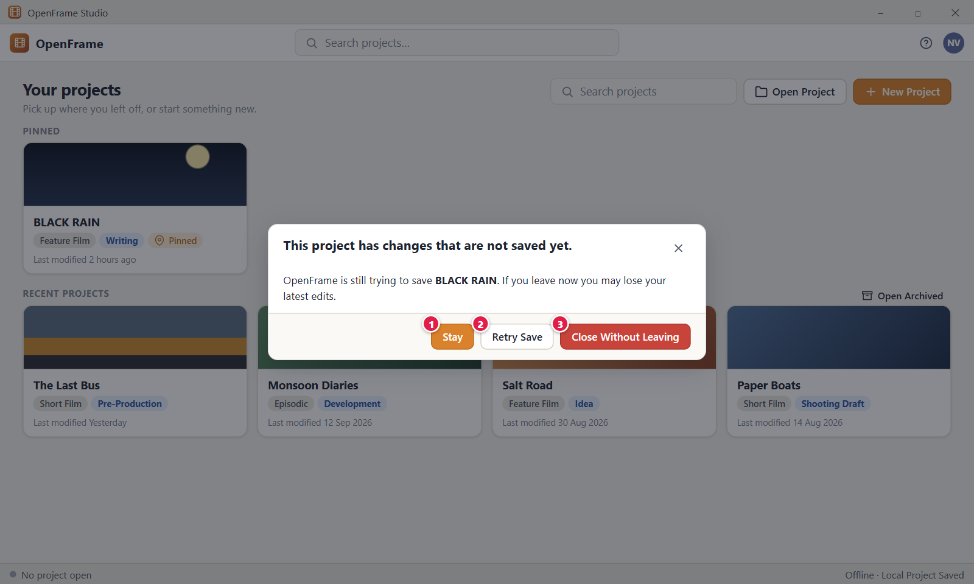
Figure 18. Leaving a project during a save problem. Red numbers are explained on the next page.

Figure 18: Leaving a project during a save problem: how it works
PARTS OF THIS SCREEN  1 Stay Closes the dialog and keeps you in the project. Nothing is closed and nothing is lost. It does not save and does not clear the save error. Esc does the same.  2 Retry Save Tries to save once more. While it works it shows "Saving…". If it works, the dialog closes and the switch or close you started goes ahead. If not, an error message gives the reason and the dialog stays so you can choose again.  3 Close Without Leaving In the app this red button is called "Close Without Saving". It leaves the project at once and accepts that the latest edits that could not be stored are lost. Work saved earlier is intact. | HOW TO USE IT  1. Read the dialog. It says "This project has changes that are not saved yet."  2. Click Retry Save first. If it works, you leave with your work saved.  3. Click Stay if you want to fix the cause, for example reconnect the drive or free disk space.  4. Click Close Without Saving only if you accept losing the newest edits.  GOOD TO KNOW · EDGE CASES  • The text reads "OpenFrame is still trying to save BLACK RAIN. If you leave now you may lose your latest edits." It names the project you are leaving. When you close the window it says "your work".  • Button labels say what they do. There is no plain OK or Cancel for this choice.  • The dialog appears only on a Save error or when some editor text could not be stored. With "Saved" you leave at once. A save that is only in progress is waited for.  • The dialog shows over the project you are leaving, because the project stays open until you choose.  • Retry Save works only if the cause is fixed. After it succeeds you see "Saved. Everything is stored on this computer."
See also: Figure 17 Save error: your work is still open Figure 13 Switching projects from the top bar Figure 16 Recovering after a crash or power cut Figure 3 Home: your projects

Figure 19: Save and offline status panel
What it is for. Clicking the save indicator at the bottom left opens a small panel. It says whether your work is safely on disk, where the project folder is, and what you can do about it. It does not take you away from your page. It answers the question: is my work safe on this computer?
How to get here. On any project screen, click "Saved" (or "Saving" or "Save error") at the bottom left of the window. The panel opens above the strip. It is not available on Home, where no project is open.
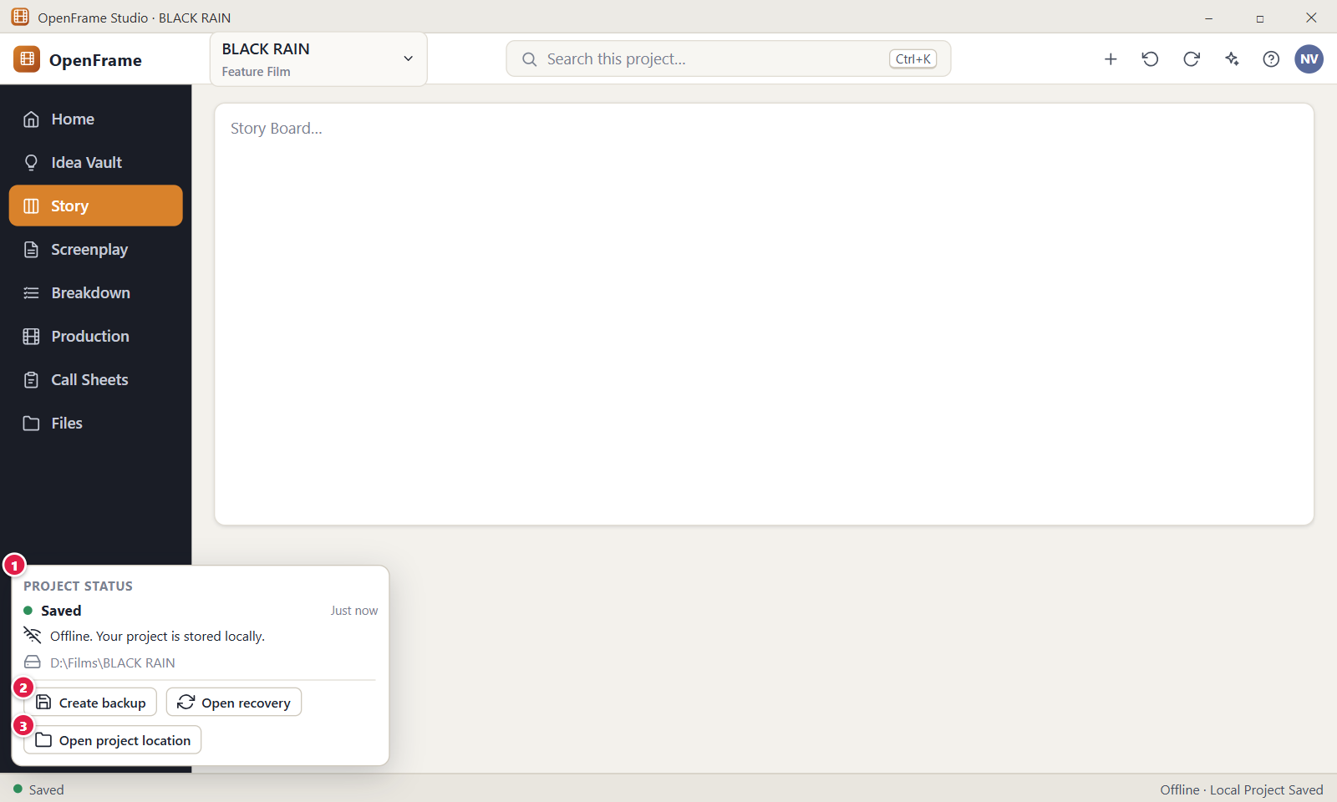
Figure 19. Save and offline status panel. Red numbers are explained on the next page.

Figure 19: Save and offline status panel: how it works
PARTS OF THIS SCREEN  1 PROJECT STATUS The whole panel. It shows a colored dot with the state word and the time of the last save, then the line "Offline: your project is stored locally.", the full path of the project folder and the buttons. The states are "Saved" (green), "Saving" (amber), "Saved · finishing export" (amber) and "Save error" (red). During an error the message shows in red. You can select and copy the path. Esc or a click outside closes the panel.  2 Create backup This button is not in the panel. The first button is "Save now", which reads "Retry Save" during an error. It saves a checkpoint, the same as Ctrl+S, and shows "Saved. Everything is stored on this computer." To make a backup package, use Create Backup… in the project selector menu under Backup & Portability.  3 Open project location Opens the folder that holds the project in Windows File Explorer. It changes nothing in the folder. If Windows cannot open it, for example because the drive is missing, an error message appears. Do not edit or move files in that folder while the app is open. | HOW TO USE IT  1. Click "Saved" at the bottom left.  2. Read the state word, the time and the folder path.  3. Click Save now to write a confirmed checkpoint.  4. Click Open project location if you want to see the project folder.  5. Press Esc to close the panel.  GOOD TO KNOW · EDGE CASES  • Offline is a normal state, not an error. Everything works without a network, and the AI works after its one-time download.  • The status text never mentions a cloud. There is no "Syncing" state.  • OpenFrame saves every change as you work. Save now and Ctrl+S add a confirmed checkpoint. That checkpoint is the last saved version used by Open recovery and by crash recovery.  • The panel also has an Open recovery button and a small Activity button.  • Before you have made any confirmed save, Open recovery says "There is no confirmed saved version yet. Your work saves continuously; use Save (Ctrl+S) to create one."
See also: Figure 14 Anatomy of the OpenFrame window Figure 17 Save error: your work is still open Figure 16 Recovering after a crash or power cut Figure 169 Creating a backup Figure 152 Activity History

Figure 20: The + quick-actions menu
What it is for. The plus button in the top bar opens a short menu of the most common create actions, available from any project screen. It answers the question: how do I start a new idea, scene card, character or import without hunting for the right workspace?
How to get here. On any project screen, click the + button at the top right of the top bar, left of the Undo button. Ctrl+Shift+N (New Idea) and Ctrl+N (New Scene Card) run two of the items without opening the menu.
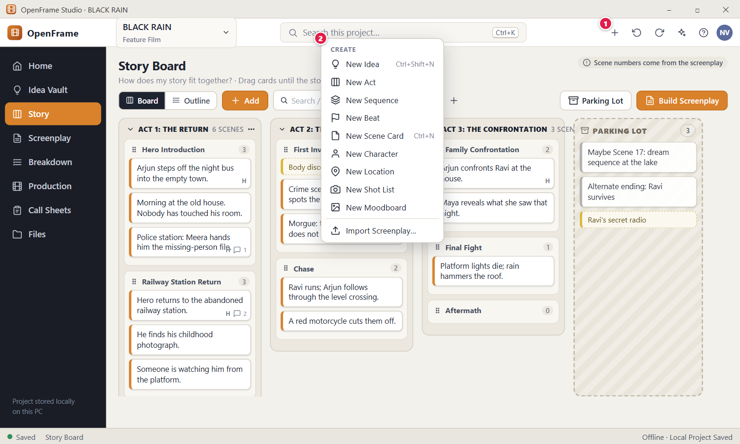
Figure 20. The + quick-actions menu. Red numbers are explained on the next page.

Figure 20: The + quick-actions menu: how it works
PARTS OF THIS SCREEN  1 Create (+) button The + button. Its tooltip is "Create". It is always on while a project is open. Esc or a click outside closes the menu, and nothing is created.  2 CREATE The menu. In order: New Idea (Ctrl+Shift+N), New Act, New Sequence, New Beat, New Scene Card (Ctrl+N), New Character, New Location, New Shot List, New Moodboard, then Import Screenplay…, then New Note, New Task and New Project…. The list is the same on every page. Each item opens the right workspace and starts the create step there. New Shot List and New Moodboard only open the Shots and Moodboards pages in Production. New Project… closes the open project first, with the save-problem check, and opens the New Project dialog. | HOW TO USE IT  1. Click the + button in the top bar.  2. Choose New Idea to capture a thought, or press Ctrl+Shift+N.  3. Or choose New Scene Card, or press Ctrl+N, to add a card to the Story Board.  4. Or choose Import Screenplay… to start an import.  5. Type into the new object that opens.  GOOD TO KNOW · EDGE CASES  • These are the same actions offered inside each workspace.  • The menu is not contextual. It shows the same list wherever you are.  • New Scene Card and New Beat create an empty object at once and open it for typing. Undo is always available.  • Ctrl+N is ignored while a text box has focus or a dialog is open.  • Scene cards carry no scene numbers. The Story Board says "No scene numbers; they come from the screenplay".  • The shortcut hints follow your keyboard settings. Ctrl+Shift+N and Ctrl+N are the defaults.
See also: Figure 50 Add menu: Act, Sequence, Beat, Scene Figure 58 The Parking Lot Figure 63 Build Screenplay: preview Figure 21 Undo and Redo Figure 24 Project Idea Vault: Visual Grid

Figure 21: Undo and Redo
What it is for. Every meaningful editing or arranging action can be undone and redone, and each one has a label in plain words. This makes it safe to try things. It answers one question: how do I take back what I just did?
How to get here. Use the two round-arrow buttons in the top bar, left of the AI sparkle button. Keyboard: Ctrl+Z to undo, Ctrl+Y or Ctrl+Shift+Z to redo. A short message with an Undo link appears at the bottom of the window after an action, for example on the Story Board after you move a card.
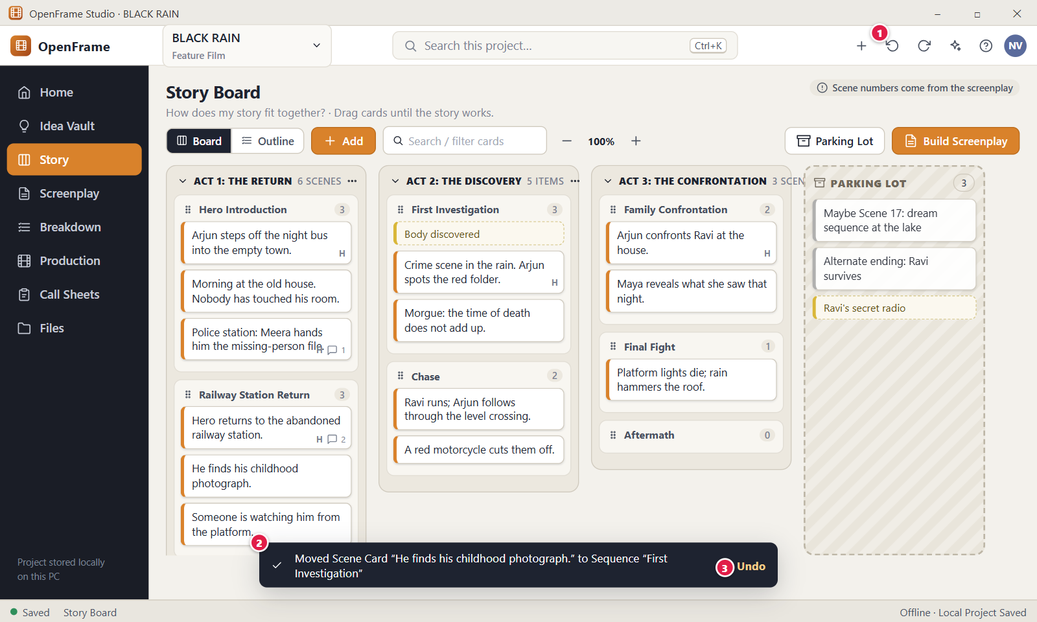
Figure 21. Undo and Redo. Red numbers are explained on the next page.

Figure 21: Undo and Redo: how it works
PARTS OF THIS SCREEN  1 Undo and Redo buttons Two round-arrow buttons in the top bar. Hover over one to see the action it will reverse or repeat, for example "Undo: Moved Scene Card ...". Both are grey when there is nothing to undo or redo, and the tooltips then read "Nothing to undo" and "Nothing to redo".  2 Confirmation message A dark bar at the bottom of the window that says in plain words what just happened, such as which card moved and where. It goes away by itself after about 5 seconds, or you can close it with the × button. Long names are cut with three dots.  3 Undo The link inside the bar. It undoes the latest step in your history, which is normally the action named in the bar. If you made another change after it, the link undoes that newer change. | HOW TO USE IT  1. Drag a card on the Story Board into another sequence, for example "He finds his childhood photograph." into "First Investigation".  2. Read the bar at the bottom of the window. It names the card and the sequence.  3. Click "Undo" in the bar, or press Ctrl+Z, to put the card back.  4. Hover over the right round-arrow button to see what Redo will repeat.  5. Click it, or press Ctrl+Y, to move the card again. A bar reads "Redid: ...".  GOOD TO KNOW · EDGE CASES  • Undo covers text edits made through the app, card create, delete and move, board reorder, breakdown links, shot reorder, schedule moves, note changes and form edits. A large import counts as one step where that is practical.  • Routine actions such as moving a card, adding a comment or adding a shot never ask for confirmation, because Undo is always there. Only destructive actions, such as deleting a project or a draft, permanent deletion, replacing a screenplay by import or overwriting data from an exchange package, ask first.  • Inside a text box, Ctrl+Z is that text box's own undo. The top-bar buttons and the keys outside a text box undo project actions. The screenplay editor has its own undo while you type.  • History is kept for each person and each project, survives closing the app, and holds up to 300 steps. Typing in one place within 4 seconds counts as one step.  • A new action clears the Redo steps. View settings are not undoable, and permanent project deletion cannot be undone.  • If the same content was changed again by another route, Undo says "This step can't be undone because the same content was changed afterwards. Your latest work was kept." Every undo also appears in Activity History.
See also: Figure 49 Story Board: Board view Figure 14 Anatomy of the OpenFrame window Figure 44 Recently Deleted Figure 152 Activity History

Figure 22: Project settings
What it is for. Project settings holds the few descriptive details of a project: title, type, status and project notes, plus language, genre and creator. You can change them at any time. It answers: how do I rename the film or change its details without touching the work?
How to get here. On Project Home, click "Project settings" at the top right. You can also open the project menu in the top bar and click "Project settings". Only the Owner can save changes. On one PC, the person who opens the folder is the Owner.
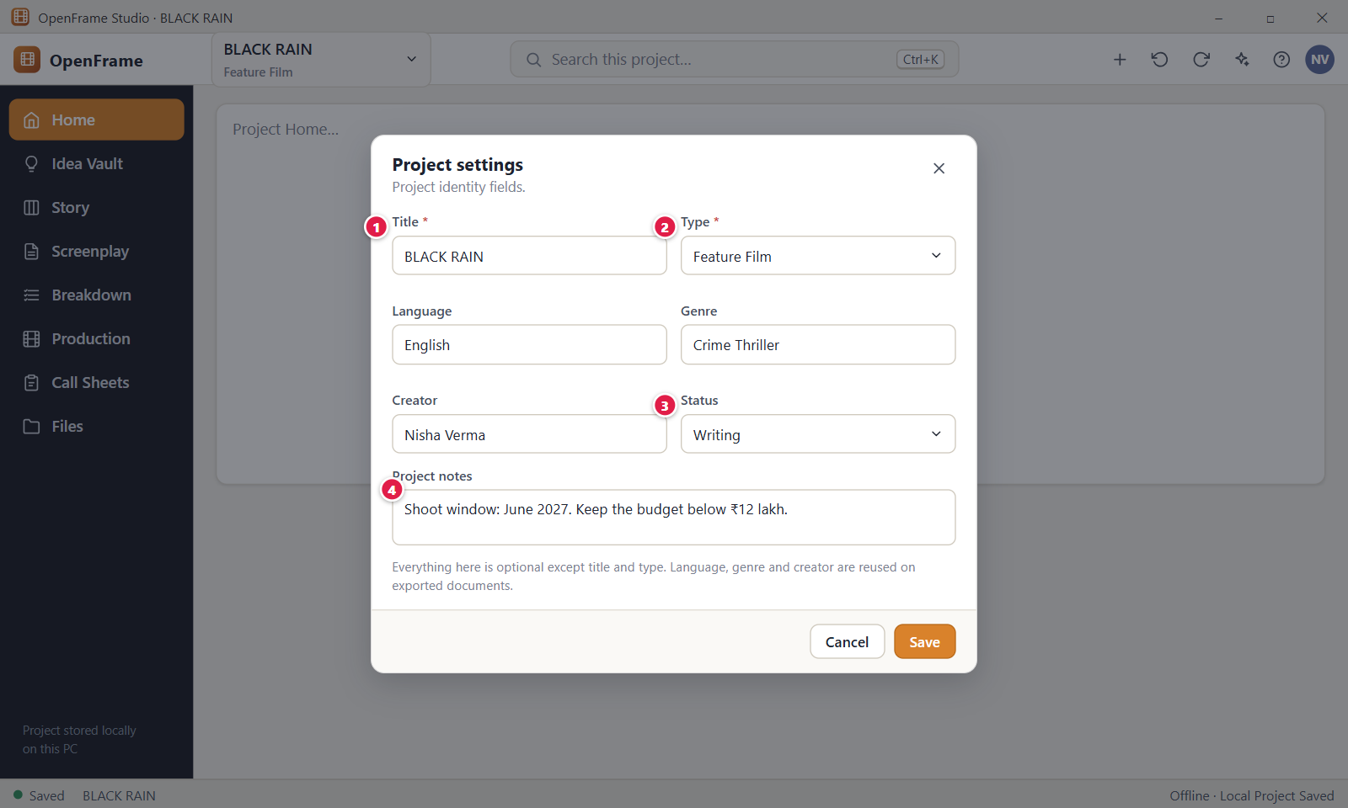
Figure 22. Project settings. Red numbers are explained on the next page.

Figure 22: Project settings: how it works
PARTS OF THIS SCREEN  1 Title (required) The project title. It shows on Project Home, in the top-bar selector, in the Windows title bar, on the Application Home card and on exported documents. It must be 1 to 200 characters. Spaces at the start and end are removed. If you clear it, the form says "A title is required." Renaming changes only the title, not the project folder on disk.  2 Type (required) The kind of project. In the app the choices are Feature Film, Short Film, Episodic and Series. Switching between the film group and the episodic group shows "Changing the type never deletes anything you have written." The type decides, for example, whether Story shows an Episodes page.  3 Status A label for where the project is. The choices are Idea, Development, Writing, Rewrite, Shooting Draft, Pre-Production, Shoot Preparation and Shooting. "Archived" is a separate switch, not in this list. The label creates no tasks and blocks nothing.  4 Project notes A free note kept with the project, such as a shoot window or a budget limit. It is optional and holds up to 20000 characters, with line breaks kept as you type them. Other notes live in Notes & Tasks. | HOW TO USE IT  1. Open Project Home and click "Project settings".  2. Change the Title, for example from "BLACK RAIN" to "BLACK RAIN 2".  3. Pick a Type and a Status from the lists.  4. Type a note in Project notes, for example the shoot window and budget.  5. Click Save. A message reads "Updated project settings" with an Undo link.  GOOD TO KNOW · EDGE CASES  • Only Title and Type are required. Everything else is optional, and no budget, schedule, team, cast or location is asked for here.  • The form also has a Logline box that holds up to 1000 characters.  • Language, genre and creator are reused on exported documents, so fill them in before you export a script.  • Cancel and the close button drop what you typed without asking. Nothing is saved until you click Save.  • Two projects can have the same title. If the title and the status both change in one save, Undo takes them back in two steps.  • Enter saves when the cursor is in a one-line field, and Esc closes the form without saving.
See also: Figure 12 Project Home: an active project Figure 15 Changing the project status Figure 8 New Project dialog (blank) Figure 13 Switching projects from the top bar Figure 151 Project Notes and Lightweight Tasks

Figure 23: Deleting a project (strong confirmation)
What it is for. This dialog is the last step before a whole project leaves the project list. It asks you to type the project name, and it offers Archive Instead as the safer choice. It answers: am I sure I want to delete this project, and is there a gentler option?
How to get here. On Home, right-click the project card, or click the "..." button on the card, then click "Delete Project..." at the bottom of the menu. You cannot open it from inside an open project: close the project first.
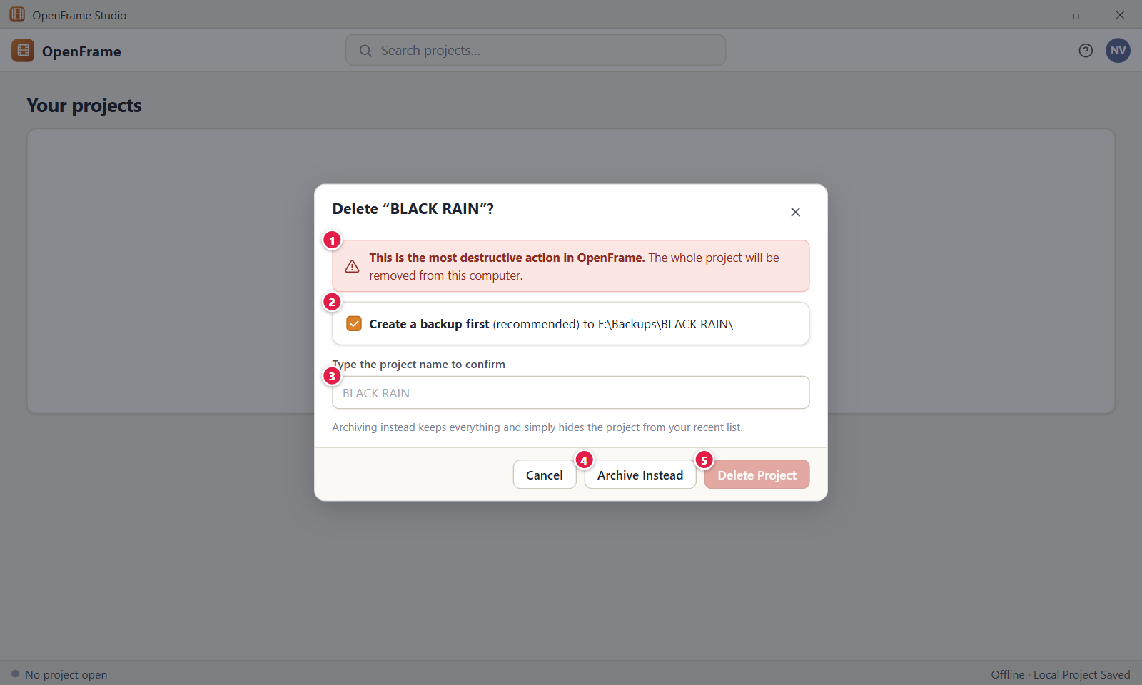
Figure 23. Deleting a project (strong confirmation). Red numbers are explained on the next page.

Figure 23: Deleting a project (strong confirmation): how it works
PARTS OF THIS SCREEN  1 Warning A red banner that reads "This is the most destructive action in OpenFrame. The whole project will be removed from this computer." Under it, a paragraph explains that the project folder is moved to the Windows Recycle Bin, and that files linked from other folders are not touched. It cannot be dismissed.  2 Create a backup first This option is not in the current version. The dialog has no backup card and no backup path. Your recovery paths are the Windows Recycle Bin and any backup you made earlier.  3 Project name box Type the project name here. The Delete Project button stays off until your text matches the title. The match ignores spaces at the start and end but is case sensitive, so "black rain" does not match "BLACK RAIN". Enter deletes when the name matches.  4 Archive Instead The safer choice. It hides the project from your recent list and keeps every file. It needs no typed text. The project appears under Open Archived, where you can restore it. The button is not shown if the project is already archived.  5 Delete Project The red button. It is pale and disabled until the typed name matches. When you click it, the label reads "Deleting...", the project folder moves to the Windows Recycle Bin and the card leaves Home. You need the permanent-delete right, which the Owner of the local project has. | HOW TO USE IT  1. On Home, right-click the project card, for example BLACK RAIN.  2. Click "Delete Project..." and read the red warning.  3. To keep the project, click "Archive Instead". It moves to Open Archived and nothing is lost.  4. To delete it, type the exact title, BLACK RAIN, in the name box.  5. Click "Delete Project". A message reads that the project was moved to the Windows Recycle Bin.  GOOD TO KNOW · EDGE CASES  • Delete does not erase files for good. The folder goes to the Windows Recycle Bin and you can restore it there with Windows Restore. Emptying the Recycle Bin is a Windows action.  • Files that a project only links to, and that sit in other folders, are not deleted.  • If you are not sure, archive. Archiving keeps the folder and everything inside it.  • Esc or Cancel closes the dialog and nothing is deleted.  • If Windows cannot move the folder, the app says "OpenFrame couldn't move this project to the Recycle Bin. Nothing was deleted."  • If the project is open, the app says "Close this project before deleting it."
See also: Figure 3 Home: your projects Figure 5 Project card menu: pin, rename, duplicate, archive Figure 6 Archived projects Figure 7 Project unavailable (drive missing or file moved)

Chapter 2: Idea Vault: Capture Anything
The Idea Vault is a loose place to capture anything for your film: notes, images, links, files, voice notes and video. You can group ideas in collections, keep a vault that belongs to no project, search it, and send an idea to the Story Board.

Screens in this chapter
Figure | Screen | Page
Figure 24 | Project Idea Vault: Visual Grid | 62
Figure 25 | Idea Vault: Card view | 65
Figure 26 | Idea Vault: List view | 67
Figure 27 | Idea Vault: Folder view | 69
Figure 28 | Idea Vault: empty state | 71
Figure 29 | Add menu: Note, Image, URL, File, Voice Note, Video | 73
Figure 30 | Text note editor (autosave) | 75
Figure 31 | Idea Vault item detail: image | 77
Figure 32 | Adding a URL | 79
Figure 33 | Recording a voice note | 81
Figure 34 | Dragging files into the Vault | 83
Figure 35 | Drag-in result: partial success | 85
Figure 36 | External file unavailable | 87
Figure 37 | Selecting several items | 89
Figure 38 | Right-click menu on a Vault item | 91
Figure 39 | Send to Story Board | 93
Figure 40 | Global Idea Vault | 95
Figure 41 | Copy a Global idea to a project | 97
Figure 42 | Searching the Vault | 99
Figure 43 | Quick Capture | 101
Figure 44 | Recently Deleted | 103
Figure 45 | Research collection with verification flags | 105
Figure 46 | Creating a collection | 107
Figure 47 | Everything the Vault can hold | 109

Figure 24: Project Idea Vault: Visual Grid
What it is for. The Project Idea Vault in Grid view is the film's creative dump. Notes, images, links, PDFs, voice notes and videos sit side by side as cards. It answers one question: what have I collected for this film?
How to get here. Click "Idea Vault" in the left navigation with your project open, or click "Open Idea Vault" on Project Home. The Vault opens in Grid view the first time, and later it opens in the view you used last.
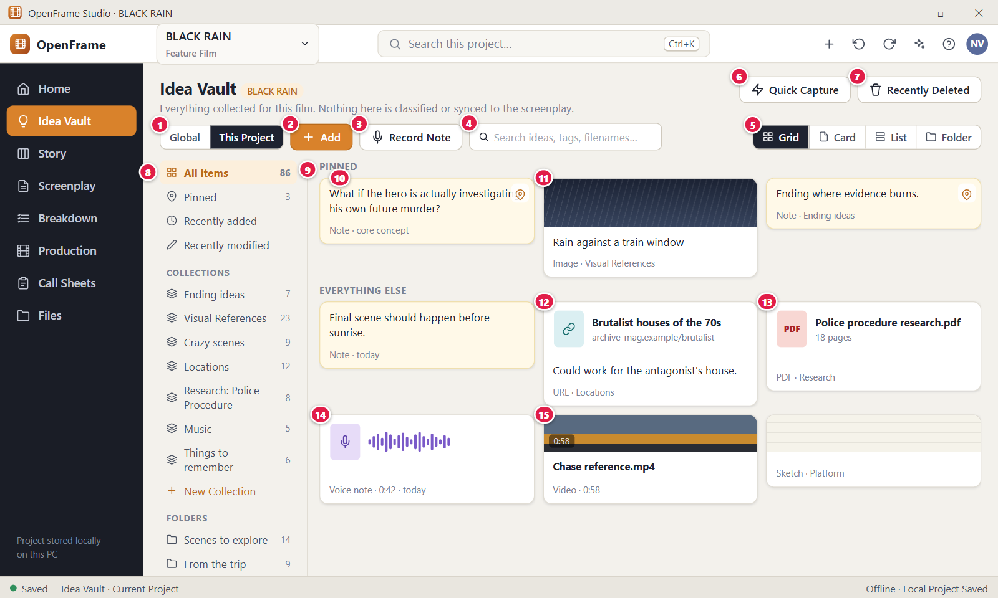
Figure 24. Project Idea Vault: Visual Grid. Red numbers are explained on the next page.

Figure 24: Project Idea Vault: Visual Grid: how it works
PARTS OF THIS SCREEN  1 Global / This Project Switches between the Global Idea Vault, for ideas across your whole filmmaking life, and this film's Project Idea Vault. The two hold separate items. The side you pick is not remembered: the Vault always opens on This Project. The control is hidden when no project is open.  2 Add The main action. The menu lists Note, Image, URL, File, Audio / Voice Note, Audio file, Video, Quote, Sketch and Quick Capture. No title, folder, tag or collection is ever required. You can also drag files in from File Explorer. Items added while a folder or collection is open land in it.  3 Record Note Opens the Record Note dialog and starts the microphone at once. Windows may ask for microphone permission the first time. Stop & Save stores a voice note, and a message reads Added with the recording length.  4 Search ideas, tags, filenames... Finds items by title, note text, caption, link, quote source, file name and tag. Results update shortly after you stop typing and a line reads "N results for ...". Esc or the X clears the box. Ctrl+F puts the cursor here. The limit is 500 characters.  5 Grid / Card / List / Folder Chooses how the same Vault is shown: thumbnails, text-first cards, one row per item, or folder tiles. Your choice is saved on this computer and applies to every project. Folder view shows only the folders and the items of the folder you are in, so at the top level it shows items that are in no folder.  6 Quick Capture Opens a small window with one text box. Save stores the text as a note with no title and a message reads "Saved to the Project Idea Vault". Shortcut: Ctrl+Shift+N. Enter or Ctrl+Enter saves, Shift+Enter starts a new line, Esc cancels.  7 Recently Deleted Opens the page where deleted items wait until you restore them or delete them for good. Items stay there for 30 days. A message "Deleted ... You can restore from Recently Deleted." appears with an Undo link when you delete a card.  8 Left panel Filters the Vault: All items, Pinned, Recently added, Recently modified, your own Collections and your own Folders. The two Recently entries show the latest 100 items. Names of collections and folders are 1 to 120 characters, and OpenFrame never creates names for you. Right-click a collection or folder to rename or delete it.  9 PINNED A heading above your pinned items. It shows only in Grid view, when something is pinned, the panel is on All items and no search is active. Other items sit under "Everything else". In the other views, a small pin icon marks a pinned card. Pinning changes display order only and never moves a file.  10 Note card A text note, such as "What if the hero is actually investigating his own future murder?". It shows the title if there is one and up to 5 lines of text. A note with no title and no text reads "Untitled note". Click once to select it, double-click or press Enter to open it. A selection bar "1 selected" appears at the bottom.  11 Image card A thumbnail with the title, caption or file name under it. The original image file stays the main source. You can add png, jpg, jpeg, gif, webp, bmp, heic and svg files. A file whose name starts with "Screenshot" is stored as a Screenshot.  12 URL card A link card. The link is the main content, and it keeps working when no preview can be fetched, for example offline. A link without http:// or https:// gets https:// added. Other link types are refused with "Only web links starting with http:// or https:// can be saved as URL items." Nothing is downloaded.  13 PDF card A card with a red PDF badge and the file name. In the app it shows no page count. A PDF that cannot be previewed is still stored, and the drawer shows "Open externally" so it opens in your PDF app. Files up to 8 GB are accepted, and folders are refused.  14 Voice note card Shows a microphone icon, the name such as "Voice note 0:42" and the length. A voice note made with Record Note gets that name when you give none. The drawer plays the recording. Audio files added with "Audio file" are stored as Audio, not Voice note.  15 Video card A dark block with a play mark, the length and the file name. The Vault keeps the video file in the project folder as a reference and is not a video editor. If the length is unknown the block shows the word "Video". You can add mp4, mov, m4v, mkv, avi and webm files. | HOW TO USE IT  1. Open the Idea Vault for BLACK RAIN from the left navigation.  2. Click "Add", choose Note and type an idea, for example "What if the hero is actually investigating his own future murder?". It saves as you type.  3. Drag a picture such as rain-train-window.jpg from File Explorer onto the page to add an image card.  4. Type a word in the search box to find items, then press Esc to clear it.  5. Click "New Collection" in the left panel and name it, for example "Ending ideas", to group items. This is optional.  6. Right-click a card or open it and pin the best ideas to keep them under "Pinned" in Grid view.  GOOD TO KNOW · EDGE CASES  • No title, folder, tag or category is ever required. An untitled image or voice note is valid.  • The Vault is not linked to the screenplay or the Story Board. Nothing you type here appears there unless you copy it with Send to Story.  • The Vault is not docked beside the screenplay. To use it while you write, switch to it from the left navigation.  • Deleting a card moves it to Recently Deleted for 30 days, and you can undo it from the message at once.  • Useful keys: Ctrl+A selects every visible item, Delete removes the selected cards, Esc clears the selection, F2 opens the selected item with the cursor in its title.  • The chip beside the page title shows the project name or "Global". It is a label, not a button.
See also: Figure 25 Idea Vault: Card view Figure 26 Idea Vault: List view Figure 27 Idea Vault: Folder view Figure 28 Idea Vault: empty state Figure 29 Add menu: Note, Image, URL, File, Voice Note, Video Figure 30 Text note editor (autosave)

Figure 25: Idea Vault: Card view
What it is for. Card view shows the Project Idea Vault text first, with larger cards. It is the best view for reading long notes without opening them. It answers: what do my notes actually say?
How to get here. Open the Idea Vault from the left navigation, then click "Card" in the view switcher at the top right of the toolbar. The app remembers your choice.
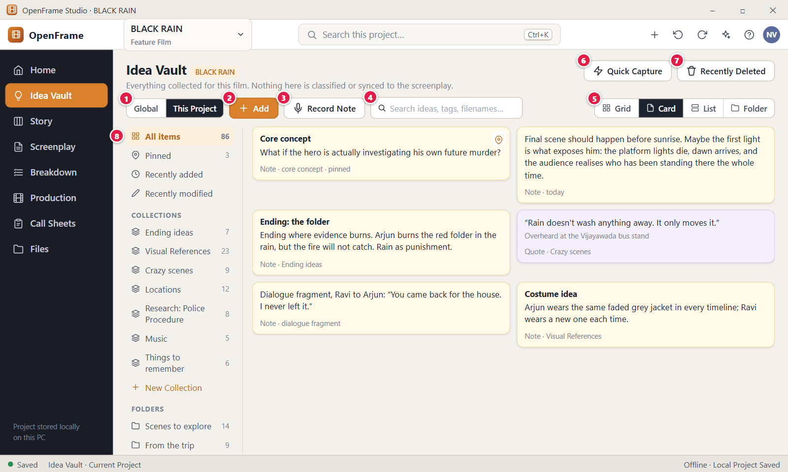
Figure 25. Idea Vault: Card view. Red numbers are explained on the next page.

Figure 25: Idea Vault: Card view: how it works
PARTS OF THIS SCREEN  1 Global / This Project Switches between the Global Idea Vault and this film's Project Idea Vault. Card view stays on while you switch. The selection is cleared and the side is not remembered after a restart. The control is hidden when no project is open.  2 Add Opens the menu of item kinds: Note, Image, URL, File, Audio / Voice Note, Audio file, Video, Quote, Sketch and Quick Capture. Items are sorted newest first, so a new card appears at the top. It needs no title or tag.  3 Record Note Opens the Record Note dialog and starts the microphone. A saved recording becomes a voice note card with a microphone icon, its name and its length.  4 Search ideas, tags, filenames... Finds items by title, note text, caption, link, source, file name and tag. Matching cards stay large. A line above the cards reads "N results for ...". Ctrl+F puts the cursor here, and Esc or the X clears it.  5 Grid / Card / List / Folder Card is the active choice. Card view shows up to 3 columns of wide cards with up to 12 lines of note text, and image thumbnails are taller than in Grid. Grid, Card and List show the same items. Folder view shows only the open folder.  6 Quick Capture Opens a small window with one text box and saves a note with no title. Shortcut: Ctrl+Shift+N. Enter or Ctrl+Enter saves, Shift+Enter starts a new line and Esc cancels. Save is off while the box is empty.  7 Recently Deleted Opens the page of deleted items. A deleted card leaves Card view at once and waits there for 30 days until you restore it or delete it for good.  8 Left panel Filters what Card view shows: All items, Pinned, the latest 100 added or modified, one collection or one folder. Counts show beside All items, Pinned, collections and folders. In Folder view, clicking an entry that is not a folder switches the view to Grid. | HOW TO USE IT  1. Open the Idea Vault and click "Card" in the view switcher.  2. Read your longer notes straight from the cards, without opening them.  3. Click "Pinned" in the left panel to see only your pinned notes as large cards.  4. Type a word, for example "jacket", in the search box. Only matching cards stay.  5. Press Esc in the search box to bring all cards back.  6. Double-click a card to open it and edit it.  GOOD TO KNOW · EDGE CASES  • Card, Grid, List and Folder views show the same items. Switching never copies or changes anything.  • The view you pick is remembered on this computer for the next time you open the Vault.  • Card view does not group pinned items under a heading. A pinned card shows a small pin icon and stays in date order.  • A note without a title shows its text. A note with neither title nor text reads "Untitled note".  • An empty collection says "This collection is empty. Add items to it from their menu or the selection bar." and an empty Pinned list says "Nothing pinned yet. Pin items to keep them at the top."  • The chip next to the page title is a label. It does not open anything.
See also: Figure 24 Project Idea Vault: Visual Grid Figure 26 Idea Vault: List view Figure 27 Idea Vault: Folder view Figure 30 Text note editor (autosave)

Figure 26: Idea Vault: List view
What it is for. List view shows the Project Idea Vault as one row per item, with type, collection, tags and dates. It is made for large vaults. It answers: which item is the one I am looking for, among hundreds?
How to get here. Open the Idea Vault from the left navigation, then click "List" in the view switcher at the top right of the toolbar.
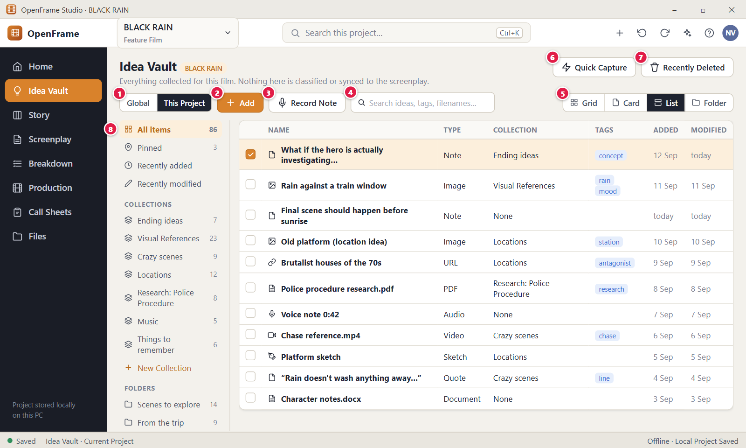
Figure 26. Idea Vault: List view. Red numbers are explained on the next page.

Figure 26: Idea Vault: List view: how it works
PARTS OF THIS SCREEN  1 Global / This Project Switches between the Global Idea Vault and this film's Project Idea Vault. Each vault has its own rows. Switching clears the selection and closes the item drawer, and List view stays on. The control is hidden when no project is open.  2 Add Opens the menu of item kinds: Note, Image, URL, File, Audio / Voice Note, Audio file, Video, Quote, Sketch and Quick Capture. A new item becomes the top row, because rows are newest first. No title or tag is needed.  3 Record Note Opens the Record Note dialog and starts the microphone. A saved recording becomes a row of type "Voice note", named "Voice note" with its length when you give no name.  4 Search ideas, tags, filenames... Finds rows by title, note text, caption, link, source, file name and tag. While you search, rows are ordered by how well they match, not by date. Ctrl+F puts the cursor here, and Esc or the X clears it. The limit is 500 characters.  5 Grid / Card / List / Folder List is the active choice. Each row is one line high, and only the rows on screen are drawn, so long lists stay smooth. Grid, Card and List show the same items. Your choice is saved on this computer.  6 Quick Capture Opens a small window with one text box. Save stores a note with no title, and it appears as a row of type "Note". Shortcut: Ctrl+Shift+N. Enter or Ctrl+Enter saves, Shift+Enter starts a new line, Esc cancels.  7 Recently Deleted Opens the page of deleted items. A deleted row leaves the list at once and waits there for 30 days before it is removed for good.  8 Left panel Filters the rows: All items, Pinned, the latest 100 added or modified, one collection or one folder. Counts show beside the entries. Once items have tags, a Tags group appears, and clicking a tag lists the rows that carry it. | HOW TO USE IT  1. Open the Idea Vault and click "List" in the view switcher.  2. Read the columns: Name, Type, Collection, Tags, Added and Modified.  3. Type a word, for example "chase", in the search box to narrow the rows.  4. Click a collection such as "Locations" in the left panel to see only its rows.  5. Double-click a row, or press Enter on it, to open the item.  GOOD TO KNOW · EDGE CASES  • With hundreds of items, List view plus Search is the fastest way to find something.  • Rows have no tick boxes. To select several rows use Ctrl+click, Shift+click, Space or Ctrl+A.  • The column headers are plain labels. Clicking a header does not sort the list.  • A long name is cut with three dots. Hover over it to see the full name.  • The Collection cell lists every collection the item is in, separated by commas. The Tags cell lists tags separated by spaces.  • Delete removes the selected rows to Recently Deleted. A message reads, for example, "Deleted 3 items. You can restore from Recently Deleted."
See also: Figure 24 Project Idea Vault: Visual Grid Figure 25 Idea Vault: Card view Figure 27 Idea Vault: Folder view Figure 37 Selecting several items Figure 42 Searching the Vault

Figure 27: Idea Vault: Folder view
What it is for. Folder view lets you browse the Project Idea Vault like a file cabinet, folder by folder, once you have created folders. It answers: what is in this folder, and how do I get back to the top?
How to get here. Open the Idea Vault from the left navigation, then click "Folder" in the view switcher at the top right of the toolbar. If a folder is open in the left panel, the view starts inside it. Otherwise it starts at the top level.
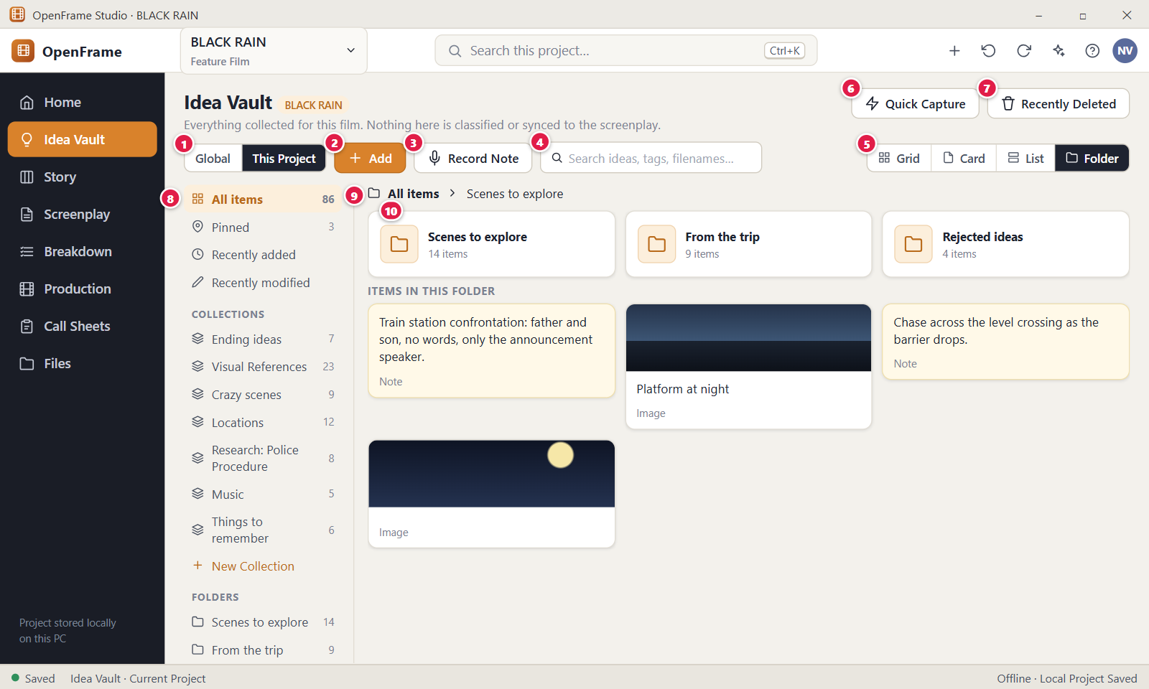
Figure 27. Idea Vault: Folder view. Red numbers are explained on the next page.

Figure 27: Idea Vault: Folder view: how it works
PARTS OF THIS SCREEN  1 Global / This Project Switches between the Global Idea Vault and this film's Project Idea Vault. Each vault has its own folders. Switching returns to the top level, clears the selection and closes the item drawer.  2 Add Opens the menu of item kinds. While a folder is open, a new Note, Image, URL, File, Video or Quote is stored in that folder, and so are files you drop on the page. Quick Capture does not use the open folder.  3 Record Note Opens the Record Note dialog and starts the microphone. A saved voice note is stored at the top level of the Vault, not in the folder you have open.  4 Search ideas, tags, filenames... Finds items by title, text, caption, link, file name and tag. In Folder view the search looks only inside the open folder, and the folder tiles are hidden while you search. Switch to Grid to search the whole Vault.  5 Grid / Card / List / Folder Folder is the active choice. Folder view shows the sub-folders and the items of one folder, not every item. At the top level it lists only the items that are in no folder. Your choice is saved on this computer.  6 Quick Capture Opens a small window with one text box. Save stores a note with no title and no folder, so it appears among the unfiled items. Shortcut: Ctrl+Shift+N.  7 Recently Deleted Opens the page of deleted items. Deleted folders are not listed there: deleting a folder keeps its items. A deleted item waits 30 days before it is removed for good.  8 Left panel Lists your collections and folders with counts. A click on a folder opens it. "New Folder" creates a folder inside the open folder in Folder view, and at the top level in other views. Right-click a folder to open, rename, add a folder inside or delete it. Names are 1 to 120 characters.  9 Breadcrumb Shows where you are, for example "All items" then "Scenes to explore". Every name except the last is a link. Click "All items" to go back to the top level. It shows only in Folder view.  10 Folder tile A tile with the folder name and the number of items directly inside it. One click opens the folder. Sub-folders come first, and the items follow under "Items in this folder". An item is in one folder at a time. To move one, right-click it, choose "Move...", pick the folder and click "Move". Items cannot be dragged onto folders. | HOW TO USE IT  1. Open the Idea Vault and click "Folder" in the view switcher.  2. Click "New Folder" in the left panel and name it, for example "Scenes to explore".  3. Click the folder tile to open it. The breadcrumb now reads "All items" then the folder name.  4. Click "Add" and choose Note. The note is stored inside this folder.  5. To file an existing item, right-click it, choose "Move...", pick the folder and click "Move".  6. Click "All items" in the breadcrumb to return to the top level.  GOOD TO KNOW · EDGE CASES  • Moving an item between folders changes organisation only. The item itself does not change. Collections can hold items from different folders.  • Deleting a folder never deletes its items. A message reads "Deleted folder ... Its items were kept and moved up a level." and you can undo it.  • Folders are records inside the project. They are not Windows folders and do not show in File Explorer.  • The count on a tile counts only the items directly inside that folder, not its sub-folders.  • An empty folder says "This folder is empty. Move items here or add new ones while it's open."  • OpenFrame never prescribes folder names. A folder name is required, and two folders may share a name.
See also: Figure 24 Project Idea Vault: Visual Grid Figure 37 Selecting several items Figure 38 Right-click menu on a Vault item Figure 46 Creating a collection

Figure 28: Idea Vault: empty state
What it is for. The empty state is what the Idea Vault shows when it holds no items. It tells you what the Vault is for and offers one obvious action. It answers: what do I do first?
How to get here. Create a new project and open it, then click "Idea Vault" in the left navigation. The Global Vault shows the same state the first time you open it: click "Global" in the toolbar, or click "Global Idea Vault" on Home.
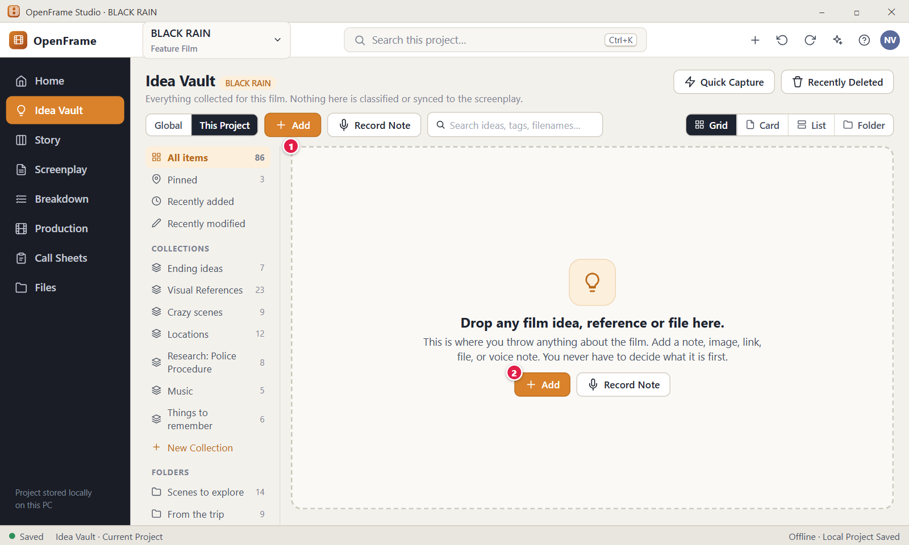
Figure 28. Idea Vault: empty state. Red numbers are explained on the next page.

Figure 28: Idea Vault: empty state: how it works
PARTS OF THIS SCREEN  1 Drop zone The message in the middle of the page. In the Project Vault the title reads "Start collecting anything about this film." In the Global Vault it reads "Drop any film idea, reference or file here." The text under it says you can throw anything about the film here, and never have to decide what it is first. You can drag files from Windows File Explorer onto the page.  2 Add The main action. It opens the same menu as the toolbar button: Note, Image, URL, File, Audio / Voice Note, Audio file, Video, Quote, Sketch and Quick Capture. Next to it the app also shows a "Record Note" button. Nothing has to be filled in. | HOW TO USE IT  1. Open the Idea Vault of a new project.  2. Click "Add" and choose Note.  3. Type your first idea. It saves as you type, and the empty state is replaced by your first card.  4. Or drag a file from File Explorer onto the page. While you drag, a message reads "Drop to add 1 item to the Project Vault".  5. Click "Record Note" if you prefer to speak your idea.  GOOD TO KNOW · EDGE CASES  • The Add button is never hidden behind a settings menu. It is in the toolbar and in the empty state.  • Deleted items do not count. If you delete the last item, the empty state comes back.  • In the empty state the left panel shows zero counts and the lines "New Collection" and "New Folder".  • If you type a search that finds nothing, the page shows "No results for ..." instead of the empty state.  • Dropping files works while the empty state shows. No type or folder is asked for.
See also: Figure 24 Project Idea Vault: Visual Grid Figure 29 Add menu: Note, Image, URL, File, Voice Note, Video Figure 34 Dragging files into the Vault Figure 40 Global Idea Vault Figure 43 Quick Capture

Figure 29: Add menu: Note, Image, URL, File, Voice Note, Video
What it is for. The Add menu asks one question only: what kind of item do you want to add? It requests the least information needed to store the item. It answers: how do I put something into the Idea Vault?
How to get here. Open the Idea Vault from the left navigation and click the orange "Add" button in the toolbar. In an empty Vault, the Add button in the middle of the page opens the same menu.
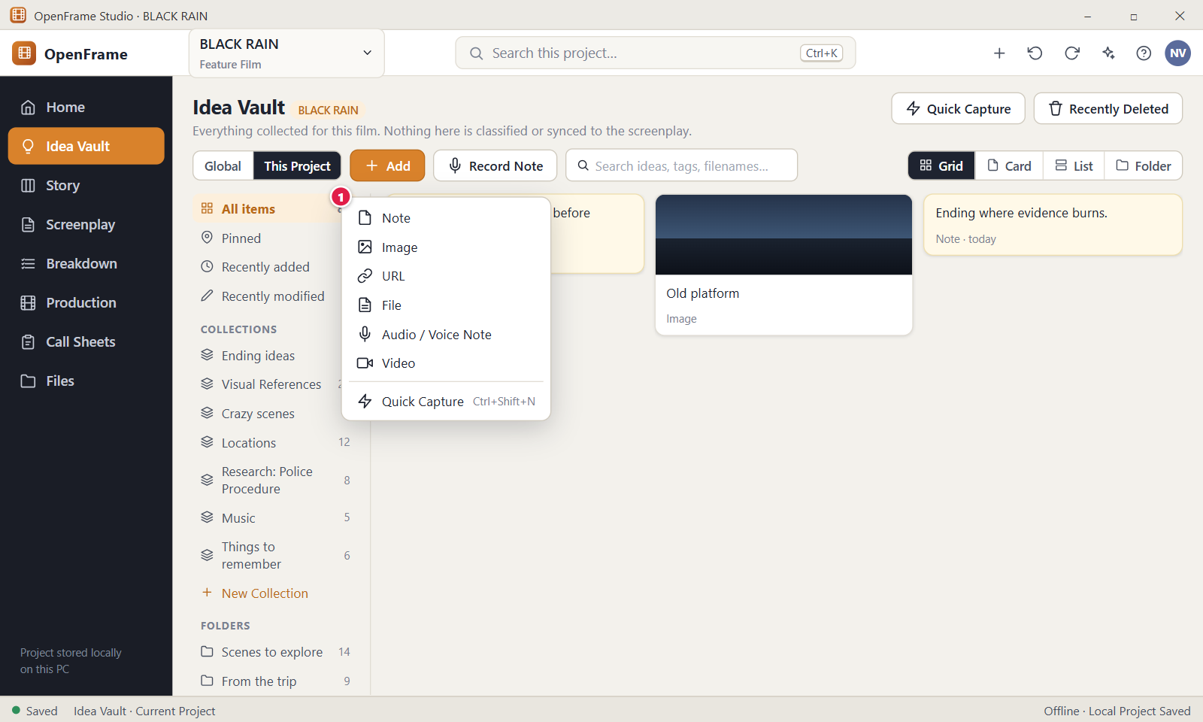
Figure 29. Add menu: Note, Image, URL, File, Voice Note, Video. Red numbers are explained on the next page.

Figure 29: Add menu: Note, Image, URL, File, Voice Note, Video: how it works
PARTS OF THIS SCREEN  1 Add menu The panel under the Add button. It lists Note, Image, URL, File, Audio / Voice Note, Audio file, Video, Quote, Sketch, and Quick Capture with its shortcut. "Audio / Voice Note" opens the recorder, and "Audio file" opens a file picker. Titles, captions, tags and collections are always optional. Items go into the folder or collection that is open in the left panel. | HOW TO USE IT  1. Click "Add" in the Vault toolbar.  2. Choose the kind of item, for example URL.  3. Fill in the one thing it asks for, such as the web link, and confirm.  4. Check the new card in the Vault. A message reads, for example, Added "station-platform.jpg".  GOOD TO KNOW · EDGE CASES  • Add asks only for the kind of item. No title, tag, collection or folder is required.  • You can drag files from File Explorer onto the page instead. Dropping several mixed files adds them all in one go, and a failed file does not stop the others.  • A file is never rejected because OpenFrame does not know whether it is story research or production reference.  • Files are copied into the project folder. The original file stays where it is and is not changed.  • A link must start with http:// or https://. Other links are refused, and a link with spaces gives "That doesn't look like a web link."  • Esc or a click outside closes the menu without adding anything. Use Down and Up to move through the entries and Enter to choose one.
See also: Figure 24 Project Idea Vault: Visual Grid Figure 30 Text note editor (autosave) Figure 32 Adding a URL Figure 33 Recording a voice note Figure 34 Dragging files into the Vault Figure 43 Quick Capture

Figure 30: Text note editor (autosave)
What it is for. The text note editor opens straight into writing, with the cursor in the note body. You can type and close, and nothing else is required. Every edit is saved as you type. It answers: how do I capture a thought without any setup?
How to get here. In the Idea Vault, click "Add" and choose Note. Or double-click an existing note card, or select it and press Enter. The editor opens as a drawer on the right side of the page. Esc does not close it: use the X.
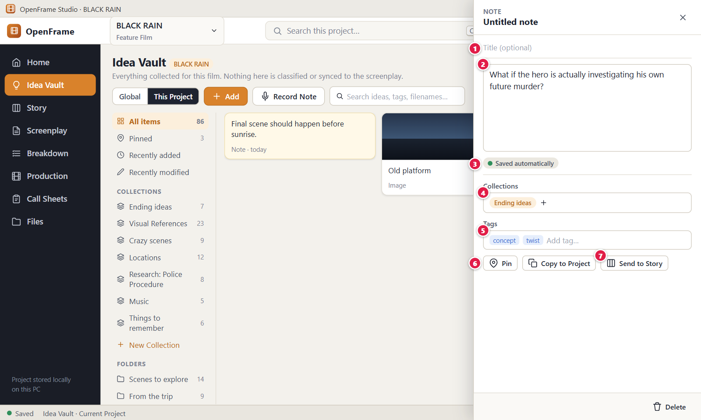
Figure 30. Text note editor (autosave). Red numbers are explained on the next page.

Figure 30: Text note editor (autosave): how it works
PARTS OF THIS SCREEN  1 Title (optional) A one-line box with the grey hint "Untitled note". A note can stay untitled. Titles hold up to 300 characters. With no title, the app shows the first line of the text as a display name, but never stores it as a title.  2 Note body A large plain-text box labelled "Note", with the cursor already inside. Type freely. Line breaks are kept. It holds up to 2 MiB of text. Only spaces counts as empty.  3 Saved automatically A small status line under the note body. It reads "Saved automatically", then "Saving..." while a save runs. If a save fails it reads "Not saved yet." with a Retry button, and your typed text stays in the box. Next to it the drawer shows when the note was added and modified.  4 Collections Shows the collections this note belongs to, as chips. When there are none it reads "Not in a collection" with an "Add to Collection..." button. A dialog lets you pick a collection or create a new one. Adding or removing never copies or deletes the note.  5 Tags Tags as small chips and a box with the hint "Add tag...". Press Enter or a comma to add one. A leading # is dropped, and "Twist" and "twist" count as one tag. A tag has at most 60 characters. The x on a chip removes it.  6 Pin A button at the top of the drawer that reads "Pin", or "Unpin" when the note is pinned. In Grid view, pinned notes sit under the heading "Pinned". In the other views a pin icon marks the card. Pinning changes display order only.  7 Send to Story A button in the drawer footer, next to Delete. It opens "Send to Story Board", where you choose Beat, Scene Card, Sequence idea or Character note and where to place it. It makes a copy and the note stays in the Vault. It is not shown in the Global Vault when no project is open. | HOW TO USE IT  1. Click "Add" in the Idea Vault and choose Note.  2. Type your thought, for example "What if the hero is actually investigating his own future murder?".  3. Optionally type a title such as "Core concept" in the Title box.  4. Add a tag in the Tags box, for example "concept", and press Enter.  5. Click the X to close the drawer. There is no Save button to press.  GOOD TO KNOW · EDGE CASES  • Every edit is saved about 0.6 seconds after you stop typing, and when a box loses focus.  • A note needs no title, tag, collection or folder. An empty note stays as "Untitled note".  • Send to Story creates a copy. The note stays in the Vault and the two are never kept in step.  • Delete does not ask for confirmation because the note goes to Recently Deleted and can be restored for 30 days.  • The copy button depends on the Vault: "Copy to Global Vault" in a Project Vault, and "Copy to Project" in the Global Vault while a project is open.  • Inside a box, Ctrl+Z undoes your typing. Outside a box it undoes the last change in the Vault, and Ctrl+Y or Ctrl+Shift+Z redoes it.
See also: Figure 24 Project Idea Vault: Visual Grid Figure 29 Add menu: Note, Image, URL, File, Voice Note, Video Figure 39 Send to Story Board Figure 41 Copy a Global idea to a project Figure 44 Recently Deleted Figure 46 Creating a collection

Figure 31: Idea Vault item detail: image
What it is for. The item detail drawer lets you look at and edit one Vault item, here an image, without forcing any structure on it. It shows a large preview and optional fields for title, caption, source link, collections and tags. It answers: what is this item, and what do I want to do with it?
How to get here. In the Idea Vault, double-click an image card, or select it and press Enter, or right-click it and click "Open". The drawer opens on the right side of the page.
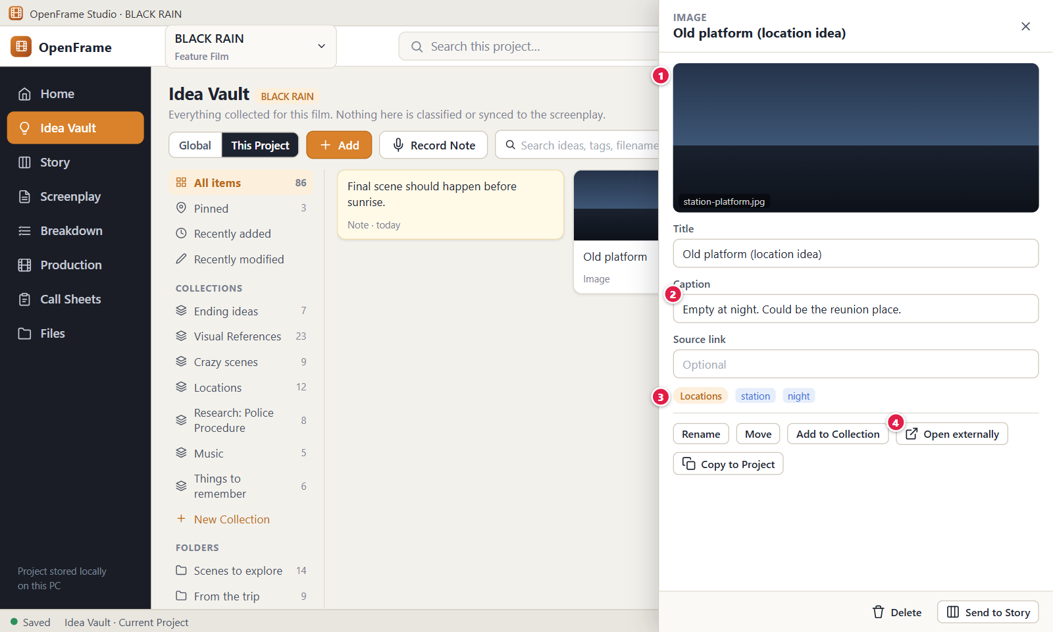
Figure 31. Idea Vault item detail: image. Red numbers are explained on the next page.

Figure 31: Idea Vault item detail: image: how it works
PARTS OF THIS SCREEN  1 Preview A large preview of the picture. A line under it shows the file name, the file size and the size in pixels. Below that, a marker reads "Stored in the vault". A picture that cannot be shown shows "This file can't be previewed here, but it is stored safely." The original file stays the main source.  2 Caption An optional box for a few words about the picture, for example "Empty at night. Could be the reunion place." It saves automatically a moment after you stop typing, and the caption shows on the card under the picture. The limit is 5000 characters.  3 Collections and tags Two separate boxes, one under the other. The Collections box reads "Not in a collection" with an "Add to Collection..." button, or shows chips such as "Locations". The Tags box takes tags such as "station" and "night". Press Enter or a comma to add a tag. All of this is optional.  4 Open externally A button under the preview. It opens the stored copy of the file in the Windows default program, such as Photos. Files OpenFrame cannot preview are still stored and open this way. A file that Windows would run as a program is shown in File Explorer instead. The button is hidden when the file is unavailable. | HOW TO USE IT  1. Double-click an image card in the Idea Vault, for example station-platform.jpg.  2. Type a caption such as "Empty at night. Could be the reunion place."  3. Click "Add to Collection..." and pick or create "Locations".  4. Type "station" in the Tags box and press Enter, then add "night".  5. Click "Open externally" if you want to see the picture in the Windows default program.  GOOD TO KNOW · EDGE CASES  • The original file stays the main source. An item that cannot be previewed is still stored.  • Renaming an item changes its display name only, not the file on disk. Use the Rename button at the top of the drawer.  • Title, caption, source link, collections and tags are all optional. The drawer never forces a name.  • The drawer also shows a Folder line and a Research flag box, which you set yourself.  • If the file is missing, for example on an external drive, the app says "This file isn't available right now. If it's on an external drive, reconnect it or relink the file."  • Delete does not ask for confirmation because the item goes to Recently Deleted and can be restored for 30 days. Esc does not close the drawer, use the X.
See also: Figure 24 Project Idea Vault: Visual Grid Figure 29 Add menu: Note, Image, URL, File, Voice Note, Video Figure 36 External file unavailable Figure 38 Right-click menu on a Vault item Figure 39 Send to Story Board Figure 44 Recently Deleted

Figure 32: Adding a URL
What it is for. The Add URL dialog stores a web link in the Idea Vault together with your own note about why the link matters. It answers: how do I keep a link without deciding what it is first?
How to get here. In the Idea Vault, click "Add" and choose URL. The same menu and dialog exist in the Global Idea Vault. Esc closes the dialog without saving.
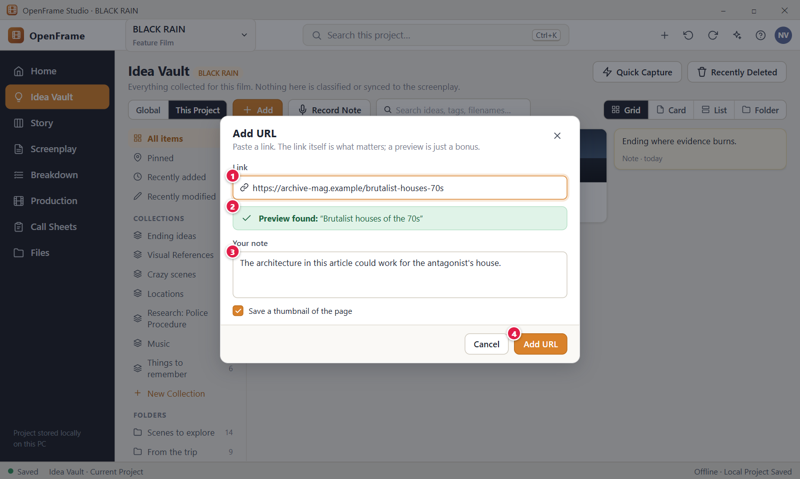
Figure 32. Adding a URL. Red numbers are explained on the next page.

Figure 32: Adding a URL: how it works
PARTS OF THIS SCREEN  1 Link A one-line box for the web address, with the hint "https://...". The cursor is already in it. It is required and holds up to 4096 characters with no spaces. A link without a scheme gets https:// added. Other schemes such as ftp:, file: or javascript: are refused. Enter saves.  2 Preview found This banner is not in the current version. OpenFrame does not fetch a page title or a thumbnail. The dialog says "OpenFrame stores the link as you entered it. Nothing is downloaded." The link itself is what matters.  3 Your note An optional box where you write why the link matters, for example that the architecture could work for the antagonist's house. Line breaks are kept, and Enter adds a new line. The note is saved with the link, shows again in the item drawer, and can be found with Vault search.  4 Add URL Saves the link and the note as one item of type URL in the Vault you are in, Project or Global. It stays grey until the Link box has text. The item is created with no folder and no collection. Errors appear under the Link box and the dialog stays open. | HOW TO USE IT  1. Click "Add" in the Idea Vault and choose URL.  2. Paste the address in the Link box, for example https://archive-mag.example/brutalist-houses-70s.  3. Type why it matters in Your note, for example "Could work for the antagonist's house."  4. Click "Add URL". A message reads Added with the link and an Undo link for 5 seconds.  5. Find the new URL card at the top of All items.  GOOD TO KNOW · EDGE CASES  • The link itself is the item. OpenFrame never downloads a page, a title or a thumbnail, so it works the same offline.  • An item without a title is valid. The card is named after the link, and you can give it a title later in the drawer.  • The same link can be added many times. There is no duplicate warning.  • The dialog opens in whichever Vault you are in. Switch Global or This Project first if you want the other Vault.  • If the Link box is empty, the message is "Link is required." A link with a space or no host gives "That doesn't look like a web link."  • Even when a folder or collection is open, the URL item is created without it.
See also: Figure 29 Add menu: Note, Image, URL, File, Voice Note, Video Figure 24 Project Idea Vault: Visual Grid Figure 40 Global Idea Vault Figure 42 Searching the Vault Figure 44 Recently Deleted

Figure 33: Recording a voice note
What it is for. The Record Note dialog records a spoken thought with your microphone and stores it in the Idea Vault as a voice note. It answers: how do I capture an idea by speaking, without typing?
How to get here. In the Idea Vault, click "Record Note" in the toolbar. It is also in the empty Vault. Or click "Add" and choose Audio / Voice Note. The same button exists in the Global Idea Vault. Recording starts as soon as the dialog opens.
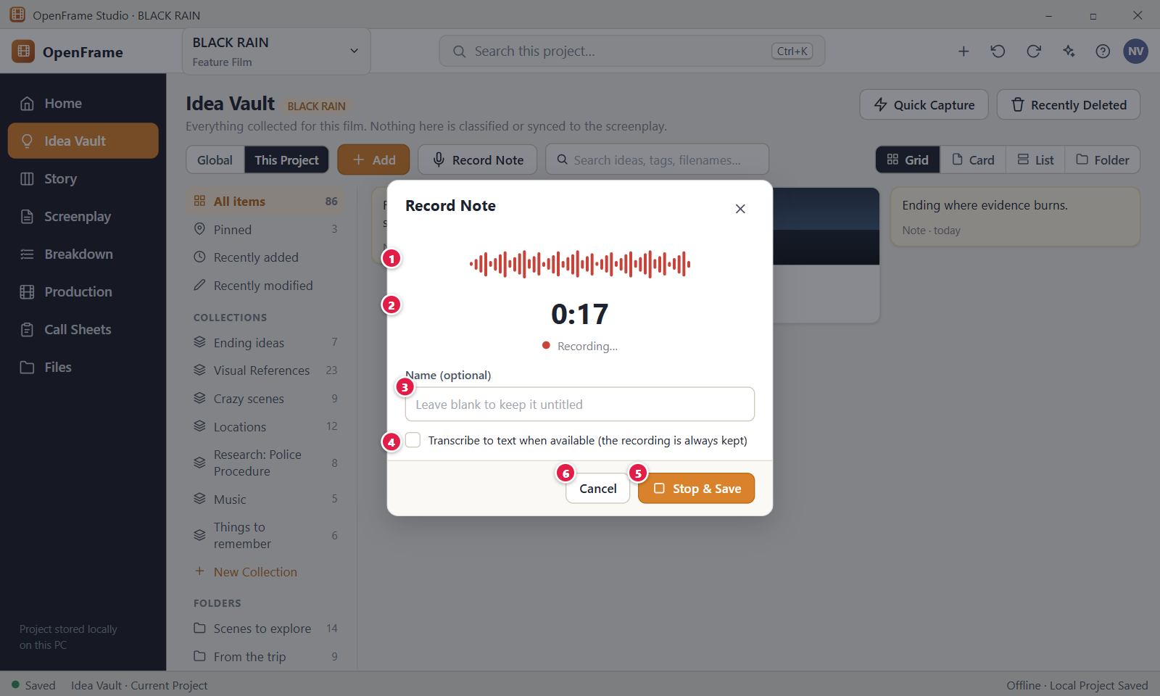
Figure 33. Recording a voice note. Red numbers are explained on the next page.

Figure 33: Recording a voice note: how it works
PARTS OF THIS SCREEN  1 Recording indicator A microphone icon with a red dot that lights up while recording, followed by the status text. It reads "Starting microphone...", then "Recording...", then "Saving...". There is no live wave meter in the current version. If the microphone cannot be used, a red banner replaces this area.  2 Timer Shows how long you have been recording, as minutes and seconds, for example 0:17. After one hour it shows hours too. The stored recording length matches it to within about a second.  3 Name (optional) A one-line box with the hint "Leave blank to keep it untitled". Recording keeps running while you type. A name holds up to 300 characters. Without a name the card is called "Voice note" plus its length. You can rename it later in the drawer.  4 Transcribe to text This option is not in the current version. OpenFrame does not turn recordings into text. The dialog says "The recording is always kept exactly as recorded."  5 Stop & Save One click ends the recording, stores it as a voice note in the open Vault and closes the dialog. There is no separate Stop button. It is off while the microphone starts and while saving. If saving fails, the dialog stays open, the recording is kept and the button reads Save so you can try again.  6 Cancel Closes the dialog, releases the microphone and throws the recording away. Nothing is stored and you are not asked to confirm. The X and Esc do the same. | HOW TO USE IT  1. Click "Record Note" in the Idea Vault toolbar.  2. If Windows asks for permission to use the microphone, allow it.  3. Wait for "Recording..." and speak your idea.  4. Optionally type a name in the Name box, for example "Meera's File".  5. Click "Stop & Save". A message reads Added with the name and an Undo link.  6. Open the new voice note card to play it back.  GOOD TO KNOW · EDGE CASES  • Recording starts the moment the dialog opens. There is no Record or Pause button.  • The audio is stored exactly as recorded. Voice notes are files inside the project, or inside the Global Idea Vault folder, and they play offline.  • If the microphone cannot be used, the Vault is left unchanged. The message says to check that a microphone is connected and that Windows allows apps to use it, under Settings, Privacy and security, Microphone. You can add an existing audio file with Add, Audio file instead.  • An empty recording is refused with "Nothing was recorded." A recording larger than 512 MiB is refused with "That recording is too large."  • A voice note with no name shows as "Voice note" plus its length, for example "Voice note 0:17".  • Esc closes the dialog and discards the recording.
See also: Figure 29 Add menu: Note, Image, URL, File, Voice Note, Video Figure 24 Project Idea Vault: Visual Grid Figure 40 Global Idea Vault Figure 44 Recently Deleted Figure 42 Searching the Vault

Figure 34: Dragging files into the Vault
What it is for. This is what the Idea Vault shows while you drag files from Windows File Explorer over it. A highlighted drop area says how many items will be added and to which Vault. It answers: can I throw a mixed set of files in without choosing categories?
How to get here. Open the Idea Vault from the left navigation. Put Windows File Explorer next to the app, select files, drag them over the Vault area and keep the mouse button down. Release to drop. It works in the Project Vault and in the Global Idea Vault.
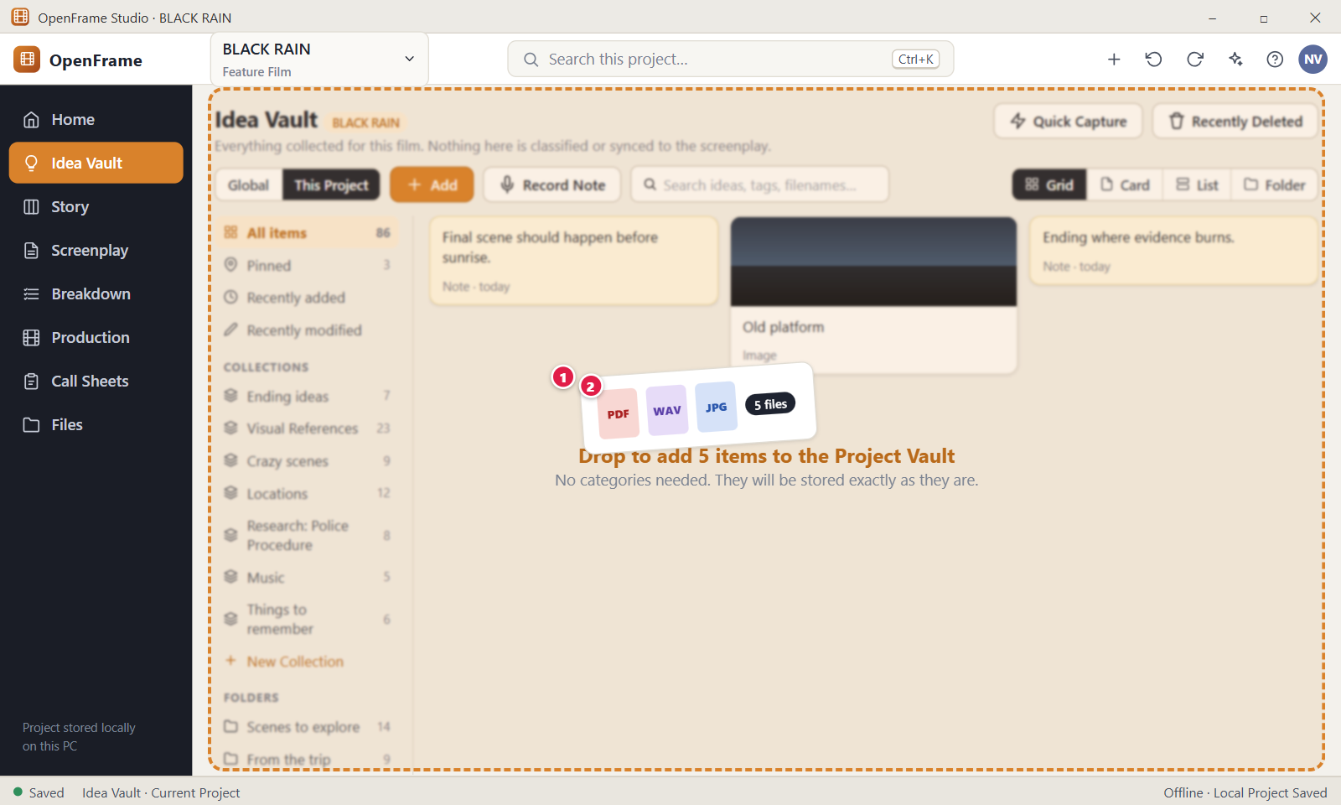
Figure 34. Dragging files into the Vault. Red numbers are explained on the next page.

Figure 34: Dragging files into the Vault: how it works
PARTS OF THIS SCREEN  1 Files being dragged The mixed set of files you drag from File Explorer, such as a PDF, a sound file and a picture. Windows draws small chips under the mouse pointer while you drag. They are not part of OpenFrame. Any file type is accepted, up to 1000 items per drop and 8 GiB per file.  2 Drop target A dashed area over the item list. It reads "Drop to add 5 items to the Project Vault", or "Global Vault" in the Global Idea Vault, and under it "No categories needed. They will be stored exactly as they are." It appears when files enter the window and disappears when they leave or are dropped. It shows only on the Vault page. | HOW TO USE IT  1. Open the Idea Vault for BLACK RAIN.  2. In File Explorer, select several files, for example a PDF, a WAV and a JPG.  3. Drag them over the Vault. The dashed area shows how many items will be added.  4. Release the mouse button.  5. Read the message "Added 5 items" and check the new cards.  GOOD TO KNOW · EDGE CASES  • You are never asked to pick a category. The type, such as Image, PDF, Audio, Video or Document, comes from the file extension.  • Files are copied into the project, or into the Global Idea Vault folder. Your originals stay where they are, and moving or deleting them later does not affect the Vault item.  • If a folder or collection is open when you drop, the new items are placed in it.  • A file that OpenFrame cannot preview is still stored as an ordinary file card.  • Dragging out of the window hides the area at once and adds nothing. A dropped folder is counted but not added. Dropping more than 1000 items gives "Add at most 1000 files at a time."  • Ctrl+Z undoes the last drop, and the message also has an Undo link for 5 seconds.
See also: Figure 35 Drag-in result: partial success Figure 24 Project Idea Vault: Visual Grid Figure 40 Global Idea Vault Figure 29 Add menu: Note, Image, URL, File, Voice Note, Video Figure 44 Recently Deleted

Figure 35: Drag-in result: partial success
What it is for. This dialog reports the result of adding several files when at least one could not be added. It lists each file as Added or Not added, keeps every file that worked and says in plain words why the others did not. It answers: what happened to my files, and what do I do about the one that failed?
How to get here. It appears by itself after you drop files on the Idea Vault, or choose files with Add, when at least one file failed. When every file is added you only see the message "Added N items".
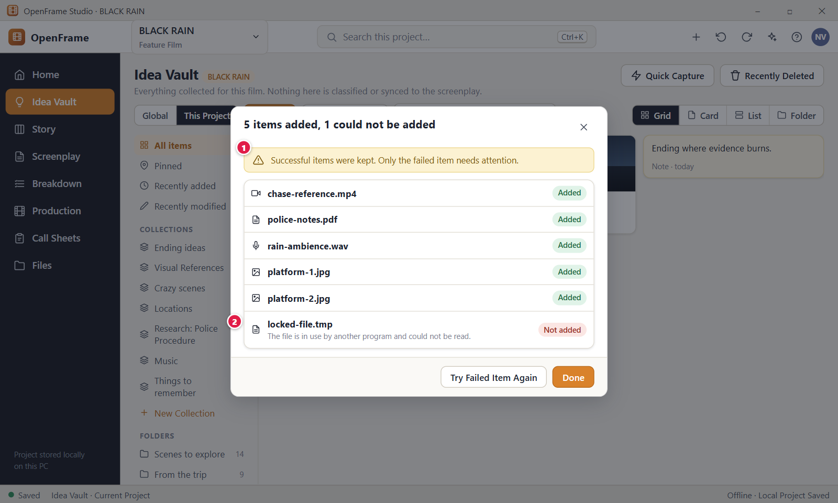
Figure 35. Drag-in result: partial success. Red numbers are explained on the next page.

Figure 35: Drag-in result: partial success: how it works
PARTS OF THIS SCREEN  1 Successful items were kept. Only the failed item needs attention. A line of plain text under the dialog title. The title counts the result, for example "5 items added, 1 could not be added". Every file that worked stays in the Vault, even while this dialog is open.  2 Failed item The row of a file that failed: its name, a red "Not added" chip and the reason in plain words. Added files are listed above it with a green "Added" chip. Long names are cut with three dots. Examples of reasons: "Please choose a file, not a folder." and "The file is in use by another program and could not be read." | HOW TO USE IT  1. Drop a mix of files on the Idea Vault, including one that cannot be read, such as a folder.  2. Read the dialog title, for example "5 items added, 1 could not be added".  3. Look at the row with the red "Not added" chip and read the reason.  4. Fix the cause, for example close the program that locks the file, then click "Try Failed Item Again".  5. Click "Done" to close the dialog. The added items stay.  GOOD TO KNOW · EDGE CASES  • Only failed files need your attention. Everything that worked stays in the Vault even if you close the dialog at once.  • A file that cannot be previewed is not a failure. It is added as an ordinary file card. Only a file that cannot be read fails.  • A dropped folder is never added. It shows as "Not added" with "Please choose a file, not a folder."  • Other reasons you may see: "The file could not be found. It may have been moved or deleted.", "The drive holding this file is not available. Reconnect it and try again." and a note that the file is larger than the 8192 MB limit.  • A full disk or a storage problem does not give this list. The whole drop is refused with "OpenFrame could not save this change yet. Your work is still open and has not been discarded." and nothing is added.  • "Try Failed Item Again" retries all failed files at once, in the same folder or collection as before. Esc closes the dialog like Done.
See also: Figure 34 Dragging files into the Vault Figure 29 Add menu: Note, Image, URL, File, Voice Note, Video Figure 24 Project Idea Vault: Visual Grid Figure 44 Recently Deleted

Figure 36: External file unavailable
What it is for. This shows an Idea Vault item whose file is missing. The card stays in its place with a red "Unavailable" badge, and its drawer explains which file is missing and where it was. It answers: what happens to my idea when its file moves or disappears, and how do I get it back?
How to get here. In the Idea Vault, a card with a red "Unavailable" badge appears when its file cannot be found. Click the card, or press Enter on it, to open its drawer on the right. The banner and buttons are there.
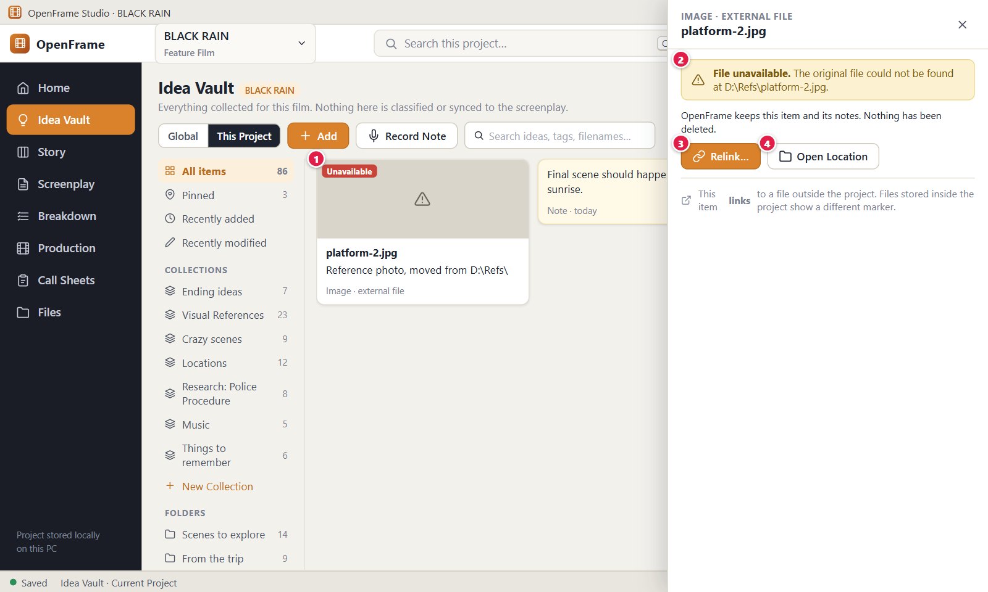
Figure 36. External file unavailable. Red numbers are explained on the next page.

Figure 36: External file unavailable: how it works
PARTS OF THIS SCREEN  1 Unavailable A red badge on the card. The card keeps its place, name and notes, and the thumbnail is not shown. In List view the badge is a red chip after the name. You can still select, move, tag, pin and delete the card. OpenFrame checks the file every time it lists the Vault, so the badge clears itself when the file is back.  2 File unavailable banner A red banner at the top of the drawer. It reads "File unavailable. The original file could not be found at" followed by the stored location. Under it: "OpenFrame keeps this item and its notes. Nothing has been deleted." While the file is missing the "Open externally" button is not shown.  3 Relink... Opens a Windows file picker so you can point the item at the file's new place. The item keeps its notes, tags and collections, and a message reads "File relinked. The item and its notes are unchanged." This button appears only for an item that links to a file outside the project. The Vault copies files into the project, so for a stored file that went missing it is not shown. The new file must be on a local drive.  4 Open Location Opens File Explorer at the folder where the file was last known, so you can look for it. It appears next to Relink only for items that link to a file outside the project. If the folder is gone, a message reads "That folder isn't available either. Reconnect the drive or relink the file." | HOW TO USE IT  1. Find the card with the red "Unavailable" badge in the Idea Vault.  2. Click it to open the drawer and read the banner. It tells you where the file was expected.  3. If the file was moved, put it back where the banner says. Reload the Vault and the badge goes away.  4. For a linked item, click "Relink..." and choose the file's new location.  5. Or click "Open Location" to look in the last known folder.  GOOD TO KNOW · EDGE CASES  • OpenFrame never deletes an item because its file is missing. The card, title, notes, tags and collections stay.  • Files added to the Vault are copied into the project. A stored file goes missing only if something outside OpenFrame renames or deletes it.  • While available, a stored file shows the green chip "Stored in the vault" and a linked file shows the chip "Linked file". The drawer adds "external file" to the type label only for linked files.  • A linked file on a network share or a mapped network drive is treated as not available on purpose. OpenFrame never connects to a share to look for it.  • OpenFrame only reports missing files. It gives no warning when a linked file changes on disk.
See also: Figure 24 Project Idea Vault: Visual Grid Figure 29 Add menu: Note, Image, URL, File, Voice Note, Video Figure 43 Quick Capture Figure 44 Recently Deleted Figure 40 Global Idea Vault

Figure 37: Selecting several items
What it is for. When you select Vault items, a bar with batch actions appears. It lets you move, group, tag, pin, copy or delete several items in one step. It answers: how do I organise many ideas at once?
How to get here. In the Idea Vault, click one card, then Ctrl+click others. Shift+click selects a range. You can also click the round check button at the top left of a card. Esc or the X at the right end of the bar clears the selection.
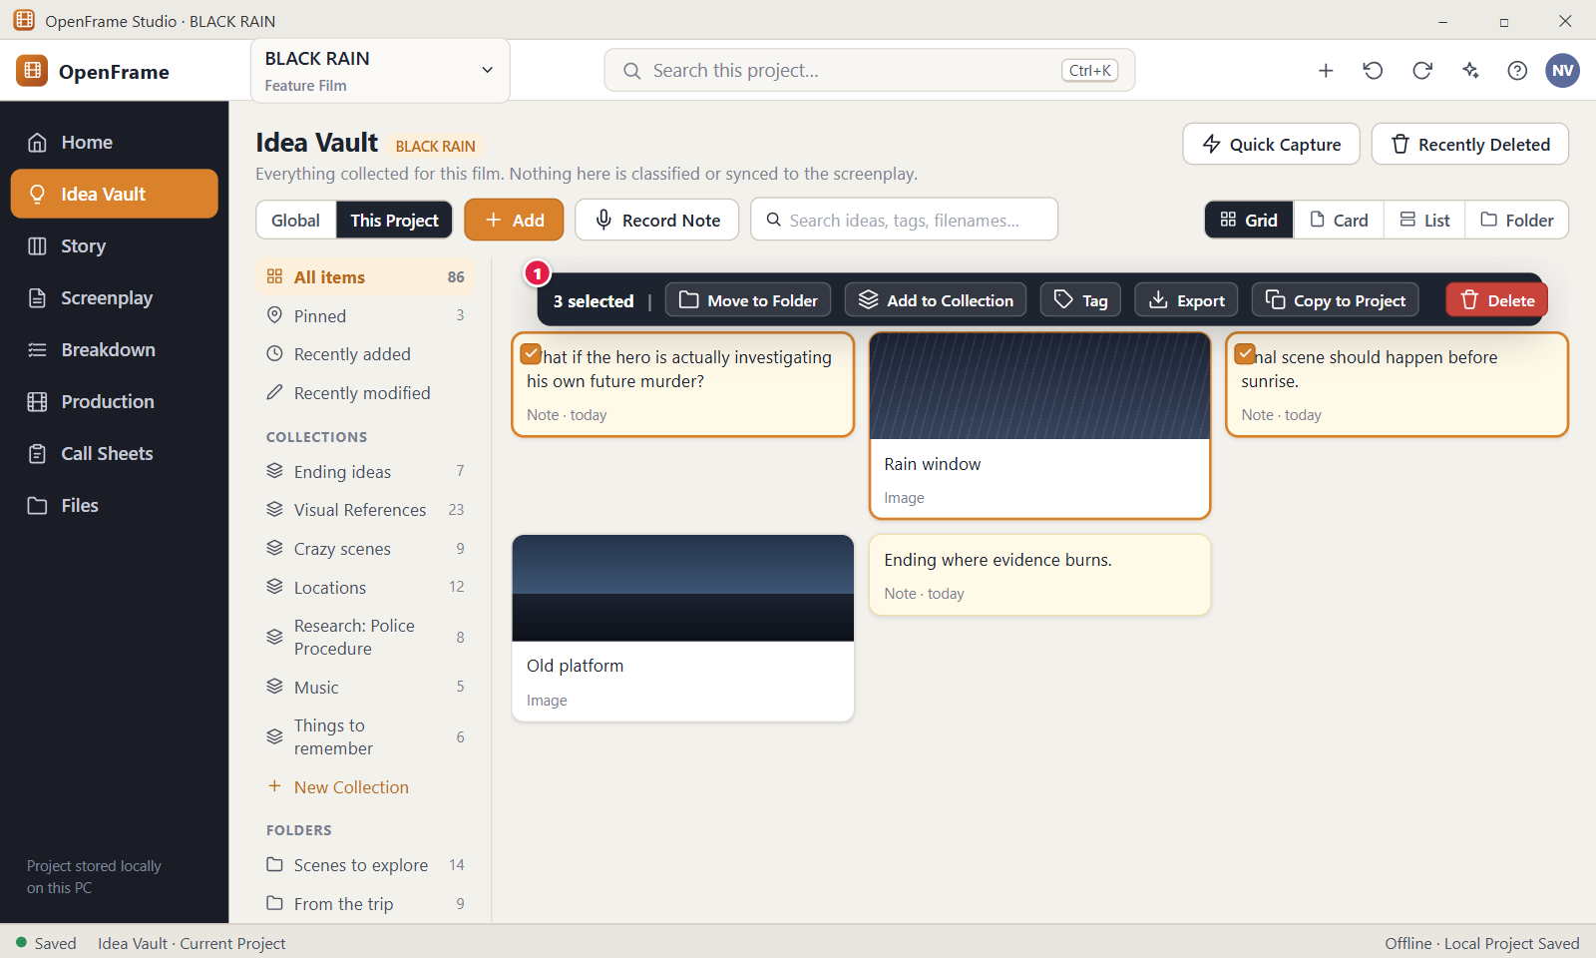
Figure 37. Selecting several items. Red numbers are explained on the next page.

Figure 37: Selecting several items: how it works
PARTS OF THIS SCREEN  1 Selection bar A bar at the bottom of the item area. It shows "N selected" and the actions that apply to all of them: Move to Folder, Add to Collection, Tag, Pin (or Unpin), Copy to Global Vault (or Copy to Project in the Global Vault), Delete, and an X to clear. It appears as soon as one item is selected. There is no Export button in the current version. Each action works on every selected item and is one Undo step, up to 1000 items. | HOW TO USE IT  1. Click a card, for example "Rain window".  2. Ctrl+click two more cards, or Shift+click to select a range. The bar reads "3 selected".  3. Click "Add to Collection" and choose "Ending ideas", or click "Tag" and type a tag.  4. Check the message, for example "Added 3 items to Ending ideas", and use its Undo link if you change your mind.  5. Press Esc, or click the X, to clear the selection.  GOOD TO KNOW · EDGE CASES  • A plain click selects only that item. Ctrl+click adds or removes one, Shift+click selects the range from the last click, and Ctrl+Shift+click adds a range.  • Space toggles the focused card or row, and Ctrl+A selects every item in the current list. List view has no tick boxes.  • Delete from the bar is immediate and asks no confirmation. Items go to Recently Deleted for 30 days, and the message has an Undo link for 5 seconds.  • Move to Folder only organises. It never copies or changes the items. Add to Collection adds references and the items stay where they are.  • Copy to Global Vault copies the items into your Global Idea Vault. In the Global Vault the button reads Copy to Project and exists only while a project is open.  • If you try more than 1000 items, the app says "Select at most 1000 items at a time."
See also: Figure 24 Project Idea Vault: Visual Grid Figure 38 Right-click menu on a Vault item Figure 41 Copy a Global idea to a project Figure 44 Recently Deleted Figure 29 Add menu: Note, Image, URL, File, Voice Note, Video

Figure 38: Right-click menu on a Vault item
What it is for. The right-click menu of a Vault item lists what you can do with that item: open it, rename it, move it, pin it, copy it, send it to the Story Board or delete it. Delete is kept apart at the bottom. It answers: what can I do with this idea, right here?
How to get here. In the Idea Vault, right-click any card in Grid, Card or Folder view, or any row in List view. Shift+F10 or the menu key on a focused card should do the same. Esc closes the menu.
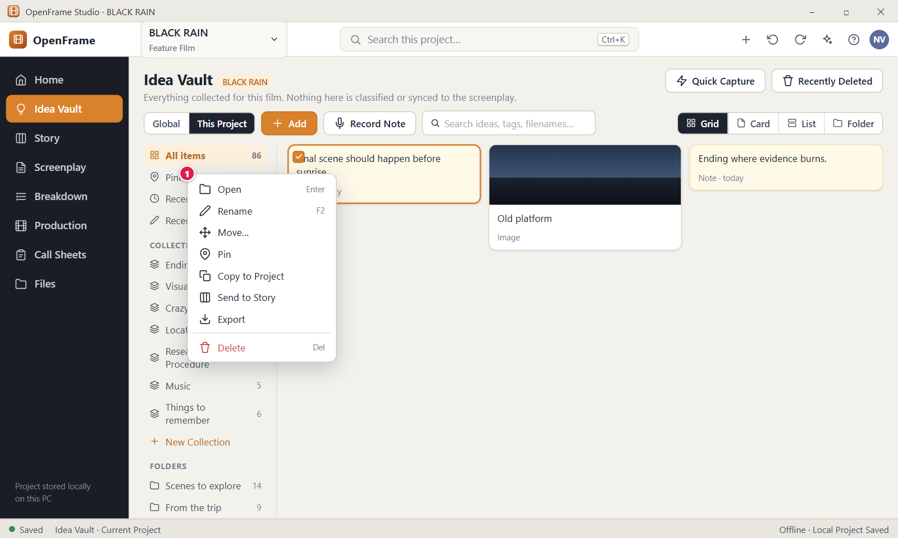
Figure 38. Right-click menu on a Vault item. Red numbers are explained on the next page.

Figure 38: Right-click menu on a Vault item: how it works
PARTS OF THIS SCREEN  1 Item menu Lists Open, Rename, Move..., Pin (or Unpin), Copy to Global Vault, Send to Story, then a "Research flag" group with Unchecked, Checked, Needs Expert Check and No flag, then Delete in red at the bottom. There is no Export entry. In the Global Vault the copy entry reads Copy to Project, and only while a project is open. Right-clicking does not select the card. If the card is part of a selection of several, the actions apply to all of them and read, for example, "Move 3 items..." and "Delete 3 items". Send to Story is hidden when more than one item is selected. | HOW TO USE IT  1. Right-click a card, for example "Old platform".  2. Click "Pin" to keep it under "Pinned" in Grid view. A message reads Pinned with the name.  3. Right-click again and click "Move..." to file it in a folder such as "Scenes to explore".  4. To mark your own research status, pick one entry under "Research flag", for example Checked.  5. Press Esc to close the menu without doing anything.  GOOD TO KNOW · EDGE CASES  • Delete sits alone at the bottom in red so you do not hit it by accident. It deletes without a question. Undo and Recently Deleted are your safety net.  • The menu shows the keys next to the entries: Enter opens, F2 renames and Del deletes.  • Right-clicking does not select the item. The menu acts on the clicked item, or on the whole selection when the clicked item is inside a selection of several.  • The Research flag entries are your own marks. OpenFrame never sets them by itself. The flag shows as a small label on the card.  • The same menu is used for notes. Other kinds of object in OpenFrame have their own right-click menus with Delete set apart, but the entries differ.
See also: Figure 24 Project Idea Vault: Visual Grid Figure 37 Selecting several items Figure 39 Send to Story Board Figure 41 Copy a Global idea to a project Figure 44 Recently Deleted

Figure 39: Send to Story Board
What it is for. This dialog turns a Vault idea into an object on the Story Board. You choose what it becomes and where it goes. It always makes a copy and never removes or changes the original idea. It answers: how does an idea move from my pile of ideas into the story structure?
How to get here. In the Idea Vault, right-click an item and click "Send to Story". Or open the item and click "Send to Story" at the bottom of its drawer. It needs an open project. From the Global Idea Vault it sends the idea into the open project's Story Board.
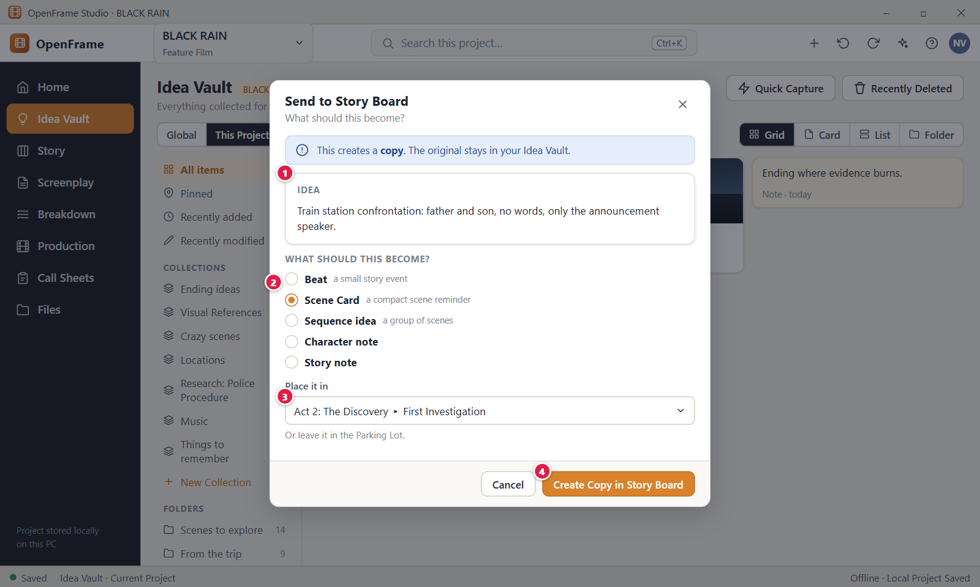
Figure 39. Send to Story Board. Red numbers are explained on the next page.

Figure 39: Send to Story Board: how it works
PARTS OF THIS SCREEN  1 The idea being sent A read-only box labelled "Idea" that shows what you are promoting: the title in bold and the text of the item, up to 5 lines. For a link it shows the address, and for a file its name. You cannot edit it here.  2 What should this become? Four round choices: Beat (a small story event), Scene Card (a compact scene reminder), Sequence idea (a group of scenes) and Character note. Scene Card is chosen when the dialog opens. "Story note" is not offered in the current version. Character note has no place choice, and an image item becomes the character's picture.  3 Place it in A list for where the new object goes. For Beat and Scene Card it holds "Parking Lot", every act, and every sequence as "Act title > Sequence title". It starts on "Parking Lot". A Sequence idea goes into an act, so only acts are listed. The Parking Lot holds ideas that are not yet part of the story flow.  4 Create Copy in Story Board Creates one Story object as a copy, closes the dialog and shows a message that ends "The original stays in your Idea Vault." with an "Open Story Board" button. It is off while the act list loads, while saving, and for a Sequence idea when the project has no act. | HOW TO USE IT  1. Right-click an idea in the Idea Vault, for example "Train station confrontation: father and son, no words, only the announcement speaker.", and click "Send to Story".  2. Choose what it should become, for example Scene Card.  3. Open "Place it in" and pick "Act 2: The Discovery > First Investigation", or leave it in the Parking Lot.  4. Click "Create Copy in Story Board".  5. Click "Open Story Board" in the message to see the new card.  GOOD TO KNOW · EDGE CASES  • Send to Story always makes a copy. The original stays in the Idea Vault and is never removed. Later changes on either side do not reach the other.  • Sending is always your own action. Nothing in the Vault goes to the Story Board by itself.  • If the project has no act yet, choosing Sequence idea shows "There are no acts yet. Add an act on the Story Board first, or choose Beat or Scene Card."  • When the item has a title, the title becomes the short text and the body becomes the note on the new object. Very long text is cut: a Beat at 2000 characters, a Scene Card description at 500.  • You cannot send several items at once. Send to Story is hidden when more than one item is selected.  • Esc or Cancel closes the dialog and creates nothing.
See also: Figure 38 Right-click menu on a Vault item Figure 24 Project Idea Vault: Visual Grid Figure 49 Story Board: Board view Figure 40 Global Idea Vault Figure 41 Copy a Global idea to a project

Figure 40: Global Idea Vault
What it is for. The Global Idea Vault holds ideas that belong to you and not to one film: references, notes and files for someday. It works like the Project Idea Vault but is shared by all projects and is available even when no project is open. It answers: what do I have that might matter someday?
How to get here. With a project open, click "Idea Vault" in the left navigation, then click "Global" in the scope control. With no project open, click "Global Idea Vault" at the top right of Home. "Your projects" takes you back. The files are kept in the folder Documents\OpenFrame\Global Idea Vault.
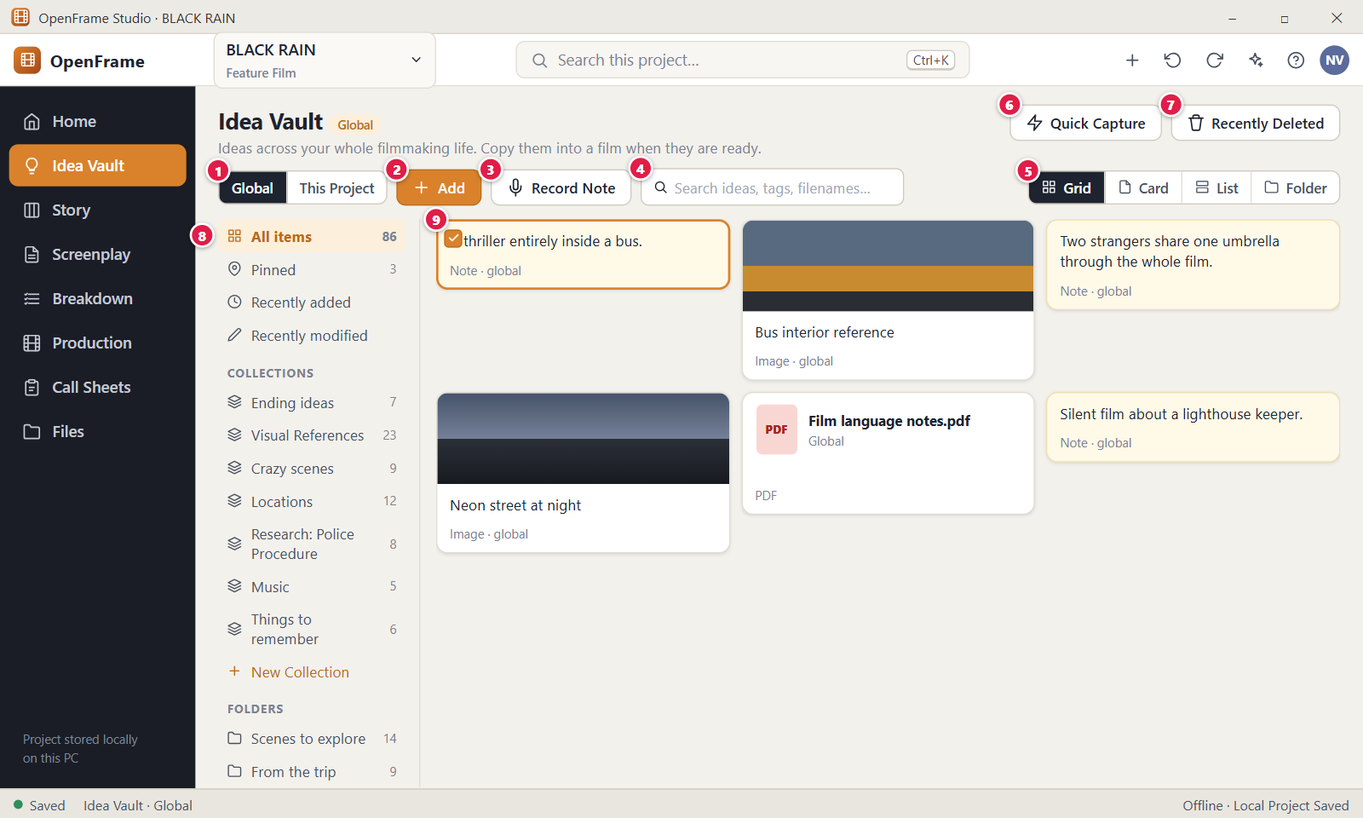
Figure 40. Global Idea Vault. Red numbers are explained on the next page.

Figure 40: Global Idea Vault: how it works
PARTS OF THIS SCREEN  1 Global / This Project A two-part switch at the top left of the toolbar. It shows only while a project is open. The active part is dark. Switching goes back to All items and clears the selection and the open drawer. The two Vaults share nothing: items, folders, collections and tags are separate. You always have full rights in the Global Vault on your own computer.  2 Add Opens the menu of item kinds: Note, Image, URL, File, Audio / Voice Note, Audio file, Video, Quote, Sketch and Quick Capture. Everything goes into the Vault you are viewing. You can also drag files onto the page.  3 Record Note Starts a voice recording at once. While Global is shown, the voice note is stored in the Global Idea Vault and is not in the Project Vault.  4 Search ideas, tags, filenames... Finds items by title, note text, caption, link, file name and tag, in the Vault you are viewing only. It matches the beginnings of words, ignores capitals and needs every typed word to match. Ctrl+F focuses it. Esc clears it. The limit is 500 characters.  5 Grid / Card / List / Folder Four views of the same items. Changing the view changes only how they are shown. List shows Name, Type, Collection, Tags, Added and Modified. Your choice is remembered after restart and used for both Vaults.  6 Quick Capture Opens a small window to save a text idea at once. It says "Saving to your Global Idea Vault". Shortcut: Ctrl+Shift+N, which also works on Home. Enter or Ctrl+Enter saves, Shift+Enter adds a line, Esc cancels. A message reads "Saved to the Global Idea Vault" with Undo.  7 Recently Deleted Opens the page of deleted items of the Vault you are viewing. Items stay 30 days, then they are removed for good. "Back to Vault" returns you.  8 Left panel Narrows the Vault: All items, Pinned, Recently added, Recently modified, your own Collections, your Folders and, once you have tags, your Tags. The Global Vault has its own collections, folders and counts. A new collection needs a name of 1 to 120 characters.  9 Selected idea card A Global note card shown as selected, for example "A thriller entirely inside a bus." A selected card has a filled round check, and a bar reads "1 selected". The meta line reads the type and the day, such as "Note · today". With a project open, the bar and the right-click menu offer Copy to Project to use the idea in a film. Double-click opens the drawer. | HOW TO USE IT  1. On Home, click "Global Idea Vault", or open a project and switch the scope control to Global.  2. Click "Add", choose Note and type an idea, for example "A thriller entirely inside a bus."  3. Use Quick Capture with Ctrl+Shift+N to save another thought in seconds.  4. Open a project, switch to Global, select the card and click "Copy to Project" when you want it in the film.  5. Click "Recently Deleted" if you removed something by mistake.  GOOD TO KNOW · EDGE CASES  • A Global idea is never linked to a project by itself. It enters a film only when you copy it on purpose.  • The Global Vault works with no project open. It has its own undo history, its own Recently Deleted and its own collections and folders.  • With no project open there is no scope control, no Copy to Project and no Send to Story, because there is no film to copy into. The footer reads "No project open · Global Idea Vault".  • Under the heading the page says "Ideas across your whole filmmaking life. Copy them into a film when they are ready."  • The Vault is kept on this computer, outside every project folder. Changes that arrive from another person's Exchange Package never reach it.  • An empty Global Vault says "Drop any film idea, reference or file here."
See also: Figure 24 Project Idea Vault: Visual Grid Figure 41 Copy a Global idea to a project Figure 3 Home: your projects Figure 42 Searching the Vault Figure 44 Recently Deleted

Figure 41: Copy a Global idea to a project
What it is for. This dialog copies an idea from the Global Idea Vault into the film you have open. The copy is independent, so you can change it in the film without touching the Global original. It answers the question: how do I use a someday idea in this film?
How to get here. Open a project, then go to Idea Vault > Global. Right-click an item and choose Copy to Project, or select it and click Copy to Project in the bar, or open it and click Copy to Project in its drawer. The button does not exist when no project is open.
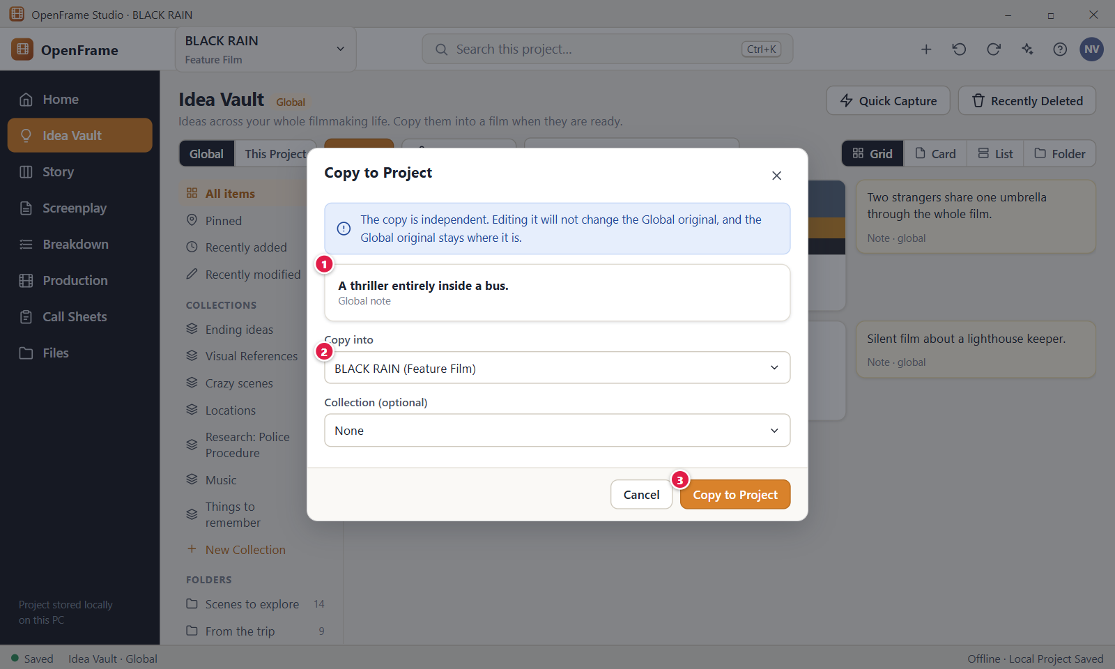
Figure 41. Copy a Global idea to a project. Red numbers are explained on the next page.

Figure 41: Copy a Global idea to a project: how it works
PARTS OF THIS SCREEN  1 Idea being copied A box that shows the name of the item and its kind, for example "A thriller entirely inside a bus." with "Global note" under it. Other types read "Global item". If you selected several items, it reads "3 items". You cannot edit it.  2 Copy into The film that receives the copy, for example "BLACK RAIN (Feature Film)". It is always the film that is open and it cannot be changed. To copy into another film, open that film first. Below it, "Collection (optional)" lists "None" and the collections of the film; pick one to place the copy in it.  3 Copy to Project Creates an independent copy in the Project Vault and closes the dialog. A message confirms it and offers Undo. The Global original stays where it is. | HOW TO USE IT  1. Open BLACK RAIN and go to Idea Vault > Global.  2. Right-click the note "A thriller entirely inside a bus." and choose Copy to Project.  3. Check the name in the box at the top.  4. If you want, open "Collection (optional)" and choose a collection such as "Ending ideas".  5. Click Copy to Project.  6. Click This Project to see the new note in the Project Vault.  GOOD TO KNOW · EDGE CASES  • It is a copy, not a link. Editing the film copy never changes the Global original, and there is no sync in either direction. The wording is always "Copy to Project".  • You can copy the same idea more than once. Each click makes another copy, and the app does not warn about duplicates.  • The copy keeps the title, text, tags and research flag, and gets its own duplicate of any file. It is not pinned and not placed in a folder. Its drawer says it was copied from your Global Idea Vault.  • You can copy up to 1000 items at a time. Select several items first and the dialog reads "N items".  • Cancel, the X at the top right and Esc all close the dialog without copying.  • The same dialog works the other way. In This Project, Copy to Global Vault keeps an idea outside the film.
See also: Figure 40 Global Idea Vault Figure 24 Project Idea Vault: Visual Grid Figure 37 Selecting several items Figure 38 Right-click menu on a Vault item Figure 39 Send to Story Board

Figure 42: Searching the Vault
What it is for. Vault search finds ideas by what you remember of them: a word from the title, the note text, a caption, the file name or a tag. You never have to sort ideas first. It answers the question: where is that idea about the station?
How to get here. Left navigation > Idea Vault. Click the box "Search ideas, tags, filenames…" or press Ctrl+F. The Global Idea Vault has the same search box. The search at the top of the window (Ctrl+K) is a different search that covers the whole project.
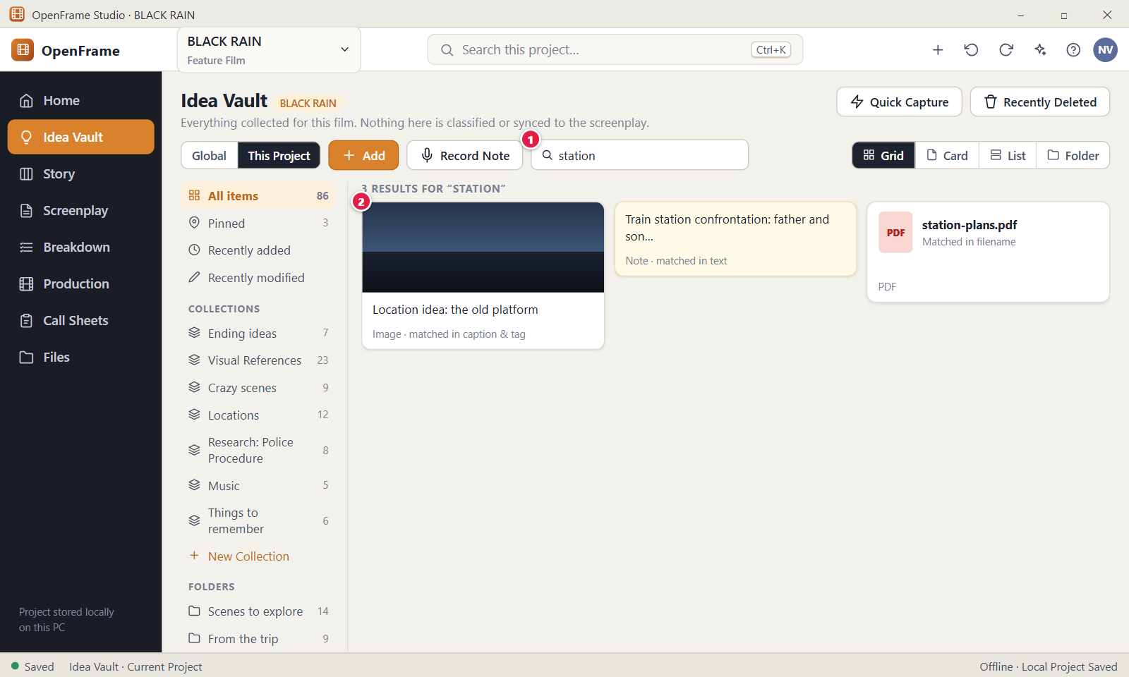
Figure 42. Searching the Vault. Red numbers are explained on the next page.

Figure 42: Searching the Vault: how it works
PARTS OF THIS SCREEN  1 Search box Type what you look for, for example "station". The list shrinks to the matching items, best match first, and a line above the cards counts the results, for example "3 results for “station”". Clear the box (or press Esc) to see all items again. Ctrl+F puts the cursor in the box.  2 Result card A normal Vault card with one extra small line that says which part matched, such as "Matched in caption & tag". The kind line (for example "Image · today") is shown separately. A single click selects the card. Double-click it, or press Enter on a selected card, to open it. Pressing Enter inside the search box does nothing. | HOW TO USE IT  1. Open BLACK RAIN and go to Idea Vault.  2. Click the search box, or press Ctrl+F.  3. Type "station". Results appear about a fifth of a second after you stop typing.  4. Read the line above the cards, then look at the small "Matched in" line on each card to see why it was found.  5. Double-click "Location idea: the old platform" to open it in the drawer.  6. Clear the box to see every item again.  GOOD TO KNOW · EDGE CASES  • The search covers the fields you can read: title, note text, caption, link, quote source, file name and tags. It does not look inside PDFs, images or audio.  • Each word you type must match the start of a word in the item. "stat" finds "station", but "tion" does not, and "station" does not find "stations". Upper and lower case are the same.  • If you type several words, an item must match all of them.  • Only the view you picked is searched. If you chose Pinned, a collection, a folder or a tag on the left, only items inside it are searched. Choose All items to search everything. Items in Recently Deleted are not searched.  • Results are ordered by how well they match, with a word in the name counting more than one in a caption or tag, not by date.  • With no match the app says "No results for “zzzz”" and reminds you that search looks at titles, note text, captions, filenames and tags. The search text can be up to 500 characters.
See also: Figure 24 Project Idea Vault: Visual Grid Figure 40 Global Idea Vault Figure 36 External file unavailable Figure 44 Recently Deleted Figure 43 Quick Capture

Figure 43: Quick Capture
What it is for. Quick Capture is a small window for the moment a thought arrives. It has one text box and saves your words as an ordinary text note in the Idea Vault, then closes. It answers the question: how do I capture this idea before I forget it?
How to get here. In a project, press Ctrl+Shift+N from any screen, or go to Idea Vault and click Quick Capture at the top right. You can also use the last item of the Add menu, or the "+" button in the top bar and choose "New Idea". With no project open, Ctrl+Shift+N on Home captures into the Global Idea Vault.
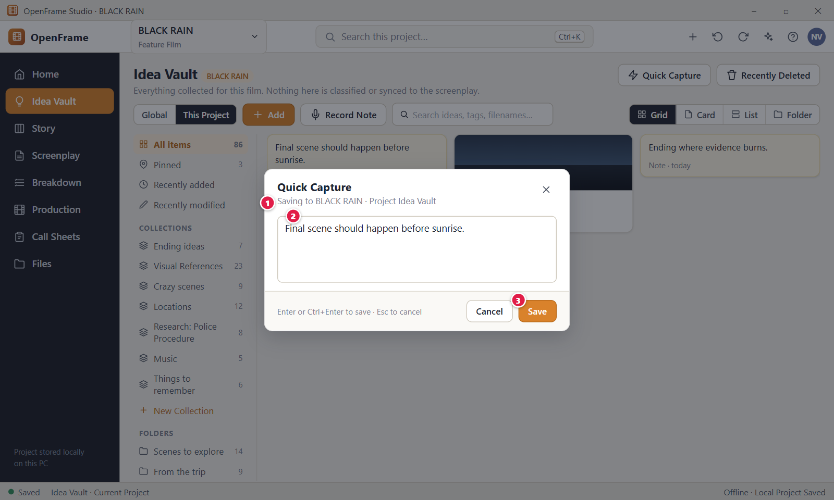
Figure 43. Quick Capture. Red numbers are explained on the next page.

Figure 43: Quick Capture: how it works
PARTS OF THIS SCREEN  1 Saving to BLACK RAIN · Project Idea Vault A grey line that says where the note will go. It names the open project and its vault. With the Global tab shown, or with no project open, it reads "Saving to your Global Idea Vault". The dialog has no control to change the project, so the note goes to the vault the page shows.  2 Text box A multi-line box with the cursor already in it. Type the thought here. Enter saves, and Shift+Enter starts a new line. The text needs at least one character that is not a space, and it is saved exactly as typed.  3 Save Creates an ordinary note in the vault and closes the window at once. A message appears for 5 seconds with an Undo link. The button stays off while the box is empty or holds only spaces. Cancel and the X at the top right close the window without saving. | HOW TO USE IT  1. Press Ctrl+Shift+N, or click Quick Capture on the Idea Vault page.  2. Check the grey line: it should say "Saving to BLACK RAIN · Project Idea Vault".  3. Type the idea, for example "Final scene should happen before sunrise."  4. Press Enter, or click Save.  5. Click Undo in the message if you saved by mistake.  6. Look in Idea Vault > All items for the new note.  GOOD TO KNOW · EDGE CASES  • Enter alone saves. The hint under the box reads "Enter or Ctrl+Enter to save · Shift+Enter for a new line · Esc to cancel".  • Cancel, the X, Esc and a click on the dimmed area throw away what you typed, with no question. If a save fails, the text stays in the box.  • The note has no title, folder or collection. Its card shows the first line of the text, cut at 80 characters.  • Quick Capture never creates a Scene Card, a Beat or screenplay text. Use Send to Story on the note later if you want a Story item.  • Ctrl+Shift+N is the default shortcut. You can change it in Settings > Keyboard shortcuts.  • The text can be up to 2 MiB. Above that the app says "Text is too long." and keeps what you typed.
See also: Figure 24 Project Idea Vault: Visual Grid Figure 29 Add menu: Note, Image, URL, File, Voice Note, Video Figure 12 Project Home: an active project Figure 44 Recently Deleted

Figure 44: Recently Deleted
What it is for. Recently Deleted holds the Idea Vault items, folders and collections you deleted. Nothing is gone after one click: you can bring an item back, or remove it for good after a second confirmation. It answers the question: can I get back what I deleted by mistake?
How to get here. Open a project, go to Idea Vault and click Recently Deleted at the top right. The list shows the vault of the tab you were on, This Project or Global. Click Back to Vault to return.
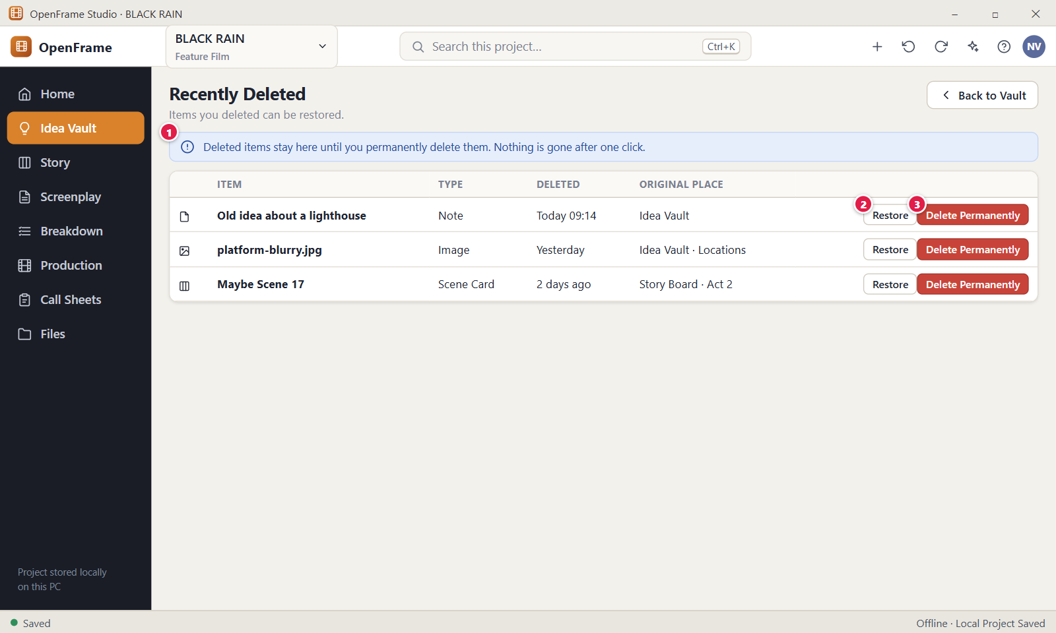
Figure 44. Recently Deleted. Red numbers are explained on the next page.

Figure 44: Recently Deleted: how it works
PARTS OF THIS SCREEN  1 Explanation banner A blue banner under the title. In the app it reads "Deleted items stay here for 30 days, then they are removed for good. Restore them before then, or delete them sooner." After 30 days OpenFrame removes the items for good, with no network needed.  2 Restore Brings the item back to the place it was deleted from and removes the row from the list. It asks no question. If the original folder was deleted too, the item returns to All items and a message tells you so. Each row has its own Restore button.  3 Delete Permanently Removes the item from this computer for good. A window asks "Delete permanently?" first and names the item. Any file stored with the item, such as an image, is removed too. This cannot be undone, and only the project Owner can do it. | HOW TO USE IT  1. Open BLACK RAIN and go to Idea Vault.  2. Click Recently Deleted at the top right.  3. Find "Old idea about a lighthouse" in the list. The "Removed in" column shows how many days it has left.  4. Click Restore on its row. A message confirms it and offers Undo.  5. Click Back to Vault and check that the note is in the vault again.  GOOD TO KNOW · EDGE CASES  • After a normal delete you see "Deleted “name”. You can restore from Recently Deleted." with an Undo link, and Ctrl+Z also restores the item.  • The list has the columns Item, Type, Deleted, Removed in and Original place, with the newest delete first. The Original place shows a folder name, or only "Idea Vault" for an item deleted from a collection or the top level.  • Each vault has its own list. This Project and Global never mix.  • This page lists only Idea Vault items, folders and collections. Scene Cards and other project objects are in the project-wide Recently Deleted.  • Deleting never destroys linked objects. A Story copy made with Send to Story stays when you delete the vault note.  • When the list is empty it reads "Nothing deleted". Permanent deletion has no Undo link.
See also: Figure 24 Project Idea Vault: Visual Grid Figure 157 Recently Deleted (whole project) Figure 43 Quick Capture Figure 46 Creating a collection

Figure 45: Research collection with verification flags
What it is for. This screen shows a collection used for research, here "Research: Police Procedure", in the Idea Vault. Each source can carry a verification flag that only you set: Unchecked, Checked or Needs Expert Check. It answers the question: which of my research sources have I checked, and which need an expert?
How to get here. Left navigation > Idea Vault. Under COLLECTIONS in the left panel, click the collection you made for research. To set a flag, right-click a card or row and choose Research flag, or double-click the item and use the Research flag list.
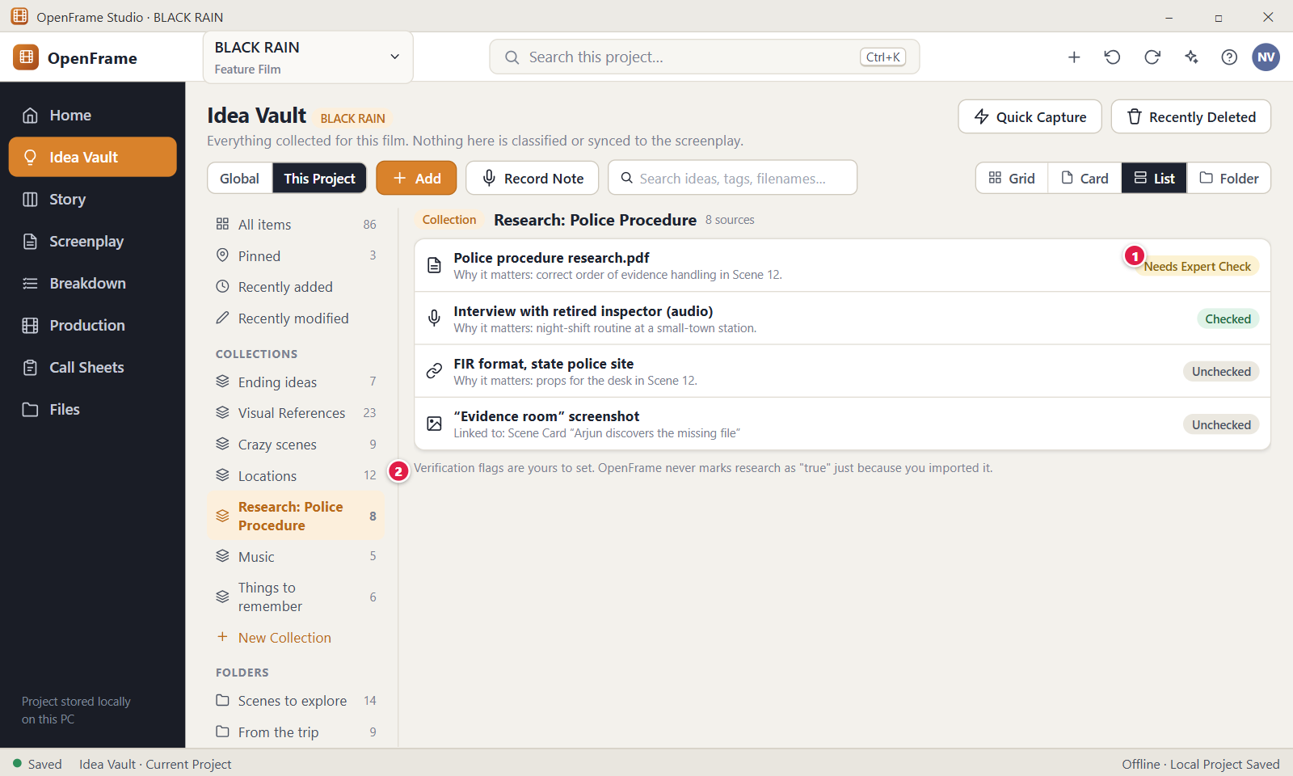
Figure 45. Research collection with verification flags. Red numbers are explained on the next page.

Figure 45: Research collection with verification flags: how it works
PARTS OF THIS SCREEN  1 Needs Expert Check A small label on an item that shows its verification flag. The three flags are Unchecked, Checked and Needs Expert Check, and you choose them. An item with no flag shows no label. You can also choose No flag to clear it.  2 Verification flags note The line "Verification flags are yours to set. OpenFrame never marks research as true just because you imported it." It says a flag is always your own judgement. In the app you see it under the Research flag list in the item window, not under the list of sources. | HOW TO USE IT  1. Open BLACK RAIN and go to Idea Vault.  2. Click your research collection in the left panel, for example "Research: Police Procedure".  3. Right-click "Police procedure research.pdf" and open Research flag.  4. Choose Needs Expert Check. A message confirms it and offers Undo.  5. Look for the label on the card or row.  6. To clear it, right-click the item again and choose No flag.  GOOD TO KNOW · EDGE CASES  • OpenFrame never sets a flag for you. Imported, copied or added items start with no flag.  • Any item in any vault can carry a flag, and any collection can hold flagged items. There is no special research collection type.  • If you select several items first, the menu sets the flag on all of them.  • The label shows in Grid, Card and List views, in every collection that holds the item, and in search results.  • The collection screen shows only the items. It has no "Why it matters" line and no link from a source to a Scene Card. Use the Caption to note why a source matters.  • Removing an item from a collection, or deleting the collection, never deletes the item.
See also: Figure 24 Project Idea Vault: Visual Grid Figure 46 Creating a collection Figure 43 Quick Capture Figure 29 Add menu: Note, Image, URL, File, Voice Note, Video

Figure 46: Creating a collection
What it is for. The New Collection window creates an empty, named group in the Idea Vault, for example "Ending ideas". A collection is an optional theme group: it never moves or copies the items you put in it. It answers the question: how do I group related ideas under a name I choose?
How to get here. Left navigation > Idea Vault. In the left panel, under COLLECTIONS, click "+ New Collection". It also opens from the "New Collection…" button in the Add to Collection window, which you reach by selecting items and clicking Add to Collection in the bar.
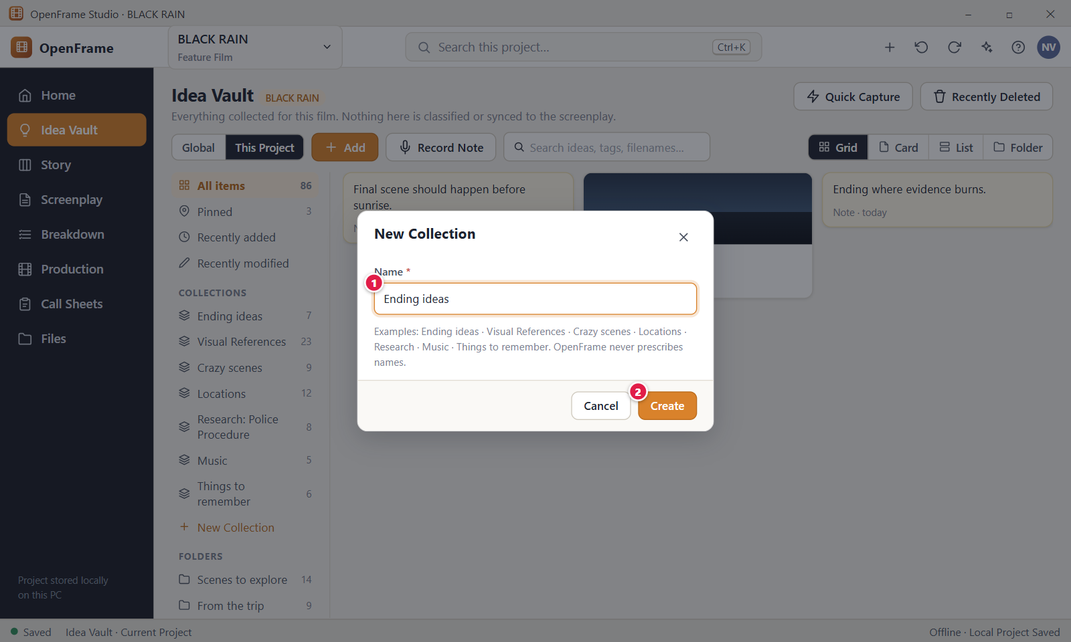
Figure 46. Creating a collection. Red numbers are explained on the next page.

Figure 46: Creating a collection: how it works
PARTS OF THIS SCREEN  1 Name The only field, marked with a star because it is required. The cursor is already in it, and Enter creates the collection. The name can be up to 120 characters and spaces at both ends are removed. Two collections may have the same name. A grey hint under the box lists example names; they are suggestions only and are not created for you.  2 Create Creates the empty collection and opens it in the Vault. With an empty name, the app says "Name is required." and creates nothing. Cancel and the X at the top right close the window without creating anything. | HOW TO USE IT  1. Open BLACK RAIN and go to Idea Vault.  2. Click "+ New Collection" under COLLECTIONS in the left panel.  3. Type a name, for example "Ending ideas".  4. Click Create, or press Enter.  5. Read "This collection is empty. Add items to it from their menu or the selection bar."  6. Select items in All items and use Add to Collection in the bar to fill it.  GOOD TO KNOW · EDGE CASES  • A collection is a group of references. An item can be in several collections and in a folder at the same time.  • Removing an item from a collection, or deleting the collection, never deletes the item. Deleting shows "Deleted collection “Ending ideas”. Its items were kept." with an Undo link, and the collection goes to Recently Deleted.  • You add items with Add to Collection in the selection bar or in the item window. You cannot drag an item onto a collection.  • Collections belong to one vault. A collection made in Global is not in BLACK RAIN, and the other way round.  • OpenFrame never prescribes names, and no message appears after Create. The new, empty collection just opens.  • Esc closes the window without creating anything. If you opened it from the Add to Collection window and collections already exist, Cancel takes you back to that list.
See also: Figure 24 Project Idea Vault: Visual Grid Figure 45 Research collection with verification flags Figure 44 Recently Deleted Figure 47 Everything the Vault can hold

Figure 47: Everything the Vault can hold
What it is for. This sheet lists the twelve kinds of item the Idea Vault can hold and how each kind looks on a card. It answers the question: what can I put in the Vault, and what will I see after I add it? None of the kinds needs a title, a category or a folder.
How to get here. Open a project and go to Idea Vault. Use the Add menu, Record Note, Quick Capture (Ctrl+Shift+N), the New Folder and New Collection links in the left panel, or drag files from Windows Explorer into the Vault.
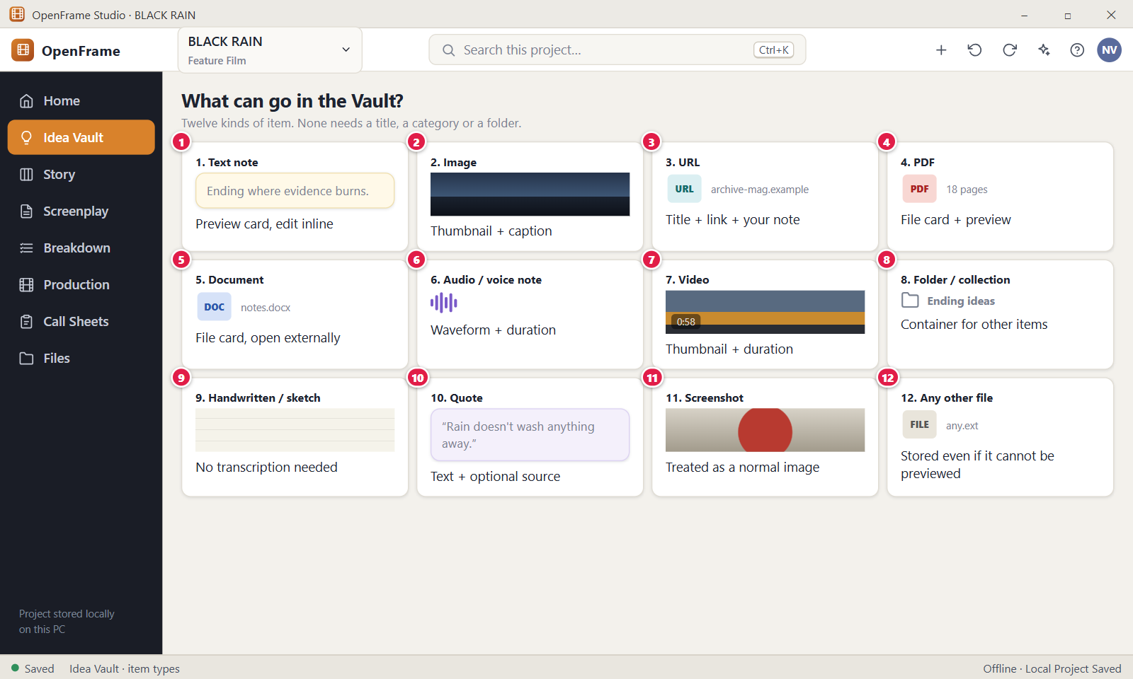
Figure 47. Everything the Vault can hold. Red numbers are explained on the next page.

Figure 47: Everything the Vault can hold: how it works
PARTS OF THIS SCREEN  1 Text note Shows the first words of the note (up to 80 characters). Double-click it, or press Enter on it, to open the item window, where you edit the text. It saves while you type, with no Save button. The title is optional; an empty note shows "Untitled note". Quick Capture and Add > Note both make notes.  2 Image A card with a thumbnail and the file name. Add it with Add > Image or by dragging an image file in. The picker offers png, jpg, jpeg, gif, webp, bmp, heic and svg. The original file is copied into the project, and the caption is optional.  3 URL A card for a web link. Add > URL opens a window with a Link box and an optional note about why you saved it. The card shows the host name and your note. OpenFrame stores the link as you entered it and does not download the page. Only http and https links are accepted.  4 PDF A file card with a red PDF mark and the file name. Add it with Add > File or by dragging a .pdf file in. The card shows no page count and no preview. You can open the PDF in the program Windows uses for PDFs.  5 Document A file card with the file extension in a blue mark, for example DOCX, and the file name. Word, spreadsheet, presentation and screenwriting files such as docx, xlsx, fdx and fountain are treated as documents. The file opens in an outside program.  6 Audio / voice note A card with a music or microphone mark, the name and the length. Use Add > "Audio / Voice Note" or Record Note to record with the microphone, or Add > "Audio file…" to add a file. The card shows no waveform. A recording stays exactly as recorded and is never transcribed.  7 Video A card with a dark block, a play mark and the length once it is known. It does not show a frame of the video. Add it with Add > Video or by dragging a file in. The Vault stores the video; it is not a video editor.  8 Folder / collection Two containers you name yourself. A folder holds items and an item sits in one folder. A collection is a theme group and an item can be in many. Make them with "+ New Folder" and "+ New Collection" in the left panel. Names can be up to 120 characters. Deleting either one never deletes its items.  9 Handwritten / sketch A drawn picture or a scan of handwriting, kept as an image. Add > Sketch opens a drawing window with Fine, Medium and Bold lines, an Eraser and a Clear button. Save Sketch stays off until you draw something. A scanned page is added with Add > Image.  10 Quote A card for words you heard or read, shown in italics with an optional source line. Add > Quote opens the item window with Title, Quote and Source. The card adds the curly quotation marks itself, so do not type them.  11 Screenshot An image whose file name starts with "Screenshot" or "Screen Shot". It looks like any image, with a thumbnail. OpenFrame decides this from the file name and never asks you.  12 Any other file A file card for anything else, with the extension in a grey mark. The file is stored even if it cannot be previewed. Add > File accepts up to 8 GiB per file and 1,000 files at a time. A folder cannot be added. OpenFrame never runs stored files; Open externally hands them to Windows. | HOW TO USE IT  1. Open BLACK RAIN and go to Idea Vault.  2. Click Add and choose a kind, for example Image, URL or Quote.  3. Fill in the window that opens. For an image, pick the file; for a URL, paste the link and add a short note.  4. Or drag files from Windows Explorer straight into the Vault. Drop to add them.  5. Look at the new card and compare it with the kinds on this page.  6. Double-click a card to open it and add a title or caption if you want one.  GOOD TO KNOW · EDGE CASES  • OpenFrame decides the kind of a file from its extension, not from its content. You are never asked to classify an item.  • A file that cannot be previewed is still stored. Use Open externally to open it in another program.  • Adding a file makes a copy inside the project. Deleting the original from your desktop does not remove it from the Vault.  • No kind needs a title. An untitled item shows the first line of its text or its file name.  • A voice note needs a microphone and Windows permission to use it. If it fails, the app tells you to check Settings > Privacy & security > Microphone.  • An .aac audio file becomes a plain File item, and a .webm file counts as audio.
See also: Figure 24 Project Idea Vault: Visual Grid Figure 29 Add menu: Note, Image, URL, File, Voice Note, Video Figure 33 Recording a voice note Figure 43 Quick Capture Figure 46 Creating a collection

Chapter 3: Story Board: Shape the Story
The Story Board is where you shape the story with Acts, Sequences, Beats and Scene Cards. You can drag cards, park the ones you do not need, try alternatives by duplicating, build a screenplay from the cards, and keep your characters, timeline and (for series) seasons and episodes.

Screens in this chapter
Figure | Screen | Page
Figure 48 | Story Board: empty state | 113
Figure 49 | Story Board: Board view | 115
Figure 50 | Add menu: Act, Sequence, Beat, Scene | 118
Figure 51 | Creating an Act (title only) | 120
Figure 52 | Story Board: Outline view | 122
Figure 53 | Scene Card detail drawer | 124
Figure 54 | Dragging a card: insertion line | 126
Figure 55 | Moving a Sequence between Acts | 128
Figure 56 | Right-click menu on a Scene Card | 130
Figure 57 | Selecting several cards | 132
Figure 58 | The Parking Lot | 134
Figure 59 | Duplicating a card to try an alternative | 136
Figure 60 | Beat Card and Convert to Scene | 138
Figure 61 | Deleting a non-empty Act | 140
Figure 62 | Deleting a card that has a linked screenplay scene | 142
Figure 63 | Build Screenplay: preview | 144
Figure 64 | Building when a screenplay already exists | 146
Figure 65 | Warning before a board reorder changes a written script | 148
Figure 66 | Zooming out to see the whole film | 150
Figure 67 | Characters directory | 152
Figure 68 | Adding a character (duplicate-name check) | 154
Figure 69 | Character relationship view | 156
Figure 70 | Story Timeline (optional) | 158
Figure 71 | Sequence Hub | 160
Figure 72 | Exporting the Story Board or Outline as PDF | 162
Figure 73 | Series → Season → Episode (episodic projects) | 164
Figure 74 | Season Board: reordering episodes | 166

Figure 48: Story Board: empty state
What it is for. This is the Story Board of a project that has no Acts, Sequences, Beats or Scene Cards yet. It explains in one sentence what a Scene Card is and offers two ways to start: Add Scene and Add Act. It answers the question: how do I start shaping my story?
How to get here. Left navigation > Story, in a project whose Story Board is empty. From Project Home, click Open Story Board. You can also press Ctrl+K and search for "Story".
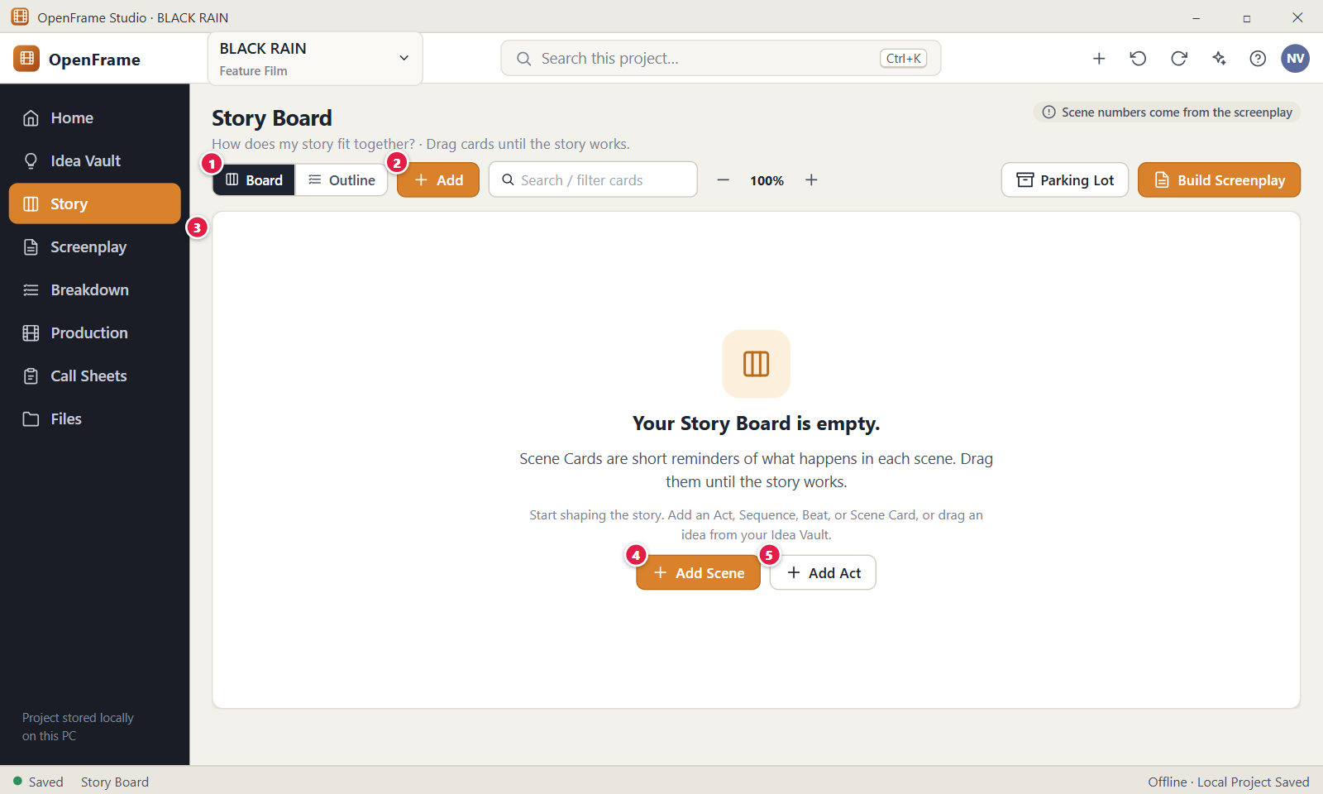
Figure 48. Story Board: empty state. Red numbers are explained on the next page.

Figure 48: Story Board: empty state: how it works
PARTS OF THIS SCREEN  1 Board / Outline Two views of the same story. Board is the visual wall of cards and Outline is a compact indented list. The dark one is selected, and Board is the default. Switching never changes your story. With an empty board both views show the same message.  2 Add Opens the Add menu: Act, Sequence, Beat, Scene Card (Ctrl+N) and From Idea Vault…. Sequence is greyed out while the board has no Act.  3 Empty-state message Shows "Your Story Board is empty." and the line "Scene Cards are short reminders of what happens in each scene. Drag them until the story works." It disappears as soon as any object exists, even a Beat in the Parking Lot.  4 Add Scene The main first action. On an empty board it creates an Act called "Act 1" and one blank Scene Card inside it, ready to type. The box is labelled "Short description" with the hint "What happens in this scene?". Enter saves, Shift+Enter adds a line, and Esc keeps the blank card.  5 Add Act Opens a field labelled "Act title" on the board. Press Enter to create the Act, or Esc to cancel. The title can be up to 200 characters. Acts are optional, and you can build the story from Scene Cards and Sequences alone. | HOW TO USE IT  1. Open a project whose Story Board is empty and click Story in the left navigation.  2. Click Add Scene to create your first card, or Add Act to start with structure.  3. Type what happens, for example "Arjun steps off the night bus into the empty town."  4. Press Enter to save the card.  5. Click Add and choose Scene Card (Ctrl+N) to add the next one.  6. Drag the cards until the story works.  GOOD TO KNOW · EDGE CASES  • Add Scene on an empty board also creates "Act 1" for the card, because every Scene Card sits in an Act, a Sequence, the Parking Lot or the Unassigned area. You can rename or delete the Act later.  • The Story Board never shows scene numbers. The grey note at the top right says they come from the screenplay.  • The Parking Lot button shows or hides the holding area for cards that are not in the active story. Zoom has six steps from 50 to 150 percent. Both choices are remembered on this computer.  • Build Screenplay on an empty board only explains that there are no Scene Cards yet.  • The page also has tabs Board, Outline, Characters and Timeline above the title, an Export button and a three-dot menu for more actions.
See also: Figure 49 Story Board: Board view Figure 50 Add menu: Act, Sequence, Beat, Scene Figure 51 Creating an Act (title only) Figure 52 Story Board: Outline view Figure 58 The Parking Lot Figure 63 Build Screenplay: preview

Figure 49: Story Board: Board view
What it is for. Board view is the wall of your story. Acts are wide bands, Sequences are groups inside them, and compact Scene Cards and lighter Beat Cards sit inside the Sequences. A dashed Parking Lot column holds cards that are not in the active story. It answers the question: how does my story fit together?
How to get here. Left navigation > Story. Board is the default view. From Project Home, click Open Story Board. On an empty board it appears after you add the first Act or Scene Card.
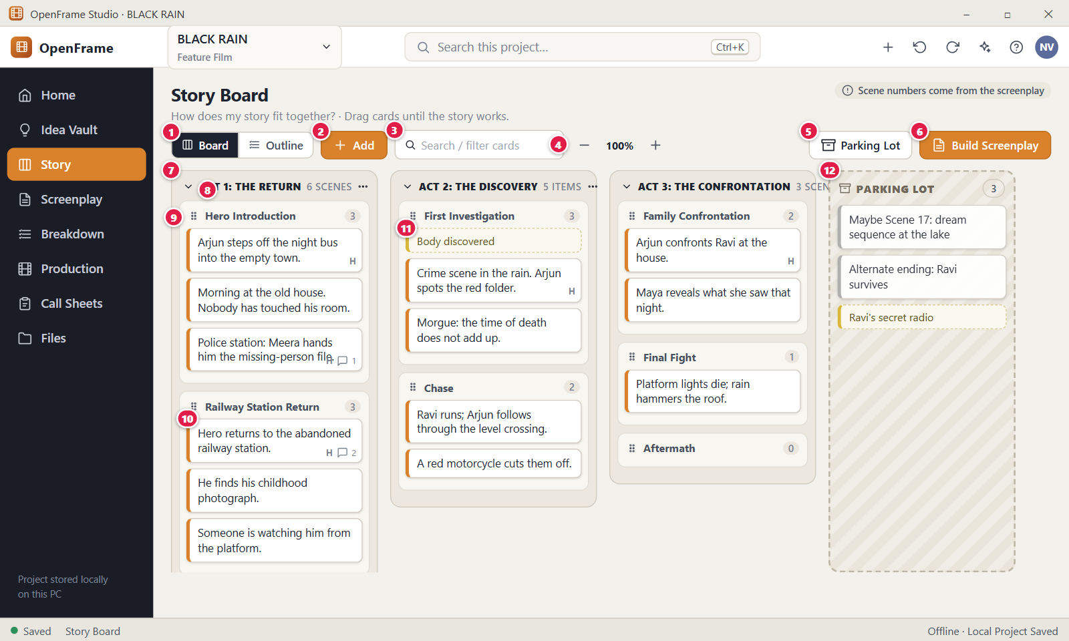
Figure 49. Story Board: Board view. Red numbers are explained on the next page.

Figure 49: Story Board: Board view: how it works
PARTS OF THIS SCREEN  1 Board / Outline Switches between Board (this screen) and Outline. Both views show the same objects in the same order, and switching never changes them. The same two choices also appear as tabs above the page title.  2 Add Opens the Add menu with Act, Sequence, Beat, Scene Card and From Idea Vault…. A new Scene Card or Beat goes after the selected card in the same place, or at the end of a selected Sequence. With nothing selected it goes at the end of the last Act. A Sequence always goes into the last Act.  3 Search / filter cards Type to hide cards that do not match. A Scene Card matches on its description, heading or notes, and a Beat on its text or note. A Sequence stays when its name or any card inside matches, and Acts always stay visible. It filters by text only, and nothing is removed from the story. A small x clears the filter, and it is cleared when the app restarts.  4 Zoom A minus button, the current value (100%) and a plus button. The steps are 50, 70, 85, 100, 125 and 150 percent. Zoom only changes how dense the cards look and never changes stored text. The value is kept on this computer and the control is hidden in Outline view.  5 Parking Lot Shows or hides the Parking Lot column on the right. It is shown the first time you use the app on a computer, and your last choice is remembered. Hiding it deletes nothing.  6 Build Screenplay Opens the preview "Build Screenplay from Story Board", which turns the active Scene Cards into a screenplay draft in board order. Parking Lot cards are left out. Nothing is created until you confirm in the preview.  7 Act A wide band such as "ACT 1: THE RETURN". It holds Sequences, and can also hold Scene Cards or Beats directly. Acts sit side by side from left to right and the board scrolls sideways. Drag an Act header to move the Act with everything in it. An empty Act reads "Add a sequence or scene." and has the buttons "+ Scene", "+ Sequence" and "+ Beat".  8 Act header Shows a collapse arrow, the title, a count such as "6 scenes" and a three-dot menu. Double-click the title to rename it. The menu has Rename, Edit note…, Add Sequence, Add Scene, Add Beat, Move Left, Move Right and Delete. The count shows Scene Cards only, and reads "N items" when the Act has no Scene Card.  9 Sequence header A named group of scenes, for example "Hero Introduction", with a drag grip, a collapse arrow and the number of Scene Cards. Beats are not counted. Double-click the name to rename it. Double-click the rest of the header to open the Sequence drawer. Right-click for Open, Rename, Move…, Add Scene, Add Beat and Delete.  10 Scene Card A compact rectangle with the short description. A small "H" means the card has a scene heading. A speech bubble with a number shows open comments. Click to select, and double-click or press Enter to open its drawer. Drag it to move it, or right-click for the menu. No scene number or production data appears.  11 Beat Card A lighter card with a dashed outline for a small story event, such as "Body discovered", that may become a scene later. It can sit in an Act, a Sequence or the Parking Lot. Its menu includes Convert to Scene. The Beat stays after converting and is marked "Converted".  12 Parking Lot A dashed, striped column for cards and Beats that are not in the active story, with a count in its header. Parked items are not deleted and are left out of Build Screenplay. Empty, it reads "Drag cards and beats here to keep them out of the story without deleting them." Use "+ Beat" and "+ Scene" at the bottom to add parked items. | HOW TO USE IT  1. Click Story in the left navigation.  2. Click Add > Act and give it a title such as "ACT 1: THE RETURN".  3. Click "+ Sequence" in the Act and name it, for example "Hero Introduction".  4. Click "+ Scene" in the Sequence and type "Arjun steps off the night bus into the empty town."  5. Drag cards to reorder them, or drag a card you are unsure of into the Parking Lot.  6. Type a word in "Search / filter cards" to find a card, then click Build Screenplay when the story is ready.  GOOD TO KNOW · EDGE CASES  • The board and the screenplay are separate. Moving cards on the Story Board never rewrites screenplay text.  • Structure is optional at every level. A Scene Card or Beat can sit directly under an Act without a Sequence.  • Existing cards are opened in the drawer to edit. Only a brand-new card is edited in place.  • Delete or Backspace deletes the selected card, Ctrl+D duplicates it, and Alt+Up and Alt+Down move it one place. Deleted cards go to Recently Deleted and can be restored.  • Zoom, the Parking Lot toggle and the filter only change what you see. Whether Acts and Sequences are collapsed is saved in the project.  • The board never shows scene numbers. They come later from the screenplay order.
See also: Figure 48 Story Board: empty state Figure 50 Add menu: Act, Sequence, Beat, Scene Figure 52 Story Board: Outline view Figure 53 Scene Card detail drawer Figure 54 Dragging a card: insertion line Figure 55 Moving a Sequence between Acts

Figure 50: Add menu: Act, Sequence, Beat, Scene
What it is for. The Add menu is the one place where every Story Board object is created: Act, Sequence, Beat or Scene Card, plus a shortcut to the Idea Vault. Each object needs almost no information. It answers the question: how do I add something to the story?
How to get here. Left navigation > Story, then click the orange Add button in the toolbar. Ctrl+N creates a Scene Card directly without opening the menu. The "+" button at the top of the window also offers New Act, New Sequence, New Beat and New Scene Card.
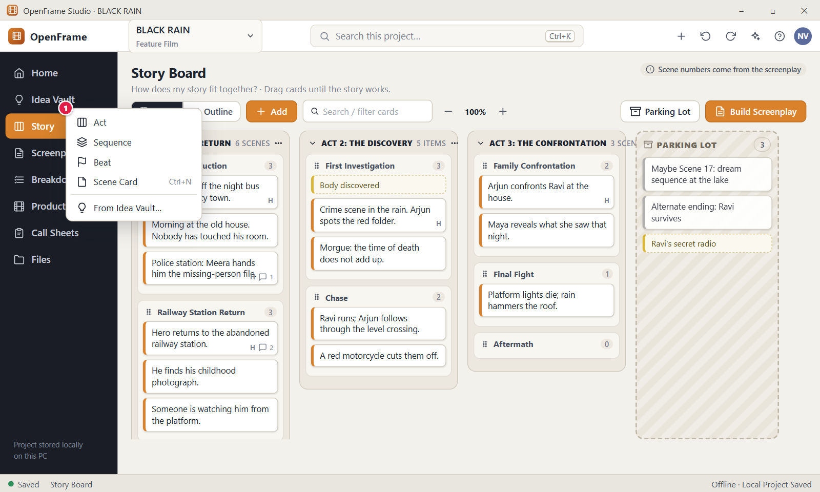
Figure 50. Add menu: Act, Sequence, Beat, Scene. Red numbers are explained on the next page.

Figure 50: Add menu: Act, Sequence, Beat, Scene: how it works
PARTS OF THIS SCREEN  1 Add menu The open menu lists Act, Sequence, Beat, Scene Card (Ctrl+N), a divider and From Idea Vault…. Act asks for a title only. Sequence asks for a name only and is greyed out while the board has no Act. Beat and Scene Card are created blank at once and open a text box for typing. From Idea Vault… only opens the Idea Vault. It copies nothing and shows no picker. The menu closes after a choice, on Esc, or when you click outside it. | HOW TO USE IT  1. Click Story in the left navigation, then click Add.  2. Choose Act, type "Act 1: The Return" in the "Act title" field and press Enter.  3. Click Add > Sequence, type "Hero Introduction" in the "Sequence name" field and press Enter.  4. Click Add > Scene Card, or press Ctrl+N, and type what happens in the scene.  5. Press Enter to save the card. Press Shift+Enter if you want a new line inside it.  6. Click Add > Beat to note a small story event such as "Body discovered".  GOOD TO KNOW · EDGE CASES  • Scene Cards and Beats are created blank and at once. Esc keeps the blank card, so delete it if you do not want it.  • A new Sequence always goes into the last Act, even if a card in another Act is selected. To add one to another Act, use that Act's menu or its "+ Sequence" button.  • A new Scene Card or Beat goes after the selected card, or at the end of a selected Sequence. With nothing selected it goes at the end of the last Act.  • Act titles and Sequence names can be up to 200 characters. A Scene Card or Beat can hold up to 20,000 bytes of text.  • From Idea Vault… takes you to the Idea Vault. There you use Send to Story, which makes a copy and leaves the original idea in place.  • Ctrl+N works from any screen of an open project when your cursor is not in a text box and no dialog is open. You can change the key in Settings > Keyboard shortcuts.
See also: Figure 48 Story Board: empty state Figure 49 Story Board: Board view Figure 51 Creating an Act (title only) Figure 53 Scene Card detail drawer Figure 24 Project Idea Vault: Visual Grid

Figure 51: Creating an Act (title only)
What it is for. Creating an Act needs only a title. This screen shows the title field on the board while you type the name of a new Act. A note is optional and can be added later with Edit note…. It answers the question: what do I type to add an Act?
How to get here. Story > Add > Act. Other ways: the "Add Act" button on an empty board, or the "+" button at the top of the window and then New Act.
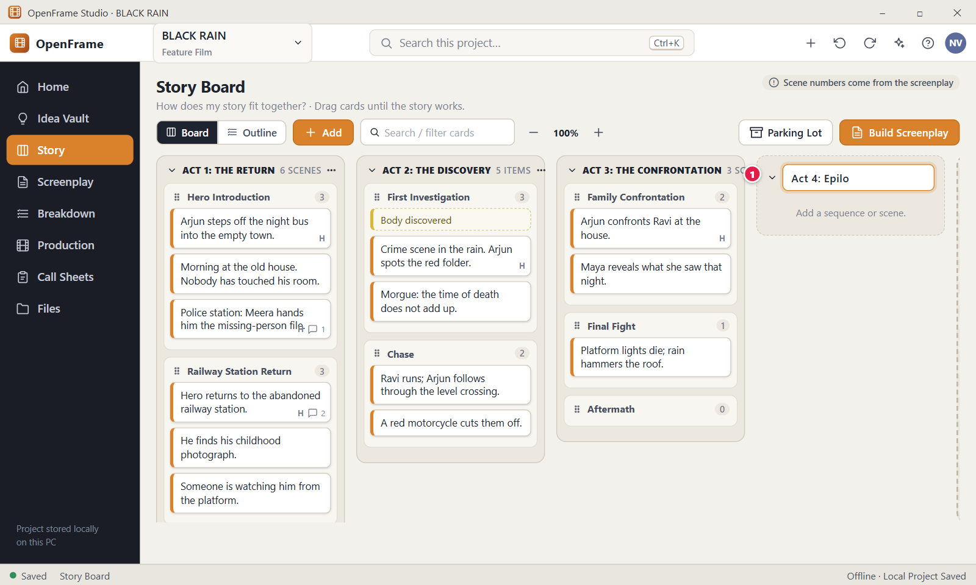
Figure 51. Creating an Act (title only). Red numbers are explained on the next page.

Figure 51: Creating an Act (title only): how it works
PARTS OF THIS SCREEN  1 New Act title A field labelled "Act title" with the hint "Act title, e.g. Act 1: The Return". Type the title and press Enter to create the Act at the end of the Acts. Esc cancels. The title is trimmed and can be 1 to 200 characters. An empty title creates nothing and shows no error. The Act is also saved when you click away from the field with text in it. | HOW TO USE IT  1. Click Story in the left navigation.  2. Click Add > Act. The title field opens at the right of the existing Acts.  3. Type a title, for example "Act 4: Epilogue".  4. Press Enter. The new Act appears as a band at the end of the board.  5. Add a sequence or a scene to it with the buttons in the Act.  GOOD TO KNOW · EDGE CASES  • Below the field the app shows "Press Enter to add the Act. You can add a note later." Add the note afterwards from the Act's three-dot menu, Edit note….  • An empty Act is allowed. It reads "Add a sequence or scene." until you add something.  • Two Acts may have the same title, and the app does not block it.  • New Acts always go at the end. To change the order, drag the Act header or use Move Left and Move Right in its menu.  • A title longer than 200 characters is refused with "Act title is too long (maximum 200 characters)."  • Renaming an Act changes only the Story Board. It never edits screenplay text.
See also: Figure 48 Story Board: empty state Figure 49 Story Board: Board view Figure 50 Add menu: Act, Sequence, Beat, Scene Figure 52 Story Board: Outline view Figure 55 Moving a Sequence between Acts

Figure 52: Story Board: Outline view
What it is for. Outline view shows the same story as a compact indented list: Act, then Sequence, then Beat or Scene. It is the best view for working on exact order and hierarchy. It answers the question: where does each Act, Sequence, Beat and Scene Card sit?
How to get here. Story, then click Outline in the Board and Outline switch (or the Outline tab above the page title). From the Board, click Outline.
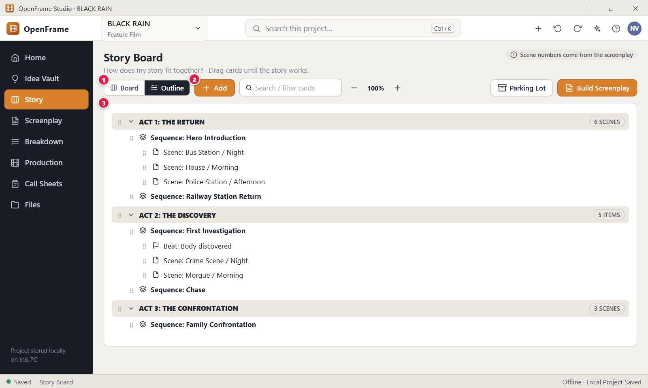
Figure 52. Story Board: Outline view. Red numbers are explained on the next page.

Figure 52: Story Board: Outline view: how it works
PARTS OF THIS SCREEN  1 Board / Outline Switches between the two views of the same story. Outline is selected here, shown dark. Switching never changes order or content, and a change in one view appears in the other. The zoom control is shown in Board view only.  2 Add Opens the Add menu: Act, Sequence, Beat, Scene Card and From Idea Vault…. New objects appear as rows in the right place. Act and Sequence names are typed in an inline row. A Sequence goes into the last Act, and a Scene Card or Beat goes after the selected row.  3 Outline list Each Act is a tinted row with its title and a count such as "6 scenes". Sequences, Beats and Scenes are indented below it with a drag grip at the left, and rows start with "Sequence: ", "Beat: " or "Scene: ". Arrows collapse and expand Acts and Sequences. A scene row shows the short description, and the heading only when the description is empty. The list always ends with a row "Parking Lot (N)" that lists parked items. | HOW TO USE IT  1. Click Story in the left navigation, then click Outline.  2. Click the arrow beside "ACT 1: THE RETURN" to collapse or expand it.  3. Drag a Scene row by its grip to a new place, or focus it and press Alt+Up or Alt+Down.  4. Double-click a Scene row to open its drawer and edit it.  5. Double-click an Act title to rename it.  6. Click Board to go back to the wall of cards.  GOOD TO KNOW · EDGE CASES  • Outline is for hierarchy and order only. It shows no production data and no scene numbers.  • Drag works only from the grip at the left of a row, not from the text. If you drop a row somewhere that is not allowed, such as a Sequence onto a Scene, the row goes back and nothing changes.  • Act counts include Scene Cards only, never Beats. An Act with no Scene Card shows "N items". A converted Beat shows a "Converted" label.  • Right-click a Sequence, Beat or Scene row for its menu: Open, Duplicate, Move…, Send to Parking Lot, Delete and more. Sequences are renamed from this menu.  • Whether an Act or Sequence is collapsed is saved in the project and shared with Board view.  • Build Screenplay uses the order of this outline and leaves out Parking Lot items.
See also: Figure 49 Story Board: Board view Figure 50 Add menu: Act, Sequence, Beat, Scene Figure 53 Scene Card detail drawer Figure 56 Right-click menu on a Scene Card Figure 58 The Parking Lot Figure 63 Build Screenplay: preview

Figure 53: Scene Card detail drawer
What it is for. The Scene Card drawer is a larger editor that opens beside the board. It gives you room to work out one scene (heading, description, notes, attachments) without turning the card into a form. It answers the question: what do I currently mean by this scene?
How to get here. Story > Board. Double-click a Scene Card, or select it and press Enter, or right-click it and choose Open. From Outline, double-click a Scene row. The drawer slides in from the right edge.
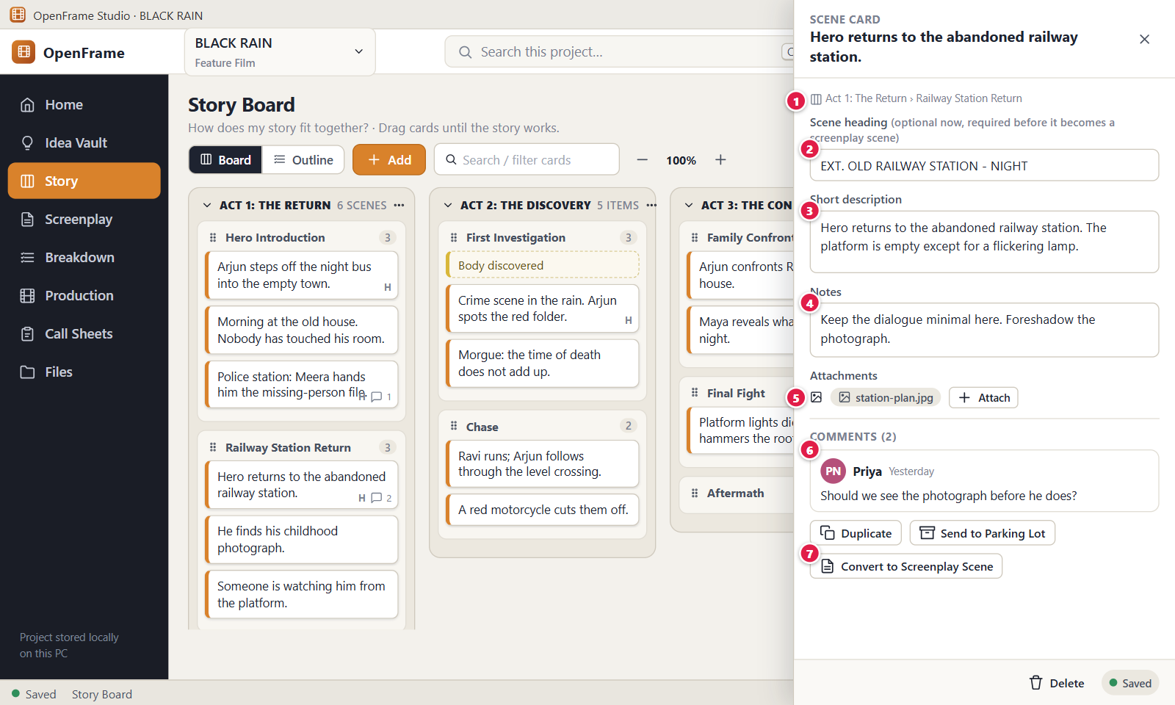
Figure 53. Scene Card detail drawer. Red numbers are explained on the next page.

Figure 53: Scene Card detail drawer: how it works
PARTS OF THIS SCREEN  1 Where it sits A small label above the first field that shows where the card is, for example "Act 1: The Return › Railway Station Return". A parked card shows "Parking Lot" and an unplaced card shows "Unassigned". It is read-only and updates when you move the card.  2 Scene heading The box for a proposed screenplay heading such as "EXT. OLD RAILWAY STATION - NIGHT". The label reads "Scene heading (optional now, required before it becomes a screenplay scene)". It can be up to 200 characters. A blank box removes the "H" mark from the card. It must start with INT., EXT., INT./EXT. or similar only when you build the card into a screenplay.  3 Short description The main field, and the text the compact card shows on the board. The drawer title shows its first line. Limit: 20,000 bytes. Long text is cut on the card only, and the full text is stored. A new card shows the hint "What happens in this scene?". The app also has a "Long description" field below it for scene-development text, up to 100,000 characters.  4 Notes Free-form notes for yourself, with the hint "Freeform scene notes". They do not show on the board card. Limit: 500,000 bytes.  5 Attachments Reference files shown as chips, with an Attach button that opens the Windows file window "Attach a reference file". Click a chip to open the file in the program Windows uses for it. The x on a chip removes it from the card. A card can hold up to 50 attachments, and they never become production assets automatically.  6 Comments In the app this area shows only the line "Comments (N open)" when the card has open comments, and nothing when it has none. The drawer has no comment thread and no way to add a comment. Comments appear as a speech bubble with a number on the card.  7 Convert to Screenplay Scene Starts Build Screenplay with this card already ticked. It creates nothing by itself: you confirm in the preview. If the card has no valid heading, the preview asks for one or lets you leave the card out. The button is off for a card in the Parking Lot. | HOW TO USE IT  1. Double-click the Scene Card "Hero returns to the abandoned railway station." on the Story Board.  2. Type a heading in the heading box, for example "EXT. OLD RAILWAY STATION - NIGHT".  3. Edit the Short description so it says what happens in the scene.  4. Add private thoughts in Notes, such as "Keep the dialogue minimal here."  5. Click Attach and choose a reference picture such as station-plan.jpg.  6. Click the X at the top right, or press Esc, to close the drawer.  GOOD TO KNOW · EDGE CASES  • There is no Save button. Edits save about a second after you stop typing and when you leave a field. The label at the bottom reads "Saving…", "Saved" or "Not saved", and it is blank before your first edit.  • At the bottom of the drawer, Duplicate makes an independent copy placed after the original, Send to Parking Lot parks the card, and Delete moves it to Recently Deleted with a message and Undo.  • A card used to build a screenplay scene asks before it is deleted and says the screenplay scene stays. Later edits to the card never change the screenplay.  • The drawer holds no production fields such as props, budget, shots or scene number.  • Only the X button and Esc close the drawer. Clicking the board does not.  • If the card was deleted while the drawer was open, the app says "This Scene Card is no longer on the Story Board. It may have been deleted."
See also: Figure 49 Story Board: Board view Figure 52 Story Board: Outline view Figure 56 Right-click menu on a Scene Card Figure 58 The Parking Lot Figure 63 Build Screenplay: preview

Figure 54: Dragging a card: insertion line
What it is for. While you drag a Scene Card or Beat, OpenFrame shows exactly where it will land, so you never have to guess. This screen shows the lifted card and the blue insertion line. It answers the question: where will this card go when I let go?
How to get here. Story > Board. Press and hold a Scene Card or Beat with the left mouse button and move the mouse a few pixels. In Outline, drag from the grip at the left of the row.
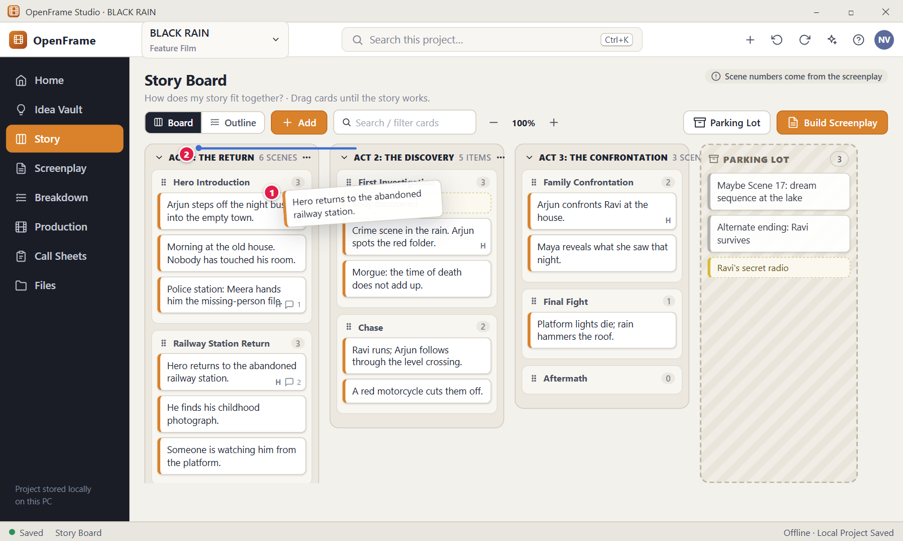
Figure 54. Dragging a card: insertion line. Red numbers are explained on the next page.

Figure 54: Dragging a card: insertion line: how it works
PARTS OF THIS SCREEN  1 Card being dragged The card follows the pointer as a lifted copy showing the first line of its text, while its old place fades. A plain click only selects it, and the drag starts after the pointer moves 6 pixels. If you drag one of several selected cards, all of them move together and the lifted card reads "2 cards" or "N items".  2 Insertion line A thin blue line between two cards that shows where the card will be inserted when you release the button. The upper half of a card means before it and the lower half means after it. When the target is a whole Act, Sequence or the Parking Lot, that container is outlined instead. Releasing over no marker cancels the move. | HOW TO USE IT  1. Click Story to open the board.  2. Press and hold the card "Hero returns to the abandoned railway station." and move the mouse.  3. Move over another Sequence and watch the blue line or outline.  4. Release the button where you want the card. A message such as "Moved Scene Card “…” to Sequence “…”" confirms it.  5. Press Ctrl+Z if you want to put it back.  GOOD TO KNOW · EDGE CASES  • Drop a card on the Parking Lot column to park it without deleting it. The column must be shown for this to work.  • Releasing over an invalid place, such as the Add button, returns the card to where it was. There is no half-moved state.  • Dropping a card on its own place changes nothing.  • A drag keeps the card's identity, comments and attachments. Nothing is duplicated, and no confirmation is asked.  • A drag never changes the screenplay. Board order only matters when you use Build Screenplay or Apply Board Order to Screenplay.  • Dragging works at every zoom level and while a filter is active. When you drag an Act sideways, the marker is a vertical line.
See also: Figure 49 Story Board: Board view Figure 52 Story Board: Outline view Figure 55 Moving a Sequence between Acts Figure 56 Right-click menu on a Scene Card Figure 58 The Parking Lot

Figure 55: Moving a Sequence between Acts
What it is for. You can drag a Sequence from one Act to another, and it carries all its Scene Cards and Beats with it. This screen shows the lifted Sequence, the highlighted destination Act and the blue line where the Sequence will land. It answers the question: where will this Sequence go, and does everything inside it come along?
How to get here. Story > Board. Press and hold the header of a Sequence, the bar with its name and count, move the mouse a few pixels and drag over another Act. As a keyboard alternative, right-click the Sequence header and choose Move….
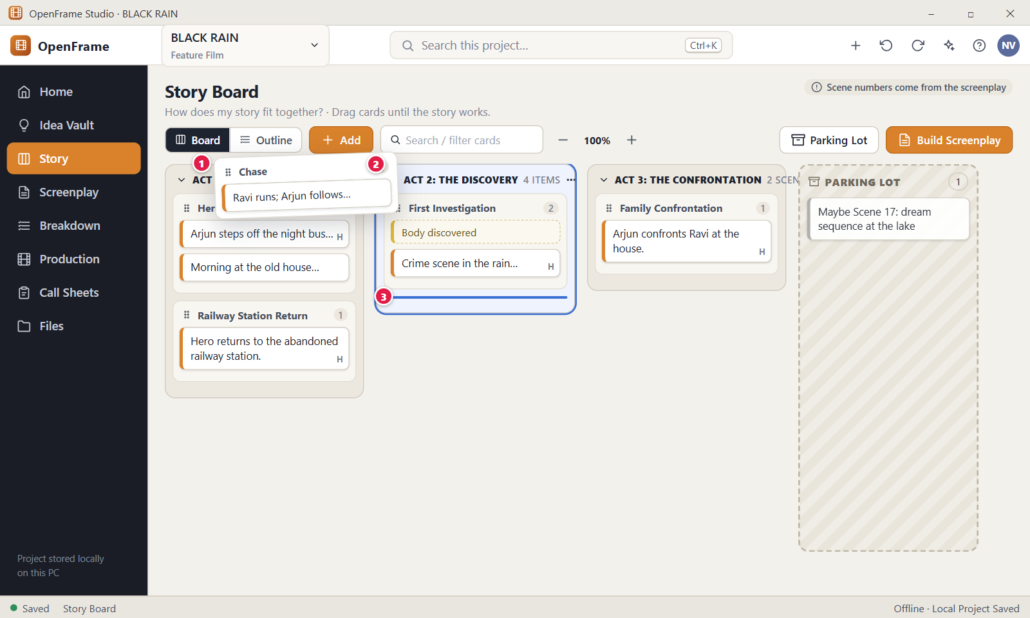
Figure 55. Moving a Sequence between Acts. Red numbers are explained on the next page.

Figure 55: Moving a Sequence between Acts: how it works
PARTS OF THIS SCREEN  1 Sequence being dragged The lifted element shows the Sequence name. All its cards and Beats travel with it. Drag from the header, not from a card inside it. Double-clicking the header opens the Sequence drawer instead. A Sequence can only land inside an Act, never inside another Sequence or the Parking Lot.  2 Destination Act The Act under the pointer is outlined in blue, which means the Sequence will move into it. After the drop, the source Act loses the Scene Cards of the Sequence and the destination Act gains them, so their counts change.  3 Insertion point A blue line inside the destination Act that shows where the Sequence will land among the other items. A line above a Sequence means before it, and a line at the end of the Act means at the end. | HOW TO USE IT  1. Click Story to open the board.  2. Press and hold the header of the Sequence "Chase" and move the mouse.  3. Drag it over "ACT 1: THE RETURN" and watch the blue outline appear.  4. Move to the place you want and check the blue line.  5. Release the button. A message says "Moved Sequence “Chase” to Act “…”".  6. Press Ctrl+Z if you want to undo the move.  GOOD TO KNOW · EDGE CASES  • Moving a Sequence keeps every card's identity, comments and attachments. Nothing is duplicated.  • Releasing over a place that is not allowed returns the Sequence to its old place with no change.  • Only cards and Beats can go to the Parking Lot. To set aside a whole Sequence, select its cards with Ctrl+click and drag them.  • Moving an Act moves it with all its Sequences and scenes. A Sequence is only a group on the Story Board, so moving it never changes the screenplay.  • No confirmation appears for a move, and Undo is always available.  • At 50 percent zoom all Acts fit on a smaller screen, which makes dragging between distant Acts easier. In Outline, use the grip at the left of the Sequence row.
See also: Figure 49 Story Board: Board view Figure 52 Story Board: Outline view Figure 54 Dragging a card: insertion line Figure 51 Creating an Act (title only)

Figure 56: Right-click menu on a Scene Card
What it is for. Right-clicking a Scene Card shows everything you can do with that card. Only actions that make sense for a Scene Card appear, with nothing about payroll, call sheets or production. It answers the question: what can I do with this card?
How to get here. Story > Board. Right-click a Scene Card. The same menu opens when you right-click a Scene row in Outline. Beats, Sequences and Acts have their own menus.
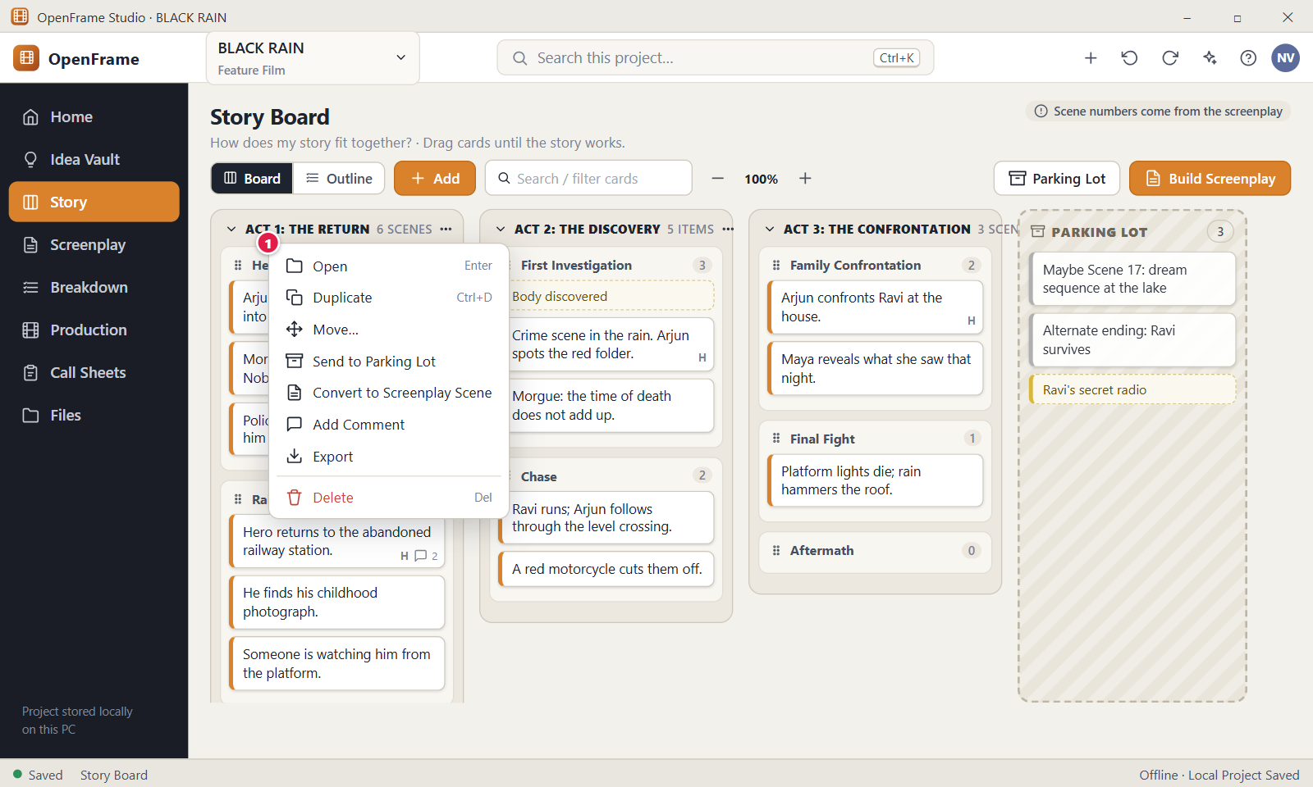
Figure 56. Right-click menu on a Scene Card. Red numbers are explained on the next page.

Figure 56: Right-click menu on a Scene Card: how it works
PARTS OF THIS SCREEN  1 Scene Card menu In the app the menu lists Open (Enter), Duplicate (Ctrl+D), Move…, Send to Parking Lot, Convert to Screenplay Scene, Copy as Beat, and Delete (Del, in red). It has no Add Comment item and no Export item. Export for the Story Board is the Export button at the top right of the page. With several cards selected, right-clicking one of them makes Duplicate, Move…, Send to Parking Lot, Convert and Delete act on all of them. Esc or a click outside closes the menu without doing anything. | HOW TO USE IT  1. Click Story to open the board.  2. Right-click the card "Hero returns to the abandoned railway station."  3. Choose Move… to open "Move to…", pick a destination such as a Sequence or the Parking Lot, and click Move.  4. Right-click the card again and choose Duplicate to make an independent copy right after it.  5. Right-click a card you are unsure of and choose Send to Parking Lot.  6. Choose Delete to remove a card you no longer need. Use the Undo link in the message if you change your mind.  GOOD TO KNOW · EDGE CASES  • Move… lists every Act, its Sequences and the Parking Lot in a Destination list. The card is added at the end of the place you choose.  • For a card in the Parking Lot, the menu reads Restore to Story instead of Send to Parking Lot, and Convert to Screenplay Scene is greyed out. A restored card goes back to its old place, or to Unassigned if that place is gone.  • Convert to Screenplay Scene opens Build Screenplay with this card ticked and creates nothing until you confirm. A card without a valid heading must get one or be left out.  • Copy as Beat makes a Beat from the card text and leaves the card unchanged.  • Delete is recoverable through Undo, Ctrl+Z or Recently Deleted. A card used to build a screenplay scene asks "Delete this Scene Card?" first, and the screenplay scene always stays.  • A Beat menu offers Open, Convert to Scene, Duplicate, Move…, Send to Parking Lot and Delete. A Sequence menu offers Open, Rename, Move…, Add Scene, Add Beat and Delete. An Act uses its three-dot button instead of a right-click menu.
See also: Figure 49 Story Board: Board view Figure 52 Story Board: Outline view Figure 53 Scene Card detail drawer Figure 58 The Parking Lot Figure 63 Build Screenplay: preview

Figure 57: Selecting several cards
What it is for. This screen shows the Story Board with three Scene Cards selected at once. A dark bar appears above the board with actions that apply to the whole selection. It answers the question: how do I move, copy, park or delete several cards in one step without losing their order?
How to get here. Left navigation > Story, Board view. Click one Scene Card, then hold Ctrl and click two more. The bar appears as soon as 2 or more cards or Beats are selected.
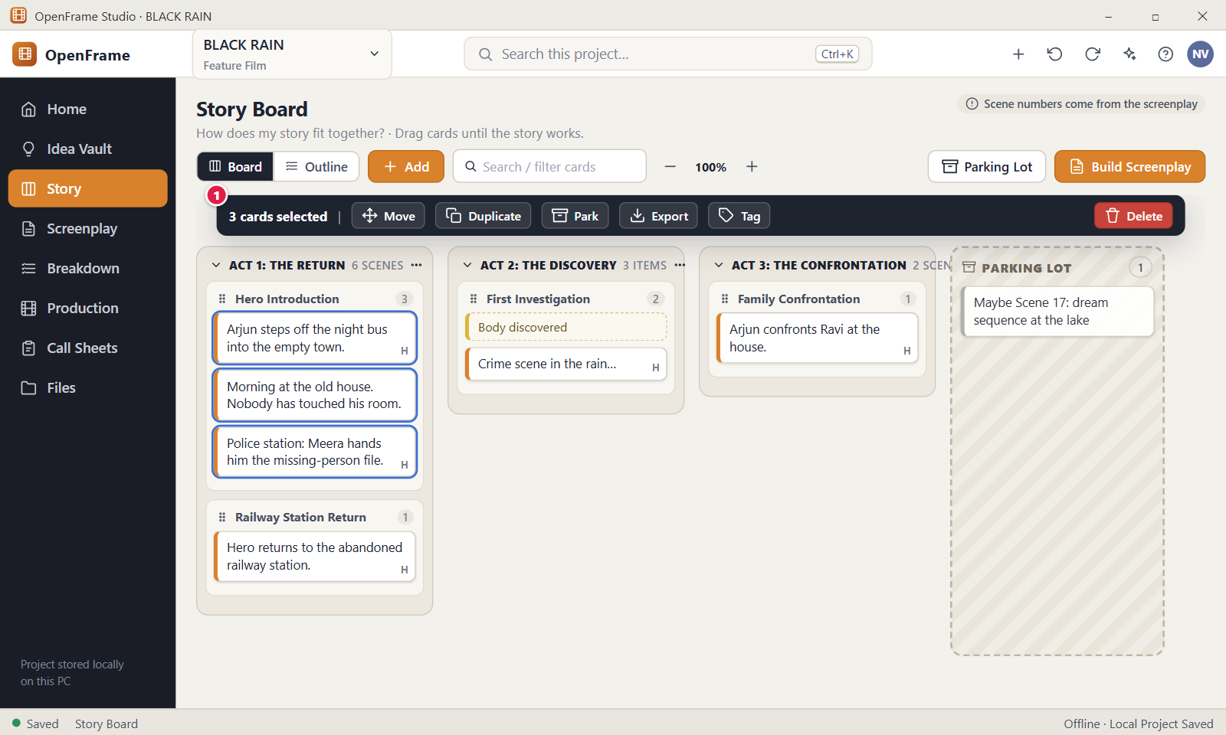
Figure 57. Selecting several cards. Red numbers are explained on the next page.

Figure 57: Selecting several cards: how it works
PARTS OF THIS SCREEN  1 Selection bar A dark bar that reads "3 cards selected" (or "N items selected" when a Beat is included). It has the buttons Move…, Duplicate, Park and Delete, and a round button that clears the selection. It has no Export and no Tag button. Actions keep the board order of the cards, and one action covers up to 2000 items. Sequences are never counted. Press Esc, click empty board space or use the round button to clear the selection. | HOW TO USE IT  1. Click Story to open the board.  2. Click the card "Arjun steps off the night bus into the empty town."  3. Hold Ctrl and click two more cards. The bar appears and reads "3 cards selected".  4. Click Park to move all three to the Parking Lot, or Move… to choose another place.  5. Read the message, for example "Moved 3 Scene Cards to the Parking Lot", and use Undo if needed.  GOOD TO KNOW · EDGE CASES  • One selected card does not show the bar. You need 2 or more.  • Shift+click toggles one card like Ctrl+click. It does not select a range, and you cannot draw a selection box with the mouse.  • Delete on cards that were not used to build a screenplay removes them at once, with an Undo message. If a selected card is linked to a screenplay scene, a dialog such as "Delete 2 items?" asks first.  • Drag any one selected card to move the whole group. The cards keep their order.  • Duplicate makes new independent cards. Moved cards keep their identity.  • To export a selection, use the Export button at the top right of the page and choose "Selected items only (N)".
See also: Figure 49 Story Board: Board view Figure 50 Add menu: Act, Sequence, Beat, Scene Figure 58 The Parking Lot Figure 62 Deleting a card that has a linked screenplay scene Figure 66 Zooming out to see the whole film

Figure 58: The Parking Lot
What it is for. The Parking Lot is the hatched column at the right of the Story Board. It holds cards and Beats that are not part of the story for now, such as "Maybe Scene 17: dream sequence at the lake". It answers the question: where can I keep an idea I may want later without deleting it and without touching the screenplay?
How to get here. Left navigation > Story. The Parking Lot column is on the right of the board. If it is hidden, click "Parking Lot" in the toolbar. To park a card, drag it onto the column, right-click it and choose Send to Parking Lot, or select cards and click Park.
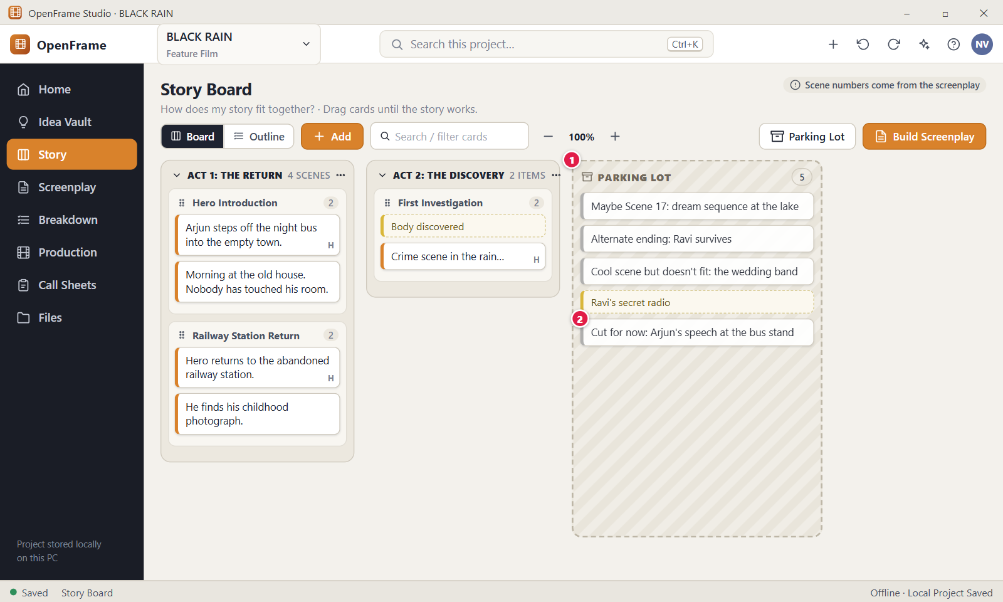
Figure 58. The Parking Lot. Red numbers are explained on the next page.

Figure 58: The Parking Lot: how it works
PARTS OF THIS SCREEN  1 Parking Lot The hatched column that holds parked Scene Cards and Beats, with its name and a count of all parked items in the header. Sequences and Acts cannot be parked. Parked items are not counted in Acts, are left out of Build Screenplay, and keep their text, notes, colour, attachments and screenplay link. When it is empty it reads "Drag cards and beats here to keep them out of the story without deleting them." The buttons "Beat" and "Scene" at the bottom create a new item directly in the column.  2 Parked card One parked item, such as "Cut for now: Arjun's speech at the bus stand". It keeps all its content. To bring it back, right-click it and choose Restore to Story, click Restore in its window, or drag it into an Act or Sequence. Items sit in the order they were placed. On a parked Scene Card, Convert to Screenplay Scene is greyed out. | HOW TO USE IT  1. Click Story to open the board.  2. Drag the card "He finds his childhood photograph." onto the Parking Lot column. A message says "Moved Scene Card “…” to the Parking Lot".  3. Check that the count in the Parking Lot header went up.  4. Right-click the parked card and choose Restore to Story to bring it back.  5. If the column is hidden, click "Parking Lot" in the toolbar to show it again.  GOOD TO KNOW · EDGE CASES  • Parking never deletes a card and never changes the screenplay. The card keeps its link to a screenplay scene.  • Restore to Story puts the item back where it was parked from. If that Act or Sequence is gone, it goes to the end of the last Act, or to an Unassigned column when the board has no Act.  • The toolbar button only shows or hides the column. It does not open another page, and hiding the column moves nothing. The choice is remembered on this computer.  • In Outline view the Parking Lot is a section at the end called "Parking Lot (N)".  • A Beat made with no Act on the board goes to the Parking Lot, because nothing else can hold it.  • Export leaves parked items out unless you tick "Include Parking Lot". There is no branching or Alternate Outline. Duplicate, reorder, park and undo are the ways to try things.
See also: Figure 49 Story Board: Board view Figure 57 Selecting several cards Figure 60 Beat Card and Convert to Scene Figure 63 Build Screenplay: preview

Figure 59: Duplicating a card to try an alternative
What it is for. This screen shows two Scene Cards side by side after you duplicate one: the original "Hero confronts father at house." and the copy "Hero confronts father at hospital.". It answers the question: how do I try a different version of a scene and keep the first one safe?
How to get here. Left navigation > Story. Right-click a Scene Card and choose Duplicate, or click the card and press Ctrl+D, or open the card and click Duplicate in its footer. For several cards, use Duplicate in the selection bar.
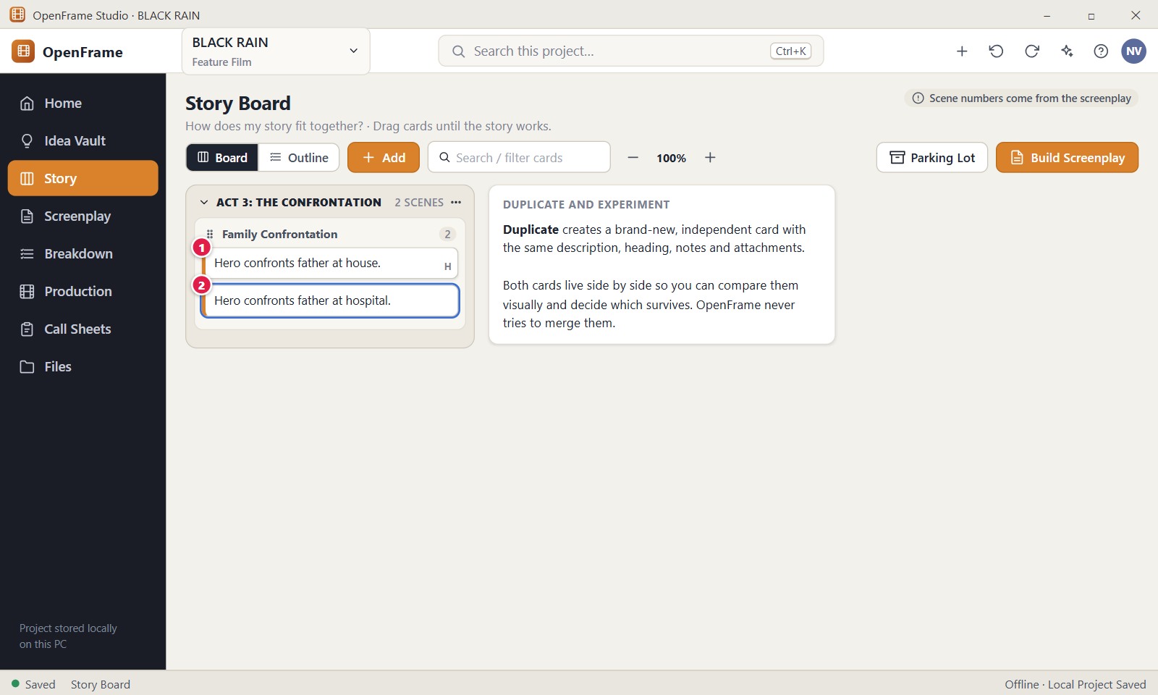
Figure 59. Duplicating a card to try an alternative. Red numbers are explained on the next page.

Figure 59: Duplicating a card to try an alternative: how it works
PARTS OF THIS SCREEN  1 Original The Scene Card you duplicated. It stays exactly as it was: text, heading, notes, colour, attachments and any link to a screenplay scene.  2 Duplicate The copy, placed directly after the original in the same Act, Sequence or Parking Lot, and selected with a blue outline. It has its own identity and copies the short and long description, heading, notes, colour, attachments and character links. It does not copy the link to a screenplay scene. Double-click it to open it and change the text, for example from "house" to "hospital". | HOW TO USE IT  1. Click Story and find the card "Hero confronts father at house."  2. Click the card and press Ctrl+D. A message says "Duplicated Scene Card “Hero confronts father at house.”".  3. Double-click the new copy to open its drawer.  4. Change the short description to "Hero confronts father at hospital." The change saves by itself.  5. Compare the two cards side by side, then park or delete the one you do not want.  GOOD TO KNOW · EDGE CASES  • OpenFrame never merges two cards. Both live side by side and you decide which one stays.  • A copy is independent. Editing the original later does not change the copy.  • The copy is not linked to any screenplay scene, even when the original is, and it has no number.  • The copy is selected but not in edit mode. Double-click it to change the text.  • There is no branching and no version tree. Duplicate, reorder, park and undo are the tools for trying alternatives.  • If you want an empty card instead of a copy, use Add > Scene Card.
See also: Figure 49 Story Board: Board view Figure 57 Selecting several cards Figure 58 The Parking Lot Figure 62 Deleting a card that has a linked screenplay scene

Figure 60: Beat Card and Convert to Scene
What it is for. This screen shows the window of a Beat Card, "Body discovered", open at the right of the Story Board. A Beat is a small story event, smaller than a Scene Card. The window lets you edit its text, note and colour, and turn it into a Scene Card with Convert to Scene. It answers the question: how does a loose idea become a scene without losing the idea?
How to get here. Left navigation > Story. Create a Beat with Add > Beat, or from the Idea Vault with Send to Story. Open it by double-clicking the dashed Beat on the board, or select it and press Enter, or right-click it and choose Open.
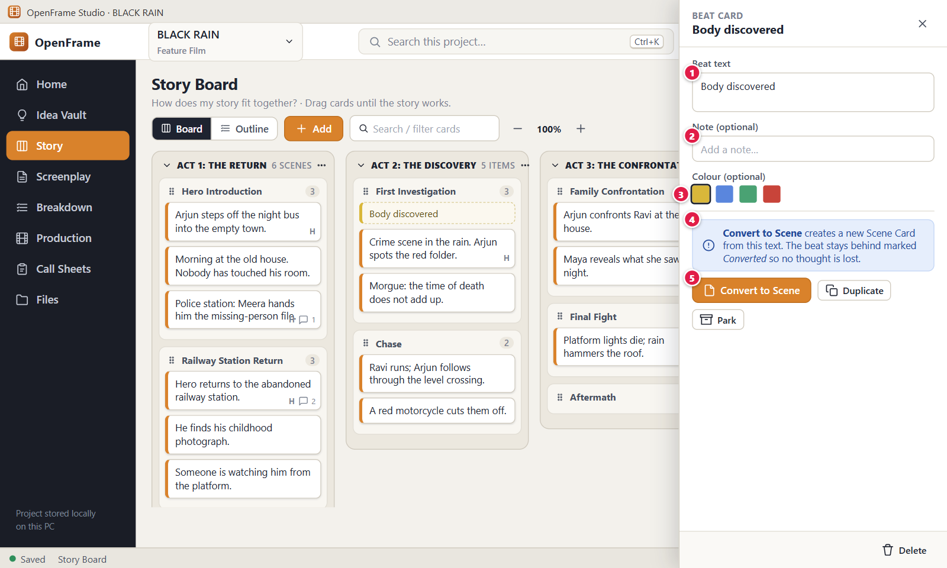
Figure 60. Beat Card and Convert to Scene. Red numbers are explained on the next page.

Figure 60: Beat Card and Convert to Scene: how it works
PARTS OF THIS SCREEN  1 Beat text The text of the Beat and the title of the window. It is the only content a Beat needs, and it may even stay empty (an empty Beat shows "Blank beat"). It can be up to 20,000 bytes and saves by itself about a second after you stop typing.  2 Note (optional) A field with the hint "Add a note…" for thoughts that do not belong in the Beat text. It can be up to 500,000 bytes and does not show on the board card.  3 Colour (optional) A row of swatches. The app offers None and nine colours: yellow, orange, red, pink, purple, blue, teal, green and gray. The colour you pick paints the left edge of the Beat on the board. It is decoration only and has no status meaning. None is the default.  4 Conversion note Grey text at the bottom of the window that explains Convert to Scene: it creates a new Scene Card from this text, and the Beat stays behind marked Converted so no thought is lost. After a conversion, a green box at the top reads "Converted to a Scene Card. This beat stays as a reference." with an "Open card" button.  5 Convert to Scene Creates a new Scene Card whose short description is the Beat text, placed right after the Beat in the same Act, Sequence or Parking Lot. The Beat stays and shows a "Converted" label. The window then shows the new card, and the button is off because a Beat converts only once. The new card has no scene heading, so Build Screenplay asks for one later. | HOW TO USE IT  1. Click Story and double-click the dashed Beat "Body discovered".  2. Edit the Beat text if you want, and add a note such as "Who finds it first?"  3. Pick a colour swatch if you want to mark the Beat on the board.  4. Click Convert to Scene.  5. Read the message "Converted Beat to a Scene Card. The beat stays, marked Converted."  6. Add a scene heading to the new Scene Card before you build the screenplay.  GOOD TO KNOW · EDGE CASES  • A Beat can stay a Beat forever. It never changes the screenplay and needs no heading.  • Beats can sit in an Act, a Sequence or the Parking Lot, but not in the Unassigned column. The app then says "Add the beat to an Act, a Sequence or the Parking Lot."  • The footer has Duplicate (a new Beat right after this one), Park or Restore, and Delete in red. Delete asks no question because a Beat is not linked to a screenplay. It goes to Recently Deleted, and deleting a converted Beat does not delete its Scene Card.  • There is no Save button. The footer shows Saving…, Saved or Not saved.  • An Attach button lets you add reference files to a Beat, up to 50.  • Press Esc or click the X to close the window. Anything typed in the last second is saved first.
See also: Figure 50 Add menu: Act, Sequence, Beat, Scene Figure 58 The Parking Lot Figure 63 Build Screenplay: preview Figure 59 Duplicating a card to try an alternative

Figure 61: Deleting a non-empty Act
What it is for. This dialog opens when you delete an Act that still holds Sequences and cards. It makes you choose what happens to them. It answers the question: how do I remove an Act without losing the scenes inside it by accident?
How to get here. Left navigation > Story. On the Board, click the three dots in the header of an Act (the button "Act options for" and the Act name), then choose Delete. An empty Act is deleted at once, without this dialog.
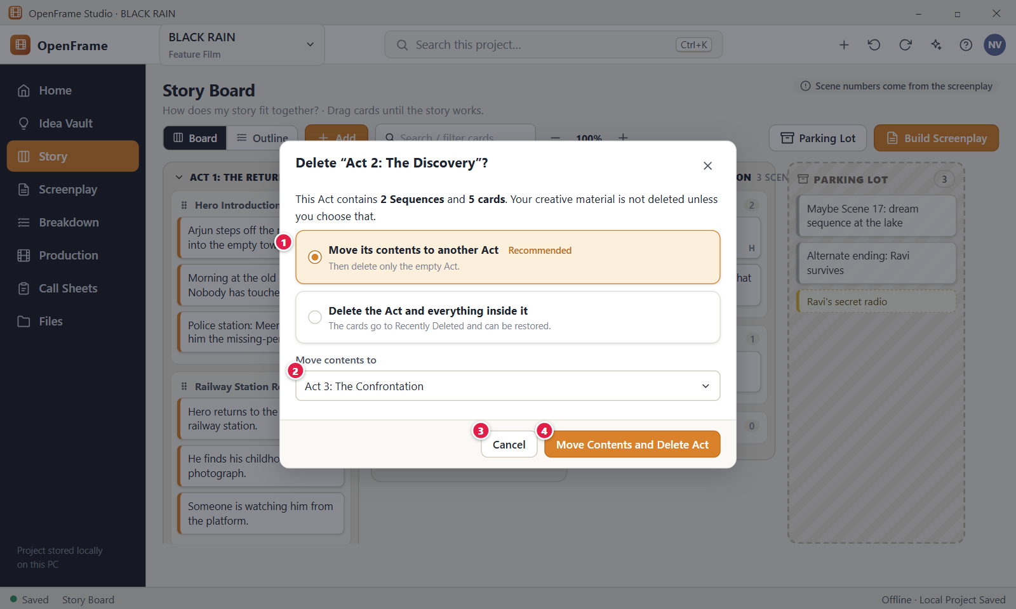
Figure 61. Deleting a non-empty Act. Red numbers are explained on the next page.

Figure 61: Deleting a non-empty Act: how it works
PARTS OF THIS SCREEN  1 Your choices Two options: "Move its contents to another Act" (marked Recommended) or "Delete the Act and everything inside it". The text above them tells you how many Sequences, cards and beats the Act holds. The first option is selected by default.  2 Move contents to The list of places for the moved contents. It holds every other Act and "Unassigned (keep aside)". The Act you are deleting is not in the list. The list shows only while the first option is selected, and OpenFrame preselects the first other Act.  3 Cancel Closes the dialog and leaves the board as it was. Esc and the X at the top right do the same.  4 Move Contents and Delete Act Moves the contents to the Act you chose, then deletes the empty Act, in one step. If you pick the second option, the button reads "Delete Act and Contents" and turns red. A message reads "Deleted Act" with the Act name and an Undo link. | HOW TO USE IT  1. Open Story and find the Act you want to remove, for example "Act 2: The Discovery".  2. Click the three dots in the Act header and choose Delete.  3. Read the counts in the dialog so you know what the Act holds.  4. Keep "Move its contents to another Act" and pick the destination, for example "Act 3: The Confrontation".  5. Click "Move Contents and Delete Act".  6. Check the destination Act. Its old cards come first, then the moved Sequences with their cards.  GOOD TO KNOW · EDGE CASES  • OpenFrame never deletes the cards of an Act silently. A non-empty Act always asks first.  • Moved items go to the end of the chosen Act and keep their old order.  • Deleting a non-empty Sequence asks a similar question, with "Move Cards and Delete Sequence" or "Delete Sequence and Cards".  • Everything you delete goes to Recently Deleted, and Ctrl+Z undoes the deletion. Redo is Ctrl+Y or Ctrl+Shift+Z.  • An Act has no right-click menu and no Del key shortcut. Use the three dots menu.  • Deleting an Act or its cards never changes your screenplay. Screenplay scenes are separate.
See also: Figure 49 Story Board: Board view Figure 62 Deleting a card that has a linked screenplay scene Figure 58 The Parking Lot Figure 157 Recently Deleted (whole project)

Figure 62: Deleting a card that has a linked screenplay scene
What it is for. This dialog asks "Delete this Scene Card?" when the card was used to create a screenplay scene. It tells you the screenplay scene stays. It answers the question: if I delete a card from the Story Board, do I lose a scene of my script?
How to get here. Left navigation > Story. Right-click the card and choose Delete, or click the card and press Delete, or open the card and click Delete in its window footer. A card that was used to build a screenplay shows a small page icon.
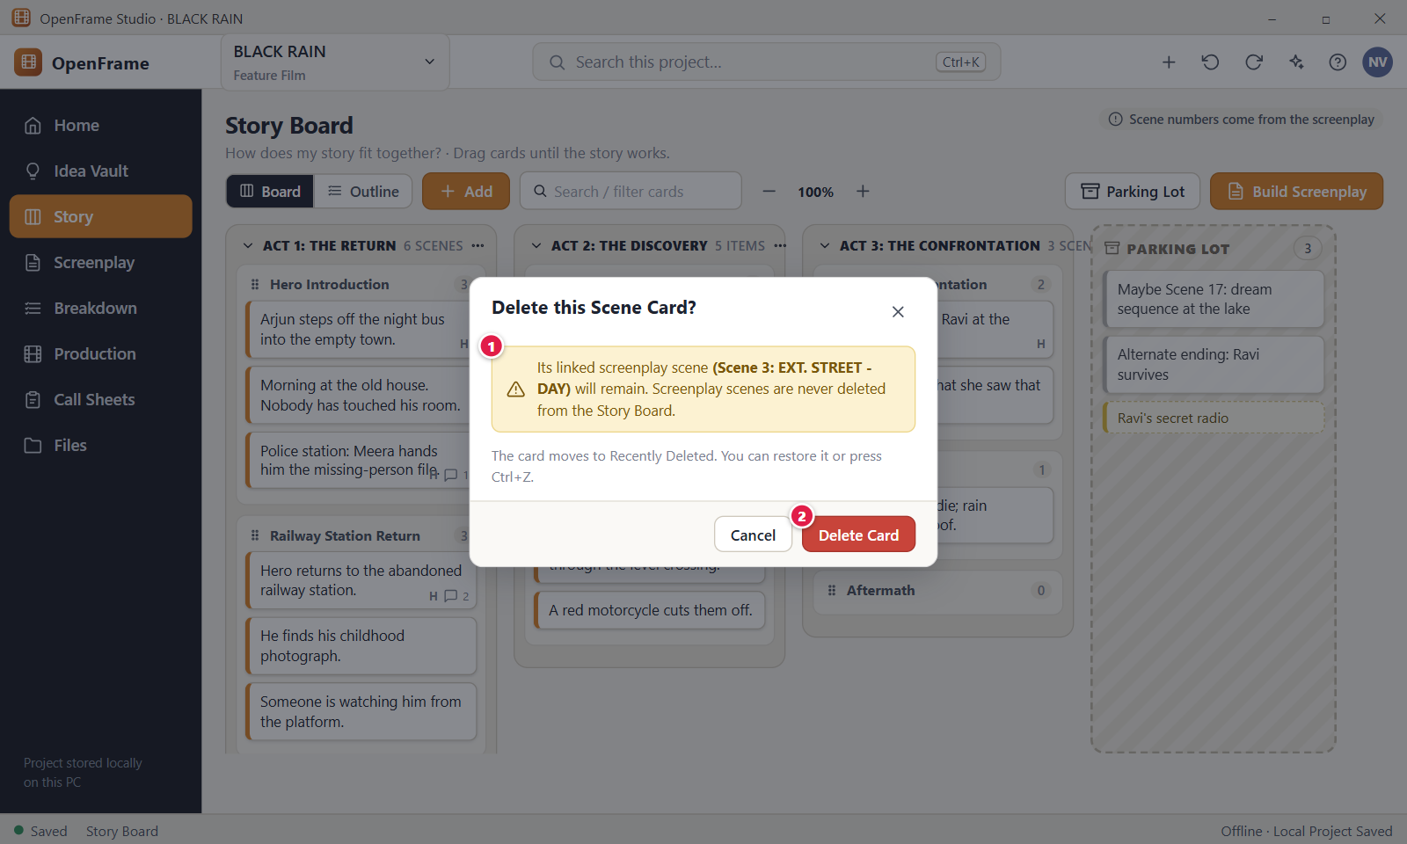
Figure 62. Deleting a card that has a linked screenplay scene. Red numbers are explained on the next page.

Figure 62: Deleting a card that has a linked screenplay scene: how it works
PARTS OF THIS SCREEN  1 Warning Says that the linked screenplay scene, for example "Scene 3: EXT. STREET - DAY", will remain, and that screenplay scenes are never deleted from the Story Board. A grey line below says the card moves to Recently Deleted. The scene number is worked out from the screenplay order at that moment.  2 Delete Card The red button. It moves the card to Recently Deleted and leaves the screenplay, its drafts and its scene numbers untouched. A message reads "Deleted Scene Card" with the card text and an Undo link. | HOW TO USE IT  1. Open Story and find the card, for example "Arjun steps off the night bus into the empty town.".  2. Right-click the card and choose Delete, or select it and press Delete.  3. Read the warning. It names the screenplay scene that stays.  4. Click "Delete Card" to continue, or "Cancel" to keep the card.  5. Use the Undo link in the message, or press Ctrl+Z, if you change your mind.  GOOD TO KNOW · EDGE CASES  • Deleting a Scene Card never deletes a screenplay scene. After a build, the card and the scene are separate.  • The dialog appears only for cards linked to a screenplay scene. Other cards go to Recently Deleted at once, with an Undo message and no question.  • A deleted card can be restored from Recently Deleted or with Undo. It keeps its link to the screenplay scene.  • If the linked scene cannot be reached, because its draft or screenplay is in Recently Deleted, the warning leaves out the brackets and the scene name.  • Press Esc, click Cancel or click the X to close the dialog and keep the card.
See also: Figure 63 Build Screenplay: preview Figure 61 Deleting a non-empty Act Figure 76 The screenplay editor (Standard mode) Figure 157 Recently Deleted (whole project)

Figure 63: Build Screenplay: preview
What it is for. Build Screenplay turns the Scene Cards of your Story Board into screenplay scenes, in board order. This preview window shows the order, flags cards without a valid scene heading, and lets you choose how card text is used and where the script goes. Nothing is created until you click Build Screenplay.
How to get here. Left navigation > Story, then click Build Screenplay in the toolbar. To build from one card only, right-click the card and choose Convert to Screenplay Scene.
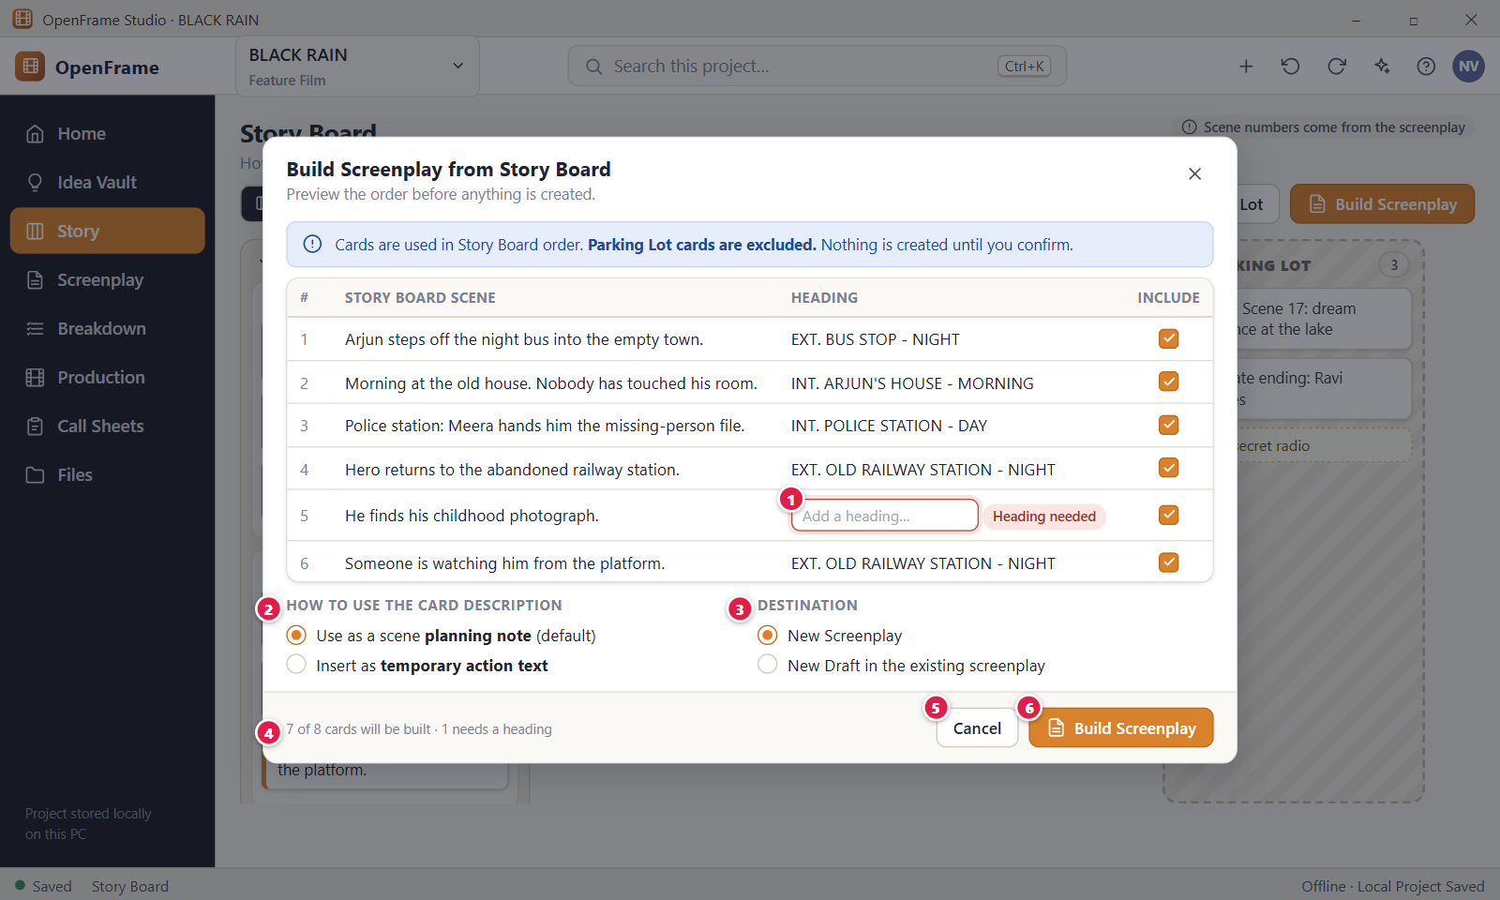
Figure 63. Build Screenplay: preview. Red numbers are explained on the next page.

Figure 63: Build Screenplay: preview: how it works
PARTS OF THIS SCREEN  1 Heading needed A row whose card has no valid scene heading has an empty red box with the hint "Add a heading…" and a yellow label "Heading needed". Type a heading such as INT. POLICE STATION - NIGHT, or click "Leave out" next to the label to untick the row. OpenFrame never invents a heading. A heading starts with INT., EXT., EST., INT./EXT., EXT./INT. or I/E, is up to 200 characters, and is also saved on the card.  2 Description treatment Under "How to use the card description" you choose what happens to each card's short text. "Use as a scene planning note" is the default: the text becomes a note outside the printed script. "Insert as temporary action text" puts the text in the scene as an action line, with a note asking you to rewrite it as screenplay prose.  3 Destination "New Screenplay" creates a screenplay with its first draft, and a box lets you set its title (default: the project title). "New Draft in the existing screenplay" adds a draft and never changes an existing one. The second choice is greyed out until a screenplay exists.  4 Summary Reads, for example, "7 of 8 cards will be built · 1 needs a heading". It counts the ticked cards against all active Scene Cards, and the ticked cards that still lack a valid heading. Parking Lot cards are not counted.  5 Cancel Closes the window and creates nothing. Esc and the X do the same. Headings you typed in the window are not saved.  6 Build Screenplay Creates the scenes in Story Board order with capital headings, links each card to its new scene (the card then shows a small page icon) and opens the screenplay at the first new scene. A message reads "Built" with the draft name, the scene count and an Undo link. The button stays grey while a ticked card has no heading or the title is empty. | HOW TO USE IT  1. Open Story and click Build Screenplay.  2. Check the rows are in the order you want. Cards are used in Story Board order.  3. Fix each row marked "Heading needed": type a heading, for example EXT. OLD RAILWAY STATION - NIGHT, or click "Leave out".  4. Choose how to treat the card descriptions.  5. Choose the destination. For a new screenplay, check the title.  6. Read the summary, then click Build Screenplay. You land at the first new scene.  GOOD TO KNOW · EDGE CASES  • The scene heading is optional on the Story Board. This window is the only place that insists on it.  • After the build, cards and screenplay scenes are separate. Editing a card later does not change the script.  • Only ticked cards are built. Unticked cards and Parking Lot cards stay on the board.  • A new draft in an existing screenplay is named "Draft N from Story Board" and does not become the current draft. Your existing drafts are never overwritten.  • A title that another screenplay already uses is refused. A build is limited to 5000 cards.  • Cancel, the X and Esc create nothing.
See also: Figure 64 Building when a screenplay already exists Figure 65 Warning before a board reorder changes a written script Figure 58 The Parking Lot Figure 62 Deleting a card that has a linked screenplay scene Figure 76 The screenplay editor (Standard mode)

Figure 64: Building when a screenplay already exists
What it is for. When your project already has a screenplay, building from the Story Board never overwrites it. The Build Screenplay window explains this and lets you choose between adding a new draft and creating a separate screenplay. It answers the question: can a second build destroy the screenplay I have already written?
How to get here. Left navigation > Story, then click Build Screenplay in the toolbar, in a project that already holds a screenplay. The choices sit under Destination in the same Build Screenplay window as Figure 63. There is no separate second window.
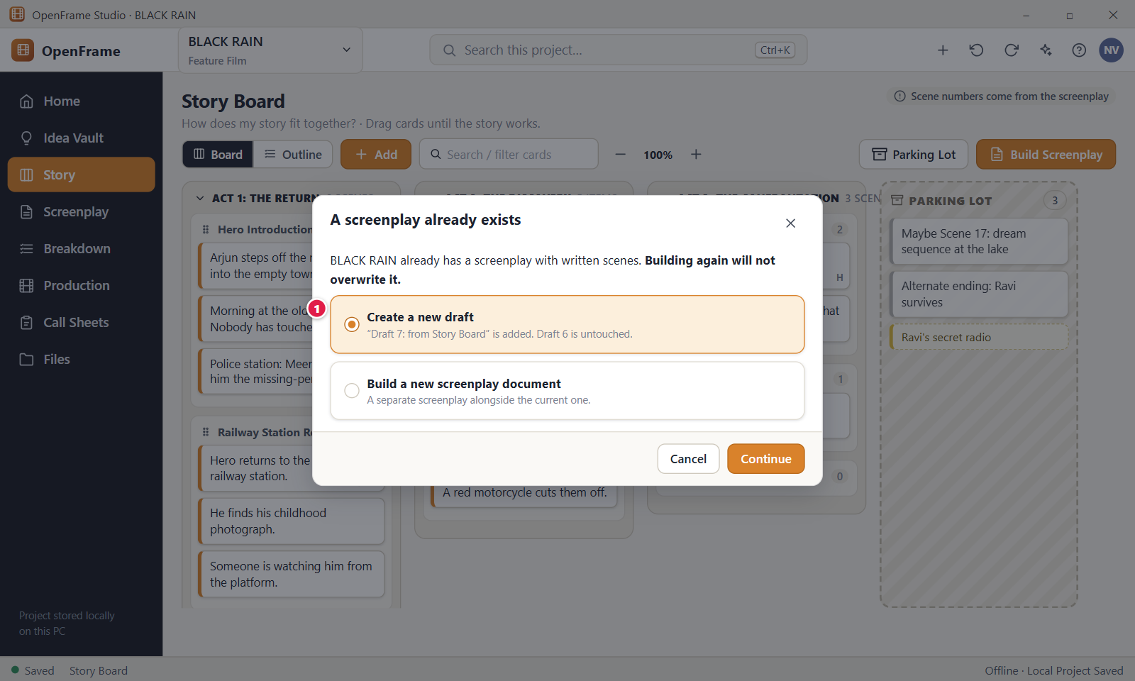
Figure 64. Building when a screenplay already exists. Red numbers are explained on the next page.

Figure 64: Building when a screenplay already exists: how it works
PARTS OF THIS SCREEN  1 Create a new draft Two choices under Destination: "New Draft in the existing screenplay" and "Build a new screenplay document". A line above them says building again will not overwrite the script. A new draft is named "Draft N from Story Board", is added beside your current drafts and does not become the current draft. A new screenplay document sits next to the first one, has its own first draft, and needs a title that no other screenplay uses. In the app the button that starts the build is "Build Screenplay", and "Cancel" closes the window with nothing created. | HOW TO USE IT  1. Open Story and click Build Screenplay.  2. Read the line that says the existing screenplay will not be overwritten.  3. Choose "New Draft in the existing screenplay" to add a draft, or "Build a new screenplay document" for a separate script.  4. For a new document, type a title that differs from your other screenplays, for example BLACK RAIN Alt. With two or more screenplays, pick the target from the Screenplay list when you add a draft.  5. Click Build Screenplay. The Screenplay workspace opens at the first new scene.  6. Switch to the new draft in the Screenplay workspace when you want to work in it.  GOOD TO KNOW · EDGE CASES  • Building again never overwrites. It either adds a draft to a screenplay or creates a separate screenplay.  • This is the same protection that screenplay import gives: your existing writing stays as it is.  • A locked draft, such as "Draft 6: Shooting Draft", is not changed. A new draft can still be added beside it.  • OpenFrame names the draft for you: N is the number of drafts plus 1. A new screenplay starts with "Draft 1 from Story Board".  • A new screenplay title that another screenplay already uses is refused, whatever the capital letters.  • Cancel, the X and Esc create nothing.
See also: Figure 63 Build Screenplay: preview Figure 65 Warning before a board reorder changes a written script Figure 76 The screenplay editor (Standard mode)

Figure 65: Warning before a board reorder changes a written script
What it is for. This window, "Apply this order to the written screenplay?", shows which screenplay scenes would change number if the Story Board order were copied into the script. The screenplay is your written script, so reordering scenes that are already written is always a deliberate choice. It answers the question: what exactly will change in my script if I apply the board order?
How to get here. Left navigation > Story. Click the three dots button at the right end of the toolbar ("More Story Board actions"), then choose "Apply Board Order to Screenplay…". Reordering cards on the board does not open this window by itself.
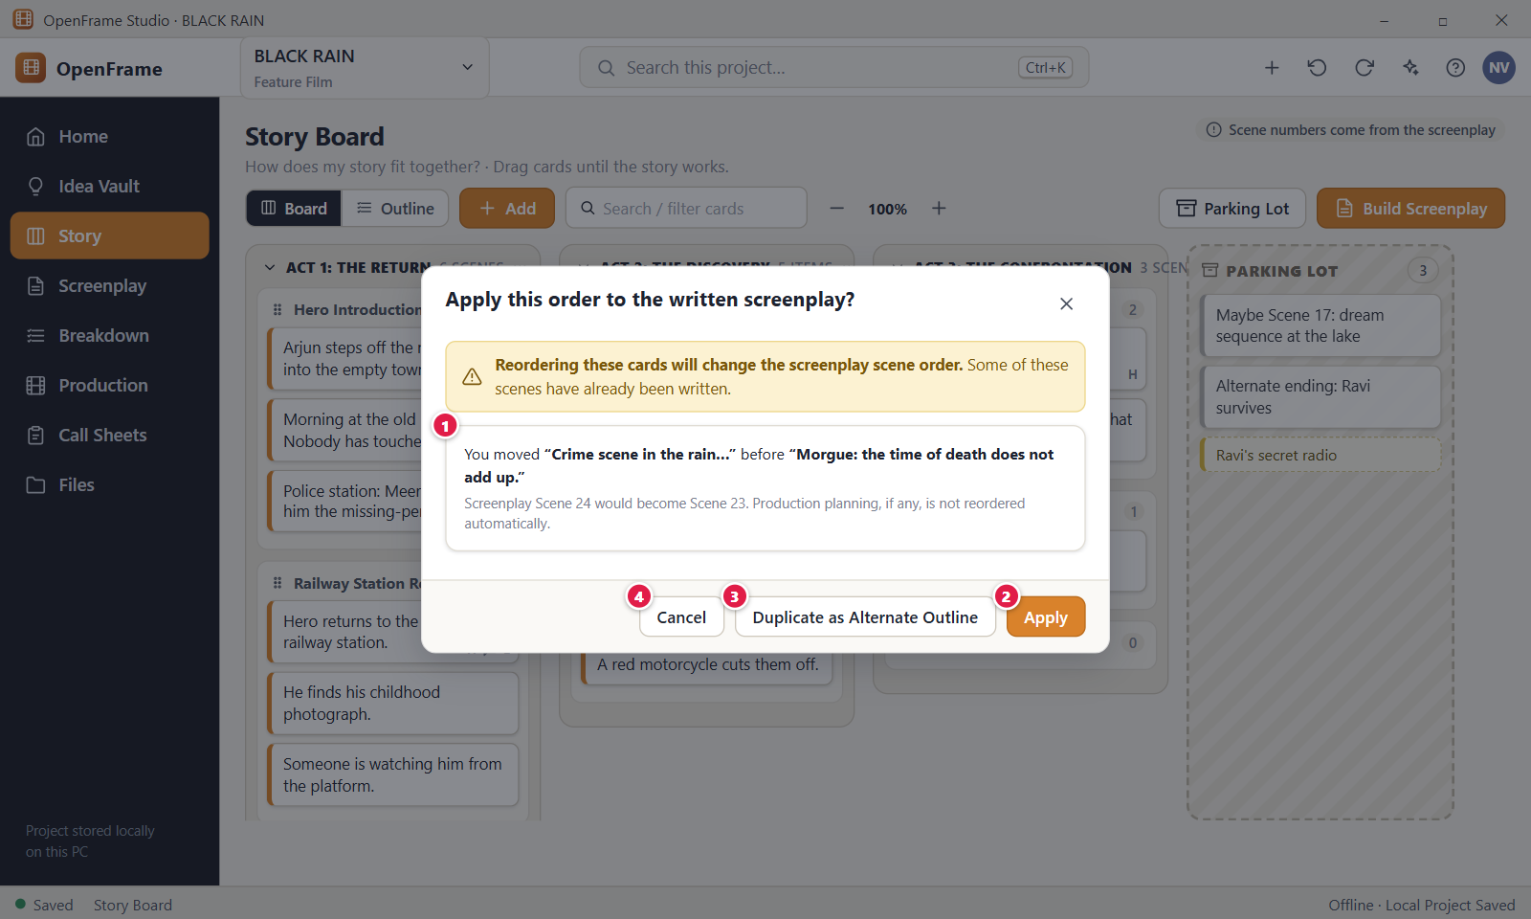
Figure 65. Warning before a board reorder changes a written script. Red numbers are explained on the next page.

Figure 65: Warning before a board reorder changes a written script: how it works
PARTS OF THIS SCREEN  1 What would change A list with one line for each screenplay scene that would get a new number, for example "Screenplay Scene 3 would become Scene 2: INT. MORGUE - MORNING". A grey line says production planning is not reordered automatically. Only scenes built from a card take part. The app lists the changed scenes and does not name the cards you moved.  2 Apply Renumbers the linked screenplay scenes to match the board. Scene text does not change. A message reads "Applied the Story Board order to" with the draft name and an Undo link. A locked draft refuses the change.  3 Duplicate as Alternate Outline This button is not in the current version. The window has only "Cancel" and "Apply". To try another order, duplicate a card or park it in the Parking Lot instead.  4 Cancel Closes the window and leaves the screenplay as it was. The board keeps its new card order. Esc and the X do the same. | HOW TO USE IT  1. Reorder cards on the Story Board, for example move "Crime scene in the rain" before the Morgue card.  2. Click the three dots button at the right end of the toolbar and choose "Apply Board Order to Screenplay…".  3. If you have two or more screenplays, pick one from the "Screenplay to reorder" list.  4. Read the list of scenes that would change number.  5. Click Apply to renumber the scenes, or Cancel to keep the script as it is.  6. Press Ctrl+Z if you want the old scene order back.  GOOD TO KNOW · EDGE CASES  • Ordinary board edits never touch the screenplay. The board can create scenes with Build Screenplay and can reorder them only when you ask.  • Scenes you wrote by hand, with no card, keep their place.  • A locked draft cannot be reordered. The window says to start a revision in the Screenplay workspace first.  • If the draft already follows the board, the window says so. With no screenplay yet, it points you to Build Screenplay.  • Production planning, such as the schedule and call sheets, is not reordered for you.  • Parked cards are not in the story order, so moving them never matters here.
See also: Figure 63 Build Screenplay: preview Figure 64 Building when a screenplay already exists Figure 59 Duplicating a card to try an alternative Figure 76 The screenplay editor (Standard mode)

Figure 66: Zooming out to see the whole film
What it is for. Zoom lets you see many Story Board cards at once. At low zoom each card shows only one line of its text. It answers the question: how can I see the whole film at a glance and then zoom back in to work on details?
How to get here. Left navigation > Story, Board tab. Use the minus and plus buttons on both sides of the zoom value ("100%") in the toolbar, to the right of the search box. The zoom buttons are not shown in the Outline tab.
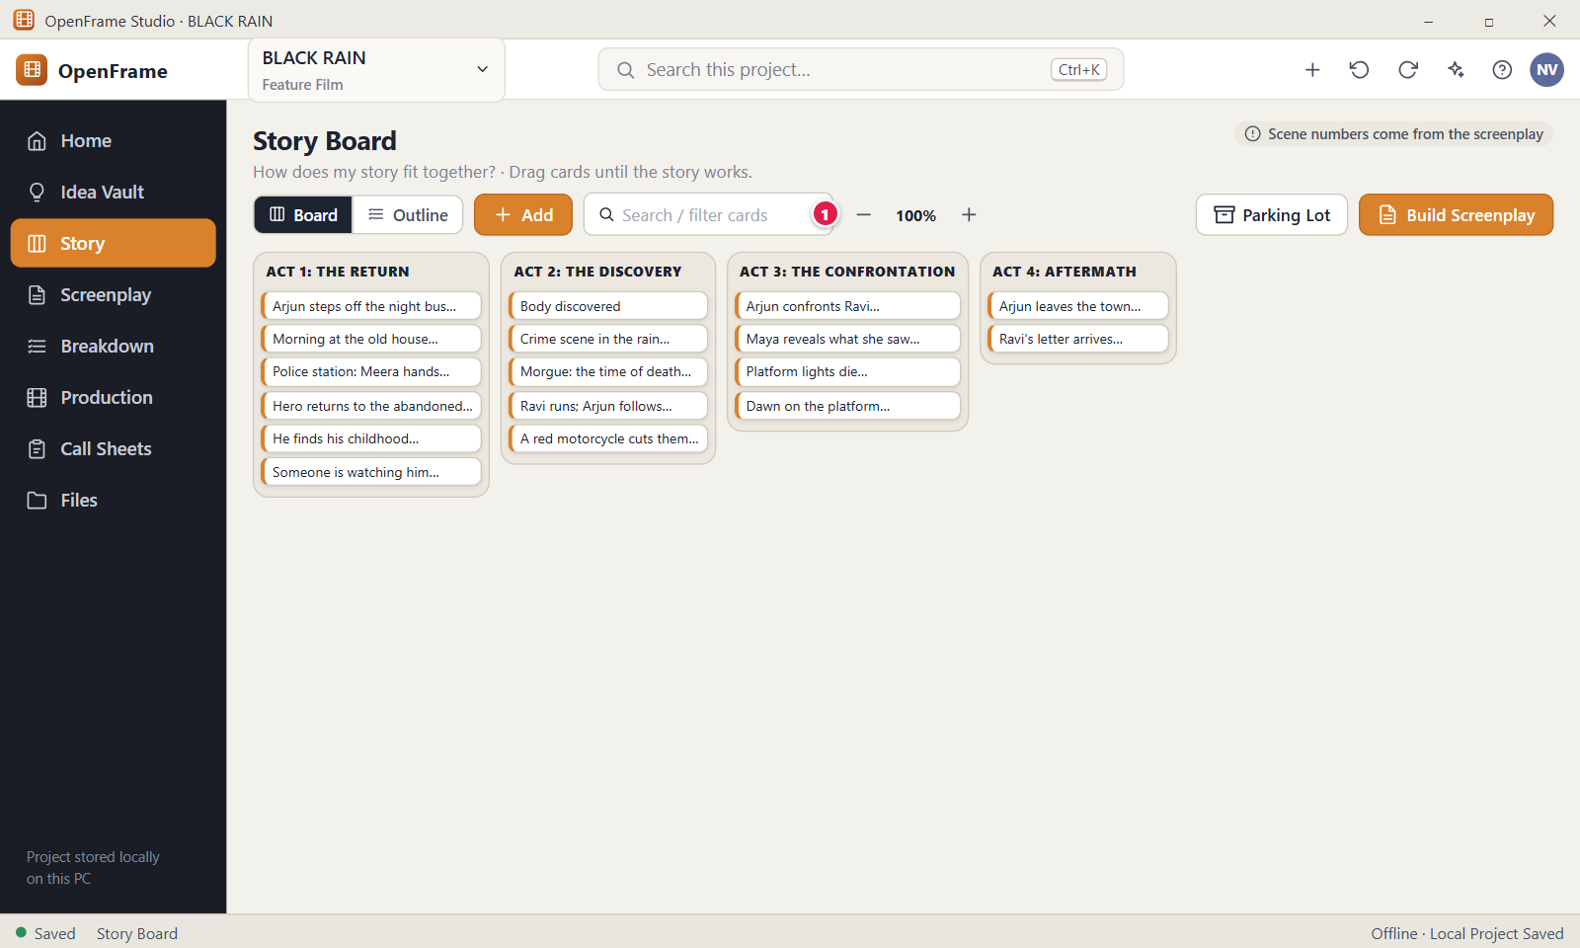
Figure 66. Zooming out to see the whole film. Red numbers are explained on the next page.

Figure 66: Zooming out to see the whole film: how it works
PARTS OF THIS SCREEN  1 Zoom controls The minus button ("Zoom out"), the value and the plus button ("Zoom in"). There are six steps: 50%, 70%, 85%, 100%, 125% and 150%. Zoom out stops at 50% and Zoom in stops at 150%. Zoom changes size only. It never changes card text, order, selection or your screenplay. | HOW TO USE IT  1. Open Story and stay on the Board tab.  2. Click the minus button until you can see all your Acts, for example 50% for the four Acts of BLACK RAIN.  3. Scan the story. At 70% or less each card shows one line of its text.  4. Click the plus button to zoom back in and read full card text.  5. If the Acts are wider than the window at a high zoom, scroll sideways to reach the last Act.  GOOD TO KNOW · EDGE CASES  • Zoom is a viewing aid. It never changes stored text, order or the screenplay.  • Act and Sequence headers and counts stay visible at low zoom. Only the card text is cut to one line, and long descriptions and notes on rich cards are hidden.  • The zoom value and the Parking Lot visibility are remembered on this computer, not in the project file. There is no setting to turn this off.  • Zoom exists only in the Board tab. The Outline has no zoom, and the Board keeps its value when you come back.  • Hiding the Parking Lot with its toggle gives the Acts more room at low zoom.  • The Add menu works at every zoom level. A new card is drawn at the same size as the other cards.  • The app has no keyboard shortcut or mouse wheel gesture for zoom. Use the two buttons.
See also: Figure 49 Story Board: Board view Figure 52 Story Board: Outline view Figure 58 The Parking Lot

Figure 67: Characters directory
What it is for. The Characters tab is a simple story directory. The left panel lists every character with a role and a scene count. The right panel shows the selected character and the screenplay scenes where that character speaks. It answers the question: where does each character show up in my script?
How to get here. Left navigation > Story, then the Characters tab (the tabs are Board, Outline, Characters, Timeline). Quick route: the plus button in the top bar > New character.
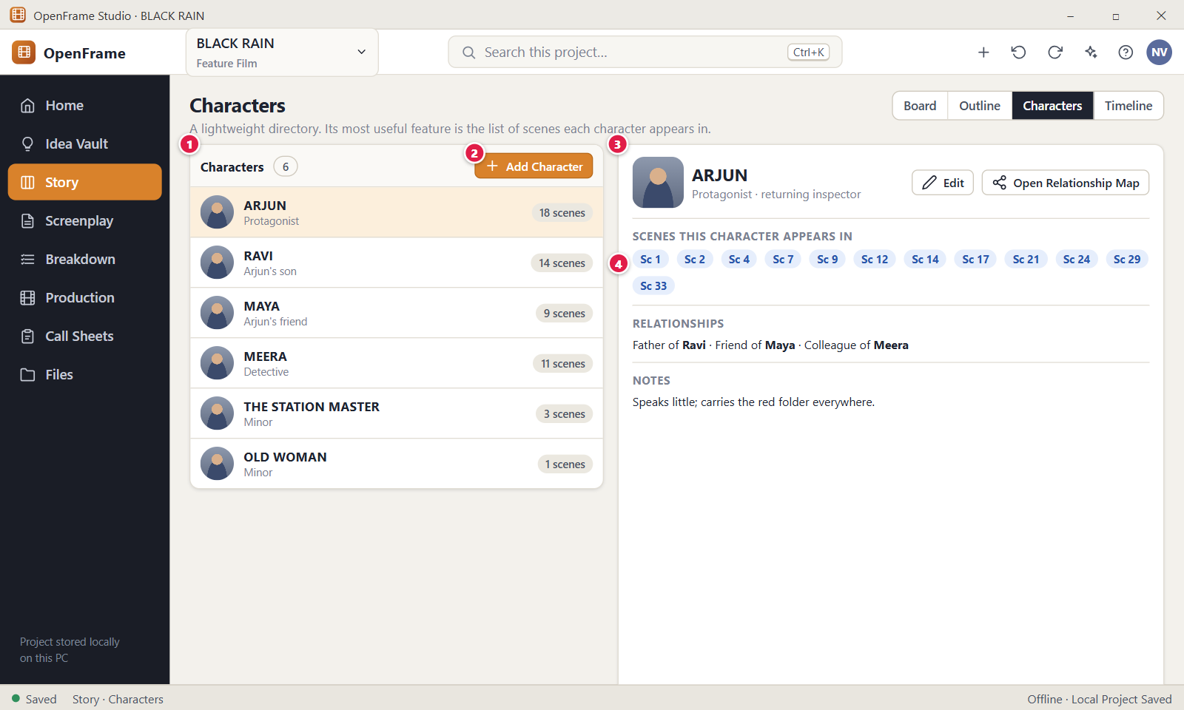
Figure 67. Characters directory. Red numbers are explained on the next page.

Figure 67: Characters directory: how it works
PARTS OF THIS SCREEN  1 Characters The character list. Each row shows a picture or initials, the name, the role and a label such as "11 scenes". Click a row to show that character on the right. The check box "Show archived characters" under the list adds archived rows, which carry the label "Archived".  2 Add Character Opens the "New Character" window. Only a name is required (up to 120 characters). Role / title, Image and Short description are optional. If the name matches an existing character, a yellow line warns you and offers "Use Existing" or "Create Another Character Anyway".  3 ARJUN The record of the selected character: picture, name, role and description, then the scenes, the relationships, the linked Scene Cards and the notes. "Edit" changes name, role and description. "Open Relationship Map" opens the map. A menu holds Add image or Change image, Remove image, Archive or Unarchive, and Delete. Notes save when you leave the field.  4 Scenes this character appears in One blue chip "Sc N" for each screenplay scene where the character has a dialogue cue. Click a chip to open that scene in the screenplay, and hover it to see the scene heading. OpenFrame fills the chips in from the screenplay. You cannot add, remove or edit a chip by hand. | HOW TO USE IT  1. Open Story and click the Characters tab.  2. Click a character in the list, for example RAVI, to see the record.  3. Read the "Scenes this character appears in" chips to see where the character speaks.  4. Click a chip such as "Sc 12" to jump to that scene in the screenplay.  5. To add someone new, click Add Character, type a name such as MEERA, then click Create.  6. Use Edit to add a role such as "Detective" and a short description.  GOOD TO KNOW · EDGE CASES  • OpenFrame matches a character to scenes by the name in the dialogue cue. A cue like "ARJUN (V.O.)" or "ARJUN (CONT'D)" counts as ARJUN. A scene counts once, however many cues it has.  • The scenes come from the current draft of the most recently edited screenplay. A character with no cue shows "0 scenes" and a note that no scenes mention the name yet.  • Renaming the record does not rewrite the screenplay and can drop the scene count to 0. Use Find & Replace in the screenplay to rename dialogue.  • Deleting a character that is used in the screenplay or production offers Archive instead of a destructive removal.  • A false detection cannot be corrected on this screen. Change the cue in the screenplay instead.  • Ctrl+Z undoes add, edit, archive and delete.
See also: Figure 68 Adding a character (duplicate-name check) Figure 69 Character relationship view Figure 76 The screenplay editor (Standard mode) Figure 49 Story Board: Board view

Figure 68: Adding a character (duplicate-name check)
What it is for. The New Character window adds one entry to the Characters directory. When the name you type matches a character that already exists, the window shows that character and asks what to do. It answers the question: is this person already in my project?
How to get here. Left navigation > Story > Characters tab, then click Add Character above the list. The plus menu in the top bar > New Character opens the same window from any screen.
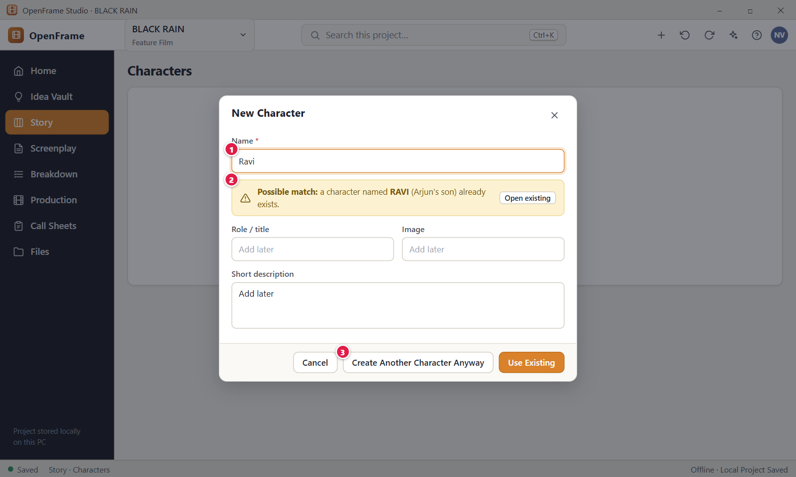
Figure 68. Adding a character (duplicate-name check). Red numbers are explained on the next page.

Figure 68: Adding a character (duplicate-name check): how it works
PARTS OF THIS SCREEN  1 Name (required) The only required box. The cursor is in it when the window opens. OpenFrame trims spaces at both ends and accepts up to 120 characters. Role / title, Image and Short description are optional and can be added later. The Image button opens a file chooser that accepts PNG, JPG, GIF, WEBP and BMP files.  2 Possible match A yellow warning under the Name box, for example "Possible match: a character named RAVI (Arjun's son) already exists.". The brackets show the Short description of the existing character. It only warns and never blocks you. A match means the same name, ignoring capital letters. A part of a name, such as "Rav", does not match.  3 Create Another Character Anyway Saves a second character with the same name as a separate record. Use it only when two people really share a name. The other footer buttons are "Cancel" and "Use Existing". "Use Existing" creates nothing, selects the matching character in the list and ignores anything you typed in the other boxes. | HOW TO USE IT  1. Open Story > Characters and click Add Character.  2. Type the name, for example Ravi.  3. If a yellow warning appears, read which character it names.  4. Click Use Existing to open that character, or Create Another Character Anyway if you need a second one.  5. If there is no warning, add a role such as "Teen son" if you like and click Create Character.  6. Look for the message "Added character" with an Undo button.  GOOD TO KNOW · EDGE CASES  • Nothing is saved until you click a create button. Cancel, the X and Esc throw away what you typed.  • The warning checks for the same name only. It does not look for similar spellings.  • Archived characters count as a match only while "Show archived characters" is ticked in the list.  • The app has no "Open existing" button in the warning. Use "Use Existing" in the footer instead.  • Any characters are allowed in a name, including Indian-language text, because a character is not a file name.  • Adding a character does not change your screenplay. Scenes appear on the character page when the script has dialogue cues with the same name.
See also: Figure 67 Characters directory Figure 69 Character relationship view Figure 49 Story Board: Board view

Figure 69: Character relationship view
What it is for. The Character relationships screen draws a simple map of which characters are related and how, using short labels you type, such as "father of". It is an optional visual helper, not a character-analysis system. It answers the question: who is connected to whom?
How to get here. Left navigation > Story > Characters tab. Click a character in the list, then click Open Relationship Map in the detail panel. Click Back to Characters to return.
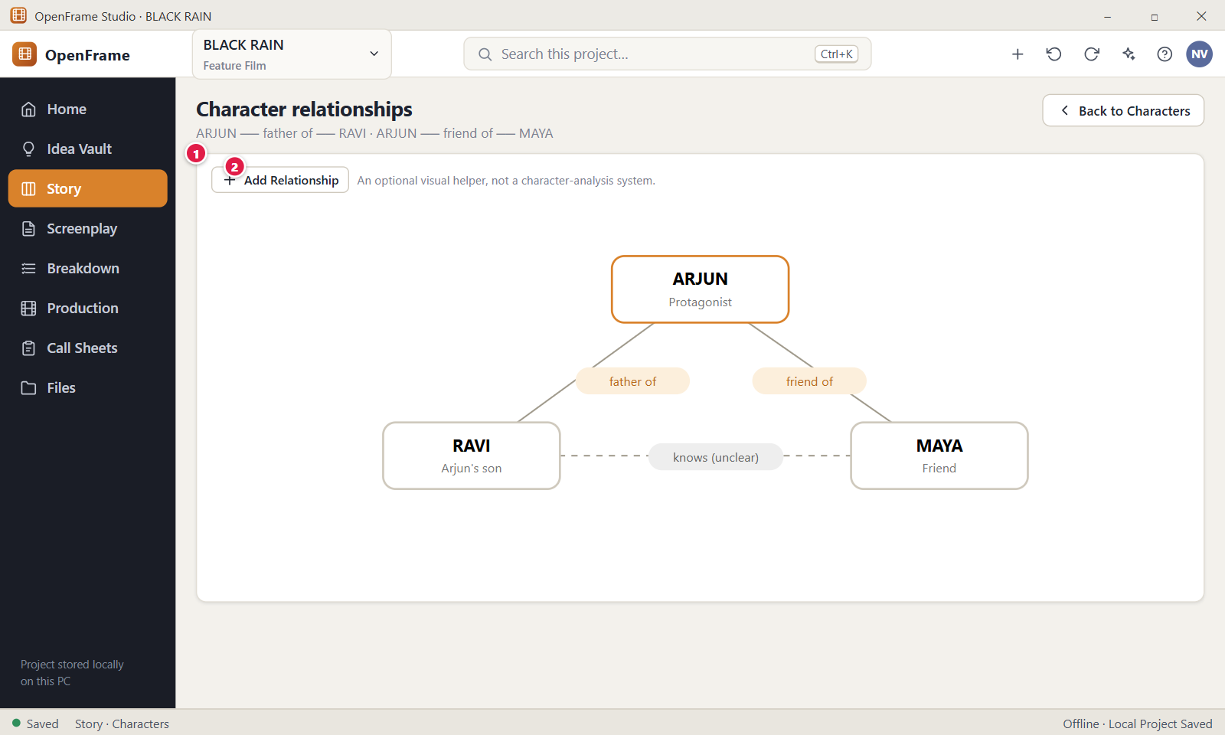
Figure 69. Character relationship view. Red numbers are explained on the next page.

Figure 69: Character relationship view: how it works
PARTS OF THIS SCREEN  1 Relationship map The panel that draws each character who has at least one relationship as a round node, with a line and a label between related characters. Nodes show the name in capitals, cut to the first 10 characters. Under the drawing, each relationship is listed, for example ARJUN, father of, RAVI, with a small cross to remove it. Removing a line does not delete either character.  2 Add Relationship Opens a window with a Character list, a box "is" for the label, a second Character list and an optional note. The label is required, up to 80 characters, and a list of suggestions such as "father of" and "friend of" helps you type. The two characters must differ. Click Add Relationship in the window to draw the line. | HOW TO USE IT  1. Open Story > Characters and click a character.  2. Click Open Relationship Map.  3. Click Add Relationship.  4. Choose the first character, type the label such as "mentor of", and choose the second character.  5. Add a note if you like, then click Add Relationship.  6. Click Back to Characters when you are done.  GOOD TO KNOW · EDGE CASES  • Labels are free text. The suggestion list only helps typing, and any text up to 80 characters is accepted.  • OpenFrame adds nothing for you. Adding "father of" does not add "son of", and nothing is scored.  • A character with no relationship has no node on the map, and archived characters are not drawn.  • Removing a relationship removes only the line. A message with an Undo button appears.  • The map does not affect your screenplay or your schedule.  • With no relationships yet, the map says "No relationships yet.".
See also: Figure 67 Characters directory Figure 68 Adding a character (duplicate-name check) Figure 49 Story Board: Board view

Figure 70: Story Timeline (optional)
What it is for. The Story Timeline groups the scenes of your current screenplay draft by story day, for example DAY 1 and DAY 2. It matters only when your film has real time-continuity limits. It answers the question: on which story day does each scene happen?
How to get here. Left navigation > Story, then the Timeline tab (next to Board, Outline and Characters). Until the project has screenplay scenes, the tab shows an empty message.
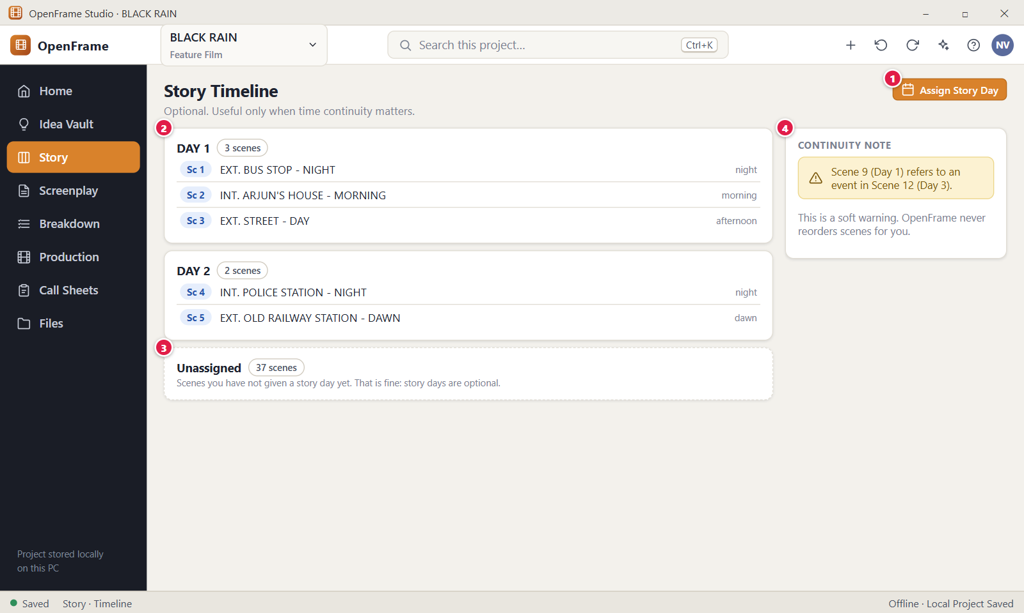
Figure 70. Story Timeline (optional). Red numbers are explained on the next page.

Figure 70: Story Timeline (optional): how it works
PARTS OF THIS SCREEN  1 Assign Story Day Gives the scenes you ticked one story day. Tick scenes, click the button, type a day such as 1 or Flashback (up to 40 characters) and click Assign. The same window has "Clear Story Day" and "Cancel". The button is greyed out until you tick a scene, and it is not shown to a read-only user.  2 A story day One card for each story day, such as "DAY 1", with the scene count. Each row shows a tick box, "Sc N" (the position of the scene in the draft), the scene heading and a small time note box, for example "night". Cards with numbers come first in number order, then other labels, and Unassigned comes last. Scenes keep their screenplay order.  3 Unassigned The last card. It holds every scene with no story day yet, and the text says story days are optional. Unassigned is normal. The card disappears when every scene has a day.  4 Soft continuity warning This warning is not in the current version. OpenFrame does not check whether a later event sits on an earlier day. The Timeline only groups, and a line under the cards says OpenFrame never reorders scenes for you. | HOW TO USE IT  1. Open Story and click the Timeline tab.  2. Tick the scenes that happen on the same day, for example the first three scenes of BLACK RAIN.  3. Click Assign Story Day.  4. Type the day, for example 1, and click Assign.  5. Type a time note such as "night" in the small box on a scene row if you want one.  6. Use Clear Story Day in the same window to take scenes out of a day.  GOOD TO KNOW · EDGE CASES  • Story Day is never needed on a Story Board card. Days belong to screenplay scenes that already exist.  • A number such as 1 shows as DAY 1. Any other text shows as you typed it.  • The time note is optional, up to 80 characters, and saves when you leave the box.  • Press Enter in the Story Day box to assign. Esc closes the window without assigning.  • The Timeline never reorders scenes and does not change the screenplay text.  • It shows the current draft of the chosen screenplay. In a series project, an Episode list picks which screenplay it shows.
See also: Figure 49 Story Board: Board view Figure 76 The screenplay editor (Standard mode) Figure 63 Build Screenplay: preview

Figure 71: Sequence Hub
What it is for. The Sequence Hub is a side panel that shows one Sequence of the Story Board with its scenes, its note and its attached files. A Sequence is a named group of scene cards inside an Act. It answers the question: what belongs to this sequence, and what do I know about it?
How to get here. Left navigation > Story > Board. Right-click a Sequence, for example "Railway Station Return", and choose Open. You can also click the Sequence title bar and press Enter, or double-click the title bar. The panel slides in from the right.
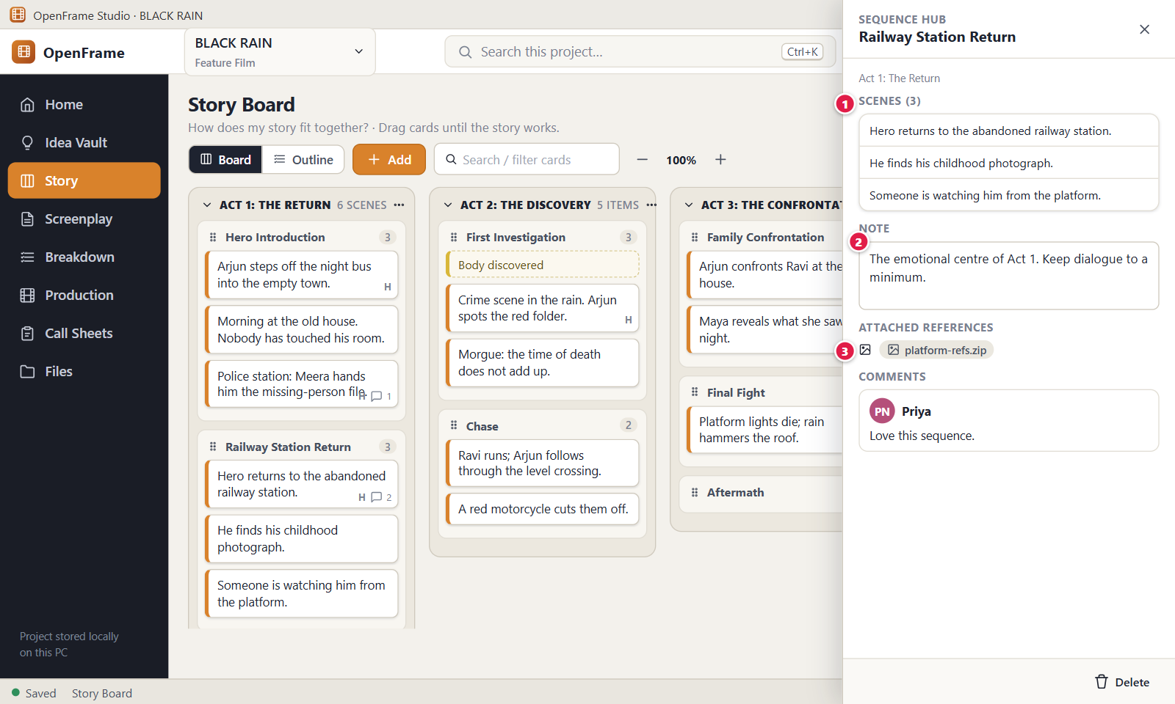
Figure 71. Sequence Hub. Red numbers are explained on the next page.

Figure 71: Sequence Hub: how it works
PARTS OF THIS SCREEN  1 Scenes in the sequence The list headed "Scenes" with a count, such as "Scenes (3)". Each entry shows the card text. Click one to open that card in the panel. Only scene cards are listed, not beats. The list is read only: drag cards on the board to add, move or reorder them.  2 Note A free text box for a small note about the Sequence. It saves by itself a moment after you stop typing, and the footer shows "Saving…" and then "Saved". The note stays in the project and is printed only if you tick "Include notes" in the Story Board export.  3 Attached references In the app this area is called Attachments. Click "Attach" to add a file, one at a time, up to 50 per Sequence. Each file is a chip with a small cross to remove it. Click a chip to open the file with the Windows default program. Files that Windows could run are shown in File Explorer and not started. | HOW TO USE IT  1. Open Story > Board and right-click a Sequence such as "Railway Station Return".  2. Choose Open. The Sequence Hub slides in.  3. Check the scenes in the list. Click one to see its card.  4. Type a note in the Note box, for example "The emotional centre of Act 1. Keep dialogue to a minimum.".  5. Click Attach and choose a reference file such as platform-refs.zip.  6. Click the X at the top right to close the panel.  GOOD TO KNOW · EDGE CASES  • A Sequence has one key field: its name. There is no purpose field. You can edit the name in the panel.  • A Sequence is only a Story Board grouping. It does not become part of the screenplay text.  • Attachments are copies kept inside the project. They are reference material only and are not added to ordinary exports.  • This panel has no Comments section for a Sequence in the current version.  • The Delete button in the footer deletes the Sequence. An empty one goes at once. If it holds cards, a window asks whether to move the cards out first (recommended) or delete them too. Linked screenplay scenes are never deleted.  • Everything saves by itself. There is no Save button. Esc closes the panel.
See also: Figure 49 Story Board: Board view Figure 50 Add menu: Act, Sequence, Beat, Scene Figure 58 The Parking Lot Figure 63 Build Screenplay: preview Figure 72 Exporting the Story Board or Outline as PDF

Figure 72: Exporting the Story Board or Outline as PDF
What it is for. The Export Story Board window saves the Story Board, or its outline, as a file you can send to a director or producer. It makes a snapshot and never changes your project. It answers four questions: what you export, which version, in what format and where it is saved.
How to get here. Left navigation > Story > Board or Outline. Click Export in the page header, next to the title "Story Board". To export only some items, select them on the board first. The board context menus have no Export command.
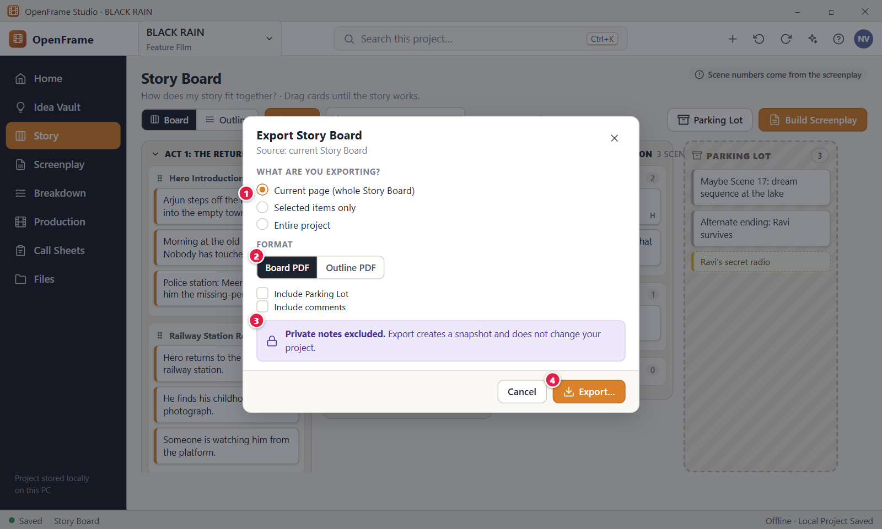
Figure 72. Exporting the Story Board or Outline as PDF. Red numbers are explained on the next page.

Figure 72: Exporting the Story Board or Outline as PDF: how it works
PARTS OF THIS SCREEN  1 Scope The choices under "What are you exporting?". "Current page (whole Story Board)" exports the board you are looking at. "Selected items only" exports the Acts, Sequences, Beats or cards you selected, with their children, and is greyed out until you select something. "Entire project" adds the board of every episode in a series project. The line "Source: current Story Board" tells you the version.  2 Format Choose PDF, Plain text or CSV. With PDF, a Layout list offers "Outline PDF" (a readable list, the default) or "Board PDF" (a landscape page with cards in a grid for each Act). Plain text and CSV carry the outline. Options add the Parking Lot, notes and open comments. The window shows a suggested file name.  3 Privacy line The banner "Private notes excluded. Export creates a snapshot and does not change your project.". Private notes are never in the file, whatever you tick. "Include notes" adds only the ordinary notes of Acts, Sequences, Beats and cards.  4 Export… Opens the Windows Save window, then writes the file. You cannot save inside the project's own folder. When it is done, "Export complete" shows the file name, scope, contents, format, pages and location, with the buttons "Reveal in File Manager" and "Close". | HOW TO USE IT  1. Open Story > Board. Select some items first if you want to export only those.  2. Click Export in the page header.  3. Choose the scope under "What are you exporting?".  4. Choose the format, and for PDF the layout. Tick "Include Parking Lot" or "Include comments" if you need them.  5. Click Export… and choose a folder such as Documents in the Windows Save window.  6. Click "Reveal in File Manager" to find the file, then "Close".  GOOD TO KNOW · EDGE CASES  • Every export is a snapshot. It does not change the Story Board and does not stay connected to it.  • The suggested name looks like "BLACK RAIN - Story Board - 2026-10-18.pdf". You can change it in the Save window.  • The Parking Lot is left out unless you tick "Include Parking Lot".  • Attachments are not put in the file. Cards have no scene numbers, because numbers come from the screenplay.  • An empty Story Board gives the message "The Story Board is empty, so there is nothing to export yet.".  • Your choices are not remembered. The window opens with the defaults each time. Esc, Cancel and the X write nothing.
See also: Figure 49 Story Board: Board view Figure 71 Sequence Hub Figure 58 The Parking Lot Figure 73 Series → Season → Episode (episodic projects)

Figure 73: Series → Season → Episode (episodic projects)
What it is for. The Series screen is the home of an episodic project. It lists the episodes of each season with their status and opens one episode at a time. Each episode has its own Story Board, screenplay and production plan. It answers the question: which episode am I working on?
How to get here. Open the episodic project from Project Home. Left navigation > Story, then the Episodes tab. The tab shows only for an episodic or series project, or a project that already has episodes. The app has no Series link on Project Home.
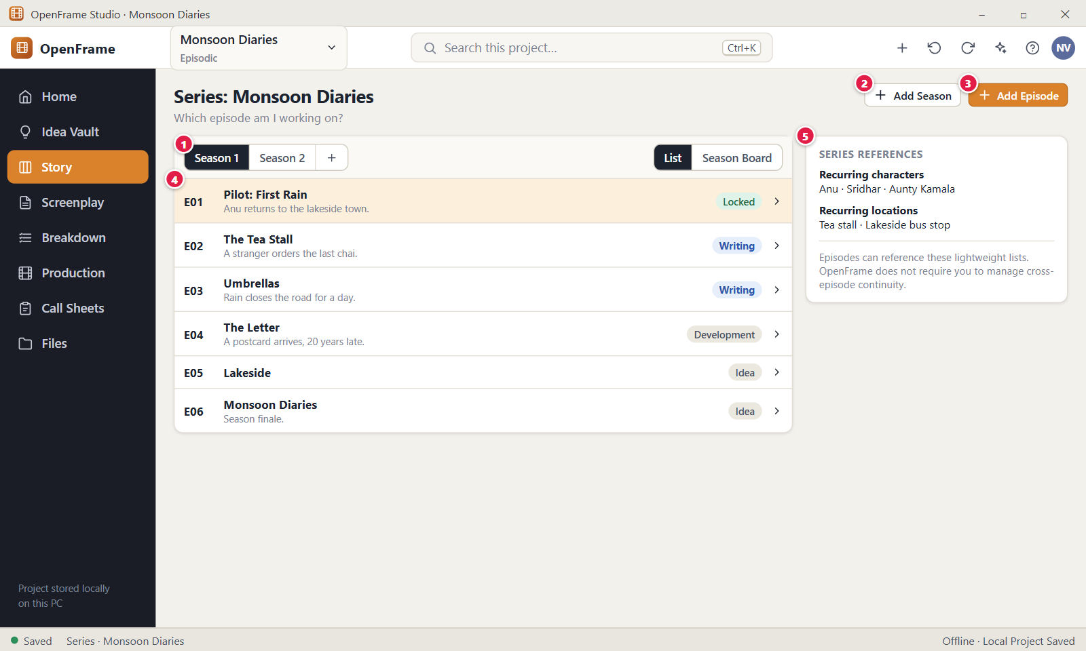
Figure 73. Series → Season → Episode (episodic projects). Red numbers are explained on the next page.

Figure 73: Series → Season → Episode (episodic projects): how it works
PARTS OF THIS SCREEN  1 Season selector One button for each season, for example "Season 1" and "Season 2". Click one to list its episodes. Episodes that belong to no season sit under "No season". The "…" button after the buttons offers "Rename season…", "Move left" and "Delete season". Deleting a season keeps its episodes.  2 Add Season Creates the next season at once, with no window, and switches to it. It is named "Season N" and starts empty. A message "Added a season" has an Undo link.  3 Add Episode Opens the "New Episode" window for the active season. Title is required (up to 200 characters). One-line summary is optional. Status is Idea, Development, Writing, Rewrite, Locked, Shooting or Complete, and starts at Idea. You can also pick the season. The episode number comes from its order, so there is no number box.  4 Episode row One row for each episode: a code such as E01, the title, the one-line summary, the number of cards on its Story Board and a status chip. Click the row to open that episode's Story Board. The "…" menu has "Open Story Board", "Edit…", "Duplicate…" and "Delete".  5 Series-level references A small panel called "Series references". In the app it shows only how many recurring characters the project has, taken from the Characters directory. It shows no names and no locations. A line says OpenFrame does not require you to manage cross-episode continuity. | HOW TO USE IT  1. Open Story and click the Episodes tab.  2. Click Add Season if you need a new one, then pick it in the season selector.  3. Click Add Episode, type a title such as "The Tea Stall", set the status and click Create Episode.  4. Click the episode row to open its Story Board.  5. Use the Episode list in the Story workspace to move between episodes.  GOOD TO KNOW · EDGE CASES  • The episode code (E01) comes from the order in the season. Moving, duplicating or deleting an episode renumbers the others.  • Each episode has its own Story Board. Changing one episode never changes another.  • The status chip is only a label. A status of Locked does not lock the episode or its screenplay.  • Duplicate makes a new episode with its own identity. In the app it can copy the Story Board as new, independent cards. Screenplay links are not copied.  • Deleting an episode moves it and its Story Board to Recently Deleted together. You can restore it or use Undo.  • The List and Season Board switch shows the same episodes either as rows or as cards you can drag into a new order.
See also: Figure 74 Season Board: reordering episodes Figure 49 Story Board: Board view Figure 12 Project Home: an active project Figure 67 Characters directory

Figure 74: Season Board: reordering episodes
What it is for. The Season Board shows the episodes of one season as cards you drag into a new order. It lets you plan the season at a glance, with no arcs, beats or dates. It answers the question: in which order should the episodes of this season run?
How to get here. Open the episodic project. Left navigation > Story > Episodes tab, choose the season, then click Season Board in the view switch at the right of the toolbar. Click Back to list to return.
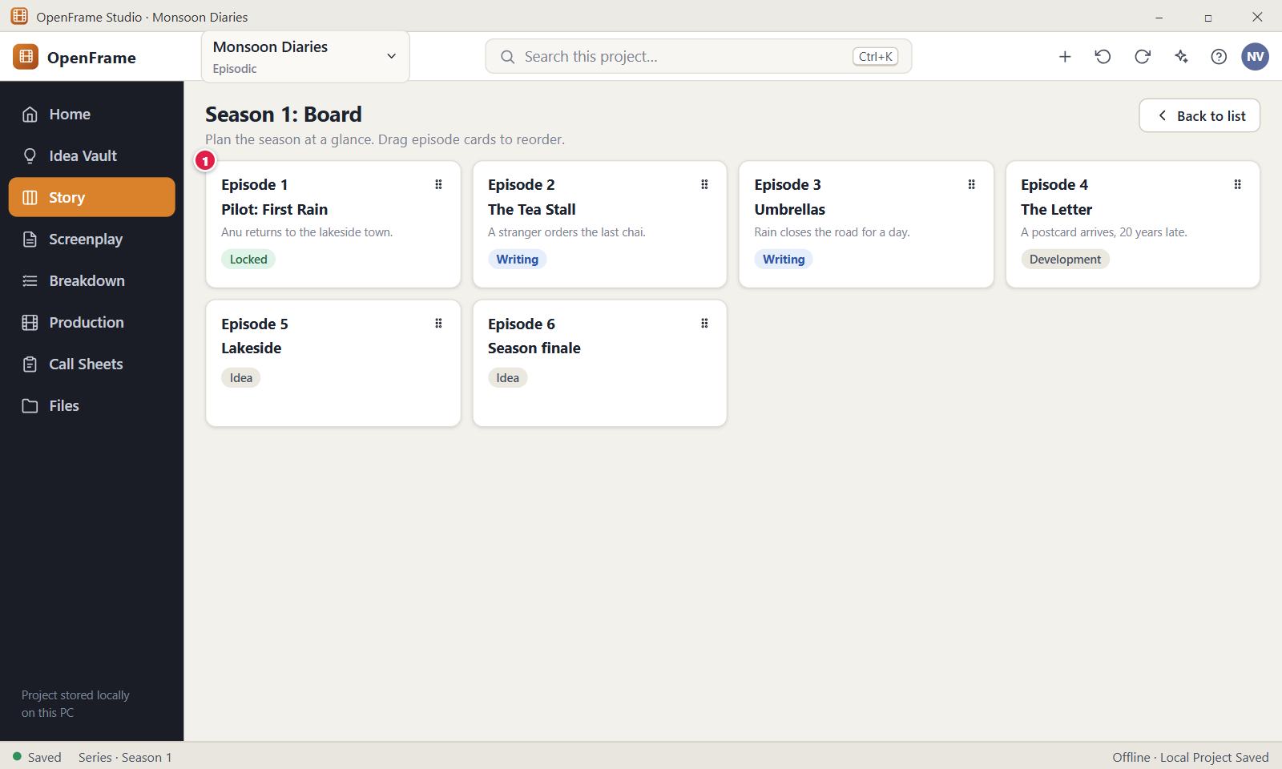
Figure 74. Season Board: reordering episodes. Red numbers are explained on the next page.

Figure 74: Season Board: reordering episodes: how it works
PARTS OF THIS SCREEN  1 Episode card One card for each episode of the season. It shows "Episode N", the title, the one-line summary and the status chip. Drag a card onto another position to change the order. Double-click a card, or press Enter on it, to open that episode's Story Board. The chip is only a label and cannot be changed here. | HOW TO USE IT  1. Open Story > Episodes and pick the season you want to plan.  2. Click Season Board in the view switch.  3. Drag an episode card, for example "The Letter", onto the place where you want it.  4. Check the new "Episode N" labels. The message "Reordered episodes" has an Undo link.  5. Double-click a card to open that episode, or click Back to list.  GOOD TO KNOW · EDGE CASES  • A plain click does not move a card. The drag starts only after the pointer moves a few pixels.  • Reordering renumbers the episodes. The numbers always follow the order, and you cannot type them.  • Only the episodes of the active season are on the board. To move an episode to another season, use Edit on the list.  • The app has no keyboard way to reorder cards. Enter on a focused card opens its Story Board.  • Changing or deleting one episode never affects the others. A status such as Locked does not stop a card from moving.  • Your edit permission is needed to reorder.
See also: Figure 73 Series → Season → Episode (episodic projects) Figure 49 Story Board: Board view Figure 12 Project Home: an active project

Chapter 4: Screenplay: Write, Draft, Review, Lock, Import and Export
The Screenplay workspace is a real screenplay editor. You write, keep named drafts, compare them, run review rounds, lock a Shooting Draft, handle revisions, import an existing script, and export or print.

Screens in this chapter
Figure | Screen | Page
Figure 75 | Screenplay: empty state | 170
Figure 76 | The screenplay editor (Standard mode) | 172
Figure 77 | Choosing screenplay element types | 175
Figure 78 | Find and replace in the screenplay | 177
Figure 79 | Focus mode (full-screen writing) | 179
Figure 80 | Writing Room: script with a reference panel | 181
Figure 81 | Scene notes and private notes | 183
Figure 82 | Adding and resolving comments on script text | 185
Figure 83 | Drafts: named drafts and recovery history | 187
Figure 84 | Creating a new named draft | 189
Figure 85 | Comparing two drafts | 191
Figure 86 | Review rounds | 193
Figure 87 | Starting a review round | 195
Figure 88 | Locking the Shooting Draft | 197
Figure 89 | Editing a locked draft: Start Revision | 199
Figure 90 | Revision label, colour and changed scenes | 201
Figure 91 | Importing a screenplay: choose the source | 203
Figure 92 | Import preview and warnings | 205
Figure 93 | Import failed (safe failure) | 207
Figure 94 | Import report | 209
Figure 95 | Exporting the screenplay | 211
Figure 96 | Document preview and printing | 213
Figure 97 | Scene Hub: what exists around a scene | 215
Figure 98 | Right-click menu on a screenplay scene | 217
Figure 99 | Moving a scene that is already in production planning | 219
Figure 100 | Title page details | 221
Figure 101 | Deleting a draft | 223

Figure 75: Screenplay: empty state
What it is for. This is the Screenplay screen of a project that has no screenplay yet. It offers three ways to begin: type from scratch, build scenes from the Story Board, or import a script you already have. It answers the question: how do I start my screenplay?
How to get here. Left navigation > Screenplay in a project with no screenplay. On Project Home of a new project you can also click the Write/Import Screenplay card. In a series project, choose an episode first.
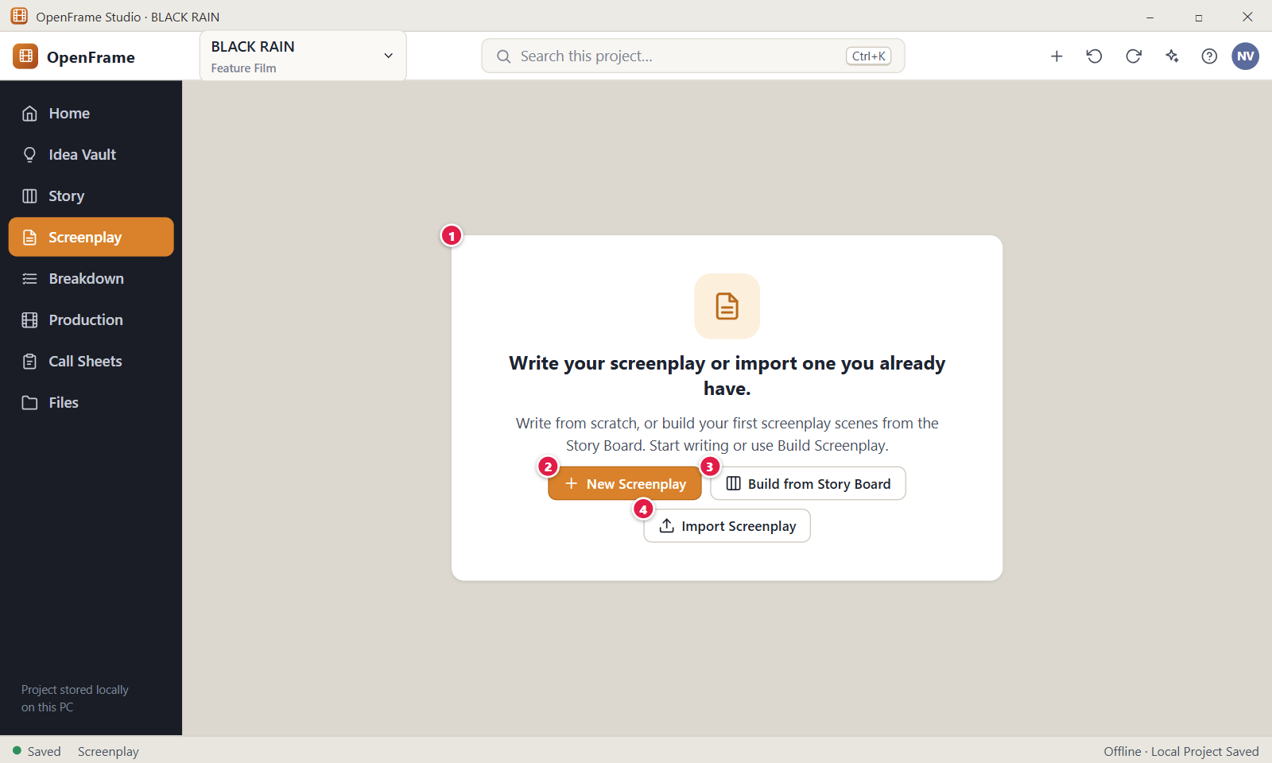
Figure 75. Screenplay: empty state. Red numbers are explained on the next page.

Figure 75: Screenplay: empty state: how it works
PARTS OF THIS SCREEN  1 Empty-state message The heading "Write your screenplay or import one you already have." with a line that explains the three starts. It shows only while the project, or the open episode, has no screenplay, and returns if you delete the only one. If your role cannot edit, the buttons are hidden.  2 New Screenplay Creates the screenplay with one blank scene and opens the editor. It takes the project title, or the episode title, as its title. The first draft is named "Draft 1" and is the current draft. A message "Created" with the title has an Undo link.  3 Build from Story Board Takes you to the Story Board. It creates nothing itself. There, click Build Screenplay in the toolbar to open the preview and create the scenes from your Scene Cards.  4 Import Screenplay Opens the Import Screenplay window for a script you already have: Fountain, FDX, PDF, TXT, DOCX or pasted text. A successful import creates the screenplay and opens its new draft in the editor. | HOW TO USE IT  1. Open Screenplay in a new project.  2. Click New Screenplay to type from scratch, or pick one of the other two buttons.  3. For the Story Board route, click Build from Story Board, then Build Screenplay on the Story Board and follow the preview.  4. For the import route, click Import Screenplay and follow the window.  5. Start typing in the page once the editor opens.  GOOD TO KNOW · EDGE CASES  • The screenplay never depends on the Story Board or the Idea Vault. You may skip both and press New Screenplay.  • New Screenplay does not ask for a title. It uses the project title, and a number is added if that title is taken, for example "BLACK RAIN (2)". You can rename the screenplay and the draft later.  • A project can hold more than one screenplay. Add more later with the screenplay picker in the editor toolbar.  • The words "Start writing or use Build Screenplay." are part of this empty screen. The new blank page has no hint text.  • Deleting a screenplay moves it with all its drafts to Recently Deleted for 30 days. Restore brings it back with its drafts, locked drafts, scene numbers and page setup.  • In a series project each episode keeps its own screenplays. Choose an episode first, and use "All episodes" to go back.
See also: Figure 76 The screenplay editor (Standard mode) Figure 63 Build Screenplay: preview Figure 49 Story Board: Board view Figure 91 Importing a screenplay: choose the source Figure 12 Project Home: an active project

Figure 76: The screenplay editor (Standard mode)
What it is for. This is where the movie is written. The page sits in the centre, the scene navigator on the left and the draft controls in the toolbar above. It answers "What is the movie on the page?" and, because every change is saved as you type, "Is my work safe?".
How to get here. Left navigation > Screenplay. From Project Home, click Continue screenplay. Ctrl+K searches the whole project and can open a scene.
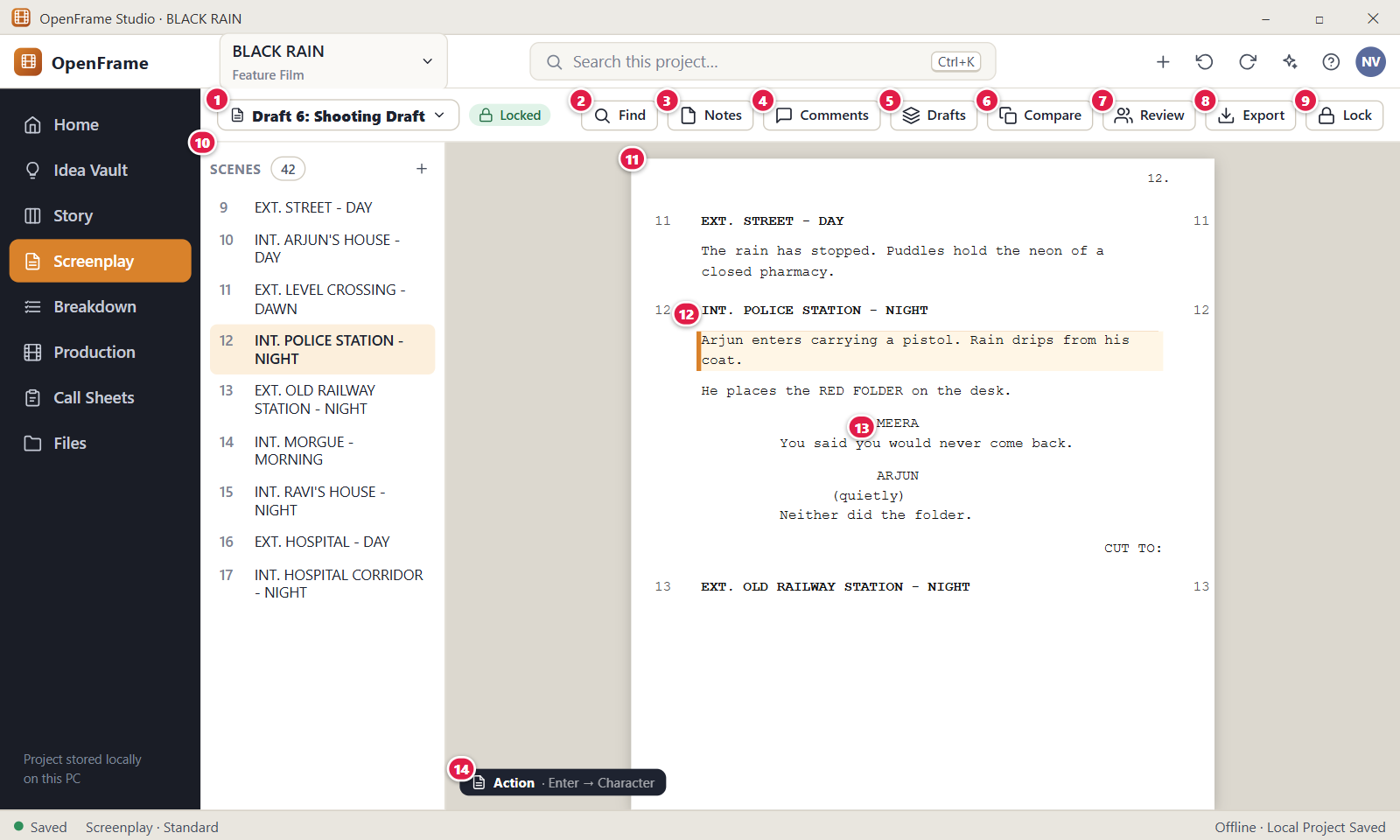
Figure 76. The screenplay editor (Standard mode). Red numbers are explained on the next page.

Figure 76: The screenplay editor (Standard mode): how it works
PARTS OF THIS SCREEN  1 Draft selector Shows the name of the open draft, for example "Draft 6: Shooting Draft", with a chip such as Locked, Draft or In review. Click it for the list of drafts, headed "Open draft", and pick one. It also offers "Drafts…" and, for Owners and Editors, "New Draft…". Opening another draft saves your typing first and does not change which draft is Current.  2 Find Opens the find and replace bar over the page. It searches only the screenplay that is open. Shortcut: Ctrl+F. Press Esc to close it and return to the page. This is not the project search (Ctrl+K).  3 Notes Opens or closes the Scene Notes panel on the right. It shows and hides the panel. Whether note lines show inside the script is a separate switch in the View menu or the check box "Show notes in the script". Only one right panel is open at a time.  4 Comments Opens or closes the Comments panel. When the draft has open comments the label shows their number, for example "Comments (2)". Opening it closes the Notes panel.  5 Drafts Opens the Drafts drawer: your named drafts, the Current and Locked chips, Compare, New Draft and the Recovery History. The page stays visible behind the drawer.  6 Compare Opens the draft comparison for the open draft and another draft. Your typing is saved first. Use the Back control of the comparison to return to the editor.  7 Review Opens the review rounds screen for this screenplay. Your typing is saved first. Going back returns you to the editor.  8 Export Opens the Export Screenplay window for the open draft. Export makes a copy and the draft does not change. Private notes are never exported, and "Include notes" is off by default.  9 Lock Marks the open draft as the Locked Shooting Draft, after a confirmation window. It shows only on drafts that are not locked, for Owners and Editors. On a draft that is already locked, the same place shows "Revisions", which opens the Revisions drawer.  10 Scene navigator Lists every scene with its generated number and heading, with the total next to "Scenes". Click a row to jump to that scene. The + button adds a scene after the current one, and a right-click on a row opens a menu of scene actions. The + button and the drag handle are missing on a locked draft. Alt+Down and Alt+Up move to the next and previous scene.  11 The screenplay page The writing surface. Text formats itself by element type: scene heading, action, character, parenthetical, dialogue, transition and shot. About half a second after you stop typing, the toolbar label goes "Saving…" and then "Saved". You never press Save, but Ctrl+S saves at once.  12 Scene heading The line that starts a scene: INT. or EXT., the place and the time of day, on one line of up to 300 characters. The scene number, for example 12, is generated and shown in both margins. You never type it. A suggestion list offers places and times, and changes the text only when you accept an item.  13 Character cue The name of the speaker, centred above the dialogue, on one line and shown in capitals. While you type, a list suggests names from Characters, Cast and the script, and extensions such as V.O. and CONT'D. A new name offers "Create New", which adds it to Characters.  14 Element indicator A small label at the bottom left of the page, for example "Action · Enter → Character". It names the element at the cursor and what Enter starts next. Click it to change the element type. On a draft that cannot be edited it reads "Read only" instead of the Enter hint. | HOW TO USE IT  1. Open Screenplay and click into the page.  2. Type a scene heading such as INT. POLICE STATION - NIGHT and press Enter. The next line is Action.  3. Press Enter after the action to start a character cue, for example MEERA, then Enter again for her dialogue.  4. Click a scene in the navigator to jump to it, or press Alt+Down for the next scene.  5. Watch the toolbar label. When it reads "Saved", your work is stored on this computer.  6. Press Ctrl+Z to undo and Ctrl+Y or Ctrl+Shift+Z to redo.  GOOD TO KNOW · EDGE CASES  • Undo and Redo use the project history, the same list as the Undo button in the top bar. The history keeps 300 steps, and typing in one element within 4 seconds is one step.  • If a save fails, the label shows "Not saved yet. Retrying", your text stays on the page and OpenFrame tries again every 3 seconds.  • Capitals in headings, cues, transitions and shots are only a display rule. Your text is stored as you typed it.  • A locked draft can always be read and exported. Typing in it offers to start a revision, and nothing changes until you accept.  • Tab in the page changes the element type and does not move focus. Press Esc first to leave the page.  • The Idea Vault is not shown beside the script. Use the left navigation or Ctrl+K.
See also: Figure 75 Screenplay: empty state Figure 77 Choosing screenplay element types Figure 78 Find and replace in the screenplay Figure 79 Focus mode (full-screen writing) Figure 80 Writing Room: script with a reference panel Figure 81 Scene notes and private notes

Figure 77: Choosing screenplay element types
What it is for. The screenplay has eight element types. This screen shows the Element type menu, with a shortcut for each type, and the rule for what Enter starts next. It answers "How do I change a line from Action to Dialogue, and what will Enter give me?"
How to get here. Screenplay, then click the element indicator at the bottom left of the page, for example "Action · Enter → Character". You can also press Ctrl+1 to Ctrl+7 with the cursor in a line.
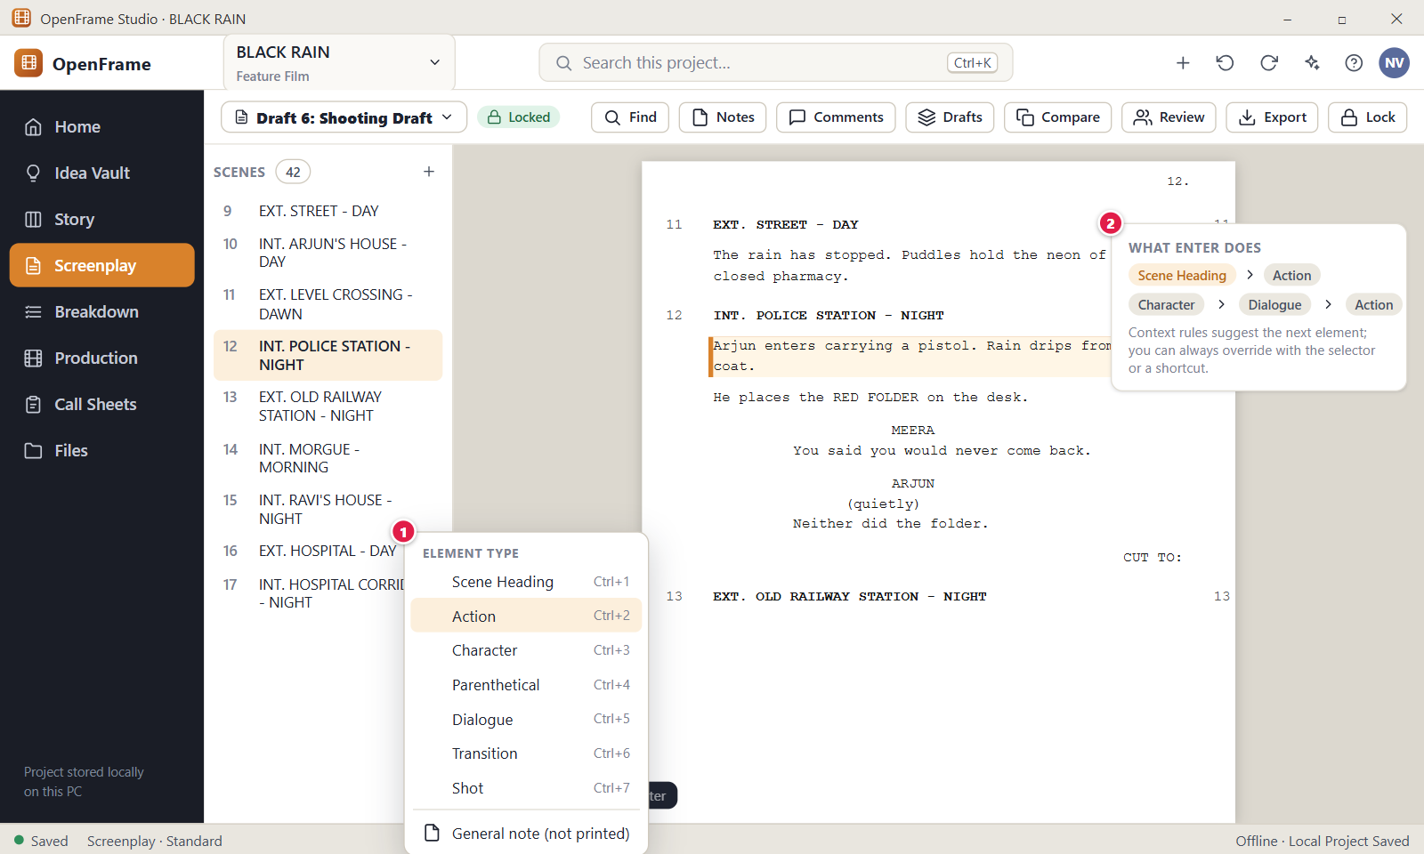
Figure 77. Choosing screenplay element types. Red numbers are explained on the next page.

Figure 77: Choosing screenplay element types: how it works
PARTS OF THIS SCREEN  1 Element selector The menu headed "Element type". It lists Scene Heading (Ctrl+1), Action (Ctrl+2), Character (Ctrl+3), Parenthetical (Ctrl+4), Dialogue (Ctrl+5), Transition (Ctrl+6) and Shot (Ctrl+7), then "General note (not printed)" and "Insert page break" (Ctrl+Enter). Choosing an item changes the line, or every selected line. All items are greyed out on a locked draft. You can change the keys in Settings > Keyboard shortcuts.  2 Automatic progression The editor suggests the next element when you press Enter, and you can always override it. The indicator shows the rule, for example "Character · Enter → Dialogue". The app has no separate card for this rule on the page. Pressing Enter on an empty line converts it, so an empty Action line becomes a Scene Heading. | HOW TO USE IT  1. Put the cursor in a line of the screenplay.  2. Click the element indicator, or press a shortcut such as Ctrl+3 to make the line a Character cue.  3. Type the name, for example MEERA, and press Enter. The next line is Dialogue.  4. Type the dialogue and press Enter. The next line is Action.  5. Press Enter on an empty Action line to turn it into a new Scene Heading.  6. Press Ctrl+Z if a conversion is not what you wanted.  GOOD TO KNOW · EDGE CASES  • The rules are: Scene Heading to Action, Action to Character, Character to Dialogue, Parenthetical to Dialogue, Dialogue to Action, Transition to Scene Heading, Shot to Action, General note to Action.  • Changing a body line into a Scene Heading starts a new scene and adds a row to the navigator. Changing a heading into Action joins its lines to the previous scene. The first block of a draft must stay a Scene Heading.  • Character, Parenthetical, Transition and Shot lines are one line only. Dialogue can hold line breaks with Shift+Enter.  • A General note is shown in italics. It is not printed and is left out of exports unless you choose "Include notes". You can hide it on the page with "Hide notes in the script".  • Only Shot and General note are optional. Tab and Shift+Tab cycle through Action, Character, Parenthetical and Dialogue.  • On a locked draft the indicator reads "Read only" and the menu is disabled.
See also: Figure 76 The screenplay editor (Standard mode) Figure 81 Scene notes and private notes Figure 95 Exporting the screenplay Figure 91 Importing a screenplay: choose the source

Figure 78: Find and replace in the screenplay
What it is for. Find and replace works inside the screenplay that is open. It is plain, literal text search with next, previous, replace, replace all, match case, whole word and a choice of one scene or the whole script. It answers "Where does this word appear in my script, and can I change it everywhere safely?"
How to get here. Screenplay, then click Find in the toolbar or press Ctrl+F. Close it with Esc or the X. This is not the project-wide search (Ctrl+K).
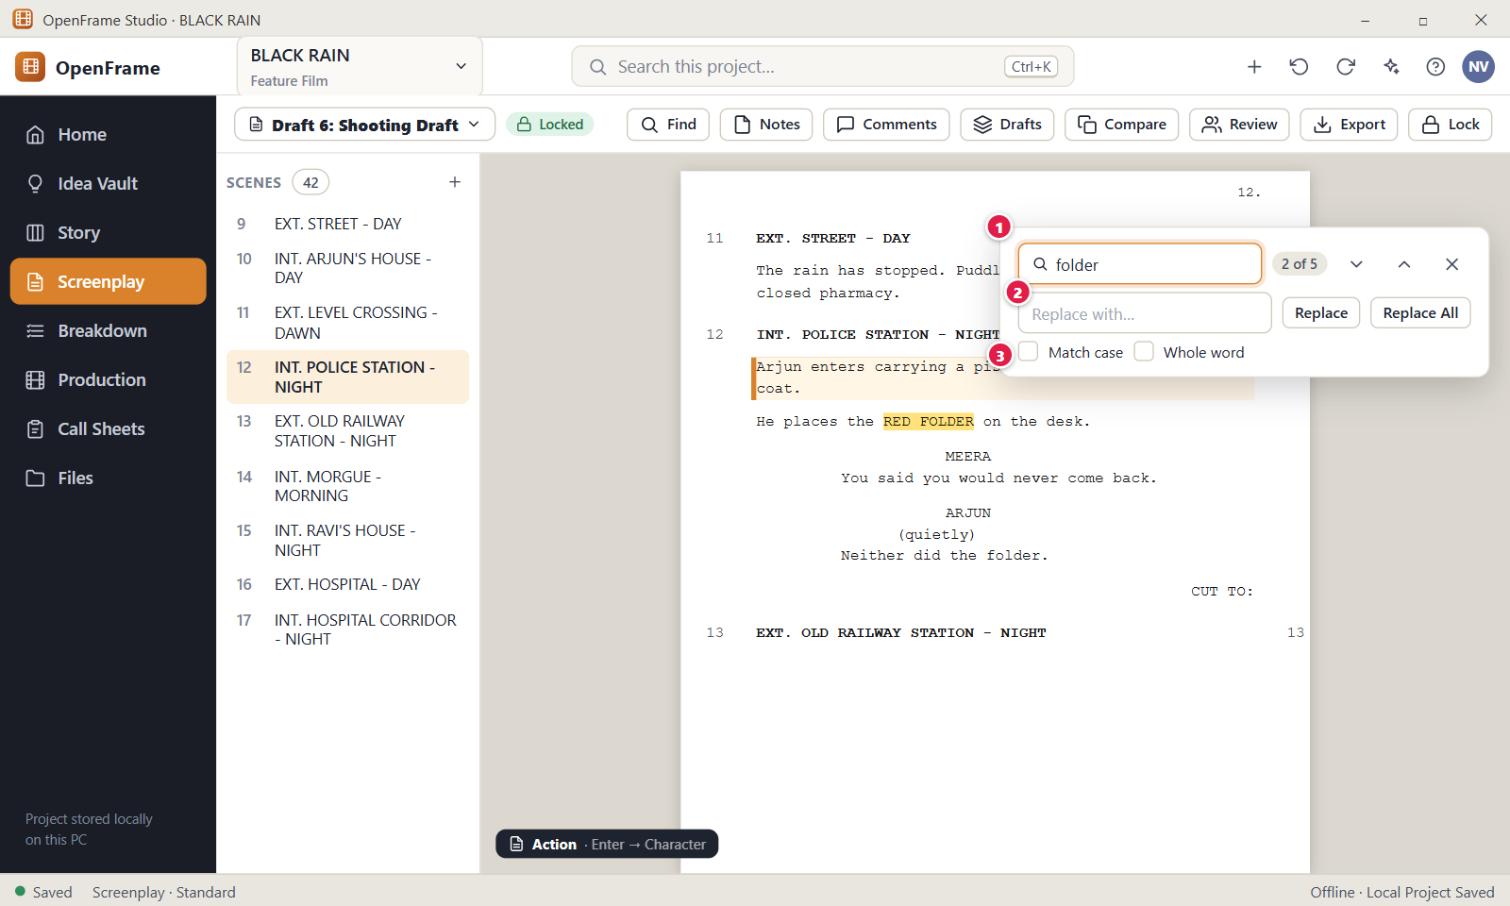
Figure 78. Find and replace in the screenplay. Red numbers are explained on the next page.

Figure 78: Find and replace in the screenplay: how it works
PARTS OF THIS SCREEN  1 Find bar The card at the top right of the page. Type in "Find in script" and matches highlight in the page. The counter shows the current match, for example "2 of 5". Enter goes to the next match and Shift+Enter to the previous one, and both wrap round at the ends. Esc closes the bar and clears the highlights. With no match the counter says "No matches found".  2 Replace The field "Replace with…" and the buttons "Replace" and "Replace All". Replace changes the current match and selects the next one. Replace All changes every match in the chosen scope in one step, and a message says how many were replaced. Press Ctrl+Z to undo either. A locked draft shows no Replace row.  3 Options "Match case" treats capital letters as different letters. "Whole word" matches only complete words. A "Search in" choice picks "This scene" or "Whole script". "This scene" locks the search to the scene where your cursor was. | HOW TO USE IT  1. Press Ctrl+F and type the word, for example folder.  2. Press Enter to step through the matches, and Shift+Enter to go back.  3. Tick Match case or Whole word if you need a stricter search.  4. Choose "This scene" or "Whole script" in "Search in".  5. Type the new text in "Replace with…", for example RED FILE, and click Replace for one match or Replace All for every match.  6. Press Esc to close the bar.  GOOD TO KNOW · EDGE CASES  • Search is literal. The characters . * ( ) are ordinary letters, and there is no pattern mode.  • Find covers scene headings, action, character names and dialogue of the open draft. Notes are searched and replaced only while they are shown on the page.  • Replace All is all or nothing. If one change would break a rule, such as a heading over 300 characters, nothing changes. It is one step in Undo.  • The Find text can be 1 to 500 characters. The replacement can be up to 2,000 characters, and an empty replacement deletes the matches.  • A locked draft can be searched but not changed.  • If you choose "This scene" with the cursor in no scene, OpenFrame asks you to click in a scene first.
See also: Figure 76 The screenplay editor (Standard mode) Figure 83 Drafts: named drafts and recovery history Figure 81 Scene notes and private notes

Figure 79: Focus mode (full-screen writing)
What it is for. Focus mode hides the scene navigator, the toolbar and the side panels so that only the page remains. It is a presentation change, and the editor works exactly as before. It answers "Can I write without distractions?"
How to get here. Screenplay, then the View and more icon button at the right end of the toolbar, then Focus Mode. There is no key for it by default. Leave it with Exit Focus at the top right of the page.
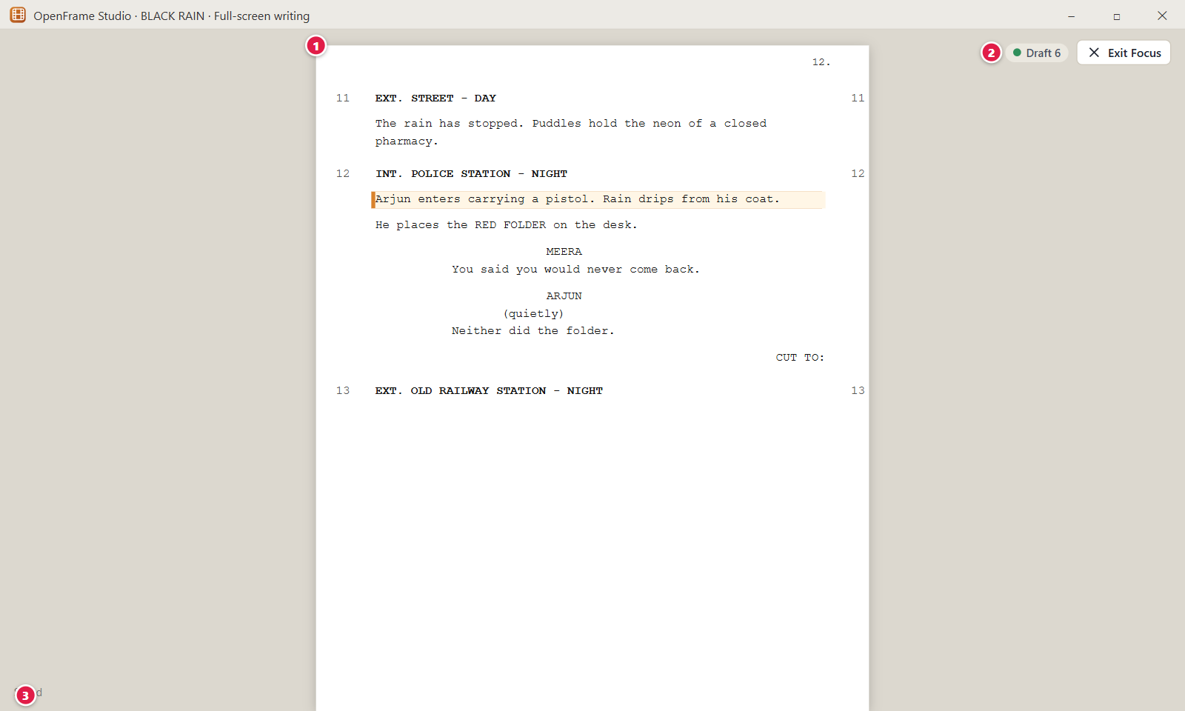
Figure 79. Focus mode (full-screen writing). Red numbers are explained on the next page.

Figure 79: Focus mode (full-screen writing): how it works
PARTS OF THIS SCREEN  1 The page The screenplay page with nothing around it except a small bar at the top right. Typing, find (Ctrl+F), undo, redo, save and the element shortcuts Ctrl+1 to Ctrl+7 still work. Alt+Down and Alt+Up move between scenes. The toolbar, navigator, side panels and element indicator are hidden.  2 Exit Focus The small button in the bar. It leaves Focus mode at once and brings back the toolbar, the navigator and the panel that was open before. Your cursor and scroll position stay. Esc does not exit Focus mode, so use this button.  3 Minimal status The bar shows the draft name and a save label: "Saved", "Saving…" or "Not saved yet. Retrying". If a save fails, your text stays on the page and OpenFrame tries again every 3 seconds. The status bar at the bottom of the window stays visible. | HOW TO USE IT  1. Open Screenplay and click the View and more button at the right end of the toolbar.  2. Choose Focus Mode.  3. Write as usual. Press Ctrl+F if you need to find something.  4. Watch the save label in the small bar.  5. Click Exit Focus to return to the normal layout.  GOOD TO KNOW · EDGE CASES  • Entering and leaving Focus mode never changes your text, your draft or its lock.  • Focus mode keeps the application header and left navigation visible. It does not make the window full screen.  • Hidden does not mean off. Ctrl+1 to Ctrl+7 still change element types, although the element indicator is not shown.  • The mode is stored with your layout, so the app may reopen in Focus mode after a restart.  • In a locked draft, typing still offers to start a revision.  • The menu also offers Standard Mode and Writing Room Mode.
See also: Figure 76 The screenplay editor (Standard mode) Figure 80 Writing Room: script with a reference panel Figure 78 Find and replace in the screenplay

Figure 80: Writing Room: script with a reference panel
What it is for. The Writing Room is a layout, not a separate document. It shows the screenplay with one or two reference panels on the right: Story Board, Scene Notes, Characters, Comments or Draft information. It answers "What reference do I need while writing this scene?"
How to get here. Screenplay, then the View and more icon button at the right end of the toolbar, then Writing Room Mode. Choose panels with the tab buttons above the right-hand area. Switch back with View and more > Standard Mode.
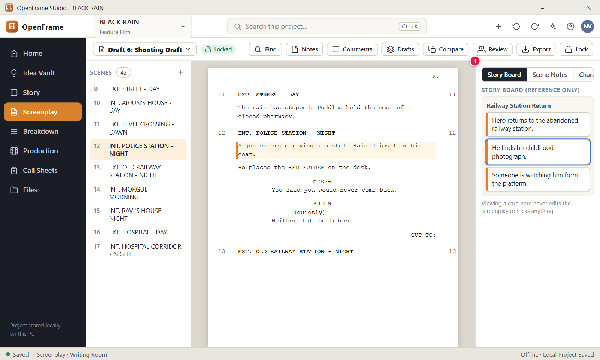
Figure 80. Writing Room: script with a reference panel. Red numbers are explained on the next page.

Figure 80: Writing Room: script with a reference panel: how it works
PARTS OF THIS SCREEN  1 Side panel The area to the right of the page, with tab buttons for "Story Board", "Scene Notes", "Characters", "Comments" and "Draft information". A pressed tab means that panel is open. Up to two panels stay open, and opening a third closes the oldest. Each panel has an X to close it. The panels have a fixed width and cannot be resized. With none open, the page stays centred. | HOW TO USE IT  1. Open Screenplay and click the View and more button at the right end of the toolbar.  2. Choose Writing Room Mode.  3. Click a tab such as "Story Board" to open that panel.  4. Click a second tab, for example "Characters", to open it beside the first.  5. Put the cursor in a scene, for example scene 12, to see the matching Story Board card.  6. Click the X on a panel to close it, or choose Standard Mode to return.  GOOD TO KNOW · EDGE CASES  • The Story Board panel is read-only reference. It never edits the screenplay or a card, and it is not kept in step with the screenplay. It shows the card linked to the scene where your cursor is.  • With no linked card the panel says so. With the cursor in no scene it asks you to place the cursor in a scene.  • The Idea Vault is deliberately not offered as a side panel. Use the left navigation or Ctrl+K.  • The panels follow the draft you open in the draft selector. On a locked draft you can read every panel, but note editing buttons are hidden.  • In Standard mode only one panel can be open, and Notes and Comments open from the toolbar.  • Your panel arrangement is stored per project and per user. If a panel cannot load, the screenplay stays fully usable.
See also: Figure 76 The screenplay editor (Standard mode) Figure 79 Focus mode (full-screen writing) Figure 81 Scene notes and private notes Figure 82 Adding and resolving comments on script text Figure 49 Story Board: Board view

Figure 81: Scene notes and private notes
What it is for. A scene can carry working notes that live outside the printed script, and private notes that only you can see. This panel shows both for the scene where your cursor is. It answers the question: what did I note about this scene, and what stays private?
How to get here. Open the Screenplay and click Notes in the toolbar. The panel "Scene notes: Scene 12" opens on the right and follows your cursor from scene to scene. In Writing Room Mode, use the tab "Scene Notes".
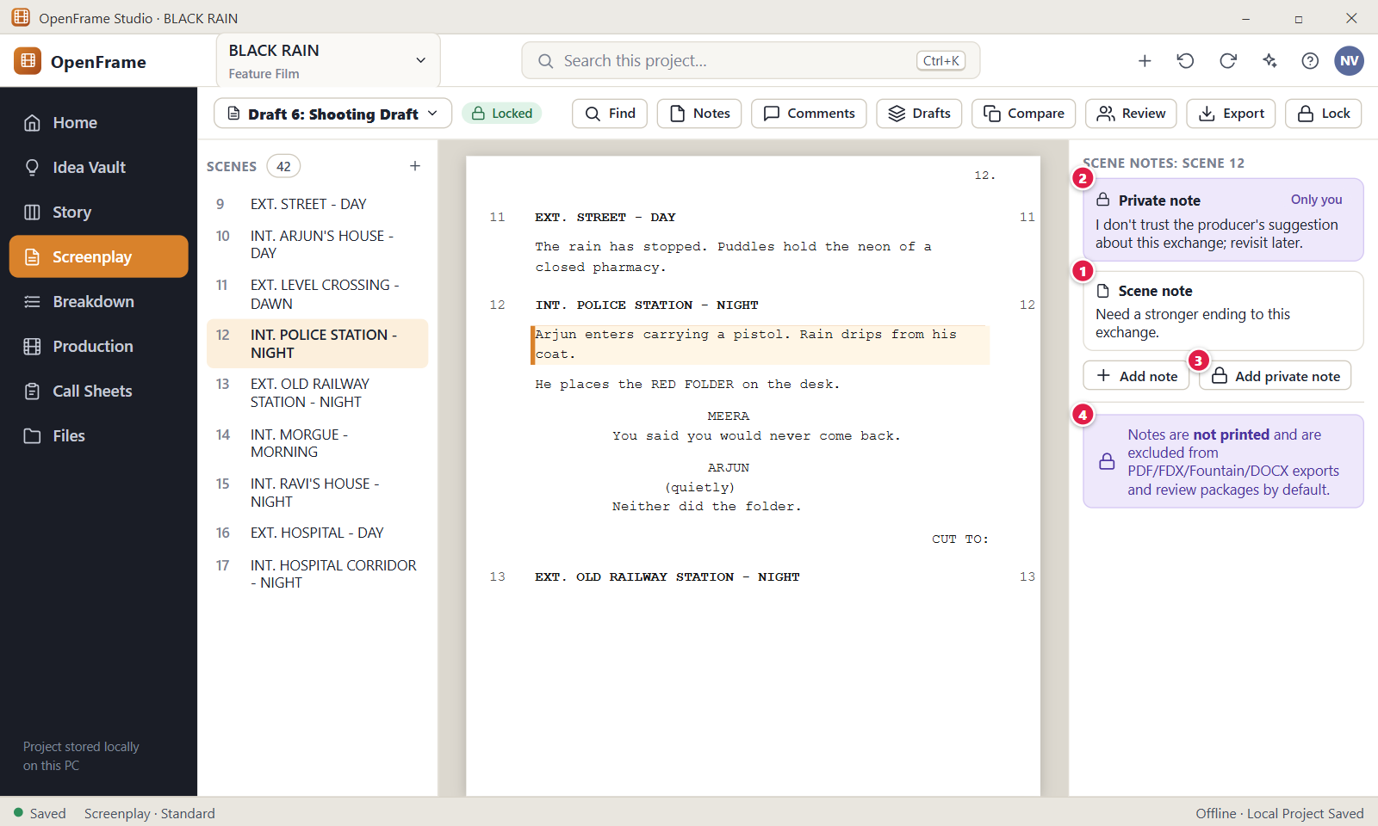
Figure 81. Scene notes and private notes. Red numbers are explained on the next page.

Figure 81: Scene notes and private notes: how it works
PARTS OF THIS SCREEN  1 Scene note The working note of the scene, for example "Need a stronger ending to this exchange." It is not part of the printed script. Each scene has one note and the card says "No scene note yet." until you save one. Use the small Add or Edit button on the card to change it. This works only in a draft that is not locked, and a note holds up to 20,000 letters.  2 Private note A note that only you can see. The card shows a lock icon, the title "Private note" and the chip "Only you". It is never shared and never exported. The three-dot menu on the card has Edit and Delete. Delete happens at once, with no question asked.  3 Add private note Opens an empty box titled "Private note" at the top of the panel. Type your text and click Save. Save stays off while the box is empty. Cancel closes the box. This button also works on a locked draft.  4 Notes are not printed The line at the bottom of the panel: "Notes are not printed and are excluded from PDF/FDX/Fountain/DOCX exports and review packages by default." In the app it is a plain line of text, not a coloured banner. The Export window has an option "Include notes", which is off by default. Private notes are never included, whatever you choose. | HOW TO USE IT  1. Open the Screenplay and click in scene 12, "INT. POLICE STATION - NIGHT".  2. Click Notes in the toolbar. The panel title reads "Scene notes: Scene 12".  3. Click Add note below the cards, type "Need a stronger ending to this exchange." and click Save.  4. Click Add private note, type "I don't trust the producer's suggestion about this exchange; revisit later." and click Save.  5. Click in scene 13 and then back in scene 12. Each scene shows its own notes.  6. Open Export and check that the dialog says "Private notes excluded."  GOOD TO KNOW · EDGE CASES  • A scene note and a General note are different things. The scene note lives in the panel. A General note is a line inside the script, and the panel lists those under "In-script notes".  • The checkbox "Show notes in the script" changes only what you see on the page. It never deletes a note.  • On a locked draft the Add and Edit buttons for the scene note are hidden, but you can still read the note and add private notes.  • A note longer than 20,000 letters is refused with a message and your saved note stays as it was.  • If your cursor is in no scene, the panel says "Place the cursor in a scene to see its notes."  • A Full Project Package or Backup made by the owner may contain private notes. It is labelled a private project transfer. Review packages and exchange packages never contain them.
See also: Figure 76 The screenplay editor (Standard mode) Figure 77 Choosing screenplay element types Figure 80 Writing Room: script with a reference panel Figure 95 Exporting the screenplay

Figure 82: Adding and resolving comments on script text
What it is for. You select some script text, click Comment, write and post. Replies stay inside the same thread and you resolve the thread when it is done. Comments never change the script. It answers the question: what do I want to tell someone about this exact line?
How to get here. Open the Screenplay and select words inside one line with the mouse. Click the Comment button that appears next to the selection. You can also click Comments in the toolbar and use "Comment on Scene 12" or "Comment on draft". In Writing Room Mode, use the tab "Comments".
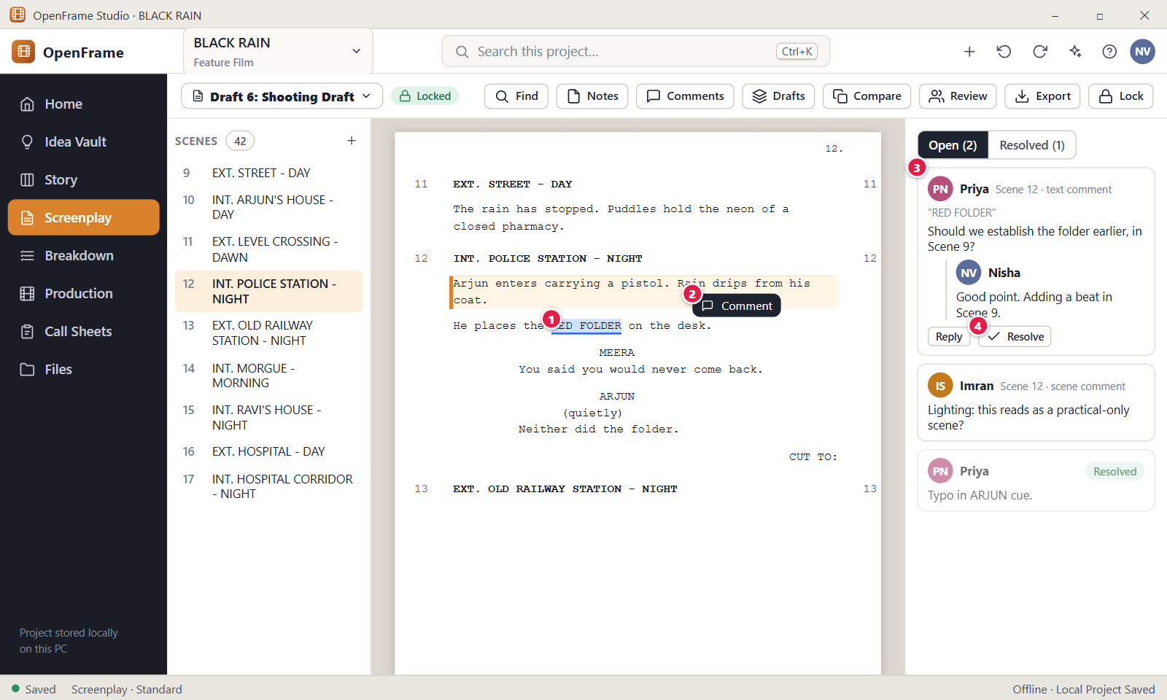
Figure 82. Adding and resolving comments on script text. Red numbers are explained on the next page.

Figure 82: Adding and resolving comments on script text: how it works
PARTS OF THIS SCREEN  1 RED FOLDER The selected words in scene 12. A comment can point at an exact range of text inside one line, at a whole scene, or at the whole draft. The Comment button appears only when the selection sits inside one line and holds at least one letter or digit. A selection across two lines gives no button.  2 Comment The small button that appears next to the selection. Click it to open the Comments panel with a box for your text. Type the comment and click Comment, or press Ctrl+Enter. Esc cancels. The button is off when the box is empty, and a comment holds up to 20,000 letters. It does not appear in Focus mode.  3 Comment thread A card with the author, the target (for example "Scene 12 · text comment"), the quoted text, the comment and its replies. Click Reply to answer inside the same thread. The link at the top jumps to the text. The three-dot menu has Edit, Mark In Discussion or Mark Open, and Delete.  4 Resolve Marks the thread as done. The thread moves to the tab "Resolved" and stays in history. The same button then reads Reopen and brings the thread back to the Open list. You resolve a thread from its first comment, not from a reply. | HOW TO USE IT  1. Open scene 12 and select the words RED FOLDER with the mouse.  2. Click the Comment button that appears next to the selection.  3. Type "Should we establish the folder earlier, in Scene 9?" and press Ctrl+Enter.  4. Find the new card under "Open (1)". Click Reply, write an answer and send it.  5. Click the link "Scene 12 · text comment" to jump back to the exact words.  6. When the question is settled, click Resolve. Open the tab "Resolved" to see the thread.  GOOD TO KNOW · EDGE CASES  • Comments never change the script text. You can comment on a locked draft.  • Comments belong to one draft. A draft made later does not need to show the same threads.  • If later edits remove the exact words a comment points to, the card shows the chip "Context moved" and stays with the nearest scene. It never disappears.  • Resolved threads show only under the tab "Resolved". The numbers in "Open (N)", "Resolved (M)" and on the toolbar button update at once.  • Delete has no question asked. You can delete your own comments. The owner and editors can delete anyone's.  • The same select, comment, post flow works on scene cards, beats, sequences, acts, panels, shots, locations and breakdown items in their own screens.
See also: Figure 76 The screenplay editor (Standard mode) Figure 86 Review rounds Figure 97 Scene Hub: what exists around a scene Figure 80 Writing Room: script with a reference panel

Figure 83: Drafts: named drafts and recovery history
What it is for. OpenFrame keeps two layers of versions: named drafts that you create on purpose, and quiet automatic history for recovery. This drawer shows both. It answers the question: which version am I working on, and what can I restore?
How to get here. Open the Screenplay and click Drafts in the toolbar. You can also open the draft selector and click "Drafts…". The drawer opens on the right and the page stays visible behind it.
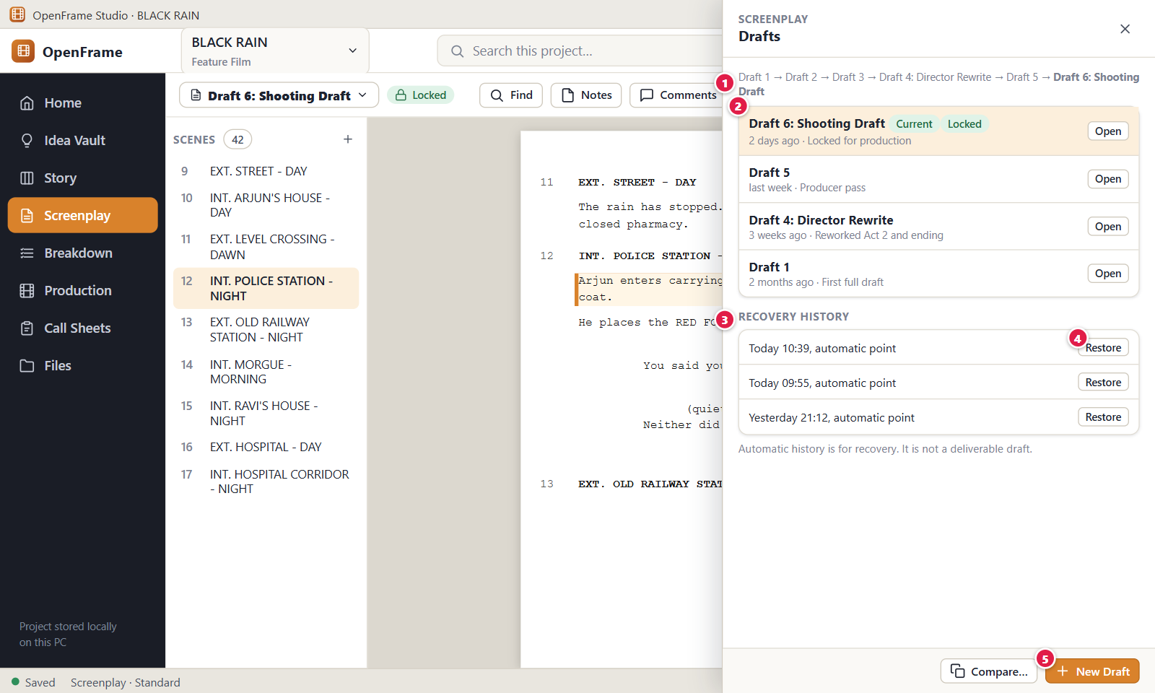
Figure 83. Drafts: named drafts and recovery history. Red numbers are explained on the next page.

Figure 83: Drafts: named drafts and recovery history: how it works
PARTS OF THIS SCREEN  1 Draft lineage One line at the top that shows where the Current draft came from, for example "Draft 1 → Draft 2 → Draft 3 → Draft 4: Director Rewrite → Draft 5 → Draft 6: Shooting Draft". The Current draft is in bold. It shows names only and you cannot click it.  2 Draft rows One row per named draft, newest first. Each row shows the name, chips such as Current, Locked, Draft or In review, the age, the note and where the draft came from. Click Open to switch to it. The three-dot menu has Open, Rename…, Mark current, Restore as new draft, Compare with current, Start Review…, Lock as Shooting Draft… and Delete…. The Open button of the draft you are in is greyed out.  3 Recovery History Automatic history points of the open draft, newest first. A point is written when a draft is created and then at most once every 5 minutes while you edit. The newest 60 points are kept. A locked draft collects no new points. Each line shows the time, the reason and the number of scenes.  4 Restore The button on a Recovery History line. It creates a new draft from that point, makes it Current and opens it. The draft you were in is never overwritten. The drawer closes and a message offers Undo. Owners and editors see this button.  5 New Draft The orange button at the bottom right of the drawer. It opens the New Draft window (Figure 84), which starts from the open draft. Typing you have not saved yet is saved first. Only owners and editors see this button. | HOW TO USE IT  1. Open the Screenplay and click Drafts in the toolbar.  2. Read the lineage line to see which draft is Current, for example "Draft 6: Shooting Draft".  3. Click New Draft, give it a name such as "Draft 7" and create it. It becomes Current.  4. Edit the new draft. After about 5 minutes a new line "automatic point" appears under Recovery History.  5. Click Restore on an older line to get a new draft named "Restored from Draft 7 (automatic point)".  6. To go back to another draft, open its three-dot menu and choose Mark current.  GOOD TO KNOW · EDGE CASES  • You do not need to save a version every ten minutes. Automatic history does it quietly.  • Restoring never overwrites the draft you are in. It always makes a new draft.  • Rename changes only the label. A name must be unique in the screenplay, ignoring capital letters.  • Delete asks for confirmation and moves the draft to Recently Deleted. The Current draft cannot be deleted until another draft is made Current.  • To compare two drafts, use Compare with current in a row menu or the Compare… button. You do not tick two drafts in the list.  • The text at the bottom reads "Automatic history is for recovery. It is not a deliverable draft. Restoring creates a new draft; nothing is replaced."
See also: Figure 76 The screenplay editor (Standard mode) Figure 84 Creating a new named draft Figure 85 Comparing two drafts Figure 86 Review rounds Figure 88 Locking the Shooting Draft Figure 101 Deleting a draft

Figure 84: Creating a new named draft
What it is for. A named draft is a milestone, for example Draft 2, Director Rewrite, Producer Pass or Shooting Draft. This window copies a draft into a new named draft. It answers the question: which draft do I copy, and what do I call the copy?
How to get here. Open the Screenplay, click Drafts, then click New Draft in the drawer. You can also open the draft selector in the toolbar and choose "New Draft…".
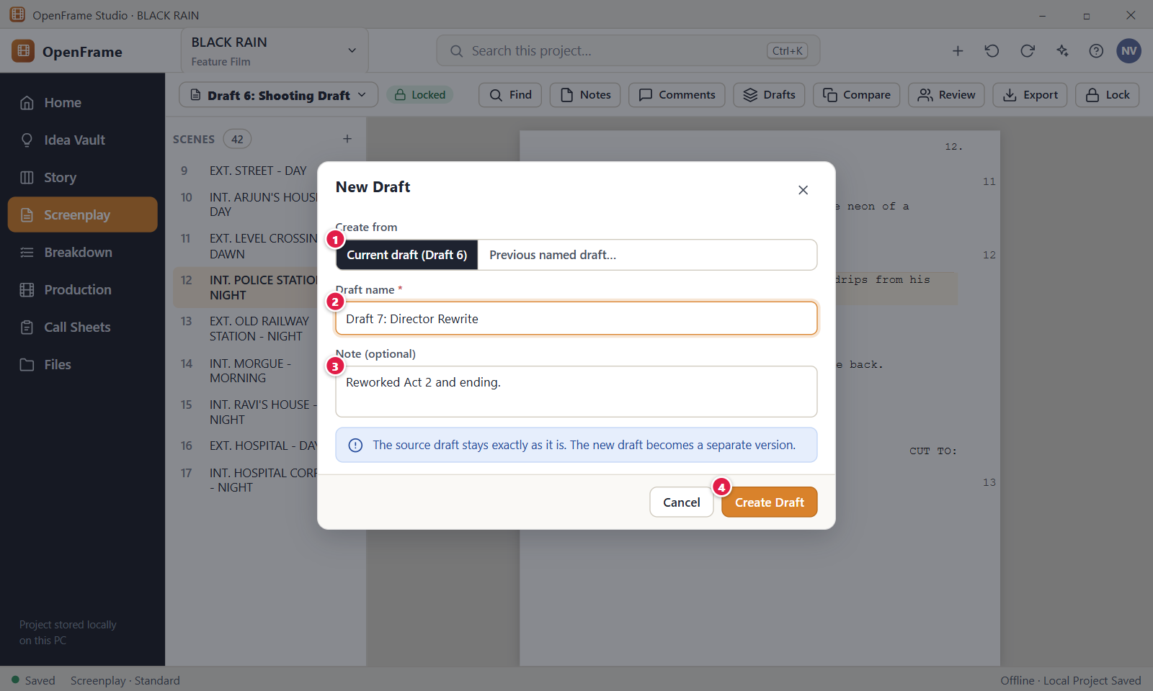
Figure 84. Creating a new named draft. Red numbers are explained on the next page.

Figure 84: Creating a new named draft: how it works
PARTS OF THIS SCREEN  1 Create from Two buttons that decide which draft is copied. "Current draft (Draft 6)" copies the draft you have open, whatever its name. "Previous named draft…" shows a list called "Source draft" where you pick any other draft. A locked draft can be the source, and the copy is not locked. The second button is missing when the screenplay has only one draft.  2 Draft name The name of the new draft, for example "Draft 7: Director Rewrite". The app fills in the first free name such as "Draft 7", and you can type over it. The name is required, holds up to 120 characters and must be unique in the screenplay, ignoring capital letters. A duplicate shows "Another draft already has this name. Choose a different name."  3 Note An optional reminder of what changed, for example "Reworked Act 2 and ending." It shows under the draft name in the Drafts drawer. A note can hold up to 2,000 characters. You can change it later with Rename….  4 Create Draft Makes the new draft from the source, makes it the Current draft and opens it. The source draft is not changed. The button stays off while the name is empty. A message "Created draft" with the new name appears and offers Undo. | HOW TO USE IT  1. Open the Screenplay and click Drafts in the toolbar.  2. Click New Draft at the bottom right of the drawer.  3. Leave "Current draft" selected, or choose "Previous named draft…" and pick a source from the list.  4. Type a name such as "Draft 7: Director Rewrite".  5. Type a note such as "Reworked Act 2 and ending." if you want one.  6. Click Create Draft. The new draft opens and you can type in it.  GOOD TO KNOW · EDGE CASES  • The source draft stays exactly as it is, including a locked state. A locked Shooting Draft stops being Current but is not changed.  • The new draft copies the scenes, text, scene notes and element types of the source. It starts with the status Draft.  • The name is only a label and can contain any characters. Enter inside the name field does not create the draft, so click the button.  • A note longer than 2,000 characters is refused when you click Create Draft, and the message appears under the name field.  • Press Esc or click Cancel to close the window without creating a draft.  • You do not need to save a version every ten minutes. Automatic history records recovery points quietly (Figure 83).
See also: Figure 83 Drafts: named drafts and recovery history Figure 76 The screenplay editor (Standard mode) Figure 101 Deleting a draft Figure 85 Comparing two drafts

Figure 85: Comparing two drafts
What it is for. Draft comparison shows what changed between two named drafts of one screenplay, scene by scene, before you read the exact words. It answers the question: what exactly changed between Draft 6 and Draft 7? The screen is read-only. It never merges, edits or saves anything.
How to get here. Open the Screenplay and click Compare in the toolbar. It is off while the screenplay has only one draft. You can also click Drafts and then Compare…, or open the three-dot menu of a draft and choose "Compare with current". Use "Back to script" to return to the editor.
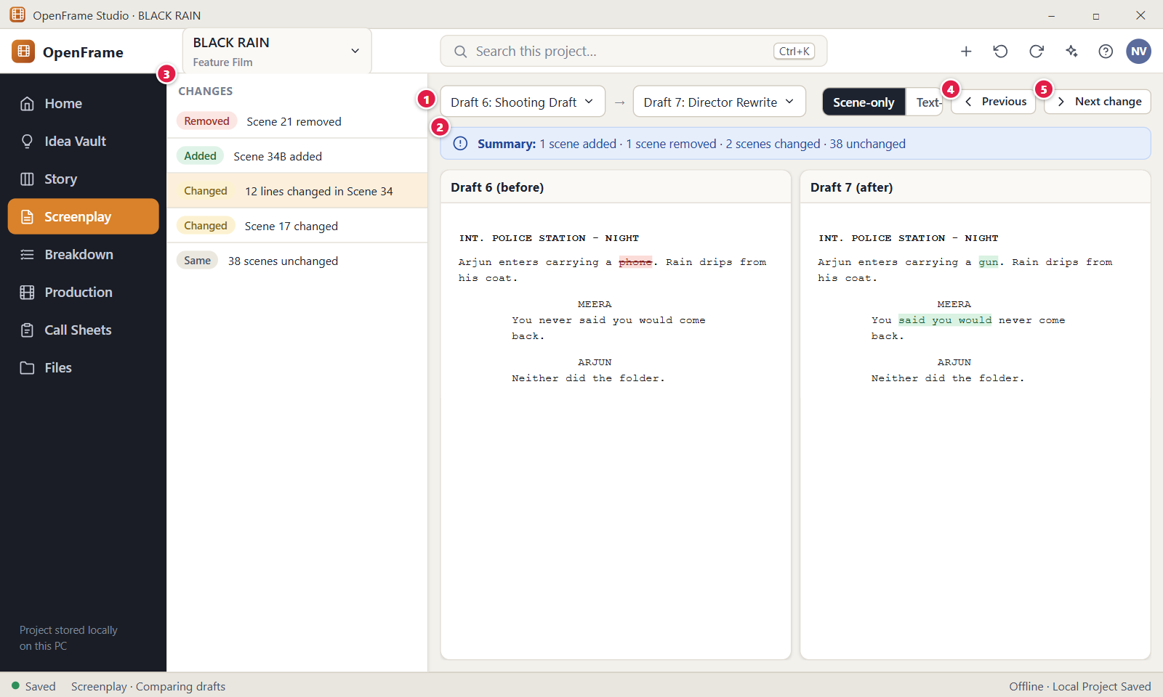
Figure 85. Comparing two drafts. Red numbers are explained on the next page.

Figure 85: Comparing two drafts: how it works
PARTS OF THIS SCREEN  1 Draft pickers Two lists at the top: Before (the older draft) and After (the newer draft). The comparison runs at once when you choose two different drafts. There is no Compare button on this screen. If both lists show the same draft, the screen says "Choose two different drafts to compare."  2 Summary One line of plain text that counts the scenes: added, removed, changed, moved and unchanged. For example "Summary: 1 scene added · 1 removed · 2 changed · 0 moved · 9 unchanged". If some scene matches are unsure, a yellow warning asks you to check them.  3 CHANGES The left column lists every scene that is not unchanged, in the order Removed, Added, Changed, Moved, then one grey row for the unchanged scenes. Rows read like "Scene 21 removed", "Scene 34B added" and "12 lines changed in Scene 34". Click a row to show that scene in the right pane. The grey row does nothing when clicked.  4 Previous Selects the previous change and shows it in the right pane. From the first change it jumps to the last one. It skips the unchanged row and is off when there are no changes.  5 Next change Selects the next change and shows it in the right pane. From the last change it jumps to the first one. It skips the unchanged row and is off when there are no changes. | HOW TO USE IT  1. Open the Screenplay and click Compare in the toolbar.  2. Choose the older draft in Before and the newer draft in After, for example Draft 6 and Draft 7.  3. Read the Summary line to see how many scenes were added, removed, changed or moved.  4. Click a row in CHANGES to read that scene in the right pane.  5. Click Next change to step through every change, and Previous to go back.  6. Click "Back to script" when you are done.  GOOD TO KNOW · EDGE CASES  • Comparison is read-only. There is no merge. To keep a change, edit a draft by hand or create a new draft.  • The screen opens in Text-only view. Scene-only shows a table with the columns Change, Before draft, After draft and Matched by.  • Moved scenes have their own group. A scene that only moved says "The text of this scene is identical; only its position changed."  • Scenes are matched by their stable identity first. If a script has none, as with imports, the app matches by heading and order and flags unsure matches instead of guessing.  • If nothing differs, the screen says "No differences found."  • Colour is only a helper. Every row also has a text label such as Removed, Added, Changed, Moved or Same.
See also: Figure 83 Drafts: named drafts and recovery history Figure 76 The screenplay editor (Standard mode) Figure 90 Revision label, colour and changed scenes Figure 88 Locking the Shooting Draft

Figure 86: Review rounds
What it is for. A review round collects feedback on one named draft in one place, instead of loose comments everywhere. The screen shows the round's name, source draft, reviewers, deadline and counts, the notes grouped by scene, and the selected note with its replies. It answers the question: what feedback is still open on this draft?
How to get here. Open the Screenplay and click Review in the toolbar. To create a round first, open Drafts, open the three-dot menu of a draft and choose "Start Review…". Use "Back to script" to return to the editor.
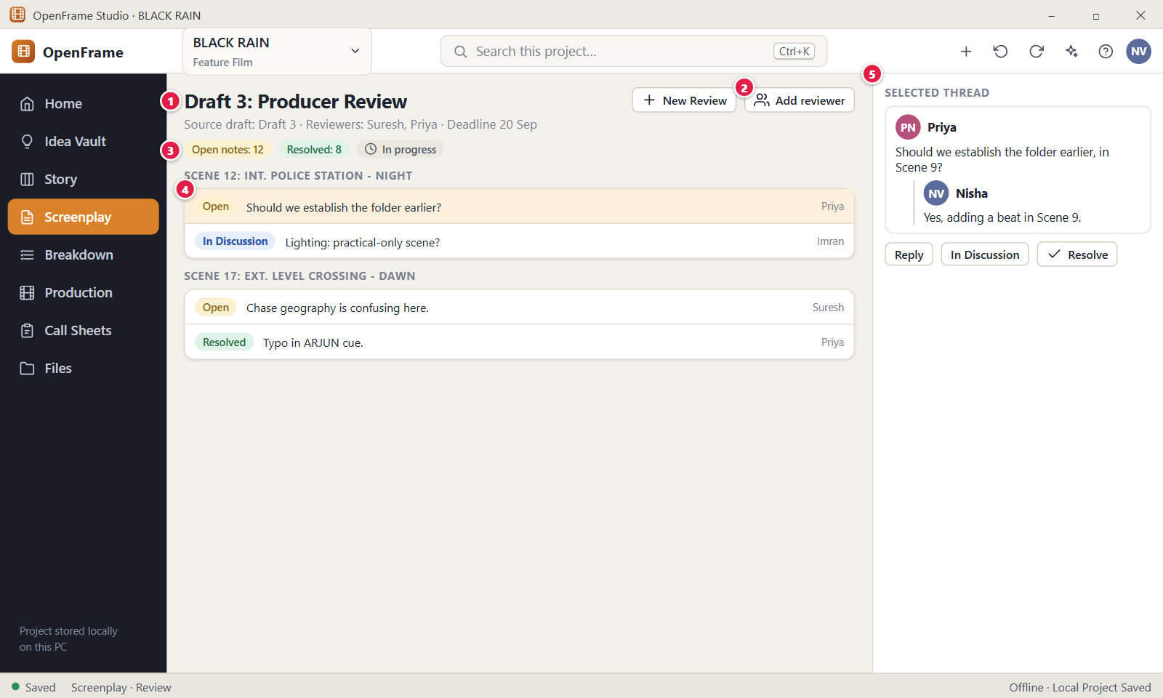
Figure 86. Review rounds. Red numbers are explained on the next page.

Figure 86: Review rounds: how it works
PARTS OF THIS SCREEN  1 Draft 3: Producer Review The title of the round, with one line under it: "Source draft: Draft 3 · Reviewers: Suresh, Priya · Deadline 20 Sep". A round belongs to exactly one draft, and that draft shows the chip "In review". When the project has several rounds, a list called "Review round" lets you switch between them. The date follows your Windows region format.  2 Add reviewer Opens a small window with the field "Reviewer name". Type a name and click Add, or press Enter. Reviewers are plain names, not user accounts, and nothing is sent to them. A name up to 80 letters is allowed, up to 50 reviewers per round, and a repeated name is added once. The button is shown only while the round is in progress.  3 Status counts Three chips: "Open notes", "Resolved" and the state of the round. Open notes counts notes that are Open or In Discussion. Replies are not counted. A finished round shows "Complete" instead of "In progress" and a green banner.  4 Notes grouped by scene The notes of the round, one group per scene in scene order, for example "Scene 12: INT. POLICE STATION - NIGHT". Each row shows a status chip (Open, In Discussion or Resolved), the note and the author. Notes on the whole draft sit in the group "Whole draft". Click a row to read it in the panel on the right.  5 Selected thread Shows one note with its author, text and replies. Reply opens a box with Cancel and Reply, and Ctrl+Enter sends. Resolve closes the note. The three-dot menu "Comment actions" has "Mark In Discussion", "Mark Open", Edit and Delete. Until you pick a row it says "Select a note to read and answer it." | HOW TO USE IT  1. Open the Screenplay, click Drafts and choose "Start Review…" from the menu of the draft you want read.  2. Click Review in the toolbar. The new round opens with its source draft and reviewers.  3. Click Add reviewer if you want to add another name.  4. Open the script, select text, click Comment and write a note. It reaches the open round of that draft.  5. Back in Review, click a note under its scene group, then click Reply to answer.  6. Click Resolve when the note is dealt with. The counts update at once.  7. Click Complete Review when all feedback is in. The script is not locked.  GOOD TO KNOW · EDGE CASES  • Starting or completing a review never locks the script and never changes its text. Locking is a separate action (Figure 88).  • Reviewers are names, not accounts. To get notes from people outside this computer, use a Review Package (an Exchange Package file).  • Resolved notes are not deleted. They stay in the round and under the Resolved tab of the Comments panel.  • A note reaches a round only when someone comments on the draft that has an open round. Without an open round it is a normal comment.  • When a round has no notes, the screen says "No notes yet. Open the script, select text, and choose Comment to add the first note to this review."  • Normal screenplay exports do not include review comments or private notes.
See also: Figure 87 Starting a review round Figure 83 Drafts: named drafts and recovery history Figure 88 Locking the Shooting Draft Figure 76 The screenplay editor (Standard mode)

Figure 87: Starting a review round
What it is for. The New Review window starts a review round on one draft: a name, the draft the reviewers will read, optional reviewer names and an optional deadline. It answers the question: which draft do I send for feedback, and to whom? Starting a round never locks or edits the script.
How to get here. Open the Screenplay, click Review in the toolbar, then click New Review. You can also open Drafts, open the three-dot menu of a draft and choose "Start Review…"; the window then opens with that draft chosen. You need the Owner or Editor role.
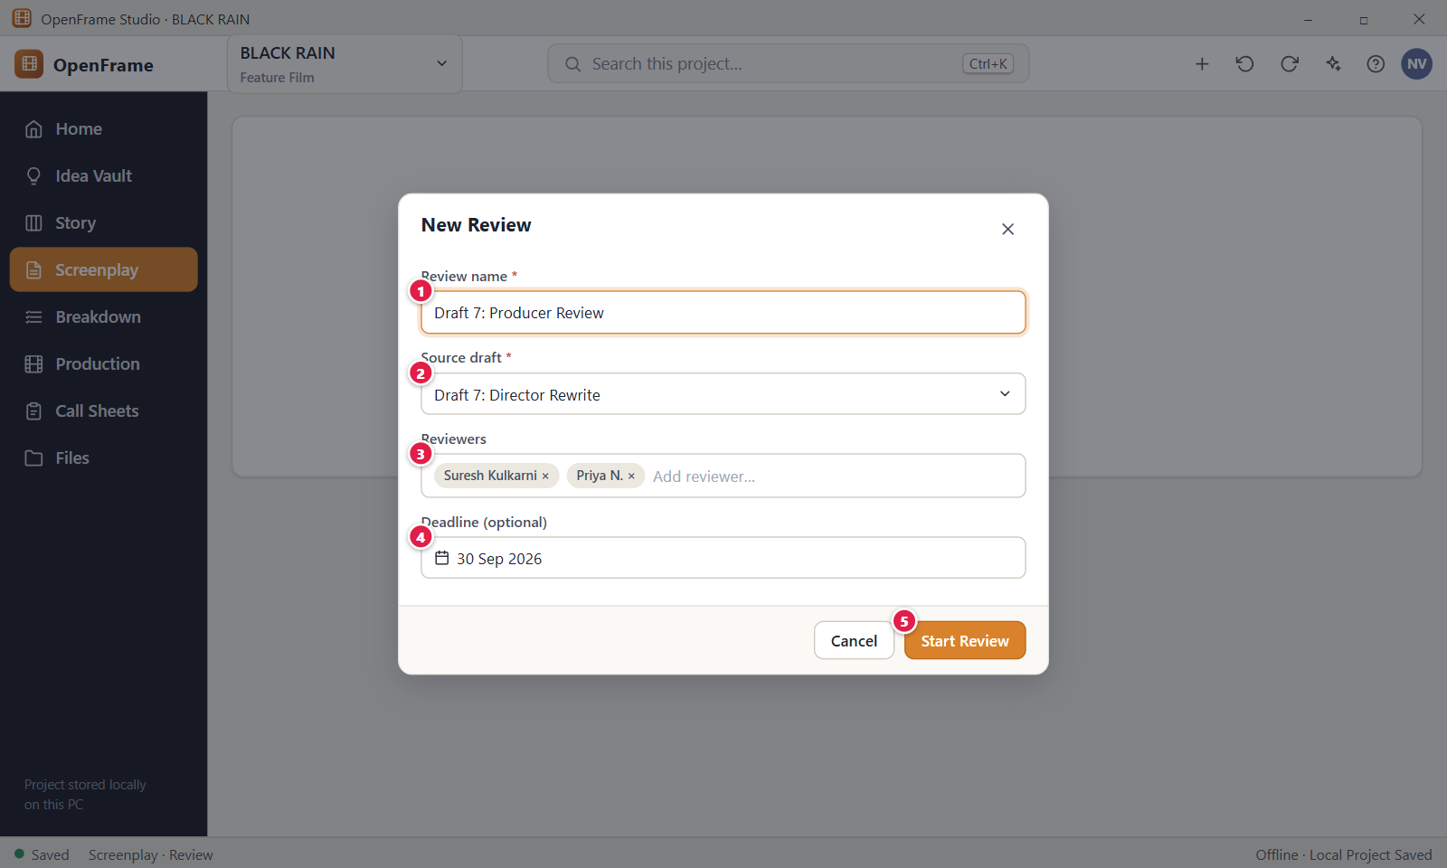
Figure 87. Starting a review round. Red numbers are explained on the next page.

Figure 87: Starting a review round: how it works
PARTS OF THIS SCREEN  1 Review name The name of the round. It is the title on the Review screen and in the "Review round" list. The app fills in "Review of" and the draft name, for example "Review of Draft 7: Director Rewrite", and you can type over it. The name is required and holds up to 120 characters. Two rounds may share a name.  2 Source draft A list of every draft in the screenplay. The reviewers read this draft and the round is tied to it. Any draft can be chosen, including a locked one. A normal draft changes to "In review", and a locked draft stays Locked.  3 Reviewers An optional list of names. Type a name in the box "Add reviewer…" and press Enter or leave the box to turn it into a chip. The small cross on a chip removes it. Names hold up to 80 letters, you can add up to 50, and a repeated name counts once. Reviewers are labels only and nothing is sent to anyone.  4 Deadline (optional) The day the feedback is due. In the app you choose it with the Windows date picker, and it shows on the Review screen as "Deadline 30 Sep" in your regional format. It does not lock anything and sends no reminder. A date that is not real is refused with "Enter the deadline as a date, for example 2026-09-30."  5 Start Review Creates the round, closes the window and opens the new round on the Review screen. A message "Started review" with the name appears and offers Undo. The button stays off while the name is empty. | HOW TO USE IT  1. Open the Screenplay and click Review, then New Review.  2. Check the Review name, for example "Draft 7: Producer Review", and change it if you like.  3. Choose the Source draft the reviewers will read.  4. Type a reviewer name such as Suresh Kulkarni and press Enter. Add Priya N. the same way.  5. Pick a deadline with the date picker if you want one.  6. Click Start Review. The round opens with "Open notes: 0" and "Resolved: 0".  GOOD TO KNOW · EDGE CASES  • Starting a review never locks the script and never changes its text.  • Nothing is emailed or shared from this window. To send a draft to someone outside this computer, export a Review Package.  • A draft that is already locked can be reviewed and it stays locked.  • If you close the window with Esc or Cancel, anything you typed is dropped without a warning.  • A name still typed in the reviewer box when you click Start Review is included.  • If the round cannot be created, a message such as "The review could not be started." appears under the Review name field and the window stays open.
See also: Figure 86 Review rounds Figure 83 Drafts: named drafts and recovery history Figure 88 Locking the Shooting Draft

Figure 88: Locking the Shooting Draft
What it is for. The Lock window turns one named draft into the Locked Shooting Draft, the fixed baseline that production (breakdown, schedule, call sheets) can rely on. It shows a short checklist first, then asks for one click to confirm. It answers the question: am I sure this draft is the approved shooting script?
How to get here. Open the Screenplay and click Lock in the toolbar. The button shows only for a draft that is not locked, and only to the owner or an editor. You can also open Drafts, open the three-dot menu of a draft and choose "Lock as Shooting Draft…".
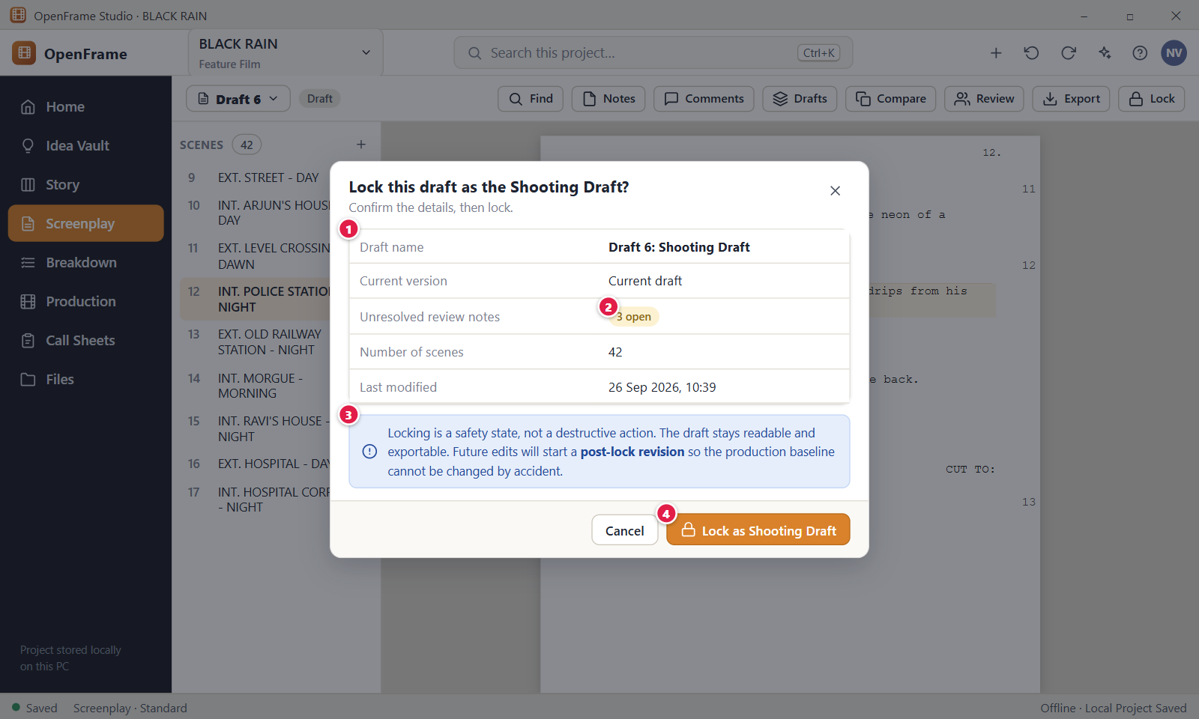
Figure 88. Locking the Shooting Draft. Red numbers are explained on the next page.

Figure 88: Locking the Shooting Draft: how it works
PARTS OF THIS SCREEN  1 Lock checklist A table that sums up the draft before you lock it: "Draft name", "Current version", "Unresolved review notes", "Number of scenes" and "Last modified". "Current version" reads for example "Current draft · Draft". You cannot edit anything in the table. Grey bars show while the numbers load.  2 3 open A yellow chip with the number of review notes that are not resolved yet, followed by a few short samples of those notes. It reads "None" when there are no open notes. You are told the number but you do not have to resolve the notes before you lock.  3 Locking is a safety state Fixed text under the table: "Locking is a safety state, not a destructive action. The draft stays readable and exportable. Future edits will start a post-lock revision so the production baseline cannot be changed by accident." In the app it is plain text, not a coloured banner.  4 Lock as Shooting Draft Confirms the lock. The draft status changes to Locked, the time and your name are recorded, the scene numbers are frozen and the page layout is saved as the baseline for later revisions. A message with Undo appears. The toolbar button Lock is replaced by Revisions. A draft that is already locked cannot be locked again. | HOW TO USE IT  1. Open the draft you want to approve, for example Draft 6.  2. Click Lock in the toolbar. The window "Lock this draft as the Shooting Draft?" opens.  3. Read the checklist: the scene count, the last change time and the number of open review notes.  4. Click Lock as Shooting Draft.  5. Check that the status chip in the toolbar reads "Locked" and that the toolbar now shows Revisions.  GOOD TO KNOW · EDGE CASES  • Locking deletes and hides nothing. The draft stays readable and exportable.  • Locking freezes the scene numbers. A scene added later gets a label such as 12A, and a deleted scene stays in the numbering as OMITTED.  • After the lock, typing in the draft opens a question that offers a revision instead (Figure 89).  • You can see who locked the draft and when under View and more, Draft information.  • Only the project owner can unlock a draft, from Revisions. Unlocking removes the page baseline but keeps the frozen scene numbers.  • A locked draft that is the only production baseline cannot be deleted.
See also: Figure 89 Editing a locked draft: Start Revision Figure 90 Revision label, colour and changed scenes Figure 86 Review rounds Figure 83 Drafts: named drafts and recovery history Figure 95 Exporting the screenplay

Figure 89: Editing a locked draft: Start Revision
What it is for. When you type into the Locked Shooting Draft, OpenFrame stops the edit and asks whether to create a revision instead. This protects the production baseline from accidental changes. The window changes nothing by itself. It only offers to start a revision or to leave the locked draft as it is.
How to get here. Open the Screenplay with a locked draft open (the status chip reads "Locked"). Click into the script and type a letter, paste, or press Delete. The window opens by itself. You need a role that can edit, which means Owner or Editor.
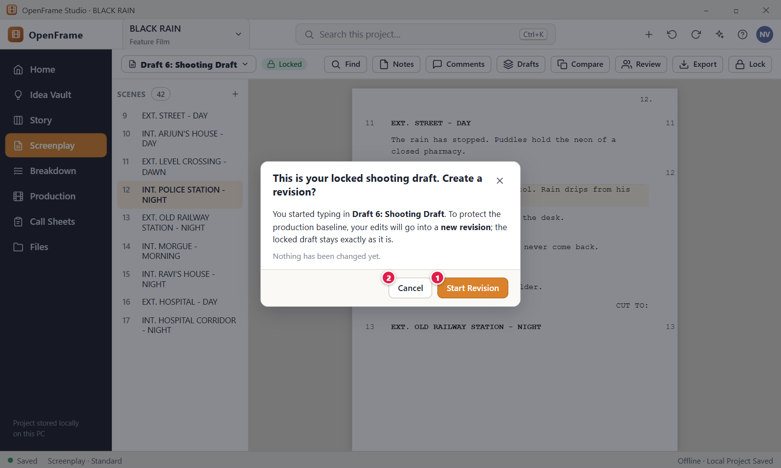
Figure 89. Editing a locked draft: Start Revision. Red numbers are explained on the next page.

Figure 89: Editing a locked draft: Start Revision: how it works
PARTS OF THIS SCREEN  1 Start Revision Closes this window and opens the Start Revision form (Figure 90), where you name the revision and choose a colour. The revision is a writable copy of the locked draft. Nothing is created until you confirm that form. The locked draft stays exactly as it is.  2 Cancel Closes the window and leaves the locked draft as it is. Esc does the same. The letter you typed or the text you pasted is not kept. | HOW TO USE IT  1. Open a locked draft such as Draft 6: Shooting Draft.  2. Click into a line of the script and type a letter. No letter is added, and the window "This is your locked shooting draft. Create a revision?" opens.  3. Read the text: "Nothing has been changed yet."  4. Click Start Revision to continue to the revision form, or click Cancel to leave the draft untouched.  5. In the revision form, name the revision and confirm. Then type again in the new revision.  GOOD TO KNOW · EDGE CASES  • A locked draft is always readable and exportable. Only edits are stopped.  • The edit that opened the window is not applied. After you start the revision, type it again.  • Cancel is the safe choice. The locked draft stays exactly as it is.  • The window opens at most once every second and a half, so fast typing does not stack windows.  • If your role cannot edit, you see the message "You can read this screenplay, but your role doesn't allow editing it." instead of this window.
See also: Figure 88 Locking the Shooting Draft Figure 90 Revision label, colour and changed scenes Figure 76 The screenplay editor (Standard mode)

Figure 90: Revision label, colour and changed scenes
What it is for. After a draft is locked, every production change is made in a revision with a label (for example Revision A) and a colour, so a crew can tell which pages changed. This screen starts a revision, lists the revision history with the locked baseline, and shows which scenes the open revision changed. It answers the question: what changed since the shooting draft, and which revision is this?
How to get here. Open the Screenplay with a locked draft or a revision open and click Revisions in the toolbar. It replaces the Lock button once a draft is locked. To start a revision, click Start Revision in the Revisions panel, or type into a locked draft and click Start Revision (Figure 89).
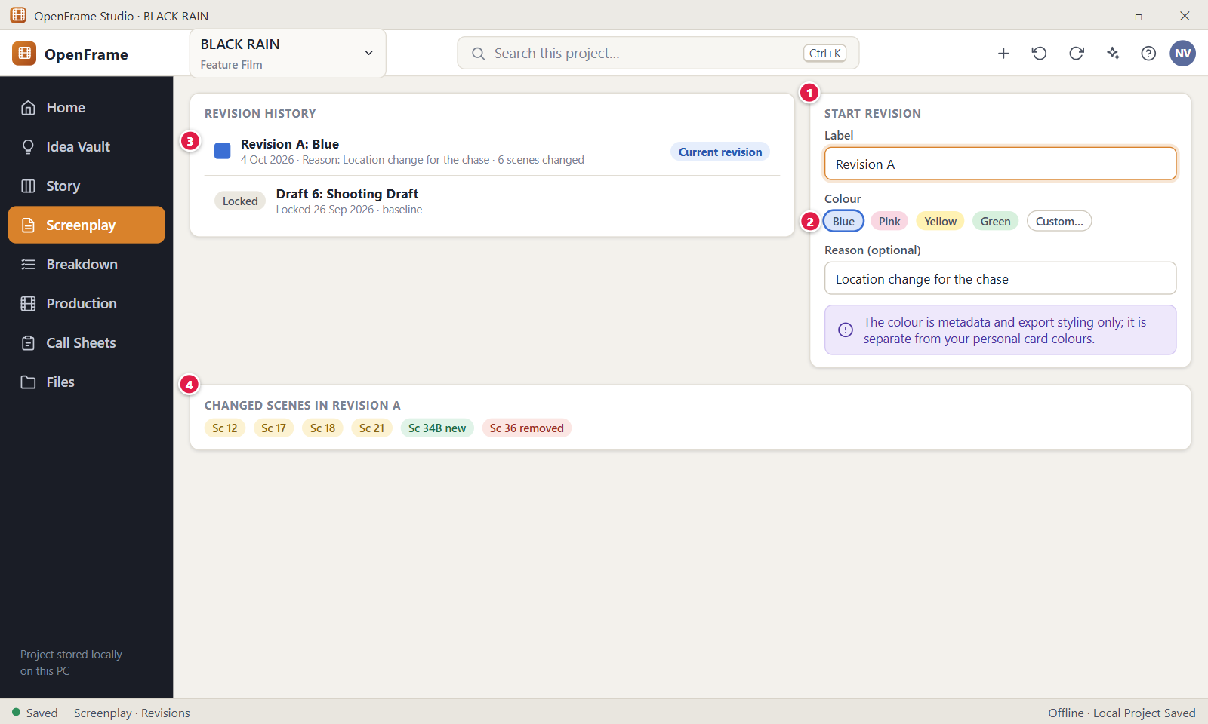
Figure 90. Revision label, colour and changed scenes. Red numbers are explained on the next page.

Figure 90: Revision label, colour and changed scenes: how it works
PARTS OF THIS SCREEN  1 START REVISION The Start Revision window. It asks for a Label (the first free letter, such as "Revision A"), a colour, a revision date and an optional reason. Clicking Start Revision creates a new writable draft from the locked one and opens it. The locked draft never changes. In the app this is a separate window, and the history and changed scenes are in the Revisions side panel.  2 Colour Choices for the revision colour: Blue, Pink, Yellow, Green and Custom…. Blue is chosen at first. Custom… shows a colour picker. The colour marks revision pages in exports and is always shown with a text label. It does not change text colours in the editor.  3 Revision A: Blue One row of the revision history: a colour square, the label and colour ("Revision A · Blue"), the date and the reason, and an Open button. The newest revision is first, then the locked baselines. Open loads that draft and is off for the draft that is already open. The app does not show a count of changed scenes in this row.  4 CHANGED SCENES IN REVISION A Chips for the scenes the revision changed compared with its locked source, such as "Sc 5", "Sc 5A new" and "Sc 9 removed". A line "Changed pages" names the pages, and the last line sums up the counts: changed, added, removed and moved. With no edits it says "No scenes changed yet." | HOW TO USE IT  1. Open the locked draft and click Revisions in the toolbar.  2. Click Start Revision in the panel.  3. Check the label "Revision A", choose a colour such as Pink, and type a reason such as "Location change for the chase".  4. Click Start Revision. The app opens the new draft "Revision A" and the locked draft stays Locked.  5. Edit the scenes you need to change.  6. Click Revisions again and read the chips under the changed scenes.  GOOD TO KNOW · EDGE CASES  • Revision colours are for production revisions only. Ordinary Draft 1 and Draft 2 writing does not use them.  • The colour is only a label and export styling. It is separate from your personal card colours.  • Scene numbers stay frozen after a lock. A new scene gets a label such as 5A, and a deleted scene stays as OMITTED.  • Breakdown and Schedule move to a newer approved revision only when you choose it.  • Unlock draft in the panel is for the project owner only. It does not ask you to confirm.  • With no revisions yet, the panel says "No revisions yet."
See also: Figure 88 Locking the Shooting Draft Figure 89 Editing a locked draft: Start Revision Figure 85 Comparing two drafts Figure 95 Exporting the screenplay Figure 83 Drafts: named drafts and recovery history

Figure 91: Importing a screenplay: choose the source
What it is for. Import Screenplay brings an existing script into OpenFrame in three steps: choose the source, preview how OpenFrame read it, then import. This first step picks a file or accepts pasted text. Nothing is created until the last step, and an existing screenplay is never replaced.
How to get here. Open the Screenplay. If the project has no screenplay yet, click Import Screenplay on the empty page. With a screenplay open, use the View and more menu and choose "Import screenplay…" (Owner or Editor only). From anywhere, use the + button at the top and choose "Import Screenplay…".
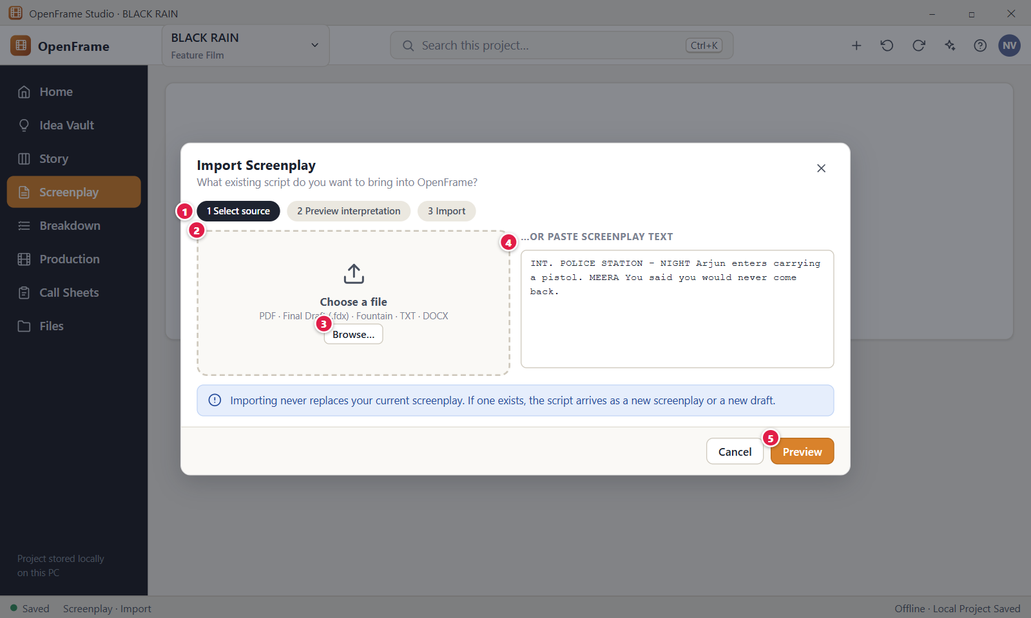
Figure 91. Importing a screenplay: choose the source. Red numbers are explained on the next page.

Figure 91: Importing a screenplay: choose the source: how it works
PARTS OF THIS SCREEN  1 1 Select source, 2 Preview interpretation, 3 Import Three labels that show where you are. The current step is dark and the others are grey. They are not buttons. You move on with the buttons at the bottom of the window: Preview goes to step 2, and a successful Import goes to step 3.  2 Choose a file The box on the left shows the accepted types: PDF, Final Draft (.fdx), Fountain, TXT and DOCX. After you pick a file it shows the file name and a Clear button. A file can be up to 100 MiB, and text files up to 20 MiB of text. Older .doc files and other types such as rtf or pages are refused with a message. Your original file is never changed.  3 Browse… Opens the Windows file picker titled "Choose a screenplay to import". You can pick one file. Choosing a file clears any pasted text and any chosen sample script.  4 …OR PASTE SCREENPLAY TEXT A large text box for pasting a script instead of choosing a file. It follows the same preview and import steps as a TXT file. You can paste up to 5 MiB. Text that starts with a Fountain title line such as "Title: BLACK RAIN" is read as Fountain. The box is off while a file is chosen.  5 Preview Reads the chosen file or pasted text and shows how OpenFrame understood it. It creates nothing in the project. The button is off until you choose a file or paste text, and it reads "Reading…" while it works. | HOW TO USE IT  1. Open the Screenplay and start Import Screenplay from the empty page, the View and more menu, or the + button.  2. Click Browse… and pick a file such as BLACK-RAIN-valid.fountain. You can also paste the script text into the box.  3. Check that the file name appears in the left box. Click Clear if you picked the wrong file.  4. Click Preview to go to step 2 and see how the script was read.  5. Click Cancel at any time to leave without changing the project.  GOOD TO KNOW · EDGE CASES  • Import never replaces your current screenplay. If one exists, the script arrives as a new screenplay or a new draft.  • Nothing is created in step 1 or step 2. The project changes only when you click Import.  • PDF import is best effort, because a PDF may not carry screenplay structure. OpenFrame shows warnings before you commit.  • The window also offers four sample scripts under "Or open a sample script": Example Feature, Example Short, Example Scene and FDX Interchange Test.  • The Project Home card "Write/Import Screenplay" only opens the Screenplay screen. The import window is opened from there.  • If a file cannot be read, a message tells you what was wrong and that your project was not changed (Figure 93).
See also: Figure 92 Import preview and warnings Figure 93 Import failed (safe failure) Figure 94 Import report Figure 76 The screenplay editor (Standard mode) Figure 104 Breakdown: scene list, script and elements

Figure 92: Import preview and warnings
What it is for. The import preview shows how OpenFrame understood the file before anything is created: the facts it found, the warnings, every detected scene heading with a status, and where the script will go. It answers the question: did OpenFrame read my script correctly, and where will it be saved? You can still go back or cancel without changing the project.
How to get here. Open the Screenplay, start Import Screenplay (Figure 91), choose a file or paste text, and click Preview. You need a project role that can import, which means Owner or Editor.
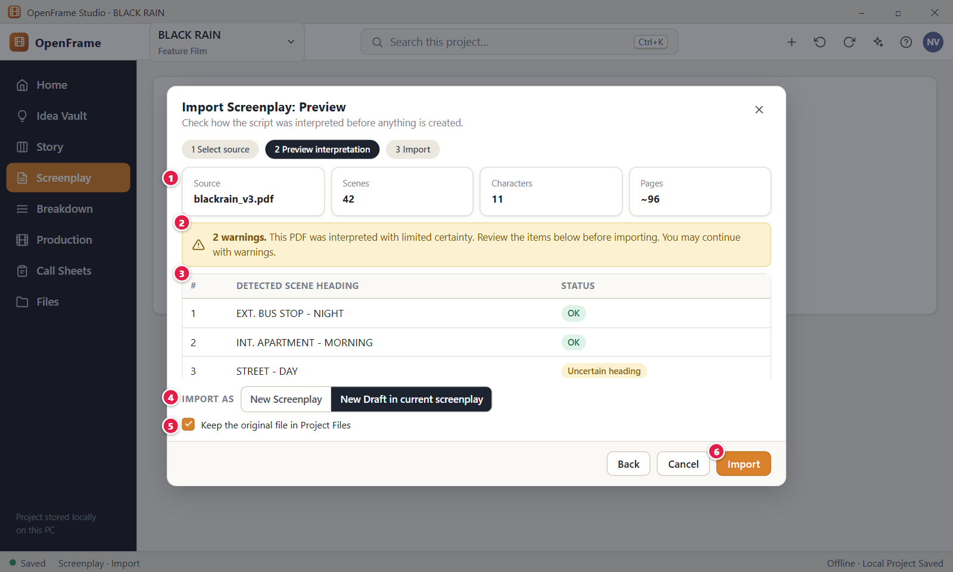
Figure 92. Import preview and warnings. Red numbers are explained on the next page.

Figure 92: Import preview and warnings: how it works
PARTS OF THIS SCREEN  1 Source, Scenes, Characters, Pages Four boxes with what OpenFrame found: the source name and type, the number of scenes, the number of characters and the approximate page count. A tilde before the pages means approximate. Chips add a confidence level, the title (for example "Title: BLACK RAIN"), the author and the number of dialogue blocks. A PDF is never shown as high confidence.  2 Warnings banner Tells you how many warnings exist and whether the file was read with certainty. Green means no warnings, blue means minor ones, and yellow means you should review the items. The button Show warnings opens the list, where each line has the chip "Needs attention" or "Info". Warnings never block the import.  3 Detected scene heading A table with one row per detected scene, in script order, with a Status chip: OK, Uncertain heading, Potentially empty or Before first scene. Check the headings here. The table is read-only, so fix a wrong heading in the source file or after the import. With no scenes it says "No scenes were detected."  4 IMPORT AS Chooses where the script goes. New Screenplay creates a separate screenplay. New Draft adds a named draft to an existing screenplay, and this is chosen first when the project already has one. Existing drafts are never overwritten. A Draft name field lets you name the new draft. If you leave it empty, the app uses the file name followed by "(imported)".  5 Keep the original file in Project Files A checkbox that is ticked at first. When ticked, OpenFrame also stores a copy of the source file in Project Files. For pasted text it reads "Keep the pasted text in Project Files". The original on your disk is never changed.  6 Import Creates the screenplay or draft and moves to the report (Figure 94). The button reads "Importing…" while it works. The import is all or nothing: if it fails, nothing is left behind. A message with Undo appears when it succeeds. | HOW TO USE IT  1. In step 1, choose BLACK-RAIN-valid.fountain and click Preview.  2. Read the facts at the top. For BLACK RAIN you should see 12 scenes and 4 characters.  3. Click Show warnings if the banner lists any, and read the items marked "Needs attention".  4. Scan the scene table. Rows marked Uncertain heading or Potentially empty need a second look.  5. Under IMPORT AS, choose New Draft or New Screenplay and type a draft name if you want one.  6. Leave the Project Files box ticked to keep a copy, then click Import.  GOOD TO KNOW · EDGE CASES  • Preview is read-only. Nothing is created until you click Import, and the original file is never changed.  • Warnings do not mean the script is unusable. They mark items worth checking, and you can import with them.  • A preview is kept for 1 hour. After that you see "This import preview is no longer available. Choose the file again to preview it. Your project was not changed."  • In a series project, the first choice reads "New Screenplay for episode" and you must pick an episode. With no episode, Import stays off until you add one.  • If the draft name is already taken, the app adds a number to it.  • Plain text and pasted text have no built-in structure. OpenFrame reads headings and character names from the layout and says so in an information warning.
See also: Figure 91 Importing a screenplay: choose the source Figure 93 Import failed (safe failure) Figure 94 Import report Figure 83 Drafts: named drafts and recovery history Figure 154 Project Files (file cabinet)

Figure 93: Import failed (safe failure)
What it is for. When an import cannot work, this screen says which file, at which stage and what was wrong, and confirms that your project and the original file were not changed. It then offers a safe next step. It answers the question: what went wrong, and is my work safe?
How to get here. It appears by itself in the Import Screenplay window (Figure 91) when you click Preview on a file that cannot be read, such as a damaged or empty file, or on pasted text that is not a screenplay. It can also appear when you click Import after the preview has expired.
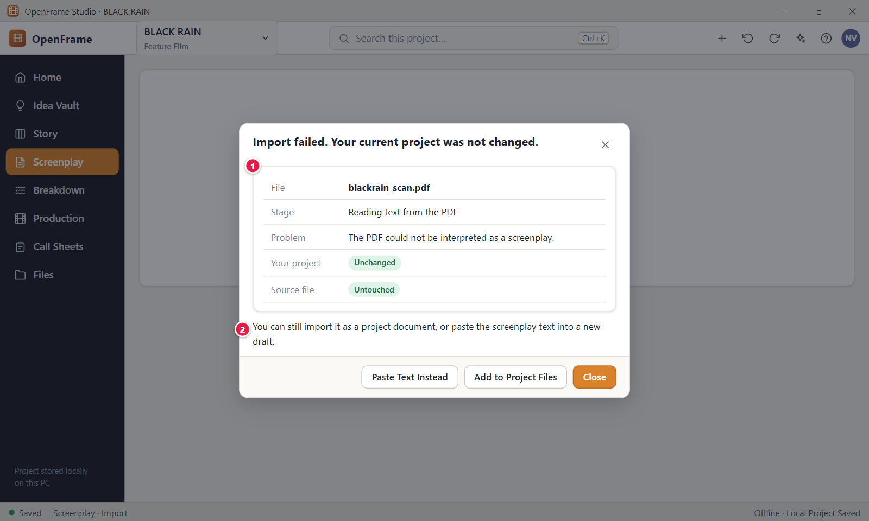
Figure 93. Import failed (safe failure). Red numbers are explained on the next page.

Figure 93: Import failed (safe failure): how it works
PARTS OF THIS SCREEN  1 Failure details A card that names the file (or "Pasted text"), the stage where reading stopped, and the problem in plain words. The stage can be "Reading text from the PDF", "Checking the file type", "Opening the document", "Reading the Final Draft file" or "Reading the file". Green chips say your project is "Unchanged" and the source file is "Untouched". The window title reads "Import failed. Your current project was not changed."  2 You can still import it as a project document A sentence under the card that tells you what you can still do. For a file, it says you can import it as a project document or paste the screenplay text into a new draft. For an empty file, a file that is too large, or pasted text, it says "You can paste the screenplay text instead, or choose another file." The button Add to Project Files copies the file into Project Files and does not turn it into a screenplay. | HOW TO USE IT  1. Read the Stage and Problem rows to see why the file was refused.  2. Check that Your project shows "Unchanged".  3. Click Add to Project Files if you want to keep the file as a normal project file. A message "Added" with the file name appears and the window closes.  4. Or click Paste Text Instead and paste the screenplay text to try again.  5. Click Close to leave the window. Nothing was added to the project.  GOOD TO KNOW · EDGE CASES  • A failed import never leaves partial data behind. No screenplay, draft or file is created.  • The title already says your project was not changed, so the Problem row leaves that sentence out.  • The stage and the problem change with the file. A damaged PDF says it "may be damaged or password-protected". A damaged Final Draft file says it is "damaged or incomplete".  • Add to Project Files shows only when a file was chosen and the problem is not an empty or too large file.  • The Source file row shows only when you chose a file. For pasted text the first row reads "Source" with the value "Pasted text".  • Add to Project Files stores a copy only. The original stays where it was.
See also: Figure 91 Importing a screenplay: choose the source Figure 92 Import preview and warnings Figure 94 Import report Figure 154 Project Files (file cabinet)

Figure 94: Import report
What it is for. After an import, this short report confirms what was created: the name of the new draft or screenplay, how many scenes and characters were imported, how long the script is, and how many warnings need attention. It answers the question: what exactly did the import create, and is anything left to check?
How to get here. It appears by itself after you click Import in the preview (Figure 92). The editor behind the window already shows the imported draft.
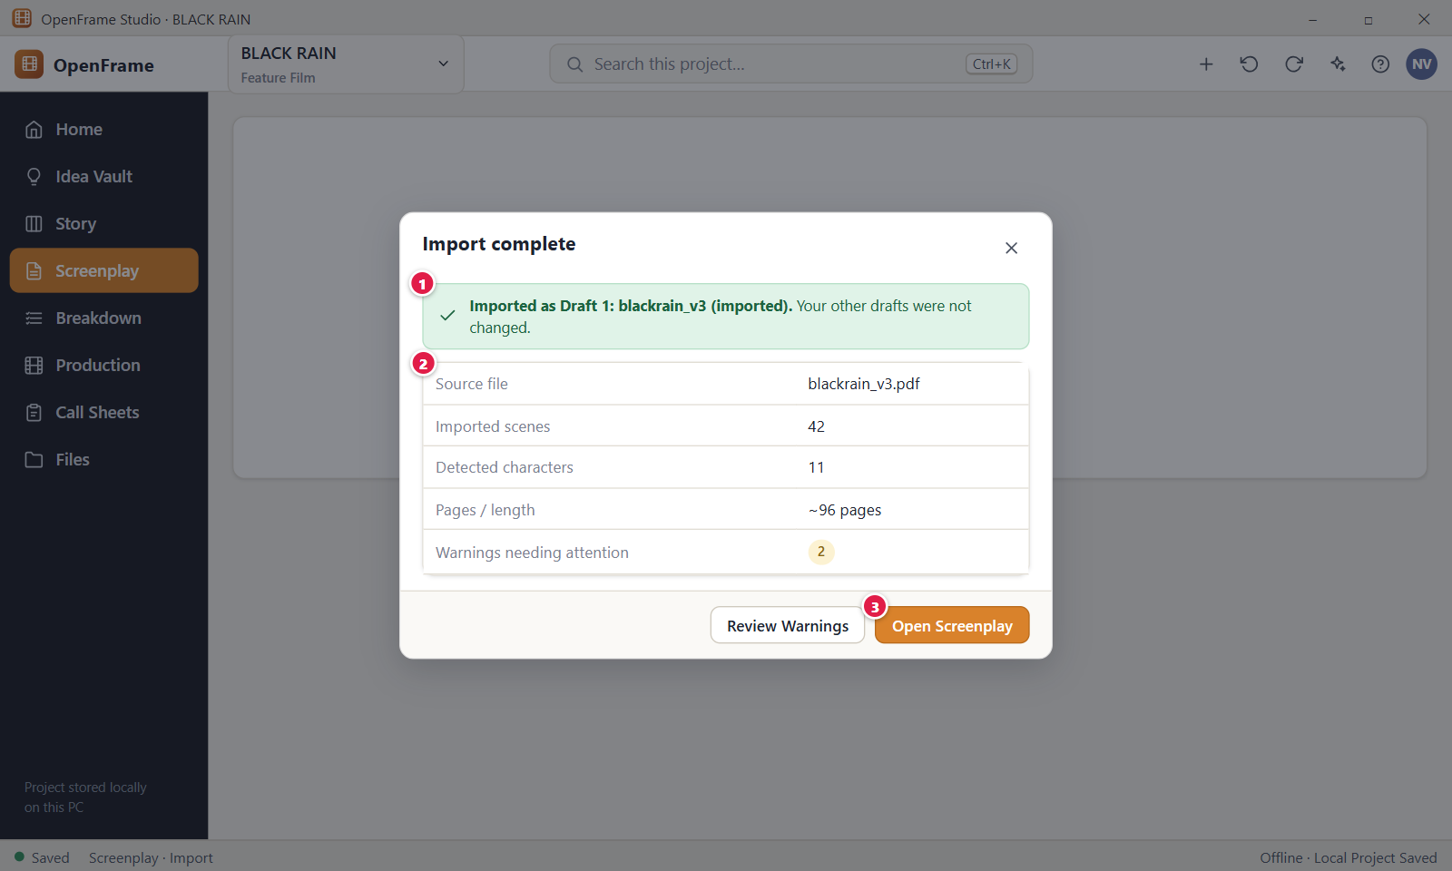
Figure 94. Import report. Red numbers are explained on the next page.

Figure 94: Import report: how it works
PARTS OF THIS SCREEN  1 Result banner A green banner at the top. For a new draft it reads "Imported as Draft N: <name>. Your other drafts were not changed." For a new screenplay it reads that the script was imported as a new screenplay and that nothing else in your project was changed. The draft number is the count of drafts after the import. A draft imported into an existing screenplay does not become the Current draft.  2 Import report A table with the facts: "Source file", "Imported scenes", "Detected characters", "Pages / length" (for example "~96 pages") and "Warnings needing attention". The chip is yellow above 0 and green at 0, and it counts only warnings that need attention, not information notes. When you kept the original, a row "Original file" reads "Kept in Project Files".  3 Open Screenplay Closes the report and opens the new script in the editor with the imported draft selected. Because the editor behind the window already shows the new draft, the click mostly just closes the window. If any warnings exist, a Review Warnings button also appears. | HOW TO USE IT  1. Click Import in the preview. A message "Imported" with the draft name appears.  2. Read the banner to see the name of the new draft, for example "BLACK-RAIN-valid (imported)".  3. Check the table: the scene and character counts should match the preview.  4. Click Review Warnings if the chip shows a number above 0, and read the items.  5. Click Open Screenplay to start working on the imported draft.  GOOD TO KNOW · EDGE CASES  • Imported content becomes screenplay or draft content only. It does not create Story Board cards or production data by itself.  • An imported draft in an existing screenplay is not marked Current. Use Mark current in the Drafts drawer if you want that.  • The chip counts only warnings that need attention, so it can differ from the count in the preview banner, which includes information notes.  • Closing the report does not undo the import. Use Undo in the message, or Ctrl+Z, to remove it.  • Existing drafts are never overwritten by an import.
See also: Figure 92 Import preview and warnings Figure 76 The screenplay editor (Standard mode) Figure 83 Drafts: named drafts and recovery history Figure 154 Project Files (file cabinet)

Figure 95: Exporting the screenplay
What it is for. Export Screenplay creates a clean document snapshot of one draft in the format you need: PDF, Final Draft (.fdx), Fountain or DOCX. The window answers four questions at once: what am I exporting, which version, in which format, and where will it be saved. Export never changes the project and never includes private notes.
How to get here. Open the Screenplay and click Export in the toolbar. You can also right-click a scene in the navigator and choose "Export Scene". Owners, editors and export-only members can export.
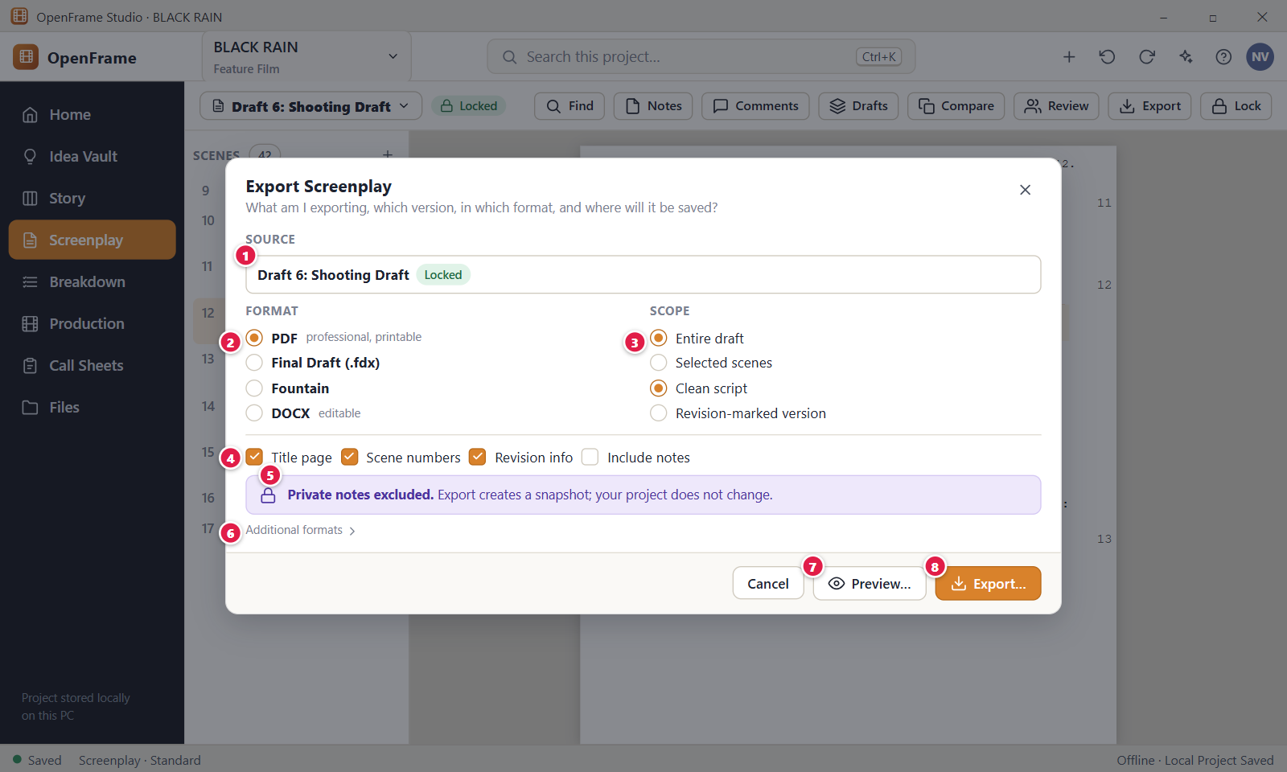
Figure 95. Exporting the screenplay. Red numbers are explained on the next page.

Figure 95: Exporting the screenplay: how it works
PARTS OF THIS SCREEN  1 Source Shows which draft is exported, with a status chip (Draft, Review, Locked or Revision) and the scene count. OpenFrame never picks the latest draft silently, so the name is always visible. With more than one draft the name is a list, and the current draft reads "(current)". Changing the draft clears any scenes you ticked. A locked draft can be exported.  2 Format Choose one: PDF (professional, printable), Final Draft (.fdx), Fountain or DOCX (editable). PDF is chosen at first. FDX and Fountain keep the screenplay structure and can be imported again. DOCX keeps readable content for editing. The format sets the file ending in the Save window.  3 Scope Two choices. First: Entire draft or Selected scenes, which shows a tick list of scenes. Second: Clean script or Revision-marked version, which marks revised lines in PDF, DOCX and FDX. Fountain and plain text cannot show revision marks. With Selected scenes and nothing ticked, Preview… and Export… stay off.  4 Options Four tick boxes: Title page, Scene numbers, Revision info and Include notes. Title page, Scene numbers and Revision info are ticked at first. Include notes is off and adds only the notes written in the script, never private notes or review comments. Revision info is off when Title page is off.  5 Private notes excluded A fixed line: "Private notes excluded. Export creates a snapshot; your project does not change." It also shows on the "Export complete" screen. Editing an exported file outside OpenFrame never changes the project.  6 Additional formats A link at the bottom. Click it to reveal one more choice, "Plain text (.txt)", a screenplay laid out in plain characters. The link then disappears. Plain text cannot show revision marks.  7 Preview… Opens the Print Preview inside the same window so you can see the pages before you save anything (Figure 96). It is off when Selected scenes is chosen and no scene is ticked. Back to Export Options returns here with your settings.  8 Export… Opens the Windows Save window titled "Export Screenplay" with a suggested name such as "BLACK RAIN - Draft 6 Shooting Draft.pdf". After you save, an "Export complete" screen lists the source, format, scenes and location, with the buttons Show in Folder and Close. You cannot save inside the project's own folder. | HOW TO USE IT  1. Open the Screenplay and click Export in the toolbar.  2. Check the Source draft, for example Draft 6: Shooting Draft.  3. Choose a Format, for example PDF.  4. Choose the Scope. To export only a few scenes, pick Selected scenes and tick them.  5. Set the Options, then click Preview… if you want to see the pages first.  6. Click Export…, choose a folder such as Documents and click Save.  7. On the "Export complete" screen, click Show in Folder to find the file.  GOOD TO KNOW · EDGE CASES  • Export is a copy. Editing the exported file outside OpenFrame never changes your project.  • Selected scenes keep their numbers from the full draft when Scene numbers is on.  • The PDF fonts cover Latin scripts, Devanagari, Telugu, Tamil, Malayalam and Kannada. If the draft has other characters, no PDF is written and the message suggests DOCX, Final Draft or Fountain.  • A draft with no scenes cannot be exported. The message says "This draft has no scenes to export yet."  • Exports cannot be saved inside the project's own folder or on a drive that is missing. The message asks you to choose another place.  • Export does not make a draft Current and does not lock or change anything.
See also: Figure 96 Document preview and printing Figure 88 Locking the Shooting Draft Figure 90 Revision label, colour and changed scenes Figure 91 Importing a screenplay: choose the source Figure 83 Drafts: named drafts and recovery history

Figure 96: Document preview and printing
What it is for. Print Preview shows the pages that will leave the app, before you print them or save them as a PDF. It answers the question: does this document look correct? The settings on this screen change only the outgoing document, never the screenplay.
How to get here. Open the Screenplay, click Export in the toolbar, keep the format PDF and click Preview…. The window changes to "Print Preview". There is no File menu and no Ctrl+P shortcut for it.
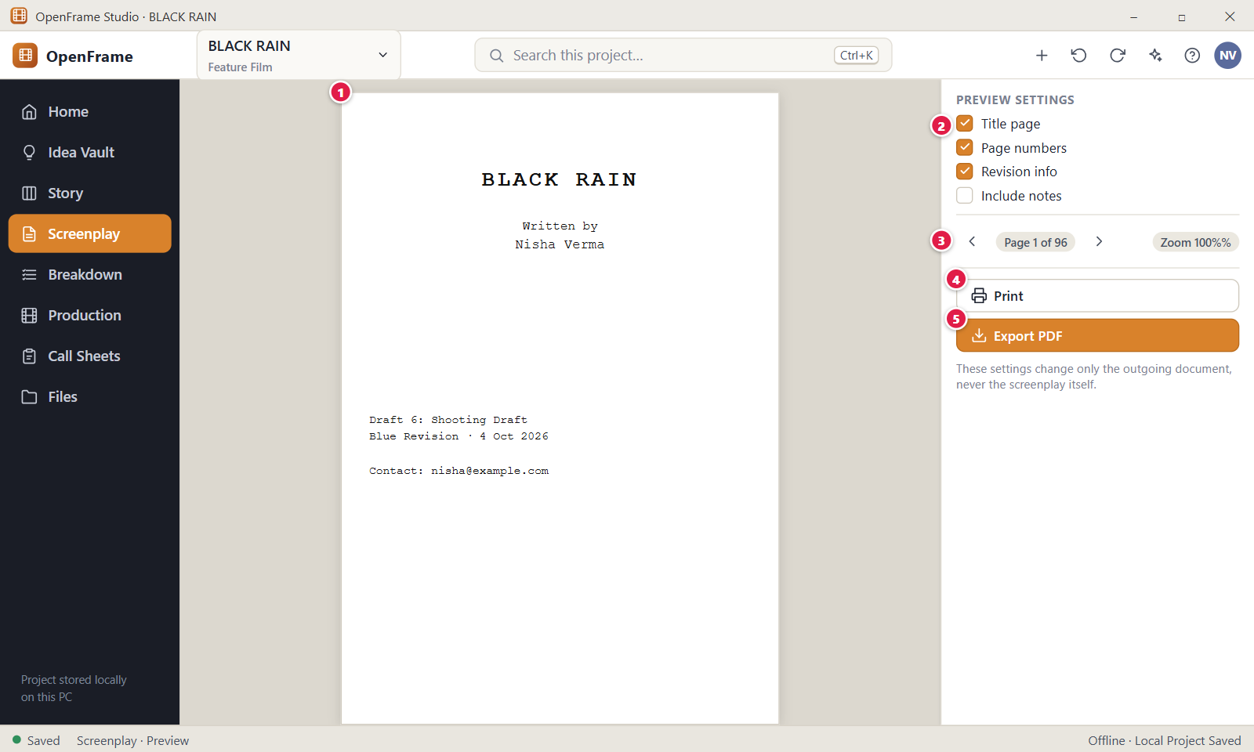
Figure 96. Document preview and printing. Red numbers are explained on the next page.

Figure 96: Document preview and printing: how it works
PARTS OF THIS SCREEN  1 BLACK RAIN title page The page area shows one page of the outgoing document at a time, in Courier at true proportions. Page 1 is the title page when "Title page" is on. It uses the same layout as the PDF, so what you see is what the file holds. You cannot type in it. Private notes are never drawn. A grey block shows while it loads.  2 Title page A tick box in the preview settings that adds or removes the title page from this output. Unticking it also turns off "Revision info". The choice is shared with the Export window. It does not change the Page setup or the title page fields.  3 Page navigation and zoom Two rows of buttons. Previous page and Next page move one page at a time, and a chip shows your position, such as "Title page · 1 of 14". Zoom out and Zoom in change the view in steps of 50%, 75%, 100% and 125%. Zoom changes only the view, not the printed size.  4 Print Sends every page to the Windows print window at true size, not only the page on screen. It is off while the preview loads, when there is nothing to show, and while a print job is open. Printing does not change the project.  5 Export PDF Creates a PDF with the settings from this preview. It opens the Windows Save window first and suggests a name such as "BLACK RAIN - Draft 6 Shooting Draft.pdf". It reads "Exporting…" while it works. After saving, an "Export complete" screen appears. It is off when the draft has characters the PDF font cannot print. | HOW TO USE IT  1. Open the Screenplay, click Export and choose PDF.  2. Click Preview…. The first page shown is the title page.  3. Click Next page to read through the script pages, and use Zoom in or Zoom out if you need.  4. Untick Title page to see the document without it. Tick it again to bring it back.  5. Click Print to send the pages to the Windows print window, or click Export PDF and choose where to save.  6. Click Back to Export Options to return, or Close to leave.  GOOD TO KNOW · EDGE CASES  • Print and Export PDF use the same layout, so the paper and the PDF match the preview.  • The settings on this screen are for this output only. The screenplay and its Page setup never change.  • Private notes are never printed or exported. Include notes adds only the notes written in the script.  • A locked draft can be previewed, printed and exported freely. Locking blocks typing, not output.  • If the draft has no pages, the preview says "Nothing to show." If it cannot load, you see "The preview could not be prepared."  • The Windows print window belongs to Windows. Its layout and printers are not part of OpenFrame.
See also: Figure 95 Exporting the screenplay Figure 100 Title page details Figure 76 The screenplay editor (Standard mode) Figure 88 Locking the Shooting Draft

Figure 97: Scene Hub: what exists around a scene
What it is for. The Scene Hub is a side panel that lists what exists around one scene: the screenplay, the breakdown, shots, storyboard panels, the schedule, comments and the Story Board card. It answers the question: what exists around this scene? It also lets you jump to the right workspace with that scene already in focus.
How to get here. Open the Screenplay and right-click a scene in the scene list on the left, then choose "Scene Hub" (Figure 98). You can also open the View and more menu (the columns icon at the right end of the toolbar) and choose "Scene Hub…" for the scene where your cursor is.
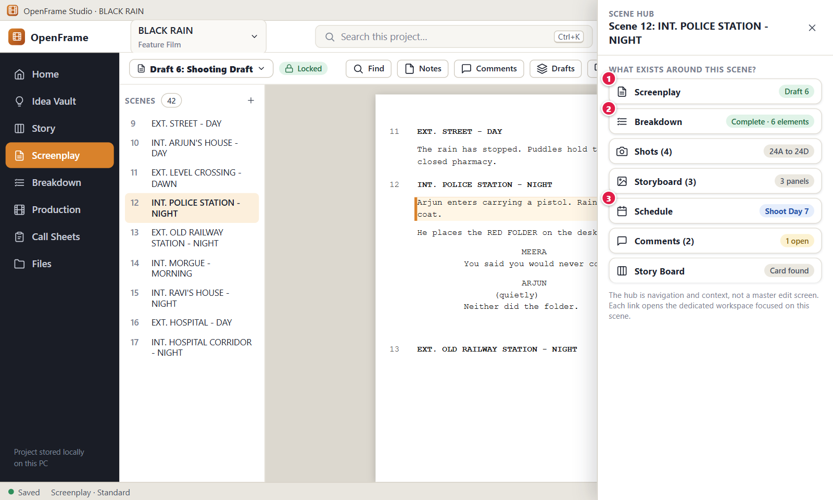
Figure 97. Scene Hub: what exists around a scene. Red numbers are explained on the next page.

Figure 97: Scene Hub: what exists around a scene: how it works
PARTS OF THIS SCREEN  1 Screenplay The first row. Its right side shows the name of the draft that holds the scene, for example "Draft 6: Shooting Draft". Because you are already in the editor, clicking it only closes the hub. Scene 12 stays open in the editor.  2 Breakdown Shows how many breakdown elements the scene has, for example "6 elements", or "4 confirmed · 2 suggested" when suggestions are waiting. With none it says "Nothing created yet". Click it to close the hub and open Breakdown (Figure 104) on the same scene.  3 Schedule The label reads "Schedule (1)" with the number of schedule strips for the scene, or "Schedule (0)" with "Nothing created yet" when the scene is not scheduled. The row does not show a shoot day name. Click it to open Production on the Schedule tab with the scene in focus. The hub never changes the schedule. | HOW TO USE IT  1. Open the Screenplay and right-click scene 12, "INT. POLICE STATION - NIGHT", in the scene list.  2. Choose "Scene Hub". The panel opens on the right with the title "Scene 12: INT. POLICE STATION - NIGHT".  3. Read the rows to see what exists: Screenplay, Breakdown, Shots, Storyboard, Schedule, Comments and Story Board.  4. Click Breakdown to jump to the Breakdown workspace with scene 12 selected.  5. Come back to the Screenplay and press Esc to close the hub.  GOOD TO KNOW · EDGE CASES  • The hub is for navigation and context. It never edits anything.  • Shots, Storyboard and Schedule show a count in the label, for example "Shots (4)". They stay at 0 until you create production data for the scene.  • The Story Board row says "Card found" when a card is linked to the scene and "No linked card" when none is. Comments says "No comments yet." when empty.  • The hub works on a locked draft because it only reads.  • Production data follows the scene itself, not its number, so counts do not change when a scene is renumbered.  • Esc closes the panel.
See also: Figure 98 Right-click menu on a screenplay scene Figure 104 Breakdown: scene list, script and elements Figure 99 Moving a scene that is already in production planning Figure 83 Drafts: named drafts and recovery history Figure 88 Locking the Shooting Draft

Figure 98: Right-click menu on a screenplay scene
What it is for. The scene menu is the right-click menu of a scene in the screenplay scene list. It jumps to the other workspaces with that scene already chosen, and offers Scene Hub, comments, copy and export. It answers the question: where can I take this scene next?
How to get here. Open the Screenplay and right-click any scene row in the scene list on the left, for example scene 12 "INT. POLICE STATION - NIGHT". The menu opens only from the scene list. A right-click on a heading in the page does not open it.
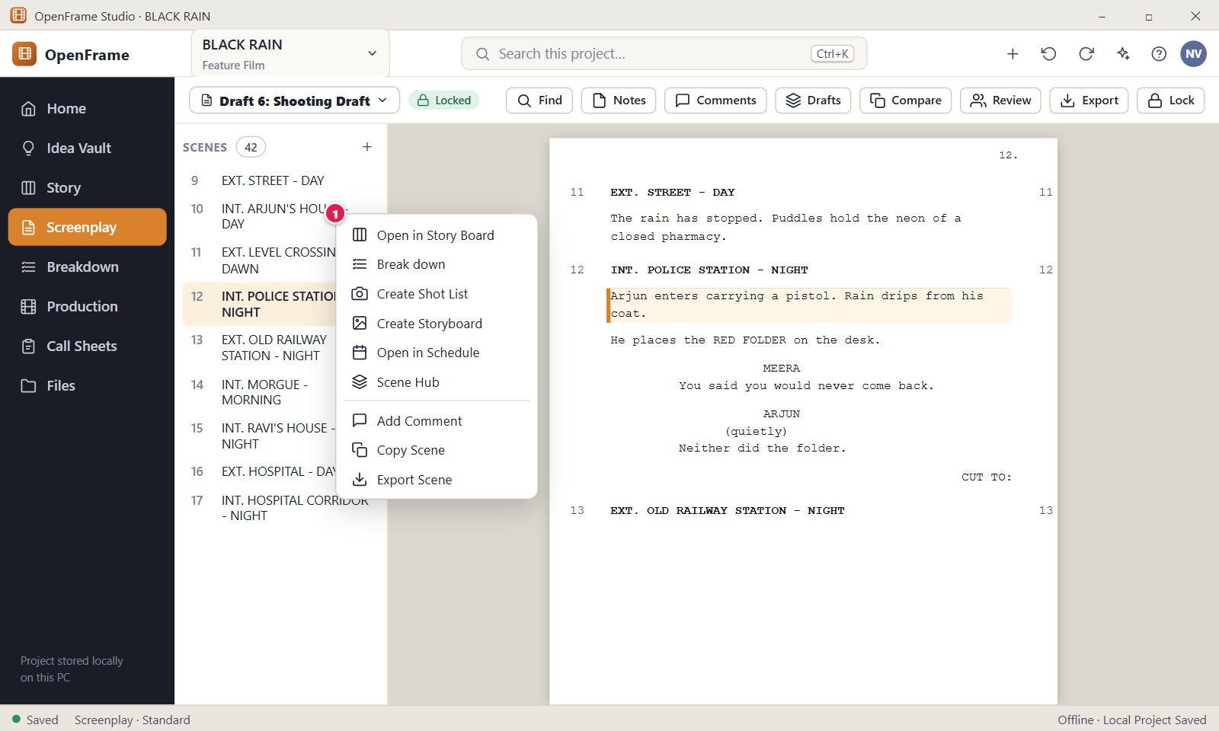
Figure 98. Right-click menu on a screenplay scene. Red numbers are explained on the next page.

Figure 98: Right-click menu on a screenplay scene: how it works
PARTS OF THIS SCREEN  1 Scene menu A list that opens at the pointer. The first group jumps to other workspaces: Open in Story Board, Break down, Create Shot List, Create Storyboard and Open in Schedule. The second group has Scene Hub, Add Comment, Copy Scene and Export Scene. On a draft you can edit, four more items follow: "Scene number…", "Move up", "Move down" and "Delete scene". On a locked draft the menu ends after Export Scene. Add Comment is hidden if your role cannot comment. Esc or a click outside closes the menu. | HOW TO USE IT  1. Open the Screenplay and right-click scene 12 in the scene list.  2. Choose "Break down" to open Breakdown with scene 12 selected.  3. Go back, right-click the scene again and choose "Scene Hub" to see what exists around it (Figure 97).  4. Choose "Copy Scene". A message "Copied Scene 12" confirms it.  5. Choose "Export Scene" to open the Export window (Figure 95).  GOOD TO KNOW · EDGE CASES  • Each "Open in" item only moves you to the other workspace. It changes nothing by itself.  • "Create Shot List" and "Create Storyboard" open the tab for the scene. They do not add a shot or panel on their own.  • "Copy Scene" copies plain text and does not change the project. If the clipboard is blocked, you see "The scene could not be copied to the clipboard."  • "Export Scene" opens the full Export window with Entire draft chosen. It does not pick the scene for you, so choose Selected scenes if you want only this one.  • "Move up" and "Move down" can show a warning when the scene is already used in production planning (Figure 99).
See also: Figure 97 Scene Hub: what exists around a scene Figure 99 Moving a scene that is already in production planning Figure 104 Breakdown: scene list, script and elements Figure 95 Exporting the screenplay Figure 76 The screenplay editor (Standard mode)

Figure 99: Moving a scene that is already in production planning
What it is for. This warning appears when you move a scene that production already depends on. Story order and shooting order are different things, so OpenFrame tells you the scene is used in breakdown, shots, storyboard or the schedule before it changes the script number. It answers the question: what happens to production if I move this scene?
How to get here. Open the Screenplay, right-click a scene in the scene list and choose "Move up" or "Move down" (Figure 98), or drag the scene by its grip handle. The window opens only when the scene has production data. Otherwise the scene moves at once. A locked draft has no Move up, Move down or drag handle.
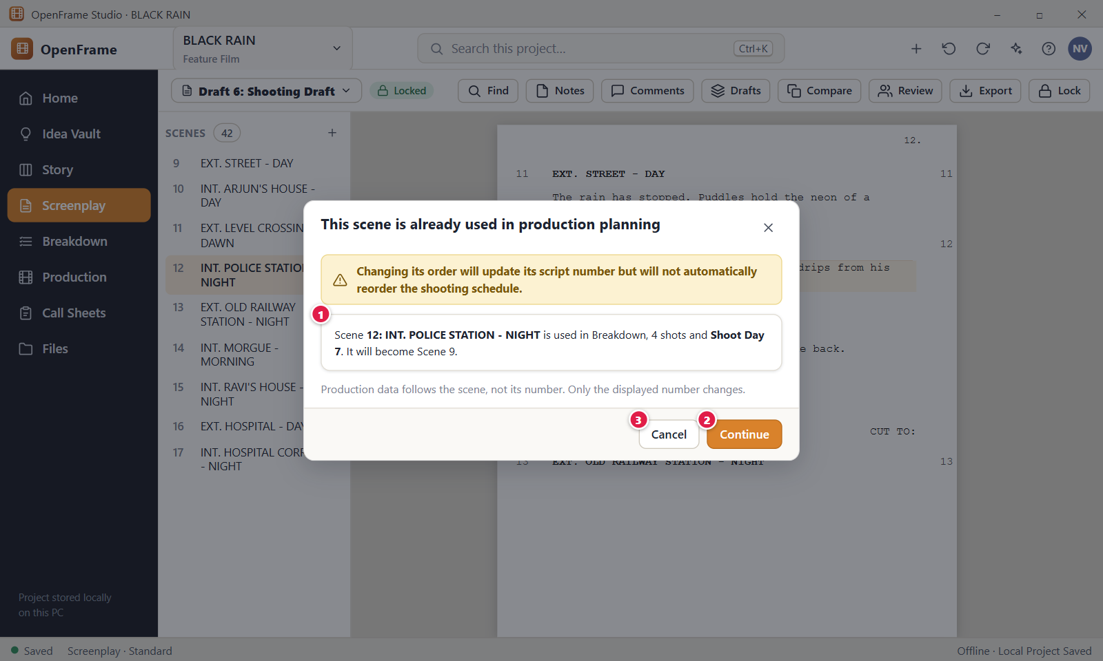
Figure 99. Moving a scene that is already in production planning. Red numbers are explained on the next page.

Figure 99: Moving a scene that is already in production planning: how it works
PARTS OF THIS SCREEN  1 Warning text The title reads "This scene is already used in production planning". The body names the scene, lists where production uses it, and says its new number, for example "Scene 12: INT. POLICE STATION - NIGHT is used in Breakdown and 4 shots. It will become Scene 11." The list can also mention storyboard panels and the shooting schedule. A grey line says that production data follows the scene, not its number.  2 Continue Makes the move. The scene gets its new position and number in the script, and the message "Moved the scene to position 11" appears with Undo. The shooting schedule is not reordered. Breakdown, shots, storyboard and schedule data stay attached to the scene.  3 Cancel Closes the window and leaves the order alone. Esc does the same. Nothing is moved and no message appears. | HOW TO USE IT  1. Open an editable draft in the Screenplay. Scene 12 must already have production data, such as a breakdown element.  2. Right-click scene 12 in the scene list and choose "Move up".  3. Read the warning to see where the scene is used and which number it will get.  4. Click Continue to move the scene, or click Cancel to keep the order.  5. If you moved it by mistake, click Undo in the message or press Ctrl+Z.  GOOD TO KNOW · EDGE CASES  • Production data follows the scene itself, not its number. Only the displayed number changes.  • The shooting schedule is never reordered automatically, because story order and shooting order are different.  • The warning appears for Move up, Move down and for drag and drop.  • Moving a scene with no production data is silent and still offers Undo.  • One Undo moves the scene back.
See also: Figure 98 Right-click menu on a screenplay scene Figure 97 Scene Hub: what exists around a scene Figure 103 Start Production Setup: choose the production source Figure 88 Locking the Shooting Draft

Figure 100: Title page details
What it is for. The Title page window holds the text that is printed on page 1 of an exported or printed screenplay: the title, who wrote it, the draft and revision lines and the contact block. It answers the question: what will the first page of my script say?
How to get here. Open the Screenplay, open the View and more menu (the columns icon at the right end of the toolbar) and choose "Title page…". The item is greyed out for roles that cannot edit. The Export window has no link to it.
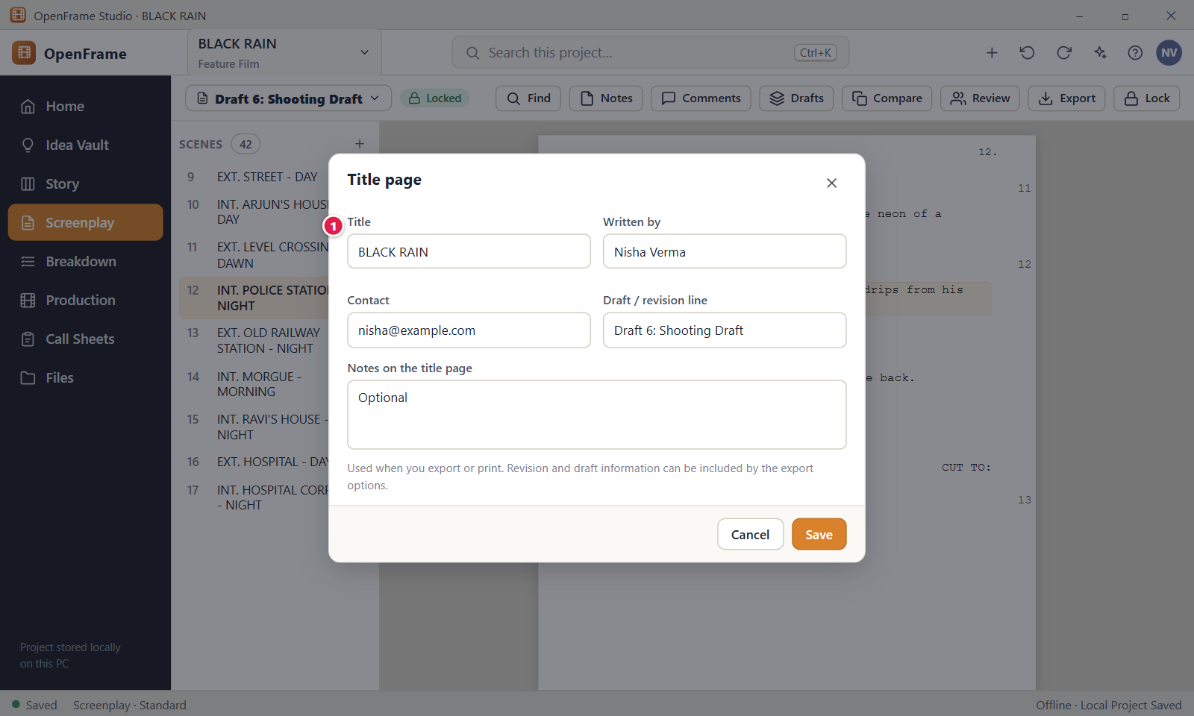
Figure 100. Title page details. Red numbers are explained on the next page.

Figure 100: Title page details: how it works
PARTS OF THIS SCREEN  1 Title The title printed in capitals at the top of the title page. It is also the name of the screenplay and part of the default file name of exports. It is required and holds up to 200 characters, and Save stays off while it is empty. Changing it renames the screenplay but not the project name in the top bar or on Home. Below it the window has more fields: Written by, Credit line, Based on, Draft, Revision, Date, the contact fields, Representation, Notes on the title page and Copyright. A live preview on the right shows the page, and a box lets you leave the title page out of exports and printing. | HOW TO USE IT  1. Open the Screenplay, then View and more, then "Title page…".  2. Type the title, for example BLACK RAIN. The preview on the right updates after a moment.  3. Fill in "Written by", for example Nisha Verma, and the contact fields.  4. Leave Credit line, Draft and Revision empty to use the built-in defaults.  5. Click Save. A message "Saved the title page" appears with Undo.  6. Open Export, then Preview…, to see the new title page as page 1.  GOOD TO KNOW · EDGE CASES  • The title page text is used only when you export or print. The export options can switch the title page and the revision information on or off.  • An empty Credit line prints "Written by". An empty Draft uses the draft name. An empty Revision uses the label and colour of the open revision.  • The title page belongs to the screenplay, so every draft prints the same title page.  • Cancel, the close button and Esc drop your changes without asking.  • If a field is too long, Save shows an error under the Title field, even when another field is the cause. For example, "Written by is too long."  • The title page can be saved while the Shooting Draft is locked.
See also: Figure 96 Document preview and printing Figure 95 Exporting the screenplay Figure 76 The screenplay editor (Standard mode) Figure 88 Locking the Shooting Draft

Figure 101: Deleting a draft
What it is for. This dialog asks before a screenplay draft is deleted. A deleted draft is not gone for good: it moves to Recently Deleted and you can restore it. It answers "Am I sure, and what stops me from deleting the wrong draft?".
How to get here. Left navigation > Screenplay, then the "Drafts" button in the toolbar. On the row of the draft, click the three-dot button "Actions for" that draft and choose "Delete…" at the bottom of the menu. There is no right-click on a draft row. Only the Owner and Editor see "Delete…".
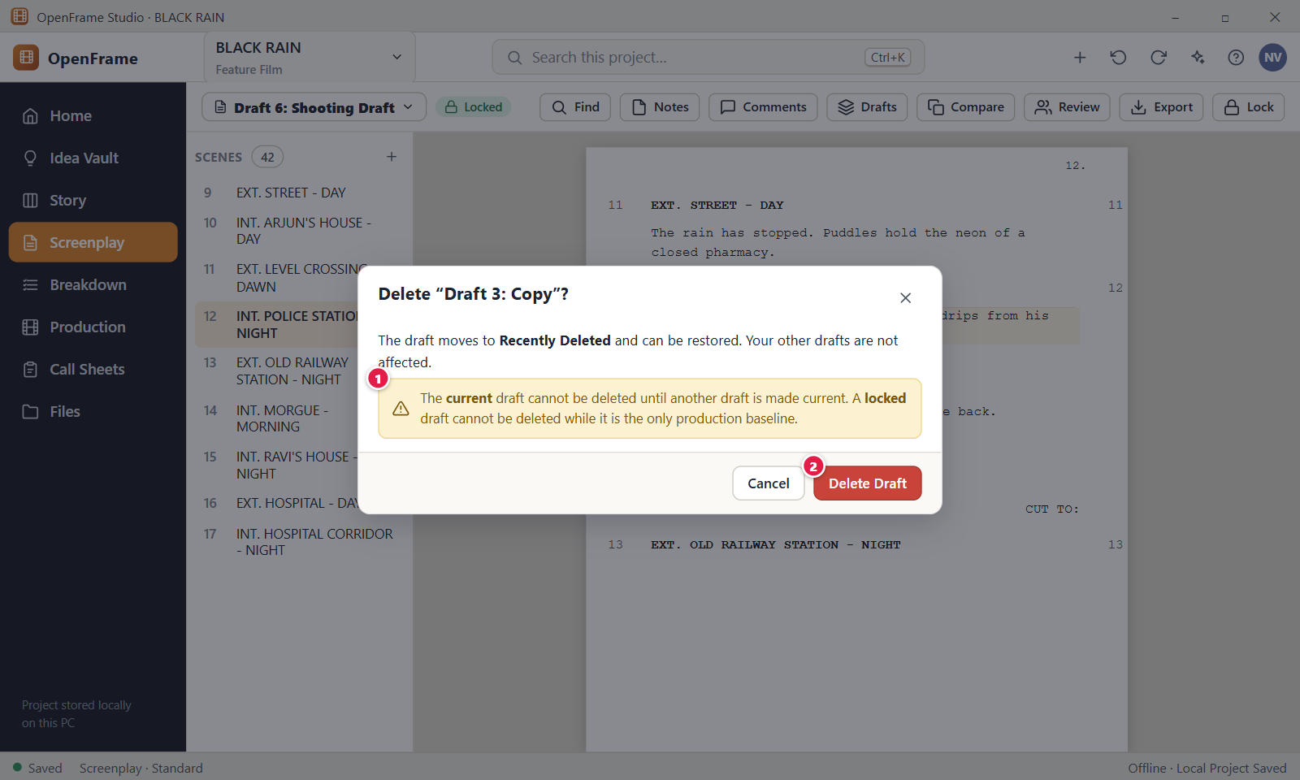
Figure 101. Deleting a draft. Red numbers are explained on the next page.

Figure 101: Deleting a draft: how it works
PARTS OF THIS SCREEN  1 Safety rules The text under the title explains what protects your drafts. The dialog says the draft moves to Recently Deleted and can be restored, and that your other drafts are not affected. Small grey text adds the two rules: the current draft cannot be deleted until another draft is made current, and a locked draft cannot be deleted while it is the only production baseline. For the current draft this turns into an amber banner: "This is the current draft. Make another draft current before deleting it."  2 Delete Draft Moves the draft to Recently Deleted. The button is red and is disabled for the current draft. A toast confirms with an Undo link, and the draft leaves the Drafts list. The app also refuses to delete the only locked draft and the draft used as the Production Source, and it tells you why. | HOW TO USE IT  1. Open Screenplay and click "Drafts" in the toolbar.  2. Make sure the draft you want to remove is not the current one. If it is, choose "Mark current" on another draft, for example "Draft 6: Shooting Draft".  3. On the row of the draft to remove, click the three-dot button and choose "Delete…".  4. Read the dialog. It names the draft in the title, for example "Draft 3: Copy".  5. Click "Delete Draft". Click "Cancel", the X, or press Esc if you change your mind.  6. To bring the draft back, click Undo in the toast, or press Ctrl+Z. Later, open the project menu at the top left, choose "Recently Deleted" and click "Restore" on its row.  GOOD TO KNOW · EDGE CASES  • Deleting a draft is recoverable. It stays in Recently Deleted for 30 days. After that it is removed for good.  • The current draft is protected. Make another draft current first, then delete.  • A locked draft that is the only locked draft cannot be deleted. The message reads "This locked draft is the only production baseline, so it can't be deleted." If you have two locked drafts, the older one that is not current can be deleted.  • A draft used as the Production Source cannot be deleted either. Choose a different Production Source first.  • Deleting one draft never changes your other drafts or the screenplay itself. Renaming a draft changes only its label, never its text.  • Viewers, Commenters and Export-only members do not see "Delete…" in the menu.
See also: Figure 83 Drafts: named drafts and recovery history Figure 84 Creating a new named draft Figure 88 Locking the Shooting Draft Figure 103 Start Production Setup: choose the production source

Chapter 5: Production: Breakdown, Catalog, Locations, Cast & Crew, Visual Planning and Shot Lists
Production turns the locked script into a plan: choose the production source, break the script down into elements, keep a catalog, locations, cast and crew, moodboards, storyboards and shot lists.

Screens in this chapter
Figure | Screen | Page
Figure 102 | Production overview (dashboard) | 227
Figure 103 | Start Production Setup: choose the production source | 229
Figure 104 | Breakdown: scene list, script and elements | 231
Figure 105 | Breakdown: no source chosen | 233
Figure 106 | Tagging highlighted text | 235
Figure 107 | Reviewing suggested elements | 237
Figure 108 | Reusing an existing catalog item | 239
Figure 109 | Adding an element manually | 241
Figure 110 | After a script change: review breakdown differences | 243
Figure 111 | Updating the production source to a newer draft | 245
Figure 112 | Needs Review queue | 247
Figure 113 | Production Catalog | 249
Figure 114 | Archiving or replacing a catalog item | 251
Figure 115 | Locations list | 253
Figure 116 | Location details: photos, notes, scenes | 255
Figure 117 | Replacing a rejected location for selected scenes | 257
Figure 118 | Cast list | 259
Figure 119 | Assigning an actor to a character | 261
Figure 120 | Crew list | 263
Figure 121 | Moodboard canvas | 265
Figure 122 | Exporting a moodboard | 267
Figure 123 | Storyboard panels for a scene | 269
Figure 124 | Add Panel: import, sketch or empty | 271
Figure 125 | Sketching a panel | 273
Figure 126 | Shot list for a scene | 275
Figure 127 | Shot details (technical fields) | 277

Figure 102: Production overview (dashboard)
What it is for. The Production overview is a small status page. It answers "What do I need to do next to prepare the shoot?" with a few numbers and a short list of things that need attention. Every card opens the workspace where you can act on it.
How to get here. Left navigation > Production. The "Overview" tab opens first. The tabs along the top switch between the production tools.
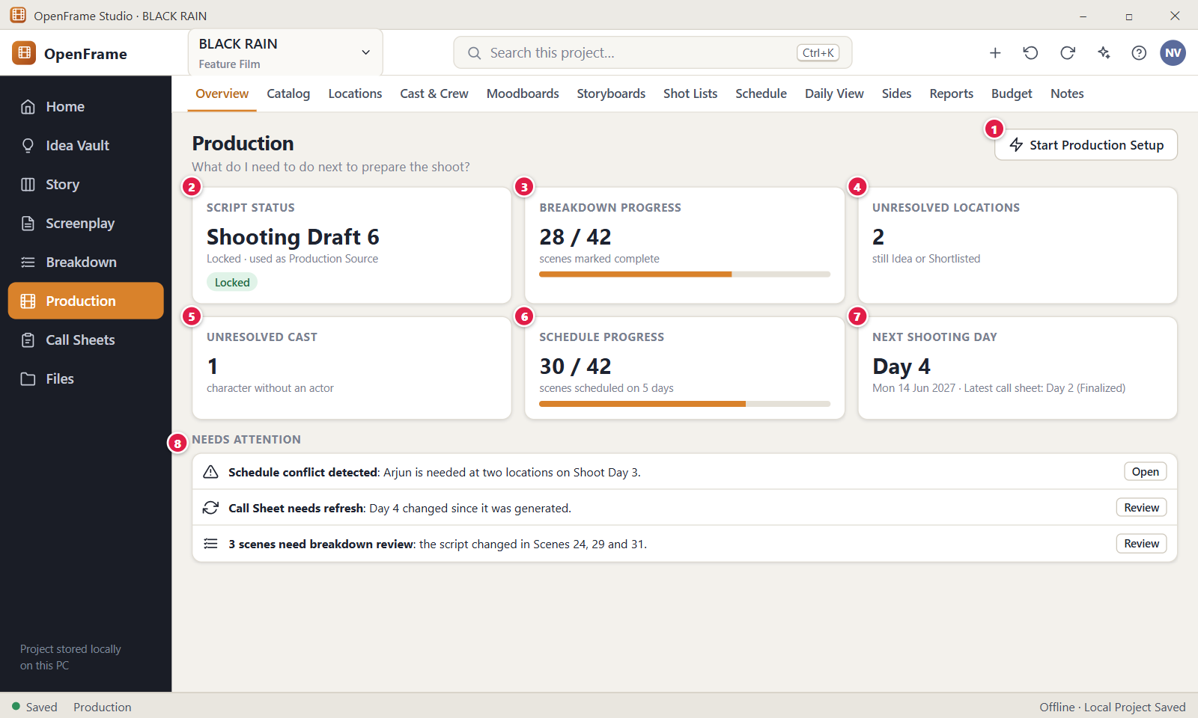
Figure 102. Production overview (dashboard). Red numbers are explained on the next page.

Figure 102: Production overview (dashboard): how it works
PARTS OF THIS SCREEN  1 Start Production Setup Opens the dialog that chooses which screenplay draft production is based on. Once a source is set, the same button is called "Change Production Source" and choosing another draft leads to an update review instead of a silent switch. Only the Owner and Editor see it. Your screenplay is never changed.  2 Script status Shows which draft is the Production Source, for example "Draft 6: Shooting Draft", with the screenplay title and "Locked · used as Production Source". A green "Locked" chip appears for a locked draft. Click it to open Breakdown. With no source it says "No source yet" and opens the setup dialog.  3 Breakdown progress Shows how many scenes you marked complete in Breakdown, for example "28 / 42", with a progress bar. "Complete" is a mark you set yourself. It does not mean every requirement was found. Click the card to open Breakdown.  4 Unresolved locations Counts locations that are still at Idea or Shortlisted. Confirmed and Rejected locations are not counted. Click the card to open the Locations tab.  5 Unresolved cast Counts characters that have no actor assigned. A character counts until a primary actor is assigned. Click the card to open the Cast & Crew tab.  6 Schedule progress This card is not in the current version. The overview shows a "Catalog" card in its place. Open the Schedule tab to see which scenes are scheduled.  7 Next shooting day This card is not in the current version. Open the Schedule tab for the shooting days and the Daily View tab for a day.  8 Needs attention A short list of items that need a look, each with a bold title, one sentence and one button. Examples are "Newer revision available", scenes that need breakdown review, and "Needs casting" with the character names. An item disappears when its cause is fixed. When nothing is open it says "Nothing needs attention right now." | HOW TO USE IT  1. Click Production in the left navigation. The Overview opens.  2. If "Script status" says "No source yet", click "Start Production Setup" and choose the draft, for example "Draft 6: Shooting Draft" of BLACK RAIN.  3. Read the cards. "Unresolved cast" shows 1 when one character has no actor.  4. Under "Needs attention", click the button on an item, for example "Open" on "Needs casting", to go to the place where you fix it.  5. Use the tabs along the top to move to Catalog, Locations, Cast & Crew, Schedule and the other tools.  GOOD TO KNOW · EDGE CASES  • The page stores nothing of its own. Every number comes from another screen, so it is always up to date.  • No number blocks your work. You can keep working when a number is incomplete.  • There are 13 tabs: Overview, Catalog, Locations, Cast & Crew, Moodboards, Storyboards, Shot Lists, Schedule, Day Out of Days, Daily View, Sides, Reports and Budget. A short film can use only a few of them.  • Needs attention items cannot be dismissed. They go away when you resolve them.  • Viewers and Commenters can open the cards but cannot start the setup or change the source.  • The tab strip scrolls sideways when the window is narrow.
See also: Figure 103 Start Production Setup: choose the production source Figure 104 Breakdown: scene list, script and elements Figure 105 Breakdown: no source chosen Figure 141 Call Sheets list

Figure 103: Start Production Setup: choose the production source
What it is for. This dialog hands the script over to production. You choose which screenplay draft is the official source for the shoot. OpenFrame then prepares the breakdown scenes from it, so nobody retypes a scene. It answers "Which draft is production based on?".
How to get here. Left navigation > Production > Overview > "Start Production Setup". You can also reach it from Breakdown with no source ("Select Source") and from "Change source" in the Breakdown banner. Only the Owner and Editor can set the source.
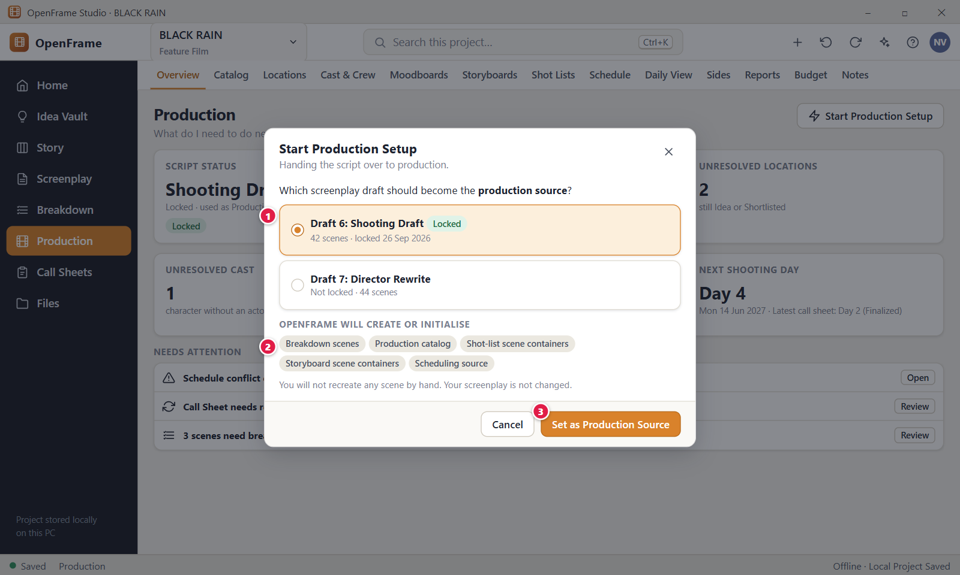
Figure 103. Start Production Setup: choose the production source. Red numbers are explained on the next page.

Figure 103: Start Production Setup: choose the production source: how it works
PARTS OF THIS SCREEN  1 Draft list One card per draft, each with the draft name, the scene count and the lock date or "Not locked". A check mark shows the chosen card. The first locked draft is chosen for you. Any draft that is not deleted can be chosen, locked or not, although a locked Shooting Draft is the usual choice. With no drafts, the dialog tells you to write or import a screenplay first.  2 What gets initialised A box titled "OpenFrame will create or initialise". It lists three things: the breakdown scenes (one per screenplay scene, numbered automatically), the production catalog, and the scene list used by shot lists, storyboards and the schedule. Below it is an optional field "Why this draft? (optional)" that keeps up to 1,000 characters. This box shows only while no source is set.  3 Set as Production Source Records your choice. The dialog closes and a toast says "Production Source set to “Draft 6: Shooting Draft”. Your screenplay is not changed." with an Undo link. The button is disabled until a draft is chosen. Once a source exists, the button is called "Review Production Update" and opens the update review instead. | HOW TO USE IT  1. Open Production > Overview and click "Start Production Setup".  2. Click the draft to use. For BLACK RAIN, choose "Draft 6: Shooting Draft" (42 scenes, locked).  3. Optional: type a short reason in "Why this draft? (optional)", for example "Locked shooting draft".  4. Click "Set as Production Source".  5. Open Breakdown. All 42 scenes are listed with their screenplay numbers and headings.  GOOD TO KNOW · EDGE CASES  • Your screenplay is never changed by this dialog, and you do not recreate any scene by hand.  • Production stays on the chosen draft when you write a newer revision. It changes only when you review and confirm an update.  • At first setup no scene is marked "Needs breakdown".  • A draft that is the Production Source cannot be deleted.  • Cancel, the X and Esc close the dialog without setting anything.  • Viewers and Commenters cannot set the source.
See also: Figure 102 Production overview (dashboard) Figure 105 Breakdown: no source chosen Figure 104 Breakdown: scene list, script and elements Figure 111 Updating the production source to a newer draft Figure 88 Locking the Shooting Draft

Figure 104: Breakdown: scene list, script and elements
What it is for. Breakdown turns a screenplay scene into a list of what the scene needs to shoot: cast, locations, props, wardrobe and more. It answers "What does this scene require to shoot?". The scene list is on the left, the scene text in the middle and the scene's breakdown on the right.
How to get here. Left navigation > Breakdown. You can also right-click a scene in the Screenplay scene list and choose "Break down", or use the "Breakdown" row in the Scene Hub. A Production Source must be set first, otherwise Breakdown shows its empty state.
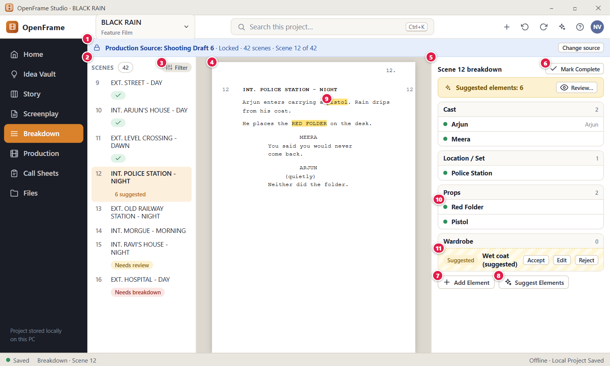
Figure 104. Breakdown: scene list, script and elements. Red numbers are explained on the next page.

Figure 104: Breakdown: scene list, script and elements: how it works
PARTS OF THIS SCREEN  1 Production Source banner A blue bar that names the draft this breakdown is based on, for example "Production Source: Draft 6: Shooting Draft of “BLACK RAIN” · Locked · 42 scenes · Scene 12 of 42". It has "Change source" (for roles that can edit) and an export button for the breakdown report. When a newer draft exists, a second bar says "Newer revision available" with "Review Production Update" and "Dismiss".  2 Scene list Lists every scene of the Production Source with its number and heading. A green check marks a complete scene. Other chips are "n suggested", "Needs review" and "Needs breakdown". Click a scene to open it, or use Arrow Up and Arrow Down. Numbers and headings come from the screenplay and cannot be edited here.  3 Filter A chip with a menu above the scene list. It offers All scenes, Only unreviewed, Only suggested, Only missing a breakdown, Script changed, Complete and Not complete, then "Any category" and the eleven categories. A status and a category can be combined. The app remembers your choice on this computer.  4 Script reading pane The middle pane shows the scene text so you can read it while you tag. It is read-only: Breakdown never changes your screenplay. Select words inside one line to open a small menu "Tag “…” as…" with the eleven categories. A scene with no text says "This scene has no text yet."  5 Breakdown panel The right panel, titled for example "Scene 12 breakdown". It groups the scene's elements by category and shows only categories that have content. Click a category header to collapse or expand it. An empty scene says "Nothing broken down yet." and tells you how to start.  6 Mark Complete Marks this scene's breakdown as complete. It is a planning mark that you set yourself. It does not claim every real-world need was found. After you click, it reads "Complete"; click again to reopen the scene. The scene gets a green check and the count on the Production overview goes up.  7 Add Element Opens the "Add Element" dialog so you can add an element by typing, without highlighting text. You choose a category (Props is the default), a name and optional notes. A manual element is confirmed at once.  8 Suggest Elements Asks OpenFrame to read the scene and propose likely elements. Nothing is added to production until you accept it. It works with fixed rules, uses no AI model and needs no network, so the same scene gives the same suggestions. While it runs the label reads "Suggesting…".  9 Highlighted text A word in the script that has an element tagged to it, such as "pistol". It is highlighted in the colour of its category, and a tooltip shows, for example, "Props: Pistol". Suggested words are marked more lightly. The highlight belongs to the breakdown, not to the screenplay.  10 Confirmed element A confirmed element, such as "Red Folder", shown as an ordinary row with a colour dot and its name. Its three-dot button offers "Show in script", "Show all scenes with this item", "Open in Catalog", "Edit notes…" and "Remove from scene". Removing it takes it out of this scene only. The catalog item stays.  11 Suggested element A suggestion, such as "Wet coat (suggested)", has a "Suggested" chip and shows the phrase it matched. You decide with Accept, Edit or Reject. Reject removes it for this scene, and it is not proposed again there. A suggestion is not production data until you accept it. | HOW TO USE IT  1. Click Breakdown in the left navigation and select Scene 12, "INT. POLICE STATION - NIGHT", in the scene list.  2. Select the word "pistol" in the script and tag it as a prop from the small menu.  3. Click "Suggest Elements". Look at the rows marked "Suggested" in the panel.  4. Click Accept on the suggestions you want and Reject on the rest. Use Edit to change the category or name first.  5. Click "Add Element" for anything the scene needs that has no words in the script, for example a Red Folder.  6. When the scene is finished, click "Mark Complete".  GOOD TO KNOW · EDGE CASES  • Breakdown never changes the screenplay text. Tagging, accepting and removing only touch the breakdown.  • There are exactly eleven categories: Cast, Extras / Background, Location / Set, Props, Wardrobe, Vehicles, Hair / Makeup, Special Effects, VFX, Sound and Animals. Empty ones are not shown.  • If the screenplay changes after you broke a scene down, the scene gets the chip "Needs review". Nothing is deleted.  • Suggestions appear only when you click "Suggest Elements". Nothing is added until you accept it.  • "Mark Complete" can be reopened at any time.  • Tagging, adding, accepting and marking complete are for roles that can edit. Others can read the breakdown.
See also: Figure 105 Breakdown: no source chosen Figure 106 Tagging highlighted text Figure 107 Reviewing suggested elements Figure 108 Reusing an existing catalog item Figure 109 Adding an element manually Figure 102 Production overview (dashboard)

Figure 105: Breakdown: no source chosen
What it is for. This is what Breakdown shows when no screenplay draft has been chosen as the production source. It explains what to do and offers two ways forward: choose a draft you already have, or import a script first. It answers "Why is Breakdown empty and what do I do?".
How to get here. Left navigation > Breakdown, in a project that has no Production Source. You also land here from "Break down" on a scene or from the Scene Hub when no source exists.
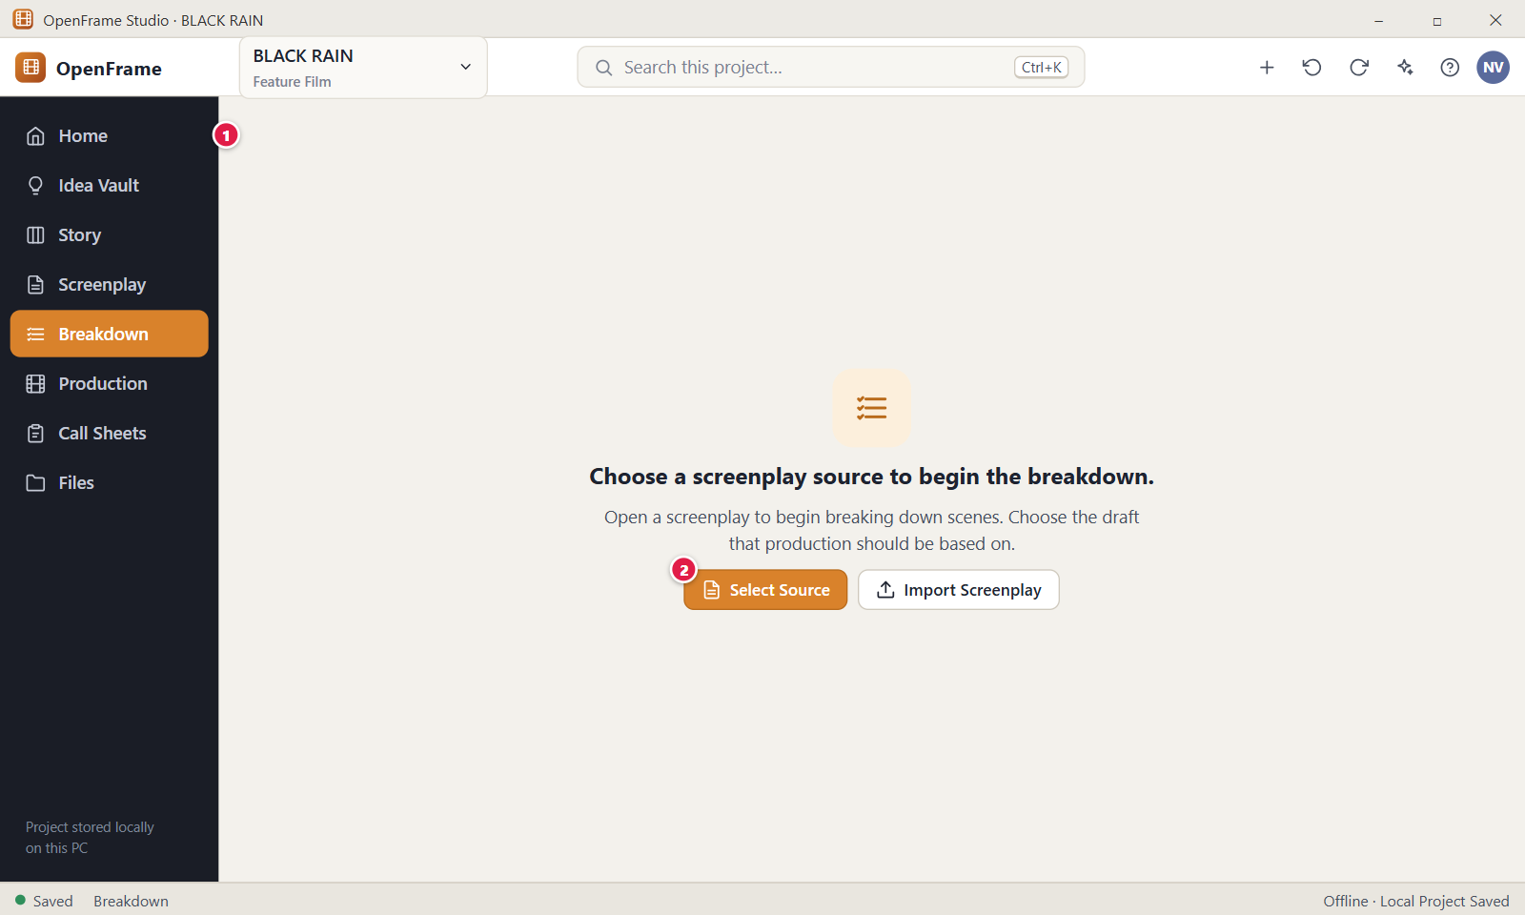
Figure 105. Breakdown: no source chosen. Red numbers are explained on the next page.

Figure 105: Breakdown: no source chosen: how it works
PARTS OF THIS SCREEN  1 Empty-state message The title reads "Choose a screenplay source to begin the breakdown." and the line under it says to open a screenplay and choose the draft that production should be based on. It disappears as soon as a source is set. If Breakdown cannot load, a red banner with the error and a "Try Again" button appears instead.  2 Select Source Opens the dialog "Handing the script over to production." where you choose the draft. After you click "Set as Production Source", the breakdown scenes are created and this screen is replaced by the Breakdown workspace. Only the Owner and Editor can use it. | HOW TO USE IT  1. Open Breakdown in a project with no source. The empty state appears.  2. If you have no screenplay yet, click "Import Screenplay" and bring in your script, then return to Breakdown.  3. Click "Select Source".  4. Choose the draft, for example "Draft 6: Shooting Draft", and click "Set as Production Source".  5. The Breakdown workspace opens with the scene list.  GOOD TO KNOW · EDGE CASES  • The screen also has an "Import Screenplay" button next to "Select Source". It switches to Screenplay and opens the import dialog.  • Importing a script does not set the Production Source by itself. After the import you still choose the draft with "Select Source", and you stay in Screenplay until you go back to Breakdown.  • With no screenplay drafts, "Select Source" tells you to write or import a screenplay first.  • Choosing a source never changes your screenplay.  • Viewers and Commenters cannot use "Select Source".
See also: Figure 103 Start Production Setup: choose the production source Figure 104 Breakdown: scene list, script and elements Figure 102 Production overview (dashboard) Figure 76 The screenplay editor (Standard mode)

Figure 106: Tagging highlighted text
What it is for. You select a word or phrase in the script and choose its category. That creates a breakdown element and marks the words in the scene. It answers "How do I turn what I read in the script into a production need?".
How to get here. Left navigation > Breakdown > open a scene > in the middle script pane, drag over a word or double-click it. A small menu "Tag “<text>” as…" appears under the selection. You can also select the text and click "Tag Selection" in the right panel.
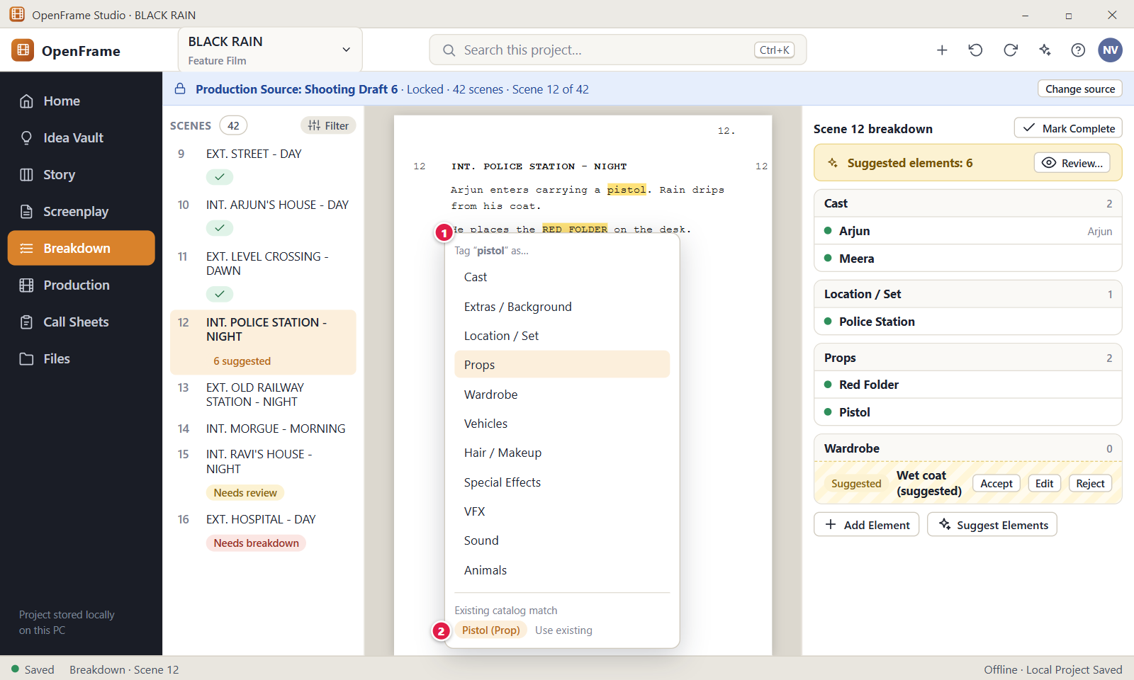
Figure 106. Tagging highlighted text. Red numbers are explained on the next page.

Figure 106: Tagging highlighted text: how it works
PARTS OF THIS SCREEN  1 Category chooser The small menu under your selection. Its header repeats the selected text, and below it are the eleven categories: Cast, Extras / Background, Location / Set, Props, Wardrobe, Vehicles, Hair / Makeup, Special Effects, VFX, Sound and Animals. Use the arrow keys and Enter, or click one. Esc or a click outside closes it. The selection must sit inside one line of the script; a selection across two lines opens nothing.  2 Existing catalog match The menu itself does not show catalog matches. After you choose a category, the dialog "Tag “<name>”" opens. It offers "Use existing" when the catalog already has the item (marked "Same item" or "Similar") next to "Create new item", so you reuse one identity instead of making a duplicate. You can edit the name, and matching runs again. | HOW TO USE IT  1. Open Breakdown and select Scene 12 in the scene list.  2. In the script pane, double-click a word such as "desk".  3. In the menu "Tag “desk” as…", choose a category, for example Props.  4. In the dialog "Tag “Desk”", check the name. Choose "Use existing" if the item is already in the catalog, or keep "Create new item".  5. Add notes if you want, then confirm. The words are highlighted and "Desk" appears in the breakdown panel.  GOOD TO KNOW · EDGE CASES  • Tagging never changes the screenplay. The highlight belongs to the breakdown only.  • A tag is added as a confirmed element at once. It is not labelled as a suggestion.  • The name is made from your selection in title case, so RED FOLDER becomes "Red Folder". You can edit it before you add it.  • Long selections are shortened to 28 characters in the menu header.  • If the element is already in the scene, the app says so and adds nothing twice.  • Only roles that can edit can tag. Viewers and Commenters can read the breakdown.
See also: Figure 104 Breakdown: scene list, script and elements Figure 108 Reusing an existing catalog item Figure 109 Adding an element manually Figure 107 Reviewing suggested elements

Figure 107: Reviewing suggested elements
What it is for. This dialog lists every suggested element for one scene so you can review them like a checklist. Nothing becomes production data until you accept it. It answers "Which of these suggestions are right?".
How to get here. Left navigation > Breakdown > open a scene. Click "Suggest Elements", then click "Review…" in the amber bar "Suggested elements: 6" in the right panel. "Suggest Elements" alone does not open this list.
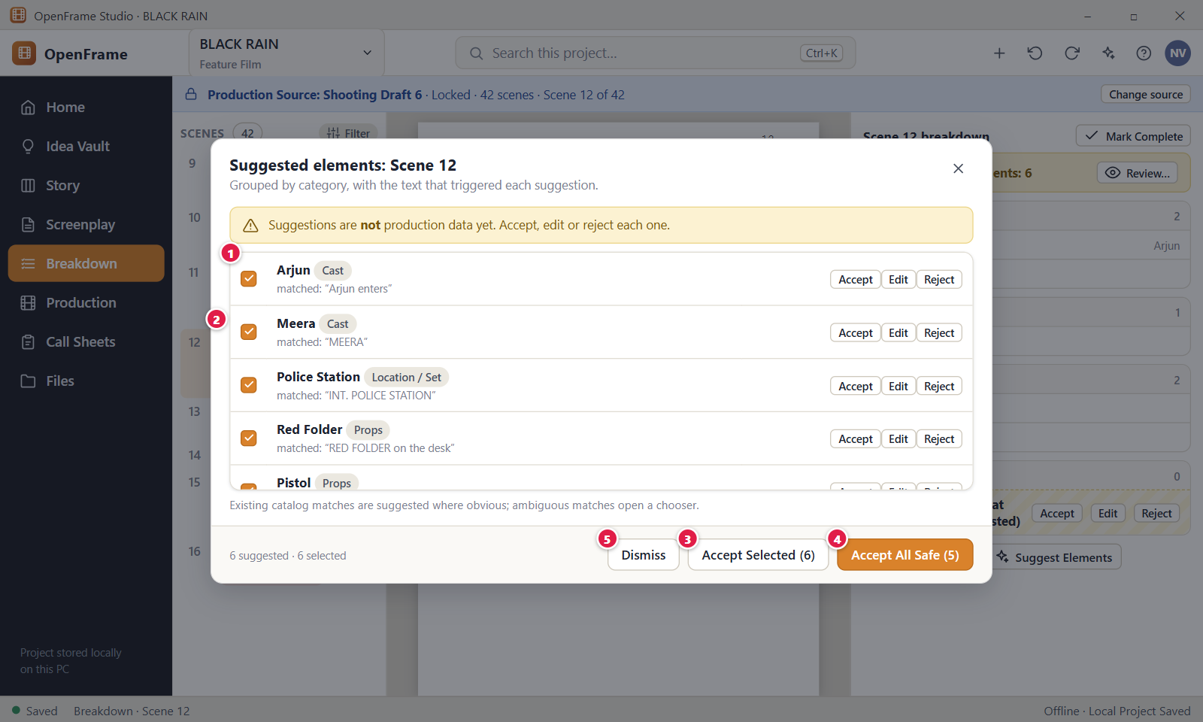
Figure 107. Reviewing suggested elements. Red numbers are explained on the next page.

Figure 107: Reviewing suggested elements: how it works
PARTS OF THIS SCREEN  1 Suggestion list Suggestions are grouped by category. Each row shows the suggested name, the phrase from the script that triggered it, a confidence word ("Likely match" or "Possible match") and a chip: "Existing: <name>", "New catalog item" or "Similar items, choose one". All rows start ticked, and the footer counts them, for example "6 suggested · 6 selected".  2 Per-row actions Each row has Accept, Edit and Reject. Accept makes the element and links it to the catalog, with a toast and Undo. If similar catalog items exist, Accept opens a chooser instead. Edit lets you change the category, name or catalog item first. Reject removes the suggestion for this scene, and it is not proposed again there.  3 Accept Selected Accepts only the ticked rows. The number in the button is the number of ticked rows, and hovering shows their categories. Rows with similar catalog items are not accepted. They stay in the list, and the toast tells you how many need a choice. The whole action is one undo step.  4 Accept All Safe Accepts every pending suggestion whose catalog match is not ambiguous, meaning an identical item exists or nothing similar exists. The number in the button is how many that are, and hovering shows the categories. It counts rows even if you unticked them. It is disabled when no suggestion is safe.  5 Dismiss This button is not in the current version. Close the list with the X at the top right or with Esc. Closing accepts and rejects nothing. The suggestions stay pending and the amber bar stays in the right panel. The footer also has "Reject Selected" for the ticked rows. | HOW TO USE IT  1. Open Breakdown, select Scene 12, and click "Suggest Elements".  2. Click "Review…" in the amber bar "Suggested elements: 6".  3. Read each row. Untick the rows you are not sure about.  4. Click Accept on a single row, or "Accept Selected" for all ticked rows, or "Accept All Safe".  5. Click Edit on a row to fix the category or name first, or Reject on a wrong guess.  6. Close the list with the X or Esc when you are done.  GOOD TO KNOW · EDGE CASES  • Suggestions come from fixed rules, not from an AI model. The same scene always gives the same suggestions, and this works offline.  • Nothing is added to production until you accept it. Accepted elements become ordinary production data.  • Reject affects this scene only. It does not delete a catalog item.  • The dialog stays open after a single Accept, so you can go on with the next row.  • Press Ctrl+Z to undo the last accept or reject.  • If the rules find nothing, that is a normal result. You can still tag text or use Add Element.  • Only roles that can edit should use these buttons. The app refuses the action for other roles.
See also: Figure 104 Breakdown: scene list, script and elements Figure 108 Reusing an existing catalog item Figure 106 Tagging highlighted text Figure 109 Adding an element manually

Figure 108: Reusing an existing catalog item
What it is for. One prop is one production identity, even when ten scenes need it. This dialog opens when a suggested element looks like something the catalog already has. You choose to reuse the existing item or to create a new one. It answers "Is this the same thing, or a new thing?".
How to get here. Left navigation > Breakdown > a scene with a pending suggestion. Click "Accept" on a suggestion whose chip says "Similar items, choose one", in the right panel or in the Review list. "Accept Selected" opens it for rows that need a choice.
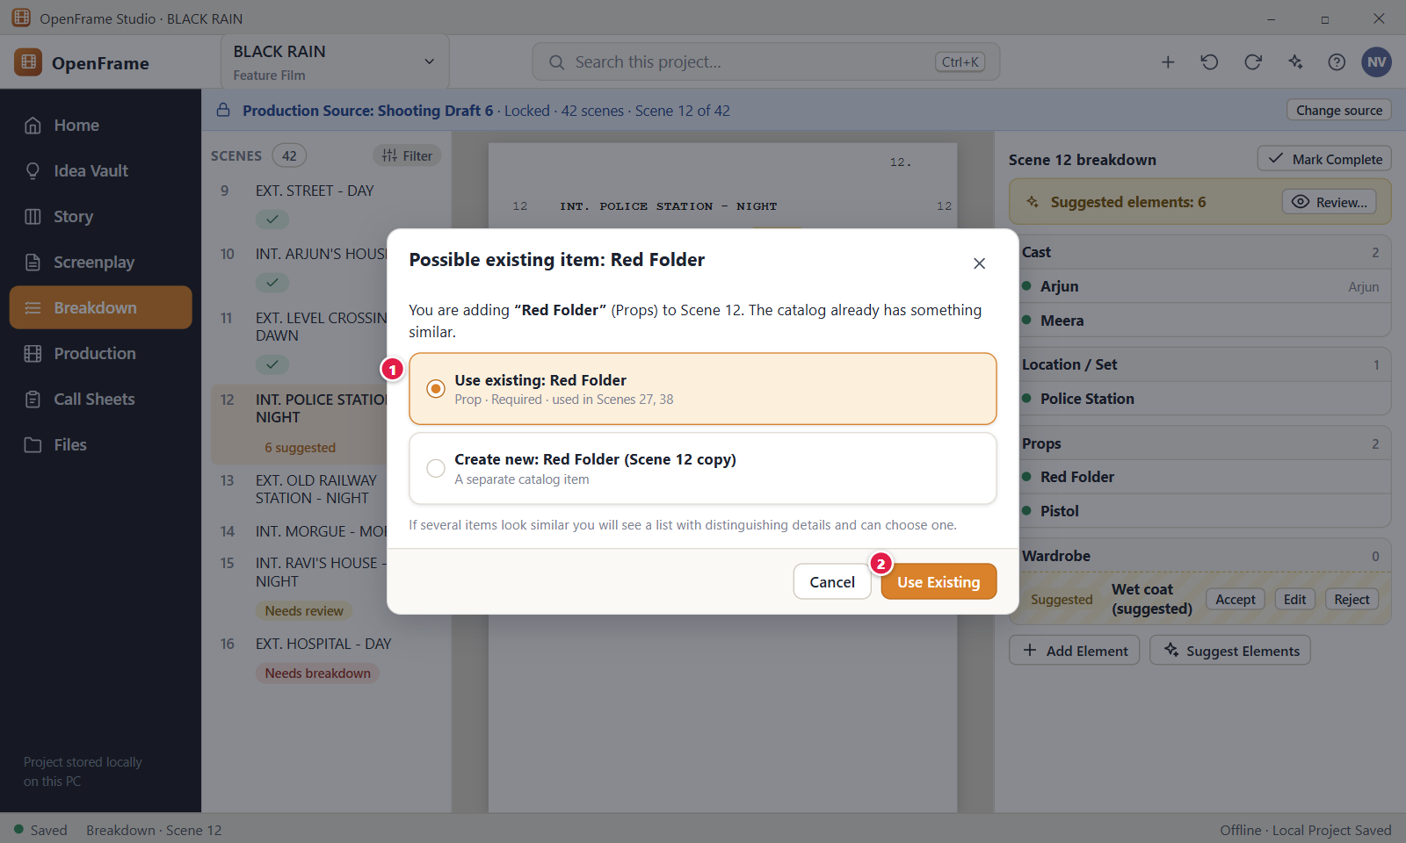
Figure 108. Reusing an existing catalog item. Red numbers are explained on the next page.

Figure 108: Reusing an existing catalog item: how it works
PARTS OF THIS SCREEN  1 Choices A list of choices. Each similar catalog item is a row "Use existing: <name>" with its category, status and the scenes that use it, plus a chip "Same item" or "Similar". The last row is "Create new item “<name>”", added to the production catalog. When several items look similar, nothing is chosen for you, and a note asks you to choose. If you change the name or category, matching runs again and your choice clears.  2 Use Existing Confirms your choice. It links this scene to the chosen catalog item, so all scenes share one production identity. The button reads "Accept" when you choose to create a new item, and it is disabled until you choose. A toast confirms, for example "Accepted “Red Folder”", with Undo. | HOW TO USE IT  1. In Breakdown, open Scene 27 and click "Suggest Elements".  2. Click "Accept" on the suggestion "Red Folder" if its chip says "Similar items, choose one".  3. Read the rows. Pick "Use existing: Red Folder" to reuse the item that Scenes 27 and 38 already use.  4. Or pick "Create new item “Red Folder”" if it is a different prop.  5. Click "Use Existing" (or "Accept"). The element appears in the scene's breakdown.  6. Click Cancel, the X, or press Esc to leave the suggestion pending.  GOOD TO KNOW · EDGE CASES  • This dialog opens only when the match is unclear. A single identical catalog item is accepted without it.  • An unclear match is never attached for you. You always choose.  • You can choose "Create new item" even when a similar item exists.  • Matching uses name and category. It ignores capital letters, punctuation, a leading "the", "a" or "an", and plurals.  • If the element is already in the scene, the app says "“Red Folder” is already in this scene's breakdown."  • Removing an element from one scene later removes only that scene's link. The catalog item stays.
See also: Figure 107 Reviewing suggested elements Figure 109 Adding an element manually Figure 106 Tagging highlighted text Figure 104 Breakdown: scene list, script and elements

Figure 109: Adding an element manually
What it is for. You can always add a production element by typing it. No highlighting and no suggestions are needed. As you type the name, the catalog shows matching items, so you can reuse an item instead of making a duplicate. It answers "What else does this scene need?".
How to get here. Left navigation > Breakdown > open a scene, for example Scene 12 > right panel > "Add Element". The button is shown to roles that can edit, for scenes that are in the Production Source.
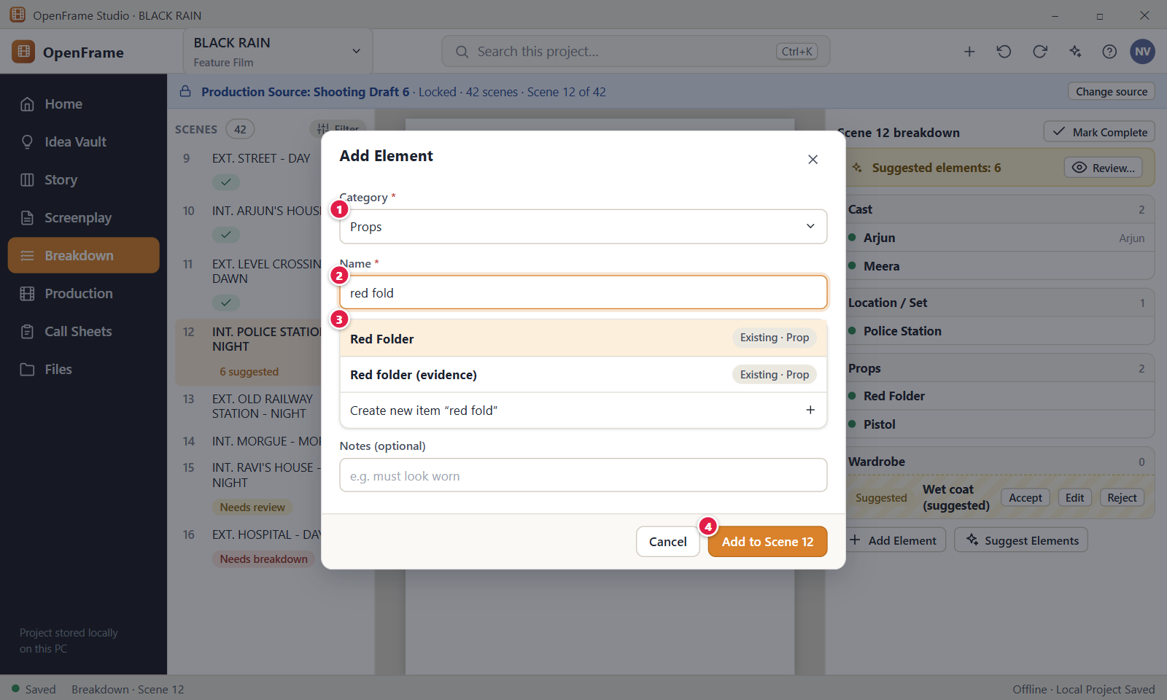
Figure 109. Adding an element manually. Red numbers are explained on the next page.

Figure 109: Adding an element manually: how it works
PARTS OF THIS SCREEN  1 Category A drop-down with the eleven categories: Cast, Extras / Background, Location / Set, Props, Wardrobe, Vehicles, Hair / Makeup, Special Effects, VFX, Sound and Animals. It starts on "Props". Changing it clears your catalog choice and runs the matching again. A new Cast element is linked to the character of the same name, and a new Location element to the location of the same name.  2 Name The name of the element, 1 to 200 characters, with the hint "e.g. Red Folder". The cursor is already in it. As you type, the list below updates after a short pause. If the field is empty or has only spaces, the add button stays disabled. Pressing Enter adds the element once a catalog choice is made.  3 Matches The list under the name. Each similar catalog item is a row "Use existing: <name>" with its category, status and the scenes that use it. The last row is "Create new item “<what you typed>”". Rows are marked "Same item" or "Similar". If nothing is similar, "Create new item" is chosen for you. A single identical item is chosen for you as well. Otherwise you must choose.  4 Add to Scene Adds the element to the scene as a confirmed element, with the scene number in the button, for example "Add to Scene 12". It links the existing item or creates a new catalog item, which starts as Required. A toast says, for example, "Added “Rope” to Scene 12" with Undo. The button is disabled until the name and a choice are filled. | HOW TO USE IT  1. Open Breakdown and select Scene 12.  2. Click "Add Element" in the right panel.  3. Leave Category on "Props" or choose another one.  4. Type the name, for example "Rope". Watch the list of matches.  5. Choose "Use existing" to reuse an item, or "Create new item “Rope”".  6. Click "Add to Scene 12".  GOOD TO KNOW · EDGE CASES  • A manual element is confirmed at once. It is your own decision, so it is not labelled as a suggestion.  • A pending suggestion with the same name and category is replaced by your element.  • You cannot add the same element twice to one scene. The app says "“Pistol” is already in this scene's breakdown."  • Matching ignores capital letters and punctuation, drops a leading "the", "a" or "an", and treats a plural like the singular. Small typing slips still match, but a name that is far off does not.  • An element added this way has no highlighted text. "Show in script" then says it was added without tagging script text.  • Cancel and the X close the dialog and add nothing.
See also: Figure 104 Breakdown: scene list, script and elements Figure 108 Reusing an existing catalog item Figure 106 Tagging highlighted text Figure 107 Reviewing suggested elements

Figure 110: After a script change: review breakdown differences
What it is for. This dialog opens when the script text of one scene changed after that scene was broken down. It shows what the script no longer says, what it now says and what the change touches, and it asks you to choose. It answers "What happens to my production data for this scene?".
How to get here. Left navigation > Breakdown. Select a scene with the yellow chip "Needs review". In the right panel, click Review in the yellow banner. You can also click "Needs Review (N)" under the scene list and then Review beside the scene.
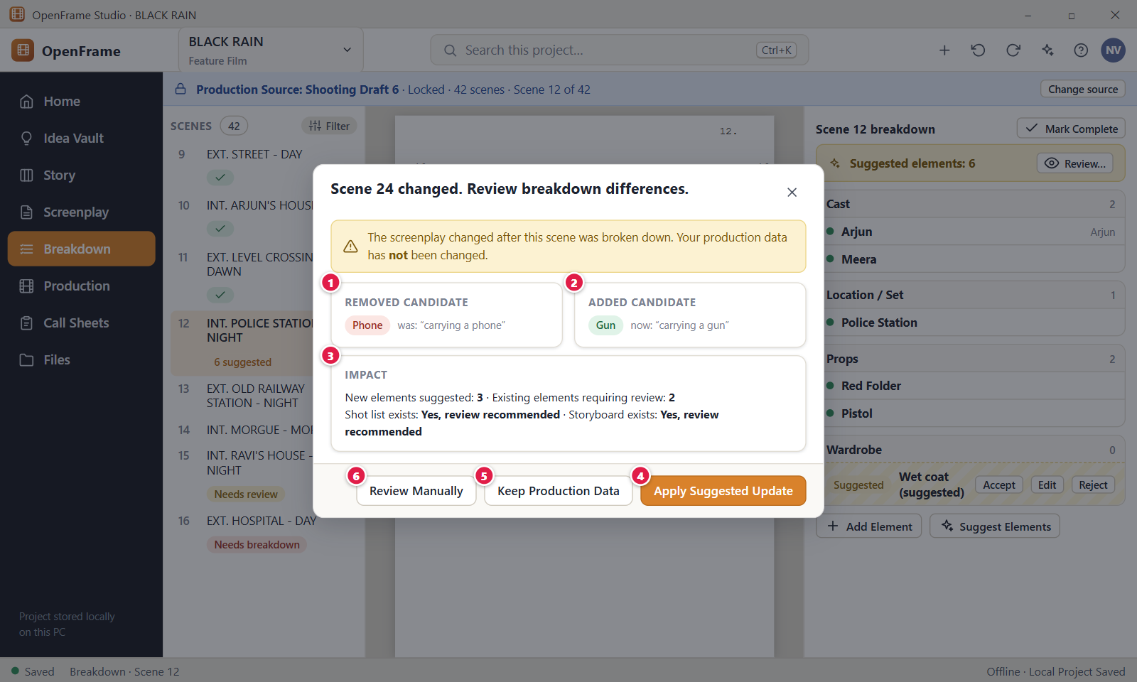
Figure 110. After a script change: review breakdown differences. Red numbers are explained on the next page.

Figure 110: After a script change: review breakdown differences: how it works
PARTS OF THIS SCREEN  1 Removed candidate An element the earlier script text suggested and the changed text no longer suggests. It shows a red chip "Removed candidate", the element name, its category and the quoted script words. It is only a hint. OpenFrame never removes the element from your breakdown.  2 Added candidate An element the changed text suggests that the earlier text did not. It shows a green chip "Added candidate", the name, the category and the quoted words. It becomes a pending suggestion only if you click "Apply Suggested Update".  3 Impact A short list of how big the change is: "New elements suggested" and "Existing elements requiring review", with the names to review. A line "Shot list exists: Yes. Review recommended." shows only when the scene has shots, and a similar line for a storyboard appears only when it has a storyboard panel.  4 Apply Suggested Update Turns every new candidate into a pending suggestion for this scene and makes the current script text the new baseline. Existing elements stay. The scene loses the chip "Needs review". You still accept the suggestions one by one. Owner and Editor only.  5 Keep Production Data Leaves the breakdown exactly as it is, accepts the changed script text as the new baseline and clears the review flag. No suggestion is created. Owner and Editor only.  6 Review Manually Closes the dialog and leaves you in Breakdown to edit elements yourself. It does not open an item-by-item list. The scene stays flagged "Needs review" until you choose Keep Production Data or Apply Suggested Update. | HOW TO USE IT  1. Open Breakdown and select a scene that shows "Needs review", for example Scene 24.  2. Click Review in the yellow banner of the right panel.  3. Read the removed and added candidates and the Impact lines.  4. Click "Apply Suggested Update" to get the new candidates as suggestions, or "Keep Production Data" to change nothing.  5. If you apply the update, open "Suggested elements" and accept or reject each suggestion.  GOOD TO KNOW · EDGE CASES  • OpenFrame never removes production data because the script changed.  • Both "Keep Production Data" and "Apply Suggested Update" make the current script text the new baseline. "Review Manually" does not.  • Both choices can be undone with Ctrl+Z.  • New scenes appear as "Needs breakdown". Removed scenes move to "Removed scenes" and keep their breakdown for reference.  • Shot lists and storyboards are kept. They show a note that the scene changed since planning until you mark them reviewed.  • Esc and the X close the dialog without a change. Viewers and Commenters cannot apply or keep.
See also: Figure 104 Breakdown: scene list, script and elements Figure 111 Updating the production source to a newer draft Figure 112 Needs Review queue Figure 107 Reviewing suggested elements

Figure 111: Updating the production source to a newer draft
What it is for. Production follows one named screenplay draft, the Production Source, until you decide to move it. This dialog compares the current source with a newer draft, counts what changed scene by scene, and lets you move production to the new draft or stay where you are. It answers "What will happen to my breakdown, shots and schedule if I switch to Draft 7?".
How to get here. Left navigation > Breakdown. In the yellow banner "Newer revision available:", click "Review Production Update". You can also click "Change source" in the blue Production Source bar, choose another draft and click "Review Production Update". The dialog is titled "Update Production from" and the draft name.
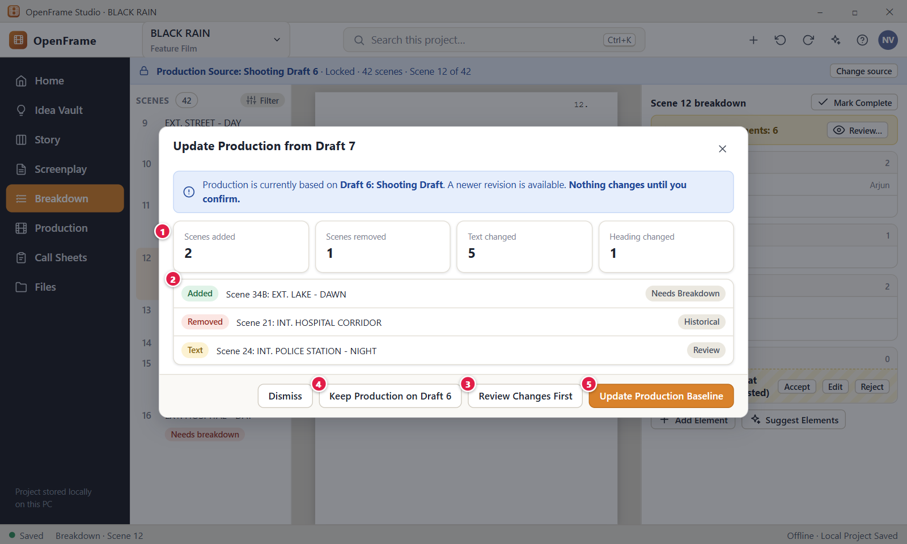
Figure 111. Updating the production source to a newer draft. Red numbers are explained on the next page.

Figure 111: Updating the production source to a newer draft: how it works
PARTS OF THIS SCREEN  1 What changed Four count tiles: "Scenes added", "Scenes removed", "Text changed" and "Heading changed". Scenes are matched by their stable identity, not by number. A grey line below can add counts such as "1 moved · 1 need a manual match · 36 unchanged". Changes to page or length are not shown.  2 Impact by scene A list of the affected scenes, up to 8, each with the scene number, heading, a sentence and a state chip: "Needs Breakdown" for a new scene, "Historical" for a removed scene, "Review" for a changed one. More scenes end with "…and N more." A closing line says nothing is deleted and all breakdown elements are kept.  3 Review Changes First Shows the full list of changed scenes when more than 8 changed. It appears only then. It does not open scenes one at a time. Nothing is changed by looking at the list.  4 Keep Production on Draft 6 Closes the dialog and leaves the Production Source where it is. The label names your current source. The yellow banner "Newer revision available:" stays until you click Dismiss in that banner.  5 Update Production Baseline Makes the new draft the Production Source. This click is the confirmation, and there is no second dialog. Breakdown elements follow their scenes. New scenes become "Needs breakdown", changed scenes "Needs review", and removed scenes stay as history. Shots, storyboards and the schedule are not touched. Owner and Editor only. | HOW TO USE IT  1. Open Breakdown and click "Review Production Update" in the yellow banner.  2. Read the four counts, for example scenes added and text changed.  3. Scroll the scene list and read what happens to each scene.  4. Click "Update Production Baseline" to move production to the new draft, or "Keep Production on Draft 6" to stay.  5. Open the scenes marked "Needs breakdown" and "Needs review" and work through them.  GOOD TO KNOW · EDGE CASES  • Nothing changes until you click "Update Production Baseline". Looking at the comparison is safe.  • Production does not follow your edits automatically. Writing a newer draft never moves the source.  • Nothing is deleted. Removed scenes keep their breakdown as history under "Removed scenes".  • The update is one undo step: press Ctrl+Z to undo it.  • Esc and the X close the dialog without a change.  • Anyone can open the comparison, but only the Owner and Editor can update the baseline.  • Changing the source is not the same as locking a draft. The source can be a locked or an unlocked draft.
See also: Figure 103 Start Production Setup: choose the production source Figure 104 Breakdown: scene list, script and elements Figure 110 After a script change: review breakdown differences Figure 112 Needs Review queue Figure 138 Script changed in scheduled scenes: review changes

Figure 112: Needs Review queue
What it is for. A short list of the scenes whose script text or heading changed after production planning began. It answers "Which scenes do I have to look at because the script moved under them?". Nothing in production is deleted or rescheduled by this list.
How to get here. Left navigation > Breakdown. In the scene list, click "Needs Review (N)" at the bottom of the list. The line appears only when N is more than 0. Click "Back to Breakdown" to return.
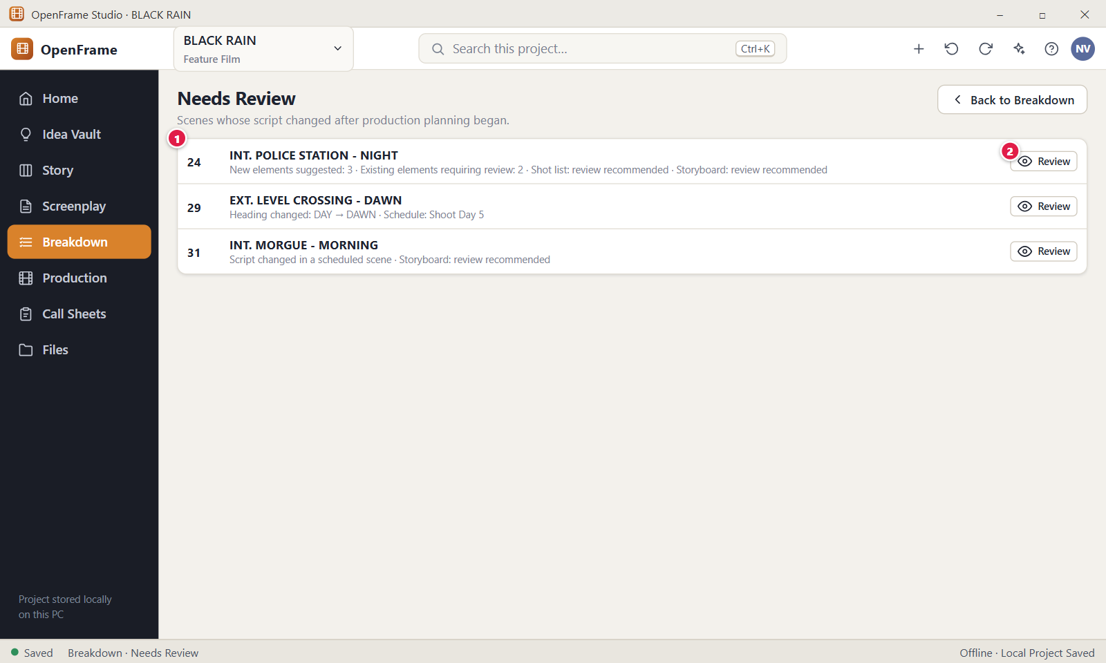
Figure 112. Needs Review queue. Red numbers are explained on the next page.

Figure 112: Needs Review queue: how it works
PARTS OF THIS SCREEN  1 Scenes needing review One row for every flagged scene in the Production Source. A row shows the scene number, the heading, a one-line reason such as "Scene 24 changed in Draft 7. Review Breakdown.", the time of the change and how many elements are kept. A chip says "Heading changed", "Text changed", or both. The counts of new suggestions, shots and storyboard appear only in the review dialog.  2 Review Opens the scene in Breakdown with the dialog "Scene 24 changed. Review breakdown differences." The button itself changes nothing. The choices in the dialog decide what happens. Each Review button acts only on its own row. | HOW TO USE IT  1. Open Breakdown and click "Needs Review (N)" under the scene list.  2. Read the rows. Each says why the scene is flagged, for example that its heading changed.  3. Click Review on a row, for example Scene 24.  4. In the dialog, choose "Keep Production Data" or "Apply Suggested Update".  5. Click "Back to Breakdown" when the list is empty or you are done.  GOOD TO KNOW · EDGE CASES  • The chip "Needs review" in the scene list and a row in this queue are the same flag. Both disappear after you keep the data or apply the update.  • A scheduled scene stays on its shooting day. The schedule shows its own warning. This list does not move anything.  • Removed scenes are not in this queue. They are under "Removed scenes (N)" in the scene list.  • When nothing is flagged the page says "Nothing to review." and that every planned scene matches the Production Source text.  • The Production overview shows a card such as "3 scenes need breakdown review" that opens the first flagged scene.
See also: Figure 104 Breakdown: scene list, script and elements Figure 110 After a script change: review breakdown differences Figure 111 Updating the production source to a newer draft Figure 138 Script changed in scheduled scenes: review changes Figure 102 Production overview (dashboard)

Figure 113: Production Catalog
What it is for. The Catalog is the reusable directory of the things and people the film needs: props, wardrobe, vehicles, cast, locations and more. Each item is stored once, even when ten scenes use it. It answers "What does this film need, what is its status and where is it used?".
How to get here. Left navigation > Production, then the "Catalog" tab in the tab row. Click a row to open the item in the drawer on the right. The buttons "Add Item" and "Export" sit in the page header, and the open drawer covers them.
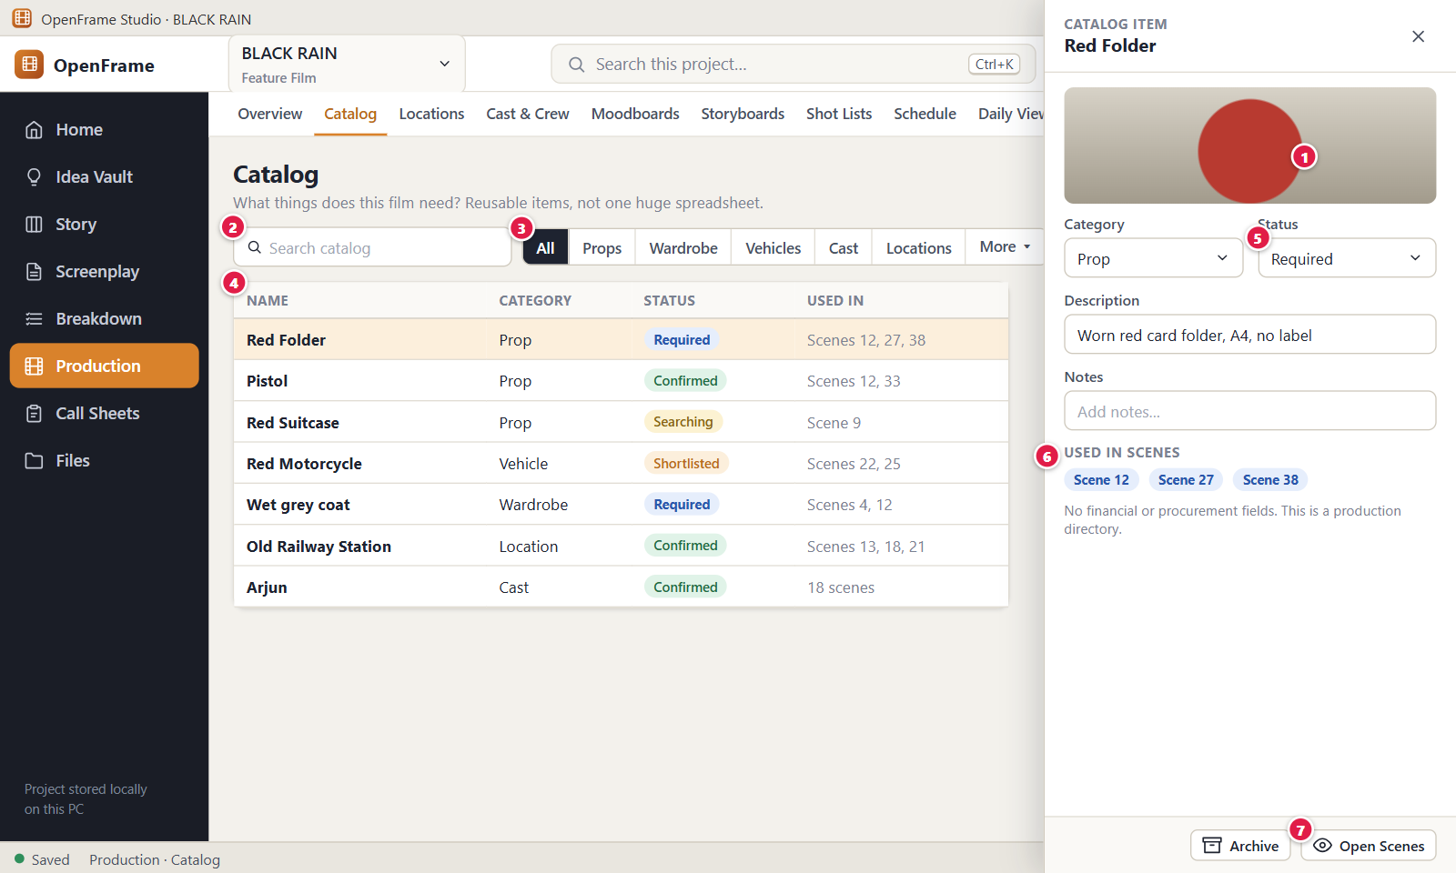
Figure 113. Production Catalog. Red numbers are explained on the next page.

Figure 113: Production Catalog: how it works
PARTS OF THIS SCREEN  1 Add Item Opens the "Add Item" dialog to create an item by hand. It asks for Category, Name (required), Status (starts on Required) and an optional Description. If an item with that name exists in the category, a yellow line warns that adding creates a separate item. Items you confirm in Breakdown appear here on their own. Only roles that can edit see the button.  2 Search A box labelled "Search catalog". It filters the table while you type, by name, other names, description and notes. It does not search category or status, so use the filter for those. It works together with the category filter and the "Show archived" box.  3 Category filter A row of buttons: All, Props, Wardrobe, Vehicles, Cast and Locations. A "More" menu holds Extras / Background, Hair / Makeup, Special Effects, VFX, Sound and Animals. "Locations" filters the category Location / Set. "All" is selected at first.  4 Catalog list One row per item, sorted by category and then by name. The columns are Name, Category, Status and Used in, for example "Scenes 12, 27, 38". Click a row, or press Enter on it, to open the drawer. Right-click a row for Open, Open Scenes, Archive… and Delete…. An empty catalog says "The catalog is empty."  5 Status A drop-down in the drawer that records how far sourcing has come. The values are Required, Searching, Shortlisted, Confirmed and Not Required. New items start on Required. The new value is saved at once and the chip in the table changes colour. It does not touch the screenplay.  6 Used in scenes Small scene chips, such as Scene 12, in the drawer. Click a chip to open that scene in Breakdown. The list comes from the breakdown, so you cannot type it. An unused item says "Not used in any scene yet." A removed scene shows as "Removed scene".  7 Open Scenes Opens Breakdown limited to the scenes that need this item. A blue bar says, for example, "Showing the 3 scenes that use Red Folder (Props)." with a "Show all scenes" button. The button is disabled when the item is used in no scene. | HOW TO USE IT  1. Open Production and click the "Catalog" tab.  2. Click "Props" in the category filter, or type "folder" in "Search catalog".  3. Click the row "Red Folder" to open its drawer.  4. Change the Status to "Shortlisted", then "Confirmed" when the prop is secured.  5. Click a scene chip, such as Scene 12, to see the item in the breakdown, or click "Open Scenes".  6. Close the drawer with the X. Click "Add Item" to add a prop by hand.  GOOD TO KNOW · EDGE CASES  • Renaming an item changes it everywhere in the app. Files you exported earlier keep the old wording.  • Archive is preferred to Delete. Delete moves the item to Recently Deleted for 30 days.  • Archived items are hidden unless you tick "Show archived". They appear muted with the chip "Archived".  • The Catalog has no price, budget or procurement field. Money belongs in the Budget tab.  • In the drawer the category is shown but cannot be changed. To use another category, create a new item.  • "Export" creates a snapshot with scene usage as Excel (XLSX), CSV or PDF. Contact details are never exported.
See also: Figure 114 Archiving or replacing a catalog item Figure 108 Reusing an existing catalog item Figure 104 Breakdown: scene list, script and elements Figure 102 Production overview (dashboard)

Figure 114: Archiving or replacing a catalog item
What it is for. This dialog asks you to confirm before a catalog item is archived, and explains what archiving does to the scenes that still use it. It also offers a safer way out: replace the item in selected scenes with another one. It answers "What happens to my scenes if I archive Red Folder?".
How to get here. Left navigation > Production > Catalog. Click the row "Red Folder", then "Archive" in the drawer footer. You can also right-click the row and choose "Archive…". The dialog is titled "Archive “Red Folder”?".
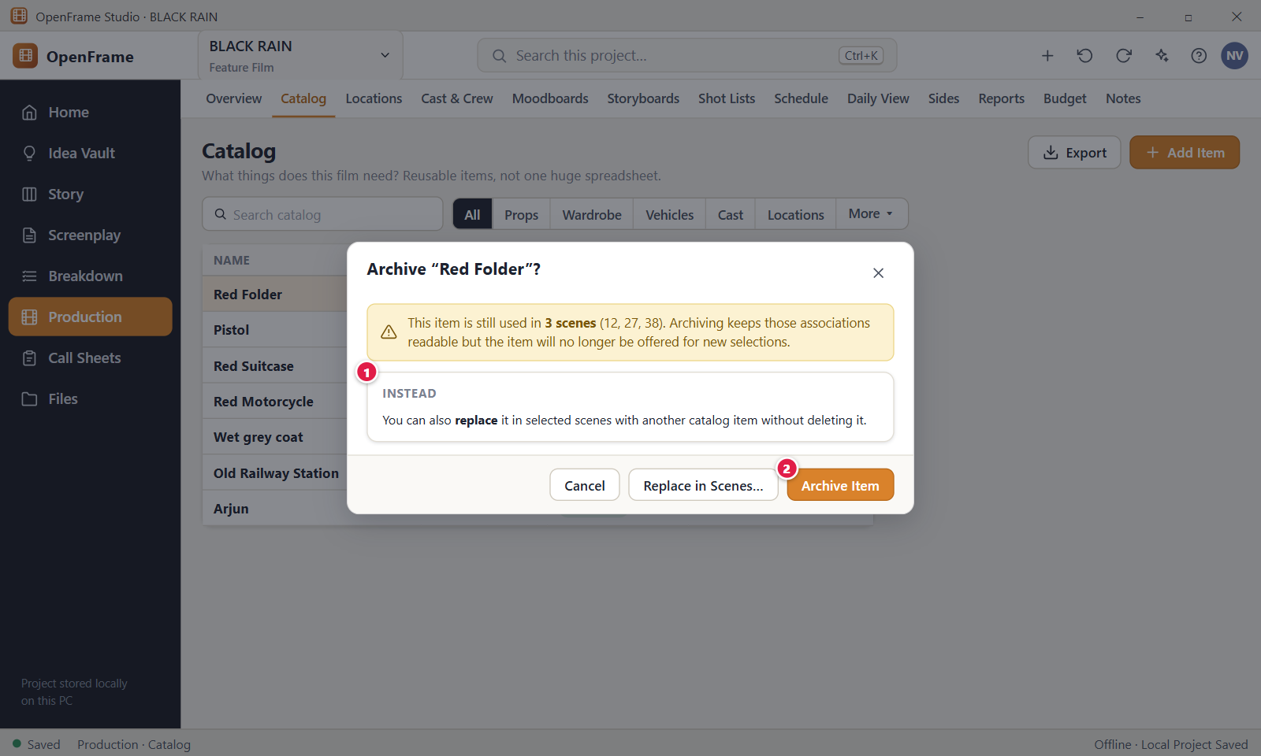
Figure 114. Archiving or replacing a catalog item. Red numbers are explained on the next page.

Figure 114: Archiving or replacing a catalog item: how it works
PARTS OF THIS SCREEN  1 Alternative A card headed "Instead" that offers to replace the item in selected scenes with another catalog item, without deleting it. Its button "Replace in Scenes…" opens a dialog with a Replacement drop-down (items of the same category that are not archived) and a tick box for every scene. It shows only when the item is used in a scene and you can edit.  2 Archive Item Confirms the archive. The item leaves normal selection and gets the chip "Archived". Its scene links stay readable, and nothing is deleted or renamed. New breakdown choices no longer offer it. Restore it any time from the drawer. | HOW TO USE IT  1. Open Production > Catalog and click the row "Red Folder".  2. Click "Archive" in the drawer footer.  3. Read the dialog. It says which scenes still use the item, for example 12, 27 and 38.  4. To keep the old item but use another one in some scenes, click "Replace in Scenes…", pick the replacement, tick the scenes and click the replace button.  5. Otherwise click "Archive Item". Click Cancel, the X, or press Esc to keep the item as it is.  GOOD TO KNOW · EDGE CASES  • Archiving keeps history readable. Scenes that used the item still show it.  • Archived items are hidden in the list until you tick "Show archived".  • Choosing an archived item in Breakdown is refused until you restore it.  • Delete is a separate, stronger action that moves the item to Recently Deleted for 30 days. Archiving is usually the better choice for items still in use.  • The replacement must be in the same category. Replacing changes production links only, never the screenplay.  • Press Ctrl+Z to undo the archive or the replacement.
See also: Figure 113 Production Catalog Figure 104 Breakdown: scene list, script and elements Figure 108 Reusing an existing catalog item

Figure 115: Locations list
What it is for. Locations is a practical scouting notebook: every place the film might use, with its status and the number of scenes that need it. The status is the quickest signal when you scan the page. It answers "Which places can we use?".
How to get here. Left navigation > Production, then the "Locations" tab. You can also reach it from a location link in Breakdown or from the Production overview. Click a card to open its details drawer.
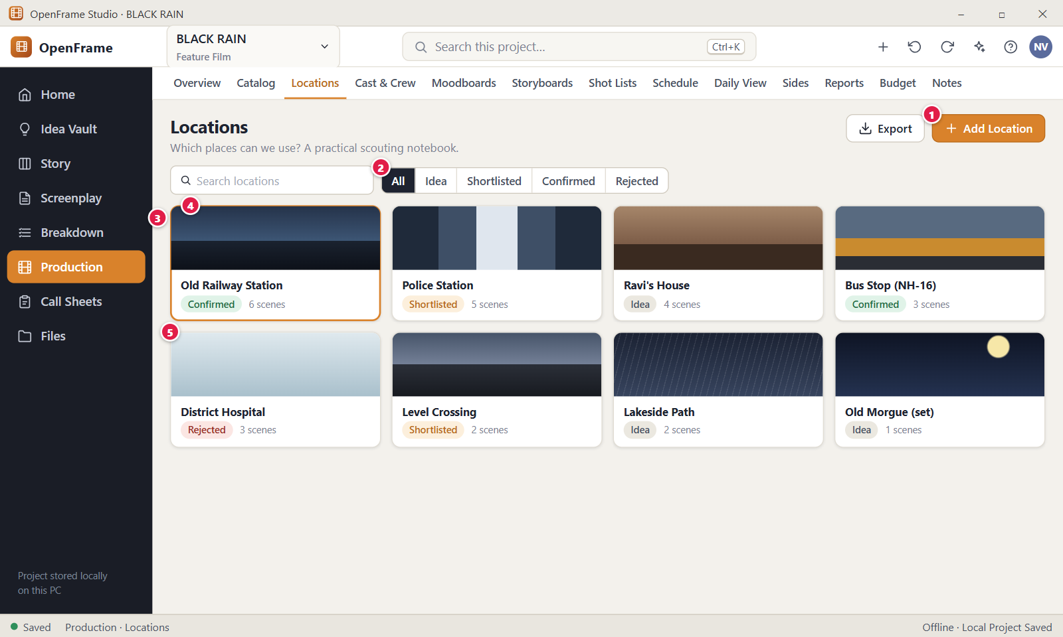
Figure 115. Locations list. Red numbers are explained on the next page.

Figure 115: Locations list: how it works
PARTS OF THIS SCREEN  1 Add Location Opens the "Add Location" dialog. Only the name is required. You can also fill Address / area, Contact, Nearest hospital and Status (it starts on Idea). Confirming a location does not assign it to scenes. Duplicate names are allowed. Only roles that can edit see the button.  2 Status filter Five buttons: All, Idea, Shortlisted, Confirmed and Rejected. The path of a place runs from Idea to Shortlisted to Confirmed, or to Rejected. A search box "Search locations" and the tick box "Show archived" sit in the same row. Search covers name, address, nearest hospital and practical notes. It never searches contact details.  3 Location cards A grid of cards sorted by name. Each card shows a photo (a grey pin if there is none), the name, a status chip and the scene count, for example "6 scenes" or "1 scene". Click a card to open its drawer. Right-click for Open, Archive and Delete…. An empty project says "No locations yet."  4 Selected location The card of the location whose drawer is open is outlined. In the example, Old Railway Station is Confirmed and needed by 6 scenes. The outline ends when you close the drawer.  5 Rejected A location you decided against stays in the list with the chip "Rejected". Rejecting does not remove it or touch the screenplay. When its drawer is open and scenes still use it, a banner offers "Replace…" so those scenes can move to another place. | HOW TO USE IT  1. Open Production and click the "Locations" tab.  2. Click "Add Location", type a name such as "Old Railway Station", and click "Add Location" in the dialog.  3. Use the status buttons to find places, for example "Shortlisted".  4. Click a card to open its drawer, set the status to "Confirmed" and add photos and notes.  5. For a place you dropped, set its status to "Rejected" and use "Replace…" to move its scenes.  GOOD TO KNOW · EDGE CASES  • Changing the status never edits the screenplay and never assigns the location to scenes by itself.  • The scene count comes from the breakdown. You cannot type it.  • Archive is preferred to Delete. Delete moves the location to Recently Deleted for 30 days. The scenes keep their breakdown.  • Contact details are private. Only the Owner and Editor see them.  • There is no Export button on this tab. Location data is exported from the Reports tab.  • Archived cards are hidden unless you tick "Show archived".
See also: Figure 116 Location details: photos, notes, scenes Figure 117 Replacing a rejected location for selected scenes Figure 104 Breakdown: scene list, script and elements Figure 102 Production overview (dashboard)

Figure 116: Location details: photos, notes, scenes
What it is for. The location drawer holds everything about one place: status, photos, address, contact, safety details, practical notes and the scenes that need it. It answers "What do we know about this place, and which scenes depend on it?".
How to get here. Left navigation > Production > Locations, then click a location card. The drawer opens on the right with the word LOCATION and the place name as its title.
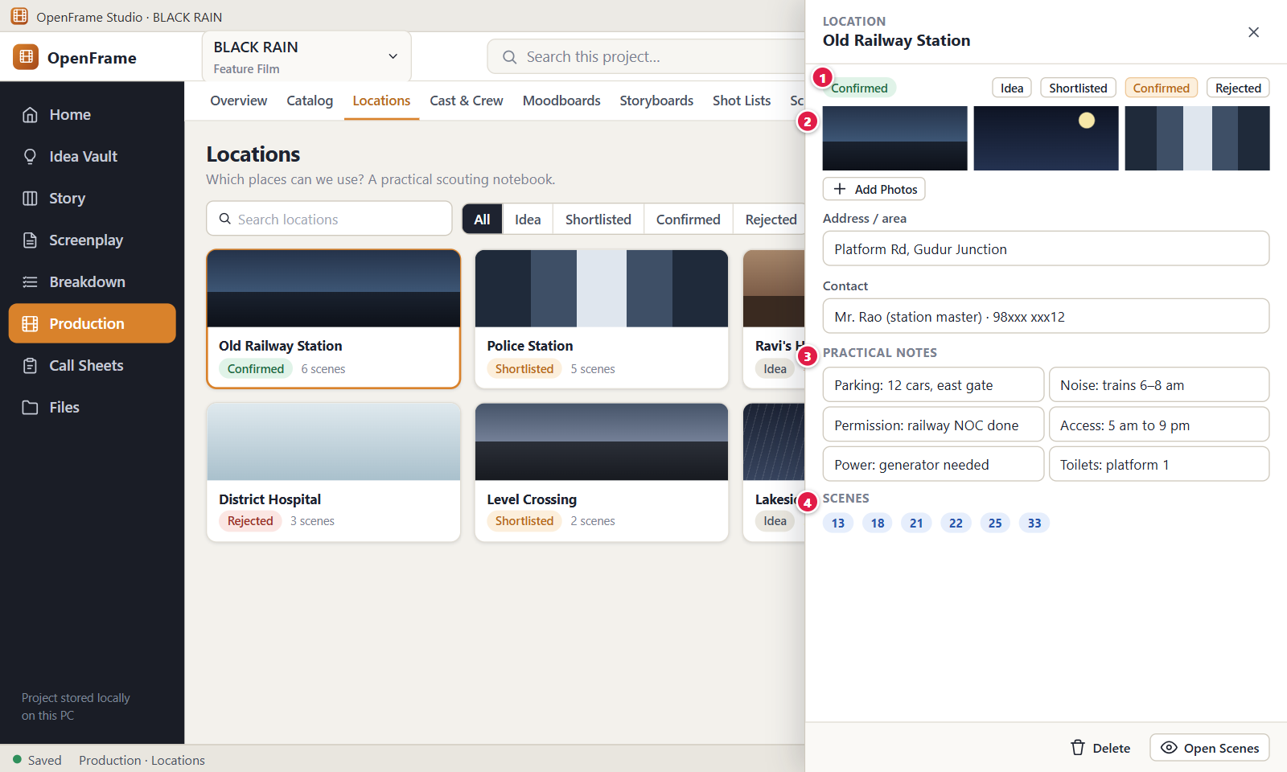
Figure 116. Location details: photos, notes, scenes. Red numbers are explained on the next page.

Figure 116: Location details: photos, notes, scenes: how it works
PARTS OF THIS SCREEN  1 Status buttons Four buttons: Idea, Shortlisted, Confirmed and Rejected. The current one is highlighted. Click another to change the status at once. Any status can be set from any other. The hint says a status change never alters the screenplay, and confirming does not assign the place to scenes.  2 Photos A strip of photos. "Add Photos" takes one or many images (JPG, PNG, GIF, WebP and similar). Hover a photo for Move earlier, Move later and Remove photo. The first photo is the thumbnail on the card. Photos are stored in the project and work offline. A removed photo shows a toast with Undo.  3 Practical notes Labelled fields for Parking, Noise, Permission, Access, Power, Toilets, Nearby facilities, Travel and Other notes, for example "12 cars, east gate" under Parking. Each takes up to 4,000 characters and is saved when you leave the field.  4 Scenes Every scene that needs this place, as chips such as "Scene 13". Click a chip to open the scene in Breakdown. If no scene uses it, the drawer says to tag it in the Breakdown as Location / Set. A scene removed from the source shows "Removed scene". | HOW TO USE IT  1. Open Production > Locations and click the card "Old Railway Station".  2. Click "Confirmed" in the status row.  3. Click "Add Photos" and choose your scouting pictures. Use Move earlier to put the best one first.  4. Type the address and the practical notes, such as parking and access times.  5. Click a scene chip, for example "Scene 13", to open it in Breakdown.  6. Close the drawer with the X. Your edits are already saved.  GOOD TO KNOW · EDGE CASES  • Text fields save when you leave them, so click out of the field before you close the drawer.  • Contact, Emergency contact and Nearest hospital are personal data. Only the Owner and Editor see them. They are never exported and never given to the AI assistant.  • A Rejected location that scenes still use shows a banner "Rejected, but still used in 3 scenes." with "Replace…".  • "Open Scenes" in the footer opens Breakdown on the first scene that uses the place only. Use the chips for the others.  • "Delete" asks first and moves the location to Recently Deleted for 30 days. "Archive" is the milder choice.  • Viewers and Commenters can read the drawer but cannot change it.
See also: Figure 115 Locations list Figure 117 Replacing a rejected location for selected scenes Figure 143 Call Sheet editor Figure 104 Breakdown: scene list, script and elements

Figure 117: Replacing a rejected location for selected scenes
What it is for. When a location is Rejected, you can point selected scenes at a practical substitute without touching the screenplay. This dialog lets you choose the substitute and the scenes. It answers "Which scenes move to the new place, and what stays unchanged?".
How to get here. Left navigation > Production > Locations. Click a Rejected location that scenes still use, for example District Hospital. In the drawer, click "Replace…" in the yellow banner "Rejected, but still used in 3 scenes." The dialog is titled "Replace a rejected location".
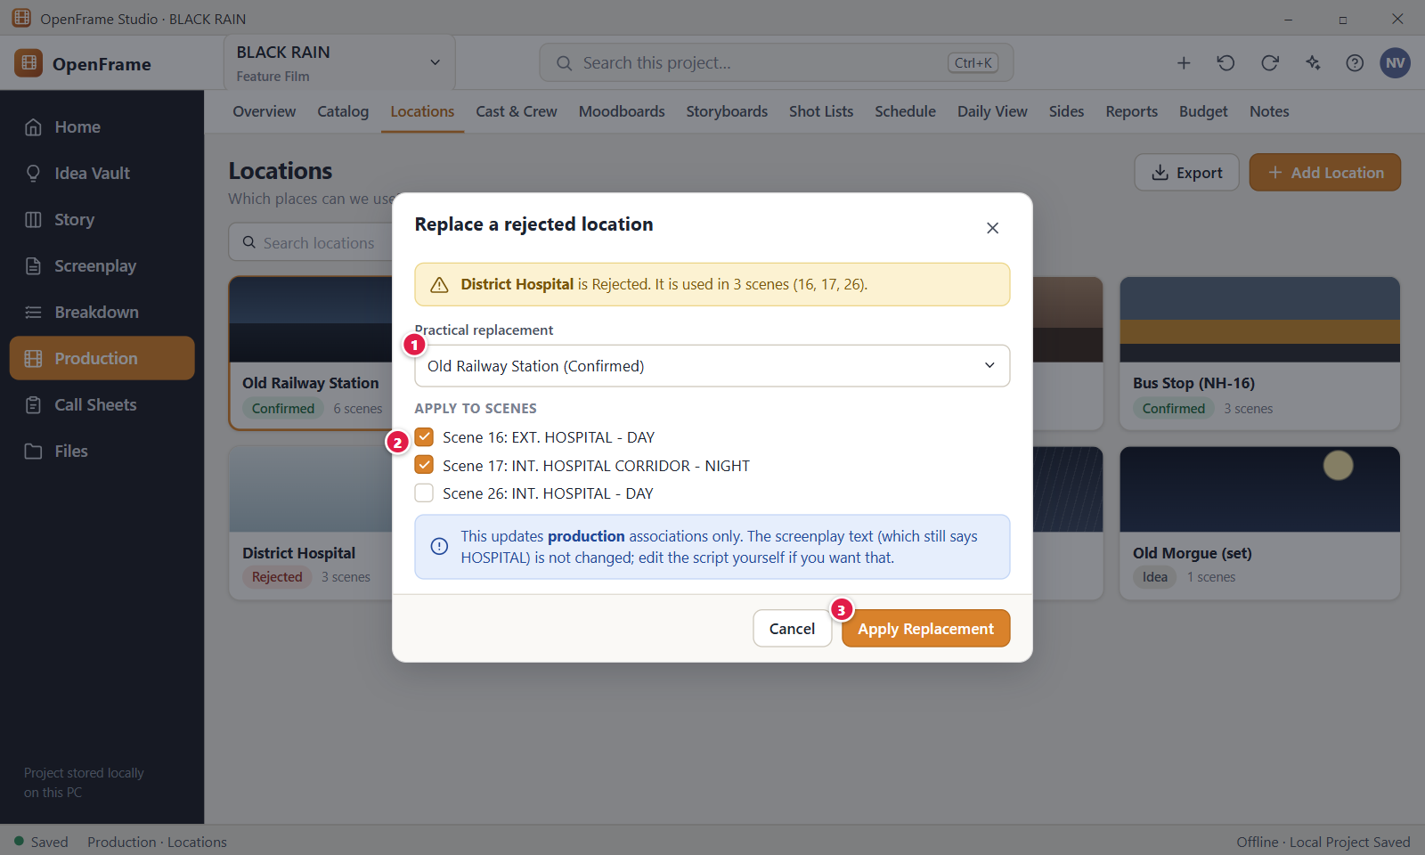
Figure 117. Replacing a rejected location for selected scenes. Red numbers are explained on the next page.

Figure 117: Replacing a rejected location for selected scenes: how it works
PARTS OF THIS SCREEN  1 Practical replacement A drop-down of the other locations that are not Rejected and not archived, each shown with its status, for example "Old Railway Station (Confirmed)". The first Confirmed location is chosen for you. If there is none, the dialog tells you to add the replacement as a location first. You cannot choose the same location or an archived one.  2 Apply to scenes One tick box for every scene of the current Production Source that uses the rejected place, labelled like "Scene 16: EXT. HOSPITAL - DAY". All are ticked at first. Untick the scenes that should stay. At least one scene must stay ticked.  3 Apply Replacement Moves the Location / Set link of the ticked scenes from the rejected place to the replacement. Only production links change. The screenplay text and the rejected location stay. The rejected location keeps its status and shows the line "Practical replacement: <name>". The button is disabled until a replacement and a scene are chosen. | HOW TO USE IT  1. Open Production > Locations and click the Rejected card "District Hospital".  2. Click "Replace…" in the yellow banner.  3. Choose the replacement, for example "Old Railway Station (Confirmed)".  4. Untick any scene that should keep the old place.  5. Click "Apply Replacement".  GOOD TO KNOW · EDGE CASES  • Replacing changes production links only. The scene heading in the screenplay still names the old place until you edit the script yourself.  • The rejected location is not deleted. It stays Rejected and remembers its replacement.  • If a scene already needs the replacement, it is not linked twice. The old link goes to Recently Deleted and can be restored.  • Only scenes of the current Production Source are listed.  • Press Ctrl+Z to undo the replacement. Esc, the X and Cancel close the dialog without a change.  • The "Replace…" banner appears only for a Rejected location that at least one scene still uses.
See also: Figure 115 Locations list Figure 116 Location details: photos, notes, scenes Figure 104 Breakdown: scene list, script and elements Figure 135 Shooting Day detail

Figure 118: Cast list
What it is for. The Cast list connects real people to story characters and keeps light availability notes. It is a small directory, not an HR system. It answers "Who plays which character, how do I reach them, and which characters still need an actor?".
How to get here. Left navigation > Production, then the "Cast & Crew" tab. It opens on Cast. You can also use Assign Actor from Characters in Story, or the Production overview, where unresolved cast is counted.
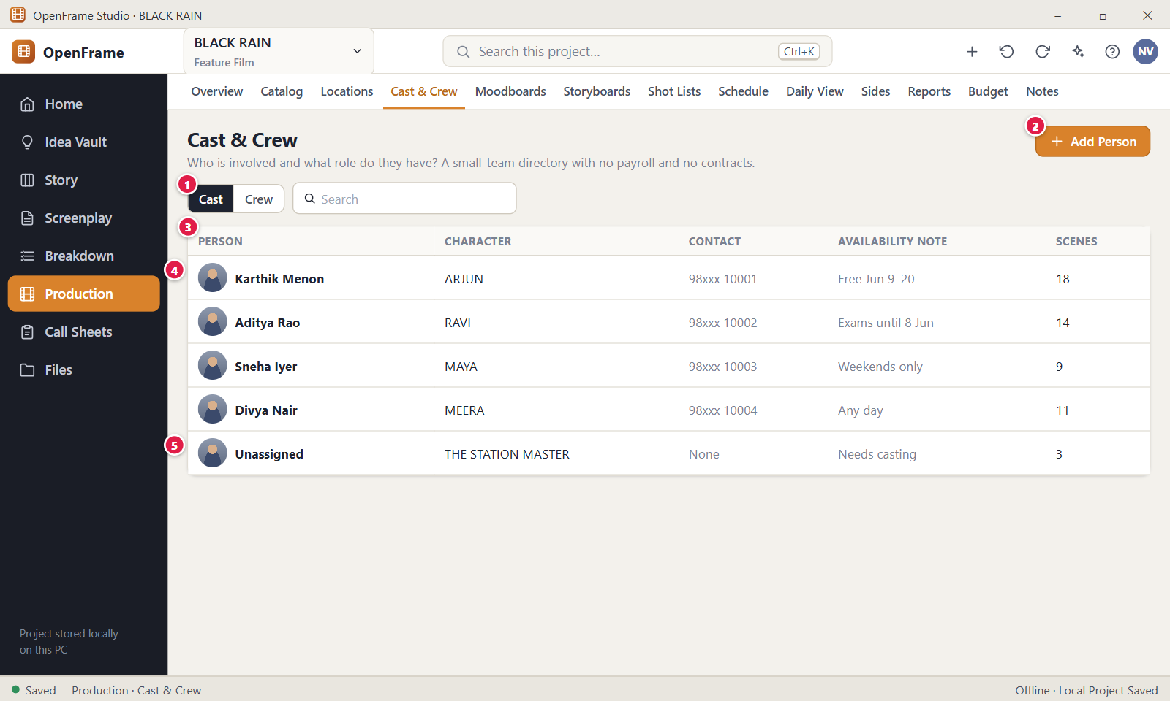
Figure 118. Cast list. Red numbers are explained on the next page.

Figure 118: Cast list: how it works
PARTS OF THIS SCREEN  1 Cast | Crew A switch between the cast list and the crew list. Cast is selected at first. The search box and the tick box "Show archived" sit next to it. On Cast, search matches the person, the character and the availability note.  2 Add Person On the Cast view it opens one dialog where you type the actor's name and choose the character. The dialog button is "Assign". Contact, photo and availability are added afterwards in the drawer. Only roles that can edit see the button.  3 Cast rows One row per cast member, with Person, Character, Contact, Availability note and Scenes. Click a row to open the drawer. Right-click for Open, Assign Character…, Archive and Delete…. Contact shows "Hidden" if your role may not see it. The Scenes number counts scenes of the Production Source that mention the character. It is plain text and does not open the scenes.  4 Availability note A short note in plain words, such as "Free Jun 9 to 20", with the number of date ranges. It is a reminder, not a calendar. It does not block the schedule. The drawer has a notes field (up to 4,000 characters) and an editor for date ranges.  5 Unresolved cast A character with no actor appears as an "Unassigned" row with the chip "Needs casting" and an "Assign" button. Such characters count as unresolved cast on the Production overview. | HOW TO USE IT  1. Open Production and click the "Cast & Crew" tab. Cast is shown.  2. Find the row "THE STATION MASTER" marked "Needs casting" and click "Assign".  3. Type the actor's name and confirm the character. Choose the casting type, then click "Assign".  4. Click the new row to open the drawer. Add the contact and an availability note, for example "Free Jun 9 to 20".  5. Check the Production overview. The unresolved cast count has gone down by one.  GOOD TO KNOW · EDGE CASES  • The character stays a story object. The actor is the real person linked to it.  • There is no salary, contract, union or payroll field on purpose.  • One character has one primary actor by default. You can add an alternate or double casting. Making a new primary turns the old one into an alternate.  • Contact details are private. Only the Owner and Editor see them. They are never exported, never searched and never given to the AI assistant.  • Removing someone from the directory does not change call sheets you already issued.  • An empty project says "No cast yet." Characters from the Production Source appear here on their own.
See also: Figure 119 Assigning an actor to a character Figure 120 Crew list Figure 102 Production overview (dashboard) Figure 143 Call Sheet editor

Figure 119: Assigning an actor to a character
What it is for. This compact dialog links a real person to a story character. You choose the character from the list, or type a new character name, and click Assign. It answers "Which character does this person play?".
How to get here. Left navigation > Production > Cast & Crew. Click "Add Person", or click "Assign" in an Unassigned row, or right-click a cast row and choose "Assign Character…". From Story > Characters the entry is "Assign Actor".
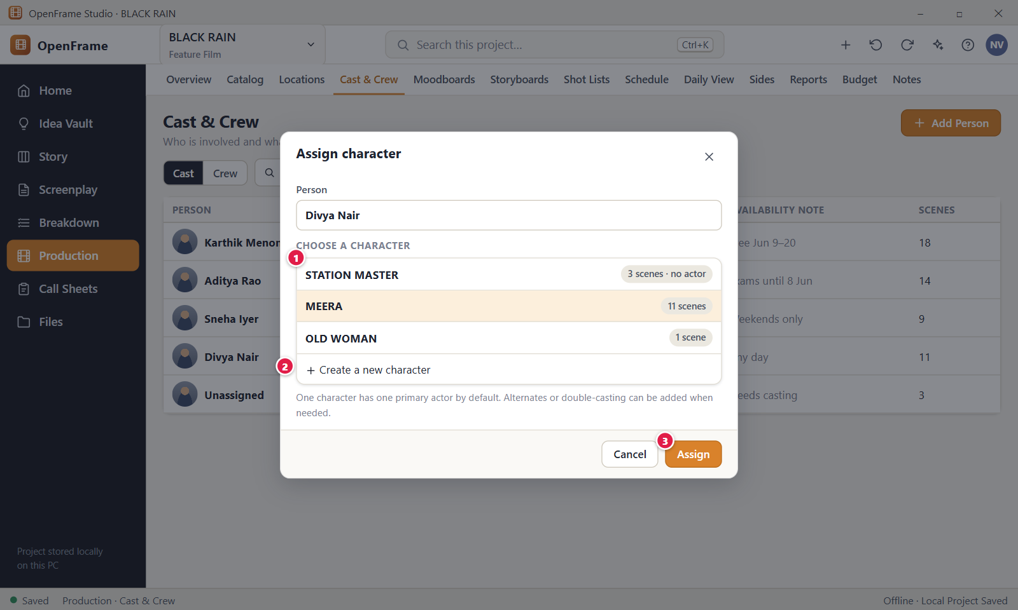
Figure 119. Assigning an actor to a character. Red numbers are explained on the next page.

Figure 119: Assigning an actor to a character: how it works
PARTS OF THIS SCREEN  1 Existing characters The characters of the Production Source, one per row, with the scene count and the actor, for example "3 scenes · no actor" or "played by <person>". Pick one row. The character you came from is already selected. Choosing a row clears the text in the new character field. The list scrolls when it is long.  2 Create a new character A text field for a character that is not in the script yet, with the hint "For a character that isn't in the script yet." The name is stored in capitals and extra spaces are removed. A typed name wins over a chosen row. It only stores the name on the cast member. It does not add a character in Story > Characters.  3 Assign Links the person to the character and closes the dialog. It stays disabled until a person name and a character are present. A "Casting" control offers "Primary actor" and "Alternate / double". The primary is the default when the character has none. Making a new primary turns the old one into an alternate. | HOW TO USE IT  1. Open Production > Cast & Crew and click "Add Person".  2. Type the actor's name in the Person field, for example "Latha Menon".  3. Click the character in the list, for example "STATION MASTER". Or type a new name in "Create a new character".  4. Check the Casting control: "Primary actor" or "Alternate / double".  5. Click "Assign". A toast confirms who plays the character.  GOOD TO KNOW · EDGE CASES  • Assigning never edits the screenplay.  • One character has one primary actor by default. "Alternate / double" adds a second person without replacing the first.  • If the project has no characters yet, the dialog says "No characters found in the Production Source yet. Create one below."  • When you assign a character to an existing cast member, the Person field is read-only.  • Press Ctrl+Z to undo the assignment. Cancel, the X and Esc close the dialog without a change.
See also: Figure 118 Cast list Figure 120 Crew list Figure 102 Production overview (dashboard)

Figure 120: Crew list
What it is for. The Crew list records who does what on the film and how to reach them. It feeds the call sheet. It is a small directory, not HR software. It answers "Who is on the crew, in which department, and how do I contact them?".
How to get here. Left navigation > Production > Cast & Crew, then click "Crew" in the Cast | Crew switch. The page header still says Cast & Crew.
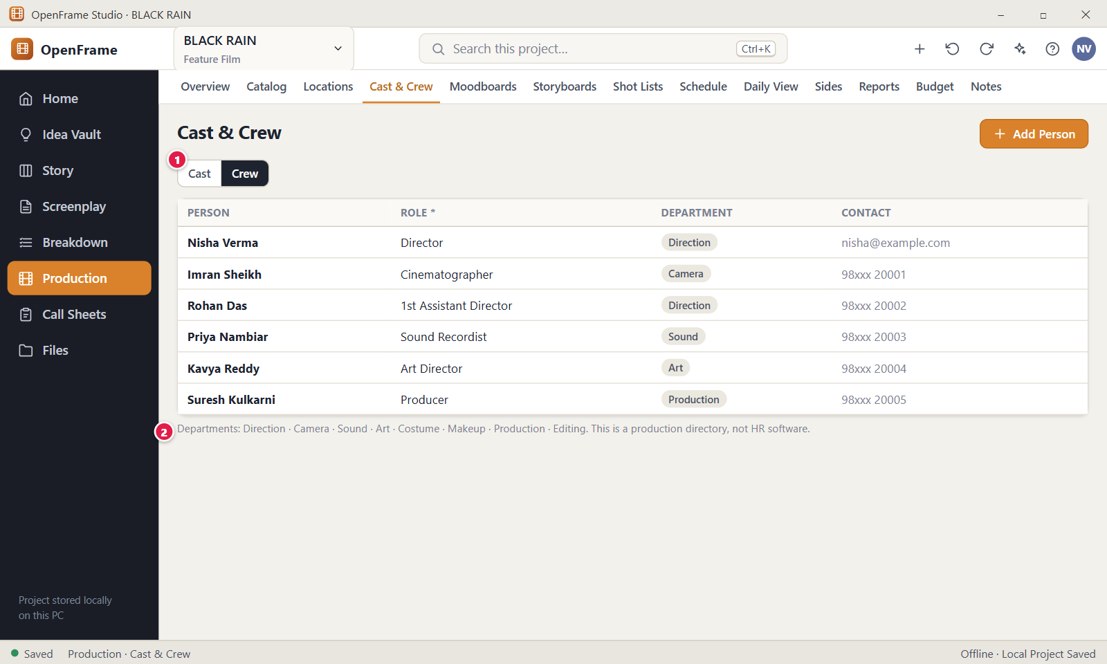
Figure 120. Crew list. Red numbers are explained on the next page.

Figure 120: Crew list: how it works
PARTS OF THIS SCREEN  1 Crew tab The "Crew" side of the Cast | Crew switch. Click it to show the crew list. The columns are Person, Role, Department and Contact. The search box and the tick box "Show archived" stay in the same row. The view returns to Cast when you leave the tab.  2 Roles and departments Role is required for every crew member, for example "Director of Photography". Department is optional. The eight departments are Direction, Camera, Sound, Art, Costume, Makeup, Production and Editing, shown as plain text in the table. A grey line under the table names them and says this is a production directory, not HR software. | HOW TO USE IT  1. Open Production > Cast & Crew and click "Crew".  2. Click "Add Person".  3. Type the person's name and the role, for example "Director of Photography".  4. Choose a department, such as Camera, and add a contact if you want.  5. Click "Add to Crew". The new person appears in the table.  GOOD TO KNOW · EDGE CASES  • The button "Add to Crew" stays disabled until the person name and the role are filled.  • There is no salary, contract, union or payroll field anywhere.  • Crew appear on call sheets depending on the shooting day. Removing a person does not change call sheets you already issued.  • Archive hides the person unless "Show archived" is ticked. Remove moves them to Recently Deleted for 30 days.  • Contact details are private. Only the Owner and Editor see them. They are never exported, never searched and never given to the AI assistant.  • An empty list says "No crew yet."
See also: Figure 118 Cast list Figure 143 Call Sheet editor Figure 102 Production overview (dashboard)

Figure 121: Moodboard canvas
What it is for. A moodboard is a freeform canvas of references, like pinning pictures, notes and links on a wall. It shows the director and the team how the film should look and feel. It answers one question: what should this film feel like?
How to get here. Left navigation > Production, then the tab Moodboards. You can also click the + quick action in the top bar and choose New Moodboard. The page opens on the first board in the list.
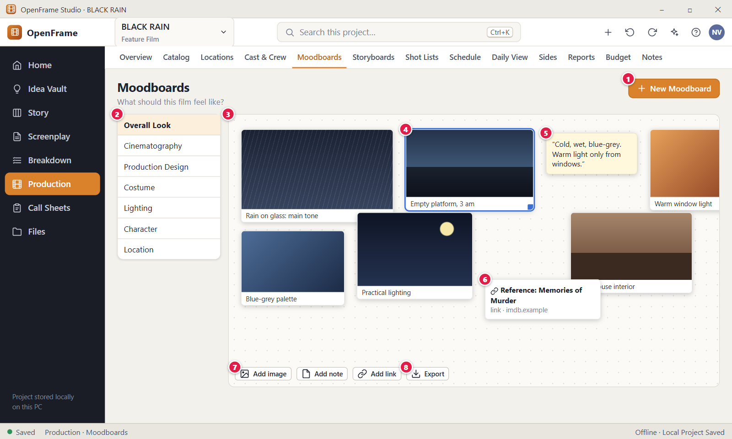
Figure 121. Moodboard canvas. Red numbers are explained on the next page.

Figure 121: Moodboard canvas: how it works
PARTS OF THIS SCREEN  1 New Moodboard Opens a dialog where you name a new board (required, up to 120 characters). Small buttons suggest Overall Look, Cinematography, Production Design, Costume, Lighting, Character and Location, but any name works. You can also pick a scene in "Reference for a scene". Click Create Moodboard to finish.  2 Board list The column of boards on the left. Click a board to open it. Each row shows the board name and how many items it holds. Right click a row to Rename, add Board notes, Move up, Move down or Delete.  3 Canvas The dotted area that holds the tiles of the open board. Drag tiles anywhere, resize them and stack them. Add items with the buttons above the canvas, by dropping image files from File Explorer, or by pasting with Ctrl+V. A pasted image becomes an image tile, a web address becomes a link tile and other text becomes a note.  4 Selected tile A selected tile has a blue outline and a small square handle at its lower right corner. Drag the tile to move it and drag the handle to resize it. Hold Shift while resizing to change the shape of an image. The bar above the canvas then shows a caption field and the buttons Bring to front, Send to back, Edit item and Delete item.  5 Text note A sticky-style note with free text, up to 4,000 characters. Double click it to edit the text, the caption and the internal flag. An internal note is blue and shows "Internal, left out of exports".  6 Link tile A small card with a title and the web host. Double click it to open the address in your default browser. Only web addresses starting with http or https are accepted, and an address without a scheme gets https:// added.  7 Add image In the app this is a menu with two entries: "From file…" and "From Idea Vault…". From file takes several pictures at once (up to 200). From Idea Vault copies a picture onto the board and leaves the vault item unchanged. The Add image, Add note and Add link buttons sit in a bar above the canvas.  8 Export Opens the export dialog for the open board and makes a PDF snapshot (see Figure 122). In the app this button is in the page header, left of New Moodboard, and it shows only when a board exists. | HOW TO USE IT  1. Click New Moodboard, type a name such as "Interiors" and click Create Moodboard.  2. Drag a few pictures from File Explorer onto the canvas, or choose Add image > From file….  3. Click Add note and write a short line, for example "Cold, wet, blue-grey. Warm light only from windows."  4. Click Add link and enter the address of a reference film or article.  5. Click a picture and type a short caption in the bar above the canvas.  6. Drag the tiles into place and use the corner handle to resize them.  7. Click Export when you want to share the board.  GOOD TO KNOW · EDGE CASES  • Moodboards are references only. They never change your breakdown, schedule or any other production data.  • Pictures added from the Idea Vault are copies. Changing the board does not change the vault.  • Moves and resizes save when you let go, and each one is a single undo step with Ctrl+Z.  • Shift+click or Ctrl+click adds tiles to the selection, and a drag moves them all together. Arrow keys nudge the selection, and Delete removes it.  • A picture that cannot be found shows "Image unavailable" with its file name instead of disappearing.  • An empty board shows "Drop images, notes and references here." Dropping a file that is not an image gives the message "Only images can be dropped on a moodboard. Other files were skipped."
See also: Figure 122 Exporting a moodboard Figure 116 Location details: photos, notes, scenes Figure 24 Project Idea Vault: Visual Grid Figure 102 Production overview (dashboard)

Figure 122: Exporting a moodboard
What it is for. This dialog turns one moodboard into a clean PDF you can send to a cinematographer or producer. You choose what goes in, and internal notes stay out unless you tick them. It answers: what exactly will leave the project in this file?
How to get here. Left navigation > Production > Moodboards. Open a board, then click Export in the page header, left of New Moodboard. The dialog is titled "Export moodboard" followed by the board name.
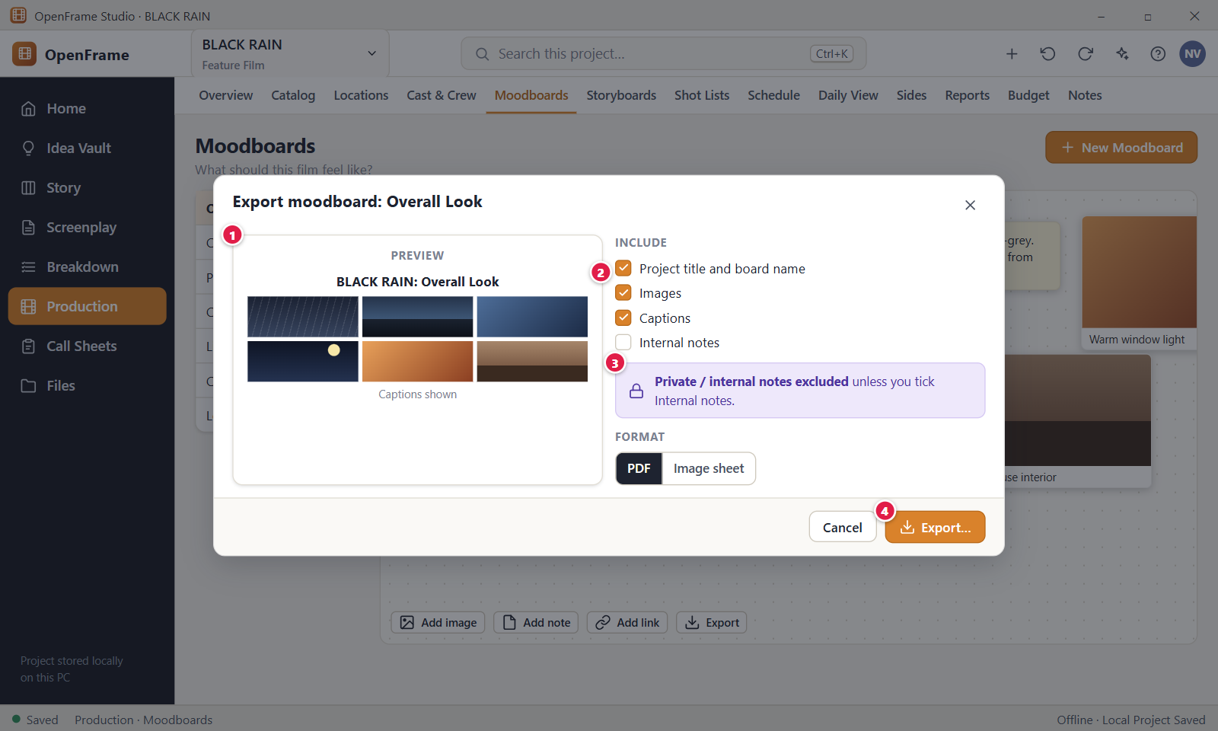
Figure 122. Exporting a moodboard. Red numbers are explained on the next page.

Figure 122: Exporting a moodboard: how it works
PARTS OF THIS SCREEN  1 Preview This control is not in the current version. The dialog has no live preview. It shows the suggested file name under the format choice, for example "BLACK RAIN - Moodboard - Overall Look - 2026-10-18.pdf", and after the export it shows an "Export complete" summary. Open the PDF to check the result.  2 What to include In the app this group is called Options and has four tick boxes: project title and board name, Images, Captions and Internal notes. Title, Images and Captions are ticked at first and Internal notes is not. Unticking Images leaves only the captions.  3 Privacy A banner at the bottom reads "Private / internal notes excluded unless you tick Internal notes. Export creates a snapshot and does not change your project." After the export, the result dialog repeats "Private notes excluded" even if you ticked Internal notes, so go by the options you chose.  4 Export… Opens the Windows Save dialog with the suggested file name, then writes the PDF. The button reads "Exporting…" while the file is made. If you cancel the Save dialog, nothing is written. It needs the Export permission (Owner, Editor or Export-only). | HOW TO USE IT  1. Open Production > Moodboards and select the board, for example Overall Look.  2. Click Export in the page header.  3. Check the Options: leave Internal notes unticked unless the recipient should see them.  4. Click Export… and choose a folder and file name in the Save dialog.  5. Wait for "Export complete", then click Reveal in File Manager to find the PDF, or Close.  GOOD TO KNOW · EDGE CASES  • The PDF is a snapshot taken at the moment of export. Editing the file never changes the board.  • The only format is PDF. The layout is landscape with 3 pictures per row, followed by a section called "Notes and links".  • Internal notes, items marked internal and the board notes appear only when you tick Internal notes. Each one is marked "(Internal)".  • If everything you selected is empty, the app shows "This moodboard has nothing to export with the selected options."  • The dialog does not remember your last choices. Each time it opens with the defaults.  • Characters that Windows does not allow in a file name are replaced by spaces.
See also: Figure 121 Moodboard canvas Figure 116 Location details: photos, notes, scenes

Figure 123: Storyboard panels for a scene
What it is for. A storyboard is a simple, ordered series of picture panels for one scene. It is a planning aid, not illustration software. This screen answers: what will the audience see in this scene, panel by panel?
How to get here. Left navigation > Production, then the tab Storyboards. You can also open Scene Hub > Storyboard for a scene. The page opens on the first scene that already has a storyboard, otherwise on the first scene.
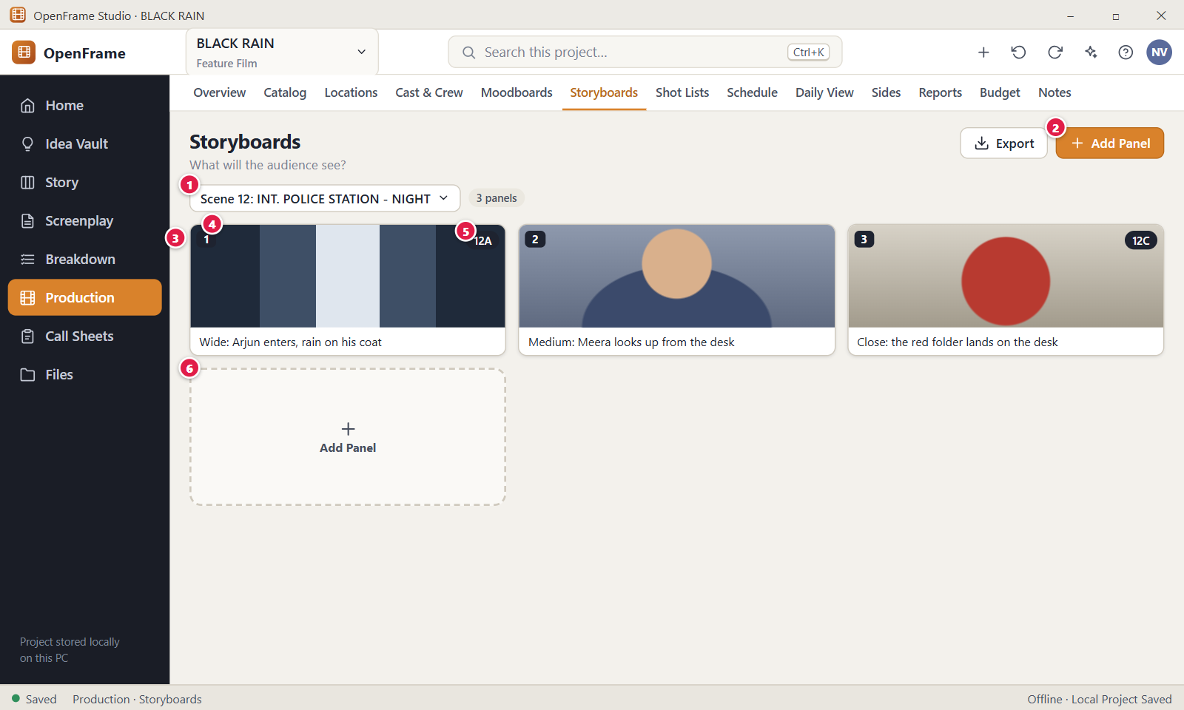
Figure 123. Storyboard panels for a scene. Red numbers are explained on the next page.

Figure 123: Storyboard panels for a scene: how it works
PARTS OF THIS SCREEN  1 Scene selector A drop-down under the page title. The panels on the page belong to the scene you pick. A scene that changed since planning ends with ", review". Storyboards of scenes removed from the script are grouped under "Removed from script".  2 Add Panel A menu button at the top right with three entries: Import Image, Draw / Sketch and Empty Panel. The first panel of a scene also creates its storyboard. Next to it, New Storyboard creates a second or standalone storyboard.  3 Panels The ordered panels, three per row. Each shows its number, the picture and a short description. Drag a panel to a new place and the numbers follow. You can also focus a panel, press Space, use the arrow keys and press Space again. Right click for Open, Move to storyboard…, Link Shot… and Delete.  4 Panel 1 One panel. Click it or press Enter to open its drawer with Description, Visual, Framing, Camera movement, Angle, Duration, Dialogue / sound note, Storyboard note and Shot. Fields save when you leave them. Duration takes 0 to 3,600 seconds. The Delete button in the footer removes the panel.  5 Linked shot badge In the app the badge reads just the shot label, for example "12A", not "Shot 12A". It appears only on panels linked to a shot. Click it to open the shot in Shot Lists. The letter follows the order of shots in the scene, so panel 3 can be 12C while panel 2 has no shot.  6 Add Panel tile The dashed tile after the last panel. It opens the same menu as the header button: Import Image, Draw / Sketch and Empty Panel. An empty scene shows "Create panels for this scene." | HOW TO USE IT  1. Choose a scene in the scene selector, for example Scene 12: INT. POLICE STATION - NIGHT.  2. Click Add Panel and choose Import Image, Draw / Sketch or Empty Panel.  3. Click the new panel and write a short description, for example "Wide: Arjun enters, rain on his coat".  4. Drag the panels into the order you want. Panel numbers follow automatically.  5. To tie a panel to a shot, right click it, choose Link Shot… and pick the shot.  6. Click Export when the storyboard is ready to share.  GOOD TO KNOW · EDGE CASES  • Starting a storyboard creates empty panels only. OpenFrame never invents a picture sequence unless you ask the AI assistant to help.  • If the script of a scene changes later, your panels are kept. The page shows "Scene 12 changed since planning" until you click Mark reviewed.  • A storyboard and a shot list are independent. Neither needs the other, and linking is optional.  • Removing a shot link with Unlink deletes neither the panel nor the shot.  • You can paste an image with Ctrl+V to add it as a new panel. Ctrl+Z undoes adds, moves, deletes and text edits.  • Export makes a PDF only. You can export the current storyboard, all storyboards or selected ones, and shot notes are off by default.
See also: Figure 124 Add Panel: import, sketch or empty Figure 125 Sketching a panel Figure 126 Shot list for a scene Figure 138 Script changed in scheduled scenes: review changes

Figure 124: Add Panel: import, sketch or empty
What it is for. This is the Add Panel menu on the Storyboards screen. A storyboard panel is one picture box with a short description, in the order the audience will see it. The menu answers: how do I get a picture into a new panel?
How to get here. Left navigation > Production > Storyboards. Pick a scene in the scene selector, then click Add Panel at the top right. The same three choices appear in the dashed Add Panel tile at the end of the grid and in the buttons of an empty scene.
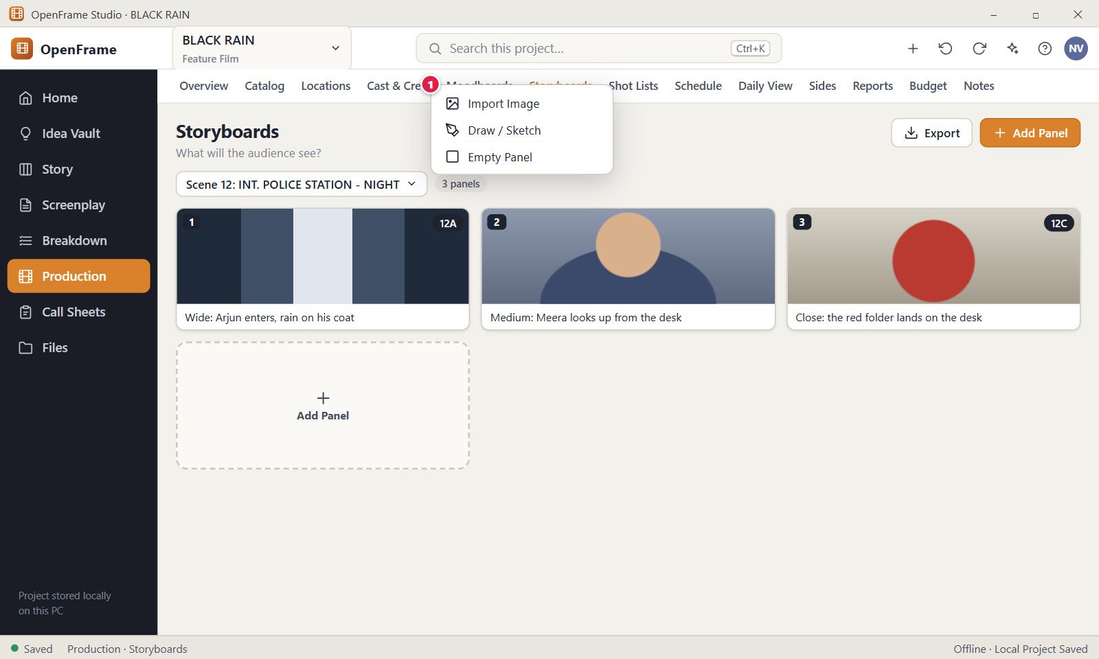
Figure 124. Add Panel: import, sketch or empty. Red numbers are explained on the next page.

Figure 124: Add Panel: import, sketch or empty: how it works
PARTS OF THIS SCREEN  1 Add Panel menu Three entries in this order. "Import Image" opens a Windows file dialog, copies the picture into the project and adds a panel with it. "Draw / Sketch" opens the sketch dialog (Figure 125). "Empty Panel" adds a placeholder box you fill later. The new panel goes to the end of the storyboard. | HOW TO USE IT  1. Select the scene in the scene selector.  2. Click Add Panel at the top right.  3. Choose Import Image, Draw / Sketch or Empty Panel.  4. For Import Image, pick a PNG, JPEG, GIF, WebP, BMP or SVG file.  5. Click the new panel to add a description, or drag it to a new place.  GOOD TO KNOW · EDGE CASES  • The first panel of a scene also creates that scene's storyboard. There is no separate create step.  • Imported pictures are copied into the project. Moving or deleting the original file later changes nothing.  • A file of another type gives "That file isn't an image OpenFrame can show. Choose a PNG, JPEG, GIF, WebP, BMP or SVG image." No panel is created.  • Pasted or sketched image data is limited to 25 MiB. Larger data gives "That image is too large."  • You need the Edit permission (Owner or Editor) to add panels.  • You can also paste a picture with Ctrl+V to add it as a panel. Ctrl+Z or the Undo link in the toast takes the new panel back.  • The sketch tool is basic on purpose. For polished art, import an image made elsewhere.
See also: Figure 123 Storyboard panels for a scene Figure 125 Sketching a panel Figure 127 Shot details (technical fields) Figure 126 Shot list for a scene Figure 102 Production overview (dashboard)

Figure 125: Sketching a panel
What it is for. This is the "Draw / Sketch panel" dialog. It gives you a plain drawing surface for a quick thumbnail of a shot. It answers: can I sketch the picture myself without leaving OpenFrame? The tools are few on purpose.
How to get here. Left navigation > Production > Storyboards. Select a scene, click Add Panel and choose Draw / Sketch. The same dialog opens from the "Draw / Sketch…" button in the panel drawer when you change the picture of an existing panel.
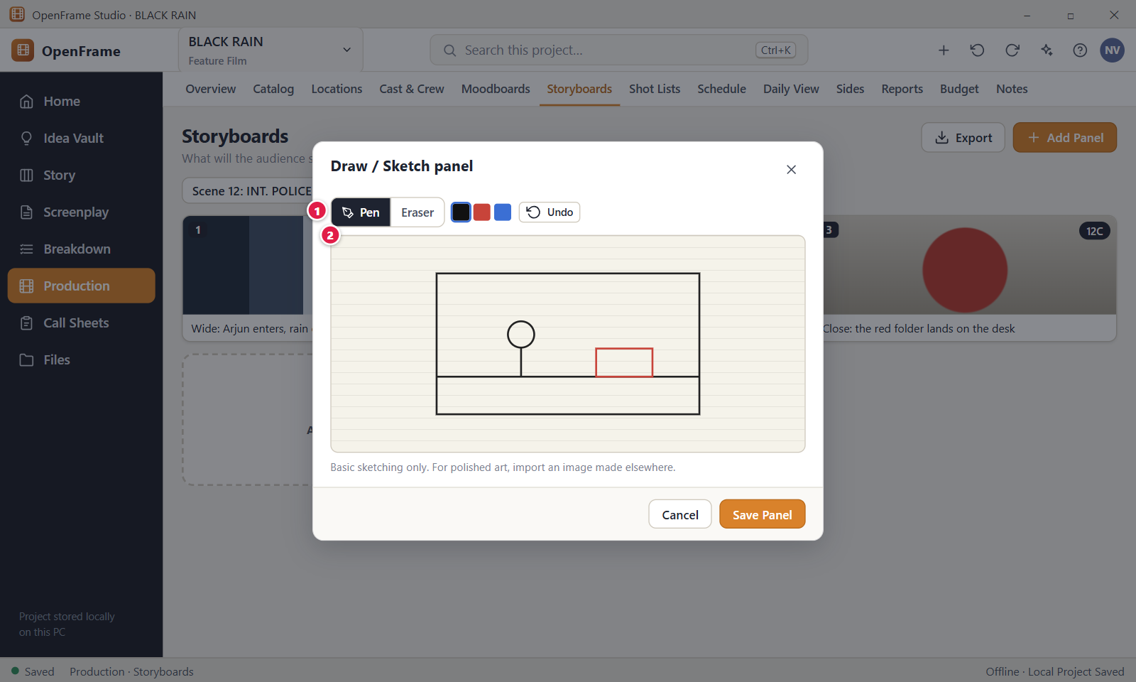
Figure 125. Sketching a panel. Red numbers are explained on the next page.

Figure 125: Sketching a panel: how it works
PARTS OF THIS SCREEN  1 Tools The tool row above the drawing area. It holds the Pen and Eraser choice, three ink colours (Black, Red, Blue), Undo and Clear. Pen and black ink are selected at first. Undo and Clear stay disabled until you draw. Choosing an ink switches back to the Pen.  2 Drawing area A white surface in a 16 to 9 shape. Draw with the mouse, a pen tablet or a finger. A click without moving draws a dot. The eraser paints white, so the saved picture always has a white background. | HOW TO USE IT  1. Click Add Panel and choose Draw / Sketch.  2. Draw your shot with the Pen. Click Red or Blue to change the ink.  3. Switch to Eraser to rub out parts. Click Undo to take back the newest stroke.  4. Click Save Panel. The sketch is added as a new panel at the end of the storyboard.  5. Click Cancel, press Esc or click the X to leave without keeping the drawing.  GOOD TO KNOW · EDGE CASES  • Sketching is basic on purpose: there are no layers, shapes, text, fill or zoom. For polished art, import an image made elsewhere.  • The pen line is thin and the eraser is much thicker. The eraser rubs out what you drag over, not a whole stroke.  • Save Panel is disabled until you have drawn at least one stroke.  • Cancel, Esc and the X discard the drawing without asking.  • The sketch is stored as an ordinary picture in the project. You can replace or clear it later from the panel drawer.  • Clear removes the whole drawing. Undo takes back one stroke per click.
See also: Figure 124 Add Panel: import, sketch or empty Figure 123 Storyboard panels for a scene Figure 127 Shot details (technical fields)

Figure 126: Shot list for a scene
What it is for. The Shot Lists screen is a practical camera-planning list for one scene at a time. It answers: how will I capture this scene? Each shot gets a letter that follows its position (12A, 12B, 12C). Only a short description is required. Camera details are optional.
How to get here. Left navigation > Production > Shot Lists. Pick the scene in the scene selector. You can also arrive from Scene Hub (Shots) or from a storyboard panel's shot badge. Click a shot to open its detail drawer (Figure 127).
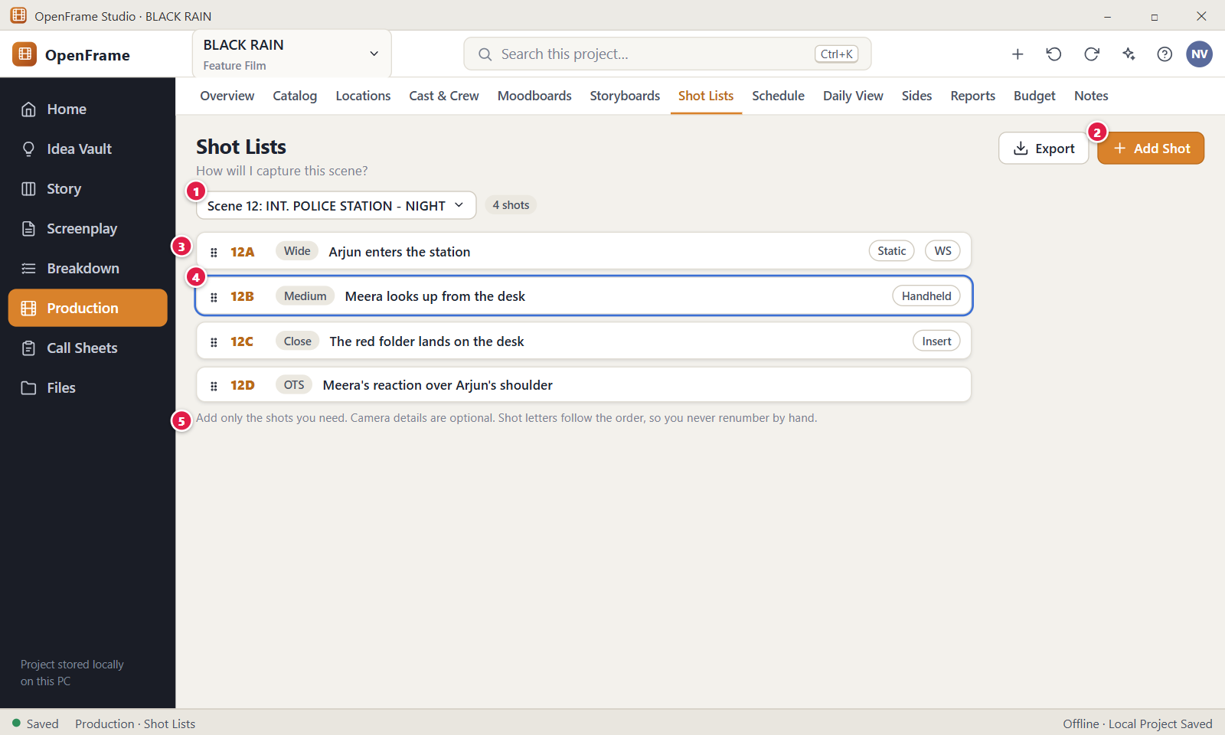
Figure 126. Shot list for a scene. Red numbers are explained on the next page.

Figure 126: Shot list for a scene: how it works
PARTS OF THIS SCREEN  1 Scene selector A drop-down named "Scene". Shots belong to the scene you choose, and new shots go into it. The first entry is "All scenes", which lists every shot grouped by scene but does not allow adding a shot. Tick "Show removed scenes" to see shots of scenes that left the script.  2 Add Shot The header button moves the cursor to the quick-add box under the list, or adds the shot at once if you already typed a description. The description is the only required field (1 to 2,000 characters). An empty box shows "Describe the shot to add it." The button is off while "All scenes" is selected.  3 Shot rows The ordered shots of the scene. Each row shows a drag handle, the shot letter, the description and small chips for size, movement, angle and lens when they are filled in. Drag the handle to reorder and the letters renumber at once. Right click for Open, Duplicate, Move to scene…, Attach Storyboard…, Create storyboard panel and Delete.  4 Selected shot Click a row to select it and open its detail drawer on the right. Ctrl+click and Shift+click select several rows without opening the drawer. Closing the drawer keeps the list as it is.  5 Guidance A permanent hint under the list. In the app it reads "Add only the shots you need. Camera details are optional. Shot letters are generated from order, so you never renumber by hand." | HOW TO USE IT  1. Choose a scene in the scene selector, for example Scene 12: INT. POLICE STATION - NIGHT.  2. Click in the quick-add box and type a short description, for example "Meera looks up from the desk".  3. Press Enter or click Add Shot. The shot appears at the end with the next letter.  4. Drag the handle of a shot to change the order. The letters follow.  5. Click a shot to open its drawer and add camera details if you need them.  6. Click Export to share the list as PDF, CSV or Excel.  GOOD TO KNOW · EDGE CASES  • Shot letters are never stored. A reorder, delete or duplicate changes the letters of the shots below it. This is on purpose.  • A shot is complete with only a description. Empty camera fields are not an error.  • If the scene text changes later, your shots are kept. A yellow banner "Scene N changed since planning" appears with a Mark reviewed button.  • Export offers PDF, CSV and Excel. You can export the current scene, selected scenes or the whole project.  • Master, coverage and insert are not a fixed list. Write them in the description or camera notes if you need them.  • Delete or Backspace removes the selected shots, up to 500 at a time. Ctrl+Z brings them back.
See also: Figure 127 Shot details (technical fields) Figure 124 Add Panel: import, sketch or empty Figure 123 Storyboard panels for a scene Figure 102 Production overview (dashboard) Figure 130 Stripboard: Unscheduled pool and shooting days

Figure 127: Shot details (technical fields)
What it is for. This is the detail drawer of one shot. It keeps the camera fields out of the way until you open the shot. Here a shot gets its optional technical details, a reference image and links to storyboard panels. It answers: what exactly do I want for this shot?
How to get here. Left navigation > Production > Shot Lists. Choose the scene, then click a shot row such as 12B. The drawer opens on the right. A storyboard panel's shot badge and search results open it too.
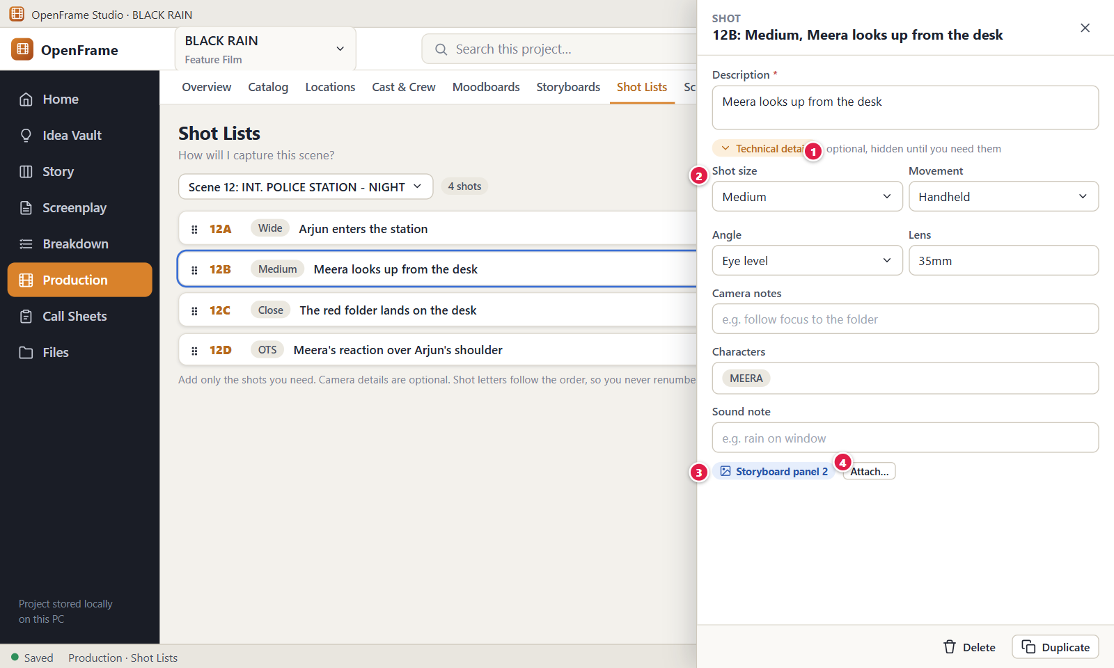
Figure 127. Shot details (technical fields). Red numbers are explained on the next page.

Figure 127: Shot details (technical fields): how it works
PARTS OF THIS SCREEN  1 Technical details hint The grey text "optional, hidden until you need them" beside the Technical details toggle. It tells you the camera fields are optional and can be folded away. A shot is valid with only its description.  2 Shot size, Movement, Angle, Lens Four short text fields. Below them sit Camera notes, Characters and Sound note. All are free text with suggestions as you type, not a fixed list. Each field saves when you press Enter or leave it. Size, movement, angle and lens take up to 200 characters. The notes take up to 4,000.  3 Storyboard panel Lists the storyboard panels linked to this shot as chips such as "Storyboard panel 2". Click a chip to open that panel, or its small X to detach it. A shot can have more than one panel. The Create panel button adds a panel from the shot's description, size, movement and angle.  4 Attach… Opens the dialog "Attach storyboard panel to 12B". Pick a panel from any storyboard, with those of this scene listed first. A panel already attached is greyed out. Choosing a panel attaches it at once, and Cancel closes the dialog. | HOW TO USE IT  1. Click a shot row, for example 12B, to open its drawer.  2. Check the Description. It is the only required field.  3. Click Technical details to unfold the camera fields and fill in what you need, such as Medium and Handheld.  4. Add character names in Characters. Type a name and press Enter. The hint "In this scene" lists names from the script.  5. Click Attach… to link an existing storyboard panel, or Create panel to make one from the shot.  6. Close the drawer. Everything is already saved.  GOOD TO KNOW · EDGE CASES  • There is no Save button. Each field saves when you press Enter or leave it, so closing the drawer loses nothing.  • In the app the drawer also has an "Add reference image…" button, then Replace… and Remove. It is a visual aid copied into the project.  • Duplicate copies the shot just below it with the same details but without its storyboard panels. Delete removes the shot without a question and sends it to Recently Deleted.  • Character names are free text and are not linked to the Cast list. A shot holds up to 60 names.  • An empty description shows "Description is required." under the field.  • The letter in the title (12B) comes from the shot's position. It changes when shots above it are added, deleted or moved.
See also: Figure 126 Shot list for a scene Figure 124 Add Panel: import, sketch or empty Figure 123 Storyboard panels for a scene Figure 102 Production overview (dashboard)

Chapter 6: Scheduling, Call Sheets and Production Documents
Scheduling and production documents: the shooting schedule (stripboard, list and calendar), call sheets, sides, reports, budget, notes and tasks, templates, files, activity history, search and Recently Deleted.

Screens in this chapter
Figure | Screen | Page
Figure 128 | Shooting Schedule: nothing created yet | 281
Figure 129 | Creating the schedule | 283
Figure 130 | Stripboard: Unscheduled pool and shooting days | 285
Figure 131 | Stripboard: List view | 287
Figure 132 | Schedule calendar | 289
Figure 133 | Dragging a scene into a day | 291
Figure 134 | Adding a break marker or off day | 293
Figure 135 | Shooting Day detail | 295
Figure 136 | Schedule conflict warning | 297
Figure 137 | Grouping suggestion | 299
Figure 138 | Script changed in scheduled scenes: review changes | 301
Figure 139 | Exporting the schedule | 303
Figure 140 | Daily Production View | 305
Figure 141 | Call Sheets list | 307
Figure 142 | Creating a call sheet from a shooting day | 309
Figure 143 | Call Sheet editor | 311
Figure 144 | Adding optional call-sheet sections | 313
Figure 145 | Call sheet marked stale after a schedule change | 315
Figure 146 | Refresh preview before updating a call sheet | 317
Figure 147 | Finalizing and exporting a call sheet | 319
Figure 148 | Sides for a shooting day | 321
Figure 149 | Production Reports | 323
Figure 150 | Lightweight budget snapshot (P1) | 325
Figure 151 | Project Notes and Lightweight Tasks | 327
Figure 152 | Activity History | 329
Figure 153 | Template browser (P1) | 331
Figure 154 | Project Files (file cabinet) | 333
Figure 155 | Permissions (removed in this version) | 335
Figure 156 | Global project search | 336
Figure 157 | Recently Deleted (whole project) | 338

Figure 128: Shooting Schedule: nothing created yet
What it is for. This is the Schedule tab of a project that has no shooting schedule yet. It explains the next step and offers one button to start. It answers: where do I begin planning shooting days? A schedule is always built from one screenplay draft, called the Production Source.
How to get here. Left navigation > Production > Schedule, in a project that has not created a schedule yet. Once a schedule exists, this screen is replaced by the stripboard (Figure 130).
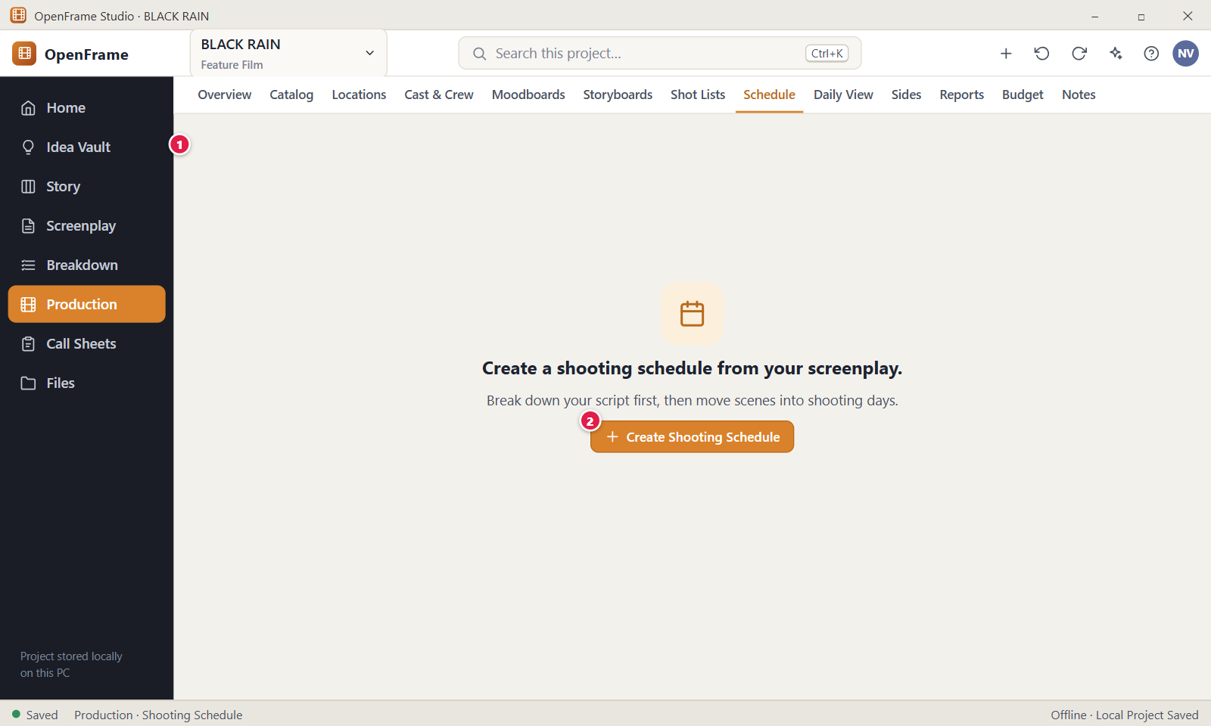
Figure 128. Shooting Schedule: nothing created yet. Red numbers are explained on the next page.

Figure 128: Shooting Schedule: nothing created yet: how it works
PARTS OF THIS SCREEN  1 Empty-state message It reads "Create a shooting schedule from your screenplay. Break down your script first, then move scenes into shooting days." The app adds the line "Production source: <draft name> · <N> scenes." A breakdown helps but is not required.  2 Create Shooting Schedule Opens the dialog where you confirm the screenplay source (Figure 129). Opening the dialog changes nothing. If no Production Source is chosen yet, the app shows an "Open Breakdown" button here instead. You need the Edit permission. | HOW TO USE IT  1. Open Production > Schedule.  2. If the screen asks you to choose a Production Source, click Open Breakdown and choose it there. This is done by the project Owner.  3. Click Create Shooting Schedule.  4. Confirm the source in the dialog and click Create Schedule.  GOOD TO KNOW · EDGE CASES  • The empty state is not an error. Nothing is missing or broken.  • You can create a schedule before a breakdown exists. The breakdown only adds locations and cast to the strips.  • OpenFrame never picks a Production Source silently. If none is chosen, it sends you to Breakdown.  • A project has one schedule. A second create is refused with "This project already has a shooting schedule."  • After the schedule is created, this empty screen does not come back unless the schedule is deleted.
See also: Figure 129 Creating the schedule Figure 130 Stripboard: Unscheduled pool and shooting days Figure 104 Breakdown: scene list, script and elements Figure 102 Production overview (dashboard)

Figure 129: Creating the schedule
What it is for. This dialog creates the shooting schedule. It shows which screenplay draft the schedule will be built from and tells you that every scene starts in the Unscheduled pool. It answers: which script is this schedule for, and what will I get?
How to get here. Left navigation > Production > Schedule. On the empty screen (Figure 128) click "Create Shooting Schedule". The dialog opens over a dimmed screen.
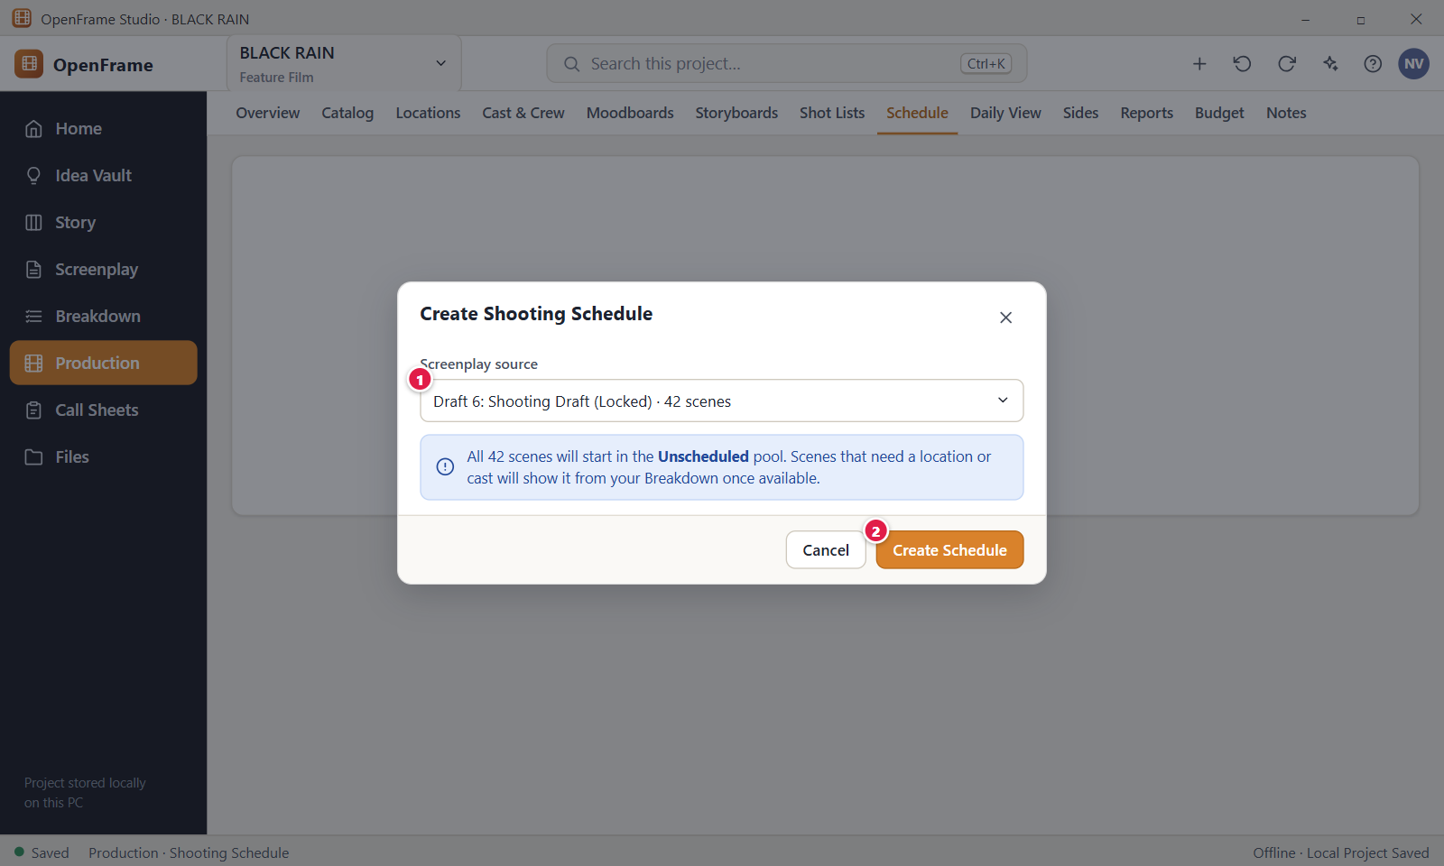
Figure 129. Creating the schedule. Red numbers are explained on the next page.

Figure 129: Creating the schedule: how it works
PARTS OF THIS SCREEN  1 Screenplay source A read-only line naming the screenplay, the draft, its status and the scene count, for example "BLACK RAIN, Draft 6: Shooting Draft (Locked) · 42 scenes". It looks like a field but you cannot edit it. Omitted scenes are not counted. To use another draft, close the dialog and choose another Production Source in Breakdown. Under the line, a blue note explains that all scenes start Unscheduled and that location and cast come from your Breakdown.  2 Create Schedule Creates one schedule named "Shooting Schedule" with the status Draft. Every scene except omitted ones becomes a strip in the Unscheduled pool. No shooting days exist yet. The dialog has no name field: you can rename the schedule later in Schedule settings. | HOW TO USE IT  1. On the Schedule tab, click Create Shooting Schedule.  2. Read the source line and check that it is the draft you want to shoot.  3. Click Create Schedule.  4. The toast says "Created the shooting schedule" and the stripboard opens.  GOOD TO KNOW · EDGE CASES  • Every scene starts Unscheduled. Nothing is placed on a day for you, and there is no automatic optimiser.  • Creating the schedule does not change the screenplay or the breakdown.  • The word "(Locked)" in the source line is part of the draft label, not a warning.  • Cancel, the X and Esc all close the dialog and create nothing. Clicking outside the dialog does the same.  • Press Ctrl+Z after the dialog closes to undo the creation.  • If the draft changes later, the schedule shows a warning banner and lets you review. It never moves scheduled scenes by itself.
See also: Figure 128 Shooting Schedule: nothing created yet Figure 130 Stripboard: Unscheduled pool and shooting days Figure 104 Breakdown: scene list, script and elements

Figure 130: Stripboard: Unscheduled pool and shooting days
What it is for. The stripboard is the main planning view of the shooting schedule. Every strip is one screenplay scene. You drag strips from the Unscheduled pool into shooting days and set the shooting order inside each day. It answers: when and where will we shoot this scene?
How to get here. Left navigation > Production > Schedule, after the schedule has been created. The page opens in Board view. The Board, List and Calendar buttons switch the view.
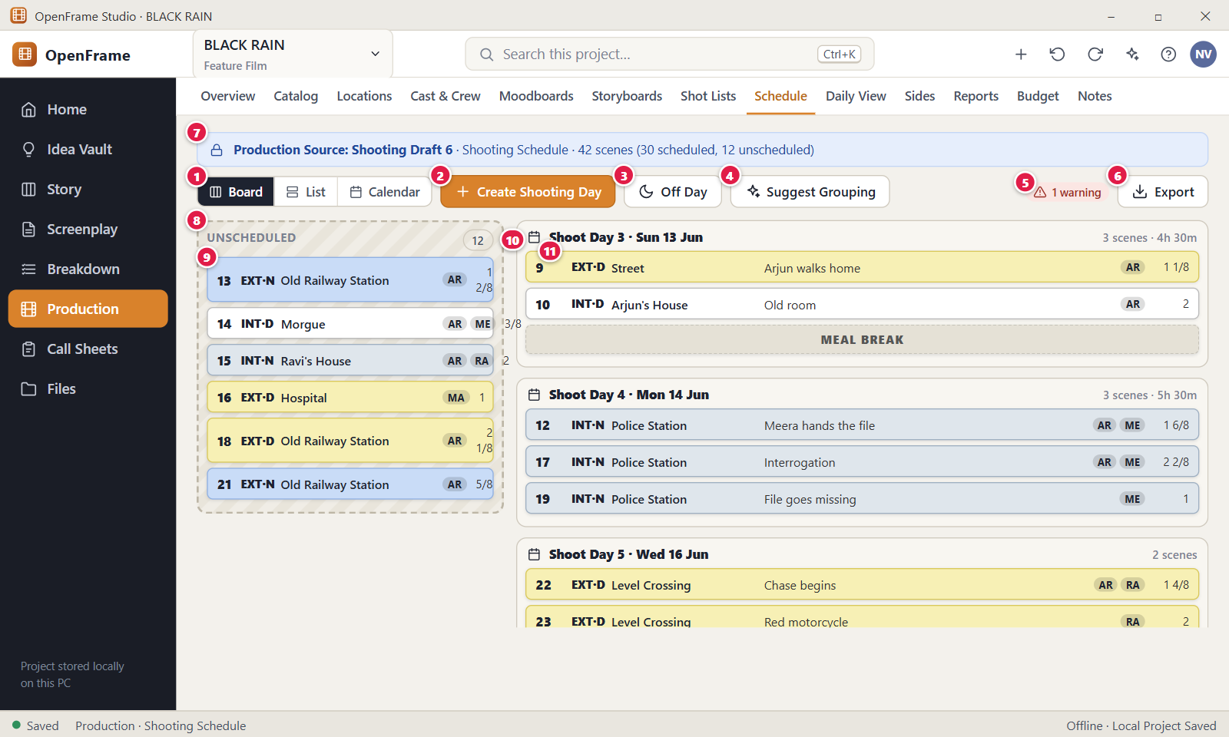
Figure 130. Stripboard: Unscheduled pool and shooting days. Red numbers are explained on the next page.

Figure 130: Stripboard: Unscheduled pool and shooting days: how it works
PARTS OF THIS SCREEN  1 Board / List / Calendar Three views of the same schedule: strips, a table and a month grid. Change data in one and the others follow. The board is selected each time you open the tab, because the choice is not saved.  2 Create Shooting Day Adds a day at the end. A small dialog asks for an optional date and optional day notes (up to 4,000 characters). The day number is not typed. It comes from the order of days (Shoot Day 1, 2, 3) and renumbers when days move. The first new day changes the schedule from Draft to Active.  3 Off Day Adds a day with no scenes, for rest or logistics. The dialog asks for an optional date and note. An off day has no number. You cannot drop scenes on it, and a day that holds scenes cannot be turned into an off day.  4 Suggest Grouping Opens a drawer with advice, such as scenes that share a location or have the same cast. Nothing moves unless you accept a suggestion.  5 Warnings A chip such as "1 warning" (red) or "0 warnings" (green). Click it to open the Schedule assistance drawer. Warnings include an actor needed at two places, a day over the target length (10 hours at first), and a scene removed from the script but still scheduled. They are advice and block nothing unless strict validation is on in Schedule settings.  6 Export Opens "Export Shooting Schedule" with PDF, Spreadsheet (XLSX) and CSV. Scope is the entire schedule, the current day or selected days. You need the Export permission. See Figure 139.  7 Source banner A blue banner naming the draft, the schedule, the scene total and the split, for example "42 scenes (30 scheduled, 12 unscheduled)". It shows " · Finalized" for a finalized schedule. A yellow banner with Review changes appears when the script changed.  8 Unscheduled pool The column on the left with every scene that is not on a day. A scene leaves it when you place it on a day and returns when you remove it from the day. When it is empty it says "Every scene is scheduled." The filter bar fades strips that do not match but never hides them.  9 Strip One scene: number, EXT or INT with day or night, location, a short synopsis, cast initials and the page count in eighths. Click it to open the drawer for the estimated time, start time and page count. The menu has Details…, Move to, Move up, Move down and Remove from Day. A star after the pages means you typed the count by hand.  10 Day header Shows the day title such as "Shoot Day 3 · Sun 13 Jun 2027", the total "3 scenes · 4h 30m", the call sheet state and any warning count. The time adds only the estimates you typed. The three-dot menu has day actions such as Edit date, Meal Break, Travel, Company Move, Set as Off Day, Insert day after and Delete day. Click the title to open the day detail (Figure 135).  11 Scene in a day A strip placed on a day. Drag it inside the day to change the shooting order, to another day to move it, or to the pool to unschedule it. Moving a scene marks the call sheets of both days "Needs refresh". The strip menu is a non-drag alternative. | HOW TO USE IT  1. Click Create Shooting Day, enter a date such as 13 Jun 2027 and click Create Day.  2. Drag a strip, for example scene 13 EXT·N Old Railway Station, from Unscheduled onto the day.  3. Drag strips up or down inside the day to set the shooting order.  4. Click a strip to enter an estimate such as 1h 30m and a start time such as 14:30.  5. Click the warnings chip and fix or keep each warning.  6. Click Export when the plan is ready to share.  GOOD TO KNOW · EDGE CASES  • Removing a scene from a day only unschedules it. It stays in the screenplay and returns to the pool.  • A scene without an estimate adds nothing to the day total. The day never guesses.  • Strip colour follows the usual convention: EXT day yellow, EXT night blue, INT day white, INT night grey. The EXT and INT text carries the same information.  • Delete day has no confirmation. Its scenes go back to Unscheduled.  • A finalized schedule refuses changes with "This schedule is finalized. Reopen it to make changes." Use Reopen… to continue.  • To move strips without a mouse, focus a strip, press Space, use the arrow keys and press Space again. Ctrl+Z undoes the last change.
See also: Figure 131 Stripboard: List view Figure 132 Schedule calendar Figure 133 Dragging a scene into a day Figure 134 Adding a break marker or off day Figure 135 Shooting Day detail Figure 136 Schedule conflict warning

Figure 131: Stripboard: List view
What it is for. The List view shows the shooting schedule as one table, with one row per scene. It is the fast way to read every scene's day, pages, estimate and cast side by side. It answers: which day is each scene on, and what is still missing?
How to get here. Left navigation > Production > Schedule, then click List in the Board / List / Calendar control.
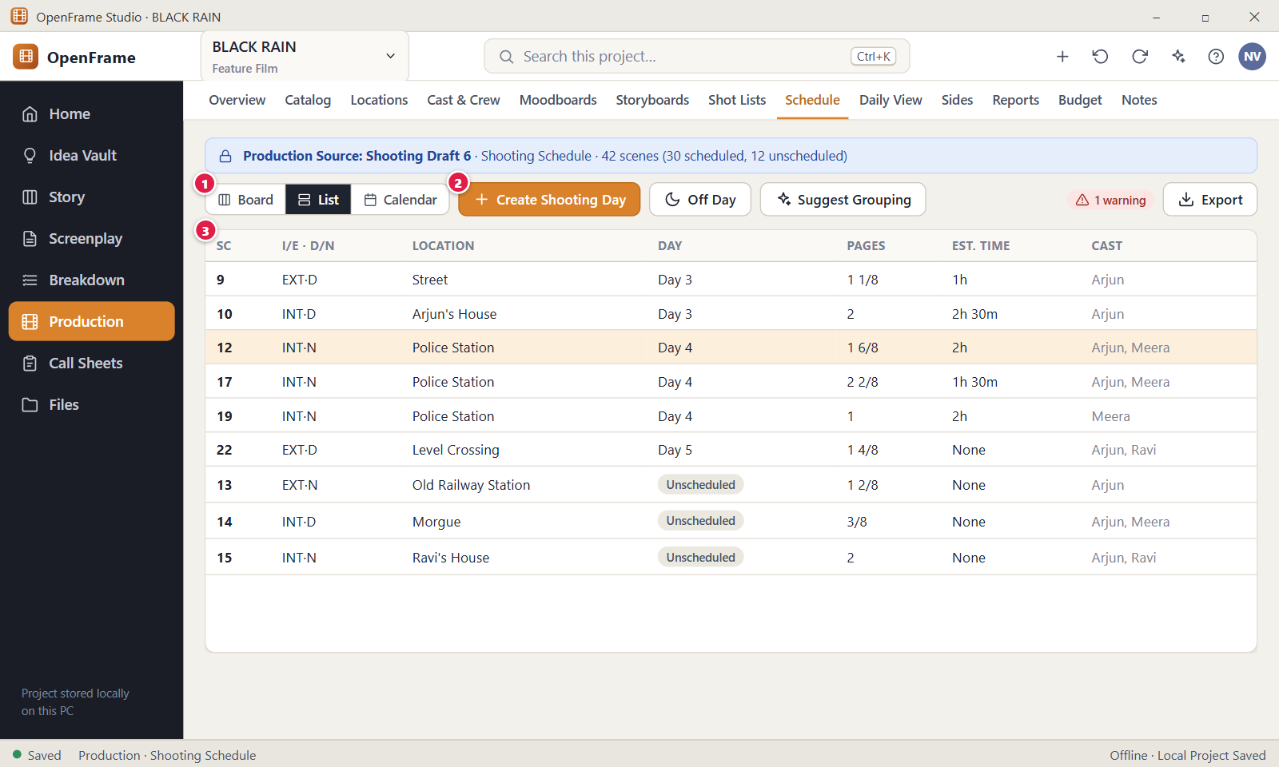
Figure 131. Stripboard: List view. Red numbers are explained on the next page.

Figure 131: Stripboard: List view: how it works
PARTS OF THIS SCREEN  1 Board / List / Calendar The view switch. List is selected here. All three views show the same data, so a change in one appears in the others. The view you pick is not saved when you leave the tab.  2 Create Shooting Day Opens the "Create Shooting Day" dialog with an optional date and optional day notes. The new day then appears in the Move to choices of the row menu. The day number is automatic.  3 Schedule table The columns are Sc, I/E · D/N, Location, Day, Start, Pages, Est. time, Cast and a row menu. Rows are sorted by scene number, with scheduled and unscheduled scenes mixed. Day shows the shooting day or "Unscheduled". Missing values show the word "Missing". Click a row to open the scene drawer, or use the three-dot menu: Details…, Move to, Move up, Move down, Remove from Day. | HOW TO USE IT  1. Click List in the view switch.  2. Scan the Day column for scenes that still say "Unscheduled".  3. Click a row, for example scene 12, to open its drawer.  4. Type an estimate such as 1h 30m, a start time and, if you need it, a page count.  5. To change the day, open the row menu and choose Move to, then pick a shooting day.  GOOD TO KNOW · EDGE CASES  • In the app you do not edit cells in place. Click the row to open the drawer, and use the row menu to move a scene to another day.  • Estimates are optional and never guessed. A day total is only the sum of the estimates you entered plus break durations.  • A star after the pages, such as "1 2/8*", means the page count was typed by hand.  • The table is sorted by scene number, not by shooting order. Shooting order shows on the Board and in the day detail.  • If a filter matches no scene, the table shows "No matching scenes."  • Moving a scene marks the call sheets of the affected days "Needs refresh". An issued PDF is never overwritten.
See also: Figure 130 Stripboard: Unscheduled pool and shooting days Figure 132 Schedule calendar Figure 135 Shooting Day detail Figure 137 Grouping suggestion Figure 136 Schedule conflict warning

Figure 132: Schedule calendar
What it is for. The Calendar view maps your shooting days to real dates on a month grid, including off days and the state of each day's call sheet. It answers: which dates are we shooting, and which are free?
How to get here. Left navigation > Production > Schedule, then click Calendar in the Board / List / Calendar control.
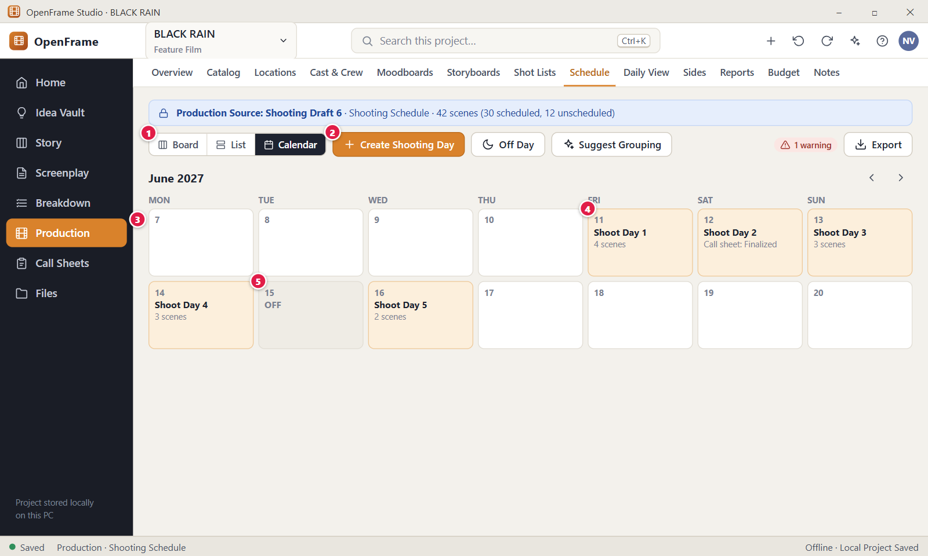
Figure 132. Schedule calendar. Red numbers are explained on the next page.

Figure 132: Schedule calendar: how it works
PARTS OF THIS SCREEN  1 Board / List / Calendar The view switch. Calendar is selected here. The choice is not saved, and the filter bar is hidden in this view.  2 Create Shooting Day Opens the "Create Shooting Day" dialog with an optional date and optional notes. A day with a date appears on that date in the grid. A day without a date is listed in a card called "Not yet dated" below the grid.  3 Month grid A month with arrows named Previous month and Next month, the weekdays MON to SUN and six weeks of dates. Weeks start on Monday and dates of neighbouring months are faded. The grid opens on the month of the first dated day. A date with a shooting day shows its name, the scene count and the call sheet state.  4 Shooting day One shooting day inside its date, for example "Shoot Day 1" and "4 scenes". The call sheet line reads "Call sheet: Draft", "Call sheet: Needs refresh" or "Call sheet: Final". Click it to open the day detail (Figure 135), where you can change the date.  5 Off day A day without scenes, for rest or logistics, shown as the date number and the bold word OFF. Click it to open the day detail and read its note. An off day has no scenes and no call sheet. | HOW TO USE IT  1. Click Calendar in the view switch.  2. Use Previous month and Next month to find your shooting period.  3. Click a shooting day, for example Shoot Day 1, to open its details.  4. Click Edit date in the day detail to move the day to another date, then click Save date.  5. Check "Not yet dated" below the grid for days that still need a date.  GOOD TO KNOW · EDGE CASES  • The calendar is a map of dates, not an editor. In the app only an existing day is clickable, and an empty date does nothing. Create days with Create Shooting Day or Off Day.  • Changing a day's date marks an existing call sheet of that day "Needs refresh". The call sheet itself is not rewritten and an issued PDF is never overwritten.  • A shooting day can exist without a date. It stays in "Not yet dated" until you set one.  • Two days on the same date are both listed in that date's cell.  • A date with both an off day and a shooting day counts as a shooting date.  • The scene count such as "4 scenes" counts scenes only, not breaks.
See also: Figure 130 Stripboard: Unscheduled pool and shooting days Figure 131 Stripboard: List view Figure 135 Shooting Day detail Figure 141 Call Sheets list Figure 134 Adding a break marker or off day

Figure 133: Dragging a scene into a day
What it is for. This is the board while you drag a scene strip. You see the strip in your hand and the day that will receive it. It answers: where exactly will this scene go if I let go now? Nothing changes until you release the mouse.
How to get here. Left navigation > Production > Schedule, Board view. Press on a strip in the Unscheduled pool or in a day, hold the mouse button and move the pointer.
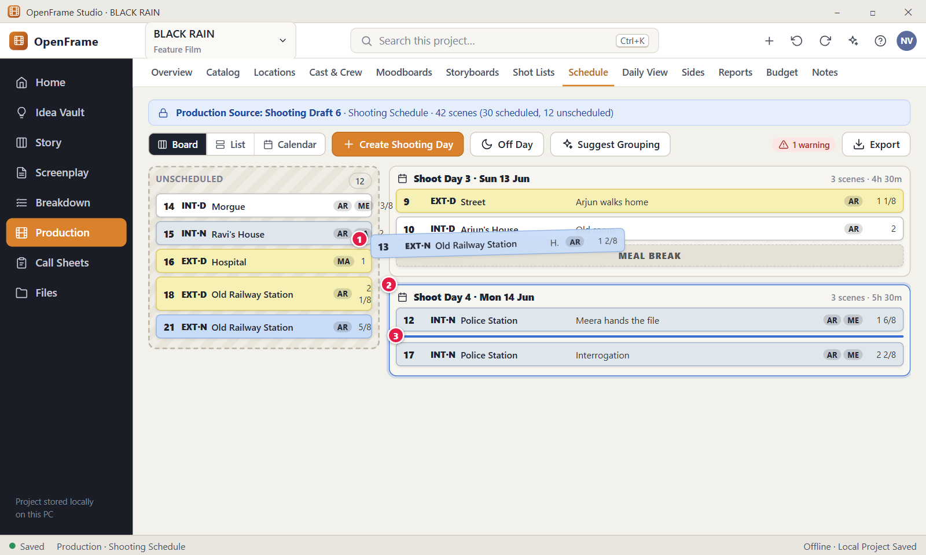
Figure 133. Dragging a scene into a day. Red numbers are explained on the next page.

Figure 133: Dragging a scene into a day: how it works
PARTS OF THIS SCREEN  1 Strip being dragged A slightly tilted copy of the strip, with a shadow, follows the pointer while the original stays in place, faded. A drag starts after the pointer moves a few pixels, so a plain click still opens the strip drawer. Press Esc to cancel.  2 Destination day While the strip is over a day, that day column gets a blue border. The Unscheduled pool gets the same border when the strip is over it. After the drop, the day total and scene count update. A drop on an off day is refused.  3 Insertion position In the app there is no thin blue line. The other strips slide apart to open a gap where the scene will land. Dropping on a strip puts the dragged strip at that place. Dropping on the empty part of a day puts it last. | HOW TO USE IT  1. Press on a strip, for example scene 13 EXT·N Old Railway Station, and move the pointer.  2. Move over the day you want. Wait for the blue border.  3. Watch the gap between strips to see where the scene will land.  4. Release the mouse to drop the scene, or press Esc to cancel.  5. Press Ctrl+Z if you want to undo the move.  GOOD TO KNOW · EDGE CASES  • An invalid drop returns the strip to where it was and changes nothing.  • Dragging works only in Board view. In List and Calendar, use the row menu Move to.  • To drag without a mouse, focus a strip, press Space, use the arrow keys and press Space again to drop. The strip menu also offers Move to, Move up, Move down and Remove from Day.  • There is no automatic optimiser. No scene moves unless you, or a suggestion you accept, move it.  • Moving a scene marks the call sheets of both days "Needs refresh". An issued PDF is never overwritten.  • On a finalized schedule a drop is refused with "This schedule is finalized. Reopen it to make changes."
See also: Figure 130 Stripboard: Unscheduled pool and shooting days Figure 134 Adding a break marker or off day Figure 136 Schedule conflict warning Figure 142 Creating a call sheet from a shooting day

Figure 134: Adding a break marker or off day
What it is for. This is the action menu of one shooting day. From it you add break rows (meal, travel, company move, custom note) so the day reads realistically, turn a day into an off day, or go to the day notes. It answers: how do I show breaks and rest days in the schedule?
How to get here. Left navigation > Production > Schedule, Board view. Click the three-dot button at the right end of a day header (named "Shoot Day 3 actions"). The same break choices are in the "Add break" menu of the day detail (Figure 135).
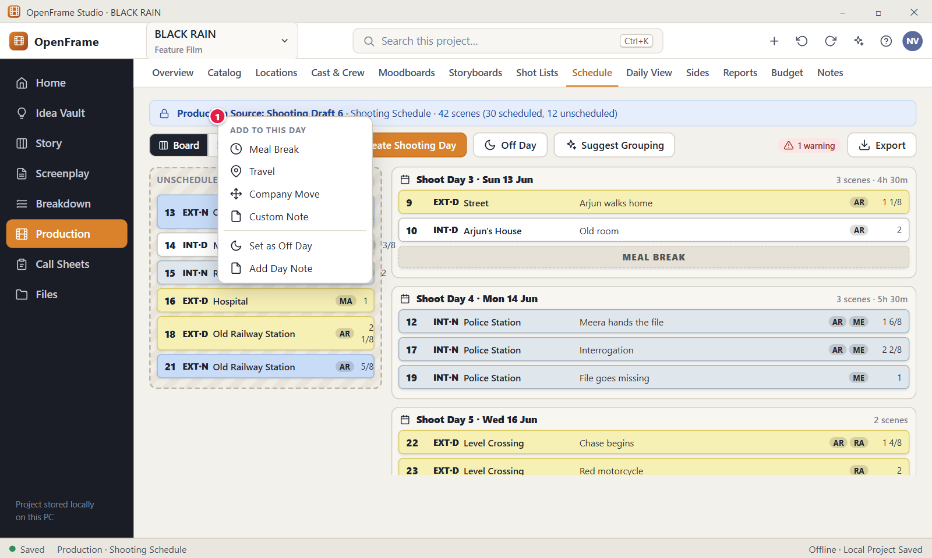
Figure 134. Adding a break marker or off day. Red numbers are explained on the next page.

Figure 134: Adding a break marker or off day: how it works
PARTS OF THIS SCREEN  1 Add to this day The heading in the day menu above Meal Break, Travel, Company Move and Custom Note. Each choice opens a small dialog for an optional label, time (such as 20:30), duration (such as 45m or 1h 30m) and notes. Custom Note needs text of up to 120 characters. The row shows in capitals, for example "MEAL BREAK at 20:30 (45m)", and a duration counts toward the day's time. The menu also holds Open day details, Edit date, Set as Off Day, Add Day Note, Insert day after, Duplicate day (breaks and notes only), Create Call Sheet and Delete day. | HOW TO USE IT  1. Click the three-dot button in the header of the day.  2. Under "Add to this day", choose Meal Break, Travel, Company Move or Custom Note.  3. Fill in the time and duration, for example 20:30 and 45m.  4. Confirm. A dashed break row appears between the strips.  5. Click a break row later if you want to edit or remove it.  GOOD TO KNOW · EDGE CASES  • Breaks are rows, not scenes. They do not appear in List view and are never counted in "N scenes".  • Set as Off Day is disabled while the day has scenes. Move the scenes away first. An off day loses its number and later shooting days renumber.  • Add Day Note does not open a dialog. It goes to the day detail, where the Day notes box is.  • Duplicate day copies notes, target and breaks only. It never copies scenes.  • Delete day has no confirmation. Its scenes return to Unscheduled.  • On a finalized schedule the menu actions are refused with "This schedule is finalized. Reopen it to make changes."
See also: Figure 130 Stripboard: Unscheduled pool and shooting days Figure 135 Shooting Day detail Figure 132 Schedule calendar Figure 136 Schedule conflict warning

Figure 135: Shooting Day detail
What it is for. This page is the working surface for one shooting day. It lists the day's scenes and breaks in shooting order and shows what the day needs: locations, cast, estimated time, notes and call sheet. It answers: what exactly are we doing on this day? It is also where you start the call sheet.
How to get here. Left navigation > Production > Schedule. Click the name of a shooting day on the board or in the calendar, or choose "Open day details" in the day's three-dot menu. Back to schedule returns to the board.
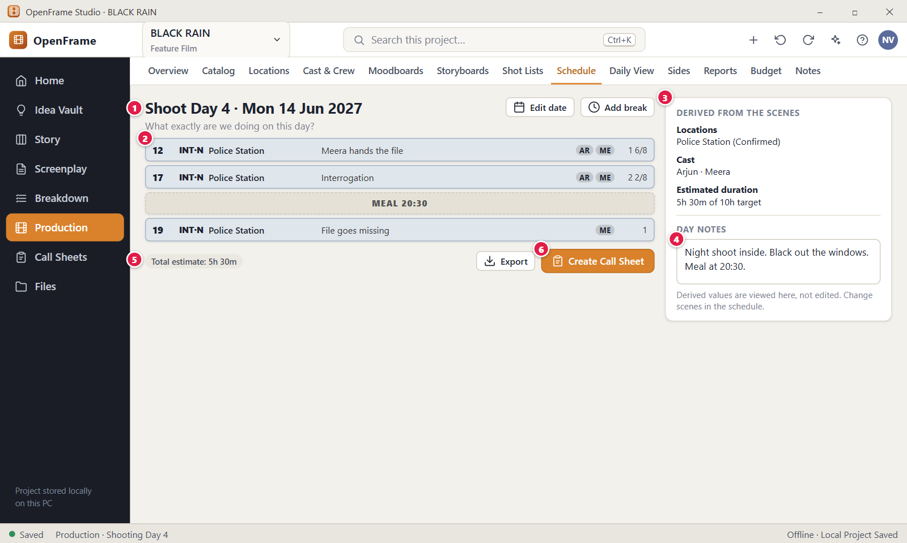
Figure 135. Shooting Day detail. Red numbers are explained on the next page.

Figure 135: Shooting Day detail: how it works
PARTS OF THIS SCREEN  1 Header Shows the day title, for example "Shoot Day 4 · Mon 14 Jun 2027". The buttons beside it are Back to schedule, Edit date, Add break and a three-dot menu. The day number comes from the order of days and is not typed. For an off day the title is "Off Day".  2 Scenes in shooting order The day's scenes and break rows from top to bottom. Click a strip to open its drawer, or use its menu: Details, Move to, Move up, Move down, Remove from Day. Click a break row to edit it. An empty day shows "No scenes scheduled." with Add Scene and Off Day buttons.  3 Derived from the scenes A card with locations, cast and estimated duration, such as "5h 30m of 10h target" with a red "Over target" chip when needed. You cannot edit these here. The card also has a Day target box (15 minutes to 24 hours) and optional Crew call, Shooting start and Target wrap times.  4 Day notes A free text box for notes about the whole day, up to 4,000 characters, for example "Night shoot inside. Black out the windows." It saves when you click outside the box and marks an existing call sheet "Needs refresh".  5 Footer A row under the list with the chip "Total estimate: 5h 30m" (or "Missing"), chips for scenes without an estimate and total pages, the Export button and the call sheet button. Export offers the scope "Current day only".  6 Create Call Sheet Starts a call sheet for this day, pre-filled from the day, and opens the Call Sheets screen. It reads "Open Call Sheet" when the day already has one. There is one call sheet per day, and the button is not shown on an off day. Missing call times and contacts show as blank placeholders and do not block creation. | HOW TO USE IT  1. Click the day name, for example Shoot Day 4, on the board.  2. Check the scenes. Use Move up and Move down in a strip menu to fix the order.  3. Click Add break and choose Meal Break, Travel, Company Move or Custom Note.  4. Set the Day target and the Crew call time in the card on the right.  5. Write any notes for the whole day in Day notes.  6. Click Create Call Sheet to start the call sheet for this day.  GOOD TO KNOW · EDGE CASES  • The card "Derived from the scenes" is a view. Change locations and cast in Breakdown, Locations or Cast & Crew, and the estimate in the scene drawer.  • The total is the sum of the estimates you entered plus break durations. OpenFrame never invents an estimate, a location or a call time.  • Changing the date, notes, day times or scenes of a day marks its call sheet "Needs refresh". The issued PDF is never overwritten.  • If a scene changed in the screenplay, its strip shows "Script changed" and you decide what to do. The day record is kept.  • An off day has no scenes, no call sheet and no day times.  • A day target that cannot be read shows "Enter the target day length, e.g. 10h."
See also: Figure 130 Stripboard: Unscheduled pool and shooting days Figure 132 Schedule calendar Figure 134 Adding a break marker or off day Figure 136 Schedule conflict warning Figure 139 Exporting the schedule Figure 142 Creating a call sheet from a shooting day

Figure 136: Schedule conflict warning
What it is for. This is the "Schedule assistance" drawer. It lists practical conflicts in the schedule, such as one actor needed at two places on the same day, or a day longer than its target. It warns and explains, and leaves every decision to you. It answers: what could go wrong with this plan?
How to get here. Left navigation > Production > Schedule, Board view. Click the warning chip, for example "1 warning", next to the Suggest Grouping button. Strips that are part of a warning have a red outline on the board.
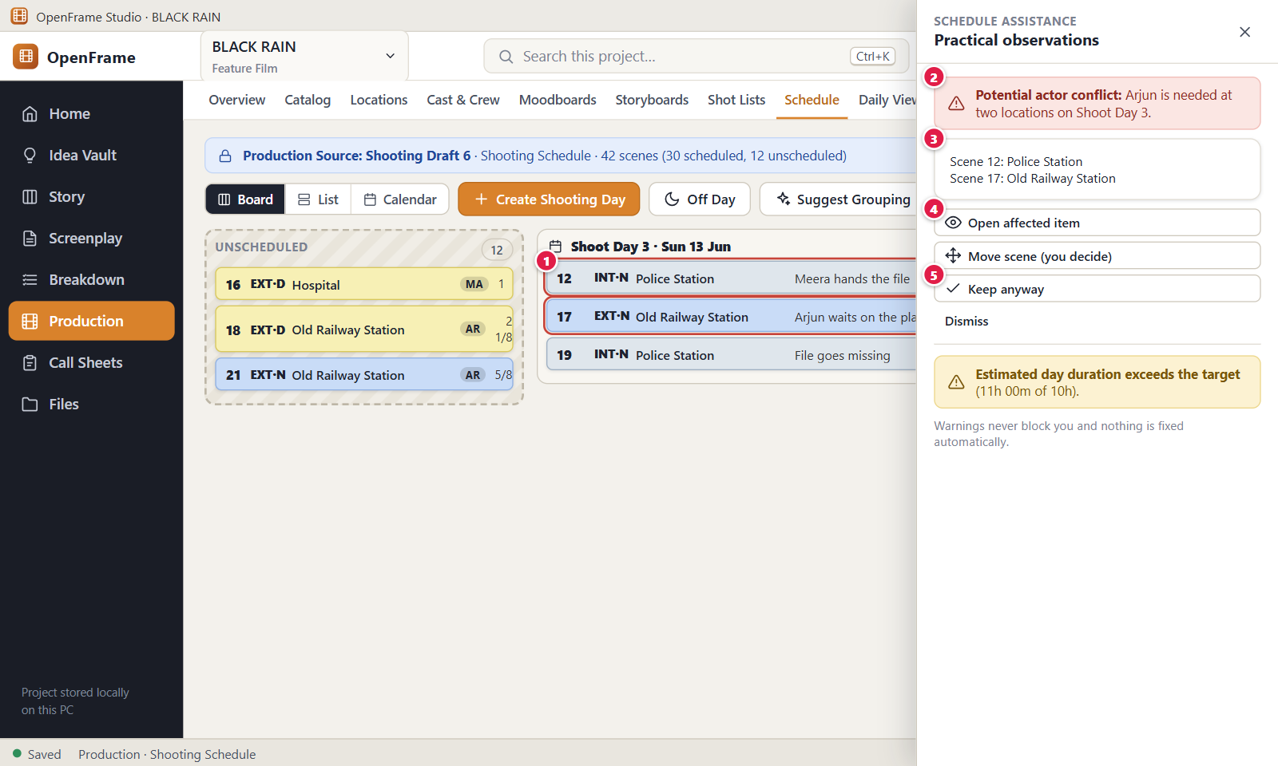
Figure 136. Schedule conflict warning. Red numbers are explained on the next page.

Figure 136: Schedule conflict warning: how it works
PARTS OF THIS SCREEN  1 Conflict outline A strip that takes part in an open warning has a red outline on the board, next to its day. The outline goes away when you fix the conflict, keep the warning or dismiss it. You can still drag and edit the strip as usual.  2 Warning sentence The first line of a card, for example "Potential actor conflict: ARJUN is needed at two locations on Shoot Day 3." Other warnings say that a day is missing location information, that the day estimate exceeds the target ("11h of 10h"), that travel pushes the day past its target, that a call sheet is out of date, that a removed scene is still scheduled, or that a location is needed by two days on the same date.  3 Affected scenes A grey line under the sentence that names the colliding scenes and places. In the app it is one line, for example "Scene 12, Scene 17: Police Station / Old Railway Station".  4 Open affected item Takes you to the day page where you can see and change its scenes. The drawer closes and nothing changes. The "Move scene (you decide)" button does the same: it opens the day and moves nothing.  5 Keep anyway Tells OpenFrame you know about the warning and keep the schedule as it is. The card moves to "Kept or dismissed" with the mark "Kept anyway", and the warning stops counting in the chip. "Show again" brings it back. Dismiss works the same way with the mark "Dismissed". | HOW TO USE IT  1. Click the warning chip on the Schedule tab to open the drawer.  2. Read each card, for example the actor conflict on Shoot Day 3.  3. Click Open affected item to go to that day.  4. Move one of the scenes yourself, for example to another day.  5. If the plan is fine as it is, click Keep anyway or Dismiss on the card.  GOOD TO KNOW · EDGE CASES  • Warnings never block you and nothing is fixed automatically. By default every warning is advice.  • Keep anyway and Dismiss only mark a warning. They change no scene, day or call sheet.  • A kept or dismissed warning comes back as new if the conflict changes, because the decision belongs to the exact wording.  • Strict validation is an optional setting in Schedule settings. With it on, a move that creates a warning asks you to choose Keep Anyway.  • Red outlines show only in Board view. In List and Calendar the chip shows the count.  • If there is nothing to report, the drawer says "No warnings. The schedule looks consistent."
See also: Figure 130 Stripboard: Unscheduled pool and shooting days Figure 135 Shooting Day detail Figure 137 Grouping suggestion Figure 142 Creating a call sheet from a shooting day

Figure 137: Grouping suggestion
What it is for. This drawer gives advice about grouping scenes that share a location or have exactly the same cast, so you need fewer location changes or fewer actor days. Every suggestion is a hint. Nothing moves unless you click Apply manually and confirm. It answers: is there an obvious way to make the plan simpler?
How to get here. Left navigation > Production > Schedule. Click Suggest Grouping in the toolbar. The drawer "Grouping suggestions" opens on the right and looks for suggestions straight away.
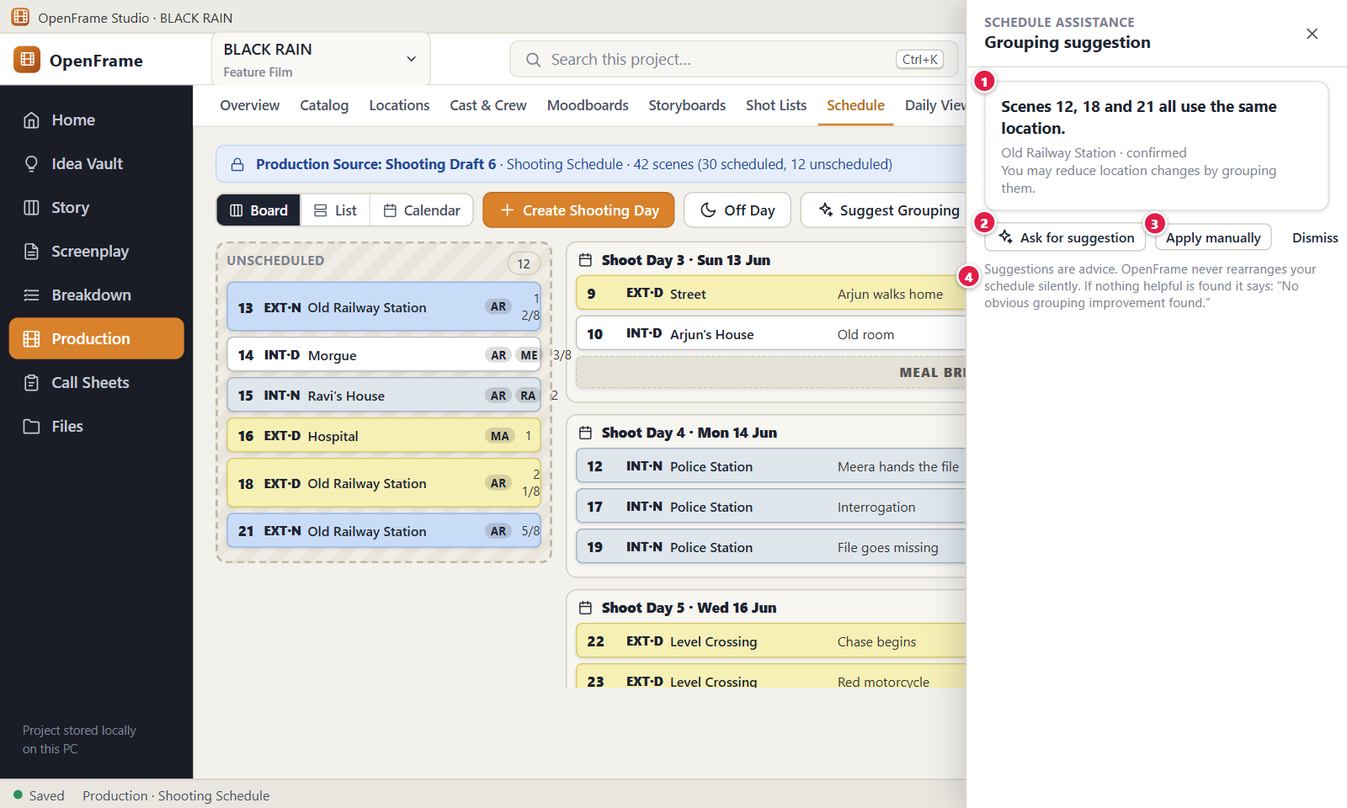
Figure 137. Grouping suggestion. Red numbers are explained on the next page.

Figure 137: Grouping suggestion: how it works
PARTS OF THIS SCREEN  1 Suggestion card States the observation first, for example "Scenes 12, 18 and 21 all use the same location." A chip shows the shared location with its status, and an advice line follows. A cast suggestion reads "Scenes 3 and 7 need exactly the same cast." Each card has the buttons Apply manually and Dismiss.  2 Ask for suggestion In the app this button sits at the top of the drawer. It asks again for suggestions based on the schedule as it is now. The drawer also asks once when it opens. The calculation runs inside OpenFrame with plain rules, with no AI model and no network.  3 Apply manually Opens the question "Group these scenes?" with a Shooting day list. It preselects the day that already holds most of the scenes. After you click "Move scenes", the scenes not yet on that day are placed after the scenes already there. You can undo it in one step.  4 Advice note The footer reads "Suggestions are advice. OpenFrame never rearranges your schedule silently." When nothing helpful is found, the body of the drawer says "No obvious grouping improvement found." | HOW TO USE IT  1. Click Suggest Grouping on the Schedule tab.  2. Read each card, for example scenes 12, 18 and 21 sharing the Old Railway Station.  3. Click Apply manually on a card you like.  4. Choose the shooting day in the question dialog.  5. Click Move scenes, or Cancel to leave everything as it is.  GOOD TO KNOW · EDGE CASES  • Suggestions look only at shared locations and identical cast. They do not look at the durations you entered.  • A suggestion appears only when its scenes are in at least two different places. Scenes already together, or all still unscheduled, give no suggestion.  • Dismiss only hides a card while the drawer is open. It is not saved, and the card returns the next time you open the drawer.  • Off days are not offered in the Shooting day list.  • A grouping follows the usual move rules. It is refused on a finalized schedule, and the call sheets of the days involved become "Needs refresh".  • Press Ctrl+Z to undo a grouping that you applied.
See also: Figure 130 Stripboard: Unscheduled pool and shooting days Figure 136 Schedule conflict warning Figure 133 Dragging a scene into a day Figure 128 Shooting Schedule: nothing created yet

Figure 138: Script changed in scheduled scenes: review changes
What it is for. This dialog lists the scheduled scenes whose script text, heading or page count changed after the schedule was built. It answers: what did the script change do to my schedule? Opening it changes nothing in the schedule.
How to get here. Left navigation > Production > Schedule. When the Production Source script has changed, a warning banner appears above the board. Click its "Review changes" button. The title reads, for example, "Script changed in 3 scheduled scenes".
Figure 138. Script changed in scheduled scenes: review changes. Red numbers are explained on the next page.

Figure 138: Script changed in scheduled scenes: review changes: how it works
PARTS OF THIS SCREEN  1 Changed scenes A table with the columns Sc, Heading, Change and Scheduled. Chips show what changed: "Heading changed", "Text changed", "Estimate may change" (the page count changed), "Removed from script" (red), "Restored in script" and "Scene split, review it". New scenes show as one summary row such as "1 new scene", marked Unscheduled. The rows are read-only.  2 Update Schedule In the app the button is called "Update Schedule" and it applies the update directly, without a separate review screen. Changed scenes are marked Changed, removed scenes are marked Removed and kept in the schedule history, and new scenes are added to Unscheduled. It never moves or deletes a scheduled scene. You need the Edit permission, and it is refused on a finalized schedule. | HOW TO USE IT  1. Open Production > Schedule and look for the banner "Script changed in N scenes."  2. Click Review changes.  3. Read the list, for example scene 24 "Text changed" or scene 31 "Estimate may change".  4. Click Update Schedule to record the differences, or Close to decide later.  5. Check the affected days on the board and fix anything you need to.  GOOD TO KNOW · EDGE CASES  • Nothing in the schedule changes automatically. A new Production Source only shows the banner. The schedule changes when you click Update Schedule.  • Update Schedule only flags changes. Removed scenes stay marked in the schedule history until you confirm their removal.  • If a new page count changes a day's estimate, the day is flagged. The estimate is recalculated after the update.  • A call sheet made from an affected day is marked "Needs refresh". Its exported PDF is never overwritten.  • On a finalized schedule you see "This schedule is finalized. Reopen it to make changes."  • Press Ctrl+Z after closing the dialog to undo Update Schedule. Close, the X and Esc leave the schedule unchanged.
See also: Figure 130 Stripboard: Unscheduled pool and shooting days Figure 104 Breakdown: scene list, script and elements Figure 145 Call sheet marked stale after a schedule change Figure 141 Call Sheets list

Figure 139: Exporting the schedule
What it is for. This dialog exports the shooting schedule as a file you can print or share. You choose which days to include and the file format. It answers: how do I get the schedule out of OpenFrame without changing it?
How to get here. Left navigation > Production > Schedule, then click Export at the top right of the board. The dialog "Export Shooting Schedule" also opens from a shooting day, where "Current day only" is available.
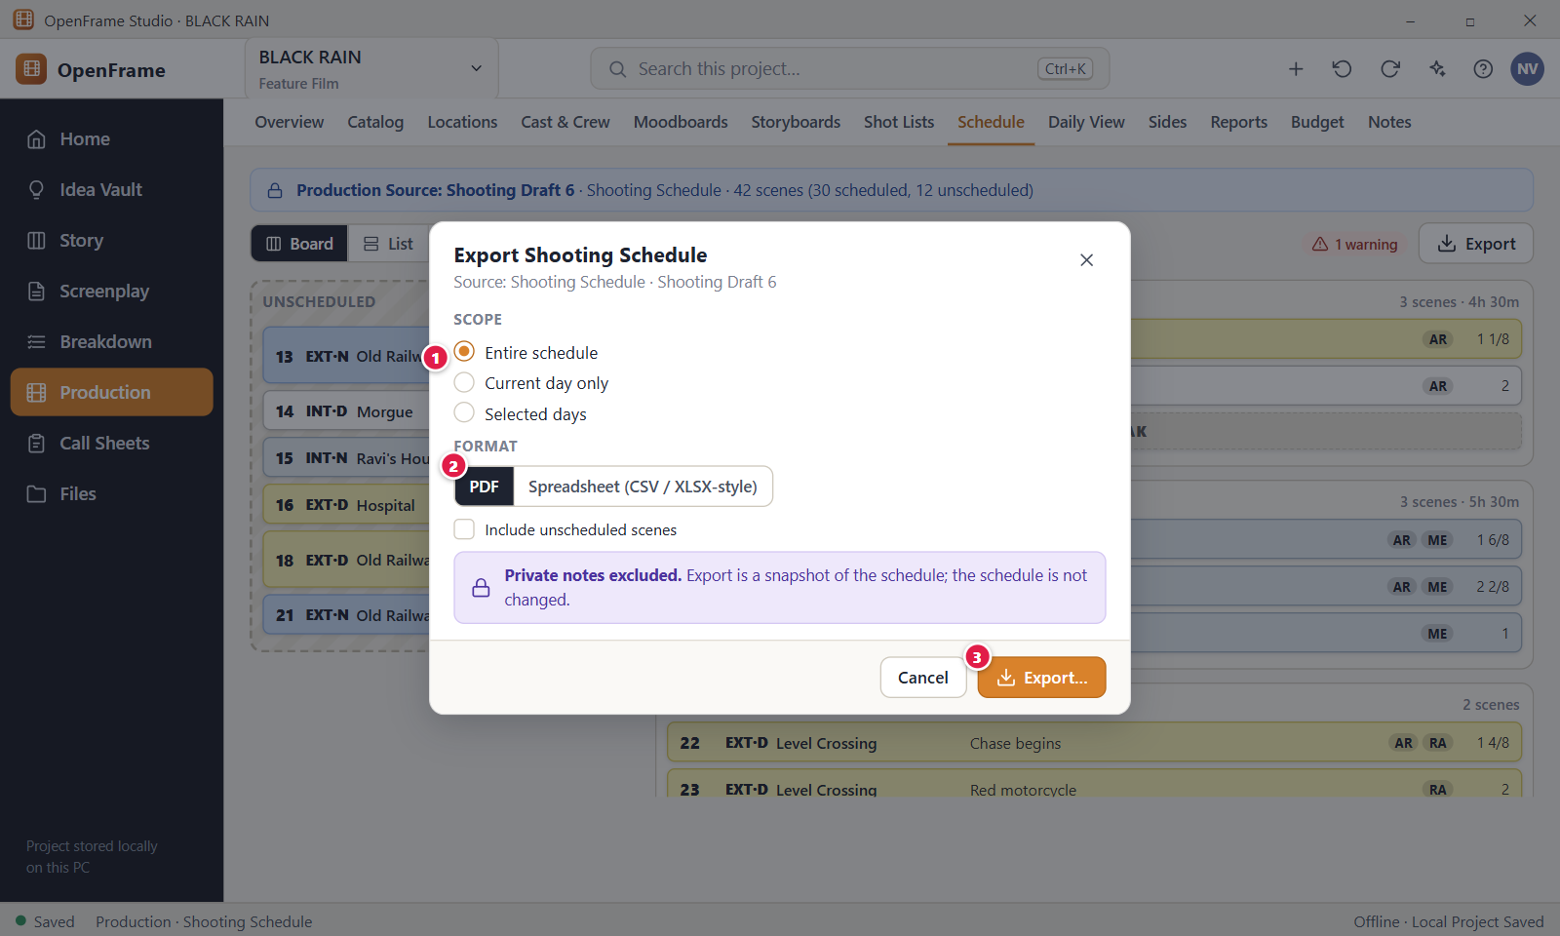
Figure 139. Exporting the schedule. Red numbers are explained on the next page.

Figure 139: Exporting the schedule: how it works
PARTS OF THIS SCREEN  1 Scope Under the heading "What are you exporting?" you choose "Entire schedule", "Current day only" or "Selected days". Current day only is off when you open the dialog from the board. Selected days shows a list of days with check boxes, and you must tick at least one. Two tick boxes add the unscheduled scenes and the scene notes (off by default).  2 Format In the app there are three choices: PDF, Spreadsheet (XLSX) and CSV. PDF is a printable landscape stripboard. A line under the choice shows the suggested file name, for example "BLACK RAIN - Shooting Schedule - 2026-10-18.pdf".  3 Export… Opens the Windows Save dialog and writes the file. It reads "Exporting…" while it works. You need the Export permission. Choose a folder outside the project's own folder. When the file is written, an "Export complete" dialog opens with a button to reveal the file. | HOW TO USE IT  1. Open Production > Schedule and click Export.  2. Choose the scope: the entire schedule, or tick the days you want under Selected days.  3. Choose PDF, Spreadsheet (XLSX) or CSV.  4. Click Export… and pick a folder and file name in the Save dialog.  5. In "Export complete", click Reveal in File Manager to find the file.  GOOD TO KNOW · EDGE CASES  • The note "Private notes excluded." is always shown. Private notes are never exported. Scene notes are included only if you tick "Include scene notes".  • The file stays exactly as exported even if the schedule changes later. The export never changes the schedule.  • PDF pages print "Created with OpenFrame Studio" at the bottom. CSV files have no such row, so they open cleanly in other programs.  • The file carries the date of the last schedule change, so exporting unchanged data twice gives two identical files.  • Exports cannot be saved inside the project's own folder. Choose another place, such as Documents.  • With no shooting day yet, the Selected days list says "Create a shooting day first."
See also: Figure 130 Stripboard: Unscheduled pool and shooting days Figure 138 Script changed in scheduled scenes: review changes Figure 140 Daily Production View Figure 149 Production Reports

Figure 140: Daily Production View
What it is for. The Daily Production View is a one-screen summary of one shooting day: scenes, location, cast, call sheet state, notes and key props. It answers: what do I need to know for this day? It is for reading and for jumping to the full record, not for editing the schedule.
How to get here. Left navigation > Production > Daily View. In the current version this is the only way in. The Schedule day page has no Daily View link.
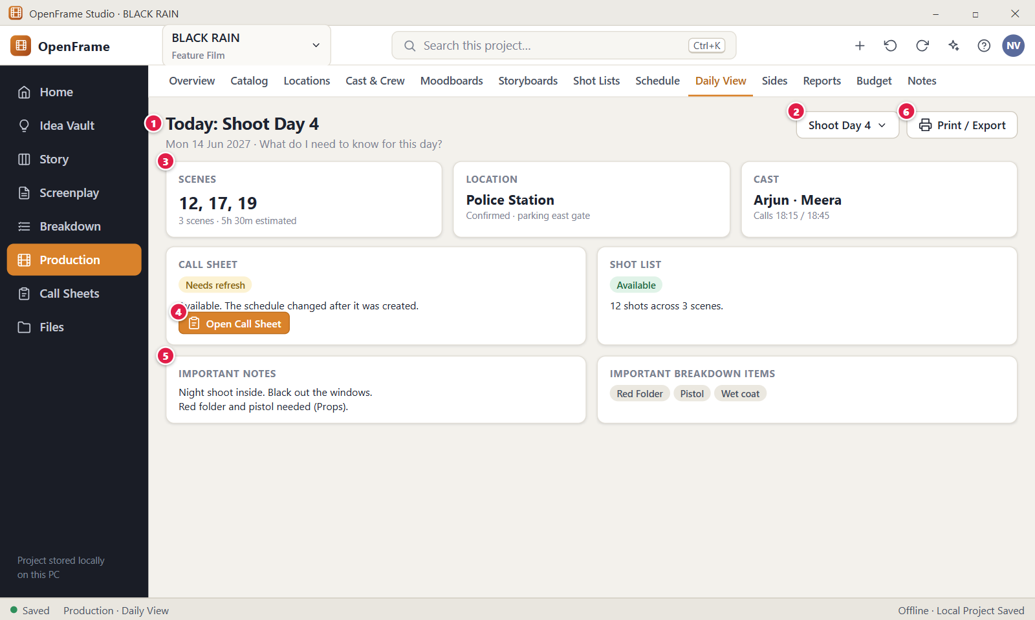
Figure 140. Daily Production View. Red numbers are explained on the next page.

Figure 140: Daily Production View: how it works
PARTS OF THIS SCREEN  1 Day heading Shows the day name, with "Today: " in front only when the day is dated today. Under it come the date and the question "What do I need to know for this day?" On opening, the app picks the day dated today, otherwise the next dated day, otherwise the first working day. An off day shows an "Off day" chip.  2 Day selector In the app this is a drop-down list named "Shooting day" at the top right. It lists every day of the schedule, including off days, and switches the whole screen to the day you pick. Back and Forward return to the earlier day.  3 Scenes, location and cast The Scenes card shows the day's scenes as number buttons, with the count and the estimated time. Click a number to open that scene in Breakdown. The Location card links to Locations and shows "Address missing" when there is no address. The Cast card links to Cast & Crew and shows call times, or "Call times not entered yet".  4 Call sheet The Open Call Sheet button opens the call sheet of this day. When the day has none, the button reads "Create Call Sheet" and creates one first (you need the Edit permission). A status chip shows Draft, Needs refresh or Final. Off days have no call sheet.  5 Important notes The card shows the day notes written on the shooting day, with line breaks kept. Markers such as a meal break show as small chips below. With no notes it says "No day notes." Edit the notes in the Schedule day page. A separate card, "Important breakdown items", lists confirmed props, wardrobe and other items as chips.  6 Print / Export This button is not in the current version. To get a document for one day, use Export on the Schedule day page, or the call sheet PDF. | HOW TO USE IT  1. Open Production > Daily View.  2. Choose the day you want in the Shooting day drop-down.  3. Read the Scenes, Location and Cast cards.  4. Click a scene number to open it in Breakdown if you need detail.  5. Click Open Call Sheet, or Create Call Sheet if the day has none yet.  GOOD TO KNOW · EDGE CASES  • Daily View is mostly read-only. It is not a second schedule editor, and all values come from the selected shooting day and its linked records.  • The heading says "Today: " only when the day date is today's date. A day dated in the future does not show it.  • If the day has open schedule warnings, a yellow banner appears above the cards with an Open day button.  • The call sheet card says "Available and up to date with the schedule." for Draft, "Available. The schedule changed after it was created." for Needs refresh, and "Finalized and matches the schedule." for Final.  • Only confirmed breakdown items appear. Suggested items that you have not confirmed are left out.  • With no schedule or no day, the screen says "Select or create a shooting day."
See also: Figure 130 Stripboard: Unscheduled pool and shooting days Figure 141 Call Sheets list Figure 143 Call Sheet editor Figure 145 Call sheet marked stale after a schedule change Figure 148 Sides for a shooting day

Figure 141: Call Sheets list
What it is for. The Call Sheets list shows every call sheet of the project, one row per shooting day and revision, with its date and state. It answers the question: which shooting day document do I need? From here you create, open, export, refresh, finalize or delete a call sheet.
How to get here. Click Call Sheets in the left navigation. It is a main workspace of its own, not a tab of Production.
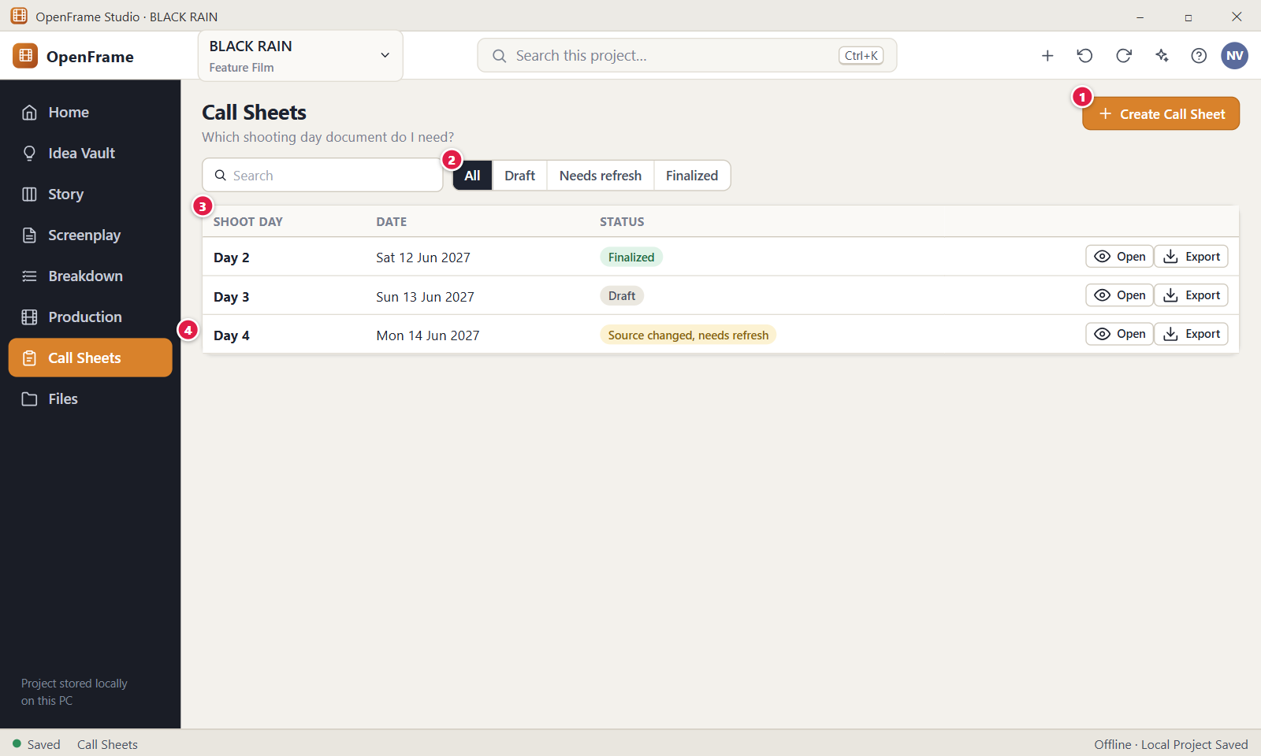
Figure 141. Call Sheets list. Red numbers are explained on the next page.

Figure 141: Call Sheets list: how it works
PARTS OF THIS SCREEN  1 Create Call Sheet Opens a dialog where you choose the shooting day the new call sheet starts from. Off days cannot have a call sheet, and a day that already has one is not offered again. You need the Edit permission.  2 Status filter Choose All, Draft, Needs refresh or Final to show only sheets in that state. In the app the last choice is called Final, not Finalized. Next to it are a Search box and the check box "Show replaced revisions".  3 Call sheets table One row per call sheet with the columns Shoot day, Date, Status and Revision. Each row has the buttons Open and Export and a "..." menu with Open, Refresh, Finalize and Delete. Double-click a row to open it. The list is sorted by date, newest revision first.  4 Day 4 row A sheet that is out of date because the schedule changed after it was prepared. Its chip reads "Needs refresh" in the app. The sheet itself stays readable and unchanged until you refresh it. | HOW TO USE IT  1. Click Call Sheets in the left navigation.  2. Click Create Call Sheet and choose a shooting day, for example Shoot Day 5 of BLACK RAIN.  3. Use the status buttons or the Search box to find a sheet, for example Needs refresh.  4. Click Open on a row, or double-click it, to edit the sheet.  5. Click Export on a row to make a PDF of that sheet.  GOOD TO KNOW · EDGE CASES  • Opening, exporting or editing a call sheet never changes the schedule.  • A call sheet is never deleted when its shooting day is deleted. The row stays and shows "(day deleted)" after the day name.  • Delete asks no question. The sheet moves to Recently Deleted and the message offers Undo. Ctrl+Z also undoes it.  • A Final sheet never turns into Needs refresh. Older revisions that a newer one replaced are hidden until you tick "Show replaced revisions".  • With no call sheets the page says "Create a call sheet from a shooting day." If nothing matches your filter it says "No matching call sheets."  • Create, refresh, finalize and delete need the Edit permission. Export needs the Export permission.
See also: Figure 142 Creating a call sheet from a shooting day Figure 143 Call Sheet editor Figure 145 Call sheet marked stale after a schedule change Figure 147 Finalizing and exporting a call sheet Figure 140 Daily Production View

Figure 142: Creating a call sheet from a shooting day
What it is for. This dialog starts a new call sheet from one shooting day, so you never type the day again. It answers the question: which day is this call sheet for, and what will OpenFrame fill in for me?
How to get here. Click Call Sheets in the left navigation, then click Create Call Sheet. In Schedule and in Daily View the Create Call Sheet button on a working day makes the sheet at once, without this dialog.
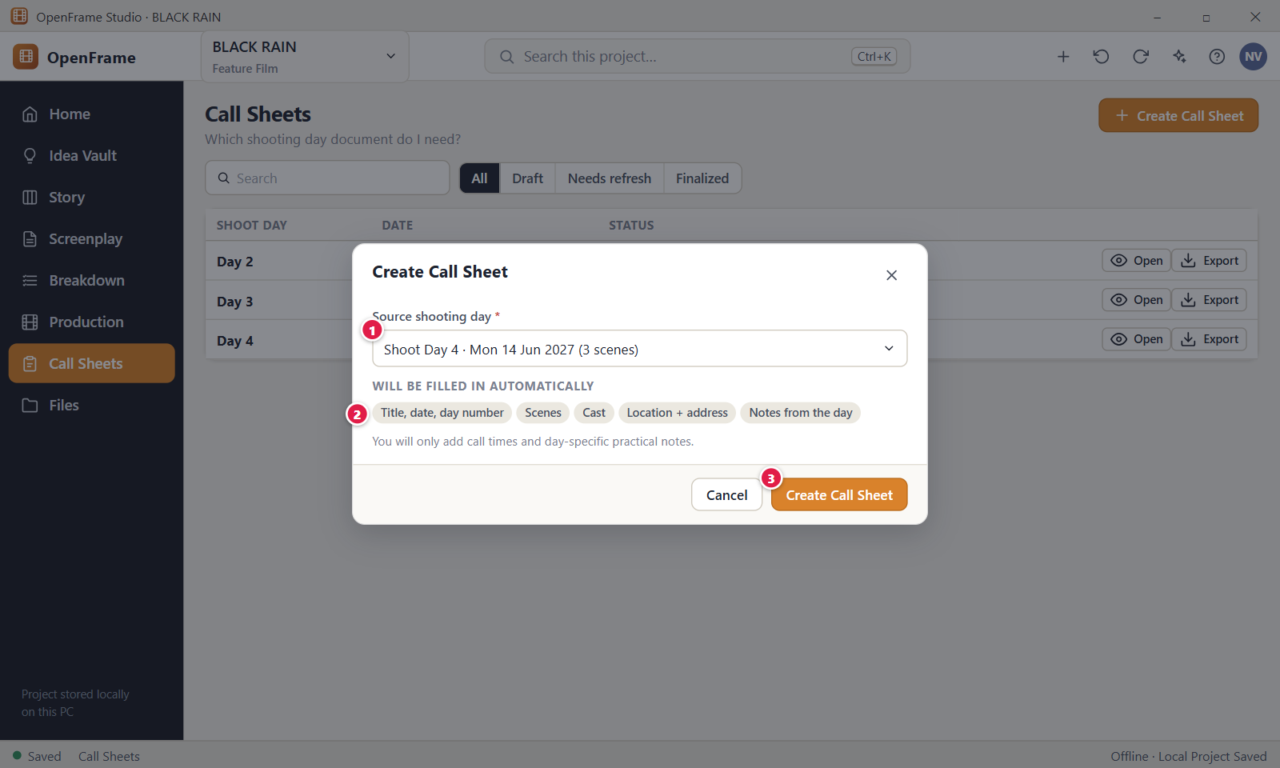
Figure 142. Creating a call sheet from a shooting day. Red numbers are explained on the next page.

Figure 142: Creating a call sheet from a shooting day: how it works
PARTS OF THIS SCREEN  1 Source shooting day A required drop-down. It lists only working days that have no call sheet yet, in schedule order, for example "Shoot Day 4 · Mon 14 Jun 2027". The first free day is chosen for you. The app does not show the scene count in the label.  2 Will be filled in automatically Tells you what OpenFrame copies into the sheet. In the app this is a bulleted list: title, date, day number and day times; the scene schedule; talent with cast ID numbers; locations with address, parking and access; and extras, department notes, advance schedule and crew when the project has them. Under it a hint says you add call times, weather and day-specific notes.  3 Create Call Sheet Creates one Draft sheet titled "Call Sheet: Day 4" for the chosen day and opens it in the editor. It is disabled when no day can be chosen. Next to it is a Cancel button that closes the dialog and creates nothing. | HOW TO USE IT  1. Click Call Sheets in the left navigation.  2. Click Create Call Sheet at the top right.  3. Check the day in the Source shooting day list. Pick another one if you need it.  4. Read the list of what is filled in for you.  5. Click Create Call Sheet. The editor opens with the new sheet.  GOOD TO KNOW · EDGE CASES  • The dialog does not ask for a title. The sheet is named from the day.  • Anything nobody has entered, such as a cast call time, shows "Needs input" in red. It never blocks the sheet.  • If every working day already has a sheet, the app says "Every shooting day already has a call sheet. Open it from the list to update it."  • If the project has no schedule, the app says "Create a shooting schedule and a shooting day first."  • Press Esc or click Cancel to leave without creating anything. Ctrl+Z undoes a sheet you just created.  • After creation the sheet is its own document. Editing it never changes the schedule.
See also: Figure 141 Call Sheets list Figure 143 Call Sheet editor Figure 140 Daily Production View Figure 130 Stripboard: Unscheduled pool and shooting days

Figure 143: Call Sheet editor
What it is for. The Call Sheet editor is a page that looks like the printed call sheet. Scenes, cast and location come from the shooting day, and you add call times, notes and contacts right in the page. It answers the question: what does everyone need to know for this day?
How to get here. Click Call Sheets in the left navigation, then click Open on a row or double-click the row. You also arrive here after Create Call Sheet and from Open Call Sheet in Daily View.
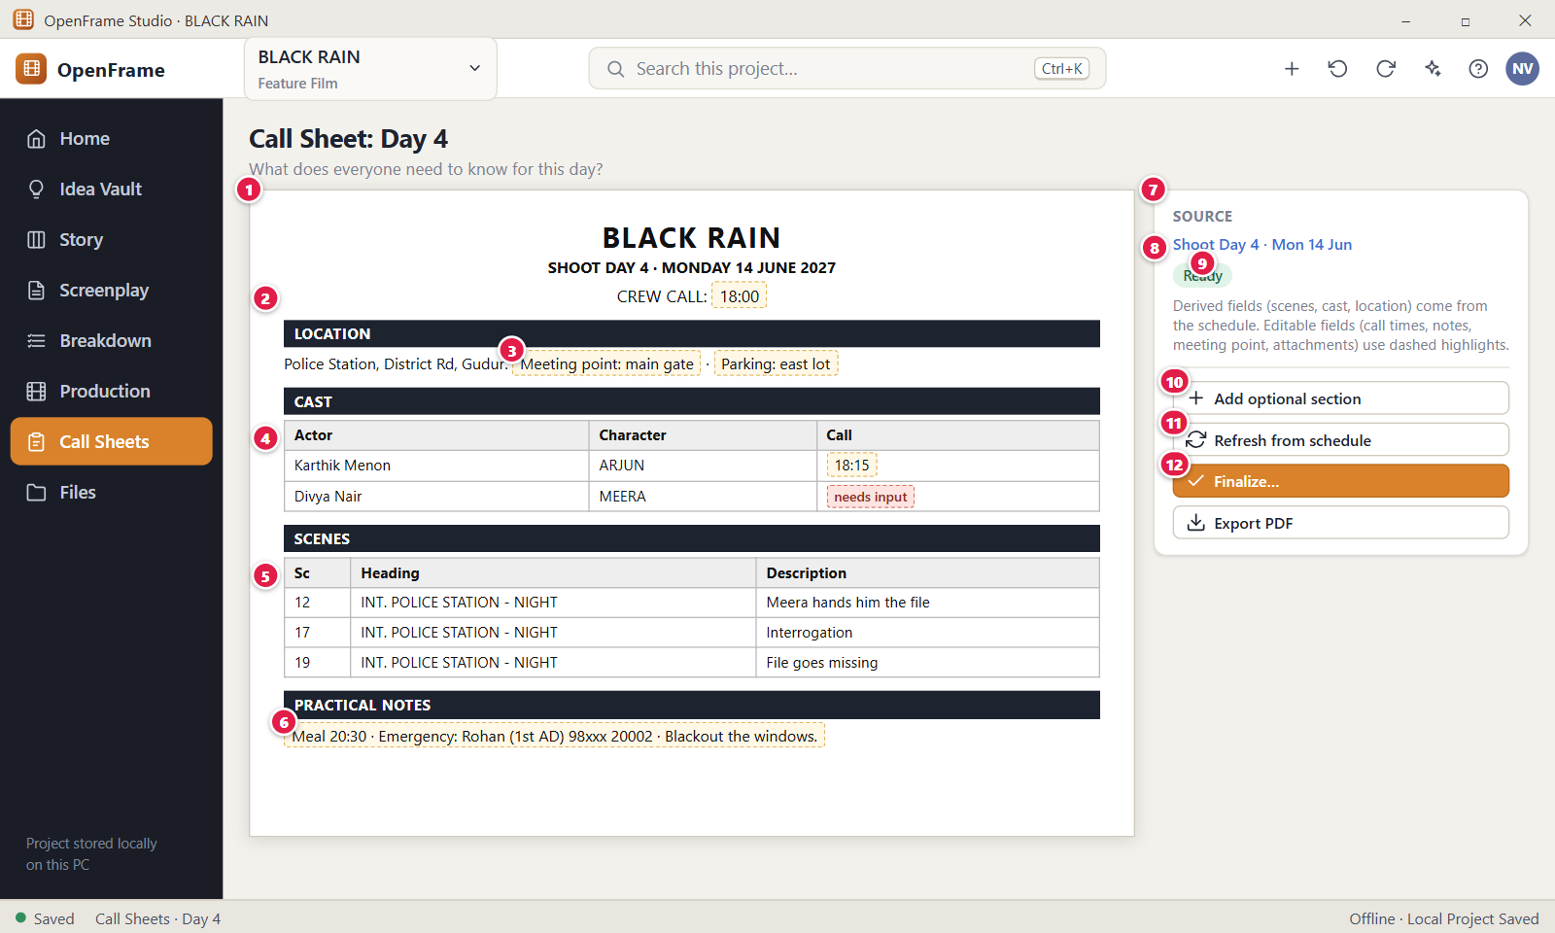
Figure 143. Call Sheet editor. Red numbers are explained on the next page.

Figure 143: Call Sheet editor: how it works
PARTS OF THIS SCREEN  1 The document The white page with six sections that are always shown: Production header, Day and times, Locations, Scene schedule, Talent and Practical notes. Dashed boxes mark what you can edit. The page saves by itself about half a second after you stop typing, and there is no Save button.  2 Crew call The time the whole crew must arrive, filled in from the shooting day, for example 18:00. If the day has none, the field is red and reads "Needs input". It is free text and must not be empty when you finalize. Next to it are General call, Shooting call, Breakfast, Lunch, Estimated wrap and Notes from the day.  3 Meeting point An editable field in the Locations section. In the app each location has labelled fields: Address, Meeting point, Parking, Access, Nearest hospital, Location contact and Notes. Address and Nearest hospital read "Needs input" when empty.  4 Cast table In the app this section is called Talent. Its columns are ID, Actor, Character, Status, Pickup, Makeup, Call and Contact and notes. Character follows the cast assignment and is read-only. You can type Actor, Status, Pickup, Makeup, Call and the contact fields. An empty Actor or Call reads "Needs input".  5 Scenes table The scenes of the day in shooting order, with meal and travel rows between them. The columns are Start, Sc, Set and description, I/E, D/N, Pages, Cast and Location. Only the Start times can be typed. Everything else comes from the schedule and the screenplay.  6 Practical notes A set of labelled fields: Parking, Meeting point, Transport, Meals, Toilets, Access, Safety and Emergency contact, plus the text areas Special instructions and Production notes. Meals and Transport are filled from the schedule markers. Emergency contact reads "Needs input" until you type it.  7 Source panel The card on the right. It shows the source day, the status, the revision number such as v1, how many values are missing, and the action buttons. It also lists the revisions when there is more than one.  8 Source day link Opens that shooting day in Production, Schedule. Your edits are saved first. If the day was deleted, the link still shows the stored day name.  9 Status The status chip. In the app it reads Draft, Needs refresh or Final. There is no Ready state. It shows next to the page title and in the Source panel.  10 Add optional section In the app this button is called Add Section. It opens a menu of extra sections for the page. It is not shown on a Final sheet.  11 Refresh from schedule Opens a preview of what would change. Nothing is applied until you click Apply Update. It is disabled if the source day was deleted. On a Final sheet this button is called Start New Revision.  12 Finalize… Opens the Finalize dialog that freezes this version as the issued call sheet. The crew call must not be empty. It is not shown on a Final sheet. You need permission to finalize. | HOW TO USE IT  1. Open the call sheet for the day, for example Call Sheet: Day 4 of BLACK RAIN.  2. Check the crew call and type call times in the Talent table.  3. Fill in the Meeting point, Parking and the Practical notes fields.  4. Click Add Section if you need weather, files or images.  5. Click Refresh from schedule if the status says Needs refresh.  6. Click Finalize… when the sheet is ready, then click Export PDF.  GOOD TO KNOW · EDGE CASES  • Editing the call sheet never changes the schedule. To change the schedule, work in Schedule.  • Text without a dashed box comes from the schedule. The next Apply Update replaces it. Your typed times, notes and contacts are kept where they still apply.  • A Final sheet cannot be edited. The app says "This call sheet is final. Start a new revision to make changes."  • A sheet can hold at most 500 rows per table and 512 KiB in total. Over that the save is refused.  • OpenFrame does not check the format of times. Weather, sunrise and sunset are typed by hand and never looked up online.  • Ctrl+Z undoes your last group of edits. Ctrl+Y or Ctrl+Shift+Z redoes it. Tab moves to the next field.
See also: Figure 141 Call Sheets list Figure 142 Creating a call sheet from a shooting day Figure 144 Adding optional call-sheet sections Figure 145 Call sheet marked stale after a schedule change Figure 146 Refresh preview before updating a call sheet Figure 147 Finalizing and exporting a call sheet

Figure 144: Adding optional call-sheet sections
What it is for. This menu adds optional sections to a call sheet. The sheet stays short by default and shows an extra section only when you add it. It answers the question: how do I add weather, files, images or special notes to this call sheet?
How to get here. Open a Draft or Needs refresh call sheet, then click Add Section in the Source panel on the right. The picture calls this button Add optional section.
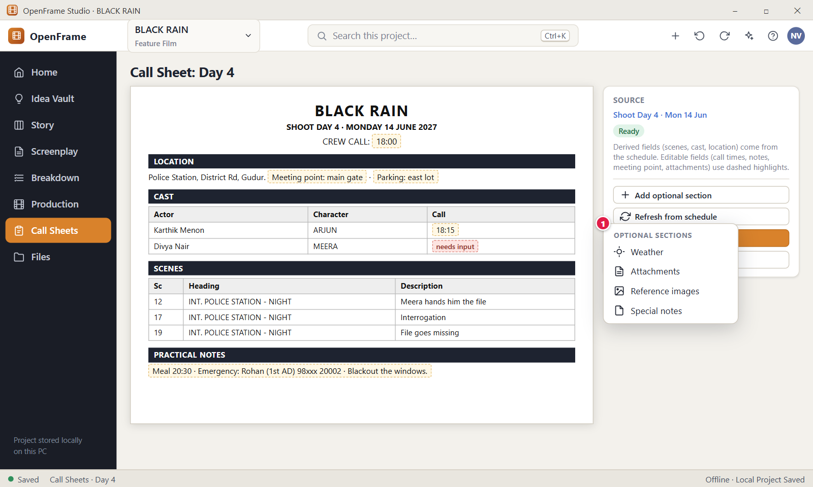
Figure 144. Adding optional call-sheet sections. Red numbers are explained on the next page.

Figure 144: Adding optional call-sheet sections: how it works
PARTS OF THIS SCREEN  1 Optional sections The menu under the Add Section button. Each item adds one section to the end of the page. The app lists Weather, Extras, Department notes, Advance schedule, Crew, Walkie channels and contacts, Reference images, Attachments and Special notes, and below a line a Custom field. Sections already on the page are greyed out. Extras, Department notes, Advance schedule and Crew are filled from the project when it has the data. | HOW TO USE IT  1. Open a call sheet that is not Final.  2. Click Add Section in the Source panel.  3. Choose a section, for example Weather.  4. Fill in the new section on the page.  5. To remove a section, click the small X in its dark header bar. Ctrl+Z brings it back.  GOOD TO KNOW · EDGE CASES  • Weather has the fields Forecast, Sunrise and Sunset. You type them. OpenFrame never looks them up online.  • Attachments copies the file you choose into the project. The PDF lists the file names and does not embed the files.  • Reference images accepts picture files and shows thumbnails. The PDF embeds the images.  • Special notes is one text area for anything unusual about the day.  • Removing a section deletes what you typed in it, until you undo.  • A Final sheet keeps its sections but cannot add or remove them.
See also: Figure 143 Call Sheet editor Figure 145 Call sheet marked stale after a schedule change Figure 147 Finalizing and exporting a call sheet

Figure 145: Call sheet marked stale after a schedule change
What it is for. When the schedule changes after a call sheet was made, the sheet is marked instead of being rewritten behind your back. This screen shows that marked state. It answers the question: is this call sheet still true, and what do I do about it?
How to get here. Click Call Sheets in the left navigation and open a sheet whose row says "Needs refresh". To see it with BLACK RAIN, move scene 19 from Shoot Day 4 to Shoot Day 5 in Production, Schedule, then open the Day 4 call sheet.
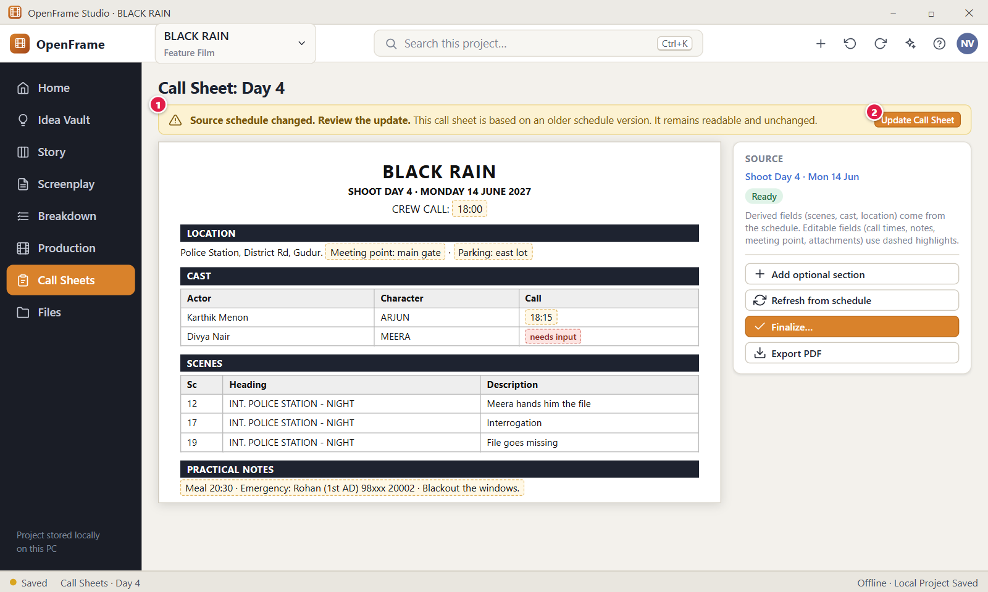
Figure 145. Call sheet marked stale after a schedule change. Red numbers are explained on the next page.

Figure 145: Call sheet marked stale after a schedule change: how it works
PARTS OF THIS SCREEN  1 Stale banner A yellow warning above the sheet. In the app it reads "Needs refresh.", then tells you that the schedule changed after the sheet was prepared, with the date and time, lists what changed (for example Date, Scenes, Cast, Locations) and says nothing changes until you review the update. The sheet below stays readable and unchanged.  2 Update Call Sheet In the app this button is called Review Update. It opens the preview of the differences and changes nothing by itself. On a Final sheet the banner is blue and the button is Start New Revision. If the shooting day was deleted, the button is not shown. | HOW TO USE IT  1. Open the call sheet that shows the yellow banner.  2. Read which areas changed in the banner.  3. Click Review Update to see the differences.  4. Click Apply Update in the preview if you want the new schedule data.  5. Check that the status chip goes back to Draft.  GOOD TO KNOW · EDGE CASES  • A stale sheet is marked, never silently rewritten.  • The state is worked out from the schedule each time. You cannot switch it on or off by hand.  • In the app any change to the day marks the sheet, for example scenes, cast, locations, date, day times, breaks, notes and extras. A change only to a call sheet note does not.  • The status chip reads Needs refresh while the banner shows. The app has no Ready state.  • If you finalize a stale sheet, the app asks you to refresh first or to choose "Finalize this version anyway".  • An exported PDF is not changed by a schedule change. Export again after you refresh.
See also: Figure 143 Call Sheet editor Figure 146 Refresh preview before updating a call sheet Figure 141 Call Sheets list Figure 138 Script changed in scheduled scenes: review changes Figure 147 Finalizing and exporting a call sheet

Figure 146: Refresh preview before updating a call sheet
What it is for. This dialog shows exactly what would change in a call sheet if you bring it up to date with the schedule. Nothing is applied until you click Apply Update. It answers the question: what will this refresh do to my call sheet?
How to get here. Open a stale call sheet and click Review Update in the yellow banner, or click Refresh from schedule in the Source panel. In the Call Sheets list you can also use the row menu "..." or a right-click and choose Refresh. The dialog title is "Update call sheet: review changes".
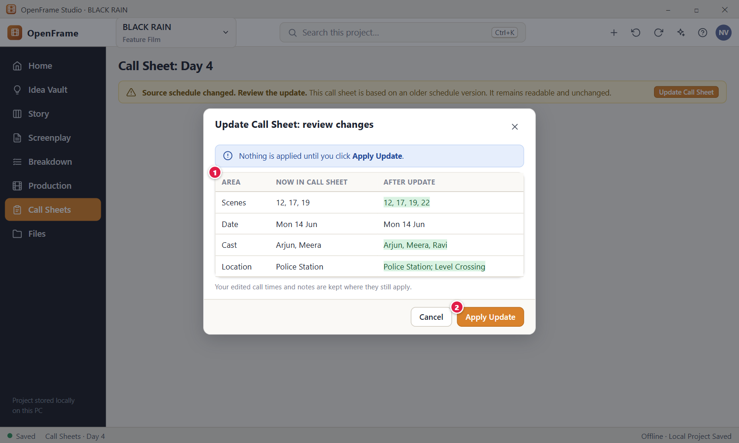
Figure 146. Refresh preview before updating a call sheet. Red numbers are explained on the next page.

Figure 146: Refresh preview before updating a call sheet: how it works
PARTS OF THIS SCREEN  1 Differences table Compares each area of the sheet now with the result after the update. Rows that change are marked "(changes)". The app has up to ten rows: Date, Day, Scenes, Schedule rows, Cast, Locations, Times, Day notes, Meal and breaks and Travel, with a short summary list above. Empty cells read "None". If nothing differs, a green banner says "This call sheet already matches the schedule."  2 Apply Update Brings the sheet up to date. Scenes, cast, locations, date and times follow the schedule. Your typed call times, notes, contacts and added sections are kept where they still apply. The sheet goes back to Draft. On a Final sheet this button is called Create New Revision and starts a new Draft revision. Next to it are Cancel and the X, which close the dialog without applying anything. | HOW TO USE IT  1. Open the stale call sheet.  2. Click Review Update in the banner.  3. Read the Differences table. Scenes that were added or removed are listed line by line.  4. Click Apply Update to accept the changes, or Cancel to keep the sheet as it is.  GOOD TO KNOW · EDGE CASES  • Refreshing always shows the changes first. Nothing is overwritten without the preview and your click on Apply Update.  • If a value you typed still equals the old schedule value, the new schedule value replaces it.  • A Final sheet never changes. Create New Revision makes a v2 Draft and the old one stays Final.  • If the shooting day was deleted, the dialog says there is nothing to update from and Apply Update is disabled. The sheet stays readable.  • Preview and apply never change the schedule. Ctrl+Z undoes Apply Update after the dialog has closed. Esc closes the dialog.
See also: Figure 145 Call sheet marked stale after a schedule change Figure 143 Call Sheet editor Figure 141 Call Sheets list Figure 147 Finalizing and exporting a call sheet

Figure 147: Finalizing and exporting a call sheet
What it is for. Finalizing a call sheet freezes it as the version you send. Exporting writes the PDF. They are two separate actions on purpose. This screen answers the question: is this the version I am actually sending?
How to get here. Open a call sheet from Call Sheets, then in the Source panel click Finalize… for the dialog "Finalize call sheet" or Export PDF for the dialog "Export Call Sheet". In the Call Sheets list the row button Export opens the export dialog, and the row menu item Finalize opens the finalize dialog.
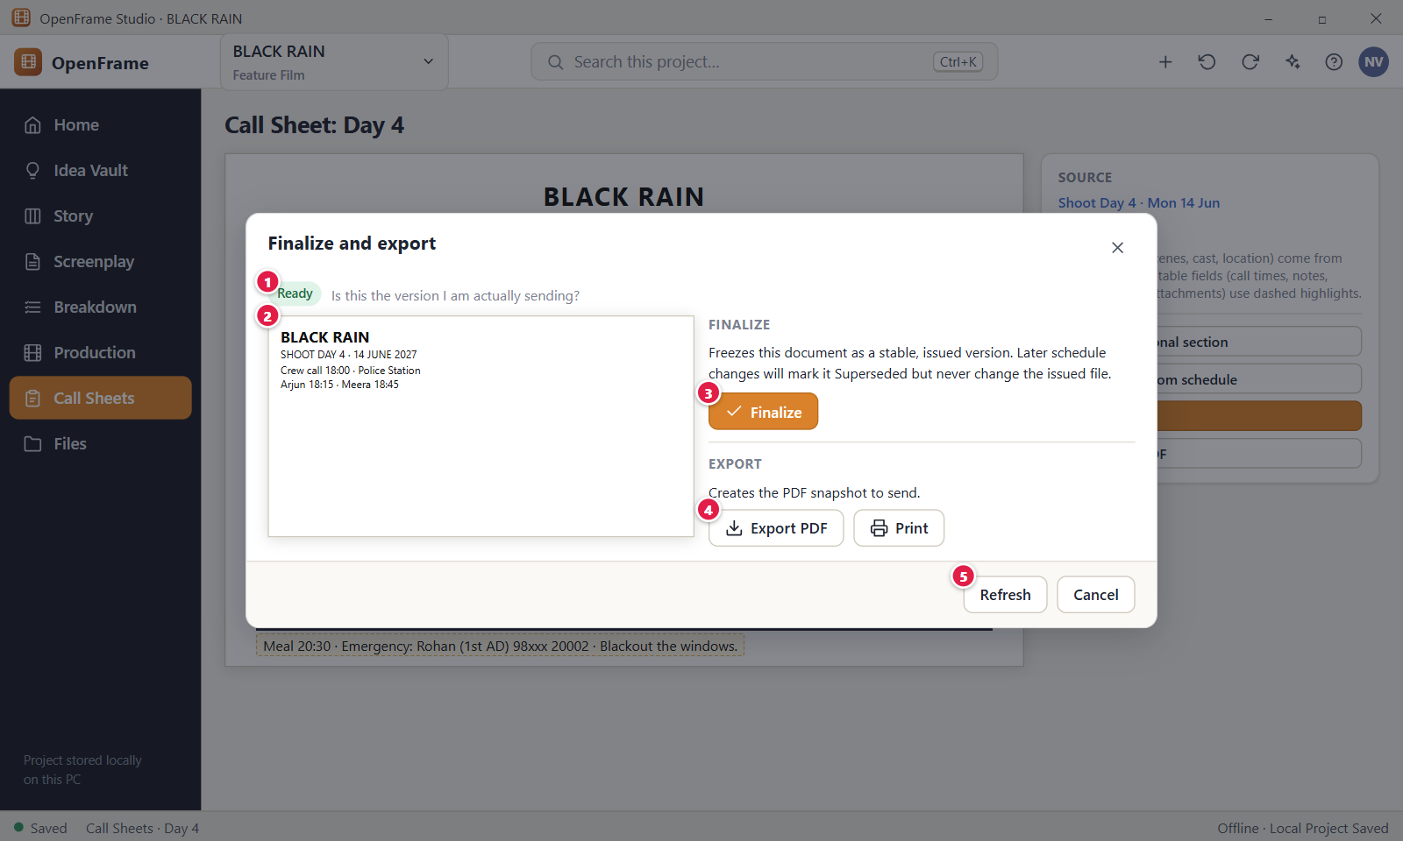
Figure 147. Finalizing and exporting a call sheet. Red numbers are explained on the next page.

Figure 147: Finalizing and exporting a call sheet: how it works
PARTS OF THIS SCREEN  1 Ready The status chip at the top of the Finalize dialog, next to the question "Is this the version you are sending?". In the app it reads Draft for a current sheet or Needs refresh for a stale one. There is no Ready state.  2 Preview of the outgoing document In the app this is one short summary: production title, day, date, crew call, the number of scenes and the number of cast members, for example "Crew call 18:00 · 3 scenes · 2 cast". It is not a page preview. An empty crew call shows "Needs input" in red. If other values are missing, a line counts them.  3 Finalize Freezes the sheet as a Final snapshot. Later schedule changes never change it and lead to a new revision. The crew call must not be empty. On a stale sheet the button changes to "Finalize this version anyway" after your first click. You need permission to finalize.  4 Export PDF Opens the dialog "Export Call Sheet" and writes the sheet as a PDF through the Windows Save dialog. You can export a Draft sheet too, but the PDF is then marked "DRAFT, not final". A Final sheet is exported from its frozen snapshot.  5 Refresh This button is not in the dialogs of the app. To update the sheet from the schedule first, close the dialog and use Refresh from schedule in the Source panel. The app also has no Print button: open the PDF in a PDF viewer and print it there. | HOW TO USE IT  1. Open the call sheet and check the crew call.  2. If the sheet says Needs refresh, click Refresh from schedule and apply the update first.  3. Click Finalize… and read the summary. Click Finalize.  4. Click Export PDF. Leave "Include the added sections" ticked if you want weather, extras, notes and attachments in the PDF.  5. Click Export… and choose where to save the file, for example BLACK RAIN - Call Sheet Day 4.  6. Send the PDF by your normal channel: email, a messaging app or USB.  GOOD TO KNOW · EDGE CASES  • Finalize and Export are separate. OpenFrame does not send the PDF for you.  • Only the crew call is required to finalize. Other values that read "Needs input" do not block it.  • A Final sheet cannot be edited or finalized again. After a schedule change you start a new revision.  • The PDF prints "Created with OpenFrame Studio" at the bottom and leaves out private notes.  • A failed finalize or export keeps your draft intact. Export never changes the schedule.  • Ctrl+Z undoes Finalize after the dialog has closed. Esc closes either dialog.
See also: Figure 143 Call Sheet editor Figure 145 Call sheet marked stale after a schedule change Figure 146 Refresh preview before updating a call sheet Figure 141 Call Sheets list Figure 139 Exporting the schedule

Figure 148: Sides for a shooting day
What it is for. Sides are the script pages for the scenes of one shooting day, a companion to the call sheet. On this screen you choose the day, the scenes and the cast, preview the pages and save or export them. It answers the question: what script pages does this team need for this shooting day?
How to get here. Click Production in the left navigation, then the Sides tab. There is no Generate Sides button in the Schedule day view. Sides need a shooting schedule. Without one the page says "Sides need a shooting schedule." with an Open Schedule button.
Figure 148. Sides for a shooting day. Red numbers are explained on the next page.

Figure 148: Sides for a shooting day: how it works
PARTS OF THIS SCREEN  1 Setup The card on the left. It holds the Shooting day list, the scene check boxes, the choice For (All cast or Selected cast), two check boxes, the buttons Preview, Save Sides and Export PDF, and the list of saved sides. The first working day is chosen at the start. Off days are not listed. Changing the day ticks all its scenes again.  2 Scenes One check box per scheduled scene of the day, with the scene number and heading, for example "12: INT. POLICE STATION - NIGHT". All are ticked at the start. At least one must stay ticked, or the preview and buttons are disabled.  3 Include call-sheet cover page When ticked, the sides start with a cover showing the day, date, crew call, locations, cast with call times and day notes. It is not ticked at the start. Without a call sheet for the day the cover shows the day and locations only. Below it the check box "Show draft / revision name" is ticked at the start.  4 Page preview A paper-style, read-only preview on the right. It shows a header line such as "BLACK RAIN · SIDES · SHOOT DAY 4" and the draft name, then each scene with its action, character and dialogue lines. It shows script text only. Private notes never appear.  5 Export PDF Opens the dialog "Export Sides" and writes the sides as a PDF in screenplay format through the Windows Save dialog. It is enabled when a day and at least one scene are chosen. Next to it, Save Sides stores the current sides as a snapshot in the list of saved sides. | HOW TO USE IT  1. Click Production, then Sides.  2. Choose the Shooting day, for example Shoot Day 4 of BLACK RAIN.  3. Untick scenes you do not need. Choose Selected cast to keep only scenes of certain actors.  4. Tick Include call-sheet cover page if you want one.  5. Check the page preview.  6. Click Export PDF, or click Save Sides to keep a snapshot.  GOOD TO KNOW · EDGE CASES  • Sides show the draft name in the header, so readers know which version of the script they have.  • A PDF and a saved snapshot never change when the screenplay changes later. The live preview follows the current script.  • With Selected cast, only scenes that have at least one ticked person remain. With no cast on the day the list reads "No confirmed cast on this day."  • Deleting a saved snapshot moves it to Recently Deleted.  • The PDF uses Courier 12 and prints "Created with OpenFrame Studio" in the bottom margin. Text the font cannot print stops the export.  • Everyone can view the preview. Saving needs the Edit permission and Export needs the Export permission.
See also: Figure 140 Daily Production View Figure 143 Call Sheet editor Figure 130 Stripboard: Unscheduled pool and shooting days Figure 104 Breakdown: scene list, script and elements Figure 76 The screenplay editor (Standard mode)

Figure 149: Production Reports
What it is for. Reports gives you a few practical reports built from your current project data. You pick a report, filter its rows, then export it or save a snapshot. It answers the question: what concise production information do I need to see or send?
How to get here. Click Production in the left navigation, then the Reports tab (after Sides).
Figure 149. Production Reports. Red numbers are explained on the next page.

Figure 149: Production Reports: how it works
PARTS OF THIS SCREEN  1 Report picker The six reports: Scene Report, Location Report, Cast Scene Report, Prop Report, Schedule Report and Breakdown Completeness. In the app they are a vertical list on the left. Scene Report is chosen when you open the page, and a report is built the moment you click it.  2 Report table The result of the chosen report. The Location Report has the columns Location, Status, Address, Scenes and Shooting days. The status words are Idea, Shortlisted and Confirmed, or "From heading" when a location comes only from a scene heading. You cannot edit the rows. Change the data in its own workspace.  3 Export Opens the Export dialog for the report on screen, for example "Export Location Report". Choose PDF, CSV or Excel and save the file through the Windows Save dialog. The filter you typed is used and noted in the file. You need the Export permission.  4 Read-only note The picture shows a hint under the table. In the app there is a filter box above the table instead. If nothing matches, the screen says "No matching data." and the filter stays visible. The app has no Print button: export the PDF and print it from a PDF viewer. | HOW TO USE IT  1. Click Production, then Reports.  2. Click a report in the list, for example Cast Scene Report.  3. Type in the filter box to narrow the rows, for example a location name. Click Clear to reset.  4. Click Save snapshot if you want a frozen copy to keep.  5. Click Export, choose PDF, CSV or Excel, and save the file.  GOOD TO KNOW · EDGE CASES  • Reports are read-only and built on demand from the current Production Source and the schedule.  • A saved snapshot never changes when your data changes. Delete it with the bin icon. Undo is available.  • The filter matches any cell, ignores capital letters and stops at 200 characters.  • A value nobody set reads "Not set" in the Scene Report. A scene that is not scheduled reads "Unscheduled".  • If the project has no Production Source, the app says "Choose a Production Source in Breakdown first."  • Everyone can view reports. Saving a snapshot needs the Edit permission.
See also: Figure 115 Locations list Figure 118 Cast list Figure 104 Breakdown: scene list, script and elements Figure 130 Stripboard: Unscheduled pool and shooting days Figure 139 Exporting the schedule

Figure 150: Lightweight budget snapshot (P1)
What it is for. The Budget is a small planning view that shows the rough scale of the project: a planned estimate, a contingency and a few lines under simple categories. It is not accounting. It answers the question: how much are we roughly planning to spend?
How to get here. Click Production in the left navigation, then the Budget tab (after Reports). Without a budget the page shows "Start a budget" with a currency choice and the button Start budget. The budget is optional.
Figure 150. Lightweight budget snapshot (P1). Red numbers are explained on the next page.

Figure 150: Lightweight budget snapshot (P1): how it works
PARTS OF THIS SCREEN  1 Planning banner The blue banner "Use a simple estimate for planning. Formal accounting is outside OpenFrame." It is always shown. A yellow banner "Review budget." can appear below it when the Production Source changed. Its button Mark reviewed dismisses it.  2 Summary tiles In the app there are three tiles: Planned (the sum of all planned amounts), Actual and Difference. Under them a line shows your overall plan and the contingency. The button Edit plan opens "Budget plan", where you set the currency, the planned total, the contingency as a percent or an amount, and notes.  3 Budget table The lines grouped by category, with the columns Category, Line item, Planned, Actual and Difference, and a total row after each category. The categories are Cast, Crew, Locations, Equipment, Art/Props, Travel/Transport, Food, Post/Other and Contingency. Each row has an Edit (pencil) and a Delete (bin) icon.  4 Add Line Opens the dialog "Add Line" with Category, Line item, Planned, Actual and Notes. A line needs a description and a planned amount of zero or more. Negative or malformed amounts are refused and no valid line is lost. Next to it is the Export button for PDF, CSV or Excel. | HOW TO USE IT  1. Click Production, then Budget.  2. If the page says "Start a budget", choose a currency and click Start budget.  3. Click Edit plan to set an overall planned total and a contingency, for example 10 percent.  4. Click Add Line, choose a category such as Locations, type "Railway permission" and a planned amount.  5. Fill in the Actual amount later, when you know what was spent.  6. Click Export to save a summary.  GOOD TO KNOW · EDGE CASES  • There is no payroll, tax, union, ledger, invoice or purchase order feature.  • Budget values never change by themselves when the script or schedule changes. OpenFrame only reminds you to review.  • Difference is Planned minus Actual. A line with no Actual reads "Not spent yet" and is never counted as under plan.  • Changing the currency does not convert any amount. It only changes the symbol.  • Save snapshot stores a frozen, read-only copy. Deleted lines and snapshots can be recovered with Undo or Recently Deleted.  • With no lines the page says "No lines yet. Add a line for each rough cost you expect."
See also: Figure 149 Production Reports Figure 138 Script changed in scheduled scenes: review changes Figure 102 Production overview (dashboard) Figure 151 Project Notes and Lightweight Tasks

Figure 151: Project Notes and Lightweight Tasks
What it is for. Notes & Tasks holds free-form project notes and a very small task list, only what supports filmmaking. It is for small things that do not belong anywhere else, such as a meeting note or an action to remember. It answers the question: what small things must I remember for this project?
How to get here. Click the project name "BLACK RAIN" at the top left and choose Notes & Tasks. You can also click the "+" button at the top and choose New Note or New Task, or use the Notes & Tasks button on Project Home. It is a page of its own, not a Production tab.
Figure 151. Project Notes and Lightweight Tasks. Red numbers are explained on the next page.

Figure 151: Project Notes and Lightweight Tasks: how it works
PARTS OF THIS SCREEN  1 New Note Creates an empty note at once and opens it in a side panel where you type a title and text. The note saves by itself while you type. An unused note stays in the list as "Untitled note" until you delete it.  2 Project Notes The list of notes, newest first, with pinned notes on top. Each row shows the title (or the first line), a preview and the day it changed. A search box named "Search notes" filters the list. In the note panel you can Delete or Pin and Unpin. Notes never appear in formal documents.  3 New Task Opens the task panel "New Task". Only the title is required. You can also set a due date, an owner, a related item and notes. Click Add Task to save. With an empty title the app says "Give the task a short title."  4 Tasks The list of tasks. Each row has a check box, the title, the owner, a chip for the related item, the due date and the state. The filter Open is chosen at the start, and the chip next to the heading counts the open tasks. A past due date shows in red with "overdue". | HOW TO USE IT  1. Click the project name at the top left and choose Notes & Tasks.  2. Click New Note, type a title such as "Location meeting notes" and the text.  3. Click New Task and type a title such as "Confirm police station".  4. Pick a due date, an owner or a related item if you need them, then click Add Task.  5. Tick the check box in a task row when it is done. Untick it to reopen it.  6. Use the filters Open, Done and All, and the Owner filter, to find tasks.  GOOD TO KNOW · EDGE CASES  • Completing a task changes only the task, never the scene, location or other item it relates to.  • A task is only Open or Done. There are no dependencies, Gantt charts, time tracking or sprint boards.  • A task can relate to a scene, scene card, character, location, breakdown item, cast, crew, shooting day or call sheet. Click the chip to open it. If the item was deleted, the chip reads "(deleted)".  • Deleted notes and tasks go to Recently Deleted, and Ctrl+Z restores them.  • Notes in this version have a title, text and a pin only. They have no tag, attachment or related item.  • Empty lists say "No notes yet." and "No tasks yet." Ctrl+K searches notes and tasks too.
See also: Figure 12 Project Home: an active project Figure 102 Production overview (dashboard) Figure 115 Locations list Figure 130 Stripboard: Unscheduled pool and shooting days Figure 143 Call Sheet editor

Figure 152: Activity History
What it is for. Activity History is a read-only list of the important things that happened in the project: who did what, when, and to which object. It answers the question: what important actions have happened in this project? It is for orientation, not for auditing.
How to get here. Click the project name "BLACK RAIN" at the top left and choose Activity. You can also click the Activity button on Project Home, or click the Saved area at the bottom left and choose Activity. It is not in the left navigation.
Figure 152. Activity History. Red numbers are explained on the next page.

Figure 152: Activity History: how it works
PARTS OF THIS SCREEN  1 Filter buttons Five buttons above the list: All, Drafts, Story, Production and Exchange. They only change what you see. Drafts shows screenplay events. Story shows Story Board and Idea Vault events. Production shows catalog, location, cast, crew, moodboard, storyboard, shot, schedule, call sheet, budget, report and breakdown events. Exchange shows package, import and export events. All is chosen each time you open the page.  2 Activity list The events, newest first. Each row shows the time, the person, what they did and the affected object. Times read "Today 10:41", "Yesterday 09:12" or a date such as "12 Oct 14:05". The Open button jumps to the object, and it is shown only while the object still exists. | HOW TO USE IT  1. Click the project name at the top left and choose Activity.  2. Scroll the list to see the latest events.  3. Click Production to see only production events, for example a call sheet that was finalized.  4. Click Open on a row to go to the object.  5. Click Show older activity at the bottom to load more.  GOOD TO KNOW · EDGE CASES  • Ordinary typing is never recorded, and private notes never write an entry.  • You cannot edit, delete or export entries. Undoing an action does not remove its entry.  • The list loads 200 entries first. Each click on Show older activity loads 200 more, up to 1000.  • The filter is not remembered. It goes back to All when you leave the page.  • Empty lists say "No major activity yet." or "Nothing of this kind has happened yet."  • Everyone who can view the project can read Activity.
See also: Figure 12 Project Home: an active project Figure 49 Story Board: Board view Figure 83 Drafts: named drafts and recovery history Figure 158 The Share / Exchange menu Figure 151 Project Notes and Lightweight Tasks

Figure 153: Template browser (P1)
What it is for. The Template browser holds saved starting points: screenplay starters, Story Board starters, call sheet layouts, shot lists, moodboards and simple budgets. It answers the question: would a saved starting point help me begin faster? Using a template always creates independent content, and a blank start always stays possible.
How to get here. Click the project name "BLACK RAIN" at the top left and choose Templates, or click the Templates button on Project Home. Both open Project settings on its Templates tab. The New Project dialog has no template choice.
Figure 153. Template browser (P1). Red numbers are explained on the next page.

Figure 153: Template browser (P1): how it works
PARTS OF THIS SCREEN  1 Built-in The templates that come with OpenFrame. The app has 8: Feature Film Screenplay, Short Film Screenplay, Episodic / Series, Simple Story Board, Indie Call Sheet, Shot List, Moodboard and Lightweight Budget. They are read-only. You can preview one, use it in this project, or copy it to your own templates.  2 Project starter This card is not in the current version. A card shows the template name, its type and a short description, for example Feature Film Screenplay, "Screenplay starter · Feature film · three acts". Click a card to preview it. The card menu offers Preview, a create action for the type (such as Start the screenplay or Create a call sheet), Use in This Project and Copy to My Templates.  3 Yours Templates you made. They are kept on this computer and are available in every project. This section is empty at first. You can edit them and delete them. Deleting asks first and does not change projects that already used the template. The app also has a third section, This project, for templates kept inside the project.  4 Create Template Opens a dialog where you give a name, a type, where to keep it (This project or Every project), an optional description and the list of items, one per line. The name is required. | HOW TO USE IT  1. Click the project name at the top left and choose Templates.  2. Click a built-in card, for example Indie Call Sheet, to preview it.  3. Open the card menu and choose Use in This Project, or the create action for that type.  4. To make your own, click Create Template, type a name such as "My short-film call sheet", choose the type and click Create.  5. To reuse a built-in one with your changes, choose Copy to My Templates, then edit the copy.  GOOD TO KNOW · EDGE CASES  • Everything made from a template is an independent copy. Changing or deleting the template later changes nothing already made. One Undo removes everything a template created.  • Built-in templates cannot be edited or deleted. Copy one to change it.  • Start the screenplay is refused when the project already has a screenplay. The app says to start a new project to use a screenplay template.  • A template can be at most 256 KB. The name is 1 to 120 characters and the description at most 200.  • Templates you delete from This project go to Recently Deleted.  • A blank start is always available. Templates are optional.
See also: Figure 12 Project Home: an active project Figure 141 Call Sheets list Figure 126 Shot list for a scene Figure 150 Lightweight budget snapshot (P1) Figure 157 Recently Deleted (whole project)

Figure 154: Project Files (file cabinet)
What it is for. Project Files is a simple cabinet for documents that do not belong to another screen: pitch decks, research PDFs, permission scans, received schedules and artwork. It answers the question: what files belong with this film? A file is either stored inside the project or linked from where it already lives.
How to get here. Click Files in the left navigation, or use the Files card on Project Home.
Figure 154. Project Files (file cabinet). Red numbers are explained on the next page.

Figure 154: Project Files (file cabinet): how it works
PARTS OF THIS SCREEN  1 Add File A drop-down button with two items. "Copy into project…" stores a copy inside the project folder. "Link to file…" keeps a reference to the original where it is. You can also drag files from Windows Explorer onto the page, and they are always copied in. You can add up to 500 files at a time, and a stored file may be up to 8 GB. Next to it is a New Folder button.  2 Files table The files with their name, a plain type (PDF, Document, Spreadsheet, Image and so on), where the file lives and when it changed. Each row has an Open button and a More actions menu with Details, Rename, Move to, Reveal in File Manager, Export Copy… and Delete. Click a row to open a details panel on the right. A search box and the buttons List and Grid sit above.  3 Stored in project A green chip. The file is a copy kept inside the project folder, so it travels with the project, a backup and a Full Project Package. If the stored copy goes missing, the chip changes to "Unavailable" and you need to restore the project folder from a backup.  4 Linked (external) A blue chip. The project keeps only a reference to a file that lives elsewhere, for example in D:\Art\. The file is not copied. If you move, rename or delete the original, the link breaks and the row shows a red "Unavailable" chip with Relink. The reference is never deleted by itself. | HOW TO USE IT  1. Click Files in the left navigation.  2. Click Add File and choose "Copy into project…" for a file you want to keep with the film, for example a pitch deck.  3. Choose "Link to file…" instead for a large file that should stay where it is.  4. Click a row to open the details panel and add notes or change the name.  5. Click Open on a row to open the file with its normal Windows app.  6. If a linked file shows Unavailable, click Relink and pick the file at its new place.  GOOD TO KNOW · EDGE CASES  • Rename changes only the name shown in OpenFrame. The file on disk keeps its name.  • Delete is recoverable. The file goes to Recently Deleted. F2 renames and Delete removes the file you selected.  • Files that could run code, such as .exe, .bat or .ps1 files, are shown in File Explorer when you click Open. They are never started.  • An image already used on a moodboard is not listed a second time.  • With no files the page says "Keep project documents and attachments here."  • A folder cannot be added as a file. The app says "Please choose a file, not a folder."
See also: Figure 12 Project Home: an active project Figure 157 Recently Deleted (whole project) Figure 156 Global project search Figure 169 Creating a backup

Figure 155: Permissions
What it is for. This screen was planned as a Permissions page: your role, a list of people with a role each, a description of the five roles and an Add Person button. It is not part of the current version. OpenFrame has no user accounts and no roles in the screens.
How to get here. Not available as a screen. There is no Permissions entry in the left navigation, the project menu, Project settings or Project Home.
Not in this version
• The Permissions page was planned but is not in this version. OpenFrame has no accounts or roles on screen. You are always the owner of the projects on your own computer.

Figure 156: Global project search
What it is for. Global project search finds a word in any part of the project and tells you where each result lives. It answers the question: where in this project is this word? It is plain word search, not a guess about meaning, and it can include the Global Idea Vault.
How to get here. Press Ctrl+K on any project screen, or click the search box "Search this project…" in the top bar. On the Project Home list of projects, Ctrl+K searches projects instead. You can change the shortcut in Settings, Shortcuts.
Figure 156. Global project search. Red numbers are explained on the next page.

Figure 156: Global project search: how it works
PARTS OF THIS SCREEN  1 Search box The text field at the top. It has the cursor when the dialog opens, and the placeholder reads "Search scenes, ideas, characters, locations, files…". Results appear shortly after you stop typing. Each word you type must match the start of a word, so "motor" finds "motorcycle" and "red motorcycle" needs both words. Esc closes the dialog.  2 Scope switch and count Two buttons: "This project" (chosen at the start) and "+ Global Idea Vault", which adds the ideas shared across all your projects. On the right the count reads "1 result" or "N results", up to 60. It reads "Searching…" while results load.  3 Result rows Each result shows a type chip, the title, a short piece of text with your words highlighted, and the place where it lives. In the app the chip names the type only, for example SCENE, CATALOG or SHOT, and the whole row is the button, with no separate Open. Click a row or press Enter to open the page with the match in view. | HOW TO USE IT  1. Press Ctrl+K.  2. Type a word, for example "motorcycle" in BLACK RAIN.  3. Click "+ Global Idea Vault" if you also want ideas from the shared vault.  4. Use the Up and Down arrow keys to move through the results.  5. Press Enter or click a row to open it. Press Esc to close the search without opening anything.  GOOD TO KNOW · EDGE CASES  • Search is plain word matching on the start of words. It does not use AI and does not guess meaning.  • It is different from Find in the screenplay (Ctrl+F), which searches only the open screenplay, and from search inside the Idea Vault.  • It covers ideas, acts, sequences, beats, scene cards, screenplay text, characters, locations, catalog items, cast, crew, shots, storyboards, call sheets, files, comments and notes.  • Your own private notes are included for you only. Results for deleted items are not shown.  • A search shows at most 60 results and accepts up to 500 characters. Use more exact words to narrow the list.  • With no match the app says "No matches. Search looks at titles, text, notes, file names and tags."
See also: Figure 76 The screenplay editor (Standard mode) Figure 113 Production Catalog Figure 126 Shot list for a scene Figure 24 Project Idea Vault: Visual Grid Figure 154 Project Files (file cabinet)

Figure 157: Recently Deleted (whole project)
What it is for. Recently Deleted is the safety net for the whole project. Cards, locations, drafts, tasks, files and templates you delete wait here, so you can restore them or remove them for good. It answers the question: can I get back what I deleted?
How to get here. Click the project name "BLACK RAIN" at the top left and choose Recently Deleted, or click the Recently Deleted button on Project Home. There is no link to it on the Files page. Ctrl+Z also restores the item you just deleted.
Figure 157. Recently Deleted (whole project). Red numbers are explained on the next page.

Figure 157: Recently Deleted (whole project): how it works
PARTS OF THIS SCREEN  1 Deleted items table The deleted items, newest first. In the app the columns are Item, Type, Deleted, Removed in (for example "30 days left") and Was in. A switch for "This project" and "Global Idea Vault" and a search box sit above. When nothing is deleted the page says "Nothing has been deleted."  2 Restore Puts the item back where it was, in its old order where possible. If its place no longer exists, it goes to an Unassigned area and the app tells you. A draft cannot be restored while its screenplay is deleted, and a screenplay cannot be restored while its episode is deleted. Restore the parent first.  3 Warning banner A yellow notice below the table. It says that Delete Permanently asks for a second, deliberate confirmation, and that Restore uses an Unassigned area when the original place is gone. The red Delete Permanently button on each row opens that confirmation. It cannot be undone, and only the Owner can use it. | HOW TO USE IT  1. Click the project name at the top left and choose Recently Deleted.  2. Find the item, for example the scene card "Maybe Scene 17". Use the search box if the list is long.  3. Click Restore to bring it back.  4. To remove an item for good, click Delete Permanently and confirm in the dialog.  GOOD TO KNOW · EDGE CASES  • Items stay for 30 days. They are then removed for good the next time the project opens.  • Deleting a source object never deletes what was made from it. Deleting a scene card does not delete the screenplay scene.  • Permanent deletion cannot be undone. Only a backup can bring the item back.  • Ctrl+Z is the fast way back for something you just deleted. Esc cancels the Delete Permanently dialog.  • The Global Idea Vault has its own Recently Deleted list.  • If the list cannot be read, the app says "Recently Deleted couldn't be loaded." and shows a Try Again button.
See also: Figure 49 Story Board: Board view Figure 154 Project Files (file cabinet) Figure 153 Template browser (P1) Figure 156 Global project search Figure 152 Activity History

Chapter 7: Collaboration, Backup and Portability
Collaboration, backup and portability. Work moves between people as files (Exchange Packages and review packages). You can back up a project, export it, restore it, and keep working when a drive is missing or you are offline.

Screens in this chapter
Figure | Screen | Page
Figure 158 | The Share / Exchange menu | 341
Figure 159 | Exporting a script review package | 343
Figure 160 | The reviewer opens the package | 345
Figure 161 | Importing a response package: preview before applying | 347
Figure 162 | A stale package: version mismatch | 349
Figure 163 | Review Queue and Unmatched Review Notes | 351
Figure 164 | Starting a local collaboration session (host) (removed in this version) | 353
Figure 165 | Joining a session (participant) (removed in this version) | 354
Figure 166 | An active session: presence and soft locks (removed in this version) | 355
Figure 167 | Resolving an editing conflict (removed in this version) | 356
Figure 168 | Disconnected from a session (removed in this version) | 357
Figure 169 | Creating a backup | 358
Figure 170 | Exporting the whole project to move it | 360
Figure 171 | Importing a project package (identity collision) | 362
Figure 172 | External drive removed while a project is open | 364
Figure 173 | Working offline | 366

Figure 158: The Share / Exchange menu
What it is for. The Share / Exchange menu is the starting point for sending part of a project to someone else and for bringing their answer back. Each item makes a package file or imports one. It answers the question: how do I hand this part of the project to another person without sending everything?
How to get here. Click the project name "BLACK RAIN" in the top bar. The project menu has a section headed "Share / Exchange". It is the same menu from every screen. It is not on the screenplay toolbar.
Figure 158. The Share / Exchange menu. Red numbers are explained on the next page.

Figure 158: The Share / Exchange menu: how it works
PARTS OF THIS SCREEN  1 Share / Exchange menu The group of items for exchange packages. In the app the items end with three dots: Export Review Package (script)…, Story Board Package…, Breakdown Package…, Shot List Package…, Schedule Package… and Call Sheet Review Package…, then Import Exchange Package…. The app adds Open Review Package…, Review Queue and Import & Export History. There is no Start Collaboration Session…, because live collaboration was removed. Packages are the only way to work with others. | HOW TO USE IT  1. Click the project name at the top left.  2. In the Share / Exchange section, choose the package for what you want to send, for example Breakdown Package….  3. Choose the scope in the dialog and save the package file.  4. Send the file by email, a messaging app, USB or a file-sharing service.  5. When someone sends a package back, choose Import Exchange Package… to preview what would change.  GOOD TO KNOW · EDGE CASES  • A package is a snapshot. It never syncs with your project, and changes on either side do not rewrite the other.  • OpenFrame does not send the file for you. No OpenFrame account or cloud is needed.  • Private notes are never included in a package.  • If there is nothing to send, the dialog says so, for example "This project has no screenplay draft to send for review yet."  • Import validates the file first. A file that is not a package leaves your project unchanged.  • Creating a package needs permission to create packages. Previewing an import changes nothing.
See also: Figure 159 Exporting a script review package Figure 161 Importing a response package: preview before applying Figure 163 Review Queue and Unmatched Review Notes Figure 83 Drafts: named drafts and recovery history Figure 164 Starting a local collaboration session (host)

Figure 159: Exporting a script review package
What it is for. This dialog creates a Script Review Package: a file a reviewer can read and comment on without receiving your whole project. It answers the question: how do I send this draft to someone for review and safely bring their notes back? It first shows exactly what the file will contain.
How to get here. Click the project name in the top bar, then choose Export Review Package (script)… in the Share / Exchange section. There is no Share button on the screenplay toolbar.
Figure 159. Exporting a script review package. Red numbers are explained on the next page.

Figure 159: Exporting a script review package: how it works
PARTS OF THIS SCREEN  1 Source draft A drop-down with the draft the reviewer will read. Each option reads like "Draft 7: Director Rewrite (current) · 44 scenes". The current draft is chosen at the start. A locked draft can be chosen. Without a draft the dialog says "This project has no screenplay draft to send for review yet."  2 Scope Three choices: "Full script" (chosen at the start), "Script + comments" and "Specific scenes only". With the last one you tick the scenes to include, and at least one must be ticked or the dialog says "Choose at least one scene."  3 Include options "Include comments" is ticked at the start. "Include attachments" shows the number of attachments and is unavailable when the draft has none. "Include private notes" is always off and cannot be switched on.  4 This package will contain A panel that lists the contents before you export: project, target draft, scope, who exported it, the date, the number of scenes and comments, and "Private notes: excluded". It is what the reviewer will see about the file. It updates when you change the draft, scope or options.  5 Export Package… Opens the Windows Save dialog and writes the package file. It is unavailable until the summary is ready and, for specific scenes, a scene is ticked. After success the dialog says "Package exported." with the file path. The app has no separate Preview button, because the summary panel is the preview. | HOW TO USE IT  1. Choose Export Review Package (script)… from the project menu.  2. Pick the Source draft, for example Draft 7: Director Rewrite.  3. Choose the Scope. For one sequence of BLACK RAIN choose Specific scenes only and tick the scenes.  4. Tick or untick Include comments and Include attachments.  5. Read the panel "This package will contain".  6. Click Export Package…, choose a folder and save the file. Then send it to your reviewer.  GOOD TO KNOW · EDGE CASES  • Exporting does not change the draft or its status, even for a locked draft.  • Private notes can never go into a review package.  • The package is a snapshot. Later changes to your project are not in the file.  • The Save dialog will not accept a folder that OpenFrame uses for its own files. The app says "OpenFrame keeps its own files in that folder. Choose a different folder."  • A failed save leaves no partial file.  • The export is listed in Activity.
See also: Figure 158 The Share / Exchange menu Figure 160 The reviewer opens the package Figure 161 Importing a response package: preview before applying Figure 83 Drafts: named drafts and recovery history Figure 152 Activity History

Figure 160: The reviewer opens the package
What it is for. This is what the reviewer sees after opening a Script Review Package on their own PC. A clear banner says it is a review copy, not the original project. The reviewer reads the script, adds comments and sends a small response file back. It answers the question: what can I do with this package, and how do I send my notes back?
How to get here. On the reviewer's PC, with any project open, click the project name in the top bar and choose Open Review Package…, then pick the package file. You can also use the project menu, Import & Export History, My reviews, Open. The reviewer needs OpenFrame but no account and no network.
Figure 160. The reviewer opens the package. Red numbers are explained on the next page.

Figure 160: The reviewer opens the package: how it works
PARTS OF THIS SCREEN  1 Review banner The banner at the top. In the app it reads "Review package. Comments are separate from the original project." followed by the draft name, who exported it and when. It also holds the Export Response Package button and a close button. The script itself is read-only.  2 Export Response Package Creates a small response file with your own comments, to send back to the author. It is unavailable until you have written at least one comment. The Windows Save dialog suggests the name "<draft name> - review response". After saving, a banner says "Response package exported. Send it back to the author." | HOW TO USE IT  1. Click the project name, choose Open Review Package…, and pick the file you received.  2. Read the script. The scene list is on the left.  3. Select some text in a scene and type your comment in the Comments panel on the right.  4. Press Ctrl+Enter or click to add the comment.  5. Click Export Response Package and save the file.  6. Send the response file back to the author.  GOOD TO KNOW · EDGE CASES  • The viewer is a full-screen page. It does not show the normal screenplay toolbar, so there is no Find, Drafts, Compare or Lock.  • Nothing the reviewer does changes the author's project. Comments stay separate until the author imports the response and chooses what to apply.  • Your comments are kept on your PC and survive a restart. Esc closes the viewer, and text you typed but did not add is lost.  • A response file holds only your own comments and the scenes they refer to. It never holds private notes.  • Only a script review package accepts comments. Other packages open read-only and say "Read-only. Nothing here changes your project."  • A damaged file is refused before the viewer opens.
See also: Figure 159 Exporting a script review package Figure 161 Importing a response package: preview before applying Figure 162 A stale package: version mismatch Figure 163 Review Queue and Unmatched Review Notes Figure 158 The Share / Exchange menu

Figure 161: Importing a response package: preview before applying
What it is for. This dialog shows what a response package from a reviewer would change in your project, before anything is applied. Nothing is applied until you choose. It answers the question: what exactly will this imported package change?
How to get here. With the project open, click the project name in the top bar and choose Import Exchange Package…, then click "Choose Package…" and pick the response file. If you started an import earlier, open the project name menu, then Import & Export History, then Imports, then Review.
Figure 161. Importing a response package: preview before applying. Red numbers are explained on the next page.

Figure 161: Importing a response package: preview before applying: how it works
PARTS OF THIS SCREEN  1 Package facts Four small cards: Package type, Source project, Source version and Compatibility. The app shows "Response package" as the type, and under the source version it shows which draft you have now. A line below says who exported the file, when, and the file name. Opening a package changes nothing in your project.  2 14 new comments received. A green banner that counts the usable comments in the package, including those that will wait in the Review Queue. It adds "Comments are attached to the matching scenes and text where safe." For an old package a yellow banner shows instead. After an import, this place shows the result.  3 Changes by object A table that groups what the package would change. Each group has a count, a state and a tick box. Click the arrow on a group to see each item with its own tick box. Text differences are shown for review only: an import never changes your screenplay text and never deletes anything.  4 Comments, Safe mapping Comments that match a scene by its identity or by exact text. They are ticked and safe to attach. They are added as normal comments on the matching scene and keep the reviewer's name and quote.  5 Comments (ambiguous match) Comments that fit more than one place. In the app this row is called "Comments: ambiguous mapping". Each item says which scenes it matches. OpenFrame does not pick one for you: these go to the Review Queue (Figure 163) where you decide.  6 Comments (no safe match) Comments whose scene or text no longer exists in your draft. In the app this row is called "Comments: unmatched (Review Queue)". They are kept as notes in the Review Queue so none is lost, and you attach them by hand later.  7 Accept All Safe Applies every change that maps safely, whatever you ticked. It also puts the ambiguous and unmatched notes into the Review Queue. It does not apply conflicts or items that need your review.  8 Import Selected Applies exactly the items you ticked. It is disabled when nothing is ticked. Items you did not tick stay in the package and are not lost.  9 Cancel Closes the dialog and leaves your project completely unchanged. You can open the package again later from Import & Export History while it is still waiting. | HOW TO USE IT  1. Open the project, click the project name in the top bar and choose Import Exchange Package….  2. Click "Choose Package…" and select the response file, for example Priya's file with 14 comments on Draft 7.  3. Check the four cards at the top. Compatibility should read Valid.  4. Read the Changes by object table. Open a group with its arrow to see single comments, and untick any you do not want.  5. Click Import Selected, or click Accept All Safe to take every safe comment.  6. Read the result banner, then open the Review Queue if some notes are waiting.  GOOD TO KNOW · EDGE CASES  • If the package is checked and fails, your project is not changed at all. If a step fails in the middle, every step already applied is undone.  • The result is stated honestly: Applied, Partially Applied, Pending Review, Rejected or Failed. OpenFrame never says the import is complete when only some items were applied.  • A package from another project, or for a screenplay that no longer exists, shows Compatibility as Rejected. You can view it, but no import button is shown.  • A package made from an older draft shows Stale and opens the stale choice first (Figure 162). Stale does not mean rejected.  • A package you already imported shows its comments under "Comments already in your project", so they are not added twice.  • The app also offers View Package, Keep as Review Record, Comments Only and a box "Create Backup Before Import", which makes a verified copy of your project data before applying.
See also: Figure 160 The reviewer opens the package Figure 162 A stale package: version mismatch Figure 163 Review Queue and Unmatched Review Notes Figure 158 The Share / Exchange menu Figure 152 Activity History

Figure 162: A stale package: version mismatch
What it is for. This dialog appears when a reviewer worked on an older draft than your current one. It shows both versions and protects your current work. It answers the question: this review is from an older draft, so what can I do with it without losing anything?
How to get here. Click the project name in the top bar, choose Import Exchange Package…, then pick a review or response package that was made from an older draft. This dialog shows before the change preview (Figure 161).
Figure 162. A stale package: version mismatch. Red numbers are explained on the next page.

Figure 162: A stale package: version mismatch: how it works
PARTS OF THIS SCREEN  1 Version warning A warning at the top that names both versions, for example "This review was created from Draft 6: Shooting Draft. Your current project is Draft 7: Director Rewrite." Under it the app says staleness does not mean rejection: the package needs review. Nothing is applied here.  2 Your options A list of choices: View the review without importing, Import comments only, Create a separate review record and Compare versions. Pick one. "Import comments only" is pre-selected and marked Default when the package has comments. Some choices show only when the package allows them.  3 Continue Does the option you selected. View opens the package read-only. Compare shows the text differences. The other two run the import and show the result in the same dialog. | HOW TO USE IT  1. Click the project name in the top bar and choose Import Exchange Package….  2. Pick the review file. The dialog opens because the package came from Draft 6 and your project is on Draft 7.  3. Read the warning to see which two drafts are involved.  4. Choose an option. Keep "Import comments only" to attach the comments to matching text without touching your draft.  5. Click Continue and read the result in the dialog.  GOOD TO KNOW · EDGE CASES  • A response package can never silently overwrite your draft. The default is comments only, or a separate review record.  • Import comments only attaches comments to matching text. Comments that cannot be placed safely go to the Review Queue (Figure 163), and screenplay text is never changed.  • Compare versions shows the text differences for review only. There is no way here to merge them into your draft.  • A separate review record keeps the package and its notes for reference, apart from your working content. If you delete it later, it goes to Recently Deleted.  • A package from another project is not stale. It is rejected and has no import options (Figure 161).  • Cancel, or the X at the top right, closes the dialog and nothing is changed.
See also: Figure 161 Importing a response package: preview before applying Figure 160 The reviewer opens the package Figure 163 Review Queue and Unmatched Review Notes Figure 157 Recently Deleted (whole project) Figure 85 Comparing two drafts

Figure 163: Review Queue and Unmatched Review Notes
What it is for. The Review Queue holds imported comments that OpenFrame could not place safely by itself. It keeps them visible until you place them, so no comment is lost. It answers the question: which imported notes still need my decision?
How to get here. Click the project name in the top bar and choose Review Queue. After an import that left notes waiting, you can also click "Open Review Queue" in the import result (Figure 161). The queue opens as a dialog over the screen you are on.
Figure 163. Review Queue and Unmatched Review Notes. Red numbers are explained on the next page.

Figure 163: Review Queue and Unmatched Review Notes: how it works
PARTS OF THIS SCREEN  1 Ambiguous mapping Comments that fit more than one place, for example the same text in two scenes. Each row shows the comment, who wrote it, why it is ambiguous, and a button for each possible scene. OpenFrame never picks one for you, and a note leaves this list only when you attach it.  2 Unmatched Review Notes Comments with no safe place because their scene or text no longer exists, for example "The scene no longer exists in Draft 7." They stay here until you attach them by hand.  3 Attach manually… Opens a list of scenes for an unmatched note, with the buttons Attach and Cancel. The comment is added to the scene you pick and keeps the reviewer's name and quote. On an ambiguous note the same button is called "Choose…", and there is also one button per candidate scene, such as "Attach to Scene 9". | HOW TO USE IT  1. Click the project name in the top bar and choose Review Queue.  2. In Ambiguous mapping, read the reason on a note, for example that it matches Scene 9 and Scene 12.  3. Click the button for the right scene, such as "Attach to Scene 9", or click "Choose…" to pick another scene.  4. In Unmatched Review Notes, click "Attach manually…", pick a scene from the list and click Attach.  5. Click Close when you are done. Notes you did not attach stay in the queue.  GOOD TO KNOW · EDGE CASES  • No comment is silently discarded. There is no Discard or Delete button in the queue.  • OpenFrame places a comment by this order: same scene identity, then the same text, then a clear heading match. If none fits safely it goes to the queue, and it never invents a place for it.  • The queue has one button at the bottom, "Close", and no "Back to Screenplay" button. Esc also closes it.  • Attached notes move to a dimmed list called Attached with a green "Attached" chip and the scene. A note cannot be attached twice.  • An attached note becomes a normal comment on its scene.  • When nothing waits, the dialog says "Nothing waiting".
See also: Figure 161 Importing a response package: preview before applying Figure 162 A stale package: version mismatch Figure 76 The screenplay editor (Standard mode) Figure 86 Review rounds Figure 158 The Share / Exchange menu

Figure 164: Starting a local collaboration session (host)
What it is for. This feature, live collaboration on a local network, was removed from the product; use Exchange Packages (Figures 158 to 163) to share work with your team.
How to get here. Not available
Not in this version
• Live collaboration over a local network was removed. Use Exchange Packages and review packages instead (Figures 158 to 163).

Figure 165: Joining a session (participant)
What it is for. This feature, live collaboration on a local network, was removed from the product; use Exchange Packages (Figures 158 to 163) to share work with your team.
How to get here. Not available
Not in this version
• Live collaboration over a local network was removed. Use Exchange Packages and review packages instead (Figures 158 to 163).

Figure 166: An active session: presence and soft locks
What it is for. This feature, live collaboration on a local network, was removed from the product; use Exchange Packages (Figures 158 to 163) to share work with your team.
How to get here. Not available
Not in this version
• Live collaboration over a local network was removed. Use Exchange Packages and review packages instead (Figures 158 to 163).

Figure 167: Resolving an editing conflict
What it is for. This feature, live collaboration on a local network, was removed from the product; use Exchange Packages (Figures 158 to 163) to share work with your team.
How to get here. Not available
Not in this version
• Live collaboration over a local network was removed. Use Exchange Packages and review packages instead (Figures 158 to 163).

Figure 168: Disconnected from a session
What it is for. This feature, live collaboration on a local network, was removed from the product; use Exchange Packages (Figures 158 to 163) to share work with your team.
How to get here. Not available
Not in this version
• Live collaboration over a local network was removed. Use Exchange Packages and review packages instead (Figures 158 to 163).

Figure 169: Creating a backup
What it is for. Create Backup writes a recovery copy of the open project into one file, separate from the live project. The dialog shows where the file will go and what it holds. It answers the question: what will I be able to restore if my disk fails?
How to get here. Open the project, click the project selector at the top left (it shows "BLACK RAIN" and "Feature Film"), and under Backup & Portability choose Create Backup….
Figure 169. Creating a backup. Red numbers are explained on the next page.

Figure 169: Creating a backup: how it works
PARTS OF THIS SCREEN  1 Save to A read-only box that shows where the backup file will be written. It is empty until you click Browse…. It holds a full file path ending in .ofbackup, not only a folder. The Windows Save window opens in Documents\OpenFrame\Backups by default.  2 What this backup contains A sentence listing the Idea Vault, Story Board, screenplay drafts, breakdown, catalog, production planning and comments, plus your private notes if you have any. Below it a small table counts "Files stored in the project", "Linked external files" and "Missing linked files". A backup never claims to hold a file it did not copy.  3 Create Backup Starts the backup with a progress bar while the project stays open. It is disabled until you choose a destination with Browse…. When it finishes, the dialog says "Backup created." with the file path and a Show in folder button. | HOW TO USE IT  1. Open BLACK RAIN and click the project selector at the top left.  2. Under Backup & Portability, choose Create Backup….  3. Click Browse…, pick a folder, ideally on another disk, and click Save.  4. If you like, type a short label in "Label (optional)", for example before-rewrite.  5. Check the table. Tick "Copy linked external files into the backup (portable backup)" if you want linked files inside the backup.  6. Click Create Backup and wait for "Backup created."  GOOD TO KNOW · EDGE CASES  • The backup name is the project name, the date and the time without a colon, for example "BLACK RAIN 2026-09-29 1042.ofbackup", followed by your label. A label can be up to 80 characters.  • A backup is one file, not a folder. It is written under a temporary name and moved into place when complete, so a failed or cancelled backup leaves no partial file.  • Linked files show a chip: Included, External (not copied) or Missing. Missing files are named in the list and the backup is still created.  • A backup is a private recovery copy, so it includes your own private notes. Review packages and normal exports never do.  • A backup on the same disk does not protect you from a disk failure. Choose another disk if you can.  • Network paths are not allowed. A folder instead of a file name, or a folder that cannot be found, is refused with a clear message.  • Creating a backup never changes or closes your open project.
See also: Figure 170 Exporting the whole project to move it Figure 171 Importing a project package (identity collision) Figure 172 External drive removed while a project is open Figure 154 Project Files (file cabinet) Figure 12 Project Home: an active project

Figure 170: Exporting the whole project to move it
What it is for. Export Full Project writes your whole working project into one file, called a Full Project Package, so you can open it on another PC. The dialog lists what goes into the package and says it is a private transfer, not a review package. It answers the question: what leaves this computer, and in which form?
How to get here. Open the project, click the project selector at the top left, and under Backup & Portability choose Export Full Project…. There is no Export button on Project Home.
Figure 170. Exporting the whole project to move it. Red numbers are explained on the next page.

Figure 170: Exporting the whole project to move it: how it works
PARTS OF THIS SCREEN  1 Include A list of seven groups that go into the package, each with the number of items in your project, for example Story Board, Characters, Timeline and Project Files. In the app all seven rows are ticked and cannot be changed, so the package always holds the whole project.  2 Private project transfer. A notice with a lock that says private notes are included because the package is for you, not for outside reviewers. Whoever restores the package becomes the owner of those notes. It keeps this package from being confused with a review package.  3 Export Project Package… Opens the Windows Save window, then writes the package with a progress bar while the project stays open. The default name is "BLACK RAIN.ofproject" in Documents\OpenFrame. When it finishes the dialog says "Project package exported." with the path and a Show in folder button. | HOW TO USE IT  1. Open BLACK RAIN and click the project selector at the top left.  2. Under Backup & Portability, choose Export Full Project….  3. Read the Include list to see what goes into the package.  4. Tick "Copy linked external files into the package" if you want linked files inside it.  5. Click Export Project Package…, choose a folder and click Save.  6. Copy the .ofproject file to the other PC, for example on a USB drive.  GOOD TO KNOW · EDGE CASES  • This is a private transfer for the project owner. To send work to other people, use an exchange or review package instead.  • Linked external files are listed as references unless you tick the copy box. Then they are copied into the package.  • The package never holds the AI models. They are stored once per Windows user, outside any project.  • The file is written under a temporary name and moved into place at the end, so a cancelled or failed export leaves no file.  • Exporting works offline and never changes or closes your open project.  • You need permission to create packages. Owner, Editor and Export-only people can export.
See also: Figure 169 Creating a backup Figure 171 Importing a project package (identity collision) Figure 154 Project Files (file cabinet) Figure 12 Project Home: an active project

Figure 171: Importing a project package (identity collision)
What it is for. This dialog opens a Full Project Package or restores a backup. When a project with the same identity is already on this computer, it stops and asks how to proceed, so opening a package never silently replaces your work. It answers the question: will opening this file overwrite my project, and is anything missing?
How to get here. On Project Home, click "Restore Backup or Package…" and choose the file. Inside an open project, click the project selector at the top left and under Backup & Portability choose Open Project Package…. The "Open Project" button on Project Home opens a project folder, not a package.
Figure 171. Importing a project package (identity collision). Red numbers are explained on the next page.

Figure 171: Importing a project package (identity collision): how it works
PARTS OF THIS SCREEN  1 Choices Two cards when the package matches a project you already have: Open as Copy and Replace Existing After Backup. Open as Copy is selected and marked Default. It makes a new project called "BLACK RAIN (copy)" and leaves yours untouched. Replace marks a high impact and asks one more time before it acts. Cancel closes the dialog.  2 Import report A short result under the choices. It says "Validated" and then whether all files are included, or how many linked external files are missing on this PC. The project still opens when files are missing. Up to 8 linked files are listed with their status and original path.  3 Continue In the app this button carries the name of the action you chose: "Open as Copy", "Replace Existing After Backup", "Open Project" or "Restore". It starts the import in the background. | HOW TO USE IT  1. On Project Home, click "Restore Backup or Package…" and choose the .ofproject or .ofbackup file.  2. Read the report under the choices. Note any missing linked files.  3. Keep Open as Copy unless you deliberately want to replace your project.  4. Click the primary button at the bottom, which reads "Open as Copy".  5. If you chose Replace, read the question "Replace the existing project?" and click "Back Up and Replace" only if you are sure.  GOOD TO KNOW · EDGE CASES  • Open as Copy gives the copy a new project identity and an empty undo history, so Ctrl+Z cannot undo steps from before the import.  • Replace first saves a backup of the existing project to the Backups folder. Work saved after the package was made will be only in that backup.  • The package is checked before anything is created. If the check fails, nothing is changed. If a replace fails, your project is put back.  • If no project with the same identity exists here, there are no cards. A banner says the package opens as the same project.  • Opening a package closes the project that is open now. If it has unsaved changes, the app asks first with Stay, Retry Save and Close Without Saving.  • A project cannot be opened from a network folder. Choose a folder on this computer.  • Private notes in the package become yours. Other people cannot see them.
See also: Figure 170 Exporting the whole project to move it Figure 169 Creating a backup Figure 12 Project Home: an active project Figure 154 Project Files (file cabinet)

Figure 172: External drive removed while a project is open
What it is for. This is what you see when the drive that holds your open project disappears, for example when a USB drive is unplugged. OpenFrame protects the edits that are not saved yet, says plainly what happened and never creates a second copy of the project. It answers the question: are my edits lost, and what can I do now?
How to get here. It appears by itself when a project on an external drive is open and the drive becomes unavailable while the app saves.
Figure 172. External drive removed while a project is open. Red numbers are explained on the next page.

Figure 172: External drive removed while a project is open: how it works
PARTS OF THIS SCREEN  1 OpenFrame can no longer reach E:\Films\BLACK RAIN. In the app this is the save-failure message: "OpenFrame could not save the latest changes to the project." It says your edits are still on screen and have not been lost, and that the drive is no longer available. The message does not print the folder path. The path is in the Project status panel, which you open from the status strip. The status strip turns red and reads "Save error" and "Offline · Local save failed".  2 Save Backup Copy… This button is not in the current version. The message has "Keep Editing" and "Retry Save" only. To keep a copy on another disk, use the project selector, then Backup & Portability, then Create Backup… (Figure 169). A backup reads from the open project, so it may not work while the drive is missing.  3 Try Again In the app this button is called "Retry Save". You find it in the message, in the red banner above the workspace and in the Project status panel. It shows "Saving…" while it runs. Ctrl+S does the same. | HOW TO USE IT  1. Keep working. A save error never stops you from typing.  2. Plug the drive back in.  3. Click Retry Save in the message, the red banner or the Project status panel, or press Ctrl+S.  4. Wait for the message "Saved. Everything is stored on this computer." The status strip returns to "Saved".  5. If the drive is gone for good, click Keep Editing and make a backup to another disk when you can.  GOOD TO KNOW · EDGE CASES  • OpenFrame never makes a new project on another drive by itself. The one project stays the one truth.  • The X at the top right works like Keep Editing. It hides the message for this failure only. The red banner and red status stay until saving works.  • If a save fails again, the error stays and a message shows the error text.  • This needs no internet. The message says the problem is with saving to your computer.  • Projects on a network folder are refused when you open them. This screen is only about local and removable drives.
See also: Figure 169 Creating a backup Figure 173 Working offline Figure 83 Drafts: named drafts and recovery history Figure 12 Project Home: an active project

Figure 173: Working offline
What it is for. OpenFrame works the same with and without a network. The status strip at the bottom of the window tells you the project is saved on this computer and never talks about syncing, accounts or the cloud. It answers the questions: can I trust "Saved", and does anything stop working when the PC is offline?
How to get here. The status strip is at the bottom of every project screen, for example the Screenplay. Open BLACK RAIN and go to Screenplay. Click "Saved" to open the Project status panel.
Figure 173. Working offline. Red numbers are explained on the next page.

Figure 173: Working offline: how it works
PARTS OF THIS SCREEN  1 Saved A coloured dot and one word at the bottom left. "Saved" (green) means your latest changes are stored in the project on this computer. "Saving" (amber) shows while a write runs, "Saved · finishing export" while an export or backup runs, and "Save error" (red) when saving fails. Click it to open the Project status panel with the time of the last save, the project folder, and the buttons Save now, Open recovery, Open project location and Activity. Ctrl+S also saves.  2 Offline · Local Project Saved A message at the bottom right with a drive icon. It always says Offline because OpenFrame has no online mode. It does not change when you switch the network on or off. If saving fails it reads "Offline · Local save failed". | HOW TO USE IT  1. Switch off Wi-Fi in the Windows taskbar, or turn on Airplane mode.  2. Open BLACK RAIN and go to Screenplay.  3. Type a line of action, for example "The rain has stopped."  4. Look at the bottom left. "Saving" turns to "Saved".  5. Click "Saved" to open the Project status panel and read the line "Offline: your project is stored locally."  GOOD TO KNOW · EDGE CASES  • Offline is a normal state, not an error. There is no sign-in, no sync queue and no syncing spinner.  • "Saved" means saved to the project file on this computer. It never means uploaded.  • Everything core works offline: projects, Idea Vault, Story Board, screenplay, drafts, comments, breakdown, catalog, scheduling, call sheets, recovery, backups and packages.  • The one time the app uses the network is the one-time download of the offline AI model, after you click the button. After that, the AI also works offline.  • Opening a web link from the app opens your Windows browser. That is the browser's network use, not the app's.  • The middle of the strip shows the workspace name, and a sub page name where one exists. It does not show the layout mode.
See also: Figure 172 External drive removed while a project is open Figure 76 The screenplay editor (Standard mode) Figure 83 Drafts: named drafts and recovery history Figure 88 Locking the Shooting Draft Figure 180 Offline AI not installed or unavailable

Chapter 8: The AI Assistant (Optional)
The optional AI Assistant runs on your computer. It answers questions, opens screens, suggests and proposes changes that you review. It never changes your project by itself.

Screens in this chapter
Figure | Screen | Page
Figure 174 | Asking the assistant questions | 369
Figure 175 | Natural-language navigation and search | 371
Figure 176 | Proposed Changes: nothing changes until you apply | 373
Figure 177 | Structured rename preview (batch operation) | 375
Figure 178 | An out-of-date proposal must be re-checked | 377
Figure 179 | Offline AI: one download, runs on this computer | 379
Figure 180 | Offline AI not installed or unavailable | 381
Figure 181 | The assistant respects permissions and private notes | 383

Figure 174: Asking the assistant questions
What it is for. The AI Assistant panel lets you ask questions about the open project in ordinary words. Counts and lists come from your project data through fixed calculations inside OpenFrame, not from a guess of the language model, and each answer says where it came from. It answers the question: what does my project contain, and how sure is the answer?
How to get here. Click the sparkle icon "Assistant" at the top right of the window, or press Ctrl+J. The panel opens on the right and narrows the page instead of covering it. You need an open project and the offline AI downloaded once (Figures 179 and 180).
Figure 174. Asking the assistant questions. Red numbers are explained on the next page.

Figure 174: Asking the assistant questions: how it works
PARTS OF THIS SCREEN  1 AI Assistant The right-hand panel. The header has the title, a status chip that reads "AI Ready" when the offline AI is installed (hover shows "Runs on this computer"), a menu icon "Offline AI settings" and the button "Close AI Assistant". Below are the Scope row, the conversation and the input box. With no project open it says "Open a project to ask about it". The panel remembers whether it was open.  2 Scope A drop-down that tells the assistant which part of the project a question is about. The default follows where you are: Current Screenplay in the Screenplay, Story Board in Story, Production Workspace in Breakdown, Production and Call Sheets, otherwise Whole Project. Current Selection, Current Scene, Specific Draft, Idea Vault Selection, Shooting Day and Call Sheet appear only when a matching item is selected or open. A "New" button next to it starts a fresh conversation.  3 Using: A small grey line under the Scope row. Before the first question it names the scope, for example "Using: Current Screenplay". After an answer it names what the answer was based on, for example "Using: Draft 6: Shooting Draft".  4 Exact answer An answer bubble. The bold sentence is the answer, for example how many distinct character cues are in the draft, and grey lines give details. A chip names the origin: "Exact · from project data" for numbers OpenFrame calculated, "Inferred · written by Offline AI" for text the AI wrote, and "Not available in project data" when there is nothing to answer from.  5 Result list An answer that lists items, such as "Scenes 2, 15 and 26 contain both." Each scene is a row with a "Show" button that opens it in the Screenplay. Up to 25 rows are shown, then "…and N more". There is no Copy button.  6 Ask or command… The input box at the bottom. Type a question or a command such as "Open Scene 42." and press Enter, or click Send. Shift+Enter adds a new line. While the assistant works, the box is locked and the conversation shows "Working on it on this computer…". | HOW TO USE IT  1. Open BLACK RAIN and press Ctrl+J to open the assistant.  2. Check the Scope, for example Current Screenplay.  3. Type "Which scenes contain Arjun and Meera?" and press Enter.  4. Read the answer and its chip, and check the "Using:" line for the draft used.  5. Click "Show" on a scene row to open that scene in the Screenplay.  GOOD TO KNOW · EDGE CASES  • Treat "Exact · from project data" numbers as calculated by OpenFrame. Text marked "Inferred · written by Offline AI" is the model's own wording.  • The model is small. If an answer is a clarifying question or "I couldn't find…", rephrase once with a more specific sentence.  • If a question is unclear, for example two similar character names, the assistant asks one question instead of guessing.  • The limit is 2,000 characters per question. An empty question is not sent. If a request fails, your text is put back and an error message shows.  • The assistant never shows another person's private notes. It works only inside the open project and does not read other projects or the Global Idea Vault.  • It also answers how-to questions about OpenFrame from a built-in guide. Meaning-based search uses an English model, so in Telugu, Hindi or Tamil only exact keyword questions work well.  • The menu icon offers "Offline AI settings…" and, when the AI is ready, "Stop Offline AI (free memory)". It starts again when you ask something.
See also: Figure 175 Natural-language navigation and search Figure 176 Proposed Changes: nothing changes until you apply Figure 179 Offline AI: one download, runs on this computer Figure 180 Offline AI not installed or unavailable Figure 181 The assistant respects permissions and private notes Figure 76 The screenplay editor (Standard mode)

Figure 175: Natural-language navigation and search
What it is for. The assistant can take you to a place in the app and can search your project. These requests only read data or move the view, so they run at once and change nothing. It answers the questions: does the assistant take me to the right place, and does it say honestly what it found?
How to get here. Open the AI Assistant (the sparkle icon "Assistant" at the top right, or Ctrl+J) and type the command in the box "Ask or command…". The offline AI must be downloaded first (Figure 179).
Figure 175. Natural-language navigation and search. Red numbers are explained on the next page.

Figure 175: Natural-language navigation and search: how it works
PARTS OF THIS SCREEN  1 Navigation command Type "Open Scene 42." and the assistant moves the app to the Screenplay at that scene and says "Opening Scene 42: INT. HOSPITAL CORRIDOR - NIGHT in the Screenplay." A grey line says "Navigation commands run directly; nothing is changed." The button "Open again" repeats the move. If the scene does not exist, it says how many scenes the draft has and does not move.  2 Search command Type "Find every scene mentioning the railway station." The assistant searches the same index as Ctrl+K and says how many results it found and where. With 3 or fewer hits it names them. With more it counts per place. Up to 3 named hits appear as "Based on:" chips that open the place. The card has an "Open" button. If nothing matches it says "Nothing in this project mentions" followed by your text. | HOW TO USE IT  1. Open BLACK RAIN and press Ctrl+J.  2. Type "Open Scene 42." and press Enter. The Screenplay opens at that scene.  3. Type "Find every scene mentioning the railway station." and press Enter.  4. Read how many results the assistant found and where.  5. Click a "Based on:" chip to open a named hit.  GOOD TO KNOW · EDGE CASES  • Navigation and search never change the project, so they need no review step. Anything that would change the project goes through Proposed Changes (Figure 176).  • You can also open places by name: Home, Idea Vault, Story, Screenplay, Breakdown, Production, Call Sheets, Files, Notes & Tasks, Activity, Recently Deleted and Project settings. The answer is "Opening" followed by the name.  • A search of up to 50 hits is used. At 50 the answer adds "(showing the first 50)". Text shorter than 2 characters gets the question "What should I look for?".  • Find in the Screenplay searches the open draft only. The assistant with scope Whole Project searches the whole project.  • Phrases like "Open the latest call sheet." depend on the small model choosing the right action. If it does not, rephrase your sentence.  • While OpenFrame prepares the project, the panel may show "Preparing project context…". The assistant can still answer some questions.  • Navigation and search work on a locked draft because they only read it.
See also: Figure 174 Asking the assistant questions Figure 176 Proposed Changes: nothing changes until you apply Figure 76 The screenplay editor (Standard mode) Figure 180 Offline AI not installed or unavailable

Figure 176: Proposed Changes: nothing changes until you apply
What it is for. When you ask the assistant to create or change something, it does not touch your project. It prepares one Proposed Changes card that shows exactly what would be created or changed, and where. Nothing happens until you click Apply Changes. It answers the questions: what will the assistant do to my project, and can I stop it?
How to get here. Open the AI Assistant (Ctrl+J) and ask for a change, for example "Create a Scene Card: Father and son meet on the empty platform; neither speaks." The card appears under the assistant's answer.
Figure 176. Proposed Changes: nothing changes until you apply. Red numbers are explained on the next page.

Figure 176: Proposed Changes: nothing changes until you apply: how it works
PARTS OF THIS SCREEN  1 Proposed Scene Card The review card for the change. It has the heading "Proposed Changes", a bold title such as "Proposed Scene Card", the sentence "I prepared a suggestion. Nothing has been added yet.", the Affected areas, and rows that show what would be created, such as Description, Place in and Impact. A last line says how many changes the card holds and that they apply together as one step.  2 Review Changes The decision row under the card with two buttons, "Reject" and "Apply Changes". There is no automatic mode and no "always allow" option. Only your click applies a change. After you decide, the buttons are replaced by one line of text.  3 Apply In the app this button is called "Apply Changes". It checks that the project has not changed since the card was made, then applies every part together as one step that Ctrl+Z reverses. It is recorded in Activity. If any part fails, nothing is changed.  4 Cancel In the app this button is called "Reject". It discards the proposal and the line "Rejected. Nothing was changed." replaces the buttons. A rejected card cannot be applied later. Ask again instead. | HOW TO USE IT  1. Press Ctrl+J to open the assistant in BLACK RAIN.  2. Type "Create a Scene Card: Father and son meet on the empty platform; neither speaks." and press Enter.  3. Read the Proposed Changes card: the description, where it will be placed, and the impact.  4. Click Apply Changes to add it, or click Reject to drop it.  5. After applying, read "Applied 1 change. Use Undo to reverse it." Press Ctrl+Z if you change your mind.  GOOD TO KNOW · EDGE CASES  • A request like "Create the Scene Card." is not permission. The review step is always required, and nothing written in your project or in the conversation can approve a change.  • A request that needs several changes makes one card with up to 6 parts. If a request touches more than 200 items, the assistant asks you to narrow it down and changes nothing.  • If something in your project changed since the card was made, the card becomes "Proposed Changes (out of date)" and nothing is applied.  • If a change deletes items, OpenFrame first asks "Apply changes that delete items?" Deleted items go to Recently Deleted. The assistant never deletes anything for good.  • A change that would edit text of a locked draft is refused when it is prepared. Locked drafts change only through a revision.  • The card is saved with the project and stays until you apply or reject it, even after a restart. Owners and Editors can apply it.  • The model may reword your description. Compare the card with what you meant, not with your exact words.
See also: Figure 177 Structured rename preview (batch operation) Figure 178 An out-of-date proposal must be re-checked Figure 181 The assistant respects permissions and private notes Figure 49 Story Board: Board view Figure 174 Asking the assistant questions

Figure 177: Structured rename preview (batch operation)
What it is for. A project-wide rename touches many places. The assistant separates the structured references, such as the Character record, the Character cues above dialogue and the Cast entries, from ordinary dialogue and action text. It lists everything before anything changes. It answers the question: what exactly will "Rename Ravi to Raghav" change, and what will it leave alone?
How to get here. Open the AI Assistant (Ctrl+J) in BLACK RAIN and type "Rename Ravi to Raghav." The Proposed Changes card appears under the answer.
Figure 177. Structured rename preview (batch operation). Red numbers are explained on the next page.

Figure 177: Structured rename preview (batch operation): how it works
PARTS OF THIS SCREEN  1 Proposed changes: 31 objects · 5 modules The preview card. Its title counts the objects and modules. Rows show each group of references that would change, such as "Canonical Character", "Screenplay Character cues" and "Cast catalog entries". Rows below list what is left out: "Locked / not allowed", "Earlier drafts (kept as written)" and "Excluded: raw dialogue/action text". The numbers depend on your project, and the card covers at most three modules.  2 Review Changes This label is not in the current version. The card heading is "Proposed Changes". Review means reading the card, then clicking Reject or Apply Changes.  3 Reject and Apply Changes The decision row. "Apply Changes" applies the whole list as one step you can undo. "Reject" changes nothing. Only your click applies it. If one part fails, the parts already done are undone. | HOW TO USE IT  1. Open the assistant with Ctrl+J and type "Rename Ravi to Raghav."  2. Read the card title and the rows that would change.  3. Read the rows that are left out, for example the locked Draft 6: Shooting Draft.  4. Click Apply Changes to rename, or click Reject to cancel.  5. After applying, read "Applied N changes. Use Undo to reverse it." Press Ctrl+Z to undo.  GOOD TO KNOW · EDGE CASES  • Ordinary dialogue and action text is never changed by a rename, even if you ask to include it. Edit those lines in the Screenplay yourself.  • Locked drafts, earlier drafts and private notes are left alone. Locked and earlier drafts are listed on the card so you can decide.  • The Cast entry follows the Character record and the old name stays as an alias, so Breakdown references follow automatically.  • If the new name is the same as the old one, the assistant asks what the character should be called. Names can be 1 to 120 characters.  • The rename uses the current draft of each screenplay, not the draft you have open.  • If your project changes before you click Apply Changes, the card must be re-checked first (Figure 178).  • The whole rename is one undo step and is recorded in Activity as an AI-assisted action.
See also: Figure 176 Proposed Changes: nothing changes until you apply Figure 178 An out-of-date proposal must be re-checked Figure 181 The assistant respects permissions and private notes Figure 88 Locking the Shooting Draft Figure 104 Breakdown: scene list, script and elements

Figure 178: An out-of-date proposal must be re-checked
What it is for. A proposal is prepared against one state of your project. If the project changes before you apply it, the proposal may no longer be right. OpenFrame then refuses to apply it, says why, and offers a re-check that builds a fresh preview. It answers the question: why was my proposal not applied, and how do I get a correct one?
How to get here. It appears when you click Apply Changes on a Proposed Changes card after something the proposal names was changed. For example, prepare "Rename Ravi to Raghav.", edit the character Ravi in Story, then click Apply Changes. The card turns "Proposed Changes (out of date)".
Figure 178. An out-of-date proposal must be re-checked. Red numbers are explained on the next page.

Figure 178: An out-of-date proposal must be re-checked: how it works
PARTS OF THIS SCREEN  1 This proposal is out of date The notice on the card. The heading reads "Proposed Changes (out of date)" and a line gives the reason, for example "The project changed after this proposal was prepared (1 item edited). It has not been applied." It can also say an item was deleted, your permissions changed, or the proposal was prepared for a different version of the project. Nothing is applied. A hint adds: "AI never applies a stale proposal blindly. It must be re-checked against the current project."  2 Re-check & Review Rebuilds every part of the proposal against your current project and shows a fresh preview. It never applies anything. The card goes back to Pending with the buttons Reject and Apply Changes. The notice counts items, not scenes. | HOW TO USE IT  1. Prepare a change in the assistant, for example "Rename Ravi to Raghav."  2. Edit the character Ravi in Story, then click Apply Changes on the card.  3. Read the notice that says the proposal is out of date and why.  4. Click Re-check & Review.  5. Read the new preview, then click Apply Changes or Reject.  GOOD TO KNOW · EDGE CASES  • A proposal is tied to the project state it was prepared against. Any change to an item it names makes it out of date.  • The check runs when you click Apply Changes and again at Re-check. Switching drafts, using Find or opening the Drafts dialog does not make a proposal out of date.  • If an item was deleted, or the proposal can no longer be built, the card shows a Conflict with the reason, for example "I couldn't find an act called “Act 2”. It has not been applied."  • The states are Pending, Applied, Rejected, Out of date, Conflict and Failed. A failed card says nothing was changed.  • A proposal that only creates new things and names no existing item, such as a new Scene Card in the Parking Lot, has nothing that can go out of date.  • You can click Reject at any time instead. Nothing is changed.
See also: Figure 177 Structured rename preview (batch operation) Figure 176 Proposed Changes: nothing changes until you apply Figure 181 The assistant respects permissions and private notes Figure 174 Asking the assistant questions

Figure 179: Offline AI: one download, runs on this computer
What it is for. The assistant needs two AI model files that are not inside the installer. You download them once, on a click, and after that the assistant runs on this computer with no network. OpenFrame has no external AI service and never sends project content anywhere. This screen answers the question: is the AI really private, and how do I get it?
How to get here. Open the AI Assistant before the AI is downloaded (the sparkle icon "Assistant" at the top right, or Ctrl+J). The same card is in Settings: click the project selector, choose Project settings, then Offline AI. You need an open project.
Figure 179. Offline AI: one download, runs on this computer. Red numbers are explained on the next page.

Figure 179: Offline AI: one download, runs on this computer: how it works
PARTS OF THIS SCREEN  1 Content from your project will leave OpenFrame and be sent to an external AI service. This warning is not in the current version, because project content is never sent to any AI service. What you see instead, under the download card, is: "The download uses the internet once. After it, OpenFrame AI works on this computer without the internet, and your projects are never sent anywhere."  2 Provider, Context, Data sent, Why This table is not in the current version, because there is no outside provider. The download card shows its details before you click: "A one-time download of" the size, how much free space it needs, and how much is free on this drive. If the drive is too full it warns "There is not enough free space on this drive. Free some space, then download." and the button is disabled.  3 Review context… This button is not in the current version. Nothing is sent, so there is nothing to review. The assistant reads project text on this computer only, up to 6,000 characters for one request. If you already have the model files, the button "Import a model file…" is shown while a download is paused.  4 Cancel This button is not in the current version. While the download runs, the only button is "Pause". When paused, the buttons are "Resume download" and "Import a model file…". Paused data is kept. You can close the assistant panel and the download continues in the background.  5 Send to External AI This button is not in the current version. The main button of the real screen is "Download OpenFrame AI". It changes to "Resume download", "Try again" or "Download again" in other states. No project content, question or answer leaves your computer. | HOW TO USE IT  1. Open BLACK RAIN and press Ctrl+J.  2. Read the download details: the size and the free space needed.  3. Click "Download OpenFrame AI" and keep working while it downloads.  4. Click "Pause" if you need the network back. Click "Resume download" later.  5. When it is done, the panel shows "AI Ready" and you can use the assistant at once.  GOOD TO KNOW · EDGE CASES  • The AI is downloaded once after install, about 1.1 GB. It is a small chat model and a small English search model. The AI engine itself is inside the app.  • The download is the only network use of the AI. Each file is accepted only if its size and checksum match what the app expects. A file that fails is never used.  • There is one model. There is no model picker, no provider setting and no API key.  • The models are stored once per Windows user, not inside a project. Backups and project packages do not contain them.  • The assistant never shows another person's private notes. It says "The requested information is private and cannot be accessed in this context."  • Settings, then Offline AI shows the technical details and licences. It has a Graphics card choice of Automatic or Off that only changes speed, and "Remove OpenFrame AI…" when the AI is ready.  • There is no separate Update button. A newer model comes with a newer app version.
See also: Figure 174 Asking the assistant questions Figure 180 Offline AI not installed or unavailable Figure 181 The assistant respects permissions and private notes

Figure 180: Offline AI not installed or unavailable
What it is for. The AI is an optional layer. When it is not downloaded, cannot start, or stops during a request, the panel says so in plain words and everything else carries on. It answers the questions: what does the assistant panel show when the AI cannot work, and is my project safe?
How to get here. Open the AI Assistant (the sparkle icon "Assistant" at the top right, or Ctrl+J) when the offline AI is missing, damaged or has stopped.
Figure 180. Offline AI not installed or unavailable. Red numbers are explained on the next page.

Figure 180: Offline AI not installed or unavailable: how it works
PARTS OF THIS SCREEN  1 AI is not available right now The notice in the panel with a plain reason and the line "Everything else in OpenFrame works normally." If the AI files are missing from the installation it says to reinstall OpenFrame Studio. If they were changed or damaged, OpenFrame did not start them and says to reinstall. If the status cannot be read, it says "AI is currently unavailable. OpenFrame's core workflows continue to work normally." Your projects are not changed. If the AI was never downloaded, the download card (Figure 179) shows instead.  2 Set up AI… This button is not in the current version, because there is no model to set up and no provider. To get the AI, use "Download OpenFrame AI" on the download card, in the panel or in Settings, then Offline AI. The panel menu also has "Offline AI settings…". | HOW TO USE IT  1. Press Ctrl+J to open the assistant.  2. Read the notice. The chip at the top reads "Off" while the AI is not ready.  3. If the AI was not downloaded, click "Download OpenFrame AI" (Figure 179).  4. If the notice says the files are missing or damaged, reinstall OpenFrame Studio.  5. Keep working. Close the panel with "Close AI Assistant" if you do not need it.  GOOD TO KNOW · EDGE CASES  • AI is never needed to write a script, make a scene card, a breakdown, a schedule, a PDF or a call sheet.  • When the AI fails, your project is unchanged and the app says "Nothing was changed."  • There are three "not working" states: not downloaded, which shows the download card; files missing or damaged, which shows this notice; and stopped or crashed, where your next question starts it again.  • OpenFrame checks the AI files at start-up. A changed or damaged file is refused and never started.  • The chip reads "Off" when the AI cannot be used and "AI Ready" when it can.  • The panel menu item "Stop Offline AI (free memory)" only shows when the AI is ready.
See also: Figure 179 Offline AI: one download, runs on this computer Figure 174 Asking the assistant questions Figure 181 The assistant respects permissions and private notes

Figure 181: The assistant respects permissions and private notes
What it is for. The assistant can do only what you may do. It cannot bypass roles, locked drafts, private notes or the review step. When it refuses, it says so plainly, says nothing was changed and gives away nothing private. It answers the question: what does a refusal look like, and does the assistant ever leak or override anything?
How to get here. Open the AI Assistant (Ctrl+J) in BLACK RAIN and ask for something that is not allowed, for example "Read the writer's private notes." or "Replace the text of scene 12 with: Arjun enters." while Draft 6 is locked. The refusal appears as the assistant's answer.
Figure 181. The assistant respects permissions and private notes. Red numbers are explained on the next page.

Figure 181: The assistant respects permissions and private notes: how it works
PARTS OF THIS SCREEN  1 I can't do part of that. The refusal when a request needs something you may not do. In the app the bold sentence reads "I can't do that." followed by one reason and the line "Nothing was changed." No Proposed Changes card is made. The reason names the cause, for example "You are a Commenter on this project, so deleting Story Board items is not available to you." or "Draft 6: Shooting Draft is locked, so its text can't change. Start a revision to make changes." The app shows the first refused reason only.  2 The requested information is private and cannot be accessed in this context. The refusal when you ask for another person's private notes. It does not say whether such notes exist, how many there are or what they say. Nobody, not even the Owner, can read another user's private notes. The assistant reads your own private notes only when you ask for them. | HOW TO USE IT  1. Open BLACK RAIN and press Ctrl+J.  2. Type "Read the writer's private notes." and press Enter. Read the private-notes refusal.  3. With Draft 6: Shooting Draft locked, type "Replace the text of scene 12 with: Arjun enters."  4. Read the reason and the line "Nothing was changed."  5. If you need the action, do it yourself in the app if your role allows, or ask the project Owner.  GOOD TO KNOW · EDGE CASES  • A refusal is a normal answer, not an error. Your project is never changed and no card is made.  • The assistant cannot change anything by itself. Renaming, story edits, breakdown elements, schedule moves, call sheet edits and deletions all go through Proposed Changes and your click on Apply Changes.  • It never deletes anything for good, never opens or writes files you pick in a file window, and never installs or removes the offline AI by itself.  • It works only inside the open project. It does not read other projects or the Global Idea Vault.  • Wording in the chat or in your project text cannot grant a permission. Project text is treated as data, never as orders.  • Permission is checked when the proposal is prepared and again when you apply it.  • A locked draft changes only through a revision. The assistant cannot unlock a draft or edit its text.
See also: Figure 176 Proposed Changes: nothing changes until you apply Figure 178 An out-of-date proposal must be re-checked Figure 88 Locking the Shooting Draft Figure 174 Asking the assistant questions Figure 170 Exporting the whole project to move it

Appendix A. Keyboard shortcuts
Every shortcut found in the screens. Where a screen offers a different key, follow the screen.
Shortcut | What it does | Where (figures)
Alt+Down / Alt+Up | Next scene / previous scene | 76
Alt+Down / Alt+Up | Next and previous scene | 79
Alt+F4 | Close the app window and start the same check | 18
Alt+Up / Alt+Down | Moves the focused card one step | 57
Alt+Up / Alt+Down | Moves the focused item one step inside its column | 58
Alt+Up, Alt+Down | Move the focused item one place among its siblings | 49
Alt+Up, Alt+Down | Move the focused row one place among its siblings | 52
Alt+Up, Alt+Down | Move the focused card, Beat or Sequence one place among its siblings | 54
Alt+Up, Alt+Down | Move the focused Sequence one place among the items of its Act | 55
Arrow Down / Arrow Up | Next or previous scene in the scene list | 104
Arrow keys | Move focus between cards; left and right jump between Acts | 49
Arrow keys | Move focus between rows | 52
Arrow keys | Move the selected tiles by 8 pixels (32 with Shift) | 121
Arrow Up / Arrow Down, Enter | Move through and choose a category in the pop-up | 106
Ctrl or Shift + click | Add or remove an item from the selection | 49
Ctrl+1 | Scene Heading | 77
Ctrl+1 to Ctrl+7 | Sets the element type (Scene Heading, Action, Character, Parenthetical, Dialogue, Transition, Shot) | 76
Ctrl+2 | Action | 77
Ctrl+3 | Character | 77
Ctrl+4 | Parenthetical | 77
Ctrl+5 | Dialogue | 77
Ctrl+6 | Transition | 77
Ctrl+7 | Shot | 77
Ctrl+A | Selects every visible item | 24
Ctrl+A | Selects all rows | 26
Ctrl+A | Selects every item in the current list | 37
Ctrl+A | Selects all cards | 47
Ctrl+click | Adds or removes one item from the selection | 37
Ctrl+click | Adds or removes a card from the selection | 45
Ctrl+click | Adds or removes one card from the selection | 57
Ctrl+Click | Adds or removes a row from the selection | 126
Ctrl+D | Duplicate the selected card or Beat | 49
Ctrl+D | Duplicate the focused Scene or Beat | 52
Ctrl+D | Duplicates the selected card | 53
Ctrl+D | Duplicate the focused card | 56
Ctrl+D | Duplicates the focused card or the whole selection | 57
Ctrl+D | Duplicates the focused card or beat, or the whole selection | 59
Ctrl+D | Duplicates the focused Beat | 60
Ctrl+Enter | Saves the note and closes the dialog | 43
Ctrl+Enter | Inserts a page break after the current block | 76
Ctrl+Enter | Insert page break | 77
Ctrl+Enter | Posts the comment or the reply | 82
Ctrl+Enter | Sends the reply while the cursor is in the reply box | 86
Ctrl+Enter | Adds the comment you typed | 160
Ctrl+F | Puts the cursor in the Vault search box | 24
Ctrl+F | Puts the cursor in the search box | 25, 26, 27, 28
Ctrl+F | Focuses the Vault search box | 40, 42
Ctrl+F | Opens Find | 76, 78
Ctrl+F | Opens Find over the page | 79
Ctrl+F | Opens Find in the script | 97
Ctrl+F | Open Find in the script | 173
Ctrl+F or Ctrl+K | Focus the Search projects box | 3
Ctrl+F or Ctrl+K | Focus the search box on this page | 6
Ctrl+J | Open or close the AI Assistant | 14, 174, 175, 176, 177, 180, 181
Ctrl+J | Open or close the AI Assistant (shows the download card while the AI is not downloaded) | 179
Ctrl+K | Opens project search ("Search this project…") | 11
Ctrl+K | Opens project search | 12, 48
Ctrl+K | Open project search | 14
Ctrl+K | Opens the project-wide search in the top bar | 42
Ctrl+K | Project search | 113
Ctrl+K | Focuses the project search box | 140
Ctrl+K | Focus the project search box | 141
Ctrl+K | Searches the project, including notes and tasks | 151
Ctrl+K | Opens the global search dialog | 156
Ctrl+N | New Project | 3, 5
Ctrl+N | Opens the New Project dialog | 4
Ctrl+N | Opens New Project from Home | 8
Ctrl+N | New Scene Card (opens Story Board) | 12
Ctrl+N | New Scene Card | 14, 20, 49, 50
Ctrl+N | New Scene Card (from the Add menu, works on any screen of an open project when focus is not in a text field) | 48
Ctrl+O | Open Project (folder picker) | 3
Ctrl+O | Opens the folder picker to open a project | 4
Ctrl+O | Open Project | 5
Ctrl+S | Save now (checkpoint) | 14
Ctrl+S | Save now / retry the save | 17
Ctrl+S | Same as Save now | 19
Ctrl+S | Saves now | 76, 79
Ctrl+S | Save now (the same action as Retry Save) | 172
Ctrl+S | Save now | 173
Ctrl+Shift+N | Quick Capture into the Global Idea Vault | 3
Ctrl+Shift+N | New Idea (Quick Capture) | 12, 14, 20
Ctrl+Shift+N | Opens Quick Capture | 24, 25, 28, 29, 30, 31, 36, 40, 45
Ctrl+Shift+N | Opens Quick Capture from any screen of an open project; on Home it opens Quick Capture for the Global Idea Vault | 43
Ctrl+Shift+N | Opens Quick Capture, which creates a text note | 47
Ctrl+Shift+Z | Redo | 21
Ctrl+V | Pastes an image, a web address or text onto the canvas | 121
Ctrl+V | Pastes an image as a new panel | 123
Ctrl+V | Pastes an image from the clipboard as a new panel | 124
Ctrl+Y | Redo | 21, 30, 124, 143
Ctrl+Y or Ctrl+Shift+Z | Redo | 14, 76
Ctrl+Y, Ctrl+Shift+Z | Redo the move | 54, 55
Ctrl+Z | Undo the last project action | 14
Ctrl+Z | Undo the status change | 15
Ctrl+Z | Undo the latest project action | 21
Ctrl+Z | Undo the last settings change | 22
Ctrl+Z | Undo typing in the box; outside a box it undoes the last change in the vault shown | 30
Ctrl+Z | Undo the last change | 31, 48
Ctrl+Z | Undoes the last delete or restore (not a permanent delete) | 44
Ctrl+Z | Undo | 53, 76, 173
Ctrl+Z | Undo the move | 54, 55
Ctrl+Z | Undo the last menu action | 56
Ctrl+Z | Undoes the last Story Board change | 57
Ctrl+Z | Undoes the last park or restore | 58
Ctrl+Z | Undoes the duplicate | 59
Ctrl+Z | Undoes the deletion | 61
Ctrl+Z | Undoes the delete | 62
Ctrl+Z | Undoes the applied order | 65
Ctrl+Z | Undoes add, edit, archive or delete | 67
Ctrl+Z | Undoes the move after Continue | 99
Ctrl+Z | Undoes the deletion after the toast | 101
Ctrl+Z | Undo the last breakdown change | 104
Ctrl+Z | Undoes the last accept or reject | 107
Ctrl+Z | Undoes Keep Production Data or Apply Suggested Update | 110
Ctrl+Z | Undoes the last Update Production Baseline | 111
Ctrl+Z | Undoes the archive or the replacement | 114
Ctrl+Z | Undoes the last saved edit | 116
Ctrl+Z | Undoes the replacement | 117
Ctrl+Z | Undoes the assignment | 119
Ctrl+Z | Undoes add, move, delete and text edits | 123
Ctrl+Z | Undo the last add | 124
Ctrl+Z | Undo the last shot change | 126
Ctrl+Z | Undo the last saved change | 127
Ctrl+Z | Undo the schedule creation | 129
Ctrl+Z | Undo the last schedule change | 130, 131
Ctrl+Z | Undoes the move | 133
Ctrl+Z | Undo the last change on this day | 135
Ctrl+Z | Undo a grouping that was applied | 137
Ctrl+Z | Undoes "Update Schedule" | 138
Ctrl+Z | Undo create, delete or finalize | 141
Ctrl+Z | Undo the creation | 142
Ctrl+Z | Undo the last group of edits | 143
Ctrl+Z | Undo adding or removing a section | 144
Ctrl+Z | Undo the schedule change that made the sheet stale | 145
Ctrl+Z | Undoes Apply Update | 146
Ctrl+Z | Undoes Finalize | 147
Ctrl+Z | Undo an add, edit or delete of a line or a plan change | 150
Ctrl+Z | Undo create, edit, complete, delete | 151
Ctrl+Z | Undoes the last delete, which restores the item | 157
Ctrl+Z | Undo the applied change as one step | 176
Ctrl+Z | Undo the applied rename as one step | 177
Ctrl+Z / Ctrl+Y | Undo or redo the last drop | 34
Ctrl+Z / Ctrl+Y | Undo or redo in the vault shown | 40
Ctrl+Z / Ctrl+Y / Ctrl+Shift+Z | Undo and redo | 79
Ctrl+Z, Ctrl+Y, Ctrl+Shift+Z | Undo and redo | 49
Del | Delete the selected items | 38
Del or Backspace | Delete the focused card | 56
Delete | Deletes the selected cards (to Recently Deleted) | 24
Delete | Deletes the selected rows | 26
Delete | Deletes the selected items at once | 37
Delete | On the Idea Vault page, deletes the selected items into Recently Deleted | 44
Delete | Deletes the selected cards into Recently Deleted | 47
Delete | Deletes the focused parked item (goes to Recently Deleted) | 58
Delete | Deletes the focused Beat | 60
Delete | Move the selected file to Recently Deleted | 154
Delete or Backspace | Delete the selected card or Beat | 49
Delete or Backspace | Delete the focused Scene or Beat, or ask for the Sequence | 52
Delete or Backspace | Deletes the focused card or the whole selection | 57
Delete or Backspace | Deletes the focused card (opens this dialog for a linked card) | 62
Delete or Backspace | Deletes the selected tiles | 121
Delete or Backspace | Deletes the selected shots | 126
Down / Up | Moves through the menu entries | 29
Enter | Creates the project when Create is enabled | 8
Enter | Creates the project | 9
Enter | Retries the creation | 10
Enter | Save, when the focus is in a one-line field | 22
Enter | Deletes the project when the typed name matches | 23
Enter | Opens the focused card | 24, 25, 115
Enter | Opens the focused row | 26, 118
Enter | Opens the focused item or folder tile | 27
Enter | Chooses the focused entry | 29
Enter | Adds a tag when the cursor is in the tag box | 30
Enter | Opens the focused card in the drawer | 31
Enter | Opens the focused card's drawer | 36
Enter | Open the focused item | 38
Enter | Saves the note and closes the dialog | 43
Enter | Opens the focused card in the item window | 45, 47
Enter | In the Name box: creates the collection | 46
Enter | Open the selected card, Beat or Sequence in a drawer | 49
Enter | Confirms the text of a new Act, Sequence, Beat or Scene Card | 50
Enter | Creates the Act | 51
Enter | Open the drawer of the focused row | 52
Enter | Opens the drawer for the selected card | 53
Enter | Open the focused card | 56
Enter | Opens the focused Beat in its window | 60
Enter | In the Story Day box: assigns the day to the ticked scenes | 70
Enter | On a focused Sequence title bar: opens the Sequence Hub | 71
Enter | On a focused episode card: opens the Story Board of that episode | 74
Enter | Start the next element by the rules | 77
Enter | Next match | 78
Enter | In the reviewer box: adds the typed name as a chip | 87
Enter | Opens the focused row in the drawer | 113
Enter | Opens the focused crew row | 120
Enter | Opens the editor of the selected tile | 121
Enter | Opens the focused panel | 123
Enter | Adds the typed shot from the quick-add box | 126
Enter | Commits the field you are in (short fields, Characters) | 127
Enter | Commits Day target and the day time boxes | 135
Enter | Saves the Add Line dialog when focus is in an amount field | 150
Enter | Open the details drawer of the focused row | 154
Enter | Opens the highlighted result | 156
Enter | Send the question | 174
Enter (in Link) | Saves the link, same as Add URL | 32
Enter (in Name) | Adds the element when a catalog choice is made | 109
Enter (on a focused card) | Opens the item drawer | 42
Enter / Shift+Enter | New element by the rules / line break inside Action, Dialogue and note | 76
Enter or Space | Opens the strip drawer when a strip has focus | 130
Enter or Space | Opens the focused ⋯ menu button, or a focused break row | 134
Esc | Clears the Search projects box | 3
Esc | Closes the menu or a dialog without a change | 5
Esc | Clears the search box | 6
Esc | Closes the dialog | 7, 62, 139
Esc | Closes the dialog without creating a project | 8
Esc | Closes the dialog without creating | 9, 10
Esc | Close the status menu | 15
Esc | Close the dialog (same as Stay) | 18
Esc | Close the panel and return focus to the indicator | 19
Esc | Close the menu | 20, 56
Esc | Close the dialog without saving | 22
Esc | Closes the dialog without deleting | 23, 101
Esc | Clears the selection; in the search box it clears the text | 24
Esc | Closes the menu | 29
Esc | Closes the dialog without saving | 32, 100
Esc | Closes the dialog and discards the recording | 33
Esc | Closes the dialog (same as Done) | 35
Esc | Closes the drawer | 36, 53, 136
Esc | Clears the selection | 37, 57
Esc | Closes the dialog without creating anything | 39, 91
Esc | Closes the dialog without copying | 41
Esc | Cancels and discards the text | 43
Esc | Closes the "Delete permanently?" window without deleting | 44
Esc | Closes the window without creating | 46
Esc | Closes the Add menu or cancels the Act title field | 48
Esc | Close the drawer, or clear the selection | 49, 52
Esc | Cancels the text field, or closes the menu | 50
Esc | Cancels the new Act field | 51
Esc | Cancel the drag | 54
Esc | Closes the window, or cancels the inline text box | 60
Esc | Closes the dialog without changes | 61, 138
Esc | Closes the window and creates nothing | 63, 64
Esc | Closes the window without changes | 65
Esc | Closes the New Character and Edit windows | 67
Esc | Closes the New Character window without creating a character | 68
Esc | Closes the Add Relationship window without adding | 69
Esc | Closes the Assign Story Day window without assigning | 70
Esc | Closes the Sequence Hub and clears the board selection | 71
Esc | Closes the export window (when no file is being written) | 72
Esc | Closes the New Episode, Edit, Duplicate and Rename season windows without saving | 73
Esc | Leaves the page (focus out) | 76
Esc | Closes Find | 78
Esc | Leaves the page (and closes an open find bar first) | 79
Esc | Cancels the composer or the reply | 82
Esc | Closes the dialog without creating a draft | 84
Esc | Closes the dialog without creating a round | 87
Esc | Closes the dialog (same as Cancel) | 89
Esc | Closes the dialog without importing | 92
Esc | Closes the failure screen | 93
Esc | Closes the report | 94
Esc | Closes the Export dialog | 95
Esc | Closes the Scene Hub | 97
Esc | Closes the menu without action | 98
Esc | Closes the dialog like Cancel | 99
Esc | Closes the dialog without setting a source | 103
Esc | Closes the tag menu | 104
Esc | Closes the pop-up | 106
Esc | Closes the dialog without deciding | 107
Esc | Closes the dialog without accepting | 108
Esc | Closes the dialog without adding | 109
Esc | Closes the dialog without a change | 110, 111, 117, 119
Esc | Closes dialogs; closes the drawer | 113
Esc | Cancels the dialog | 114
Esc | Closes dialogs and the drawer | 115, 118, 120
Esc | Closes the drawer or the delete dialog | 116
Esc | Deselects all tiles | 121
Esc | Closes the dialog (not while exporting) | 122
Esc | Closes the dialog and discards the drawing | 125
Esc | Closes the dialog without creating a schedule | 129
Esc | Cancels a drag in progress | 133
Esc | Closes the drawer or the question dialog | 137
Esc | Closes the dialog without creating a sheet | 142
Esc | Closes the Add Section menu | 144
Esc | Closes the dialog without applying | 146
Esc | Closes the Finalize or Export dialog | 147
Esc | Closes a dialog without saving | 150
Esc | Closes the open note or task drawer | 151
Esc | Closes the dialog without opening anything | 156
Esc | Cancels the Delete Permanently dialog | 157
Esc | Closes the viewer | 160
Esc (in the box) | Clears the search | 42
F2 | Rename the focused project card | 3, 5
F2 | Opens the selected item with the cursor in its title | 24, 27
F2 | Opens the selected item with the cursor in its Title box | 31
F2 | Rename the selected item | 38
F2 | Rename the selected file (opens the drawer with the Name field) | 154
F7 | Jumps to the next spelling mistake | 76
Right arrow or Left arrow | Moves the Type choice | 9
Right-click on a scene in the scene list | Opens the scene menu | 98
Shift+Arrow | Adds the next card in that direction to the selection | 57
Shift+click | Selects the range from the last plain click | 37
Shift+click | Adds a tile to the selection | 121
Shift+Click | Selects a range of rows | 126
Shift+Enter | Inserts a line break | 43
Shift+Enter | Adds a line break in the inline Beat text box | 60
Shift+Enter | Previous match | 78
Shift+Enter | New line in the input box | 174
Shift+F10 | Opens the item menu from the keyboard | 38
Space | Toggles the focused card or row | 37
Space | Toggle selection of the focused item | 49
Space | Toggle selection of the focused row | 52
Space | Toggles the focused card in the selection | 57
Space, arrow keys, Space | Moves the focused panel by keyboard | 123
Space, arrow keys, Space | Pick up, move and drop a strip with the keyboard | 130
Space, arrow keys, Space | Pick up, move and drop a strip | 133
Tab | Moves between the heading boxes, Leave out buttons and Include boxes | 63
Tab | Moves through the list rows, the buttons and the chips | 67
Tab | Moves through Create from, Draft name, Note, Close, Cancel, Create Draft | 84
Tab | Moves to the next editable field | 143
Tab / Shift+Tab | Next / previous element type in the dialogue cycle | 76
Tab / Shift+Tab | Cycle Action, Character, Parenthetical, Dialogue | 77
Up and Down arrows | Moves the highlighted result | 156
Windows key, type openframe, Enter | Starts OpenFrame Studio from Start search | 1

Appendix B. Questions and problems
Question or problem | What to do
Windows says "Windows protected your PC". | Click More info, then Run anyway. The team build is not signed yet.
I forgot the team password. | Ask your team lead. The app does not store it in a way you can read.
Does the app need the internet? | No. Only the one-time AI download does. Everything else works offline.
A project says it is unavailable. | The drive or folder is missing. Reconnect it and choose Try Again, or choose Locate if you moved it, or Remove from List (Figure 7).
The app showed a save error. | Your work stays open. Choose Retry Save, or Keep Editing, and fix the cause such as a full or read-only drive (Figure 17).
The app closed by itself. | Start it again. It offers to keep your latest work (Figure 16). Choose the option that keeps your latest work.
An import failed. | Nothing was changed: the message ends "Your current project was not changed." Try another format. Supported: PDF, Final Draft (.fdx), Fountain, TXT and DOCX. Older .doc files must be saved as .docx first (Figures 91 to 94).
I deleted something by mistake. | Open Recently Deleted. Items stay there for 30 days and can be restored (Figures 44 and 157). Ctrl+Z also undoes the last step.
I cannot edit a script. | The draft is locked. Use Start Revision, or make a new draft (Figures 88 and 89).
A call sheet says Needs refresh. | The schedule or script changed after it was made. Open it, review the update and refresh it (Figures 145 and 146). It never changes by itself.
The AI panel asks me to download. | Open Settings > Offline AI and start the download once (Figures 179 and 180).
How do I send a problem report? | Open Project settings > Support > Export Diagnostics... and send the saved file to your team lead. It holds no script text.
Where are my projects? | In Documents\OpenFrame\Projects. Each project is a folder.

Appendix C. Glossary
Term | Meaning
Act | A major part of the story on the Story Board. Contains Sequences and Scene Cards.
Archived project | A project hidden from the recent list. Nothing is deleted. It can be reopened.
Autosave | Saving that happens by itself while you work. The status bar shows Saved.
Backup | A package of the whole project made on purpose with Create Backup.
Beat Card | A small story step on the board that can be converted into a Scene Card.
Breakdown | The step that finds production elements (props, wardrobe, cast, locations) in each scene of the locked script.
Call sheet | A daily document that tells cast and crew where to be and when.
Catalog | The list of confirmed production elements that the Breakdown builds.
Change Set | A reviewed group of changes that a person applies. The AI, imports and reviews all produce Change Sets.
Commenter | A role that may read and comment but not edit.
Draft | A named version of a screenplay.
Element (screenplay) | A kind of line in a script: Scene Heading, Action, Character, Parenthetical, Dialogue, Transition, Shot.
Element (production) | A thing a scene needs: a prop, a costume, a vehicle, an actor, a location.
Exchange Package | A file that carries work between two people by any method they choose.
Export-only | A role that may produce permitted exports and packages and nothing else.
Fountain | A plain-text screenplay format.
FDX | Final Draft XML, a screenplay file format.
Focus mode | A full-screen writing view that hides panels.
Global Idea Vault | Ideas that belong to no single project.
Home | The list of your projects, before one is open.
Idea Vault | A loose place to capture notes, images, links, files and voice notes.
Local-first | Your data lives on your computer and the app works without a network.
Lock (Shooting Draft) | Marks a draft as the one used for production. Later changes become revisions.
MISMATCH | Two sources disagree. Both are named.
Offline | No network. The app still works. The status bar always says Offline, Local Project Saved.
Owner | The role of whoever opens a project on their own computer. Can do everything.
Parking Lot | A place on the Story Board for cards you are not using yet.
Production Source | The draft that Breakdown, Schedule and Call Sheets follow until you change it.
Project Home | The front door of one open project.
Recently Deleted | Where deleted items wait for 30 days before they are purged. They can be restored.
Revision | A change to a locked draft, tracked with a label and a colour.
Review round | A set of comments from reviewers on one draft.
Scene Card | A card on the Story Board that stands for one scene.
Scene Hub | A view of everything that exists around one scene.
Sequence | A group of Scene Cards inside an Act.
Shot list | The planned camera shots for a scene.
Sides | Pages of a script cut for a shooting day.
SPEC GAP | No source defines the behaviour.
Status (project) | A label you choose, for example Idea, Writing or Shooting Draft. The app never changes it by itself.
Stale | A document that was made from older data. A stale call sheet is marked, not rewritten.
Stripboard | The schedule board: strips for scenes grouped into shooting days.
Team password | The gate password of the internal build. Asked at every start.
Viewer | A role that may only read.
Writing Room | A layout with the script next to a reference panel.

Appendix D. List of figures
Figure | Screen | Chapter | Page
Figure 1 | Starting OpenFrame Studio from Windows 11 | 1. Getting Started: Opening OpenFrame Studio and Managin | 14
Figure 2 | The start-up screen | 1. Getting Started: Opening OpenFrame Studio and Managin | 16
Figure 3 | Home: your projects | 1. Getting Started: Opening OpenFrame Studio and Managin | 18
Figure 4 | Home: first launch with no projects | 1. Getting Started: Opening OpenFrame Studio and Managin | 20
Figure 5 | Project card menu: pin, rename, duplicate, archive | 1. Getting Started: Opening OpenFrame Studio and Managin | 22
Figure 6 | Archived projects | 1. Getting Started: Opening OpenFrame Studio and Managin | 24
Figure 7 | Project unavailable (drive missing or file moved) | 1. Getting Started: Opening OpenFrame Studio and Managin | 26
Figure 8 | New Project dialog (blank) | 1. Getting Started: Opening OpenFrame Studio and Managin | 28
Figure 9 | New Project dialog (filled in) | 1. Getting Started: Opening OpenFrame Studio and Managin | 30
Figure 10 | New Project: creation error | 1. Getting Started: Opening OpenFrame Studio and Managin | 32
Figure 11 | Project Home: a brand-new project | 1. Getting Started: Opening OpenFrame Studio and Managin | 34
Figure 12 | Project Home: an active project | 1. Getting Started: Opening OpenFrame Studio and Managin | 36
Figure 13 | Switching projects from the top bar | 1. Getting Started: Opening OpenFrame Studio and Managin | 38
Figure 14 | Anatomy of the OpenFrame window | 1. Getting Started: Opening OpenFrame Studio and Managin | 40
Figure 15 | Changing the project status | 1. Getting Started: Opening OpenFrame Studio and Managin | 42
Figure 16 | Recovering after a crash or power cut | 1. Getting Started: Opening OpenFrame Studio and Managin | 44
Figure 17 | Save error: your work is still open | 1. Getting Started: Opening OpenFrame Studio and Managin | 46
Figure 18 | Leaving a project during a save problem | 1. Getting Started: Opening OpenFrame Studio and Managin | 48
Figure 19 | Save and offline status panel | 1. Getting Started: Opening OpenFrame Studio and Managin | 50
Figure 20 | The + quick-actions menu | 1. Getting Started: Opening OpenFrame Studio and Managin | 52
Figure 21 | Undo and Redo | 1. Getting Started: Opening OpenFrame Studio and Managin | 54
Figure 22 | Project settings | 1. Getting Started: Opening OpenFrame Studio and Managin | 56
Figure 23 | Deleting a project (strong confirmation) | 1. Getting Started: Opening OpenFrame Studio and Managin | 58
Figure 24 | Project Idea Vault: Visual Grid | 2. Idea Vault: Capture Anything | 62
Figure 25 | Idea Vault: Card view | 2. Idea Vault: Capture Anything | 65
Figure 26 | Idea Vault: List view | 2. Idea Vault: Capture Anything | 67
Figure 27 | Idea Vault: Folder view | 2. Idea Vault: Capture Anything | 69
Figure 28 | Idea Vault: empty state | 2. Idea Vault: Capture Anything | 71
Figure 29 | Add menu: Note, Image, URL, File, Voice Note, Video | 2. Idea Vault: Capture Anything | 73
Figure 30 | Text note editor (autosave) | 2. Idea Vault: Capture Anything | 75
Figure 31 | Idea Vault item detail: image | 2. Idea Vault: Capture Anything | 77
Figure 32 | Adding a URL | 2. Idea Vault: Capture Anything | 79
Figure 33 | Recording a voice note | 2. Idea Vault: Capture Anything | 81
Figure 34 | Dragging files into the Vault | 2. Idea Vault: Capture Anything | 83
Figure 35 | Drag-in result: partial success | 2. Idea Vault: Capture Anything | 85
Figure 36 | External file unavailable | 2. Idea Vault: Capture Anything | 87
Figure 37 | Selecting several items | 2. Idea Vault: Capture Anything | 89
Figure 38 | Right-click menu on a Vault item | 2. Idea Vault: Capture Anything | 91
Figure 39 | Send to Story Board | 2. Idea Vault: Capture Anything | 93
Figure 40 | Global Idea Vault | 2. Idea Vault: Capture Anything | 95
Figure 41 | Copy a Global idea to a project | 2. Idea Vault: Capture Anything | 97
Figure 42 | Searching the Vault | 2. Idea Vault: Capture Anything | 99
Figure 43 | Quick Capture | 2. Idea Vault: Capture Anything | 101
Figure 44 | Recently Deleted | 2. Idea Vault: Capture Anything | 103
Figure 45 | Research collection with verification flags | 2. Idea Vault: Capture Anything | 105
Figure 46 | Creating a collection | 2. Idea Vault: Capture Anything | 107
Figure 47 | Everything the Vault can hold | 2. Idea Vault: Capture Anything | 109
Figure 48 | Story Board: empty state | 3. Story Board: Shape the Story | 113
Figure 49 | Story Board: Board view | 3. Story Board: Shape the Story | 115
Figure 50 | Add menu: Act, Sequence, Beat, Scene | 3. Story Board: Shape the Story | 118
Figure 51 | Creating an Act (title only) | 3. Story Board: Shape the Story | 120
Figure 52 | Story Board: Outline view | 3. Story Board: Shape the Story | 122
Figure 53 | Scene Card detail drawer | 3. Story Board: Shape the Story | 124
Figure 54 | Dragging a card: insertion line | 3. Story Board: Shape the Story | 126
Figure 55 | Moving a Sequence between Acts | 3. Story Board: Shape the Story | 128
Figure 56 | Right-click menu on a Scene Card | 3. Story Board: Shape the Story | 130
Figure 57 | Selecting several cards | 3. Story Board: Shape the Story | 132
Figure 58 | The Parking Lot | 3. Story Board: Shape the Story | 134
Figure 59 | Duplicating a card to try an alternative | 3. Story Board: Shape the Story | 136
Figure 60 | Beat Card and Convert to Scene | 3. Story Board: Shape the Story | 138
Figure 61 | Deleting a non-empty Act | 3. Story Board: Shape the Story | 140
Figure 62 | Deleting a card that has a linked screenplay scene | 3. Story Board: Shape the Story | 142
Figure 63 | Build Screenplay: preview | 3. Story Board: Shape the Story | 144
Figure 64 | Building when a screenplay already exists | 3. Story Board: Shape the Story | 146
Figure 65 | Warning before a board reorder changes a written script | 3. Story Board: Shape the Story | 148
Figure 66 | Zooming out to see the whole film | 3. Story Board: Shape the Story | 150
Figure 67 | Characters directory | 3. Story Board: Shape the Story | 152
Figure 68 | Adding a character (duplicate-name check) | 3. Story Board: Shape the Story | 154
Figure 69 | Character relationship view | 3. Story Board: Shape the Story | 156
Figure 70 | Story Timeline (optional) | 3. Story Board: Shape the Story | 158
Figure 71 | Sequence Hub | 3. Story Board: Shape the Story | 160
Figure 72 | Exporting the Story Board or Outline as PDF | 3. Story Board: Shape the Story | 162
Figure 73 | Series → Season → Episode (episodic projects) | 3. Story Board: Shape the Story | 164
Figure 74 | Season Board: reordering episodes | 3. Story Board: Shape the Story | 166
Figure 75 | Screenplay: empty state | 4. Screenplay: Write, Draft, Review, Lock, Import and Ex | 170
Figure 76 | The screenplay editor (Standard mode) | 4. Screenplay: Write, Draft, Review, Lock, Import and Ex | 172
Figure 77 | Choosing screenplay element types | 4. Screenplay: Write, Draft, Review, Lock, Import and Ex | 175
Figure 78 | Find and replace in the screenplay | 4. Screenplay: Write, Draft, Review, Lock, Import and Ex | 177
Figure 79 | Focus mode (full-screen writing) | 4. Screenplay: Write, Draft, Review, Lock, Import and Ex | 179
Figure 80 | Writing Room: script with a reference panel | 4. Screenplay: Write, Draft, Review, Lock, Import and Ex | 181
Figure 81 | Scene notes and private notes | 4. Screenplay: Write, Draft, Review, Lock, Import and Ex | 183
Figure 82 | Adding and resolving comments on script text | 4. Screenplay: Write, Draft, Review, Lock, Import and Ex | 185
Figure 83 | Drafts: named drafts and recovery history | 4. Screenplay: Write, Draft, Review, Lock, Import and Ex | 187
Figure 84 | Creating a new named draft | 4. Screenplay: Write, Draft, Review, Lock, Import and Ex | 189
Figure 85 | Comparing two drafts | 4. Screenplay: Write, Draft, Review, Lock, Import and Ex | 191
Figure 86 | Review rounds | 4. Screenplay: Write, Draft, Review, Lock, Import and Ex | 193
Figure 87 | Starting a review round | 4. Screenplay: Write, Draft, Review, Lock, Import and Ex | 195
Figure 88 | Locking the Shooting Draft | 4. Screenplay: Write, Draft, Review, Lock, Import and Ex | 197
Figure 89 | Editing a locked draft: Start Revision | 4. Screenplay: Write, Draft, Review, Lock, Import and Ex | 199
Figure 90 | Revision label, colour and changed scenes | 4. Screenplay: Write, Draft, Review, Lock, Import and Ex | 201
Figure 91 | Importing a screenplay: choose the source | 4. Screenplay: Write, Draft, Review, Lock, Import and Ex | 203
Figure 92 | Import preview and warnings | 4. Screenplay: Write, Draft, Review, Lock, Import and Ex | 205
Figure 93 | Import failed (safe failure) | 4. Screenplay: Write, Draft, Review, Lock, Import and Ex | 207
Figure 94 | Import report | 4. Screenplay: Write, Draft, Review, Lock, Import and Ex | 209
Figure 95 | Exporting the screenplay | 4. Screenplay: Write, Draft, Review, Lock, Import and Ex | 211
Figure 96 | Document preview and printing | 4. Screenplay: Write, Draft, Review, Lock, Import and Ex | 213
Figure 97 | Scene Hub: what exists around a scene | 4. Screenplay: Write, Draft, Review, Lock, Import and Ex | 215
Figure 98 | Right-click menu on a screenplay scene | 4. Screenplay: Write, Draft, Review, Lock, Import and Ex | 217
Figure 99 | Moving a scene that is already in production planning | 4. Screenplay: Write, Draft, Review, Lock, Import and Ex | 219
Figure 100 | Title page details | 4. Screenplay: Write, Draft, Review, Lock, Import and Ex | 221
Figure 101 | Deleting a draft | 4. Screenplay: Write, Draft, Review, Lock, Import and Ex | 223
Figure 102 | Production overview (dashboard) | 5. Production: Breakdown, Catalog, Locations, Cast & Cre | 227
Figure 103 | Start Production Setup: choose the production source | 5. Production: Breakdown, Catalog, Locations, Cast & Cre | 229
Figure 104 | Breakdown: scene list, script and elements | 5. Production: Breakdown, Catalog, Locations, Cast & Cre | 231
Figure 105 | Breakdown: no source chosen | 5. Production: Breakdown, Catalog, Locations, Cast & Cre | 233
Figure 106 | Tagging highlighted text | 5. Production: Breakdown, Catalog, Locations, Cast & Cre | 235
Figure 107 | Reviewing suggested elements | 5. Production: Breakdown, Catalog, Locations, Cast & Cre | 237
Figure 108 | Reusing an existing catalog item | 5. Production: Breakdown, Catalog, Locations, Cast & Cre | 239
Figure 109 | Adding an element manually | 5. Production: Breakdown, Catalog, Locations, Cast & Cre | 241
Figure 110 | After a script change: review breakdown differences | 5. Production: Breakdown, Catalog, Locations, Cast & Cre | 243
Figure 111 | Updating the production source to a newer draft | 5. Production: Breakdown, Catalog, Locations, Cast & Cre | 245
Figure 112 | Needs Review queue | 5. Production: Breakdown, Catalog, Locations, Cast & Cre | 247
Figure 113 | Production Catalog | 5. Production: Breakdown, Catalog, Locations, Cast & Cre | 249
Figure 114 | Archiving or replacing a catalog item | 5. Production: Breakdown, Catalog, Locations, Cast & Cre | 251
Figure 115 | Locations list | 5. Production: Breakdown, Catalog, Locations, Cast & Cre | 253
Figure 116 | Location details: photos, notes, scenes | 5. Production: Breakdown, Catalog, Locations, Cast & Cre | 255
Figure 117 | Replacing a rejected location for selected scenes | 5. Production: Breakdown, Catalog, Locations, Cast & Cre | 257
Figure 118 | Cast list | 5. Production: Breakdown, Catalog, Locations, Cast & Cre | 259
Figure 119 | Assigning an actor to a character | 5. Production: Breakdown, Catalog, Locations, Cast & Cre | 261
Figure 120 | Crew list | 5. Production: Breakdown, Catalog, Locations, Cast & Cre | 263
Figure 121 | Moodboard canvas | 5. Production: Breakdown, Catalog, Locations, Cast & Cre | 265
Figure 122 | Exporting a moodboard | 5. Production: Breakdown, Catalog, Locations, Cast & Cre | 267
Figure 123 | Storyboard panels for a scene | 5. Production: Breakdown, Catalog, Locations, Cast & Cre | 269
Figure 124 | Add Panel: import, sketch or empty | 5. Production: Breakdown, Catalog, Locations, Cast & Cre | 271
Figure 125 | Sketching a panel | 5. Production: Breakdown, Catalog, Locations, Cast & Cre | 273
Figure 126 | Shot list for a scene | 5. Production: Breakdown, Catalog, Locations, Cast & Cre | 275
Figure 127 | Shot details (technical fields) | 5. Production: Breakdown, Catalog, Locations, Cast & Cre | 277
Figure 128 | Shooting Schedule: nothing created yet | 6. Scheduling, Call Sheets and Production Documents | 281
Figure 129 | Creating the schedule | 6. Scheduling, Call Sheets and Production Documents | 283
Figure 130 | Stripboard: Unscheduled pool and shooting days | 6. Scheduling, Call Sheets and Production Documents | 285
Figure 131 | Stripboard: List view | 6. Scheduling, Call Sheets and Production Documents | 287
Figure 132 | Schedule calendar | 6. Scheduling, Call Sheets and Production Documents | 289
Figure 133 | Dragging a scene into a day | 6. Scheduling, Call Sheets and Production Documents | 291
Figure 134 | Adding a break marker or off day | 6. Scheduling, Call Sheets and Production Documents | 293
Figure 135 | Shooting Day detail | 6. Scheduling, Call Sheets and Production Documents | 295
Figure 136 | Schedule conflict warning | 6. Scheduling, Call Sheets and Production Documents | 297
Figure 137 | Grouping suggestion | 6. Scheduling, Call Sheets and Production Documents | 299
Figure 138 | Script changed in scheduled scenes: review changes | 6. Scheduling, Call Sheets and Production Documents | 301
Figure 139 | Exporting the schedule | 6. Scheduling, Call Sheets and Production Documents | 303
Figure 140 | Daily Production View | 6. Scheduling, Call Sheets and Production Documents | 305
Figure 141 | Call Sheets list | 6. Scheduling, Call Sheets and Production Documents | 307
Figure 142 | Creating a call sheet from a shooting day | 6. Scheduling, Call Sheets and Production Documents | 309
Figure 143 | Call Sheet editor | 6. Scheduling, Call Sheets and Production Documents | 311
Figure 144 | Adding optional call-sheet sections | 6. Scheduling, Call Sheets and Production Documents | 313
Figure 145 | Call sheet marked stale after a schedule change | 6. Scheduling, Call Sheets and Production Documents | 315
Figure 146 | Refresh preview before updating a call sheet | 6. Scheduling, Call Sheets and Production Documents | 317
Figure 147 | Finalizing and exporting a call sheet | 6. Scheduling, Call Sheets and Production Documents | 319
Figure 148 | Sides for a shooting day | 6. Scheduling, Call Sheets and Production Documents | 321
Figure 149 | Production Reports | 6. Scheduling, Call Sheets and Production Documents | 323
Figure 150 | Lightweight budget snapshot (P1) | 6. Scheduling, Call Sheets and Production Documents | 325
Figure 151 | Project Notes and Lightweight Tasks | 6. Scheduling, Call Sheets and Production Documents | 327
Figure 152 | Activity History | 6. Scheduling, Call Sheets and Production Documents | 329
Figure 153 | Template browser (P1) | 6. Scheduling, Call Sheets and Production Documents | 331
Figure 154 | Project Files (file cabinet) | 6. Scheduling, Call Sheets and Production Documents | 333
Figure 155 | Permissions | 6. Scheduling, Call Sheets and Production Documents | 335
Figure 156 | Global project search | 6. Scheduling, Call Sheets and Production Documents | 336
Figure 157 | Recently Deleted (whole project) | 6. Scheduling, Call Sheets and Production Documents | 338
Figure 158 | The Share / Exchange menu | 7. Collaboration, Backup and Portability | 341
Figure 159 | Exporting a script review package | 7. Collaboration, Backup and Portability | 343
Figure 160 | The reviewer opens the package | 7. Collaboration, Backup and Portability | 345
Figure 161 | Importing a response package: preview before applying | 7. Collaboration, Backup and Portability | 347
Figure 162 | A stale package: version mismatch | 7. Collaboration, Backup and Portability | 349
Figure 163 | Review Queue and Unmatched Review Notes | 7. Collaboration, Backup and Portability | 351
Figure 164 | Starting a local collaboration session (host) | 7. Collaboration, Backup and Portability | 353
Figure 165 | Joining a session (participant) | 7. Collaboration, Backup and Portability | 354
Figure 166 | An active session: presence and soft locks | 7. Collaboration, Backup and Portability | 355
Figure 167 | Resolving an editing conflict | 7. Collaboration, Backup and Portability | 356
Figure 168 | Disconnected from a session | 7. Collaboration, Backup and Portability | 357
Figure 169 | Creating a backup | 7. Collaboration, Backup and Portability | 358
Figure 170 | Exporting the whole project to move it | 7. Collaboration, Backup and Portability | 360
Figure 171 | Importing a project package (identity collision) | 7. Collaboration, Backup and Portability | 362
Figure 172 | External drive removed while a project is open | 7. Collaboration, Backup and Portability | 364
Figure 173 | Working offline | 7. Collaboration, Backup and Portability | 366
Figure 174 | Asking the assistant questions | 8. The AI Assistant (Optional) | 369
Figure 175 | Natural-language navigation and search | 8. The AI Assistant (Optional) | 371
Figure 176 | Proposed Changes: nothing changes until you apply | 8. The AI Assistant (Optional) | 373
Figure 177 | Structured rename preview (batch operation) | 8. The AI Assistant (Optional) | 375
Figure 178 | An out-of-date proposal must be re-checked | 8. The AI Assistant (Optional) | 377
Figure 179 | Offline AI: one download, runs on this computer | 8. The AI Assistant (Optional) | 379
Figure 180 | Offline AI not installed or unavailable | 8. The AI Assistant (Optional) | 381
Figure 181 | The assistant respects permissions and private notes | 8. The AI Assistant (Optional) | 383

