CBM Mobile Application

Flowcharts Documentation

Version: 1.2.1
Date: 12-03-2026
Prepared By: Development Team (Pavan A)
Organization: INDXO AI PVT LTD

Table of Contents
- Section 1: Complete Application Flow
- Section 2: Login Flowchart
- Section 3: Dashboard Navigation Flow
- Section 4: Door Survey Flowchart
- Section 5: Vision Screening Flowchart
- Section 6: Education Module Flowchart
- Section 7: Humanitarian Module Flowchart
- Section 8: Training Attendance Flowchart
- Section 9: API Data Flow
- Section 10: Offline Mode Flow
- Section 11: Data Synchronization Flow

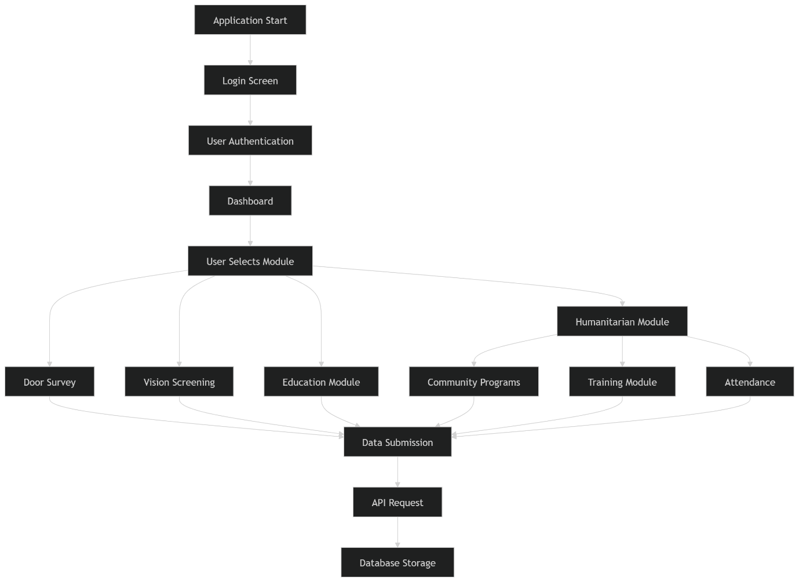
Section 1: Complete Application Flow

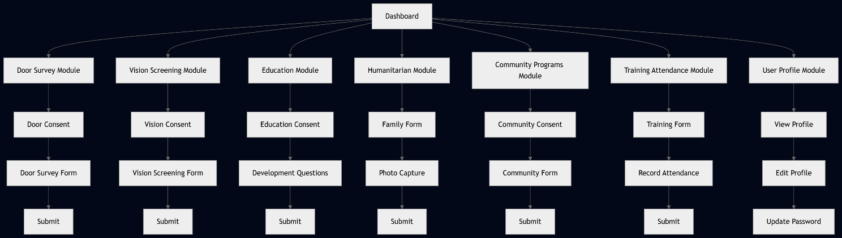
Module Selection Flow:

Section 2: Login Flowchart

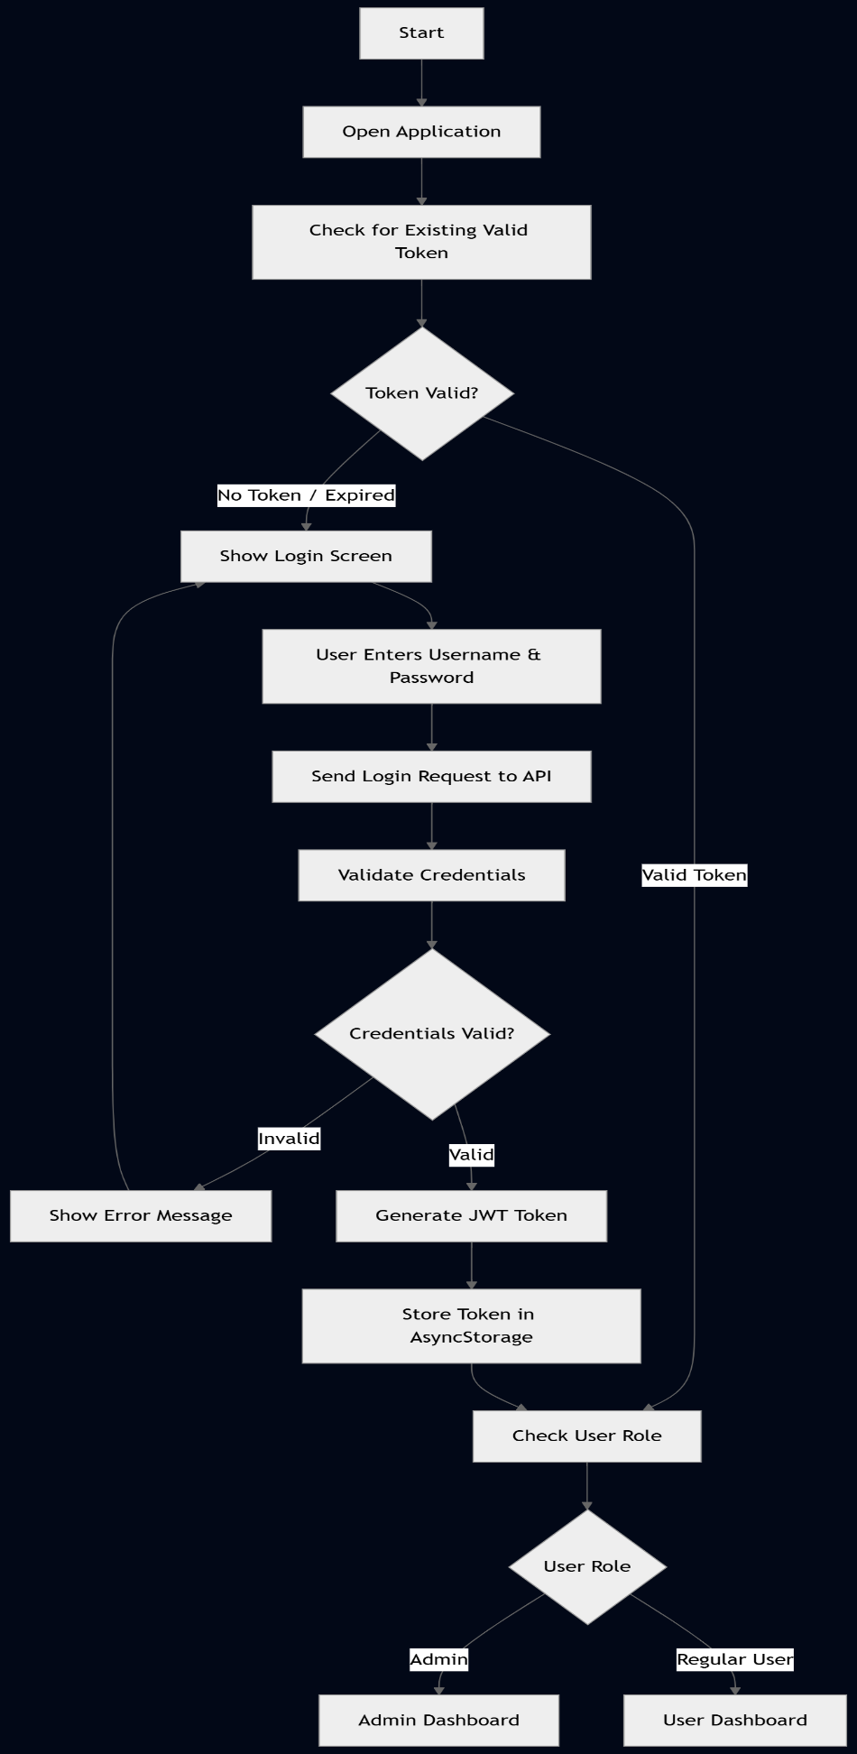

Offline Login Flow
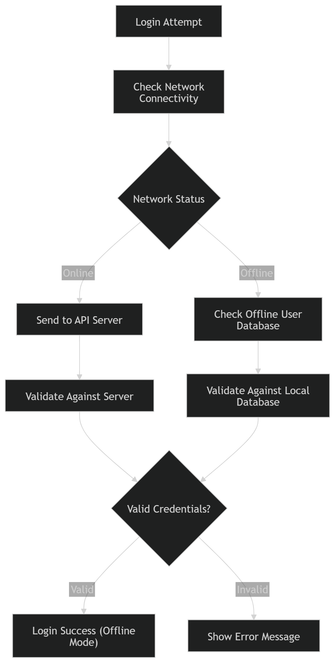

Section 3: Dashboard Navigation Flow

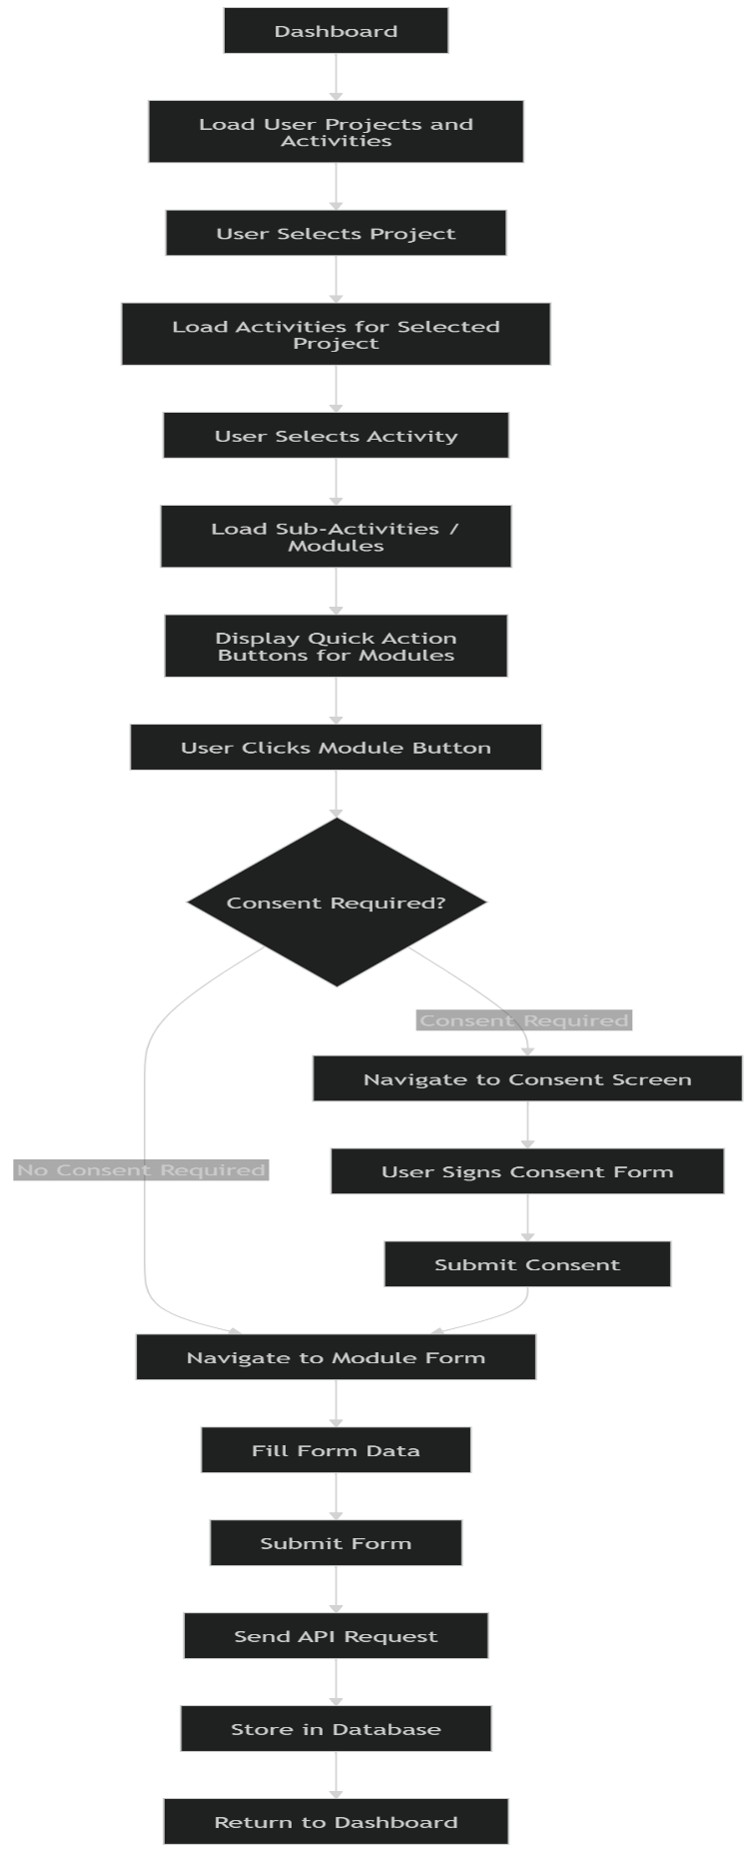

Daily Tasks Flow

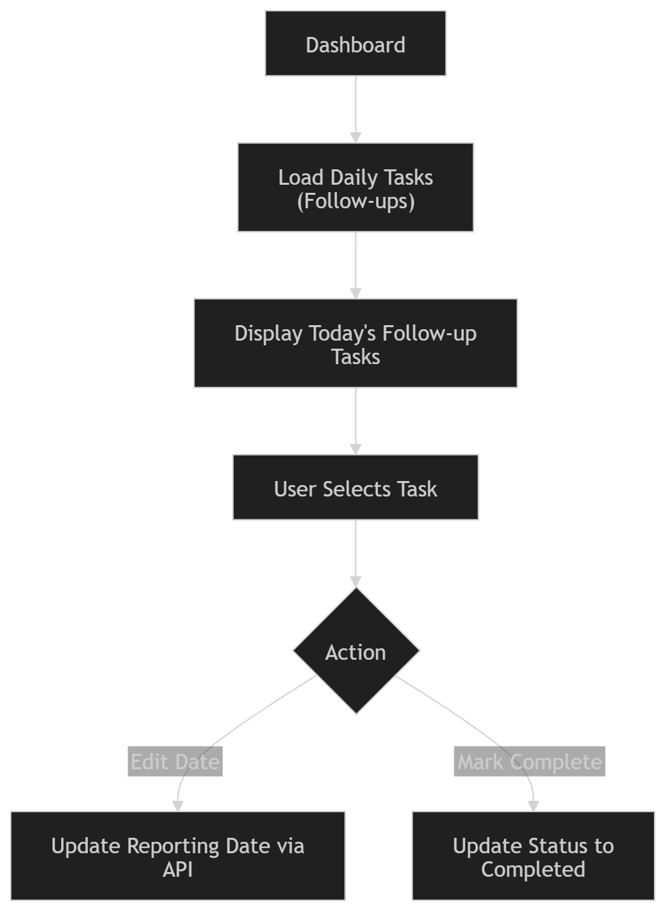

Section 4: Door Survey Flowchart:

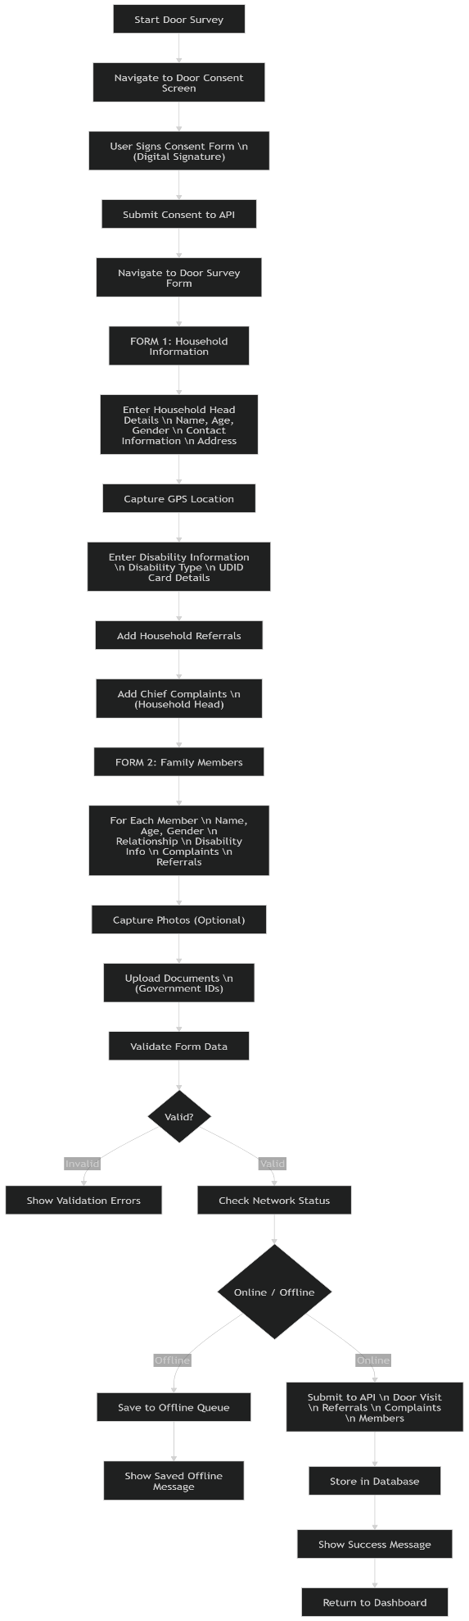

Section 5: Vision Screening Flowchart

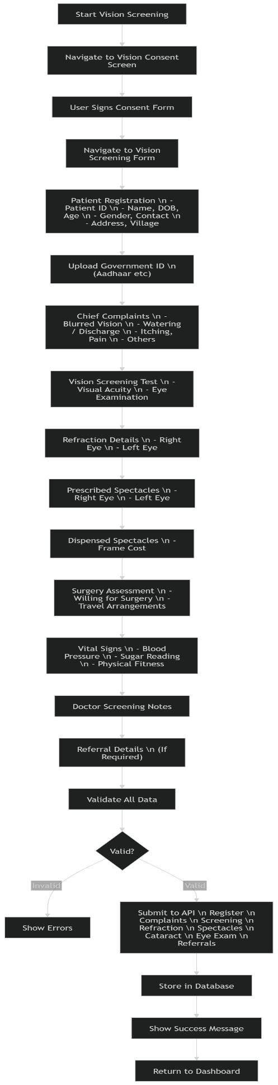

Section 6: Education Module Flowchart

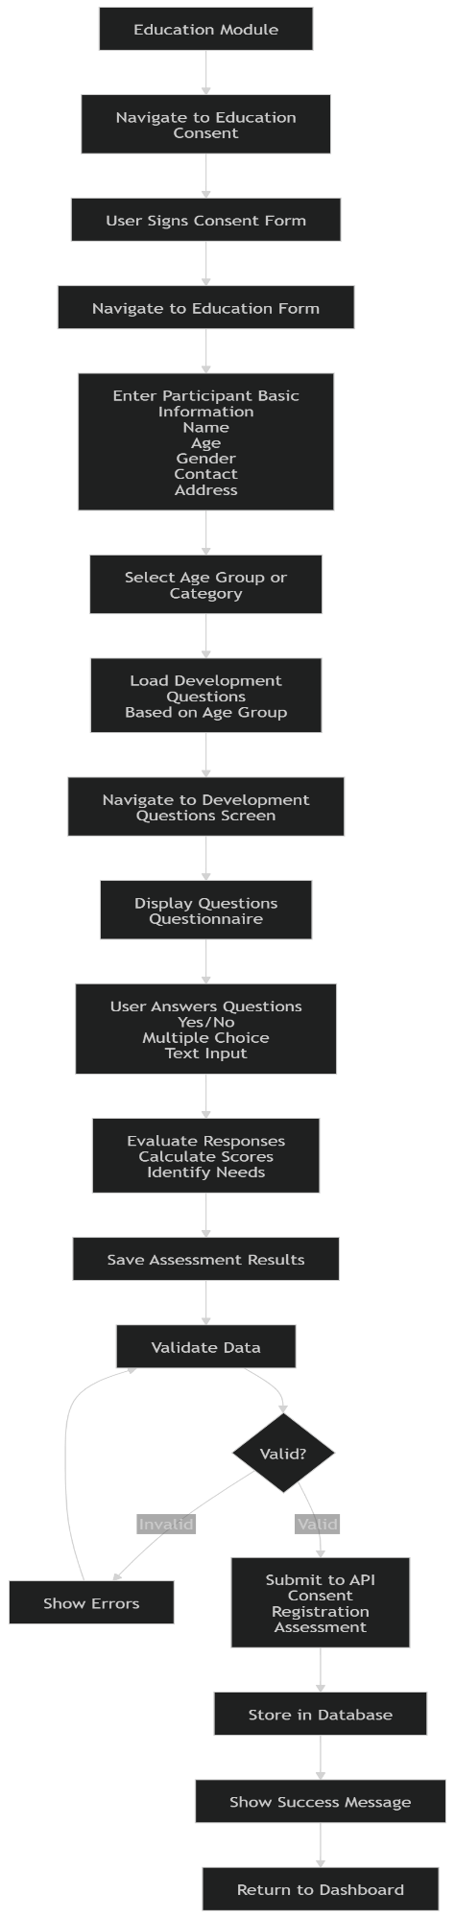

Section 7: Humanitarian Module Flowchart

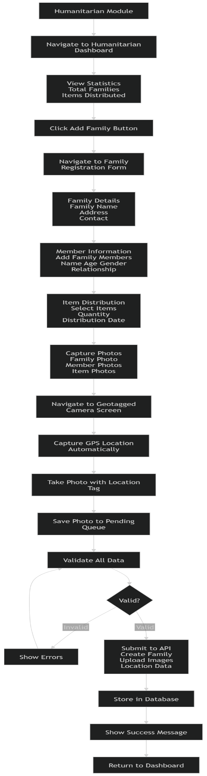

Section 8: Training Attendance Flowchart

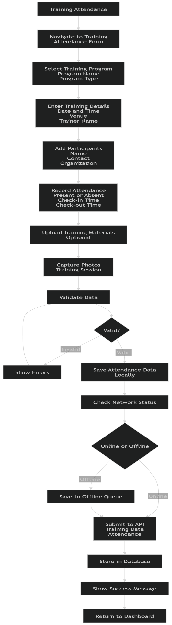

Section 9: API Data Flow

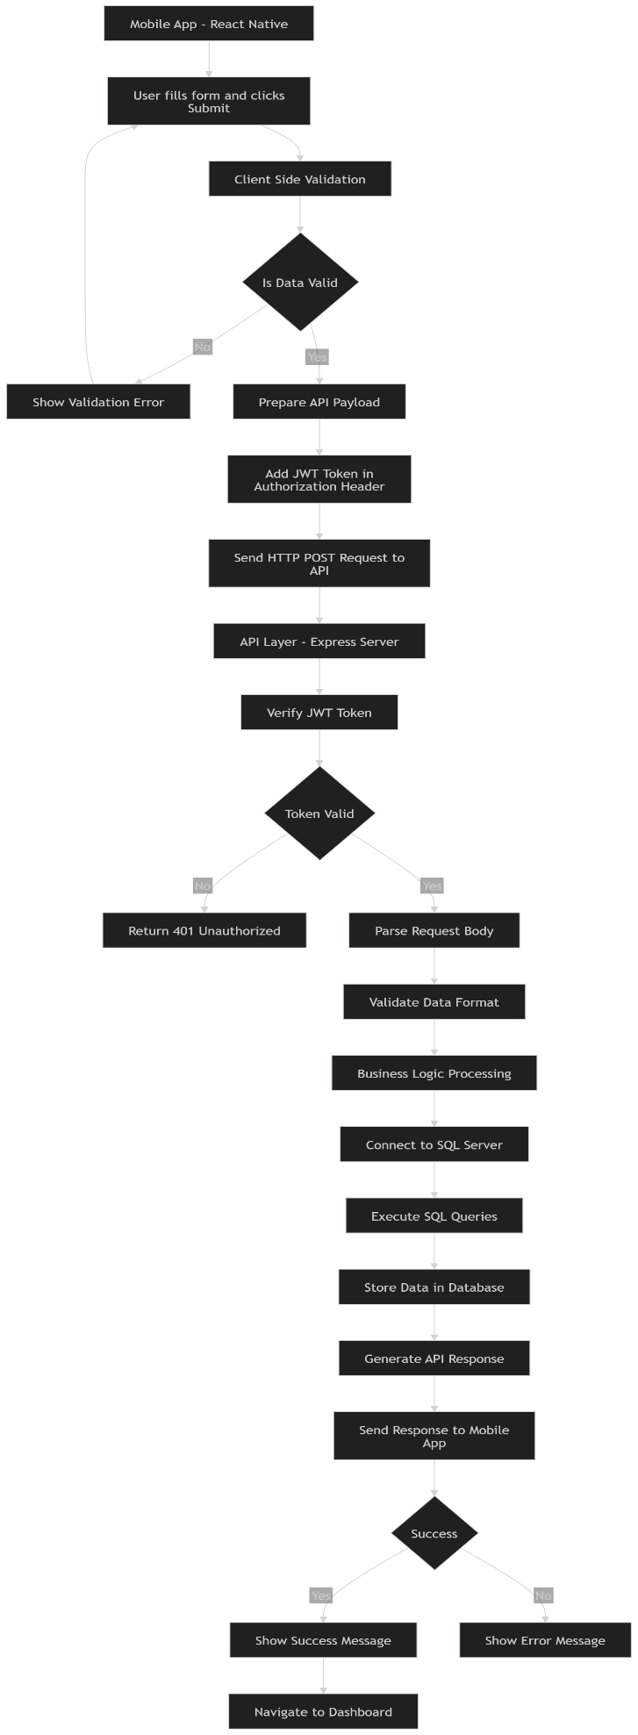

Section 10: Offline Mode Flow

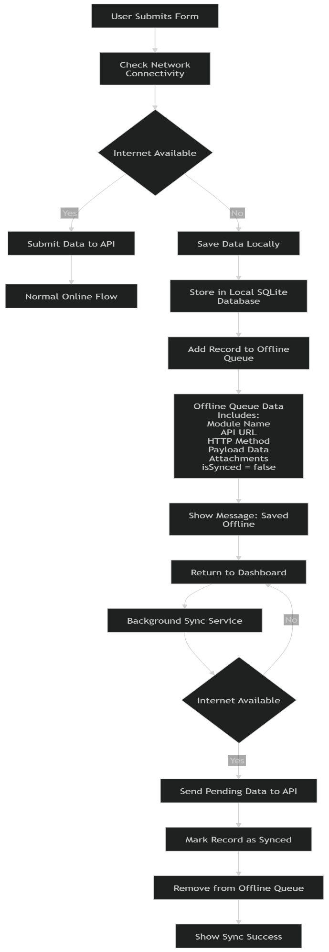

Section 11: Data Synchronization Flow
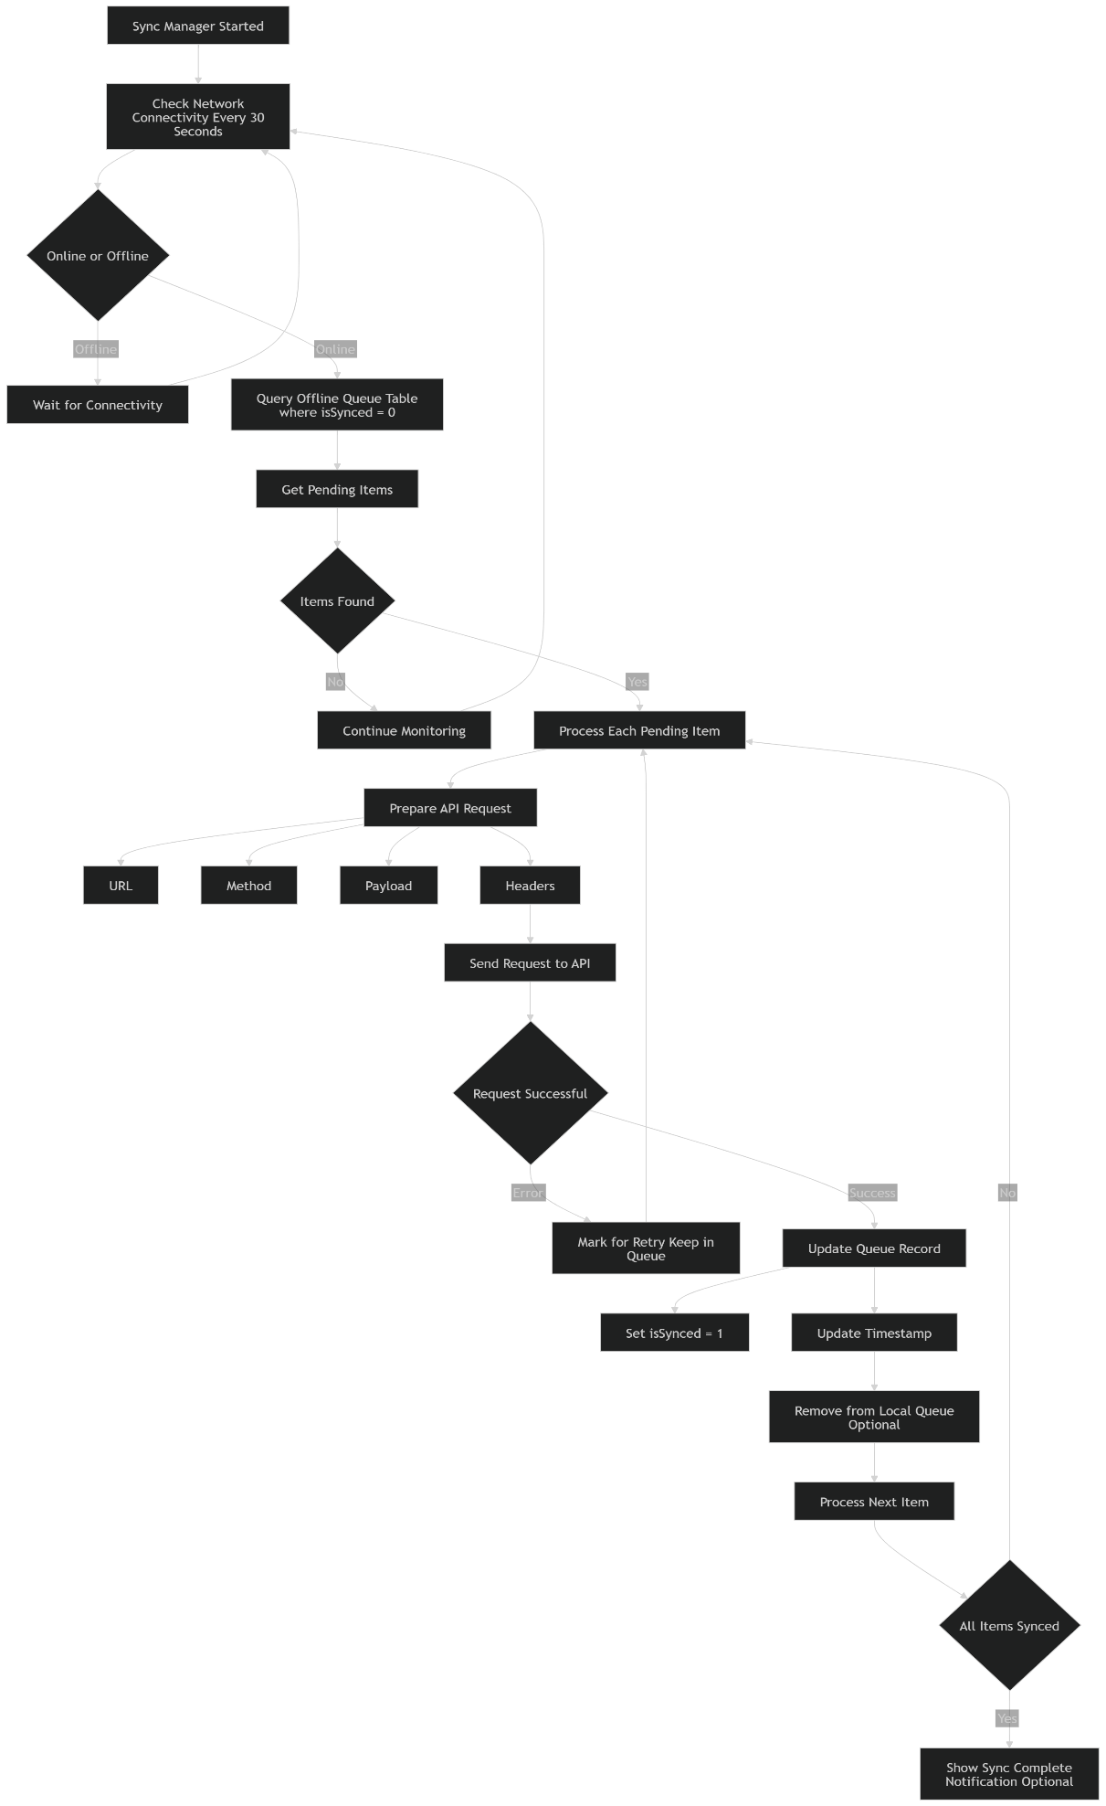

CBM Mobile Application - Flowcharts Documentation v1.2.1
© 2024 CBM India Trust. All rights reserved.

