**Linear Regression Using ‘R’**

1. The csv file uploaded in Rstudio.

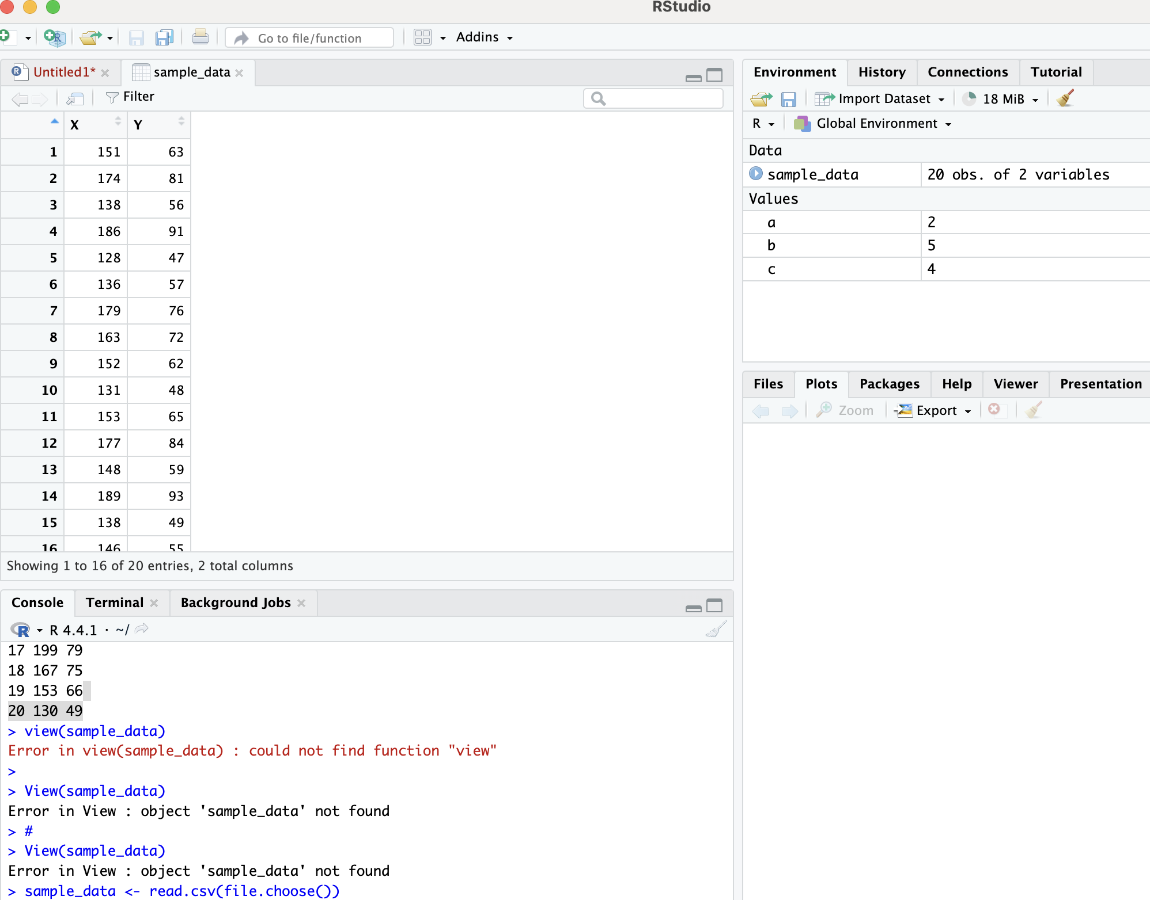

1. Summary

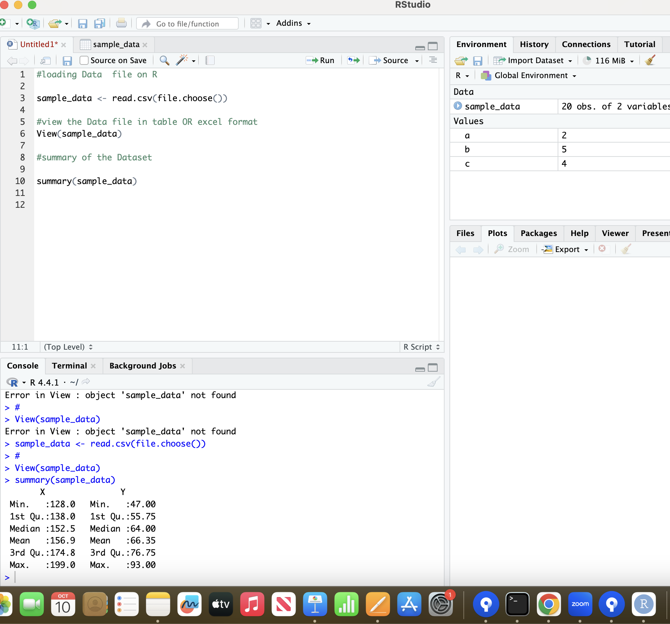

1. Structure,Scatterplot

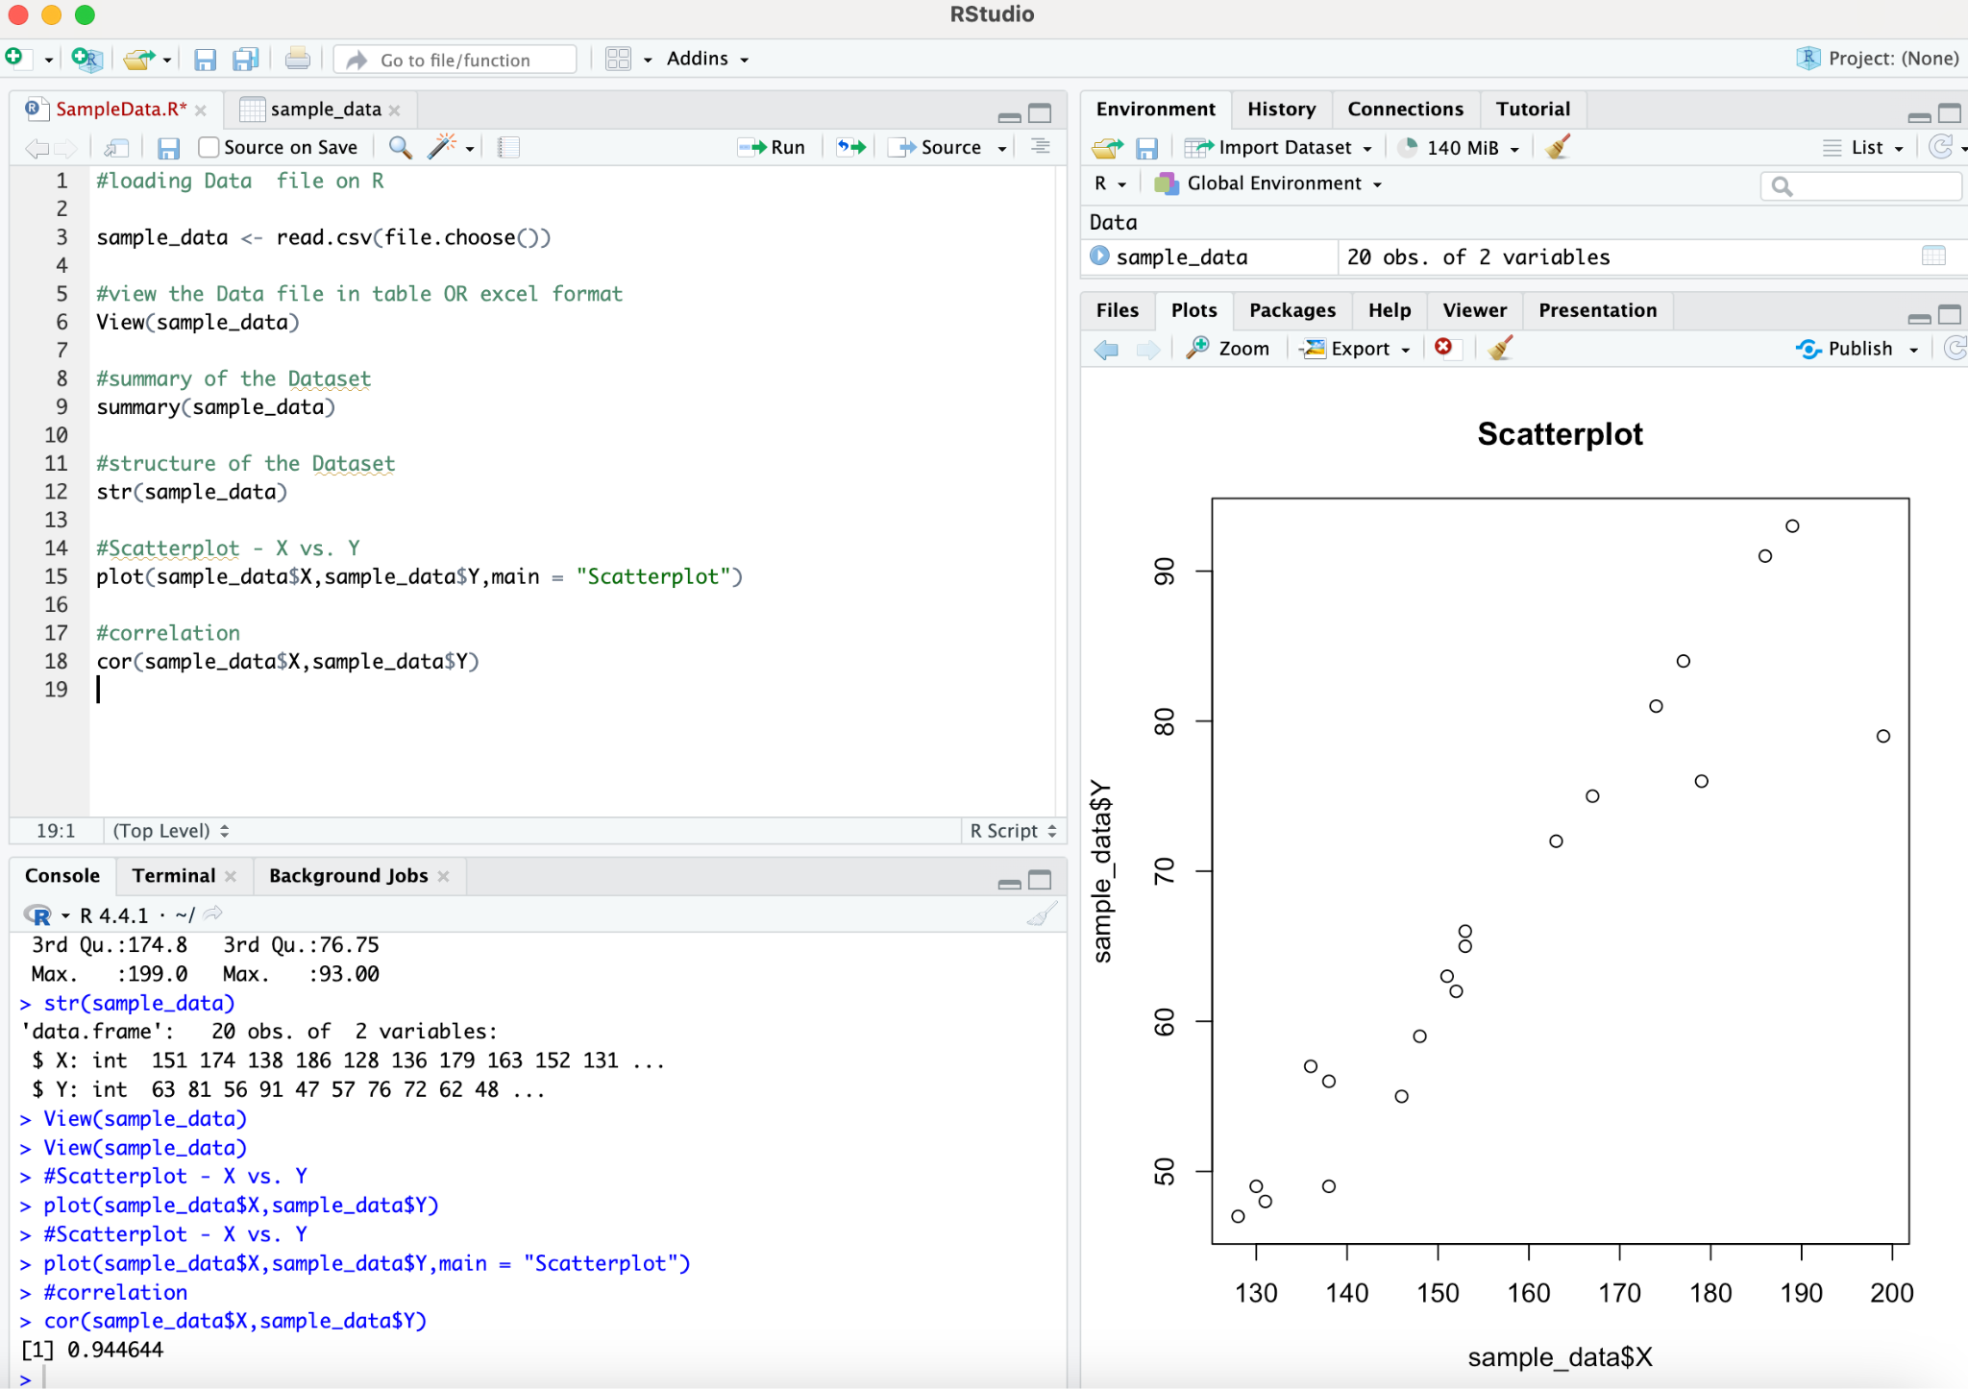

1. Intercept,Slope

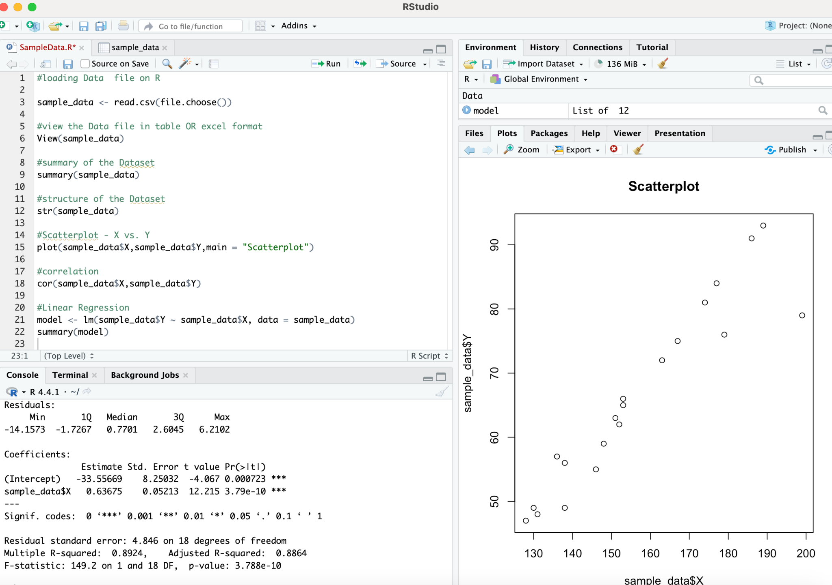

1. Linear Equation.

