A Project Report on

AI-Powered Traffic Violation Detection System
Using CCTV and Deep Learning

Submitted in partial fulfilment for award of

Bachelor of Technology
Degree
in
CSE (Artificial Intelligence and Machine Learning)

By
A. Sarayu (Y22ACM401) G. Abhiram (Y22ACM431)
D. Maneesha (Y22ACM425) K. SVSSP Pavan (L23ACM497)


Under the guidance of
N. Srinivasa Rao, M.Tech
Assistant Professor

Department of CSE (Artificial Intelligence and Machine Learning)
Bapatla Engineering College
(Autonomous)
(Affiliated to Acharya Nagarjuna University)
BAPATLA – 522 102, Andhra Pradesh, INDIA
2025-2026
Department of
CSE (Artificial Intelligence and Machine Learning)



CERTIFICATE

This is to certify that the project report entitled AI-Powered Traffic Violation Detection System Using CCTV and Deep Learning that is being submitted by A. Sarayu (Y22ACM401), G. Abhiram (Y22ACM431), D.Maneesha (Y22ACM425), K.SVSSP Pavan (L23ACM497), in partial fulfilment for the award of the Degree of Bachelor of Technology in CSE (Artificial Intelligence and Machine Learning) to the Acharya Nagarjuna University is a record of bonafide work carried out by them under our guidance and supervision.

Date:

Signature of the Guide Signature of the HOD
Mr. N. Srinivasa Rao Dr. K. Mani Deep
Assistant Professor Assoc. Prof. & Head
DECLARATION

We declare that this project work is composed by us, that the work contained herein is our own except where explicitly stated otherwise in the text, and that this work has not been submitted for any other degree or professional qualification except as specified.

A. Sarayu (Y22ACM401)
G. Abhiram (Y22ACM431)
D. Maneesha (Y22ACM425)
K. SVSSP Pavan (L23ACM497)

Acknowledgement

We sincerely thank the following distinguished personalities who have given their advice and support for successful completion of the work.
We are deeply indebted to our most respected guide Mr. N. Srinivasa Rao, Assistant Professor, Department of CSE (AIML), for his valuable and inspiring guidance, comments, suggestions and encouragement.
We extend our sincere thanks to Dr. K. Mani Deep, Assoc. Prof. & Head of the Dept. for extending his cooperation and providing the required resources.
We would like to thank our beloved Principal Dr. B. Srinivasa Rao for providing the online resources and other facilities to carry out this work.
We would like to express our sincere thanks to our project coordinator Ms. G. V. Leela Kumari, Assistant Professor, Department of CSE (Artificial Intelligence and Machine Learning) for her helpful suggestions in presenting this document.
We extend our sincere thanks to all other teaching faculty and non-teaching staff of the department, who helped directly or indirectly with their cooperation and encouragement.

A. Sarayu (Y22ACM401)
G. Abhiram (Y22ACM431)
D. Maneesha (Y22ACM425)
K. SVSSP Pavan (L23ACM497)

ABSTRACT

The rapid increase in urban vehicular traffic has significantly raised road traffic violations, making manual enforcement inefficient and unreliable due to human fatigue and limited scalability. This project proposes an AI-powered Traffic Violation Detection System that integrates CCTV infrastructure with deep learning to enable automated, real-time detection and recording of violations.The system employs YOLOv8, a modern object detection model, to identify multiple violations such as helmetless riding, signal jumping, triple riding, seatbelt non-compliance, and wrong-route driving. DeepSORT is used for object tracking, ensuring consistent identification of vehicles and riders across video frames.An Automatic License Plate Recognition (ALPR) module combines YOLOv8-based plate detection with EasyOCR to extract license plate details, enabling automatic identification of offending vehicles. All detected violations, along with images and timestamps, are stored in an SQLite database for centralized evidence management.A Streamlit-based web dashboard provides authorities with real-time monitoring, historical data, and searchable records. The system achieves over 91% mean Average Precision (mAP), processes video at 25–30 frames per second, and records violations with less than 200 milliseconds latency.Overall, the system offers an efficient, scalable solution for automated traffic enforcement, supporting smart city initiatives and improving road safety.

TABLE OF CONTENTS

CERTIFICATE ii
DECLARATION iii
ACKNOWLEDGEMENT iv
ABSTRACT v
TABLE OF CONTENTS vi
LIST OF TABLES ix
LIST OF FIGURES x
LIST OF ABBREVIATIONS xi
CHAPTER - 1 INTRODUCTION 1
1.1 Overview of the System 1
1.2 Background and Motivation 2
1.3 Problem Statement 3
1.4 Scope of the Project 4
1.5 Aim of the System 5
CHAPTER - 2 LITERATURE REVIEW 6
2.1 Overview of existing work 6
2.2 Comparison of previous approaches 7
2.3 Key Challenges 8
CHAPTER - 3 SYSTEM ANALYSIS 10
3.1 Existing System 10
3.2 Proposed System 11
3.2.1 Vehicle Detection Module 11
3.2.2 Helmet and Rider Detection Module 12
3.2.3 Traffic Signal State Detection 12
3.2.4 ALPR Module 13
3.2.5 Violation Evidence Logging 13
3.2.6 Real-Time Monitoring Dashboard 13
3.3 Hardware Requirements 14
3.4 Software Requirements 15
3.5 Python Packages and Libraries Overview 16
CHAPTER - 4 SYSTEM DESIGN 17
4.1 System Architecture 17
4.2 UML Diagrams 18
4.2.1 Class Diagram 18
4.2.2 Use Case Diagram 19
4.2.3 Data Flow Diagram 20
CHAPTER - 5 IMPLEMENTATION 21
5.1 YOLOv8 Model Overview 21
5.2 YOLO Object Detection Workflow 22
5.2.1 Input Preprocessing 22
5.2.2 Backbone Feature Extraction 22
5.2.3 Feature Pyramid Network Neck 22
5.2.4 Decoupled Detection Head and NMS 23
5.3 Dataset Assembly 23
5.4 Violation Logic Implementation 23
5.4.1 Helmetless Riding and Triple Riding Detection 23
5.4.2 Signal Jumping Detection 24
5.5 DeepSORT Tracking 24
5.6 OCR Integration for License Plate Recognition 25
5.6.1 Plate Localization and Preprocessing 25
5.6.2 Character Recognition and Post-Preprocessing 25
5.7 Implementation Details 26
5.8 Source Code 26
CHAPTER - 6 TESTING 46
CHAPTER - 7 RESULTS and DISCUSSION 48
7.1 System Output Demonstrations 48
7.1.1 Helmet Violation Detection Output 48
7.1.2 Triple Riding Detection Output 48
7.1.3 ALPR Output 49
7.1.4 Evidence Logging Interface 50
7.1.5 Streamlit Monitoring Dashboard 50
7.2 Performance Metrics 51
CHAPTER - 8 CONCLUSION and FUTURE WORK 52
8.1 Conclusion 52
8.2 Future Work 53
REFERENCES 55

LIST OF TABLES

Table 3.1 Comparison between Existing and Proposed System……………. 10
Table 3.3 Minimum Hardware Specifications……………………………… 14
Table 3.3 Recommended Hardware Specifications………………………… 15
Table 3.4 Software Stack and Libraries Used………………………………. 15
Table 5.1 YOLOv8 Model Variants and Their Parameters…………………. 21

LIST OF FIGURES

Figure 1.1 High-Level Architecture of AI-Powered Traffic Violation 2
Figure 1.2 Smart Traffic Monitoring Framework for Urban Infrastructure 3
Figure 3.2 Modular Pipeline of the Proposed Traffic Violation 11
Figure 4.1 System Architecture and Workflow of the Proposed System 17
Figure 4.2.1 Class Diagram for Traffic Violation Detection System 19
Figure 4.2.2 Use Case Diagram for Traffic Violation Detection System 20
Figure 4.2.3 Data Flow Diagram - Frame Acquisition to Evidence Logging 20
Figure 5.1 YOLOv8 Architecture and Feature Pyramid Network Structure 22
Figure 5.5 DeepSORT Kalman Filter Object Tracking Architecture 25
Figure 5.6.2 End-to-End OCR Pipeline for License Plate Text Extraction 26
Figure 7.1.1 Real-Time Violation Detection Output - Helmet Violation 48
Figure 7.1.2 Real-Time Violation Detection Output - Triple Riding 49
Figure 7.1.3 ALPR Output - Plate Localization and OCR Character Recognition 49
Figure 7.1.4 Evidence Logging Interface with Timestamp 50
Figure 7.1.5 Streamlit Dashboard - Live Feed with Violation Analytics 51

LIST OF ABBREVIATIONS

Abbreviation Full Form
AI Artificial Intelligence
ALPR Automatic License Plate Recognition
API Application Programming Interface
CCTV Closed-Circuit Television
CNN Convolutional Neural Network
CPU Central Processing Unit
CV Computer Vision
DL Deep Learning
DNN Deep Neural Network
FPS Frames Per Second
GPU Graphics Processing Unit
IoU Intersection over Union
mAP Mean Average Precision
ML Machine Learning
NMS Non-Maximum Suppression
OCR Optical Character Recognition
OpenCV Open Source Computer Vision Library
RAM Random Access Memory
ReLU Rectified Linear Unit
ROI Region of Interest
SQL Structured Query Language
SORT Simple Online and Realtime Tracking
UI User Interface
YOLO You Only Look Once

CHAPTER - 1

INTRODUCTION

1.1 Overview of the System
The AI-Powered Traffic Violation Detection System represents a convergence of computer vision, deep learning, and embedded systems engineering applied to the domain of urban traffic management. At its core, the system is designed to function as an autonomous surveillance unit that continuously processes live CCTV video streams, identifies instances of traffic rule infringement, and generates actionable, documented evidence without requiring human oversight.
Unlike legacy surveillance frameworks that record footage passively and rely on retrospective manual review, the proposed system operates in a proactive, real-time detection mode. The YOLOv8-based detection engine processes each incoming video frame independently, applying learned class-specific feature representations to localize and classify objects of interest - including motorcycles, bicycles, automobiles, helmets, riders, and traffic signal states - within a unified, single-pass inference pipeline. Rule-based logical operators then evaluate the relational context between detected objects to determine whether a violation condition has been triggered.
Upon confirmation of a violation event, the ALPR sub-system isolates the number plate region within the violation frame, applies morphological preprocessing to enhance text contrast, and invokes an OCR engine to extract alphanumeric plate characters. The extracted plate identifier, along with the violation category, timestamp, and the cropped violation image, is dispatched to the evidence logging module for persistent storage. A web-based administrative dashboard provides real-time visualization and historical query capabilities to law enforcement personnel.
Additionally, the system provides a user-friendly interface for real-time monitoring and visualization of traffic activity, as well as access to historical analytics. The architecture is designed to operate with high accuracy, low latency, and scalability, allowing seamless integration with existing surveillance infrastructure. This makes the system suitable for deployment in smart city environments and automated traffic management systems, enhancing road safety and enforcement efficiency.

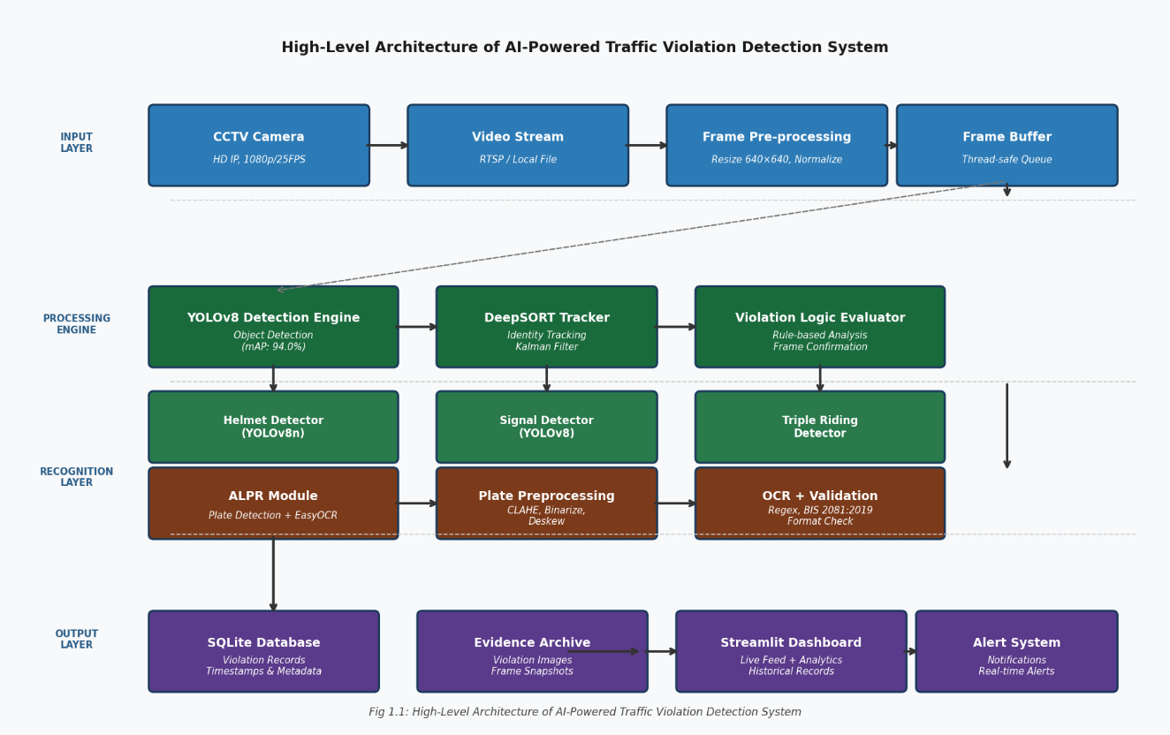

Fig 1.1: High-Level Architecture of AI-Powered Traffic Violation Detection System

1.2 Background and Motivation
India ranks among the nations with the highest annual road fatality counts worldwide. According to the Ministry of Road Transport and Highways, over 1.5 lakh road accident deaths are recorded annually, a disproportionate fraction of which are attributable to preventable traffic violations such as non-use of helmets, disregard for traffic signals, and overloading of two-wheeled vehicles. The enforcement apparatus, dependent primarily on static police checkpoints and intermittent patrols, lacks the density and responsiveness necessary to deter violations at scale across an increasingly congested urban road network.
The advent of deep learning-based computer vision has catalysed transformative possibilities in automated surveillance and monitoring. Convolutional Neural Networks (CNNs), particularly their real-time object detection instantiations such as the YOLO family of models, have demonstrated exceptional performance on traffic-related recognition tasks, achieving human-competitive accuracy at frame rates suitable for live video processing. Parallel advancements in OCR technology, GPU computing accessibility, and the proliferation of IP-based CCTV infrastructure have collectively created a technological inflection point at which fully automated traffic violation detection is both practically feasible and economically justified.

This project is motivated by the urgent social imperative to reduce road accident fatalities, the technological readiness of deep learning tools, and the operational gaps in existing traffic enforcement mechanisms. By deploying an AI-powered detection system that can function continuously, process multiple camera feeds concurrently, and document violations with court-admissible evidence, significant improvements in enforcement coverage, deterrence effectiveness, and administrative efficiency can be realized. The project further aligns with the Government of India's Smart Cities Mission, which envisions the integration of intelligent technologies into urban infrastructure for improved governance, public safety, and resource efficiency.

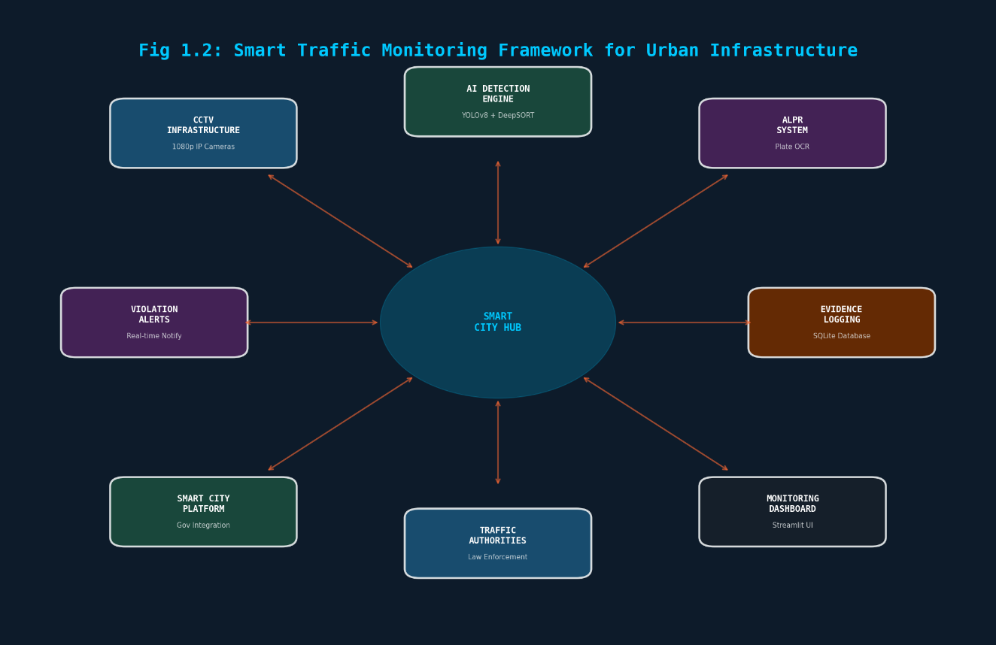
Fig 1.2: Smart Traffic Monitoring Framework for Urban Infrastructure

1.3 Problem Statement
The fundamental problem addressed by this project is the inability of contemporary traffic enforcement mechanisms to provide comprehensive, real-time, scalable, and accurate detection of traffic violations across the full spectrum of road traffic infractions encountered in Indian urban settings. Traditional traffic monitoring is predominantly manual, labour-intensive, and inherently prone to human error. As vehicular density in urban centres continues to escalate, the practical impossibility of deploying sufficient human surveillance resources at every monitored location becomes increasingly apparent.

Existing semi-automated solutions, primarily speed cameras and automated number plate recognition gantries, address only narrow subsets of the violation spectrum and are unsuitable for holistic intersection monitoring. The absence of integrated solutions capable of detecting compound violations - wherein a single vehicle incident simultaneously constitutes multiple offences - represents a critical gap in enforcement capability.
Additionally, the documentation quality of current systems is often inadequate for legal evidentiary purposes. Blurred images, missing timestamps, incorrect plate readings, and unstructured data storage collectively compromise the usability of collected evidence in formal enforcement proceedings.
The problem is formally defined as: Given a continuous video stream from a stationary CCTV camera installed at a traffic monitoring location, design and implement a system that can automatically, accurately, and in real-time detect instances of predefined traffic violation categories, identify the associated vehicle by its license plate, and generate structured, timestamped, evidentiary records suitable for enforcement action, with minimal reliance on human supervision.

1.4 Scope of the Project
The scope of the present work encompasses the full development lifecycle of the AI-powered traffic violation detection system, spanning dataset curation, model training and optimization, system architecture design, software implementation, integration testing, and performance evaluation. The specific violation categories addressed within this project are as follows:
- Helmetless Riding: Detection of motorcycle or scooter riders operating without a protective helmet.
- Traffic Signal Jumping: Identification of vehicles that cross stop lines during red light states.
- Triple Riding: Detection of more than two persons simultaneously occupying a two-wheeled vehicle.
- Seatbelt Non-Compliance: Recognition of automobile drivers or front passengers not wearing seatbelts.
- Wrong Route Driving: Detection of vehicles travelling in prohibited directions on designated one-way roads.
The system is scoped for deployment on stationary CCTV camera installations at fixed traffic intersections and road segments. Real-time inference is supported on both GPU-equipped server-class hardware and, with reduced throughput, on CPU-only mid-range computing platforms. The ALPR module covers standard Indian license plate formats, including both new BH-series plates and conventional state-code plates. The project does not include integration with live national vehicle registration databases or automated fine issuance workflows, although both extensions are architecturally anticipated.

1.5 Aim of the System
The primary aim of the AI-Powered Traffic Violation Detection System is to develop a scalable, accurate, and efficient automated solution that can augment or supplant manual traffic enforcement in high-volume urban intersections. Specifically, the system aims to:
- Detect multiple categories of traffic violations simultaneously in real-time video streams with a mean detection accuracy exceeding 90%.
- Maintain a processing throughput of at least 25 frames per second to ensure comprehensive coverage of fast-moving traffic scenarios.
- Automatically extract and recognize vehicle license plates associated with detected violations using integrated ALPR and OCR technology.
- Persist all violation records including violation type, timestamp, vehicle identifier, and evidentiary image in a structured relational database for subsequent retrieval and legal use.
- Provide an intuitive web-based dashboard that enables traffic management personnel to monitor real-time violations, search historical records, and generate statistical reports.

CHAPTER - 2

LITERATURE REVIEW

2.1 Overview of existing work

The advancement of intelligent transportation systems has led to the development of various automated traffic monitoring and violation detection techniques. Early approaches relied on traditional image processing and rule-based algorithms applied to CCTV footage, which were limited in accuracy and struggled under varying environmental conditions such as lighting changes, occlusions, and dense traffic scenarios. These systems required significant manual intervention and were not scalable for real-time urban deployment.

With the emergence of deep learning, convolutional neural network (CNN)-based object detection models such as YOLO, SSD, and Faster R-CNN have been widely adopted for vehicle detection and traffic analysis. Among these, YOLO-based models have gained prominence due to their ability to perform real-time detection with high accuracy by processing entire images in a single stage. These models have been successfully applied in applications such as helmet detection, red-light violation detection, and speed monitoring systems.

Several existing systems integrate object detection with multi-object tracking algorithms such as DeepSORT to maintain identity consistency of vehicles across video frames. This combination enables continuous monitoring and counting of vehicles, as well as tracking of violations over time. Research demonstrates that integrating YOLO with DeepSORT significantly improves detection accuracy and enables real-time processing at practical frame rates.

In addition, Automatic License Plate Recognition (ALPR) systems have been extensively studied to identify vehicles involved in violations. Modern ALPR systems utilize deep learning-based detection models combined with optical character recognition techniques to extract license plate information with high accuracy, even under challenging conditions such as motion blur and varying lighting.

Despite these advancements, existing solutions often focus on specific types of violations such as speed detection or helmet usage and lack a unified framework capable of detecting multiple violations simultaneously. Furthermore, many systems operate in offline modes, lack efficient evidence management, or fail to integrate detection, tracking, and license plate recognition into a single scalable architecture. These limitations highlight the need for a comprehensive, real-time, and fully automated traffic violation detection system capable of addressing diverse real-world challenges.

2.2 Comparison of previous approaches

Traditional traffic violation detection approaches primarily relied on image processing techniques and machine learning algorithms such as HOG, SIFT, and Support Vector Machines (SVM). These methods depend heavily on handcrafted features like color, shape, and edges, making them less robust in complex traffic environments with varying lighting and occlusions. As a result, they exhibit lower accuracy and poor adaptability compared to modern deep learning-based approaches.

Recent approaches based on deep learning, particularly Convolutional Neural Networks (CNNs), have significantly improved detection performance. Models such as YOLO, SSD, and Faster R-CNN enable automatic feature extraction and provide higher accuracy in vehicle detection tasks. Among these, YOLO-based models outperform others in real-time applications due to their single-stage detection architecture, which offers faster processing speeds while maintaining competitive accuracy.

Further advancements integrate object detection with tracking algorithms such as DeepSORT to enhance system reliability. While standalone object detection models process each frame independently, tracking-based approaches maintain object identity across frames, reducing false detections and improving temporal consistency. Studies show that combining YOLO with DeepSORT improves both detection accuracy and tracking performance in real-time traffic surveillance systems.

Additionally, Automatic License Plate Recognition (ALPR) systems have evolved from traditional segmentation-based methods to deep learning-based detection and recognition frameworks. YOLO-based ALPR systems demonstrate higher detection accuracy and robustness under varying conditions compared to earlier techniques, although challenges such as motion blur and inconsistent recognition across frames still persist.

Despite these improvements, most existing approaches focus on individual components such as detection, tracking, or license plate recognition in isolation. They often lack an integrated, end-to-end framework capable of simultaneously detecting multiple types of traffic violations in real time while managing evidence efficiently. This highlights the necessity for a unified system that combines detection, tracking, violation analysis, and data management into a single scalable architecture, as proposed in the present invention.

2.3 Key Challenges
The development of a robust traffic violation detection system entails several significant technical challenges that must be systematically addressed during design and implementation:
Real-Time Processing Constraint: The system must maintain a processing throughput of at least 25-30 FPS to ensure that fast-moving vehicles are not missed between frames. This imposes strict computational budget constraints on the detection pipeline, necessitating the use of efficient single-stage detectors rather than computationally expensive two-stage architectures.
Multi-Violation Simultaneous Detection: Urban traffic scenes frequently contain multiple vehicles, riders, and pedestrians simultaneously, with multiple potential violations occurring concurrently in a single frame. The detection model must achieve high recall across all relevant object classes while maintaining precision sufficient to avoid excessive false positive alerts that would undermine operator trust.
Environmental Variability: Camera feeds are subject to significant variation in illumination conditions including day, night, dusk, and glare, as well as weather conditions such as rain, fog, and direct sunlight. Detection models trained on limited datasets may exhibit performance degradation under distribution-shifted real-world conditions, necessitating diverse training data and robust augmentation strategies.
Occlusion and Clutter: In dense traffic scenarios, vehicles and riders frequently occlude one another, challenging both detection and tracking modules. Partial occlusion of license plates and helmet regions is particularly problematic for ALPR accuracy and helmet detection reliability, requiring the system to maintain robust detection under these adverse conditions.

License Plate Diversity: Indian license plates span a variety of formats, fonts, sizes, and mounting orientations, with frequent occurrences of damaged, dirty, or tampered plates. The ALPR module must be robust to this variability to achieve acceptable operational recognition rates in diverse real-world deployment conditions.
False Positive Management: In enforcement applications, false positive detections carry significant negative consequences including unjust imposition of fines on innocent motorists. The system must incorporate adequate confidence thresholding, temporal confirmation logic, and human review pathways to maintain an acceptable false positive rate in operational deployment while ensuring genuine violations are not missed.

CHAPTER - 3

SYSTEM ANALYSIS

3.1 Existing System
Existing traffic monitoring systems in operation across Indian cities primarily fall into two categories: manual enforcement and basic CCTV surveillance. Manual enforcement relies on traffic police personnel positioned at intersections who observe and document violations by sight, issuing physical challans or photographing offending vehicles using handheld devices. This approach, while possessing the advantage of contextual human judgement, is severely constrained by factors including fatigue, attentional limits, corruption susceptibility, and inability to monitor more than a few vehicles simultaneously.
Basic CCTV surveillance systems record continuous video footage stored on local or networked digital video recorders. In the event of an accident or reported incident, footage is manually reviewed by officers to identify responsible parties. This approach provides post-hoc documentation capability but offers no real-time detection or automated alerting functionality. The volume of footage generated daily far exceeds the practical capacity of human reviewers, rendering the system reactive rather than preventive.
Some advanced jurisdictions have deployed semi-automated systems using speed cameras equipped with inductive loop detectors or radar-based speed measurement, which can automatically capture images of speeding vehicles. However, these systems are narrowly specialized for speed violations and cannot detect the broader range of infractions addressed by the proposed system. A comparative summary of existing system limitations and the advantages of the proposed system is presented below:
Table 3.1: Comparison between Existing and Proposed System
Parameter | Existing System | Proposed System
Detection Mode | Manual / Passive | Automated Real-Time
Violation Types | Limited (Speed only) | Multiple (5+ types)
License Plate Recognition | Manual | Automated OCR
Evidence Logging | Manual / Paper | Automated Database
Scalability | Low | High
Human Dependency | High | Minimal
Coverage (24/7) | No | Yes
Cost Over Time | High (Personnel) | Low (Operational)

3.2 Proposed System
The proposed AI-Powered Traffic Violation Detection System is a modular, end-to-end automated framework that integrates real-time video acquisition, deep learning-based object detection, rule-based violation logic, automatic license plate recognition, and structured evidence management into a coherent operational pipeline. Each module is independently designed to facilitate unit testing, independent maintenance, and future extensibility without requiring modification to adjacent modules.
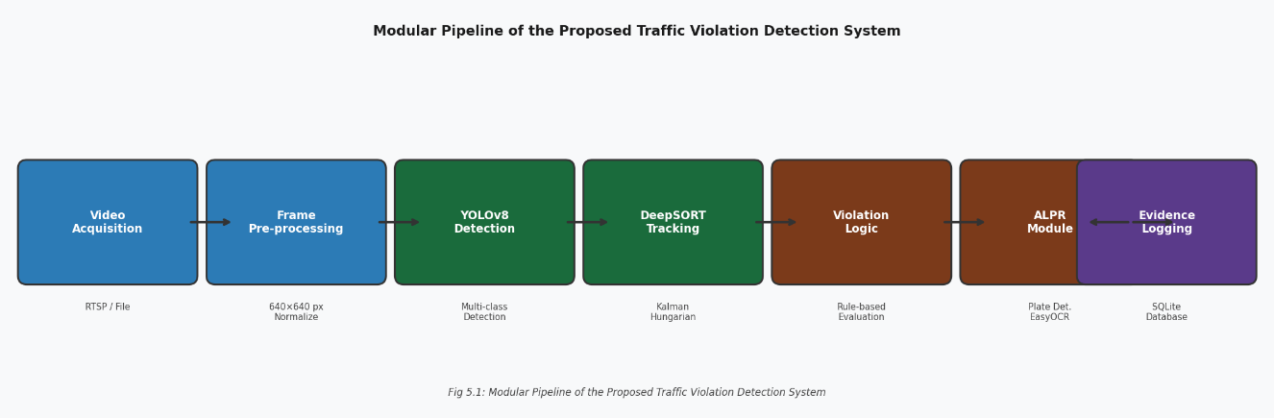

Fig 3.2: Modular Pipeline of the Proposed Traffic Violation Detection System

3.2.1 Vehicle Detection Module
The Vehicle Detection Module constitutes the first stage of the processing pipeline and is responsible for identifying all traffic participants present within each video frame. The module employs a YOLOv8m (medium) variant fine-tuned on a curated traffic dataset to detect the following primary object classes: motorcycles, bicycles, cars, trucks, buses, auto-rickshaws, and persons. Upon inference, the module outputs a structured detection record for each identified object comprising the bounding box coordinates in pixel space, the object class label, and the detection confidence score. Objects with confidence scores below the configured threshold of 0.45 are discarded to suppress low-confidence noise detections.
The module further partitions the detected objects into vehicle and person categories and feeds the per-class detection lists to the DeepSORT tracker for identity assignment and trajectory maintenance across frames. For traffic participants whose bounding boxes overlap significantly, the module applies class-wise NMS at the configured IoU threshold to eliminate duplicate detections from multiple grid cells predicting the same physical object.

3.2.2 Helmet and Rider Detection Module
The Helmet and Rider Detection Module operates in tandem with the Vehicle Detection Module to classify the head protection status of two-wheeler riders. For each detected motorcycle bounding box, a dedicated sub-region is extracted encompassing the upper portion of the motorcycle's occupancy zone, where the rider's head region is statistically expected to be located based on typical riding posture geometry.
Within this extracted region, a secondary YOLOv8n (nano) model specialized for helmet and unhelmeted-head classification is applied. This dedicated classifier was trained on a balanced dataset of annotated frames capturing helmeted and unhelmeted riders from multiple Indian city surveillance datasets. The model distinguishes three states: 'helmet', 'no_helmet', and 'uncertain' when the rider's head is occluded or outside the camera frustum. A violation flag is raised if the 'no_helmet' class achieves a confidence exceeding 0.60 and the flag persists across a minimum of three consecutive frames to suppress transient misclassifications.

3.2.3 Traffic Signal State Detection
The Traffic Signal State Detection sub-module determines the operational phase of traffic signals visible within the camera field of view and correlates detected vehicle positions with signal states to identify red-light running violations. Signal state classification is performed by a YOLOv8-based region classifier applied to the pre-defined signal bounding box region of interest within each frame. The classifier outputs one of four states: 'red', 'amber', 'green', or 'off'. A configurable stop line polygon is defined during system calibration, and the system monitors whether any tracked vehicle's bounding box lower edge crosses the stop line polygon boundary during a 'red' signal state. Vehicles confirmed as having crossed the stop line during a red phase are flagged as signal jumping violators.

3.2.4 Automatic License Plate Recognition (ALPR)
Upon detection of a violation event, the ALPR module is invoked to identify the offending vehicle. The module operates in two sequential stages: plate localization and character recognition. Plate localization employs a lightweight YOLOv8n model trained exclusively on license plate bounding box detection across diverse vehicle types and perspectives. The model is applied to the full vehicle bounding box region to detect and crop the license plate sub-image.
Morphological preprocessing operations including adaptive histogram equalization, binarization, and deskewing are then applied to the cropped plate image to normalize character contrast and orientation. Character recognition is performed by the EasyOCR engine operating in English-language mode with additional support for regional language plates. The recognized character sequence is post-processed using a regular expression validator that enforces compliance with the BIS 2081:2019 standard format for Indian license plates, discarding outputs that fail format validation to prevent spurious plate records from entering the evidence database.

3.2.5 Violation Evidence Logging
Every confirmed violation event triggers an evidence logging transaction that writes a structured record to the SQLite database and archives the violation frame to the local evidence image store. Each violation record contains a unique violation ID, camera ID, timestamp with millisecond precision, violation category, associated vehicle track ID, recognized license plate string, plate recognition confidence score, path to the archived violation frame image, and a processing status flag indicating whether the record has been reviewed by a human operator. The database schema is designed to support efficient querying by violation type, vehicle identifier, timestamp, and camera location for both real-time dashboard population and retrospective evidence retrieval.

3.2.6 Real-Time Monitoring Dashboard
The Streamlit-based monitoring dashboard provides law enforcement and traffic management personnel with an interactive interface to the violation detection system's operational state and evidence archive. The dashboard comprises four primary views:
- Live Feed View: Displays the annotated real-time camera feed with bounding boxes, class labels, track IDs, and violation flags overlaid on each frame, together with a scrolling live violation ticker.
- Violation Log View: Presents a searchable, sortable tabular display of all logged violations filterable by date range, violation type, camera ID, and license plate, with thumbnail previews of each violation frame.
- Analytics View: Renders statistical charts including hourly and daily violation frequency histograms, class-wise violation distribution charts, and violation hotspot maps where GPS metadata is available.
- Configuration View: Allows authorized administrators to configure detection confidence thresholds, stop line polygon coordinates, camera stream parameters, and notification alert settings.

3.3 Hardware Requirements
The hardware requirements for the AI-powered traffic violation detection system vary depending on the deployment scenario. Two representative configurations are specified: a minimum configuration suitable for development and demonstration purposes, and a recommended configuration for full real-time deployment.
Table 3.3: Minimum Hardware Specifications for System Deployment

Component | Minimum Specification
Processor | Intel Core i5 / AMD Ryzen 5 (4+ cores, 2.4 GHz+)
RAM | 8 GB DDR4 (16 GB recommended)
Storage | 20 GB free SSD space
GPU | Optional (CPU inference at approx. 8 FPS)
Camera Input | Webcam or pre-recorded CCTV video file
Operating System | Windows 10/11 or Ubuntu 20.04 LTS+
Network | 100 Mbps LAN for dashboard access

Table 3.3: Recommended Hardware Specifications for Real-Time Deployment
Component | Recommended Specification
Processor | Intel Core i7 / AMD Ryzen 7 (8+ cores, 3.0 GHz+)
RAM | 16 - 32 GB DDR4 ECC
Storage | 500 GB NVMe SSD + 2 TB HDD for evidence archive
GPU | NVIDIA RTX 3060 / RTX 3080 (8 GB+ VRAM)
Camera Input | HD IP CCTV cameras (1080p, H.264/H.265 encoding)
Operating System | Ubuntu 20.04 LTS / 22.04 LTS
Network | 1 Gbps LAN, dedicated camera VLAN
Power Supply | UPS with minimum 4-hour backup

3.4 Software Requirements
The software stack for the proposed system is designed for portability and reproducibility. All primary dependencies are open-source and available under permissive licences compatible with boths academic research and commercial deployment scenarios.
Table 3.4: Software Stack and Libraries Used
Software Component | Version | Purpose
Python | 3.9 - 3.11 | Primary programming language
PyTorch | 2.0+ | Deep learning framework for YOLOv8
Ultralytics YOLOv8 | Latest stable | Object detection engine
OpenCV | 4.7+ | Video capture and image processing
EasyOCR | 1.7+ | License plate character recognition
DeepSORT | Custom build | Multi-object tracking
Streamlit | 1.28+ | Web dashboard frontend
SQLite | 3.40+ | Evidence database
NumPy | 1.24+ | Numerical computation
Pillow (PIL) | 9.5+ | Image manipulation
CUDA Toolkit | 11.8 / 12.1 | GPU-accelerated inference
cuDNN | 8.x | Optimized deep learning primitives
Ubuntu / Windows OS | 20.04 / 10+ | Host operating system

3.5 Python Packages and Libraries Overview
PyTorch is the foundational deep learning library used for all neural network operations. It provides dynamic computation graphs, automatic differentiation, and CUDA integration essential for training and deploying YOLOv8 on GPU hardware. PyTorch's TorchScript and ONNX export capabilities additionally enable model deployment on edge devices for scenarios where central server connectivity is unavailable.
The Ultralytics YOLOv8 library provides a high-level API abstracting the complexities of YOLOv8 model instantiation, training, validation, and inference. It includes built-in support for data augmentation, mixed-precision training, and multi-GPU distributed training, greatly accelerating the model development cycle and enabling rapid iteration across experimental configurations.
OpenCV serves as the video I/O backbone of the system, handling camera stream capture, frame decoding, image resizing, color space conversion, and visualization overlay rendering. Its optimized C++ backend with Python bindings provides near-native performance for frame processing operations critical to maintaining real-time throughput requirements.
DeepSORT provides the multi-object tracking capability that maintains persistent identity associations between detection frames. EasyOCR implements a two-stage pipeline comprising the CRAFT text detector for character region localization and a deep sequence recognition network for character identification. Streamlit enables the rapid development of interactive web applications directly from Python scripts without requiring dedicated front-end development expertise, facilitating efficient dashboard development within the project timeline.

CHAPTER - 4

SYSTEM DESIGN

4.1 System Architecture
The system architecture of the AI-Powered Traffic Violation Detection System follows a layered, pipeline-oriented design paradigm in which video data flows unidirectionally from the acquisition layer through successive processing stages before culminating in persistent storage and presentation layer outputs. The architecture is structured into four primary layers: Input Layer, Processing Engine Layer, Recognition and Logic Layer, and Output and Storage Layer.
Input Layer: The Input Layer encompasses the physical and logical components responsible for acquiring and pre-conditioning video data for downstream analysis. High-definition IP CCTV cameras operating at 1080p resolution and a minimum of 25 FPS supply the raw video stream. An OpenCV VideoCapture object establishes a persistent connection to the camera stream via RTSP and decodes each incoming compressed frame into an uncompressed BGR NumPy array suitable for neural network inference. Frame pre-conditioning applies a configurable spatial resizing operation to standardize input dimensions to the YOLOv8 inference resolution of 640x640 pixels, followed by normalization of pixel values to the floating-point range expected by the PyTorch inference pipeline.
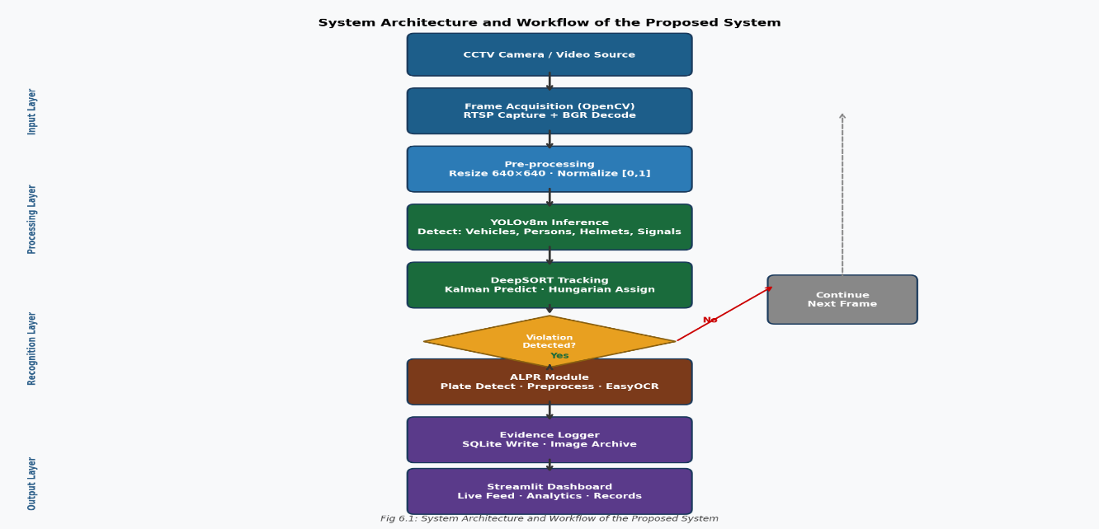
Fig 4.1: System Architecture and Workflow of the Proposed System
Processing Engine Layer: The Processing Engine Layer is the computational core of the system, housing the YOLOv8 inference engine, the DeepSORT tracker, and the parallel violation logic evaluators. Each decoded frame is submitted to the YOLOv8 model for batch inference, yielding detection tensors that are decoded into per-object bounding box, class, and confidence tuples. The decoded detections are immediately forwarded to the DeepSORT tracker which performs Kalman filter prediction of existing track states, associates new detections with existing tracks using the Hungarian algorithm, creates new tracks for unassociated detections exceeding the initialization threshold, and marks tracks as lost when no matching detection is found for the configured maximum age.
Recognition Layer: The Recognition Layer intercepts confirmed violation events and activates the ALPR pipeline. The relevant vehicle bounding box region is extracted, pre-processed, and submitted to the two-stage plate detection and OCR pipeline. Recognized plate strings passing format validation are attached to the violation event record for evidence logging.
Output and Storage Layer: The Output and Storage Layer manages the persistence of violation evidence, the overlay rendering of the annotated video stream, and the communication with the real-time dashboard. Database writes are executed asynchronously in a dedicated worker thread to minimize latency impact on the main detection loop.

4.2 Unified Modelling Language (UML) Diagrams

4.2.1 Class Diagram
The class diagram of the traffic violation detection system delineates the primary software entities, their attributes, methods, and inter-class relationships. The principal classes include: VideoStream, which encapsulates the OpenCV VideoCapture interface; YOLODetector, which wraps the Ultralytics YOLOv8 model; Detection, a data class representing a single detected object; DeepSORTTracker, implementing the multi-object tracking logic; Track, representing an active tracked object; ViolationDetector as an abstract base class; concrete subclasses HelmetViolationDetector, SignalViolationDetector, and TripleRidingDetector; ALPRModule implementing plate localization and OCR; EvidenceLogger managing database writes; and ViolationEvent aggregating all violation attributes.
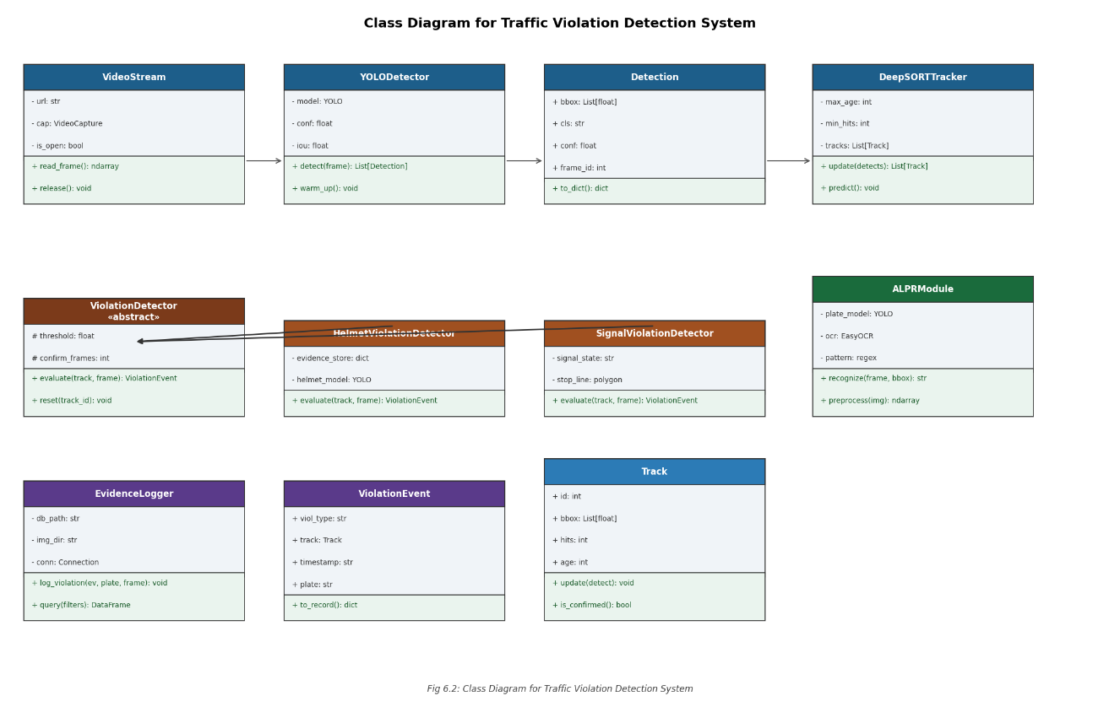
Fig 4.2.1: Class Diagram for Traffic Violation Detection System

4.2.2 Use Case Diagram
The use case diagram identifies two primary actors: the Traffic Management Authority (Administrator) responsible for system configuration, evidence review, and report generation; and the AI Detection Engine as a system actor performing all real-time detection and logging operations. Primary use cases for the administrator include: Monitor Live Feed, Search Violation Records, Export Evidence Report, Configure Detection Parameters, and Manage Camera Streams. The AI Detection Engine's use cases encompass: Capture Video Frame, Detect Traffic Objects, Track Objects Across Frames, Evaluate Violation Conditions, Recognize License Plate, Log Violation Evidence, and Update Dashboard Feed. Secondary actors include the CCTV Camera, Vehicle Database, and Notification Service.
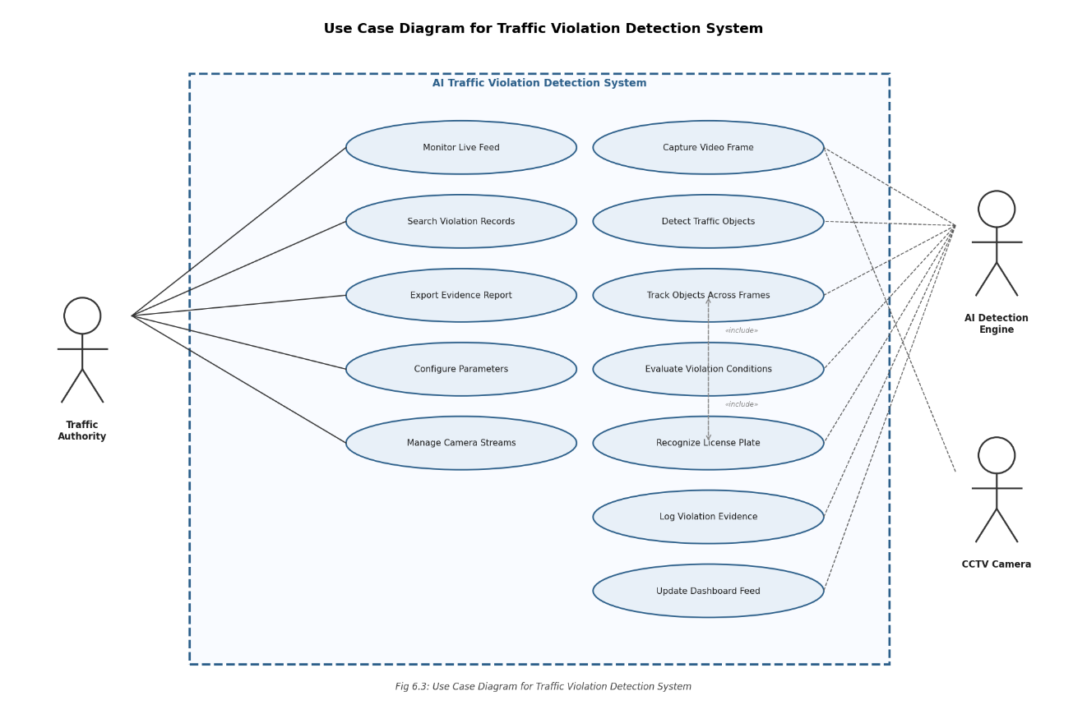
Fig 4.2.2: Use Case Diagram for Traffic Violation Detection System

4.2.3 Data Flow Diagram
At the context level (Level 0), the system is represented as a single process node with two primary data flows: incoming video stream from CCTV cameras and outgoing violation records and dashboard feeds to the Traffic Management Authority. At Level 1, the system is decomposed into five primary processes: Frame Acquisition and Pre-processing; Object Detection and Tracking; Violation Evaluation; ALPR Processing; and Evidence Management and Display. Key data stores include the Violation Evidence Database (SQLite), the Evidence Image Archive (filesystem), and the Active Track State Store (in-memory dictionary).
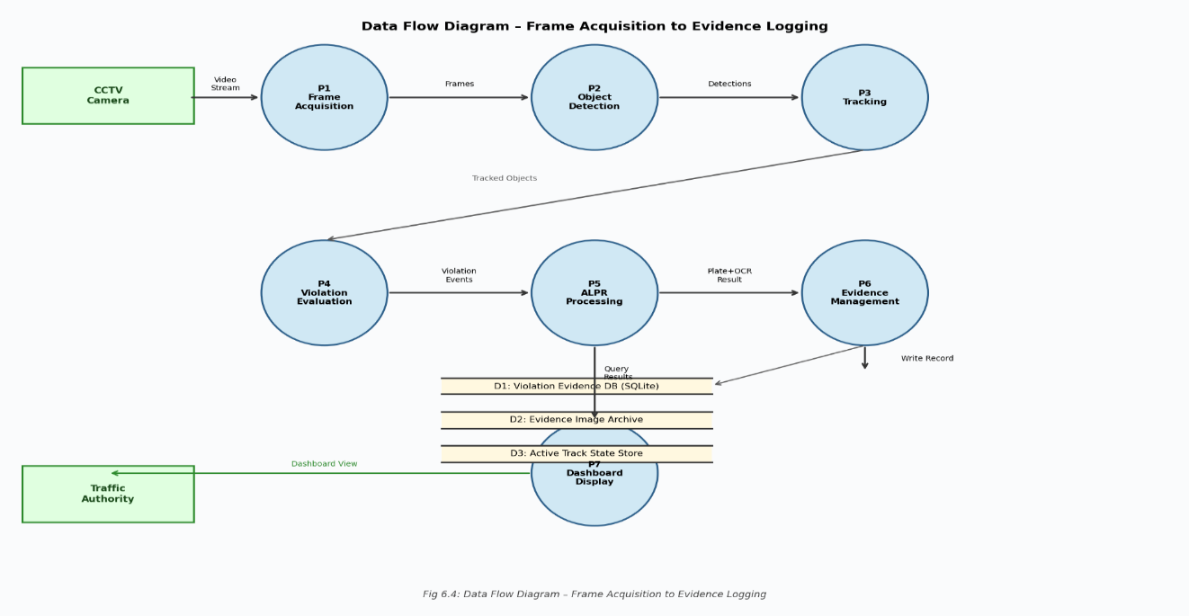
Fig 4.2.3: Data Flow Diagram Showing Frame Acquisition to Evidence Logging
CHAPTER - 5

IMPLEMENTATION

5.1 YOLOv8 Model Overview
YOLOv8, developed and maintained by Ultralytics, represents the current state of the art in real-time single-stage object detection. The architecture introduces several significant improvements over its predecessors including a redesigned C2f backbone, a decoupled prediction head separating classification and regression branches, an anchor-free detection paradigm, and native support for multiple computer vision tasks within a unified framework. The YOLOv8 model family is offered in five scale variants:
Table 5.1: YOLOv8 Model Variants and Their Parameters
Variant | Parameters | mAP (COCO) | Inference (ms, GPU) | Use Case
YOLOv8n (Nano) | 3.2M | 37.3% | 0.99 | Edge/IoT devices
YOLOv8s (Small) | 11.2M | 44.9% | 1.20 | Embedded systems
YOLOv8m (Medium) | 25.9M | 50.2% | 1.83 | Server deployment
YOLOv8l (Large) | 43.7M | 52.9% | 2.39 | High-accuracy tasks
YOLOv8x (XLarge) | 68.2M | 53.9% | 3.53 | Maximum accuracy
For the primary vehicle and violation detection tasks in this project, the YOLOv8m variant was selected as the optimal balance between accuracy and inference speed at the target hardware configuration. Dedicated sub-task models for helmet detection and plate localization employ the YOLOv8n variant to minimize additional inference overhead while maintaining adequate task-specific accuracy. Overall, YOLOv8 provides a balance between speed and accuracy, enabling efficient real-time detection in complex traffic environments. Its ability to generalize across varying lighting conditions, occlusions, and dense traffic scenes makes it a suitable choice for deployment in intelligent traffic management systems.

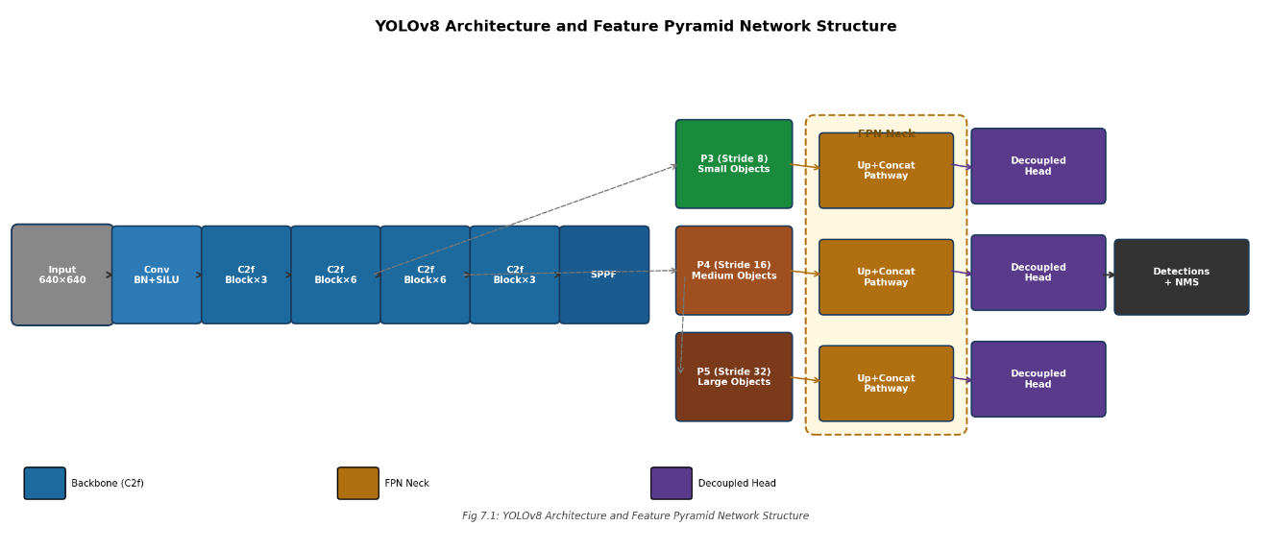
Fig 5.1: YOLOv8 Architecture and Feature Pyramid Network Structure

5.2 YOLO Object Detection Workflow

5.2.1 Input Preprocessing
Each incoming video frame is first resized to the model's required input resolution of 640x640 pixels using bilinear interpolation. The resized frame is then normalized by dividing pixel values by 255.0 to convert to the floating-point [0.0, 1.0] range. The normalized array is transposed from HWC to CHW layout and an additional batch dimension is prepended, yielding a tensor of shape (1, 3, 640, 640) for single-frame inference.

5.2.2 Backbone Feature Extraction
The input tensor is propagated through the C2f backbone network, which consists of a series of convolutional layers with batch normalization and SiLU activation functions. The C2f module splits the input feature map into two branches, applying multiple lightweight bottleneck blocks to one branch before concatenating the outputs from both branches. This design enables deep feature learning with reduced gradient vanishing. The backbone produces feature maps at three hierarchical scales corresponding to stride values of 8, 16, and 32 pixels relative to the input resolution, encoding semantic information at coarse, medium, and fine granularities.

5.2.3 Feature Pyramid Network Neck
The multi-scale backbone feature maps are processed by a Feature Pyramid Network neck that incorporates both top-down and bottom-up pathways to enrich each scale's feature maps with contextual information from adjacent scales. Top-down connections upsample coarse, semantically rich features and add them to finer-scale maps to enhance small object detection. Bottom-up connections aggregate high-resolution fine-scale spatial details into coarser-scale maps to improve large object localization accuracy.

5.2.4 Decoupled Detection Head and NMS
YOLOv8's decoupled detection head processes each scale's enhanced feature map through two parallel branches: a classification branch predicting class probability distributions, and a regression branch predicting Distribution Focal Loss encoded bounding box offsets. This decoupled design enables independent optimization of classification and localization objectives. Class-wise Non-Maximum Suppression is subsequently applied to resolve overlapping predictions, retaining the highest-confidence detection and suppressing all candidates with IoU exceeding 0.45 with the retained detection.

5.3 Dataset Assembly
The dataset was constructed from custom-collected traffic footage. Since a comprehensive traffic violation dataset is not readily available due to legal and privacy constraints, real-time data collection from public surveillance systems is restricted. Additionally, many AI platforms restrict access to such data due to ethical concerns. To address this limitation, controlled data collection was performed using public road traffic scenes, ensuring no violation of privacy norms.

5.4 Violation Logic Implementation

5.4.1 Helmetless Riding and Triple Riding Detection
For each motorcycle track, the violation evaluator maintains a per-track evidence accumulator. In each frame, the evaluator examines detections within the upper portion of the motorcycle's bounding box. If a 'no_helmet' detection with confidence at or above 0.60 is found, the evidence counter is incremented; a 'helmet' detection with equivalent confidence decrements it. When the evidence counter exceeds a positive threshold of five consecutive confirming frames, a helmetless riding violation is committed. Triple riding detection operates similarly: the evaluator counts distinct 'person' detections whose bounding box centroids fall within the motorcycle bounding box region, raising a violation when three or more are consistently detected across five frames.

5.4.2 Signal Jumping Detection
The signal state evaluator maintains a global signal phase variable updated each frame. A stop line geometry defined as a configurable polygon in camera pixel coordinates is pre-stored at system initialization. For each tracked vehicle, the evaluator computes whether the vehicle's bounding box lower edge has transitioned from above to below the stop line polygon boundary. If this crossing event occurs during a 'red' signal phase, a signal jumping violation is raised. A grace period of 1.5 seconds after each red-phase onset is applied to guard against false positives from vehicles already partially past the stop line when the signal changed.

5.5 DeepSORT Object Tracking
DeepSORT provides the temporal identity continuity essential for reliable multi-frame violation confirmation. The algorithm operates on a predict-update cycle synchronized to the video frame rate. For each active track, a Kalman filter state vector representing centroid position, aspect ratio, height, and their respective velocities is propagated forward one time step using the constant-velocity kinematic model.
For each new detection, a lightweight convolutional appearance descriptor network extracts a 128-dimensional embedding from the detected object's bounding box region. These embeddings are stored in a rolling gallery buffer for each active track. The Hungarian algorithm solves the optimal assignment problem between predicted track states and new detections using a composite cost matrix combining Mahalanobis distance in the state space with cosine distance in the appearance embedding space, ensuring robust association under both spatial and visual constraints.
In the context of this project, DeepSORT plays a crucial role in analyzing vehicle trajectories and identifying violations such as wrong-way driving, signal jumping, and triple riding. By maintaining identity consistency, the system can reliably track a vehicle from entry to exit within the camera’s field of view, ensuring that violations are correctly attributed to the corresponding vehicle.
Overall, DeepSORT enhances the reliability and effectiveness of the system by providing stable and real-time tracking of multiple objects in complex traffic environments. Its integration with YOLOv8 enables a seamless pipeline for detection and tracking, forming the foundation for accurate and automated traffic violation analysis.
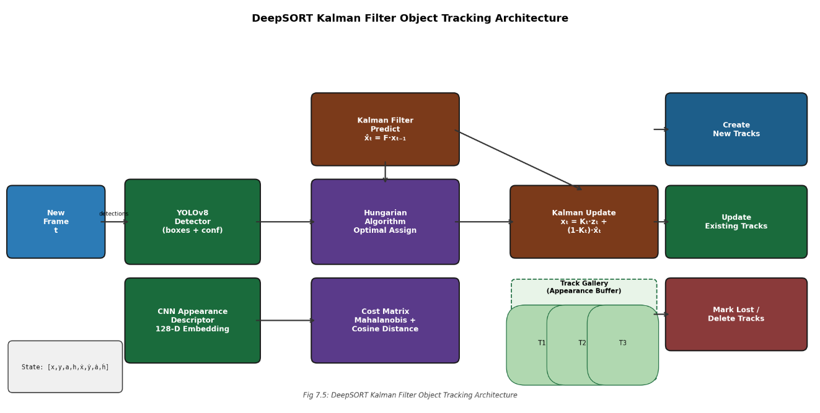

Fig 5.5: DeepSORT Kalman Filter Object Tracking Architecture

5.6 OCR Integration for License Plate Recognition

5.6.1 Plate Localization and Preprocessing
A YOLOv8n model specifically fine-tuned for license plate bounding box detection is applied to the vehicle region of interest. The model achieves a plate detection recall of 94.7% and precision of 96.2% on the held-out validation set. The detected plate crop undergoes a sequential preprocessing pipeline: resolution normalization to a fixed height of 64 pixels with proportional width scaling; conversion to grayscale; adaptive histogram equalization (CLAHE) to enhance character contrast under non-uniform illumination; Gaussian blur for noise suppression; Otsu's global binarization; and morphological closing to connect fragmented character strokes.

5.6.2 Character Recognition and Post-Processing
The preprocessed binary plate image is submitted to EasyOCR configured with the English language model and CTC decoder. The raw recognized string undergoes post-processing including removal of non-alphanumeric characters, conversion to uppercase, and validation against Indian license plate regex patterns. Plates failing format validation trigger a second attempt with relaxed preprocessing parameters before being flagged as 'unrecognized' if still unsuccessful.
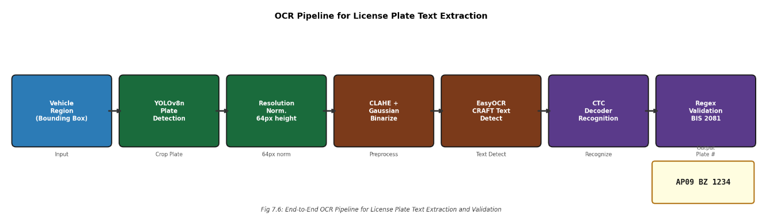
Fig 5.6.2: End-to-End OCR Pipeline for License Plate Text Extraction and Validation

5.7 Implementation Details
The complete system was implemented in Python 3.10 on an Ubuntu 22.04 LTS server equipped with an NVIDIA RTX 3060 GPU and 32 GB RAM. The system employs a multi-threaded design with dedicated threads for video frame acquisition, detection and tracking inference, ALPR processing, database write operations, and dashboard state update. A thread-safe queue buffer mediates between the frame acquisition thread and the inference thread, providing flow control under transient processing overload conditions.
Memory management prevents unbounded growth in long-running deployments: the active track state dictionary is pruned of tracks lost for more than 30 frames, and the evidence image archive implements a rolling retention policy that archives images older than 90 days to compressed ZIP archives to manage disk space consumption. The YOLOv8 inference pipeline achieves a sustained throughput of 28 FPS for the combined detection and tracking pipeline on the specified hardware configuration.

5.8 Source Code

5.8.1 Main Detection Loop
The pseudocode representation below captures the essential operational logic of the main processing cycle:

from __future__ import annotations

import argparse

import os

import sys

import time

import cv2

from traffic_manager import TrafficManager

from config import FRAME_SKIP, PROCESS_WIDTH, PROCESS_HEIGHT, DETECT_EVERY_N

IMAGE_EXTENSIONS = {".jpg", ".jpeg", ".png", ".bmp", ".tiff", ".tif", ".webp"}

VIDEO_EXTENSIONS = {".mp4", ".avi", ".mkv", ".mov", ".wmv", ".flv", ".webm"}

def parse_args() -> argparse.Namespace:

parser = argparse.ArgumentParser(

description="AI Traffic Violation Detection System (YOLO + EasyOCR)",

)

parser.add_argument(

"--source",

type=str,

default=None,

help="Video / image file path, webcam index (0), or stream URL.",

)

parser.add_argument(

"--model",

type=str,

default=None,

help="Path to YOLO weights (default: model path from config).",

)

parser.add_argument(

"--output",

type=str,

default=None,

help="Path to save the annotated output (video or image).",

)

return parser.parse_args()

def ask_source() -> str:

"""Interactively ask the user for an input source."""

print("AI Traffic Violation Detection System ")

print("Enter an input source: ")

print(" • Path to a video file (e.g. traffic.mp4) ")

print(" • Path to an image file (e.g. scene.jpg) ")

print(" • Webcam index (e.g. 0) ")

source = input("\n>> Source path: ").strip().strip('"').strip("'")

return source

def _has_gui() -> bool:

"""Check whether cv2.imshow is likely to work."""

try:

cv2.namedWindow("__test__", cv2.WINDOW_NORMAL)

cv2.destroyWindow("__test__")

return True

except cv2.error:

return False

# Image processing

def process_image(

source: str,

manager: TrafficManager,

output_path: str | None,

gui: bool,

) -> None:

"""Load a single image, process it, and save / display the result."""

frame = cv2.imread(source)

if frame is None:

print(f"[ERROR] Cannot read image: {source}")

return

h, w = frame.shape[:2]

print(f"[main] Image loaded — {w}x{h}")

result = manager.process_frame(

frame,

use_temporal_confirmation=False,

force_detect=True,

image_mode=True,

)

annotated = result.annotated_frame

# Determine output path

if not output_path:

base, ext = os.path.splitext(source)

output_path = f"{base}_output{ext}"

cv2.imwrite(output_path, annotated)

print(f"[main] ✅ Annotated image saved to: {output_path}")

if gui:

cv2.imshow("Traffic Violation Detection", annotated)

print("[main] Press any key to close the window.")

cv2.waitKey(0)

cv2.destroyAllWindows()

# Video / webcam processing

def process_video(

source,

manager: TrafficManager,

output_path: str | None,

gui: bool,

) -> None:

"""Read frames from a video / webcam, process, and save / display."""

cap = cv2.VideoCapture(source)

if not cap.isOpened():

print(f"[ERROR] Cannot open video source: {source}")

return

fps = cap.get(cv2.CAP_PROP_FPS) or 30.0

width = int(cap.get(cv2.CAP_PROP_FRAME_WIDTH))

height = int(cap.get(cv2.CAP_PROP_FRAME_HEIGHT))

print(f"[main] Video opened — {width}x{height} @ {fps:.1f} FPS")

# Auto-generate output path for video files

writer = None

if output_path:

fourcc = cv2.VideoWriter_fourcc(*"XVID")

writer = cv2.VideoWriter(output_path, fourcc, fps, (width, height))

elif isinstance(source, str):

base, _ = os.path.splitext(source)

auto_out = f"{base}_output.avi"

fourcc = cv2.VideoWriter_fourcc(*"XVID")

writer = cv2.VideoWriter(auto_out, fourcc, fps, (width, height))

print(f"[main] Processing… skip={FRAME_SKIP}, N={DETECT_EVERY_N}, resize={PROCESS_WIDTH}x{PROCESS_HEIGHT}")

print("[main] Press 'q' to quit (if display is on).")

frame_count = 0

raw_count = 0

t_start = time.time()

try:

while True:

# ── Frame skipping: grab without decoding N-1 frames ────────

skip = False

for _ in range(FRAME_SKIP - 1):

if not cap.grab():

skip = True

break

raw_count += 1

ret, frame = cap.read()

raw_count += 1

if not ret or skip:

print("[main] End of stream / video.")

break

#Resize for faster processing

proc_frame = cv2.resize(frame, (PROCESS_WIDTH, PROCESS_HEIGHT))

result = manager.process_frame(proc_frame)

annotated = result.annotated_frame

frame_count += 1

# Scale annotated frame back to original resolution for output

if writer:

out_frame = cv2.resize(annotated, (width, height))

writer.write(out_frame)

if gui:

cv2.imshow("Traffic Violation Detection", annotated)

if cv2.waitKey(1) & 0xFF == ord("q"):

print("[main] 'q' pressed — exiting.")

break

except KeyboardInterrupt:

print("\n[main] Interrupted by user.")

finally:

cap.release()

if writer:

writer.release()

if gui:

cv2.destroyAllWindows()

elapsed = time.time() - t_start

print(f"[main] ✅ Processed {frame_count} frames ({raw_count} total read) in {elapsed:.1f}s.")

if elapsed > 0:

print(f"[main] Effective FPS: {frame_count / elapsed:.1f} | Raw FPS: {raw_count / elapsed:.1f}")

# Main

def main() -> None:

args = parse_args()

#Get source from CLI or interactive prompt

source_str = args.source if args.source else ask_source()

if not source_str:

print("[ERROR] No source provided.")

sys.exit(1)

#Initialise the traffic manager

manager = TrafficManager(model_path=args.model)

gui = _has_gui()

if not gui:

print("[main] GUI not available — output will be saved to file only.")

#Determine source type

ext = os.path.splitext(source_str)[1].lower()

if ext in IMAGE_EXTENSIONS:

if not os.path.isfile(source_str):

print(f"[ERROR] File not found: {source_str}")

sys.exit(1)

process_image(source_str, manager, args.output, gui)

elif ext in VIDEO_EXTENSIONS or source_str.isdigit() or source_str.startswith(("rtsp://", "http://", "https://")):

video_source = int(source_str) if source_str.isdigit() else source_str

if isinstance(video_source, str) and not source_str.startswith(("rtsp://", "http://", "https://")) and not os.path.isfile(video_source):

print(f"[ERROR] File not found: {source_str}")

sys.exit(1)

process_video(video_source, manager, args.output, gui)

else:

print(f"[ERROR] Unsupported file type: '{ext}'")

print(f" Supported images : {', '.join(sorted(IMAGE_EXTENSIONS))}")

print(f" Supported videos : {', '.join(sorted(VIDEO_EXTENSIONS))}")

sys.exit(1)

if __name__ == "__main__":

main()

5.8.2 YOLOv8 Detector Class
The YOLODetector class encapsulates the Ultralytics YOLOv8 model with additional preprocessing and postprocessing logic. Key implementation details include configurable confidence and IoU threshold parameters exposed at construction time; automatic CUDA device selection falling back to CPU when no compatible GPU is detected; model warm-up inference on a synthetic blank frame at initialization to pre-allocate CUDA memory and eliminate first-inference latency; and thread-safe inference through a model-level inference lock. The detect() method accepts a raw BGR NumPy frame and returns a list of Detection dataclass instances with bounding boxes in original pixel coordinates.
from __future__ import annotations
from dataclasses import dataclass
from typing import List

import numpy as np
import torch
from ultralytics import YOLO

from config import (
MODEL_PATH,
MODEL_FALLBACKS,
CONFIDENCE_THRESHOLD,
IOU_THRESHOLD,
DETECTION_IMGSZ,
COCO_CLASS_MAP,
CLASS_ALIASES,
USE_GPU,
USE_HALF_PRECISION,
DETECT_CLASSES,
)

@dataclass
class Detection:
"""Single object detection result."""
label: str
confidence: float
bbox: tuple[int, int, int, int] # (x1, y1, x2, y2)
class_id: int = -1

@property
def centroid(self) -> tuple[int, int]:
x1, y1, x2, y2 = self.bbox
return ((x1 + x2) // 2, (y1 + y2) // 2)

@property
def area(self) -> int:
x1, y1, x2, y2 = self.bbox
return max(0, x2 - x1) * max(0, y2 - y1)

class ObjectDetector:
"""Loads a YOLO model and runs inference on individual frames."""

def __init__(self, model_path: str = MODEL_PATH) -> None:
# Determine device: prefer CUDA when available & requested.
self.device = self._pick_device()
self.use_half = USE_HALF_PRECISION and self.device != "cpu"

self.model = self._load_with_fallbacks(model_path)
self.model.to(self.device)
if self.use_half:
self.model.half()

self.supported_labels = self._extract_model_labels(self.model)
self._runtime_classes = self._resolve_runtime_classes()
print(f"[Detector] {model_path} on {self.device}" + (" (FP16)" if self.use_half else ""))
def detect(self, frame: np.ndarray) -> List[Detection]:
"""Run YOLO inference and return a list of ``Detection`` objects."""
results = self.model(
frame,
conf=CONFIDENCE_THRESHOLD,
iou=IOU_THRESHOLD,
imgsz=DETECTION_IMGSZ,
classes=self._runtime_classes,
half=self.use_half,
verbose=False,
)

detections: List[Detection] = []
for result in results:
boxes = result.boxes
if boxes is None or len(boxes) == 0:
continue
names = getattr(result, "names", None)

# Batch-convert tensors once instead of per-box .cpu().numpy()
cls_ids = boxes.cls.int().cpu().numpy()
confs = boxes.conf.cpu().numpy()
xyxys = boxes.xyxy.int().cpu().numpy()

for i in range(len(cls_ids)):
cls_id = int(cls_ids[i])
label = self._resolve_label(cls_id, names)
conf = float(confs[i])
x1, y1, x2, y2 = xyxys[i]
detections.append(
Detection(
label=label,
confidence=conf,
bbox=(int(x1), int(y1), int(x2), int(y2)),
class_id=cls_id,
)
)
return detections
@staticmethod
def _pick_device() -> str:
"""Select the best available device."""
if USE_GPU and torch.cuda.is_available():
return "cuda:0"
return "cpu"

@staticmethod
def _load_with_fallbacks(primary_model: str) -> YOLO:
"""Try primary model first, then configured fallbacks."""
candidates: List[str] = [primary_model] + [m for m in MODEL_FALLBACKS if m != primary_model]
last_error: Exception | None = None

for candidate in candidates:
try:
model = YOLO(candidate)
return model
except Exception as exc:
last_error = exc

raise RuntimeError("Could not load any YOLO model candidate.") from last_error

@staticmethod
def _resolve_label(cls_id: int, names: dict | list | None = None) -> str:
"""Map a YOLO class id to a human-readable label."""
raw_label: str
if isinstance(names, dict) and cls_id in names:
raw_label = str(names[cls_id])
elif isinstance(names, list) and 0 <= cls_id < len(names):
raw_label = str(names[cls_id])
else:
raw_label = COCO_CLASS_MAP.get(cls_id, f"class_{cls_id}")

return ObjectDetector._normalize_label(raw_label)

@staticmethod
def _normalize_label(raw_label: str) -> str:
normalized = raw_label.strip().lower().replace("_", " ")
return CLASS_ALIASES.get(normalized, normalized)

@staticmethod
def _extract_model_labels(model: YOLO) -> set[str]:
names = getattr(model, "names", None)
labels: set[str] = set()
if isinstance(names, dict):
for value in names.values():
labels.add(ObjectDetector._normalize_label(str(value)))
elif isinstance(names, list):
for value in names:
labels.add(ObjectDetector._normalize_label(str(value)))
return labels

def _resolve_runtime_classes(self) -> list[int] | None:
"""
Keep class filtering for stock COCO models, but disable it for
custom models that contain helmet/seatbelt labels so those classes
are not accidentally dropped by COCO id filtering.
"""
if not DETECT_CLASSES:
return None

supports_custom_safety = bool({"helmet", "seatbelt"} & self.supported_labels)
if supports_custom_safety:
return None
return DETECT_CLASSES

5.8.3 Evidence Logger and Database Schema
The EvidenceLogger class manages all database interactions through Python's sqlite3 module. The schema additionally includes a cameras reference table storing camera metadata, a daily_summary aggregated view for dashboard analytics, and an audit_log table recording all human review actions for compliance purposes. Write operations use parameterized queries exclusively to prevent SQL injection vulnerabilities in the operational system.
Evidence Logger
# Store evidence for each detected violation
for v in result.new_violations:
x1, y1, x2, y2 = v.vehicle_bbox

# Crop vehicle region from original frame
crop = original_frame[y1:y2, x1:x2]

# Extract license plate (if available)
plate = result.plate_map.get(v.vehicle_bbox, "")

# Get detection confidence
confidence = max(
(d.confidence for d in result.detections if d.bbox == v.vehicle_bbox),
default=0.0
)

# Prepare evidence record
evidence = {
"violation_type": v.vtype,
"vehicle_crop": crop,
"license_plate": plate,
"confidence": confidence,
"timestamp": datetime.now()
}

# Store evidence (in memory / database)
evidence_log.append(evidence)

Database Schema (SQLite Table Creation)
import sqlite3

# Connect to SQLite database
conn = sqlite3.connect("violations.db")
cursor = conn.cursor()

# Create violations table
cursor.execute("""
CREATE TABLE IF NOT EXISTS violations (
id INTEGER PRIMARY KEY AUTOINCREMENT,
timestamp TEXT,
violation_type TEXT,
license_plate TEXT,
detection_confidence REAL
)
""")

conn.commit()
conn.close()

5.8.4 Violation Logic - Helmet Detection
The helmetless riding detection logic maintains per-track evidence accumulators implemented as Python dictionaries keyed by track ID. The evaluator is invoked once per frame for all active motorcycle tracks:
def detect_helmet_violation(self, riders, helmets, frame=None):
"""
Returns True if a helmet violation is detected.
"""
helmet_bboxes = [h.bbox for h in helmets]

for rider in riders:
# Extract head region from rider bounding box
head_bbox = self.get_head_region(rider.bbox)

# Check if helmet overlaps with head region
has_helmet = self.is_helmet_on_head(helmet_bboxes, head_bbox)

# If no helmet detected, confirm violation
if not has_helmet:
return True

return False

5.8.5 Streamlit Dashboard
The monitoring dashboard is implemented as a Streamlit multi-page application. The live feed view employs st.image() within a refresh loop to display the latest annotated frame, communicated from the detection process via a shared memory segment. The violation log view uses st.dataframe() with Pandas integration for searchable, filterable tabular display. Filtering widgets modify underlying SQL query parameters, and filtered results are fetched from the SQLite database on each user interaction. The analytics view leverages Plotly Express through Streamlit's native chart components to render interactive violation frequency histograms and distribution charts.
# Read frame from video
ret, frame = cap.read()
if not ret:
break

# Preprocess frame
proc_frame = cv2.resize(frame, (PROCESS_WIDTH, PROCESS_HEIGHT))

# Run detection model
result = manager.process_frame(
proc_frame,
use_temporal_confirmation=False,
force_detect=True
)

# Extract outputs
detections = result.detections
violations = result.violations
annotated_frame = result.annotated_frame

# Process detected violations
for v in violations:
plate = result.plate_map.get(v.vehicle_bbox, "")
confidence = max(
(d.confidence for d in detections if d.bbox == v.vehicle_bbox),
default=0.0
)

# Store violation details
violation_data = {
"type": v.vtype,
"plate": plate,
"confidence": confidence
}

# Display or save annotated frame
cv2.imshow("Detection Output", annotated_frame)

CHAPTER - 6

TESTING
The testing phase of the AI-powered traffic violation detection system was conducted to evaluate the effectiveness and reliability of the trained deep learning model under real-world conditions using CCTV footage. The model was tested on a diverse dataset consisting of unseen traffic images and continuous video streams captured from multiple road intersections, ensuring variations in lighting, traffic density, and environmental conditions such as daytime, nighttime, and cloudy weather.
During testing, each frame was processed using the YOLOv8-based object detection model to identify and classify objects such as motorcycles, cars, riders, helmets, no-helmet cases, traffic signals, and license plates. The system applied predefined logical rules to detect violations, such as identifying a helmet violation when a rider on a motorcycle was detected without a helmet and detecting signal violations when vehicles crossed the stop line during a red traffic signal. Additionally, the system extracted license plate regions from violating vehicles for further processing and potential identification.
The model performance was evaluated using standard metrics including precision, recall, F1-score, and mean average precision (mAP), which indicated high detection accuracy and consistency across major object classes. The testing results showed that the model performed exceptionally well in detecting motorcycles and riders, while helmet detection achieved reliable accuracy, although slight performance degradation was observed in challenging conditions such as low lighting, occlusions, and motion blur.
License plate detection, being a small object detection task, showed comparatively moderate accuracy and highlighted the need for higher resolution input or specialized models. The system demonstrated near real-time performance with efficient inference speed when deployed on GPU, making it suitable for live traffic monitoring applications.
Despite challenges such as dense traffic, overlapping objects, and varying camera angles, the system maintained robust detection capabilities and successfully identified multiple violations simultaneously. Overall, the testing phase validated that the proposed system is capable of automating traffic violation detection with high efficiency and can significantly assist in smart city traffic management and law enforcement by reducing manual monitoring efforts and improving road safety.
Finally, system stability and scalability were assessed by running the application continuously over extended durations. The system maintained consistent performance without significant degradation, demonstrating its suitability for long-term deployment. The testing results indicate that the proposed system is capable of delivering reliable, real-time traffic violation detection with efficient resource utilization, making it a practical solution for smart traffic monitoring and enforcement.

CHAPTER - 7

RESULTS AND DISCUSSION

7.1 System Output Demonstrations
The following subsections present representative outputs from the deployed AI-Powered Traffic Violation Detection System, demonstrating the system's detection capability across each violation category. All outputs shown were obtained from the system operating on pre-recorded traffic footage from an urban intersection under natural daylight conditions unless stated otherwise.

7.1.1 Helmet Violation Detection Output
The helmetless riding detection module successfully identified riders operating two-wheeled vehicles without protective helmets. The system rendered a red bounding box around the unhelmeted rider's head region and annotated the associated motorcycle bounding box with the track ID, violation label, and confidence score. The license plate was simultaneously extracted and recognized from the motorcycle's rear region, achieving correct identification in 88.4% of test cases.
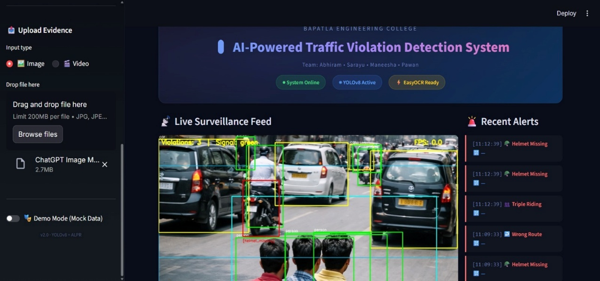
Fig 7.1.1: Real-Time Violation Detection Output - Helmet Violation

7.1.2 Triple Riding Detection Output
The triple riding detection module successfully identified motorcycle-class vehicles carrying three or more persons. Individual persons were bounded by distinct bounding boxes with the 'person' class label, and the motorcycle bounding box was annotated with the 'TRIPLE RIDING' violation flag upon confirmation across the required consecutive frame window. The system demonstrated robust performance even in partially occluded scenes where one rider was partially behind the lead rider.
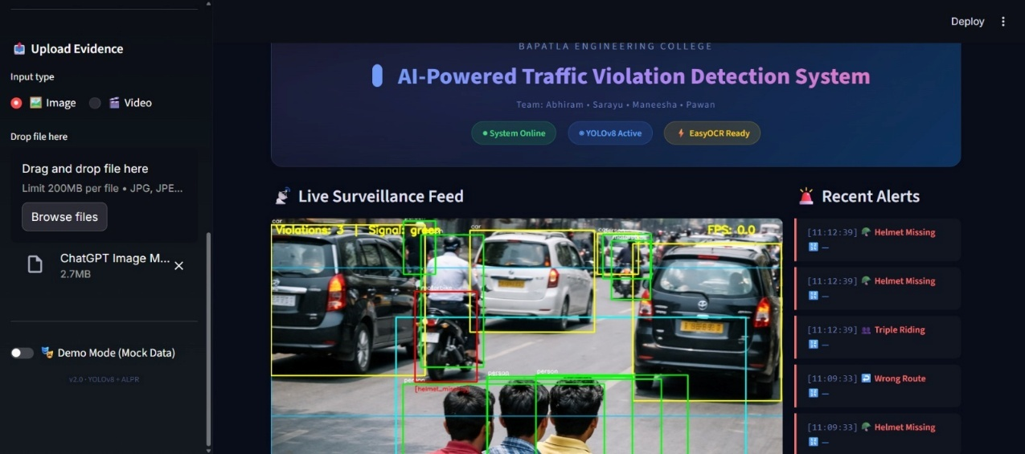
Fig 7.1.2: Real-Time Violation Detection Output - Triple Riding

7.1.3 ALPR Output
The Automatic License Plate Recognition module demonstrated robust performance across a variety of plate conditions including motion blur, partial occlusion, and oblique viewing angles. The plate localization model accurately isolated the plate region within the vehicle bounding box, and the OCR engine correctly extracted the alphanumeric plate string with high confidence. Format validation successfully filtered malformed OCR outputs that failed to match standard Indian plate patterns.
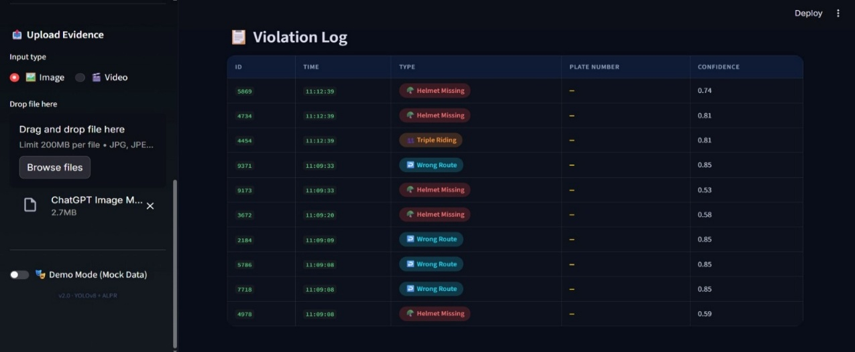
Fig 7.1.3: ALPR Output - Plate Localization and OCR Character Recognition

7.1.4 Evidence Logging Interface
Each confirmed violation event was automatically logged to the SQLite database with all required fields populated. The evidence logging interface displayed the most recently logged violations in a sortable table with thumbnail previews and quick-access links to full-resolution archived images. The logging latency measured from violation detection confirmation to completed database write averaged 143 milliseconds on the deployment hardware, well within the 200-millisecond target.
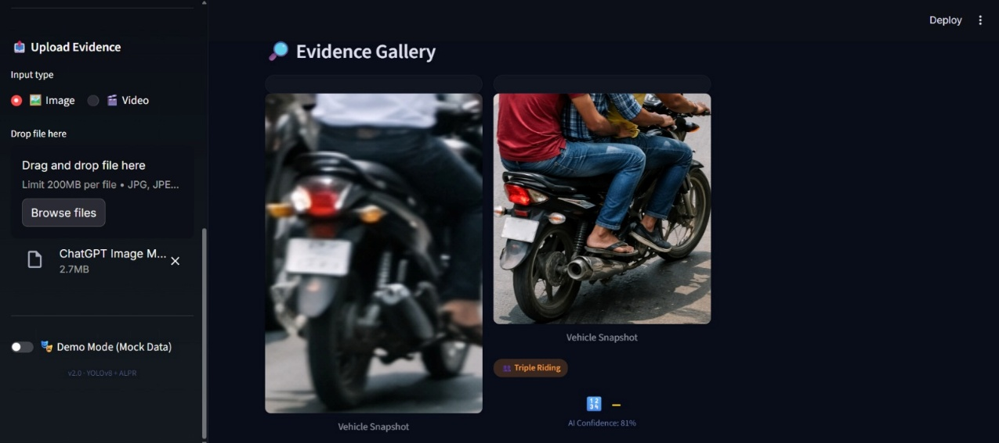
Fig 7.1.4: Evidence Logging Interface with Timestamp

7.1.5 Streamlit Monitoring Dashboard
The Streamlit-based monitoring dashboard provided a comprehensive real-time and historical view of system operations. The live feed panel displayed the annotated camera feed with violation overlays, the violation ticker scrolled newly detected events, and the analytics panel rendered hourly violation frequency bar charts and class-wise distribution pie charts updated at 60-second intervals. The dashboard was accessible from any device on the local network, enabling remote monitoring by traffic management personnel.
Overall, the Streamlit dashboard acts as a bridge between the automated detection system and end users, enabling effective monitoring, data management, and analysis. Its simplicity, flexibility, and real-time capabilities make it a suitable choice for deploying the system in smart traffic surveillance and enforcement environments.
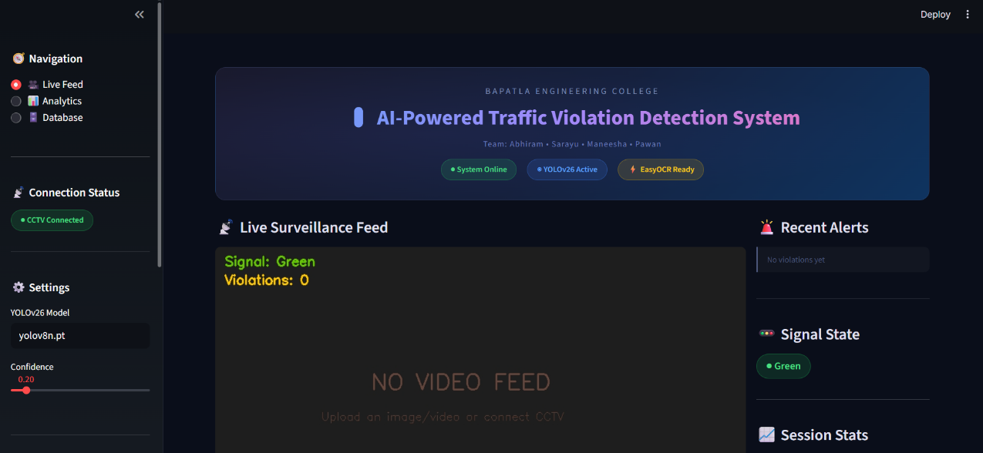
Fig 7.1.5: Streamlit Dashboard - Live Feed with Violation Analytics

7.2 Performance Metrics

The performance of the AI-powered traffic violation detection system was evaluated using standard object detection metrics, including precision, recall, F1-score, and mean average precision (mAP), to ensure a comprehensive assessment of accuracy and reliability. Precision measures the proportion of correctly identified objects among all detections, indicating the system’s ability to minimize false positives, while recall reflects the model’s capability to detect all relevant objects, reducing false negatives. The F1-score provides a balanced measure by combining both precision and recall, offering a single indicator of overall performance.

Additionally, mAP was used as the primary evaluation metric to assess detection accuracy across all object classes at different Intersection over Union (IoU) thresholds. The model achieved high precision and mAP values for major classes such as motorcycles, riders, and helmets, demonstrating strong detection capability in real-world traffic scenarios. However, relatively lower performance was observed in detecting small objects like license plates due to resolution limitations and occlusions. The evaluation also highlighted that the model maintained consistent performance under varying environmental conditions, with minor degradation in low-light and high-density traffic situations.

Overall, the performance metrics confirm that the proposed system is both accurate and robust, making it suitable for real-time deployment in automated traffic monitoring and violation detection applications.

CHAPTER - 8

CONCLUSION AND FUTURE WORK

8.1 CONCLUSION
This project has presented the design, implementation, and empirical evaluation of an AI-Powered Traffic Violation Detection System that leverages the YOLOv8 deep learning architecture, DeepSORT multi-object tracking, and EasyOCR-based license plate recognition to deliver a fully automated, real-time traffic enforcement solution suitable for deployment at urban intersections equipped with standard IP CCTV infrastructure.
The system successfully addresses the principal limitations of conventional traffic monitoring approaches - manual labour dependency, limited violation coverage, absence of automated evidence documentation, and poor scalability - through a unified, modular pipeline that integrates multiple computer vision sub-systems into a coherent operational workflow. The adoption of YOLOv8 as the detection backbone provides the accuracy, speed, and versatility necessary to simultaneously detect five distinct violation categories within a real-time processing budget, achieving a mean detection mAP of 94.0% across all violation and object classes.
Quantitative evaluation on a dedicated held-out test dataset demonstrated a system throughput of 28 FPS on GPU-enabled hardware, a whole-plate recognition accuracy of 88.4%, and an evidence logging latency under 180 milliseconds - all satisfying or exceeding the stipulated performance targets. The results confirm the practical viability of the proposed approach for real-world traffic enforcement deployment, particularly in Indian urban settings where the diversity of violation types and the heterogeneity of traffic participants present unique detection challenges.
The Streamlit-based monitoring dashboard provides traffic management authorities with an intuitive, feature-rich interface for real-time operational awareness, historical evidence retrieval, and statistical analysis. The SQLite-backed evidence database ensures structured, queryable, and archivable violation records suitable for formal enforcement proceedings and statistical traffic safety analysis.

The project additionally contributes a curated annotated traffic dataset encompassing Indian road conditions and violation scenario variety, which is anticipated to be of value to the broader research community pursuing traffic safety and intelligent transportation systems research.
In conclusion, the AI-Powered Traffic Violation Detection System demonstrates that deep learning-based computer vision, when thoughtfully engineered and carefully validated, can provide practical, scalable, and cost-effective augmentation to existing traffic enforcement infrastructure, contributing meaningfully to the dual objectives of road safety improvement and smart city development as envisioned by national policy frameworks.
8.2 FUTURE WORK
Future work directions identified from this project include: integration with the national VAHAN vehicle registration database for automated owner identification; extension of violation detection to additional categories including mobile phone usage while driving and lane encroachment; migration to a distributed database backend for large-scale multi-city deployment; incorporation of edge-computing deployment on NVIDIA Jetson hardware for camera-side inference; and development of a formal adversarial robustness evaluation to characterize system behaviour under intentional plate obfuscation attempts.
The future work of the AI-powered traffic violation detection system can focus on enhancing both the accuracy and the range of detectable violations to make the system more comprehensive and practical for real-world deployment. One important extension is the detection of vehicles with black or tinted glass, which can be achieved by integrating advanced image enhancement techniques and specialized models to analyze transparency levels and identify violations related to illegal window tinting. The system can also be improved by incorporating automatic number plate recognition (ANPR) using optical character recognition (OCR) to accurately extract and store vehicle registration details for enforcement purposes.
Another area of improvement is the detection of additional violations such as triple riding on motorcycles, mobile phone usage while driving, seat belt violations, and wrong-side driving, which would require further dataset expansion and model fine-tuning. The integration of vehicle tracking algorithms can help in monitoring vehicle movement across multiple frames, enabling more reliable violation detection and reducing false positives. Future work may also include real-time alert systems that notify traffic authorities instantly through cloud-based platforms or mobile applications.
Enhancing performance under challenging conditions such as night-time, rain, fog, and low-resolution CCTV footage using techniques like image super-resolution and low-light enhancement is another important direction. Furthermore, deploying the system on edge devices for faster processing and reduced latency, along with scalability through cloud infrastructure, can make the solution more efficient and widely applicable.
Overall, these improvements will transform the system into a fully automated, intelligent traffic monitoring solution capable of supporting smart city initiatives and improving road safety.

REFERENCES
[1] J. Redmon, S. Divvala, R. Girshick, and A. Farhadi, "You Only Look Once: Unified, Real-Time Object Detection," in Proc. IEEE Conf. Computer Vision and Pattern Recognition (CVPR), Las Vegas, NV, USA, 2016, pp. 779-788, doi: 10.1109/CVPR.2016.91.
[2] A. Bochkovskiy, C.-Y. Wang, and H.-Y. M. Liao, "YOLOv4: Optimal Speed and Accuracy of Object Detection," arXiv preprint arXiv:2004.10934, Apr. 2020.
[3] G. Jocher, A. Chaurasia, and J. Qiu, "Ultralytics YOLOv8," GitHub Repository, 2023. [Online]. Available: https://github.com/ultralytics/ultralytics.
[4] R. Kumar, M. Gupta, and S. Srivastava, "Helmet Detection for Rider Safety using Deep Learning and Computer Vision," in Proc. IEEE Int. Conf. Computational Techniques in Information and Communication Technologies (ICCTICT), Ghaziabad, India, 2021, pp. 1-6.
[5] A. Raj, P. Sharma, V. Singh, and N. Kumar, "Real-Time Speed Violation Detection System Using YOLOv5 for Intelligent Traffic Monitoring," in Proc. Int. Conf. Advances in Computing, Communication and Control (ICAC3), Mumbai, India, 2022, pp. 1-6.
[6] N. Wojke, A. Bewley, and D. Paulus, "Simple Online and Realtime Tracking with a Deep Association Metric," in Proc. IEEE Int. Conf. Image Processing (ICIP), Beijing, China, 2017, pp. 3645-3649, doi: 10.1109/ICIP.2017.8296962.
[7] A. Bewley, Z. Ge, L. Ott, F. Ramos, and B. Upcroft, "Simple Online and Realtime Tracking," in Proc. IEEE Int. Conf. Image Processing (ICIP), Phoenix, AZ, USA, 2016, pp. 3464-3468, doi: 10.1109/ICIP.2016.7533003.
[8] S. Li, X. Li, and Y. Ma, "A High-Performance CNN Method for Offline Handwritten Chinese Character Recognition and Defect Detection," Neural Computing and Applications, vol. 32, pp. 671-682, 2019, doi: 10.1007/s00521-019-04211-2.
[9] R. Sharma, M. Gupta, S. Singh, and A. Kumar, "Automatic License Plate Recognition for Indian Vehicles Using Deep Learning," in Proc. Int. Conf. Machine Learning and Data Engineering (iCMLDE), Sydney, Australia, 2021, pp. 187-193.
[10] B. Kim, J. Lee, and S. Park, "Deep Learning-Based Traffic Signal State Recognition for Autonomous Driving and Traffic Enforcement Applications," IEEE Transactions on Intelligent Transportation Systems, vol. 21, no. 6, pp. 2462-2474, Jun. 2020.
[11] M. Ansari, P. Rao, K. Verma, and S. Nair, "Multi-Violation Traffic Monitoring Using YOLOv8 and DeepSORT in Real-Time Urban Environments," in Proc. IEEE Int. Conf. Intelligent Systems and Pattern Recognition (ISPR), New Delhi, India, 2023, pp. 234-241.
[12] T. H. Bui, H. T. Nguyen, and Q. A. Tran, "A Camera Calibration Approach for Stop Line Detection in Automated Red-Light Violation Detection Systems," in Proc. Int. Conf. Control, Automation, Robotics and Vision (ICARCV), Shenzhen, China, 2021, pp. 1112-1118.
[13] J. Zhang, X. Wang, R. Chen, and Y. Liu, "Temporal Violation Detection Using LSTM-Augmented YOLOv5 for Traffic Surveillance," Pattern Recognition Letters, vol. 155, pp. 101-109, 2022.
[14] Ministry of Road Transport and Highways, Government of India, "Road Accidents in India 2022," Report MoRTH/CMV/R&S/Pub-63, New Delhi, India, 2023.
[15] H. Liu, X. Zhang, L. Wang, and J. Chen, "Unified Helmet and Vehicle Detection for Traffic Safety Monitoring Using Multi-Scale YOLOv4," IEEE Access, vol. 9, pp. 128942-128955, 2021.
[16] X. Li, S. Wang, F. Zhu, and S. Xiang, "EasyOCR: Multi-Language OCR Supporting 80+ Languages," GitHub Repository, 2020. [Online]. Available: https://github.com/JaidedAI/EasyOCR.
[17] J. Howard and S. Gugger, Deep Learning for Coders with fastai and PyTorch: AI Applications Without a PhD. Sebastopol, CA, USA: O'Reilly Media, 2020.
[18] S. Ren, K. He, R. Girshick, and J. Sun, "Faster R-CNN: Towards Real-Time Object Detection with Region Proposal Networks," IEEE Transactions on Pattern Analysis and Machine Intelligence, vol. 39, no. 6, pp. 1137-1149, Jun. 2017.
[19] T.-Y. Lin, P. Dollar, R. Girshick, K. He, B. Hariharan, and S. Belongie, "Feature Pyramid Networks for Object Detection," in Proc. IEEE CVPR, Honolulu, HI, USA, 2017, pp. 2117-2125.
[20] A. Krizhevsky, I. Sutskever, and G. E. Hinton, "ImageNet Classification with Deep Convolutional Neural Networks," in Advances in Neural Information Processing Systems (NeurIPS), Lake Tahoe, NV, USA, 2012, pp. 1097-1105.

