5CS045 Full Stack Development 
Server Access Guide
Your server account gives you three websites and a database. Wherever this guide shows student_username, use your own username.

1 Get your account
- Open https://fullstack.heraldcollege.edu.np/.
If your browser warns that your connection is not private, click Advanced, then the link ending in (unsafe). In Firefox, click Advanced, then Accept the Risk and Continue. In Safari, click Show Details, then visit this website. This is expected on this server, but never do it on other websites.
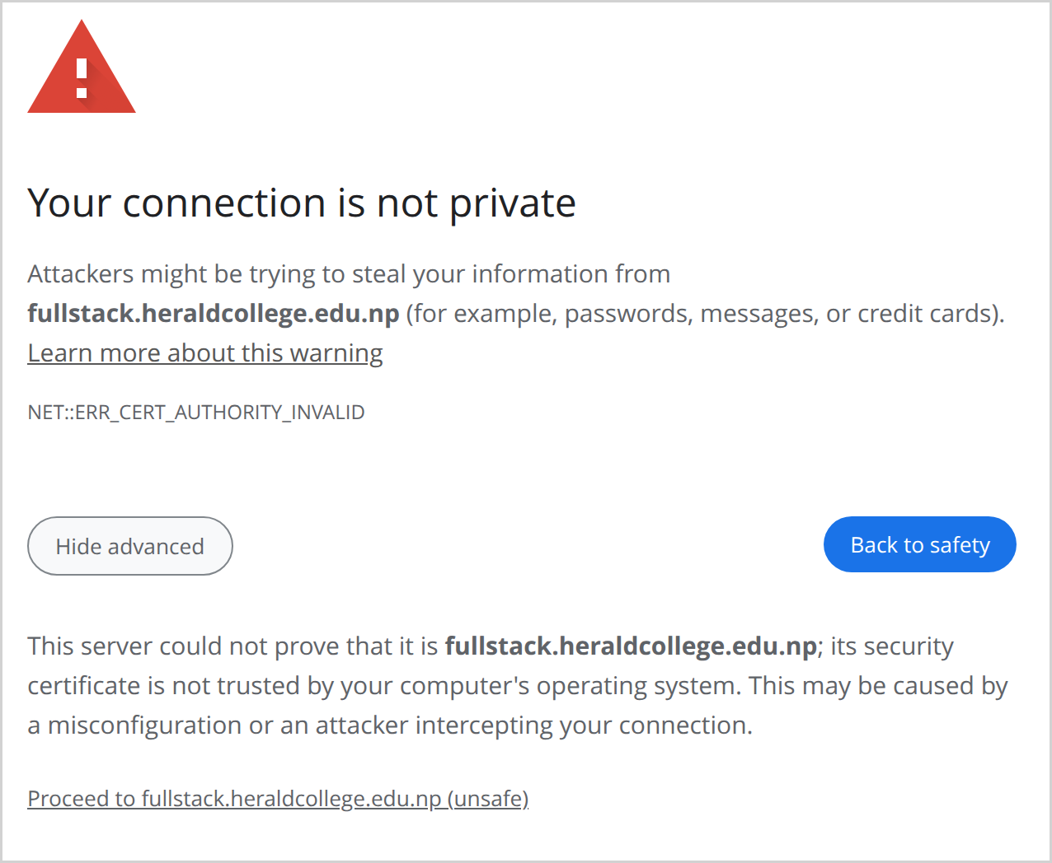
- Type your college email and click Register.
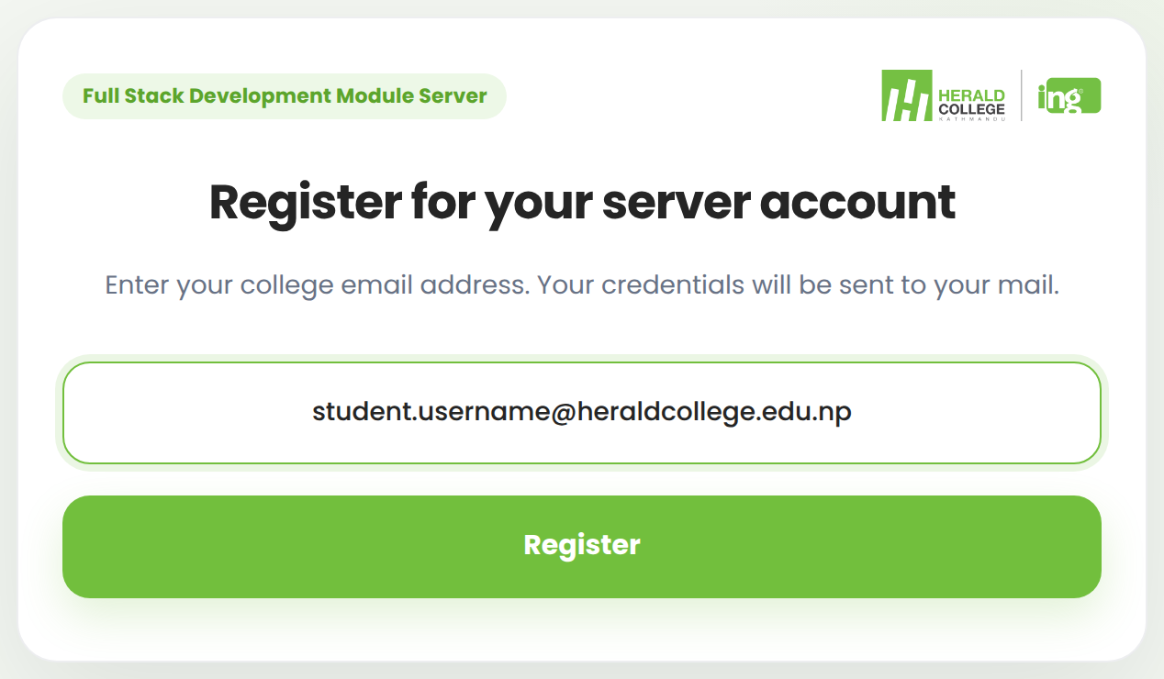
- Your username and password arrive by email, in Your Server Credentials (check spam too). Keep the email: you can register only once. The same password works for everything in this guide, so never change it with passwd.

2 Your websites
Your home page is https://fullstack-student.heraldcollege.edu.np/~student_username/. Each of its three folders is a website at that address plus the folder name, for example .../~student_username/exam/.
Folder | Use it for
workshops | Your weekly work, each week in its own folder such as week1 (it opens at .../workshops/week1/)
exam | Task 1, the timed exam
assessment | Task 2, your final project

Never delete or rename these three folders.

3 Log in with SSH
Open PowerShell (Windows) or Terminal (Mac) and type:
ssh -p 50222 student_username@fullstack.heraldcollege.edu.np
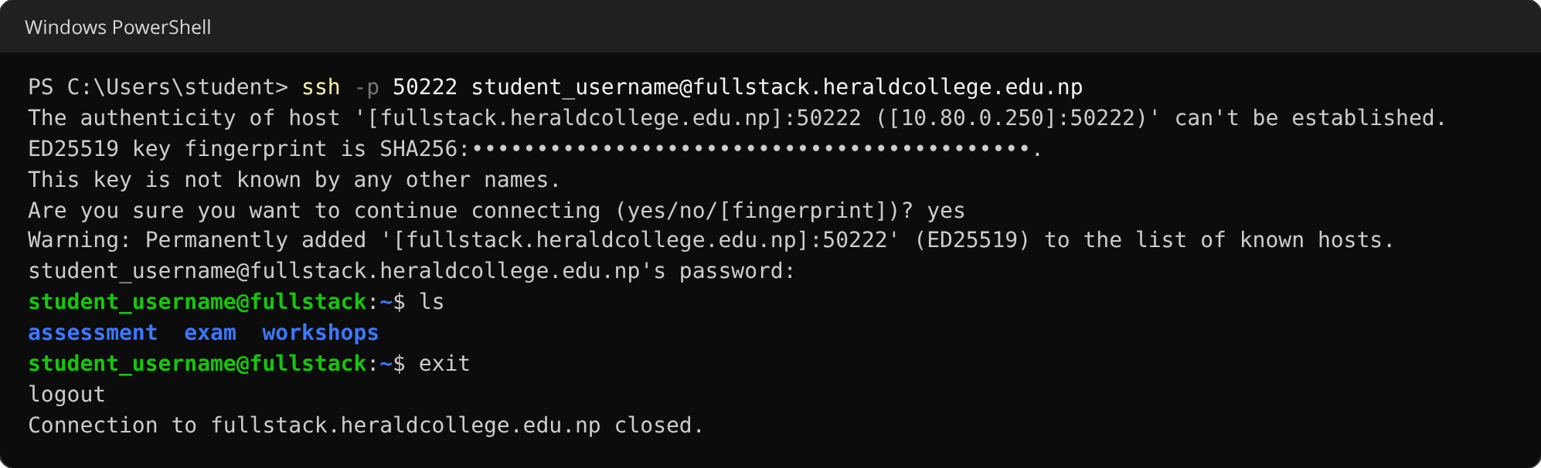
- The first time, type yes and press Enter.
- Your password stays invisible while you type it or paste it (Ctrl+V, or Cmd+V on a Mac). Press Enter.
- Five wrong passwords block your computer, often your whole lab, for an hour.
- Type exit to leave.

4 Upload your work
Run these on your own computer, not inside SSH, from the folder that contains your work. On Windows, open that folder in File Explorer, click the address bar, type powershell and press Enter. On a Mac, type cd and a space in Terminal, drag the folder in and press Enter. Note that scp takes the port with a capital -P.
A week of workshop work:
scp -P 50222 -r week1 student_username@fullstack.heraldcollege.edu.np:~/workshops/
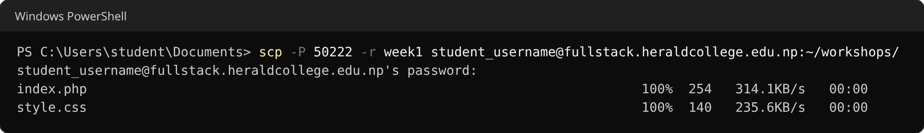
It is now live at https://fullstack-student.heraldcollege.edu.np/~student_username/workshops/week1/
Your assessment or exam: name the folder on your computer assessment (or exam), in lower case. The command ends in :~/, with nothing after it:
scp -P 50222 -r assessment student_username@fullstack.heraldcollege.edu.np:~/
Run the same command again after every change. Files you delete on your computer stay on the server until you remove them in SSH with rm.

5 Your database
Your database is called student_username. To manage it, open phpMyAdmin at https://fullstack.heraldcollege.edu.np/phpmyadmin/ and log in with your username and password.
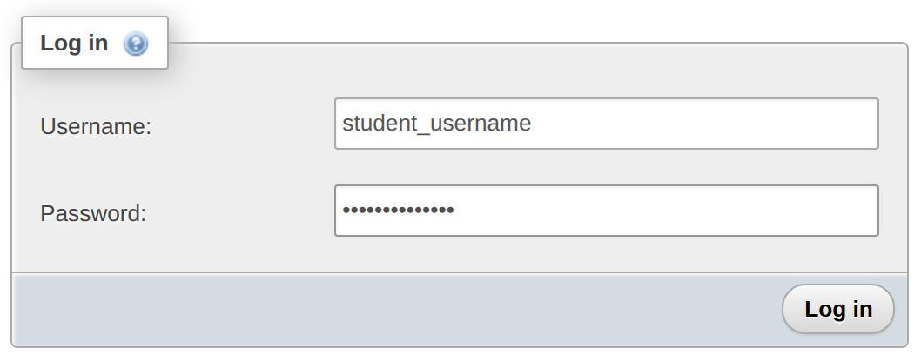
Connect from PHP like this, in a file such as config.php inside your project folder (never in a public Git repository):
<?php
$pdo = new PDO(
'mysql:host=localhost;dbname=student_username;charset=utf8mb4',
'student_username',
'your-password'
);
phpMyAdmin's Import tab takes .sql files up to 1 MB. For a bigger one, upload it, log in with SSH, go to its folder with cd and run:
mysql -u student_username -p student_username < schema.sql

6 Good to know
- PHP 8.3, MySQL (MariaDB), Git and Composer are installed. For Blade (Week 6), log in with SSH, go to your project folder with cd and run:
composer require jenssegers/blade
- You have 500 MB for files and 100 MB for your database. Forms on your websites can accept uploads of up to 20 MB.
- .htaccess files have no effect on this server.

7 If something goes wrong
You see | Do this
403 Forbidden | The folder has no index.php or index.html (all lower case). Add one.
404 Not Found or File not found. | Check the address. It must match your folder and file names exactly, capitals included.
HTTP ERROR 500 or a blank page | Your PHP has an error. In SSH, this shows it:  tail ~/.sessions/php-error.log
Permission denied when logging in | Wrong password. Copy it again from the email.
A login, upload or page cannot connect | Check that ssh and scp commands include 50222. If they do, use 10.80.0.250 in place of the server's name (the part ending in heraldcollege.edu.np). If that also fails, your computer may be blocked: ask your tutor.
Disk quota exceeded | You are out of space. Delete files you no longer need.
INSERT command denied | Your database is full. Delete tables you no longer need. Saving works again within 15 minutes.
Access denied to a database when loading a .sql file | Delete the CREATE DATABASE and USE lines from the file, then load it again.

Still stuck? Ask your tutor. Send your username and a screenshot of the problem.

