
5CS045 Full Stack Development
Server Access Guide
2026/27. Replaces the guide for the old shared Herald College Server.
The module has its own server. It gives you a login, three websites and a database. This guide shows every step: the exact command to type and a picture of what you should see. Read it even if you used the old server last year, because a few things have changed.

Quick reference
I want to | Address or command
Sign up | https://fullstack.heraldcollege.edu.np/
Open my websites | https://fullstack-student.heraldcollege.edu.np/~sarayu_gautam/
Use my database | https://fullstack.heraldcollege.edu.np/phpmyadmin/
Log in with SSH | ssh sarayu_gautam@fullstack.heraldcollege.edu.np
Upload a week of workshop work | scp -r week1 sarayu_gautam@fullstack.heraldcollege.edu.np:~/workshops/
Upload my assessment folder | scp -r assessment sarayu_gautam@fullstack.heraldcollege.edu.np:~/
Make uploads from Windows visible (in SSH) | setfacl -R -m g:www-data:rX ~/workshops ~/exam ~/assessment
Read my PHP errors (in SSH) | tail -n 5 ~/.sessions/php-error.log

In every command, sarayu_gautam is an example. Type your own username instead. If a name does not work, use the server's address 10.80.0.250 in its place, in commands and in the browser.

In this guide
1 Get your account | 5 Your database
2 Your websites | 6 What you can use
3 Log in with SSH | 7 When something goes wrong
4 Upload your files | 8 Getting help

1 Get your account
- Open https://fullstack.heraldcollege.edu.np/ in your browser. If it says Your connection is not private, that is expected for this server: click Advanced, then the link to continue. There is more about this warning below.
- Type your college email (it must end in @heraldcollege.edu.np) and click Register.
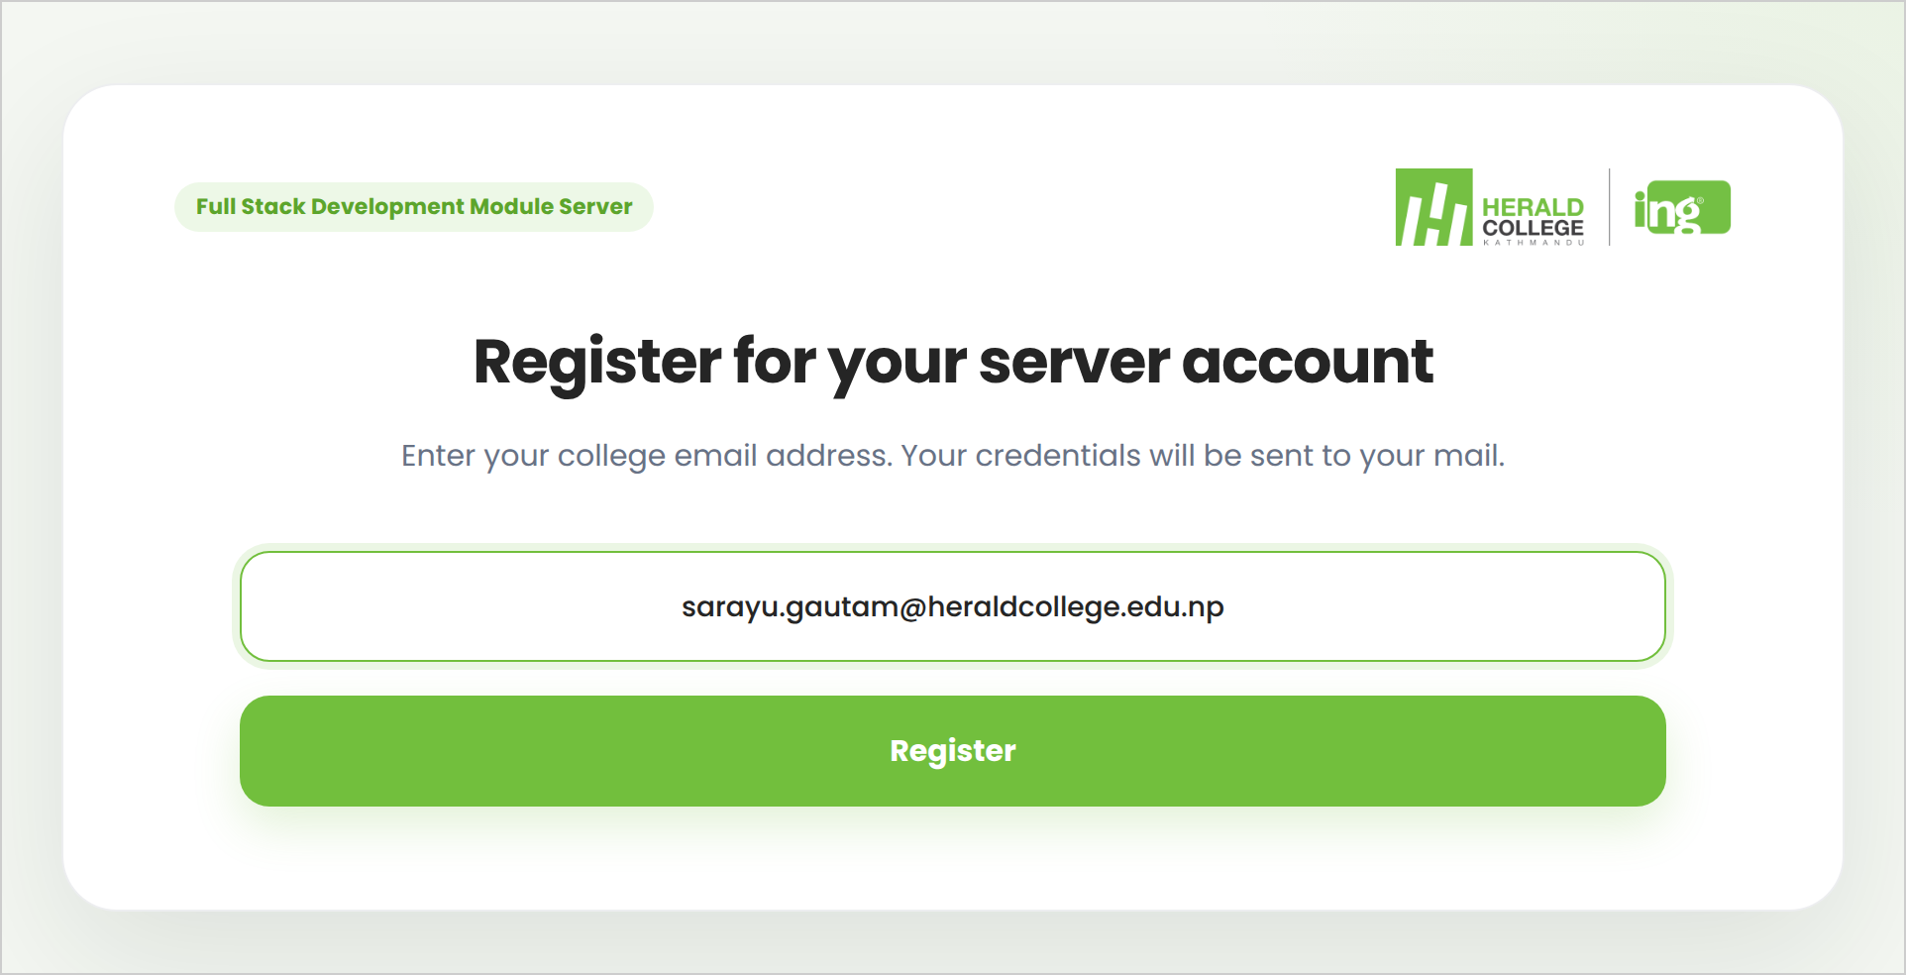
The sign-up page, https://fullstack.heraldcollege.edu.np/
- The page says Your account is ready. Look in your college inbox for an email called Your Server Credentials. If it is not there after a few minutes, check your spam or junk folder.
The message after you click Register
The email looks like this (your password is where the dots are):
Subject: Your Server Credentials

Here are your access details:
-----------------------------
Username: sarayu_gautam
Password: ••••••••••••••
Database: sarayu_gautam

Your websites:
Workshops: https://fullstack-student.heraldcollege.edu.np/~sarayu_gautam/workshops/
(make one folder for each week, for example workshops/week1)
Assessment: https://fullstack-student.heraldcollege.edu.np/~sarayu_gautam/assessment/
Exam: https://fullstack-student.heraldcollege.edu.np/~sarayu_gautam/exam/
- Your username comes from your email. sarayu.gautam@heraldcollege.edu.np becomes sarayu_gautam. You cannot choose it.
- One password does everything: SSH, SCP, SFTP apps, phpMyAdmin and MySQL. It is 14 letters and numbers with no 0, O, 1, l or I, so it is easy to read. Copying and pasting it is safest.
- You can register only once. Lost the email or forgot the password? Ask your tutor, who can send it again or give you a new one.
- Please do not change the password yourself with passwd. It would change your SSH password but not your database password, and the two would no longer match.

About the "Your connection is not private" warning
The server uses its own security certificate, which browsers do not recognise yet. Your connection is still encrypted. To continue:
- Chrome or Edge: click Advanced, then Proceed to (Edge: Continue to) the server's name (unsafe).
- Firefox: click Advanced, then Accept the Risk and Continue.
- Safari: click Show Details, then visit this website, then Visit Website.
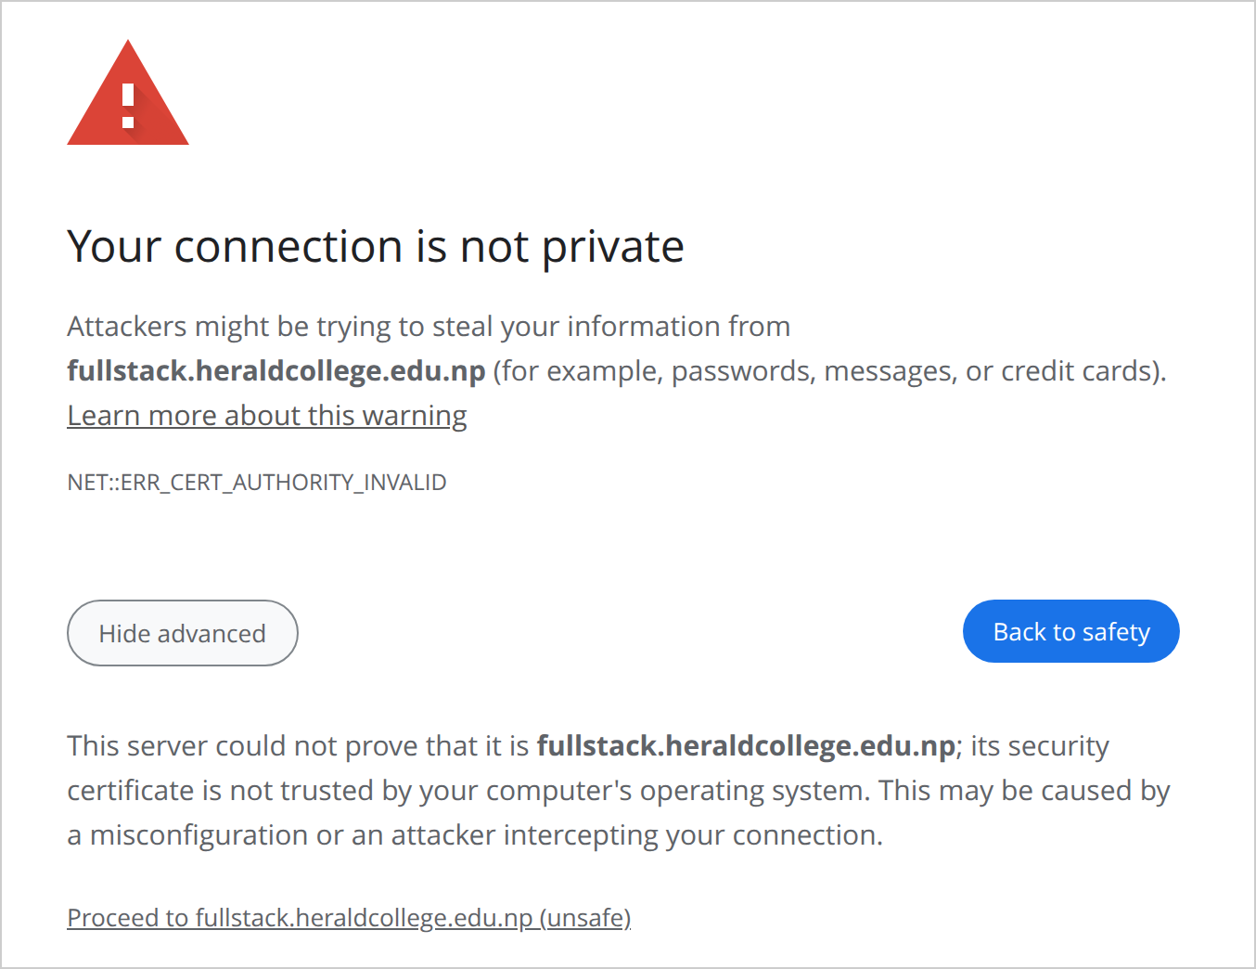
Chrome, after clicking Advanced. Click the link at the bottom.
Your browser remembers your choice for a while. It asks separately for each name: fullstack.heraldcollege.edu.np (sign-up and phpMyAdmin) and fullstack-student.heraldcollege.edu.np (your websites).
Important Only do this for the module server. If any other website shows this warning, do not continue.

2 Your websites
Your home page is https://fullstack-student.heraldcollege.edu.np/~sarayu_gautam/. It links to your three folders. It works within a minute of registering.
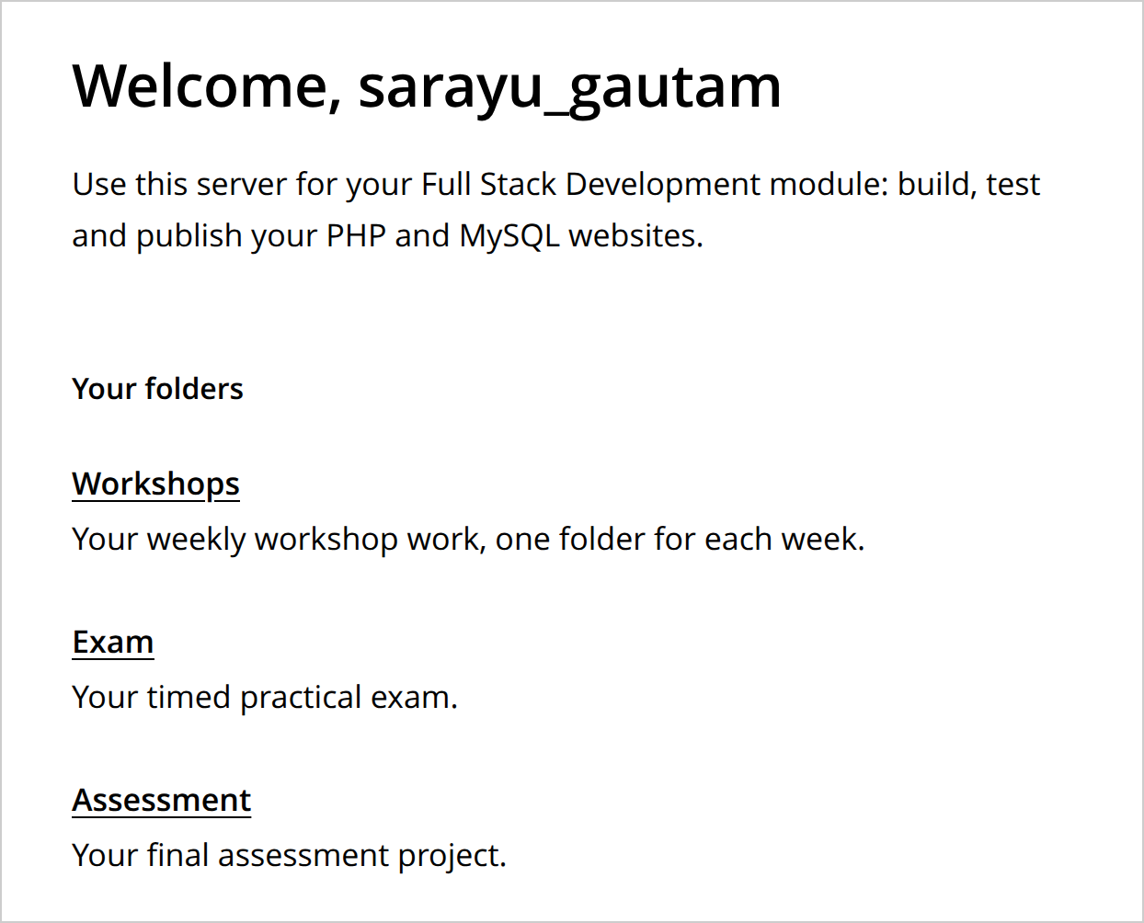
https://fullstack-student.heraldcollege.edu.np/~sarayu_gautam/
Folder | What goes in it | Web address
workshops | Your weekly workshop work, one folder for each week (week1, week2 and so on). | .../~sarayu_gautam/workshops/week1/
exam | Task 1: the timed practical exam. | .../~sarayu_gautam/exam/
assessment | Task 2: your final assessment project. | .../~sarayu_gautam/assessment/

- Anything you upload is on the web straight away. Uploads from Windows need one extra command first (see section 4). You never need chmod.
- Only files inside workshops, exam and assessment are on the web.
- Until you upload your own work, each folder shows a short note page. Your own index.php or index.html replaces it.
- Names must match exactly, in lower case: index.php (not Index.php) and assessment (not Assessment).
- Files and folders whose names start with a dot, such as .env or .git, are never shown on the web.
- Other students cannot open or change your files on the server, and you cannot open theirs.
- Keep Task 1 and Task 2 work in the right folder. Your tutor marks each task from its own folder.
Important Never delete or rename the workshops, exam or assessment folders themselves. They are set up so the web server can read them, and a new folder with the same name will not work. If it happens, ask your tutor to repair it.

3 Log in with SSH
SSH gives you a command line on the server. You type the commands in a terminal on your own computer:
- Windows: open PowerShell or Terminal from the Start menu. SSH is built in.
- Mac: open Terminal (in Applications, then Utilities).
Type this and press Enter:
ssh sarayu_gautam@fullstack.heraldcollege.edu.np
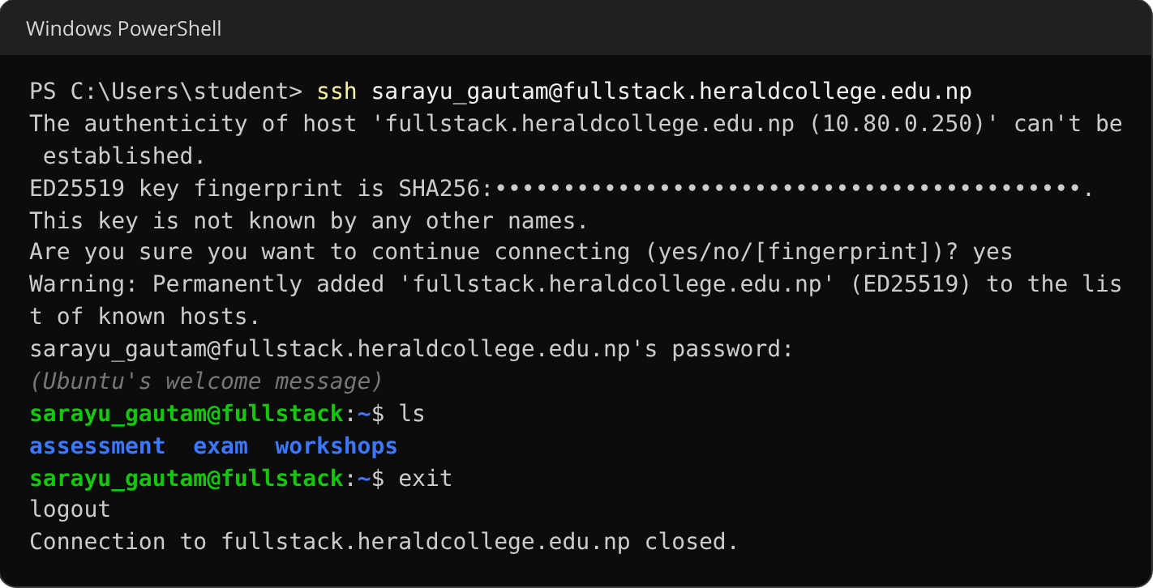
Your first login. The dots hide the server's fingerprint, a long code.
- The first time only, it asks Are you sure you want to continue connecting? Type yes and press Enter.
- Type or paste your password and press Enter. Nothing appears while you type. That is normal. To paste, press Ctrl+V or right-click (Windows), or press Cmd+V (Mac). Have the email open first: you have 60 seconds.
- When you see sarayu_gautam@fullstack:~$ you are on the server. Try ls to list your folders. Type exit to leave.
If ssh says Could not resolve hostname or the connection times out, use the server's address instead of its name:
ssh sarayu_gautam@10.80.0.250
Careful Five wrong passwords within 10 minutes block your computer's network address for an hour, and a whole lab can share one address. Three blocks in one day make it a week, and then the websites stop opening too. If your password is refused twice, stop and copy it again from the email, or ask your tutor.

4 Upload your files
Uploads run on your own computer, not inside SSH. If your terminal shows sarayu_gautam@fullstack, type exit first.
Open the terminal in the folder that contains your week1 or assessment folder (not inside it):
- Windows 11: in File Explorer, go to that folder (for example Documents), right-click an empty space and choose Open in Terminal.
- Windows 10: go to that folder, hold Shift, right-click an empty space and choose Open PowerShell window here.
- Mac: in Terminal, type cd and a space, drag that folder into the window and press Enter.

Workshops: one folder for each week
This uploads the folder week1 into your workshops folder:
scp -r week1 sarayu_gautam@fullstack.heraldcollege.edu.np:~/workshops/
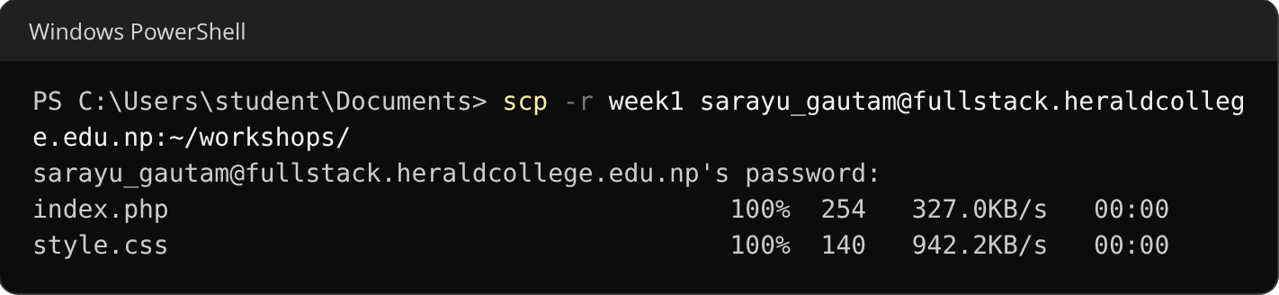
Each file is listed as it uploads.
On Windows its built-in scp uploads files that only you can read, so the web server shows 403 Forbidden for them. After each upload, log in with SSH and run this once (Mac users can skip it):
setfacl -R -m g:www-data:rX ~/workshops ~/exam ~/assessment
It prints nothing when it works. You can run it as often as you like.
Your page is now live at https://fullstack-student.heraldcollege.edu.np/~sarayu_gautam/workshops/week1/

The week1 page on the web

Assessment and exam
Keep your project in a folder called assessment on your computer (or exam for the exam). Upload the whole folder to your home folder. Its files go into the folder of the same name on the server:
scp -r assessment sarayu_gautam@fullstack.heraldcollege.edu.np:~/
scp -r exam sarayu_gautam@fullstack.heraldcollege.edu.np:~/
- The folder name must be assessment in lower case. A folder called Assessment is uploaded but is not on the web.
- The command ends in :~/ (your home folder). Do not add assessment/ at the end, or you get an assessment folder inside your assessment folder.
- Your site opens at https://fullstack-student.heraldcollege.edu.np/~sarayu_gautam/assessment/
- To update your site, change the files on your computer and run the same command again. Files with the same name are replaced. From Windows, run the setfacl command afterwards, as above.
- scp never deletes anything. To remove an old file from the server, log in with SSH and use rm, for example rm ~/assessment/old.php.
Ended up with an assessment folder inside your assessment folder? Log in with SSH, remove the extra one, then upload again:
rm -rf ~/assessment/assessment

Prefer dragging and dropping?
Use WinSCP or FileZilla (Windows), or Cyberduck or FileZilla (Mac), with these settings:
Protocol | SFTP (not FTP)
Host | fullstack.heraldcollege.edu.np (or 10.80.0.250)
Port | 22
Username and password | Your own, from the email

5 Your database
You have one MySQL (MariaDB) database. Its name is your username, and it uses your usual password.

phpMyAdmin, in your browser
Open https://fullstack.heraldcollege.edu.np/phpmyadmin/ and log in with your username and password.
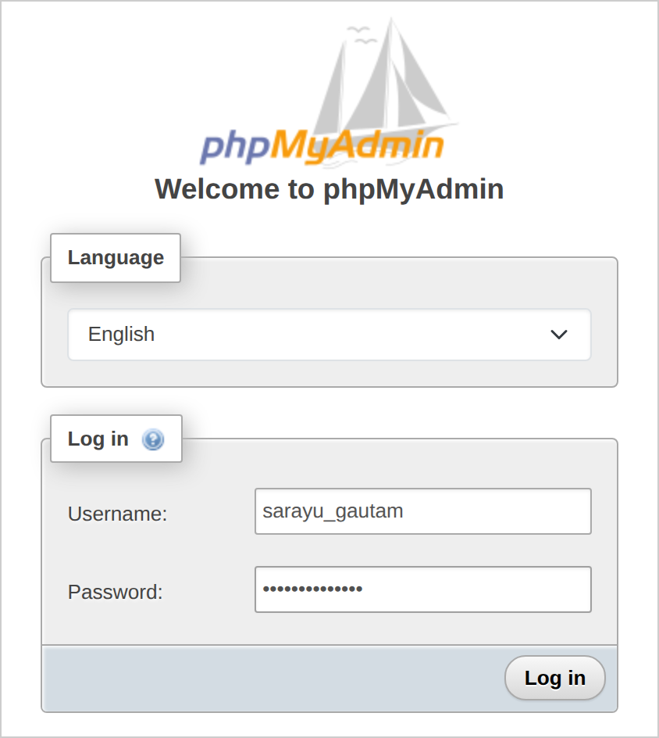
https://fullstack.heraldcollege.edu.np/phpmyadmin/
Your database is on the left. Click it to see your tables, or use the SQL tab to run queries and the Import tab to load a .sql file of up to 1 MB. For a bigger file, use the command line below.
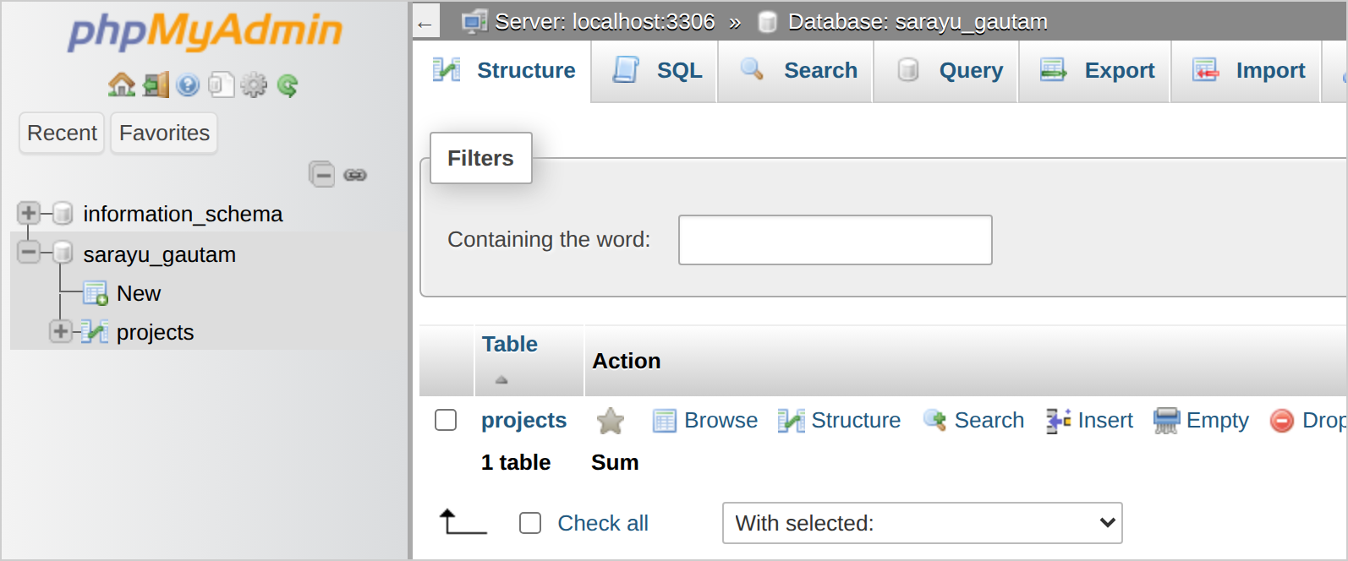
Your database and its tables

The command line, inside SSH
After logging in with SSH, type:
mysql -u sarayu_gautam -p
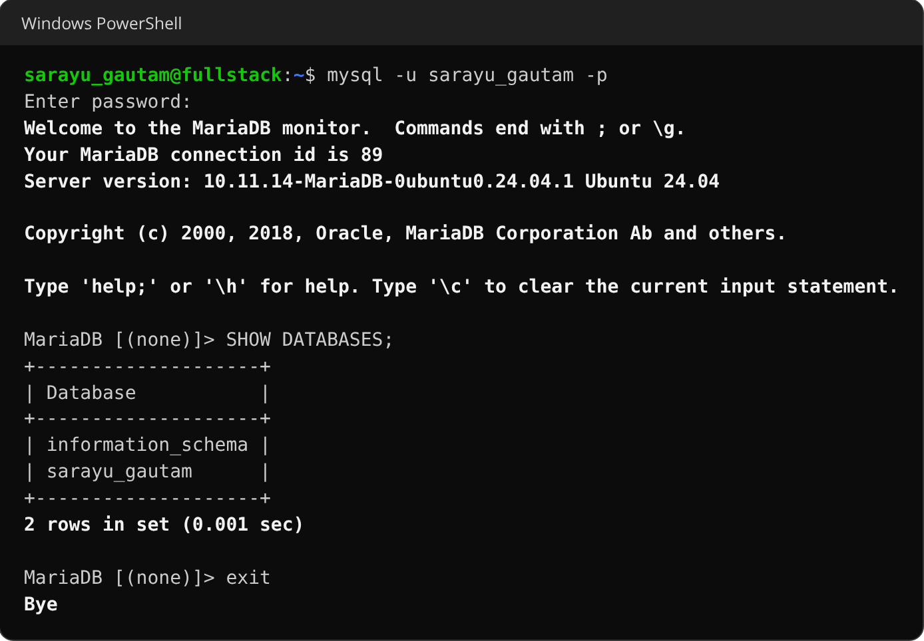
Enter your password when asked. SHOW DATABASES; lists your database. exit leaves.
To load a .sql file you have uploaded (for example schema.sql in your assessment folder):
cd ~/assessment
mysql -u sarayu_gautam -p sarayu_gautam < schema.sql
You can only use your own database, so if the file has CREATE DATABASE or USE lines, delete them first.

Connecting from PHP
Use localhost as the host, and your username as the database name:
<?php
$pdo = new PDO(
'mysql:host=localhost;dbname=sarayu_gautam;charset=utf8mb4',
'sarayu_gautam', // your username
'your-password' // your password
);
Keep these details in one file, such as config.php, inside your project folder. The web server runs PHP files rather than showing them, so the password stays hidden. Never put that file in a public Git repository.
Other kinds of file in your web folders can be downloaded by anyone who guesses the address. Do not leave .sql dumps, zip files or backup copies (such as config.php.save) there.

6 What you can use
- PHP 8.3, MariaDB (MySQL), Git and Composer are installed, and the nano editor for quick changes over SSH.
- Blade templates (Week 6): in your project folder, run composer require jenssegers/blade. If Composer cannot download on the server, run the same command on your own computer and upload the project with its vendor folder.
- npm: install packages inside your project with npm install. Global installs (npm install -g) are not allowed and fail with a permission error.
- Your PHP code can only open files inside your three web folders, so keep everything your site needs, including config.php, inside the project folder.
- The server runs nginx, not Apache, so .htaccess files do nothing: no rewrite rules and no "Deny from all". Link to your .php files directly, for example project.php?id=3.
Every student has the same limits, so nobody can slow the server down for everyone else:
Limit | Size | What happens at the limit
Disk space (everything you store) | 500 MB | Saving fails with Disk quota exceeded
Database | 100 MB | It becomes read-only until it is smaller (checked every 15 minutes)
Each PHP page | 128 MB memory, 30 seconds, uploads up to 20 MB | That page fails
PHP pages at the same time | 4 | Extra visitors wait
Programs you run over SSH | 1 CPU core, 1 GB memory | The program slows down, or stops if it runs out of memory
Scheduled jobs (cron) | Not available

To see how much space you are using, log in with SSH and type:
du -sh ~
The "no CMS, no frameworks" rule for Task 1 (the exam) is a rule of the assessment, not a limit of the server. Check the assessment brief for what each task allows.

7 When something goes wrong

A page shows HTTP ERROR 500 or a blank page
Your PHP has an error. For safety, errors are not shown on the page. They are written to a log that only you can read:

What a PHP error looks like in the browser
Log in with SSH and read the last lines of the log:
tail -n 5 ~/.sessions/php-error.log
If it says No such file or directory, PHP has not logged any errors yet.
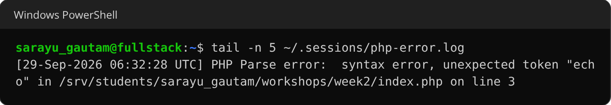
The file and line number of the error, here a missing semicolon on the line before line 3.

Other problems
What you see | What to do
Permission denied, please try again (SSH or scp) | The password is wrong. Copy it again from the email. After five wrong tries your computer is blocked for an hour.
Could not resolve hostname, or the connection times out | Use 10.80.0.250 instead of fullstack.heraldcollege.edu.np. If that also fails, ask your tutor.
404 Not Found (or File not found. for a .php address) | No file matches the address. Check the spelling and the capitals (Week1 is not week1), and that your files are inside workshops, exam or assessment.
403 Forbidden | The folder has no index.php or index.html (in lower case): add one, or put the file name at the end of the address. Or you uploaded from Windows: log in with SSH and run  setfacl -R -m g:www-data:rX ~/workshops ~/exam ~/assessment
Disk quota exceeded (an upload may only say Failure) | You have used your 500 MB. Delete what you do not need, such as zip files, old uploads or vendor folders you can rebuild. To see which folders are big:  du -h -d1 ~  To clear the Composer and npm download caches:  rm -rf ~/.cache/composer ~/.npm
INSERT command denied (or UPDATE, CREATE) | Your database is over 100 MB. Drop or empty (TRUNCATE) tables you do not need; writing works again within 15 minutes. If you only deleted rows, ask your tutor to shrink the database.
Sign-up says Please use your @heraldcollege.edu.np college email | Use your college email, not a personal one.
Sign-up says This email has already been registered | You already have an account. Ask your tutor to send your login again.
Sign-up says Please wait a few minutes before trying this email again | Each email can try once every 5 minutes.
Sign-up says Too many registration attempts from this network | A lab shares one network address, and it allows 40 sign-ups every 15 minutes. Wait 15 minutes and try again.

8 Getting help
Contact your tutor if:
- the registration email has not arrived after you checked your spam folder;
- SSH, scp or phpMyAdmin refuses a password you are sure is right;
- your computer or lab has been blocked after wrong passwords;
- something in this guide does not match what you see.
Tell them your username and what you see. A screenshot of the message helps a lot.

