**Kathmandu University**

**Department of Computer Science and Engineering**

**Dhulikhel, Kavre**



**A Project Report**

**on**

**“RESTAURANT DBMS”**

**[Course Code: COMP232]**

**(For partial fulfillment of II Year/ II Semester in Computer Engineering)**

**Submitted By**

Sailesh Dahal (10)

Sarayu Gautam (14)

Awan Shrestha (45)

Sabil Shrestha (51)

**Submitted To**

**Mr. Santosh Khanal**

Assistant Professor

**Department of Computer Science and Engineering**

**Submission Date**

22nd July, 2019

# List of figures

Figure 1: Cart 36

Figure 2: Menu 36

Figure 3: Signup page 37

Figure 4: Signup page 37

Figure 5: orders page 38

Figure 6: Tables before normalization 38

Figure 7: Tables after normalization 39

Figure 8: ER Diagram before normalization 40

Figure 9: ER Diagram after normalization 41

# Introduction

## Background

This project is a web-based Restaurant Database Management System which is built using MySQL and Node.js. This project mainly focuses on handling various data related to restaurant management. These include user data, import data, data related to food order, menu contents, restaurant data, data related to reservation and home delivery, and financial data of restaurant.

This project was built with a concept to enhance and digitalize restaurant management so that the data is stored in efficient format which preserves all the data that are generated in the restaurant in comparison to the old traditional way when data used to be stored manually in file system or paper note books.

## Objectives

1. To understand the concept of database management system.
2. To enhance our skill on database management system.
3. To create a database management system to manage a restaurant and its internal affairs.
4. To create a simple web application to perform and demonstrate the basic operations on the database including create, read, update and delete.

# Synopsis

The database represents a Restaurant that has tables, staffs, stock, import, menu, system of home delivery and reservation, and food order. There are total 24 tables among which 21 are entity tables and 3 are relationship tables. This project contains two types of users: Restaurant staff and customer.

The restaurant staffs belong to different category as per their role such as “Manager”, “Chef”, “Waiter”. The manager of the restaurant acts as the head of the restaurant who manages other staffs, decides menu of the restaurant, can update food items and their price, manages imports, issues bill for orders, handle reservations and homedelivery. The kitchen staffs can read orders and prepare order accordingly. They can also view current pantry status, and manage the imported goods. The serving staffs such as “Waiter” can take orders and insert them into the system so that kitchen staffs can view those orders.

The customers are those who can request for a reservation or place a home delivery request. In both cases, the customers must be logged in to the system providing their basic information. While making a reservation, the customer must provide date and time on which date they want to reserve a table in the restaurant. They should also specify the number of persons they are reserving for. While placing a home delivery request, a customer selects food items with their quantity and places the order.

A particular import is made from a particular company whose contact information is stored in the system. An import may contain many items that are stored as import details. Each import detail fills the stock of the same name with updated date of the import.

A menu has its start date and its name. Only a particular menu can be activated at a time. A menu can be discarded for a time and can be re activated as per the seasonal or any other requirements. A menu represents collection of food items which are sorted according to their category. A food item may or may not be available at a time.

# Design and Implementation

## System Requirement Specification

1. **Programming Language**: JavaScript
2. **Framework**: Node.js
3. **Database Management System**: MySQL
4. **Tools Used**: phpMyAdmin, MySQL Workbench, Visual Studio Code

## List of Entities with justification

1. **contact_info**

This entity stores the contact information of users, restaurant and import company so as to avoid redundancy caused due to the repetition of similar type of information in multiple tables.

1. **users**

This entity stores the information regarding the authentication credentials of the different type of users who need to sign in and signup in the system for different purposes.

1. **staff**

This entity is a child of user entity that stores information particularly about staffs working in the restaurant.

1. **staff_category**

This entity is for categorizing staffs based on their role and salary. No staffs with a category not stored in the system can exist.

1. **customer**

This entity is the child of user entity for representing a customer. This customer can make a reservation or request for a home delivery.

1. **restaurant**

This entity represents the restaurant and provides information about total number of staffs and tables present in the restaurant along with its capacity.

1. **import_company**

This entity represents the company from which imports to the restaurant is made. Total transaction and remaining transaction to that company is stored.

1. **import**

This entity represents an import made at a particular date from a company which is identified by its unique bill number.

1. **import_detail**

This is a weak entity of parent entity import. This entity is responsible for storing details of goods imported in a particular import.

1. **import_type**

This entity categorizes the imported goods into different type on the basis of their storage and use. This entity also has a measuring unit for a type of import.

1. **stock**

This entity represents the stock of a particular good present in the restaurant. The stock is filled whenever an import is made.

1. **food_category**

This entity categorizes food item prepared in the restaurant.

1. **food_item**

This entity represents a particular food item that is prepared in the restaurant. It has its price and belongs to a food category.

1. **menu**

This entity represents the restaurant menu which is currently active.

1. **menu_content**

This entity is a weak entity of menu, which represents the food item present in the menu and its availability.

1. **restaurant_table**

This entity stores the number and vacancy of a particular table in the restaurant.

1. **reservation**

This entity represents a table reservation made by a customer for a certain date and time for given number of persons.

1. **home_delivery**

This entity represents a particular home delivery made by a customer.

1. **food_order**

This entity represents a particular food order placed whether by a homedelivery of by a waiter.

1. **order_item**

This entity is weak entity of food_order and consists information about a particular ordered item along with its quantity.

1. **bill**

This entity represents the bill issued for a particular order made at a particular date which includes total price of the order.

1. **order_relates_staff**

This is a relationship table which shows which staff took which order.

1. **order_relates_table**

This is a relationship table which shows which order went to which table

1. **order_relates_home_delivery**

This is a relationship table which distinguishes home delivered ordered from normal orders.

## List of attributes with justification

1. **contact_info**
   1. **contact_info_id**

This is the PRIMARY KEY which is VARCHAR (100) needed to represent contact information of a particular user, restaurant or an import company.

* 1. **name**

This represents name of user or a restaurant or an import company which is a VARCHAR (100) and this cannot be null.

* 1. **email**

This represents email of user or a restaurant or an import company which is a VARCHAR (100) and this cannot be null.

* 1. **address**

This represents address of user or a restaurant or an import company which is a VARCHAR (150) and this cannot be null.

* 1. **phone**

This represents phone number of a user or a restaurant or an import company which is a VARCHAR (30) and this cannot be null.

1. **users**
   1. **user_id**

This is the PRIMARY KEY which is VARCHAR (100) needed to represent contact information of a particular user. It is also a FOREIGN KEY of parent table **contact_info.**

* 1. **username**

This is a username which is VARCHAR (50), used by users for login and signup in the system.

* 1. **password**

This is the hashed password used for logging into the system.

1. **staff**
   1. **staff_id**

This is the PRIMARY KEY which is VARCHAR (100) needed to represent contact information of a particular staff. It is also a FOREIGN KEY of parent table **contact_info.**

* 1. **staff_category**

This is a FOREIGN KEY VARCHAR (100) of parent table **staff_category** which provides information about the category to which the particular staff belongs.

* 1. **last_paid_date**

This is a TIMESTAMP used for determining the last paid date of a staff.

* 1. **joined_date**

This is a TIMESTAMP stored as a DEFAULT TIMESTAMP of the time when the staff is created.

1. **staff_category**
   1. **staff_category**

This is a VARCHAR (100) that determines to which category a staff belongs.

* 1. **salary**

This is a DOUBLE (10,2) that determines the salary of a staff belonging to particular category.

1. **customer**
   1. **customer_id**

This is the PRIMARY KEY which is VARCHAR (100) needed to represent contact information of a particular customer. It is also a FOREIGN KEY of parent table **contact_info.**

1. **restaurant**
   1. **restaurant_id**

This is the PRIMARY KEY which is VARCHAR (100) needed to represent contact information of a particular restaurant. It is also a FOREIGN KEY of parent table **contact_info.**

* 1. **total_staff**

This is an INTEGER (10) used to store total staff working in the restaurant.

* 1. **capacity**

This is an INTEGER (10) which tells the capacity of the restaurant to accommodate customers.

* 1. **total­_tables**

This in an INTEGER (10) that stores total tables present in the restaurant.

1. **import_company**
   1. **import_company_id**

This is the PRIMARY KEY which is VARCHAR (100) needed to represent contact information of a particular company. It is also a FOREIGN KEY of parent table **contact_info.**

* 1. **total_transactions**

This is DOUBLE (10,2) which stores the total amount of transactions made with that company.

* 1. **remain_transactions**

This is DOUBLE (10,2) which stores the remaining amount of transactions made with that company.

1. **import**
   1. **import_company_id**

This is a VARCHAR (100) FOREIGN KEY of parent table **import_company** which is needed to determine which import was supplied by which company.

* 1. **bill_no**

This is INTEGER (10) PRIMARY KEY of import which stores the bill number issued for that particular import.

* 1. **total_price**

This is DOUBLE (10,2) which stores the total price of that import.

* 1. **import_date**

This is a TIMESTAMP stored as CURRENT_TIMESTAMP at the time when the import data is inserted.

1. **import_detail**
   1. **import_good**

This is VARCHAR (200) which determines the name of the imported good.

* 1. **import_type**

This is a VARCHAR (120) which is a FOREIGN KEY of the parent table **import_type** which determines the type to which that imported good belongs.

* 1. **bill_no**

This is an INTEGER (10) which is a FOREIGN KEY to the parent table **import** which determines to which import this imported good belongs.

* 1. **quantity**

This is a DOUBLE (10,2) which stores the quantity of particular imported good.

* 1. **price**

This is a DOUBLE (10,2) which stores the price of particular imported good.

1. **import_type**
   1. **import_type**

This is a VARCHAR (120) which is PRIMARY KEY used to determine the type of import.

* 1. **measure_unit**

This is a VARCHAR (10) which determines the unit of measurement of import belonging to a particular import type.

1. **stock**
   1. **stock_name**

This is a VARCHAR (200) which is a PRIMARY KEY used to determine the name of the stock.

* 1. **type_of_stock**

This is a VARCHAR (120) which is a FOREIGN KEY to the parent table import type which determines the type of stock.

* 1. **last_import­_date**

This is a TIMESTAMP which is a FOREIGN KEY of parent table **import** which determines the last date in which the stock was filled.

* 1. **quantity**

This is a DOUBLE (10,2) which stores the current quantity of a particular stock.

1. **food_category**
   1. **food_category_name**

This is a VARCHAR (100) which is a PRIMARY KEY of **food_category** that determines to which category a food item belongs.

1. **food_item**
   1. **food_item_name**

This is a VARCHAR (100) which is a PRIMARY KEY and is used to determine a particular food item.

* 1. **food_item­­­_price**

This is a DOUBLE (10,2) which determines price of a particular food item.

* 1. **food_category_name**

This is a VARCHAR (100) which is a FOREIGN KEY of parent table **food_category** which determines the category to which a food item belongs.

1. **menu**
   1. **menu_name**

This is a VARCHAR (100) which is a PRIMARY KEY used to determine a particular menu.

* 1. **menu_start_date**

This is a DATE that represents the starting date of use of a particular menu. It is also a PRIMARY KEY.

* 1. **menu_end_date**

This is a DATE that represents the end date of the menu if a menu has been discarded.

* 1. **is_menu_active**

This is a BOOLEAN with default value 0 which determines whether a particular menu is currently active or not.

1. **menu_content**
   1. **menu_name**

This is a VARCHAR (100) which is a FOREIGN KEY of parent table **menu** which determines the menu to which a particular menu content belongs.

* 1. **food_item­_name**

This is a VARCHAR (100) which is a FOREIGN KEY of parent table **food_item** which is used to determine the name of a particular menu content.

* 1. **is_food­_available**

This is a BOOLEAN with default value 1 which is used to determine whether a food item is currently available or not.

1. **restaurant_table**
   1. **table_no**

This is an INTEGER (10) which is a PRIMARY KEY which uniquely identifies a table of the restaurant.

* 1. **is_empty**

This is a BOOLEAN with default value 1 which determines whether a particular table is currently vacant or not.

1. **reservation**
   1. **customer_id**

This is the FOREIGN KEY of parent table **customer** which is VARCHAR (100) needed to represent contact information of a particular customer who made the reservation.

* 1. **table_no**

This is the FOREIGN KEY of parent table **restaurant_table** which is INTEGER (10) which determines the table for which reservation is made.

* 1. **number_of_person**

This is an INTEGER (2) to determine the number of persons for whom the reservation is made.

* 1. **reservation_date**

This is a TIMESTAMP which is stored as CURRENT_TIMESTAMP at the time on which the reservation was made. This is also a PRIMARY KEY

* 1. **reservation_fulfilled_status**

This is a BOOLEAN with default value 0 which determines whether a reservation was fulfilled or not.

* 1. **reserved_for_date**

This is a TIMESTAMP which determines for which date a particular reservation was made.

* 1. **reserved_for_time**

This is a TIME which determines for which time of day a particular reservation was made.

1. **home_delivery**
   1. **home_delivery_no**

This is a VARCHAR (120) which is a primary key and uniquely determines a particular home delivery.

* 1. **customer_id**

This is the FOREIGN KEY of parent table **customer** which is VARCHAR (100) needed to represent a particular customer who placed the home delivery request.

* 1. **delivery_staff_id**

This is the FOREIGN KEY of parent table **staff** which is VARCHAR (100) needed to represent a particular staff who delivered the delivery.

* 1. **is_delivered**

This is a BOOLEAN with default value 0 to determine whether a home delivery was delivered or not.

1. **food_order**
   1. **order_id**

This is a VARCHAR (120) which is a PRIMARY KEY for uniquely determining a particular order.

* 1. **order_time**

This is a TIMESTAMP stored as CURRENT_TIMESTAMP which determines when the order was placed.

1. **order_item**
   1. **order_id**

This is a VARCHAR (50) which is a FOREIGN KEY of parent table **food_order** which determines to which particular order the given order item belongs.

* 1. **food_item­_name**

This is a VARCHAR (100) which is a FOREIGN KEY of parent table **food_item** which determines the name of a particular order item.

* 1. **quantity**

This is an INT (3) which stores the quantity of a particular order item placed in an order.

1. **bill**
   1. **bill_no**

This is an INTEGER (10) which is a PRIMARY KEY that uniquely identifies a particular bill.

* 1. **order_id**

This is a VARCHAR (50) which is a FOREIGN KEY of parent table **food_order** which determines to which particular order the given bill is issued.

* 1. **total_price**

This is a DOUBLE (10,2) which determines the total price issued in that bill.

* 1. **issue­­_date**

This is a TIMESTAMP stored as CURRENT_TIMESTAMP to determine the date in which a particular bill was issued.

## Candidate keys/ Primary keys/ Composite Keys

1. **contact_info**

CANDIDATE KEY: contact_info_id,

PRIMARY KEY: contact_info_id

We chose contact_info_id as candidate key because throughout this relation only contact_info_id is unique among other attributes and it uniquely determines the values of all other attributes present in contact_info table. This is also a primary key because it is a least subset of candidate key.

1. **users**

CANDIDATE KEY: user_id

PRIMARY KEY: user_id

We chose user_ id as candidate key because throughout this relation only user_id is unique among other attributes and it uniquely determines the values of all other attributes present in user table. Also, it is foreign key referencing contact_info_id in contact_info table which is always unique.

Here user_id is also a primary key.

1. **staff**

CANDIDATE KEY: staff_id, joined_date

PRIMARY KEY: staff_id

We chose staff_id, joined_date as candidate key because throughout this relation only staff_id and joined_date is unique among other attributes and they uniquely determine the values of all other attributes present in staff table.

Also, staff_id is foreign key referencing user_id in user table which is always unique. Hence, staff_id is a primary key.

1. **staff_category**

CANDIDATE KEY/PRIMARY KEY: staff_category

We choose staff_category as candidate key/ primary key because it uniquely determines all the tuples.

1. **customer**

CANDIDATE KEY: customer_id

PRIMARY KEY: customer_id

We chose customer_ id as candidate key because throughout this relation only customer_id is unique among other attributes and it uniquely determines the values of all other attributes present in customer table. Also, it is foreign key referencing user_id in users table which is always unique.

Here customer_id is also a primary key.

1. **restaurant**

CANDIDATE KEY: restaurant_id

PRIMARY KEY: restaurant_id

We chose restaurant_ id as candidate key because throughout this relation only restaurant_id is unique among other attributes and it uniquely determines the values of all other attributes present in restaurant table. Also, it is foreign key referencing contact_info_id in contact_info table which is always unique.

Here restaurant_id is also a primary key.

1. **import_company**

CANDIDATE KEY: import_company_id

PRIMARY KEY: import_company_id

We chose import_company_ id as candidate key because throughout this relation only import_company_id is unique among other attributes and it uniquely determines the values of all other attributes present in import_company table. Also, it is foreign key referencing contact_info_id in contact_info table which is always unique.

Here import_company_id is also a primary key.

1. **import**

CANDIDATE KEY: bill_no, import_date

PRIMARY KEY: bill_no

We chose bill_no, import_date as candidate key because throughout this relation only bill_no and import_date is unique among other attributes and they uniquely determine the values of all other attributes present in import table.

bill_no is a primary key.

1. **import_type**

CANDIDATE KEY/PRIMARY KEY: import_type

We choose import_type as candidate key/ primary key because it uniquely determines all the tuples.

1. **stock**

CANDIDATE KEY/ PRIMARY KEY: stock_name

We choose stock_name as candidate key/ primary key because it uniquely determines all the tuples.

1. **food_category**

CANDIDATE KEY/ PRIMARY KEY: food_category_name

We choose food_category_name as candidate key/ primary key because it uniquely determines all the tuples.

1. **food_item**

CANDIDATE KEY/ PRIMARY KEY: food_item

We choose food_item as candidate key/ primary key because it uniquely determines all the tuples.

1. **menu**

CANDIDATE KEY/PRIMARY KEY: menu_name, menu_start_date

We chose menu_name, menu_start_date as candidate key/primary key because throughout this relation only menu_name and menu_start_date is unique among other attributes and they uniquely determine the values of all other attributes present in menu table.

1. **restaurant_table**

CANDIDATE KEY/ PRIMARY KEY: table_no

We choose table_no as candidate key/ primary key because it uniquely determines all the tuples.

1. **reservation**

CANDIDATE KEY/ PRIMARY KEY: reservation_date

We choose reservation_date as candidate key/ primary key because it uniquely determines all the tuples.

1. **home_delivery**

CANDIDATE KEY/ PRIMARY KEY: home_delivery_no

We choose home_delivery_no as candidate key/ primary key because it uniquely determines all the tuples.

1. **food_order**

CANDIDATE KEY: order_id, order_time

PRIMARY KEY: order_id

We chose order_id, order_time as candidate key because throughout this relation only order_id and order_time are unique among other attributes and they uniquely determine the values of all other attributes present in food_order table.

order_id is a primary key.

1. **bill**

CANDIDATE KEY: bill_no, issue_date

PRIMARY KEY: bill_no

We chose bill_no, issue_date as candidate key because throughout this relation only bill_no and issue_date is unique among other attributes and they uniquely determine the values of all other attributes present in bill table.

bill_no is a primary key.

## Partial dependency/ transitive dependency/functional dependency

1. **contact_info** (contact_info_id, name, address, email, phone)

Keys → contact_info_id

F = {contact_info_id → name, address, email, phone}

1. **food_category** (food_category, food_category_name)

Keys → food_category, food_category_name

F = {food_category → food_category_name, food_category_name → food_category}

1. **food_item** (food_item_name, food_item_price, food_category)

Keys → food_item_name

F = {food_item_name → food_item_price, food_category}

1. **menu** (menu_name, menu_start_date, menu_end_date, is_menu_active)

Keys → menu_name, menu_start_date

F = {menu_name, menu_start_date → menu_end_date, is_menu_active}

1. **menu_content** (menu_name, food_item_name, is_food_available)

It is a weak entity having no keys.

F = {food_item_name → is_food_available}

1. **customer** {customer_id}

Keys → customer_id

There is no functional dependency.

1. **manager** (username, password, name)

Keys → username, name

F = {username, name → password, username → password, name → password}

Partial Dependency = {username → password, name → password}

1. **staff_category** (staff_category, salary)

Keys → staff_category

F = {staff_category → salary}

1. **staff** (staff_category, last_paid_date, staff_id, joined_date)

    Key→ staff_id

    F= {staff_id staff_category, last_paid_date, joined_date}

1. **import_company** (import_company_id, total_transactions, remain_transactions, purchase type)

    Keys→ import_company_id

    F= {import_company_id→ total_transactions, remain_transactions, purchase_type}

1. **restaurant** (restaurant_id, total_staff, capacity, total_tables)

    Keys → restaurant_id

    F= {restaurant_id → total_staff, capacity, total_tables}

1. **restaurant_table** (table_no, is_empty)

    Keys → table_no

    F= {table_no → is_empty}

1. **import** (import_company_id, import_good, bill_no, quantity, price, import_date)

    Keys → bill_no, import_date

    F= {bill_no, import_date → import_company_id, import_good, quantity,

bill_no → price}

1. **stock** (name, type_of_stock, import_date, quantity)

    Keys → name

    F= {name→ type_of_stock, import_date, quantity}

1. **reservation** (customer_id, table_no, number_of_person, reservation_date)

    Keys → customer_id, reservation_date

    F = {customer_id → table_no, number_of_person, reservation_date → table_no}

1. **bill** (bill_no, order_id, total_price)

    Keys → bill_no

    F= {bill_no → order_id, total_price}

1. **home_delivery** (customer_id, staff_id, bill_no, order date, is_delivered)

    Keys → customer_id, order_date

    F= {customer_id → staff_id, bill_no, order_date → is_delivered}

## Normalization

**import** (import_company_id, import_good, bill_no, quantity, price, import_date)

Keys → bill_no, import_date

F= {bill_no, import_date → import_company_id, import_good, quantity,

bill_no → price}

In this relation, there exists partial dependency, here bill_no and import_date which are primary key is related to every item in the relation, but bill_no being a prime attribute is related to price which is a non-prime attribute. So, we decompose relation import into

**import** (bill_no, total_price, import_date)

**import_detail** (import_good, quantity, price)

In similar way we have decomposed relation into following schemas into 2NF form:

1. **restaurant** (restaurant_id, total staff, capacity, total_tables)
2. **contact_info** (contact_info_id, name, address, email, phone)
3. **staff_category** (staff_category, salary)
4. **staff** (staff_id, last_paid_date, joined_date)
5. **bill** (bill_no, total_price, issue_date)
6. **menu_content**(is_food_available)
7. **menu** (menu_name, menu_start_date, menu_end_date, is_menu_active)
8. **food_category**(food_category_name)
9. **food_item** (food_item_name, food_item_price)
10. **order_item**(quantity)
11. **food_order** (order_id, order_time)
12. **restaurant_table** (table_no, is_empty)
13. **reservation** (reservation_date, number_of_person, reservation_fulfilled_status, reserved_for_date, reserved_for_time)
14. **stock** (stock_name, type_of_stock, last_import_date, quantity)
15. **import_type** (import_type, measure_unit)
16. **import_detail** (import_good, quantity, price)
17. **import** (bill_no, total_price, import_date)
18. **import_company** (import_company_id, total_transactions, remain_transactions)
19. **customer** (customer_id)
20. **users** (user_id, username, password)
21. **home_delivery** (home_delivery_no, is_delivered)

# Appendix

## Database scripts

CREATE DATABASE restaurant;

USE restaurant;

CREATE TABLE IF NOT EXISTS contact_info

(

contact_info_id VARCHAR (100),

name VARCHAR (100) NOT NULL,

address VARCHAR (150) NOT NULL,

email VARCHAR (150) NOT NULL,

phone VARCHAR (30) NOT NULL,

PRIMARY KEY (contact_info_id)

);

CREATE TABLE IF NOT EXISTS users (

user_id VARCHAR (100),

username VARCHAR (50),

password VARCHAR (255),

PRIMARY KEY (user_id),

FOREIGN KEY (user_id) REFERENCES contact_info(contact_info_id) ON DELETE CASCADE

);

CREATE TABLE IF NOT EXISTS food_category

(

food_category_name VARCHAR (100),

PRIMARY KEY (food_category_name)

);

CREATE TABLE IF NOT EXISTS food_item

(

food_item_name VARCHAR (100),

food_item_price DOUBLE (10,2),

food_category_name VARCHAR (100),

PRIMARY KEY (food_item_name),

FOREIGN KEY (food_category_name) REFERENCES food_category(food_category_name)

);

CREATE TABLE IF NOT EXISTS menu

(

menu_name VARCHAR (100),

menu_start_date DATE,

menu_end_date DATE,

is_menu_active BOOLEAN DEFAULT 0,

PRIMARY KEY (menu_name, menu_start_date)

);

CREATE TABLE IF NOT EXISTS menu_content

(

menu_name VARCHAR (100),

food_item_name VARCHAR (100),

is_food_available BOOLEAN DEFAULT 1,

FOREIGN KEY (menu_name) REFERENCES menu(menu_name),

FOREIGN KEY (food_item_name) REFERENCES food_item(food_item_name)

);

CREATE TABLE IF NOT EXISTS customer (

customer_id VARCHAR (100) PRIMARY KEY,

FOREIGN KEY (customer_id) REFERENCES users(user_id)

);

CREATE TABLE IF NOT EXISTS staff_category

(

staff_category VARCHAR (100) PRIMARY KEY,

salary DOUBLE (10,2)

);

CREATE TABLE IF NOT EXISTS staff (

staff_id VARCHAR (100) PRIMARY KEY,

staff_category VARCHAR (100),

last_paid_date TIMESTAMP,

joined_date TIMESTAMP DEFAULT CURRENT_TIMESTAMP UNIQUE,

FOREIGN KEY (staff_id) REFERENCES users(user_id) ON DELETE CASCADE,

FOREIGN KEY (staff_category) REFERENCES staff_category(staff_category) ON DELETE CASCADE);

CREATE TABLE IF NOT EXISTS import_company

(

import_company_id VARCHAR (100) PRIMARY KEY,

total_transactions DOUBLE (10,2) DEFAULT 0.0,

remain_transactions DOUBLE (10,2) DEFAULT 0.0,

FOREIGN KEY (import_company_id) REFERENCES contact_info(contact_info_id)

);

CREATE TABLE IF NOT EXISTS restaurant

(

restaurant_id VARCHAR (100) PRIMARY KEY,

total_staff INTEGER (10),

capacity INTEGER (10),

total_tables INTEGER (10),

FOREIGN KEY (restaurant_id) REFERENCES contact_info(contact_info_id) ON DELETE CASCADE

);

CREATE TABLE IF NOT EXISTS restaurant_table (

table_no INTEGER (10) PRIMARY KEY,

is_empty BOOLEAN DEFAULT 1

);

CREATE TABLE IF NOT EXISTS import (

import_company_id VARCHAR (100),

bill_no INTEGER (10),

total_price DOUBLE (10,2),

import_date TIMESTAMP DEFAULT CURRENT_TIMESTAMP UNIQUE NOT NULL,

PRIMARY KEY (bill_no),

FOREIGN KEY (import_company_id) REFERENCES import_company(import_company_id)

);

CREATE TABLE IF NOT EXISTS import_type (

import_type VARCHAR (120) PRIMARY KEY,

measure_unit VARCHAR (10)

);

CREATE TABLE IF NOT EXISTS import_detail (

import_good VARCHAR (200),

import_type VARCHAR (128),

bill_no INTEGER (10),

quantity DOUBLE (10,2),

price DOUBLE (10,2),

FOREIGN KEY (bill_no) REFERENCES import(bill_no) ON DELETE CASCADE,

FOREIGN KEY (import_type) REFERENCES import_type(import_type)

);

CREATE TABLE IF NOT EXISTS stock (

stock_name VARCHAR (200) PRIMARY KEY,

type_of_stock VARCHAR (120),

last_import_date TIMESTAMP,

quantity DOUBLE (10,2),

FOREIGN KEY (last_import_date) REFERENCES import(import_date),

FOREIGN KEY (type_of_stock) REFERENCES import_type(import_type)

);

CREATE TABLE IF NOT EXISTS reservation

(

customer_id VARCHAR (100),

table_no INTEGER (10),

number_of_person INTEGER (2),

reservation_date TIMESTAMP DEFAULT CURRENT_TIMESTAMP UNIQUE,

reservation_fulfilled_status BOOLEAN DEFAULT false,

reserved_for_date TIMESTAMP,

reserved_for_time TIME,

PRIMARY KEY (reservation_date),

FOREIGN KEY (customer_id) REFERENCES customer(customer_id),

FOREIGN KEY (table_no) REFERENCES restaurant_table(table_no)

);

CREATE TABLE IF NOT EXISTS food_order

(

order_id VARCHAR (120),

order_time TIMESTAMP DEFAULT CURRENT_TIMESTAMP UNIQUE,

PRIMARY KEY (order_id)

);

CREATE TABLE IF NOT EXISTS home_delivery (

home_delivery_no VARCHAR (120),

customer_id VARCHAR (120),

delivery_staff_id VARCHAR (120),

is_delivered BOOLEAN DEFAULT 0,

PRIMARY KEY (home_delivery_no),

FOREIGN KEY (customer_id) REFERENCES customer(customer_id),

FOREIGN KEY (delivery_staff_id) REFERENCES staff(staff_id)

);

CREATE TABLE IF NOT EXISTS order_item (

order_id VARCHAR (50),

food_item_name VARCHAR (100),

quantity INT (3),

FOREIGN KEY (order_id) REFERENCES food_order(order_id),

FOREIGN KEY (food_item_name) REFERENCES food_item(food_item_name)

);

CREATE TABLE IF NOT EXISTS bill (

bill_no INTEGER (10) PRIMARY KEY,

order_id VARCHAR (120),

total_price DOUBLE (10,2),

issue_date TIMESTAMP DEFAULT CURRENT_TIMESTAMP UNIQUE,

FOREIGN KEY (order_id) REFERENCES food_order(order_id)

);

CREATE TABLE IF NOT EXISTS order_relates_staff (

order_id VARCHAR (50),

staff_id VARCHAR (120),

FOREIGN KEY (order_id) REFERENCES food_order(order_id),

FOREIGN KEY (staff_id) REFERENCES staff(staff_id)

);

CREATE TABLE IF NOT EXISTS order_relates_table (

order_id VARCHAR (50),

table_no INT (11),

FOREIGN KEY (order_id) REFERENCES food_order(order_id),

FOREIGN KEY (table_no) REFERENCES restaurant_table(table_no)

);

CREATE TABLE IF NOT EXISTS order_relates_home_delivery (

order_id VARCHAR (50),

customer_id VARCHAR (120),

FOREIGN KEY (order_id) REFERENCES food_order(order_id),

FOREIGN KEY (customer_id) REFERENCES home_delivery(customer_id)

);

SELECT user_id, username, email, name, address, phone FROM users INNER JOIN contact_info ON users.user_id=contact_info.contact_info_id WHERE user_id=?

SELECT * FROM contact_info WHERE email=? AND contact_info_id!=?

UPDATE contact_info SET email=?,name=?,address=?,phone=? WHERE contact_info_id=?

INSERT INTO contact_info SET name=?,email=?,phone=?,address=?,contact_info_id=?

INSERT INTO import_company SET total_transactions=?,remain_transactions=?, import_company_id=?

SELECT import_company_id,name,phone,email,address,total_transactions,remain_transactions FROM import_company INNER JOIN contact_info ON import_company.import_company_id= contact_info.contact_info_id ORDER BY name

SELECT import_company_id,name,phone,email,address,total_transactions,remain_transactions FROM import_company INNER JOIN contact_info ON import_company.import_company_id= contact_info.contact_info_id where import_company_id=? ORDER BY name

UPDATE contact_info SET name=?,address=?,email=?,phone=? WHERE contact_info_id=?

UPDATE import_company SET total_transactions=?,remain_transactions=? WHERE import_company_id=?

DELETE FROM import_company WHERE import_company_id=?

DELETE FROM contact_info WHERE contact_info_id=?

INSERT INTO import SET import_company_id=?,bill_no=?,total_price=?,import_date=?

INSERT INTO import_detail SET import_good=?,bill_no=?,quantity=?,price=?,import_type=?

SELECT * FROM stock WHERE stock_name=?

INSERT INTO stock SET stock_name=?, type_of_stock=?,last_import_date=?,quantity=?

UPDATE stock SET type_of_stock=?,last_import_date=?,quantity=quantity+? WHERE stock_name=?

SELECT import_company_id,import.bill_no,total_price,import_date FROM import ORDER BY import_date LIMIT ?,20

SELECT import_company_id,import.bill_no,total_price,import_date,quantity,price,import_good FROM import INNER JOIN import_detail ON import.bill_no= import_detail.bill_no WHERE import.bill_no=?

SELECT bill_no,total_price,import_date FROM import WHERE import_company_id=? ORDER BY import_date LIMIT ?,20

SELECT quantity,price,import_good FROM import_detail WHERE bill_no=?

DELETE FROM import WHERE bill_no=?

SELECT user_id,username,password,email,name,address,phone,staff_category FROM users INNER JOIN contact_info ON users.user_id=contact_info.contact_info_id INNER JOIN staff ON users.user_id= staff.staff_id WHERE users.username=? AND staff.staff_category=?

SELECT user_id,username,password,email,name,address,phone FROM users INNER JOIN contact_info ON users.user_id=contact_info.contact_info_id WHERE username=?

INSERT INTO food_order SET order_id=?,order_time=?

INSERT INTO order_item SET order_id=?,food_item_name=?, quantity=?

INSERT INTO order_relates_staff SET order_id=?,staff_id=?

INSERT INTO order_relates_table SET order_id=?,table_no=?

DELETE FROM food_order WHERE order_id=?

SELECT table_no from restaurant_table where is_empty=1 limit 1

INSERT INTO reservation SET customer_id=?,number_of_person=?,table_no=?,reserved_for_date=?,reserved_for_time=?

SELECT customer_id,name,phone,email,address,reservation_date,reserved_for_date,reserved_for_time,table_no,number_of_person FROM reservation INNER JOIN users ON reservation.customer_id= users.user_id INNER JOIN contact_info ON users.user_id= contact_info.contact_info_id ORDER BY reservation_date

SELECT customer_id,name,phone,email,address,reservation_date,reserved_for_time,table_no,number_of_person FROM reservation INNER JOIN users ON reservation.customer_id= users.user_id INNER JOIN contact_info ON users.user_id= contact_info.contact_info_id where reserved_for_date =?

SELECT name,phone,email,address,reservation_date,reserved_for_date,reserved_for_time,table_no,number_of_person FROM reservation INNER JOIN users ON reservation.customer_id= users.user_id INNER JOIN contact_info ON users.user_id= contact_info.contact_info_id where customer_id=?

SELECT customer_id,name,phone,email,address,reservation_date,reserved_for_date,reserved_for_time,number_of_person FROM reservation INNER JOIN users ON reservation.customer_id= users.user_id INNER JOIN contact_info ON users.user_id= contact_info.contact_info_id where table_no=?

UPDATE reservation SET reserved_for_date=?,reserved_for_time=?,number_of_person=?,reservation_fulfilled_status=? WHERE table_no=? and reservation_date=?

DELETE FROM reservation WHERE table_no=? and reservation_date

INSERT INTO contact_info SET contact_info_id=?,name=?,address=?,email=?,phone=?

INSERT INTO restaurant SET restaurant_id=?,total_staff=?,capacity=?,total_tables=?

INSERT INTO restaurant_table SET table_no=?

DELETE FROM contact_info WHERE contact_info_id=?

SELECT * FROM contact_info WHERE email=? AND contact_info_id!=?

UPDATE contact_info AS c INNER JOIN restaurant AS r ON c.contact_info_id=r.restaurant_id SET c.email=?,c.name=?,c.address=?,c.phone=?,r.total_staff=?,r.capacity=?,r.total_tables=? WHERE r.restaurant_id=?

SELECT r.restaurant_id,c.name,c.email,c.address,c.phone,r.total_staff,r.capacity,r.total_tables FROM contact_info AS c INNER JOIN restaurant AS r ON c.contact_info_id=r.restaurant_id WHERE r.restaurant_id=?

SELECT username,email FROM users INNER JOIN contact_info ON users.user_id=contact_info.contact_info_id WHERE username=? OR email=?

INSERT INTO contact_info SET contact_info_id=?,name=?,address=?,email=?,phone=?

INSERT INTO users SET user_id=?,username=?,password=?

INSERT INTO customer SET customer_id=?

DELETE FROM contact_info WHERE contact_info_id=?

SELECT username,email,staff_category FROM users LEFT JOIN contact_info ON users.user_id=contact_info.contact_info_id LEFT JOIN staff ON users.user_id=staff.staff_id WHERE (username=? OR email=?) OR staff_category=?

SELECT * FROM staff_category WHERE staff_category=?

INSERT INTO contact_info SET contact_info_id=?,name=?,address=?,email=?,phone=?

INSERT INTO users SET user_id=?,username=?,password=?

INSERT INTO staff SET staff_id=?,staff_category=?

DELETE FROM contact_info WHERE contact_info_id=?

SELECT username,email,staff_category FROM users LEFT JOIN contact_info ON users.user_id=contact_info.contact_info_id LEFT JOIN staff ON users.user_id=staff.staff_id WHERE (username=? OR email=?) AND staff_category=?

SELECT * FROM staff_category WHERE staff_category=?

INSERT INTO contact_info SET contact_info_id=?,name=?,address=?,email=?,phone=?

INSERT INTO users SET user_id=?,username=?,password=?

INSERT INTO staff SET staff_id=?,staff_category=?

DELETE FROM contact_info WHERE contact_info_id=?

SELECT username,email,staff_category FROM users LEFT JOIN contact_info ON users.user_id=contact_info.contact_info_id LEFT JOIN staff ON users.user_id=staff.staff_id WHERE (username=? OR email=?) AND staff_category=?

SELECT * FROM staff_category WHERE staff_category=?

INSERT INTO contact_info SET contact_info_id=?,name=?,address=?,email=?,phone=?

INSERT INTO users SET user_id=?,username=?,password=?

INSERT INTO staff SET staff_id=?,staff_category=?

DELETE FROM contact_info WHERE contact_info_id=?

SELECT * FROM contact_info WHERE contact_info_id IN(SELECT customer_id FROM customer)

SELECT contact_info.*,staff.staff_category FROM contact_info INNER JOIN staff ON contact_info.contact_info_id=staff.staff_id WHERE staff.staff_id IN (SELECT staff_id FROM staff)

UPDATE contact_info SET name=?,address=?,email=?,phone=? WHERE contact_info_id=?

DELETE users.*,contact_info.* FROM users INNER JOIN contact_info ON users.user_id=contact_info.contact_info_id WHERE users.user_id=?

SELECT * FROM staff_category

UPDATE staff_category SET salary=? WHERE staff_category=?

SELECT COALESCE(SUM(total_price),0) AS import_amount, COUNT(bill_no) AS total_imports FROM import WHERE YEAR(import_date)=? AND MONTH(import_date)=? AND DAY(import_date)=?

SELECT COALESCE(SUM(total_price),0) AS import_amount, COUNT(bill_no) AS total_imports FROM import WHERE YEAR(import_date)=? AND MONTH(import_date)=?

SELECT COALESCE(SUM(total_price),0) AS import_amount, COUNT(bill_no) AS total_imports FROM import WHERE YEAR(import_date)=?

SELECT import_good,sum(quantity) AS quantity,sum(price) as total_cost,sum(price)*100/(select sum(price) from import_detail) as percentage from import_detail group by import_good,import_type ORDER BY total_cost DESC

SELECT import_type,count(import_good)*100/(SELECT count(import_good) from import_detail) AS percentage,sum(price) as total_price,sum(quantity) as total_quantity from import_detail group by import_type ORDER BY total_price

SELECT * FROM restaurant_table

UPDATE restaurant_table SET is_empty=? WHERE table_no=?

## Screenshots

## UI Screenshots

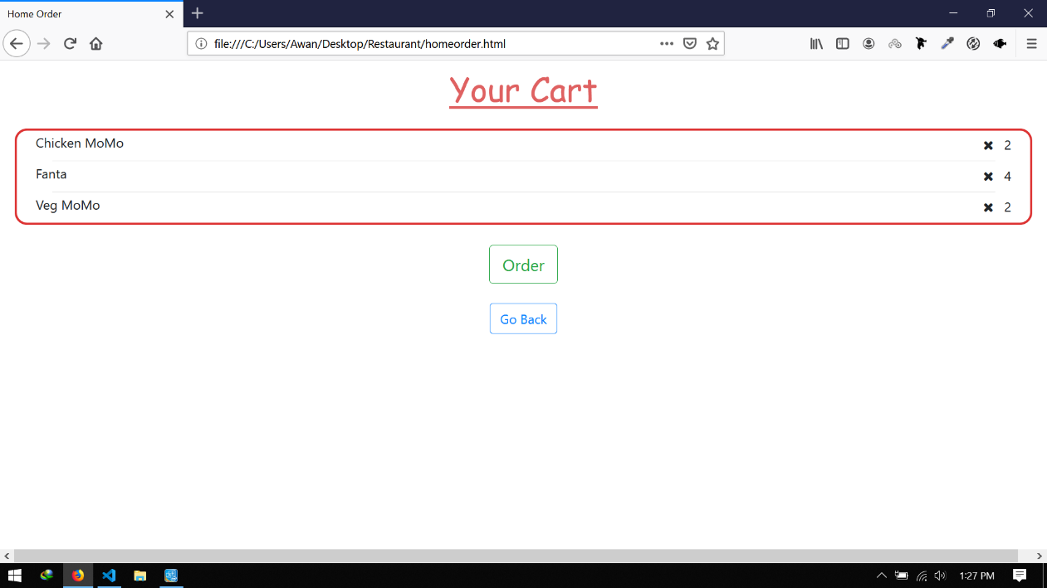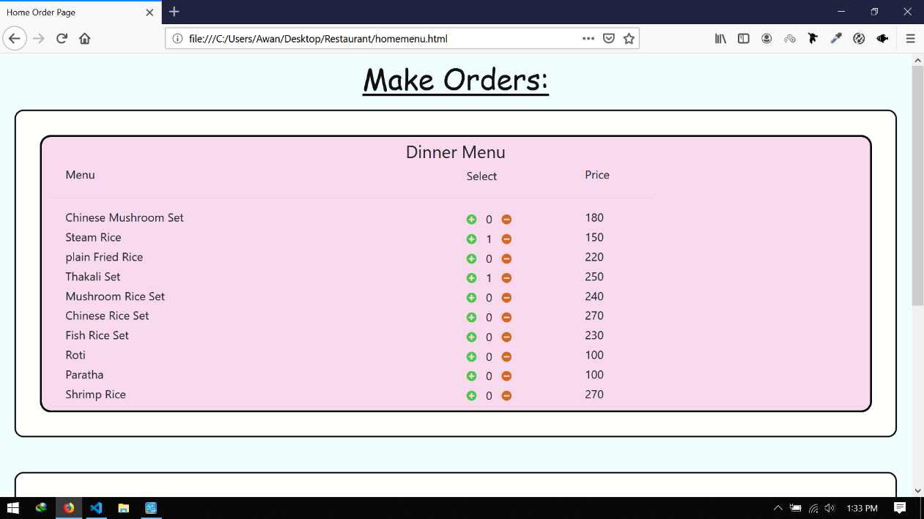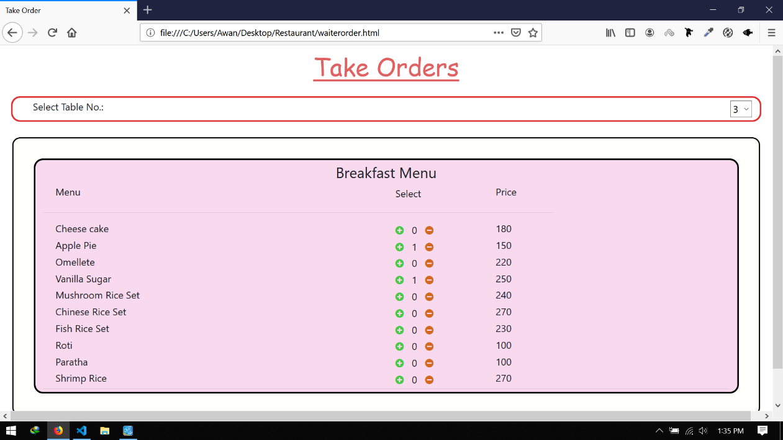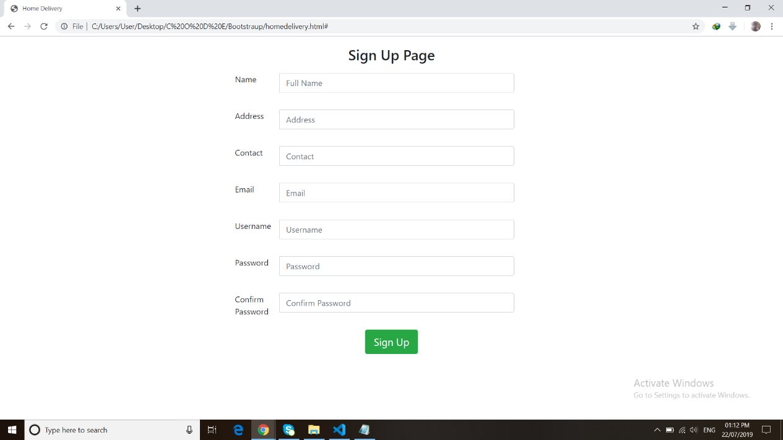

Figure : Cart

Figure : Menu

Figure : Signup page

Figure : Signup page

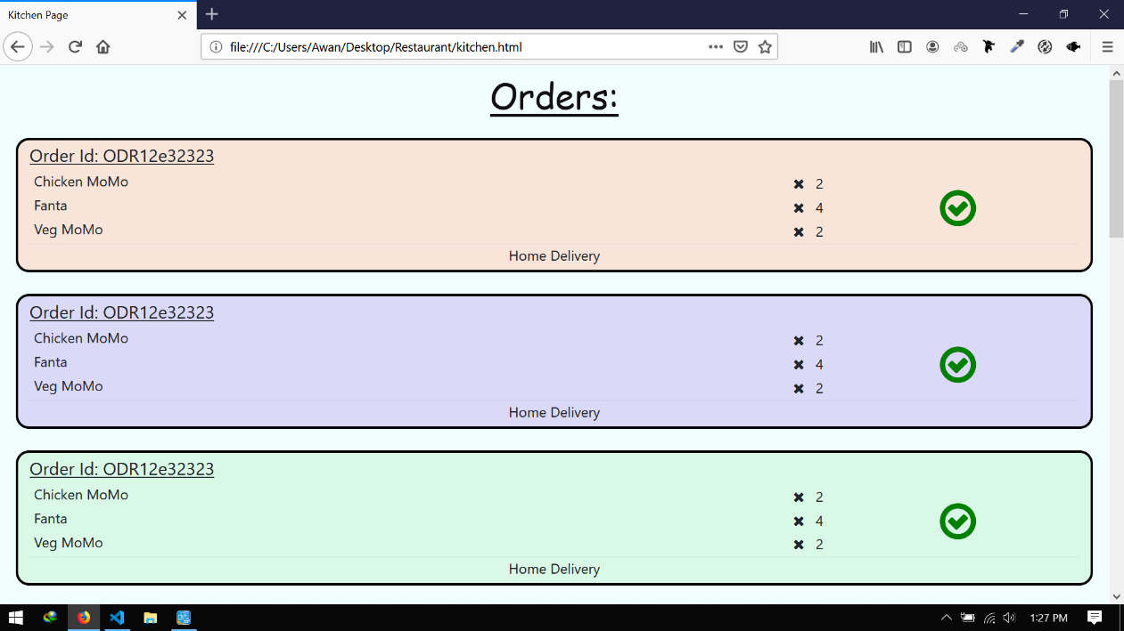

Figure : orders page

## Tables and ER diagrams

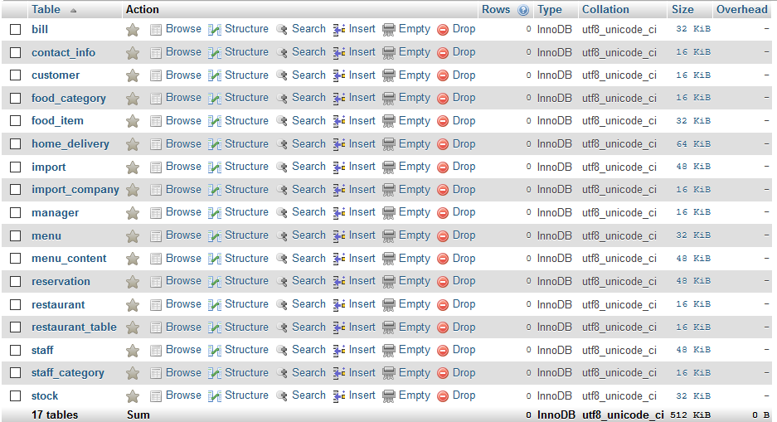

Figure : Tables before normalization

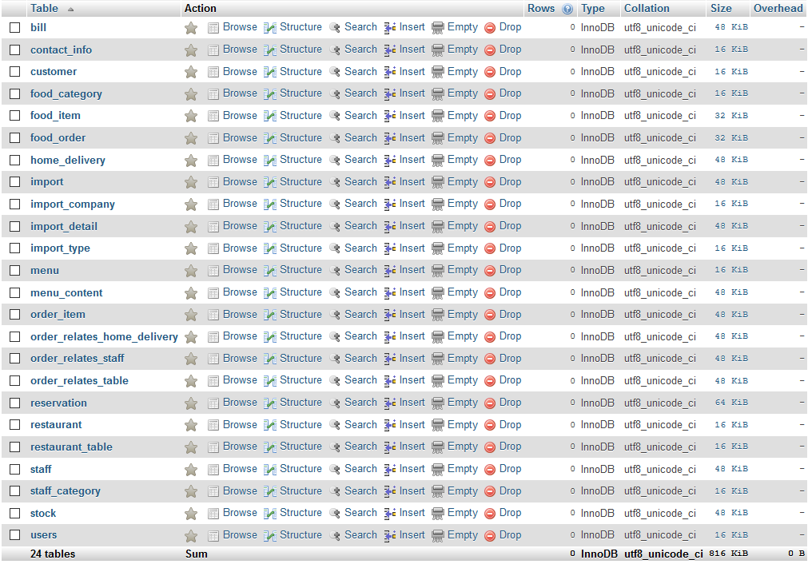

Figure : Tables after normalization

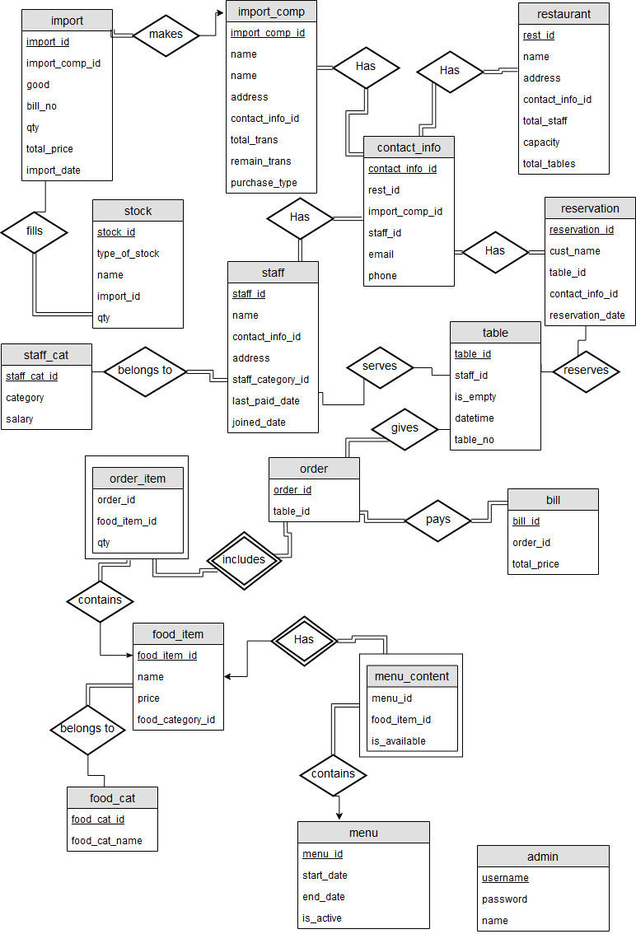

Figure 8: ER Diagram before normalization

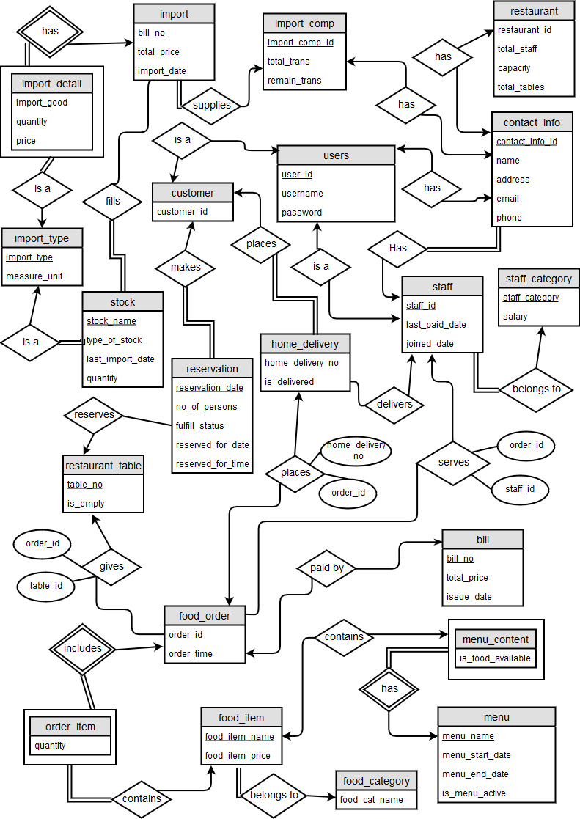

Figure : ER Diagram after normalization

Table of Contents

List of figures ii

Chapter 1: Introduction 1

1.1. Background 1

1.2. Objectives 1

Chapter 2: Synopsis 2

Chapter 3: Design and Implementation 3

3.1. System Requirement Specification 3

3.2. List of Entities with justification 3

3.3. List of attributes with justification 6

3.4. Candidate keys/ Primary keys/ Composite Keys 14

3.5. Partial dependency/ transitive dependency/functional dependency 18

3.6. Normalization 21

Chapter 4: Appendix 23

4.1. Database scripts 23

4.2. Screenshots 36

4.2.1. UI Screenshots 36

4.2.2. Tables and ER diagrams 38