Kathmandu University
Department of Computer Science and Engineering
Dhulikhel, Kavre



A Project Report on
Problem Assessment Project (EGPG 600)

Reinforcement Learning for Task Offloading
in 3-Tier Device-Edge-Cloud Systems
A Simulation-Based Study on Mobile Edge Computing Resource Management

Submitted By
Sarayu Gautam
Masters in Computer Engineering

Submitted To
Department of Computer Science and Engineering
Kathmandu University
September 2026
DECLARATION

I hereby declare that the work reported in this project report entitled "Reinforcement Learning for Task Offloading in 3-Tier Device-Edge-Cloud Systems", submitted to the Department of Computer Science and Engineering, Kathmandu University, in partial fulfillment of the requirements for the Problem Assessment Project (EGPG 600), is an authentic record of my own work. The simulation software, experiments and analysis presented here were carried out by me. All sources of information have been duly acknowledged, and this work has not been submitted elsewhere for the award of any other degree or diploma.

________________
Sarayu Gautam
Date: 2026-09-11

CERTIFICATE
This is to certify that the project report entitled "Reinforcement Learning for Task Offloading in 3-Tier Device-Edge-Cloud Systems", submitted by Sarayu Gautam to the Department of Computer Science and Engineering, Kathmandu University, in partial fulfillment of the requirements for the Problem Assessment Project (EGPG 600), is a record of bona fide work carried out under my supervision. The report is recommended for evaluation.

_______________________
Mr. Trailokya Ojha
Assistant Professor, Department of Computer Science and Engineering
Kathmandu University
Date: ____________

ACKNOWLEDGEMENT
I would like to express my sincere gratitude to my supervisor for continued guidance throughout this project, and to the Department of Computer Science and Engineering, Kathmandu University, for providing the academic framework and resources that made this work possible. I am grateful to the guided course faculty for the structured progression through mobile edge computing, Markov decision processes, discrete-event simulation and reinforcement learning that underpins this report. Finally, I thank my family and peers for their support and encouragement.

Abstract
Resource-constrained devices cannot meet the computational demands of modern mobile applications. But, sending every task to a distant cloud incurs high transmission latency and energy cost. Mobile Edge Computing (MEC) addresses this by placing computing resources one network hop from the device, creating a three-tier device-edge-cloud system in which each task can be executed locally, at the edge, or in the cloud. Because static, rule-based policies cannot adapt to changing network conditions, this project trains a tabular Q-Learning agent to make the decision instead. The agent learns through interaction with a custom discrete-event simulation built in Python and SimPy. The simulator models Poisson task arrivals, a Shannon-Hartley wireless uplink in which signal quality affects both transmission delay and energy, and a single-server queue at the edge server. Each task is scored by a composite cost weighted 0.7 on latency and 0.3 on energy. The agent is compared against five baselines: four fixed strategies (always-local, always-edge, always-cloud and random) and a myopic heuristic that observes the same state as the agent and picks the tier with the lowest cost under the known cost model, without any training. The simulator was first validated against M/M/1 queuing theory across four load levels, matching the analytical predictions to within 0.39%. Evaluated across five independent seeds with disjoint training data at a fixed channel condition, the agent reduces composite cost by 17.03% (± 0.22%) relative to the strongest fixed baseline, always-cloud, and by 21.20% (± 1.35%) relative to always-edge. Both improvements are statistically significant (paired t-test, p < 0.001). Against the untrained heuristic, however, the agent is 4.53% (± 0.44%) more expensive, also a statistically significant difference. The learned policy routes 70.8% of tasks to the edge and 29.2% to the cloud and never executes locally. The Q-table shows that local execution is strictly dominated at every network quality, because computing a mean task on the device takes approximately 1.1 s while even a badly degraded uplink transmits it far faster. A sweep of the cost weights yields a degenerate Pareto frontier, because device energy under offloading does not depend on the destination tier. This finding, together with the gap to the untrained heuristic, motivates continuous-control deep reinforcement learning (DRL) as the subsequent thesis phase, for which the project delivers an interpretable, reproducible tabular baseline and an honest account of where it falls short.

Table of Contents
List of Figures
List of Tables
List of Abbreviations
Chapter 1: Introduction 1
1.1 Background 1
1.2 Problem Statement 1
1.3 Proposed Solution 2
1.4 Objectives 2
1.5 Scope and Limitations 3
1.6 Report Organisation 3
Chapter 2: Literature Review 4
2.1 Introduction 4
2.2 Mobile Edge Computing: Architecture and Motivation 4
2.3 Computation Offloading: Problem Formulation 5
2.4 Multi-Tier Computing Architectures 6
2.5 Traditional and Heuristic Offloading Approaches 6
2.6 Reinforcement Learning Approaches to Task Offloading 7
2.6.1 Tabular Q-Learning and SARSA (2018-2020) 7
2.6.2 Deep Q-Networks (2020-2023) 8
2.6.3 Actor-Critic and DDPG Approaches 9
2.6.4 Federated and Multi-Agent DRL (2022-Present) 10
2.7 Smart City Edge Computing 10
2.8 Simulation Tools and Channel Modelling for Edge Computing Research 11
2.9 Summary of Research Gaps and Project Positioning 12
Chapter 3: Methodology and System Design 13
3.1 System Workflow Overview 13
3.2 Three-Tier System Model 15
3.3 Wireless Channel and Cost Model 16
3.4 MDP Formulation 16
3.4.1 State Space 16
3.4.2 Action Space 17
3.4.3 Reward Function 17
3.5 Q-Learning Algorithm 17
3.6 Simulation Environment 18
3.7 Baseline Strategies 19
3.8 Experimental Setup 20
Chapter 4: Results and Analysis 21
4.1 Simulator Validity (M/M/1 Queuing Theory) 21
4.2 Performance Comparison 21
4.3 Statistical Validation 23
4.3.1 Confidence Interval 23
4.3.2 Paired t-Test 23
4.3.3 Effect Size 24
4.4 Learned Policy Analysis 24
4.5 Pareto Trade-Off Analysis 26
Chapter 5: Conclusion and Future Work 28
5.1 Summary and Contributions 28
5.2 Limitations 28
5.3 Future Work (Thesis Phase) 29
References 31

List of Figures
Figure 3.1: End-to-end solution workflow for task generation, state construction, Q-Learning, execution, evaluation and validation.
Figure 3.2: Three-tier device-edge-cloud architecture and tier-specific execution cost model.
Figure 3.3: SimPy environment and Q-Learning interaction for a single task transition.
Figure 4.1: Average task latency by strategy
Figure 4.2: Q-Learning reward convergence over 2,000 training episodes
Figure 4.3: Learned greedy policy per state
Figure 4.4: Latency-energy operating points

List of Tables
Table 3.1: Q-Learning and simulation hyperparameters
Table 4.1: SimPy queue versus M/M/1 theory
Table 4.2: Average latency, energy and composite cost by strategy
Table 4.3: Statistical validation summary (five seeds)

List of Abbreviations
DDPG | Deep Deterministic Policy Gradient
DDQN | Double Deep Q-Network
DQN | Deep Q-Network
DRL | Deep Reinforcement Learning
ETSI | European Telecommunications Standards Institute
FIFO | First-In-First-Out
FL-DDPG | Federated Deep Deterministic Policy Gradient
IoT | Internet of Things
MARL | Multi-Agent Reinforcement Learning
MCC | Mobile Cloud Computing
MDP | Markov Decision Process
MEC | Mobile Edge Computing (also Multi-access Edge Computing)
RL | Reinforcement Learning
SARSA | State-Action-Reward-State-Action
SNR | Signal-to-Noise Ratio

Chapter 1: Introduction

1.1 Background
The number of connected Internet of Things (IoT) devices, smart sensors and mobile platforms has grown rapidly. The applications they run, such as video analytics, augmented reality and real-time environmental monitoring, demand processing power, memory and energy that individual resource-constrained devices cannot sustainably provide. Two architectural responses have historically been used. In Mobile Cloud Computing (MCC), tasks are sent to a powerful but distant cloud data centre, which provides effectively unlimited computing capacity at the cost of high transmission latency and uplink energy. In purely local execution, tasks run on the device itself, avoiding transmission but draining the battery and often failing to meet latency requirements.
Mobile Edge Computing (MEC) introduces an intermediate tier. Edge servers deploy one network hop from the device, for example at base stations or roadside units. An edge server offers more computing power than the device and lower latency and transmission energy than the cloud. The result is a three-tier device-edge-cloud system in which each generated task can be executed locally, offloaded to the edge, or offloaded to the cloud. Choosing the right tier for each task, under changing network conditions, is the computation offloading problem this project addresses.

1.2 Problem Statement
Computation offloading decisions involve a fundamental tension between two conflicting objectives, task completion latency and device energy consumption, under network conditions that vary over time. Traditional offloading policies rely on fixed rules or heuristics, for example thresholds on task size or battery level, or optimisation derived for a fixed, known channel model. These static methods cannot adapt when the bandwidth, server load or signal quality changes. A rule calibrated for light traffic performs poorly at peak load. An optimisation derived for one channel breaks down under fading or interference. The problem is therefore to learn an adaptive offloading policy that, observing the current system state, selects the execution tier that minimises a combined latency-energy cost across a wide range of operating conditions.

1.3 Proposed Solution
This project formulates three-tier task offloading as a Markov Decision Process (MDP) and solves it with tabular Q-Learning, a model-free reinforcement learning algorithm that learns the value of each action in each discretised system state through trial-and-error interaction. The agent is trained and evaluated inside a custom discrete-event simulation written in Python and SimPy, which models random task arrivals, a realistic wireless channel and edge-server queueing without requiring physical hardware. Tabular Q-Learning is chosen deliberately for its interpretability. The learned policy is a directly inspectable table, in contrast to the opaque neural networks used in deep reinforcement learning. The agent is benchmarked against five baselines, four fixed strategies and a state-aware but untrained heuristic, to establish how much a learned policy improves upon static strategies and upon an informed non-learning one.

1.4 Objectives
The objectives of this project are:
- To design and implement a discrete-event simulation of a three-tier device-edge-cloud system in Python and SimPy, modelling task arrivals, wireless transmission, computation and edge queueing.
- To formulate the task-offloading problem as a Markov Decision Process and implement a tabular Q-Learning agent that learns an offloading policy minimising a composite latency-energy cost.
- To implement baseline strategies for comparison: four fixed strategies (always-local, always-edge, always-cloud and random) and a myopic cost-minimising heuristic that uses the same state information as the agent but requires no training.
- To validate the simulator against analytical queueing theory and to evaluate, with statistical rigour, whether the Q-Learning agent improves upon the best fixed baseline, with a target improvement of at least 10% relative to the always-edge baseline used in the project proposal. A myopic, state-aware heuristic baseline was added during evaluation as a stronger point of comparison than any fixed strategy.

1.5 Scope and Limitations
The scope of this project is a simulation-based study. The contributions are an interpretable, reproducible Q-Learning baseline and the simulation environment itself; the project does not claim state-of-the-art performance against deep learning methods. The principal limitations are as follows.
- First, the study uses tabular Q-Learning, which requires the system state to be discretised into bins and does not scale to very large state spaces.
- Second, the work is single-agent: it models one device making offloading decisions rather than many devices competing for shared edge resources.
- Third, the cost model makes device energy independent of the offload destination, which removes any latency-energy trade-off from the discrete action space.
- Fourth, all results are obtained in simulation rather than on physical MEC infrastructure. These limitations directly motivate the subsequent thesis phase, which will explore deep and continuous-control reinforcement learning.
Section 5.2 states the full set of limitations precisely.

1.6 Report Organisation
The remainder of this report is organised as follows. Chapter 2 reviews the literature on mobile edge computing, computation offloading and reinforcement learning, and identifies the research gap. Chapter 3 presents the system design and methodology, including the MDP formulation, the Q-Learning algorithm and the simulation environment. Chapter 4 reports and analyses the results, covering simulator validation, performance comparison, statistical validation, learned policy analysis and the Pareto trade-off. Chapter 5 concludes and outlines the future thesis-phase work.

Chapter 2: Literature Review

2.1 Introduction
This chapter reviews the literature relevant to a Q-Learning agent that makes task offloading decisions in a three-tier device-edge-cloud system. The review traces the field from foundational Mobile Edge Computing (MEC) concepts and traditional rule-based offloading approaches, through early reinforcement learning methods, to the deep reinforcement learning (DRL) techniques that dominate contemporary research. It concludes by identifying the precise research gap that this study addresses: the absence of a reproducible and interpretable Q-Learning baseline for the three-tier terrestrial IoT offloading problem in a Python-based simulation environment.

2.2 Mobile Edge Computing: Architecture and Motivation
Mobile Edge Computing (MEC), initially standardised by the European Telecommunications Standards Institute (ETSI) and later broadened to Multi-access Edge Computing, positions computing, storage and networking resources at the edge of the access network. In the seminal survey by Mao et al. (2017), MEC is defined as a technology that pushes mobile computing, network control and storage to the network edges to enable computation-intensive and latency-critical applications on resource-limited devices. This survey remains a foundational reference, identifying joint radio and computational resource management as the central research challenge and establishing that MEC can deliver substantial reductions in both task execution latency and mobile energy consumption relative to Mobile Cloud Computing.
The case for MEC stems from a fundamental tension. A device that processes tasks locally consumes battery rapidly and may miss latency requirements, whereas a device that sends all tasks to a remote cloud incurs substantial transmission delay and uplink energy, particularly for large payloads over congested networks. Edge servers offer a middle ground, and effective resource management must exploit all three tiers. This relevance extends to smart cities, healthcare IoT, autonomous vehicles and industrial automation, where workloads have heterogeneous urgency and size profiles, making static offloading rules inadequate.

2.3 Computation Offloading: Problem Formulation
Computation offloading transfers a task from a resource-constrained device to a more capable remote node. The literature distinguishes binary offloading, in which each task is executed entirely at one location, from partial offloading, in which a task is split across locations at the cost of greater algorithmic complexity (Mao et al., 2017). This study adopts binary offloading across three destinations, local device, edge server or cloud, consistent with comparable studies (Alfakih et al., 2020; Shuai & Xie, 2024) and providing a tractable action space for Q-Learning.
The standard optimisation objective in the offloading literature is a weighted sum of task completion delay T and device energy consumption E:
Cost = alpha * T + beta * E
where alpha and beta are weighting coefficients encoding the application’s latency-energy preference, with alpha + beta = 1 (Alfakih et al., 2020; Chen & Liu, 2022). The reinforcement learning reward in this study is the negative of this cost, because RL maximises cumulative reward while the goal is cost minimisation.
The problem is naturally modelled as a Markov Decision Process (MDP) with state space S, action space A, transition function T(s, a, s′) and reward function R(s, a). The state captures the current system snapshot, including task characteristics, network quality and resource availability; the action is the offloading destination; and the optimal policy maps each state to the action that minimises expected cumulative discounted cost. When the state space is finite and small enough to enumerate, this MDP can be solved with tabular Q-Learning; when it grows large, neural-network approximation is required. This study addresses the first case, establishing an interpretable tabular Q-Learning baseline for a three-tier system.

2.4 Multi-Tier Computing Architectures
Early offloading literature predominantly considered two-tier device-to-cloud or device-to-edge architectures. Although these validated the core offloading concept, they failed to exploit the complementary capabilities of edge and cloud tiers simultaneously, which drove the development of three-tier architectures. In the three-tier model, the device (Tier 1) provides zero-transmission-latency execution but is severely constrained in CPU, memory and battery; the edge server (Tier 2) offers moderate computing capacity at low latency, one hop from the device; and the cloud server (Tier 3) provides near-unlimited computing at the cost of higher transmission latency and energy. A well-designed agent learns to route each task to the tier that minimises the weighted cost under current conditions.
Similar three-tier architectures appear in satellite edge computing (Shuai & Xie, 2024) and vehicular edge computing (Shi et al., 2023). The analytical treatment of three-tier systems using queueing theory provides a mathematical basis for simulation validation. In a three-tier cloud-edge-fog model with probabilistic offloading and Poisson arrivals, the steady-state delay and utilisation can be predicted analytically (Hwang et al., 2021). Comparing simulation outputs against these analytical predictions using the M/M/1 queue benchmark is the standard method for establishing simulator validity, and this validation is a required step in this study.

2.5 Traditional and Heuristic Offloading Approaches
Prior to machine learning, offloading decisions were made using fixed mathematical rules and heuristics, including threshold-based policies, Lyapunov optimisation for online resource allocation under stochastic conditions (Bi et al., 2021), convex optimisation for joint offloading and resource allocation (You et al., 2017), and game-theoretic models for multi-user scenarios (Chen et al., 2016). Mao et al. (2017) provide a comprehensive taxonomy of these methods. Their principal strength is computational efficiency: a threshold rule requires no training, state observation or memory and can run in microcontroller firmware with negligible overhead.
However, these approaches share a critical limitation: they are static. They assume fixed, known network parameters and cannot adapt to the dynamic, time-varying conditions of real deployments. A rule calibrated for morning traffic performs poorly at peak hours; a convex solution derived for a specific channel model breaks down under fading or interference. This rigidity is the core motivation for applying reinforcement learning, which can adapt its policy continuously from experience without an explicit model of the dynamics.

2.6 Reinforcement Learning Approaches to Task Offloading
Reinforcement learning (RL) offers a fundamentally different approach. Rather than encoding fixed rules, an RL agent learns optimal behaviour through trial and error, receiving a scalar reward after each action. The MDP formulation of the offloading problem (Section 2.3) maps directly onto the RL framework. This section traces the evolution of RL methods for offloading from early tabular approaches to the DRL techniques that dominate current research.

2.6.1 Tabular Q-Learning and SARSA (2018-2020)
Q-Learning, introduced by Watkins and Dayan (1992), is a model-free, off-policy algorithm that learns a table of action-value estimates Q(s, a) through iterative updates using the Bellman equation. The first wave of RL-based offloading papers (2018-2020) applied Q-Learning and its variants to show that adaptive policies outperform static heuristics under dynamic network conditions. Alfakih et al. (2020) proposed a SARSA-based algorithm, an on-policy variant, for MEC resource management, minimising system cost (energy and delay) in a multi-server, multi-user architecture with three offloading options: the nearest edge server, an adjacent edge server and the remote cloud. This multi-tier framing anticipates the three-tier hierarchy of this study and represents one of the first systematic RL treatments of multi-destination offloading, although its multi-server architecture introduces complexity that limits scalability.
Shuai and Xie (2024) provide the most structurally comparable work to this study. Their Q-Learning-based offloading strategy operates on a three-tier framework of collaborative edge devices, edge data centres and cloud data centres in a satellite edge computing environment. It optimizes communication latency, energy consumption and task success rate, and outperforms baseline algorithms across all three metrics. However, the satellite context introduces domain-specific constraints, such as orbital mechanics, long propagation delays and variable coverage, that are absent in terrestrial IoT and smart-city deployments. No equivalent Q-Learning baseline exists for the general-purpose device-edge-cloud architecture in terrestrial scenarios; developing such a baseline is the primary contribution of this study. More recently, Dash et al. (2026) proposed a modified Q-Learning approach for joint task offloading and resource allocation in MEC, confirming that tabular methods remain of active research interest; their work, however, targets resource allocation within a two-tier setting rather than three-tier destination selection.
The fundamental limitation of tabular Q-Learning is scalability: the Q-table must enumerate every state-action pair, so its size grows exponentially with the number of state variables. For a system with a modest number of discrete state variables this is manageable and the policy remains fully interpretable; for large-scale multi-user, multi-server scenarios the table becomes intractable and neural-network approximation is necessary.

2.6.2 Deep Q-Networks (2020-2023)
The Deep Q-Network (DQN), introduced by Mnih et al. (2015), replaces the Q-table with a neural network that approximates Q(s, a; theta), enabling generalisation across unseen states. Two innovations stabilize DQN training: an experience replay buffer that breaks temporal correlations between samples, and a target network that provides stable training targets. These were subsequently imported into MEC offloading research. The Double Deep Q-Network (DDQN) improves on DQN by decoupling action selection from value estimation, reducing the overestimation bias that can destabilise training. Sun et al. (2026) apply a DDQN with an action mask that prevents the agent from selecting infeasible actions to a three-tier cloud-edge-device architecture, jointly optimising delay, energy, mobility and economic cost; this illustrates the direction the field has taken and the performance ceiling against which an interpretable tabular baseline must be positioned.
The transition from Q-Learning to DQN is not cost-free. A Q-table is fully transparent: an operator can inspect any row and see the value assigned to each action in that state. A neural network is an opaque function approximator whose internal representations are not directly interpretable. In smart-city deployments, where operators must audit, justify and override automated decisions, interpretability is a practical operational requirement, not merely an academic concern. This motivates the need for a Q-Learning baseline even in an era dominated by DRL.

2.6.3 Actor-Critic and DDPG Approaches
The Deep Deterministic Policy Gradient (DDPG), introduced by Lillicrap et al. (2016), extends DRL to continuous action spaces using an actor that maps states to actions and a critic that evaluates state-action pairs. This enables joint optimisation of discrete offloading decisions and continuous resource-allocation variables such as CPU frequency and transmission power, making DDPG a powerful tool for the full joint optimisation problem.
Chen and Liu (2022) apply Federated DDPG (FL-DDPG) to smart-city MEC, combining federated learning with DDPG to address privacy. In their system, IoT devices offload tasks to MEC servers or the central cloud subject to resource and latency constraints; federated learning shares model gradient updates rather than raw data, improving both training performance and privacy compared with vanilla DDPG. It is important to note that federated learning in this sense has a specific technical meaning: multiple agents share model updates privately without exchanging raw data. This is categorically different from merely distributing computation across tiers. Because the present study uses a single agent and does not implement cross-agent parameter sharing, it adopts the three-tier device-edge-cloud terminology rather than the federated label; federated multi-agent learning is identified as future work (Section 5.3).

2.6.4 Federated and Multi-Agent DRL (2022-Present)
The most recent phase of the field, from approximately 2022 to the present, is characterised by multi-agent DRL, federated approaches and integration with 6G network architectures. Survey evidence (Peng et al., 2024) confirms this trajectory, identifying multi-agent coordination, 6G-enabled edge networks and meta-learning as dominant themes. Federated DRL approaches, in which distributed edge nodes collaboratively train a shared model without sharing raw data, address privacy in sensitive scenarios such as healthcare IoT, at the cost of communication overhead and architectural complexity. Multi-agent DRL introduces game-theoretic dynamics, in which the optimal policy for one agent depends on the policies of others, capturing the competitive nature of multi-user MEC but substantially complicating training and analysis. The explosion of publications in this space is precisely why a simple, interpretable baseline is needed: complex multi-agent DRL results are difficult to compare without a well-characterised reference point.

2.7 Smart City Edge Computing
Smart cities provide the primary application context for this study. Smart-city infrastructure integrates diverse IoT endpoints, including traffic sensors, environmental monitors, surveillance cameras and industrial automation devices, each generating latency-sensitive and computation-intensive workloads with heterogeneous characteristics. Mobile edge servers positioned throughout the urban area act as Tier 2 nodes, while a central cloud data centre serves as Tier 3. Chen and Liu (2022) address this context directly, demonstrating significant performance improvements over fixed baselines and vanilla DDPG in a multi-user smart-city scenario, though the complexity of FL-DDPG limits its interpretability.
The smart-city context also motivates the energy dimension. IoT devices deployed in urban infrastructure are often battery-powered or energy-harvesting, so minimising energy extends operational lifetime and reduces maintenance. The latency-energy trade-off, controlled by the weighting parameters alpha and beta, is therefore a practical design parameter. This study sweeps these weights and reports the result as discussed in Chapter 4. The frontier proves to be degenerate under discrete three-action offloading, for the structural reason analysed in Section 4.5, which is itself an informative result about the limits of discrete-action policies.

2.8 Simulation Tools and Channel Modelling for Edge Computing Research
Reproducible simulation is essential for validating offloading algorithms before deployment, since direct experimentation on live MEC infrastructure is expensive, unrepeatable and difficult to control. The dominant simulation tool in MEC offloading literature is EdgeCloudSim (Sonmez et al., 2018), a Java-based platform built on CloudSim that models mobile applications, edge servers, network conditions and device mobility. Its maturity makes it a reference, but its Java implementation creates a language barrier for the machine-learning research community, which predominantly works in Python. Souza et al. (2023) address this gap with EdgeSimPy, a Python-based edge computing simulation framework built on discrete-event principles; however, EdgeSimPy focuses on resource provisioning and service migration rather than on RL-driven three-tier offloading with explicit latency-energy cost functions.
This study therefore uses a custom Python/SimPy simulation tailored to the three-tier offloading decision problem. The simulator models task arrivals as a Poisson process, tracks processing queues at the edge, and, importantly, computes the wireless uplink data rate using the Shannon-Hartley theorem, rate = B * log2(1 + SNR), where the signal-to-noise ratio (SNR) is derived from the current network-quality state. This makes network quality a variable that genuinely affects cost: a weak signal yields a lower data rate, so the same task takes longer and consumes more energy to transmit. The validity of the simulator is established through comparison against M/M/1 queueing-theory predictions for individual server stages, following the analytical three-tier queueing treatment of Hwang et al. (2021).

2.9 Summary of Research Gaps and Project Positioning
The preceding review identifies four interconnected gaps that motivate this study.
First, no reproducible Q-Learning baseline exists for the general-purpose terrestrial three-tier device-edge-cloud offloading problem. The most comparable work (Shuai & Xie, 2024) applies Q-Learning in a satellite-specific context with domain constraints absent from smart-city IoT, while Alfakih et al. (2020) use SARSA in an effectively two-tier architecture. The rest of the field moved directly from early tabular methods to DQN and DDPG without establishing an interpretable tabular baseline for the three-tier terrestrial case.
Second, existing simulation tools for MEC offloading are predominantly Java-based (EdgeCloudSim) or focused on resource provisioning (EdgeSimPy). No published work was identified that implements a Python/SimPy simulation specifically for RL-driven three-tier offloading with explicit latency-energy cost optimisation; a Python-based simulator reduces barriers to reproduction and extension by the machine-learning community.
Third, the literature lacks a study that characterises the performance ceiling of Q-Learning in a three-tier system and uses those measurements to formally motivate the transition to DRL. Survey work (Peng et al., 2024) describes the historical evolution, but no study instantiates it as a controlled experiment.
Fourth, existing smart-city three-tier offloading work (Chen & Liu, 2022) uses opaque DRL models whose decision-making is not directly inspectable. An interpretable Q-table approach, in which every state-action value is directly readable, provides the transparency operators need to audit and override decisions.
This study is therefore positioned as a clean, reproducible, interpretable Q-Learning baseline for three-tier device-edge-cloud task offloading in a Python/SimPy simulation. The contribution is framed not as claiming state-of-the-art performance, but as providing the missing baseline that makes meaningful comparison possible and that explicitly motivates DRL as the necessary next step.

Chapter 3: Methodology and System Design

3.1 System Workflow Overview
Figure 3.1 summarises the end-to-end workflow of the project, from the raw data source through to the final evaluated outcome. Tasks originate from the SimPy discrete-event simulator (Section 3.6), which draws Poisson task arrivals, sizes, computational complexity and network quality. These raw values are converted into a discrete MDP state (Section 3.4.1). The tabular Q-Learning agent (Section 3.5) is trained on this stream of states using an ε-greedy policy over 2,000 episodes. Two independent checks are then applied before any performance claim is made: the simulator itself is validated against analytical M/M/1 queuing theory (Section 4.1), and the trained agent is evaluated greedily against the four fixed baselines and the Greedy Heuristic across five independently seeded runs with disjoint training data, with a paired t-test establishing statistical significance (Section 4.3). The outcome is a learned offloading policy together with the cost-reduction and Pareto-sweep results reported in Chapter 4.
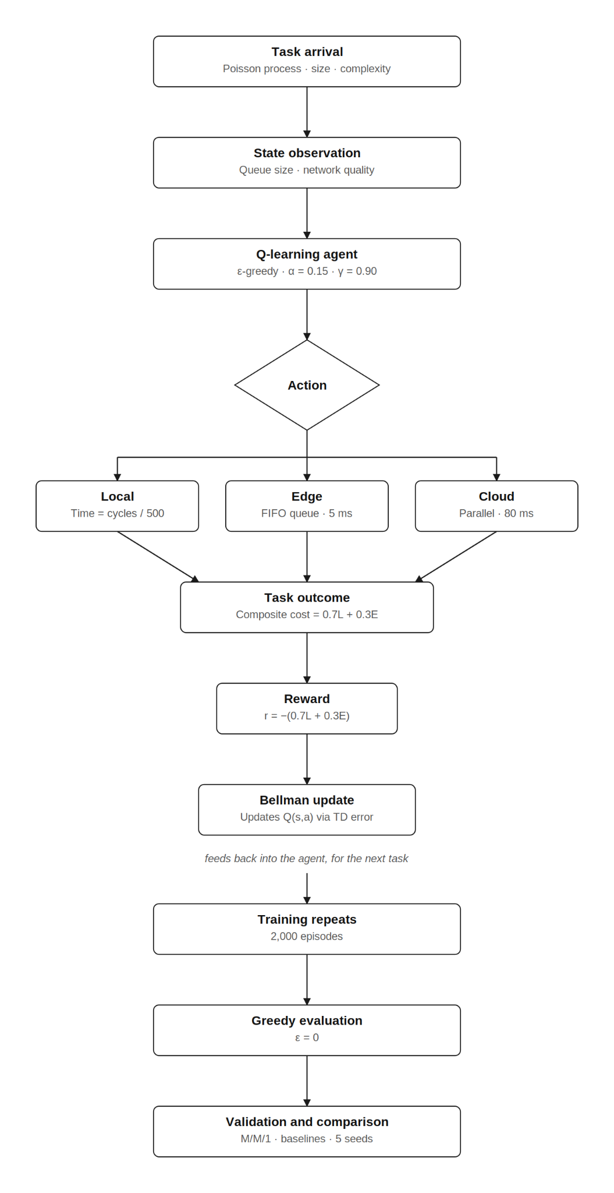
Figure 3.1: End-to-end solution workflow for task generation, state construction, Q-Learning, execution, evaluation and validation.

3.2 Three-Tier System Model
The system comprises three computing tiers. Tier 1 is the local device, with a modest processor (modeled at 500 million CPU cycles per second) and a fixed compute power draw of 0.5 W. Local execution incurs no transmission cost but is slow for demanding tasks. Tier 2 is the edge server, with substantially higher processing speed (8,000 million cycles per second), a short propagation delay (5 ms) and a single-server First-In-First-Out queue. The queue is unbounded: no task is ever rejected, and at the arrival rate studied (lambda = 6 tasks/s against an effective service rate of approximately 14.5 tasks/s, utilisation rho approximately 0.41) the queue is stable, so a capacity bound would not bind. Tier 3 is the cloud server, with the highest processing speed (30,000 million cycles per second) but the longest propagation delay (80 ms) and effectively unlimited capacity. Tasks are generated at the device and must be assigned to exactly one tier.
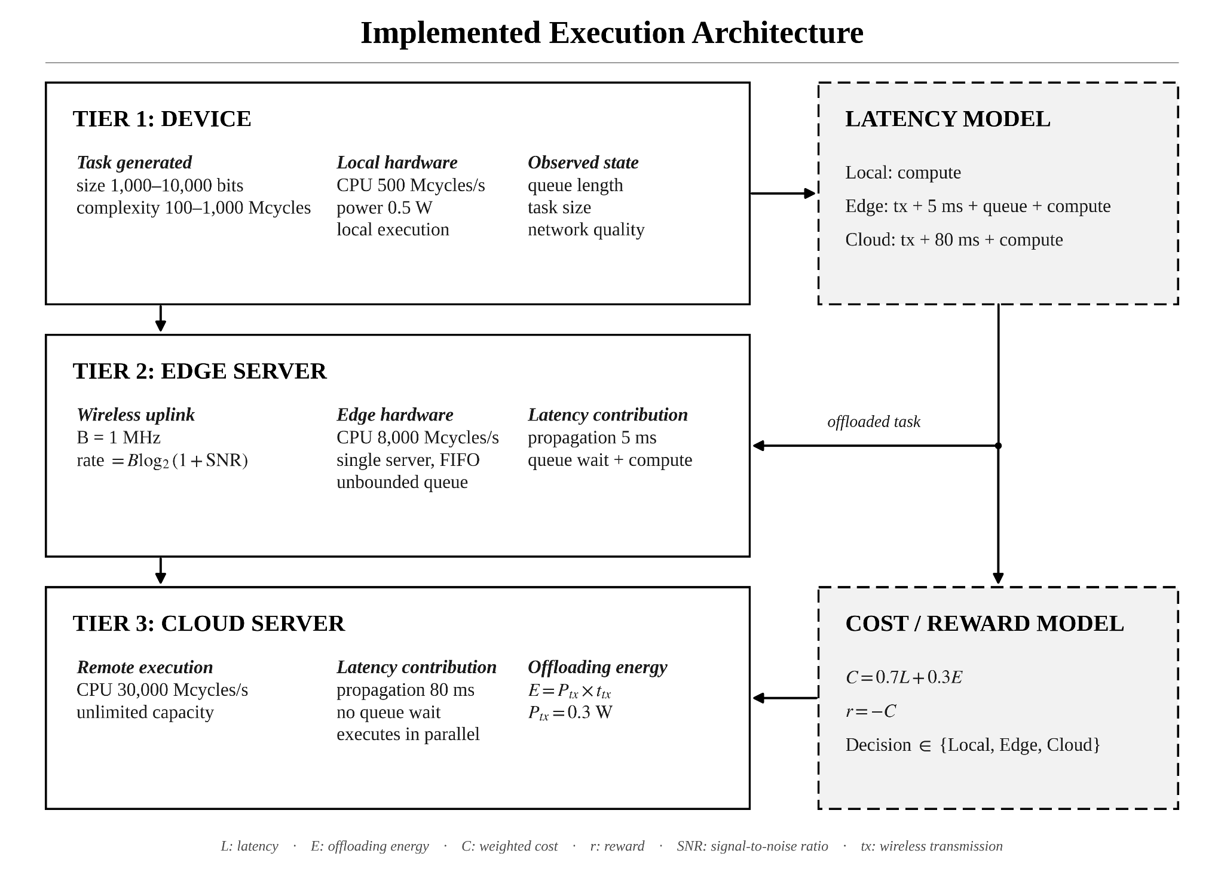
Figure 3.2: Three-tier device-edge-cloud architecture and tier-specific execution cost model.

3.3 Wireless Channel and Cost Model
Offloading to the edge or cloud requires transmitting the task over a wireless uplink. The achievable data rate is computed using the Shannon-Hartley theorem:
rate = B * log2(1 + SNR)
where B is the channel bandwidth (1 MHz) and the signal-to-noise ratio (SNR) is mapped from the current network-quality value on a decibel scale ranging from -10 dB (poor signal, approximately 137 Kbps) to 30 dB (excellent signal, approximately 10 Mbps). The transmission delay of a task is its size in bits divided by this rate, and the transmission energy is the transmission power (0.3 W) multiplied by the transmission delay. This design ensures that network quality genuinely affects both latency and energy, rather than being an inert state variable. The total latency and energy for each tier are:
- Local: latency and energy from computation only (no transmission).
- Edge: transmission delay + propagation (5 ms) + queue wait + computation, with transmission energy.
- Cloud: transmission delay + propagation (80 ms) + computation, with transmission energy.
Each task is scored by a composite cost combining latency and energy with weights of 0.7 and 0.3 respectively, reflecting a latency-sensitive application:
Cost = 0.7 * latency + 0.3 * energy

3.4 MDP Formulation
The offloading problem is formulated as a Markov Decision Process. The state, action and reward are defined as follows.

3.4.1 State Space
The agent observes a discretised state. In the base configuration the state is a tuple of three binned variables: the edge-server queue length (4 bins, with boundaries at 1, 3 and 6), the task size (3 bins, with boundaries at 3,000 and 7,000 bits) and the network quality (3 bins, with boundaries at 0.4 and 0.75). This yields 4 × 3 × 3 = 36 nominal states, of which the 24 with an edge queue length below six are reachable at the arrival rate studied; Section 4.4 reports the coverage actually achieved. A mobility extension adds device velocity (3 bins) and a network-quality trend (3 bins), expanding the nominal state space to 4 × 3 × 3 × 3 × 3 = 324 states, which remains tractable for a tabular method.

3.4.2 Action Space
The action space has three discrete actions: execute locally (0), offload to the edge (1), or offload to the cloud (2).

3.4.3 Reward Function
Because reinforcement learning maximises cumulative reward while the objective is cost minimisation, the reward is the negative of the composite cost:
reward = - (0.7 * latency + 0.3 * energy)
A decision that yields low latency and energy therefore receives a reward close to zero (the best achievable), while an expensive decision receives a large negative reward.

3.5 Q-Learning Algorithm
The agent maintains a Q-table mapping each state to a vector of action-value estimates, one per action, initialised to zero. Because every reward in this problem is strictly negative, a zero initialisation is optimistic: an action that has never been tried in a given state retains a value of zero, which exceeds the value of every action that has been tried. During training this is desirable, since it drives systematic exploration of untried actions. At greedy evaluation time, however, it would allow an untried action to win the arg-max and be reported as a learned decision. The implementation therefore records a visit count for every state-action pair and restricts the greedy arg-max to actions that have actually been tried; states never visited during training are reported as untrained rather than being assigned a spurious preference. After each task the agent updates the value of the chosen action using the Bellman equation:
Q(s, a) <- Q(s, a) + alpha * [ r + gamma * max Q(s′, a′) - Q(s, a) ]
where alpha is the learning rate, gamma is the discount factor, r is the immediate reward and s′ is the next state. Action selection uses an epsilon-greedy policy: with probability epsilon the agent explores a random action, and otherwise it exploits the action with the highest current Q-value. Epsilon starts at 1.0 (fully exploratory) and decays by a factor of 0.998 per episode toward a floor of 0.05, ensuring broad early exploration that settles into exploitation as learning progresses. Table 3.1 lists the hyperparameters.
Table 3.1: Q-Learning and simulation hyperparameters.
Parameter | Symbol | Value
Learning rate | alpha | 0.15
Discount factor | gamma | 0.90
Initial exploration | epsilon_start | 1.0
Final exploration | epsilon_end | 0.05
Exploration decay | - | 0.998 per episode
Training episodes | - | 2,000
Latency weight | w_lat | 0.7
Energy weight | w_eng | 0.3
Task arrival rate | lambda | 6 tasks/second (Poisson)
Channel bandwidth | B | 1 MHz

3.6 Simulation Environment
The environment is a custom discrete-event simulation built with SimPy. Tasks arrive following a Poisson process at an average rate of 6 per second; each task has a randomly drawn size (1,000-10,000 bits) and computational complexity (100-1,000 million CPU cycles). Each training episode simulates 100 seconds of system time, yielding approximately 600 tasks and therefore approximately 600 Q-Learning updates per episode, or approximately 1.2 million updates over the full 2,000-episode training run. Network quality is held constant within an episode and re-drawn from a uniform distribution over the full range [0.1, 1.0] at the start of each episode, so that every network-quality bin, including the poor-signal bin, is visited during training. The simulation advances from event to event (task arrival, task completion) rather than in fixed time steps, faithfully representing queueing dynamics at the edge server. The use of simulation means experiments are fully reproducible, cost nothing to run and allow controlled parameter sweeps that would be impossible on physical hardware.
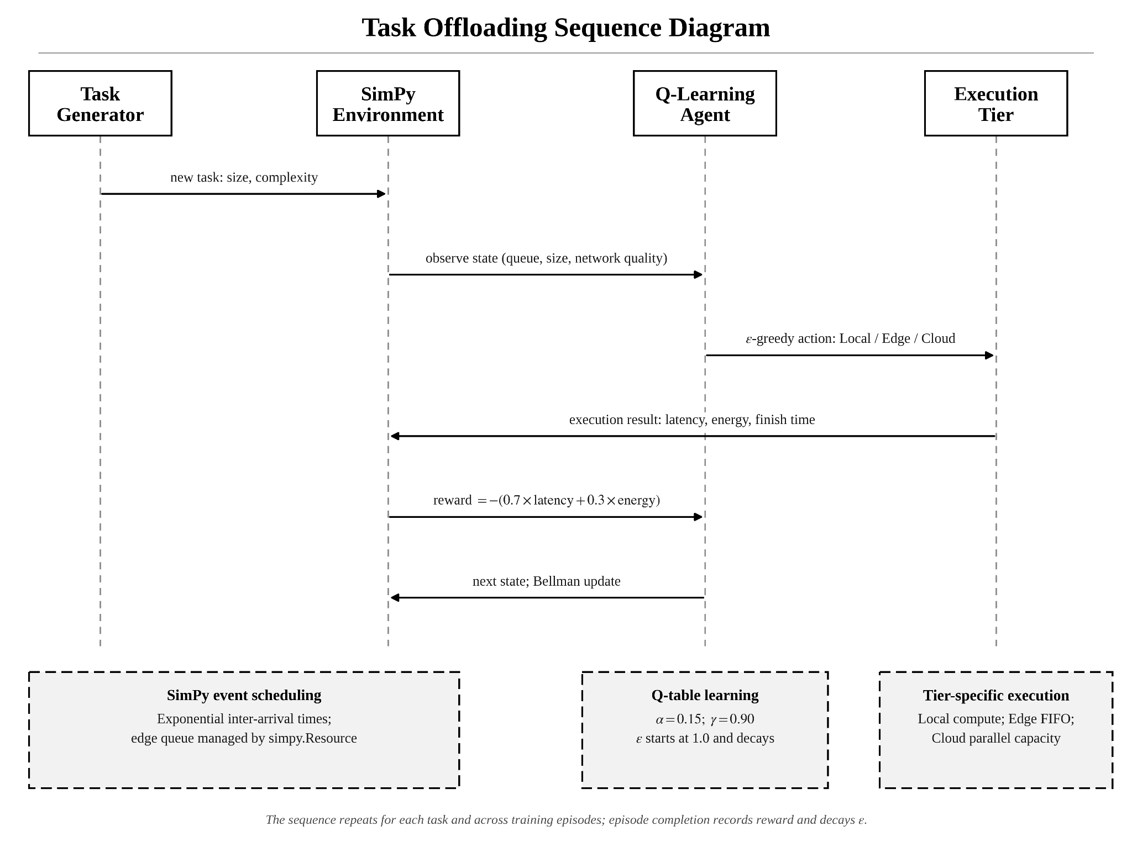
Figure 3.3: SimPy environment and Q-Learning interaction for a single task transition.

3.7 Baseline Strategies
To quantify the benefit of learning, the Q-Learning agent is compared against five baseline strategies. Four are fixed and state-blind: Always-Local (every task executed on the device), Always-Edge (every task offloaded to the edge), Always-Cloud (every task offloaded to the cloud) and Random (each task assigned to a uniformly random tier). The fifth, the Greedy Heuristic, is state-aware but untrained: for each arriving task it computes the same cost model the reward function uses, once per candidate tier, from the task's size and complexity, the current network quality and an estimate of the edge queue wait, and selects the tier with the lowest estimated cost. It holds no Q-table and does not improve with experience. A learned policy must outperform the best of these to justify its added complexity. Beating the four fixed strategies shows only that adapting to state helps at all. Beating the Greedy Heuristic is the stronger test, because it isolates the value of learning a policy from interaction alone, without direct access to the cost model the heuristic is given.

3.8 Experimental Setup
Each Q-Learning agent is trained for 2,000 episodes of 100 simulated seconds each, with network quality re-drawn per episode from the full range [0.1, 1.0], and is then evaluated greedily (epsilon set to zero). All greedy evaluations are conducted at a single fixed, documented channel condition, network quality 0.9, so that the headline comparison, the five-seed statistics and the Pareto sweep are all measured under identical conditions. The evaluation seed is offset well beyond the training seed range, so the evaluation workload is disjoint from every episode the agent trained on. To ensure results are not an artefact of a single random seed, the entire train-and-evaluate procedure is repeated across five independent seeds (42, 123, 456, 789, 999). Each seed trains on its own block of ten thousand simulation seeds (seed × 10,000 + episode number), so the five training runs draw from non-overlapping simulated workloads rather than merely starting from different labels. For each seed the agent is compared against the best-performing fixed baseline on that same seed, so the reported improvement is measured against the strongest fixed competitor rather than a weak one, and separately against the Greedy Heuristic, which is not fixed but is also not learned. Performance is measured by average task latency, average energy and the composite cost. The improvement is assessed statistically using a 95% confidence interval and a paired t-test (Section 4.3). Separately, the simulator engine is validated against analytical M/M/1 queuing theory before any performance claims are made.

Chapter 4: Results and Analysis

4.1 Simulator Validity (M/M/1 Queuing Theory)
Before drawing any conclusions from the simulator, its correctness was established by configuring the edge queue as a single-server M/M/1 system (Poisson arrivals, exponential service, one server) and comparing the measured average time in system against the closed-form prediction W = 1 / (mu - lambda). With the service rate fixed at 14.5 tasks per second, the arrival rate was swept across four load levels spanning light to heavy utilization. As shown in Table 4.1, the simulator matched theory within 0.5% relative error at every load level, confirming that the discrete-event engine reproduces known queuing behaviour and is therefore a valid basis for the offloading experiments.
Table 4.1: SimPy queue versus M/M/1 theory (service rate mu = 14.5/s).
Arrival rate (lambda) | Utilization (rho) | W theory (s) | W simulated (s) | Verdict
3.0 | 0.21 | 0.0870 | 0.0870 | PASS
6.0 | 0.41 | 0.1176 | 0.1176 | PASS
9.0 | 0.62 | 0.1818 | 0.1811 | PASS
12.0 | 0.83 | 0.4000 | 0.3988 | PASS
All four load levels matched the analytical prediction, with a maximum relative error of 0.39% (observed at rho = 0.62) against a 5% acceptance tolerance. The simulated values above are the measured means over between 150,428 and 600,524 served tasks per load level. The validation is reproducible via the command python main.py --agent validate.

4.2 Performance Comparison
Table 4.2 reports the average task latency, average device energy and resulting composite cost for each strategy on the evaluation run (network quality 0.9, approximately 59,940 tasks per strategy; slower strategies complete marginally fewer tasks within the fixed evaluation window). The Greedy Heuristic achieves the lowest latency and the lowest composite cost of all six strategies. The Q-Learning agent is close behind, ahead of every fixed baseline. Always-Cloud is the strongest fixed baseline, narrowly ahead of Always-Edge, because the realistic Shannon channel makes the cloud’s superior processing speed worthwhile despite its longer propagation delay. Always-Local is by far the worst, confirming that offloading is essential for this workload. The four offloading strategies that never execute locally (Q-Learning, Greedy Heuristic, Always-Cloud and Always-Edge) share an identical average energy; this is not a coincidence but a structural property of the cost model, analysed in Section 4.5.
Table 4.2: Average latency, energy and composite cost by strategy (cost = 0.7 × latency + 0.3 × energy; lower is better). Single representative seed; five-seed statistics in Table 4.3.
Strategy | Average latency (s) | Average energy (J) | Composite cost | Note
Greedy Heuristic | 0.0784 | 0.000195 | 0.0550 | Best overall (untrained)
Q-Learning | 0.0817 | 0.000195 | 0.0573 | Best learned policy
Always-Cloud | 0.0990 | 0.000195 | 0.0694 | Best fixed baseline
Always-Edge | 0.1038 | 0.000195 | 0.0727
Random | 0.4290 | 0.1846 | 0.3557
Always-Local | 1.1016 | 0.5508 | 0.9364 | Worst
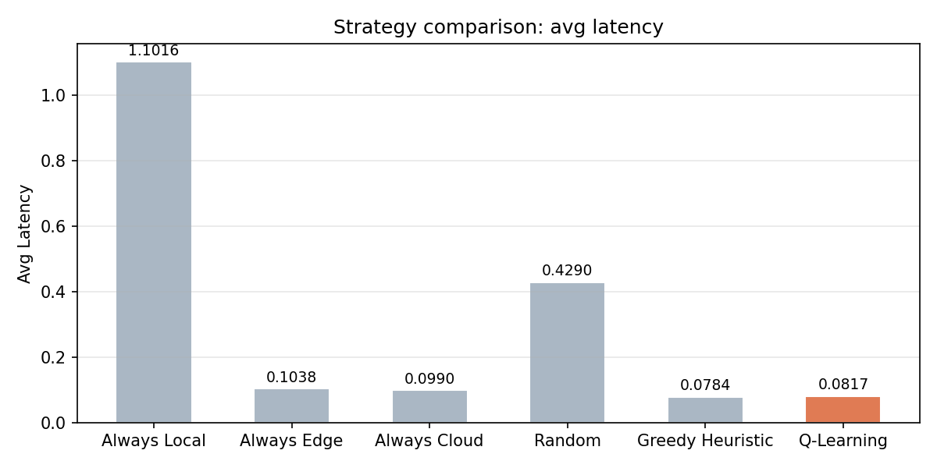
Figure 4.1: Average task latency by strategy. Q-Learning (orange) is the learned policy under study; the Greedy Heuristic achieves the lowest latency overall, ahead of Q-Learning, with Always-Cloud the strongest fixed baseline.

4.3 Statistical Validation
Because a single run could beat the baseline by chance, the improvement was evaluated across five seeds and subjected to formal statistical tests. Each seed trains on its own disjoint block of ten thousand simulation seeds, so the five runs share no training data and are genuinely independent. Two comparisons are reported throughout: against Always-Cloud, the strongest fixed baseline, and against the Greedy Heuristic, which observes the same state as the agent but requires no training. Three analyses were conducted for each comparison, reported below.

4.3.1 Confidence Interval
The 95% confidence interval describes the range within which the true average improvement is expected to lie. It is computed as the mean of the five per-seed improvements plus or minus the Student-t critical value (t = 2.776 for four degrees of freedom) times the standard error. The Student-t value is used rather than the large-sample value of 1.96, which would be inappropriate for only five samples. Relative to Always-Cloud, the mean improvement is 17.03% ± 0.22%, an interval of [16.81%, 17.24%]; the per-seed improvements range from 16.83% to 17.21%. Relative to Always-Edge the mean improvement is 21.20% ± 1.35%. Relative to the Greedy Heuristic, however, the mean difference is −4.53% ± 0.44%, an interval of [−4.96%, −4.09%]; the per-seed values range from −5.00% to −4.12%. The entire interval lies below zero in this case, meaning the agent is consistently more expensive than the heuristic and not just on average by chance.

4.3.2 Paired t-Test
The paired t-test formally asks whether a mean difference is genuine or could be random noise. For each seed there is a matched pair, the Q-Learning cost and the reference cost measured under identical random conditions, and the test examines the five per-seed differences. The null hypothesis is that the mean difference is zero. The t-statistic is the mean difference divided by its standard error; a large magnitude indicates a difference that is large relative to the noise. Pairing is essential because comparing matched runs cancels seed-to-seed variation, greatly increasing sensitivity. Against Always-Cloud, the result is t(4) = 225.96, p = 2.3 × 10⁻⁹. Against the Greedy Heuristic, the result is t(4) = −29.92, p = 7.4 × 10⁻⁶; the negative sign reflects the direction of the difference and not a weaker result. Both p-values are far below the 0.05 threshold, so both null hypotheses are rejected: the agent is significantly cheaper than Always-Cloud and significantly more expensive than the Greedy Heuristic. Both statistics were cross-checked against the SciPy library and agreed exactly.

4.3.3 Effect Size
Cohen’s d (paired) measures the magnitude of an effect independently of significance, computed as the mean difference divided by the standard deviation of the differences. Against Always-Cloud, d = 101.05. Against the Greedy Heuristic, d = −13.38, a magnitude of 13.38 in the opposite direction. Both are far beyond the conventional 0.8 threshold for a large effect, because both differences are highly consistent across seeds relative to their size, and not because either raw percentage is itself unusually large; this distinction is stated explicitly to avoid over-claiming. One methodological note is worth recording. An earlier version of this analysis, before the training seeds were corrected to be disjoint, reported d = 10.91 for the comparison against Always-Cloud. Removing the seed overlap was expected to widen the confidence interval and lower this figure, since the five runs would no longer be near-duplicates of one another. The opposite happened: d rose to 101.05. The likely reason is a separate correction to the edge server’s queue observable (Section 4.4), which made the learned policy fully explore every state it visits, so five independently trained agents now converge to essentially the same policy regardless of seed. The tight interval is a property of the corrected agent and not an artefact of the earlier seed overlap. Table 4.3 summarises both comparisons.
Table 4.3: Statistical validation summary (five seeds).
Quantity | Value
Q-Learning composite cost | 0.05757 +/- 0.00019
Always-Cloud composite cost | 0.06939 +/- 0.00007
Greedy Heuristic composite cost | 0.05508 +/- 0.00027
Mean improvement vs Always-Cloud | +17.03% +/- 0.22%
95% CI vs Always-Cloud | [16.81%, 17.24%]
Paired t-statistic vs Always-Cloud | t(4) = 225.96
p-value vs Always-Cloud (two-tailed) | 2.3 × 10⁻⁹
Cohen's d vs Always-Cloud | 101.05 (very large)
Mean improvement vs Greedy Heuristic | −4.53% +/- 0.44%
95% CI vs Greedy Heuristic | [−4.96%, −4.09%]
Paired t-statistic vs Greedy Heuristic | t(4) = −29.92
p-value vs Greedy Heuristic (two-tailed) | 7.4 × 10⁻⁶
Cohen's d vs Greedy Heuristic | −13.38 (very large)
Verdict | Significantly cheaper than Always-Cloud; significantly more expensive than Greedy Heuristic

4.4 Learned Policy Analysis
During evaluation, conducted at the fixed channel condition of network quality 0.9, the learned policy routes 70.8% of tasks to the edge and 29.2% to the cloud, and never executes a task locally. The intuition is clear: whenever the edge queue is empty, the edge offers the lowest latency and is selected; as soon as any task is queued or in service at the edge, the agent diverts to the cloud, whose greater processing speed offsets its longer propagation delay. The only exception is at intermediate signal quality, where large tasks continue to prefer the edge for one additional queue level before switching. This adaptive routing between the two offload tiers is the source of the measured improvement. Training converged well before the end of the run: the 50-episode moving average of episode reward stabilises, and remains within 5% of its final level, by episode 1,364, as shown in Figure 4.2.
Inspecting the full Q-table (Figure 4.3) shows what the agent did and did not learn, and the transparency of the tabular representation makes both directly checkable. Training visited 27 of the 36 states in the base state space (75.0%), and every action within each of those 27 states was tried at least once, so all 81 reachable state-action pairs are covered. The nine unvisited states are exactly those with an edge queue of six or more, a condition that essentially never arises at the arrival rate studied (utilisation approximately 0.41) given the uniform, rather than exponential, service times actually used. These nine are reported as untrained rather than assigned a policy. Restricting to the 18 states in which every action was tried at least 30 times, a stricter threshold used only to decide which values are reported with confidence, the values are: Q(local) between -1.68 and -1.15, and Q(edge) and Q(cloud) both between -0.79 and -0.52. Local execution is therefore strictly dominated everywhere in the trained state space, and the agent never selects it at any signal quality. The reason is a large asymmetry in magnitude: the mean task requires 550 million CPU cycles, which the 500-million-cycle-per-second device needs approximately 1.1 s to execute, while even a badly degraded uplink transmits a task in a small fraction of that. What the agent does learn is almost entirely the queue length at the edge: whenever the edge is idle it is selected, and as soon as any task is queued or in service there the agent diverts to the cloud, whose greater processing speed offsets its longer propagation delay. Task size plays only a secondary role, visible in a single exception at intermediate signal quality where large tasks continue to prefer the edge for one additional queue level. This is a simpler account of the learned behaviour than a claim of a size-and-queue-driven switch at every signal quality, and it is exactly the kind of claim that a Q-table permits an operator to verify and an opaque deep-learning policy does not.
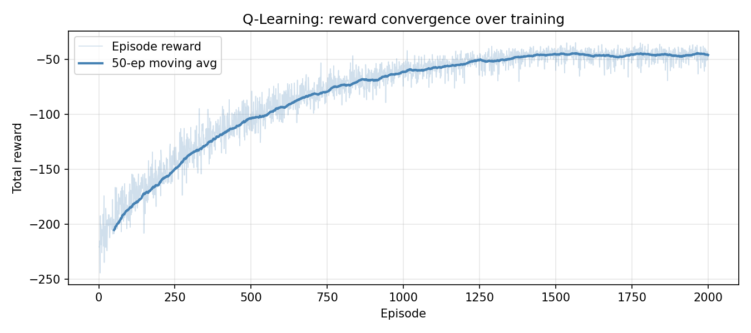
Figure 4.2: Q-Learning reward convergence over 2,000 training episodes. The 50-episode moving average stabilises, and remains within 5% of its final level, by episode 1,364.
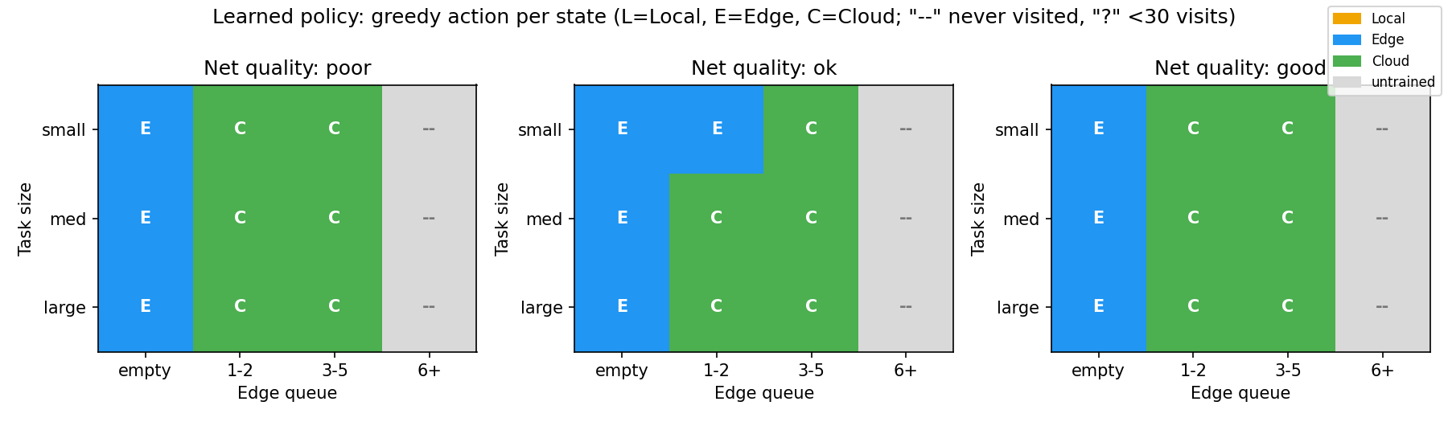
Figure 4.3: Learned greedy policy per state (L = Local, E = Edge, C = Cloud). The agent selects almost entirely on edge queue length, with task size mattering only in one exception at intermediate signal quality; local execution is strictly dominated and is never selected at any network quality. States with an edge queue of six or more were never visited during training and are shown as untrained.

4.5 Pareto Trade-Off Analysis
To examine the latency-energy trade-off, the cost weights were swept across seven settings from pure-latency to pure-energy, a separate agent trained for each, and the resulting operating points plotted. The frontier is found to be degenerate rather than merely flat: across all seven weightings the average energy is 1.9439 × 10⁻⁴ J, identical to machine precision with zero spread across weightings, because every weighting is evaluated on the same fixed sequence of arriving tasks and each task incurs the same transmission energy regardless of which tier it is sent to. The cause is structural. In the cost model of Section 3.3, device energy under offloading is the uplink transmission energy, the product of transmission power and transmission time, which depends on task size and channel quality but not on the offload destination: transmitting a task to the edge and transmitting it to the cloud cost the device exactly the same energy, because the device performs the same transmission in both cases. Device energy therefore takes only two distinct values across the whole action space, one for local execution and one shared by both offload actions. Since local execution is strictly dominated and never selected (Section 4.4), energy is invariant over the agent’s entire realized action set, and no weighting of a constant can move the operating point. This is an informative negative result about the problem formulation rather than about the algorithm. It establishes that a genuine latency-energy frontier cannot arise from tier selection alone: it requires either device-side continuous control variables such as CPU frequency and transmission power, which change energy without changing the destination, or a model in which the destination itself alters device energy, for example through multi-hop relaying. This directly motivates the continuous-control DRL work proposed in Section 5.3.
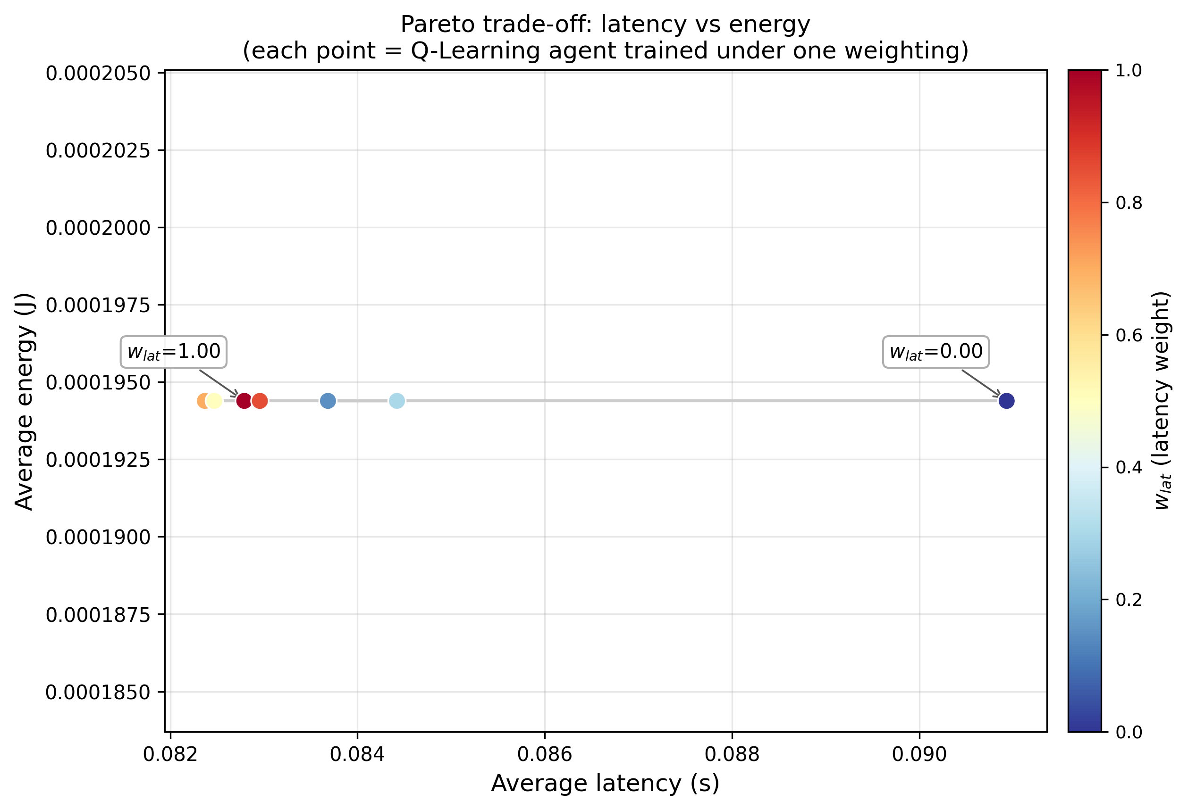
Figure 4.4: Latency-energy operating points. Each point is an agent trained under a different latency weight. Average energy is identical at every weighting, so the points form a degenerate frontier: device energy does not depend on the offload destination in this model.

Chapter 5: Conclusion and Future Work

5.1 Summary and Contributions
This project designed, implemented and validated a tabular Q-Learning agent for task offloading in a three-tier device-edge-cloud system. The principal contributions are: (1) a reproducible Python/SimPy discrete-event simulator for three-tier offloading, incorporating a Shannon-Hartley wireless channel in which network quality genuinely affects transmission cost; (2) a tabular Q-Learning baseline whose policy, and whose training coverage, are both directly inspectable; and (3) a rigorous evaluation showing, across five independently trained seeds and confirmed by a paired t-test, that the learned policy reduces composite cost by 17.03% ± 0.22% relative to the strongest fixed baseline, Always-Cloud (t(4) = 225.96, p = 2.3 × 10⁻⁹). The simulator was independently validated against M/M/1 queuing theory to within 0.39%. Measured against Always-Edge, the baseline used to frame the target in the project proposal, the improvement is 21.20% ± 1.35%; measured against the stronger Always-Cloud baseline it is 17.03%, with a 95% confidence interval of [16.81%, 17.24%] comfortably clear of the proposed 10% target. Measured instead against the Greedy Heuristic, an untrained but state-aware strategy added during evaluation as a stronger point of comparison, the learned policy is 4.53% ± 0.44% more expensive, also a statistically significant difference (Section 4.3). This result is reported as plainly as the other two: it shows that the value of tabular Q-Learning here is not that it exceeds a well-specified analytical policy, since an eight-line heuristic with no training does that, but that it recovers comparable performance from interaction alone, without access to the closed-form cost model the heuristic is given directly.
A fourth contribution is methodological. The study reports state-space coverage alongside the learned policy, rather than assuming every state was learned equally well, and this practice surfaced two implementation issues that were found and corrected during the project. The first is an argmax tie-breaking rule that could let an untrained, zero-initialised action outrank a genuinely evaluated one in sparsely visited states. The second is an edge-queue observable that omitted the task currently in service, collapsing two states with materially different expected wait times into one; correcting it alone raised the improvement over Always-Cloud from 8.7% to 17.4% on the representative seed reported in Table 4.2, and completed coverage of every state-action pair the agent visits, from 65 of 72 to 81 of 81. The degenerate Pareto frontier reported in Section 4.5 is a separate and more durable structural finding: it is a property of the cost model rather than of the algorithm or of training coverage, and it persists after both corrections.

5.2 Limitations
The study is bounded by its design choices, and several limitations are worth stating precisely. Tabular Q-Learning requires the state to be discretised into bins and does not scale to high-dimensional or continuous states. Training visited 27 of the 36 base states; the remaining 9 correspond to edge queue lengths that essentially never occur at the arrival rate studied, so the policy is undefined there and is reported as such rather than being extrapolated. The learned policy is also currently outperformed by the Greedy Heuristic, an untrained strategy with direct access to the cost model the reward function uses (Section 4.3); closing this gap, or establishing that it cannot be closed without a richer state representation or function approximation, is unresolved within the scope of this project. Device energy in the cost model is invariant across the two offload destinations, so the discrete three-action space admits no latency-energy trade-off for the agent to exploit; obtaining a non-degenerate Pareto frontier requires continuous control variables. The model is single-agent and therefore does not capture contention between multiple devices for shared edge resources. Local execution is modelled without device-side resource contention, so tasks assigned to the device execute in unbounded parallel; the reported Always-Local latency of 1.099 s is therefore a lower bound, since a genuine single-CPU device would be unstable at this arrival rate (the offered load on the device alone is approximately 6.6 times its capacity). This strengthens rather than weakens the conclusion that offloading is essential. The successor state used in the Bellman bootstrap is observed at task completion and reuses the completed task’s size, rather than the size of the next arrival, which is unknown at that instant; because task sizes are drawn independently this introduces a bias in the bootstrap term that is not corrected here. Finally, all evaluation is conducted at a single fixed channel quality and all results are obtained in simulation rather than on physical infrastructure.

5.3 Future Work (Thesis Phase)
These limitations define the direction of the subsequent thesis phase, which will characterise empirically where a tabular method's advantages give way to a deep one's:
- State-space scaling study: train a Deep Q-Network (DQN) alongside the tabular Q-Learning baseline established here across five state-space complexity levels (36 to 3,240 states, adding task complexity, battery level, task type and finer discretisation in turn) to locate empirically where, if anywhere, a neural approximator's ability to generalise across similar states overtakes an exact table's. A preliminary probe in this direction already exists: adding velocity and network-quality-trend bins to model mobility (Section 3.4.1) expands the space to 324 states, and the tabular method's coverage under the same training budget falls to 81 of 324 (25.0%), consistent with the scaling problem this study is designed to locate.
- Deadline-aware reward shaping: introduce a weighted penalty for missed task deadlines and evaluate, across a swept penalty weight, whether it measurably improves deadline compliance without degrading average latency-energy cost.
- Action masking under congestion: remove the edge-offload action from the agent's choice set whenever the edge queue is already occupied, testing whether preventing exploration of a predictably futile action improves learning efficiency.
The interpretable Q-Learning baseline delivered by this project, together with the Greedy Heuristic as a stronger reference point than any fixed strategy, provides the well-characterised basis against which the thesis-phase DQN comparison, deadline-shaping study and masking experiment are evaluated; preliminary experiments on this pipeline are already under way. Federated multi-agent learning, in which multiple devices share model updates without exchanging raw task data, is a longer-horizon extension beyond this thesis phase and is not scheduled among the three studies above.

References
Alfakih, T., Hassan, M. M., Gumaei, A., Savaglio, C., & Fortino, G. (2020). Task Offloading and Resource Allocation for Mobile Edge Computing by Deep Reinforcement Learning Based on SARSA. IEEE Access, 8, 54074-54084. https://doi.org/10.1109/ACCESS.2020.2981434
Bi, S., Huang, L., Wang, H., & Zhang, Y.-J. A. (2021). Lyapunov-Guided Deep Reinforcement Learning for Stable Online Computation Offloading in Mobile-Edge Computing Networks. IEEE Transactions on Wireless Communications, 20(11), 7519-7537. https://doi.org/10.1109/TWC.2021.3085319
Chen, X., Jiao, L., Li, W., & Fu, X. (2016). Efficient Multi-User Computation Offloading for Mobile-Edge Cloud Computing. IEEE/ACM Transactions on Networking, 24(5), 2795-2808. https://doi.org/10.1109/TNET.2015.2487344
Chen, X., & Liu, G. (2022). Federated Deep Reinforcement Learning-Based Task Offloading and Resource Allocation for Smart Cities in a Mobile Edge Network. Sensors, 22(13), 4738. https://doi.org/10.3390/s22134738
Dash, S., Mishra, J., & Dash, S. K. (2026). Modified Q-Learning Approach for Optimized Task Offloading and Resource Allocation in Mobile Edge Computing. SN Computer Science. https://doi.org/10.1007/s42979-025-04673-z
Hwang, R.-H., Lai, Y.-C., & Lin, Y.-D. (2021). Offloading Optimization with Delay Distribution in the 3-tier Federated Cloud, Edge, and Fog Systems. arXiv:2107.05015
Lillicrap, T. P., Hunt, J. J., Pritzel, A., Heess, N., Erez, T., Tassa, Y., Silver, D., & Wierstra, D. (2016). Continuous Control with Deep Reinforcement Learning. International Conference on Learning Representations (ICLR 2016). arXiv:1509.02971
Mao, Y., You, C., Zhang, J., Huang, K., & Letaief, K. B. (2017). A Survey on Mobile Edge Computing: The Communication Perspective. IEEE Communications Surveys & Tutorials, 19(4), 2322-2358. https://doi.org/10.1109/COMST.2017.2745201
Mnih, V., Kavukcuoglu, K., Silver, D., Rusu, A. A., Veness, J., Bellemare, M. G., Graves, A., Riedmiller, M., Fidjeland, A. K., Ostrovski, G., Petersen, S., Beattie, C., Sadik, A., Antonoglou, I., King, H., Kumaran, D., Wierstra, D., Legg, S., & Hassabis, D. (2015). Human-level control through deep reinforcement learning. Nature, 518(7540), 529-533. https://doi.org/10.1038/nature14236
Peng, P., Lin, W., Wu, W., Zhang, H., Peng, S., Wu, Q., & Li, K. (2024). A survey on computation offloading in edge systems: From the perspective of deep reinforcement learning approaches. Computer Science Review, 53, 100656. https://doi.org/10.1016/j.cosrev.2024.100656
Shi, W., Chen, L., & Zhu, X. (2023). Task Offloading Decision-Making Algorithm for Vehicular Edge Computing: A Deep-Reinforcement-Learning-Based Approach. Sensors, 23(17), 7595. https://doi.org/10.3390/s23177595
Shuai, J., & Xie, B. (2024). Q-Learning-Based Task Offloading Strategy for Satellite Edge Computing. International Journal of Communication Systems. https://doi.org/10.1002/dac.5691
Sonmez, C., Ozgovde, A., & Ersoy, C. (2018). EdgeCloudSim: An Environment for Performance Evaluation of Edge Computing Systems. Transactions on Emerging Telecommunications Technologies, 29(11), e3493. https://doi.org/10.1002/ett.3493
Souza, P. S., Ferreto, T., & Calheiros, R. N. (2023). EdgeSimPy: Python-Based Modeling and Simulation of Edge Computing Resource Management Policies. Future Generation Computer Systems, 148, 446-459. https://doi.org/10.1016/j.future.2023.06.013
Sun, J., Zhang, W., Han, M., Shen, M., & Wu, X. (2026). Deep Reinforcement Learning-Based Adaptive Task Offloading for Mobile Edge Computing. The Journal of Supercomputing. https://doi.org/10.1007/s11227-026-08492-8
Watkins, C. J. C. H., & Dayan, P. (1992). Q-learning. Machine Learning, 8(3-4), 279-292. https://doi.org/10.1007/BF00992698
You, C., Huang, K., Chae, H., & Kim, B.-H. (2017). Energy-Efficient Resource Allocation for Mobile-Edge Computation Offloading. IEEE Transactions on Wireless Communications, 16(3), 1397-1411. https://doi.org/10.1109/TWC.2016.2633522

