PURPLE TEAM CYBERSECURITY PROJECT REPORT
Attacker Simulation, Apache Log Analysis and Firewall Rule Verification
Field | Detail
Student Name | Sarayu
Batch | B22
Project Type | Purple Team Cybersecurity Project
Roles Performed | Attacker and Defender — both performed by Sarayu
Target Asset | Apache2 web app “CYVERO | Cyber Defense” on the Defender host
Technologies | Kali Linux, Nmap, Gobuster, Nikto, curl, Apache2, UFW, Windows 11
All commands used in this project are highlighted in yellow throughout this report.

Introduction
Purple Team exercises combine offensive and defensive perspectives so the same practitioner can generate attack telemetry and then analyse it, giving an accurate, correlated view of the full attack-to-detection lifecycle. This project was conducted entirely in an isolated lab network (192.168.1.0/24) with no production systems or real users involved. Sarayu performed reconnaissance and enumeration as attacker, then switched to defender to investigate the resulting Apache2 logs and apply a defensive response.

Project Objectives
- Understand attacker-side reconnaissance methodology against a Linux web server.
- Identify exposed services using active scanning (Nmap).
- Perform controlled web-content enumeration (Gobuster).
- Generate observable HTTP telemetry for later log correlation.
- Run an automated web-server assessment (Nikto) and interpret findings.
- Analyse Apache2 logs to reconstruct attacker activity.
- Correlate suspicious request patterns with the attacker's IP.
- Validate that legitimate client traffic stays distinguishable from attacker traffic.
- Apply and verify a UFW firewall rule against the identified attacker IP.
- Build practical, evidence-based Purple Team skills.

Lab Environment
Role | Machine | IP | Purpose
Attacker | Kali Linux Clone | 192.168.1.11 | Reconnaissance and enumeration against the defender host
Defender | Kali Linux | 192.168.1.14 | Hosts the web app, logs access, applies the firewall rule
Client | Windows 11 | 192.168.1.9 | Generates legitimate traffic for validation

Network Architecture
All three machines share the 192.168.1.0/24 LAN. The Defender host is both the protected web asset and the analysis/response point.
Kali Linux Clone (Attacker) — 192.168.1.11
↓
Reconnaissance & web-service enumeration
↓
Kali Linux (Defender / Web Server) — 192.168.1.14
↓
Log monitoring, correlation, UFW rule enforcement
↓
Windows 11 Client — 192.168.1.9

Tools and Technologies
Tool | Role in This Project
Kali Linux (x2) | Attacker clone and Defender/web-host instance
ping / curl | Connectivity and HTTP testing
Nmap | Service/version discovery on the defender host
Gobuster | Web directory/content enumeration
Nikto | Automated web-server vulnerability scan
Apache2 | Web server hosting the target app; source of access.log
tail / grep / awk / wc | Log monitoring and analysis by the defender
UFW | Host firewall — default-deny baseline and attacker DENY rule
Windows 11 | Legitimate client for validation

Environment Setup
Figure 1: Attacker Host IP
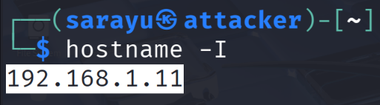
Kali Linux Clone (Attacker)
$ hostname -I
Result: 192.168.1.11 Meaning: Confirms the attacker's source IP used throughout.
Figure 2: Defender Host IP
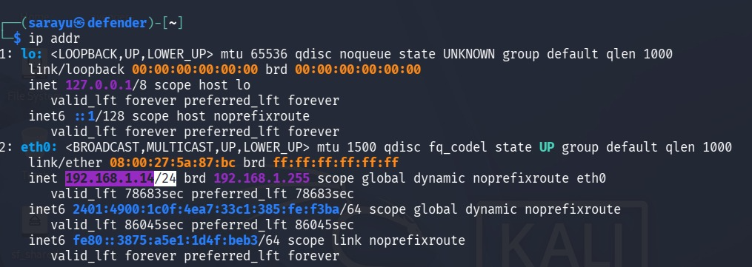
Kali Linux (Defender)
$ ip addr
Result: eth0 inet 192.168.1.14/24 Meaning: Confirms the defender/web-server address.
Figure 3: Apache2 Package Check
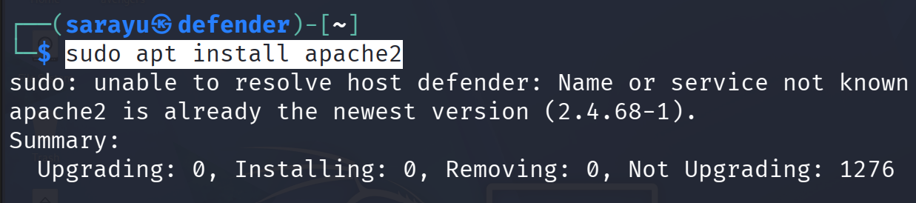
Kali Linux (Defender)
$ sudo apt install apache2
Result: “already the newest version (2.4.68-1)” Meaning: Confirms Apache2 2.4.68 was present.
Figure 4: Apache2 Service Status
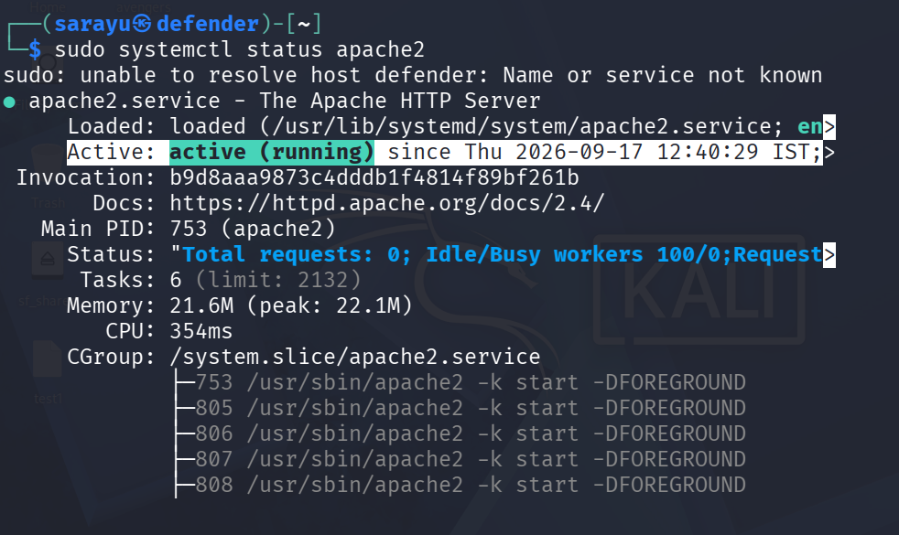
Kali Linux (Defender)
$ sudo systemctl status apache2
Result: Active: active (running) since 2026-09-17 12:40:29 IST Meaning: Confirms the web server was live before the attack.
Figure 5: Web Content Prep
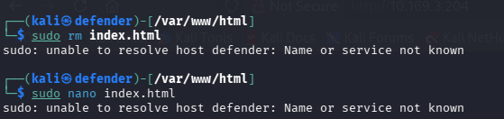
Kali Linux (Defender)
$ cd /var/www/html && sudo rm index.html && sudo nano index.html
Result: Default page replaced with custom “CYVERO” page Meaning: The page later targeted by the attacker.
Figure 6: UFW Baseline
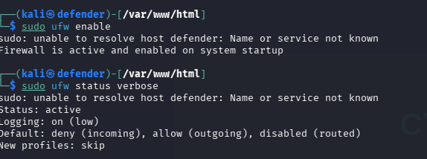
Kali Linux (Defender)
$ sudo ufw enable && sudo ufw status verbose
Result: Default: deny (incoming), allow (outgoing) Meaning: Baseline firewall posture, prior to any attacker-specific rule.
Figure 7: Client IP
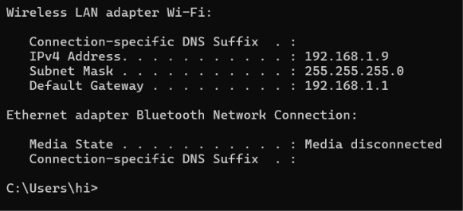
Windows 11 (Client)
$ ipconfig
Result: IPv4 Address: 192.168.1.9 Meaning: Confirms the client IP seen later in the access log.

Attacker Phase
Sarayu operated as attacker from 192.168.1.11 against the defender host 192.168.1.14, using the commands highlighted below.
Connectivity Testing
Figure 8: ICMP Test
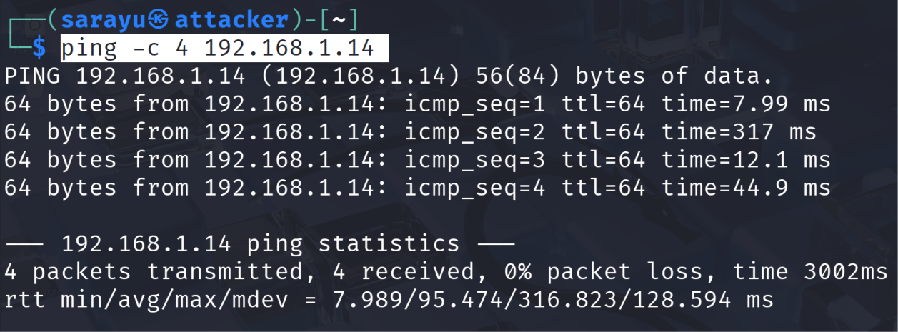
Kali Linux Clone (Attacker)
$ ping -c 4 192.168.1.14
Result: 4/4 packets received, 0% loss Meaning: Confirms reachability before scanning.
Figure 9: HTTP Test
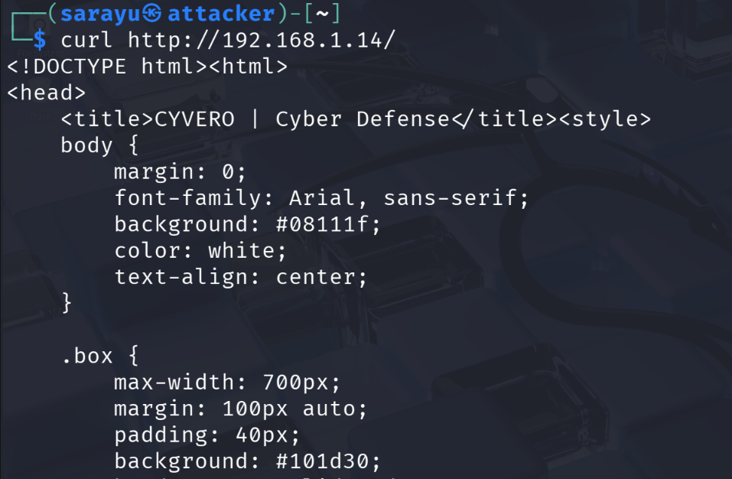
Kali Linux Clone (Attacker)
$ curl http://192.168.1.14/
Result: Full HTML of “CYVERO | Cyber Defense” returned Meaning: Confirms HTTP-layer reachability.
Nmap Reconnaissance
Figure 10: Service Discovery
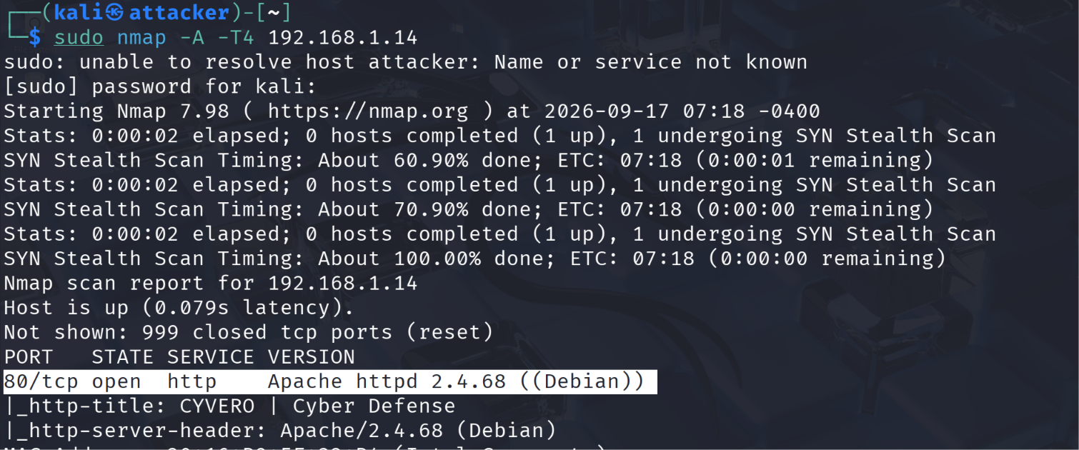
Kali Linux Clone (Attacker)
$ sudo nmap -A -T4 192.168.1.14
Result: 80/tcp open http — Apache httpd 2.4.68 (Debian) Meaning: Defines the attack surface as a single HTTP service.
Gobuster / Content Discovery
Figure 11: Directory Enumeration
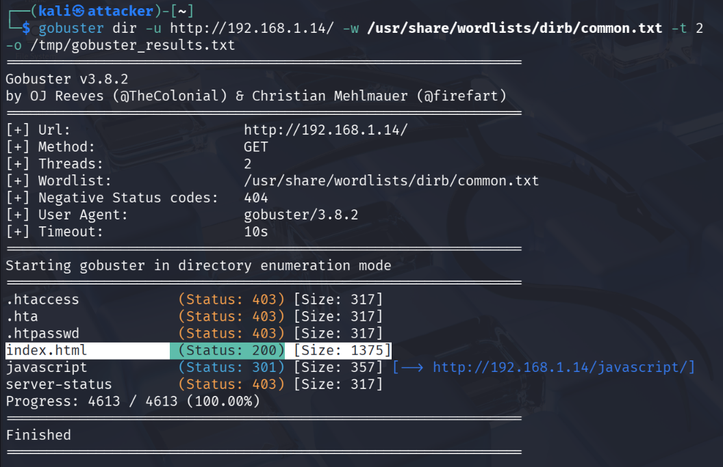
Kali Linux Clone (Attacker)
$ gobuster dir -u http://192.168.1.14/ -w /usr/share/wordlists/dirb/common.txt -t 2 -o /tmp/gobuster_results.txt
Result: .htaccess/.hta/.htpasswd/server-status 403; index.html 200; javascript 301 Meaning: Maps accessible vs restricted paths.
HTTP Request Simulation
Figure 12: Request Burst
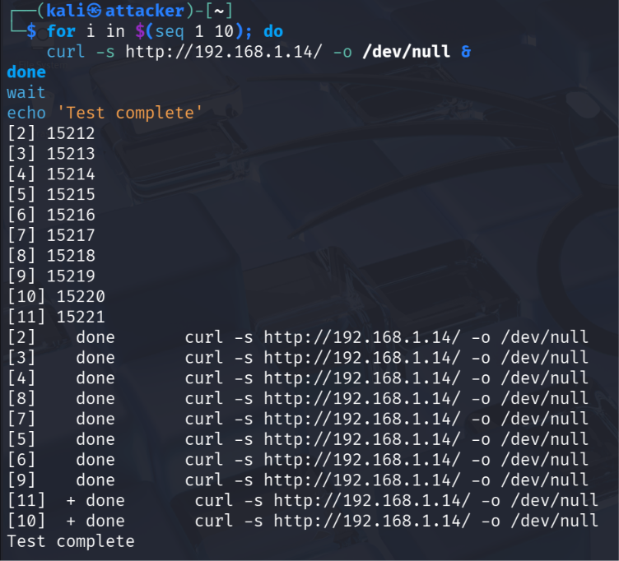
Kali Linux Clone (Attacker)
$ for i in $(seq 1 10); do curl -s http://192.168.1.14/ -o /dev/null & done; wait
Result: 10 background jobs completed, “Test complete” Meaning: Generates a scripted burst of near-simultaneous requests.
Nikto / Web Assessment
Figure 13: Web-Server Scan
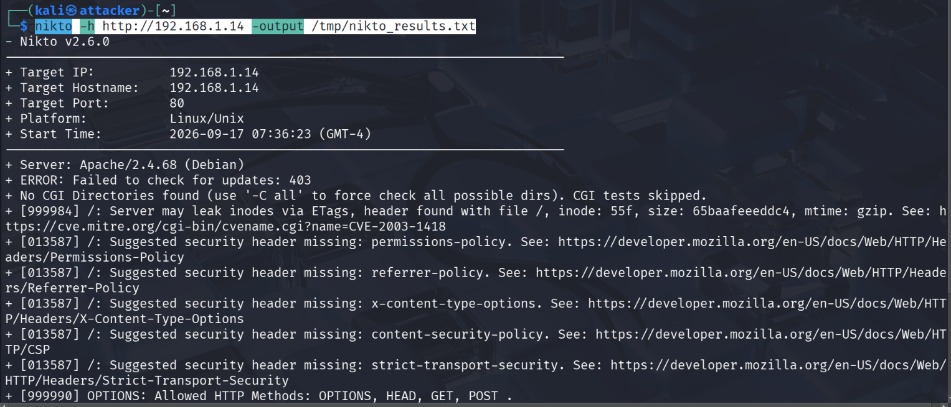
Kali Linux Clone (Attacker)
$ nikto -h http://192.168.1.14 -output /tmp/nikto_results.txt
Result: Missing security headers; Apache/2.4.68 (Debian) Meaning: Identifies web-server hardening gaps.
Other Attacker Activity
Figure 14: Target App — Attacker's View
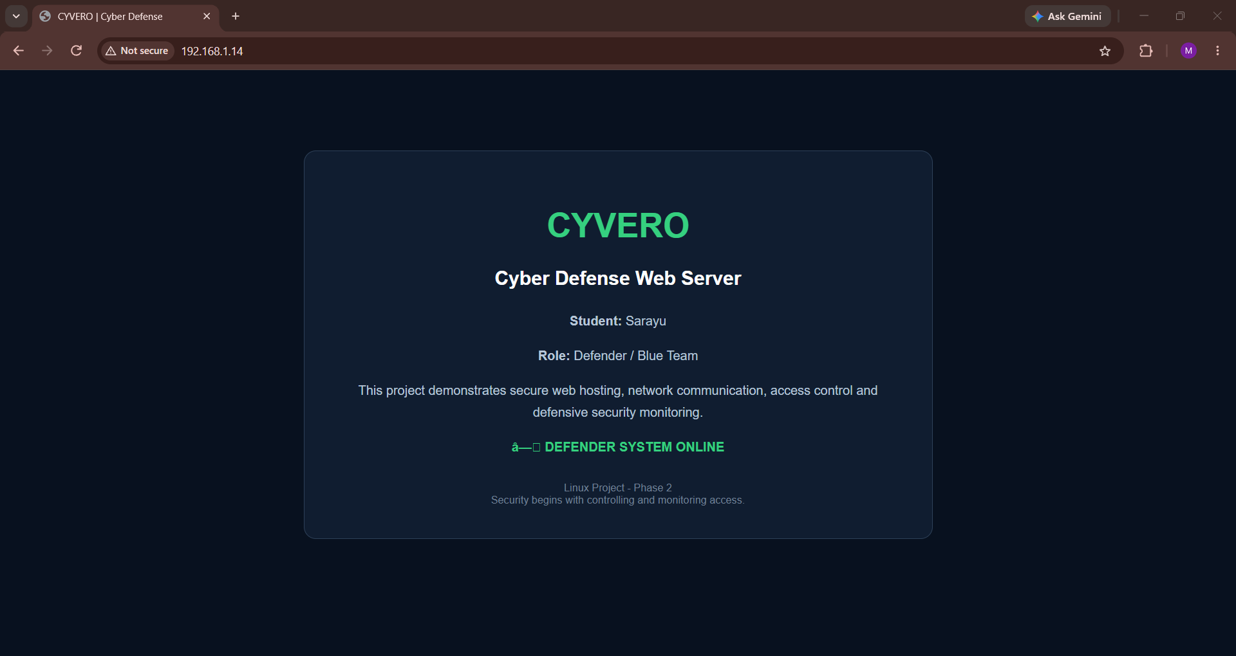
Kali Linux Clone (browser) (Attacker)
Result: “CYVERO | Cyber Defense” page rendered, “Role: Defender / Blue Team” Meaning: Confirms the exact content that was scanned.

Defender Phase
Sarayu switched to defender on the same host (192.168.1.14) to investigate the resulting telemetry.
Defender-Side Check & Log Monitoring
Figure 15: ICMP Check of Attacker
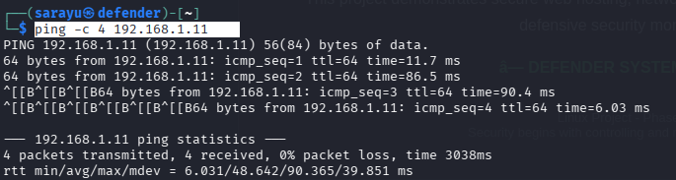
Kali Linux (Defender)
$ ping -c 4 192.168.1.11
Result: 4/4 packets received, 0% loss Meaning: Confirms defender-side reachability of the attacker.
Figure 16: Apache2 Access Log — Real-Time
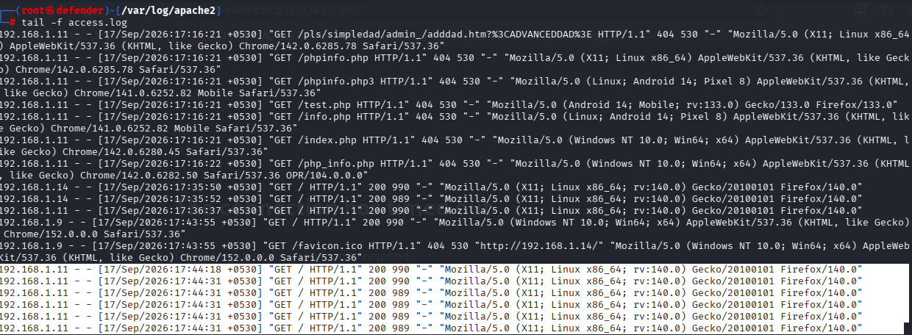
Kali Linux (Defender)
$ tail -f access.log
Result: .11 = repeated 404 probes (phpinfo.php, test.php, admin path, etc.) each with a different User-Agent; .14 = self-test GET / 200; .9 = client GET / 200 & /favicon.ico 404; .11 = repeated GET / 200 burst Meaning: Primary evidence for suspicious-activity ID and IP correlation.
Figure 17: Access Log Volume
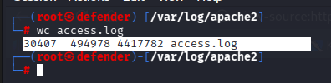
Kali Linux (Defender)
$ wc access.log
Result: 30,407 lines / 494,978 words / 4,417,782 bytes Meaning: Quantifies the scale of logged activity.
Suspicious Activity & IP Correlation
- Repeated 404 requests to PHP-info/admin-style paths, each with a different User-Agent, within one second — automated scripted probing, not manual browsing.
- A later burst of identical GET / requests in a narrow window — matches the attacker's scripted HTTP burst.
- All suspicious entries trace to 192.168.1.11, matching the attacker's own confirmed IP (Figure 1) and Nmap/Gobuster/Nikto targets (Figures 10–13).
HTTP Status Codes Observed
Code | Meaning | Context
200 | OK | Defender self-test, client requests, attacker burst
301 | Redirect | Gobuster: /javascript path
403 | Forbidden | Gobuster: .htaccess, .htpasswd, server-status
404 | Not Found | Attacker's PHP-info/admin probe requests
Investigation Steps
1. Monitored the access log in real time.
2. Extracted suspicious 404-probe and request-burst entries.
3. Identified the common source IP: 192.168.1.11.
4. Matched request patterns and timing to the attacker's known actions.
5. Concluded the traffic was reconnaissance/enumeration, not legitimate use.
6. Applied a targeted defensive response (below).
Defensive Response — Firewall Rule Verification
A UFW rule was applied to deny the attacker's IP while explicitly allowing the client and the host itself. No ufw.log entries were captured; the evidence here is limited to the rule-status output and the attacker's resulting connection failures.
Figure 18: UFW Rule — Attacker Denied
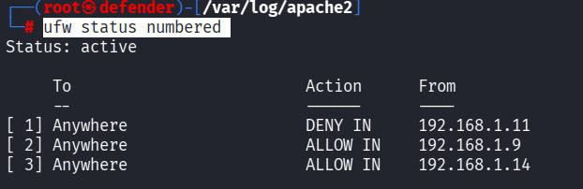
Kali Linux (Defender)
$ sudo ufw insert 1 deny from 192.168.1.11 to any
Result: [1] DENY IN From 192.168.1.11; [2] ALLOW IN From 192.168.1.9; [3] ALLOW IN From 192.168.1.14 Meaning: Direct evidence the defensive rule was active.
Figure 19: Attacker Connection Failure — Browser
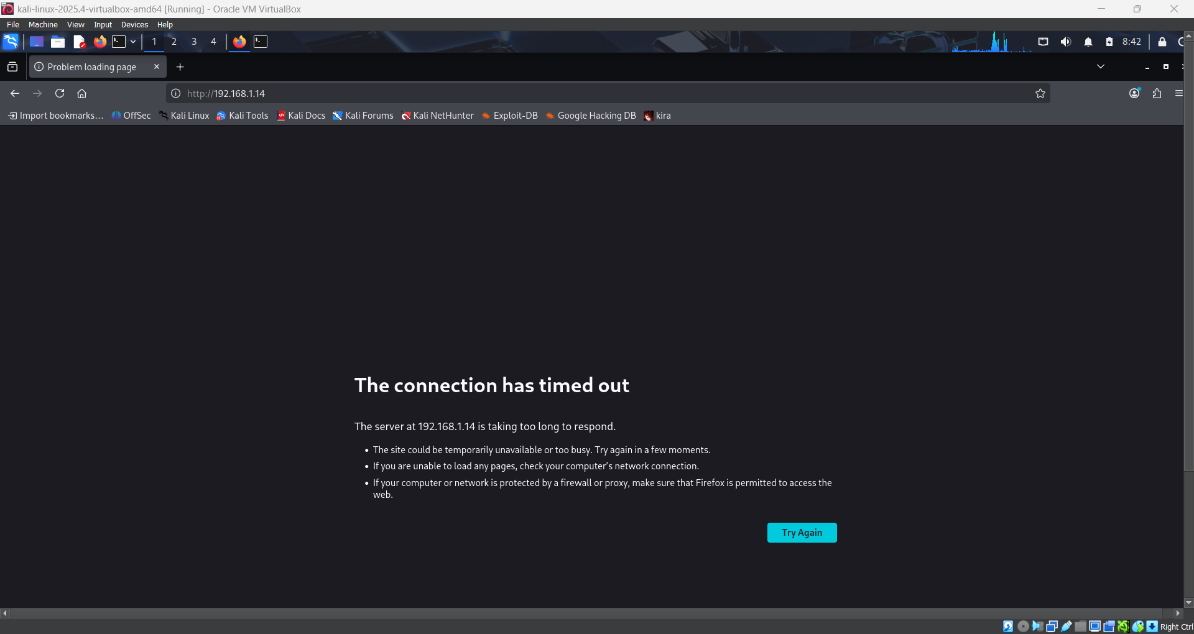
Kali Linux Clone (browser) (Attacker)
Result: “The connection has timed out” Meaning: Attacker unable to reach the server after the rule was applied.
Figure 20: Attacker Connection Failure — curl
Kali Linux Clone (Attacker)
$ curl http://192.168.1.14
Result: “Failed to connect ... Could not connect to server” Meaning: Second, independent confirmation of the block.
Scope note: no ufw.log entries exist in the evidence. The response above is limited to 'ufw status numbered' output and the attacker's failed reconnection attempts.

Windows 11 Client Validation
The Windows 11 client (192.168.1.9, confirmed via ipconfig in Figure 7) generated a single GET / (200) and GET /favicon.ico (404) in the same access log (Figure 16), using a standard Chrome/Windows User-Agent — clearly distinguishable from the attacker's repeated, multi-path, varying-User-Agent probing.

Attack Activity vs. Detection & Response
Phase | Attacker Activity | Defender Observation | Evidence
Recon | ping / curl to 192.168.1.14 | Defender pinged .11 back; matching log entries | Fig 8, 9, 15
Enumeration | Nmap scan; Gobuster brute-force | High log volume; 404/403 pattern | Fig 10, 11, 16, 17
HTTP Burst | 10-request curl loop | Repeated GET / from .11 in a narrow window | Fig 12, 16
Web Scan | Nikto scan | Varying-User-Agent probe pattern | Fig 13, 16
Investigation | — | Source IP correlated to attacker | Fig 16
Response | Subsequent connections failed | UFW DENY rule verified | Fig 18, 19, 20
Client Validation | — | Client traffic stayed distinct | Fig 7, 16

Purple Team Analysis
One practitioner, Sarayu, generated the offensive activity and then analysed its defensive footprint — the attacker and defender roles are the same person throughout.
RED — Sarayu as Attacker (192.168.1.11)
↓
Recon → Nmap → Gobuster → HTTP Burst → Nikto → Telemetry
↓
BLUE — Sarayu as Defender (192.168.1.14)
↓
Log Monitoring → IP Correlation → Investigation → UFW Response → Client Validation

Attack–Detection Correlation
Attacker Action | Defender Evidence | Meaning
Nmap scan | Port 80/Apache 2.4.68 fingerprint (Fig 10) | Attack surface = single HTTP service
Gobuster brute-force (4,613 reqs) | Log volume 30,407 lines (Fig 17); 403/301 codes | Sensitive paths correctly restricted
10-request HTTP burst | Repeated GET / 200 in a narrow window (Fig 16) | Scripted burst distinguishable from normal use
Nikto scan | Varying-User-Agent 404 probes (Fig 16) | Classic automated-scanner signature
UFW DENY rule (defender) | Attacker curl/browser connections failed (Fig 19, 20) | Confirms the defensive rule was effective

Security Findings
Finding | Evidence | Significance
Single exposed HTTP service, precise version disclosure | Nmap: Apache httpd 2.4.68 (Debian) | Enables fast, targeted vulnerability lookup
Web structure enumerable via brute-force | Gobuster 200/301/403 results | Sensitive paths (.htaccess etc.) were correctly restricted
Missing recommended security headers | Nikto findings | Reduces defence-in-depth against client-side attacks
Automated scanning is detectable in logs | Repeated 404s, varying User-Agents (Fig 16) | Validates manual log review as a viable detection method
Attacker IP unambiguously identified | All suspicious entries = 192.168.1.11 | Enables confident correlation
Legitimate traffic stayed distinguishable | Client's single GET/favicon vs attacker bursts | Supports low false-positive detection
Firewall rule successfully applied & corroborated | ufw status + failed attacker reconnections | Confirms a working, verifiable containment control

Mitigation & Hardening Recommendations
Demonstrated in this project: a UFW rule denying the attacker IP (192.168.1.11), verified and corroborated by failed reconnection attempts.
Recommended / Future Controls
- Add missing security headers (CSP, X-Content-Type-Options, HSTS, Referrer-Policy, Permissions-Policy).
- Rate limiting (UFW 'limit', mod_evasive) to throttle scanning traffic.
- Centralized logging / SIEM for cross-host correlation.
- IDS/IPS (Fail2Ban, Suricata) for automated detection.
- Web Application Firewall (WAF) to filter known probe patterns.
- Enable and review UFW's own block log (/var/log/ufw.log) — not captured in this project.
- Automated alerting on repeated-404 / burst patterns instead of manual tail -f.
- Formal, repeatable incident-response runbook.

Incident Response Workflow
1. Detect — Demonstrated — manual real-time log review
2. Collect logs — Demonstrated — access.log examined
3. Identify source — Demonstrated — 192.168.1.11 correlated
4. Correlate — Demonstrated — matched to attacker commands/timestamps
5. Investigate — Demonstrated — structured process followed
6. Validate — Demonstrated — client traffic confirmed distinct
7. Contain — Demonstrated — UFW DENY rule applied & verified
8. Recover — Recommended/Future — no formal recovery step evidenced
9. Document — Demonstrated — this report
10. Improve detection — Recommended/Future — rate limiting, IDS/IPS, WAF

Project Timeline
Phase | Summary
1. Environment Prep | IPs verified; Apache2 confirmed running; UFW baseline enabled
2. Recon | ICMP/HTTP connectivity confirmed (.11 → .14)
3. Enumeration | Nmap + Gobuster executed (~16:53 IST)
4. Web Activity | HTTP burst + Nikto (17:10–17:16 IST)
5. Investigation | Access log reviewed, IP correlated (17:16–17:44 IST)
6. Client Validation | Windows 11 traffic logged (17:43 IST)
7. Defensive Response | UFW DENY rule applied & verified
8. Findings | Purple Team correlation & recommendations compiled

Lessons Learned
- Even a simple scan sequence (ping, curl, Nmap, Gobuster, a burst, Nikto) enumerates a server's surface and generates tens of thousands of log lines.
- Automated tooling leaves recognisable fingerprints — repeated 404s, inconsistent User-Agents, tight timing — detectable through manual log review alone.
- Correlation is far more reliable when the analyst already knows the attacker's actions and timing, as in a Purple Team format.
- A single host-based firewall rule can be confirmed effective simply by observing the attacker's own failed reconnection attempts.
- Performing both roles personally made attack-to-detection cause-and-effect directly observable rather than theoretical.

Project Limitations
- Conducted entirely in an isolated lab (private IPs); findings may not generalise to production systems.
- Only three machines were used; no additional network devices or hosts.
- All conclusions are limited to what is directly visible in sarayu.docx and p2.docx.
- No ufw.log entries were captured — the defensive response is evidenced only via rule-status output and attacker connection failures.
- Firewall Sentinel's IPs (192.168.1.67/90/12) and screenshots belong to that reference document only, not this project.
- Minor timestamp/timezone differences exist between the two source documents (GMT-4 vs IST), reflecting VM clock settings, not a sequence inconsistency.
- Hardening actually implemented was limited to one UFW rule plus a default-deny baseline; broader controls remain future work.

Conclusion
This project demonstrated a complete, evidence-based Purple Team exercise: Sarayu (B22) simulated reconnaissance and web-service enumeration as attacker (192.168.1.11), then investigated the resulting Apache2 telemetry as defender (192.168.1.14), correlating suspicious activity precisely to the attacker's IP. A Windows 11 client (192.168.1.9) confirmed legitimate traffic remained distinguishable throughout, and a targeted UFW rule was applied and verified, with its effect corroborated by the attacker's own failed reconnection attempts. Every claim in this report is tied directly to captured evidence, with demonstrated actions clearly separated from recommended future controls.

Appendix A — Command Reference
All commands actually executed in this project, grouped by machine. These are the same highlighted commands shown against each figure earlier in this report.
Attacker Commands — Kali Linux Clone (192.168.1.11)
hostname -I
ping -c 4 192.168.1.14
curl http://192.168.1.14/
sudo nmap -A -T4 192.168.1.14
gobuster dir -u http://192.168.1.14/ -w /usr/share/wordlists/dirb/common.txt -t 2 -o /tmp/gobuster_results.txt
for i in $(seq 1 10); do curl -s http://192.168.1.14/ -o /dev/null & done; wait
nikto -h http://192.168.1.14 -output /tmp/nikto_results.txt
curl http://192.168.1.14 (post-block attempt — failed)
Defender Commands — Kali Linux (192.168.1.14)
ip addr
sudo apt install apache2
sudo systemctl status apache2
cd /var/www/html && sudo rm index.html && sudo nano index.html
sudo ufw enable && sudo ufw status verbose
curl http://localhost/
ping -c 4 192.168.1.11
tail -f access.log (/var/log/apache2)
wc access.log
sudo ufw insert 1 deny from 192.168.1.11 to any
ufw status numbered
Client Commands — Windows 11 (192.168.1.9)
ipconfig
Reference Only — Not Executed in This Project
From the Firewall Sentinel PDF (its own reference IPs 192.168.1.67/90/12); shown only to support the mitigation recommendations:
sudo ufw allow 22/tcp
sudo ufw allow 80/tcp
sudo ufw limit 22/tcp
sudo tail -f /var/log/ufw.log
sudo ufw delete 1

Appendix B — Evidence Mapping
Evidence | Source | Role | What It Proves
Figures 1, 8–14, 19–20 | sarayu.docx | Attacker | Recon, enumeration, web activity, post-block failures
Figures 2–7, 15–18 | p2.docx | Defender / Client | Setup, log monitoring, correlation, UFW verification, client validation
Methodology only (install steps, UFW ordering, ufw.log format) | Firewall Sentinel PDF | Reference only | Explains general methodology — IPs/screenshots not used as this project's evidence

Final Purple Team Flow
Sarayu — Attacker (192.168.1.11)
↓
Recon → Nmap → Gobuster → HTTP Burst → Nikto → Telemetry
↓
Sarayu — Defender (192.168.1.14)
↓
Log Monitoring → Suspicious-Activity Detection → IP Correlation → Investigation
↓
Defensive Response — UFW DENY Rule Applied & Verified
↓
Windows 11 Client Validation (192.168.1.9)
↓
Findings → Mitigation & Hardening Recommendations

