WEEK-12
IAM
1. Administrative Setup (Root User)
Step 1: Log in to the AWS Management Console as the Root User.
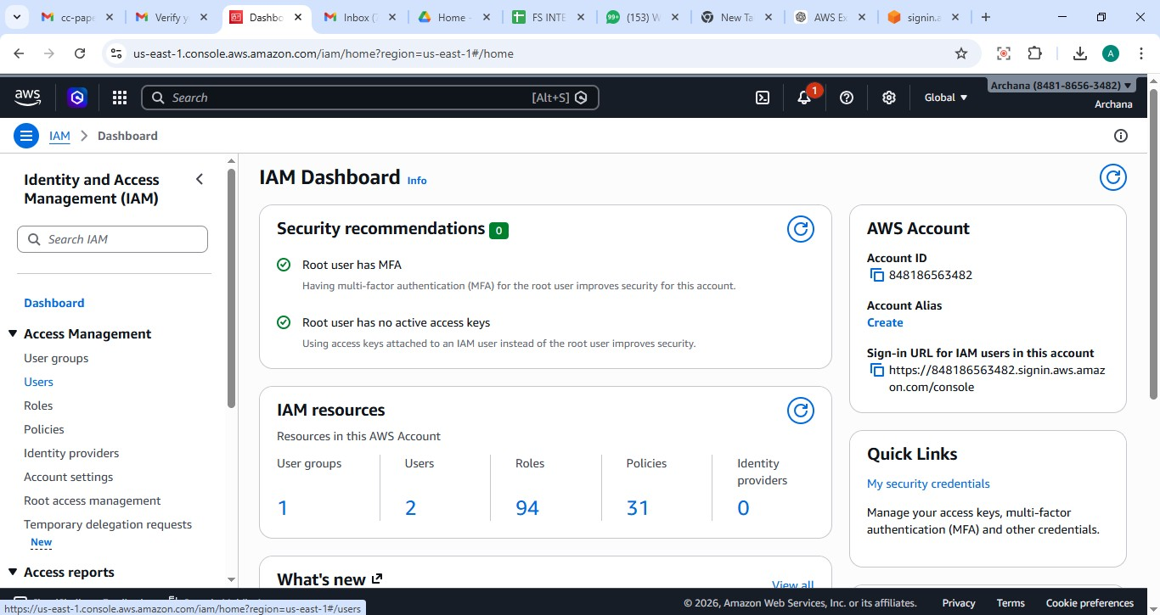
Step 2: Search for IAM under the "Security, Identity, & Compliance" category. Step 3: Navigate to Users and click Create user.

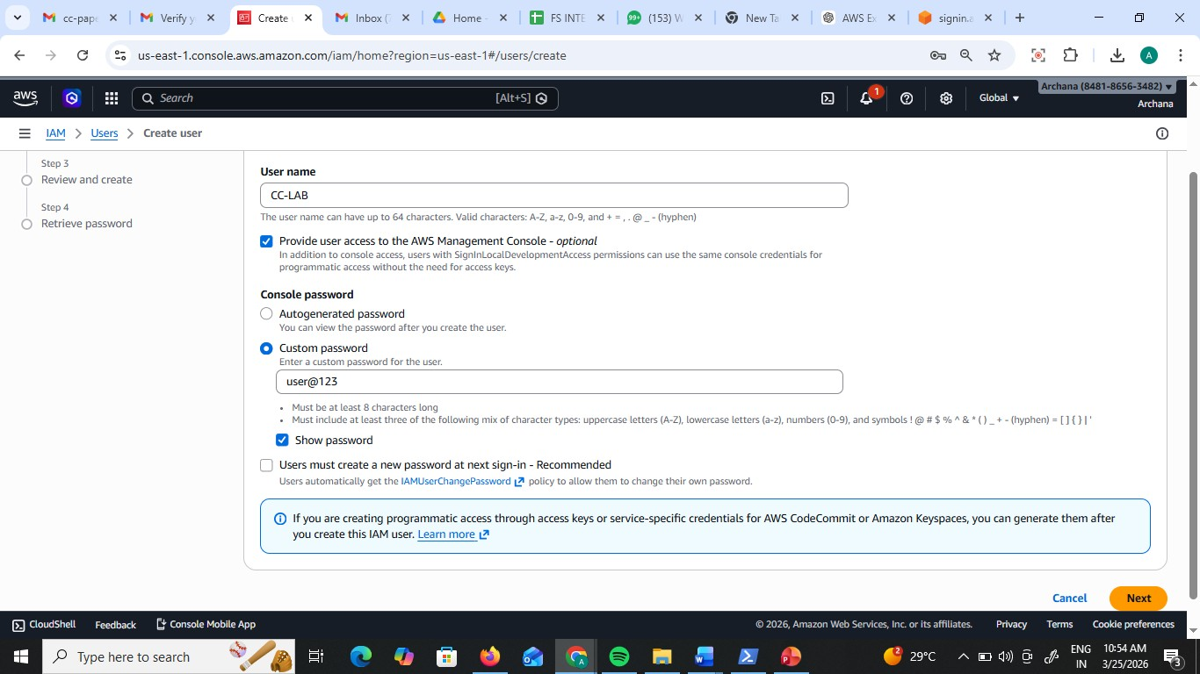
Step 4: User Details: Enter a name (e.g., S3_Specialist). Check the box for "Provide user access to the AWS Management Console." – custom password.

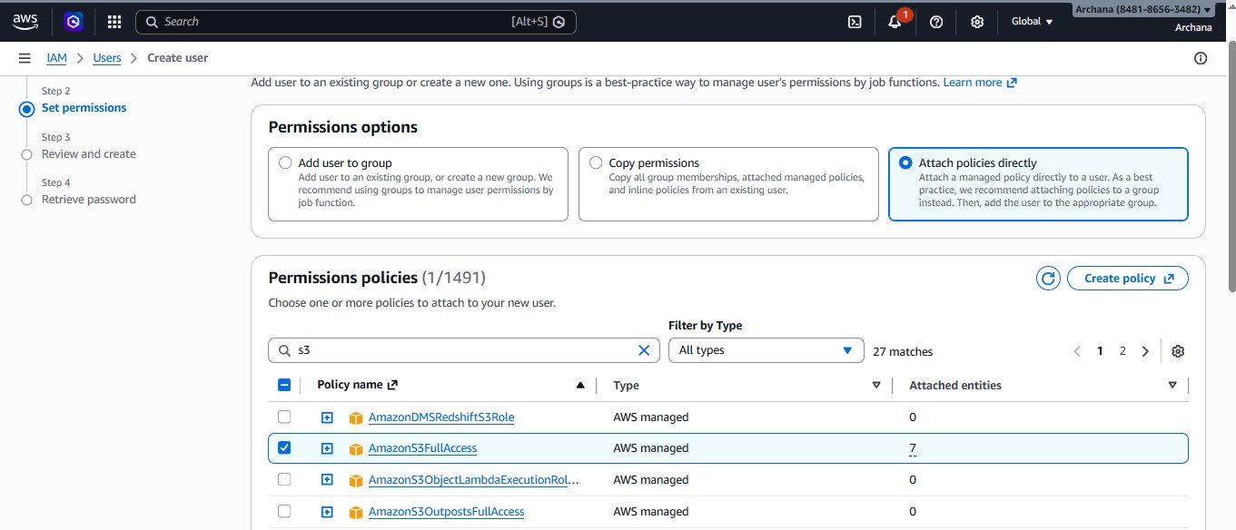
Step 5: Set Permissions: Select "Attach policies directly." Search for and select AmazonS3FullAccess.

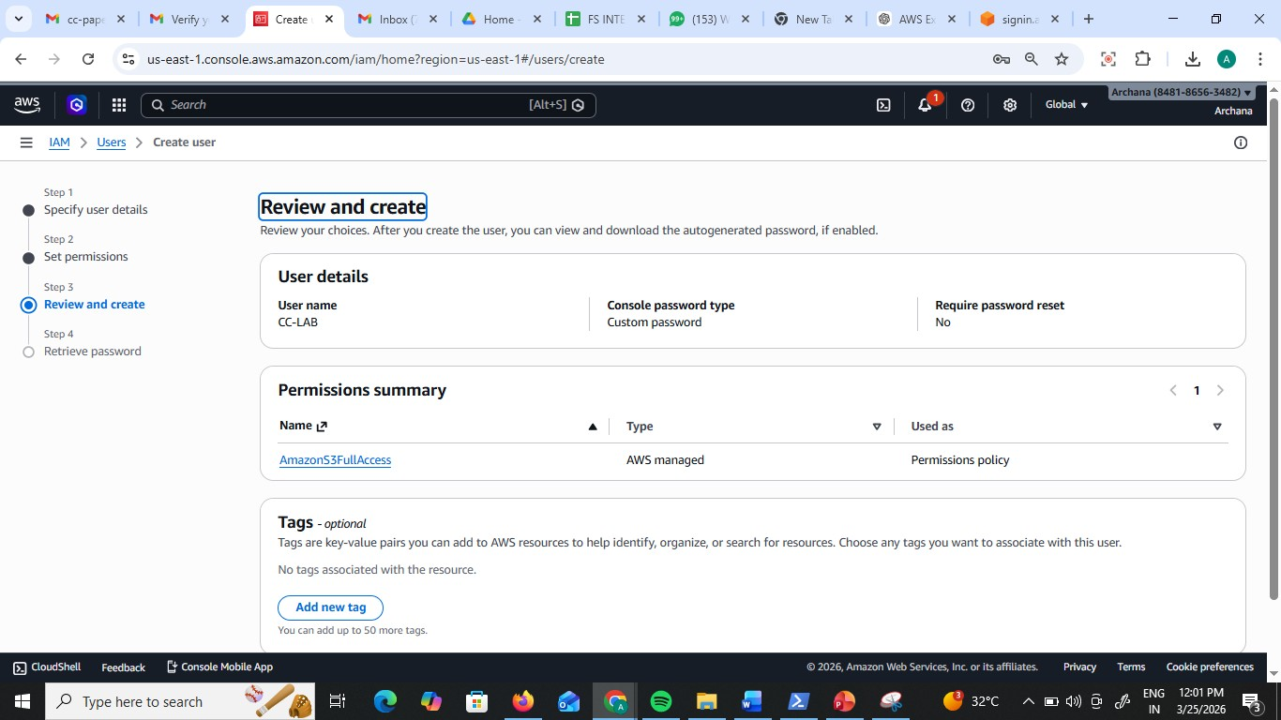
Step 6: Review & Create: Complete the wizard. On the final page, click Download .csv file.

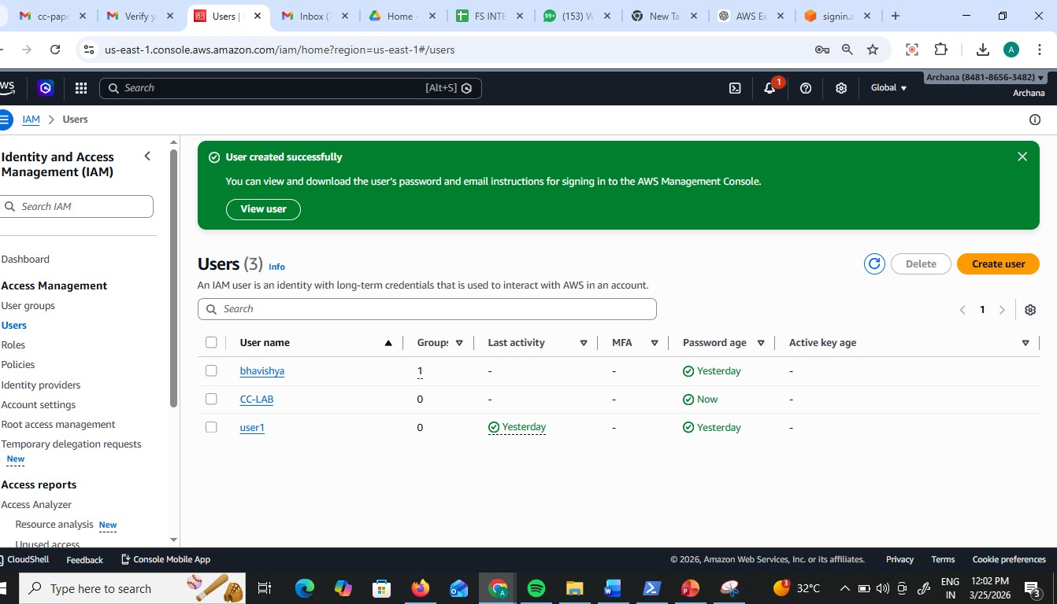
Now you see CC-LAB user created

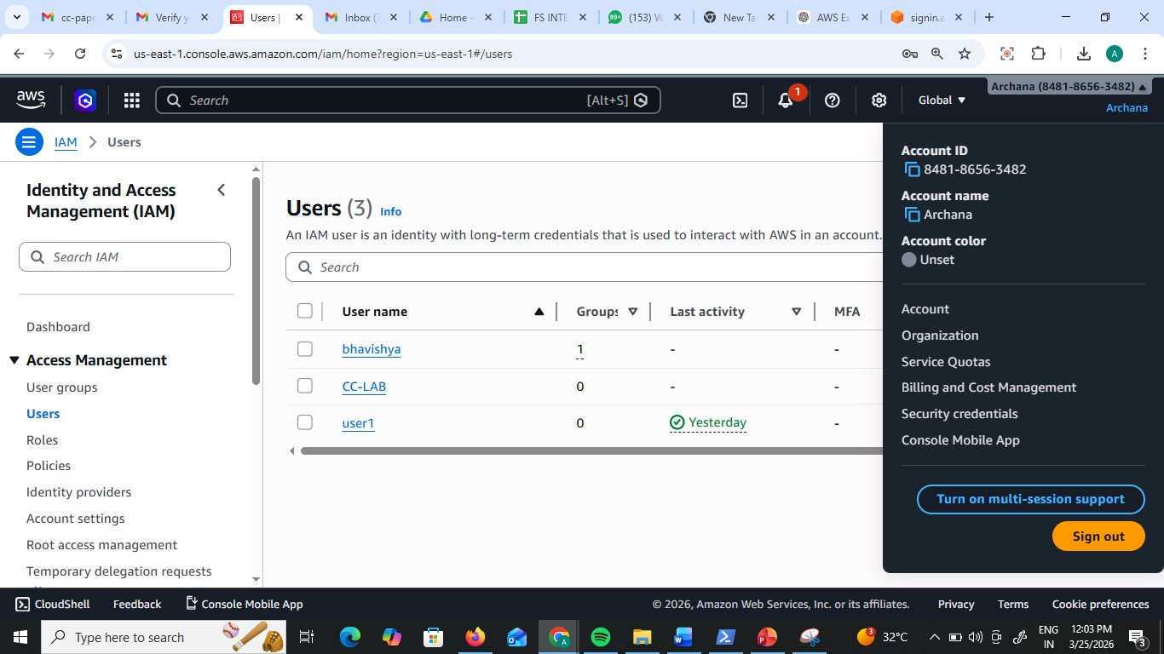
Step 7: Copy your 12-digit Account ID (found in the top-right dropdown or the .csv) and Sign Out.

Step 8: Use the Sign-in URL from the .csv (or go to the AWS sign-in page and select IAM User).
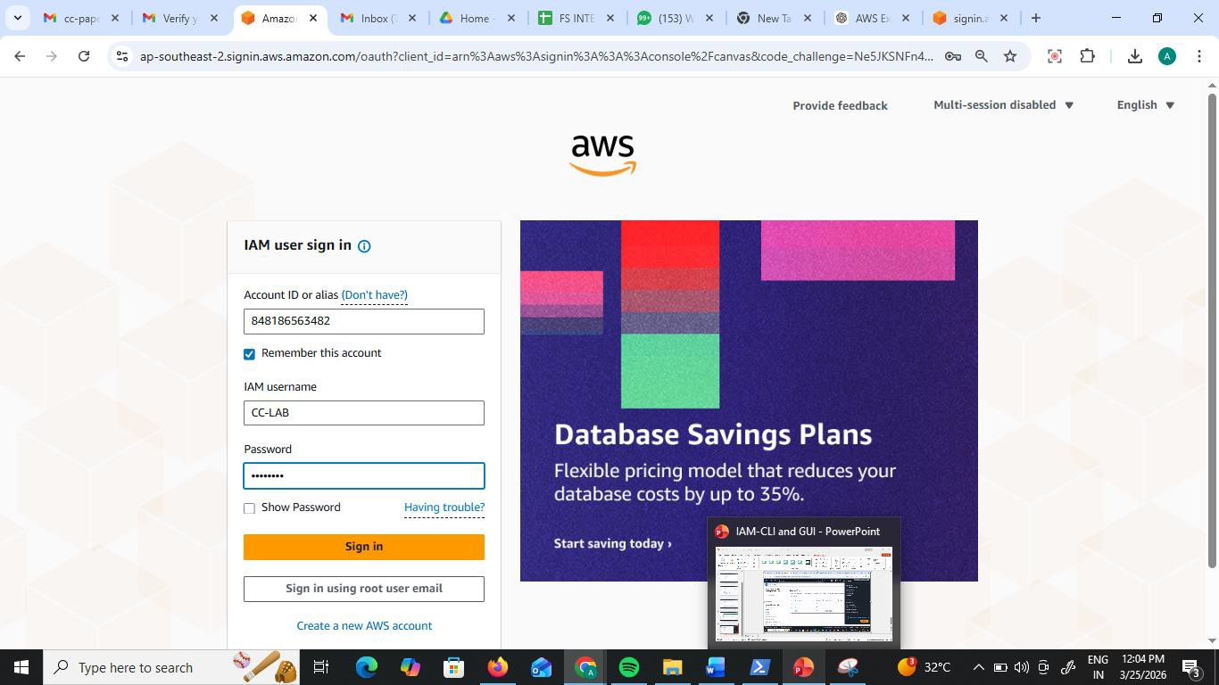
Step 9: Enter the Account ID, then the IAM Username and Password from the .csv.

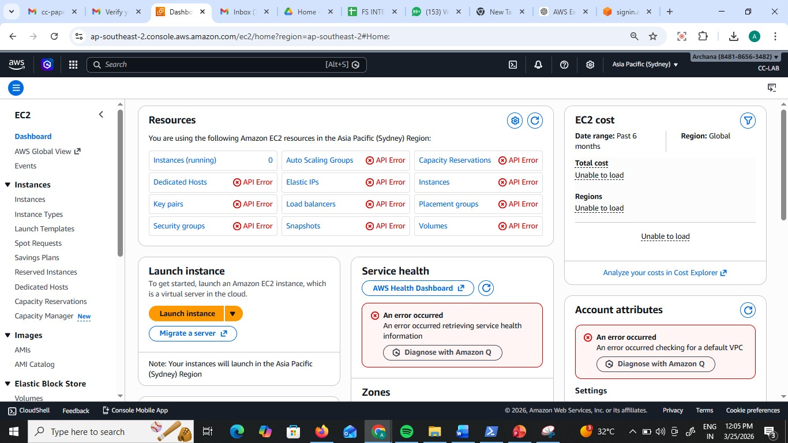
Test 1 (Failure): Navigate to EC2. Try to view instances. You will see "API Error" or "Access Denied." This proves the user is restricted.

Test 2 (Success): Navigate to S3. Create a new bucket. It will work perfectly because of the attached policy.

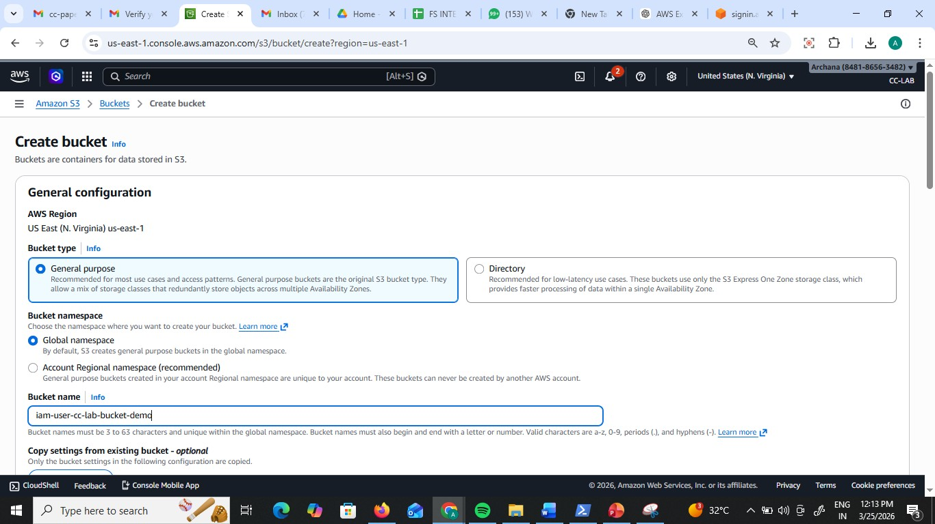

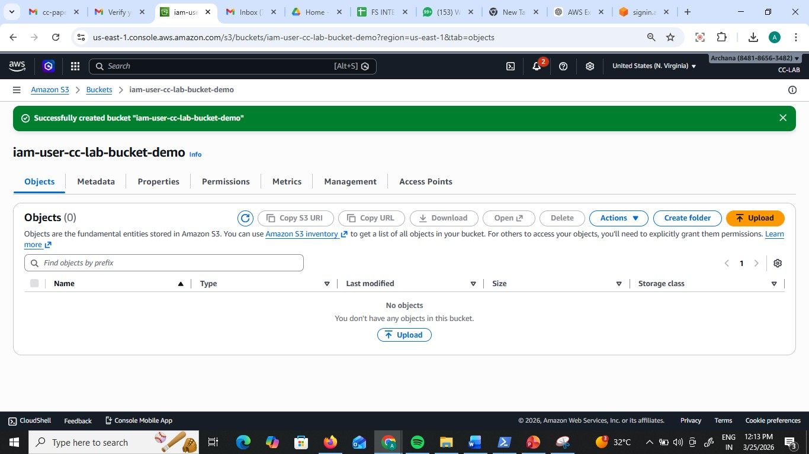

Part B: CLI Access (Programmatic Access)
Objective: Access AWS resources from a standalone system (CMD/Terminal) using security keys.
- Credential Generation
Step 1: While logged in as an Admin/Root, go to IAM > Users and click on your user.
Step 2: Go to the Security credentials tab. Scroll to Access keys and click Create access key.
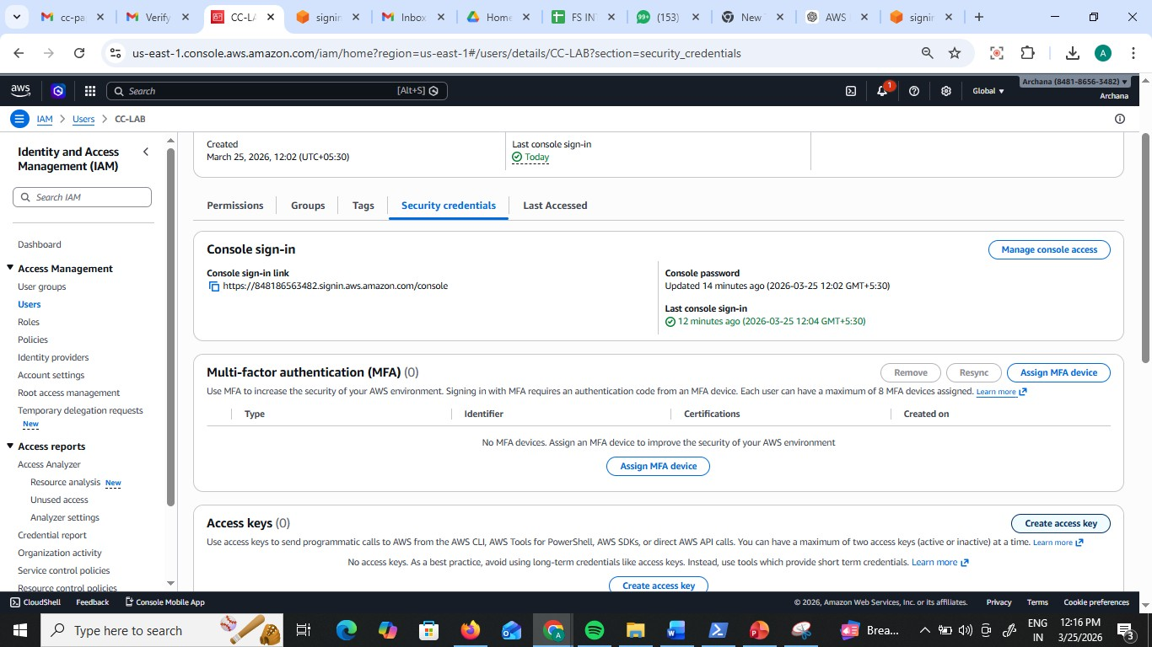

Step 3: Select Command Line Interface (CLI). Acknowledge the warning and click Next.

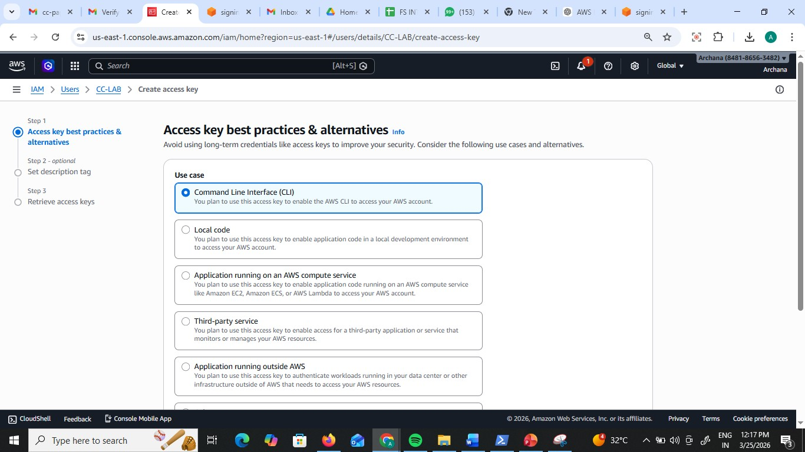

Step 4: Download the .csv file. > Critical: This contains the Access Key ID and Secret Access Key. If lost, you must delete and recreate them.

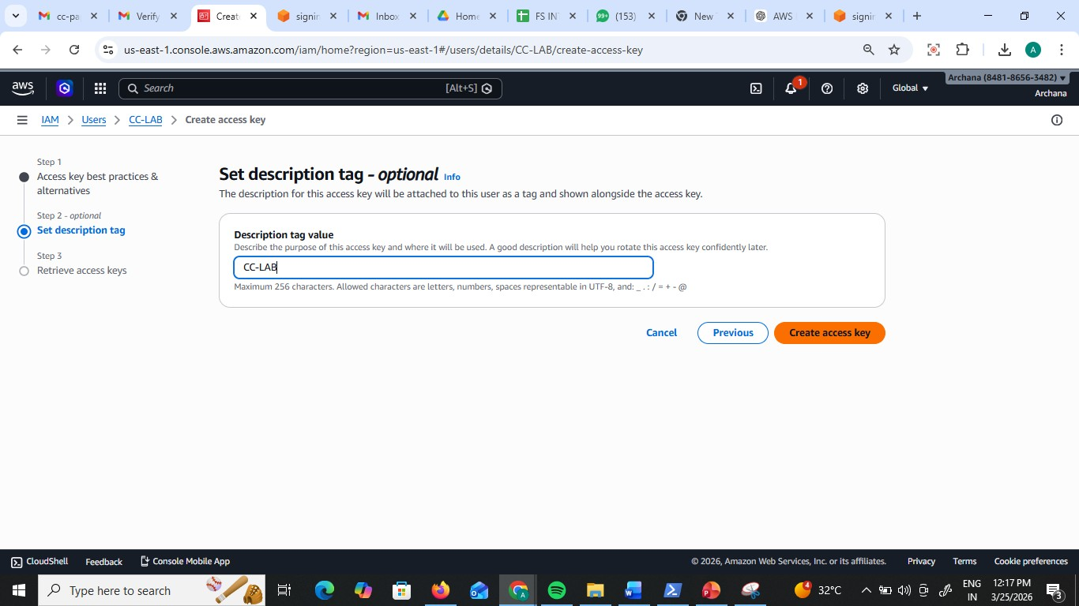

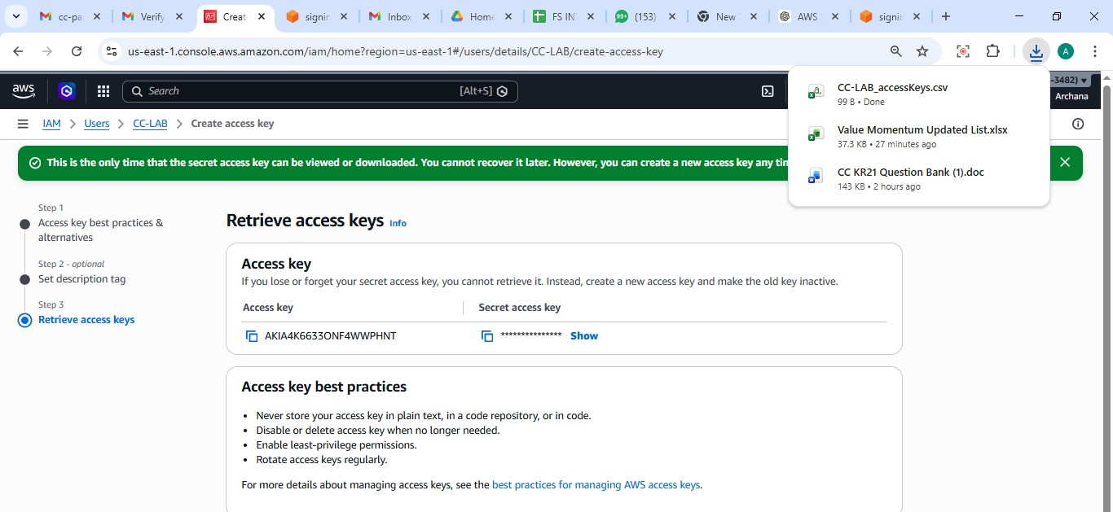

- Standalone System Configuration
Step 5: Install the AWS CLI Tool from google on your computer

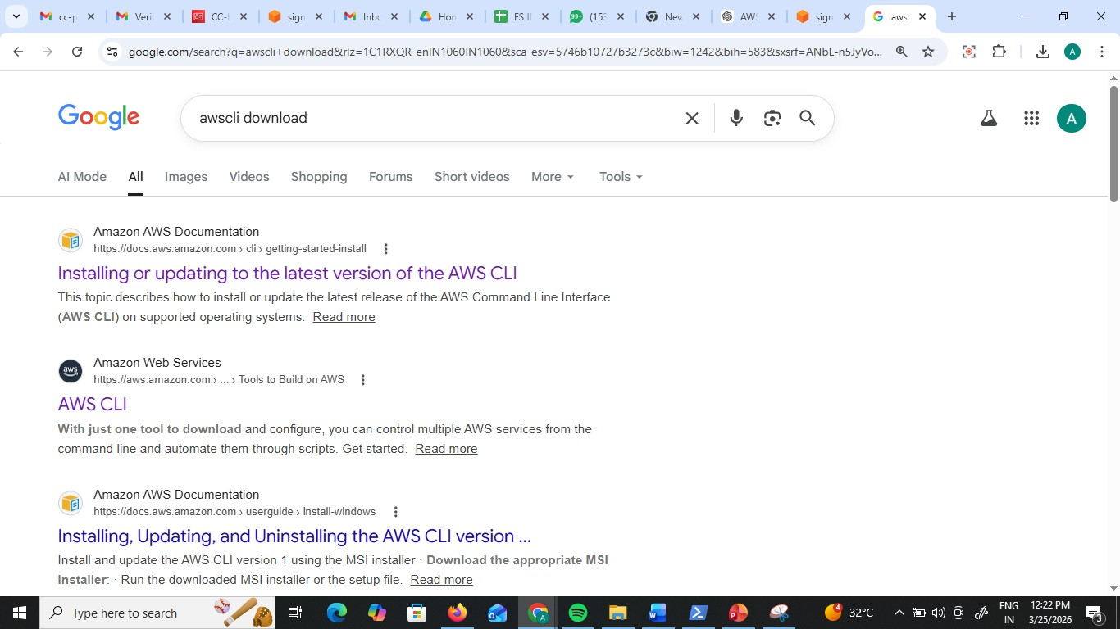

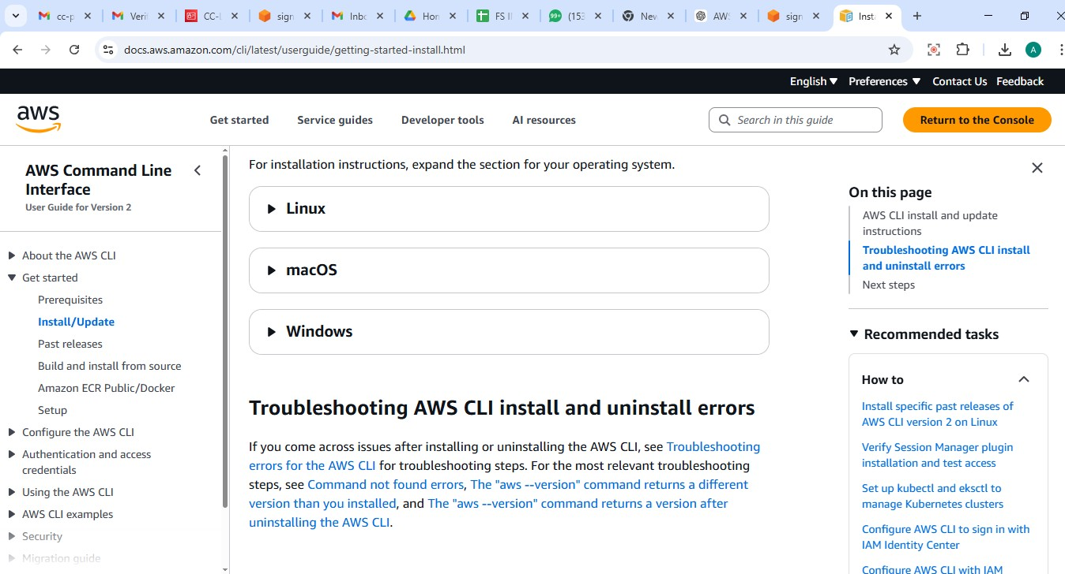

Download https://awscli.amazonaws.com/AWSCLIV2.msi
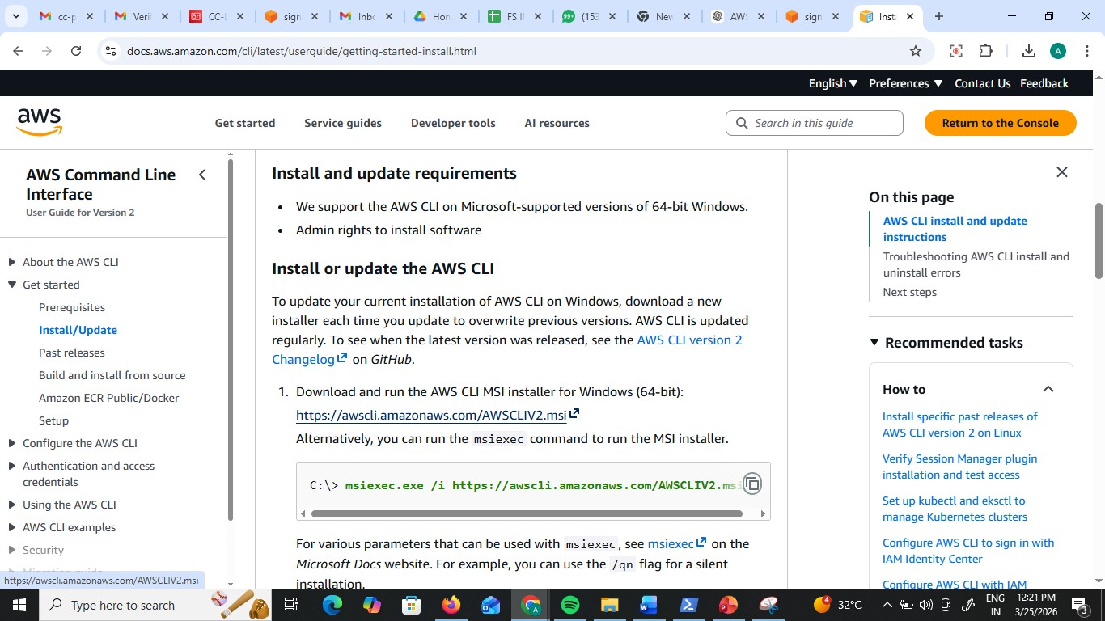

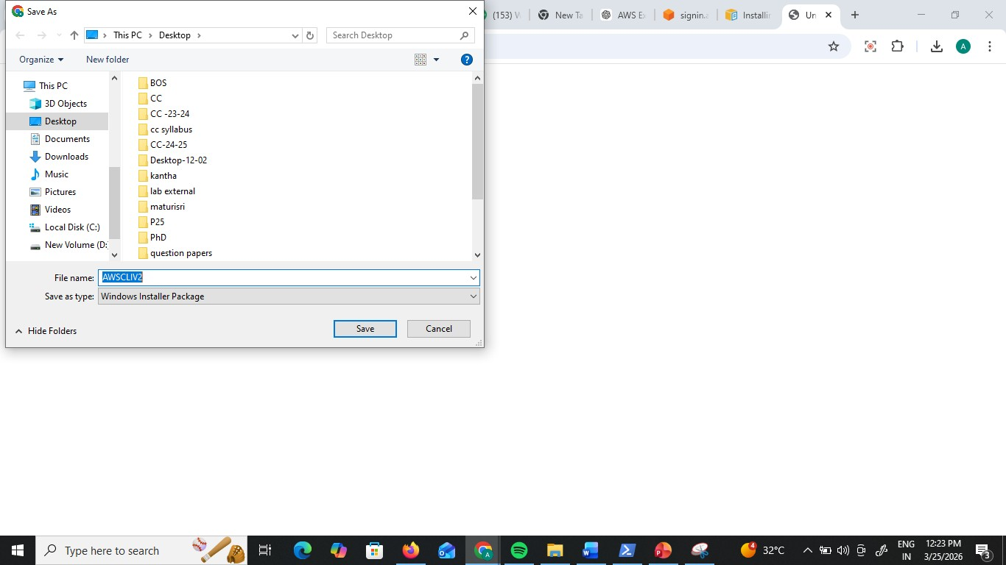

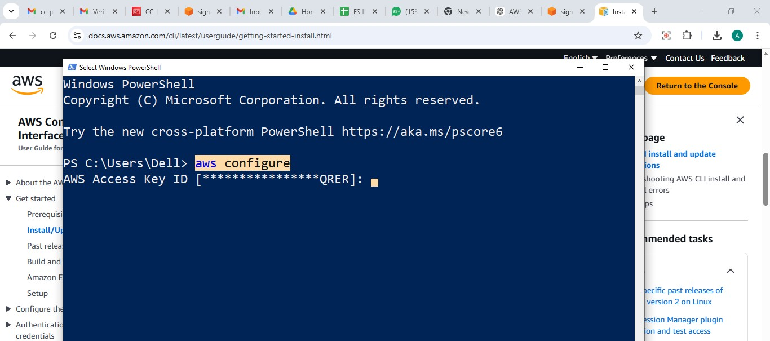
Step 6: Open your Command Prompt (CMD) or Terminal. Step 7: Type aws configure and press Enter.

Step 8: Provide the following from your .csv: Access Key ID
Secret Access Key
Default region: (e.g., ap-south-1)
Default output: json
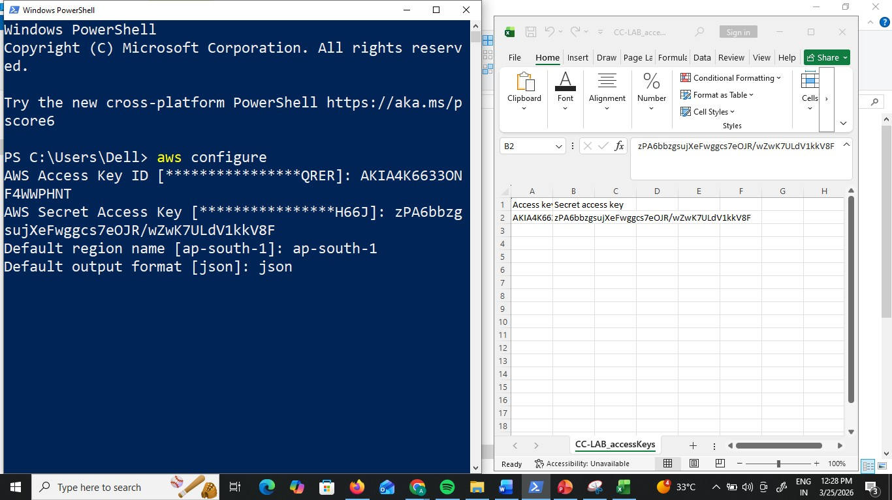

Run aws ec2 describe-nstances.
Result: You will get an (AccessDenied) error.

This confirms that the CLI is respecting the same IAM policy as the GUI.

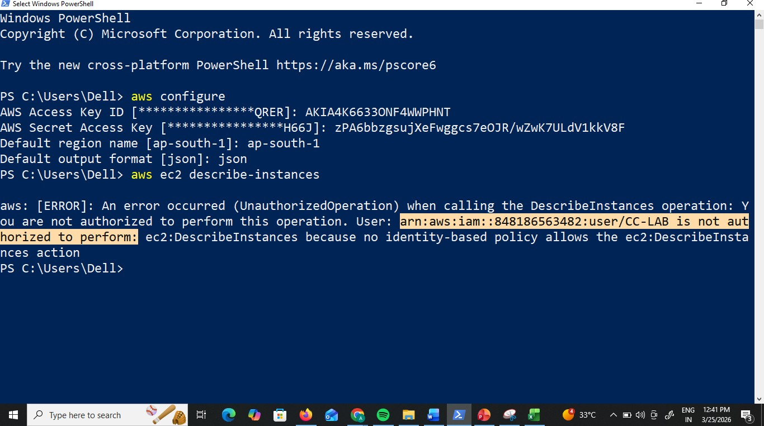

- Verification via Commands
Step 9: Run aws s3 ls. This should list your buckets

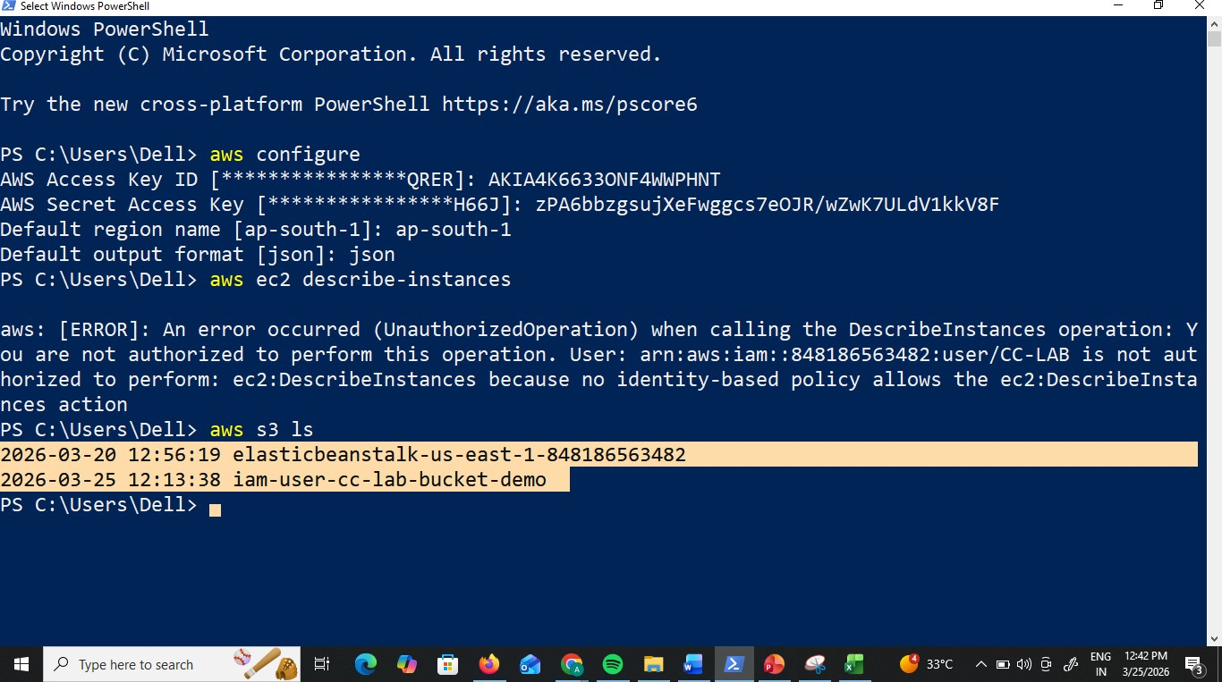

Step 10: Run aws s3 mb s3://your-unique-bucket-name. (Success)

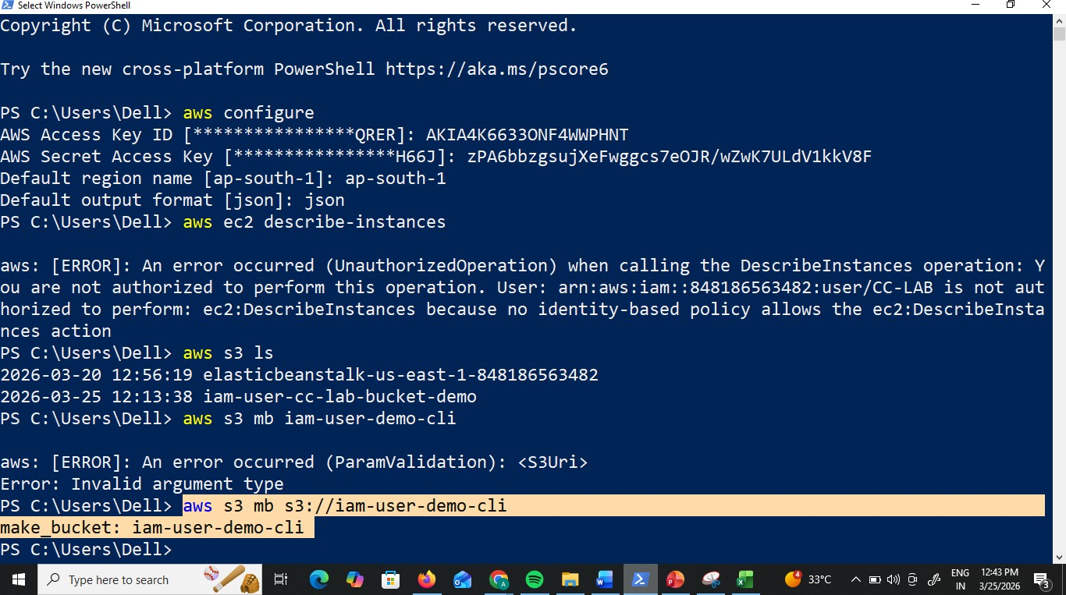

Check in console you see the bucket created from CLI

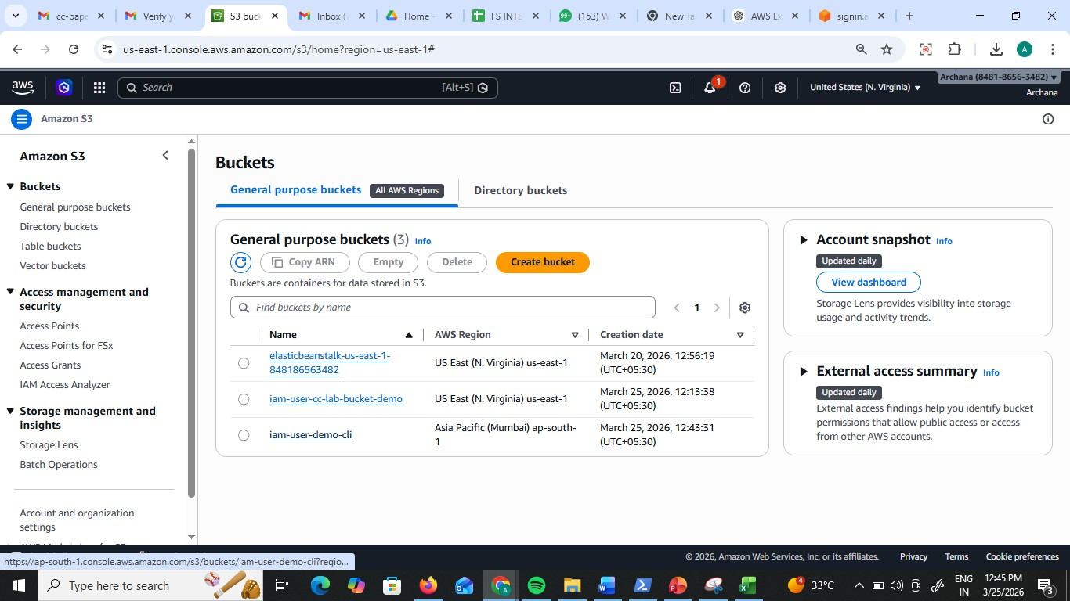

Scenario 1: Security Risk
Q: You logged into AWS using the root user for daily work. What’s wrong here?

✅ Scenario 2: Account Compromise
Q: Your AWS bill suddenly increases and you suspect root user compromise. What steps will you take?

✅ Scenario 3: Root Credentials Lost
Q: What if you forgot root user password?
✅ Scenario 4: Root Access Keys
Q: Why should you avoid creating access keys for root user?

✅ Scenario 5: New Developer Joining
Q: A new developer joins your team. How do you give access?

✅ Scenario 6: Least Privilege
Q: A user needs only S3 read access. What will you do?

✅ Scenario 7: Temporary Access
Q: A contractor needs access for 2 weeks.

✅ Scenario 8: Access Denied Error
Q: User gets “Access Denied” while accessing EC2. Why?

✅ Scenario 9: Multiple Users Same Permissions
Q: 50 users need same access. What is best practice?

✅ Scenario 10: Configure CLI
Q: You installed AWS CLI. How do you configure it?

✅ Scenario 11: Create IAM User via CLI
Q: How to create IAM user using CLI?

✅ Scenario 12: Attach Policy via CLI
Q: Give S3 read access to user using CLI

✅ Scenario 13: Create Access Keys via CLI
Q: How to generate access keys for IAM user?

✅ Scenario 14: List IAM Users
Q: How to check all users using CLI?

✅ Scenario 15: Delete IAM User via CLI
Q: How to safely delete a user?
1Q: CLI command fails with AccessDenied. What to check?

