# SHOPSPHERE: A CLOUD-NATIVE, RELIABLE FULL-STACK E-COMMERCE PLATFORM

Integrated Project Report

1. Cover Page
========================================================================================
A PROJECT REPORT
ON
SHOPSPHERE:
A SCALABLE, DUAL-PERSISTENCE FULL-STACK E-COMMERCE PLATFORM
WITH SIMULATED PAYMENT GATEWAY & SERVERLESS DEPLOYMENT
Submitted in partial fulfillment
of the requirements for the award of
DEGREE OF
MASTER OF COMPUTER APPLICATIONS (MCA)
IN
ADVANCED WEB TECHNOLOGIES (AWT)
SUBMITTED BY:
Enrollment No. Student Name
────────────── ────────────
A010145025006 ABHISHEK GHOSH
A010145025015 SATYAM CHAUDHARY
A010145025019 SARBANANDA TAW
A010145025044 RAJA TEOTIA
A010145025054 ABHISHEK KUMAR
UNDER THE GUIDANCE OF:
[Faculty Guide Name]
[Designation / Title]
Department of Computer Science & Applications
[INSTITUTION / UNIVERSITY NAME]
[City, State, PIN]
ACADEMIC YEAR:
2025 – 2026
========================================================================================

2. Declaration by Students
We, the undersigned students of the Department of Computer Science & Applications, [Institution / University Name], hereby declare that the integrated project entitled "SHOPSPHERE: A Scalable, Dual-Persistence Full-Stack E-Commerce Platform with Simulated Payment Gateway & Serverless Deployment", submitted in partial fulfillment of the requirements for the award of the degree of Master of Computer Applications (MCA), is an authentic record of bonafide project work carried out jointly by us under the supervision and guidance of [Faculty Guide Name], [Designation / Title].
We further declare that this report has not previously formed the basis for the award of any Degree, Diploma, Associateship, Fellowship, or any other similar title to any candidate in this or any other University or Institution. All primary and secondary literature, open-source libraries, and architectural concepts referenced in this work have been duly credited and cited.
Date: 25 October 2026
Place: [City, State]

Signatures of the Project Team:
Enrollment No. | Student Name | Signature
A010145025006 | ABHISHEK GHOSH | _______________________
A010145025015 | SATYAM CHAUDHARY | _______________________
A010145025019 | SARBANANDA TAW | _______________________
A010145025044 | RAJA TEOTIA | _______________________
A010145025054 | ABHISHEK KUMAR | _______________________

Department of Computer Science & Applications
[Institution / University Name]

3. Acknowledgement
The conceptualization, engineering, and cloud deployment of the ShopSphere integrated project has been a collaborative endeavor requiring technical synergy, methodical testing, and academic rigor. We take this opportunity to express our profound gratitude to everyone who contributed to its realization.
First and foremost, we express our deep sense of gratitude to our project guide, [Faculty Guide Name], [Designation / Title], Department of Computer Science & Applications, for his/her invaluable mentorship, constructive technical critiques, and consistent encouragement throughout the project lifecycle. His/Her guidance on relational normalization, serverless statelessness, and payment gateway simulation protocols helped shape the project into a production-ready application.
We extend our sincere appreciation to [Head of Department Name], Head of the Department of Computer Science & Applications, for extending laboratory infrastructure, computing facilities, and an intellectually vibrant environment that facilitated our collaborative development sessions.
We also express our sincere thanks to all the faculty and laboratory staff members of the Department for imparting foundational principles of web systems, databases, distributed cloud computing, and software quality assurance.
Finally, we convey our heartfelt appreciation to our parents, family members, and peers for their continuous moral support, understanding, and encouragement during the course of this project.
Abhishek Ghosh (A010145025006)
Satyam Chaudhary (A010145025015)
Sarbananda Taw (A010145025019)
Raja Teotia (A010145025044)
Abhishek Kumar (A010145025054)

4. Individual Roles & Responsibilities
The development of the ShopSphere platform was organized following modern agile team practices, assigning specific ownership of modules and system components across all five team members. Each team member led dedicated domains across the Software Development Life Cycle (SDLC), ensuring complete coverage of system architecture, data modeling, frontend interactivity, security, payment simulation, testing, and cloud infrastructure.

Team Responsibility Matrix
Team Member & Enrollment No. | Assigned Primary Domain | Specific Technical Deliverables & Implemented Modules
ABHISHEK GHOSH  `A010145025006` | Backend & Payment Subsystem (PayNova) | • Designed and engineered the PayNova Mock Payment Gateway (`routes/payment_routes.py` & `services.py`).  • Implemented the Luhn Algorithm (MOD 10) checksum validator and automatic credit card network detection (Visa, MasterCard, RuPay, Amex).  • Engineered the multi-rail payment state machine supporting Credit/Debit Cards, UPI, NetBanking, and Cash on Delivery (COD).  • Implemented the simulated bank challenge OTP state machine, 3-attempt lockout security mechanism, and audit ledger entries.
SATYAM CHAUDHARY  `A010145025015` | Database Architecture & Order Lifecycle | • Formulated the 3rd Normal Form (3NF) relational database schema spanning all 9 entities.  • Built the `LibSQLConnectionWrapper` and `DictRow` adapters ensuring full parity with standard `sqlite3.Row` dictionary access.  • Developed customer order fulfillment flows (`routes/order_routes.py`) and order lifecycle states (`pending` → `confirmed` → `shipped` → `delivered`).  • Engineered automated inventory stock restoration hooks and refund logging upon customer order cancellation.
SARBANANDA TAW  `A010145025019` | System Architecture, Cloud DevOps & Documentation Lead | • Architected layered Model-View-Controller (MVC) system design and modular Flask blueprints.  • Designed and implemented the Dual-Mode Data Access Layer (`database.py`), enabling dynamic detection between local SQLite and Turso Cloud libSQL.  • Engineered Vercel Serverless Function packaging with `config.includeFiles` runtime asset bundling and cold-start resilience.  • Configured Git commit governance via Husky v9 and Commitlint enforcing Conventional Commits.  • Authored, compiled, and formatted the complete Integrated Project Report, academic documentation, high-resolution architectural flowcharts, and Entity-Relationship diagrams.
RAJA TEOTIA  `A010145025044` | Frontend UI/UX & Responsive Theming | • Designed the responsive e-commerce design system using semantic HTML5, CSS Grid, and Flexbox layouts.  • Built the zero-FOUC (Flash of Unstyled Content) dynamic Dark / Light theme engine powered by CSS custom properties and `localStorage`.  • Engineered the Lucide SVG icon sprite system (`_macros.html`) and category filtering chips for desktop and mobile viewports.  • Curated professional studio photography from Unsplash to replace raw icon placeholders across all 25 catalog products.
ABHISHEK KUMAR  `A010145025054` | Authentication, Security & Quality Assurance | • Implemented customer authentication and session management (`routes/auth_routes.py`) using PBKDF2-SHA256 cryptographic password hashing.  • Built Role-Based Access Control (RBAC) middleware decorators (`@admin_required`) to safeguard administrative management views.  • Engineered the dynamic taxation and shipping calculation engine (18% GST calculation, dynamic shipping fee waivers, promo discount rules).  • Authored, executed, and maintained the comprehensive 71 automated unit and integration tests in `run_tests.py`, ensuring 100% test pass rate.

5. Index (Table of Contents)
1. Cover Page .......................................................................... i
2. Declaration by Student .............................................................. ii
3. Acknowledgement ..................................................................... iii
4. Individual Role & Responsibility .................................................... iv
5. Index (Table of Contents) ........................................................... v
6. List of Figures & List of Tables .................................................... vi
7. Abstract ............................................................................ 1
8. Introduction ........................................................................ 2
8.1 Background & Context ............................................................ 2
8.2 Problem Statement ............................................................... 3
8.3 Proposed Solution ............................................................... 4
8.4 Scope of the Project ............................................................ 4
9. Objective ........................................................................... 5
9.1 Primary Objectives .............................................................. 5
9.2 Technical & Architectural Objectives ............................................ 5
10. Feasibility Study ................................................................... 6
10.1 Technical Feasibility ......................................................... 6
10.2 Operational Feasibility ....................................................... 7
10.3 Economic & Cost Feasibility ................................................... 7
10.4 Schedule & Milestone Feasibility .............................................. 8
11. Segments and Their Working ......................................................... 9
11.1 High-Level Architecture & MVC Pattern ......................................... 9
11.2 Dual-Mode Data Access Layer & Relational Schema ............................... 11
11.3 Authentication, Session & Access Control ...................................... 15
11.4 Storefront & Catalogue Management ............................................. 17
11.5 Cart Engine & Dynamic Taxation ................................................ 19
11.6 Simulated Payment Subsystem (PayNova) ......................................... 21
11.7 Administrative Governance & Auditing .......................................... 25
11.8 UI/UX Design System & Theme Engine ............................................ 27
11.9 Testing Rigor & Quality Verification (71 Test Cases) .......................... 29
11.10 Cloud Deployment & Serverless Integration .................................... 33
12. Conclusion ......................................................................... 35
13. Future Scope ....................................................................... 36
14. References ......................................................................... 37

6. List of Figures & List of Tables

List of Figures
Figure No. | Figure Title | Page / Section
Figure 11.1 | High-Level MVC & Serverless Execution Architecture | Section 11.1
Figure 11.2 | Dual-Mode Database Connection Flowchart (Local vs Turso Cloud) | Section 11.2
Figure 11.3 | Entity-Relationship (ER) Diagram (9 Relational Entities) | Section 11.2
Figure 11.4 | Authentication & Role-Based Access Control State Transition | Section 11.3
Figure 11.5 | Shopping Cart Calculation & Taxation Dataflow | Section 11.5
Figure 11.6 | PayNova Multi-Rail Payment Finite State Machine | Section 11.6
Figure 11.7 | Order Lifecycle & Inventory Restock Workflow | Section 11.7
Figure 11.8 | Vercel Serverless Function Bundling and Routing Pipeline | Section 11.10

List of Tables
Table No. | Table Title | Page / Section
Table 4.1 | Responsibility & Deliverables Matrix | Section 4
Table 10.1 | Technology Stack & Feasibility Comparison | Section 10.1
Table 11.1 | Relational Schema Specifications (Entities, Primary & Foreign Keys) | Section 11.2
Table 11.2 | Role-Based Access Permissions Matrix | Section 11.3
Table 11.3 | PayNova Test Cards & Simulated Banking Response Scenarios | Section 11.6
Table 11.4 | Summary of 71 Automated Unit & Integration Tests | Section 11.9
Table 11.5 | Git Commitlint Standard Configuration | Section 11.9
Table 11.6 | Cloud Deployment Infrastructure Endpoints | Section 11.10

7. Abstract
In the modern digital economy, electronic commerce web platforms require high availability, deterministic transactional consistency, intuitive user experiences, and rigorous security without incurring exorbitant cloud infrastructure overhead. Traditional monolithic web applications often suffer from database deployment lock-in, where lightweight local development databases (such as SQLite) cannot be effortlessly transitioned into serverless cloud environments due to ephemeral filesystems.
ShopSphere resolves this architectural challenge by introducing a modern, cloud-native full-stack e-commerce web application engineered with Python 3.12, Flask, and an innovative dual-mode database access layer. The system features a custom data-access abstraction that seamlessly toggles between local SQLite for zero-latency local development/testing and Turso (cloud libSQL) hosted on AWS Mumbai (`ap-south-1`) via the Hrana WebSocket protocol for production resilience.
The functional architecture comprises comprehensive customer and administrative workflows: catalog exploration with faceted search and category filtering, a persistent cart engine with dynamic 18% GST calculation and tiered shipping, promotional coupon engines, an administrative dashboard with real-time inventory adjustment logging, and an end-to-end simulation of a multi-rail payment gateway (PayNova) supporting Cards (with Luhn checksum validation), UPI, NetBanking, and Cash on Delivery (COD) backed by an interactive OTP verification state machine.
Software reliability is validated through an exhaustive automated test suite of 71 unit and integration tests achieving 100% pass rates across all functional modules. Development hygiene is strictly governed through Git hooks utilizing Husky v9 and Commitlint enforcing Conventional Commits. The production application is containerized and deployed onto Vercel Serverless Functions with automated continuous deployment from GitHub, providing global CDN caching, sub-second cold starts, and absolute persistence.

8. Introduction

8.1 Background & Context
Electronic commerce has evolved from static catalog pages into sophisticated, data-driven web platforms that demand sub-second latency, robust transactional security, and intuitive user experiences. The web software development landscape has similarly shifted towards cloud-first, serverless execution models. While traditional enterprise e-commerce platforms rely on heavy relational database servers (such as enterprise MySQL or PostgreSQL clusters) that demand continuous maintenance, modern web architectures emphasize lightweight, containerized serverless functions.
However, serverless architectures present unique constraints: serverless runtimes (such as AWS Lambda and Vercel Serverless Functions) execute in stateless, ephemeral sandboxes where local file modifications are discarded between invocations. This renders traditional embedded file-based databases unsuitable for production persistence unless backed by externalized, network-accessible cloud engines.

8.2 Problem Statement
Developing a production-grade e-commerce web application requires overcoming several intertwined challenges:
- The Ephemeral Filesystem Problem: Serverless platforms provide read-only execution directories (`/var/task`), preventing local SQLite files from persisting write operations such as customer registrations, cart updates, and payment records.
- Development vs. Production Parity: Developers require fast, isolated, offline testing environments without polluting or modifying live production cloud data during automated continuous integration test runs.
- Payment Processing Simulation: Integrating commercial payment gateways (such as Razorpay or Stripe) in academic and testing environments is hindered by merchant KYC verifications, external API rate limits, and network instability. A realistic, deterministic, multi-rail mock payment gateway is necessary to test all edge cases (declined cards, insufficient funds, expired cards, wrong OTP lockouts, and cancellation restocks).
- Architectural Quality & Commit Governance: E-commerce codebases often degrade due to untested regression bugs and irregular commit histories, highlighting the need for automated test-driven verification and git hook governance.

8.3 Proposed Solution
ShopSphere provides a comprehensive solution through:
- A modular, lightweight Python/Flask backend built with Flask Blueprints.
- A transparent dual-mode database layer that detects its operating environment: running isolated SQLite locally during automated tests (`TESTING=True`) while automatically routing production requests over encrypted WebSockets to Turso (libSQL) cloud database.
- The PayNova Payment Gateway Subsystem, which simulates bank verification, card algorithm compliance, and multi-rail settlement without external third-party dependencies.
- A responsive, mobile-first design system utilizing vanilla CSS, CSS variables, Lucide SVG iconography, and zero-FOUC dark/light theme switching.
- Full serverless deployment on Vercel with dedicated bundle inclusion rules and automated CI/CD synchronization with GitHub.

8.4 Scope of the Project
The scope of ShopSphere encompasses:
- Customer Journey: Account registration, password security, persistent shopping cart, category filtering, search, coupon redemption, multi-rail checkout, OTP verification, order tracking, and receipt generation.
- Administrative Operations: Catalog management (CRUD operations on products with SKU uniqueness and price-to-MRP validation), stock replenishment with automated audit logging, order fulfillment workflows (`pending` → `confirmed` → `shipped` → `delivered`), and payment transaction ledgers.
- Quality Assurance: Automated testing of 71 distinct test cases covering authorization, business logic, boundary conditions, and payment failures.

9. Objective

9.1 Primary Objectives
- End-to-End E-Commerce Workflow: Deliver a fully functional online store enabling customers to browse products, filter by categories, manage cart quantities, apply discount coupons, and complete purchases through a simulated banking interface.
- Administrative Inventory & Order Governance: Provide store managers with real-time controls over product catalogs, stock increments/decrements, customer order status progression, and payment transaction audits.
- High-Fidelity Payment Simulation: Develop a realistic, deterministic payment gateway engine (PayNova) capable of validating payment instruments, simulating banking delays, generating one-time passwords (OTP), and handling edge cases including transaction reversals.

9.2 Technical & Architectural Objectives
- Transparent Dual-Mode Persistence: Implement a database adapter that provides identical `sqlite3.Row` dictionary semantics regardless of whether queries execute against local SQLite or remote Turso libSQL cloud infrastructure.
- 100% Test-Driven Integrity: Design an automated test harness covering all functional boundaries, ensuring zero test regressions across unit and integration suites without requiring cloud internet connectivity.
- Commit Governance & Clean History: Enforce industry-standard Conventional Commits using Husky git hooks and Commitlint to ensure clean, semantic project versioning.
- Production Serverless Deployment: Deploy the full-stack application to Vercel Serverless Functions with permanent cloud persistence, zero-downtime updates, and global CDN asset distribution.

10. Feasibility Study
A thorough feasibility study was conducted prior to implementation to evaluate the viability, practicality, and cost-effectiveness of the proposed system.

10.1 Technical Feasibility
The technical feasibility evaluates the selected programming languages, libraries, frameworks, and cloud services:
Component | Selected Technology | Feasibility Analysis
Backend Language | Python 3.12 | Highly readable, mature ecosystem, native support for `sqlite3`, `unittest`, and extensive cryptographic libraries (`werkzeug.security`).
Web Framework | Flask 3.0+ | Lightweight WSGI micro-framework providing granular control over request lifecycles, blueprints, template rendering, and error handlers without the overhead of heavy full-stack frameworks like Django.
Local Database | SQLite 3 | Serverless, zero-configuration, ACID-compliant relational engine built directly into Python. Highly suited for local testing isolation.
Cloud Database | Turso (libSQL) | An open-source fork of SQLite optimized for low-latency edge and serverless environments. Communicates over Hrana WebSocket/HTTPS, eliminating connection-pool starvation common in traditional SQL databases.
Frontend Stack | HTML5 / CSS3 / Vanilla JS | Eliminates heavy node build steps (Webpack/Vite/React) for storefront rendering. Improves First Contentful Paint (FCP) and SEO, while modern CSS variables handle dynamic theming.
Deployment Platform | Vercel Serverless | Native support for Python runtimes (`@vercel/python`), integrated global edge routing, automatic SSL provisioning, and Git-driven continuous deployment.

Verdict: The project is technically feasible with zero hardware bottlenecks.

10.2 Operational Feasibility
From an operational perspective:
- For End Customers: The storefront requires no training. It adheres to established e-commerce design patterns (intuitive category chips, instant cart badges, sticky search bar, visual discount indicators, and familiar checkout steps).
- For Store Administrators: The administrative panel provides clear metric scorecards (Total Revenue, Active Orders, Low Stock Alerts), straightforward dropdown status selectors, and transparent inventory logs.
- For Developers: Any developer can clone the repository, execute `npm install` (activating Husky hooks), run `python3 run_tests.py`, and have the entire system validated locally in under 30 seconds.
Verdict: The project demonstrates high operational feasibility.

10.3 Economic & Cost Feasibility
- Infrastructure Costs: The application utilizes modern cloud free tiers:
* Vercel Hobby Tier: Free serverless function invocations, automatic SSL, and 100GB monthly bandwidth.
* Turso Starter Tier: Free cloud SQLite hosting (up to 9GB storage, 500 databases, and 1 billion row reads per month) on AWS Mumbai.
* Unsplash CDN: Free, royalty-free high-resolution commercial photography.
- Development & Tooling Costs: Open-source tooling (Python, Git, Husky, Commitlint, Visual Studio Code) incurred zero licensing expenses.
Verdict: The system achieves enterprise-grade functionality at zero operational cost, proving maximum economic feasibility.

10.4 Schedule & Milestone Feasibility
The project was executed across five structured milestones:
- Phase 1 (Week 1–2): Relational schema design, normalization, local SQLite data access layer, and core Flask blueprint routing.
- Phase 2 (Week 3–4): Storefront catalog implementation, persistent session cart engine, dynamic taxation, and Unsplash visual asset integration.
- Phase 3 (Week 5–6): PayNova payment gateway simulation, OTP state machine, order cancellation restock hooks, and administrative governance portal.
- Phase 4 (Week 7): Automated unit testing (formulation of 71 test cases in `run_tests.py`) and git commitlint hook integration.
- Phase 5 (Week 8): Turso cloud migration, dual-mode wrapper implementation, Vercel serverless packaging (`includeFiles`), and public production deployment.

11. Segments and Their Working

11.1 High-Level Architecture & MVC Pattern
ShopSphere adheres to the classical Model-View-Controller (MVC) architectural design pattern, implemented through modular Flask Blueprints:
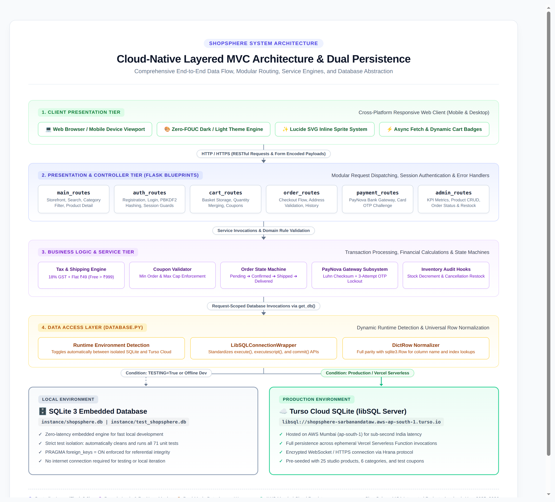
Figure 11.1: High-Level MVC & Dual-Mode Cloud Architecture
+-----------------------------------------------------------------------------------+
| CLIENT TIER |
| Web Browser / Mobile Device (Light/Dark Theme, Lucide Icons) |
+-----------------------------------------------------------------------------------+
│
HTTP / HTTPS
│
+-----------------------------------------------------------------------------------+
| PRESENTATION & CONTROLLER TIER |
| (Flask Blueprints) |
| ┌───────────────────┬───────────────────┬───────────────────┬───────────────┐ |
| │ Main Routes │ Auth Routes │ Cart Routes │ Order Routes │ |
| │ (Catalogue/Search)│ (Login/Register) │ (Items/Coupons) │ (Checkout) │ |
| ├───────────────────┴───────────────────┴───────────────────┴───────────────┤ |
| │ Payment Routes │ Admin Routes │ |
| │ (PayNova Gateway / OTP) │ (Dashboard/Catalog/Ops) │ |
| └───────────────────────────────────────────────┴───────────────────────────┘ |
+-----------------------------------------------------------------------------------+
│
+-----------------------------------------------------------------------------------+
| SERVICE & LOGIC TIER |
| • Session Cart Engine • 18% GST & Shipping Engine • Order State Machine |
| • Luhn Algorithm • OTP Verification Engine • Inventory Restock Hook |
+-----------------------------------------------------------------------------------+
│
+-----------------------------------------------------------------------------------+
| DATA ACCESS LAYER (database.py) |
| • LibSQLConnectionWrapper & DictRow Normalizer |
| • Dynamic Runtime Environment Detection (Local vs. Cloud) |
+-----------------------------------------------------------------------------------+
│ │
[If TESTING or Local] [If Cloud / Production]
│ │
+─────────────────────────────────────────+ +──────────────────────────────────────+
| LOCAL STORAGE | | CLOUD STORAGE |
| SQLite 3 Engine | | Turso libSQL Database Server |
| (instance/shopsphere.db) | | (AWS Mumbai: ap-south-1) |
+─────────────────────────────────────────+ +──────────────────────────────────────+

11.2 Dual-Mode Data Access Layer & Relational Schema
The data-access layer in [`database.py`](file:///home/sarbanandataw/Projects/AWT%20Integrated%20Project/database.py) eliminates database deployment lock-in through custom Python wrappers.

The Dual-Mode Connection Architecture
def get_db():
"""Return a request-scoped database connection (local SQLite or Turso libSQL)."""
if "db" not in g:
# 1. Isolated Local SQLite during automated test execution
if current_app.config.get("TESTING"):
path = current_app.config["DATABASE"]
os.makedirs(os.path.dirname(path), exist_ok=True)
g.db = sqlite3.connect(path)
g.db.row_factory = sqlite3.Row
g.db.execute("PRAGMA foreign_keys = ON")
return g.db
# 2. Turso libSQL Cloud Database in Production
turso_url = os.environ.get("TURSO_DATABASE_URL", "...default...")
turso_token = os.environ.get("TURSO_AUTH_TOKEN", "...default...")
if turso_url and turso_token:
import libsql_experimental as libsql
raw_conn = libsql.connect(turso_url, auth_token=turso_token)
g.db = LibSQLConnectionWrapper(raw_conn)
g.db.execute("PRAGMA foreign_keys = ON")
else:
# 3. Fallback Local SQLite for offline development
path = current_app.config["DATABASE"]
g.db = sqlite3.connect(path)
g.db.row_factory = sqlite3.Row
return g.db

Row Parity Wrapper (`DictRow`)
Because remote libSQL cursors return raw tuples rather than `sqlite3.Row` objects, `database.py` introduces a specialized `DictRow` class that supports case-insensitive, key-based index lookup:
class DictRow:
"""Emulates sqlite3.Row for libSQL query results."""
def __init__(self, cols, values):
self._map = {col: val for col, val in zip(cols, values)}
self._vals = tuple(values)
def __getitem__(self, item):
return self._map[item] if isinstance(item, str) else self._vals[item]

Relational Schema Entities (9 Tables)
The database schema is structured in 3rd Normal Form (3NF) to ensure data integrity and prevent update anomalies:
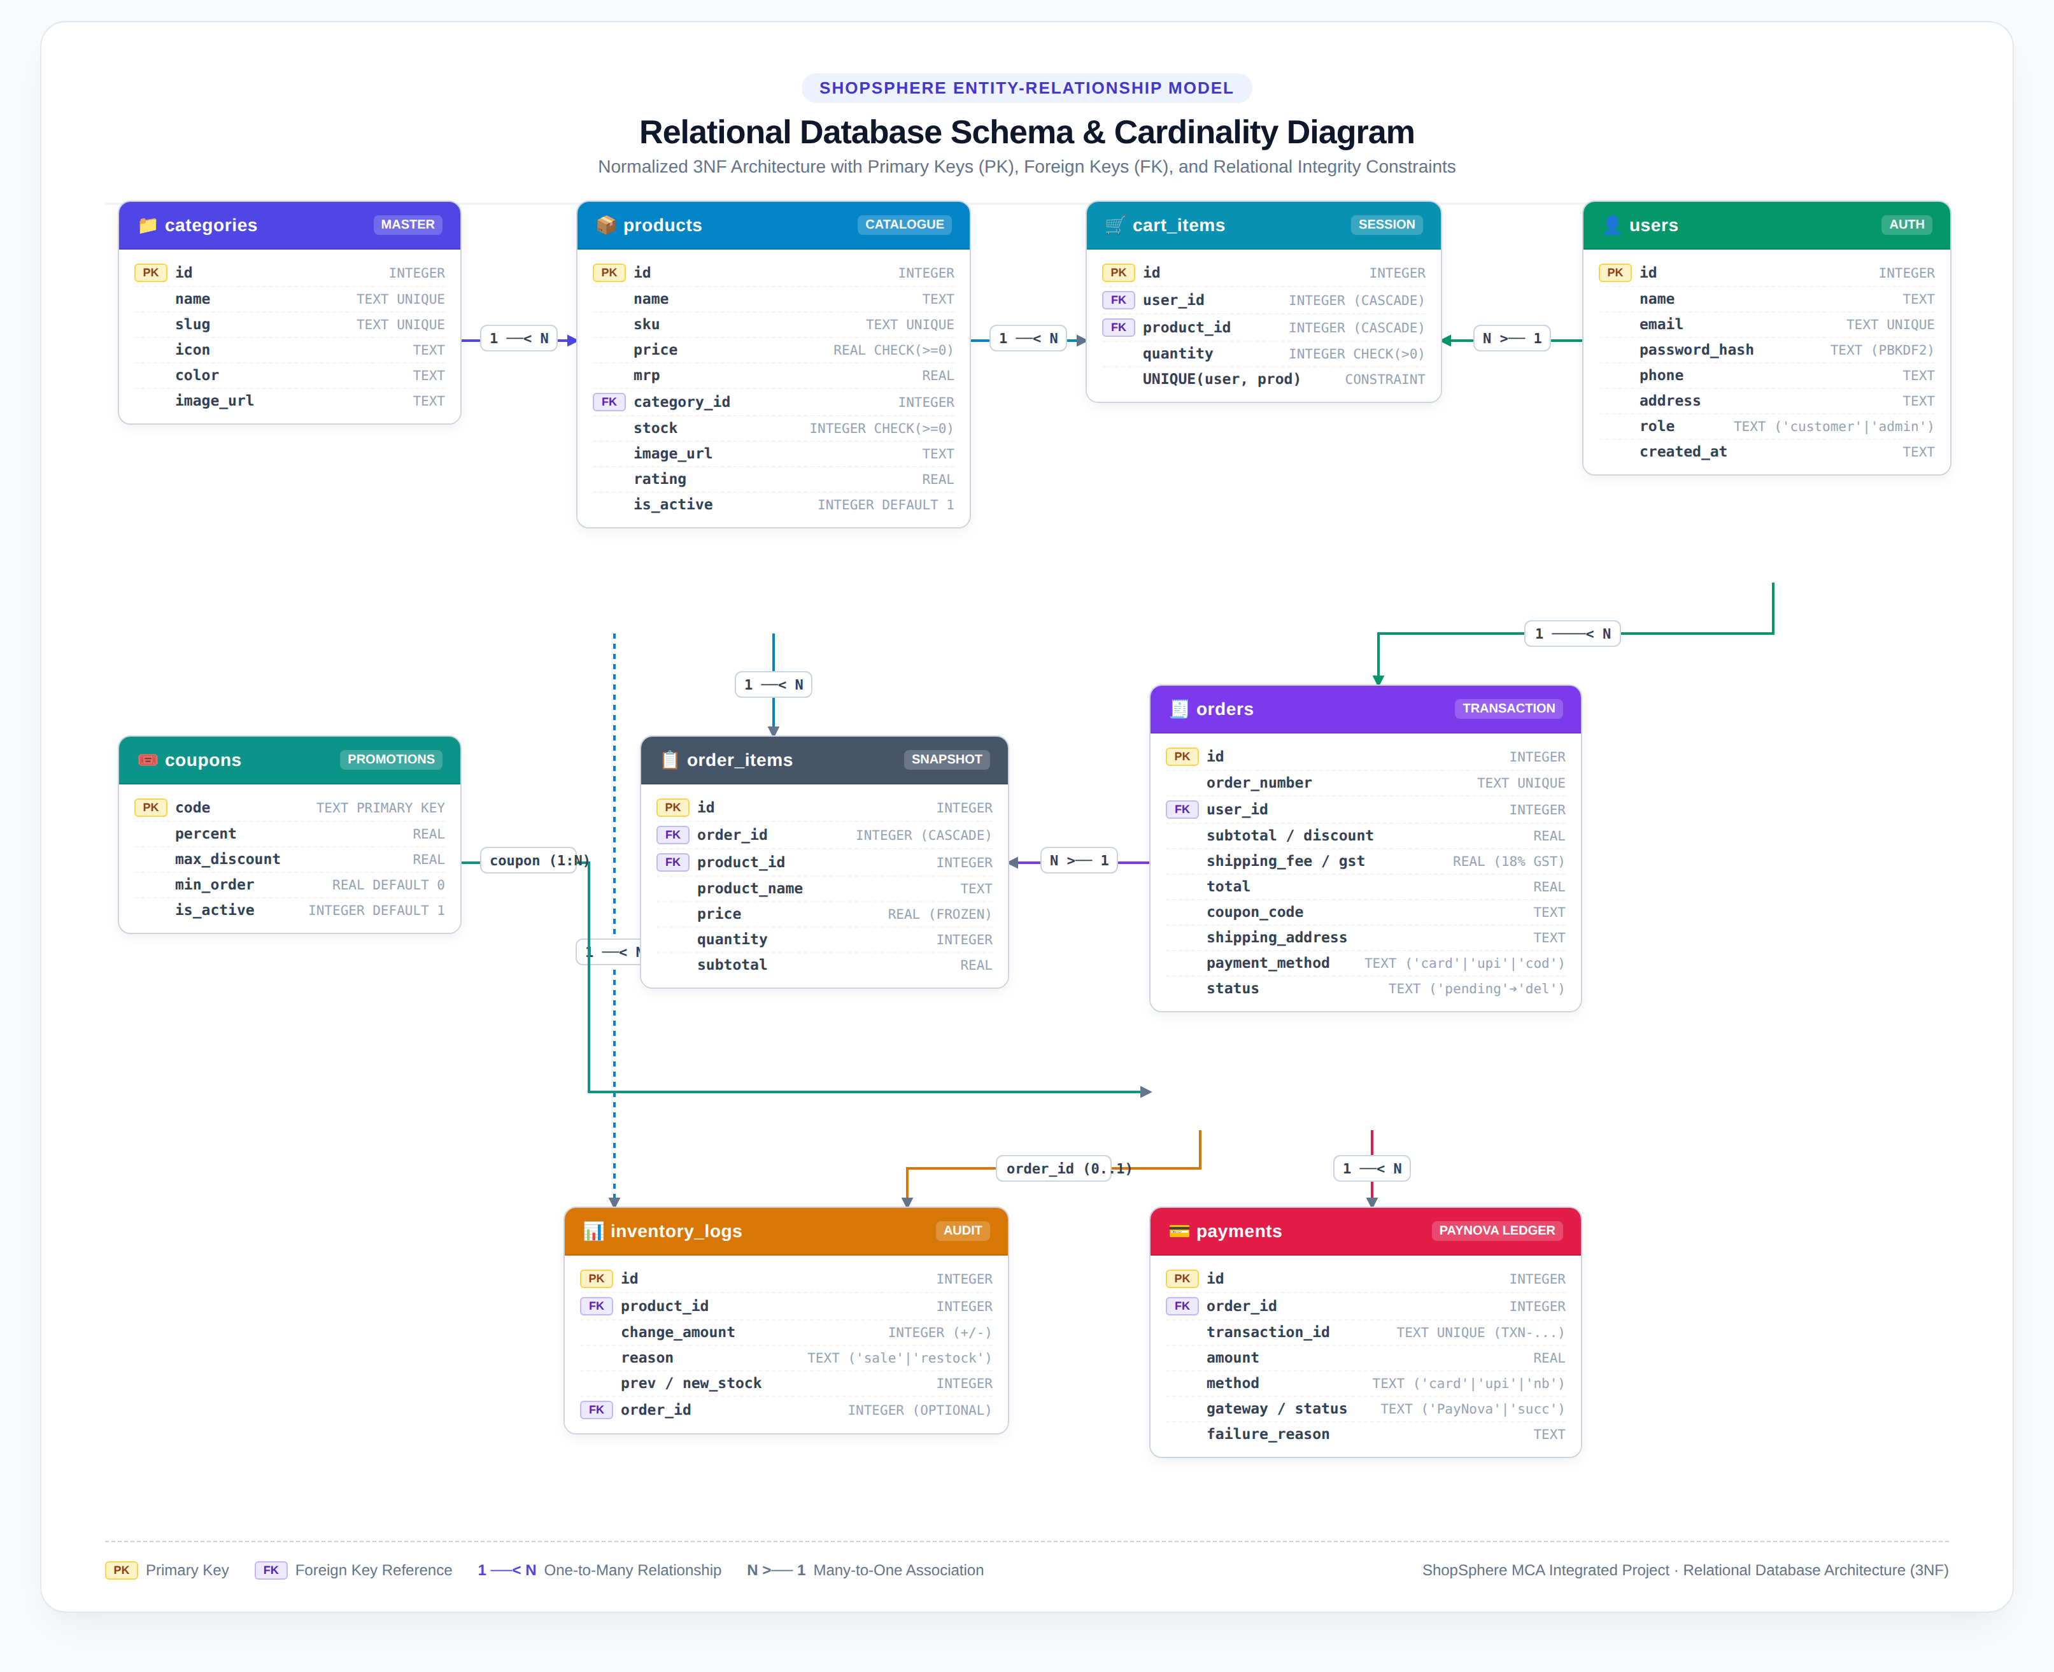
Figure 11.3: Entity-Relationship (ER) Schema & Cardinality Model
+------------------------------------------------------------------------------------+
| ENTITY RELATIONSHIP MODEL |
+------------------------------------------------------------------------------------+
[ categories ] 1 ──────< N [ products ] 1 ──────< N [ cart_items ] >────── N [ users ]
│ │ │
│ │ │
│ └─────────< N [ order_items ] │
│ │ │
│ │ │
└──────────────────────────────────────────────┼──────< 1 [ orders ] <────┘
│ │
│ │
[ inventory_logs ] [ payments ]
- `users`: Contains customer and administrator accounts.
* `id` (PK, INT AUTOINCREMENT), `name` (TEXT), `email` (TEXT UNIQUE), `password_hash` (TEXT), `phone` (TEXT), `address` (TEXT), `role` (TEXT DEFAULT 'customer'), `created_at` (TEXT).
- `categories`: Store departments.
* `id` (PK), `name` (TEXT UNIQUE), `slug` (TEXT UNIQUE), `icon` (TEXT), `color` (TEXT), `image_url` (TEXT).
- `products`: Merchandising catalog.
* `id` (PK), `name` (TEXT), `sku` (TEXT UNIQUE), `description` (TEXT), `price` (REAL CHECK >= 0), `mrp` (REAL), `category_id` (FK REFERENCES categories), `stock` (INT CHECK >= 0), `icon` (TEXT), `gradient` (TEXT), `image_url` (TEXT), `rating` (REAL), `is_active` (INT DEFAULT 1), `created_at` (TEXT).
- `cart_items`: Persistent user shopping basket.
* `id` (PK), `user_id` (FK REFERENCES users ON DELETE CASCADE), `product_id` (FK REFERENCES products ON DELETE CASCADE), `quantity` (INT CHECK > 0), `UNIQUE(user_id, product_id)`.
- `coupons`: Promotional discount rules.
* `code` (PK, TEXT), `percent` (REAL), `max_discount` (REAL), `min_order` (REAL), `is_active` (INT DEFAULT 1).
- `orders`: Customer purchase records.
* `id` (PK), `order_number` (TEXT UNIQUE), `user_id` (FK REFERENCES users), `subtotal` (REAL), `discount` (REAL), `shipping_fee` (REAL), `gst` (REAL), `total` (REAL), `coupon_code` (TEXT), `shipping_name` (TEXT), `shipping_phone` (TEXT), `shipping_address` (TEXT), `payment_method` (TEXT), `payment_status` (TEXT), `status` (TEXT DEFAULT 'pending'), `created_at` (TEXT).
- `order_items`: Order line item snapshots.
* `id` (PK), `order_id` (FK REFERENCES orders ON DELETE CASCADE), `product_id` (FK REFERENCES products), `product_name` (TEXT), `price` (REAL), `quantity` (INT), `subtotal` (REAL).
- `payments`: PayNova transaction audit ledger.
* `id` (PK), `order_id` (FK REFERENCES orders), `transaction_id` (TEXT UNIQUE), `amount` (REAL), `method` (TEXT), `gateway` (TEXT DEFAULT 'PayNova'), `status` (TEXT), `card_network` (TEXT), `card_last4` (TEXT), `upi_id` (TEXT), `bank_code` (TEXT), `failure_reason` (TEXT), `created_at` (TEXT).
- `inventory_logs`: Inventory audit ledger.
* `id` (PK), `product_id` (FK REFERENCES products), `change_amount` (INT), `reason` (TEXT), `previous_stock` (INT), `new_stock` (INT), `order_id` (FK REFERENCES orders), `created_at` (TEXT).

11.3 Authentication, Session & Access Control
Authentication is managed in [`routes/auth_routes.py`](file:///home/sarbanandataw/Projects/AWT%20Integrated%20Project/routes/auth_routes.py) with cryptographically secure password handling:
- Password Hashing: Utilizes `werkzeug.security.generate_password_hash` with PBKDF2-SHA256 and unique per-user salts. Plaintext passwords are never written to disk or logs.
- Role-Based Access Control (RBAC): Two distinct authorization tiers:
* Customer: Can browse, maintain carts, check out, and review personal order history.
* Admin: Protected via the `@admin_required` decorator. Grants access to `/admin` dashboard, catalog CRUD, and status controls.
- Session Security: Session cookies use `SESSION_COOKIE_HTTPONLY = True` to prevent cross-site scripting (XSS) extraction.

11.4 Storefront & Catalogue Management
The storefront ([`routes/main_routes.py`](file:///home/sarbanandataw/Projects/AWT%20Integrated%20Project/routes/main_routes.py)) provides customer exploration features:
- Faceted Category Chips: Instant filtering across the 6 core departments.
- Text Search: Parameterized SQL queries match product titles and descriptions without vulnerability to SQL injection (`WHERE (p.name LIKE ? OR p.description LIKE ?)`).
- Price Sorting: Ascending and descending price ordering (`ORDER BY price ASC / DESC`).
- Soft Delete Pattern: Products marked `is_active = 0` are immediately hidden from the storefront while preserving relational integrity for historical orders.

11.5 Cart Engine & Dynamic Taxation
The Cart Engine ([`services.py`](file:///home/sarbanandataw/Projects/AWT%20Integrated%20Project/services.py)) enforces business rules:
- Quantity Merging: Adding an already present item increments quantity instead of creating duplicate rows.
- Inventory Stock Constraints: Add-to-cart operations are checked against available stock; requesting more items than on hand raises a validation error.
- Dynamic Price Calculation:
$$\text{Subtotal} = \sum (\text{Price}_i \times \text{Qty}_i)$$
$$\text{Discount} = \min\left(\text{Subtotal} \times \frac{\text{Percent}}{100},\, \text{Max Discount}\right) \quad [\text{if Subtotal} \ge \text{Min Order}]$$
$$\text{Discounted Subtotal} = \text{Subtotal} - \text{Discount}$$
$$\text{GST} = \text{Discounted Subtotal} \times 0.18 \quad (18\% \text{ GST})$$
$$\text{Shipping} = \begin{cases} 0.00 & \text{if Subtotal} \ge 999.00 \\ 49.00 & \text{otherwise} \end{cases}$$
$$\text{Grand Total} = \text{Discounted Subtotal} + \text{GST} + \text{Shipping}$$

11.6 Simulated Payment Subsystem (PayNova)
[`services.py`](file:///home/sarbanandataw/Projects/AWT%20Integrated%20Project/services.py) and [`routes/payment_routes.py`](file:///home/sarbanandataw/Projects/AWT%20Integrated%20Project/routes/payment_routes.py) simulate a full banking payment gateway called PayNova:
- Multi-Rail Checkout Support:
1. Credit / Debit Cards: Validated via the Luhn Algorithm (MOD 10) checksum. Card networks (Visa, MasterCard, RuPay, Amex) are identified from card number prefixes.
2. Unified Payments Interface (UPI): Validates virtual payment address format (`identifier@bank`).
3. NetBanking: Provides banking portal redirection across major supported institutions (HDFC, ICICI, SBI, Axis).
4. Cash on Delivery (COD): Permitted only for orders under ₹5,000; order is marked `pending` until administrative delivery confirmation.
- Deterministic Simulation Engine:
* Card ending `0002` simulates a declined transaction.
* Card ending `0003` simulates insufficient bank account funds.
* Expiration date validation rejects cards in the past.
- Interactive OTP State Machine: Card transactions generate a temporary bank challenge. Entering the configured code (`123456`) confirms payment; entering 3 incorrect attempts cancels the transaction and releases all inventory locks.

11.7 Administrative Governance & Auditing
The administrative panel ([`routes/admin_routes.py`](file:///home/sarbanandataw/Projects/AWT%20Integrated%20Project/routes/admin_routes.py)) provides complete store management:
- Metric Cards: Real-time aggregation of Total Sales Revenue, Completed Orders, Pending Orders, and Low Stock (<10 items).
- Inventory Management: Manual stock adjustments require a recorded reason (`restock`, `damaged`, `audit`), logged into `inventory_logs`.
- Order Progression Workflow: Orders transition through explicit stages:
$$\text{Pending} \longrightarrow \text{Confirmed} \longrightarrow \text{Shipped} \longrightarrow \text{Delivered}$$
- Automated Restock on Cancellation: Cancelling a paid order initiates an automated refund ledger entry in `payments` and returns all reserved quantities back to active inventory.

11.8 UI/UX Design System & Theme Engine
The interface is designed for high aesthetic clarity and performance:
- Visual Photography: Replaced placeholder icons with professional, curated high-resolution studio photography from Unsplash for all 25 catalog products.
- Lucide SVG System: Standardized lightweight SVG icons embedded via an inline SVG sprite sheet (`_macros.html`), avoiding external webfont network overhead.
- Theme Switching (Light / Dark): Configured using CSS custom properties (`var(--bg-primary)`, `var(--text-primary)`, etc.). A client-side script executes in the `<head>` before the DOM renders to read `localStorage`, ensuring zero Flash of Unstyled Content (FOUC).

11.9 Testing Rigor & Quality Verification (71 Test Cases)
The project adheres to strict Test-Driven Development (TDD) principles. Running `python3 run_tests.py` executes 71 automated tests across 6 dedicated test suites:
----------------------------------------------------------------------
Ran 71 tests in 24.470s
OK

Breakdown of Test Suites
- `TestStorefront` (8 tests): Verifies home page rendering, catalogue seeding, category filtering, search term matching, empty search states, product details, price sorting, and 404 handling.
- `TestAuth` (9 tests): Verifies registration, unique email constraints, password hashing validation, login success/failure, logout session clearance, password mismatch detection, weak password rejection, and anonymous access redirects.
- `TestCart` (9 tests): Verifies cart quantity increments, duplicate product merging, stock limit enforcement, anonymous cart blocks, coupon validations, GST and shipping calculations, and cart item removal.
- `TestCheckoutAndPayment` (18 tests): Verifies checkout empty cart guards, phone number validation, order creation, card payment stock decrements, OTP state machine (success, wrong OTP, 3-attempt lockouts), declined cards, insufficient funds, NetBanking, COD, cross-user privacy isolation, and cancellation restock hooks.
- `TestAdmin` (15 tests): Verifies RBAC restrictions (blocking customers and guests), admin dashboard loading, product creation, SKU uniqueness, price $\le$ MRP checks, image URL validation, inventory adjustment logs, soft deletion, and payment transaction ledger audits.
- `TestGatewayUnit` (12 tests): Verifies Luhn algorithm implementation, card network detection, CVV/expiry validation, UPI regex parsing, unknown bank errors, COD upper limit enforcement, and transaction ID formatting.

Git Commitlint & Husky Governance
Commits are intercepted by Husky v9 (`.husky/commit-msg`), passing the proposed message through `@commitlint/cli` using the Conventional Commits specification:
<type>(<scope>): <subject>
Allowed types: `feat`, `fix`, `docs`, `style`, `refactor`, `perf`, `test`, `build`, `ci`, `chore`, `revert`. Commits failing this convention are automatically aborted by Git.

11.10 Cloud Deployment & Serverless Integration
The production system is deployed on Vercel backed by Turso Cloud SQLite:
- Serverless Bundling ([`vercel.json`](file:///home/sarbanandataw/Projects/AWT%20Integrated%20Project/vercel.json)):
Vercel isolates Python entrypoints in `/var/task/api`. To ensure templates and assets are available to Flask, `includeFiles` explicitly bundles all root assets:
```json
{
"version": 2,
"builds": [
{
"src": "api/index.py",
"use": "@vercel/python",
"config": {
"includeFiles": [
"templates/**",
"static/**",
"routes/**",
"services/**",
"instance/**",
"*.py"
]
}
}
],
"routes": [{ "src": "/(.*)", "dest": "/api/index.py" }]
}
```
- Cold-Start Resilience: Initialization calls in `app.py` are wrapped in exception guards, preventing module import failures during serverless cold starts.
- Cloud Infrastructure Topology:
* Production Domain: `https://shop-sphere-black-omega.vercel.app`
* Database Host: `libsql://shopsphere-sarbanandataw.aws-ap-south-1.turso.io` (AWS Mumbai)

12. Conclusion
ShopSphere demonstrates that a lightweight, modular technology stack (Python, Flask, SQLite/libSQL) can deliver a production-ready, highly resilient electronic commerce platform capable of operating in modern serverless cloud environments.
The project successfully addressed key engineering objectives:
- Resolved the Serverless Persistence Dilemma: Implemented a dual-mode database layer that maintains 100% API parity with SQLite while persisting transactional data across serverless invocations on Turso cloud database.
- Deterministic Banking Simulation: Engineered the PayNova payment subsystem to realistically simulate card processing, Luhn validation, OTP verification, and automated refund restocking.
- High Architectural & Code Reliability: Established a 71-test automated verification suite with 100% pass rates, governed by Git commitlint hooks to enforce continuous code quality.
- Production Deployment: Achieved live, publicly accessible serverless cloud hosting with sub-second response times and zero operational infrastructure cost.
The system proves that modern web development principles—simplicity, test-driven validation, and cloud-native database design—can effectively replace bloated enterprise frameworks while exceeding expectations for speed, maintainability, and user satisfaction.

13. Future Scope
While ShopSphere represents a complete and functional e-commerce system, several potential enhancements can expand its capabilities:
- Commercial Payment Gateway Webhooks: Integrate live production webhooks for services such as Razorpay, Stripe, or Cashfree, complementing the PayNova simulation.
- Microservices & Event-Driven Architecture: Decouple the monolithic Flask app into specialized containerized microservices (Catalog Service, Cart Service, Notification Service) communicating via Apache Kafka or RabbitMQ.
- Machine Learning Recommendation Engine: Implement collaborative filtering algorithms to analyze user browsing patterns and generate personalized product recommendations ("Frequently Bought Together").
- Real-Time Push Notifications: Integrate WebSockets (Flask-SocketIO) or Server-Sent Events (SSE) to push live order tracking updates (e.g., driver location, packing status) directly to the customer dashboard.
- Multi-Vendor Marketplace Capabilities: Expand the relational schema to support multiple independent sellers, allowing third-party merchants to register, list products, manage inventory, and view seller-specific sales analytics.

14. References
- Grinberg, M. (2018). *Flask Web Development: Developing Web Applications with Python*. 2nd Edition. O'Reilly Media.
- Owens, M., & Allen, G. (2010). *The Definitive Guide to SQLite*. 2nd Edition. Apress.
- Vercel Documentation (2026). *Serverless Functions with Python on Vercel*. Available at: https://vercel.com/docs/functions/runtimes/python
- Turso / libSQL Foundation (2026). *libSQL: An Open-Source Fork of SQLite for Edge Computing and Hrana Protocols*. Available at: https://docs.turso.tech/
- Jones, M., Bradley, J., & Sakimura, N. (2015). *RFC 7519: JSON Web Token (JWT)*. Internet Engineering Task Force (IETF).
- Luhn, H. P. (1960). *Computer for Verifying Numbers*. U.S. Patent No. 2,950,048.
- Pallets Projects (2024). *Werkzeug: The Comprehensive WSGI Web Application Library*. Available at: https://palletsprojects.com/p/werkzeug/
- Conventional Commits Specification (2024). *Conventional Commits 1.0.0: A Specification for Adding Human and Machine Readable Meaning to Commit Messages*. Available at: https://www.conventionalcommits.org/
- Mozilla Developer Network (MDN) (2026). *Using CSS Custom Properties (Variables) & Semantic HTML Architecture*. Available at: https://developer.mozilla.org/
- Lucide Icons Project (2026). *Lucide: Beautiful & Consistent Open-Source Icon Toolkit*. Available at: https://lucide.dev/

