Name – Sarbasish Chowdhury
Roll – 11500221024
Sub – PCC CS593 (OOPS)
Assignment – 3a (Method Overloading)

1.
Code:
import java.util.Scanner;

class AddAmount {
int amount = 50;
AddAmount(){
System.out.println("No amount is added\nCurrent Balance = " + amount+"$");
}
AddAmount(int a){
amount += a;
System.out.println(a+"$ is added\nCurrent Balance = "+amount+"$");
}
}

public class piggieBank {
public static void main(String args[]){
AddAmount obj1 = new AddAmount();
Scanner sc = new Scanner(System.in);
System.out.println("Enter amount to add: ");
int x = sc.nextInt();
AddAmount obj2 = new AddAmount(x);
}
}

Output:

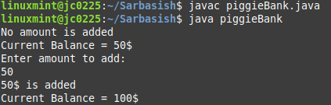

2. Code:
import java.util.Scanner;
class Rectangle{
int length, breadth;
Rectangle(){
length = breadth = 0;
}
Rectangle(int d){
length = breadth = d;
}
Rectangle(int l, int b){
length = l;
breadth = b;
}
public void calArea(){
int a = length * breadth;
System.out.println("The area of the rectangle is " + a);
}
}
public class area {
public static void main(String args[]){
Scanner s = new Scanner(System.in);
Rectangle r1 = new Rectangle();
r1.calArea();
System.out.println("Enter single parameter for length and breadth: ");
int n = s.nextInt();
Rectangle r2 = new Rectangle(n);
r2.calArea();
System.out.println("Enter length: ");
int l = s.nextInt();
System.out.println("Enter breadth: ");
int b = s.nextInt();
Rectangle r3 = new Rectangle(l,b);
r3.calArea();
}
}
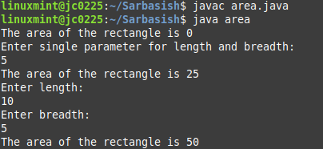
Output:

3. Code:
import java.util.Scanner;

class S {
String name;
S(){
name = "Unknown";
}
S(String n){
name = n;
}
public void printName(){
System.out.println("The name of the Student is "+name);
}
}

public class studentName {
public static void main(String args[]){
Scanner y = new Scanner(System.in);
S obj1 = new S();
obj1.printName();
System.out.println("Enter student's name: ");
String name = y.next();
S obj2 = new S(name);
obj2.printName();
}
}

Output:
