**A REPORT**

**ON**

**Hotel Management System**

## **By**

K. Himakar Reddy - AP22110011215

M. Lohith - AP22110011229

B. Sai Ganesh - AP22110011320

Ishraful Ansari - AP22110011525

Sandesh Patel - AP22110011637

Sarbesh Yadav - AP22110011510

***Under the Supervision of***

**Dr. Kavitha Rani Karnena  
Assistant Professor**

**Department of Computer Science and Engineering  
SRM University-AP**

**BACHELOR OF TECHNOLOGY  
IN  
COMPUTER SCIENCE AND ENGINEERING**

***Prepared in the partial fulfillment of the***

Project

|  |
| --- |
|  |

#### SRM UNIVERSITY, AP

**(April,2025)**

**Acknowledgement**

I would like to take this opportunity to express my heartfelt gratitude to all those who have supported me directly or indirectly throughout the course of this thesis work. Their valuable guidance, encouragement, and support have played a crucial role in the successful completion of this project.

The author expresses their gratitude to Prof. Dr. Kavitha Rani Karnena, their supervisor, for her invaluable guidance, encouragement, and support throughout the thesis work. Her patience, motivation, and belief in their abilities have been a great source of inspiration. Working under her supervision has been a privilege, shaping their academic and professional growth.

Faculty members and peers have provided valuable suggestions and discussions, significantly contributing to the learning process. Family and friends have given the author the strength to overcome challenges and stay focused on their goals.

Lastly, the author thanks everyone who has directly or indirectly contributed to the successful completion of this thesis. Their encouragement and support mean a lot to them, and they truly appreciate it.

The author is open to any modifications to the thesis, and they encourage others to reach out to them for any necessary modifications.

**ABSTRACT**

The Hotel Management System (HMS) is a comprehensive software solution designed to streamline and automate various operations within a hotel, ensuring enhanced efficiency and improved customer satisfaction. This system enables hotel staff to manage key tasks such as booking reservations, check-in/check-out processes, room assignments, billing, inventory management, and customer feedback collection. It also supports dynamic pricing based on room availability, seasonal demand, and customer preferences. The system integrates real-time data to provide accurate and up-to-date information on room occupancy and availability.

The core functionality includes user-friendly interfaces for both customers and hotel staff, allowing guests to make reservations online, modify bookings, and request services. For hotel staff, the system offers administrative tools to monitor bookings, generate reports, manage housekeeping schedules, and track payments. The HMS is built on modern technologies such as a relational database management system (RDBMS) for efficient data storage and retrieval, and is designed to support multi-user access, ensuring that different departments (e.g., reception, housekeeping, and management) can work seamlessly together.

With features such as automated notifications, room categorization, customer loyalty programs, and integration with external systems (e.g., payment gateways, POS systems), the Hotel Management System aims to reduce operational costs, enhance decision-making, and improve the overall guest experience, making it an indispensable tool for modern hospitality businesses.

**Table of Contents Page No**

**Abstract-------------------------------------------------------------------- I**

**Chapter 1. Introduction 1**

**1.1. Problem Statement 1**

**1.2. Motivation 1**

**1.3. Objectives 2**

**1.4. Scope of the Project 2**

**Chapter 2. System Architecture 3  
2.1. Technology Stack (Java, MySQL) 3  
2.2. System Components 4  
2.3. Database Design 5**

**Chapter 3. Core Features 6  
3.1. Hotel Management 6  
3.2. Room Management 7  
3.3. Customer Management 8  
3.4. Database Integration 9**

**Chapter 4. User Interface 14  
5.1. Main Dashboard 14  
5.2. Room Management Interface 15  
5.3. Customer Management Interface 16**

**Chapter 5. Testing and Validation 18  
5.1. System Testing 18  
5.2. User Acceptance Testing 19**

**Chapter 6. Future Enhancements 21  
6.1. Potential Improvements 21  
6.2. Scalability Considerations 21  
6.3. Additional Features 21**

**References---------------------------------------------------------------- 24 Introduction**

**1.1 Problem Statement**

The Hotel Management System (HMS) addresses the complexities involved in managing various hotel operations, ranging from reservations and check-ins to billing and guest services. In the hospitality industry, managing guest experiences, optimizing room occupancy, and ensuring smooth communication between various departments (e.g., reception, housekeeping, and restaurant services) is crucial. Traditional manual systems or basic software solutions often struggle with issues such as inaccurate booking records, delayed service delivery, inefficient resource management, and lack of real-time data synchronization.

This results in customer dissatisfaction, increased operational costs, and administrative challenges. Additionally, modern travelers demand a seamless and efficient booking experience, real-time updates on room availability, personalized services, and quick check-in/check-out processes. The absence of a centralized system that integrates all hotel functions can lead to inefficiencies, miscommunication, and a lack of actionable insights for management.

The Hotel Management System aims to overcome these challenges by providing a unified platform for managing reservations, guest services, billing, room inventory, and staff coordination. By automating routine tasks, streamlining communication, and providing real-time data analytics, the system seeks to enhance operational efficiency, improve customer experience, and enable better decision-making. The integration of advanced technologies, such as AI and data analytics, can further personalize guest services, optimize resource allocation, and boost profitability in the competitive hospitality sector.

**1.2 Motivation**

The motivation behind the development of the Hotel Management System (HMS) is to address the challenges faced by the hospitality industry in managing guest experiences, operational efficiency, and resource allocation. Traditional hotel management approaches, which often rely on manual processes or disconnected systems, can result in inefficiencies, miscommunication, and increased operational costs. Furthermore, the rising expectations of modern travelers, who demand fast, seamless, and personalized services, necessitate the adoption of innovative solutions.

This project aims to provide an integrated, real-time, and user-friendly system that optimizes hotel operations, enhances the guest experience, and improves resource management. By automating processes such as reservations, billing, room assignments, and service requests, the HMS helps hotel staff deliver faster, more accurate, and consistent services. It also enables management to access real-time data and analytics for better decision-making and improved guest satisfaction.

The motivation extends beyond mere operational efficiency. The system aims to improve customer satisfaction by offering features such as personalized services, loyalty programs, and faster check-ins/outs, contributing to a competitive edge in the crowded hospitality industry. By incorporating AI-powered tools for predictive analytics, customer preferences, and dynamic pricing, the HMS fosters innovation, reduces operational costs, and ultimately leads to increased profitability and customer loyalty.

**1.3 Objective**

The objective of this project is to develop a comprehensive and efficient Hotel Management System (HMS) that integrates various hotel operations into a single platform. The system is designed to automate and streamline key tasks such as room reservations, check-ins/check-outs, billing, inventory management, and guest services. By incorporating real-time data and analytics, the HMS aims to enhance operational efficiency, improve guest experience, and enable effective decision-making for hotel management.

The system will support a user-friendly interface for both guests and hotel staff. Guests will be able to make reservations, view room availability, and modify bookings, while staff will have access to tools for managing room assignments, guest requests, and generating reports. The project prioritizes real-time operation and scalability, ensuring that the system can handle a high volume of simultaneous transactions in busy hotel environments. Additionally, the system will include features such as automated billing, dynamic pricing based on occupancy, and integration with external systems like payment gateways and Point of Sale (POS) systems.

**1.4 Scope of the Project**

This project focuses on developing an advanced Hotel Management System that integrates all major hotel operations into one centralized platform. The scope includes the design and implementation of features such as room reservations, guest check-ins/outs, billing, inventory management, and staff coordination. It will cater to a variety of hotel types, from small boutique hotels to large resorts, by offering scalable and customizable solutions.

The system will be designed for easy integration with external tools, such as online payment gateways, POS systems, and customer loyalty programs, ensuring that hotels can enhance their operations and services with minimal effort. The system will be accessible on both web and mobile platforms, ensuring that guests and hotel staff can interact with it at any time.

While the primary focus is on hotel operations, the system will also incorporate advanced functionalities like dynamic pricing, predictive analytics for resource management, and reporting tools for decision-making. These features are intended to optimize hotel occupancy, improve customer service, and provide actionable insights for management. Additionally, AI-driven personalization will be explored to enhance the guest experience, such as tailored services based on guest preferences.

**CHAPTER 2**

**System Architecture**

**2.1 Technology Stack (Java, MySQL)**

The choice of technology stack is a crucial aspect of the system’s performance, scalability, and maintainability. For this project, we have selected **Java** for the backend development and **MySQL** for the database management.

**Java**:  
Java is a widely-used, object-oriented programming language that provides robustness, security, and cross-platform compatibility. It is well-suited for large-scale applications, making it an ideal choice for developing a hotel management system where performance and reliability are critical. The key advantages of Java for this project include:

* **Platform Independence**: Java applications can run on any platform with the Java Virtual Machine (JVM), making it ideal for deployment across different operating systems.
* **Security**: Java provides a strong security model, which is essential for protecting sensitive data like guest information, financial transactions, and booking details.
* **Scalability**: Java can easily handle large amounts of data and users, which is necessary for a hotel management system that needs to scale as the business grows.
* **Extensive Libraries and Frameworks**: Java offers a wide range of libraries and frameworks that help accelerate development. For this project, frameworks like **Spring** or **Hibernate** can be used to streamline the development process.

**MySQL**:  
MySQL is an open-source relational database management system (RDBMS) that is widely used in enterprise-level applications. It is chosen for its ability to handle large datasets, ensure data integrity, and provide high performance in database queries. Key benefits of MySQL include:

* **Relational Database Structure**: MySQL’s use of tables, rows, and relationships is ideal for managing structured hotel data, such as room bookings, customer profiles, payments, etc.
* **Performance and Speed**: MySQL is optimized for high-speed data processing, which is crucial for real-time operations in a hotel management system.
* **Data Security**: MySQL provides a range of security features, such as encryption and access control, to protect sensitive customer and business data.
* **Open-Source and Cost-Effective**: MySQL is free to use, which reduces overall project costs, and its vast community support provides easy access to resources and solutions.

By integrating **Java** for the system logic and **MySQL** for the database, the technology stack provides a robust foundation for the hotel management system, ensuring reliable performance and scalability.

**2.2 System Components**

The hotel management system is designed to be modular, with several key components that interact with each other to provide a seamless experience for both hotel staff and guests. The main system components include:

1. **User Interface (UI)**:  
   The user interface is designed to be intuitive and user-friendly, enabling hotel staff to easily manage operations such as bookings, room assignments, and guest information. The UI is built using Java Swing or JavaFX to create interactive graphical interfaces. The key features of the UI include:
   * **Main Dashboard**: Displays an overview of the hotel’s operations, including room availability, ongoing bookings, and guest information.
   * **Room Management Interface**: Allows staff to view and update room statuses (booked, available, or under maintenance).
   * **Customer Management Interface**: Lets staff manage guest information, including check-in/check-out details and payment history.
2. **Backend Logic**:  
   The backend is built in **Java**, handling the core functionalities of the system, such as:
   * **Booking and Reservation System**: Manages guest bookings, room assignments, and reservation statuses.
   * **Payment Processing**: Handles payment transactions, integrates with payment gateways for credit card processing, and generates invoices.
   * **Staff and Inventory Management**: Tracks staff assignments, manages inventory for amenities, and handles maintenance requests.
3. **Database**:  
   The database is designed to store all the information required to run the hotel, including room details, guest profiles, booking records, and payments. The **MySQL** database interacts with the backend through SQL queries, ensuring that all the data is up-to-date and synchronized. The database design is critical for ensuring data integrity, consistency, and quick retrieval.
4. **Payment Gateway Integration**:  
   This component allows the system to process online payments securely. It integrates with external payment providers to handle credit card transactions, ensuring secure financial exchanges between the hotel and guests.
5. **Reporting and Analytics Module**:  
   This component generates various reports based on the data in the system, such as occupancy rates, revenue reports, guest satisfaction surveys, and maintenance logs. The reporting module helps hotel management make data-driven decisions.

**2.3 Database Design**

The Hotel Management System database is designed to store and manage essential information related to rooms, customers, bookings, and payments. The design focuses on maintaining data integrity, ensuring efficient data retrieval, and supporting the core functionalities of the system, such as room management, customer check-in/check-out, and payment tracking.

1. Rooms Table

The rooms table contains details about each room in the hotel. This includes information on the room type, price, availability, and maintenance status. The key fields in the table are:

* room_id: A unique identifier for each room (Primary Key).
* room_type: Specifies the type of the room (e.g., Standard, Deluxe, Suite).
* is_available: A boolean value that indicates whether the room is available for booking.
* price: The price of the room per night.
* capacity: The maximum number of guests allowed in the room.
* amenities: A list of amenities available in the room (e.g., Wi-Fi, Air Conditioning).
* needs_cleaning: A boolean value that indicates if the room requires cleaning.
* under_maintenance: A boolean value that indicates if the room is under maintenance.

2. Customers Table

The customers table stores personal information about hotel guests, as well as their booking details. The key fields in the table are:

* customer_id: A unique identifier for each customer (Primary Key).
* name: The full name of the customer.
* email: The email address of the customer.
* phone: The phone number of the customer.
* room_id: A foreign key that links the customer to a specific room (References room_id from the rooms table).
* check_in_date: The date when the customer checks in.
* check_out_date: The date when the customer checks out.
* total_amount: The total amount to be paid by the customer for their stay.
* checked_in: A boolean value that indicates if the customer has checked in.
* payment_status: The status of the customer's payment (e.g., Paid, Pending, Partial).

Relationships Between Tables

* One-to-One Relationship: The rooms table and the customers table have a one-to-one relationship through the room_id field. A room can be assigned to only one customer at a time, and each customer is associated with one room during their stay.
* Foreign Key Constraint: The room_id in the customers table is a foreign key referencing the room_id in the rooms table. This ensures referential integrity and guarantees that every customer is assigned a valid room.

Key Features of the Database Design

1. Data Integrity:
   * The use of primary keys ensures that each record is uniquely identifiable.
   * Foreign key constraints ensure referential integrity between tables, specifically between customers and rooms.
   * Appropriate data types and field sizes ensure efficient data storage and retrieval.
2. Business Logic:
   * The is_available field in the rooms table tracks room availability for booking.
   * The needs_cleaning and under_maintenance fields help in managing room status for housekeeping and maintenance purposes.
   * The payment_status in the customers table enables tracking of customer payments, whether paid, pending, or partially paid.
3. Scalability:
   * The design can easily accommodate an increasing number of rooms, customers, and bookings.
   * Additional features, such as a loyalty program, more customer details, or additional room attributes, can be incorporated by extending the schema with new tables or fields.

**CHAPTER 3**

**Core Features**

**3.1 Hotel Management**

* **Room Allocation**: The system efficiently allocates rooms to customers based on availability, ensuring that guests are assigned to rooms that meet their preferences and requirements.
* **Hotel Policies**: The system allows the configuration and management of hotel policies, including check-in/check-out times, room pricing, cancellation policies, and payment methods.
* **Maintenance Tracking**: Hotel management is also responsible for tracking the maintenance status of rooms. Rooms requiring maintenance are flagged and cannot be assigned to guests until the maintenance is completed.
* **Availability Status**: The system provides real-time visibility of room availability, helping hotel management teams optimize room bookings, manage overbookings, and improve guest satisfaction.
  1. **Room Management**

**The Room Management feature ensures that all aspects of room operations** are handled seamlessly. It includes functionalities such as:

* Room Details: The system maintains detailed information about each room, including room type (e.g., Standard, Deluxe, Suite), capacity, price per night, and amenities offered (e.g., Wi-Fi, air conditioning, TV).
* Room Status: The status of each room is tracked, including whether it is available for booking, under maintenance, or needs cleaning. This helps hotel staff manage room assignments and housekeeping tasks.
* Room Booking: The system allows customers to book rooms based on their preferences, such as room type, price range, and availability. The booking process automatically updates the room’s availability status.
* Room Pricing: Pricing can be dynamically adjusted based on factors like room type, seasonality, and demand, allowing for effective revenue management and competitive pricing.
  1. **Customer Management**

The **Customer Management** feature focuses on managing customer information and their interactions with the hotel. Key functionalities include:

* **Customer Profiles**: The system maintains a comprehensive profile for each customer, including personal details (name, contact information), booking history, preferences, and payment status.
* **Check-in/Check-out Process**: The system handles customer check-in and check-out procedures. It ensures that room assignments are accurate, payment status is updated, and relevant information is provided to both guests and hotel staff.
* **Booking History**: A complete history of bookings is tracked, helping the hotel understand customer preferences and improving future service delivery.
* **Loyalty Programs**: The system can support loyalty programs that reward repeat customers with discounts, priority booking, or exclusive offers, fostering long-term customer relationships.
* **Payment Management**: The system allows customers to make payments for bookings, track payment statuses (Paid, Pending, Partial), and issue receipts upon completion.
  1. **Database Integration**
* **Data Consistency**: All information related to rooms, customers, bookings, and payments is stored in a centralized database, ensuring consistency across the system. Any updates to room availability, customer status, or payment records are reflected instantly in the database.
* **Data Retrieval and Storage**: The system uses optimized queries to efficiently retrieve and store data, ensuring quick access to room availability, customer information, and booking records. This minimizes delays in providing critical information to staff or customers.
* **Reporting and Analytics**: Integrated database support allows for the generation of real-time reports, such as occupancy rates, financial summaries, and customer booking trends, helping management make informed decisions.
* **Security and Backup**: The database integration ensures that data is secure, with regular backups in place to prevent data loss. User roles and permissions control access to sensitive data, ensuring that only authorized personnel can view or update critical records.

**CHAPTER 4**

**User Interface**

* 1. **Main Dashboard**

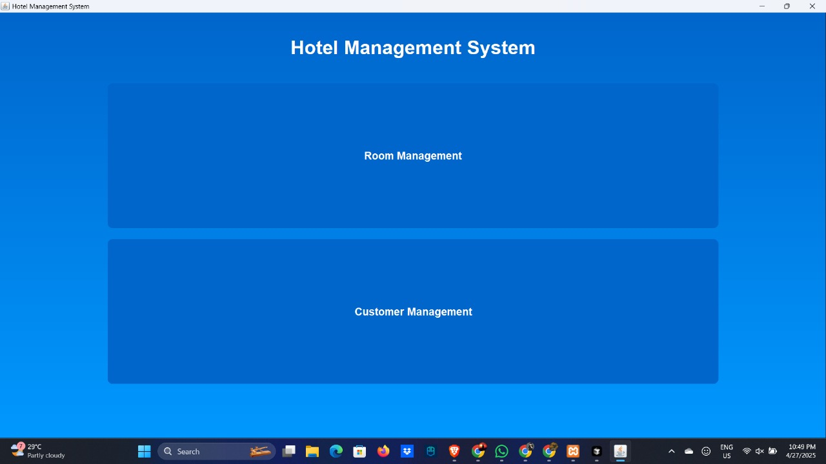

* 1. **Room Management Interface**

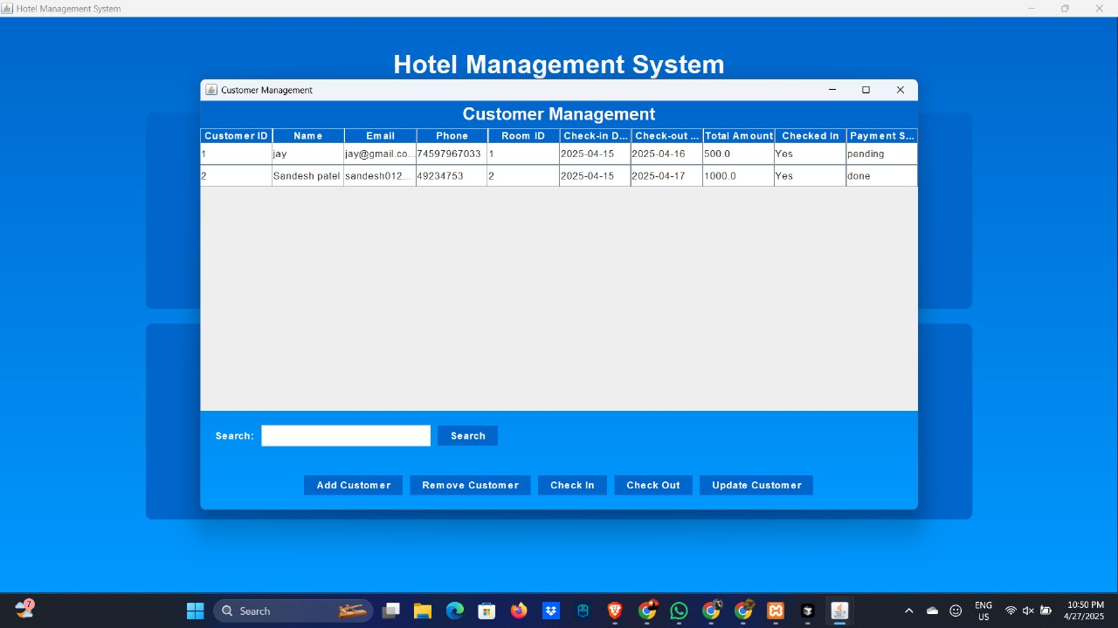

* 1. **Customer Management Interface**

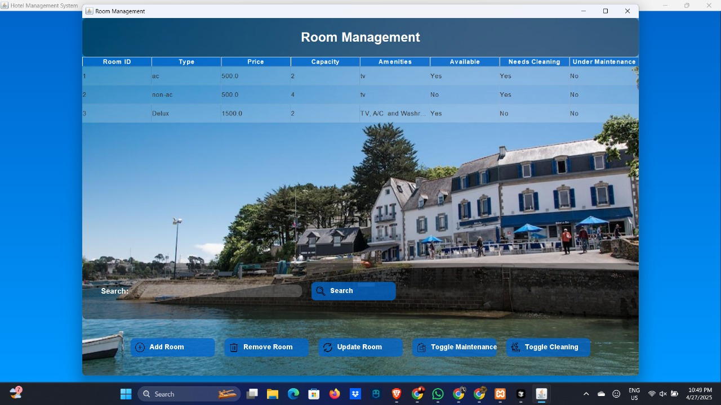

**CHAPTER 5**

**Testing and Validation**

* 1. **System Testing**

• **Functional Testing**: Verifies room booking, customer management, and payment processing.

• **Integration Testing**: Ensures seamless data flow between different modules.

• **Regression Testing**: Tests that new changes don't break existing features.

• **Error Handling**: Ensures the system gracefully handles invalid inputs or failures.

.

**5.2. User Acceptance Testing (UAT)**

* Test Scenarios: End users test the system in real-world scenarios.
* Feedback Collection: Gather feedback from hotel staff to assess usability and functionality.
* Validation Against Requirements: Ensures the system meets business needs.
* Bug Fixes: Any issues raised during UAT are addressed before final deployment.

**CHAPTER 6**

**Future Enhancements**

* 1. **Potential Improvements**

• **Mobile Application**: A mobile version for hotel staff to manage bookings and check-ins.

• **AI-based Room Recommendations**: Machine learning to suggest rooms based on customer preferences.

• **Automated Billing System**: Automatically generates invoices for guests.

• **OTA Integration**: Syncs room availability with online travel agencies like Booking.com.

.

**7.2. Scalability Considerations**

* Cloud-Based Infrastructure: Scalable cloud hosting for growth.
* Distributed Databases: Improve performance for handling large data volumes.
* Modular Architecture: Easy addition of new features without disrupting the system.

**7.3. Additional Features**

* Customer Feedback & Reviews: Collect guest feedback for improvements.
* Room Service Ordering: Allow guests to order room service through the system.
* Smart Room Integration: Integrate IoT for smarter room features like lighting and temperature control.

**REFERENCES**

* 1. **Hotel Management System: Concepts and Benefits**  
     *Techopedia*  
     Available at: https://www.techopedia.com/definition/32064/hotel-management-system-hms  
     *This article explains the key concepts and benefits of hotel management systems, including automation and streamlining operations in the hospitality industry*
  2. **Database Design for Hotel Management Systems**  
     *ResearchGate*  
     Availableat: <https://www.researchgate.net/publication/267224526_Database_Design_for_Hotel_Management_Systems>  
     *A paper on database design, highlighting the importance of structured data management in hotel management software.*