📖
Chapter 1
Theoretical Background: Retrieval-Augmented Generation (RAG)
This chapter introduces the core concepts, techniques, and terminology of
Retrieval-Augmented Generation that are used throughout this project.

Table of Contents
1. Introduction to RAG
2. Types of RAG
3. Chunking
4. Embeddings
5. Vector Database
6. Retrieval Techniques
7. Reciprocal Rank Fusion (RRF)
8. Reranking
9. Query Rewriting
10. Conversation Memory
11. Semantic Cache
12. Guardrails
13. Reflection
14. Evaluation
15. Best Practices for Building Production RAG Systems
16. Challenges and Limitations of RAG

1. Introduction to RAG

1.1 What is Retrieval-Augmented Generation (RAG)?
Retrieval-Augmented Generation, commonly called RAG, is a technique that combines two things: a search system (retriever) and a language model (generator). Instead of asking a language model to answer purely from what it "remembers" from training, RAG first searches a knowledge base for relevant information, and then gives that information to the language model along with the question, so it can generate an answer grounded in real, up-to-date data.
In simple words: RAG lets an LLM "look things up" before answering, similar to how a student might check a textbook before answering an exam question, instead of relying only on memory.
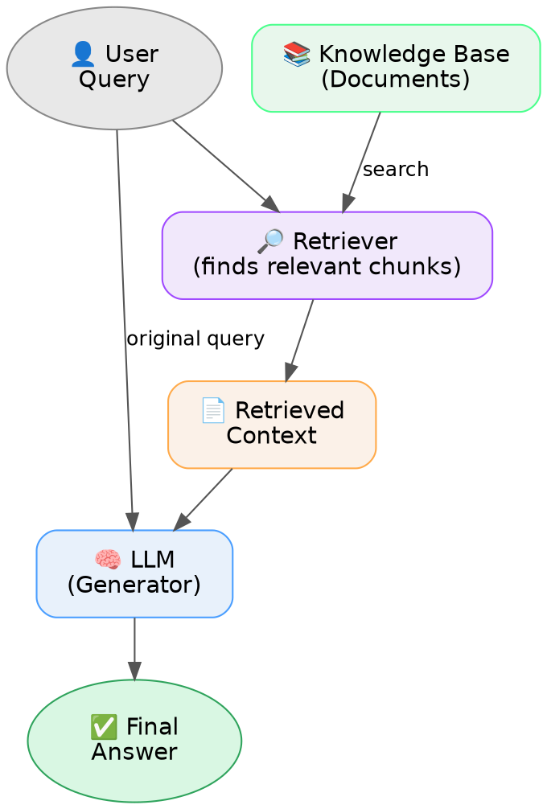
Figure 1.1 — Basic idea of Retrieval-Augmented Generation

1.2 Why RAG was Introduced
Large Language Models (LLMs) are trained on a fixed dataset up to a certain point in time. This creates several practical problems when they are used as standalone question-answering systems:
- Their knowledge is frozen at the time of training and does not include new or recent information.
- They have no access to private, organization-specific, or personal data that was never part of their training set.
- They sometimes generate confident-sounding but incorrect answers, a problem known as hallucination.
- Retraining or fine-tuning a model every time new information appears is expensive and slow.
RAG was introduced to solve these problems by connecting an LLM to an external, updatable knowledge base at answer-time, instead of baking all knowledge into the model itself.

1.3 Problems with Standalone LLMs
Problem | Explanation
Outdated knowledge | The model only knows what existed up to its training cutoff date.
No private/domain data | The model cannot know about a company's internal documents, policies, or personal files.
Hallucination | The model can generate plausible-sounding but false information, especially for facts it is unsure about.
No source traceability | There is no way to point back to "where" an answer came from.
Expensive to update | Updating the model's knowledge requires retraining or fine-tuning, which is costly and slow.

1.4 Advantages of RAG over Traditional LLMs
- Up-to-date answers, since the knowledge base can be updated at any time without retraining the model.
- Can use private or domain-specific data that the model was never trained on.
- Reduces hallucination, because answers are grounded in retrieved, real documents.
- Answers can be traced back to source documents (citations).
- Cheaper to maintain than constantly retraining or fine-tuning a large model.

1.5 Common Real-World Applications of RAG
Application | Example
Customer support chatbots | Answering questions using a company's product manuals and FAQs.
Enterprise knowledge search | Employees asking questions over internal policy or HR documents.
Legal / medical assistants | Answering questions grounded in case law, regulations, or clinical guidelines.
Research assistants | Summarizing and answering questions over large sets of research papers.
Code assistants | Answering questions using a codebase or technical documentation.

2. Types of RAG
RAG is not a single fixed technique — it has evolved into several variations, each adding more capability (and complexity) on top of the basic idea. This section explains the main types.

Naive RAG
Definition: The most basic form of RAG. The system simply retrieves the top-k most similar chunks using vector similarity search and passes them to the LLM along with the user's query.
How it works: Query is embedded, compared against stored chunk embeddings, the closest chunks are picked, and both the chunks and the query are sent to the LLM to generate an answer. There is no reranking, query rewriting, or guardrails.
Advantages: Very simple to build and understand. Fast to implement. Low engineering cost.
Disadvantages: Retrieval quality is often poor. No way to filter out irrelevant chunks. Cannot handle multi-turn conversation context. No safety checks.
Best use cases: Small prototypes, proof-of-concept demos, single-turn Q&A over a small, well-organized document set.
Limitations: Struggles with ambiguous queries, noisy retrieval results, and long conversations. Cannot verify whether the final answer is actually correct.

Standard RAG
Definition: Adds a few essential improvements over Naive RAG, such as better chunking strategy, basic metadata filtering, and simple prompt templates, while still relying on a single retrieval method (usually vector search only).
How it works: Similar flow to Naive RAG, but with tuned chunk size/overlap and a structured prompt template that clearly separates context from the question.
Advantages: Better grounded answers than Naive RAG while still being relatively simple to build.
Disadvantages: Still limited to one retrieval method, so exact keyword or ID matches can be missed. No reranking or memory.
Best use cases: Internal documentation search, FAQ bots, simple customer support assistants.
Limitations: Single retrieval method limits recall; cannot resolve conversational context across turns.

Advanced RAG
Definition: RAG enhanced with pre-retrieval and post-retrieval optimization techniques such as query rewriting, reranking, and relevance-score filtering.
How it works: The query is first rewritten/cleaned, then chunks are retrieved (vector or hybrid), reranked by a more accurate model, filtered by a relevance threshold, and only then passed to the LLM.
Advantages: Significantly better retrieval accuracy and answer grounding compared to Naive/Standard RAG.
Disadvantages: More complex to build and maintain. Extra steps (rewriting, reranking) add latency and cost.
Best use cases: Production chatbots, enterprise search assistants, knowledge-base copilots.
Limitations: Still generally relies on a single knowledge source (plain text chunks) and does not inherently support multi-hop reasoning across documents.

Hybrid RAG
Definition: Combines multiple retrieval strategies — typically dense vector search and sparse keyword search such as BM25 — and fuses their results using an algorithm like Reciprocal Rank Fusion (RRF).
How it works: The query is sent to both a vector search engine and a keyword search engine in parallel. The two ranked result lists are merged into one final ranking, which may then be reranked further.
Advantages: Captures both semantic meaning and exact keyword matches, giving higher recall than either method alone.
Disadvantages: Added engineering complexity; fusion parameters need tuning; slightly higher latency due to running two searches.
Best use cases: Technical, legal, or medical domains where both semantic understanding and exact term matching (product codes, drug names, case numbers) matter.
Limitations: Still bounded by the same underlying document chunks; effectiveness depends heavily on how well the fusion step is tuned.

Graph RAG
Definition: Uses a knowledge graph of entities and relationships, in addition to or instead of plain text chunks, so the system can reason over connections between concepts.
How it works: Documents are processed to extract entities and relationships, forming a graph. A query traverses this graph to find connected facts, which are passed to the LLM along with (or instead of) text chunks.
Advantages: Excellent for multi-hop reasoning and questions that require connecting facts scattered across multiple documents; produces more structured, factual answers.
Disadvantages: Complex to build, since it requires entity and relationship extraction; harder to maintain and keep updated; higher upfront engineering cost.
Best use cases: Research assistants, complex enterprise knowledge bases, and questions like "how are X and Y related?"
Limitations: Graph construction quality directly affects the results; not ideal for simple lookup-style questions; more computationally expensive than plain-text RAG.

Agentic RAG
Definition: RAG powered by an autonomous agent that can plan and take multiple actions — such as choosing which retriever or tool to use, whether to search again, or whether to call an external API — instead of following one fixed pipeline.
How it works: The LLM acts as an agent that reasons step by step about what information is needed, calls retrieval or other tools as required, and repeats this process until it has enough information to produce a final answer.
Advantages: Handles complex, multi-step questions; can combine multiple data sources and tools; more flexible than a fixed pipeline.
Disadvantages: Higher latency and cost due to multiple LLM calls; harder to debug and control; needs careful guardrails to avoid infinite loops or incorrect tool use.
Best use cases: Complex research tasks, multi-step problem solving, and systems that need to combine RAG with other tools such as calculators, APIs, or code execution.
Limitations: Behavior can be unpredictable if not well designed; expensive to run at scale; needs robust monitoring.

2.1 Comparison of RAG Types
Type | Retrieval Approach | Complexity | Extra Structure Needed | Best For
Naive RAG | Single vector search | Low | None | Quick prototypes
Standard RAG | Single vector search | Low-Medium | None | Simple FAQ / doc search
Advanced RAG | Vector search + rerank + rewrite | Medium-High | Optional | Production chatbots
Hybrid RAG | Vector + keyword (BM25) fused | Medium-High | Optional | Technical/legal/medical search
Graph RAG | Knowledge graph traversal | High | Yes (graph) | Multi-hop reasoning, research
Agentic RAG | Agent-driven, multi-tool | Very High | Depends | Complex multi-step tasks

3. Chunking

3.1 What is Chunking?
Chunking is the process of breaking a large document into smaller pieces, called chunks, before it is embedded and stored in a vector database. Instead of treating an entire document as one giant block of text, it is split into more manageable, retrievable units.
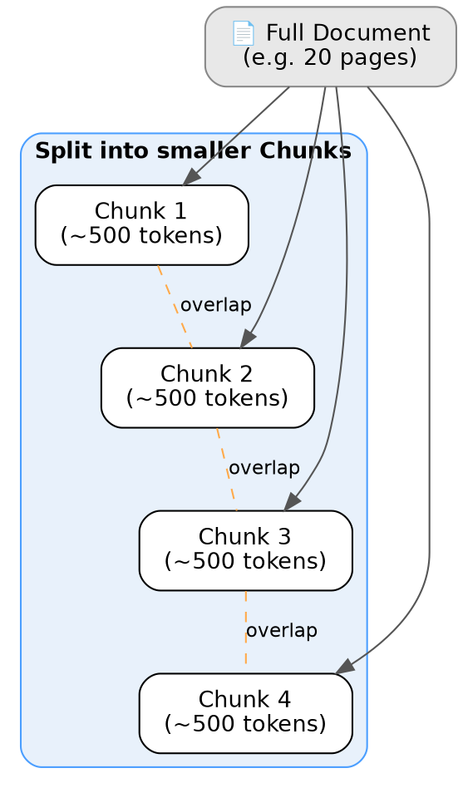
Figure 3.1 — A document split into overlapping chunks

3.2 Why Chunking is Required
- Embedding models and LLMs have limited context windows, so very large documents cannot be processed as a single unit.
- Smaller, focused chunks improve retrieval precision — the retriever can find the specific part of a document that answers a question, instead of returning an entire, mostly irrelevant document.
- Chunks that are too large dilute relevance (mixing relevant and irrelevant content together), while chunks that are too small can lose important context.

3.3 Chunk Size
Chunk size is the amount of text (usually measured in tokens or characters) contained in a single chunk. A typical range used in practice is around 300 to 800 tokens, though the ideal size depends on the type of document and how detailed the questions are expected to be.

3.4 Chunk Overlap
Chunk overlap means that a small portion of text is repeated between two consecutive chunks (for example, the last 50-100 tokens of one chunk are also included at the start of the next chunk). This prevents important context from being lost when a sentence or idea happens to fall right at a chunk boundary.

3.5 Chunking Strategies

Fixed Size Chunking
Working: The text is split into equal-sized pieces based on a fixed number of characters or tokens, regardless of sentence or paragraph boundaries, optionally with some overlap between consecutive chunks.
Advantages: Very simple and fast to implement. Predictable chunk sizes.
Disadvantages: Can cut sentences or ideas in half, which loses meaning and hurts retrieval quality.
Best use cases: Quick prototyping, or text that is already short and uniformly structured.

Recursive Chunking
Working: Tries to split text along natural boundaries first (paragraphs, then sentences, then words), and only falls back to a hard split when a piece is still too large, keeping every chunk within a size limit.
Advantages: Preserves natural document structure better than fixed-size chunking. It is the widely used default strategy in most RAG frameworks.
Disadvantages: Still a structural, not a meaning-based, approach — it does not understand whether a cut point actually separates two different ideas.
Best use cases: General-purpose document chunking; the default choice for most production RAG pipelines.

Semantic Chunking
Working: Sentences are embedded, and the similarity between consecutive sentences is measured. A new chunk begins whenever the similarity drops sharply, which usually signals a topic change.
Advantages: Produces chunks that are more meaningful and self-contained, which improves retrieval relevance.
Disadvantages: Computationally more expensive, since every sentence needs to be embedded; slower to build the index.
Best use cases: High-value knowledge bases where retrieval quality matters more than ingestion speed.

3.6 Comparison of Chunking Strategies
Strategy | Boundary Awareness | Speed | Retrieval Quality | Best Use Case
Fixed Size | None (ignores structure) | Fastest | Lowest | Quick prototypes, uniform text
Recursive | Uses paragraphs/sentences as hints | Fast | Good | General-purpose, most production pipelines
Semantic | Follows actual meaning/topic shifts | Slowest | Best | High-value knowledge bases

4. Embeddings

4.1 What are Embeddings?
An embedding is a way of converting a piece of text into a list of numbers (a vector) that captures its meaning. Text with similar meaning ends up with vectors that are close together in this numeric space, while text with different meaning ends up far apart.
For example, the sentences "How do I reset my password?" and "I forgot my login password" would have embeddings that are close to each other, even though the exact words are different.

4.2 Why Embeddings are Important in RAG
Embeddings are what make semantic search possible. Instead of matching a query to documents based only on exact words, RAG systems compare the query's embedding to each chunk's embedding to find chunks that mean the same thing as the query, even if the wording is completely different.

4.3 Dense Embeddings
Dense embeddings are fixed-length vectors (for example, 1024 numbers) where most of the values are non-zero. They are produced by neural network models (such as Cohere's embedding models or OpenAI's embedding models) and are very good at capturing overall semantic meaning.

4.4 Sparse Embeddings
Sparse embeddings are high-dimensional vectors where most values are zero, and the non-zero values represent the importance of specific keywords (similar to how BM25 or TF-IDF scoring works). They are good at exact keyword matching but do not capture deeper meaning the way dense embeddings do.

4.5 Similarity Search
Once text is converted into embeddings, the system needs a way to measure how "close" two embeddings are. Two common methods are used:
Cosine Similarity
Cosine similarity measures the angle between two vectors, ignoring their length/magnitude. In simple terms, it checks whether two vectors are pointing in a similar "direction" in meaning-space. A higher cosine similarity means the two pieces of text are more similar in meaning.
Dot Product
The dot product also compares two vectors, but unlike cosine similarity, it is affected by both the direction and the magnitude (length) of the vectors. When embeddings are normalized to the same length (a common practice), the dot product produces results equivalent to cosine similarity.

5. Vector Database

5.1 What is a Vector Database?
A vector database is a specialized type of database built to store embeddings (vectors) and search through them efficiently, even when there are millions of vectors. It uses indexing algorithms designed specifically for finding the "nearest" vectors to a given query vector, quickly and at scale.

5.2 Why Vector Databases are Used
Traditional databases (like relational SQL databases) are not designed to efficiently search through high-dimensional vectors for similarity. Vector databases solve this by using approximate nearest neighbor (ANN) search techniques, which trade a small amount of accuracy for a large gain in speed, making similarity search practical even at large scale.

5.3 Metadata Filtering
Most vector databases also allow combining similarity search with traditional filters on metadata fields — for example, searching for the most relevant chunks only within documents where document_type equals "policy" and date is after a certain year. This narrows down the search space and improves relevance for structured collections of documents.

5.4 Comparing Popular Vector Databases
Database | Hosting | Ease of Use | Scalability | Metadata Filtering | Best For
Qdrant | Open-source (self-host or managed cloud) | Moderate | High | Strong (rich filter expressions) | Production systems needing control and filtering
Pinecone | Fully managed cloud only | Very Easy | Very High | Good | Teams wanting a zero-maintenance managed service
Chroma | Open-source, lightweight | Very Easy | Low-Medium | Basic | Prototyping and local development
FAISS | Library, not a full database | Moderate | High (in-memory) | None built-in | Research and experimentation, custom pipelines

6. Retrieval Techniques
Retrieval is the process of finding the most relevant pieces of information for a given query. There are different techniques for doing this, each with its own strengths.

Vector Search
Working: The query is converted into an embedding, and the system finds the stored chunks whose embeddings are closest to it in vector space.
Advantages: Understands meaning and handles paraphrasing well; can match a query to relevant text even if the exact words differ.
Disadvantages: Can miss exact keyword, code, or ID matches; retrieval quality depends heavily on the embedding model used.
Best use cases: Natural language, conceptual questions.

BM25
Working: A keyword-based ranking method that scores documents based on term frequency and inverse document frequency statistics. It does not use embeddings.
Advantages: Excellent at exact keyword and phrase matching; fast; well understood; requires no training.
Disadvantages: Does not understand meaning, synonyms, or paraphrasing.
Best use cases: Exact term search such as product codes, names, or legal/technical clause lookup.

Hybrid Search
Working: Combines vector search and BM25 results, usually merged using a fusion method such as Reciprocal Rank Fusion (RRF).
Advantages: Gets the best of both worlds — semantic understanding plus exact keyword matching — resulting in higher recall.
Disadvantages: More complex to implement; requires fusion tuning; slightly higher compute cost.
Best use cases: Production systems that need both semantic and exact matching, such as technical or legal search.
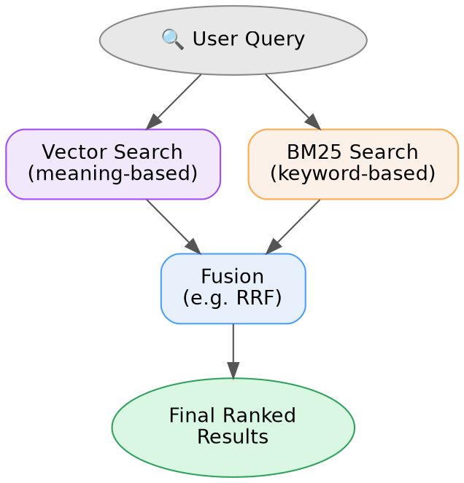
Figure 6.1 — Hybrid search combines vector search and BM25

6.1 Comparison of Retrieval Techniques
Technique | Basis | Strength | Weakness | Best Use Case
Vector Search | Semantic meaning (embeddings) | Understands paraphrasing | Misses exact terms | Conceptual questions
BM25 | Keyword statistics | Exact term matching | No semantic understanding | Codes, names, exact phrases
Hybrid Search | Both, fused together | High recall, best of both | More complex, needs tuning | Production search systems

7. Reciprocal Rank Fusion (RRF)

7.1 What is RRF?
Reciprocal Rank Fusion (RRF) is a simple algorithm used to combine the ranked results from multiple retrieval methods — for example, a vector search ranking and a BM25 ranking — into a single, unified ranking.

7.2 Why RRF is Used
Different retrieval methods produce scores on completely different, incompatible scales. A BM25 score and a cosine similarity score cannot be directly compared or added together in a meaningful way. RRF avoids this problem by using each item's rank position (1st, 2nd, 3rd, and so on) instead of its raw score, since rank positions are always comparable across methods.

7.3 Advantages
- Simple to implement and does not require any score normalization.
- Works well in practice across many different types of retrieval methods.
- Requires no training or tuning of complex parameters.

7.4 Example
Suppose a query is run through both a vector search and a BM25 search, and the same document, "Document A", appears in both result lists at different positions:
Document | Vector Search Rank | BM25 Rank | Combined RRF Rank (approx.)
Document A | 1 | 3 | 1
Document B | 2 | 1 | 2
Document C | 5 | 2 | 3
A document that ranks well across both methods (like Document A, which is near the top in both lists) ends up with a strong combined rank, even though neither individual method ranked it as the single best result. RRF rewards documents that consistently appear near the top, regardless of which method found them.

7.5 Use Cases
RRF is most commonly used in hybrid retrieval systems, and more generally in any situation where multiple ranked lists (from different search methods, or even different queries) need to be merged into one final ranking.

8. Reranking

8.1 Why Reranking is Needed
The initial retrieval step (vector search, BM25, or hybrid search) is optimized for speed, since it needs to search through potentially millions of chunks quickly. Because of this speed requirement, the top results it returns are not always perfectly ordered by true relevance — some irrelevant or only loosely related chunks can still make it into the top results. Reranking re-scores this smaller shortlist using a more accurate (but slower) model, to push the truly best chunks to the very top before they are sent to the LLM.

8.2 Bi-Encoder vs Cross-Encoder
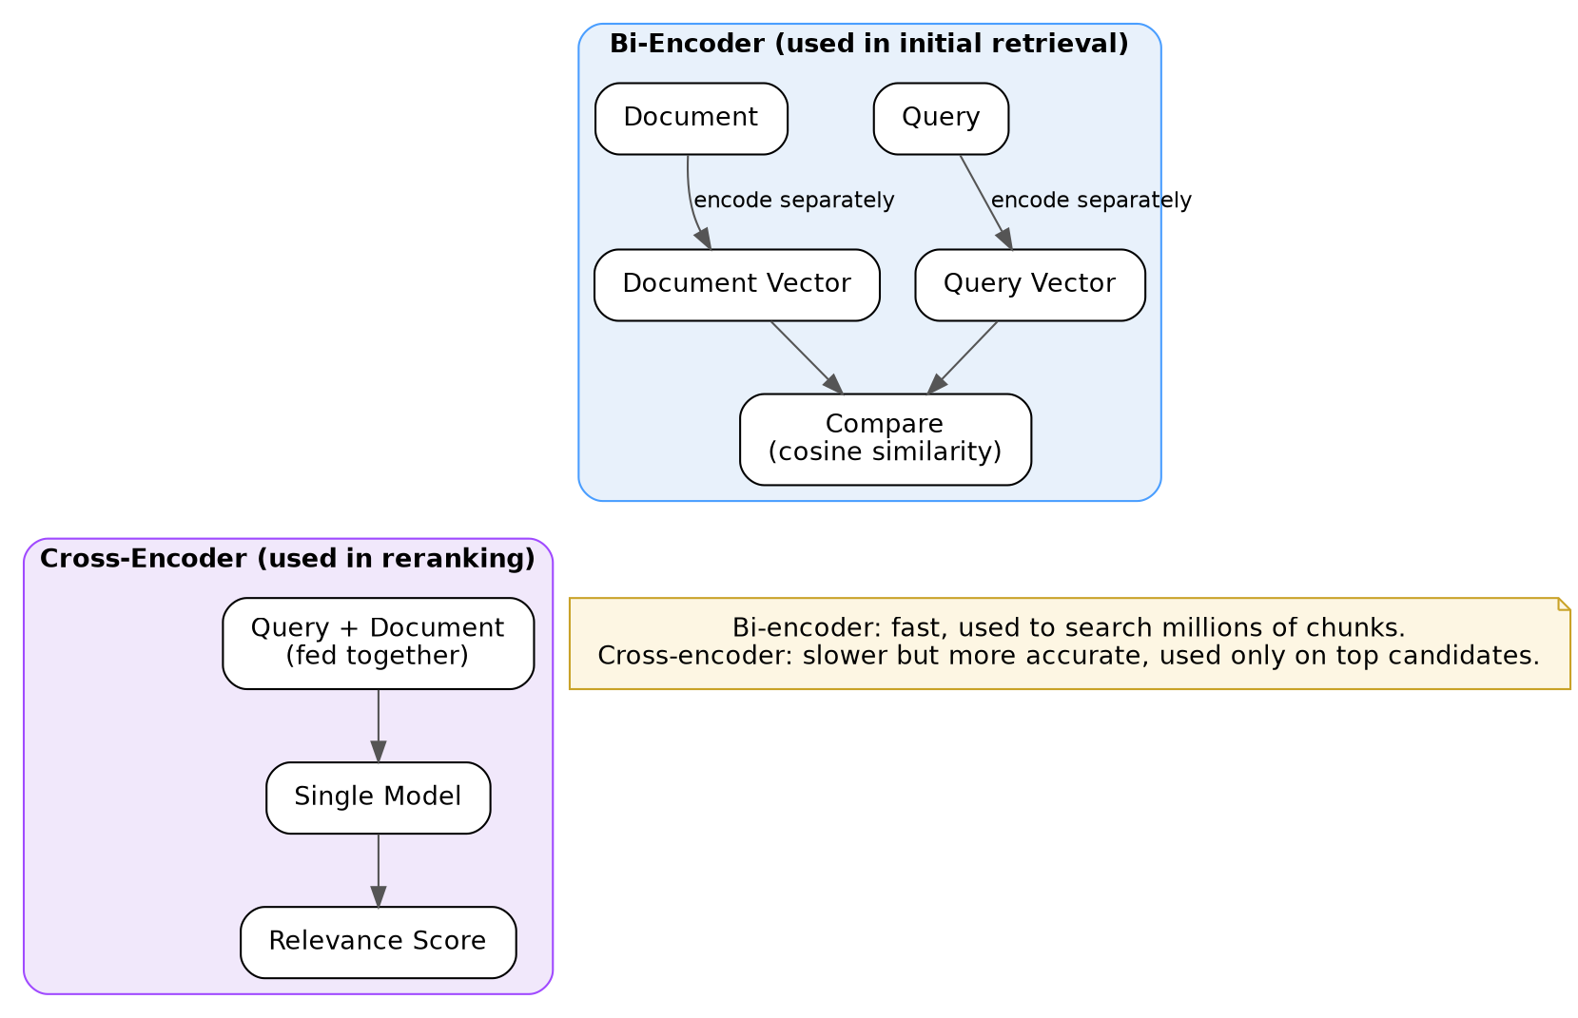
Figure 8.1 — Bi-Encoder (used for initial retrieval) vs Cross-Encoder (used for reranking)
Aspect | Bi-Encoder | Cross-Encoder
How it works | Encodes the query and each document separately into vectors, then compares them. | Feeds the query and document together into a single model, which directly outputs one relevance score.
Speed | Fast — can compare against millions of documents. | Slow — practical only on a small shortlist (e.g. top 20-50 candidates).
Accuracy | Good, but less precise. | Much more accurate, since the model sees the query and document together.
Typical role | Initial retrieval. | Reranking step after initial retrieval.

8.3 How Reranking Improves Retrieval
By re-scoring only a small shortlist of already-retrieved candidates with a much more accurate cross-encoder model, reranking pushes the most genuinely relevant chunks to the top positions and filters out near-misses, which improves the quality of the final context given to the LLM.

8.4 Example: Cohere Rerank
Cohere Rerank is a hosted reranking model (for example, rerank-english-v3.0) that takes a query and a list of candidate documents, and returns them reordered by a relevance score. It is commonly used as the reranking step directly after hybrid or vector retrieval in production RAG pipelines.

9. Query Rewriting

9.1 What is Query Rewriting?
Query rewriting is the process of transforming or improving a user's raw query before it is used for retrieval. This can include resolving pronouns, adding missing context from earlier in the conversation, fixing ambiguity, or expanding abbreviations.

9.2 Why it Improves Retrieval
In a multi-turn conversation, user queries are often incomplete or ambiguous when taken out of context. For example, if a user first asks "Tell me about product X" and then follows up with "What is its price?", the word "its" only makes sense in the context of the previous message. Rewriting this into a standalone query — "What is the price of product X?" — allows the retriever to find far more relevant chunks than the raw, ambiguous query would.

9.3 Common Use Cases
- Multi-turn conversational RAG, where later questions depend on earlier context.
- Coreference resolution — replacing words like "it", "they", or "that" with what they actually refer to.
- Query expansion — adding related terms to improve recall.
- Spelling and grammar correction before retrieval.

10. Conversation Memory

10.1 Why Memory is Needed in Conversational RAG
A RAG chatbot often needs to handle multi-turn conversations, where later questions build on earlier ones. Without memory, each query would be treated in complete isolation, losing all context from previous turns, which leads to confusing or irrelevant answers.
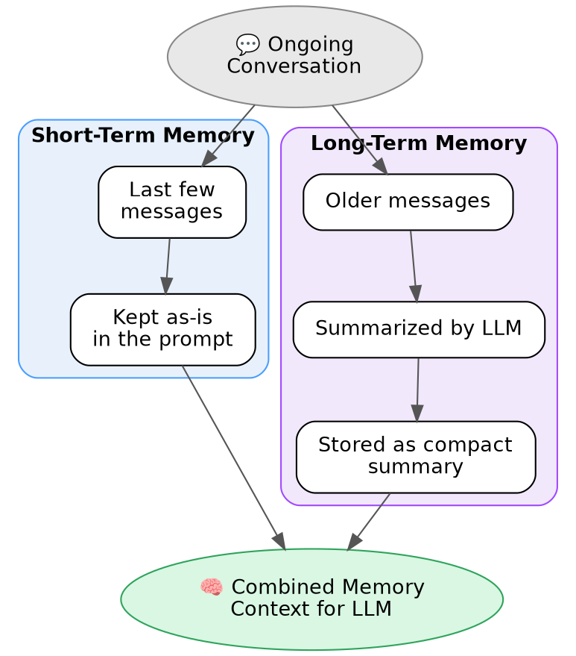
Figure 10.1 — Short-term and long-term memory combined into context for the LLM

10.2 Short-Term Memory
Short-term memory refers to the most recent messages in a conversation. These are typically kept in their raw, original form and included directly in the prompt sent to the LLM, since they are usually the most relevant to the current question.

10.3 Long-Term Memory
Long-term memory refers to older messages that are no longer kept in raw form. Instead, they are summarized (usually by an LLM) into a compact form, so that important context from earlier in the conversation is retained without using up too much of the limited context window.

10.4 Benefits and Limitations
Benefits | Limitations
Enables natural, coherent multi-turn conversations. | Summarization can lose fine detail from older messages.
Supports personalized, context-aware follow-up answers. | More memory included means more tokens, which increases cost.
Keeps the prompt size manageable over long conversations. | A poor summary can carry an incorrect context forward into later turns.

11. Semantic Cache

11.1 What is Semantic Caching?
Semantic caching is a caching technique that stores past query-answer pairs, and can return a cached answer for a new query if it is semantically similar in meaning to a previous query — not just identical in exact wording.
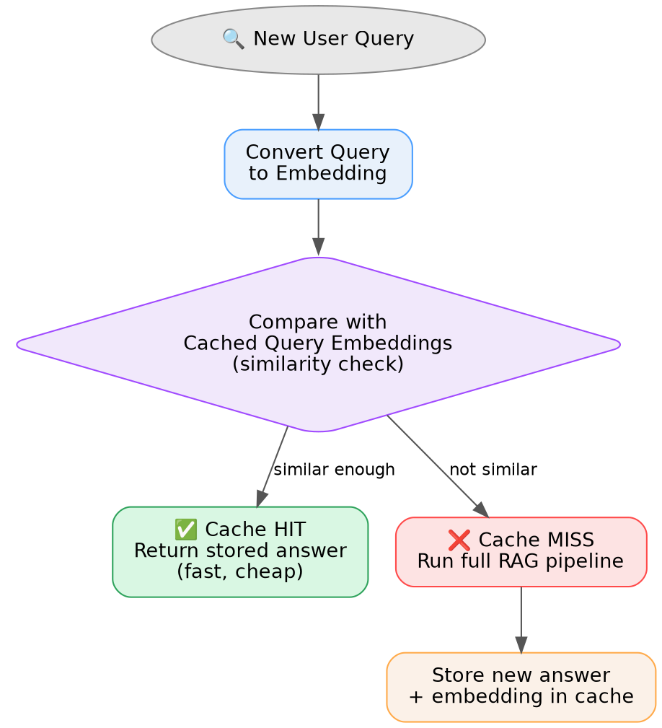
Figure 11.1 — Semantic cache lookup flow

11.2 Traditional Cache vs Semantic Cache
Traditional Cache | Semantic Cache
Matches queries by exact key (e.g. exact string match). | Matches queries by meaning, using embedding similarity.
A slightly reworded query causes a cache miss. | A reworded or paraphrased query can still result in a cache hit.
Simple and very fast to check. | Requires an embedding step and a similarity comparison, but is still much faster than the full pipeline.

11.3 Cache Hit
A cache hit occurs when a new query is found to be similar enough (above a similarity threshold) to a previously cached query. In this case, the cached answer is returned immediately, skipping the entire retrieval and generation pipeline.

11.4 Cache Miss
A cache miss occurs when no sufficiently similar cached query is found. In this case, the full RAG pipeline runs as normal, and the new query, along with its answer, is stored in the cache for potential future reuse.

11.5 Benefits
- Dramatically lowers response latency for repeated or similar questions.
- Reduces the number of LLM and embedding API calls, lowering cost.
- Reduces the load on the retrieval and generation components of the system.

12. Guardrails
Guardrails are safety and quality checks placed around a RAG pipeline to keep it safe, reliable, and trustworthy in production use.
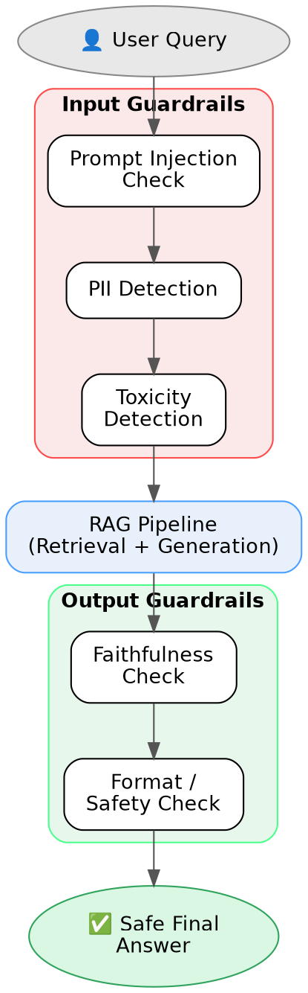
Figure 12.1 — Input and output guardrails around the RAG pipeline

12.1 Input Guardrails
Input guardrails are checks applied to the user's query before it is allowed to reach the retrieval and generation pipeline. These typically validate that the query is well-formed and safe to process.

12.2 Output Guardrails
Output guardrails are checks applied to the generated answer before it is returned to the user, verifying that it is factually grounded, correctly formatted, and safe.

12.3 Prompt Injection
Prompt injection is an attack where a user (or even content within a retrieved document) tries to manipulate the LLM into ignoring its original instructions, by embedding hidden or disguised commands inside the query or the retrieved text.

12.4 PII Detection
PII (Personally Identifiable Information) detection identifies sensitive personal data — such as phone numbers, email addresses, or ID numbers — in the input or output, to prevent this information from being leaked or misused.

12.5 Toxicity Detection
Toxicity detection identifies hateful, abusive, or otherwise harmful language in either the user's input or the model's generated output.

12.6 Why Guardrails are Important in Production RAG Systems
- They protect the system from misuse and malicious inputs.
- They protect users from receiving harmful, offensive, or incorrect answers.
- They help build user trust in the system.
- They help the system meet legal and compliance requirements around data privacy and safety.

13. Reflection

13.1 What is Reflection?
Reflection is a step in which the LLM (or another model) reviews its own generated answer against the original query and the retrieved context, checks it for correctness, and revises it if necessary, before it is shown to the user as the final answer.
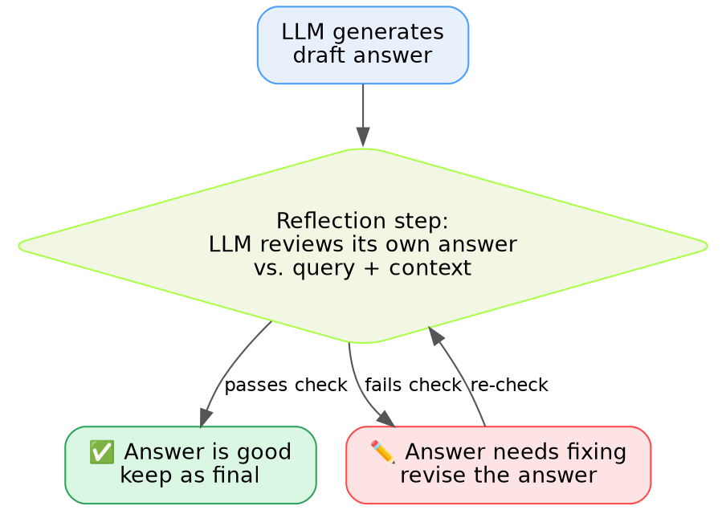
Figure 13.1 — Reflection loop: generate, review, and revise if needed

13.2 Why Reflection Improves Answer Quality
Reflection acts as a second pass of quality control, catching hallucinations, mismatches with the retrieved context, or incomplete answers that the first generation pass may have missed, before the answer ever reaches the user.

13.3 Advantages
- Higher overall answer quality and factual accuracy.
- Catches mistakes that the initial generation pass missed.

13.4 Limitations
- Adds extra latency and cost, since it requires an additional LLM call.
- Not perfect — it will not catch every single error.
- The reflection model can carry its own biases or blind spots, which may overlap with the original generation model's mistakes.

14. Evaluation

14.1 Why RAG Systems Need Evaluation
A RAG system has multiple moving parts — retrieval, reranking, generation — and any one of them can silently degrade in quality. Evaluation provides an objective way to measure and monitor answer quality over time, and to catch regressions before they affect real users.

14.2 What is DeepEval?
DeepEval is an open-source framework for evaluating the outputs of LLM and RAG systems using a defined set of metrics, including LLM-as-a-judge style scoring.

14.3 LLM-as-a-Judge
LLM-as-a-Judge is an evaluation approach where another LLM is used to score or evaluate the quality of a generated answer against defined criteria, instead of relying purely on manual human review or rigid rule-based checks. This makes it possible to evaluate large numbers of answers automatically and consistently.

14.4 Evaluation Metrics
Metric | What it Measures | When it is Used
Answer Relevancy | Measures whether the generated answer actually addresses the user's question. | Used to check that the answer stays on-topic and does not drift away from what was asked.
Faithfulness | Measures whether the claims made in the answer are actually supported by the retrieved context. | Used to detect hallucination — answers that are not grounded in the retrieved chunks.
Context Precision | Measures how much of the retrieved context is actually relevant and useful. | Used to evaluate whether the retriever is bringing back too much noise/irrelevant content.
Context Recall | Measures whether the retriever brought back all the information actually needed to answer the question fully. | Used to evaluate whether the retriever is missing important information (completeness).

15. Best Practices for Building Production RAG Systems
- Choosing the right chunk size — balance between chunks that are too small (losing context) and too large (diluting relevance); test empirically for the specific domain and document type.
- Hybrid retrieval — combine vector search and keyword search (e.g. BM25) to get both semantic understanding and exact-match recall.
- Reranking — always rerank the top retrieved candidates before generation, to improve precision of the final context.
- Query rewriting — resolve conversational context and ambiguity before running retrieval.
- Memory — keep conversation memory compact through summarization, to control both cost and latency.
- Semantic caching — cache repeated or similar queries to reduce cost and improve response time.
- Guardrails — validate both the input and the output in any production-facing system.
- Evaluation — continuously measure relevancy, faithfulness, context precision, and context recall to catch quality regressions early.

16. Challenges and Limitations of RAG

16.1 Hallucinations
Even with retrieved context, a language model can still generate plausible-sounding but false or unsupported information — this is called hallucination.

16.2 Poor Retrieval
If the retriever fails to find the relevant chunks in the first place, the LLM has no way to generate a correct, grounded answer, no matter how capable the model itself is.

16.3 Incorrect Chunking
Poor chunk boundaries can split a single idea across two chunks, or mix unrelated information into one chunk, both of which hurt retrieval relevance.

16.4 Latency
A full RAG pipeline can involve many stages — query rewriting, embedding, retrieval, reranking, generation, and reflection — and the time taken by each stage adds up, increasing overall response time.

16.5 Cost
Every embedding call, reranking call, and LLM generation call carries an associated API cost, which scales up directly with the number of users and queries.

16.6 Context Window Limitations
LLMs can only process a limited number of tokens in a single prompt. This creates a hard limit on how much retrieved context, conversation memory, and the query itself can be included together in one request.

