RC Adventure

Design Process

Sam oversaw creating most of the UI assets, as well as getting the sounds working for the game and making the finish line and scoring system. So, as such, this part of the document will have a paragraph dedicated to each, there will also be screenshots of the game and or the code to go along with it.

Sarbjot oversaw creating most of the assets and the game design. He wrote the scripts concerning collision and their placements. He also created the animation for the crane collider and fireworks that occur when the player finishes the game.

UI

So, the first thing I handled after getting started on this project was the Main Menu. For it, I used TextMeshPro to get a good-looking font for all the text, and four options in the main menu, which each do different things. The Start option would start the game and load the car selection scene, the “How to Play” and “Options” menus would open a separate menu (through disabling and enabling components), and inside the Options menu there is a volume option where you can adjust the volume of the game. Finally there’s a Quit option that quits the game.

Depicted: Main Menu

I also created or spruced up most of the in game UI, using the same style to keep it consistent. This includes most of the text in the game and the victory screen. I used Unity’s SetActive() function to toggle between UI elements as needed, which is easier and more efficient than creating them wholesale through code.

Sound

I was also in charge of sound, which in this project just meant finding appropriate sounds and music for the various things in the game. For the sound effects, while there were initial sound effects on the model we were using for the RC, they were hard on the ears and annoying after a while, so I bought an asset pack (listed in the credits), and replaced the loops from the asset with better sounding loops from the asset pack.

As for the music, I went through a few different phases with that. Initially, I wanted to create my own music, so I went and got a trial copy of Cubase LE and started fiddling with it. After figuring out that the amount of time it would take to learn all that from scratch would be well over the time I had for the assignment, however, I instead went searching for royalty free music to fit the theme (which are also listed in the credits below). In the end, I used some of Kevin MacLeod’s music, which were available for free with credit on his website, and after ensuring they fit the mood we’re working on, implemented them into the various scenes.

Victory Line and Scoring System.

The final part of the game I worked on was the victory line and the scoring system. The victory line is fairly simple, just an invisible cube that detects when something collides with it, then activates the UI elements for the victory screen and calculates the score.

As for the scoring part, I opted for a base score of 12,000, adding 1,000 points for each flag collected, 100 points deducted for each cone impacted and a further 100 deducted for each second it took to complete the course. I felt that his would be the most fun and fair way of having a score, given how the game is.

Collectables  
An item the player can collect are the flags littered around the town. These have been placed in areas where the player may miss them and risks losing points to other collision items. The items to avoid are imported from my previous assignment RunDogRun, which are the cones and pothole. We decided to use these as they were thematically appropriate.

Assets

The vehicles/collectables/collision items in the game have been created from blender, however the town itself has been imported from the game Townscaper.

Character Selection

We decided to let the player have the choice between two cars, a truck, and a Lamborghini. The former has better handling and the latter superior speed. These are factors the player will have to consider as tight passages can be harder for a player controlling the Lamborghini to traverse, but at the same time a truck player may find it hard to complete certain jumps.

Crane and its animation

There is a crane in the game that patrols an area near the end of the track. It also has an animation. However, the animation wasn’t that great as it was using an add-on called AnimAll. This adds on surpasses the need to rig a model. The crane will continuously go from one side to the next, unless it is triggered in which case it’ll get destroyed.

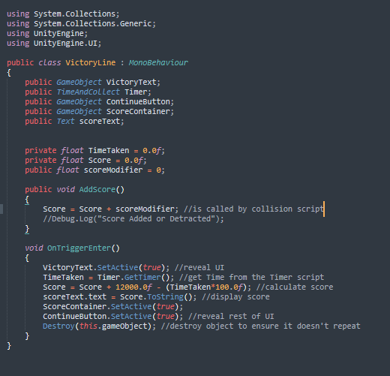

Problems faced

The main problem that we faced was using Github itself. All too often we would download each other’s work from GitHub and something would go wrong, whether that was textures not displaying, scripts becoming unattached or all other other occurrences.

As for specific problems, the two that come to mind are getting the music to transfer from the Main Menu into Character Selection, but not the main game area (as that had its own music), and the failed attempt at the Return to Main Menu button. For the first one, that was solved by setting a DoNotDestroy tag on the object initially, then destroying the object when the button to enter the game was selected. The other problem I just worked around it and made the Escape key return to the main menu, which also proved handy for testing.

Another issue we had with the project was with using TownScaper. It initially seemed like a good asset to use as it created an amazing atmosphere, however upon importing it to Blender that there were hundreds of faces on the asset that needed materials. This drained quite a bit of time as we had to think about what colour to use to keep it vibrant.

Another minor issue we had was assets created from blender partially not turning up. This was despite flipping normal's, At the end we decided to address this issue by simply only showing the back side of the cars which had come out fine.

Future Goals

As for how this project could be improved in the future, the number one thing I’d consider would be implementing a pause menu. I was considering doing this from the start but ran out of time before that could become a thing. As for others, a better-looking options menu, more options (like a full screen option) and ambient sound effects (like Seagulls) come to mind.

We also want to implement a day/night option. This would be selectable in the character selection scene. And it would also be better if we used something other than Townscaper in the future.

Credits

Music

Level Music:

"Voxel Revolution" Kevin MacLeod (incompetech.com)  
Licensed under Creative Commons: By Attribution 4.0 License  
<http://creativecommons.org/licenses/by/4.0/>

Menu Music:

"Bleeping Demo" Kevin MacLeod (incompetech.com)  
Licensed under Creative Commons: By Attribution 4.0 License  
<http://creativecommons.org/licenses/by/4.0/>

Sound Effects

Ultimate SFX & Music Bundle – Everything Bundle by Sidearm Studios

<https://assetstore.unity.com/packages/audio/sound-fx/ultimate-sfx-music-bundle-everything-bundle-200453>

Standard Assets – Unity Technologies

<https://assetstore.unity.com/packages/essentials/asset-packs/standard-assets-for-unity-2018-4-32351>

*Importing and Using Standard Assets With Unity 2020+.* (2021). Learn to Create Games. <http://learntocreategames.com/importing-and-using-standard-assets-with-unity-2020/>

TownScaper - Created by Oskar Stalberg

https://store.steampowered.com/app/1291340/Townscaper/