Dog Runner

|  |  |  |
| --- | --- | --- |
| Sarbjot Singh | 06/09/2021 | Advanced Games Programming |

## Design Decisions

1. I decided on creating an infinite runner based around a Labrador dog that is modeled and animated in Blender. The premise of the game is to collect as much food as possible whilst avoiding the traps along the way. The players success if recorded by how much food they are able to collect rather than how far they manage to go. As the game progresses the model will speed up.

* I created most of the assets used in the game and used this time to try my hand in animation, I used the add-on ‘Rigify’ to accomplish this. I found that the walk and run animations did not loop well so were excluded altogether, as seen in image 1. 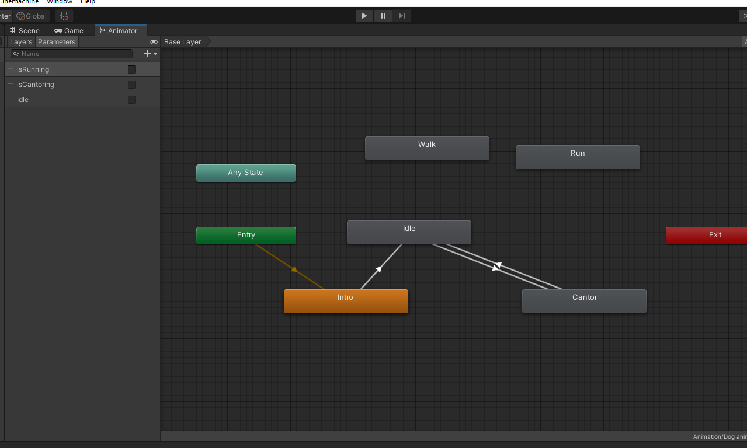image 1

1. I have organized the road blocks into prefabs, included in them are all the obstacles as well as the consumables. I placed the objects into an empty object so as to look cleaner and easier to manage.
2. Lastly, I used the inbuilt terrain system to create a thin strip of land where I could place my road. The texture used for the terrain is from the Unity store as well as the grass.
3. 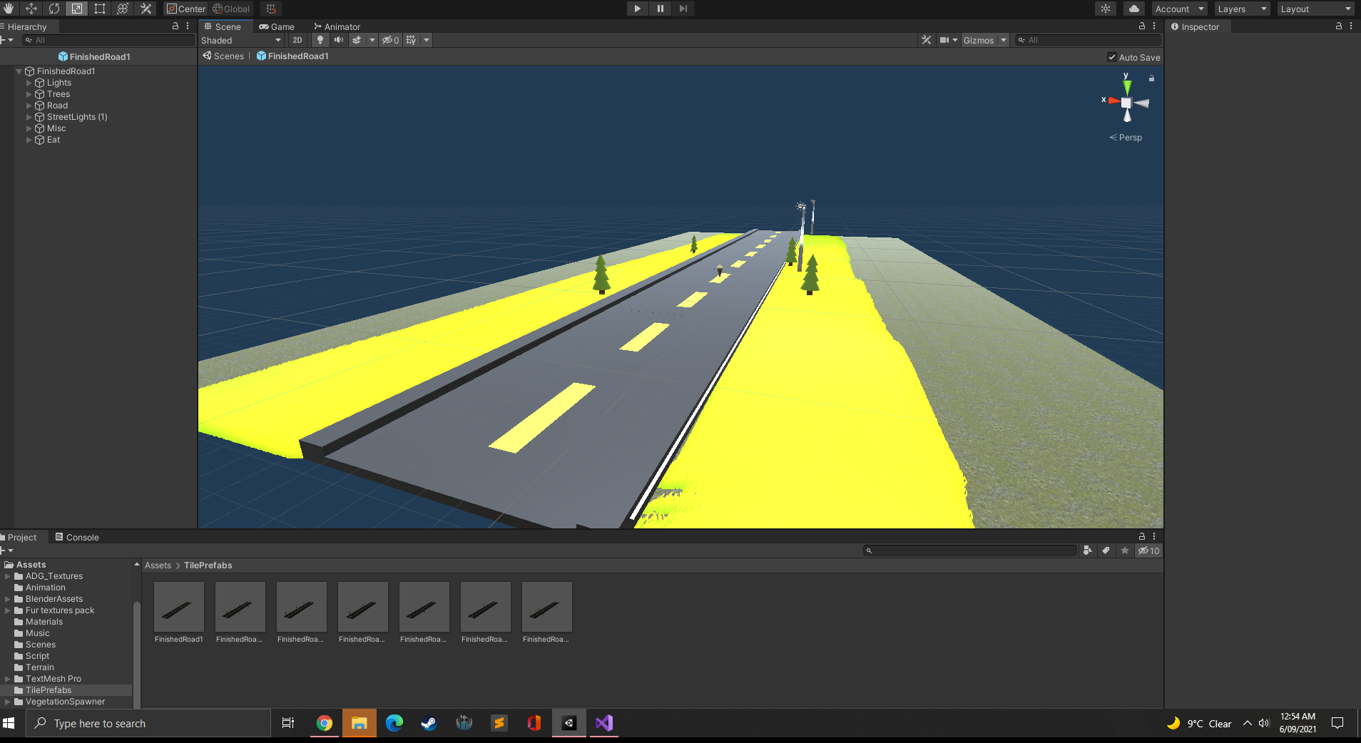Image 2

### Features of the game

* Different animations depending on speed
* Music with ability to turn it up or down in the menu
* Ability to restart the game
* Will show player distance traveled as well as amount of food eaten
* 7 different road blocks which will be placed randomly
* 3 different types of consumables
* 3 different types of obstacles
* Github link: https://github.com/SarbjotS/RunDogRun
* 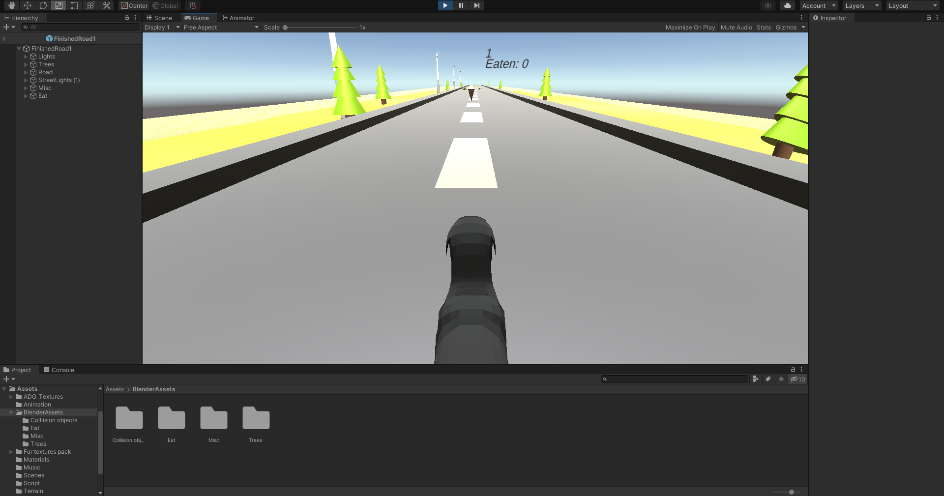Image 3