**DIFFERENT TECHNIQUES USED OF PURIFICATION OF WATER**

A project work submitted for the partial fulfillment of the requirement for the grade 11 science in chemistry

Submitted by:

Sarthak Acharya

Grade: 11

Section: DJ1

ID card number: 24093

Registration no: 793270071547



Trinity International SS & College

Dillibazar Height Kathmandu, Nepal

Ashadh 2079

**DECLARATION**

I “Sarthak Acharya” hereby declare that the project work entitled “different technique used for purification of water” under the supervision of “Beshraj Subedi and “Anand Pokhrel” of Trinity International SS & College is done originally by me and not been submitted for the elsewhere for the award of any degree. All sources of information have been specifically acknowledged by reference to the authors or institutions.

Sarthak Acharya

Grade: 11

Section: DJ1

Student Id no: 24093

Registration number: 793270071547

Email address: sarthak.acharya@trinity.edu.np

**CERTIFICATE OF APPROVAL**

The project work entitled “Different technique used for purification of water” by MR. Sarthak Acharya DJ1 And Id number 24093 under the supervision of “Beshraj Subedi and Anand Pokhrel”, of the Trinity International SS & College, Nepal, is hereby submitted for the partial fulfillment of the requirement for the grade 11 science in Chemistry in Grade 11. This project work has not been submitted in any other school /college previously for the award of Grade 11.

Supervisor:

Signature ………………. Signature ……………….

Beshraj Subedi Anand Pokhrel

Departement of chemistry

Trinity International SS & College

**AKNOWLDGEMENT**

I would like to express my greatest appreciation to the all individuals who have helped and supported me throughout the project. I am thankful to my chemistry teacher for his ongoing support during the project, from initial advice, and provision of contacts in the first stages through ongoing advice and encouragement, which led to the final report of this chemistry project.

A special acknowledgement goes to my colleagues who helped me in completing the project by exchanging interesting ideas and sharing their experience. I wish to thank my parents as well for their undivided support and interest who inspired me and encouraged me to go my own way, without whom I would be unable to complete my project.

At the end, I want to thank my friends who displayed appreciation to my work and motivated me to continue my work.

Thank you

LIST OF FIGURES

1. Different method of purification water……………………………………… 3
   1. Boiling process…………………………………………………………….. 4
   2. Types of water purifier……………………………………………………. 5
   3. Distillation process………………………………………………………… 6
   4. Sedimentation process……………………………………………………… 6

**TABLE OF CONTENTS**

Deceleration……………………………………………………………………II

Certificate of approval…………………………………………………………III

Acknowledgement …………………………………………………………….IV

Table of figure ………………………………………………………………… V

Table of content ……………………………………………………………….VI

CHAPTER ONE

Introduction

1.1Background………………………………………………………………1-2

1.2Literature ………………………………………………………………...2-3

1.3Objective …………………………………………………………………..3

CHAPTER TWO

2.1 Materials ……………………………………………………………….4

2.2 Method ………………………………………………………………..4-6

CHAPTER THREE

Result and discussion…………………………………………………………. 7

CHAPTER FOUR

4.1 Conclusion ………………………………………………………………….8

Reference……………………………….........................................................9

**CHAPTER ONE**

INTRODUCTION

1.1 Background of study

Water is an important and essential ingredient in our quest for survival on this planet. It is very essential for carrying out many metabolic activities processes in our body. But increasing in the population, the demand for drinking water has also increased dramatically and therefore it is very essential to identify resources of water from which we can use water for drinking purpose. Drinking water should be free from pathogens, chemical and should be clean

Water can be contaminated by the following agents:

■ Pathogens – disease-causing organisms that include bacteria, amoebas and viruses, as well as the eggs and larvae of parasitic worms.

■ Harmful chemicals from human activities (industrial wastes, pesticides, fertilizers).

■ Chemicals and minerals from the natural environment, such as arsenic, common salt contaminants may influence the taste, smell etc.

There are many methods for purification of water:

Household water-treatment systems

— boiling;

— Household slow sand filter;

— Domestic chlorination.

Community water-treatment systems

— Storage and sedimentation;

— up-flow roughing filter;

— slow sand filtration;

— Chlorination in piped water-supply systems.

For industrial process

* Using boilers
* Ordinary filter
* Using sand and gravel
* Clark’s method
* Calgon method
* Permutit method
* Ion-exchange method

1.2 Literature Review

Purification of drinking water is a very important problem in environmental Engineering. Purification of drinking water is typically achieved via adding Disinfectant. Chlorine is the most common disinfectant used in drinking water Purification systems because it is inexpensive and destroys a large number of pathogens. The purification of drinking water involves several stages of treatment of the raw water for the removal of suspended solids, color, and bacteria before entering the distribution network. Clarification, disinfection, pH adjustment, filtration and taste and odor removal are part of the stages of treatment. The quality of drinking water is altered by the use of nitrogen-based fertilizers commonly used in agriculture or products of domestic use. DE nitrification of drinking water is needed in this case to reduce the concentrations of nitrites and nitrates present in the raw water. However, in this document we emphasize the controller’s role in the chlorination process since this is the most common method used for the purification of drinking water.

Because water is vital to our health, it’s been a critical focal point for ancient and modern civilizations. Nearly all settlements have traditionally clustered around water sources, which usually require some type of purification to remove harmful microorganisms and unwanted substances. Throughout history, humans have used a variety of techniques to filter out impurities, with advancement soften coinciding with humanity’s expansion throughout the world. Water treatment documentation dates back over 4000 years, when most civilizations boiled and strained their water to eliminate unwanted substances. Around 500 B.C., the first known domestic filter appeared when the Greek scientist Hippocrates invented the so-called Hippocratic sleeve, which consisted of a simple cloth back filter. During the third and fourth Century, the Egyptians purified their drinking water using a variety of methods. To eliminate harmful bacteria, they boiled the water, heated it in the sun, or submerged hot iron into it. They also filtered impurities from their water by sifting it through sand and gravel. Filtration techniques changed very little until 1627, when Sir Robert Bacon made considerable advancements with sand filtration to eliminate salt from sea water.1700 (A.D.) By the 18th Century, the development of the microscope had given scientists new insight into the countless microorganisms present in water. In turn, many nations began using filters made of charcoal, sponge, and wool to eliminate unwanted organisms and particles.1854 (A.D.) Mid-way through the 19th Century, British scientist John Snow made a profound discovery when he determined that cholera was transmitted through water. After several experiments, he also found that chlorine could be used to purify contaminated water, resulting in the use of chlorination as a popular form of water purification.1900 (A.D.) by the 20th Century; most developed countries had established regulations that set minimum standards of water quality. This prompted the development of the advanced filtration methods we use today. Water Filtration Modern technology allows water treatment facilities to effectively eliminate the majority harmful substances from public drinking water. At the same time, many Americans also enjoy access to affordable private filtration systems, which make water even cleaner and better tasting. Pelican Water’s Whole House Water Filtration system uses four stages of filtration to purify tap water better than any other at-home system on the market today. This includes a 5-Micron Pre-filter System to reduce sand, silt, sediment, and debris; Granular Activated Carbon Medias (GAC) to gain a wider range of contaminant filtering capabilities; and a Copper and Zinc Oxidation Media (KDF-55) to reduce the potential growth of bacteria and algae. The result? Some of the cleanest, safest drinking water history has ever seen.

1.4 Objective of my study

* To know about different process of purification of water.
* To know about importance of water purification.

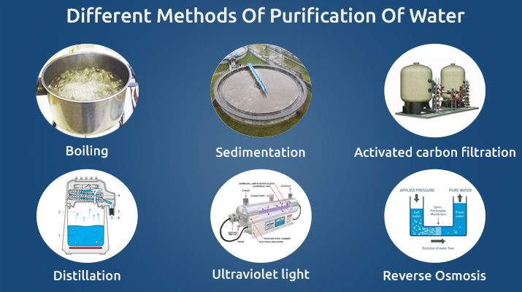

Fig (1): different method of purification of water

**CHAPTER TWO**

2.1 Materials

1. Sediment filter
2. UV filter
3. Potassium permanganate
4. Bleaching powder
5. Bio-filter
6. Dry calcium hypochlorite
7. Elemental chlorine
8. Sodium hypochlorite solution
9. Round bottom flask
10. Funnel
11. Iodine solution, tablet or crystal
    1. Methods (THEORY)

These are some common method for purification of water.

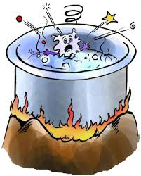Boiling process: It is a reliable, cheapest and safest method of purification of water. High temperature causes the bacteria and virus to dissipate, removing all impurities from the water. However, the dead micro-organism and impurities settle at bottom of water and it does not eliminate all impurities of water.

Fig: 1.1 Boiling process

Use of water filter: This method uses the chemical and physical process to purify the water and make it safe for human consumption. It is an economic method of water purification because little water is lost during the purification. Water filter remove the bacteria in water. The filtration process reduces the concentration of contaminants such as: suspended particles, parasites, bacteria, algae, viruses, and fungi. Different types of water filter are shown in figure:

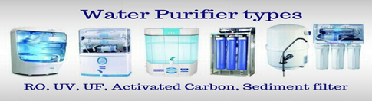

Fig: 1.2 Types of water purify

Ultraviolet light: Ultraviolet systems use UV light to produce purified water for the entire house. Without adding or taking anything away from water, UV disinfection is a cost-effective and environmentally-friendly way to remove 99.99% of harmful waterborne microorganisms.

Chemical disinfection: Disinfection is accomplished both by filtering out harmful micro-organisms and by adding disinfecting chemicals. Iodine solution, tablet or crystal: It is extremely powerful as it kills bacteria and viruses. However, it adds an unpleasant taste and can be fatal if taken in high dose

Bleaching powder: The purification of water using bleaching powder is commonly known as “chlorination”. Chlorine is added to drinking water as elemental chlorine, sodium hypochlorite solution or dry calcium hypochlorite. When applied to water, each forms free chlorine which destroys pathogenic organisms

Potassium permanganate: Potassium permanganate is used extensively in the water treatment industry. It is used as a regeneration chemical to remove iron and hydrogen sulfide (rotten egg smell) from well water via a "Manganese Greensand" Filter. "Pot-Perm" is also obtainable at pool supply stores and is used additionally to treat waste water.

Ozonization: Ozonation (also referred to as ozonisation) is a chemical water treatment technique based on the infusion of ozone into water. ... The treatment of water with ozone has a wide range of applications, as it is efficient for disinfection as well as for the degradation of organic and inorganic pollutants

Bio-filter: Bio filter is a bed of media on which microorganisms attach and grow to form a biological layer called biofilm. Typically, a bio filter has two or three phases, depending on the feeding strategy (percolating or submerged bio filter): a solid phase (media); a liquid phase (water); a gaseous phase (air).

Distillation process: Distillation is the process involving the conversion of a liquid into vapor that is subsequently condensed back to liquid form. It is exemplified at its simplest when steam from a kettle becomes deposited as drops of distilled water on a cold surface. Distillation is used to separate liquids from nonvolatile solids, as in the separation of alcoholic liquors from fermented materials, or in the separation of two or more liquids having different boiling points, as in the separation of gasoline, kerosene, and lubricating oil from crude oil. Other industrial applications include the processing of such chemical products as formaldehyde and phenol and the desalination of sea water.

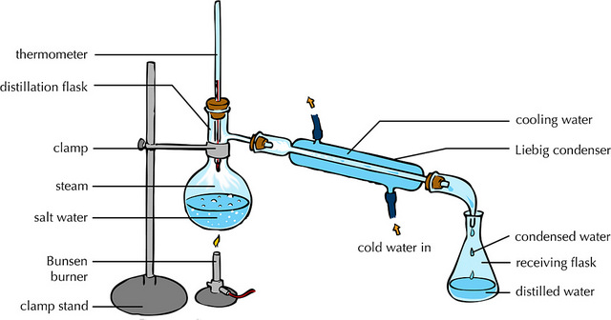

Fig: 1.3 Distillation process

Sedimentation process: Sedimentation is the process of allowing particles in suspension in water to settle out of the suspension under the effect of gravity. The particles that settle out from the suspension become sediment, and in water treatment is known as sludge.

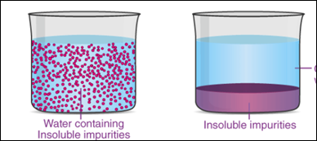

Clear water **text here**

Fig: 1.4 Sedimentation processes

**CHAPTER THREE**

Result and Discussion: The following points were known after study:

| Methods of water purification | Merits | Demerits |
| --- | --- | --- |
| 1.Boiling process | * Cheapest and easiest way. * Kills bacteria and virus and remove impurities. | * It does not eliminate all impurities |
| 2. Use of water filter | * Economical or cost-effective. * Kills bacteria and virus and remove impurities. | * Replacement and disposal cost. |
| 3.Ultravoilet light | * Chemical is not required * Cost effective * Simple mechanism | * Use a electricity * Doesn’t remove all impurities * Water needs to be pre-filter. |
| 4.chemicals disinfection | * Kill the bacteria and viruses. | * It adds an unpleasant taste and more use can be fatal. |
| 5. distillation | Remove inorganic compound. | * Chemical Reactions. |
| 6.sedimentation | Easy and impurities are removed. | Coagulants may be toxic if used improperly. May 21, 2019 by Wikipedia |

Table 1.1 merits and demerits of method of purification of water.

Source: MDPI

**Chapter Four**

4.1 CONCULSION

After the research and study the different methods of water purification was known. Most of the people use filter to purify water followed by boiling, chemical method etc. The demerits and merits of the above method were known. Water purifying helps to have dust free, pathogen free fresh water which helps to have a healthy life. Water plays such an important role in our daily lives. 70% of our body is composed of water. 70% of the earth surface is also made up of water, but out of the 70%, only 1/3 of water is consumable. In fact, this amount has been continuously to decrease as more and more industries began to pollute and damage the water For example, many toxic chemicals may be released into the water thus making the water impure. Such pollutions and damages lead the water to be contaminated and inconsumable as it may cause severe diseases. Water purification can remove all the unnecessary bacteria and viruses from the water that is hazardous for our health. Water purification may also improve the flavor and appearance of water. It removes the unpleasant odor. Therefore, water purification became one of the most useful and popular process used by people all over the world today. It is by far the most recommended and safest water treatment that is commonly used to purify damaged water into consumable water. Water purification provides us with safe, pure and clean water to consume and use.

**Reference**

1. Tamrakar, N.K.; Manandhar, K.C. 2016. Institutional Capacity Assessment of KUKL; Ministry of Urban Development (MoUD): Kathmandu, Nepal; Japan International Cooperation Agency (JICA): Tokyo, Japan,

2. Thapa, B.R.; Ishidaira, H.; Pandey, V.P.; Bhandari, T.M.; Shakya, N.M. 2018, 10, 24. Evaluation of Water Security in Kathmandu Valley before and after Water Transfer from another Basin. Water

3. Mohamed.F.; ”, 2016. Mustapha.D,;”Review on Optimization of Drinking Water TreatmentProcess.

4. Hugo.V. Lennart .B. Peng.l,; Aji P. M; “Nano cellulose-Based Materials for water Purification” , 2017

5. McLennan, J.D. To boil or not: Drinking water for children in a periurban barrio. Soc. Sci. Med. 2000, 51,1211–1220.

6.Farzin, Y.H.; Grogan, K.A. 2013 Socioeconomic factors and water quality in California. *Environ. Econ. Policy Stud.,* 15, 1–37.

7. Clasen, T.F. 2010, 44, 7357–7360. Household Water Treatment and the Millennium Development Goals: Keeping the Focus on Health. Environ. Sci. Technol.

8. Clasen, T.F.; Cairncross, S. 2004, 9, 187–191 Household water management: Refining the dominant paradigm. Trop. *Med.Int. Health*.