Student Name: Sarbodaya Jena
Student Id: 11804093
Email Address: sarbodayajena2000@gmail.com
GitHub Link: https://github.com/Sarbodaya/RoundRobin-Project.git
Code:

#include<stdio.h>
#include<conio.h>
void STACK1(int pnt,int tm);
void STACK2(int pnt,int tm);
void AddQue(int pnt);
int n,at[10],bt[10],i,tq,j;
int ct[50]={0},tat[10],rt[10];
int rqi[50]={0},c=0,st,tm=0,noe=0,pnt=0,btm[50]={0},tt,wt;
float att,awt;
int flag=0;
int main()
{

printf("*********************************Round Robin Algorithm********************************************\n");
printf("Here are Some attributes\n");
printf("AT :- Arrival Time\n");
printf("BT :- Burst Time\n");
printf("TQ :- Time Quantum\n");
printf("TAT :- Turn Around Time\n");
printf("WT :- Waiting Time\n");
printf("CT :- Completion Time\n");
printf("RT :- Responsive Time\n");
printf("\nEnter the no. of process\n");
scanf("%d",&n);
for(i=0;i<n;i++)
{
printf("Process No. [P%d]\n",i+1);
printf("Enter the Arrival Time:-\n");
scanf("%d",&at[i]);
printf("Enter the Burst time:-\n");
scanf("%d",&bt[i]);
btm[i]=bt[i];
}
printf("Enter the Time Quantum\n");
scanf("%d",&tq);
printf("GANT CHART\n");
printf("%d",at[0]);
do{
if(flag==0){
st=at[0];
if(btm[0]<=tq){
tm=st+btm[0];
btm[0]=0;
STACK1(pnt,tm);
}
else{
btm[0]=btm[0]-tq;
tm=st+tq;
STACK1(pnt,tm);
AddQue(pnt);
}
}
else{
pnt=rqi[0]-1;
st=tm;
for(i=0;i<noe && noe!=1;i++){
rqi[i]=rqi[i+1];
}
noe--;
if(btm[pnt]<=tq){
tm=st+btm[pnt];
btm[pnt]=0;
STACK2(pnt,tm);
}
else{
btm[pnt]=btm[pnt]-tq;
tm=st+tq;
STACK2(pnt,tm);
AddQue(pnt);
}
}
if(btm[pnt]==0){
ct[pnt]=tm;
}
flag++;
printf("]-P%d -[ %d",pnt+1,tm);
}
while(noe!=0);
for(i=0;i<n;i++){
rt[i]=at[i];

}
printf("\n\nPROCESS\t AT\t BT\t CT\t TT\t WT\t RT\n ");
for(i=0;i<n;i++){
tt=ct[i]-at[i];
wt=tt-bt[i];
printf("P%d\t %d\t %d\t %d\t %d\t %d\t %d\n ",i+1,at[i],bt[i],ct[i],tt,wt,rt[i]);
awt=awt+wt;
att=att+tt;
}
printf("\nAVERAGE TT: %f",att/n);
printf("\nAVERAGE WT: %f",awt/n);

}
void STACK1(int pnt,int tm){
for(i=pnt+1;i<n+1;i++){
if(at[i]<=tm){
rqi[noe]=i+1;
noe++;
}
}
}
void STACK2(int pnt,int tm){
for(i=pnt+1;i<n+1;i++){
int f1=0;
for(j=0;j<noe;j++){
if(rqi[j]==i+1){
f1++;
}
}
if(at[i]<=tm && f1==0 && btm[i]!=0){
rqi[noe]=i+1;
noe++;
}
}
}
void AddQue(int pnt){
rqi[noe]=pnt+1;
noe++;
}

- Description

We have to design a code for the round robin algorithm.We have to make a scheduler that can schedule a process at a periodical arrival time.Every process has to execute in a fixed amount of time i.e known as Time Quantum.Then the process will be preempt
after particular period of time quantum.The scheduler will select the next process in the queue and dispatcher dispatches the process for execution.Compute the Completion time,Turn Around Time,Waiting Time,Response Time.
We have to take input for CPU burst time and arrival time.

- Algorithm

1. The queue structure in ready queue is of First In First Out (FIFO) type.
2. A fixed time is allotted to every process that arrives in the queue. This fixed time is known as time quantum.
3. The first process that arrives is selected and sent to the processor for execution. If it is not able to complete its execution within the time quantum provided, then an interrupt is generated using an automated timer.
4. The process is then stopped and is sent back at the end of the queue. However, the state is saved and context is thereby stored in memory. This helps the process to resume from the point where it was interrupted.
5. The scheduler selects another process from the ready queue and dispatches it to the processor for its execution. It is executed until the time Quantum does not exceed.
6. The same steps are repeated until all the process are finished.
The round robin algorithm is simple and the overhead in decision making is very low. It is the best scheduling algorithm for achieving better and evenly distributed response time.
Complexity:
- First For LOOP :- for(i=0;i<n;i++);
- For taking no.of inputs for Process and their Arrival Time and Burst Time.
Then Complexity would be O(n).
- Do while loop:- while(noe!=0);
It will run upto noe!=0;
Complexity would be O(n);
- Second For Loop for assigning arrival time to response time.
Complexity:O(n);
- Third for loop for printing the Values.
Complexity:- O(n);
- In First Stack to store the value it will run upto n+1 times
Complexity:-O(n+1);
- In Second Stack we have used for loop inside another for loop.
for(i=pnt+1;i<n+1;i++){
int f1=0;
for(j=0;j<noe;j++){
Complexity:- (n+1)*(n)=n^2+n.
O(n^2+n).
Overall Complexity:- O(n)+O(n)+O(n)+O(n)+O(n)+O(n+1)+O(n^2+n).
O(n^2).

- Description
Round robin is a nice scheduling for processes with the same priority or in an OS without priorities or priorities based only on groups (Minix 2). It is also ok, when you use a few independent programs, because process starvation is not likely to happen.
Starvation which is never occurred in Round Robin Scheduling. All the process is using just one CPU. One of the main advantage is that this scheduling can work in any operating system.
Drawback:-
1.Longer process may starve.
2.performance depends heavily on the quantum.
3.no idea of priority
We can take for n no. Of process and can schedule the process for the execution.
Test cases :1.Time Quantum should be greater than 0 and less than 20.
Tq>0 && tq<=20
Otherwise it will suffer from starvation and the other process will not be executed.
Test Case :2.Arrival Time at>0 and at<n;
Test Case :3.Burst Time bt>0 and bt<n;
Five Revision To My Project
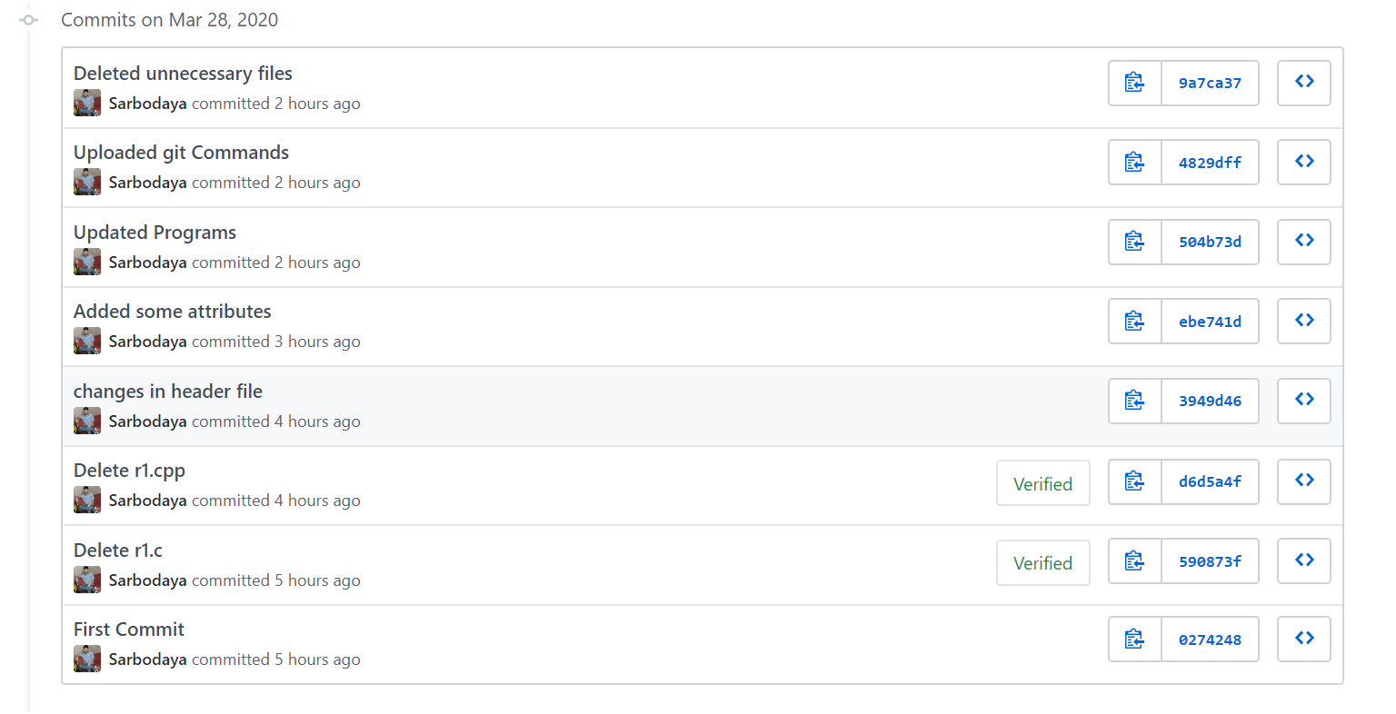
Git Hub Link:-https://github.com/Sarbodaya/RoundRobin-Project.git

Code Snippet-

