

**American International University-Bangladesh (AIUB)**

**Faculty of Science and Technology (FST)**

**Department of Computer Science (CS)**

**SDPM Group Project, Spring 2023**

**Project Title: Asset management system**

**Section: F**

**Course Teacher:** Md. Anwarul Kabir

Associate Professor, Computer Science (AIUB)

**Submitted by**

|  |  |
| --- | --- |
| **Name** | **ID** |
| Thouhida Tasnim | 20-43051-1 |
| Abu Shaleh Md. Kaium | 20-42475-1 |

**1.0 Introduction:**

An asset management system is a piece of software that enables landlords and other property managers to carry out crucial tasks relating to the property, such as maintaining and tracking tenant information, accounting and billing, maintenance, and posting vacancies online to ensure that everything runs well for the rental. This project will be very important in the modern city because housing is a huge issue in the urban region. Whenever a buyer wishes to purchase a flat, they should get in touch with the seller, who will provide all the information about the flat or property.

**2.0 Project Title**: **Asset management system**

**3.0 Objectives:**

The following are our project objectives:

• Develop a system-specific software requirement specification document.

• To develop a system that enables database users to add, modify, search for, and delete data.

• To research and evaluate the system's need specifications for managing rental properties.

• Provide a system that enables database users to add, modify, search for, and remove data.

**4.0 Justification:**

First and foremost, buyers and property owners are the project's target audience and stakeholders. The buyer saves the most time by using a PMS, which is the main advantage. All buyers and property owners will be able to connect with one another through this system in order to conduct business. Building maintenance is the single most significant factor affecting customer happiness. The greatest option to simplify rent payment for your clients is through online payment processing because they can do it from the convenience of their own homes. The customer's wants and expectations are met because they can view the rental home while seated at home. For buyers and property owners, this system offers fantastic potential, including contact management, financial management, marketing, and more.

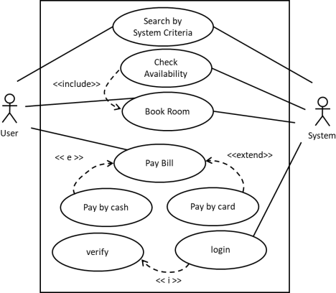**5.0 Systems Overview:**

**6.0 Stakeholders analysis:**

Project stakeholders may be internal or external to the project, actively involved, passively involved, or oblivious to the project, and they may be impacted positively or adversely by the cost, duration, scope, resources, quality, or hazards of the project.

* **Primary Stakeholder:**

**A positive stakeholder:** The project management team needs the assistance of helpful stakeholders to effectively execute the project. for instance, the Rental Project Management Team, which is actively engaged in project management tasks, Sponsors: those who contribute money.

**Internal to the project team:** Project Manager, System Analyst, Developer, tester, analyst under the direct managerial control of the project leader.

* **Secondary Stakeholder:**

**External to the project team but in the same organization:** Rental management system project information management group, User (Admin, Buyer, Tenant, Seller), Customers/users, Negotiator.

# **7.0 Feasibility study:**

From a business point of view this is project is technically feasible. The feasibility of an individual project is evaluated

* **Technical Assessment**: The technical assessment determined that the project is technically feasible as it involves developing a desktop-based application that can connect with different user groups.

However, the available hardware and software may limit the technical solutions that can be considered. To ensure feasibility, the project will need to adhere to a consistent hardware and software infrastructure.

* **Cost-Beneﬁt Analysis:** Identiﬁed all of the costs and beneﬁts of carrying out the project.
* **Costs are:**
  + Development Costs:

- Salaries and other employment-related expenses for the team members working on the development project

* + Setup Costs

-Costs of any new hardware and ancillary equipment’s.  
-Costs of ﬁle conversion.

* + Operational Costs

-Costs of operating the system once it has been installed.

* **Beneﬁts are:**
  + Direct Beneﬁts

– These accrue directly from the operation of the proposed system.

* + Intangible Beneﬁts

- Indirect benefits, which are difficult to estimate, are sometimes known as "intangible benefits.

We can Evaluate Cost-Beneﬁt Evaluation by **Return On Investment (ROI) technique:**

|  |  |
| --- | --- |
|  | Calculate ROI for **Rental**  **Property Management System**   * Average annual proﬁt   = 50,000/5  = 10,000  ROI = (average annual proﬁt/ total investment) X 100  = (10,000/100,000) X 100  = 10% |

**8.0 System Component:**

|  |  |
| --- | --- |
| **Registration Activity Task:**  On the "log in" page, users enter their required information and click on the "check" button to verify their identification. This page will ask if the information is not in the database before redirecting to the "Register" page. If the user is already registered, then the system will show an alert message that the user is already registered. If Identification No. exists in the database, then the system will display the basic details of the user and proceed as below. | |
| **Admin Module:**    **‘Dashboard’ module:**  From Dashboard admin choose to select option among ‘Properties & Building’ ‘Tenants & Units’  ‘Expense & Income’ ‘Expense & Income’. | **Tenants Module:**    **“Dashboard”:**  Tenants ‘s dashboard. |

**9.0** **Process Model to be followed:**

For the project, I have selected the waterfall process model. It is also called the linear-sequential life cycle model. Here, each phase must be completed before starting the next phase, as there is no overlap in this process model. For this model, the document must be well defined and fixed, and requirements must not be ambiguous. Requirements and projects cannot change until the end of production, or else we have to start from the beginning. The product is produced at the end of the project.

The reason I chose this model is because it is very simple and linear. Our project design is not so complex, which is perfect for this model. Requirements are defined clearly in the project planning and analysis phase, so waterfall is suitable for this project.

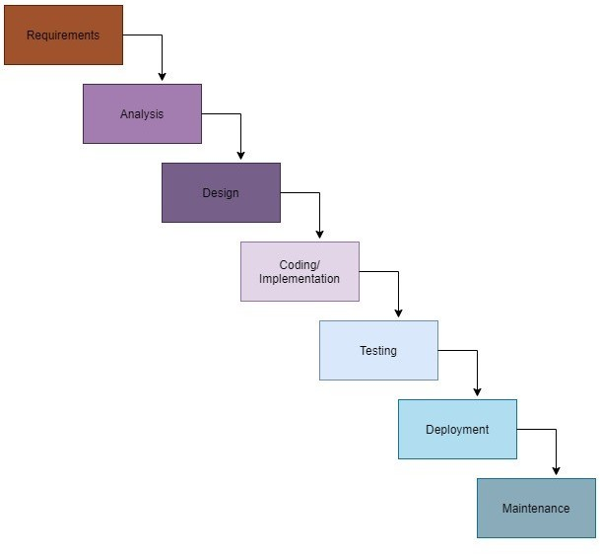

**10.0 Effort Estimation:**

**COCOMO (Constructive Cost Model)** is a regression model based on LOC. It is a procedural cost estimate model for software projects and open used as a process of reliably predicting the various parameters.

|  |  |  |  |  |  |
| --- | --- | --- | --- | --- | --- |
| **Cost Drivers** | **Very Low** | **Low** | **Nominal** | **High** | **Very high** |
| **Product attributes Product attributes** | | | | | |
| Required software reliability extent |  |  | **1.00** |  |  |
| Size of the application database |  |  | **1.00** |  |  |
| The complexity of the product |  | **0.85** |  |  |  |
| **Hardware Attributes** | | | | | |
| Run-time performance constraints |  |  |  |  | **1.30** |
| Memory constraints |  |  |  | **1.06** |  |
| The volatility of the virtual machine environment |  |  |  | **1.15** |  |
| Required turnabout time |  | **0.94** |  |  |  |
| **Personnel attributes Personnel attributes** | | | | | |
| Analyst capability |  |  |  | **0.86** |  |
| Software engineering capability |  |  |  | **0.91** |  |
| Applications experience |  |  | **1.00** |  |  |
| Virtual machine experience |  |  | **1.00** |  |  |
| Programming language experience |  |  |  | **0.95** |  |
| **Project attributes** | | | | | |
| Use of software tools |  |  |  | **0.91** |  |
| Application of software engineering methods |  |  |  | **0.91** |  |
| Required development schedule |  |  |  | **1.04** |  |

**The Intermediate COCOMO formula now takes the form:**

E= (a(KLOC)^b)*EAF.

**Multiply all the above values,**

Effort Adjustment Factor (EAF),

=1*1*0.85*1.30*1.06* 1.15*.94*.86*.91*1* 1*.95*.91*.91*1.04

=0.81

|  |  |  |  |  |
| --- | --- | --- | --- | --- |
| Software Projects | **a** | **b** | **c** | **d** |
| Organic | 2.4 | 1.05 | **2.5** | **0.38** |
| Semi Detached | 3.0 | 1.12 | 2.5 | 0.35 |
| Embedded | 3.6 | 1.20 | 2.5 | 0.32 |

**Consider, KLOC = 8000, and the project is organic**

**For, Organic Software Project,**

a =2.4

b=1.05

**So,**

**E= (a(KLOC)^b) *EAF**

= (2.4* (8000/1000) ^1.05) * 0.81

= (2.4 * (8) ^1.05) * 0.81

= 17.93 man-months  
The constant values a, b, c and d for the Basic Model for the different categories of system:

**Time = c (Effort)^d**

= 2.5*(23) ^0.38

=8.22 ~9

= 9Months

**We know that,**

**Required no. of people =** ST = PM/DM

= 18/9

=2

**Work breakdown Structure:**

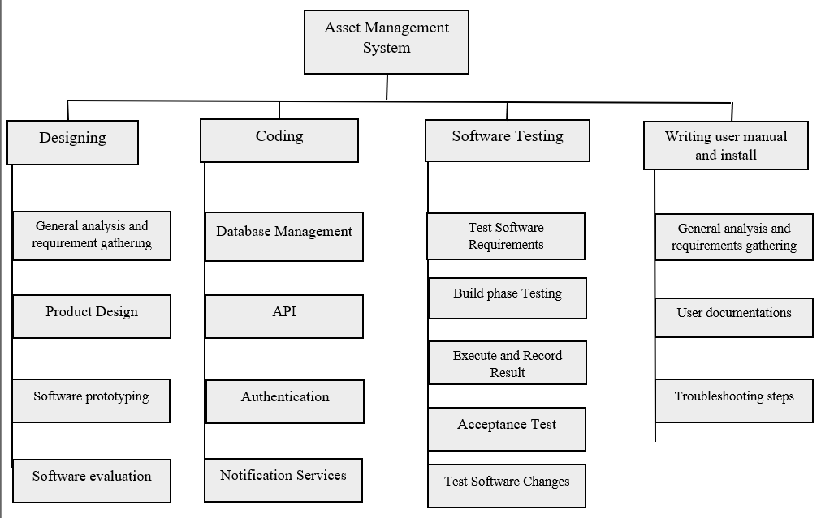

**11.0 Activity Network Diagram:**

|  |  |  |
| --- | --- | --- |
| **Activity** | **Duration(Month)** | **Precedents** |
| 1. Hardware choice | 1 |  |
| 1. Designing | 2 |  |
| 1. Code | 4 | 1 |
| 1. Software testing | 1 | 2 |
| 1. Write user manual | 1 |  |
| 1. Install and test system | 2 | 3,4,5 |

**Activity: Labeling Convention**

|  |  |  |
| --- | --- | --- |
| Earliest Start (ES) | Duration | Duration Earliest Finish (EF) |
| **Activity Label** | | |
| Latest Start (LS) | Float | Latest Finish (LS) |

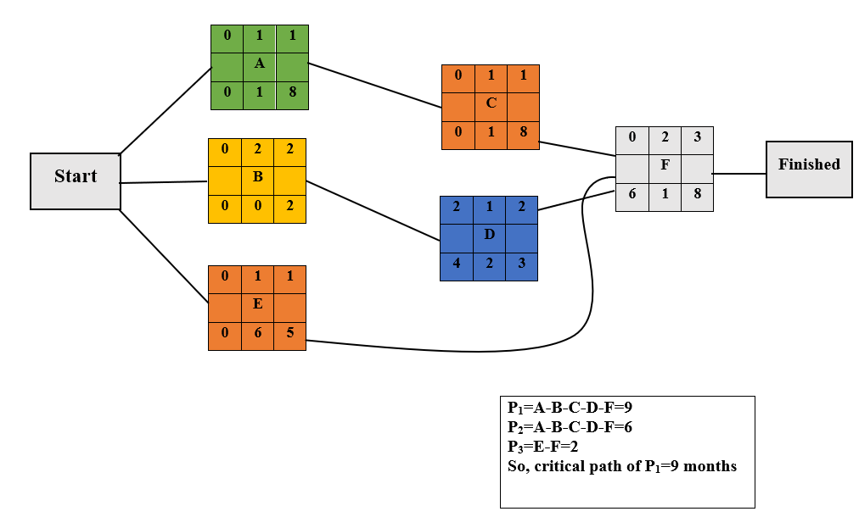

**12.0  Risk Analysis:**

|  |  |  |  |  |
| --- | --- | --- | --- | --- |
| **Risk** | **Category** | **Probability** | **Impact** | **RMMM** |
| ▪ Poor management of system | BU | 70% | 2 | Receive consulta<on form manager |
| ▪ Technical problems during management | TE | 50% | 2 | Before star<ng the project, listing all technical problem may aware the risk and also help find solution |
| ▪ Environmental damage’s | DE | 40% | 2 | Check the soil conditions before building |
| ▪ Funding lost | CU | 15% | 1 | Secure advanced payment Frequent communication |
| ▪ Schedule management plan | PR | 60% | 3 | Analysis the project and do WBS may resolve this |
| ▪ Irresponsibility of worker’s | ST | 20% | 3 | Supervised work daily |
| ▪ Uncertain change of customer Requirement’s | PS | 80% | 2 | Use simulation to avoid those risk, and show the client before starting actual project |

**Impact values:**Catastrophic -1  
Critical - 2  
Marginal - 3  
Negligible – 4

**13.0 Required Resources** :

1. System Design Document (SDD)
2. User Manual
3. Test Strategy Document
4. Defect Report

**14.0 Budget for the project**:

**Time:**

Constructive Cost Model:

* Project type : Organic (Basic COCOMO Model)
* Coefficient<effort factor>  : 2.40 [P=1.05, T=0.38]
* SLOC :10000 Lines
* Effort : (2.40* 101.05) = 26.93
* Dev. time, DM : (2.50* 26.930.38) = 8.74 = 9 Months = 2160 WH

**Budget:**

Required People, ST: Effort/DM = 26.93/8.74 = 3.80 = 4

Developer & Tester Salary in 9 months:

Per Developer salary Per working Hour = 700 Taka

Total Developer salary = 700*2160 = 15,12000 Taka

Requirement Analysis:

Time Needed: 5 weeks (25 working days = (25*12) =300 WH)

Req Analyst Person’s Hourly wage = 300 Taka

Total Req. Analyst salary = 300*300= 90,000 Taka

Resource Expense Estimation: 100000 Taka

Rent Expense:

Office space per Month = 50,000 Taka

Total in 9 Months = 450,000 Taka

Total Utilities in 9 Months (including miscellaneous): 20,000 Taka

Maintenance (Till 2 years after Delivery):

Expense per Hour: 1000 Taka

Total Estimated Time needed for Maintenance 2400 Hours

Total Estimated Maintenance Expense = 2400*1000 = 2400,000 Taka

Advertisement Marketing Cost (Annual) :

Package that includes a total of 30 minutes advertisement 3,00,000Taka

Social Media Sponsored Post:

Facebook/Instagram sponsored post cost per month 25,000Taka

Sponsored post cost in 9 months = 25,000 * 8 = 225,000/-

Total Estimated Expense:

1512000 + 90000 + 100000 + 450,000 + 20,000 + 2400,000 + 300,000 + 225,000 = 50,97,000Taka

Profit:

Reverse Expense = 15%*50,97,000 = 764,550 Taka

**Project Budget:**

50,97000 + 764,550 = **58,61,550 Taka**

**15.0  Conclusion:**

The online house rental business has emerged with a new possibility compared to past experience, where every activity concerning the house rental business was limited to a physical location only. Even though the physical search for houses has not been totally eradicated, the nature of functions and how these functions have been reshaped by the power of the internet. Nowadays, renters/tenants can reserve houses online once the customer is a registered member of the website. The software of the rental system has offered an advantage to both landlords and tenants by efficiently and effectively, just with the click of a button.

**Reference:**

1.https://[www.academia.edu/9498812/Rental_House_Management_System](http://www.academia.edu/9498812/Rental_House_Management_System) 2.https://[www.academia.edu/18928139/PROPERTY_MANAGEMENT_SYSTEM](http://www.academia.edu/18928139/PROPERTY_MANAGEMENT_SYSTEM) 3.https://creately.com/lp/network-diagram-software-online/