Supplementary Material
α-Glucosidase Inhibitory Potential of Cladonia scabriuscula Extracts in Caco-2 Cells with UHPLC-HRMS Metabolite Profiling and In Silico Molecular Docking
Contents
Figure S1 | UHPLC–HRMS base peak chromatograms of ECS and MCS
Figure S2 | MS spectrum — azelaic acid (1)
Figure S3 | MS spectrum — undecanedioic acid (2)
Figure S4 | MS spectrum — D-glucitol monostearate (3)
Figure S5 | MS spectrum — icosanedioic acid bis(2,3-dihydroxypropyl) ester (4)
Figure S6 | MS spectrum — 9Z-octadecenedioic acid (5)
Figure S7 | MS spectrum — 13-(β-D-glucosyloxy)docosanoic acid (6)
Figure S8 | MS spectrum — portentol (7)
Figure S9 | MS spectrum — 9-oxooctadecanoic acid (8)
Figure S10 | MS spectrum — heptadecyl D-glucoside (9)
Figure S11 | MS spectrum — allo-protolichestrinic acid (10)
Figure S12 | MS spectrum — linderanolide (11)
Figure S13 | MS spectrum — 3,5-dimethylorsellinic acid (12)
Figure S14 | MS spectrum — ethyl everninate (13)
Figure S15 | MS spectrum — ethyl 4-O-methylolivetolcarboxylate (14)
Figure S16 | MS spectrum — menegazziaic acid (15)
Figure S17 | MS spectrum — cryptostictic acid (16)
Figure S18 | MS spectrum — hyposalazinic acid (17)
Figure S19 | MS spectrum — homosekikaic acid (18)
Figure S20 | Chemical structures of compounds 1–18
Figure S21 | Two-dimensional interaction diagrams (top-ranked metabolites and acarbose with SI, PDB 3LPP)
Table S1 | Top-ranked docking pose of the metabolites and acarbose against sucrase-isomaltase (PDB 3LPP)

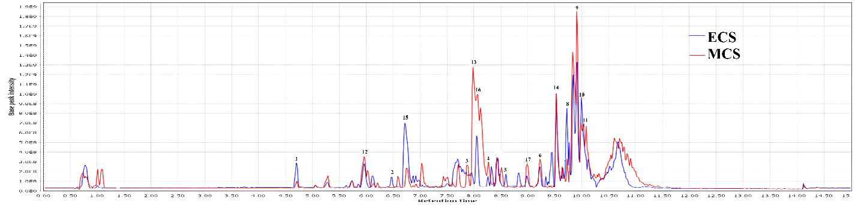
Figure S1. UHPLC–HRMS base peak chromatograms of the ethyl acetate (ECS) and methanol (MCS) extracts of Cladonia scabriuscula.
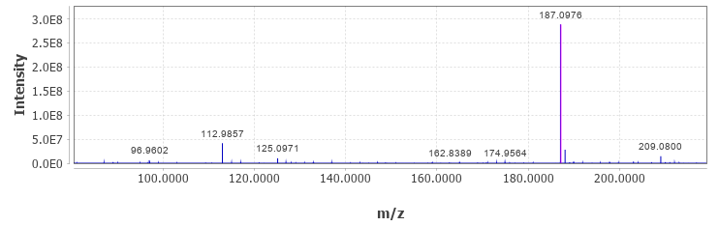

Figure S2. High-resolution mass spectrum (M–H⁻) of azelaic acid (1).
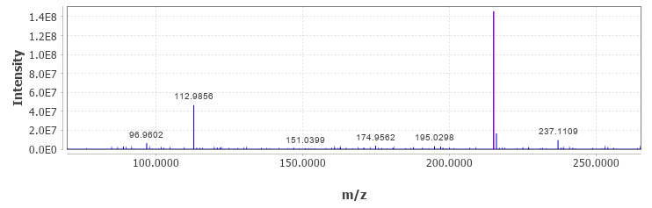

Figure S3. High-resolution mass spectrum (M–H⁻) of undecanedioic acid (2).
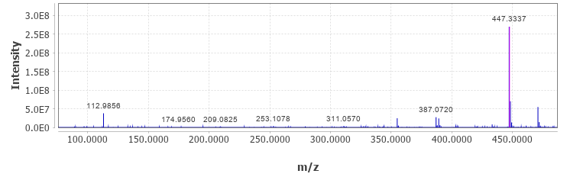

Figure S4. High-resolution mass spectrum (M–H⁻) of D-glucitol monostearate (3).

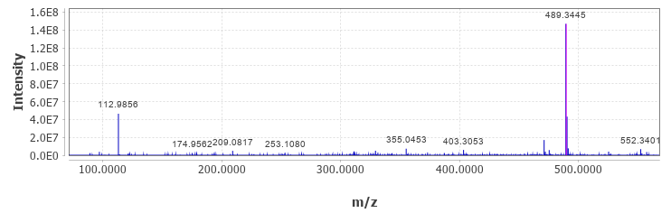

Figure S5. High-resolution mass spectrum (M–H⁻) of icosanedioic acid bis(2,3-dihydroxypropyl) ester (4).
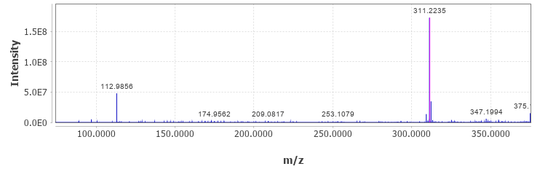

Figure S6. High-resolution mass spectrum (M–H⁻) of 9Z-octadecenedioic acid (5).
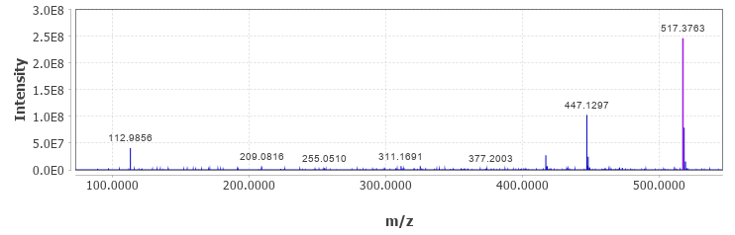

Figure S7. High-resolution mass spectrum (M–H⁻) of 13-(β-D-glucosyloxy)docosanoic acid (6).

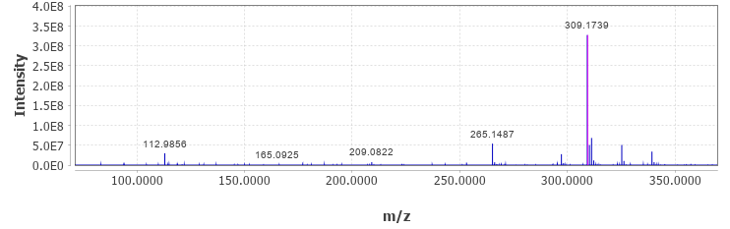

Figure S8. High-resolution mass spectrum (M–H⁻) of portentol (7).
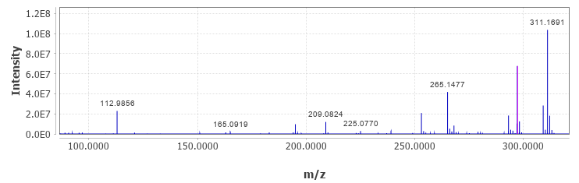

Figure S9. High-resolution mass spectrum (M–H⁻) of 9-oxooctadecanoic acid (8).
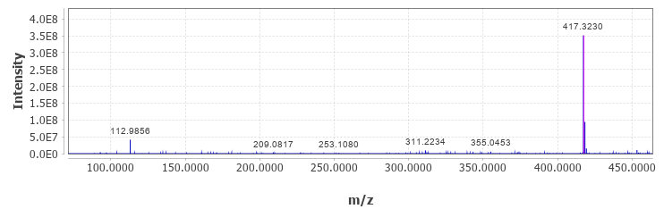

Figure S10. High-resolution mass spectrum (M–H⁻) of heptadecyl D-glucoside (9).

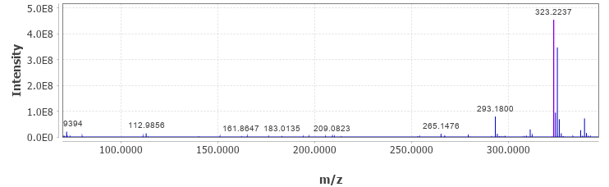

Figure S11. High-resolution mass spectrum (M–H⁻) of allo-protolichestrinic acid (10).
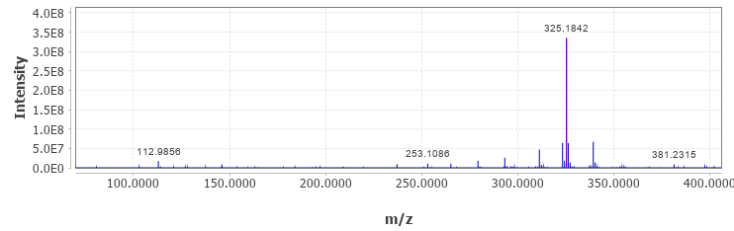

Figure S12. High-resolution mass spectrum (M–H⁻) of linderanolide (11).
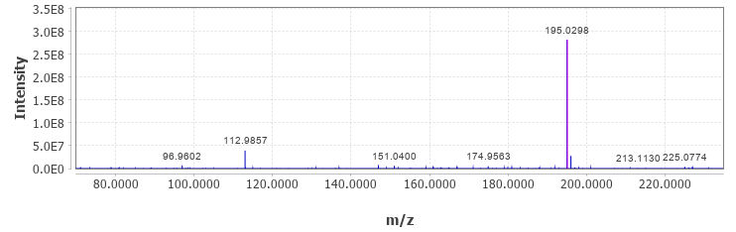

Figure S13. High-resolution mass spectrum (M–H⁻) of 3,5-dimethylorsellinic acid (12).

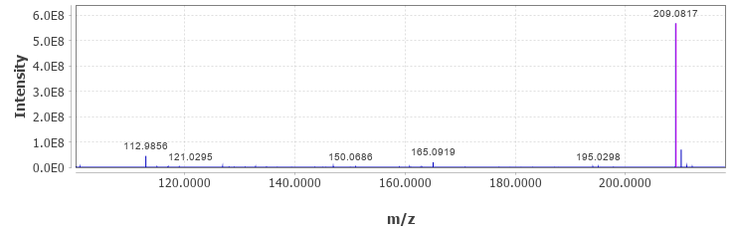

Figure S14. High-resolution mass spectrum (M–H⁻) of ethyl everninate (13).
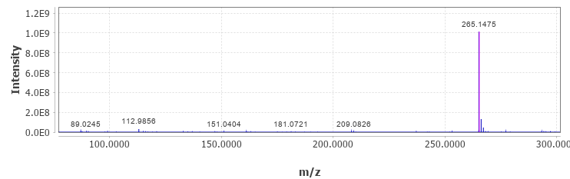

Figure S15. High-resolution mass spectrum (M–H⁻) of ethyl 4-O-methylolivetolcarboxylate (14).
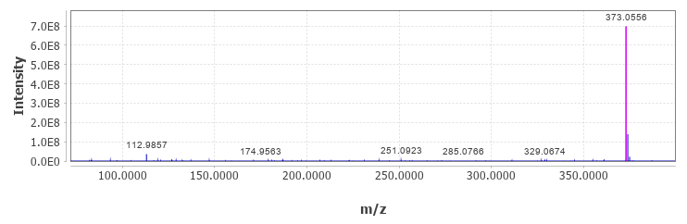

Figure S16. High-resolution mass spectrum (M–H⁻) of menegazziaic acid (15).

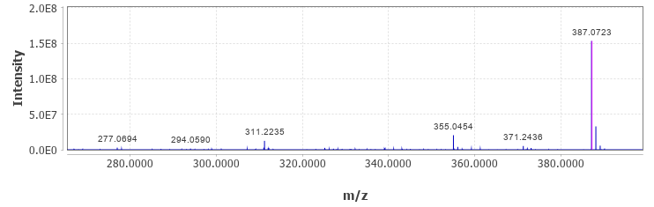

Figure S17. High-resolution mass spectrum (M–H⁻) of cryptostictic acid (16).
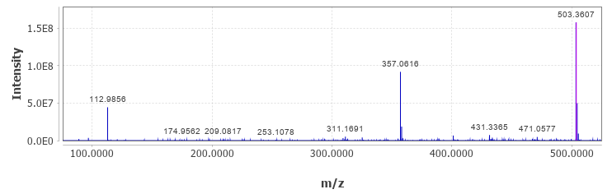

Figure S18. High-resolution mass spectrum (M–H⁻) of hyposalazinic acid (17).
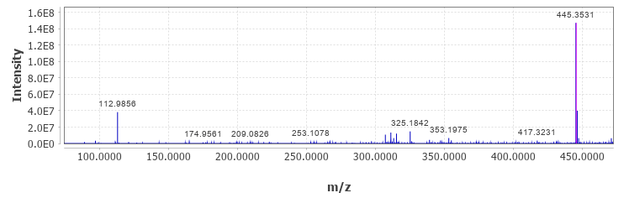

Figure S19. High-resolution mass spectrum (M–H⁻) of homosekikaic acid (18).

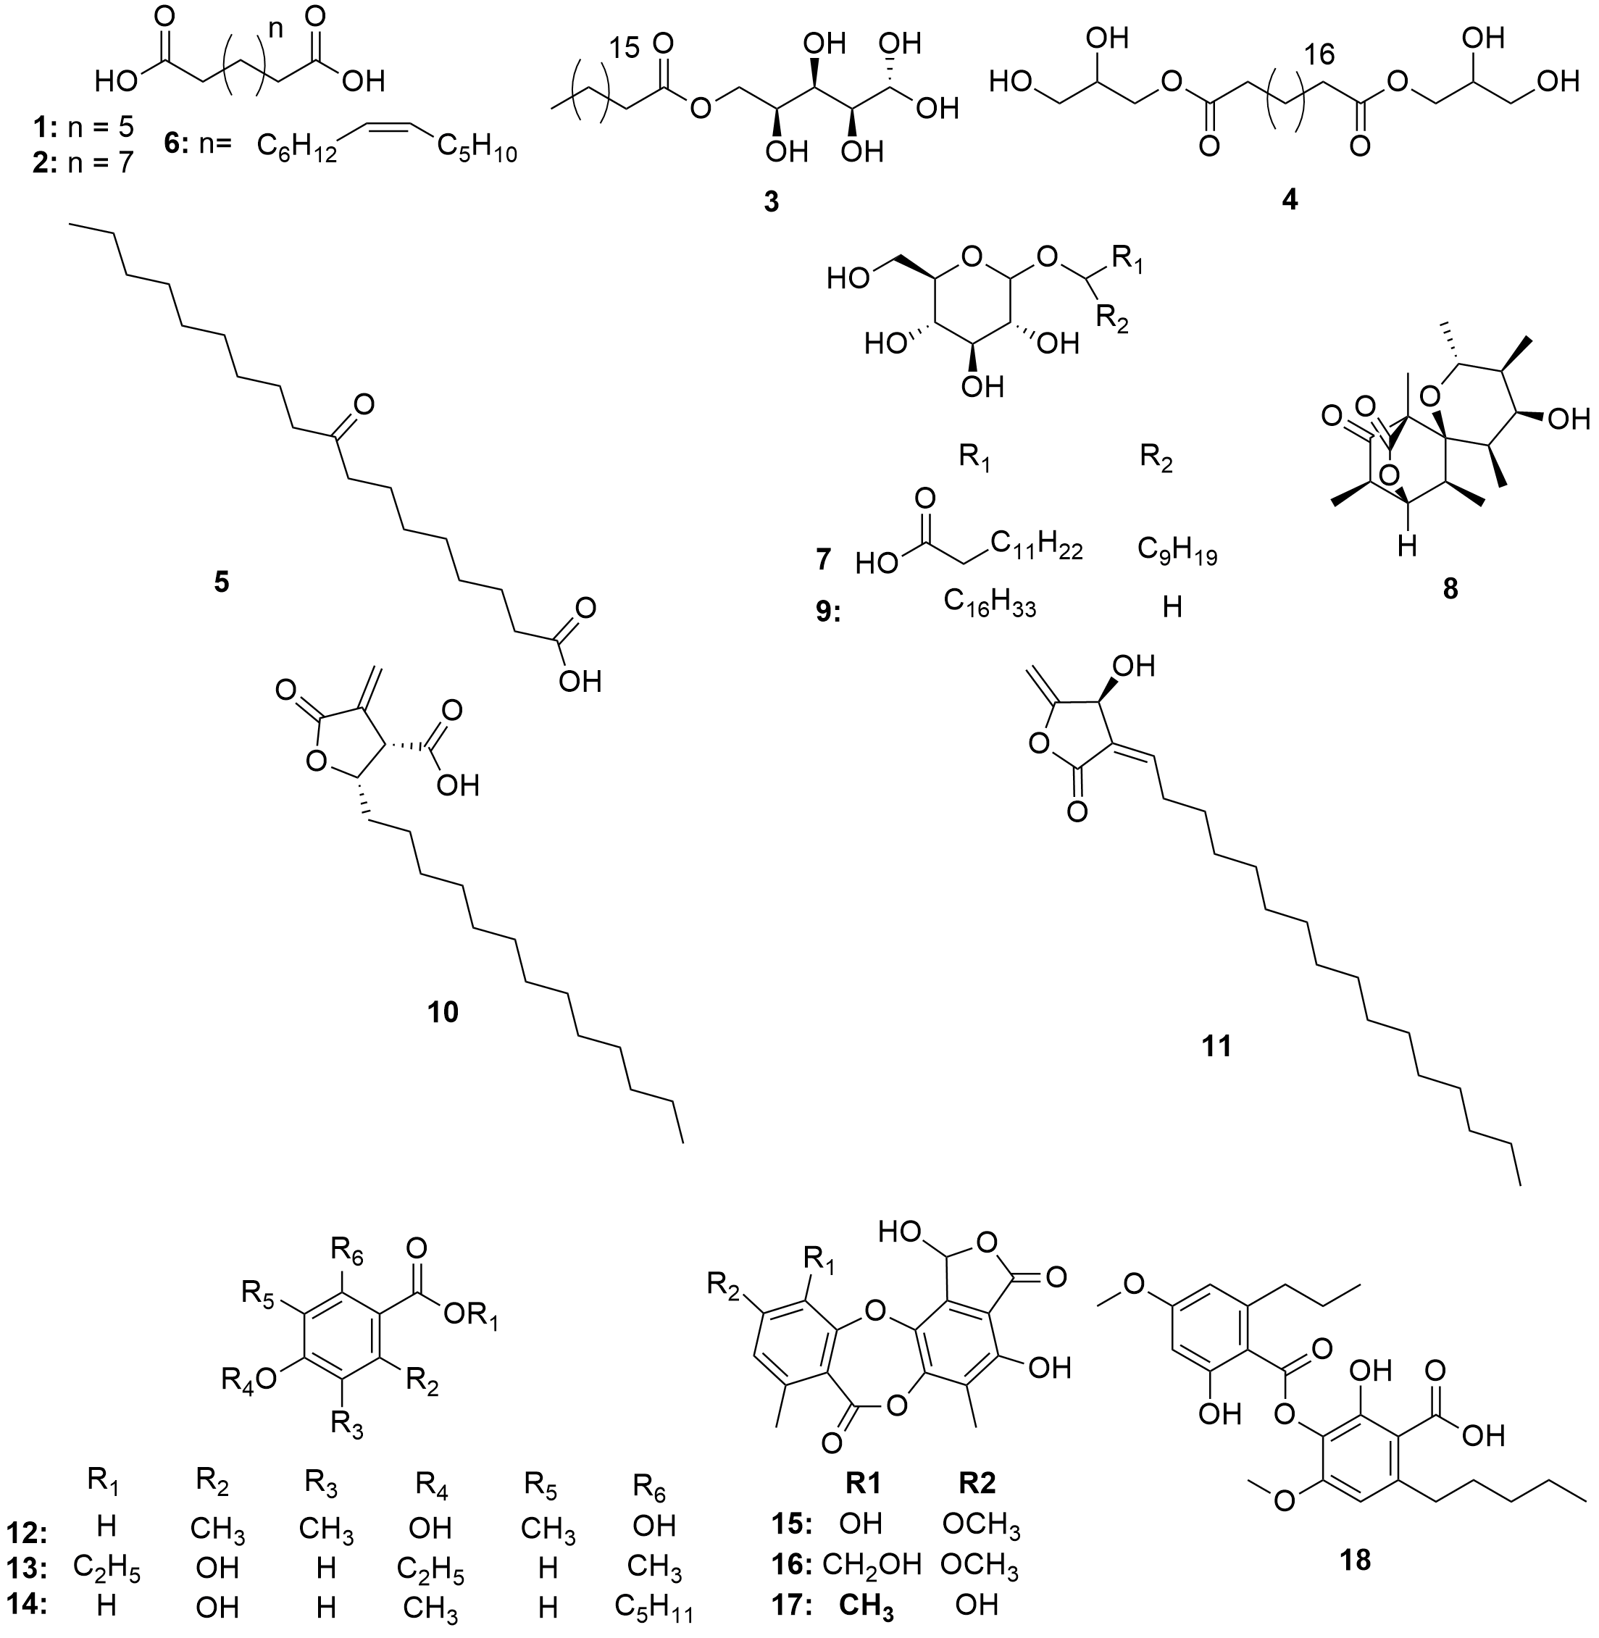
Figure S20. Chemical structures of the compounds (1–18) identified in the ethyl acetate and methanol extracts of Cladonia scabriuscula.
A  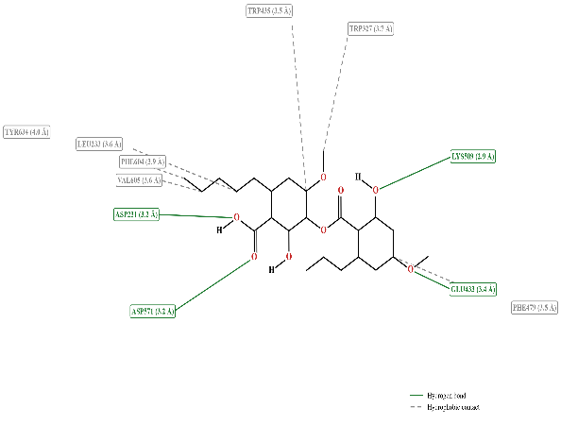 | B  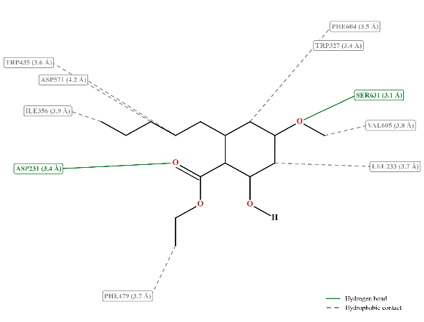
C  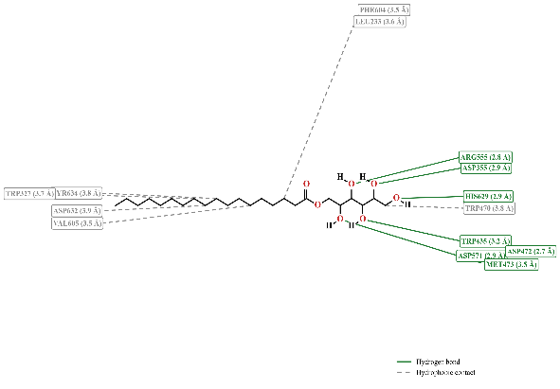 | D  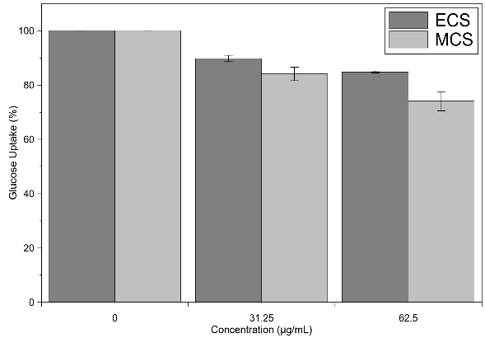
Figure S21. Two-dimensional interaction diagrams of the top-ranked Cladonia scabriuscula metabolites and acarbose with sucrase-isomaltase (PDB 3LPP): (A) homosekikaic acid (−6.39 kcal/mol); (B) ethyl 4-O-methylolivetolcarboxylate (−6.12 kcal/mol); (C) D-glucitol monostearate (−5.84 kcal/mol); (D) acarbose (−7.13 kcal/mol).
Table S1. Top-ranked docking pose of the metabolites identified in the Cladonia scabriuscula extracts and acarbose against sucrase-isomaltase (PDB 3LPP).
No. | Compound | Binding affinity  (kcal/mol) | Hydrophilic interactions  (H-bond residues) | Hydrophobic interactions  (residues)
1 | Azelaic acid | -4.43 | LYS509 | LEU233, LYS509, MET473, PHE479, PHE604, TRP327, TRP435
2 | Undecanedioic acid | -5.54 | — | LEU233, PHE604, TRP327, TRP435, TRP470, VAL605
3 | D-Glucitol monostearate | -5.84 | ARG555 | ASP355, ASP632, LEU233, PHE604, TRP327, TRP435, TRP470, TYR634, VAL605
4 | Icosanedioic acid bis(2,3-dihydroxypropyl) ester | -4.57 | ARG555, LYS509 | ASP355, ASP571, LEU233, PHE479, PHE604, TRP327, TRP435, TRP470
5 | 9Z-Octadecenedioic acid | -4.74 | — | GLN481, LEU233, PHE479, PHE604, TRP327, TRP435, VAL605
6 | 13-(beta-D-Glucosyloxy)docosanoic acid | -5.73 | ARG555 | ASP355, ASP472, ILE392, LEU233, PHE479, PHE604, TRP327, TRP435, TRP470, TRP568, TYR634
7 | Portentol | -4.81 | — | ASP632, LEU233, TRP327, TYR634, VAL605
8 | 9-Oxooctadecanoic acid | -5.55 | LYS509 | ASP571, PHE479, PHE604, TRP327, TRP435
9 | Heptadecyl D-glucoside | -5.05 | ARG555, ASP355, ASP472 | ASP355, ASP472, ASP571, LEU233, PHE604, TRP327, TRP435, TRP470, TRP568, VAL605
10 | allo-Protolichestrinic acid | -4.60 | — | PHE479, TRP327, TRP435, TYR634
11 | Linderanolide | -4.63 | — | LEU233, PHE479, PHE604, TRP327, TRP435
12 | 3,5-dimethylorsellinic acid | -4.40 | LYS509 | PHE479, TRP435
13 | Ethyl everninate | -4.27 | LYS509 | LYS509, MET473, PHE479, TRP435
14 | Ethyl 4-O-methylolivetolcarboxylate | -6.12 | — | ILE356, LEU233, PHE479, PHE604, TRP327, TRP435, VAL605
15 | Menegazziaic acid | -5.83 | LYS509 | PHE479, TRP435
16 | Cryptostictic acid | -5.22 | LYS509 | PHE479, TRP327, TRP435
17 | Hyposalazinic acid | -5.61 | LYS509 | PHE479, TRP327, TRP435
18 | Homosekikaic acid | -6.39 | ASP231 | LEU233, PHE479, PHE604, TRP327, TRP435, TYR634, VAL605
— | Acarbose | -7.13 | ARG555, ASP355, LYS509, TRP435 | ASP571, ILE356, PHE479, TRP327, TRP435, TRP470, TRP568

