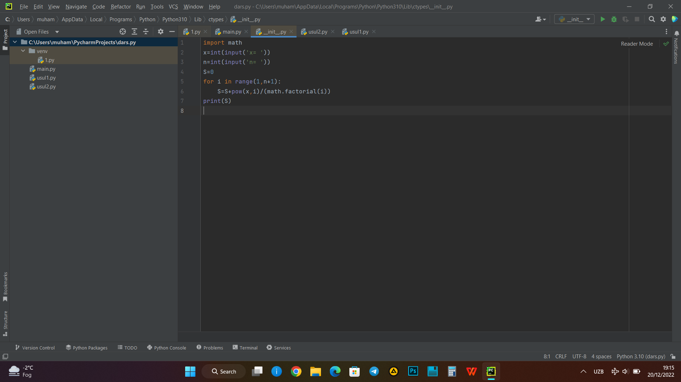

import math  
x=int(input('x= '))  
n=int(input('n= '))  
S=0  
for i in range(1,n+1):  
 S=S+pow(x,i)/(math.factorial(i))  
print(S)