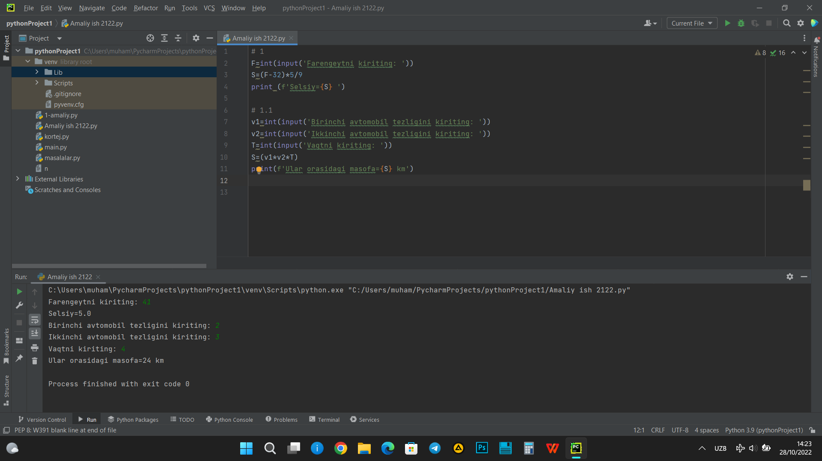

# 1  
F=int(input('Farengeytni kiriting: '))  
S=(F-32)*5/9  
print (f'Selsiy={S} ')  
  
# 1.1  
v1=int(input('Birinchi avtomobil tezligini kiriting: '))  
v2=int(input('Ikkinchi avtomobil tezligini kiriting: '))  
T=int(input('Vaqtni kiriting: '))  
S=(v1*v2*T)  
print(f'Ular orasidagi masofa={S} km')