**House Hunt: Finding your Perfect Rental Home Using**

**MERN Stack**

**Project Documentation**

1. **Introduction**

Project Title: House Hunt: Finding Your Perfect Rental Home

**Team ID:**  LTVIP2025TMID59062

**Team Size:** 4

**Team Leader:** Ravuvari Pavani

**Team member:** Salagala Sravanthi

**Team member:** Sareddy Vijay Kumar Reddy

**Team member:**  Sarun Lokesh Nune

1. **Project Overview**

**Purpose:** The purpose of **HouseHunt** is to simplify and enhance the home rental process by providing a centralized, user-friendly digital platform built on the MERN stack (MongoDB, Express.js, React, Node.js).

It aims to:

* + Connect **property owners** with **renters** directly, eliminating the need for third-party brokers.
  + Allow users to **search, filter, and book** rental properties based on location, budget, type, and facilities.
  + Empower property owners to **list and manage** their rental properties with images, categories, and availability status.
  + Provide **admins** with control over user management, property listings, and platform monitoring.

Ensure a **secure, scalable, and role-based** architecture for seamless interaction across all user types.

Ultimately, HouseHunt addresses the challenges of traditional property hunting by combining modern web technologies with an intuitive user experience.

**Features:**

**HouseHunt provides a robust set of features to enhance the rental property experience for renters, owners, and admins. The following core functionalities are implemented:**

🔐 **User Roles & Authentication**

* + **Role-based access for Renter, Owner, and Admin**
  + **JWT-based login and registration system**
  + **Secure user sessions and protected routes**

🏘️ **Property Listings**

* + **Owners can add, edit, and delete listings** • **Properties include:**

o **Type (Apartment, Villa, etc.)** o **Category (1BHK, 2BHK, etc.)** o **Facilities (Wi-Fi, Parking, Gym)** o **Price, Location, and Availability** o **Image uploads with preview**

🔍 **Advanced Search & Filtering**

* + **Renters can search properties by:** o **Location** o **Property type/category** o **Price range** o **Facilities**
  + **Real-time filtered display of matching results**

📆 **Booking & Inquiry System**

* + **Renters can book a property or send inquiries**
  + **Booking records are stored and managed per user**
  + **Owners receive requests and manage booking status**

🛠️ **Admin Dashboard**

**View and manage:** o **All users** o **All properties** o **Booking records**

* + **Approve or remove listings**
  + **Ensure platform quality and safety**

💡 **Responsive UI**

* + **Built with React and Tailwind CSS for mobile and desktop compatibility**
  + **Clean navigation, interactive forms, modals, and tooltips**

🧰 **Developer-Friendly**

* + **Modular folder structure for scalability**
  + **RESTful APIs using Express.js**
  + **Mongoose schema for MongoDB**

1. **Architecture**

HouseHunt is built using the **MERN stack** — MongoDB, Express.js, React, and Node.js — and follows a **modular, scalable, and role-based architecture**. The system is structured into four major layers:

1. **Frontend Layer (React)** 
   * Developed using **React.js** for component-based UI
   * Routing handled via **React Router**
   * Styled with **Tailwind CSS**
   * Provides pages and components for:

o Registration & Login o Property Listings o Booking Forms o Admin Dashboard

* + Communicates with backend via **Axios** over REST APIs

1. **Backend Layer (Node.js + Express.js)**

Express handles all HTTP requests • RESTful APIs for:

o User Authentication o Property CRUD operations o Booking requests

* + Middleware for role-based authorization
  + Error handling and validation included

1. **Database Layer (MongoDB with Mongoose)** • Three primary collections:

o users – stores user info, role, contact o properties – details of rental listings o bookings – rental inquiries and statuses

* + Relationships are modeled using references (e.g., userID in properties)

1. **Authentication & Authorization** 
   * **JWT tokens** issued during login
   * Middleware checks user roles for access (Renter, Owner, Admin)
   * Secure route protection for CRUD and booking actions

🔁 **Data Flow Overview**

* 1. **User logs in** → JWT token issued
  2. **Renter searches listings** → API filters listings from DB
  3. **Owner adds property** → Data sent to backend & stored
  4. **Renter sends booking request** → Booking stored in DB
  5. **Admin reviews listings/bookings** via dashboard

**Architectural Diagram:**

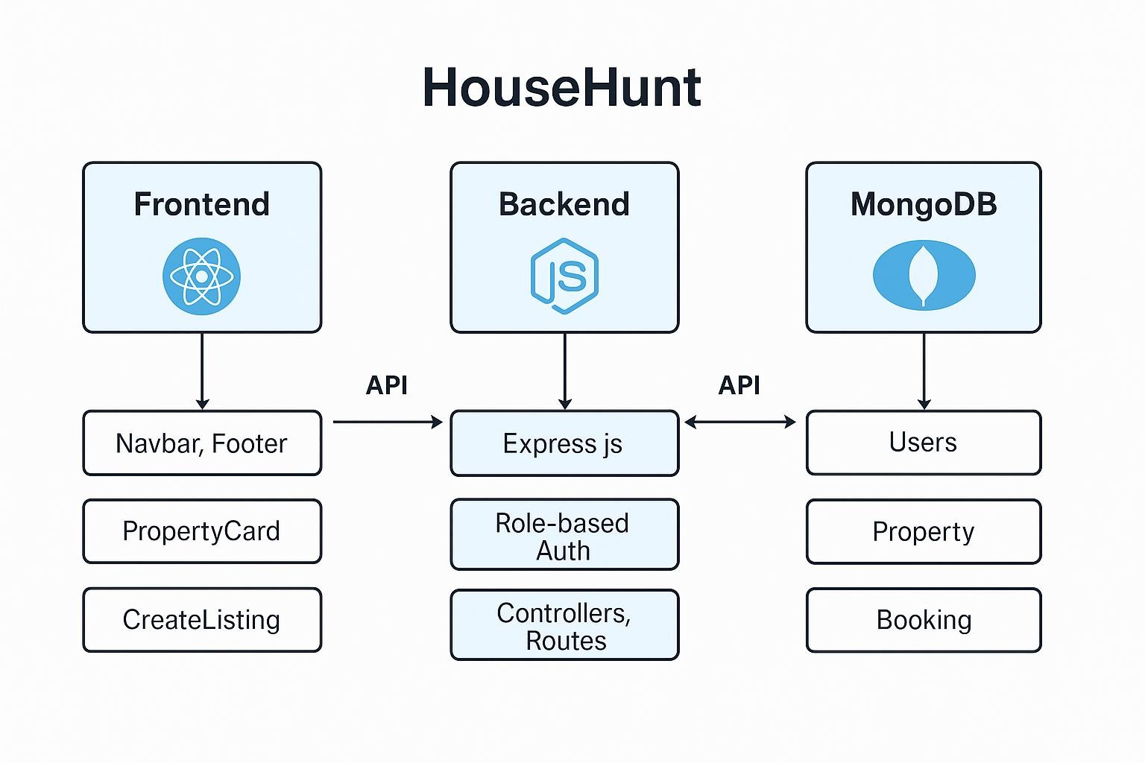

**4. Setup Instructions**

**Prerequisites**

* + - **Node.js (v18+), npm**
    - **MongoDB Atlas account**
    - **Git (for version control)**
    - **VS Code or similar editor**

1. **Backend Setup**

**Navigate to the backend/ folder and run: npm install**

**Create a .env file with:**

**MONGO_URI=your_mongodb_uri**

**JWT_SECRET=your_jwt_secret**

**PORT=5000**

**Then start the server:**

**npm run dev**

1. **Frontend Setup**

**Navigate to frontend/ and run npm install npm run dev**

**The frontend will launch at:**

**http://localhost:5173**

1. **MongoDB Atlas** 
   * **Create a free cluster** • **Add a database user**
   * **Whitelist your IP**
   * **Use the connection string in the backend .env**

1. **Configuration Tips** 
   * **Enable CORS in backend using:**

**app.use(cors());**

* + **Use tools like Postman to test API endpoints**

1. **Folder Structure**

The HouseHunt project follows a clear and modular structure, separating concerns between frontend and backend:

bash CopyEdit

HouseHunt/

│

├── client/ # React Frontend

│ ├── public/ # Public assets (favicon, index.html) │ └── src/

│ ├── components/ # Reusable UI components (Navbar, Footer, Cards)

│ ├── pages/ # Main pages (Home, Listings, Login, etc.)

│ ├── hooks/ # Custom React hooks (e.g., auth hooks)

│ ├── utils/ # Utility functions (e.g., validations) │ ├── context/ # Context Providers for auth, state, etc.

│ ├── App.js # Root component with routes

│ └── index.js # React entry point

│

├── server/ # Node.js + Express Backend

│ ├── models/ # Mongoose schemas (User, Property, Booking)

│ ├── routes/ # Route definitions (userRoutes, propertyRoutes)

│ ├── controllers/ # Logic for each API endpoint

│ ├── middleware/ # JWT auth, error handling

│ ├── config/ # DB connection and environment setup

│ ├── server.js # Entry point for backend

│ └── .env # Environment variables

│

├── .gitignore

├── README.md

└── package.json # Project dependencies

▶️ **Running the Application**

**To run the HouseHunt application locally**

✅ **Prerequisites**

**Make sure the following are installed:**

* **Node.js (v16 or higher)**
* **npm or yarn**
* **MongoDB (Local or Atlas cloud instance)**
* **Git (for cloning the project)**

🧰 **Backend Setup (Node.js + Express)**

1. **Navigate to the server directory:**

**cd server**

1. **Install dependencies:**

**npm install**

**3.Set environment variables:**

**MONGO_URI=your_mongodb_connection_string**

**JWT_SECRET=your_jwt_secret**

**PORT=5000**

1. **Start the server**

**npm run dev**

**The backend will run on:** [**http://localhost:5000**](http://localhost:5000/)

🎨 **Frontend Setup (React)**

1. **Navigate to the client directory:**

**cd client**

1. **Install dependencies:**

**npm install**

1. **Start the development server:**

**npm start**

**The frontend will run on:** [**http://localhost:3000**](http://localhost:3000/)

1. **API Documentation**

**The backend of HouseHunt uses RESTful APIs built with Node.js and Express.js. It includes endpoints for user authentication, property management, and booking operations. All data is stored and retrieved from MongoDB using Mongoose models.**

🔐 **Authentication APIs**

|  |  |  |  |
| --- | --- | --- | --- |
| **Method** | **Endpoint** | **Description** | **Access** |
| POST | /api/register | Register a new user | Public |
| POST | /api/login | Login and return JWT token | Public |
| GET | /api/profile | Get logged-in user profile | Authenticated |

🏡 **Property APIs**

|  |  |  |  |
| --- | --- | --- | --- |
| **Method** | **Endpoint** | **Description** | **Access** |
| POST | /api/properties | Create a new property listing | Owner Only |
| GET | /api/properties | Get all property listings | Public |
| GET | /api/properties/:id | Get property by ID | Public |
| PUT | /api/properties/:id | Update property by ID | Owner Only |
| DELETE | /api/properties/:id | Delete property | Owner/Admin |

📆 **Booking APIs**

|  |  |  |  |
| --- | --- | --- | --- |
| **Method** | **Endpoint** | **Description** | **Access** |
| POST | /api/bookings | Create a new booking request | Renter Only |
| GET | /api/bookings/user/:id | Get bookings by user ID | Renter Only |
| GET | /api/bookings/property/:id | Get bookings for  a specific property | Owner/Admin |
| PUT | /api/bookings/:id | Update booking status  (approve/deny) | Owner/Admin |

🛡️ **Notes**

* + Authorization is handled using JWT in the Authorization header.
  + Endpoints marked "Owner Only" or "Admin" require appropriate role-based middleware.
  + Responses are returned in JSON format.
  + All sensitive operations are protected via middleware and token verification.

1. **User Interface**

The **frontend** of HouseHunt is developed using **React.js** and styled with **Tailwind CSS**, offering a responsive and clean interface for three main user roles: **Renter**, **Owner**, and **Admin**.

# 🧰 Main Application Layout

* **Navigation Bar**: Displays brand, login/register (or profile) links, and role-specific menu items.
* **Footer**: Contains contact info, quick links, and copyright.
* **Sidebar** *(Admin only)*: Links to user/property/booking management.

# 📄 Page Structure

|  |  |
| --- | --- |
| **Page** | **Description** |
| Home | Introduction to platform, highlights key features, and call-to-action |
| Register / Login | Forms with role selection (Renter / Owner) and input validation |
| Property  Listings | Displays cards for available properties with filters and search bar |
| Property Details | Full view with images, location, price, facilities, and booking form |
| Create/Edit Listing | Form for owners to add/edit properties with image upload and dropdowns |
| My Listings | Owner dashboard for managing their posted properties |
| My Bookings | Renter dashboard showing booking requests and status |
| Admin  Dashboard | View and manage users, properties, and bookings in tabular form |

📲 **Features and Technologies** • **React Components**: o Property Card, Navbar, Footer, Sidebar, Booking Form • **State Management**: o Context API for auth and user session • **Form Handling**: o Controlled components with real-time validation • **Notifications**: o Success/error toasts using **react-toastify** • **Image Upload**: o Preview before upload, optionally linked to Cloudinary • **Routing**:

o Handled via **React Router** for SPA navigation

# 📱 Responsiveness

* Tailwind CSS ensures fully **responsive design** for mobile, tablet, and desktop.
* Uses CSS grid and flexbox for layout adaptability.

**7. Testing**

A combination of unit testing, integration testing, and manual user acceptance testing (UAT) was applied to ensure that HouseHunt is functional, secure, and user-friendly.

✅ **Unit Testing**

• Tools Used: Jest, Supertest (for backend) • Tested Components:

* API routes and controllers (register, login, property CRUD) o Utility functions (e.g., JWT generation, input validation)
* Mongoose models for schema validation

**Example:**

describe('User Registration', () => { it('should register a user with valid input', async () => { const res = await request(app).post('/api/register').send({ name: 'Test User', email: 'test@example.com', password: '123456',

role: 'renter'

});

expect(res.statusCode).toBe(201);

});

});

🔄 **Integration Testing** • APIs tested using Postman • Verified end-to-end flows:

o User registration → Login → JWT issuance o Owner creating listings → Renter viewing → Booking o Admin accessing protected dashboard routes

👥 **User Acceptance Testing (UAT)**

* Conducted across all three roles:

o Renter: Book property, view status o Owner: Add/Edit/Delete property, view bookings o Admin: Manage users, view analytics

* Feedback loop with test users to refine UI and functionality

⚠️ **Error Handling**

* All backend routes use try-catch blocks and centralized error middleware
* Frontend catches and displays network/API errors via toast notifications
* Includes 401/403 status handling for unauthorized or forbidden access

1. **Screenshots**

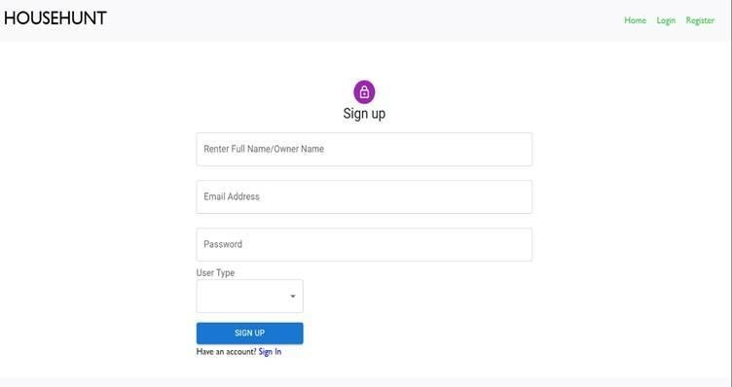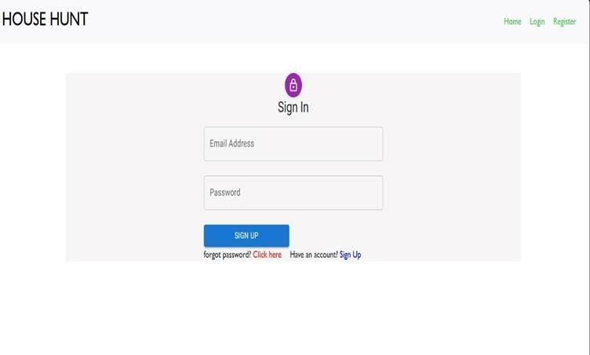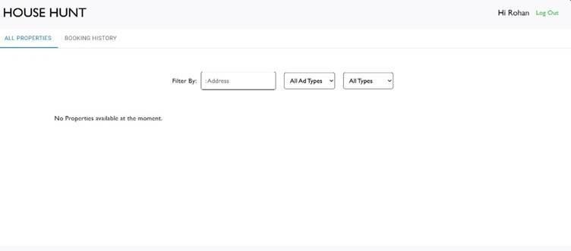

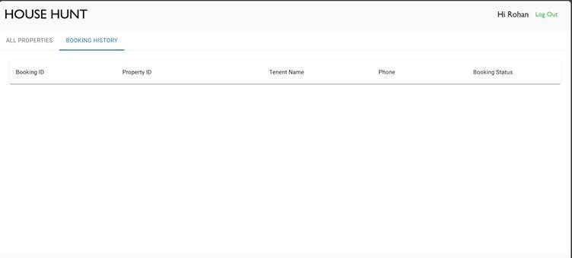

1. **Known Issues**

📷 **1. Image Upload is Local (No Cloud Storage)**

Property images are stored locally, which may not scale well for production environments.

Cloud storage services like Cloudinary or AWS S3 are recommended for better file handling and URL-based retrieval.

🔐 **2. No User Password Recovery**

Forgot password functionality is not yet implemented.

Users currently have no way to reset their credentials if lost.

💳 **3. Payment Gateway Not Integrated** No rent payment or deposit system exists yet.

Future versions may integrate Stripe or Razorpay.

📦 **4. No Real-Time Booking Confirmation**

Booking requests are stored in the database but don’t trigger notifications or real-time updates.

Notifications via email/SMS are recommended for future iterations.

📊 **5. Admin Dashboard Is Minimal**

Admin functionalities are limited to viewing data.

There's no analytics or graphical dashboard for insights like most rented areas or monthly activity.

📱 **6. Limited Mobile Optimization**

While the app is responsive, some components (like modals and tables) need better optimization for small-screen devices.

**10. Future Enhancements**

🧰 **1. Payment Gateway Integration**

* Integrate **Stripe** or **Razorpay** to allow renters to pay deposits or monthly rent securely online.

🔔 **2. Email & SMS Notifications**

* Notify owners and renters about new bookings, approvals, or cancellations.
* Reminders for upcoming rent dues or property expirations.

📱 **3. Mobile App (React Native)**

* Develop a cross-platform mobile app for Android/iOS to allow users to manage their listings and bookings on-the-go.

🧰 **4. Recommendation System**

* Use machine learning to suggest properties based on:

o User behavior o Preferred locations o Price range and amenities

💬 **5. In-App Chat System**

* Implement real-time messaging between renters and property owners to enhance communication.

📊 **6. Advanced Admin Dashboard**

* Add analytics and reporting tools for: o Monthly activity o Active listings by region o Booking trends and user engagement

🌍 **7. Map Integration**

* Integrate **Google Maps API** for visual location selection during listing creation and for property previews.

🔐 **8. Role-Based Access Control (RBAC)**

* Improve access layers with fine-grained permissions for different user roles, including sub-admins or agents.

🏘️ **9. Multi-Listing Support**

* Allow owners to add multiple units under the same building/property.