**Runbook**

|  |  |
| --- | --- |
| **Step 1** | **Configure the Northwind sample database locally** |

Downloaded “[**instnwnd (Azure SQL Database).sql**](https://github.com/microsoft/sql-server-samples/blob/master/samples/databases/northwind-pubs/instnwnd%20(Azure%20SQL%20Database).sql)” from the given github link: <https://github.com/Microsoft/sql-server-samples/tree/master/samples/databases/northwind-pubs>

Created Database with the name NorthwindDB locally in the SQL Server database and executed the file “[**instnwnd (Azure SQL Database).sql**](https://github.com/microsoft/sql-server-samples/blob/master/samples/databases/northwind-pubs/instnwnd%20(Azure%20SQL%20Database).sql)” to create all the database objects.

|  |  |
| --- | --- |
| **Step 2** | **Generate Source Database Detail Summary Report (Excel)** |

Use the attached “***useful_sqls.sql***” to get the details of database objects and summary from SQL Server Management Studio.

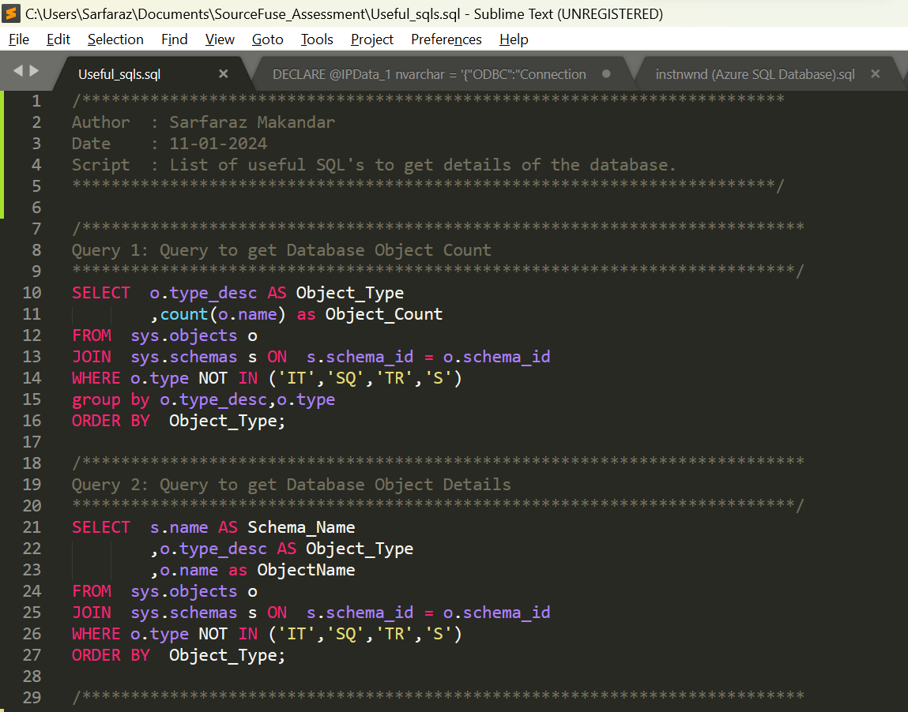

Create Excel file to maintain the source database details summary which is the reference for the entire project as the source database summary details. Please find attached document “***NorthwindDB_Details.xlsx***”

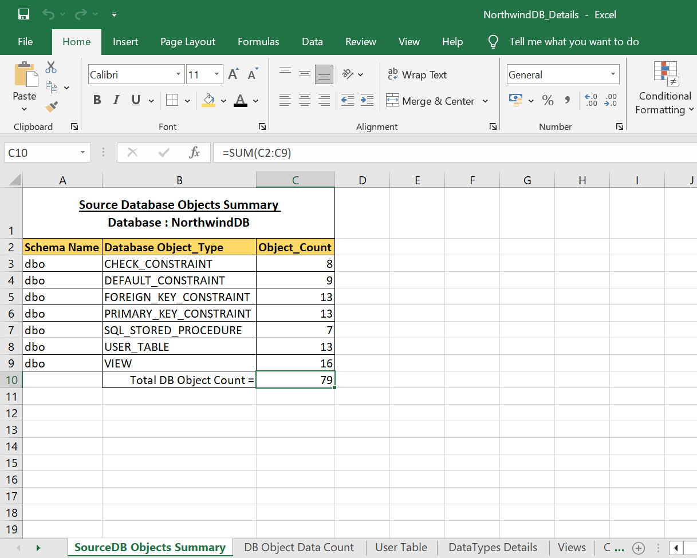

|  |  |
| --- | --- |
| **Step 3** | **RUN AWS SCT tool for schema conversion** |

We can run AWS SCT tool online/offline for schema conversion. AWS SCT tool helps to convert the schema from Source to the target database system.

**Following are the STEPS followed using AWS SCT tool.**

Create New Project:

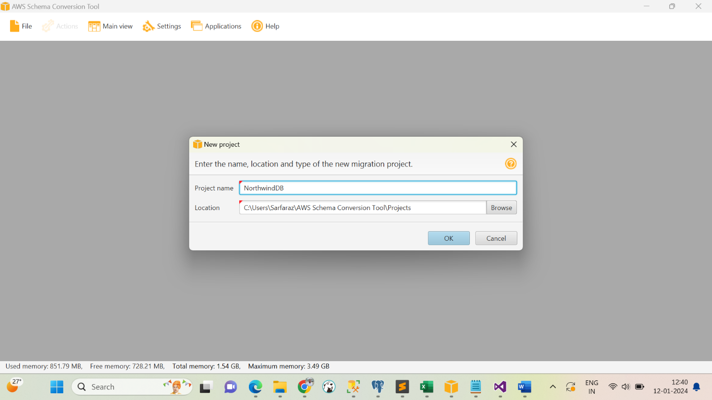

Connect/Add Source Database and Test the Connection:

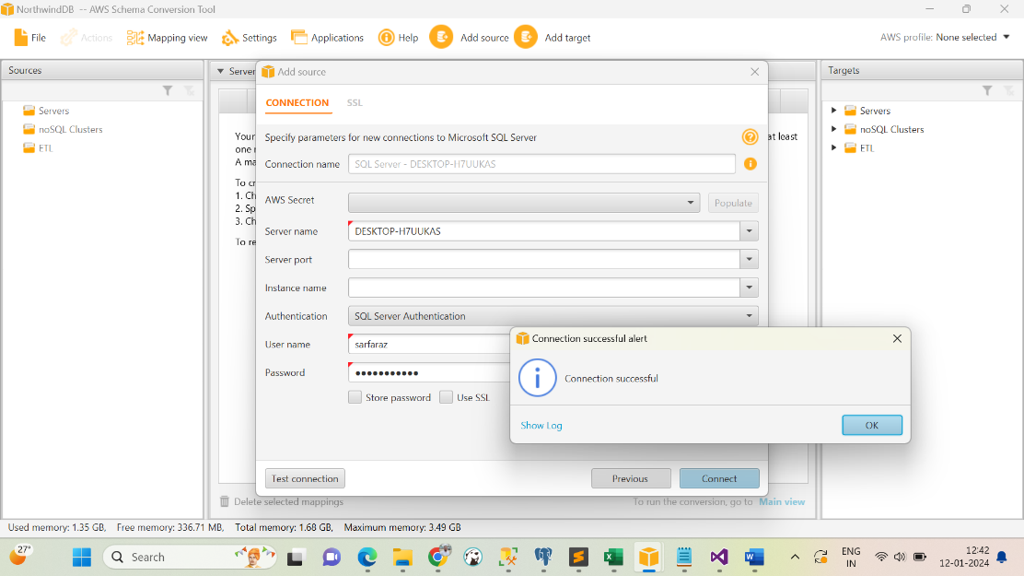

Connect/Add Target Database and Test the Connection:

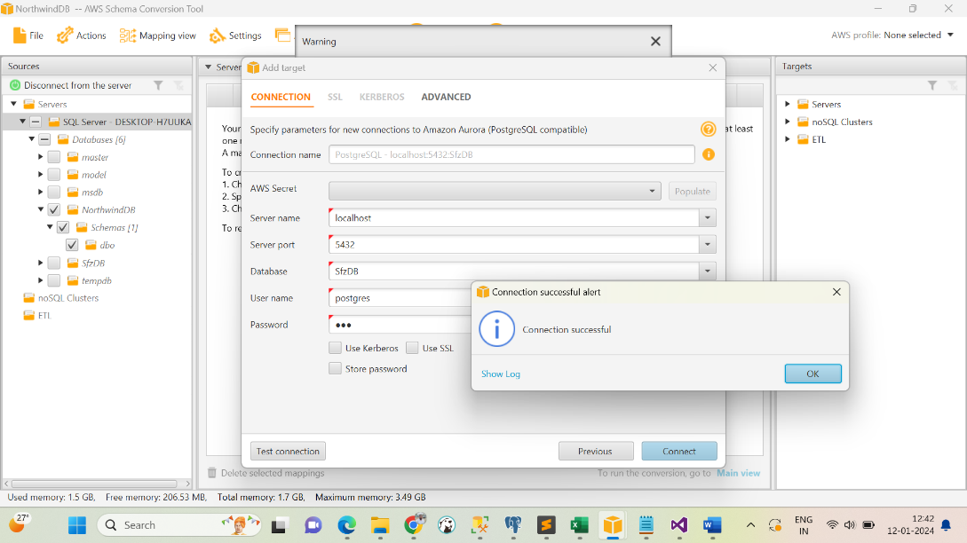

Create Mapping:

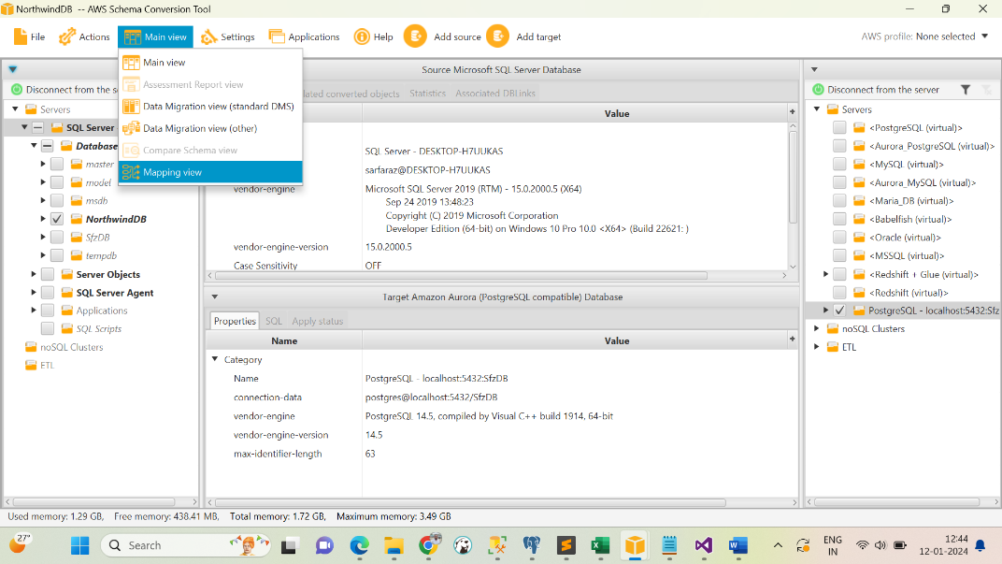

Post Mapping create the Assessment Report which help to find the Action Item(Incompatibility).

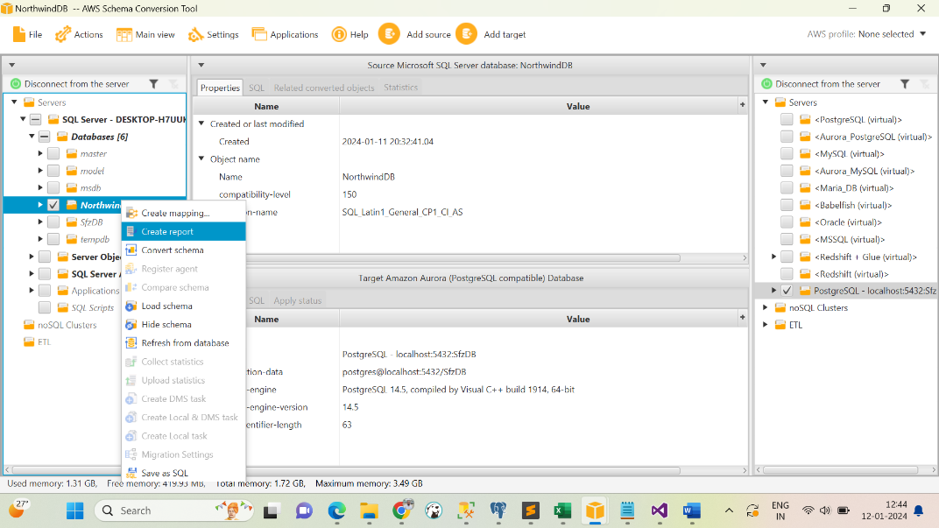

Assessment Report looks like following we also save it as PDF for future references:

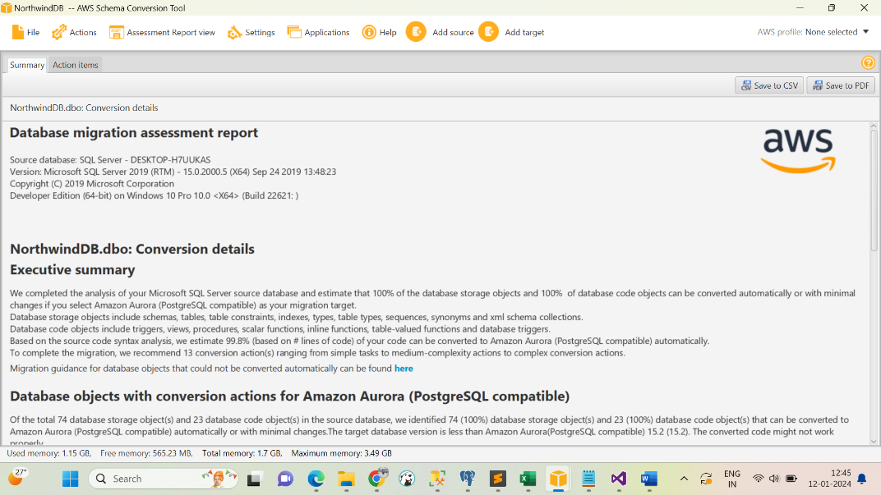

Check out some to the action items right away on screen.

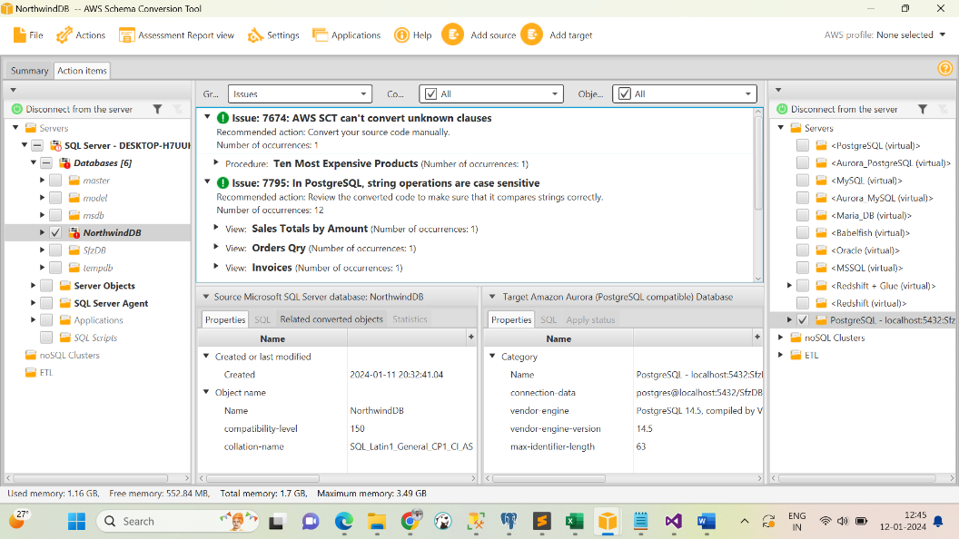

We can do correction or resolve the incompatibility on SQL tab as shown below and then convert schema.

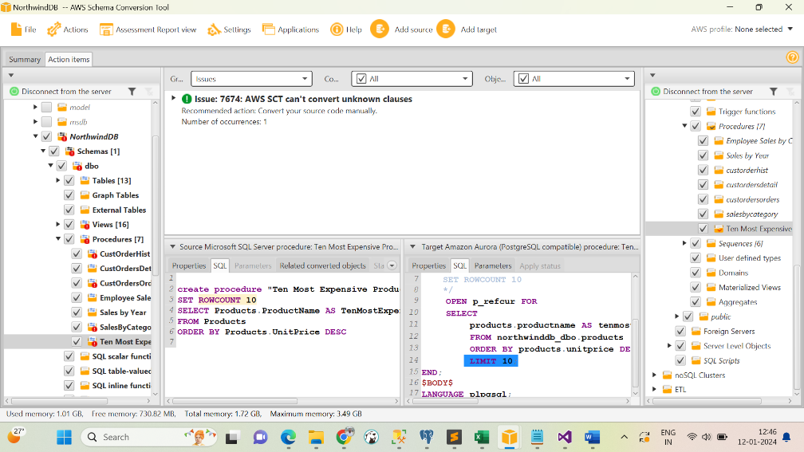

Convert Schema by right clicking on source database schema.

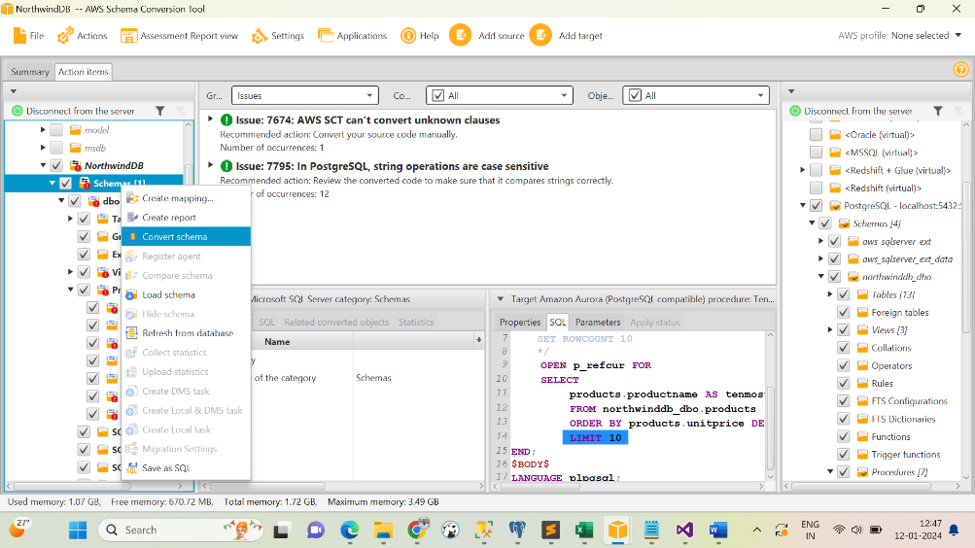

Schema Conversion in process: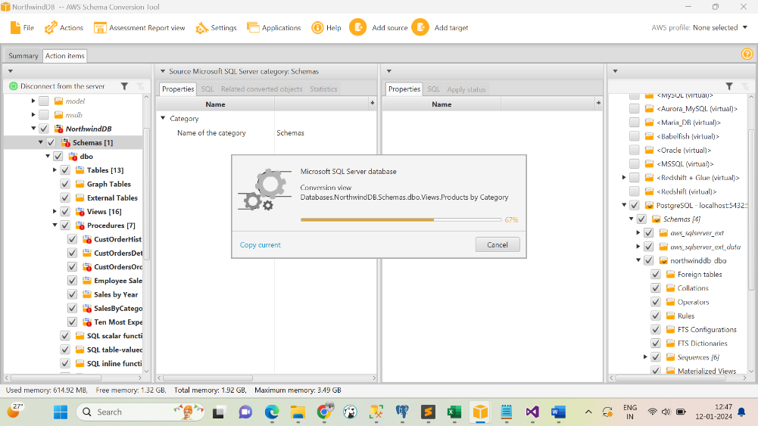

Once the conversion complete then right click on Target database and “Save SQL” or you can also “Apply to database”.

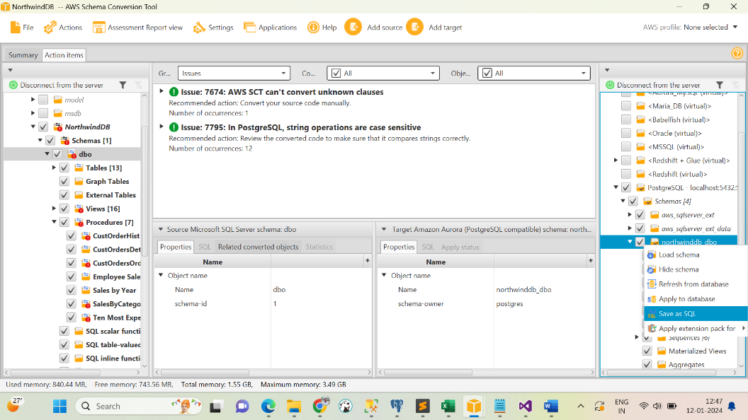

|  |  |
| --- | --- |
| **Step 4** | **Create DataType Mapping report** |

Create Datatype incompatibility report and it’s equivalent in the PostgreSQL and take the approval from client/management team. Please find the attachment “***DataTypes_Incompatibility.xlsx***”

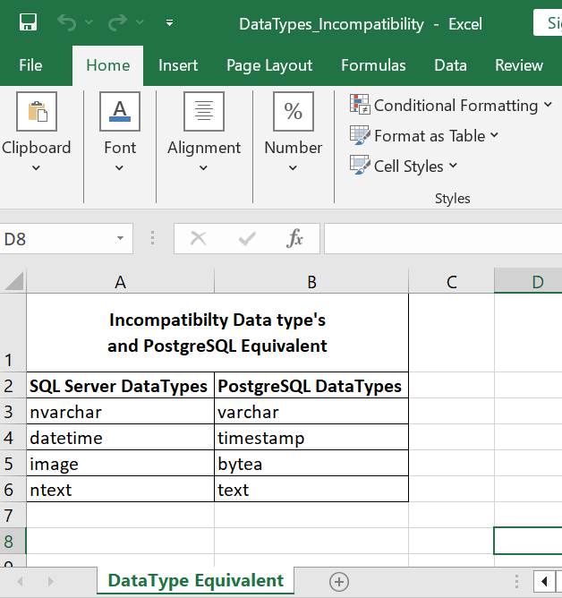

Once the client/management team confirm the datatype then proceed to ALTER the table with the equivalent datatype. Generate ALTER TABLE script to alter all the tables at once.

|  |  |
| --- | --- |
| **Step 5** | **Manually work around for incompatible database objects** |

Start the manual conversion to those objects which are occurred in AWS SCT Assessment Report. Those database objects need the manual efforts for conversion.

First step to start manual conversion is to maintain the document of incompatibility and it’s equivalent in the postgresql as show below. Please find the attachment “***PostgreSQL Incompatible Action Item with Solution.doc***”for more details.

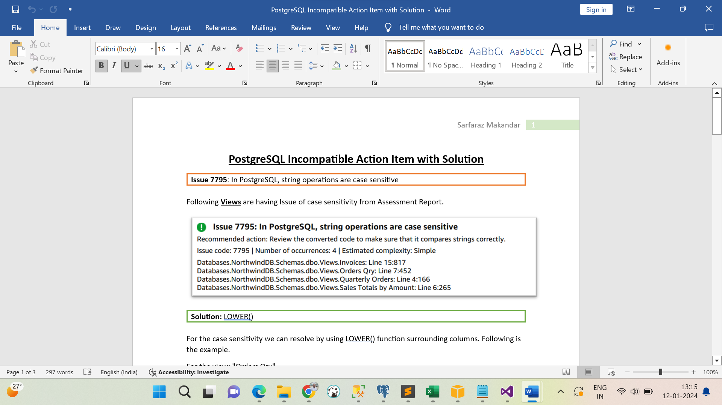

Make the manual changes to the database objects and re-create in the target database and do the database testing by executing the object.

|  |  |
| --- | --- |
| **Step 6** | **Data Migration using AWS DMS Tool** |

There are multiple tools available to migrate data from MS SQL Server to PostgreSQL for example AWS DMS, SSIS, SQL Server Import and Export Wizard, file base system (.csv), Pentaho, sqlserver2pgsql etc. Done the data migration using Import and Export Wizard as shown below because of don’t have access to AWS DMS account.

SQL Server Import and Export Wizard for Data Migration:

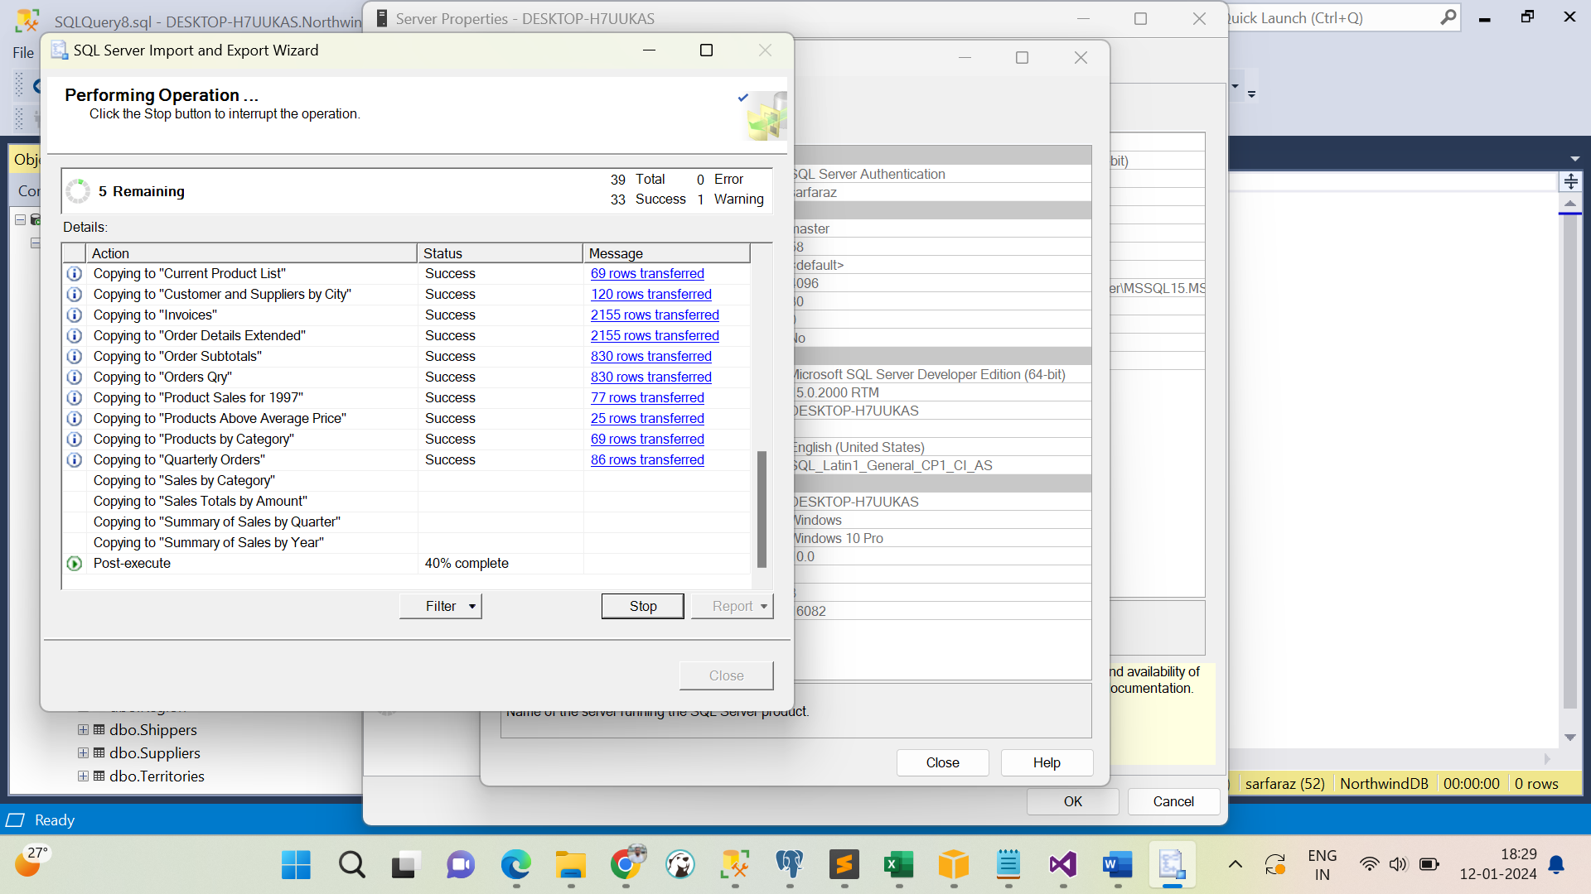

|  |  |
| --- | --- |
| **Step 7** | **Data Validation at the Target Database** |

Data validation needs to be done at the target database that is PostgreSQL Database to check the data quality.

Following scenario need to check for data validations:

* Data Count validation
* Data Type validation
* Data Quality validation
* Data Range validation
* Data Format validation
* Data Consistency validation

|  |  |
| --- | --- |
| **Step 8** | **Execute Database Object’s Function/Procedures/Views/Triggers** |

Execute following Database Objects and validate the result set with the Source Database.

* Views
* User Defined Function
* Stored Procedures
* Triggers if any

Manually execute the given database objects by passing the input values and validate from both the databases the result set should match.

|  |  |
| --- | --- |
| **Step 9** | **Code Merge** |

Once the validation of all database objects is completed successfully, need to merge the code into the GitHub/Azure Repository for the approval and merge/commit to the code repo.

|  |  |
| --- | --- |
| **Step 10** | **Deployment** |

Deploy the committed code into the UAT environment for testing, once the UAT test pass then proceed with QA/Production deployment based on the approval from higher management team.