[Year]
Testingtoolsonline.in
LearnQAonline.com
Administrator
Email:testingtoolsonline.in

E-Banking_Admin_FRS v1.0

Document Name | Version Number | Start Date | Prepared By | Reviewed By | Modified Date | Present Status
FRS-Admin/Rel1.0 | 1.0 | Mm/dd/yy | xxxxx | xxxxx | Mm/dd/yy | Completed

1.0 Home Page

1.1.0 Overview
Home page allows different users such as admin, bank employee, various customers (Individual customers, corporate customers, International Customers) to login and access the application for further usage and also it provides information about various services offered by Bank.

1.2.0 Prototype

Home Page
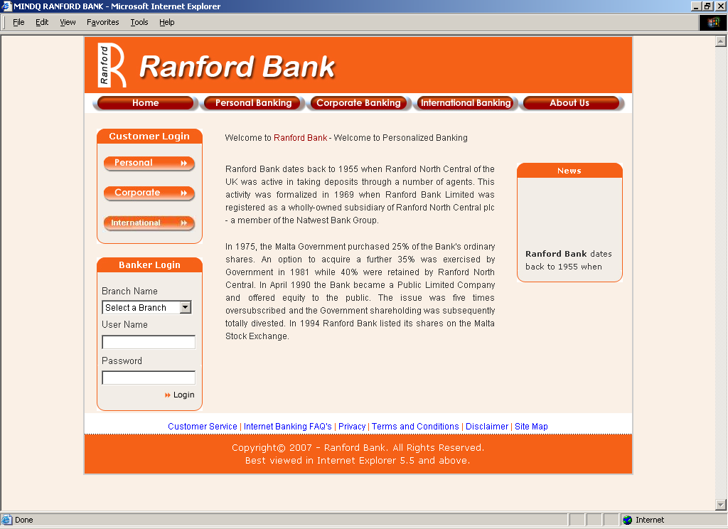

1.3.0 Page Elements

Home Page

Element Name | Element Type | User Action | System  Response
Home | Button | Click | As per task flow diagram
Personal Banking | Button | Click | As per task flow diagram
Corporate Banking | Button | Click | As per task flow diagram
International Banking | Button | Click | As per task flow diagram
About Us | Button | Click | As per task flow diagram
Customer Login
Personal | Button | Click | As per task flow diagram
Corporate | Button | Click | As per task flow diagram
International | Button | Click | As per task flow diagram

Banker Login
Branch Name | Combo box | Select | System should accept
User Name | Textbox | Enter | System should accept
Password | Textbox | Enter | System should accept
Login | Link | Click | As per task flow diagram

User information Links
Customer Service | Link | Click | As per task flow diagram
Internet Banking FAQ’s | Link | Click | As per task flow diagram
Privacy | Link | Click | As per task flow diagram
Terms and Conditions | Link | Click | As per task flow diagram
Disclaimer | Link | Click | As per task flow diagram
Site map | Link | Click | As per task flow diagram
News | Scrolling Text | NA | NA

1.4.0 Input Validations & Error States

Element Name | Valid Data | Error state
User Name | 1. Mandatory. | - Blank/Invalid- “Enter a Valid User  Name”
Password | 1. Mandatory. | - Blank/Invalid- “Enter valid password”
IF User login failed then System Should display a pop that Incorrect User Name / Password.

1.5.0 Task flow Diagram

1.5.1 Visitor Flow

Visitor

Enter valid URL

System displays Home page of Bank

Home
System displays Home page of Bank

Personal Banking
System displays information about Personal Banking

Corporate Banking
System displays information about Corporate Banking

International Banking
System displays information about International Banking

About Us
System displays information about Bank

C

Clicks clicks clicks clicks

Customer Service
System displays Customer service information of Bank

System displays some FAQ’s about Internet Banking.

Terms & Conditions
System displays terms & conditions of Internet banking

System displays privacy commitment of Bank

Site Map
System displays site map of Bank

Internet Banking FAQ’s
Privacy
Disclaimer
System displays notice and copyright of this site.

C

1.5.2 Admin Flow
System displays Home page of Ranford Bank

Admin

Enters valid URL

Enters valid User Name and Password

System displays Admin module.
Clicks
Login

1.5.3 Customer flow for Personal, corporate and International Banking.

Enter valid URL

System displays Home page of Bank

Personal
System displays login page for personal, corporate and international baking

Corporate

International

1.5.4 Banker flow for Banking Module.

Banker
System displays Home page of Bank
System displays Banker module.
Enter valid URL
Enter valid User Name and Password

Select a Branch

Click Login

1.6.0 Use Cases

1.6.1 Visitor Process flow in Home Page
Actors Action | System Response
1. Actor Enters Valid URL | 2. System displays home page with login facility.
3. Actor clicks Home | 4. System displays home page with login facility.
5. Actor clicks Personal Banking | 6. System displays information and services offered for Personal banking.
7. Actor clicks Corporate Banking | 8. System displays information and services offered for Corporate banking
9. Actor clicks International Banking | 10. System displays information and services offered for International Banking.
11. Actor clicks About Us | 12. System displays information about Bank.
13. Actor clicks Customer Service | 14. System displays Customer Service information.
15. Actor clicks Internet Banking FAQ’s | 16. System displays the information about internet banking FAQ’s.
17. Actor clicks Privacy | 18. System displays Privacy commitment of Bank.
19. Actor clicks Terms & Conditions | 20. System displays information about online banking terms and conditions.
21. Actor clicks Disclaimer | 22. System displays the notice and copyrights of this site.
23. Actor clicks site map | 24. System displays site map about this site.

1.6.2 Admin Process flow in Home Page

Actors Action | System Response
1. Actor Enters Valid URL | 2. System displays home page with login facility.
3. Actor enters valid user name | 4. System will accept.
5. Actor enters valid password | 6. System will accept.
7. Actor clicks Login | 8. System displays Admin module.

1.6.3 Customer Process flow in Home Page

Actors Action | System Response
1. Actor Enters Valid URL | 2. System displays home page with login facility.
3. Actor clicks Personal | 4. System displays login page for personal banking
5..Actor clicks Corporate | 6. System displays login page for Corporate banking
7.Actor clicks International | 8.System displays login page for International banking

1.6.4 Banker Process flow in Home Page

Actors Action | System Response
1. Actor Enters Valid URL | 2. System displays home page with login facility.
3. Actor selects respective branch | 4. System display the selected branch
5. Actor enters valid user name | 6. System will accept.
7. Actor enters valid password | 8. System will accept.
9. Actor clicks Login | 10. System displays Banker module.

2.0 Admin Home Page

2.1.0 Overview
This page allows administrator to define and manage master data such as Branches, Roles , Users and Employees related to Bank.

2.2.0 Prototype

Admin Home Page

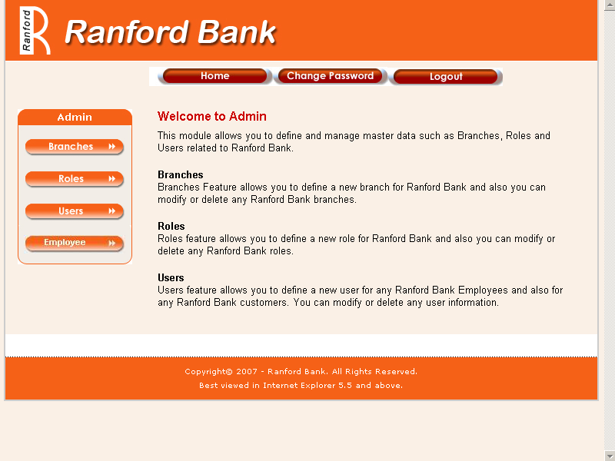

2.3.0 Page Elements

Element Name | Element Type | User Action | System  Response
Branches | Button | Click | As per task flow diagram
Roles | Button | Click | As per task flow diagram
Users | Button | Click | As per task flow diagram
Employees | Button | Click | As per task flow diagram
Home | Button | Click | As per task flow diagram
Change Password | Button | Click | As per task flow diagram
Logout | Button | Click | As per task flow diagram

2.4.0 Input Validations & Error States

NA

2.5.0 Admin Task flow diagram

Branches
Change Password
Roles
Users
Employees
Home
Logout
System displays Branches details Page.
System displays Roles details Page.
System displays Users details Page.
System displays Employees Details Page.
System displays Home page of Admin module.
System displays Change Password Page.
Logout from the system and displays Bank Home Page.

2.6.0 Use Cases

Actors Action | System Response
1. Actor clicks Branches | 2. System displays Branches details page.
3. Actor clicks Roles | 4. System displays Roles details page
5. Actor clicks Users | 6. System displays User details page.
7. Actor clicks Employees | 8. System displays Employees details page.
9. Actor clicks Home | 10. System displays Admin Home Page
11. Actor clicks Change Password | 12. System displays Change Password page.
13. Actor clicks Logout | 14. Current session will be closed and system displays Home Page.

3.0 Branches

3.1 Branches Details

3.1.1 Overview

Branches Feature allows admin to define a new branch, modify or delete any branches and also admin can search for branches information based on the given selection criteria.

3.1.2 Prototype

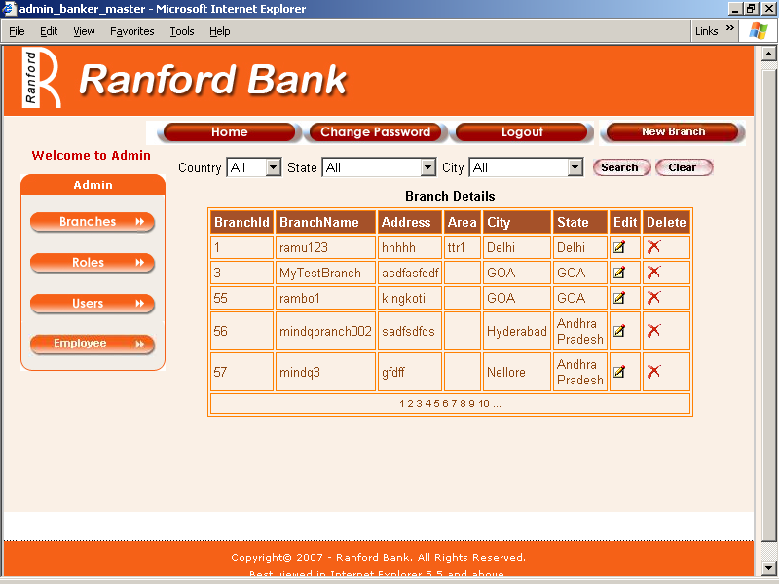

3.1.3 Page Elements

Element Name | Element Type | User Action | System  Response
Country | List box | Select | As per use cases.
State | List box | Select | As per use cases.
City | List box | Select | As per use cases.
Search | Button | Click | As per use cases
Clear | Button | Click | As per use cases
New Branch | Button | Click | As per task flow diagram

Branches Details Table
Branch Id | Tab. element | NA | NA
Branch Name | Tab. element | NA | NA
Address | Tab. element | NA | NA
Area | Tab. element | NA | NA
City | Tab. element | NA | NA
State | Tab. element | NA | NA
Edit | Image Link | Click | As per task flow diagram
Delete | Image Link | Click | As per task flow diagram

3.1.4 Input Validations & Error States
NA
3.1.5 Task flow diagram for Search and clear
System displays states with in selected Country in State List box
Selects State
System displays Cities with in selected State in City List box
Selects Country
Selects City
Click on Search
System displays branches based on the selection criteria.
System displays Country’s with in selected Country in Country List box
Click on Clear
System Clears selected criteria displays all branches.

3.1.6 Admin flow for Search and Clear.

Actors Action | System Response
1. Actor login | 2.System displays Admin module
3. Actor clicks Branches | 4. System displays branches details page.
5. Actor selects required criteria of Country/State/City and clicks Search. | 6. System displays only the branches matching the selected criteria.
7. Actor clicks Clear. | 8. System clears the given search criteria and all branches will be displayed.

3.2 New Branch Creation

3.2.1 Overview

This feature allows Admin to create a new branch for Bank.

3.2.2 Prototype
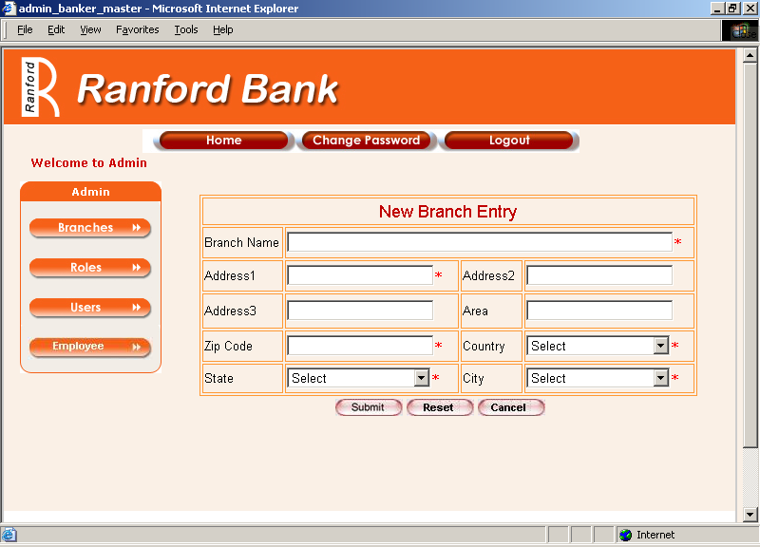

3.2.3 Page Elements

Element Name | Element Type | User Action | System  Response
Branch Name | Text box | Enter/Edit | As per task flow diagram
Address1 | Text box | Enter/Edit | System should accept
Address2 | Text box | Enter/Edit | System should accept
Address3 | Text box | Enter/Edit | System should accept
Area | Text box | Enter/Edit | System should accept
Zip code | Text box | Enter/Edit | System should accept
Country | List box | Select | As per Use cases
State | List box | Select | As per Use cases
City | List box | Select | As per Use cases
Submit | Button | Click | As per task flow diagram
Reset | Button | Click | As per task flow diagram
Cancel | Button | Click | As per task flow diagram

3.2.4 Input Validations & Error States

Element Name | Valid Data | Error state
Branch Name | - Alphanumeric only  - Start with alphabet  - Min of 6 Chars  - Max of 40 Chars  - Mandatory  - Unique | - Blank – “Please fill in the following fields – Branch Name”  - Invalid Chars- “This field should be alphanumeric starts with an alphabet”  - Invalid Range- “This field should be with in 6 - 40 chars range.  - Duplicate- “This branch already exists”
Address1 | 1. Alphanumeric and special Chars.  2.Mandatory  3. Min of 4 chars.  4. Max of 50 chars. | - Blank – “Please fill in the following fields – Address1”  - Invalid Range- “This field should be with in 4 - 50 chars range.
Address2 | 1. Alphanumeric and special Chars.  2. Max of 50 Chars. | - Invalid Length- “This field accepts a maximum of 50 Chars.
Address3 | 1. Alphanumeric and special Chars.  2. Max of 50 Chars. | - Invalid Length- “This field accepts a maximum of 50 Chars.
Area | 1. Alphanumeric and special Chars.  2. Should start with alphabet.  3. Max of 50 Chars. | - Invalid Length- “This field accepts a maximum of 50 Chars.
Zip | 1. Numeric Only  2. It should be 5 Chars  3. Mandatory | - Blank – “Please fill in the following fields – Zip”  - Invalid Chars- “This field should be numeric”  - Invalid Range- “It should be 5 chars in length”
Country | 1. Mandatory | - Blank – “Please fill in the following fields – Country”
State | 1. Mandatory | - Blank – “Please fill in the following fields – State”
City | 1. Mandatory | - Blank – “Please fill in the following fields – City”

3.2.5 Task flow diagram

Actor
Yes
No
Login
Branches
Click New Branch
Enter Branch Details
Click Submit
New Branch will be created successfully
created
Ask for valid data
Click Reset
All the data is cleared
Click Cancel
Close the page
Ok
If valid

3.2.6 Use Cases

Admin flow for Addition of New Branch.

Actors Action | System Response
1. Actor login | 2.System displays Admin module
3. Actor select Branches | 4. System displays branches details page.
5. Actor click New Branch | 6. System displays New branch Entry Page.
7. Actor Enters necessary fields with valid data and clicks Submit. | 8. System displays a message “New Branch Created successfully with Branch ID” with “Ok” Button
9. Actor enters necessary fields with valid data and clicks Reset. | 10. System clears all fields.
11. actor enters necessary fields with valid data or with out entering any fields clicks Cancel. | 12. System closes the new branch entry page and displays branches details page.

3.3 Branch Updation

3.3.1 Overview

This feature allows Admin to modify the details of a branch.

3.3.2 Prototype
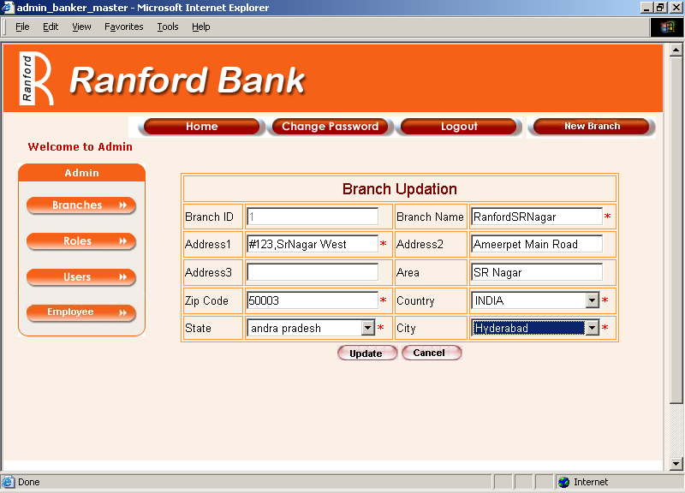

3.3.3 Page Elements

Element Name | Element Type | User Action | System  Response
Branch Id | Auto Display | NA | NA
Branch Name | Text box | Enter/Edit | As per task flow diagram
Address1 | Text box | Enter/Edit | System should accept
Address2 | Text box | Enter/Edit | System should accept
Address3 | Text box | Enter/Edit | System should accept
Area | Text box | Enter/Edit | System should accept
Zip code | Text box | Enter/Edit | System should accept
Country | List box | Select | As per Use cases
State | List box | Select | As per Use cases
City | List box | Select | As per Use cases
Update | Button | Click | As per task flow diagram
Cancel | Button | Click | As per task flow diagram

3.3.4 Input Validations & Error States

Refer 3.2.3

3.3.5 Task flow diagram
Ask for missing /valid data

OK
If modified data is Valid
Login
Branches
Select required Branch record
Update Branch Details
Click Update
Branch details will be updated successfully
Click Cancel
The page will be closed
Actor
No

Yes

3.3.6 Use Cases

Admin flow for modification of Branch.

Actors Action | System Response
1. Actor login | 2.System displays Admin module
3. Actor select Branches | 4. System displays branches details page.
5. Actor click edit for any branch | 6. System displays branch updation page.
7. Actor modifies necessary fields with valid data and clicks Update. | 8. System displays a message “New Branch Updated successfully”
9. Actor modifies necessary fields with valid data or with out modifying any fields clicks Cancel. | 12. System closes the branch updation page and displays branches details page.

Branch Deletion

3.4.0 Overview
This feature is useful for Admin to delete an unwanted branch
.

Task flow Diagram

Login
Branches
Select required Branch record
Click Delete
Select ok or cancel to confirm
If
If Dependencies
Records are shared, Cannot be deleted
Record will be deleted
Branch details page

Actor
OK
Cancel

Yes No

    - Use Cases

Admin flow for Deletion of Branch.

Actors Action | System Response
1. Actor login | 2.System displays Admin module
3. Actor select Branches | 4.System displays branches details page.
5. Actor click Delete for any branch | 6. System displays a confirmation “Are you sure you want to delete this record?” with “Ok” and “Cancel” buttons.
7. Actor click “ok” button | 8.1 System Deletes Selected Branch (if there is no dependency) and displays ”Branch Deleted Successfully” message  8.2 If dependency exists, system will not allow to delete and displays a message “its a shared record cannot be deleted”
9. Actor clicks Cancel. | 12. System closes the branch Deletion page and displays branches details page.

4.0 Roles

4.1 Roles Details Page

Overview

This Page displays all existing roles and allows admin to create a new Role, modify and delete a Role

Prototype
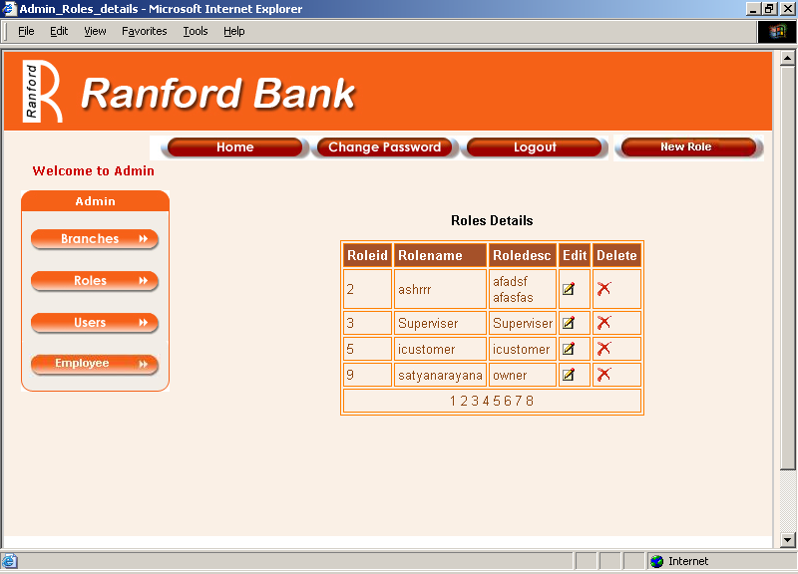

Page Elements

Element Name | Element Type | User Action | System  Response
Roles Details Table
Role Id | Tab. element | NA | NA
Role Name | Tab. element | NA | NA
Role Description | Tab. element | NA | NA
Edit | Image link | Click | As per Task flow Diagram
Delete | Image Link | Click | As per Task flow Diagram
New Role | Button | Click | As per Task flow Diagram

New Role Creation.

Overview

This feature allows admin to create a New Role.

Prototype
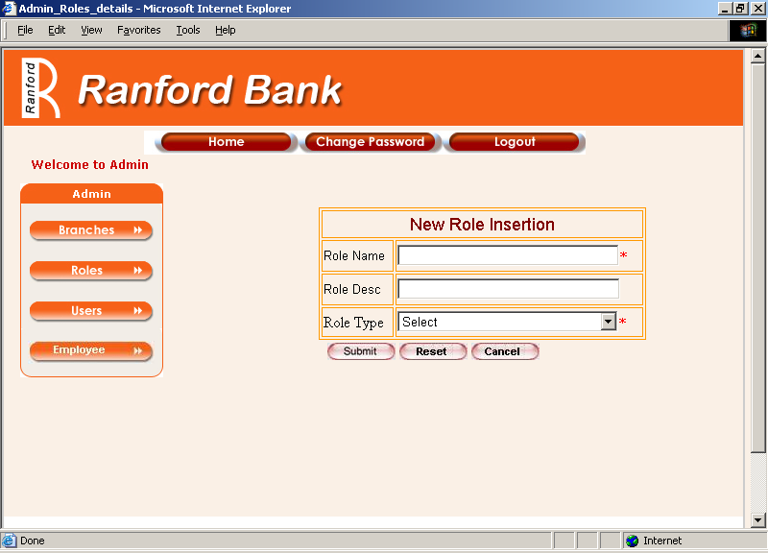

Page Elements

Element Name | Element Type | User Action | System  Response
Role Name | Text box | Enter/Edit | System should Accept
Role Description | Text box | Enter/Edit | System should Accept
Role Type | List box | Select | System should display the selected Role type.
Submit | Button | Click | As per task flow diagram
Reset | Button | Click | As per task flow diagram
Cancel | Button | Click | As per task flow diagram

    - Input Validations & Error States

Element Name | Valid Data | Error state
Role Name | - Mandatory  - Alphabets Only.  3.Min of 4 Chars Max of 30 Chars  4. Unique | 1.Blank – “Please fill in the following fields – Role Name”  - Invalid Chars- “This field should be alphabets only”  - Invalid Range- “It should be with in 4 – 30 chars in length”  - Duplicate- “This Role already exists”
Role Description | 1. Alphanumeric and special Chars.  2. Max of 50 chars. | 1.Invalid Range- “This  Field should be max of 50 chars.
RoleType | 1. Mandatory | 1. Blank – “Please fill in the following fields – Role type”

    - Task flow Diagram

Ok
Login
Roles
Select new Role in roles details page
Click new role and Enter role details
Click Submit
Click Reset
All the data is cleared
Click Cancel
Close the page
Ask for valid role details
If valid
New Role will be created
Actor
Yes
No
Login
Roles
Select new Role
Click new role and Enter role details
Click Submit
Ask for valid role details
Click Reset
All the data is cleared
Login
Roles
Login
Roles
Select new Role
Click new role and Enter role details
Click New Role Roles details page
Enter role details in Role entry page

Actor
Actor
Actor

Yes
Ask for valid role details
Ask for valid role details
No
Click Submit
No
No

Yes

All the data is cleared
All the data is cleared
Click Reset
Click Reset

    - Use Cases

Admin flow for Addition of New Role.

Actors Action | System Response
1. Actor login | 2.System displays Admin module
3. Actor select Roles | 4. System displays Roles details page.
5. Actor click New Roles | 6. System displays New Role Entry Page.
7. Enter necessary fields with valid data and clicks Submit. | 8. System displays a message “New Role Created successfully with Role Id”
9. Enters necessary fields with valid data and clicks Reset. | 10. System clears all fields.
11. Enters necessary fields with valid data or with out entering any fields clicks Cancel. | 12. System closes the new role entry page and displays roles details page.

Role Updation

Overview

This feature allows admin to modify an existing Role.

Prototype

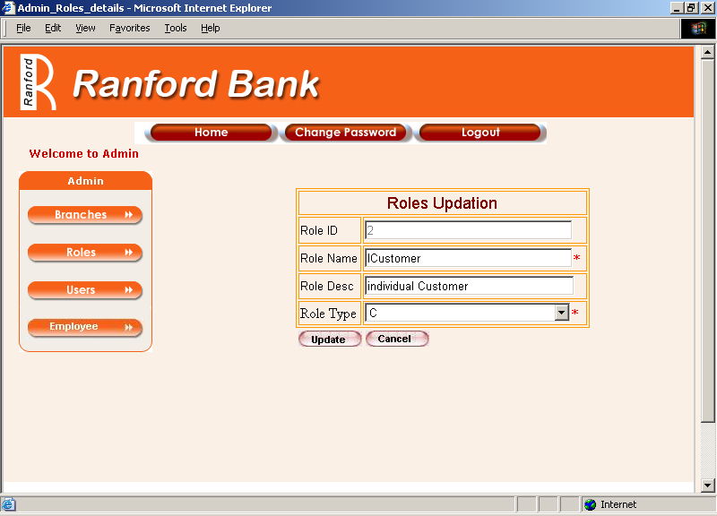

4.3.3 Page Elements

Element Name | Element Type | User Action | System  Response
Role Id | Auto Display | NA | NA
Role Name | Text box | Enter/Edit | System should Accept
Role Description | Text box | Enter/Edit | System should Accept
Role Type | List box | Select | System should display the selected Role type.
Update | Button | Click | As per task flow diagram
Cancel | Button | Click | As per task flow diagram

4.3.4 Input Validations & Error States

Refer 4.2.4

    - Task flow Diagram

Login
Roles
Select Requited Role in Details page
Click Edit and update details
Click Update
Role details will be updated successfully
Ask for missing /valid data
Click Cancel
The page will be closed
Ok
If modified data is Valid

Actor

No

Yes

    - Use Cases

Admin flow for Edit of Existing Role Information.

Actors Action | System Response
1. Actor login | 2.System displays Admin module
3. Actor select Roles | 4. System displays Roles details page.
5. Actor click edit on the respective role to be edited | 6. System displays Roles Update Page.
7. Update necessary fields with valid data and clicks Update. | 8. System displays a message “Roles Updated Successfully”
9. Update necessary fields with valid data or with out entering any fields clicks Cancel. | 10. System closes the Update role page and displays roles details page.

4. 4.0 Role Deletion

4.4.1 Overview

This feature allows admin to delete an unwanted role.

4.4.2 Task flow diagram
Actor
Cancel
Login
Roles
Select Required Role record
Click Delete
Select ok or cancel to confirm
If
If Dependencies
Records are shared, Cannot be deleted
Record will be deleted

OK

Yes No

4.4.3 Use Cases

Admin flow for Deletion of Existing Role.

Actors Action | System Response
1. Actor login | 2.System displays Admin module
3. Actor select Roles | 4. System displays Roles details page.
5. Actor click Delete on the respective role to be deleted. | 6. System displays a message “Are you sure you want to delete this record”
7. Actor Click Ok | 8. System displays a message “Deletion Successful”
9. Actor Click cancel | 10.System stops the process

5.0 Users

5.1 Users Details Page.

5.1.1 Overview

This page displays all users’ information and also allows admin to define and manage bank users.

5.1.2 Prototype

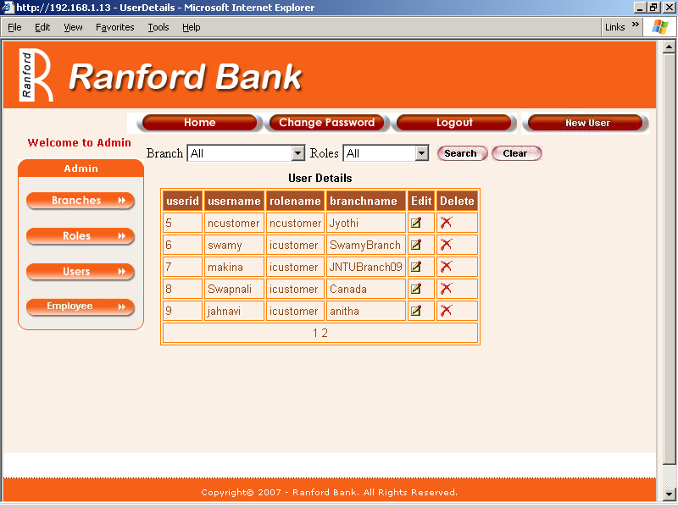

5.1.3 Page Elements

Element Name | Element Type | User Action | System  Response
Branch | List box | Select | As per use cases.
Roles | List box | Select | As per use cases.
Search | Button | Click | As per Task flow Diagram
Clear | Button | Click | As per Task flow Diagram
New User | Button | Click | As per task flow diagram
Users Details Table
User Id | Tab. Element | NA | NA
User Name | Tab. Element | NA | NA
Role Name | Tab. Element | NA | NA
Branch name | Tab. Element | NA | NA
Edit | Image Link | Click | As per task flow diagram
Delete | Image Link | Click | As per task flow diagram

5.2 New User Creation

5.2.1 Overview

This feature allows admin to create a new user for Bank. The new user id is created for the existing customers. To create new user any customer should exist.

5.2.2 Prototype
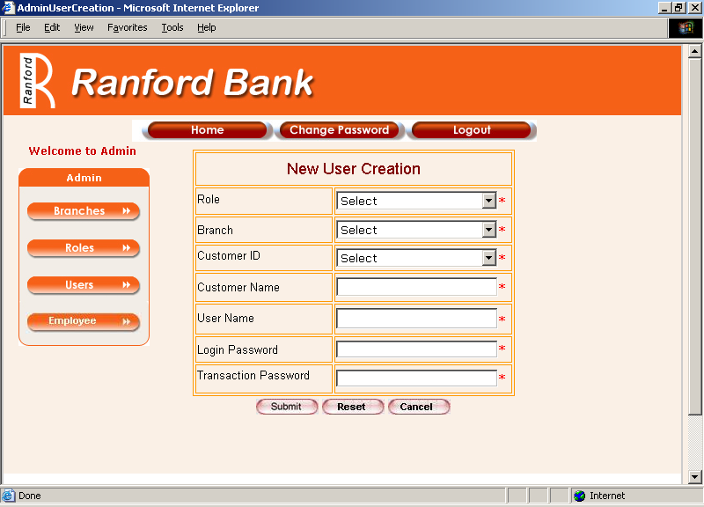

5.2.3 Page Elements

Element Name | Element Type | User Action | System  Response
User Name | Text box | Enter/ Edit | System should accept
Login Password | Text box | Enter/ Edit | System should accept
Transaction Password | Text box | Enter/ Edit | System should accept
Branch | List box | Select | Should display the selected branch
Role | List box | Select | Should display the selected role.
Customer Id | List box | Select | Should display Customer ID’s depending on selection of Role And branch.
Customer Name | Text Box | Auto Display | System displays customer name for the selected customer Id
Submit | Button | Click | As per task flow Diagram.
Reset | Button | Click | As per task flow Diagram.
Cancel | Button | Click | As per task flow Diagram.

5.2.4 input Validations

Element Name | Valid Data | Error state
User Name | 1. Alphanumeric only.  2. Start with an Alphabet.  3. Min of 4 Chars.  4. Max of 16 Chars.  5. Mandatory.  6. Unique | 1. Blank - “Please fill in the following fields – User Name”  2.Invalid Chars- “This field should be alphanumeric only”  3.Invalid Range- “It should be with in 4 - 16 chars in length”
Login Password | 1. Alphanumeric and  Special Chars.  2. Min of 4 Chars.  3. Max of 16 Chars.  4. Mandatory. | 1. Blank - “Please fill in the following fields – Login Password”  2.Invalid Range- “It should be with in 4 - 16 chars in length”
Transaction Password | 1. Alphanumeric and  Special Chars.  2. Min of 4 Chars.  3. Max of 16 Chars.  4. Mandatory. | 1. Blank - “Please fill in the following fields – Transaction Password”  2.Invalid Range- “It should be with in 4 - 16 chars in length”
RoleType | 1. Mandatory | 1. Blank – “Please fill in the following fields – Role type”
Branch | 1. Mandatory | 1. Blank – “Please fill in the following fields – Branch Name”
Customer ID | 1.Mandatory | 1. Blank – “Please fill in the following fields – Customer ID”
Customer Name | 1.Mandatory  2.Read only | 1. Blank – “Please fill in the following fields – Customer Name”

5.2.5 Task flow Diagram

Yes
No
Click Cancel
Close the page
Ok
Click Submit
Click Reset
Login
Users
Select new user in details page
Click new User and Enter user’s details
Ask for valid User details
All the data will be cleared
If valid
New User will be created
Login
Roles
Login
Roles
Login
Roles
Select new Role
Click new role and Enter role details
Select new Role
Click new role and Enter role details
Select new Role
Click new role and Enter role details

Actor
Actor
Actor
Actor

Ask for valid role details
Ask for valid role details
Ask for valid role details
No
Click Submit
No
Click Submit
No

Yes
Yes
Yes

5.2.6 Use Cases

Admin flow for Creation of New User.

Actors Action | System Response
1. Actor login | 2.System displays Admin module
3. Actor select Users | 4. System displays user details page.
5. Actor click New user | 6. System displays New user creation Page.
7. Actor Enters necessary fields with valid data and clicks Submit. | 8.System displays a message “New User Created successfully with User ID”
9. Actor enters necessary fields with valid data and clicks Reset. | 10. System clears all fields.
11. actor enters necessary fields with valid data or with out entering any fields clicks Cancel. | 12. System closes the new user creation page and displays user details page.

5.3 User Updation

5.3.1 Overview

This feature allows admin to modify existing user information.

5.3.2 Prototype

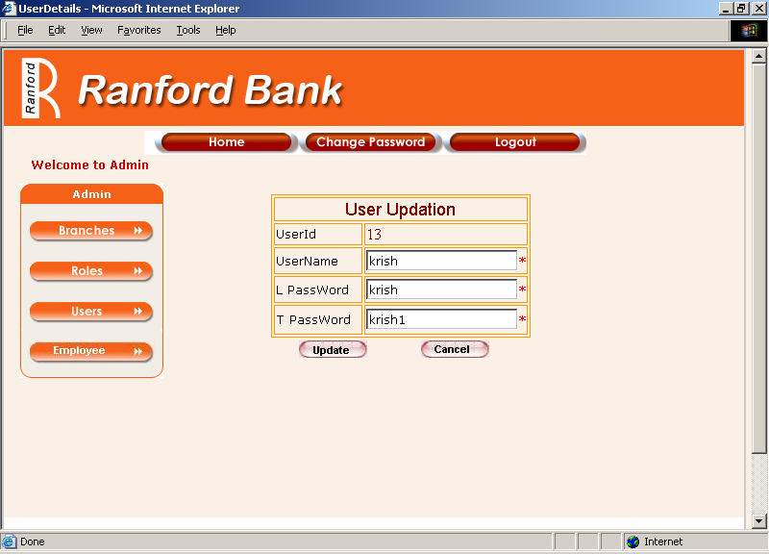

5.3.3 Page Elements

Element Name | Element Type | User Action | System  Response
User Id | Auto display | NA | NA
User Name | Text box | Enter/ Edit | System should accept
Login Password | Text box | Enter/ Edit | System should accept
Transaction Password | Text box | Enter/ Edit | System should accept
Update | Button | Click | As per task flow Diagram.
Cancel | Button | Click | As per task flow Diagram.

5.3.4 Input Validations & Error States

Refer 5.2.4

5.3.5 Task flow Diagram

Yes
Login
Users
Select required User in the list
Click Edit and update details
Click Update
User details will be updated
Ask for missing valid data
Click Cancel
The page will be close
Ok
If modified data is Valid

Actor

No

5.3.6 Use Cases

Admin flow for modification of User.

Actors Action | System Response
1. Actor login | 2.System displays Admin module
3. Actor select Users | 4. System displays users details page.
5. Actor click edit for any user | 6. System displays user updation page.
7. Actor modifies necessary fields with valid data and clicks Update. | 8. System displays a message “User Updated successfully”
9. Actor modifies necessary fields with valid data or with out modifying any fields clicks Cancel. | 12. System closes the user updation page and displays user details page.

5.4 User Deletion

5.4.1 Overview

This feature allows admin to delete an unwanted bank user.

5.4.2 Task flow Diagram
Actor
Ok
Cancel
Login
Users
Select required User in the list
Click Delete
select Ok or Cancel to confirm
The user record will be deleted
The user cannot be deleted
If

5.4.3 Use Cases

Admin flow for Deletion of a User.

Actors Action | System Response
1. Actor login | 2.System displays Admin module
3. Actor select Users | 4. System displays users details page.
5. Actor click Delete for any user | 6. System displays a confirmation window with “Yes” and “No” options.
7. If Actor clicks “Ok” | 8. System deletes the user.
9. If actor clicks “Cancel” | 10. System displays User details page.

6. Employees

6.1 Employee Details Page

6.1.0 Overview

This feature allows admin to view login user names of bank employees working with various branches and to define and manage logins for employees.

6.1.1 Prototype
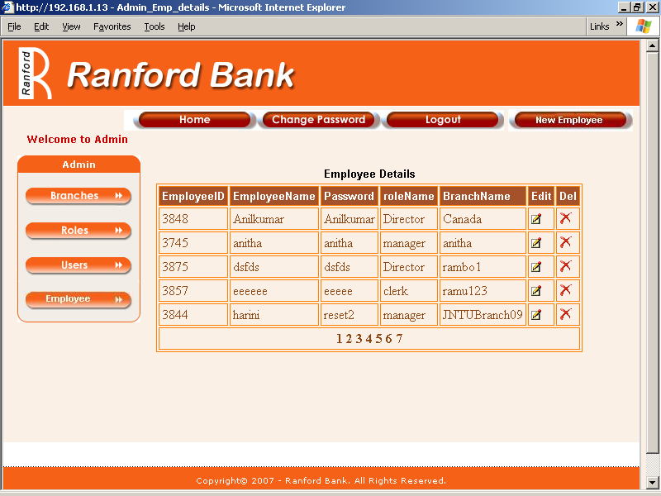

6.1.2 Page Elements

Element Name | Element Type | User Action | System  Response
Employee Id | Tab. Element | NA | NA
Employee Name | Tab. Element | NA | NA
Password | Tab. Element | NA | NA
Role | Tab. Element | NA | NA
Branch | Tab. Element | NA | NA
Edit | Button | Click | AS per task flow diagram
Delete | Button | Click | AS per task flow diagram
New Employee | Button | Click | AS per task flow diagram

6.2 New Employee Creation

6.2.1 Overview

This feature allows admin to create a new login for Bank branch employee.

6.2.2 Prototype.
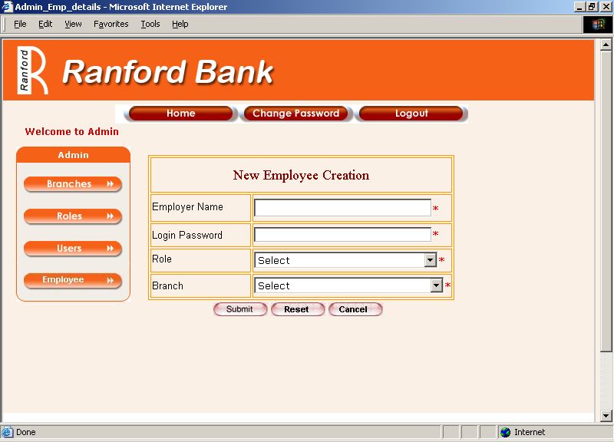

6.2.3 Page Elements

Element Name | Element Type | User Action | System  Response
Banker Name | Text box | Enter/Edit | Accepts
Login Password | Text box | Enter/Edit | Accepts
Role | List box | Select | Displays selected role
Branch | List box | Select | Displays selected role
Submit | Button | Click | As per task flow diagram
Reset | Button | Click | As per task flow diagram
Cancel | Button | Click | As per task flow diagram

6.2.4 Input Validations

Element Name | Valid Data | Error state
Banker Name | 1. Alphanumeric only.  2. Start with an Alphabet.  3. Min of 4 Chars.  4. Max of 16 Chars.  5. Mandatory.  6. Unique | - Blank/Invalid- “Enter a Valid Banker  Name”
Login Password | 1.Alphanumeric and  Special Chars.  2. Min of 4 Chars.  Max of 16 Chars.  3. Mandatory. | - Blank/Invalid- “Enter valid password”
Role | 1. Mandatory | 1. Blank- “Select a Valid Role”
Branch | 1. Mandatory | 1. Blank- “Select a Valid branch”

6.2.5 Task flow Diagram
Click Cancel
Ok
Click Submit
Login
Employee
Click New Employee
Enter Employee Details like role, branch
Ask for valid User details
All the data will be cleared
If valid
New Emp will be created

Login
Roles
Login
Roles
Login
Roles
Select new Role
Click new role and Enter role details
Select new Role
Click new role and Enter role details
Select new Role
Click new role and Enter role details

Actor
Actor
Actor
Actor

Ask for valid role details
Ask for valid role details
Ask for valid role details
No
Click Submit
No
Click Submit
No
No

Yes
Yes
Yes
Yes
All the data is cleared
All the data is cleared
All the data is cleared
Click Reset
Click Reset
Click Reset
Click Reset

Close the page

6.2.6 Use Cases

Admin flow for Addition of New Employee.

Actors Action | System Response
1. Actor login | 2.System displays Admin module
3. Actor select Employee | 4. System displays Employee details page.
5. Actor click New Employee | 6. System displays New Employee Entry Page.
7. Enter necessary fields with valid data and clicks Submit. | 8. System displays a message “Employee Created Successfully with Employee ID”
9. Enters necessary fields with valid data and clicks Reset. | 10. System clears all fields.
11. Enters necessary fields with valid data or with out entering any fields clicks Cancel. | 12. System closes the new Employee entry page and displays Employee details page.

6.3 Employee Updation

6.3.1 Overview
This feature allows admin to modify login information of a bank employee.

6.3.2 Prototype for Employee Updation

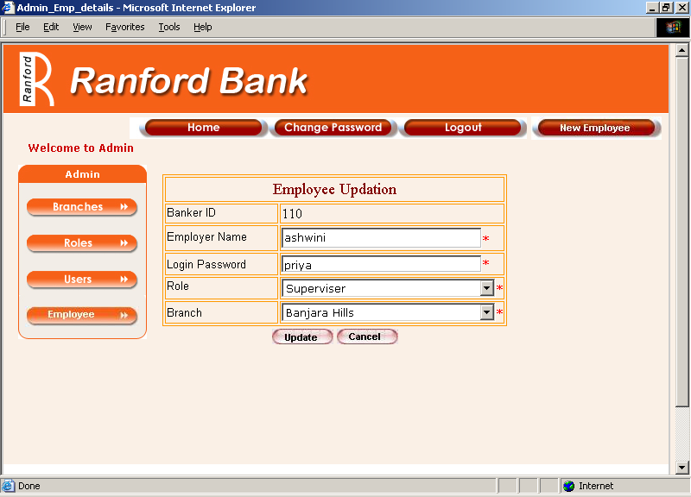

6.3.3 Page Elements

Element Name | Element Type | User Action | System  Response
Banker Id | Auto Display | NA | NA
Banker Name | Text box | Enter/Edit | Accepts
Login Password | Text box | Enter/Edit | Accepts
Role | List box | Select | Displays selected role
Branch | List box | Select | Displays selected role
Update | Button | Click | As per task flow diagram
Cancel | Button | Click | As per task flow diagram

6.3.4 input Validations & Error States

Refer 6.2.4

    - Task flow diagram

Login
Employee
Select required Employee in the Table
Click Edit and update details
Click Update
Employee details are updated successfully
Ask for missing /valid data
Click Cancel
The page is closed
Ok
If modified data is Valid

Actor

No

Yes

6.3.6 Use Cases

Admin flow for Edit of Existing Employee Details.

Actors Action | System Response
1. Actor login | 2.System displays Admin module
3. Actor select Employee | 4.System displays Employee details page.
5. Actor click edit on the respective employee details to be edited | 6. System displays Employee Update Page.
7. Update necessary fields with valid data and clicks Update. | 8. System displays a message “Updated Successfully”
9. Update necessary fields with valid data or with out entering any fields clicks Cancel. | 10. System closes the Update Employee details page and displays Employees details page.

6.4 Employee Deletion

6.4.1 Overview

This feature allows admin to delete an unwanted login of bank employee.

Login
Employee
Select required Employee in the Table
Click Delete
Select Ok or Cancel to confirm
The Employee record will be deleted
The employee cannot be deleted
If
6.4.2 Task flow diagram

Actor

Cancel

Ok

Admin flow for Deletion of Employee.

Actors Action | System Response
1. Actor login | 2.System displays Admin module
3. Actor select Employee | 4.System displays Employee details page.
5. Actor click Delete on the respective role to be deleted. | 6. System displays a message “Are you sure you want to delete this record” with “Ok” and “Cancel” buttons
7. Actor Click Ok | 8. System displays a message “Deletion Successfully”
9. Actor Click cancel | 10.System stops the process

