**ASSIGNMENT – 2**

1. Create and test an HTML document that has six short paragraphs of text that describe various aspects of the state in which you live. You must define three different paragraph styles, p1, p2, and p3. The p1 style must use left and right margins of 20 pixels, a background color of pink, and a foreground color of blue. The p2 style must use left and right margins of 30 pixels, a background color of black, and a foreground color of yellow. The p3 style must use a text indent of 1 centimeter, a background color of green, and a foreground color of white. The first and fourth paragraphs must use p1, the second and fifth must use p2, and the third and sixth must use p3. All the styles must be in inline style sheet

**PROGRAM:**

<!DOCTYPE html>

<html lang="en">

<head>

<meta charset="UTF-8">

<meta name="viewport" content="width=device-width, initial-scale=1.0">

<title>State Description</title>

</head>

<body>

<p style="text-indent: 1cm; background-color: rgb(128, 0, 43); color:green;"> <h1 style= "color: rgb(128, 0, 43);background-color:green; text-align: center;">WEB DEVELOPMENT</h1>

Web development refers to the creating, building, and maintaining of websites. It includes aspects such as web design, web publishing, web programming, and database management. It is the creation of an application that works over the internet i.e. websites.</p>

<p style="margin-left: 20px; margin-right: 20px; background-color: rgb(169, 218, 238); color: rgb(159, 159, 194);"><h1 style="color:rgb(159, 159, 194); background-color: rgb(169, 218, 238); text-align: center;">LANGUAGES IN DEVELOPMENT</h1>HTML: HTML stands for HyperText Markup Language. It is used to design the front end portion of web pages using markup language. It acts as a skeleton for a website since it is used to make the structure of a website.

CSS: Cascading Style Sheets fondly referred to as CSS is a simply designed language intended to simplify the process of making web pages presentable. It is used to style our website.

JavaScript: JavaScript is a scripting language used to provide a dynamic behavior to our website.

Bootstrap: Bootstrap is a free and open-source tool collection for creating responsive websites and web applications. It is the most popular CSS framework for developing responsive, mobile-first websites. Nowadays, the websites are perfect for all browsers (IE, Firefox, and Chrome) and for all sizes of screens (Desktop, Tablets, Phablets, and Phones).</p>

<p style=" margin-left: 20px; margin-right: 20px; background-color: rgb(143, 205, 223); color: rgb(236, 147, 147);"><h1 style=" background-color: rgb(143, 205, 223); color: rgb(236, 147, 147); text-align: center;">BACKEND </h1>Backend is the server side of a website. It is part of the website that users cannot see and interact with. It is the portion of software that does not come in direct contact with the users. It is used to store and arrange data.</p>

<p style=" margin-left: 30px; margin-right: 30px; background-color: rgb(240, 203, 203); color: blue;"><h1 style=" background-color: rgb(240, 203, 203); color: blue; text-align: center;">LANGUAGES IN BACKEND</h1>PHP: PHP is a server-side scripting language designed specifically for web development.

Java: Java is one of the most popular and widely used programming languages. It is highly scalable.

Python: Python is a programming language that lets you work quickly and integrate systems more efficiently.

Node.js: Node.js is an open source and cross-platform runtime environment for executing JavaScript code outside a browser.</p>

<p style=" margin-left: 30px; margin-right: 30px; background-color: rgb(240, 203, 203); color: blue;"><h1 style=" background-color: rgb(240, 203, 203); color: blue; text-align: center;"> SCOPE OF WEB DEVELOPMENT</h1>The scope of web development encompasses all related development activities, such as client-side scripting, server-side scripting, server and network security settings, e-commerce development, and content management system (CMS) development, in addition to web markup and code.</p>

<p style=" text-indent: 1cm; background-color: rgb(128, 0, 43); color:green;"><h1 style=" background-color: rgb(128, 0, 43); color:green; text-align: center;"> APPLICATINS OF WEB DEVELOPMENT</h1> Web application development is the creation of application programs that reside on remote servers and are delivered to the user's device over the Internet. A web application (web app) does not need to be downloaded and is instead accessed through a network.</p>

</body>

</html>

**OUTPUT:**

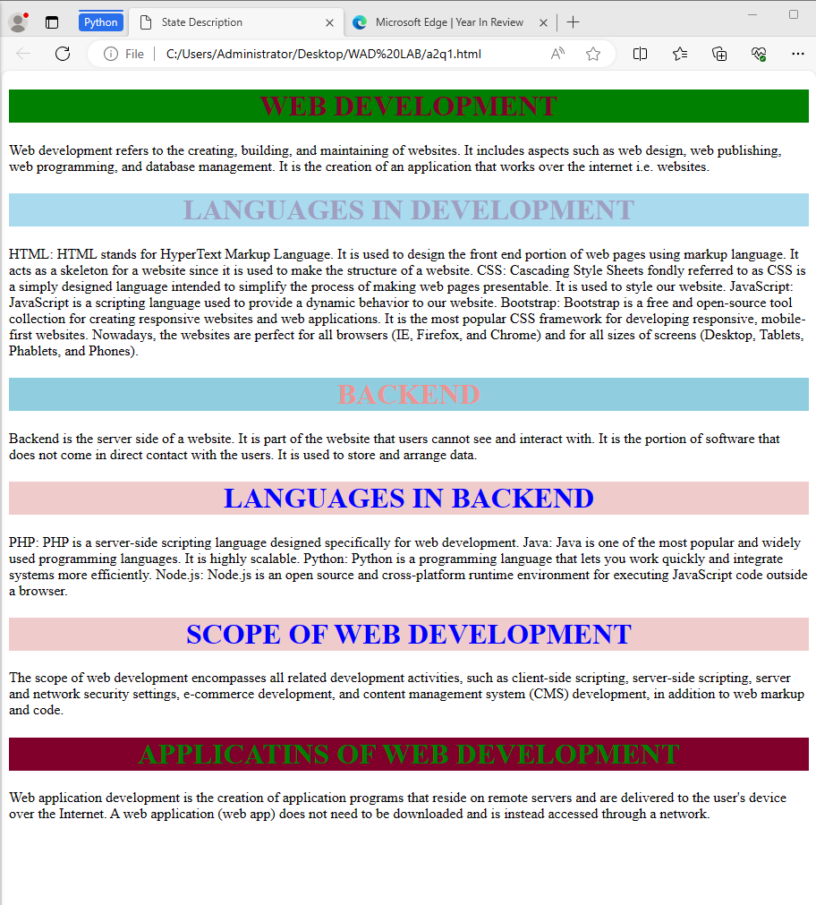

1. Rewrite the solution to Q. No. 1 such that the styling information is in a document style sheet.

**PROGRAM:**

<!DOCTYPE html>

<html lang="en">

<head>

<meta charset="UTF-8">

<meta name="viewport" content="width=device-width, initial-scale=1.0">

<title>State Description</title>

<style>

/* Paragraph Style p1 */

.p1 {

margin-left: 20px;

margin-right: 20px;

background-color: pink;

color: blue;

}

/* Paragraph Style p2 */

.p2 {

margin-left: 30px;

margin-right: 30px;

background-color: black;

color: yellow;

}

/* Paragraph Style p3 */

.p3 {

text-indent: 1cm;

background-color: green;

color: white;

}

</style>

</head>

<body>

<p class="p1">

Web development refers to the creating, building, and maintaining of websites. It includes aspects such as web design, web publishing, web programming, and database management. It is the creation of an application that works over the internet i.e. websites.</p>

<p class="p2" >HTML: HTML stands for HyperText Markup Language. It is used to design the front end portion of web pages using markup language. It acts as a skeleton for a website since it is used to make the structure of a website.

CSS: Cascading Style Sheets fondly referred to as CSS is a simply designed language intended to simplify the process of making web pages presentable. It is used to style our website.

JavaScript: JavaScript is a scripting language used to provide a dynamic behavior to our website.

Bootstrap: Bootstrap is a free and open-source tool collection for creating responsive websites and web applications. It is the most popular CSS framework for developing responsive, mobile-first websites. Nowadays, the websites are perfect for all browsers (IE, Firefox, and Chrome) and for all sizes of screens (Desktop, Tablets, Phablets, and Phones).</p>

<p class="p3">Backend is the server side of a website. It is part of the website that users cannot see and interact with. It is the portion of software that does not come in direct contact with the users. It is used to store and arrange data.</p>

<p class="p1" >PHP: PHP is a server-side scripting language designed specifically for web development.

Java: Java is one of the most popular and widely used programming languages. It is highly scalable.

Python: Python is a programming language that lets you work quickly and integrate systems more efficiently.

Node.js: Node.js is an open source and cross-platform runtime environment for executing JavaScript code outside a browser.</p>

<p class="p2" > The scope of web development encompasses all related development activities, such as client-side scripting, server-side scripting, server and network security settings, e-commerce development, and content management system (CMS) development, in addition to web markup and code.</p>

<p class="p3" >Web application development is the creation of application programs that reside on remote servers and are delivered to the user's device over the Internet. A web application (web app) does not need to be downloaded and is instead accessed through a network.</p>

</body>

</html>

**OUTPUT:**

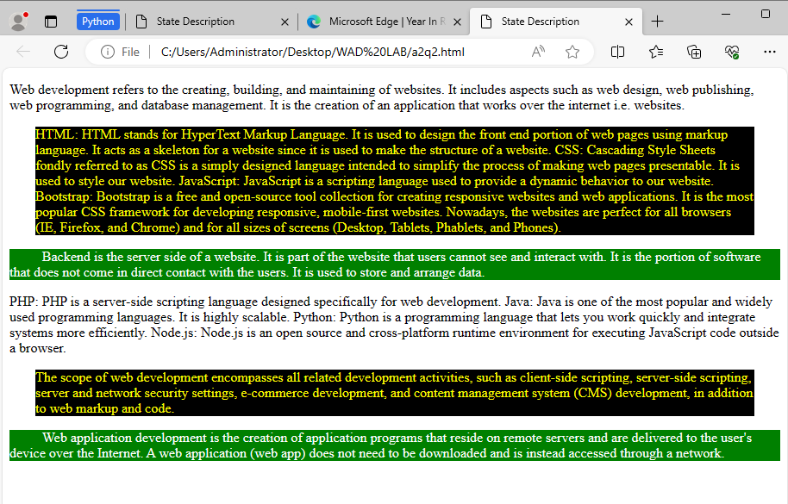

1. Create and test an HTML document that describes nested ordered lists of cars. The outer list must have three entries: compact, midsize, and sports. Inside each of these three lists there must be two sublists of body styles. The compact- and midsize-car sublists are two door and four door; the sports-car sublists are coupe and convertible. Each body-style sublist must have at least three entries, each of which is the make and model of a particular car that fits the category. The outer list must use uppercase Roman numerals, the middle lists must use uppercase letters, and the inner lists must use Arabic numerals. The background color for the compact-car list must be pink; for the midsize-car list, it must be blue; for the sports-car list, it must be red. All the styles must be in External Style Sheet.

**PROGRAM:**

**HTML CODE:**

<!DOCTYPE html>

<html lang="en">

<head>

<meta charset="UTF-8">

<meta name="viewport" content="width=device-width, initial-scale=1.0">

<link rel="stylesheet" href="a2q3.css">

<title>Nested Ordered Lists of Cars</title>

</head>

<body>

<ol class="outer-list">

<li>Compact

<ol class="compact-list">

<li><b>Two Door</b>

<ol>

<li><i>Toyota Corolla</i></li>

<li><i>Honda Civic</i></li>

<li><i>Ford Fiesta</i></li>

</ol>

</li>

<li><b>Four Door</b>

<ol>

<li><i>Nissan Sentra</i></li>

<li><i>Chevrolet Cruze</i></li>

<li><i>Mazda3</i></li>

</ol>

</li>

</ol>

</li>

<li>Midsize

<ol class="midsize-list">

<li><b>Two Door</b>

<ol>

<li><i>onda Accord Coupe</i></li>

<li><i>Ford Mustang</i></li>

<li><i>Chevrolet Camaro</i></li>

</ol>

</li>

<li><b>Four Door</b>

<ol>

<li><i>Toyota Camry</i></li>

<li><i>Nissan Altima</i></li>

<li><i>Hyundai Sonata</i></li>

</ol>

</li>

</ol>

</li>

<li>Sports

<ol class="sports-list">

<li>Coupe

<ol>

<li>Porsche 911</li>

<li>Chevrolet Corvette</li>

<li>Audi R8</li>

</ol>

</li>

<li>Convertible

<ol>

<li>Mazda MX-5 Miata</li>

<li>Ford Mustang Convertible</li>

<li>BMW Z4</li>

</ol>

</li>

</ol>

</li>

</ol>

</body>

</html>

**CSS CODE:**

body {

font-family: Arial, sans-serif;

}

.outer-list {

list-style-type: upper-roman;

}

.compact-list {

background-color: pink;

list-style-type: upper-alpha;

}

.midsize-list {

background-color: gray;

list-style-type: upper-alpha;

}

.sports-list {

background-color: red;

list-style-type: upper-alpha;

}

.outer-list ol {

list-style-type: decimal;

}

**OUTPUT:**

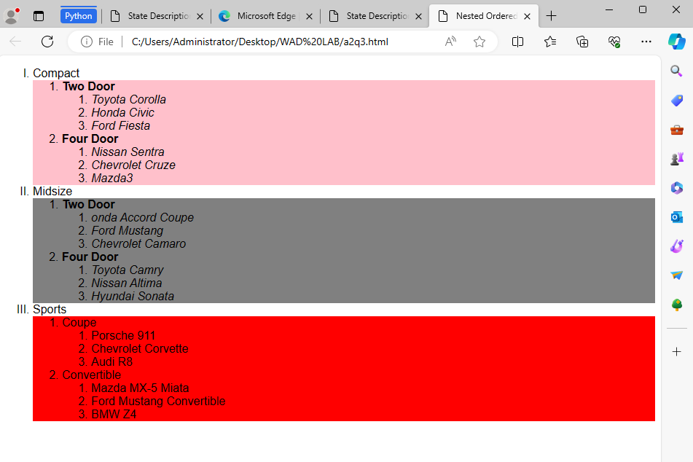

1. Create and test an HTML document that includes at least two images and enough text to precede the images, flow around them (one on the left and one on the right), and continue after the last image.

**PROGRAM:**

<!DOCTYPE html>

<html lang="en">

<head>

<meta charset="UTF-8">

<meta name="viewport" content="width=device-width, initial-scale=1.0">

<title>Images with Text Flow</title>

<style>

img {

width: 200px;

height: 200px;

margin-up:10px;

margin-bottom: 10px;

margin-right: 10px;

border:2px solid black;

float:left;

border-radius: 10%;

}

img:last-child {

width: 200px;

height: 200px;

margin-up:10px;

margin-bottom: 10px;

margin-left: 10px;

border:2px solid magenta;

float:right;

}

h1{

color:blue;

text-align: center;

background-color: blanchedalmond;

border: 2px;

}

*{

padding:20px;

background-color: beige;

margin:auto;

}

head{

border:6px solid black;

}

</style>

</head>

<body>

<h1><u>ABOUT TARTEEL</u></h1>

<img src="tarteel.png" alt="Image 1" width="300" height="200">

<p>Have you ever wished you had someone to listen to and correct your recitation or Tajweed?

If yes, this is the perfect app for you.

Have you ever wanted to increase your knowledge of the Quran by teaching and helping others to improve their understanding of the Holy Book?

If yes, this is the perfect app for you.

This app connects both listener and reciter in their free time to help each other.

So, you can rest assured that your well spent time will be your wealth here and in the heareafter.

The institute has the mission of serving the Glorious Quran within the Australian Muslim Community in distinctive and quality approach through the following:Enabling the generations to inherit the Science of recitation based on the Sanad (the chain ofQuranic recitation) back up to the prophet Muhammad peace and blessings are upon him.Educating the learners to follow the moral values of Great Quran.

</p>

<p>

<img src="ta.png" alt="Image 2" width="300" height="200">

Being proud of all those who work with the institute, caring about them and ensuring a relationship of intimacy and cooperation with the learners and memorisers at the institute. This will be based on the Islamic values of tolerance and the munificent leafy shadows of the Quran.Following methodical systematic program.Employing advanced technical and educational methods.Implementing the work in a planned and coordinated approach using modern management principles.

</p>

</body>

</html>

**OUTPUT:**

