# **Bridging Emissions and Investments A visual Analysis of Greenhouse Gas Trends and Green Bond Financing**

Abhilasha Singh, Mohammed Sarfaraz Shaik, Pranjal Wakpaijan, Rahul Arvind, Yonathan Shimelis

Columbian College of Arts and Sciences, The George Washington University

DATS 6401: Project Part IV

Dr. Anya Mendenhall

April 6 ,2025

**Introduction**

Just four stories above New York’s Union Square, at 60 E 14th Street, stands a significant landmark called the Climate Clock. This clock, which first went live in September 2020, displays a countdown of the estimated time left before global warming reaches 1.5°C above pre-industrial levels. When it was unveiled, the clock showed 7 years and 102 days. Today, it shows just 4 years and 159 days remaining. This stark reminder of the urgency of climate action is why we chose this topic. Climate change is one of the most complex challenges facing the world today, influencing scientific, economic, societal, and political spheres. Greenhouse gas (GHG) emissions, particularly carbon dioxide (CO₂), are the primary drivers of global warming. These emissions result in rising temperatures, extreme weather events, and environmental degradation. Despite increasing awareness, global GHG emissions grew by 51% from 1990 to 2021. In 2013, CO₂ levels surpassed 400 parts per million for the first time in human history, and they have continued to climb (Ge, Friedrich, & Vigna, 2022). This project aims to analyze emissions trends using data from the International Monetary Fund (IMF) Climate Data Portal, which provides a comprehensive view of emissions by country, gas type, and industry along with data on surface temperature changes and government spending on climate initiatives. We seek to contribute to ongoing discussions on climate action and policy effectiveness.

**Objective and Goals**

This project seeks to uncover the relationship between greenhouse gas emissions, their effect on the planet, and the financial mechanisms designed to mitigate them, specifically through the lens of green bond activity. By combining emissions, climate change, and climate finance data, we aim to discover any similarities in the trends between variables like climate change, policy towards climate initiatives, and emissions worldwide. We aim to answer the following questions:   
1. Which industries are the largest emitters of greenhouse gases?   
2. How have emissions changed from 2010 to 2022 across different continents and sectors?  
3. Are current environmental policies, such as the Paris Agreement, carbon taxes, and solar subsidies, effective in reducing emissions?

By addressing these questions, this project contributes to the broader discourse on climate accountability and impact. It offers a data-driven foundation for assessing whether climate finance mechanisms are making a tangible difference or whether gaps still exist between investment and impact. These insights are valuable for policymakers, investors, and international organizations aiming to shape more effective and equitable climate strategies.

**Dataset Descriptions**

**Dataset 1:** International Monetary Fund (IMF) - Climate Data Portal (Annual Greenhouse Gas Emissions Account)   
The International Monetary Fund (IMF) Climate Data Portal provides comprehensive data on annual global greenhouse gas (GHG) emissions from 2010 to 2022. This publicly available dataset, sponsored by the IMF, is designed to support climate change research, policy-making, and environmental impact assessments by tracking emissions trends across countries, industries, and gas types. It includes 1,186 records with 27 variables, comprising both categorical and continuous data. Key variables include Country, ISO3 Code, Industry, Gas Type, Emissions (measured in metric tons of CO₂ equivalent), Year, Source, and Unit. The data, covering 215 countries and six sectors with 14 sub-sectors and four gases, facilitates time-series analysis of emissions trends. It has been used in IMF analyses, including assessments of climate-related policies like the U.S. 2022 Inflation Reduction Act, and is cited by organizations such as the World Bank, the Center for Climate and Energy Solutions, and Our World in Data.

**Dataset 2:** International Monetary Fund (IMF) - Climate Data Portal (Green Bonds)  
The IMF Climate Data Portal provides annual data on green bond issuances by country from 1985 to 2022 as part of the IMF’s efforts to track global climate finance instruments supporting environmental sustainability projects. Sourced from Refinitiv and validated by country authorities and IMF staff, the dataset captures the nominal values of green bond issuances across various issuer types and currencies, offering key insights into national commitments to green investment and sustainable finance. It consists of 355 records and 42 variables, with global coverage spanning over 100 countries. Key variables include Country, Indicator, Unit, Type of Issuer, Use of Proceed, Principal Currency, and annual issuance values from 1985 to 2022 (F1985 to F2022). Categorical variables classify issuer type, purpose, and currency, while numerical variables represent issuance values in billions of USD. The dataset is referenced in IMF reports, sustainable finance research, and international climate finance monitoring efforts. It has also been cited by the International Finance Corporation (IFC) in collaboration with Amundi on emerging market green bond initiatives, as well as in the study "How Large is the Sovereign Greenium?" by Sakai Ando, Chenxu Fu, Francisco Roch, and Ursula Wiriadinata.

**Dataset 3:** International Monetary Fund (IMF)- Climate Data Portal – Annual Surface Temperature Change

The dataset provides global annual surface temperature change data from 1961 to 2023, offering insights at both country and regional levels. It includes 236 records with 73 variables comprising both categorical and numerical data. Key categorical variables include Country, ISO2 Code, ISO3 Code, Indicator, Unit, Source, CTS Code, CTS Name, and CTS Full Descriptor, while numerical variables represent annual temperature change values in degrees Celsius for each year within the dataset’s timeline. This data is utilized in the IMF's Climate Change Indicators Dashboard and is based on the publicly available GISTEMP dataset, distributed by NASA’s Goddard Institute for Space Studies (GISS), as accessed through FAOSTAT Climate Change, Climate Indicators, Temperature Change.

**Data Story**

Every year, we witness the devastating consequences of climate change—wildfires engulfing entire communities, cities drowning under record floods, and rising temperatures pushing ecosystems to collapse. Despite global commitments to cut greenhouse gas emissions, progress remains slow. The gap between climate ambition and climate action is widening. One of the biggest hurdles? Financing. Transitioning to a low-carbon economy requires trillions of dollars in investment. This is where green bonds come in—a powerful financial tool designed to fund climate solutions. In 2023 alone, $575 billion in green bonds were issued to support renewable energy, clean transportation, and sustainable infrastructure. But is it enough? And more importantly, are these funds truly making an impact, or are they falling prey to greenwashing—false claims of sustainability? To effectively communicate the intersection between greenhouse gas emissions, climate change indicators, and green bond financing, we will create a series of visualizations that highlight key trends, relationships, and regional patterns over time. The visualizations will be built in Tableau using cleaned versions of the three datasets.

**Visualizations**

Visualization 1 uses dataset 1, the annual greenhouse emissions account, to illustrate the changes in different greenhouse gas emissions from 2010 to 2022, with CO₂ being the primary contributor. The graph is relatively simple with the only variables being emissions (measured in million metric tons of CO₂ equivalent) and years. Over the years, the CO₂ curve shows a consistent increase, although there is a noticeable dip in 2020. This drop could be attributed to the COVID-19 pandemic and the pandemic-induced slowdowns in industries like transportation. It’s important to note that this decline was only temporary, highlighting the need for systemic change in order to produce more prolonged or permanent decreases in CO₂ emissions. The visualization serves as a foundation for our analysis, highlighting CO₂ as an outlier in greenhouse gas emissions.

This bar chart compares total greenhouse gas emissions across eight key industries in 2010 and 2022, measured in million metric tons of CO₂ equivalent. The pattern is clear and troubling: every industry has increased its emissions, with no sector showing a decline over the 12-year period. The energy and manufacturing industries stand out as the top emitters in both years, and they also show the largest absolute increases.

This trend is particularly significant when placed in the broader context of international climate agreements and national sustainability goals. Despite a decade marked by the Paris Agreement, carbon pricing schemes, and significant growth in green investment, we see no measurable impact on emissions at the industry level. Even sectors where cleaner alternatives are available — such as transportation and waste management — have failed to bend the emissions curve downward.

The visualization challenges the assumption that awareness and investment alone are enough. It raises critical questions:

* Are climate policies being implemented with enough force to affect high-emission sectors?
* Is green finance — like the rise in green bond spending — actually reaching the industries that need to decarbonize the most?
* Could the slight slowdown in emissions growth in some sectors (like mining or farming) signal early policy effects, or are they simply structural shifts?

By highlighting the stubbornness of emissions growth, this chart underscores one of our project’s central findings: the gap between climate ambition and real-world progress remains wide, especially in industrial sectors. It sets the stage for further exploration in Visualizations 3 and 5, where we dive deeper into CO₂ emissions and climate finance, respectively.

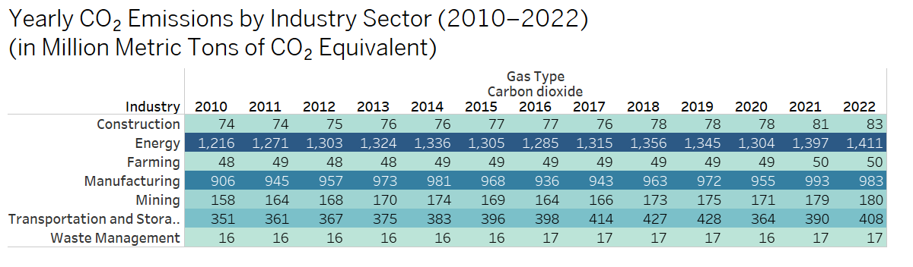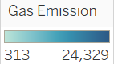

Visualization 3 builds on the insights from Visualization 2 by presenting a more granular view of CO₂ emissions, focusing solely on carbon dioxide across various industry sectors from 2010 to 2022.While Visualization 3 compared emissions across industries between just two years (2010 and 2022), Visualization 2 provides a complete year-by-year breakdown. This deeper look reveals consistent upward trends in carbon dioxide emissions in nearly every sector over the 12-year period. The energy and manufacturing sectors once again emerge as the dominant contributors to emissions. Observing the energy sector, we find the industry had a 16% increase in CO₂ emissions in 12 years. The continuity and growth observed in these emissions raise questions about the long-term effectiveness of environmental policies targeting industrial CO₂ output. The data also allows us to assess whether any policy interventions or global climate initiatives have led to noticeable slowdowns in emission growth in specific sectors. For example, while some sectors show gradual increases, others like energy display a steadier and more substantial rise, indicating the need for more targeted mitigation strategies. This expands upon our previous visualization by not only showing an increase in emission, but the failure to slow down or stop the growth rate of these emissions year over year.

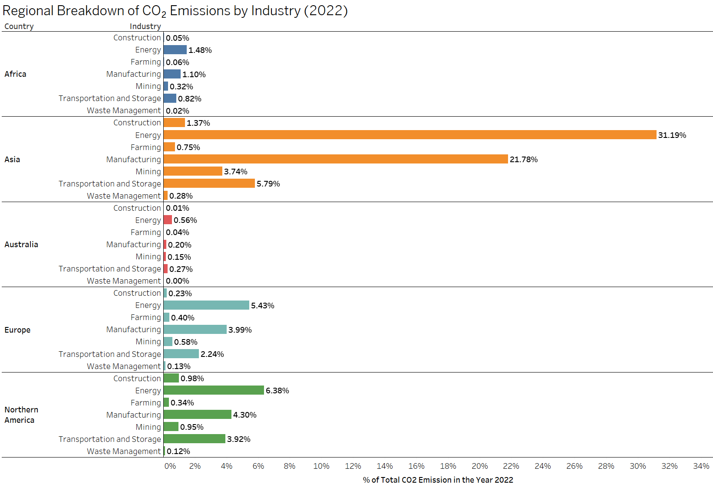

Visualization 4, also derived from Dataset 1 on annual greenhouse gas emissions, offers a clear and accessible breakdown of CO₂ emissions across continents in 2022. The chart provides a striking snapshot of how emissions are both regionally concentrated and sectorally differentiated.

Asia clearly dominates the global carbon landscape, accounting for over 50% of global CO₂ emissions in just two sectors: energy (31.2%) and manufacturing (21.8%). This concentration reflects the continent’s rapid industrial growth, high energy demand, and continued reliance on fossil fuels — factors that have made Asia a central focus of global climate negotiations.

By contrast, Europe and North America show more balanced emissions profiles across sectors, with energy and manufacturing still leading, but with noticeably lower percentages. This may reflect both more stringent climate regulations and greater investment in decarbonization technologies, though the persistence of emissions even in highly developed regions suggests there is still a long road ahead.

This visualization deepens the narrative introduced in Visualization 2 by showing not just which industries are polluting, but where those emissions are concentrated geographically.

The visualization encourages critical thinking about regional awareness and efforts to combat climate change. More specifically, it raises important questions about the role of environmental policies and climate initiatives in different parts of the world, and whether such measures are effectively driving change. Ultimately, this chart reinforces one of the project’s core takeaways: effective climate action must account for both sectoral and regional dynamics. Without a more tailored approach to high-emission regions and industries, broad global goals may continue to fall short.

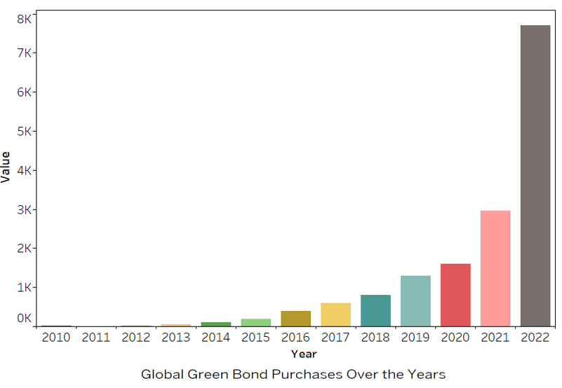

Visualization 5 represents green bond spending in the world over time (2010-2022). This visualization uses dataset 2 from the IMF on green bonds. The y-variable, values, is measured in billions of US dollars. According to the IMF, “Green bonds and sustainability-linked bonds are fixed-income securities designed specifically to support climate and environmental projects” (**International Monetary Fund (IMF).** With this visualization, we can observe if the world has accepted climate change initiatives or put a larger emphasis on combatting climate change throughout time. In the graph, we can see the largest growth in green bond issuance between 2021 and 2022. It’s also important to align certain periods of growth with context. For example, The more rapid growth seen starting around 2016 overlaps with the signing of the Paris Climate Agreement in 2016.

Visualizing these trends is powerful since we can see if climate change or emissions in the world are following a similar trend to spending on combatting climate change. For example, if we noticed a decrease in emissions or a slower growth rate in emissions while observing larger green bond purchases, it could possibly mean green bond purchases are somewhat effective. The graph can also provide insights on the overall global and government sentiment of climate change and its threat to life on Earth Lastly, we can also observe the rate of change in green bond issuance and conclude what that might mean for the world views of climate change as a threat over time. One limitation of the data is that countries did not have a measure of green bonds in many of the earlier years in our timeframe (like 2010 or 2011).

Now while the growth in green bond issuance seems like a good thing, when paired with the other visualizations, it appears we’re yet to see the impact of these measures. The precise evaluation of these bonds and other climate initiatives is key to creating stronger and more meaningful decreases in greenhouse gas emissions and climate change.

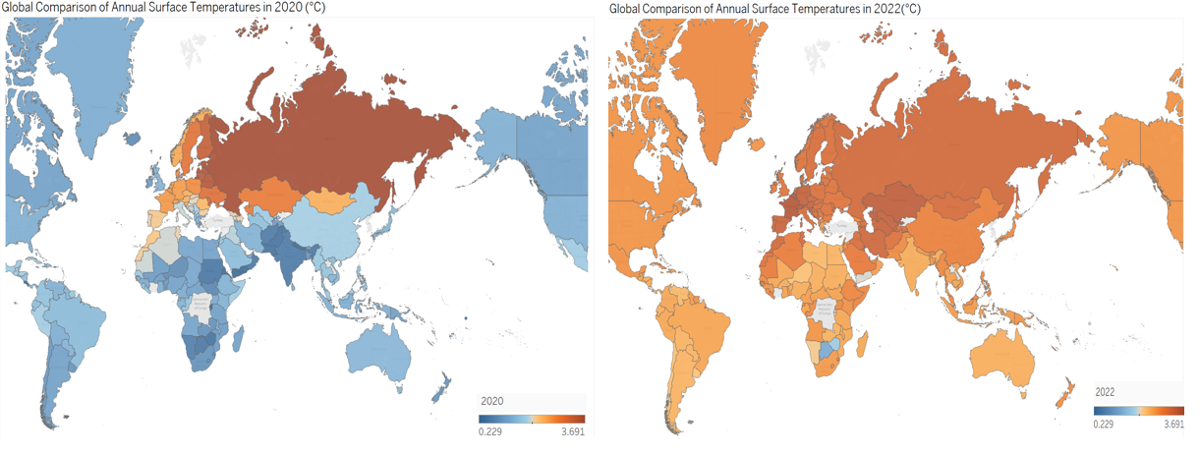

Visualization 6 displays a global comparison of annual surface temperature changes in 2020 and 2022, using a diverging color scale to indicate the degree of warming (in °C). The side-by-side maps reveal a stark shift: while 2020 saw cooler average temperatures in many regions, 2022 shows widespread and intensified warming across nearly the entire globe.

The cooler patterns in 2020 can likely be attributed to the COVID-19 pandemic, which significantly slowed industrial activity, transportation, and fossil fuel usage. However, the rapid rebound in surface temperature by 2022 underscores an idea we’ve discussed previously in this paper and project: that temporary reductions in emissions do not lead to long-term climate reversal unless accompanied by systemic, sustained change.

This visualization deepens our understanding of the threat and real impact these emissions have on us and our everyday lives. Unlike emissions data alone, temperature change reflects the lived impact of greenhouse gas accumulation over time. It reinforces the urgency of real mitigation strategies and challenges the idea that short-term disruptions (like lockdowns) are enough to move the needle meaningfully.

This final chart brings the project full circle. It shifts the focus from emissions sources and financial flows to the physical consequences of inaction, making the need for coordinated, large-scale, and enforced climate strategies even more apparent.

**Limitations**

While this analysis uncovers valuable insights into emissions and climate finance, several limitations should be acknowledged:

**Data Missing for Certain Countries**  
Some countries are not included in the datasets, which limits our ability to provide a complete global visualization or analysis.

**Underrepresentation of Regions**  
Entire regions such as South America are sparsely represented or entirely missing in some datasets, reducing the regional diversity of our findings.

**Lack of Country Reporting in Green Bond Dataset**  
In many cases, countries have not reported whether or not they received green bond financing. The absence of this official disclosure creates uncertainty about the true scale of climate finance distribution.

**Group Contribution**

Each team member actively contributed to different aspects of the workflow while gaining experience across all deliverables, including dataset selection, exploratory data analysis (EDA), visualization, and report preparation.

Pranjal led the effort in identifying and sourcing the dataset.

Yonathan, Rahul, and Abhilasha focused on conducting EDA and creating visualizations to extract meaningful insights from the data.

Sarfaraz took primary responsibility for compiling and structuring the final report.

Although each member had a primary role, collaboration occurred across all stages to ensure a well-rounded understanding of the project.

## Conclusion

Our analysis reveals a persistent rise in global greenhouse gas emissions from 2010 to 2022, with energy and manufacturing sectors driving much of the growth. Despite the implementation of international agreements and a significant increase in green bond financing, emission trends show little sign of reversal. This raises critical questions about the alignment between financial flows and environmental outcomes. While green bonds have enabled substantial investment in clean energy and infrastructure, the data suggests that current efforts may not be sufficient to counterbalance rising emissions.

Future research should explore the effectiveness and transparency of green bond allocation, as well as policy enforcement across top-emitting industries and regions. For meaningful progress, financial and regulatory strategies must work in tandem, supported by accurate monitoring and accountability mechanisms.

## References

**Cassia, R., Lombardi, A., & Russo, G.** (2018). *Climate change and the impact of greenhouse gases: CO2 and NO, friends and foes of plant oxidative stress.* *PMC.* <https://www.ncbi.nlm.nih.gov/>.

Climate Bonds Initiative. (2023). *Explaining Green Bonds*. Retrieved from <https://www.climatebonds.net>

**Dai, D., Zhang, X., Wang, Y., & Liu, Z.** (Year). *Research on industrial carbon emission prediction and resistance analysis based on CEI-EGM-RM method: A case study of Bengbu.* *Scientific Reports, Volume(Issue), Page Numbers.* https://doi.org/xxxxx

**Filonchy, M., Petrova, A., Ivanov, D., & Sidorov, P.** (2024). *Greenhouse gases emissions and global climate change: Examining the influence of CO2, CH4, and N2O.* *ScienceDirect.* <https://www.sciencedirect.com/>

**International Monetary Fund (IMF).** (n.d.). *Environmental protection expenditures.* Climate Change Indicators Dashboard. <https://www.imf.org/>

**NASA.** (n.d.). *Response to climate change (Mitigation and Adaptation - NASA Science).* NASA. <https://climate.nasa.gov/>

**World Resources Institute.** (n.d.). *Where do emissions come from? 4 charts explain greenhouse gas emissions by sector.* World Resources Institute. <https://www.wri.org/>

Flammer, C. (2021). *Corporate green bonds*. Journal of Financial Economics, 142(2), 499–516. <https://doi.org/10.1016/j.jfineco.2021.05.008>