Overview

Top/Bottom Analysis

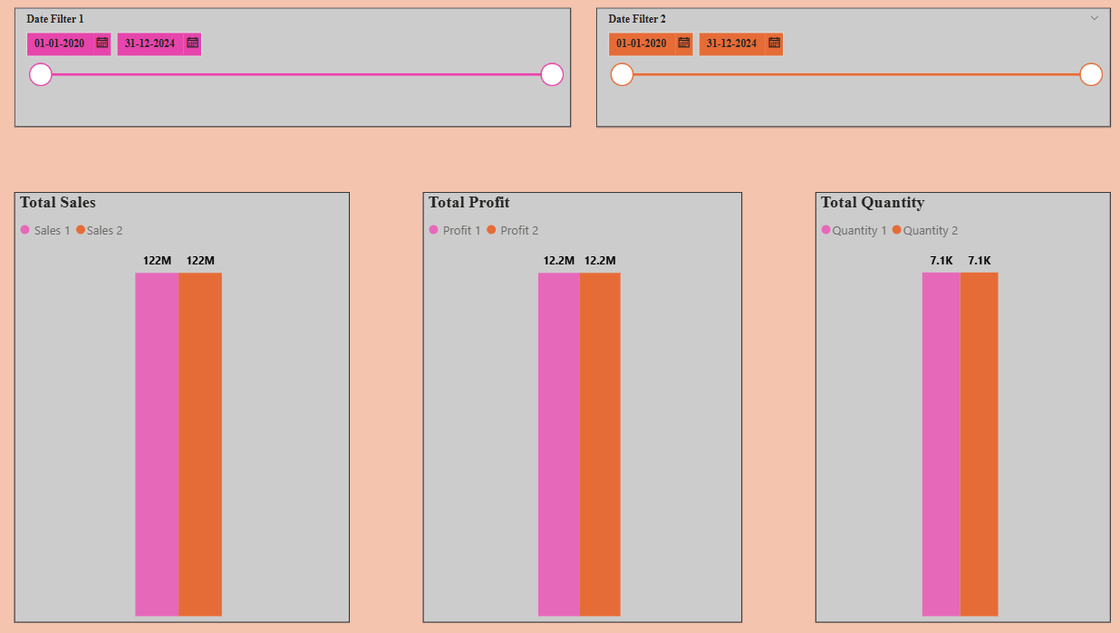

Comparison Sales/Profit/Quantity

Table Visual