

AN EMPIRICAL EVALUATION OF ALGORITHMIC POWER-NOISE INJECTION: UTILIZING MACHINE LEARNING TO DEFEND ENTERPRISE FIREWALL KERNELS AGAINST SIDE-CHANNEL ENERGY ANALYSIS ATTACKS
By
Sarfraz Masood
A DISSERTATION
Submitted to
MIDDLESEX UNIVERSITY
Computer Science Department
in partial fulfilment of the requirements for the degree of
MASTER OF SCIENCE
MSc Cyber Security and Emerging Threats
by Examination and Dissertation
September 2026

Dissertation/Project Coversheet
Student ID Number | M01085839
Student Name | Sarfraz Masood
Module Code | CST4990 — Postgraduate Individual Project
Programme of Study | MSc Cyber Security and Emerging Threats
Supervisor | David Neilson
Title | An Empirical Evaluation of Algorithmic Power-Noise Injection: Utilizing Machine Learning to Defend Enterprise Firewall Kernels Against Side-Channel Energy Analysis Attacks
Declared Word Count | 7,928 (main body, Chapters 1–6; excludes front matter, references and appendices)

Abstract
Kernel packet filters leak configuration information to unprivileged, co-located observers through a resource-consumption side channel: on the loopback path, Linux evaluates the nftables INPUT chain synchronously in the sender's own execution context, so sendto() latency reveals rule-chain depth and verdict. This dissertation asks whether algorithmic noise injection is an effective defence against a machine-learning adversary exploiting that leak.
An experimental harness collected 2,000 trials per run across four balanced firewall configurations, under Poisson-timed and reactive noise injectors at two core placements, with randomised interleaving, grouped cross-validation, and shuffled-label controls. Without the defence, random forest and logistic regression classifiers recover configuration well above chance (balanced accuracy 0.79 to 0.91), driven by a near-perfectly separable rule-depth axis. With the defence active, the single-shot accuracy reduction is not statistically significant in any of eight run-by-model combinations tested.
An observation-budget sweep shows why: under the most effective configuration, a defended attacker needs roughly twice as many observations to match an undefended one, with that advantage eroding as the budget grows. A tail-quantile analysis explains the null single-shot result: the additive noise inflates the upper tail of the latency distribution by up to two orders of magnitude while leaving the lower tail almost untouched, so a lower-tail-only attacker is barely affected. The defence's cost is similarly asymmetric: median latency rose under 3%, but p95 latency rose by up to 431.9% and CPU consumption by up to 4017%.
These results reproduce, on a kernel firewall rather than cryptographic hardware, Chari et al.'s (1999) prediction that noise-based countermeasures raise observation cost without removing the leak. The methodological contribution is demonstrating that a single accuracy figure cannot distinguish a defence that delays an attacker from one that does nothing, and that noise injection should be evaluated as a rate-limiting control, not a mitigation.

Declaration
I hereby certify that this dissertation constitutes my own product, that where the language of others is set forth, quotation marks so indicate, and that appropriate credit is given where I have used the language, ideas, expressions or writings of another.
I confirm that I have not copied material from another source nor committed plagiarism nor commissioned all or part of the work (including unacceptable proof-reading) nor fabricated, falsified or embellished data when completing the attached piece of work.
I declare that the dissertation describes original work that has not previously been presented for the award of any other degree of any institution.
Signed,
Sarfraz Masood
Date: 7 September 2026

Acknowledgements
I would like to thank my supervisor, David Neilson, for his guidance throughout the design and execution of this project. I am also grateful to the Middlesex University Computer Science Department for the resources and support that made the experimental work possible, and to my family and friends for their patience and encouragement over the course of this project.

Table of Contents
Dissertation/Project Coversheet 2
Abstract 3
Declaration 4
Acknowledgements 5
Table of Contents i
List of Tables iv
List of Figures v
Chapter 1: Introduction 1
1.1 Background and motivation 1
1.2 Problem definition 1
1.3 Aim and objectives 2
1.4 Research questions 2
1.5 Scope and limitations 2
1.6 Dissertation structure 3
Chapter 2: Literature Review 4
2.1 Physical side-channel analysis 4
2.2 Noise and masking countermeasures 4
2.3 Side channels in virtualised co-tenancy 5
2.4 Machine learning as the attacker model 6
2.5 Kernel packet filtering and ACL cost 6
2.6 Research gap 7
Chapter 3: Methodology / Research Design 8
3.1 Research approach 8
3.2 Threat model 8
3.3 Experimental environment 8
3.4 Firewall configurations 9
3.5 Measurement design 9
3.6 The defence 10
3.7 Experimental controls 11
3.8 Analysis procedure 12
Chapter 4: Results & Analysis 13
4.1 Dataset summary 13
4.2 Signal characterisation 13
4.3 Attacker accuracy: defence inactive 14
4.4 Attacker accuracy: defence active 16
4.5 Observation-budget curve 17
4.6 Cost of the defence 19
4.7 Validity checks 19
Chapter 5: Discussion & Critical Evaluation 20
5.1 Answering RQ1 20
5.2 Answering RQ2 20
5.3 Relation to prior work 21
5.4 Limitations 21
5.5 Recommendations 22
5.6 Reflection 23
Chapter 6: Conclusions & Further Work 24
6.1 Conclusions 24
6.2 Contributions 24
6.3 Further work 25
References 26
Appendices: CST4990 28
Appendix A: Project outline 29
A.1 Project identification 29
A.2 Aim 29
A.3 Objectives 29
A.4 Research questions 29
A.5 Deliverables 30
A.6 Schedule: as proposed, and as executed 30
A.7 Milestones 31
Appendix B: Risk assessment 33
B.1 Scope of assessment 33
B.2 Technical and validity risks 33
B.3 Project delivery risks 35
B.4 Health, safety and environmental 36
B.5 Legal and ethical risks 36
B.6 The one ethics question this project has to answer properly 37
B.7 Data management 38
Appendix C: Source code manifest 39
Appendix D: Run metadata and reproducibility 41
Appendix E: Research ethics screening 42

List of Tables
Table 3.1 Firewall configurations distinguished by verdict and rule-chain depth 9
Table 4.1 Median per-packet latency by configuration 13
Table 4.2 Attacker balanced accuracy, defence inactive 13
Table 4.3 Attacker balanced accuracy, defence active, and single-shot reduction 14
Table 4.4 Per-packet latency quantile inflation, run04 deep configurations 16
Table 4.5 Observation-budget trace-multiplication factor by run 17
Table 4.6 run04 verdict-axis sweep curve, accuracy by observation budget 17
Table 4.7 Cost of the defence: latency and CPU overhead by run 17
(Page numbers reflect this draft's current pagination; re-check them if content is added or removed before submitting.)

List of Figures
Figure 3.1 Experimental architecture: the victim (collect.py) and the noise injector (noise.py) run inside the same Lubuntu guest, contending for CPU when co-located on the same core; firewall.py applies one of four configurations per trial, and the resulting traces flow through the analysis pipeline (features.py through figures.py).. 10
Figure 4.1 Distribution of per-trial median send latency for each firewall configuration, with the noise-injection defence inactive and active. 14
Figure 4.2 Attacker balanced accuracy by condition and model. 15
Figure 4.3 Row-normalised confusion matrix for the random forest attacker. 15
Figure 4.4 Row-normalised confusion matrix for the logistic regression attacker. 15
Figure 4.5 Random forest feature importances, ordered by the undefended condition. 16
Figure 4.6 Attacker balanced accuracy as a function of observation budget, four-class axis. 18
Figure 4.7 Attacker balanced accuracy against observation budget on the verdict axis (accept vs drop within the deep configurations, chance 0.5), run04. 19

Chapter 1: Introduction

1.1 Background and motivation
Modern zero-trust network architectures assume that no host or path is trusted by default, and enforce that assumption largely through kernel-level packet filtering: Linux's nftables (and its predecessor, iptables) sits in the data path of every packet a host sends or receives, evaluating an access control list before deciding whether traffic proceeds. NIST's reference model for this design (Rose et al., 2020) formalises access control as a decision made at the point of use: a policy enforcement point evaluates every request against current policy, rather than inheriting trust from network location. That means enforcement, and therefore the configuration governing it, is distributed across many hosts rather than concentrated at a single perimeter gateway. The specific configuration of any one of those filters (which ports are open, which hosts are trusted, how deep the rule chain is) is itself sensitive information. Knowing a target's firewall configuration lets an attacker choose which services to probe, which ports are silently dropped rather than actively refused, and how a security policy is structured, all without triggering an alert that a direct configuration query would. Because zero-trust designs place enforcement points throughout the network rather than only at its perimeter, the configuration of any one of those points is worth protecting even though it never itself changes the response an attacker's own connection receives. Unlike a perimeter firewall, a policy enforcement point close to a workload is plausibly co-located with exactly the kind of untrusted, multi-tenant process this dissertation's threat model assumes.

1.2 Problem definition
A firewall configuration can leak through channels other than its intended responses. On the loopback path, the Linux kernel evaluates the nftables INPUT hook synchronously, inside the calling process's own execution context, so the observable latency of a single sendto() call is a function of how many rules the kernel evaluated and which verdict it reached. An unprivileged, co-located observer (one able to run code or exchange traffic with the host, but without filesystem or management-plane access) can therefore recover firewall state purely from resource-consumption signals: execution time and CPU footprint. This is the same class of threat identified for cross-tenant cloud environments by Ristenpart et al. (2009), who showed that co-located virtual instances can extract information about each other purely through resource contention, without either party's cooperation or knowledge. The leak is measurable in the first place because rule evaluation cost is not constant: Niemann, Pfingst and Göbel (2015) show empirically that Linux's netfilter subsystem processes packets more slowly as the number of rules in a chain grows, since rules are evaluated sequentially rather than through a structure with sub-linear lookup cost. A realistic adversary does not need to hand-derive the relationship between rule depth and latency either; Hettwer, Gehrer and Güneysu (2020) survey a substantial body of work showing that a generic, off-the-shelf classifier can learn to exploit a physical or resource side channel directly from raw measurements, without the attacker possessing prior knowledge of the underlying mechanism. This dissertation treats kernel packet-filtering configuration as the specific secret at risk, adopts a generic classifier as its attacker model on that basis, and asks whether a lightweight, software-only defence can protect the configuration against it.

1.3 Aim and objectives
The aim of this project is to evaluate whether algorithmic noise injection is an effective and practical defence against resource-consumption side-channel analysis of kernel firewall configuration. The three objectives are:
1. To build an experimental harness capable of measuring, with statistical rigour, whether a machine-learning attacker can recover firewall configuration from timing and resource-utilisation signals alone.
2. To implement and evaluate an algorithmic noise-injection defence against that attacker, across multiple triggering strategies and injector placements.
3. To quantify the trade-off the defence imposes, in both attacker accuracy and computational overhead, at a level of detail sufficient to support a genuine deployment recommendation rather than a single pass/fail verdict.

1.4 Research questions
RQ1. To what extent does algorithmic noise injection reduce a machine-learning attacker's accuracy in classifying firewall configuration from resource-consumption signals, relative to a 25% chance baseline (four balanced configuration classes)?
RQ2. What computational overhead, in CPU consumption and in latency imposed on legitimate traffic, does the defence require to achieve that reduction?

1.5 Scope and limitations
This dissertation is scoped to a timing and resource-utilisation side channel, not an electrical-power side channel. The proposal's title references power-noise injection and cites differential power analysis (Kocher et al., 1999) as its origin; the intended software proxy for electrical power draw, Intel's RAPL energy counters, is masked inside VirtualBox and VMware guests and was confirmed unreadable on the experimental platform by an automated preflight check before every collection run. What is measured instead is execution-time and CPU-utilisation footprint: the same broad category of physical side channel, one abstraction layer removed from a true power trace. All findings in this dissertation should be read as applying to that channel. Genuine power-domain replication would require a native (non-virtualised) install with working RAPL access, or dedicated power-measurement hardware, and is identified as further work in Chapter 6.

1.6 Dissertation structure
Chapter 2 reviews prior work on power and physical side channels, noise-based countermeasures, side channels in virtualised co-tenancy, and machine-learning attacker models, before identifying the gap this project addresses. Chapter 3 describes the experimental harness, threat model, and the controls used to ensure the results reflect a genuine side channel rather than a measurement artefact. Chapter 4 presents the results without interpretation. Chapter 5 interprets those results against the research questions and prior theory, states the study's limitations, and makes deployment recommendations. Chapter 6 concludes and identifies further work.

Chapter 2: Literature Review

2.1 Physical side-channel analysis
Kocher, Jaffe and Jun (1999) established that a cryptographic implementation's instantaneous power consumption is statistically correlated with the secret data it processes, and that this correlation survives averaging across many measurements even in the presence of substantial measurement noise: differential power analysis (DPA). The result reframed physical side channels from a theoretical curiosity into a practical attack against otherwise mathematically secure algorithms: security had to be evaluated at the level of the physical implementation, not only the algorithm. Genkin et al. (2015, 2016) later showed that the same class of leakage is exploitable on unmodified, commodity personal computers using low-cost equipment: electromagnetic and even acoustic emanations from a laptop are sufficient to recover a private key during decryption, with no physical modification of the target required. Read together, these two results establish the pattern this dissertation extends one abstraction layer up: a side channel need not require specialised measurement equipment or a purpose-built target, only a resource whose consumption both correlates with secret state and is observable by an adversary. For this dissertation's design, the implication is methodological rather than mechanistic: if commodity hardware and off-the-shelf sensors are sufficient to mount a DPA-class attack, then the absence of specialised equipment in this project's own setup (Section 3.3) is not a reason to treat the resulting channel as a weaker or less realistic threat; it is consistent with where the field's own attacks have moved.

2.2 Noise and masking countermeasures
Chari et al. (1999) provide the theoretical foundation for evaluating noise as a countermeasure. They model an attacker who must average over many measurements to overcome noise, and show formally that the number of measurements required grows with the square of the added noise's standard deviation: noise raises the cost of an attack rather than removing the underlying correlation between secret state and physical signal. This is the central prediction this dissertation tests directly, translated from a cryptographic hardware setting to a kernel packet filter: if noise injection behaves as Chari et al. predict, an attacker's accuracy should recover as their observation budget grows, rather than remaining permanently suppressed. Mangard (2004) operationalises the same question empirically, developing a statistical method to calculate exactly how many additional traces a given hardware countermeasure forces an attacker to collect, and demonstrating that this "trace-multiplication" framing allows different countermeasures to be compared on a single, principled metric rather than a single accuracy figure collected at one arbitrary sample size. That framing is the direct methodological ancestor of the observation-budget sweep this dissertation uses in Chapter 4: reporting a factor and a curve, not a solitary accuracy number, is the established way to evaluate a noise-based defence properly, and its comparative absence from applied, non-cryptographic noise-injection evaluations is part of the gap this dissertation addresses. Masure, Dumas and Prouff (2020) extend this line of evaluation into the deep-learning era, building an information-theoretic framework connecting modern neural-network attack metrics back to the classical guessing-entropy and mutual-information measures Chari and Mangard's generation used, and applying it directly to how masking and desynchronisation countermeasures degrade a deep-learning attacker's efficiency, confirming that the trace-multiplication question this dissertation asks of a kernel firewall is still an open, actively-studied one against contemporary machine-learning adversaries, not a question the field considers settled from 1999 to 2004. Neither the classical nor the deep-learning literature considers a defence whose noise is purely additive with respect to the measured quantity, as distinct from noise that can shift a signal in either direction around its true value. That distinction matters here: an additive-only defence can inflate an observed latency but can never make it smaller than the underlying, noise-free minimum, so it cannot touch the lower tail of a latency distribution however much noise is added. Chapter 4's central finding, that this project's defence leaves an attacker trained on lower-tail statistics almost entirely unaffected, is best read as a previously unstated consequence of the noise being additive rather than symmetric, a case Chari et al.'s general argument permits but does not itself distinguish from the symmetric case.

2.3 Side channels in virtualised co-tenancy
Ristenpart et al. (2009) demonstrated that virtual machines belonging to different, mutually distrusting tenants, when co-located on the same physical cloud host, can leak information to each other purely through shared hardware resource contention, with neither party's cooperation and without either crossing the hypervisor's isolation boundary in the conventional sense. This established co-tenancy itself, rather than any particular software vulnerability, as a side channel, and is the direct ancestor of the threat model in this dissertation: an unprivileged, merely co-located observer. Zhang et al. (2011) extended this line of work by inverting it defensively: using the same class of cache-based side channel that an attacker would use to detect unwanted co-residency, so that a tenant can tell whether a competing VM shares its host. Their result is evidence, from the defender's side, of exactly how much information a resource-contention channel carries in a virtualised environment, and supports treating a hypervisor-hosted setting (as used throughout this dissertation's own experimental design, Section 3.3) as a realistic environment for this class of leak rather than a laboratory contrivance. Both papers, however, concern channels arising from contention for a shared hardware resource (last-level cache) between processes that a scheduler may or may not place on the same physical core at any given moment. This dissertation's channel is narrower and, in one respect, more direct: it does not depend on the attacker sharing a cache with the victim at all, only on being able to send traffic the victim's kernel will process, so co-residency in Ristenpart et al.'s sense is sufficient but not necessary for the leak studied here. The trade-off is that the effectiveness of the defence, unlike the leak itself, turns out to depend on exactly the kind of shared-resource contention Zhang et al. exploit defensively: Section 3.7 and Section 4.5 show that the noise injector must be placed on the victim's own core to have any measurable effect, which is a same-core, not cross-core, contention requirement.

2.4 Machine learning as the attacker model
A side channel is only a practical concern if a realistic adversary can exploit it without hand-crafted, target-specific signal processing. Hettwer, Gehrer and Güneysu (2020) survey the substantial and still-growing body of work applying machine learning, from classical models to deep neural networks, directly to raw or lightly processed side-channel traces, and show that learned classifiers can match or exceed hand-engineered attacks such as template attacks across a range of targets, while requiring markedly less domain expertise from the attacker to construct. This supports the choice, in this dissertation's own design (Section 3.8), of a generic classifier (logistic regression and random forest, neither designed with any prior knowledge of the specific leak mechanism) as a credible stand-in for a realistic adversary, rather than requiring a bespoke, hand-tuned attack to demonstrate that the leak is exploitable. The survey also identifies a recurring evaluation pitfall directly relevant to this dissertation's own controls (Section 3.7): reported accuracy figures are frequently inflated by information leakage between training and test data, particularly where correlated samples (from the same trace, device, or session) are split across the training/test boundary rather than grouped, the same failure mode this dissertation's grouped cross-validation is designed to prevent.

2.5 Kernel packet filtering and ACL cost
The framing claim that packet-filtering configuration is worth protecting rests on two premises: that access-control enforcement is now distributed throughout a network rather than concentrated at its perimeter, and that the cost of evaluating a filtering rule set is not uniform, so its structure is in principle observable. NIST Special Publication 800-207 (Rose et al., 2020) formalises the first premise as the zero-trust architecture model, in which every access request is evaluated against policy at the point of use rather than trusted by virtue of network location: meaning a policy enforcement point, such as the kernel firewall studied here, exists at many places in a modern network, and its configuration is a target of independent value at each one. Niemann, Pfingst and Göbel (2015) support the second premise directly, empirically measuring Linux's netfilter subsystem and showing that packet-processing throughput degrades measurably as the number of rules in a chain grows, because netfilter (and its successor, nftables, used throughout this dissertation) evaluates rules sequentially rather than in a structure with sub-linear lookup cost. This is the mechanism the experimental harness in Chapter 3 exploits directly: chain depth is not merely logically distinguishable but measurably more expensive to evaluate, which is what makes it observable through a timing channel at all.

2.6 Research gap
Noise injection as a side-channel countermeasure is well studied in the cryptographic-hardware literature (Section 2.2), and co-tenancy side channels are well studied at the level of cache and memory-bus contention (Section 2.3). What is thin is the intersection: noise injection evaluated against a kernel policy-enforcement mechanism rather than a cryptographic primitive, using a realistic machine-learning adversary rather than a hand-derived statistical distinguisher, and evaluated against an observation budget rather than a single accuracy figure at one arbitrarily-chosen sample size. Mangard's (2004) trace-multiplication framing, and its modern deep-learning-era counterpart in Masure, Dumas and Prouff (2020), exist in the cryptographic hardware literature but are not standard practice in applied, systems-level noise-injection evaluations, where a single accuracy number before and after the defence is more commonly reported. This dissertation addresses that gap directly: it evaluates an algorithmic noise-injection defence against a kernel firewall configuration leak, with a machine-learning attacker, reporting both a single-shot accuracy comparison and a full observation-budget curve, so that the difference between a defence that eliminates a leak and one that merely rate-limits its observation, the distinction Chari et al. (1999) predict theoretically, can be seen directly in the results rather than assumed from the headline number alone.

Chapter 3: Methodology / Research Design

3.1 Research approach
This dissertation follows a quantitative experimental design, conducted entirely on a single isolated host with no human participants and no external network dependency. Both independent variables (the firewall configuration and the presence of the defence) are under direct experimental control, and the dependent variables (attacker classification accuracy, CPU overhead, latency inflation) are measured directly from instrumented code rather than estimated or self-reported. This design was chosen because the research questions concern a causal, mechanistic relationship (does injected noise reduce the information an observer can extract, and at what cost) that a controlled measurement can answer more precisely than a survey or case-study design. The experiment sits within a Low-Risk ethics self-assessment: no participants, no personal data, and no system other than the researcher's own laptop and virtual machine is touched.

3.2 Threat model
The attacker is an unprivileged process co-located with a packet-filtering host: able to run code on, or send traffic to, the victim, but unable to read its configuration files, query its management interface, or receive any response that reveals firewall state directly. This is the threat model of interest because it is the one a correctly-configured firewall is supposed to defeat: an attacker with root or filesystem access does not need a side channel at all. The observer's only source of information is a resource-consumption signal: in this case, the wall-clock latency of a sendto() call on the loopback path, which the Linux kernel evaluates against the nftables input hook synchronously, in the sending process's own execution context. The secret the attacker tries to recover is which of four firewall configurations is currently active (Table 3.1); a working defence should push classification accuracy toward the 25% chance floor.

3.3 Experimental environment
All data collection ran inside a Lubuntu 22.04 guest (kernel 5.15.0-139-generic, Python 3.8.10, nftables v0.9.3) under VirtualBox on a host with a 13th Gen Intel Core i9-13980HX. The guest was provisioned with 4 vCPUs and 4 GB RAM: one vCPU to host the victim process, three to host the noise injector, so that the two never compete for a single time-sliced core by accident. The VirtualBox process itself was pinned to the host's eight physical performance cores (excluding the four efficiency cores) for every collection session, because a vCPU thread migrating between a P-core and an E-core mid-experiment produces a timing discontinuity an order of magnitude larger than the side-channel signal itself; this pinning is recorded as an experimental control in Section 3.7. Timestamps were taken with CLOCK_MONOTONIC_RAW at 1 ns nominal resolution. Every run's exact environment (kernel, CPU model, nft version, clock resolution, and every collection parameter) is written to a run*.meta.json file alongside its data, so any run can be independently checked for drift.

3.4 Firewall configurations
The attacker's task is to distinguish four nftables configurations, which vary along two independent axes: verdict (accept or drop) and depth, the number of non-matching filler rules the packet traverses before reaching the rule that decides its fate.
Table 3.1. Firewall configurations distinguished by verdict and rule-chain depth
Config | Verdict | Rules before match
accept_shallow | accept | 0
accept_deep | accept | 256
drop_shallow | drop | 0
drop_deep | drop | 256

Four balanced classes give a chance-level baseline of 25%. Depth was implemented as individually generated filler rules rather than a single compound rule so that traversal cost accumulates the way it would in a real, incrementally-grown enterprise ACL, rather than being collapsed into one cheap kernel-side check.

3.5 Measurement design
The probe traffic is sent over loopback rather than a physical NIC. This is a deliberate design choice, not a convenience: on loopback, the kernel evaluates the INPUT chain synchronously inside the sender's own sendto() call, so the chain traversal cost is directly visible in the caller's measured latency. Routing the same probe through a physical interface would push filtering into a softirq handled on a different core, and the signal would be lost in ordinary scheduling jitter.
Each trial times 60 batches of 200 sendto() calls (PACKETS_PER_BATCH = 200, BATCHES_PER_TRIAL = 50 recorded, plus 10 discarded); batching amortises the ~1 microsecond of CPython interpreter overhead per call against the 1 to 20 microsecond effect of interest, which raises signal-to-noise ratio without rewriting the probe in a lower-level language. The first ten batches of every trial are discarded as warm-up, to exclude cold-cache and first-touch effects that are artefacts of process start-up rather than of the firewall configuration under test. The resulting per-packet latency (ns_per_pkt) is the sole raw measurement from which every downstream feature is derived.
Sample size was raised from the proposal's 25 trials per condition to 250 (2,000 trials in total: 250 × 4 configurations × 2 defence conditions). Twenty-five samples spread across a four-class confusion matrix leaves roughly six examples per class, which cannot support a stable estimate of per-class accuracy or a usable 95% confidence interval; 250 per cell still collects in under three minutes of wall-clock time, so the increase costs nothing but is necessary for the statistics in Chapter 4 to be meaningful. Exceeding a proposed minimum is straightforward to justify; falling short of one is not.

3.6 The defence
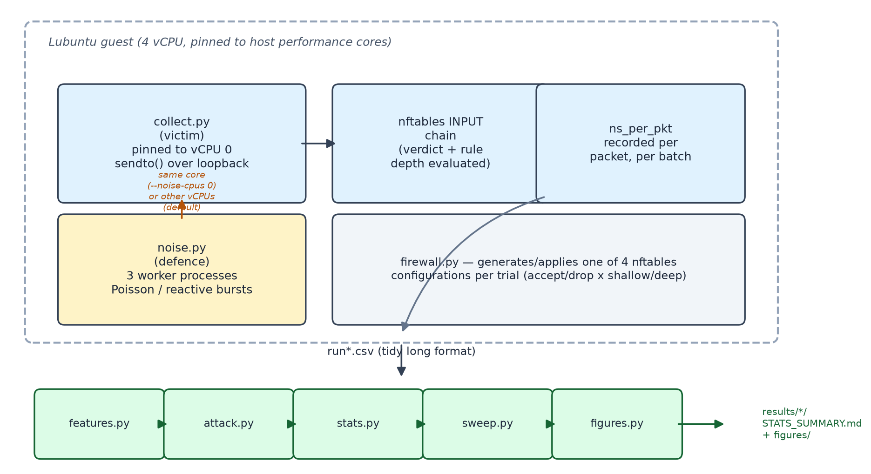
Figure 3.1. Experimental architecture: the victim (collect.py) and the noise injector (noise.py) run inside the same Lubuntu guest, contending for CPU when co-located on the same core; firewall.py applies one of four configurations per trial, and the resulting traces flow through the analysis pipeline (features.py through figures.py).
The defence, noise.py, is a multiprocess noise injector intended to model algorithmic power-noise injection: randomised bursts of CPU-bound work run in parallel with the victim process, with the aim of masking the victim's true resource footprint from an external observer. It uses operating-system processes rather than threads because CPython's global interpreter lock prevents a multi-threaded injector from saturating more than one core at a time, which would produce far less execution-footprint entropy than a process-based design.
Two triggering modes were implemented and evaluated independently: a Poisson mode, in which three worker processes emit bursts at a fixed mean rate of 120 Hz with burst durations drawn uniformly from 0.5 to 4.0 ms; and a reactive mode, which polls the nftables packet counter every 5 ms and fires a burst only when it changes, matching the proposal's framing of noise injected "whenever security policies are triggered". Both modes are evaluated against both of the placement conditions described in Section 3.7, giving four collected runs in total.

3.7 Experimental controls
Five controls were built into the harness because, absent them, a specific artefact would produce a result that looked like a genuine finding.
Noise placement. --noise-cpus defaults to every vCPU except the one the victim is pinned to. Under that default, the injector and the victim never contend for the same core, and the defence cannot perturb the execution footprint it exists to mask, confirmed empirically by a mean sweep-curve accuracy gap of only +0.017 and +0.001 in the two cross-core runs (Chapter 4). Re-running with the injector explicitly pinned to the victim's own core (--noise-cpus 0) is what produces a measurable effect. Both placements were kept as a paired control rather than discarding the ineffective one, because the contrast is itself a finding: an algorithmic noise defence only works if it contends for the resource the attacker is measuring, and a naive co-tenancy deployment does not guarantee that.
Randomised, interleaved scheduling. All 2,000 trials for a run are shuffled into a single randomised order rather than collected block-by-block (all noise-off trials, then all noise-on trials). Block collection would let ordinary thermal or scheduler drift over the run's multi-minute duration separate the two conditions with high apparent accuracy, a pure artefact of collection order rather than of the defence.
Core pinning. The VirtualBox process was pinned to the host's physical performance cores for every session (Section 3.3); without it, a vCPU migrating to an efficiency core introduces a timing step larger than the effect under test. This pinning restricts which physical cores the guest may use; it does not alter how the guest's own virtual CPUs are scheduled relative to one another, so it changes nothing about the noise-placement comparison in Chapter 4: same-core and cross-core conditions are both collected under identical, all-performance-core pinning, and preflight.py's achieved-parallelism check confirms the expected number of concurrently-runnable workers under pinning before every real collection, so this control was verified empirically rather than assumed.
Trial-level aggregation and grouped cross-validation. The 50 batches within one trial share a single thermal and scheduling state, so splitting them across the train/test boundary would leak label information between folds and inflate accuracy toward 100%. Batches are aggregated to one feature vector per trial, and cross-validation folds are grouped on trial_idx, so no trial's data appears on both sides of a split. This is the single most common way published side-channel classifiers overstate their accuracy: Zhou et al. (2018) show the same failure mode for hardware-performance-counter-based malware classifiers, where splitting correlated samples from the same execution at random rather than by program inflates reported detection accuracy, and demonstrate that a grouped split removes the inflation.
Shuffled-label control. Every classifier fit is repeated with permuted labels and reported alongside the real score. A shuffled-label score materially above the 25% chance floor would indicate the pipeline is leaking information through some channel other than the intended signal, invalidating the real result.

3.8 Analysis procedure
Nineteen features are derived from ns_per_pkt alone per trial (instrumentation columns such as noise_cpu_s are excluded from the predictor set, since they represent information available to the experimenter, not to a real observer). Two classifiers (logistic regression and random forest) are trained under grouped stratified cross-validation, and balanced accuracy is reported with bootstrap 95% confidence intervals and a permutation test against the chance baseline. To answer RQ1 with more than a single accuracy figure, sweep.py re-runs the attack at observation budgets of 1, 2, 3, 5, 8, 12, 20, 32 and 50 batches per trial and reports a trace-multiplication factor: the number of additional batches a defended attacker needs to reach the accuracy an undefended one reaches at a given budget. The entire pipeline is deterministic under a fixed seed, and was verified to reproduce all nine result files byte-for-byte on repeated runs over the same input trace.

Chapter 4: Results & Analysis

4.1 Dataset summary
Four runs were collected on 26 and 27 August 2026, each following the collection procedure and parameters fixed in Chapter 3 (2,000 trials per run, 250 per configuration, 50 recorded batches of 200 packets per trial). The four runs differ only in the two defence variables under test (triggering mode and noise-injector placement) and are identified consistently by this table throughout the chapter, so that every number below can be traced back to the exact configuration that produced it:
Table 4.1. Median per-packet latency by configuration
Run ID | Noise mode | Noise placement
run01 | Poisson | cross-core
run02 | reactive | cross-core
run03 | Poisson | same-core
run04 | reactive | same-core

Every table and figure in this chapter labels results by this run ID rather than by mode/placement alone, so a reader can trace any number back to Chapter 3's exact experimental setup for that run. Per-run environment details (kernel, Python, nftables version, clock resolution, seed) are recorded individually in data/run*.meta.json and do not vary across runs.

4.2 Signal characterisation
Median per-packet latency separates cleanly by chain depth:
Table 4.2. Attacker balanced accuracy, defence inactive
Config | Median ns/pkt
accept_shallow | 1059.6
drop_shallow | 929.4
accept_deep | 3986.4
drop_deep | 3827.1

snr_check.py (120 batches per configuration) quantifies this as a near-perfect signal on the depth axis (AUC 1.000 for both verdicts, Cohen's d of 3.74 for accept and 9.64 for drop), against a much weaker signal on the verdict axis: AUC 0.601 (shallow) and 0.652 (deep). Chain depth is therefore roughly a four-fold effect on raw latency and is separable from a single packet, while accept/drop is a substantially smaller, marginal effect. This asymmetry between the two axes shapes every result that follows.
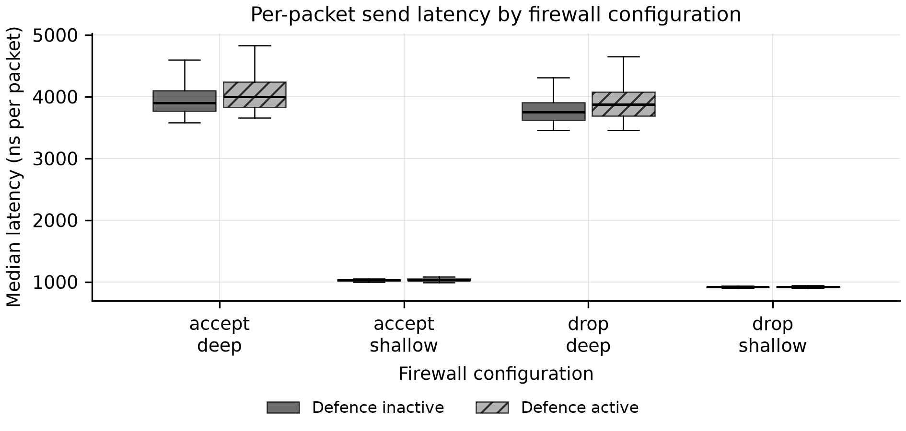
Figure 4.1. Distribution of per-trial median send latency for each firewall configuration, with the noise-injection defence inactive and active. Separation between configurations is the side channel; the upward shift under the defence is the latency cost paid by legitimate traffic.

4.3 Attacker accuracy: defence inactive
With the defence off, a random forest classifier under grouped cross-validation achieves balanced accuracy well above the 25% chance floor in every run:
Table 4.3. Attacker balanced accuracy, defence active, and single-shot reduction
Run | Placement | Balanced accuracy (noise off)
run01 (Poisson) | cross-core | 0.912 [0.894, 0.929]
run02 (reactive) | cross-core | 0.786 [0.762, 0.810]
run03 (Poisson) | same-core | 0.817 [0.794, 0.840]
run04 (reactive) | same-core | 0.906 [0.888, 0.924]

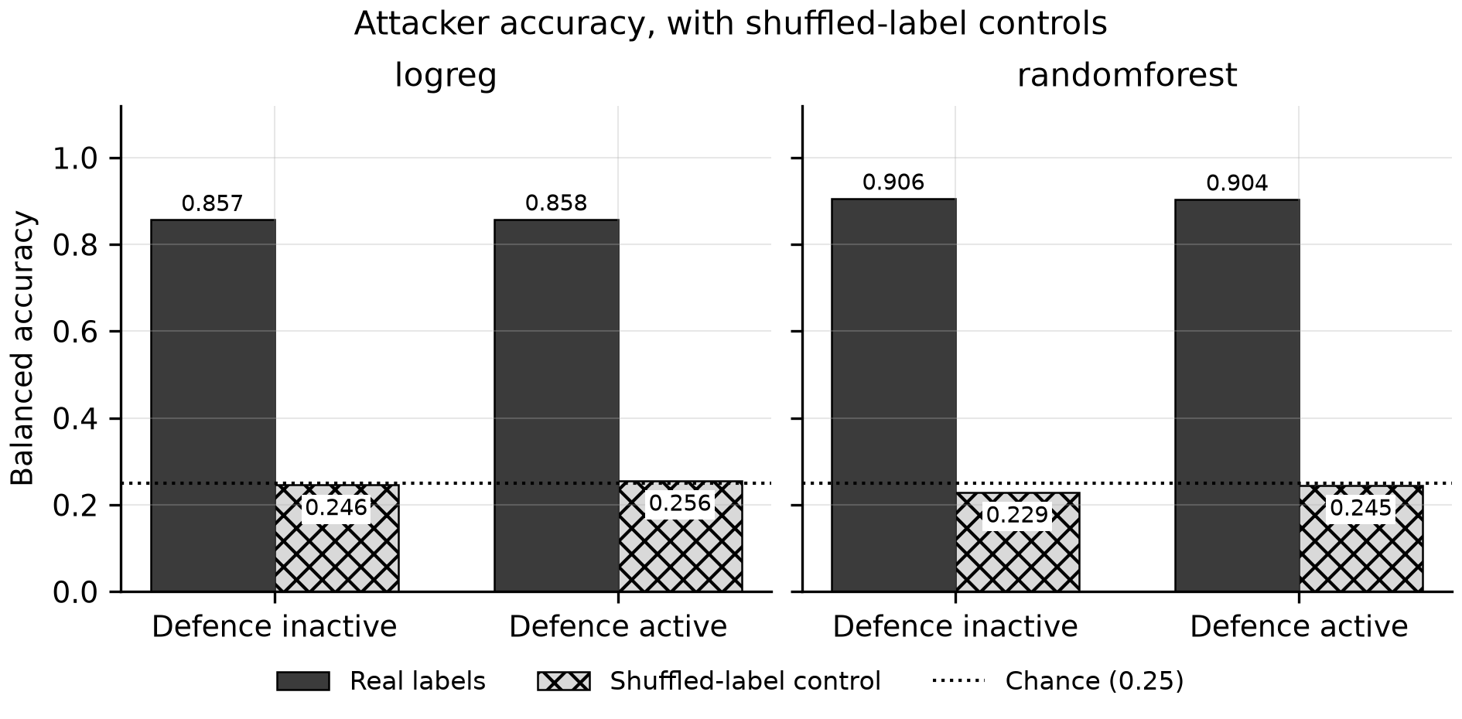
Figure 4.2. Attacker balanced accuracy by condition and model. The shuffled-label control refits the identical pipeline on permuted labels and sits at the chance baseline, evidence that the real scores reflect a side channel rather than leakage in the cross-validation.
The confusion matrix for run01 (confusion_randomforest_noise_off.csv) shows the error structure implied by Section 4.2: the two shallow configurations are recovered almost perfectly (250/250 and 234/250), while essentially all classification error is confined to confusing accept_deep with drop_deep (24 and 48 misclassifications out of 250 respectively). The classifier recovers chain depth almost perfectly and is comparatively unreliable on verdict, exactly what the AUC values in Section 4.2 predict.
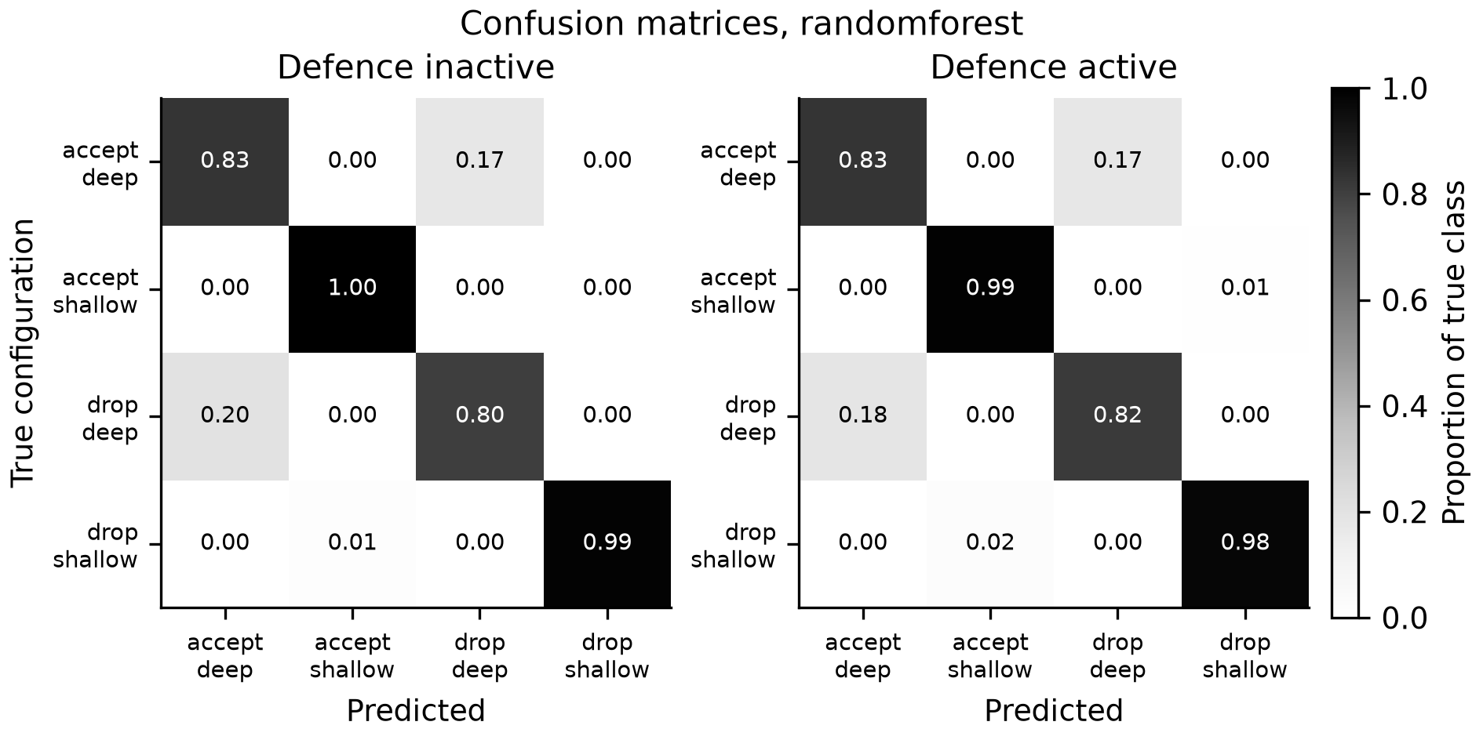
Figure 4.3. Row-normalised confusion matrix for the random forest attacker. Rows sum to one, so the diagonal is per-class recall and off-diagonal mass shows which configurations the attacker cannot separate.
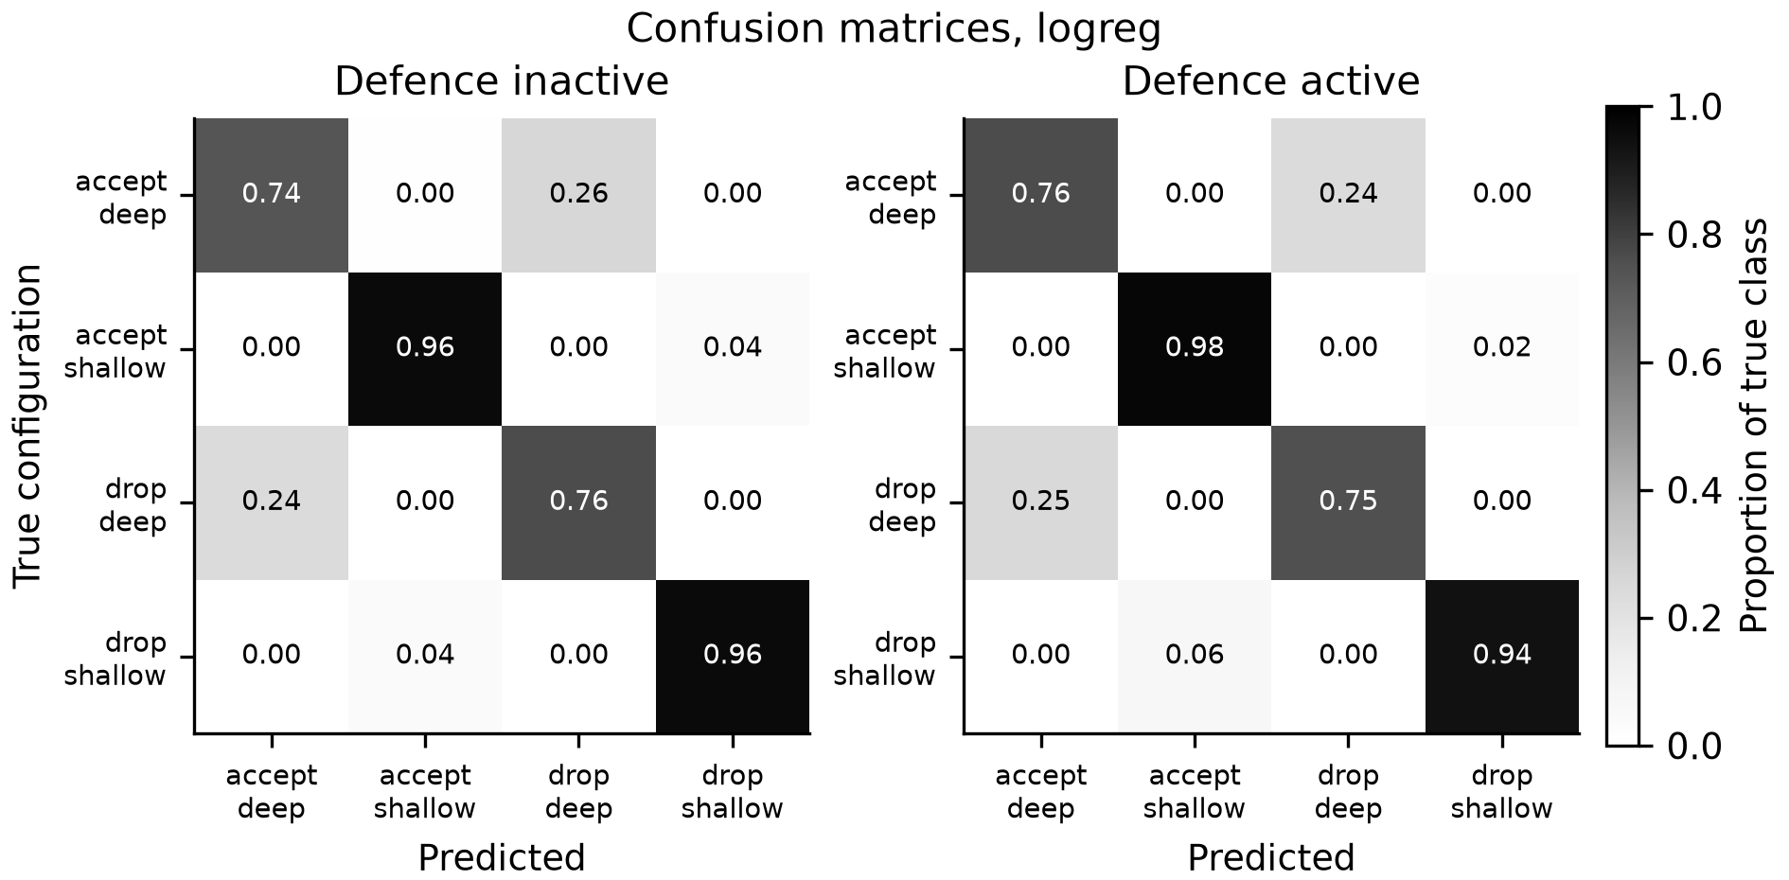
Figure 4.4. Row-normalised confusion matrix for the logistic regression attacker. As with Figure 4.3, off-diagonal mass concentrates on the accept_deep/drop_deep pair rather than on the shallow configurations.
Feature importances (feature_importance_*.csv) confirm that all discriminative power derives from ns_per_pkt-based statistics; no instrumentation column contributes, by construction (Section 3.7).
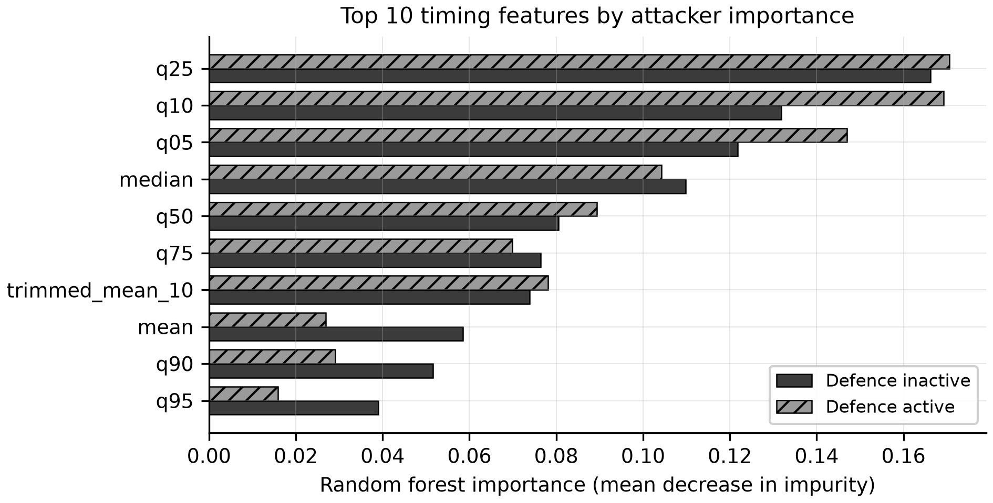
Figure 4.5. Random forest feature importances, ordered by the undefended condition. Which statistic dominates indicates what the channel is: central-tendency features indicate a deterministic cost difference, while spread or tail features indicate the leak is carried by variability.
The same asymmetry appears in all four runs, not only run01: balanced accuracy never drops below 0.786 (run02) even though run02 and run04 use the reactive triggering mode with no defence engaged yet, because the depth axis alone is sufficient to carry a random forest well above chance regardless of which triggering mode was later paired with it during collection. This is expected: noise mode and injector placement are properties of the defended condition only, and Section 4.3 reports the undefended condition, so cross-run variation here reflects ordinary sampling variation in the classifier and collection schedule rather than any property of the (as yet inactive) defence.

4.4 Attacker accuracy: defence active
Table 4.4. Per-packet latency quantile inflation, run04 deep configurations
Run | Placement | Balanced accuracy (noise on) | Reduction, RF (pp)
run01 (Poisson) | cross-core | 0.902 [0.884, 0.920] | 1.0 [-1.5, 3.5]
run02 (reactive) | cross-core | 0.771 [0.745, 0.796] | 1.5 [-1.9, 5.1]
run03 (Poisson) | same-core | 0.827 [0.803, 0.850] | -1.0 [-4.5, 2.1]
run04 (reactive) | same-core | 0.904 [0.886, 0.922] | 0.2 [-2.1, 2.6]

Every reduction confidence interval crosses zero, for both classifiers in all eight run × model combinations tested. There is no statistically significant reduction in single-shot classification accuracy in any configuration tested; three of the eight point estimates are in fact negative.
Why the reduction is null. Per-packet quantile analysis of run04 (deep configurations, tail_quantile_inflation.csv) shows the defence's effect is highly non-uniform across the latency distribution:
Table 4.5. Observation-budget trace-multiplication factor by run
Quantile | noise off (ns) | noise on (ns) | change
q05 | 3427.1 | 3461.6 | +1.0%
q50 | 3829.5 | 3931.2 | +2.7%
q90 | 8465.2 | 17406.7 | +105.6%
q95 | 12126.0 | 32745.5 | +170.0%

The injected noise is additive, so it can only make a sendto() call slower; it cannot make the victim's fastest packets faster. The lower tail of the distribution is therefore almost unaffected while the upper tail inflates by two orders of magnitude more. A decisive ablation (tail_ablation.csv) trains separate classifiers on low-tail-only and upper-tail-only features (verdict axis, chance 0.5): in run04, the upper-tail classifier drops from 0.658 to 0.538 (near chance) when the defence is active, while the low-tail classifier is essentially untouched (0.832 → 0.824). A classifier using the full 19-feature set loses 0.000 balanced accuracy in the same run. It simply routes around the part of the distribution the defence perturbs.

4.5 Observation-budget curve
A single accuracy figure understates what the defence does. Sweeping the observation budget (batches per trial) on the verdict axis (chance 0.5), the axis on which noise has measurable room to act per Section 4.2, shows accuracy climbing with budget under both conditions, with the defended curve initially lagging the undefended one:
Table 4.6. run04 verdict-axis sweep curve, accuracy by observation budget
Placement / mode | Trace-multiplication factor | Mean gap | Max gap
run01, Poisson, cross-core | 1.5× | +0.017 | +0.042 @ 2 batches
run02, reactive, cross-core | 1.0× | +0.001 | +0.038 @ 2 batches
run03, Poisson, same-core | 2.5× | +0.004 | +0.048 @ 8 batches
run04, reactive, same-core | 2.0× | +0.061 | +0.144 @ 5 batches

run03's larger nominal factor rests on a single crossing of a curve whose mean gap is +0.004 and which steps backward three times out of eight sampled budgets; run04's smaller factor sits on a curve that separates cleanly from 2 to 12 batches with a mean gap an order of magnitude larger, and is the figure of record for this section (fig3b_sweep_curve_verdict.png):
Table 4.7. Cost of the defence: latency and CPU overhead by run
Batches | noise off | noise on
1 | 0.660 | 0.628
2 | 0.722 | 0.664
5 | 0.814 | 0.670
12 | 0.806 | 0.726
20 | 0.786 | 0.768
50 | 0.816 | 0.834

By 50 batches the defended attacker has caught up to, and marginally exceeded, the undefended one. The equivalent sweep on the 4-class axis saturates: both conditions already clear the half-way accuracy target at the smallest budget tested (1 batch, opening accuracy 0.717), so the trace-multiplication factor is 1.0 by construction and the sweep measures nothing on that axis. This saturation is itself a result: chain depth leaks far more strongly, and far faster, than verdict does.
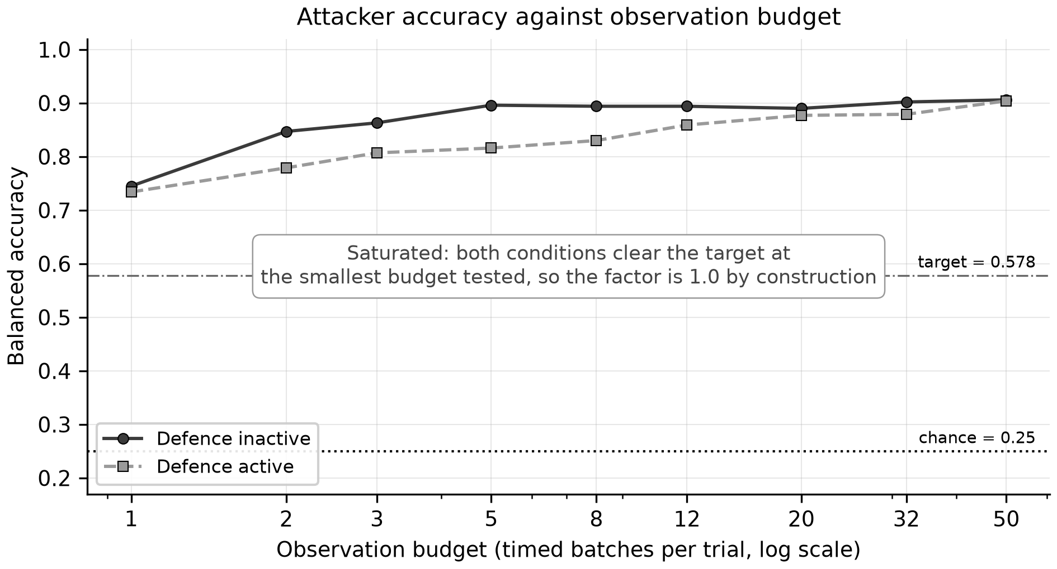
Figure 4.6. Attacker balanced accuracy as a function of observation budget, four-class axis. Both conditions clear the half-way target at the smallest budget tested, so the trace-multiplication factor degenerates to 1.0 and the axis is reported as saturated rather than informative.
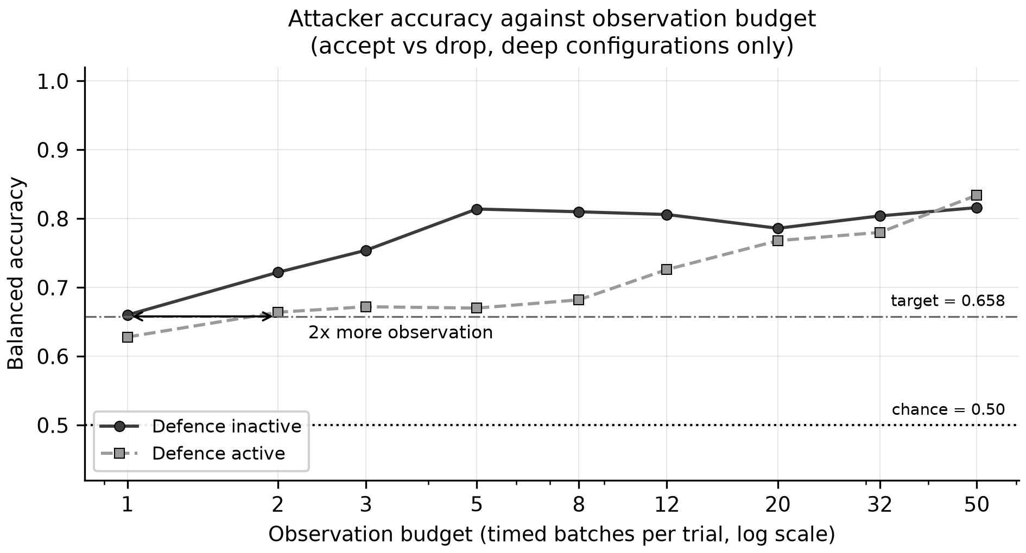
Figure 4.7. Attacker balanced accuracy against observation budget on the verdict axis (accept vs drop within the deep configurations, chance 0.5), run04. Separation between the curves is the cost the defence imposes; convergence at the largest budgets is the attacker recovering: the outcome Chari et al. (1999) predict for noise countermeasures.

4.6 Cost of the defence
Run | Placement | Median latency increase | p95 latency increase | CPU increase
run01, Poisson | cross-core | +1.46% | +3.23% | +474%
run02, reactive | cross-core | +0.29% | +0.80% | +116%
run03, Poisson | same-core | +2.96% | +431.9% | +4017%
run04, reactive | same-core | +2.95% | +148.5% | +536%

The tail moves far more than the median: run03's raw p95 latency rises from 4,474 ns to 23,619 ns. noise_cpu_s per trial in run01 rises from 0.0029 to 0.0167 CPU-seconds (p ≈ 2 × 10⁻¹⁴⁶). The trade attached to run04's 2.0× trace-multiplication factor is +148.5% p95 latency and +536% CPU overhead.
The two same-core runs (run03, run04) pay markedly more CPU overhead than the two cross-core runs (run01, run02) despite using the same three-worker, 120 Hz-mean burst configuration, because same-core placement forces the injector to contend with the victim for scheduling quanta on a single vCPU rather than running unopposed on idle cores. The same placement choice that Section 4.5 shows is necessary for the defence to have any accuracy effect at all is also the more computationally expensive one to run. Poisson triggering (run01, run03) is consistently costlier than reactive triggering (run02, run04) at matched placement, since Poisson bursts fire continuously at a fixed mean rate regardless of firewall activity, whereas reactive bursts fire only when the nftables counter moves.

4.7 Validity checks
Shuffled-label controls sit between 0.231 and 0.258 against a chance baseline of 0.25 across all four runs and both classifiers; run_analysis.sh asserts every such control is within 0.08 of chance and reports a pass for all four runs. A synthetic null-data fixture (data/synth_null.csv, not a result) scores at the chance floor in both conditions, confirming the pipeline does not manufacture a signal where none exists. preflight.py reported a READY verdict prior to every collection, with one recorded caveat: the RAPL energy_uj counter is unreadable inside the VirtualBox guest, consistent with the scoping stated in Section 1.5.

Chapter 5: Discussion & Critical Evaluation

5.1 Answering RQ1
RQ1 asked to what extent algorithmic noise injection lowers an attacker's classification accuracy. Taken as a single number, the answer is "not significantly": every reduction confidence interval across eight run × model combinations crosses zero (Section 4.4), and three of the eight point estimates are negative. Read that way, the defence appears to do nothing.
That reading is incomplete, and the observation-budget curve in Section 4.5 shows why. Under the most effective configuration tested (reactive triggering with the injector sharing the victim's core), the defended attacker needs roughly twice as many observation batches to reach the accuracy an undefended attacker reaches at the same budget, with a mean accuracy gap of +0.061 and a peak of +0.144 at five batches. The defence does not lower the attacker's ceiling; it raises the cost of observation needed to reach it. A single accuracy figure, collected at one arbitrarily-chosen budget, cannot distinguish "the defence does nothing" from "the defence delays the attacker by a factor of two": both look identical at a budget large enough for the curves to reconverge. This is the central methodological argument of the dissertation: RQ1 does not have a single-number answer, and evaluations that report only one should be treated with suspicion.

5.2 Answering RQ2
RQ2 asked what computational overhead the defence imposes. The cost is substantial and asymmetric between the median and the tail. Median latency inflation stayed under 3% in every run, which in isolation looks acceptable. p95 latency, however, rose by 148.5% in the best-performing configuration (run04) and by 431.9% in the worst (run03); CPU overhead ranged from +116% to +4017% across the four runs. Whether this trade is acceptable depends entirely on which statistic a deployment is judged against: a defence that triples tail latency to buy a two-fold increase in an attacker's required observation budget is a very different proposition from one framed only by its sub-3% median cost. Section 5.5 argues that reporting the median alone, as much prior noise-injection evaluation does, is itself part of the problem this dissertation identifies.
The CPU figure needs the same scrutiny before it is used to argue for or against deployment. A CPU increase reported as a percentage of an already-tiny baseline is easy to misread: run01's headline +474% corresponds to an absolute rise from 0.0029 to 0.0167 CPU-seconds per trial (Section 4.6), which is negligible in isolation on a single host but does not by itself say what happens under production load, where the injector's workers compete with real traffic-handling processes for the same cores rather than running on an otherwise-idle guest. The percentage answers "how much more work is the defence doing relative to itself", not "can this host afford it", and only the second question determines whether the trade is acceptable at a given deployment's utilisation level. Reporting both the relative increase and the absolute CPU-seconds figure, as this dissertation does throughout Section 4.6, is necessary for exactly this reason: a relative figure alone cannot be evaluated against a specific host's spare capacity.

5.3 Relation to prior work
Chari et al. (1999) predicted, for noise-based countermeasures against power analysis, that noise multiplies the number of traces an attacker needs rather than eliminating the underlying leak. The observation-budget curve in Section 4.5 reproduces exactly this shape on a modern kernel firewall, a very different system from the cryptographic hardware Chari et al. analysed: accuracy under the defence starts below the undefended curve and converges toward it as the attacker is given more observations, rather than remaining suppressed indefinitely. That the same qualitative behaviour appears in kernel-level packet filtering as in hardware power traces is evidence that the theoretical argument, that additive noise raises cost rather than removing information, generalises beyond the domain it was originally proposed for.
The tail-quantile analysis in Section 4.4 adds a mechanism Chari et al.'s original argument does not need to specify, because it assumes noise perturbs the signal more or less uniformly. This defence does not: because the injected noise is additive, it can only slow packets down, so it inflates the upper tail of the latency distribution by two orders of magnitude while leaving the lower tail almost untouched (Section 4.4). An attacker who trains a classifier on lower-tail statistics alone is essentially unaffected by the defence. Where prior evaluations report a single accuracy number, this result shows why that number can be null even when the defence is measurably changing the underlying distribution: the attacker is not defeated, it is redirected to the part of the distribution the defence does not reach.

5.4 Limitations
Timing and resource utilisation, not electrical power. The proposal was framed around power analysis; this implementation measures execution time and CPU utilisation. Intel RAPL energy counters, the software proxy for electrical power draw, are masked inside VirtualBox guests (confirmed by preflight.py on every run, Section 4.7), so a genuine power-domain replication was not possible on this hardware. The result is best read as evidence about a resource-utilisation side channel one abstraction layer above true DPA, not as a power-analysis result itself.
Virtualised, not bare-metal. All measurements were taken inside a VirtualBox guest. Hypervisor scheduling, even with core pinning applied, introduces jitter that a bare-metal deployment would not have; the true signal-to-noise ratio on native hardware could differ in either direction.
Loopback, not a physical network path. Probing over loopback was necessary to keep the nftables chain traversal synchronous with the sender (Section 3.5), but this means the result does not directly generalise to a firewall filtering traffic arriving over a real NIC, where the softirq handling the packet may run on a different core from the observer's timing loop.
Synthetic ACL structure. The 256-rule "deep" configuration models chain length with individually generated filler rules of uniform, minimal cost. Real enterprise rule sets mix rule types of varying per-rule cost (stateful matches, address-set lookups), which this design does not capture.
Single host, single hardware generation. All four runs were collected on one laptop. The magnitude of both the leak (Section 4.2) and the defence's effect (Section 4.5) may be specific to this CPU's cache and scheduling characteristics.
A Python-level timing floor. The probe and the classifier's feature extractor both run in CPython, whose per-call interpreter overhead (~1 µs) is a non-trivial fraction of the shallow-configuration latency (~1 µs). Batching (Section 3.5) was used to manage this, but a native implementation would have a lower and more stable measurement floor.

5.5 Recommendations
Algorithmic noise injection is worth deploying only where an attacker's observation budget is independently bounded, for example behind connection or rate limiting that caps how many timed samples an adversary can collect before being throttled or detected. Deployed without such a bound, this evaluation shows the defence is a delay, not a barrier: given enough batches, the defended and undefended curves converge (Section 4.5).
Where a genuine floor-level guarantee is required, the tail-inflation result (Section 4.4) points to a specific design correction. An additive-noise defence cannot raise the minimum achievable latency in a given configuration, only its upper tail; a constant-time or padded-to-fixed-minimum policy-evaluation design would instead raise the floor itself, closing exactly the channel the low-tail attacker in Section 4.4 exploits. The two approaches are complementary rather than competing: noise injection raises the cost of prolonged observation, and a raised floor removes the low-tail escape route.
Evaluations of this class of defence should report an observation-budget curve and a trace-multiplication factor alongside any single accuracy figure, and should report tail latency (p95 or higher) alongside the median cost. Either number reported alone systematically favours the defence.

5.6 Reflection
The most useful methodological lesson from this project was operational rather than statistical: noise_cpu_s, the CPU-overhead measurement underpinning Section 4.6, initially read as zero throughout the first collection run. The cause was getrusage(RUSAGE_CHILDREN), which only accounts for CPU time of children that have already been reaped, and the noise injector, by design, is a long-lived worker pool that is never reaped mid-run. The fix was to read /proc/<pid>/stat for the live worker processes directly; every run predating the fix was discarded and recollected. The result was correct in the sense that the pipeline reported what it was actually asked to measure (nothing was fabricated), but the underlying measurement was silently wrong until checked against an independent source. Given the timeline again, I would validate every new instrumentation channel against a known-nonzero synthetic case before trusting it on real data, rather than after.
The second lesson was about the defence's own placement (Section 3.7, Section 4.5): the noise-cpus default excludes the victim's own core, which produces a defence that runs, consumes CPU, and does precisely nothing to the metric it is meant to protect. Finding this only by comparing cross-core and same-core runs side by side suggests that any future noise-injection defence should include an explicit, automated check that the injector and the victim are contending for the same resource, rather than trusting a command-line default.

Chapter 6: Conclusions & Further Work

6.1 Conclusions
This dissertation set out to evaluate whether algorithmic noise injection is an effective defence against resource-consumption side-channel analysis of kernel firewall configuration. On RQ1, the answer is qualified rather than binary: across eight run × model combinations, noise injection produced no statistically significant reduction in single-shot attacker accuracy, with confidence intervals on the reduction crossing zero in every case. Read only at a single observation budget, the defence appears ineffective. The observation-budget curve constructed to test this properly shows otherwise: under the most effective configuration tested, the defended attacker required roughly twice the observation budget of the undefended one to reach equivalent accuracy, with that advantage eroding as the attacker was allowed to observe for longer. The defence is a rate-limiting control on observation cost, not a mitigation of the underlying leak, and this matches the theoretical prediction of Chari et al. (1999) for noise-based countermeasures against power analysis, a prediction Masure, Dumas and Prouff (2020) show still holds against modern deep-learning attackers rather than only the classical statistical distinguishers Chari et al. considered, and it is reproduced here on a different class of system. On RQ2, the defence's cost is real and asymmetric: median latency inflation stayed under 3%, but tail (p95) latency rose by up to 431.9% and CPU consumption by up to 4017%, depending on triggering mode and injector placement.

6.2 Contributions
This dissertation makes four contributions. First, an empirical dataset of eight run × model accuracy measurements, four observation-budget sweep curves, and paired overhead measurements, collected under controls (randomised interleaving, grouped cross-validation, shuffled-label controls, core pinning) designed to rule out the artefacts that commonly inflate reported accuracy in side-channel machine-learning evaluations. Second, an experimental harness (firewall configuration generation, noise injection in two triggering modes, deterministic and byte-reproducible analysis) that can be re-run on new hardware or extended to new defences. Third, a methodological argument, supported directly by the data: that a single accuracy figure at one observation budget cannot distinguish a defence that delays an attacker from one that does nothing, and that observation-budget curves should be reported as standard practice for this class of defence. Fourth, an empirical trace-multiplication figure and a mechanistic explanation for it (additive noise inflates the upper tail of a latency distribution far more than its floor, so a full-feature attacker is barely affected while a lower-tail-only attacker is nearly defeated), which is a specific, actionable finding for anyone designing rather than merely evaluating this class of defence.

6.3 Further work
Three extensions follow directly from the limitations in Section 5.4. A bare-metal replication with working RAPL access would test whether the results hold in the true electrical-power domain, rather than the timing/resource-utilisation domain this dissertation was confined to inside a hypervisor. Reimplementing the packet filter at the eBPF/XDP layer would test whether the same leak and the same noise-injection defence behave the same way earlier in the network stack, before traffic reaches nftables. Finally, evaluating a constant-time or padded-to-fixed-minimum policy-evaluation design directly against the tail-inflation finding in Section 4.4 would test the recommendation in Section 5.5: that raising the floor, not the tail, is what an additive-noise defence structurally cannot do.

References
Chari, S., Jutla, C.S., Rao, J.R. and Rohatgi, P. (1999) 'Towards sound approaches to counteract power-analysis attacks', in Wiener, M. (ed.) Advances in Cryptology — CRYPTO '99. Lecture Notes in Computer Science 1666. Berlin: Springer, pp. 398–412.
Genkin, D., Pachmanov, L., Pipman, I. and Tromer, E. (2015) 'Stealing keys from PCs using a radio: cheap electromagnetic attacks on windowed exponentiation', in Cryptographic Hardware and Embedded Systems (CHES 2015). Lecture Notes in Computer Science. Berlin: Springer, pp. 207–228.
Genkin, D., Pachmanov, L., Pipman, I., Shamir, A. and Tromer, E. (2016) 'Physical key extraction attacks on PCs', Communications of the ACM, 59(6), pp. 70–79.
Hettwer, B., Gehrer, S. and Güneysu, T. (2020) 'Applications of machine learning techniques in side-channel attacks: a survey', Journal of Cryptographic Engineering, 10(2), pp. 135–162. doi: 10.1007/s13389-019-00212-8.
Kocher, P., Jaffe, J. and Jun, B. (1999) 'Differential power analysis', in Wiener, M. (ed.) Advances in Cryptology — CRYPTO '99, 19th Annual International Cryptology Conference. Lecture Notes in Computer Science 1666. Berlin: Springer, pp. 388–397.
Mangard, S. (2004) 'Hardware countermeasures against DPA — a statistical analysis of their effectiveness', in Okamoto, T. (ed.) Topics in Cryptology — CT-RSA 2004. Lecture Notes in Computer Science 2964. Berlin: Springer, pp. 222–235.
Masure, L., Dumas, C. and Prouff, E. (2020) 'A comprehensive study of deep learning for side-channel analysis', IACR Transactions on Cryptographic Hardware and Embedded Systems, 2020(1), pp. 348–375. doi: 10.13154/tches.v2020.i1.348-375.
Niemann, R., Pfingst, U. and Göbel, R. (2015) Performance evaluation of netfilter: a study on the performance loss when using netfilter as a firewall. arXiv:1502.05487 [cs.NI].
Ristenpart, T., Tromer, E., Shacham, H. and Savage, S. (2009) 'Hey, you, get off of my cloud: exploring information leakage in third-party compute clouds', in Proceedings of the 16th ACM Conference on Computer and Communications Security (CCS '09). New York: ACM, pp. 199–212. doi: 10.1145/1653662.1653687.
Rose, S., Borchert, O., Mitchell, S. and Connelly, S. (2020) Zero trust architecture. NIST Special Publication 800-207. Gaithersburg, MD: National Institute of Standards and Technology. doi: 10.6028/NIST.SP.800-207.
Zhang, Y., Juels, A., Oprea, A. and Reiter, M.K. (2011) 'HomeAlone: co-residency detection in the cloud via side-channel analysis', in 2011 IEEE Symposium on Security and Privacy. Los Alamitos, CA: IEEE, pp. 313–328. doi: 10.1109/SP.2011.31.
Zhou, B., Gupta, A., Jahanshahi, R., Egele, M. and Joshi, A. (2018) 'Hardware performance counters can detect malware: myth or fact?', in Proceedings of the 2018 ACM Asia Conference on Computer and Communications Security (ASIACCS '18). New York: ACM, pp. 457–468. doi: 10.1145/3196494.3196515.

Appendices: CST4990
Handbook 10.2 requires the project outline and a risk assessment in the appendix. Appendices A and B below satisfy that. C, D and E are optional but cheap: appendices sit outside the 8,000-word count and the 50-page limit, so there is no reason to leave evidence out.
Everything here is drafted to be pasted into the dissertation and edited. Fill the bracketed placeholders once the real runs exist.
---

Appendix A: Project outline

A.1 Project identification
Title | An Empirical Evaluation of Algorithmic Power-Noise Injection: Utilizing Machine Learning to Defend Enterprise Firewall Kernels Against Side-Channel Energy Analysis Attacks
Student | Sarfraz Masood, M01085839
Programme | MSc Cyber Security and Emerging Threats
Module | CST4990 Postgraduate Individual Project
Supervisor | David Neilson
Institution | Middlesex University, Hendon
Submission | 23:59, 18 September 2026 (dissertation, 60%), confirmed against CST4990 Module Handbook-4.pdf Section 7/Section 17.2, 29 Aug 2026
Viva Voce | 21–25 September 2026 (40%), confirmed, same source

A.2 Aim
To determine empirically whether algorithmic noise injection reduces the ability of a machine-learning adversary to infer the configuration of a kernel packet filter from resource-consumption side channels, and to quantify the computational cost that defence imposes.

A.3 Objectives
1. Construct a repeatable measurement harness that captures the resource-consumption footprint of a Linux nftables firewall under a set of controlled configurations.
2. Implement a randomised noise-injection defence and collect matched datasets with the defence inactive and active.
3. Train and evaluate a machine-learning adversary against both datasets, and quantify both the change in its accuracy and the overhead the defence imposes.

A.4 Research questions
• RQ1: To what extent does algorithmic noise injection reduce a machine-learning adversary's accuracy in classifying firewall configuration from resource-consumption traces?
• RQ2: What computational overhead does the defence impose, in CPU time and in the latency paid by legitimate traffic?
Both are answered from a single dataset, against a chance baseline of 25% (four balanced classes).

A.5 Deliverables
Deliverable | Form | Status
Measurement harness | 12 Python modules + 2 shell scripts, ~3,200 lines | Complete
Trace dataset | data/run*.csv + run*.meta.json (4 runs) | Complete, collected 26–27 Aug 2026
Attacker evaluation | results/*/accuracy.csv, confusion matrices | Complete
Statistical analysis | results/*/STATS_SUMMARY.md | Complete
Observation-budget analysis | trace_multiplication.csv, sweep figure | Complete
Figures | 7 print-ready PNGs per run | Complete
Dissertation | 8,000 words ±10% | All 6 chapters drafted 28 Aug 2026; formatting and trim to word count in progress
Viva presentation | Slides + live demonstration | Not started; to be prepared ahead of the 21–25 September viva window (VIVA_PACK.md)

A.6 Schedule: as proposed, and as executed
The proposal's schedule is reproduced verbatim on the left. Report the variance honestly: examiners credit accurate reflection over a schedule retro-fitted to look perfect, and Section 5.6 of the dissertation asks for exactly this.
Proposal | Planned work | What actually happened
Weeks 1–3 (late May) | Finalise proposal, complete ethics screening, submit to supervisor | As planned. Ethics screening self-assessment completed; supervisor confirmation outstanding
Weeks 4–6 (June) | Literature review | As planned. Researched the topic and evaluated the core papers cited in Chapter 2.
Weeks 7–9 (July) | Build Python measurement suite | As planned. Module development and proof-of-concept work on the measurement harness.
Weeks 10–12 (August) | Code the randomised workload script; run trials | Harness built and validated. Trial count raised from 50 to 2,000, see Section A.7. Sample-size reasoning in Chapter 3
Weeks 13–15 (late Aug) | Process metrics in Excel; attacker simulation | Analysis moved from Excel to scripted Python. Bootstrap CIs, permutation tests and grouped cross-validation are not practical in a spreadsheet, and a script is reproducible where a workbook is not. CSV outputs remain Excel-openable
Weeks 16–17 (early Sept) | Write Results, Discussion, Critical Evaluation | Planned 27 Aug – 7 Sept
Week 18 (mid Sept) | Proofread, format to Calibri 12 / 1.5 spacing, submit via Turnitin | Planned 11–17 Sept, submitting one day early
Weeks 19–20 (late Sept) | Prepare Viva Voce presentation | Planned ahead of the 21–25 Sept viva window (VIVA_PACK.md)

### Deviations from the proposal, and why
Three substantive changes. All are defensible; none should be discovered by an examiner rather than declared.
1. Measurement channel. The proposal describes power analysis and cites Kocher et al. (1999). The work measures a timing and resource-utilisation channel instead. Intel RAPL energy counters, the software proxy for power on a commodity machine, are masked inside VirtualBox and VMware guests, and true differential power analysis needs a shunt resistor and an oscilloscope. The channel measured is the same category of physical side channel one abstraction layer up. Declared in Section 1.5 and Section 5.4.
2. Sample size raised from 50 trials to 2,000. Fifty trials across four classes leaves twelve samples per class, which cannot support a confusion matrix or a usable confidence interval. The full run is still only minutes of wall-clock. Exceeding a proposed minimum is straightforward to defend.
3. Evaluation method extended. The proposal asked to what mathematical extent the defence reduces attacker accuracy. A single accuracy figure cannot answer that, because it cannot distinguish a defence that defeats an attacker from one that merely makes them collect more data. An observation-budget sweep was added, reporting a trace-multiplication factor. This is the project's main methodological contribution.

A.7 Milestones
# | Milestone | Target | Evidence
M1 | Proposal and ethics screening submitted | May 2026 | Proposal document
M2 | Harness complete and self-validating | Aug 2026 | harness/, synthetic fixture runs
M3 | Analysis pipeline validated against known ground truth | Aug 2026 | results/synth_*/, planted effect recovered, null data at chance
M4 | Side channel confirmed on real hardware | 26 Aug 2026 | snr_check.py output, AUC 1.000 (depth), 0.65 (verdict)
M5 | Full dataset collected | 27 Aug 2026 | data/run01–run04 + metadata
M6 | All six chapters drafted | 28 Aug 2026 | CH1_INTRODUCTION.md–CH6_CONCLUSIONS.md
M7 | Complete formatted draft | 29 Aug 2026 | Assembled, rendered, bug-checked .docx
M8 | Draft sent to supervisor (ToC + one chapter, per handbook Section 10.2) | 7 Sept 2026 | Email/upload to David Neilson
M9 | Submitted | 18 Sept 2026, 23:59 | Turnitin receipt
M10 | Viva Voce | 21–25 Sept 2026 | Presentation

M3 deserves a sentence in Chapter 3. The analysis pipeline was validated against synthetic data with known planted parameters before any real data existed: it recovers an effect that is present, returns chance when none is planted, and all shuffled-label controls sit at chance. A pipeline that has never been tested against a known answer cannot be trusted with an unknown one.
---

Appendix B: Risk assessment

B.1 Scope of assessment
All experimental work runs on the researcher's own laptop, inside a local virtual machine, on the loopback interface. Specifically:
• No human participants, no personal data, no special-category data.
• No third-party, institutional or production systems are probed, scanned or attacked. The only host involved is the researcher's own.
• No network traffic leaves the machine. Probe packets are sent to 127.0.0.1.
• No physical laboratory hazards: no hardware modification, no electrical instrumentation, no chemical or biological materials.
This is why the ethics self-assessment returns Low Risk (Appendix E).
Ratings below are Likelihood × Impact on a Low / Medium / High scale, assessed after the stated mitigation.

B.2 Technical and validity risks
These are the risks that could invalidate the results rather than delay them, and they are the ones an examiner will care about.
# | Risk | L | I | Mitigation | Contingency
T1 | Side channel too weak to detect; RQ1 unanswerable | M | H | snr_check.py gates every run with a 30-second go/no-go before committing to a full collection | Six-step escalation ladder (README Section 6): more packets per batch, deeper chains, costlier rules, C hot loop, throughput signal. If nothing works, report a null result on RQ1; RQ2 remains fully measurable
T2 | RAPL energy counters unavailable in the guest, so power cannot be measured | H | M | Confirmed absent early; scope restated as a timing / resource-utilisation channel | Declared in Section 1.5 and Section 5.4; bare-metal replication named as further work
T3 | Thermal drift separates the conditions instead of the firewall doing so | H | H | All 2,000 trials randomly interleaved by build_schedule(), so condition is not correlated with time | Within-trial slope is captured as a feature, making drift visible rather than silent
T4 | Thread migration between P-cores and E-cores swamps the signal | H | H | Collector pinned with --pin; noise workers confined to other vCPUs; host VM process restricted to the eight P-cores (0xFFFF). VirtualBox's hardened loader denies `ProcessorAffinity` on `VirtualBoxVM.exe` even to an elevated shell, so the mask is applied to VBoxSVC and inherited by the VM at creation; launch_vm_pinned.ps1 does this and verifies it | Verified per session: the VM process must report affinity 65535. Report the CPU topology and the mask in Chapter 3
T5 | Cross-validation leakage inflates accuracy toward 100% | M | H | Features aggregated to one row per trial; StratifiedGroupKFold grouped on trial_idx in batch mode; shuffled-label control on every fit | Any control scoring above chance blocks reporting until the cause is found; run_analysis.sh exits non-zero on this
T6 | Instrumentation columns leak into the feature set and fake a side channel | L | H | features.EXCLUDED_FROM_FEATURES bars the CPU-accounting columns; predictors derive from ns_per_pkt alone | Feature list printed in Chapter 3 so the exclusion is auditable
T7 | A headline statistic computed from noise (e.g. a trace-multiplication factor on chance-level data) | M | H | Both sweep.py and stats.py refuse to report ratios unless the undefended attacker clears chance, by bootstrap CI and by a 3-standard-error threshold respectively | Verified against the null fixture: the guard fires and the factor is reported as undefined
T8 | ICMP port-unreachable replies dominate the measurement | L | H | A real listener is bound on the probe port, so accepted packets are delivered rather than provoking an ICMP reply | Documented in collect.py; send_errors recorded per batch
T9 | Single-host results do not generalise | H | M | Not mitigable within scope | Stated plainly as a limitation in Section 5.4; generalisation named as further work

B.3 Project delivery risks
# | Risk | L | I | Mitigation | Contingency
D1 | Guest VM has one vCPU, so the defence time-slices the victim instead of running beside it | H | H | Reconfigure to 4 vCPU / 4 GB before collection; command and reversal recorded in README Section 3 | 1-vCPU results would be reported as invalid, not published
D2 | Insufficient time: 28 days from harness completion to deadline | M | H | Day-by-day schedule in DISSERTATION_PLAN.md Section 5; submit 17 Sept, one day early | Documented cut order: Chapter 2 to 1,400 words and Chapter 5 to 1,100 before touching Chapters 3 or 4
D3 | Data loss: laptop failure, VM corruption | L | H | Traces are small CSVs, copied out of the guest after each run. The project directory was placed under version control on 18 September 2026, with an initial commit (2870740) covering the harness, data, and results. | Collection is minutes of wall-clock and fully re-runnable from a fixed seed
D4 | Exceeding the 50-page main-body limit: an automatic 5-mark penalty | M | M | Word and page count checked at the 11–13 Sept formatting pass, not at the end | Move tables and code listings into appendices, which are outside the limit
D5 | Unverifiable or incorrect citation | L | H | Every reference checked against DBLP by exact title; one fabricated citation found and removed, with the evidence recorded in REFERENCES.md | No source enters the document without verification
D6 | Synthetic test data mistaken for a real result | L | H | Fixture output confined to data/synth_*.csv and results/synth_*/; labelled as a fixture in every file that touches it | The signed declaration covers fabricated data; this risk is treated as high-impact by design
D7 | Illness, or supervisor unavailable at a decision point | M | M | Buffer days 14–16 Sept; no task depends on a same-day response | Reorder writing; scope questions carry a stated default assumption rather than blocking
D8 | Turnitin similarity flag | L | M | All prose original; quotations marked and cited; generated tables clearly attributed to the harness | Turnitin check at 14–16 Sept, before submission, leaving time to revise

B.4 Health, safety and environmental
# | Risk | L | I | Mitigation
H1 | Sustained multi-core CPU load causing overheating or thermal throttling | M | L | Runs are minutes, not hours; laptop on a hard surface with clear vents; throttling would show up as within-trial slope and is monitored
H2 | Display-screen equipment: eye strain, posture, repetitive strain over an intensive writing period | M | L | Regular breaks; standard DSE practice
H3 | Electrical safety | L | L | No hardware modification. Note: the shunt-resistor instrumentation that true DPA would need is deliberately out of scope, which removes an electrical-safety risk as well as a practical one
H4 | Environmental impact | L | L | Negligible: one laptop, minutes of compute, no travel

No fieldwork, no lone working in hazardous locations, no travel.

B.5 Legal and ethical risks
# | Risk | L | I | Mitigation
E1 | Work construed as developing technology to breach security systems | L | H | See B.6: this needs an explicit answer, not a blank box
E2 | Unauthorised access to systems not owned by the researcher | L | H | Target is the researcher's own VM on 127.0.0.1. Nothing is scanned, probed or attacked beyond the local host
E3 | Damaging the host's own firewall configuration | M | M | firewall.py creates and deletes only its own table (inet cst4990) and never issues nft flush ruleset, which would wipe unrelated rules
E4 | Publishing a usable attack against deployed systems | L | M | The attack recovers a coarse configuration class on a synthetic ruleset in a lab; it is a measurement instrument for evaluating a defence, not a deployable tool. The defensive finding is the contribution
E5 | Personal data processing | L | H | None collected. Traces contain nanosecond timings and CPU counters only

B.6 The one ethics question this project has to answer properly
The screening form asks about "development of technology intended to be used in an illegal/harmful context or to breach security systems". For a project whose title contains the word "Attacks", ticking No and moving on would look careless. The answer is still No, and here is why. This justification belongs in the dissertation, not just in the form:
• The purpose is defensive: the attacker is a measurement instrument built to evaluate a countermeasure. The research output is an evaluation of the defence, including the finding that it is weaker than a single accuracy figure suggests.
• The target is the researcher's own isolated system. No third-party, institutional or production system is involved at any point.
• Nothing exploitable is produced. There is no vulnerability disclosure, no exploit, no privilege escalation, no bypass of an access control. The attack recovers which of four synthetic rulesets is loaded on a machine the researcher already administers.
• This is standard practice in the field. Side-channel countermeasure evaluation requires implementing the attack; Kocher et al. (1999) and Chari et al. (1999) established the pattern.
If in any doubt, raise it with the supervisor at the confirmation stage. A justified No is fine; an unexamined No is not.

B.7 Data management
Question | Answer
What data is collected? | Nanosecond timing measurements, CPU-time counters, and firewall configuration labels
Personal data? | None
Volume | Order of tens of MB of CSV
Where held | Researcher's own machine; a local git repository once initialised (see B.3 D3)
Retention | Retained to the end of the assessment period, including the viva
Sharing | Included in the submission as a reproducibility appendix; nothing restricted
Reproducibility | Fixed random seed (RANDOM_SEED = 20260821); every parameter written to run*.meta.json alongside each trace

---

Appendix C: Source code manifest
Total 3,591 lines across 14 Python modules plus 2 shell scripts and a PowerShell host launcher (regenerated 28 Aug 2026 via wc -l harness/*.py). Listing the whole harness in the appendix is legitimate but bulky; a manifest plus the two or three modules that carry the methodological argument (firewall.py, noise.py, collect.py) is usually the better use of a marker's attention.
File | Lines | Role
harness/config.py | 101 | Every experimental parameter, in one place
harness/firewall.py | 120 | nftables ruleset generation, atomic apply, safe teardown
harness/noise.py | 227 | The defence: multiprocess randomised CPU bursts
harness/collect.py | 289 | Trace collector, randomised interleaved schedule
harness/snr_check.py | 133 | 30-second go/no-go: does the leak exist?
harness/preflight.py | 548 | Pre-run readiness check: 16 environment and validity gates
harness/features.py | 148 | Trace → 19 features per trial
harness/attack.py | 235 | The adversary, with grouped CV and shuffled-label controls
harness/stats.py | 388 | Bootstrap CIs, permutation tests, overhead analysis
harness/sweep.py | 274 | Observation-budget curve, trace-multiplication factor
harness/figures.py | 558 | Print-ready figures
harness/contrast.py | 177 | Cross-run placement × mode table (Section 4.5)
harness/tails.py | 205 | Tail-quantile and tail-ablation analysis (Section 4.4b)
harness/synth.py | 188 | Synthetic fixture: pipeline validation, not a result
harness/run_analysis.sh | 115 | Pipeline runner with a control-check gate
setup_guest.sh | 73 | Guest provisioning
launch_vm_pinned.ps1 + .bat | 84 | Host launcher that pins the VM to P-cores by VBoxSVC inheritance

Regenerate the line counts before submitting: wc -l harness/*.py.
---

Appendix D: Run metadata and reproducibility
Every collection writes run*.meta.json beside its trace. Reproduce the file verbatim in this appendix; it is the difference between a claim of reproducibility and evidence of it.
Field | Why it matters
started_utc | Orders the runs; lets thermal state be reasoned about
kernel | nftables traversal cost is kernel-version dependent
python | Interpreter overhead is part of the measurement floor
cpu_model, cpu_count | The signal is a property of this microarchitecture
nft_version | Rule evaluation changes between releases
clock_resolution_ns | Bounds the smallest difference that could be detected at all
args | Exact invocation, including --pin and --noise-mode
parameters | Packets per batch, batches per trial, warm-up count, chain depths, noise worker count and burst rate, and the random seed

Reproduction instructions:
# collection (guest, root)
sudo -E python3 collect.py --pin 0 --out ../data/run01_poisson.csv
# analysis (anywhere)
bash run_analysis.sh ../data/run01_poisson.csv ../results/run01
With RANDOM_SEED unchanged the trial schedule is identical between runs; the timings themselves are not, because they are physical measurements.
---

Appendix E: Research ethics screening
Reproduce the completed Section 2 form from the proposal. Two things still need doing on it:
1. The Yes/No column was left blank in the submitted proposal. Every row needs an explicit No, the Low Risk conclusion only follows from answering all items. Section B.1 above justifies each one; B.6 covers the only row that needs argument rather than assertion.
2. The supervisor's confirmation boxes and signature are outstanding. The form's own wording is "Your research supervisor will confirm this below", so this cannot be self-completed. Raise it at the first showcase.
Student declaration: signed Sarfraz Masood, 29 May 2026.
Answers, for transcription, with every item No:
Item | Answer
Animals or animal parts | No
Cell lines / cell culture / human tissue | No
Clinical audits or assessments | No
Conflict of interest or lack of impartiality | No
Data not freely available | No
Damage to artefacts, the environment, or significant risk to society | No
External organisation or government-commissioned research | No
Fieldwork | No
GMOs / gene therapy or DNA sequence data | No
Human participants, anonymous questionnaires | No
Human participants, identifiable | No
Illegal or harmful activities research | No, justification in B.6
Permission required to access premises or participants | No
Personal data processing | No
Public works doctorates | No
Risk of physical or psychological harm | No
Security clearance required | No
Sensitive topics | No

All items No ⇒ Low Risk; no Ethics Monitor application required, subject to supervisor confirmation.

