**Sargam Shah**

**1001275800**

**CSE 5321 Homework 6**

**4/12/2016**

**Problem 1**

1. Junit Testing

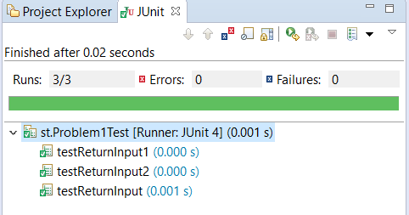

b) JaCoCo Testing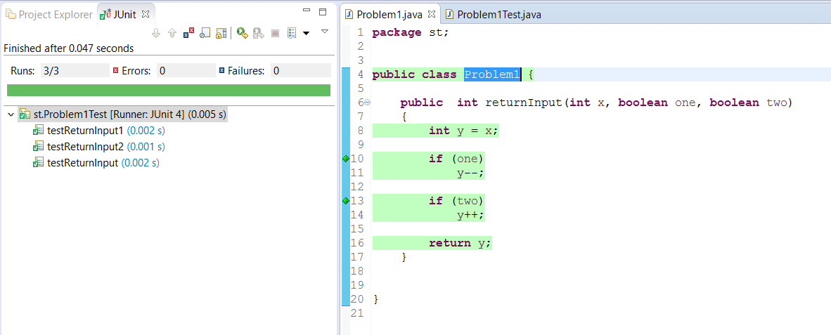

c) Test Code



d) Problem Code



**Problem 2**

1. Junit testing

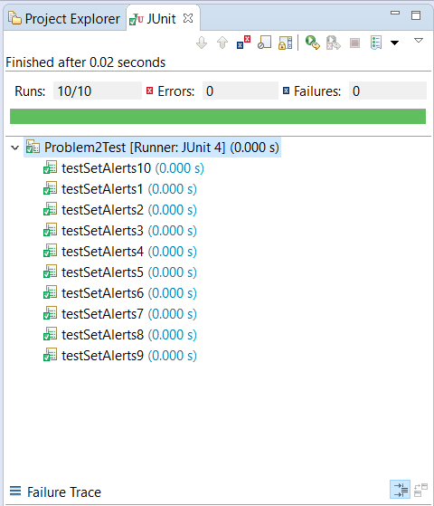

1. Jacoco Testing

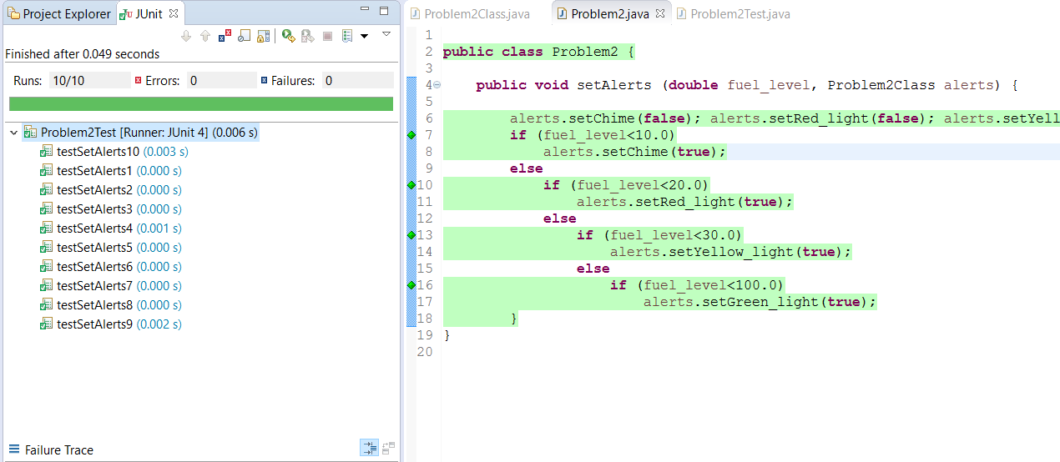

c) Test Cases Code



d) Problem Code



**Problem 3**

a) Junit testing

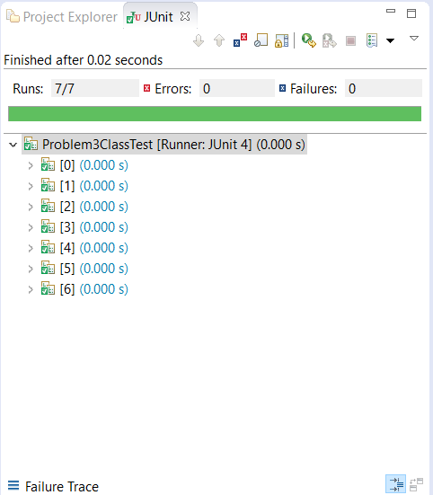

b) Jacoco testing

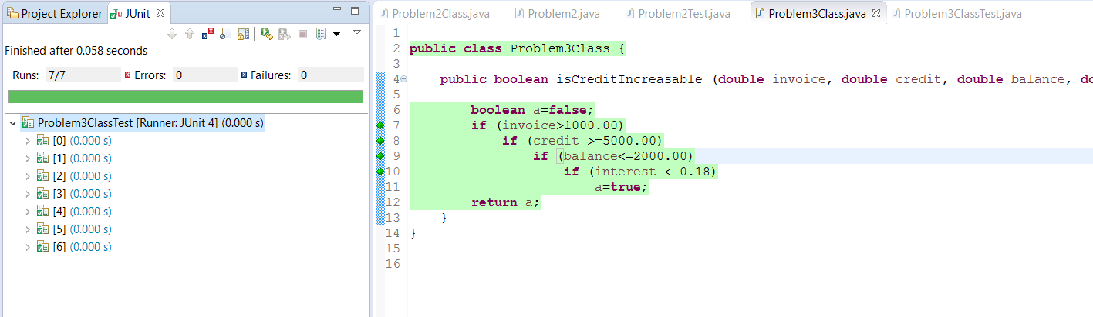

c) Test Case Code



d) Program Code



**Problem 4**

1. Junit testing

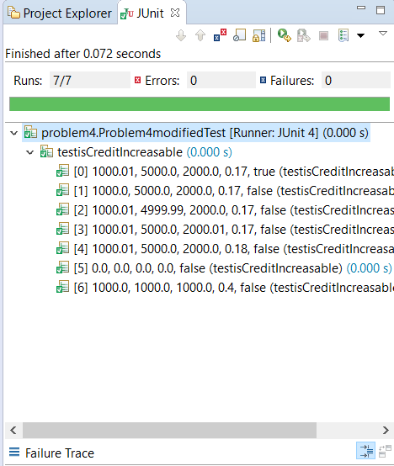

b) Jacoco testing

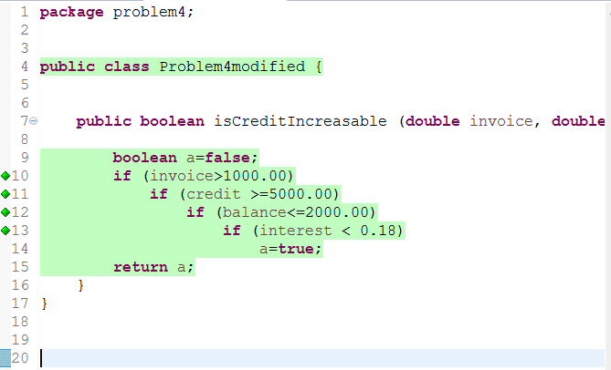

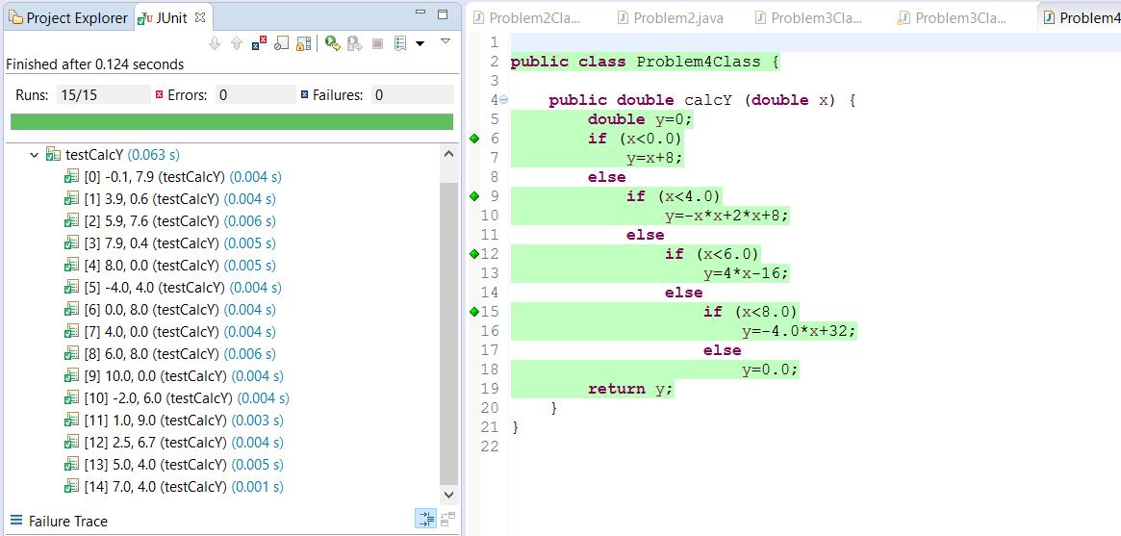

c)



d)



**Problem 5**

1. The code counts all the negative values in the given array.
2. CFG-

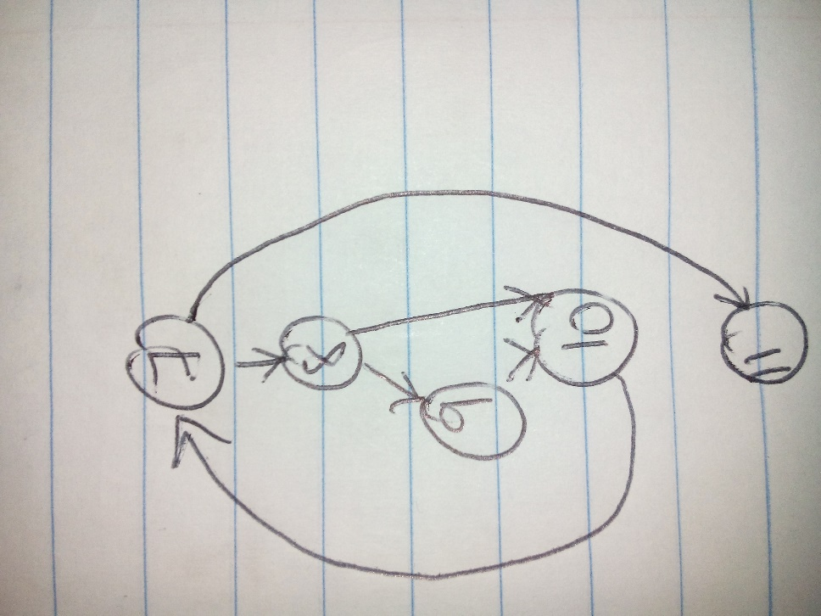

1. Basis Path Test Cases Are:

|  |  |  |  |
| --- | --- | --- | --- |
| **Test Case No.** | **Input** | **Expected O/p** | **Basis Path Tested** |
| 1 | {-1} | 1 | 7,8,9,10,11 |
| 2 | {0} | 0 | 7,8,10,11 |
| 3 | {} | 0 | 7,11 |
| 4 | {0,1,2,3} | 0 | - |
| 5 | {-3,0,3,5} | 1 | - |
| 6 | {0,8,4,-3} | 1 | - |
| 7 | {0,-4,-2,7} | 2 | - |

4.

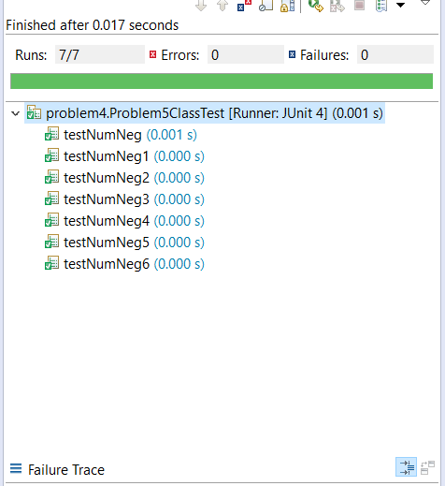

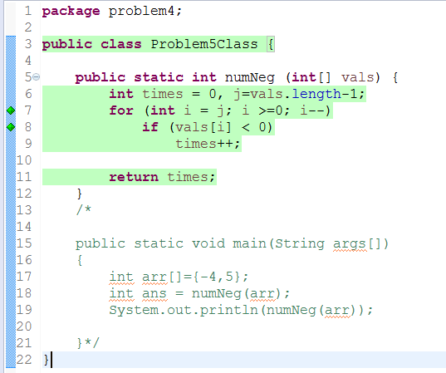

5. Modified Code is as follows.



6. Test Case Code is as follows.

