// SPDX-License-Identifier: UNLICENSED

pragma solidity ^0.8.28;

contract Bank {

mapping(address => uint256) public balanceOf;

// Deposit ETH

function deposit() public payable {

require(msg.value > 0, "Deposit amount must be greater than 0");

balanceOf[msg.sender] += msg.value;

}

// Withdraw ETH

function withdraw(uint256 amount) public {

require(amount > 0, "Withdraw amount must be greater than 0");

require(amount <= balanceOf[msg.sender], "Insufficient balance");

balanceOf[msg.sender] -= amount;

payable(msg.sender).transfer(amount);

}

// View balance

function getBalance() public view returns (uint256) {

return balanceOf[msg.sender];

}

}

Compiling the contract :

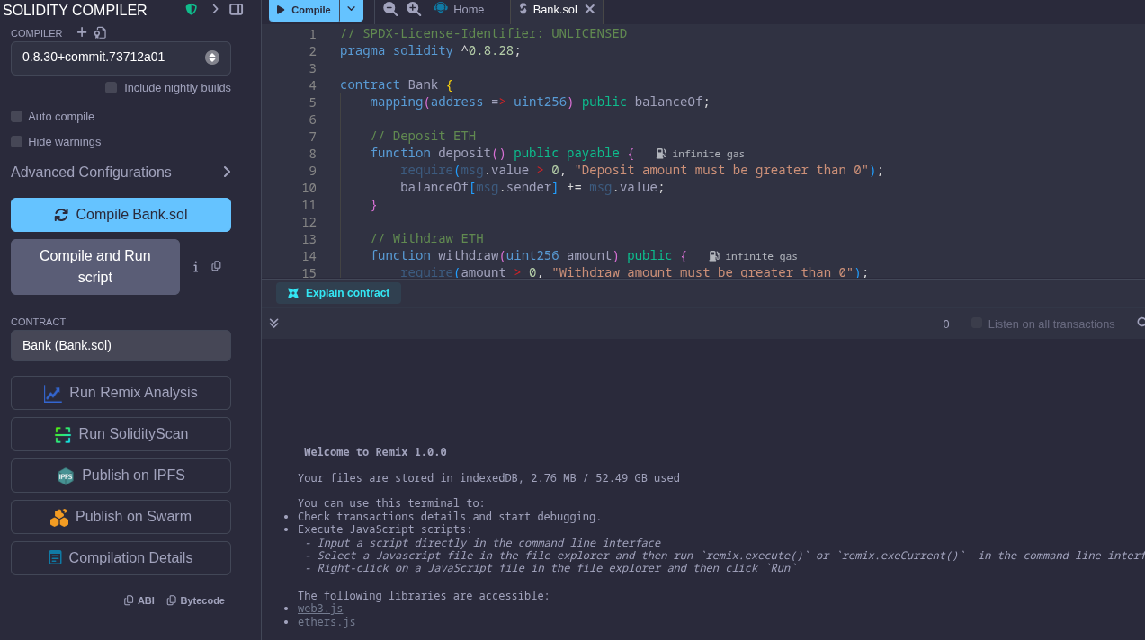

Deploying and running transactions :

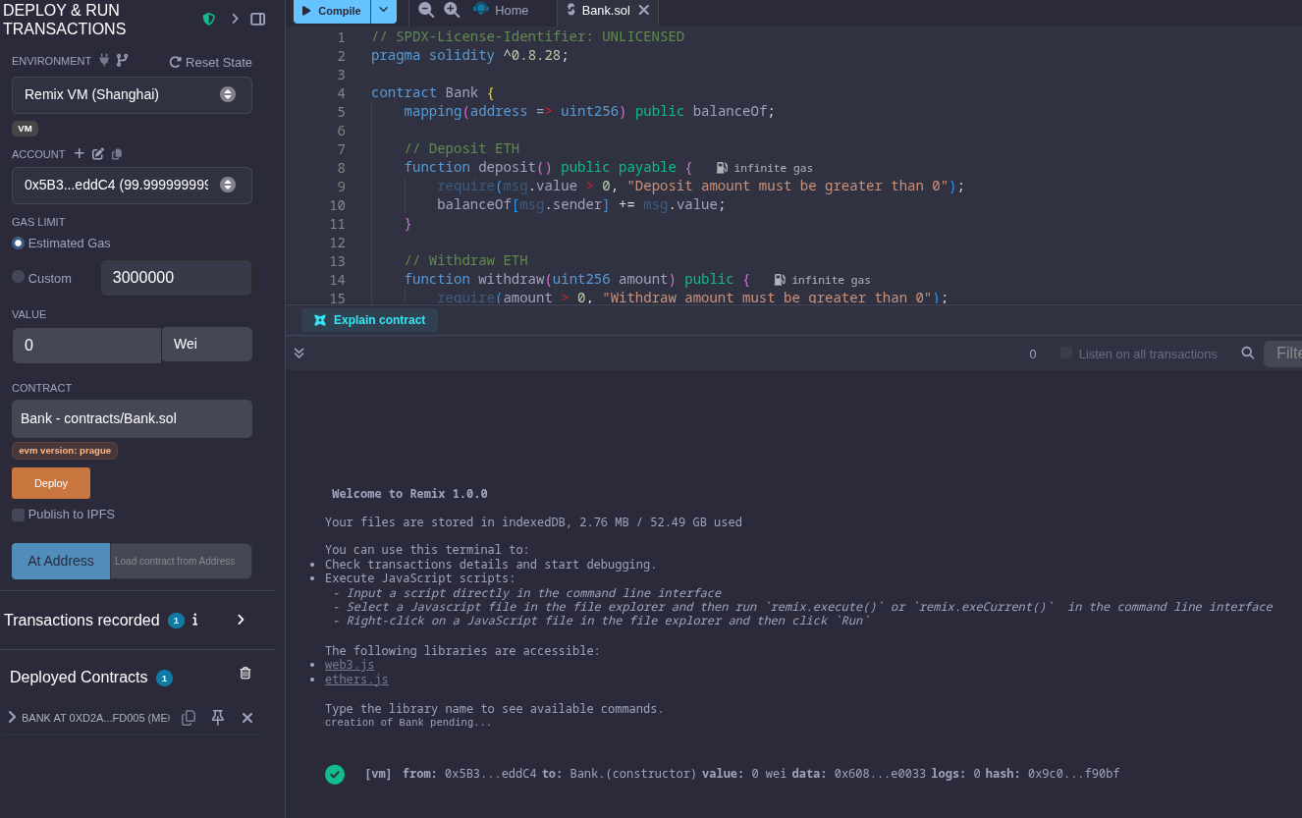

#### Transaction 1: Deposit some Ether

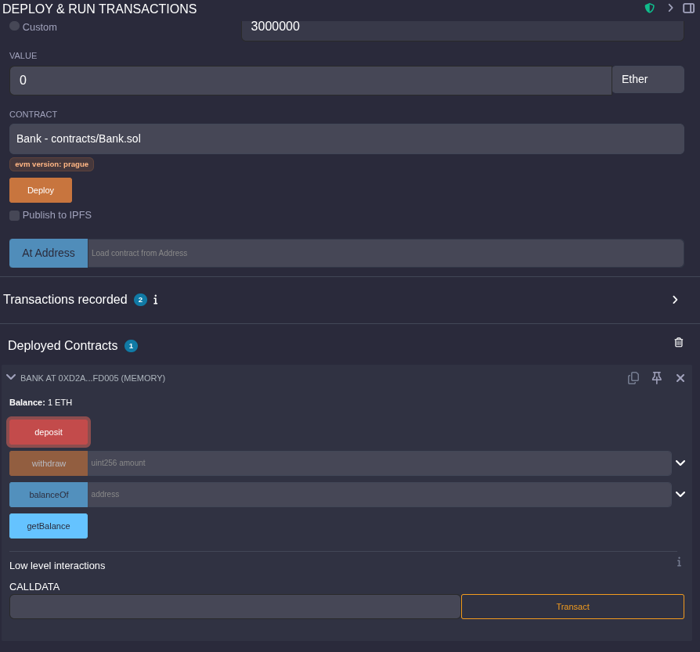

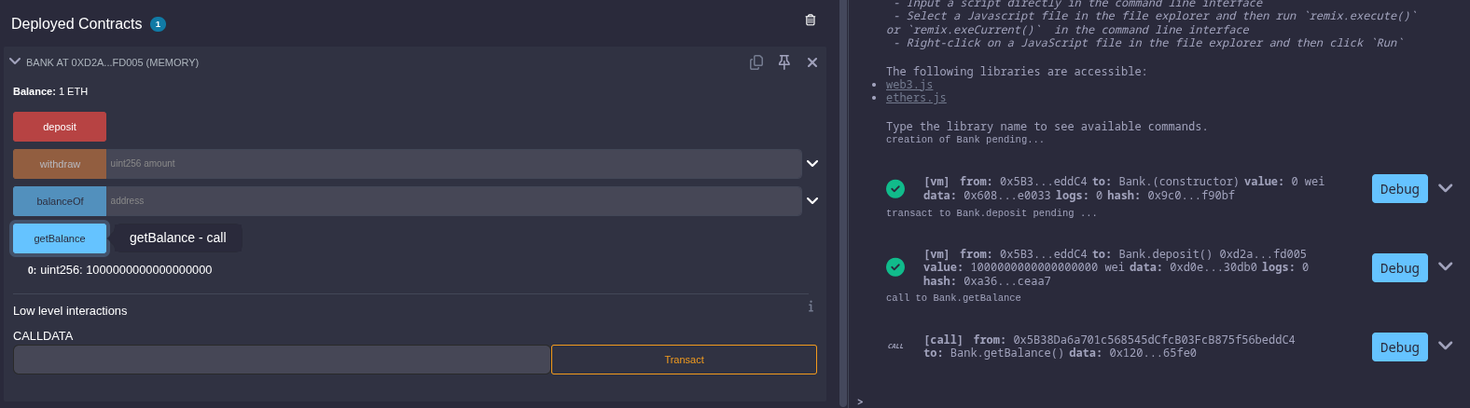

#### Transaction 3: Withdraw your Ether

