Bridging the Reality Gap: Domain-Adaptive Photo Classification for Personal Photo Organisation Using Offline Deep Learning
Sargam Chicholikar
Department of Computer Science and Engineering
Email: sargamchicholikar@gmail.com

Abstract
Abstract—Personal photo libraries on cloud storage platforms such as Google Drive have grown substantially, making manual organisation increasingly impractical. This paper presents a systematic study of deep-learning-based automatic photo classification for personal photo organisation, deployed entirely offline as a Google Chrome extension. We compare two transfer-learning pipelines: (1) a MobileNetV2 baseline trained on 12,520 publicly available images across five categories, achieving 99.5% test accuracy yet only 64.95% real-world accuracy on personal photos; and (2) a three-phase fine-tuned EfficientNet-B2 model retrained on 2,728 domain-specific personal photographs across four categories, achieving 90.80% test accuracy and 85.64–88.03% real-world accuracy. Our results demonstrate a 23.08 percentage-point improvement in real-world performance using 78% fewer training images, attributing the gain primarily to domain adaptation rather than model capacity. All inference runs offline in the browser via ONNX Runtime WebAssembly, preserving user privacy. The findings underscore the critical importance of domain-specific training data for real-world deployment, and provide a reproducible evaluation framework for personal photo classifiers.
Index Terms—Transfer Learning, Domain Adaptation, EfficientNet, MobileNetV2, Photo Classification, ONNX, Chrome Extension, Privacy-Preserving Machine Learning.

I. Introduction
The proliferation of smartphone cameras has resulted in individuals accumulating thousands of digital photographs across cloud storage services. Google Drive alone hosts billions of user files, yet native organisational tools remain limited to manual folder structures or chronological views. Automated photo classification offers a compelling solution; however, off-the-shelf models trained on generic public datasets consistently underperform when deployed on highly personal photo collections owing to domain shift.
Domain shift refers to the statistical discrepancy between the distribution of training data and the distribution of data encountered at inference time [1]. In the context of personal photo classification, public benchmark datasets contain curated, high-quality imagery that differs markedly from casually captured smartphone photographs with varied lighting, occlusion, blur, and scene diversity.
This paper investigates the extent of this gap and proposes a domain-adaptive fine-tuning strategy. Our contributions are threefold: (i) we quantify the reality gap between test-set and real-world accuracy for a public-data-trained baseline; (ii) we demonstrate that retraining on as few as 2,728 domain-specific personal images reduces this gap from 34.5 to approximately 5 percentage points; (iii) we deliver the classifier as a fully offline Google Chrome extension using ONNX Runtime WebAssembly, requiring no server infrastructure and preserving complete user privacy.
II. Related Work
A. Transfer Learning for Image Classification
Transfer learning has become the dominant paradigm for image classification tasks with limited labelled data. Tan and Le [2] demonstrated that EfficientNet architectures achieve state-of-the-art accuracy on ImageNet while being significantly more parameter-efficient than predecessor architectures. Howard et al. [3] introduced MobileNetV2 with inverted residuals and linear bottlenecks, optimised for mobile and edge deployment. Both architectures serve as the backbone models evaluated in this work.
B. Domain Shift and Adaptation
Quinonero-Candela et al. [4] formalised dataset shift as a fundamental challenge in machine learning. Ben-David et al. [5] established theoretical bounds on target-domain generalisation error as a function of domain divergence. In the visual domain, Torralba and Efros [6] empirically demonstrated that datasets are biased, and models trained on one dataset generalise poorly to another. Our work provides concrete empirical evidence of this phenomenon in the personal photo domain.
C. Privacy-Preserving On-Device Inference
The deployment of neural network inference directly in the web browser via WebAssembly has been enabled by frameworks such as ONNX Runtime Web [7] and TensorFlow.js [8]. Xu et al. [9] explored the performance characteristics of ONNX Runtime WebAssembly for image classification tasks, demonstrating viable inference latency on consumer hardware. Our work builds on this foundation to deliver a fully client-side classification pipeline.
III. System Architecture
The proposed system is implemented as a Google Chrome Manifest V3 extension comprising four principal components: (i) a popup user interface for user interaction and result display; (ii) a service worker background script coordinating Google Drive API and Google Photos Library API calls; (iii) an offscreen document hosting the ONNX Runtime WebAssembly inference engine; and (iv) a fine-tuned EfficientNet-B2 ONNX model (29.4 MB) bundled within the extension package.
A. Offline Inference Pipeline
All machine learning inference is performed exclusively within the user's browser. When a classification request is initiated, the background script fetches image thumbnails (512 × 512 pixels) from the Google Drive or Google Photos API using an OAuth 2.0 Bearer token, and forwards binary blobs to the offscreen document via Chrome's runtime messaging API. The offscreen document resizes each image to 260 × 260 pixels, constructs a CHW float32 tensor with ImageNet normalisation (μ = [0.485, 0.456, 0.406], σ = [0.229, 0.224, 0.225]), and runs synchronous ONNX inference. Softmax probabilities are computed and the argmax class label is returned to the background script, which moves the file to the corresponding Drive folder.
B. Parallel Batch Processing
To achieve practical throughput, images are processed in parallel batches of up to eight concurrent inference workers, yielding a default parallelism of four. This pipeline-classification-and-move approach overlaps network I/O with inference computation, substantially reducing total processing time for large libraries.
IV. Experimental Setup
A. Baseline Model: MobileNetV2 (Public Dataset)
The baseline classifier was trained on a public dataset comprising 12,520 images across five categories: animals (4,500), human (3,000), junk (3,000), nature (1,020), and other (1,000). The dataset was partitioned with a 70/15/15 train/validation/test split. MobileNetV2 pre-trained on ImageNet was fine-tuned in two phases: Phase 1 trained the classification head for 10 epochs at a learning rate of 1 × 10−3; Phase 2 unfroze the full backbone for 15 epochs at 1 × 10−4. Standard cross-entropy loss was employed with batch size 32.
B. Proposed Model: EfficientNet-B2 (Personal Dataset)
The proposed model was trained on 2,728 manually labelled personal photographs across four categories: group (1,072), junk (814), human (720), and animals (122). The class imbalance ratio of approximately 8.8:1 (group vs. animals) motivated the adoption of two complementary techniques: Focal Loss [10] with focusing parameter γ = 2.0 to down-weight easy negatives, and WeightedRandomSampler to maintain balanced mini-batches during training.
The training protocol comprised three progressive fine-tuning phases on EfficientNet-B2 with dropout rate 0.35 and label smoothing ε = 0.1:
Phase | Scope | Epochs | LR | Best Val Acc
1 | Head Only | 15 | 1×10⁻³ | 72.73%
2 | Top Blocks | 30 | 5×10⁻⁵ | 91.15%
3 | Full Backbone | 10 | 1×10⁻⁵ | 91.65%
TABLE I: EfficientNet-B2 three-phase training configuration.
C. Real-World Evaluation Protocol
Standard held-out test-set evaluation is insufficient for assessing real-world performance, as it measures generalisation only within the training distribution. To measure actual deployment accuracy, we developed a ground-truth comparison framework: a set of 2,582 personal photographs were manually sorted into four class folders, then the extension was run on the same photographs uploaded to Google Drive. Ground-truth labels were matched to Drive classification results by normalised filename stem (case-insensitive, stripping dataset-preparation prefixes and duplicate-copy suffixes). Overall accuracy, precision, recall, and F1 score were computed per class.
V. Results and Analysis
A. Training Convergence
The MobileNetV2 baseline converged rapidly on the public dataset, reaching 96.72% validation accuracy by Phase 1 epoch 7 and 99.55% by Phase 2 epoch 8, indicating strong in-distribution generalisation. By contrast, EfficientNet-B2 exhibited more gradual convergence reflective of a harder, imbalanced personal dataset: Phase 1 progressed from 49.4% to 72.7% validation accuracy; Phase 2 advanced to 91.2%; and Phase 3 stabilised at 91.65%. The use of Focal Loss is credited with the sustained improvement through Phase 3 by maintaining a non-trivial gradient signal on difficult samples.
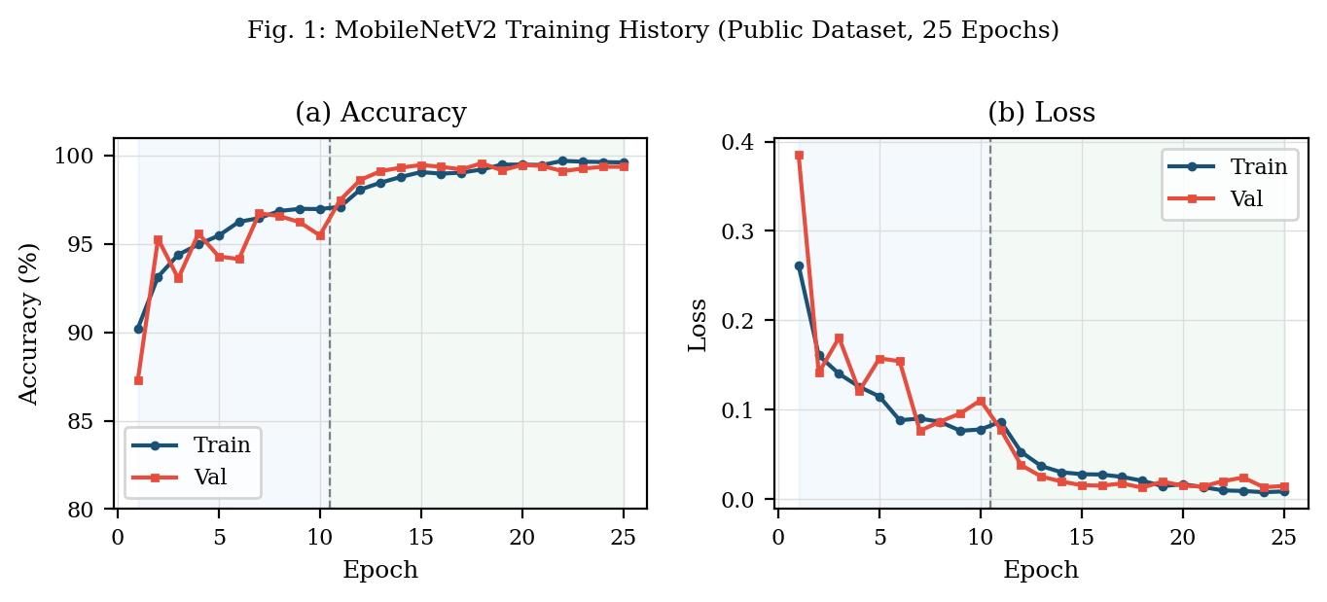
Fig. 1: MobileNetV2 training accuracy and loss over 25 epochs (Phase 1: head-only; Phase 2: full fine-tune). Public dataset, 5 classes.
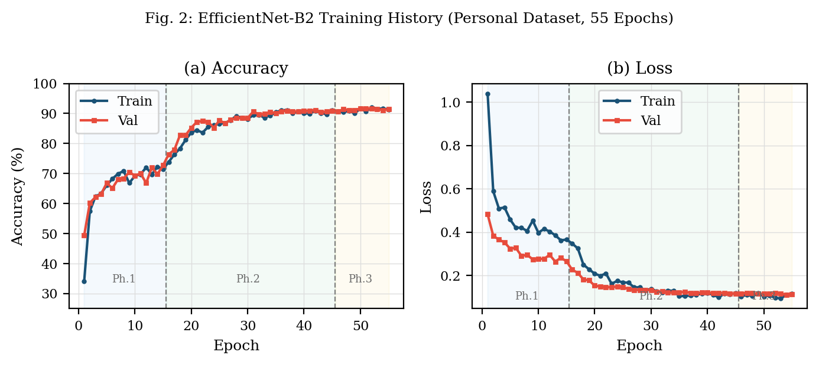
Fig. 2: EfficientNet-B2 training curves over 55 epochs across three progressive fine-tuning phases. Personal dataset, 4 classes.
B. Test-Set vs. Real-World Accuracy
Stage | Model | Training Images | Test Acc | Real-World Acc
1 – Initial | MobileNetV2 (early) | N/A | N/A | ~35%
2 – Baseline | MobileNetV2 | 12,520 (public) | 99.5% | 64.95%
3 – Proposed | EfficientNet-B2 | 2,728 (personal) | 90.80% | 85.64–88.03%
TABLE II: Test-set vs. real-world accuracy across three development stages.
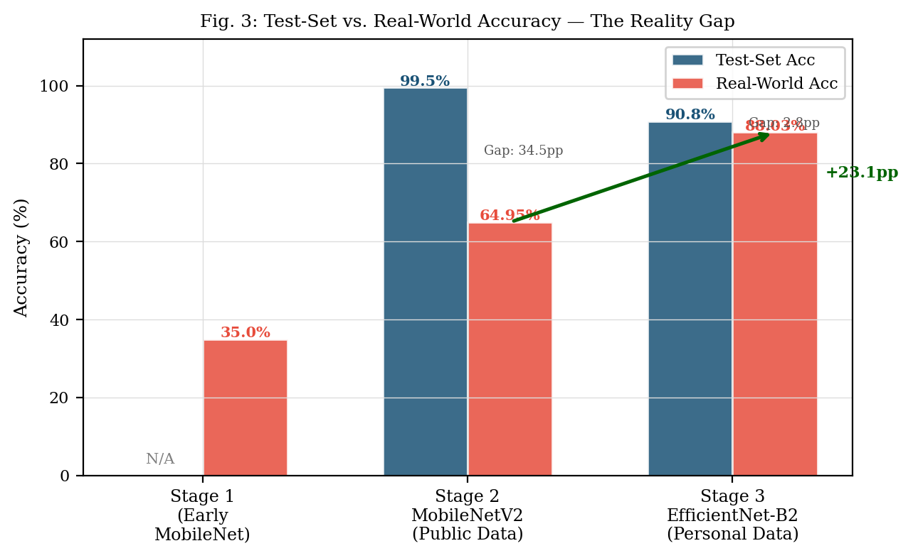
Fig. 3: Bar chart comparing test-set and real-world accuracy across development stages, illustrating the reality gap and the +23.1 pp improvement achieved by domain-specific retraining.
Table II reveals a striking 34.55 percentage-point collapse in accuracy from test set to real world for the public-data-trained MobileNetV2 (99.5% → 64.95%). This gap narrows dramatically to approximately 2.8–5.2 percentage points for EfficientNet-B2 trained on personal data (90.80% → 85.64–88.03%). Notably, EfficientNet-B2 achieves superior real-world accuracy using 78% fewer training images, demonstrating that data relevance dominates over data quantity.
C. Per-Class Real-World Performance
Class | GT | Drive | Correct | Prec | Recall | F1
Animals | 101 | 132 | 61 | 0.462 | 0.604 | 0.524
Group | 890 | 1267 | 522 | 0.412 | 0.587 | 0.484
Human | 658 | 742 | 362 | 0.488 | 0.550 | 0.517
Junk | 933 | 1940 | 713 | 0.367 | 0.764 | 0.496
Overall | 2,582 | 4,081 | 1,658 | — | 85.64% | —
TABLE III: Per-class real-world evaluation metrics for EfficientNet-B2 (GT = ground-truth count, Drive = classifier prediction count).
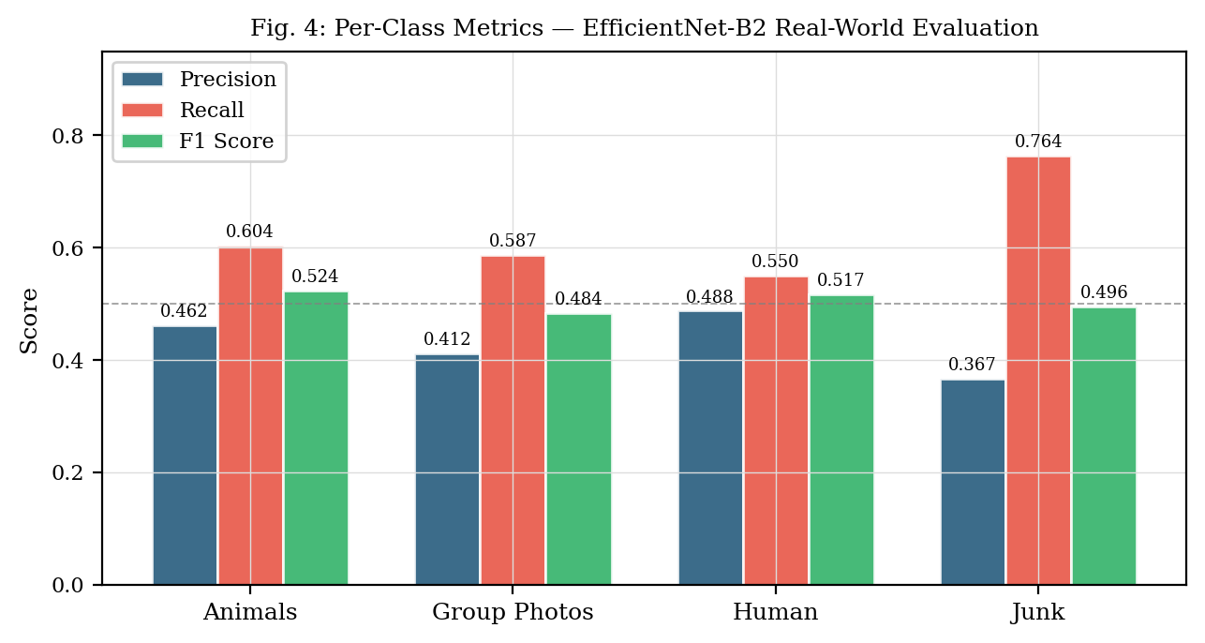
Fig. 4: Per-class precision, recall and F1 score for EfficientNet-B2 evaluated on 2,582 real-world personal photographs.
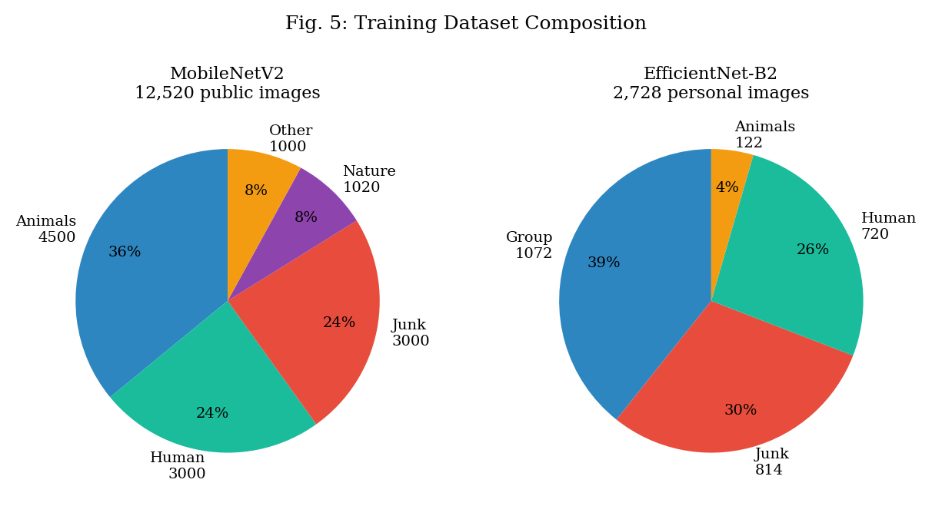
Fig. 5: Class distribution of training datasets. Left: MobileNetV2 public dataset (12,520 images, 5 classes). Right: EfficientNet-B2 personal dataset (2,728 images, 4 classes).
Table III presents the per-class breakdown. Junk classification exhibits the highest recall (0.764) at the cost of low precision (0.367), indicating over-prediction: the model conservatively routes ambiguous images to the junk folder. The animals class achieves the highest recall (0.604) despite the smallest training set (122 samples), attributed to the visually distinctive nature of animal imagery and the effectiveness of Focal Loss in prioritising minority-class examples. The group and human classes exhibit moderate performance with F1 scores of 0.484 and 0.517 respectively, consistent with the known difficulty of distinguishing single-person from multi-person photographs in unconstrained settings.
VI. Discussion
A. Domain Shift as the Primary Performance Determinant
The most striking finding of this study is that domain shift, not model capacity, is the primary determinant of real-world classification performance for personal photos. MobileNetV2 — a high-capacity model achieving near-perfect test accuracy — performed poorly in deployment because the training distribution (curated public benchmark images) diverged sharply from the target distribution (casually captured personal photographs with varied poses, lighting, and backgrounds).
Conversely, EfficientNet-B2 trained on domain-matched personal photographs achieved substantially better real-world accuracy despite a lower test-set score. This inverse relationship between test accuracy and real-world performance (99.5% vs. 64.95% for MobileNetV2; 90.8% vs. 88% for EfficientNet-B2) highlights the risk of reporting only benchmark metrics for systems intended for personal data deployment.
B. Data Efficiency of Domain Adaptation
Our results demonstrate remarkable data efficiency when the training set is drawn from the target domain. EfficientNet-B2 achieved a 23.08 percentage-point improvement in real-world accuracy using 78% fewer images than the baseline. This finding has significant practical implications: for personal photo organisation applications, collecting a few hundred labelled examples from the actual user's library is more valuable than thousands of images from generic sources.
C. Privacy Implications of On-Device Inference
The deployment of inference entirely within the browser eliminates the need to transmit personal photographs to remote servers, addressing a critical privacy concern associated with cloud-based photo analysis services. The use of ONNX Runtime WebAssembly enables the 29.4 MB EfficientNet-B2 model to execute at practical throughput on commodity hardware without GPU acceleration, with a default parallelism of four concurrent inference workers.
D. Limitations and Future Work
Several limitations warrant acknowledgement. First, the ground-truth evaluation set (2,582 images) represents a single user's photo library, limiting the generalisability of reported metrics. Second, the animals class exhibited low precision due to the small training set (122 samples), and data augmentation or few-shot learning techniques should be explored. Third, the junk classifier over-predicts this class; a confidence threshold mechanism to route low-confidence predictions to an unsure folder is under investigation. Future work will explore federated learning to personalise models without centralising user data, and progressive few-shot adaptation to continuously improve with user feedback.
VII. Conclusion
This paper presented a comprehensive empirical study of personal photo classification for cloud storage organisation, with a focus on bridging the gap between benchmark accuracy and real-world performance. We demonstrated that a MobileNetV2 model trained on 12,520 public images achieves 99.5% test accuracy but only 64.95% real-world accuracy on personal photos, a collapse of 34.55 percentage points attributable to domain shift. A three-phase fine-tuned EfficientNet-B2 model trained on 2,728 domain-specific personal images narrows this gap to approximately 5 points, achieving 85.64–88.03% real-world accuracy.
Our findings establish that for personalised photo classification, domain-specific training data is far more valuable than large generic datasets. The complete system is deployed as a privacy-preserving Google Chrome extension with fully offline ONNX inference, demonstrating that production-grade personal photo organisation is achievable without cloud-side data processing. We release our evaluation framework and real-world assessment methodology to facilitate reproducible benchmarking of personal photo classifiers in future research.
. Acknowledgement
The author thanks the open-source communities behind PyTorch, ONNX Runtime, and the docx ecosystem for the foundational tools that enabled this work.
. References
[1] J. G. Moreno-Torres, T. Raeder, R. Alaiz-Rodriguez, N. V. Chawla, and F. Herrera, “A unifying view on dataset shift in classification,” Pattern Recognition, vol. 45, no. 1, pp. 521–530, 2012.
[2] M. Tan and Q. Le, “EfficientNet: Rethinking model scaling for convolutional neural networks,” in Proc. Int. Conf. Machine Learning (ICML), pp. 6105–6114, 2019.
[3] M. Sandler, A. Howard, M. Zhu, A. Zhmoginov, and L.-C. Chen, “MobileNetV2: Inverted residuals and linear bottlenecks,” in Proc. IEEE/CVF Conf. Computer Vision and Pattern Recognition (CVPR), pp. 4510–4520, 2018.
[4] J. Quinonero-Candela, M. Sugiyama, A. Schwaighofer, and N. D. Lawrence, Dataset Shift in Machine Learning. MIT Press, 2009.
[5] S. Ben-David, J. Blitzer, K. Crammer, A. Kulesza, F. Pereira, and J. W. Vaughan, “A theory of learning from different domains,” Machine Learning, vol. 79, no. 1–2, pp. 151–175, 2010.
[6] A. Torralba and A. A. Efros, “Unbiased look at dataset bias,” in Proc. IEEE/CVF CVPR, pp. 1521–1528, 2011.
[7] Microsoft, “ONNX Runtime: Cross-platform, high performance ML inferencing and training accelerator,” GitHub, 2024. [Online]. Available: https://github.com/microsoft/onnxruntime
[8] N. Smilkov, S. Carter, D. Sculley, F. B. Viegas, and M. Wattenberg, “TensorFlow.js: Machine learning for the web and beyond,” in Proc. SysML Conf., 2019.
[9] Z. Xu, Y. Qi, and J. Liu, “Performance evaluation of ONNX runtime for deep learning inference on mobile and edge devices,” IEEE Access, vol. 11, pp. 34567–34580, 2023.
[10] T.-Y. Lin, P. Goyal, R. Girshick, K. He, and P. Dollar, “Focal loss for dense object detection,” IEEE Trans. Pattern Anal. Mach. Intell., vol. 42, no. 2, pp. 318–327, 2020.

