Subl /etc/httpd/conf/httpd.conf

find “Linsten 80”

Listen 80

<VirtualHost *:80>
ServerName <customname>
ServerAlias <customname>
ServerAdmin webmaster@localhost
DocumentRoot /var/www/html/
<Directory />
AllowOverride All
</Directory>
<Directory /var/www/html/>
Options Indexes FollowSymLinks MultiViews
AllowOverride all
Require all granted
</Directory>
ErrorLog /var/log/httpd/$domain-error.log
LogLevel error
CustomLog /var/log/httpd/$domain-access.log combined
</VirtualHost>

<VirtualHost *:80>
ServerName wpa26.dev
ServerAlias wpa26.dev
ServerAdmin webmaster@localhost
DocumentRoot /var/www/html/wpa26/phpframe/public/
<Directory />
AllowOverride All
</Directory>
<Directory /var/www/html/wpa26/phpframe/public/>
Options Indexes FollowSymLinks MultiViews
AllowOverride all
Require all granted
</Directory>
ErrorLog /var/log/httpd/$domain-error.log
LogLevel error
CustomLog /var/log/httpd/$domain-access.log combined
</VirtualHost>

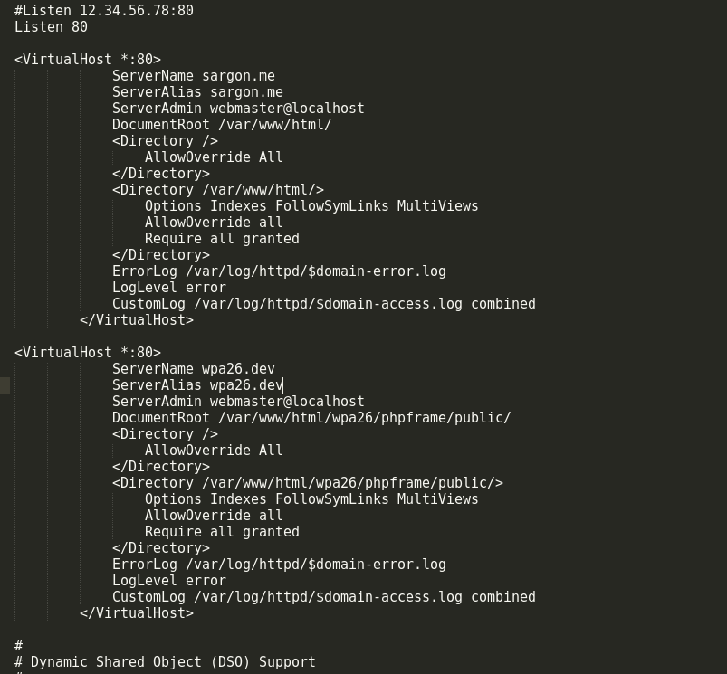
Subl /etc/hosts

add these lines

127.0.0.1 wpa26.dev
127.0.0.1 <customname>

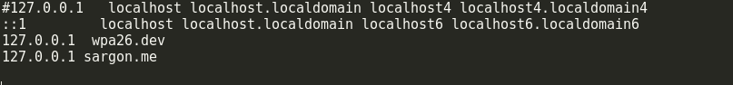

Save it and restart the httpd server.
Sudo systemctl restart httpd.server

