**Robotic Arm:**

We have run some experiment regarding the grabbing part of the robotic arm. The most available servo motor in Bangladesh is MG996R / MG995. Using this servo, it is quite difficult to grab the object from the ground using 6DOF arm. Though we bought 6 DOF arm but we modified the arm and shortened the height so that it can grab the objects so frequently.

**Arm Components (Modified):**

|  |  |  |  |
| --- | --- | --- | --- |
| **Item Name** | **Weight**  **(gm)** | **Length**  **(cm)** | **Image** |
| **1 x Metallic Claw** | **56** | **11** |  |
| **1 x Long U Shaped Bracket** | **22** | **6.4** |  |
| **2 x Multifunctional Bracket** | **16** | **5.6** |  |
| **1 x Cup Bearing** | **-** | **-** |  |
| **Item Name** | **Weight**  **(gm)** | **Length**  **(cm)** | **Image** |
| **2 x Hard U Beam** | **50** | **9** |  |
| **3 x MG996R Servo** | **55** | **~4** |  |

**­­**

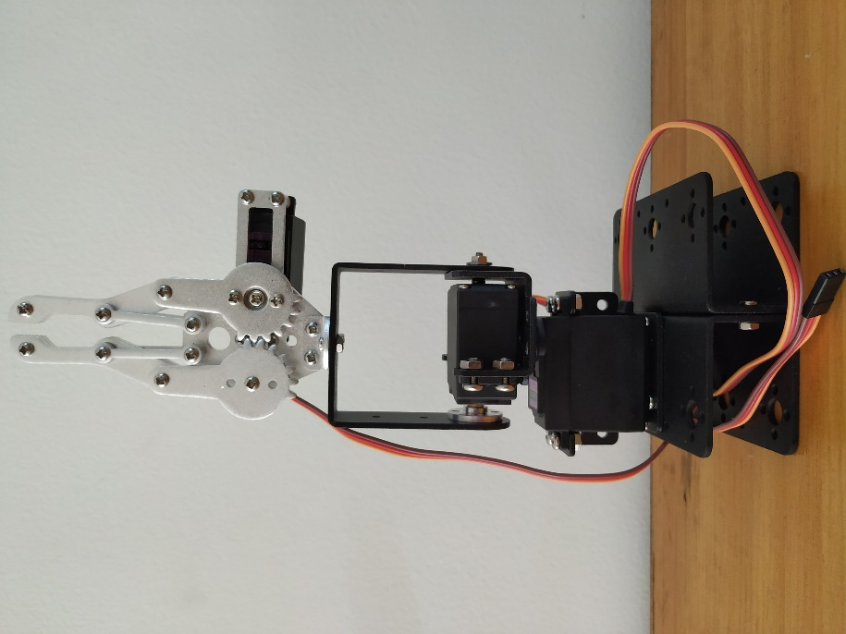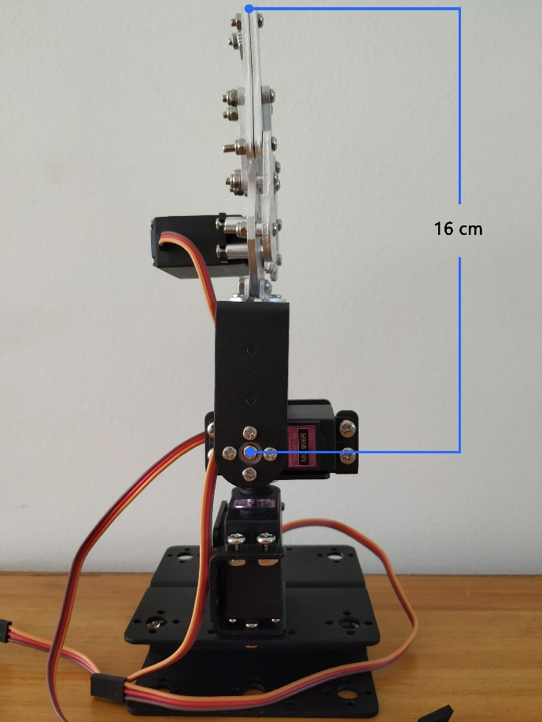

**Fig 1.1: Robotic Arm (modified) Fig 1.2: Robotic Arm (with required length)**

**Calculation:**

Torque of MG996R: **9.4 kg-cm** (at 4.8 v) [1]

Torque of MG996R: **11 kg-cm** (at 6 v) [1]

Operating Voltage: 4.8 v ~ 6.6 v [1]

We are operating at 6 v using IC-7806 regulator. So, we are getting the maximum torque of 11kg-cm. [1]

**//Torque Equation Here//**

The length from Servo2 to the gripper top is:

length of Long U Bracket + Metallic Claw – distance from edge to center of MG996R

= (6.4+11-1) cm

= 15.4 cm

~ 16 cm

Maximum weight Servo2 can lift: 11 kg-cm / 16cm = 0.6875 kg ~ 680 gm

Equipment’s total weight above Servo2 : Weight of Claw + Weight of U Bracket + MG996R servo

= (56 + 22 + 55) gm

= 133 gm, which is less than 680 gm

So, it can lift up to (680 – 133) gm = 547 gm object which is enough for our project.

**Modification Necessity:**

If we used 6 DOF then the height from Servo2 to the gripper top would be approximately 35 cm.

Then it can lift maximum weight of = 11 kg-cm / 35 cm =0.31 kg ~ 310 gm

But component’s total weight above Servo2 would be = (3*22 + 3*16 + 56 + 3*55) gm

= 335 gm, which is more than 310 gm

So, it will not work properly.

**Note:** **In fact, we ran some tests earlier on 6DOF and we saw that Servo2 fall down with the excessive weight as it’s torque is not compatible with that much weight.**

So, we modified and shortened the length. We also tried 4 DOF (modified) but that also gave us some errors. So we finally decided to move into 3 DOF (modified), compatible with XYZ (3D) rotation as it is enough for our project.

Reference:

1. <http://www.towerpro.com.tw/product/mg996r/>