**Linux Command Line Tasks**

**1. Creating and Renaming Files/Directories**

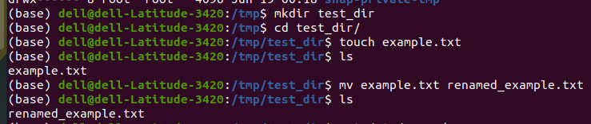

**Explanation:**

* mkdir creates a new directory
* touch creates an empty file
* mv both moves and renames files

**2. Viewing File Contents**

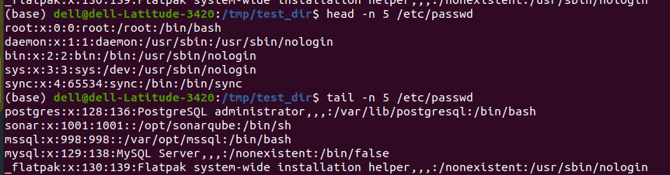

**Explanation:**

* cat shows full file contents
* head/tail show beginning/end of file
* -n specifies number of lines

**3. Searching for Patterns**

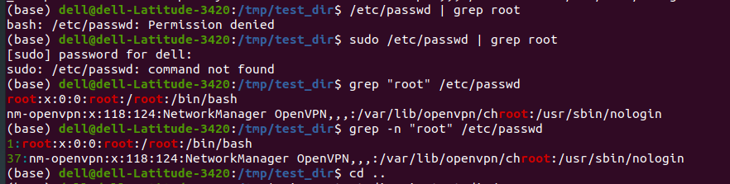

**Explanation:**

* grep searches for text patterns
* Shows all lines containing "root"

**4. Zipping and Unzipping**

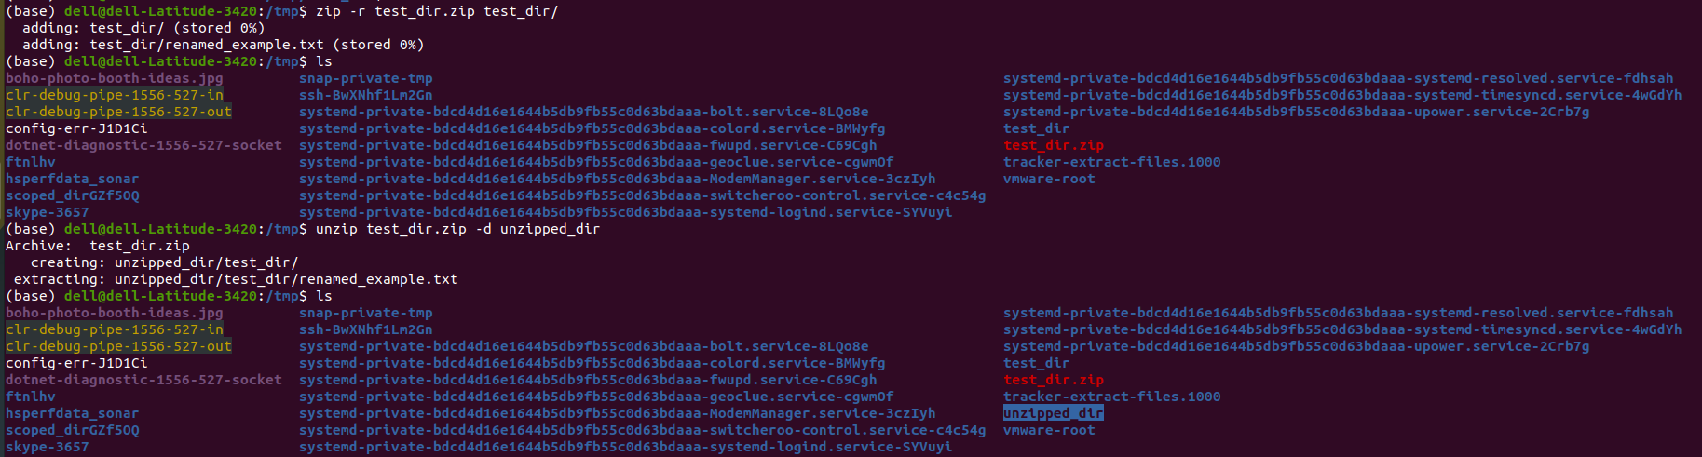

**Explanation:**

* zip -r compresses recursively
* unzip -d specifies destination directory

**5. Downloading Files.**

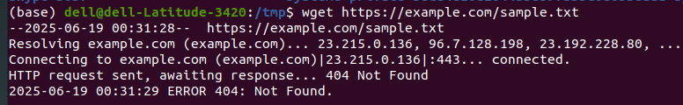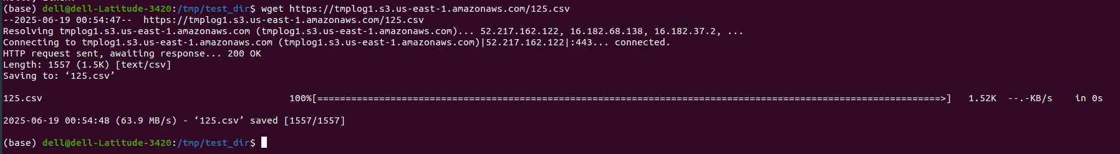

**Explanation:**

* wget downloads files from URLs
* Saves to current directory

**6. Changing Permissions**

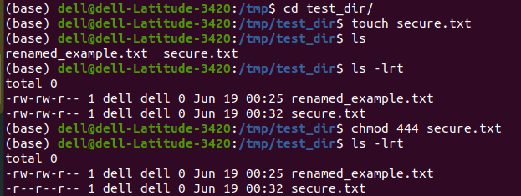

**Explanation:**

* chmod changes file permissions
* 444 gives read-only access to all

**7. Environment Variables.**

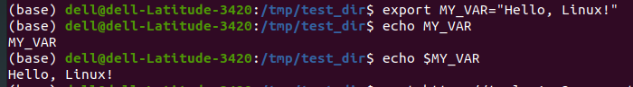

**Explanation:**

* export creates environment variables
* Access with $ prefix

____________________________________________________________________________________