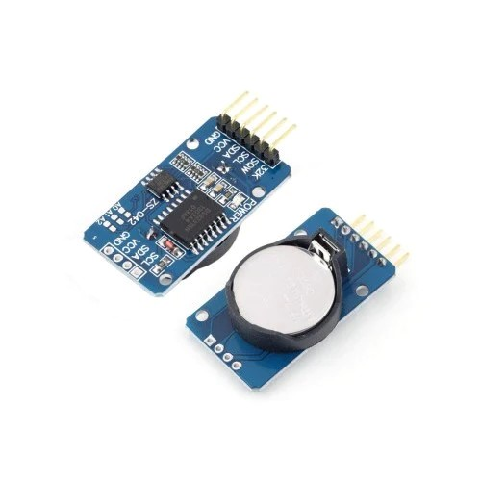**Real-Time Clock**

**រូប 2.6 Real-Time Clock DS3231**

|  |  |
| --- | --- |
| **DS3231 RTC Specifications** | |
| Operating voltage | 3.3 – 5 .5 V |
| clock chip | high-precision clock chip DS3231 |
| Clock Accuracy | 0-40 ℃ range, the accuracy 2ppm, the error was about 1 minute |
| memory chips | AT24C32 (storage capacity 32K) |
| Size | 38mm (length) * 22mm (W) * 14mm (height) |
| Weight | 8g |
| programmable | square-wave output |

**Micro SD Card**

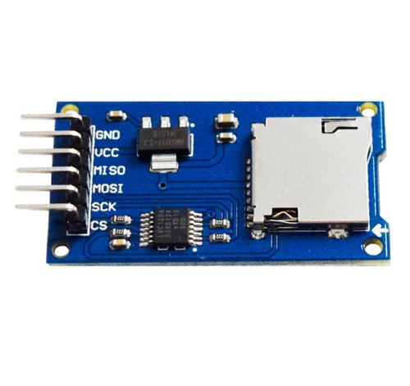

**រូប 2.7 Micro SD Card**

|  |  |
| --- | --- |
| **Micro SD Card** | |
| **Supports** | **Micro SD Card, Micro SDHC (high-speed card)** |
| **Interface level** | **5V or 3.3V** |
| **Power supply** | **4.5V ~ 5.5V, 3.3V voltage regulator circuit board** |
| **Communication interface** | **Standard SPI** |
| **Control Interface** | **A total of six pins, GND, VCC, MISO, MOSI, SCK, CS** |
| **3.3V regulator circuit** | **LDO regulator output 3.3V** |
| **Positioning holes** | **4 x M2 screw holes for easy positioning. Hole diameter is 2.2mm** |

# **SIM800C GSM GPRS Module with Bluetooth and TTS**

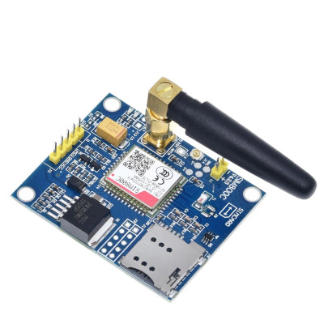

# **រូប 3.0 SIM800C GSM GPRS Module with Bluetooth and TTS**

**តារាង​ 2.5 KEY FEATURES**

|  |  |
| --- | --- |
| **Feature** | **Implementation** |
| Power Supply | 3.4V ~4.4V |
| Power saving | Typical power consumption in sleep mode is 0.88mA (BS-PA-MFRMS=9 ) |
| Frequency bands | * Quad-band: GSM 850, EGSM 900, DCS 1800, PCS 1900. SIM800C can search the 4 frequency bands automatically. The frequency bands can also be set by AT command “AT+CBAND”. For details, * Compliant to GSM Phase 2/2+ |
| Transmitting power | * Class 4 (2W) at GSM 850 and EGSM 900 * Class 1 (1W) at DCS 1800 and PCS 1900 |
| GPRS connectivity | * GPRS multi-slot class 12（default） * GPRS multi-slot class 1~12 (option) |
| Temperature range | * Normal operation: -40°C ~ +85°C * Storage temperature -45°C ~ +90°C |
| Data GPRS | * GPRS data downlink transfer: max. 85.6 kbps * GPRS data uplink transfer: max. 85.6 kbps * Coding scheme: CS-1, CS-2, CS-3 and CS-4 * PAP protocol for PPP connect * Integrate the TCP/IP protocol. * Support Packet Broadcast Control Channel (PBCCH) |
| USSD | Unstructured Supplementary Services Data (USSD) support |
| SMS | * MT, MO, CB, Text and PDU mode * SMS storage: SIM card |
| SIM interface | Support SIM card: 1.8V, 3V |
| External antenna | Antenna pad |
| Audio features | Speech codec modes:   * Half Rate (ETS 06.20) * Full Rate (ETS 06.10) * Enhanced Full Rate (ETS 06.50 / 06.60 / 06.80) * Adaptive multi rate (AMR) * Echo Cancellation * Noise Suppression |
| Serial port and USB port | **Serial port:**   * Default one Full modem serial port * Can be used for AT commands or data stream * Support RTS/CTS hardware handshake and software ON/OFF flow control * Multiplex ability according to GSM 07.10 Multiplexer Protocol * Autobauding supports baud rate from 1200 bps to 115200bps * upgrading firmware   **USB port:**   * USB_DN and USB_DP * Can be used for debugging and upgrading firmware |
| Phonebook management | Support phonebook types: SM, FD, LD, RC, ON, MC |
| SIM application toolkit | GSM 11.14 Release 99 |
| Physical characteristics | Size:17.6*15.7*2.3mm  Weight:1.3g |
| Firmware upgrade | Full modern serial port or USB port​ (recommend to use USB port) |

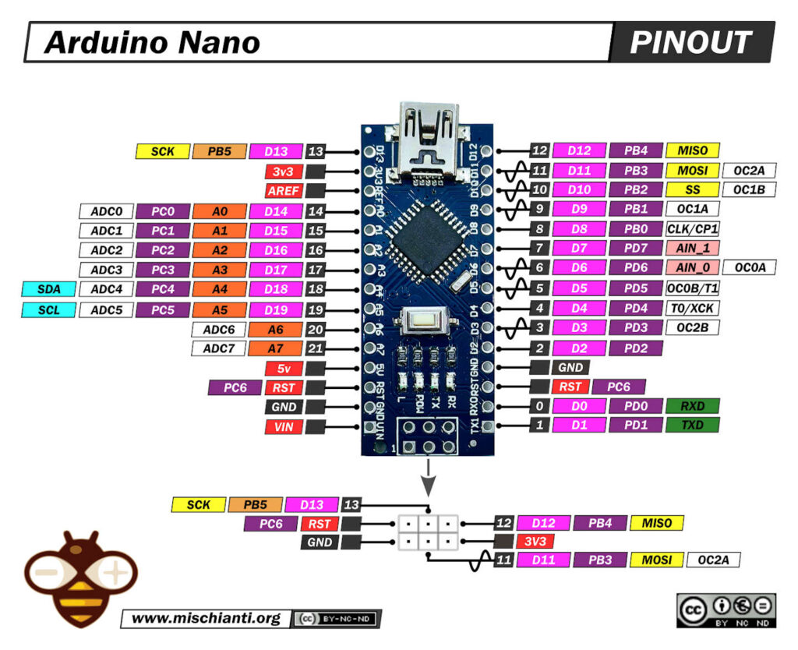**Arduino Nono**

**រូប 3.****1 Arduino Nano**

|  |  |
| --- | --- |
| **Arduino Nano** | |
| Power | Vin (6-12V input), 3.3V (50mA max), 5V, and GND |
| Analog Pins (A0 – A7) | For measuring 0-5V analog voltage |
| Digital Pins (D0 – D13) | Serve as input or output; operate at 0V or 5V |
| Serial (Rx, Tx) | For TTL serial data transmission and reception |
| External Interrupts (2, 3) | Trigger interrupts |
| PWM (3, 5, 6, 9, 11) | Provide 8-bit PWM output |
| SPI (10, 11, 12, 13) | For SPI communication |
| Inbuilt LED (13) | Controls an inbuilt LED |
| IIC (A4, A5): | For TWI communication |
| AREF | Reference voltage for input voltage |

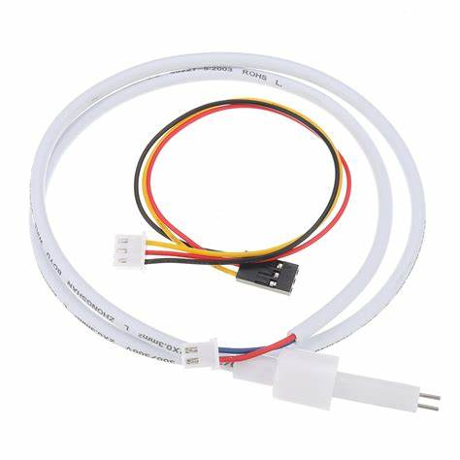TDS Sensor

**រូប 2.1 TDS sensor Waterproof**

តារាង 2.1លក្ខណៈទូទៅរបស់​ TDS Waterproof

|  |  |
| --- | --- |
| **TDS sensor Waterproof** | |
| Number of Needle | 2 |
| Total Length | 83cm |
| Connection Interface | XH2.54-2P |
| Color | Black |
| Other | Waterproof Probe |

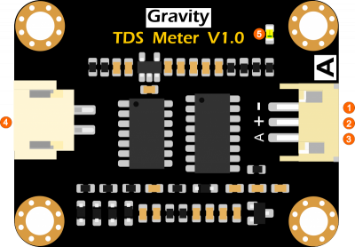TDS Meter Sensor

# រូប 2.2 TDS Meter Sensor

តារាង 2.2 លក្ខណៈទូទៅរបស់​ TDS Meter Sensor

|  |  |
| --- | --- |
| **Signal Transmitter Board** | |
| Input Voltage | 3.3 ~ 5.5V |
| Output Voltage | 0 ~ 2.3V |
| Working Current | 3 ~ 6mA |
| TDS Measurement Range | 0 ~ 1000ppm |
| TDS Measurement Accuracy | ± 10% F.S. (25 ℃) |
| Module Size | 42 * 32mm |
| Module Interface | PH2.0-3P |
| Electrode Interface | XH2.54-2P |

PH Sensor(sen0161-V2)

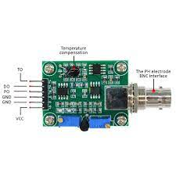រូប​ 2.3 Signal Conversion Board (Transmitter)

|  |  |
| --- | --- |
| **Signal Conversion Board (Transmitter)** | |
| Supply Voltage | 3.3V~5.5V |
| Output Voltage | 0V~3.0V |
| Probe Connector | BNC |
| Signal Connector | PH2.0-3P |
| Measurement Accuracy | ±0.1@25℃ |
| Dimension | 42mm*32mm/1.66*1.26in |

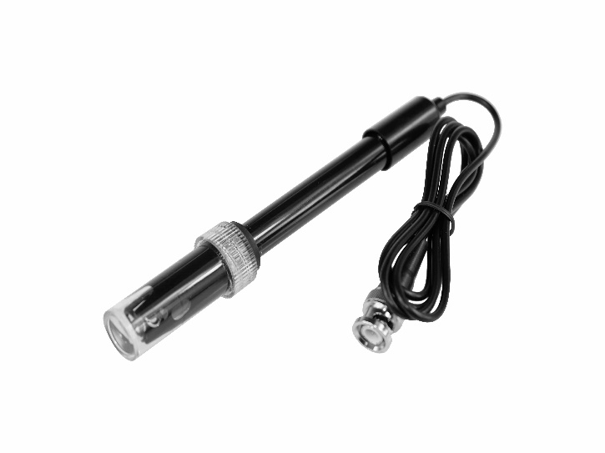PH sensor Probe

រូប​ 2.4 PH sensor Probe

តារាង​ 2.4 លក្ខណៈទូទៅរបស់ PH sensor Prode

|  |  |
| --- | --- |
| **PH sensor Prode** | |
| Prode Type | Laboratory Gade |
| Detection Range | 0~14 |
| Temperature Range | 5~60°C |
| Zero Point | 7±0.5 |
| Response Time | <2min |
| Internal Resistance | <250MΩ |
| Probe Life | >0.5 year (depending on frequency of use) |
| Cable Length | 100cm |

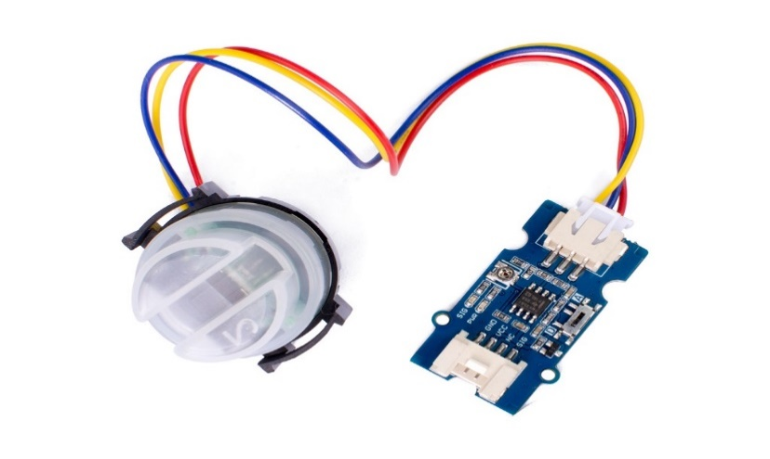Turbidity Sensor Meter

រូប 2.5 Turbidity Sensor Meter

តារាង​ 2.5 លក្ខណៈទូទៅរបស់ Turbidity Sensor Meter

|  |  |
| --- | --- |
| **Turbidity Sensor Meter** | |
| Low Power | Consumption |
| Small size | 2.0cm ×4.0cm Grove module |
| Only 3 pins needed | Save I/O resources |
| Operating Voltage | 3.3V/5V DC |
| Switch | 1 A-D toggle switch |
| Dimensions | 20x40 mm |
| Output Interface | Analog/Digital |

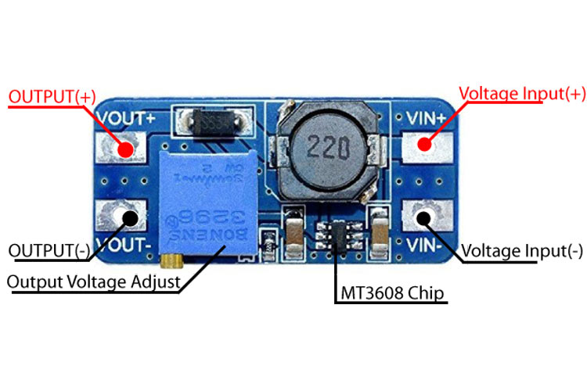**MT3608 -2A DC-DC Step Up (Boost)**

រូប 2.6 MT3608 Step-Up Power Module

តារាង​ 2.6 លក្ខណៈទូទៅរបស់ MT3608 Step-Up Power Module

|  |  |
| --- | --- |
| **MT3608 Step-Up Power Module** | |
| Input Voltage | 2-24V DC |
| Output Voltage | 5-28V DC |
| Maximum Output Current | 2A |
| Switching Frequency | 1.2Mhz |
| Output Ripple | <100mV |
| Module Size | 37.2mmx17.2mmx14.0mm |
| About | 93% Efficiency |
| Features like an under-voltage lockout | thermal overload protection |

**CN3791 12V MPPT Solar Charger Module**

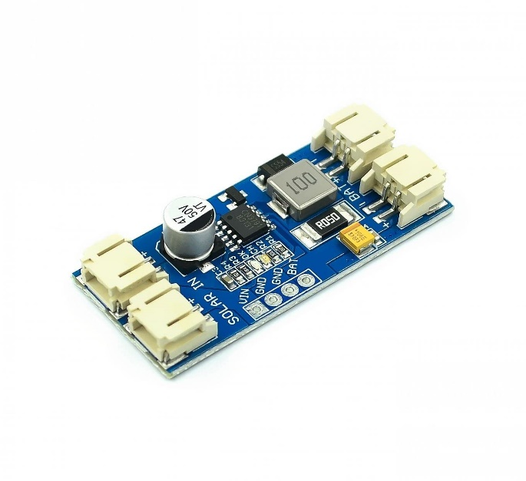រូប 2.7 CN3791 12V MPPT Solar

តារាង​ 2.7 លក្ខណៈទូទៅរបស់ CN3791 12V MPPT Solar

|  |  |
| --- | --- |
| **CN3791 12V MPPT Solar** | |
| Operating Voltage (VDC) | 12V |
| Switching Frequency | 300KHz |
| Maximum Charging Current | 2A |
| Length | 45mm |
| Height | 9.5mm |
| Shipping Weight | 0.015 kg |
| Shipping Dimensions | 5 × 2 × 1 cm |

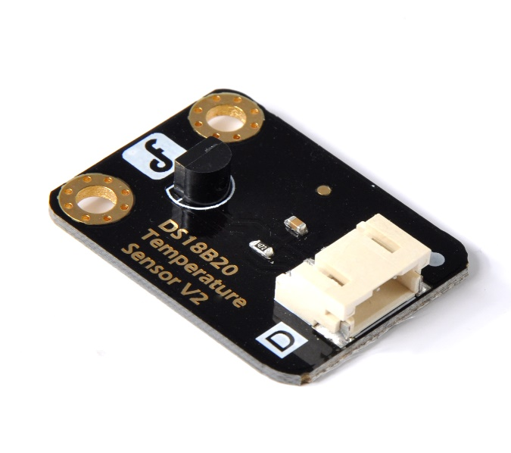**DS18B20 Temperature Sensor**

រូប 2.8 **DS18B20 Temperature Sensor**

តារាង​ 2.8 លក្ខណៈទូទៅរបស់ **DS18B20 Temperature Sensor**

|  |  |
| --- | --- |
| **DS18B20 Temperature Sensor** | |
| Supply Voltage | 3.3V to 5V |
| Temperature detection range | -55 ° C ~ +125 ° C (-67 ° F ~ +257 ° F) |
| Temperature range | -55 °C ~ +125 °C |
| Interface | Digital |
| Maximum 12-bit resolution | accuracy up to ±0.5 degrees Celsius |
| Size | 22x32mm (0.87x1.26in） |

**DS18B20 Waterproof Temperature Sensor**

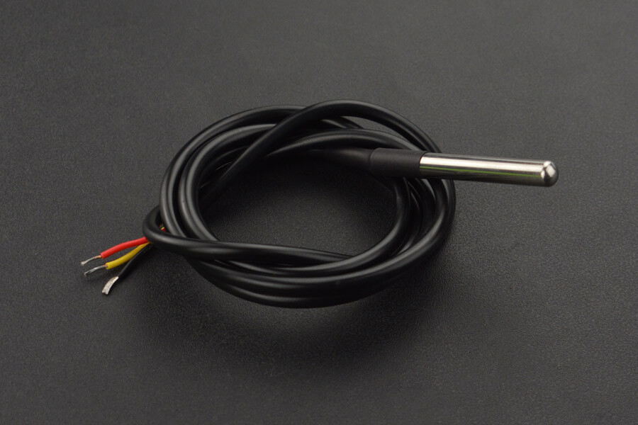

រូប 2.9 **DS18B20 Waterproof Temperature Sensor**

តារាង​ 2.9 លក្ខណៈទូទៅរបស់ **DS18B20 Waterproof Temperature Sensor**

|  |  |
| --- | --- |
| **DS18B20 Waterproof Temperature Sensor** | |
| Operating voltage | 3.0~5.5V |
| Usable temperature range | -55to125ºC (-67ºF to +257 ºF) |
| ±0.5 ºC Accuracy from | -10ºc to +85 ºc |
| Cable diameter | 4mm (0.16) |
| Length | 90cm (35.43) |

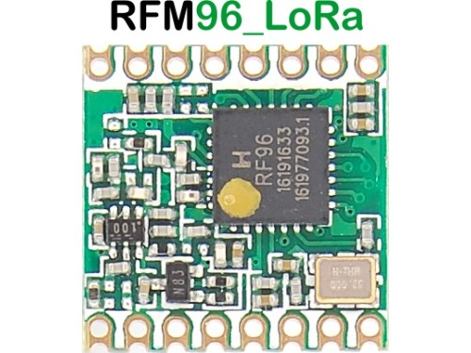LoRa RFM96

## រូប 3.0 LORA 868MHZ SX1276 RF TRANSRECEIVER MODULE RFM96W

តារាង​ 3.0 លក្ខណៈទូទៅរបស់ **LORA 868MHZ SX1276 RF TRANSRECEIVER MODULE RFM96W**

|  |  |
| --- | --- |
| **LORA 868MHZ SX1276 RF TRANSRECEIVER MODULE RFM96W** | |
| output | +20 dBm |
| V supply | 100 mW constant RF |
| High sensitivity | down to -148 dBm |
| Bullet-proof front end | IIP3 = -12.5 dBm |
| Low RX current of 10.3 mA | 200 nA register retention |
| LoRa and OOK modulation | FSK, GFSK, MSK, GMSK |
| Fully integrated synthesizer | resolution of 61 Hz |