DataBase report
Sari Itani 202201274
Roxane Mezher 202201349
Reina Al Hariri 202101305

Introduction:

This report provides a detailed overview of the database schema used to manage customer information, services offered, subscriptions, employees, departments, and other aspects of the company's operations. The report includes an Entity Relationship Diagram (ERD) to visualize the relationships between tables, followed by in-depth descriptions of each table's structure and functionalities.

ER DIAGRAM
This section dives deeper into the individual building blocks of the database schema: the tables. Each table will be presented in detail, starting with its name, which reflects the type of data it stores. We'll then identify the primary key (PK) column(s), which act as unique identifiers for each record within that table. Additionally, foreign key (FK) columns will be highlighted. These establish crucial relationships between tables, allowing data from one table to be linked to another.
For each table, we'll examine each column's name, data type (such as integer, character string, or date), and its purpose within the table's context. This will provide a clear understanding of the specific data each column holds and its relevance to the overall functionality of the table. Finally, any constraints or limitations placed on the data (e.g., a column cannot be empty or must hold unique values) will be explained to ensure data integrity and consistency. By examining these details for each table, we'll gain a comprehensive understanding of the database schema's structure and how it manages information. 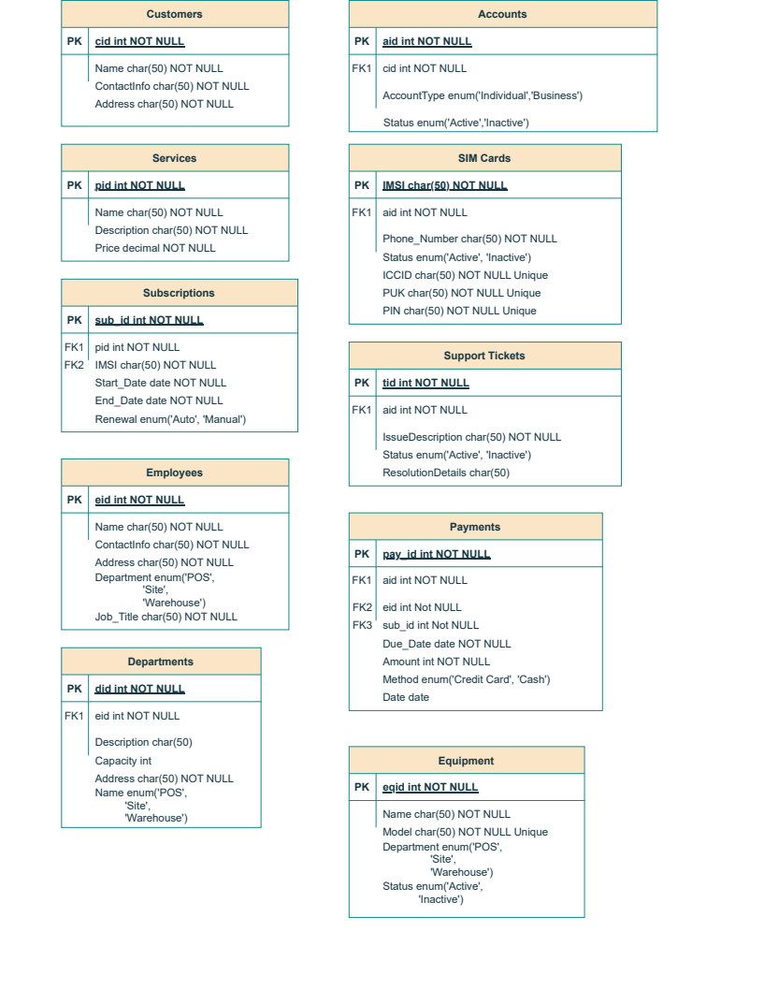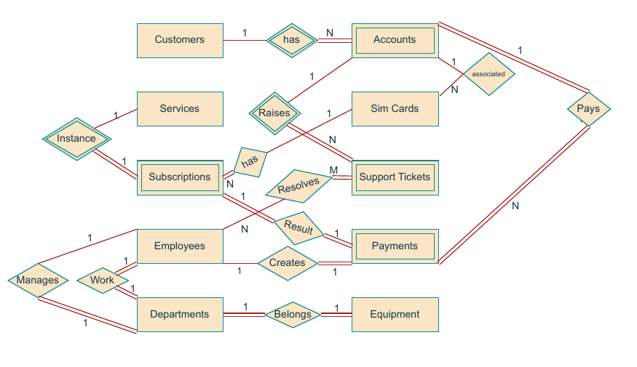

Functionalities and Use Cases
This section delves into the practical applications of the database schema. We'll explore the functionalities it supports, showcasing how this intricate data structure translates into real-world operations. Imagine scenarios like:
- Streamlining Customer Management: New customers can be effortlessly added to the system, with their contact information readily accessible. This facilitates efficient communication and service delivery.
- Tracking Service Subscriptions: The database meticulously tracks subscriptions to various services offered. This allows for monitoring subscription status, expiration dates, and potential renewal needs.
- Empowering Employee Management: Employee details are centrally stored, enabling effective management of departments and job assignments. The system facilitates tracking employee information and assigning them responsibilities based on skillsets.
- Resolving Customer Issues: Support tickets submitted by customers can be efficiently logged and tracked within the system. This allows for prompt resolution and recording of solutions, ensuring a seamless customer experience.
- Recording Financial Transactions: Payments for services and subscriptions are meticulously recorded, providing a clear financial audit trail. This ensures accurate accounting and simplifies financial management.
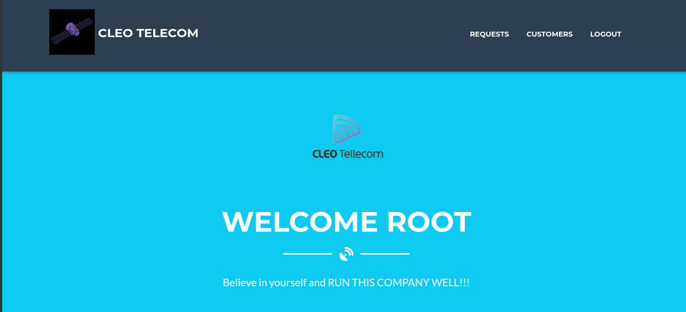
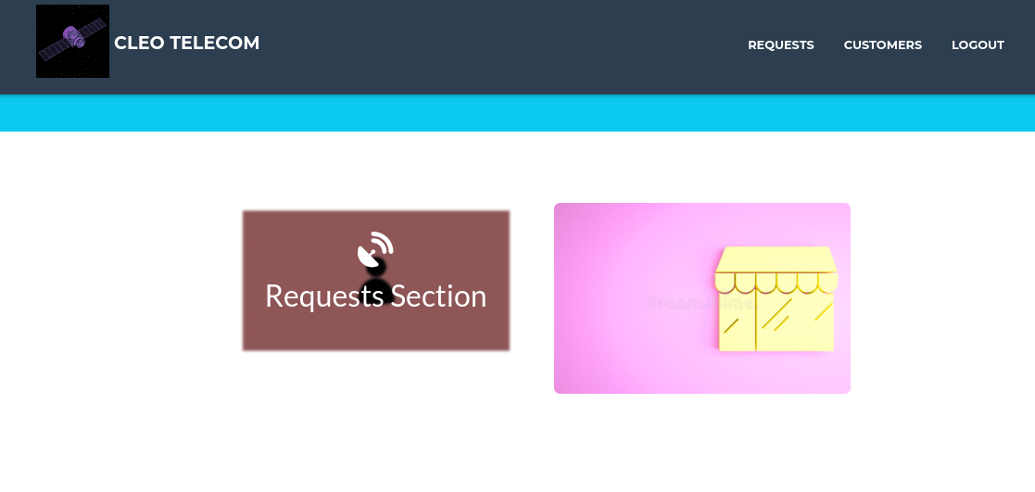
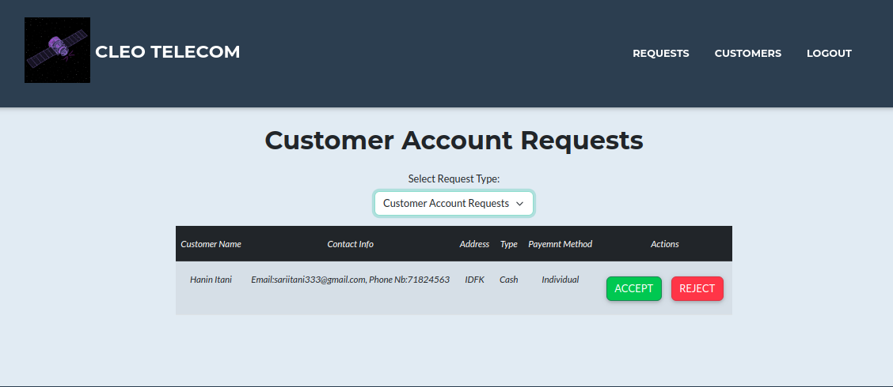
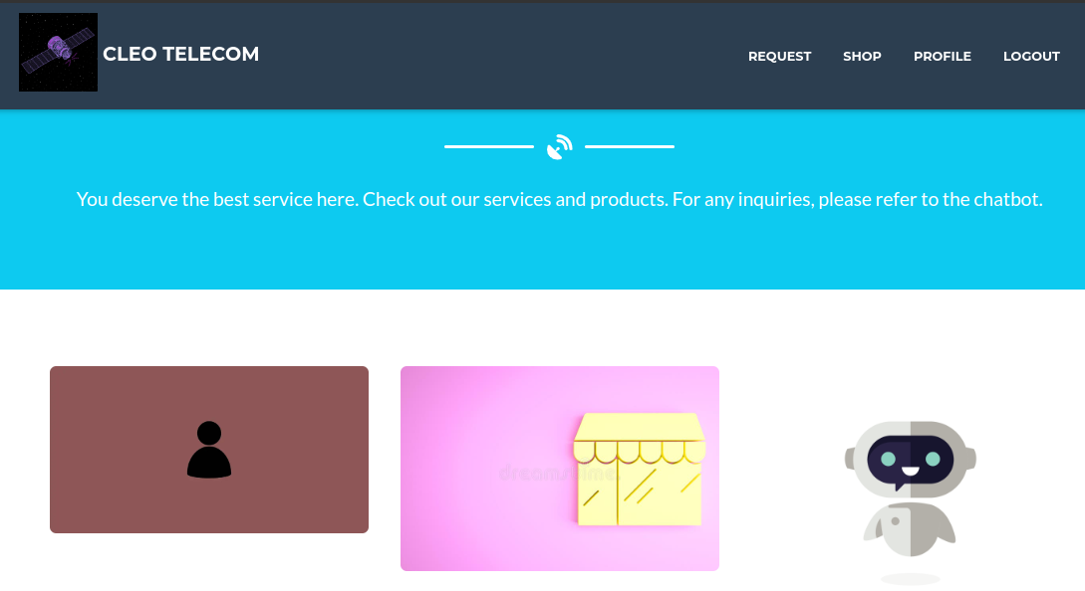
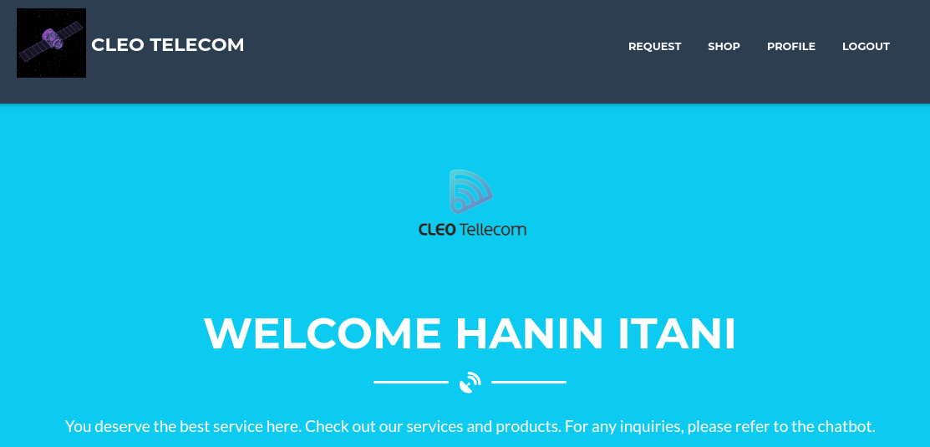
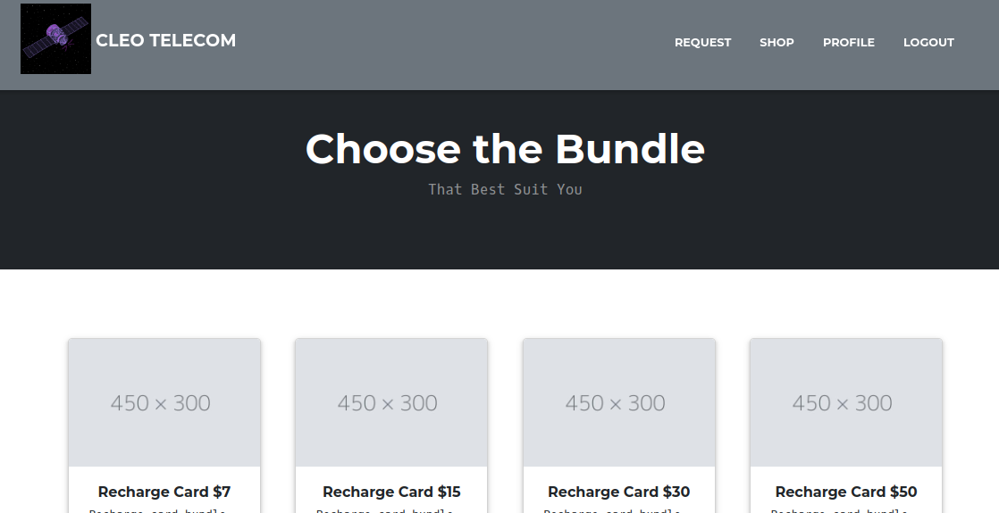
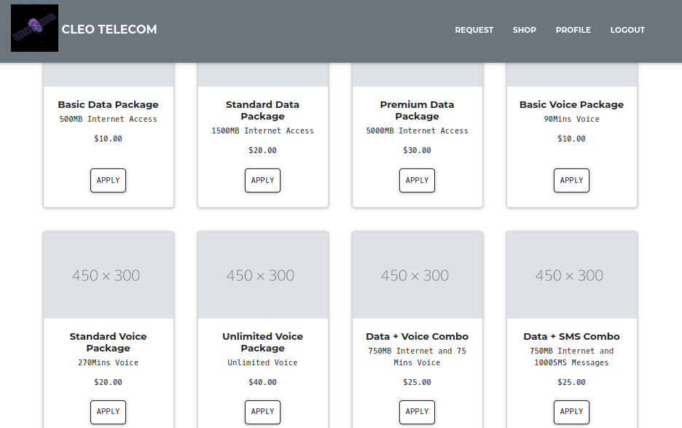
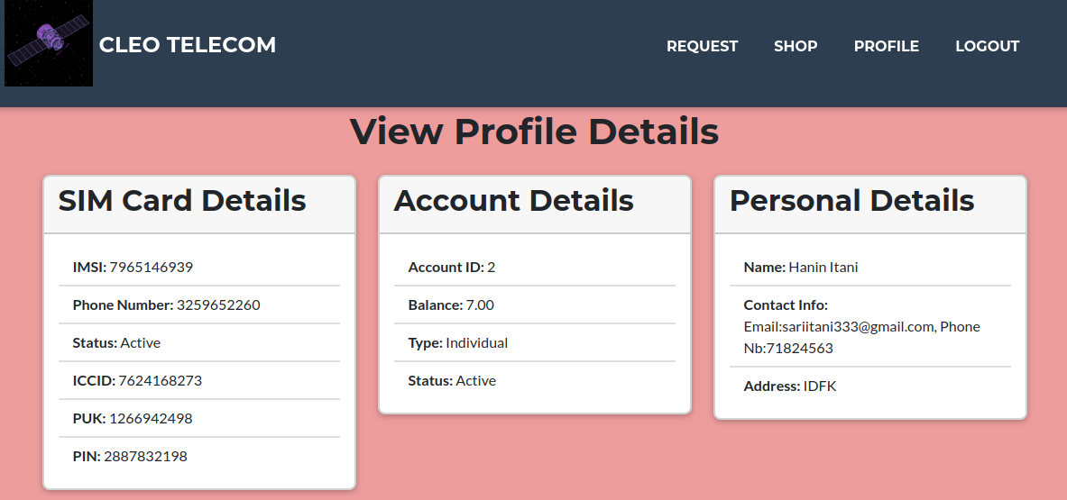
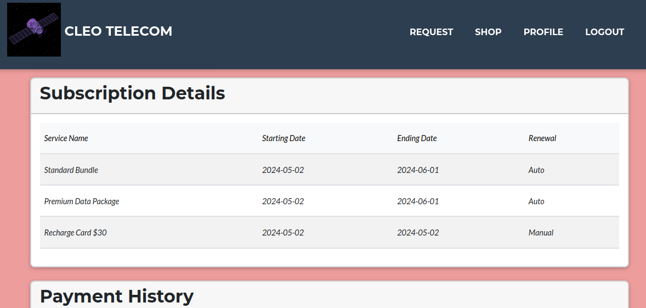
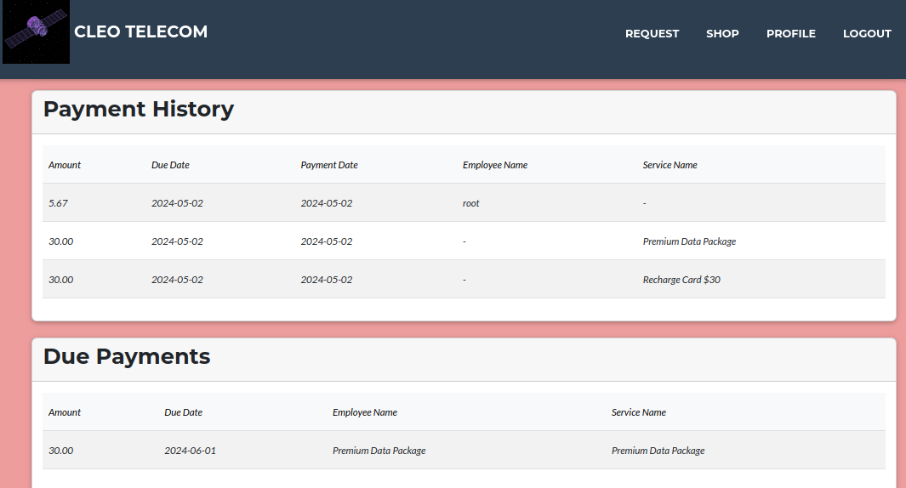
We created a website using Flask and Bootstrap5 to demonstrate some features of this DBMS.

Conclusion
In conclusion, this report has comprehensively explored the database schema that serves as the foundation for managing various aspects of the company's operations. The detailed explanations of the Entity Relationship Diagram (ERD) and individual tables provide a clear understanding of the data structure and its relationships. We've seen how the schema facilitates functionalities like efficient customer management, subscription tracking, employee management, and financial record-keeping.
Furthermore, the development of a website utilizing Flask and Bootstrap5 demonstrates the potential for leveraging this database schema to create user-friendly interfaces for interacting with the data. Moving forward, this robust database schema can be continuously optimized and expanded to accommodate the evolving needs of the company, ensuring efficient data management and supporting future growth.

