

Semester-7

**Digital Image processing (CSC-369)**

Practical Task 02



***Group Members:***

*Syed Sarib Naveed NIM-BSCS-2021-41*

*Ietazaz Aslam NIM-BSCS-2021-11*

*M Bilal NIM-BSCS-2021-23*

**Task-1:** Using Python, create grayscale image of resolution 400 x 400 pixels such that all even number columns are black (0), and all odd columns are white (255).

|  |
| --- |
| import pandas as pd  import matplotlib.pyplot as plt import seaborn as sns import numpy as np from PIL import Image from scipy.ndimage import zoom  *# Create an array of zeros (black)* image = np.zeros((400, 400), dtype=np.uint8) image[:, 1::2] = 255 img = Image.fromarray(image) img.save('Image.png')  *# Display the image using matplotlib*  plt.imshow(image, cmap='gray', vmin=0, vmax=255) plt.axis('off') *# Turn off axis labels* plt.show() |



**Task-2:** Resize this image to 200x200, and comment on the output. What do you observe?

|  |
| --- |
| *# Convert the numpy array to a PIL image* img = Image.fromarray(image) *# Resize the image to 200x200*  img_resized = img.resize((200, 200), Image.NEAREST) |
| *# Convert back to numpy array for plotting* resized_image_array = np.array(img_resized) *# Display the resized image using matplotlib*  plt.imshow(resized_image_array, cmap='gray', vmin=0, vmax=255) plt.axis('off') plt.show() |



**Observation:**

In the task, I observed that the original image, which was 400x400 in size, had an alternating pattern of black and white pixels. The pattern followed a sequence where one black pixel was followed by one white pixel across the entire image. After resizing the image to 200x200, the result was a completely white image. This occurred because the resizing process caused the black pixel values to be discarded, leaving only the white pixels, which resulted in the image appearing entirely white.

**Task-3:** Design your own algorithm and resize again such that the image details are retained in the output image.

def custom_resize(image): resized_image = np.zeros((200, 200), dtype=np.uint8) const = 0 check = -1 for i in range(200): j = 0 img_ind = 0 while j < 400:

|  |
| --- |
| if const == 0: check *= -1 if image[i, j] == 0: const += 1 else: const -= 1 if check == 1: resized_image[i, img_ind] = image[i * 2, j] img_ind += 1 j += 1 return resized_image  resized_image = custom_resize(image) *# Convert back to numpy array for plotting* a = np.array(resized_image)  *# Display the resized image using matplotlib* plt.imshow(a, cmap='gray', vmin=0, vmax=255) plt.axis('off') *# Turn off axis labels* plt.show() |

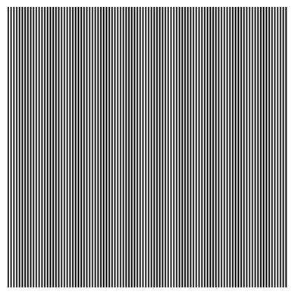

**Task-4:** Create a new image of size 400x400, but this time first 2 columns are black, then two columns are white, and this pattern continues.

*# Create an array of zeros (black)*

image_2 = np.zeros((400, 400), dtype=np.uint8)

*# Apply the alternating pattern: 2 columns black, 2 columns white* image_2[:, ::4] = 0 *# Set every 4th column (starting from 0) to*

|  |
| --- |
| *black*  image_2[:, 1::4] = 0 *# Set every 4th column (starting from 1) to black*  image_2[:, 2::4] = 255 *# Set every 4th column (starting from 2) to white*  image_2[:, 3::4] = 255 *# Set every 4th column (starting from 3) to white*  *# Save the image*  img2 = Image.fromarray(image_2) img2.save('Image_alternating.png') *# Display the image using matplotlib*  plt.imshow(image_2, cmap='gray', vmin=0, vmax=255) plt.axis('off') *# Turn off axis labels* plt.show() |

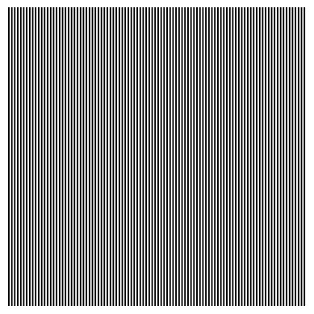

**Task-5:** Will the algorithm you designed in part 3 work with this new image? If not, how can you improve it so that it works for both images.

|  |
| --- |
| resized_image_2 = custom_resize(image_2) *# Convert back to numpy array for plotting* a = np.array(resized_image_2)  *# Display the resized image using matplotlib* plt.imshow(a, cmap='gray', vmin=0, vmax=255) |

plt.axis('off') *# Turn off axis labels* plt.show()

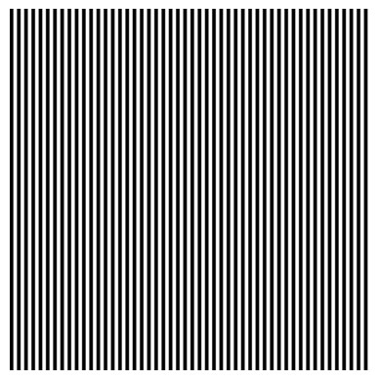

**Yes, Our Algorithm worked for both tasks**

**Task-6:** Interpolate the image created in part 1, by a factor of 2, and by a factor of 3, using the built-in functions with bilinear.Quadratic, and cubic parameters, and then compare and discuss the results.

|  |
| --- |
| *# Function to perform interpolation and display* def interpolate_image(ax, image, factor, order, interpolation_type):  zoomed_image = zoom(image, factor, order=order) ax.imshow(zoomed_image, cmap='gray', vmin=0, vmax=255) ax.set_title(f'{interpolation_type} Interpolation (Factor:  {factor})') ax.axis('off')  *# Interpolation by factor of 2 and 3 using bilinear, quadratic, and*  *cubic interpolation* factors = [2, 3]  interpolation_methods = [(1, 'Bilinear'), (2, 'Quadratic'), (3, 'Cubic')]  *# Create a single figure with 3 columns and 2 rows* fig, axes = plt.subplots(2, 3, figsize=(15, 10)) axes = axes.flatten()  *# Iterate through the factors and interpolation methods* |

for i, factor in enumerate(factors): for j, (order, interp_type) in enumerate(interpolation_methods): interpolate_image(axes[i * 3 + j], image, factor, order, interp_type)

*# Adjust layout and show the plot*

plt.tight_layout() plt.show()

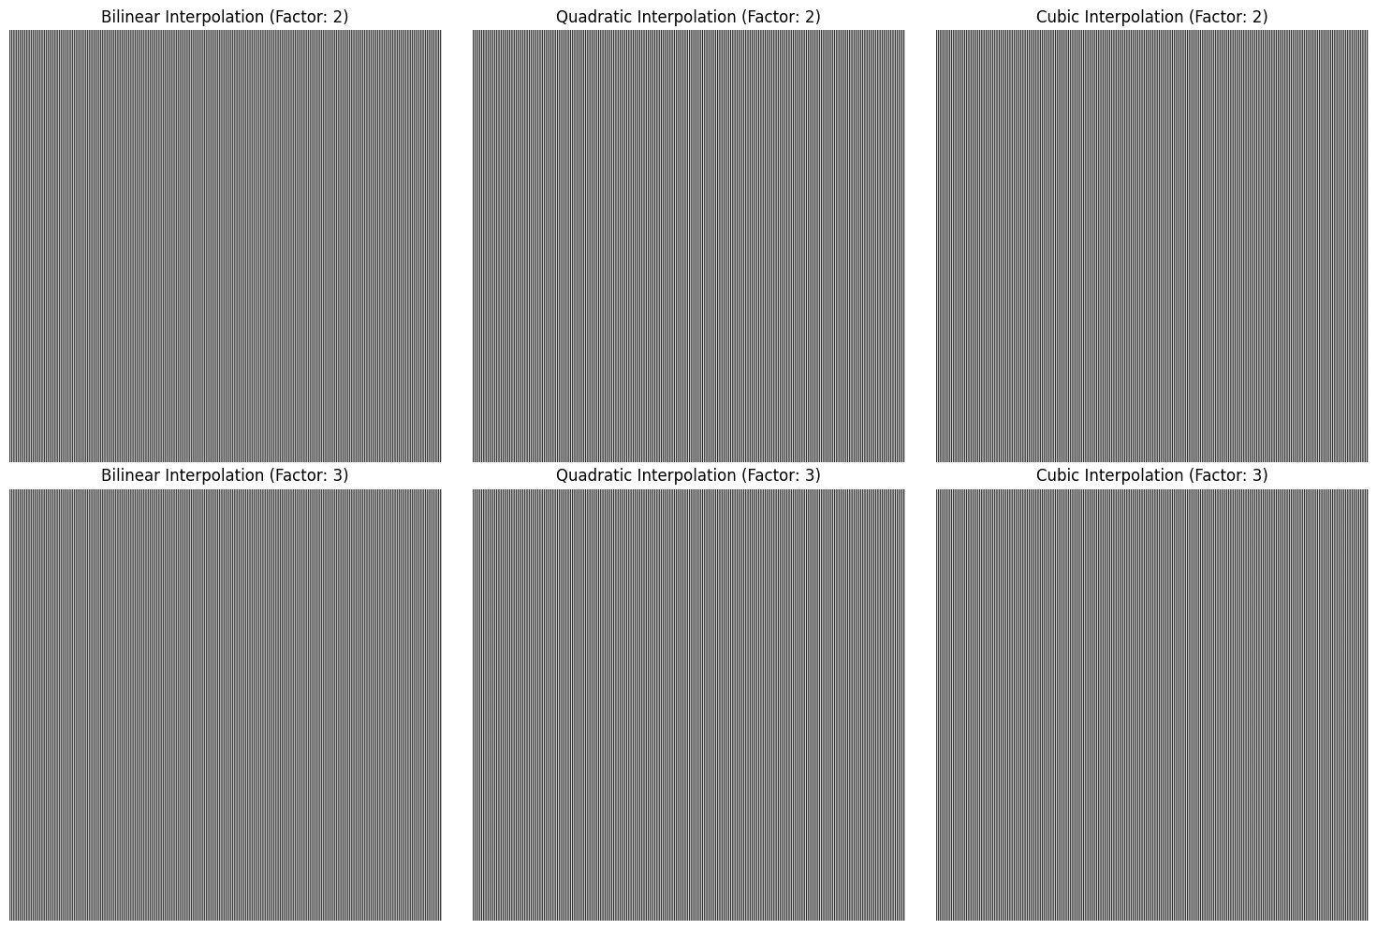

**Observation:**

With bilinear interpolation, the resulting images still showed the alternating pattern, but they appeared somewhat blurred because the new pixels were influenced by the colors of nearby pixels. The quadratic interpolation made the image look a bit smoother, with softer transitions between black and white, making it less sharp. Cubic interpolation produced the clearest image, enhancing the edges and making the pattern more distinct.

Overall, while all three methods kept the basic alternating pattern, cubic interpolation gave the best clarity, followed by quadratic and then bilinear. This shows how different interpolation techniques can affect the quality of images, especially in patterns with high contrast like the black and white pixels in this task.

**Task-7:** Now Implement your own bilinear interpolation function and resize the same input image by a factor of 2 and 3.

|  |
| --- |
| import numpy as np  import matplotlib.pyplot as plt  *# Function to perform bilinear interpolation manually* def bilinear_interpolation(image, factor):  *# Get the original dimensions*  orig_height, orig_width = image.shape new_height = int(orig_height * factor) new_width = int(orig_width * factor)  resized_image = np.zeros((new_height, new_width), dtype=np.uint8)  *# Scale factors for mapping new pixel positions to original image coordinates*  row_scale = (orig_height - 1) / (new_height - 1) col_scale = (orig_width - 1) / (new_width - 1)  *# Loop over the new image's pixels*  for i in range(new_height): for j in range(new_width):  *# Map the new image's pixel (i, j) back to the original image's coordinates*  orig_x = j * col_scale orig_y = i * row_scale x1 = int(np.floor(orig_x)) y1 = int(np.floor(orig_y)) x_diff = orig_x - x1 y_diff = orig_y - y1  x2 = min(x1 + 1, orig_width - 1) y2 = min(y1 + 1, orig_height - 1) top_left = image[y1, x1] top_right = image[y1, x2] bottom_left = image[y2, x1] bottom_right = image[y2, x2]  interpolated_value = (top_left * (1 - x_diff) * (1 - y_diff) +  top_right * x_diff * (1 - y_diff) + bottom_left * (1 - x_diff) * y_diff  +  bottom_right * x_diff * y_diff) resized_image[i, j] = int(interpolated_value) return resized_image  *# Function to display images* def display_image(image, title): plt.figure(figsize=(6, 6)) plt.title(title)  plt.imshow(image, cmap='gray', vmin=0, vmax=255)  plt.axis('off') plt.show() *# Original image* |

|  |
| --- |
| image = np.zeros((400, 400), dtype=np.uint8) image[:, 1::2] = 255 *# Example pattern*  *# Resize the image by a factor of 2 and 3 using bilinear interpolation* resized_image_2 = bilinear_interpolation(image, 2) display_image(resized_image, f'Manual Bilinear Interpolation (Factor:  {2})')  resized_image_3 = bilinear_interpolation(image, 3) display_image(resized_image, f'Manual Bilinear Interpolation (Factor: {3})') |

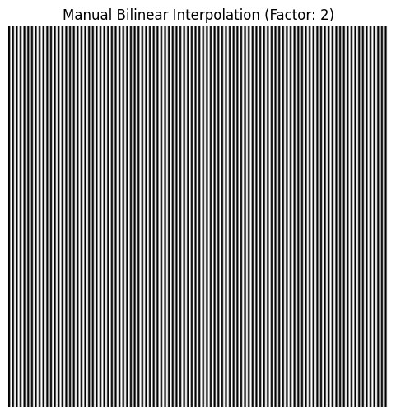

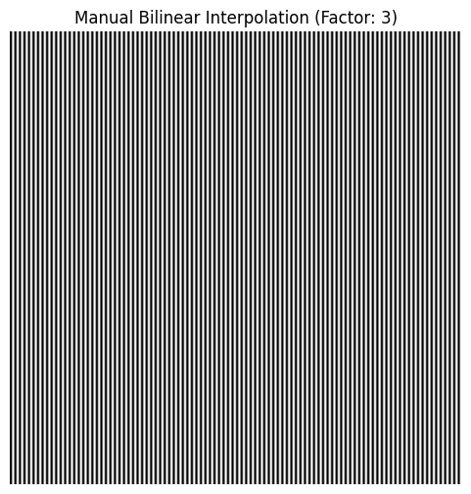

**Task-8** Calculate the difference between your output and the bilinear output of the built-in function. Do you get a completely zero difference output?

|  |
| --- |
| import numpy as np  import matplotlib.pyplot as plt from scipy.ndimage import zoom  *# Function to display the difference between two images* def display_difference(image1, image2, title): difference = np.abs(image1 - image2) plt.figure(figsize=(6, 6)) plt.title(title)  plt.imshow(difference, cmap='gray') plt.axis('off') plt.show() return difference  *# Resize using built-in bilinear interpolation (order=1)* built_in_resized_image = zoom(image, 2, order=1) |

|  |
| --- |
| *# Display the images* plt.figure(figsize=(12, 6)) plt.subplot(1, 2, 1)  plt.title('Manual Bilinear Interpolation')  plt.imshow(resized_image_2, cmap='gray', vmin=0, vmax=255) plt.axis('off')  plt.subplot(1, 2, 2)  plt.title('Built-in Bilinear Interpolation')  plt.imshow(built_in_resized_image, cmap='gray', vmin=0, vmax=255) plt.axis('off') plt.show()  *# Calculate and display the difference between the two* difference = display_difference(resized_image_2,  built_in_resized_image, 'Difference Between Manual and Built-in Interpolation') |

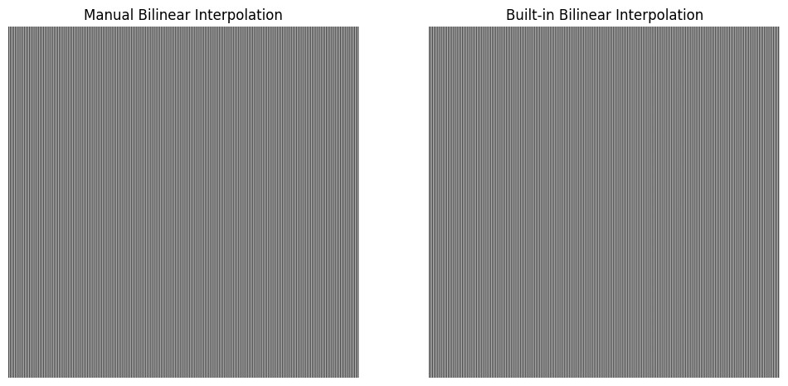

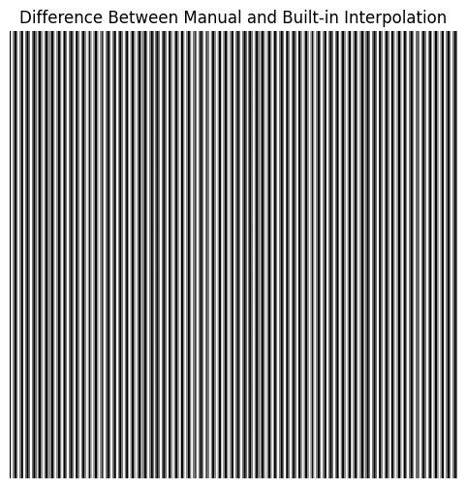

**Answer:**

No, the difference is not completelly zero.