SARIGASINI M
CB.SC.U4CSE23065

SET – 1 MODEL QP

Q2) MongoDB Database for storing BillDetails
a) Create a Database for storing BillDetails 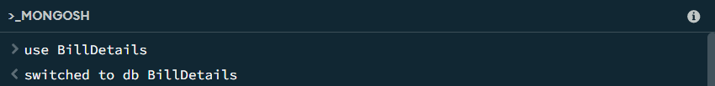

b) i) create a MongodDB document with billno:B101,vendor:xyz, date:'11-aug-2025', quantity:50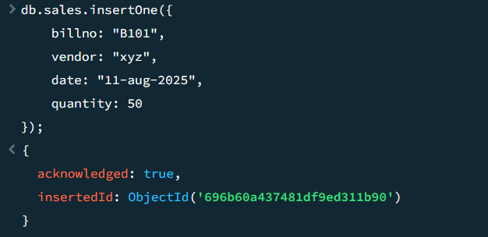
ii) create a MongodDB document with billno:B101,vendor:xyz, date:'12-aug-2025', quantity:150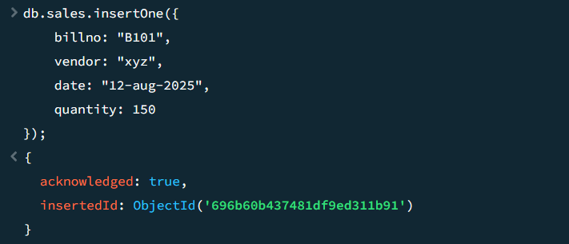
iii) create a MongodDB document with billno:B102,vendor:xy, 3 date:'13-aug-2025',quantity:50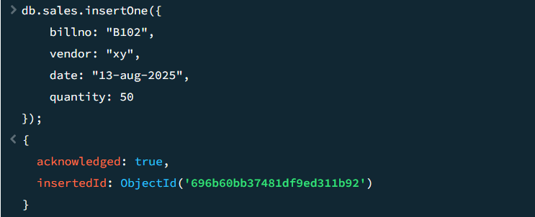
c) search for the document whose billno is B102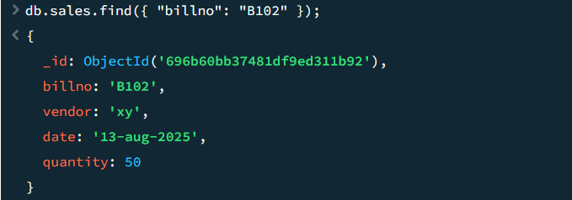
d) .Update the document whose billno is B101 and date as '11-Aug-2025' as billno:B101,vendor:xyz, date:'13-aug-2025',quantity:150
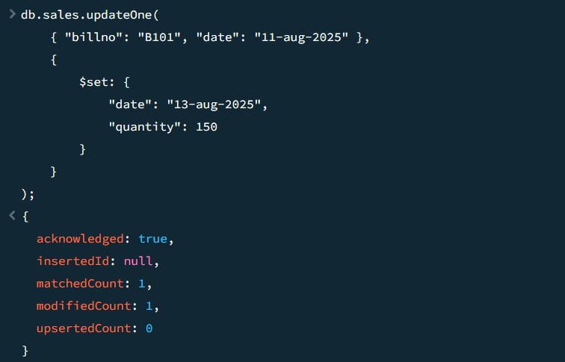
e) Remove the document whose Billno is B101
