SARIGASINI M
CB.SC.U4CSE23065
CSE A
SET 1 MODEL QP - THEORY
Question 3
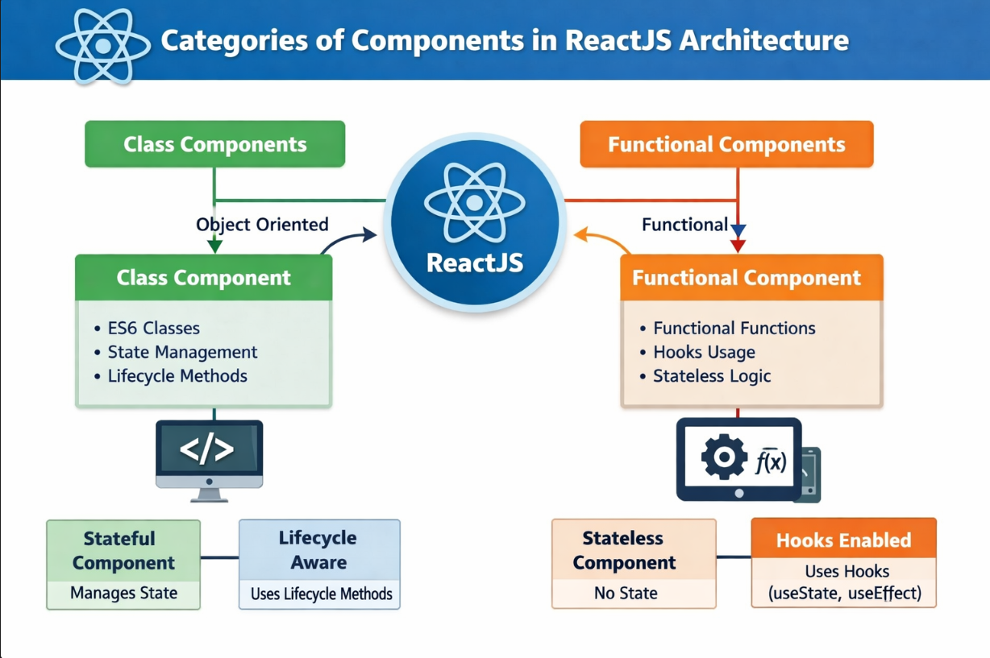

Question 4
import React from 'react'
import PropTypes from 'prop-types'
class Total extends React.Component {
render() {
const { num1, num2, num3 } = this.props;
return (
<p>
The total of {num1}, {num2} and {num3} is {num1 + num2 + num3}
</p>
);
}
}
Total.propTypes = {
num1: PropTypes.number,
num2: PropTypes.number,
num3: PropTypes.number
};
export default Total;
This component receives three numbers as props and calculates their sum inside the render() method.

Question 5
In ReactJS, the bind() method is used to bind event handlers to the component instance so that the 'this' keyword refers to the correct object.
Example:
class ButtonClick extends React.Component {
constructor(props) {
super(props);
this.state = { message: "Hello" };
this.handleClick = this.handleClick.bind(this);
}
handleClick() {
this.setState({ message: "Button Clicked!" });
}
render() {
return (
<div>
<p>{this.state.message}</p>
<button onClick={this.handleClick}>Click Me</button>
</div>
);
}
}
Explanation:
- The bind() method ensures that 'this' inside handleClick() refers to the ButtonClick component.
- Without binding, 'this' would be undefined when the event handler is called.

Question 6
State management in ReactJS is used to handle data that changes over time within a component.
Example:
class Counter extends React.Component {
constructor(props) {
super(props);
this.state = { count: 0 };
}
increment = () => {
this.setState({ count: this.state.count + 1 });
};
render() {
return (
<div>
<p>Count: {this.state.count}</p>
<button onClick={this.increment}>Increment</button>
</div>
);
}
}
Explanation:
- State is initialized in the constructor.
- setState() is used to update the state.
- When state changes, React automatically re-renders the component.

