**Screenshots**

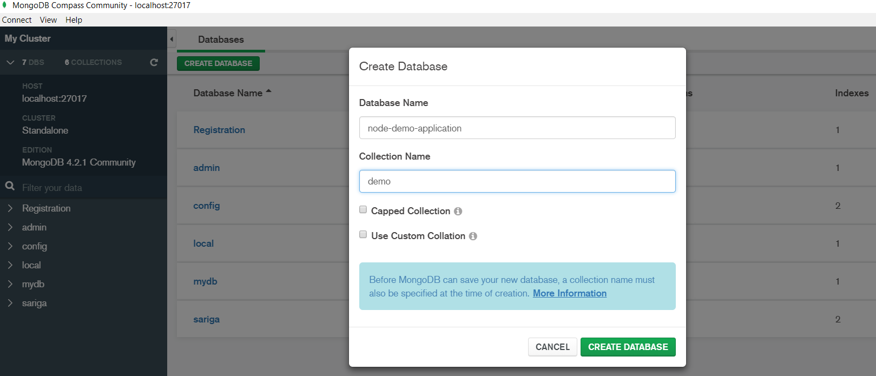

Fig1:Creating database

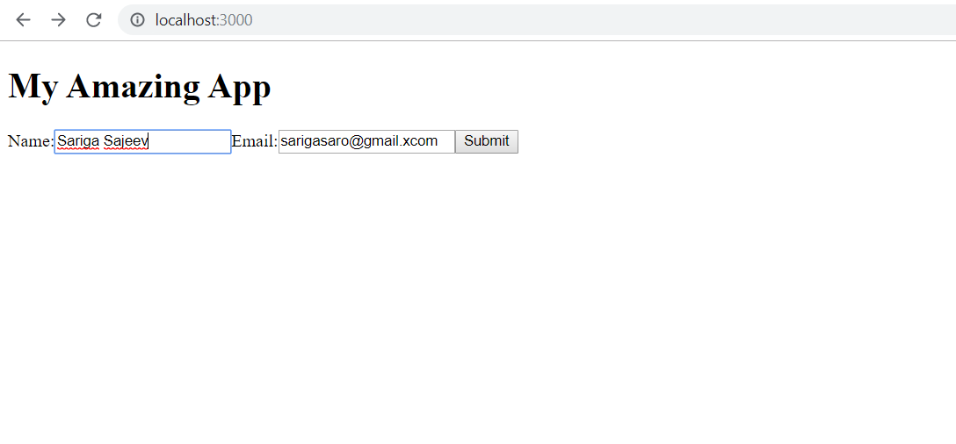

Fig2:Entering name and email to the web page

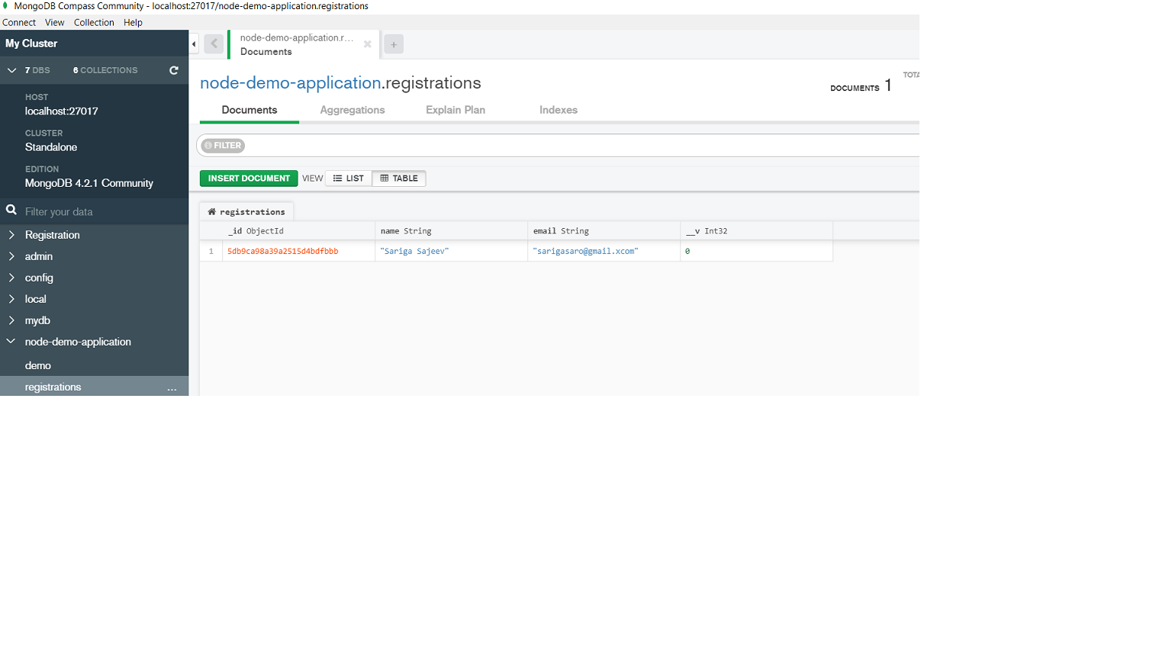

Fig3:Entered name and email id will be saved on the created database