Day 2

**INTRODUCTION TO PYTHON**

Programming Language is a form of communication that is used to instruct computer to perform some specific things. Example: Addition of two numbers.

Python is a high level; interpreter based programming language which can be used in multiple fields like Web Development, Artificial Intelligence, Networking, etc. It was created by Guido van Rossum, and released in 1991.

**FEATURES OF PYTHON**

1. Free and Open Source

2. Easy to Read and Code

3. Object-Oriented and Procedure-Oriented Language

4. Dynamically Typed Language

5. Easy to Debug

6. Large Standard Library

7. Interpreted Language and many more.

**DIFFERENCE BETWEEN RUN TIME AND COMPILE TIME.**

|  |  |
| --- | --- |
| **Run Time** | **Compile Time** |
| a. Runtime is the time at which the executable code is started running. | a. Compile time is the time at which source  code is converted to executable code |
| b. Runtime errors can be:  ○ Division by zero  ○ Square root of negative numbers,etc | b. Compile time errors can be:  ○ Syntax errors  ○ Semantic errors |

**DIFFERENCE BETWEEN INTERPRETER AND COMPILER.**

|  |  |
| --- | --- |
| **Interpreter** | **Compiler** |
| Interpreter is a program that converts source code to machine code line by line when program is executed. | Compiler is a program that converts source  code to machine code in one go and  generate executable file that can be run  directly by the computer |
| At each execution, interpreter convert  each line of user program to machine  code, the process is slower | Compiler generates executable file, so it is faster to run compiled code than interpreted code. |
| Example: Python, Ruby, etc | Example: C, C++, Java etc |

**OPERATORS, VARIABLES AND KEYWORDS IN PYTHON**

**Operators v/s Operands v/s Expressions**

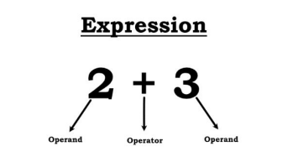

* Operators are special symbols that perform specific operations on one or more operands.
* Operands are the values that an operator acts on.
* A sequence (or combinations) of operands and operators, is called an expression.

TYPES OF OPERATOR

1. **Arithmetic Operators**

General mathematical symbols used for addition, subtraction, multiplication etc.

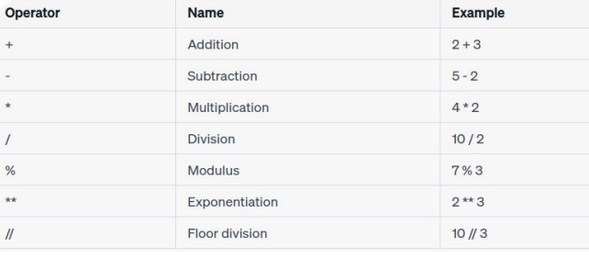

1. **Assignment operators**

Assignment operators are used to assign values to variables.

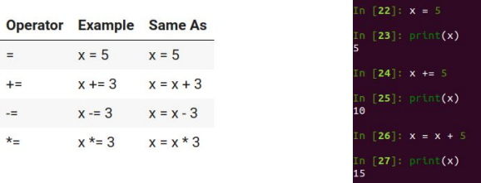

(Note: Variables are the container where we can store certain data value.)

1. **Comparison Operators**

Comparison operators are used to compare two values (operands or variables).

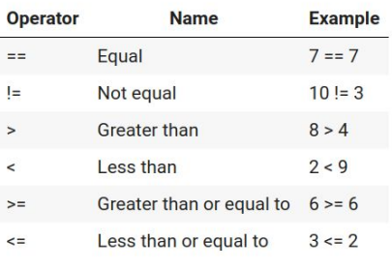

1. **Logical Operators**

Logical operators are used to combine conditional expressions.

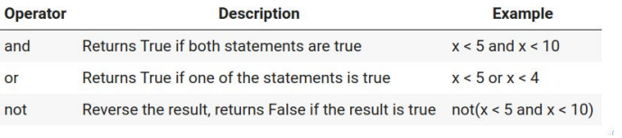

1. **Identity Operators**

Identity operators are used to compare variables.

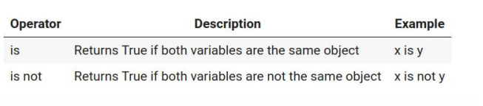

**OPERATORS PRECEDENCE**

This is used in an expression with more than one operator with different precedence to determine which operation to perform first.

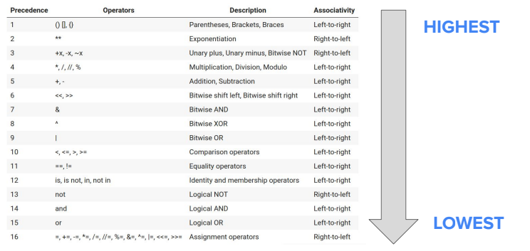

**PYTHON VARIABLES**

Variables are containers for storing data values. When you assign a value to a variable, Python reserves a space in memory to store that value.

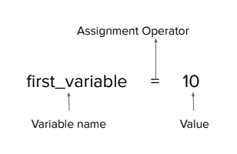

**RULES FOR CREATING VARIABLES**

1. A variable name must start with a letter or the underscore character

True: (e.g., var_name, _variable)

False: (e.g., 123var, @variable)

2. A variable name cannot start with a number

True: (e.g., variable1, _variable2)

False: (e.g., 5number, 10th_variable)

3. A variable name can only contain alpha-numeric characters and underscores (A-z, 0-9, and _)

True: (e.g., my_variable, var123)

False: (e.g., my_var$, var!able)

4. Variable names are case-sensitive (var, Var, VAR are three different variables)

5. A variable name cannot be any of the Python Keywords (error)

False: (e.g., for, if)

**NAMING CONVENTIONS**

1. Camel Case: Each word except the first; starts with a capital letter.

camelCaseDemo = "camel case"

2. Pascal Case: Each word starts with a capital letter

PascalCaseDemo = "pascal case"

3. Snake Case: Each word is separated by underscore and is lowered cased. (preferred in python)

snake_case_demo = "snake case"

**KEYWORDS AND IDENTIFIERS.**

**Keywords:**

Keywords are the reserved words in Python. We cannot use keywords as variable name, function name, or any other identifier. Keywords are used to define the syntax and structure of the Python language. In Python, keywords are case sensitive. For e.g False is keyword but false is not.

