**CRUD operations in database (mysql)**

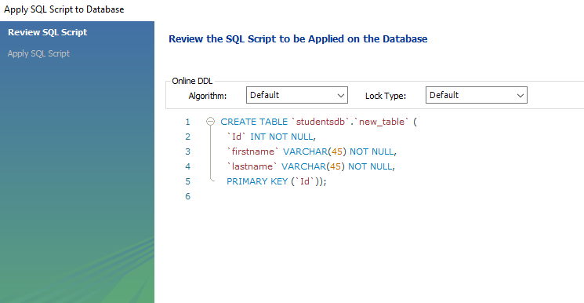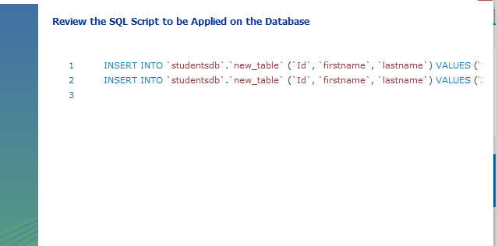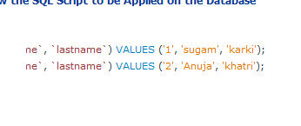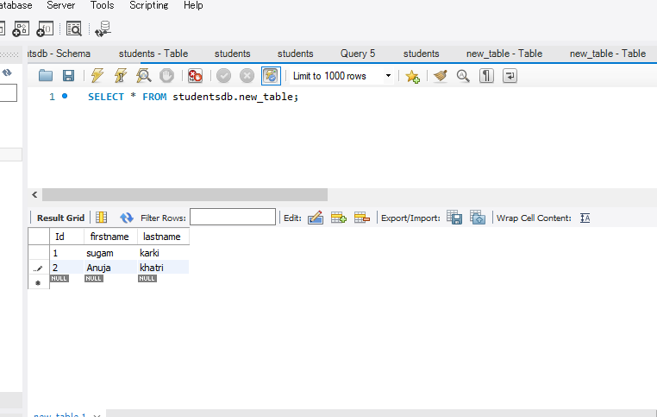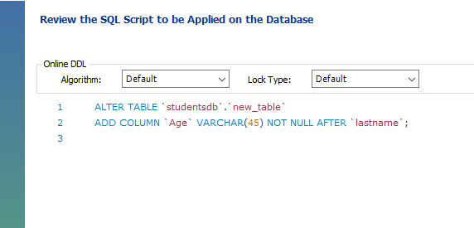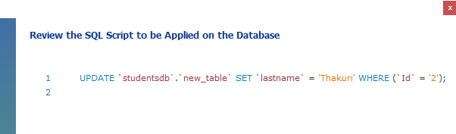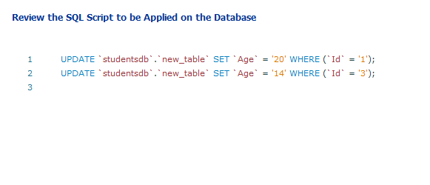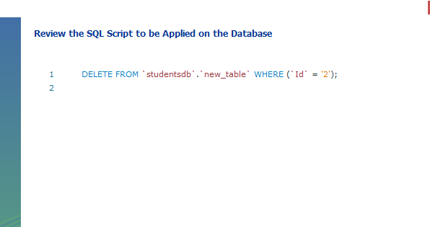

**Documentation on Installing Ubuntu on VMware, Configuring Python, and Setting Up Jupyter Notebook.**

**Installing Ubuntu on VMware.**

1. Install any virtual box you want from internet browser.
2. Download the ubuntu ISO file.
3. Open the installed VMware application.
4. Click on “Create new virtual machine”. Browse the ISO file that has been downloaded and select it.
5. Enter all the details>> click on next. Personalization of Virtual Machine(Enter username and password)
6. Enter Virtual machine name >> click on next.
7. Specify disk capacity >> click on next.
8. If needed, specify hardware as well.
9. Ubuntu is installed in your VMware now. Click on the ubuntu software on the left of your virtual box to open.