Day 2

1. Create a variable named variable test in snake case format and assign value “my
   * 1. first variable assignment”. Print the result.

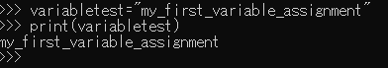

1. Create a variable named age and assign value as 20. Print the result.



1. Create a variable called z, assign x + y to it, and Display the result.Initialize,x = 20, y = 30

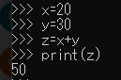

1. Create three variables x, y, z and assign same value to all 3 variables in one codeline.

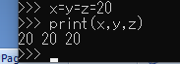

1. Develop basic calculator app for the user:

a. Input two numbers from user and assign it to variable num1 and num2

b. Perform addition of two numbers and assign to variable result_add

c. Display result_add to user.

