**SETUP**

**Database Management System for Robert H. Smith School of Business: Specialty Masters Program**

**This setup File will take you through a series of 4 steps to setup and run the entire application.**

**Step 1 : Download and install required tools and softwares**

**Step 2: Download the .zip code for application and paste at appropriate location**

**Step 3: Setup Database**

**Step 4: Run the Application**

The application requires the following software to run:

* XAMPP server

**Step 1 : Download and Run XAMPP server**

1. In your web browser, go to  <http://www.apachefriends.org/en/xampp.html> (Choose appropriate download link for your OS. This setup file gives specific instructions for Windows OS ).

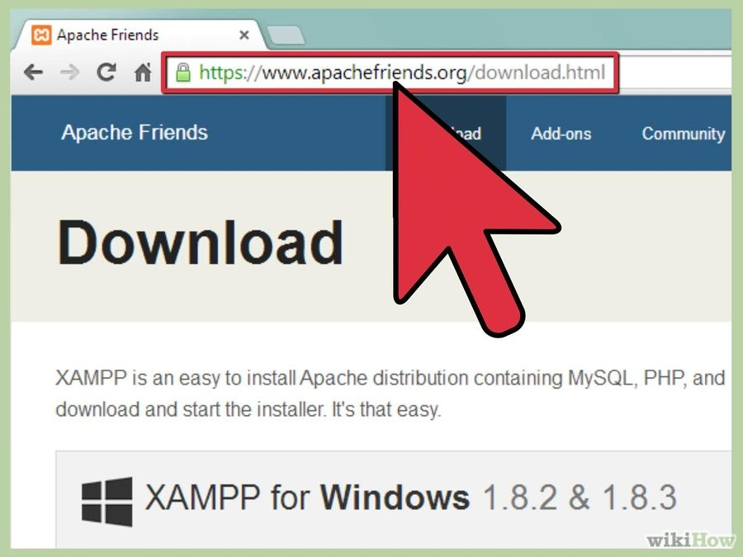

1. Click on the download link for XAMPP

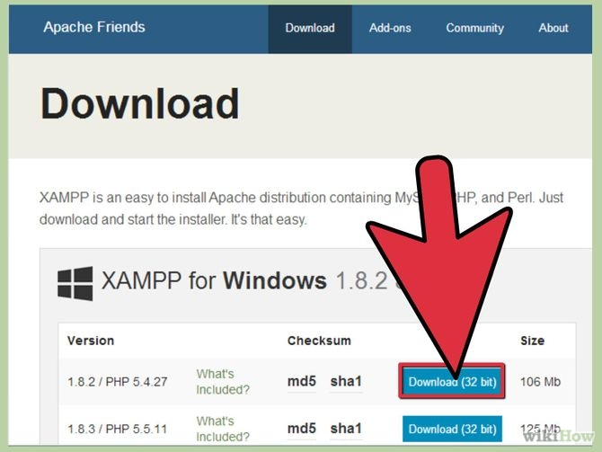

1. When prompted for the download, click "Save" and wait for your download to finish**.**

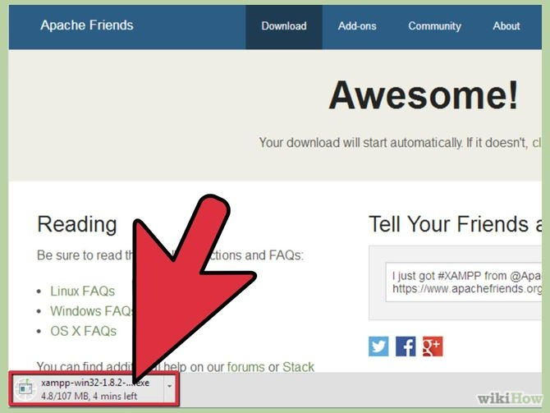

1. Once your download is complete, install the program, click on "Run"

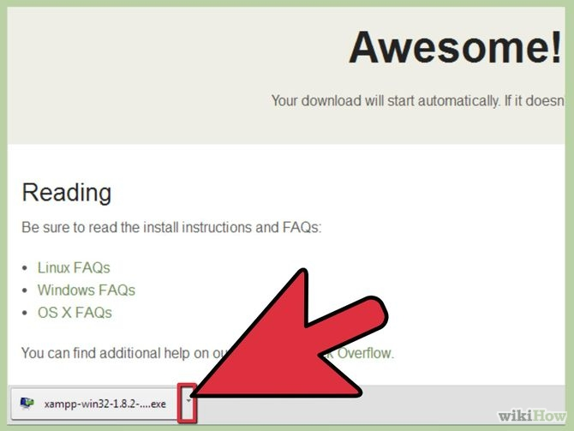

1. Accept the default settings

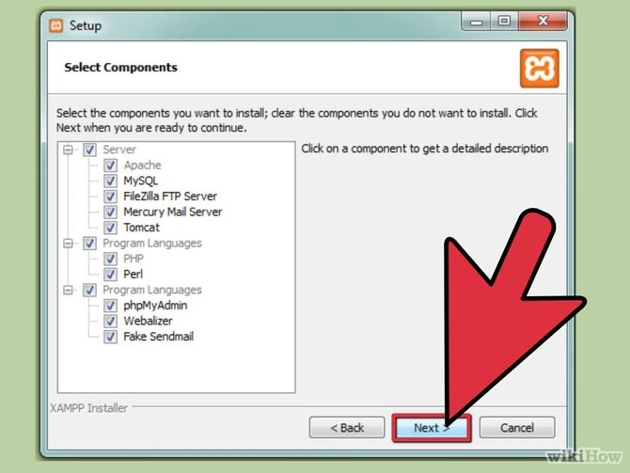

1. When your installation is complete, exit the command window by typing x on the command line.

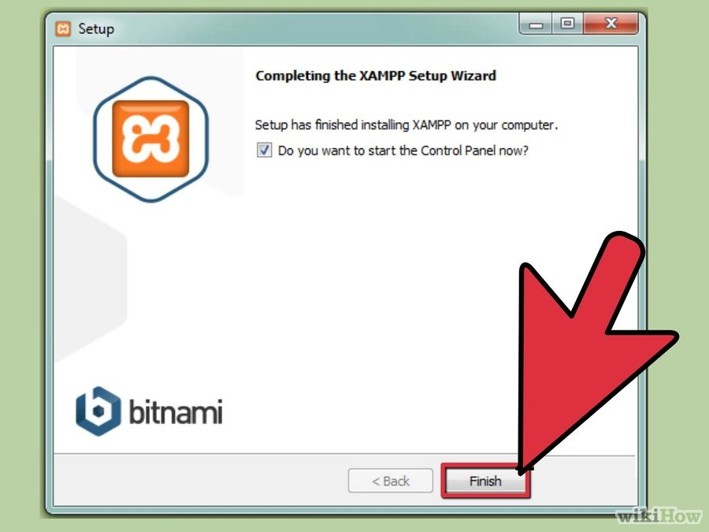

1. Start the XAMPP Control Panel.

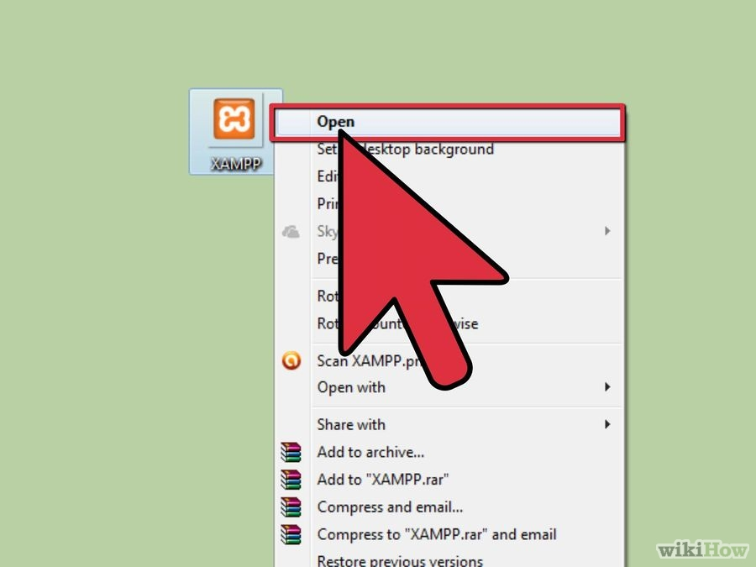

1. Start the Apache and MySQL components

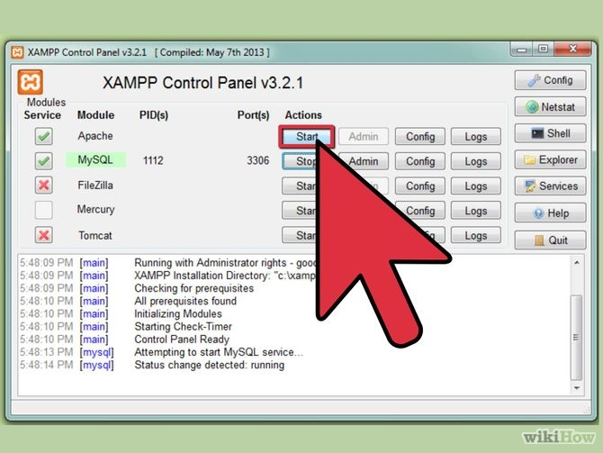

**Step 2: Download the application code folder named ‘dbmsproject’ from Project suite.**

* Save the code folder ‘dbmsproject' in following path (C:\xampp\htdocs):
* Open C:
* Open XAMPP folder
* Open htdocs folder
* Save the code folder here
* This ‘dbmsproject’ folder contains the database file (dbms_project.sql).

**Step 3: Set up database on phpMyAdmin**

* In firefox browser, go to link: <http://localhost/phpmyadmin/>

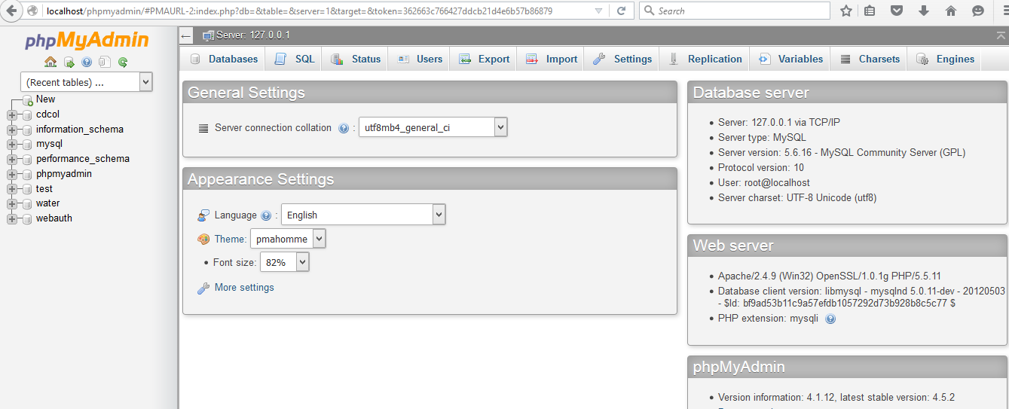

* Click on ‘databases’ tab at the top of the page.

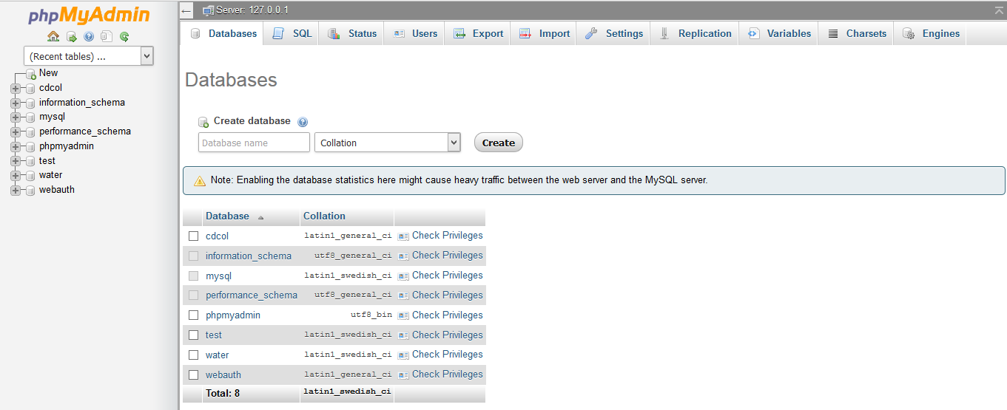

* Create a new Database named ‘dbms project’**.**

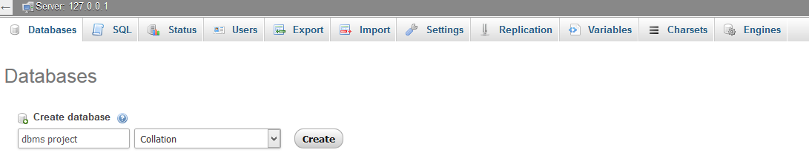

* After the database has been created, phpMyAdmin will show a message telling you that a Database has been created.
* Click on ‘dbms project’
* Click on ‘Import’ tab located at top of page.

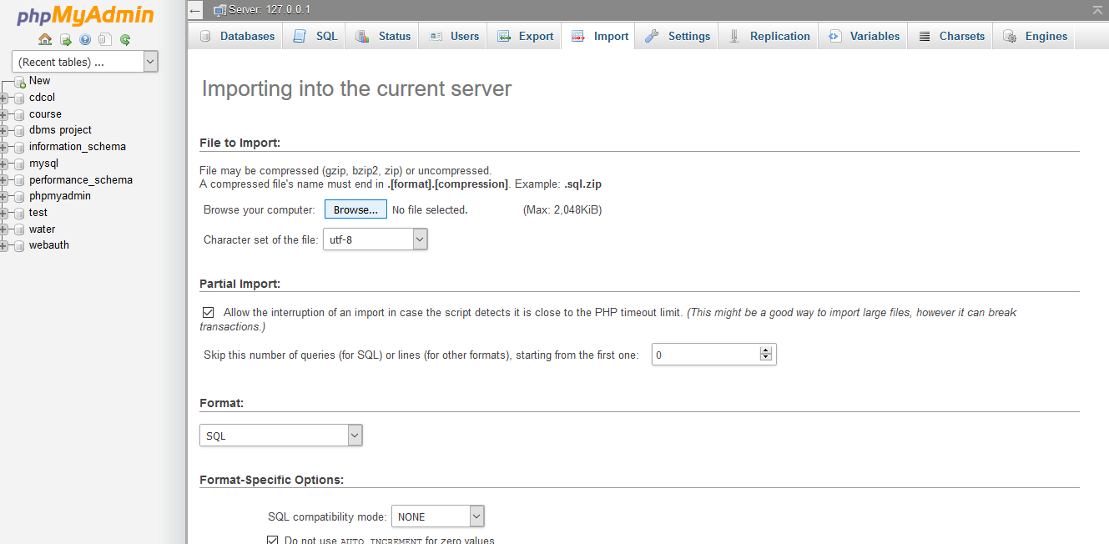

* Click on ‘browse’ button and import the file ‘dbms_project.sql’ located in the application folder ‘dbmsproject’ in Project Suite.
* This will set up the database.

**Step 4: Run Application**

* In Firefox browser, go to following link to open index: <http://localhost/dbmsproject/index.html/>

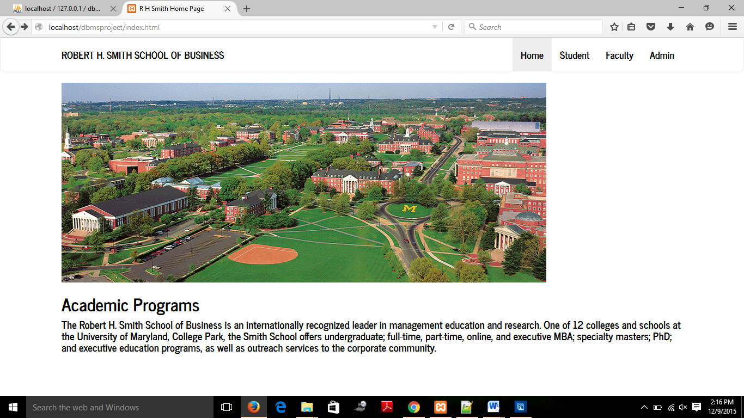

* Click on student tab at top right corner of page to view students section of website.

Enter username= Rishabh Rathod

Password= rr

Press submit

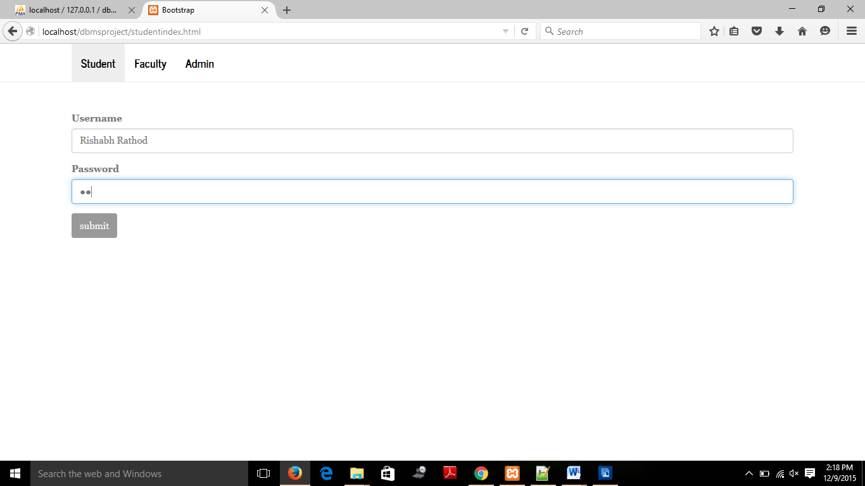

* After pressing submit, you can view student information and press ‘Edit’ button to update student details.

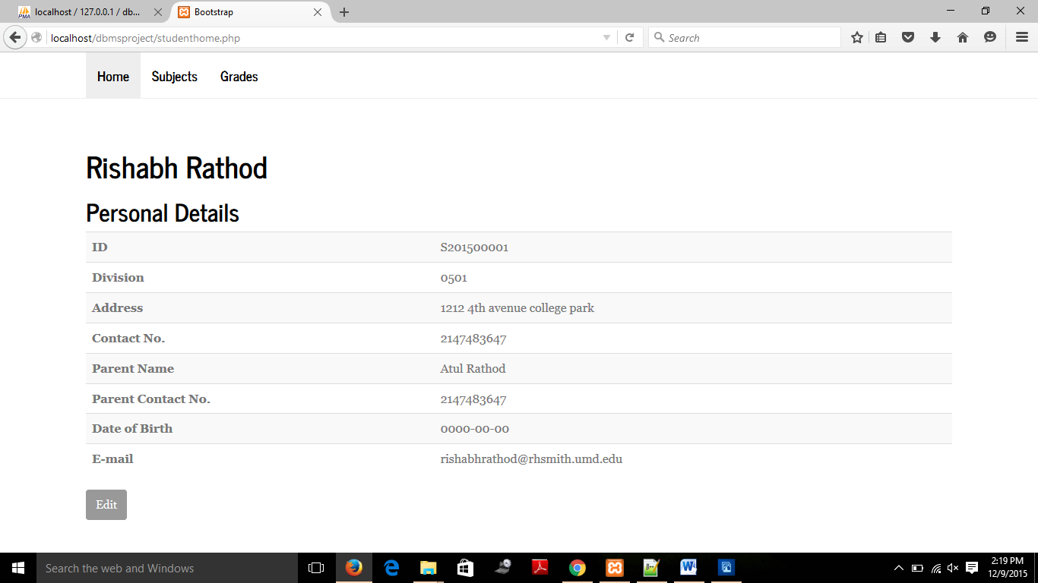

* Insert appropriate information in the fields and click ‘Update’ button

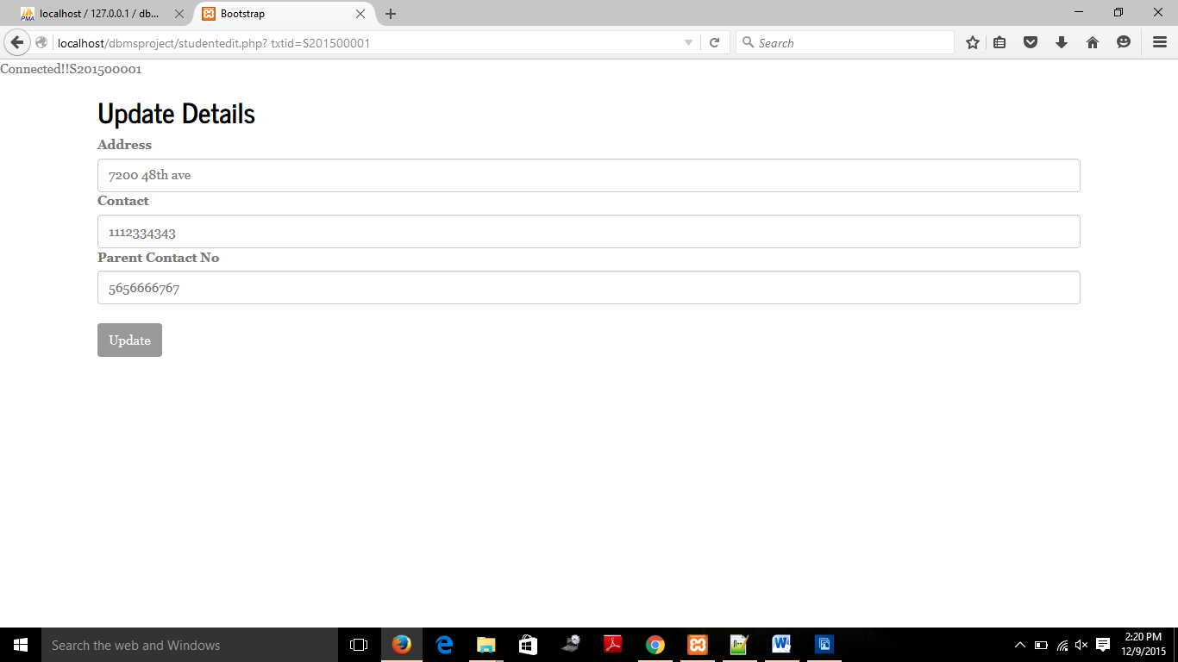

* Log out from student and go back to home page.
* Click ‘student’ tab on home page and re-login. On student home page, click on ‘subjects’ tab in top left corner of page to view subjects taken by student.

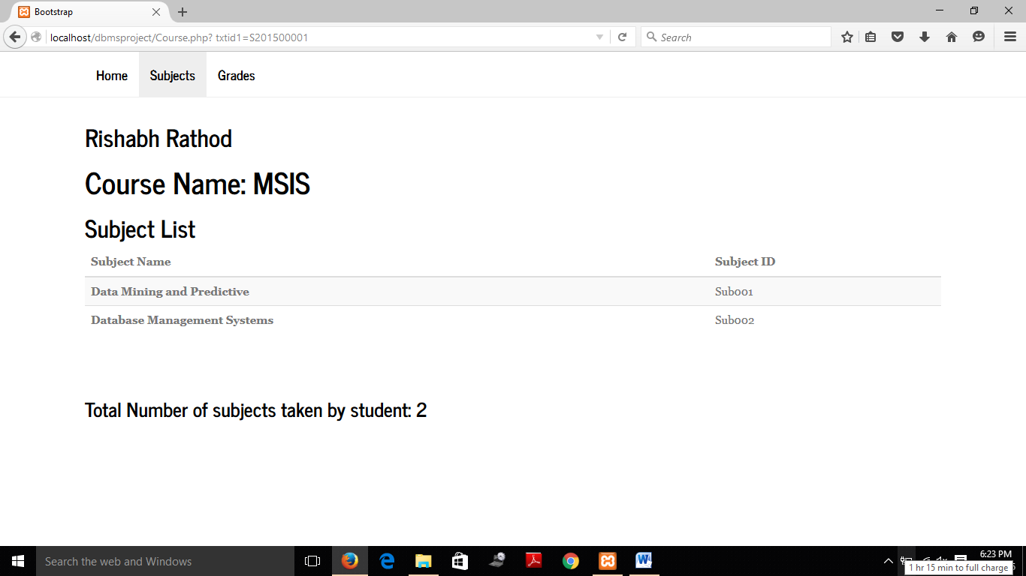

* Go back
* On student home page, click on ‘Grades’ tab in top left corner of page to view grade report.

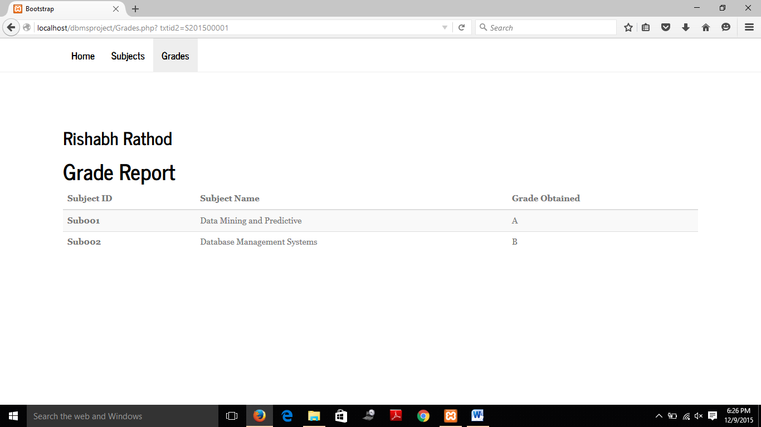

* Log out from student. (Go back and click on Home link).
* Click ‘faculty’ tab on home page .On home page, click on ’faculty’ tab at top right corner of page and log in:

Username= Peter Johnson

Password= pj

Click ‘Submit’

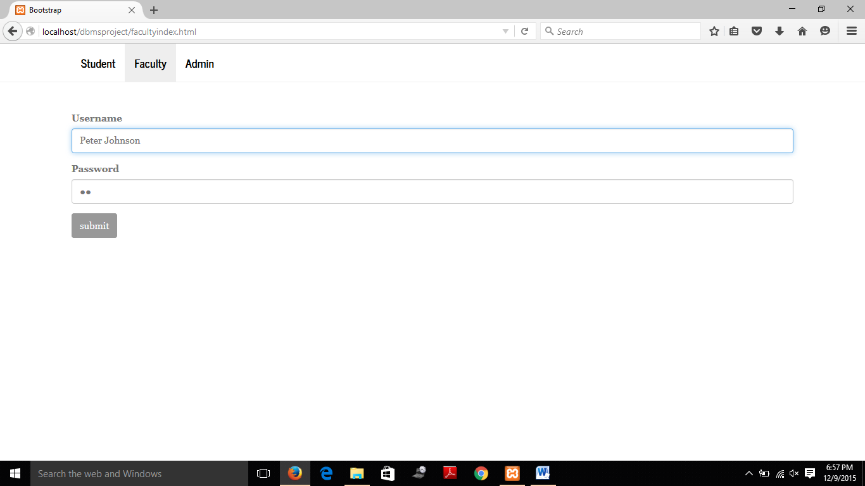

* Now you can view faculty details and click on edit to update details.
* Log out from faculty.
* Click ‘faculty’ tab on home page. On faculty home page, Click on ‘Subjects’ tab in top left corner of page to view subjects taught by faculty

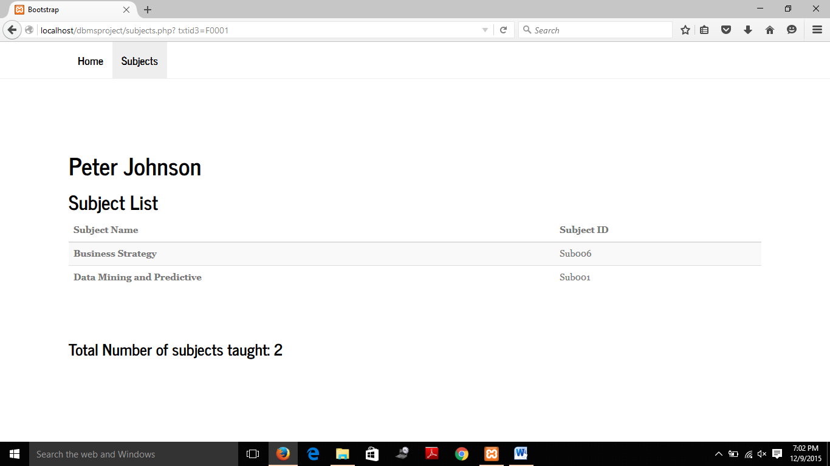

* On home page, click on ‘admin’ tab located at top right corner of the page.

Username- admin1

Password-ad

Press ‘submit’

* On this page, is a list of functionalities managed by admin. Click on ‘Add student’ to add new student details to database

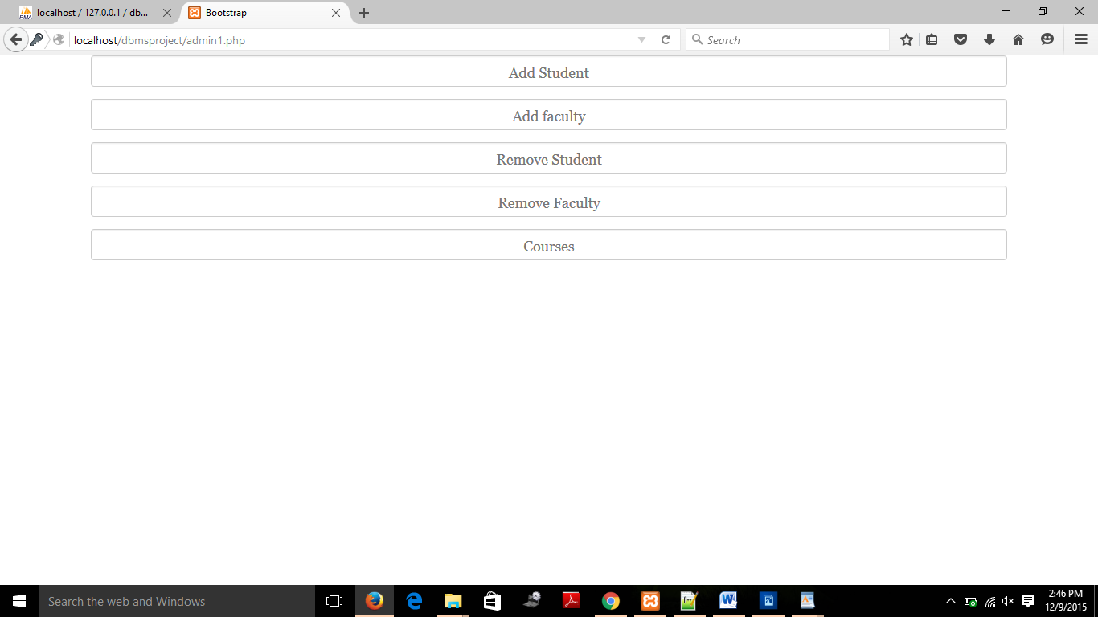

* Enter appropriate details in fields

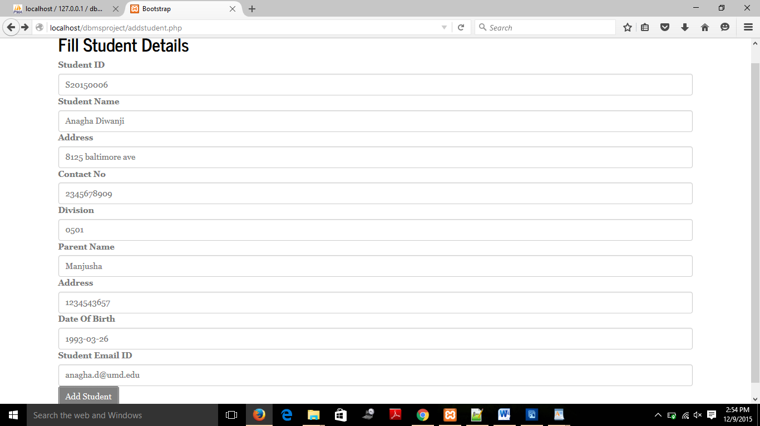

* Now you can view the added student details. Click on ‘Go to Admin Home’ to test other functionalities.
* Click on ‘Remove Student’ to delete student details
* Enter student ID of student whose details are to be deleted from database and click ‘remove Student’

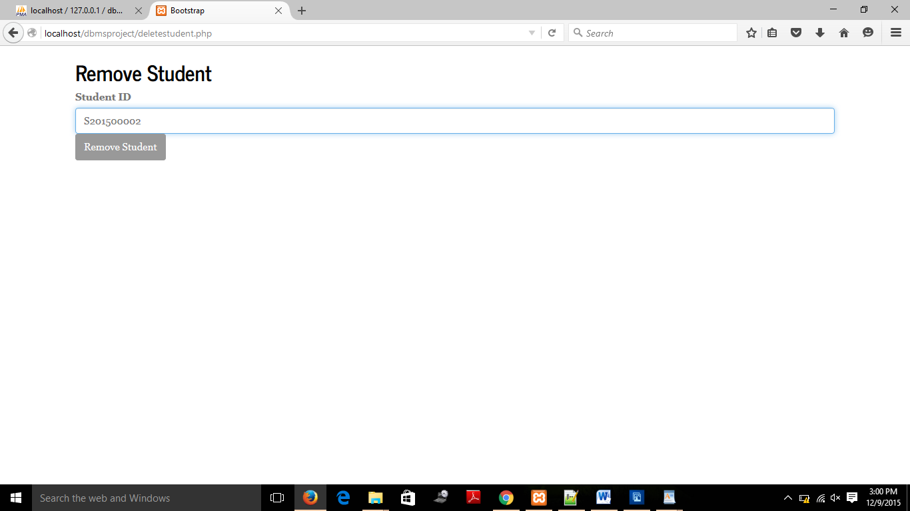

* Similarly can be done for ‘add faculty’ and ‘remove faculty’.