1. **Clone the Original Repository:** use this :

**git clone :**

If you are working with a project cloned from someone else’s repository, use:

**git clone git clone https://github.com/AayushParab44/Used_Car_Price_Predictor.git**

**2.Initialize a New Git Repository (if needed):** If you are starting fresh and the repository is not initialized, run this

**git init**

1. **Change the Git Remote to Your Own Repository:**

**git remote :**

Note:-If you cloned a repository from someone else’s GitHub account but want to push changes to **your own** repository, you must update the remote URL.

**change your git repo**:using this-

**git remote set-url origin** [**git@github.com:your-username/repo-name.git**](mailto:git@github.com:your-username/repo-name.git)

e.g**:** **git remote set-url origin https://github.com/SarikaK7/Used_Car_Prediction.git**

**Example:**  
If you originally cloned a repository from https://github.com/OtherUser/SomeRepo.git but want to push to **your own repository**, say https://github.com/YourUsername/YourRepo.git, run:

git remote set-url origin [git@github.com:YourUsername/YourRepo.git](mailto:git@github.com:YourUsername/YourRepo.git)

3. **verify the remote URL**:

**git remote -v**

3. **Add and Commit Your Changes**:

a. **git add** . :- Stage all modified files:

b.**git commit -m "new changes" :-** Commit the changes

**4.** **Handling Large Files (.pkl, .csv, etc.) in Git:**

If you have large files (e.g., .pkl, .csv) that are tracked by Git LFS (Large File Storage), you need to untrack them.

**How to move Large file(.pkl) into git:**

1. **Find LFS-tracked Files:**

**git lfs ls-files**

1. **Untrack Large Files from LFS:**

**git lfs untrack "path/to/large-file.pkl" or git lfs untrack "path/to/large-file.csv"**

**(Note:-** **refers to the local path of the file on your computer (inside your Git repository), not a GitHub URL.)**

e.g:

**git lfs untrack "D:\C-DAc kharghar\Final_Project\Used_Car_Price_Predictor\random_forest_model1.pkl**

5. **Push Your Changes to Your Own Repository:**

**git push origin main**

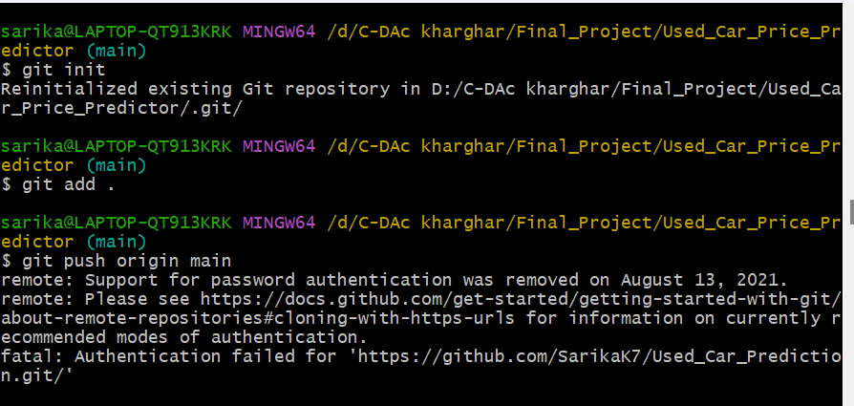

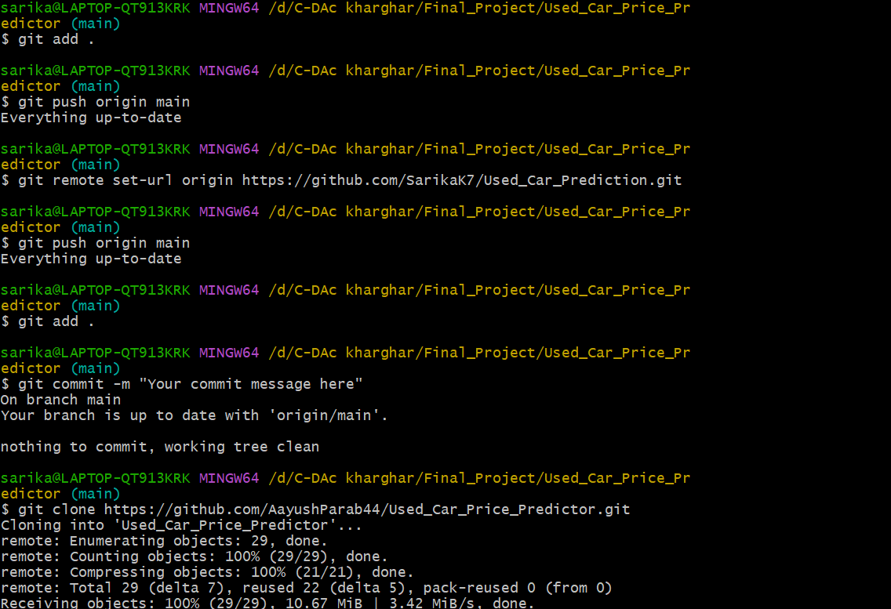

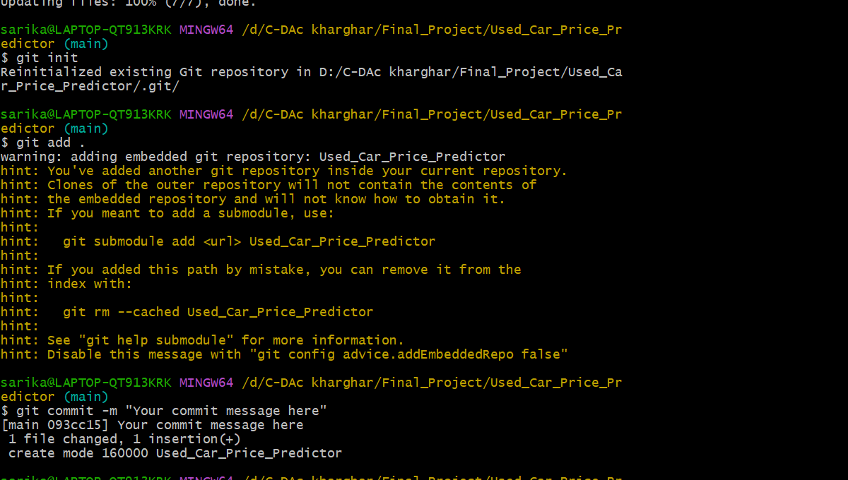

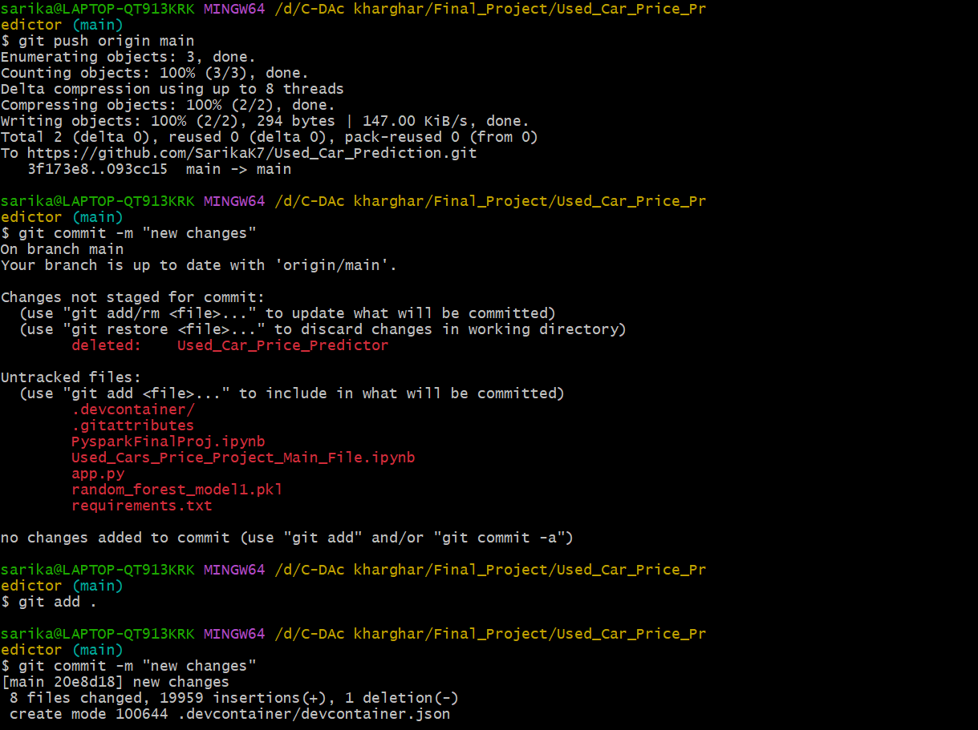

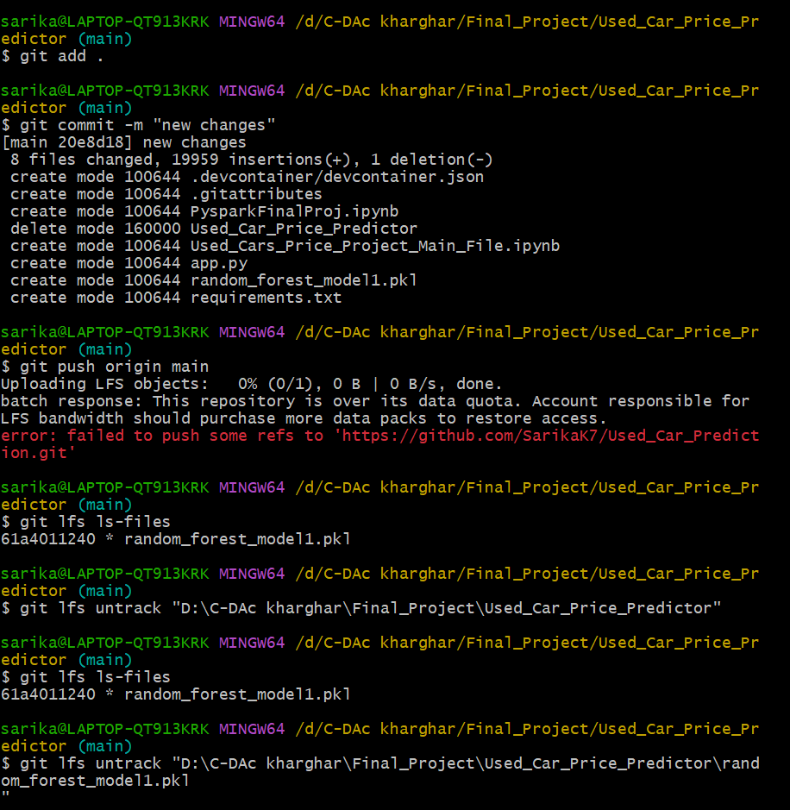

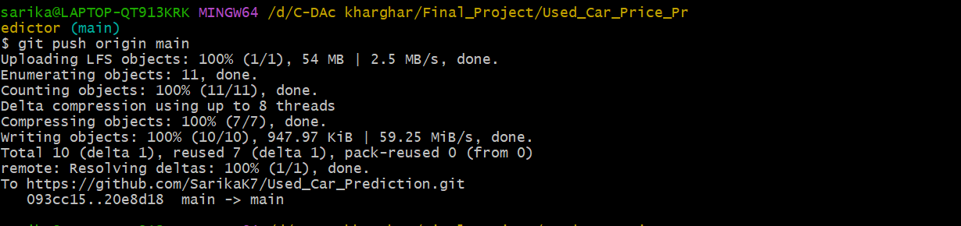

**Some other changes is also push after this changes pushed:**

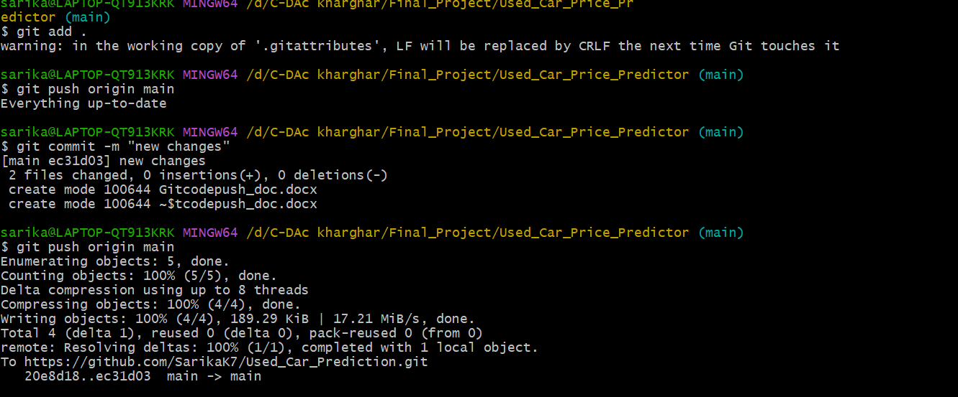

**Summary**

✅ **Clone the repository**  
✅ **Change the remote to your own GitHub repo**  
✅ **Verify the remote URL**  
✅ **Stage, commit, and push changes**  
✅ **Untrack large files (if needed)**  
✅ **Push final changes**