1. **Launch an EC2 Instance**:
   * Launch an EC2 instance with the Amazon Linux AMI.

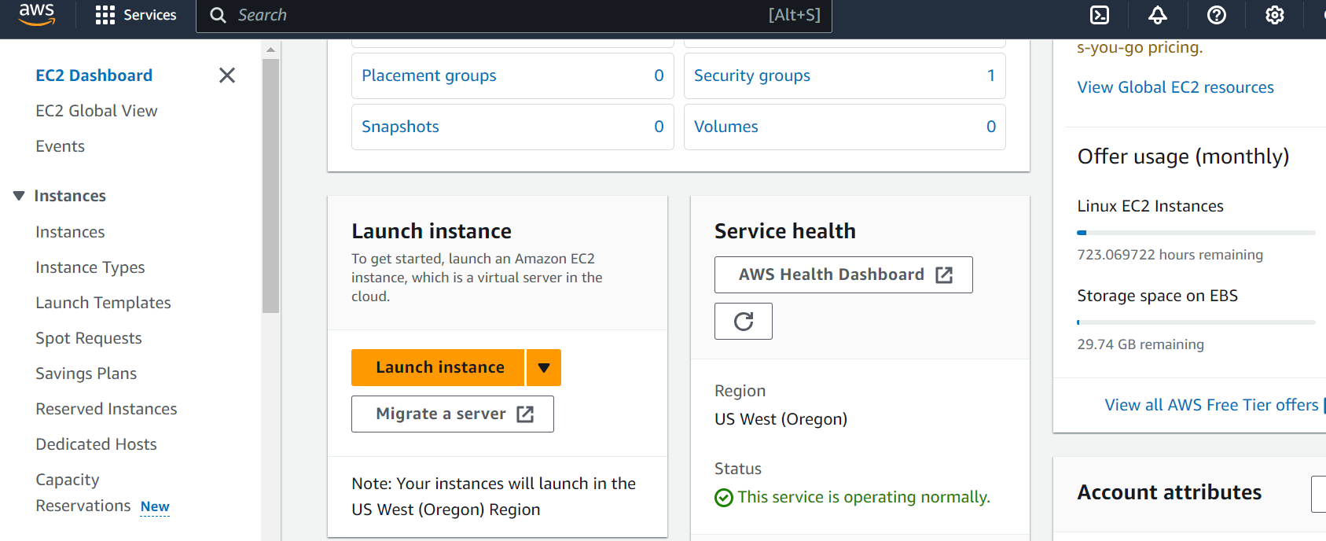

* + **Select an instance type (t2.micro) and configure it for public access.**

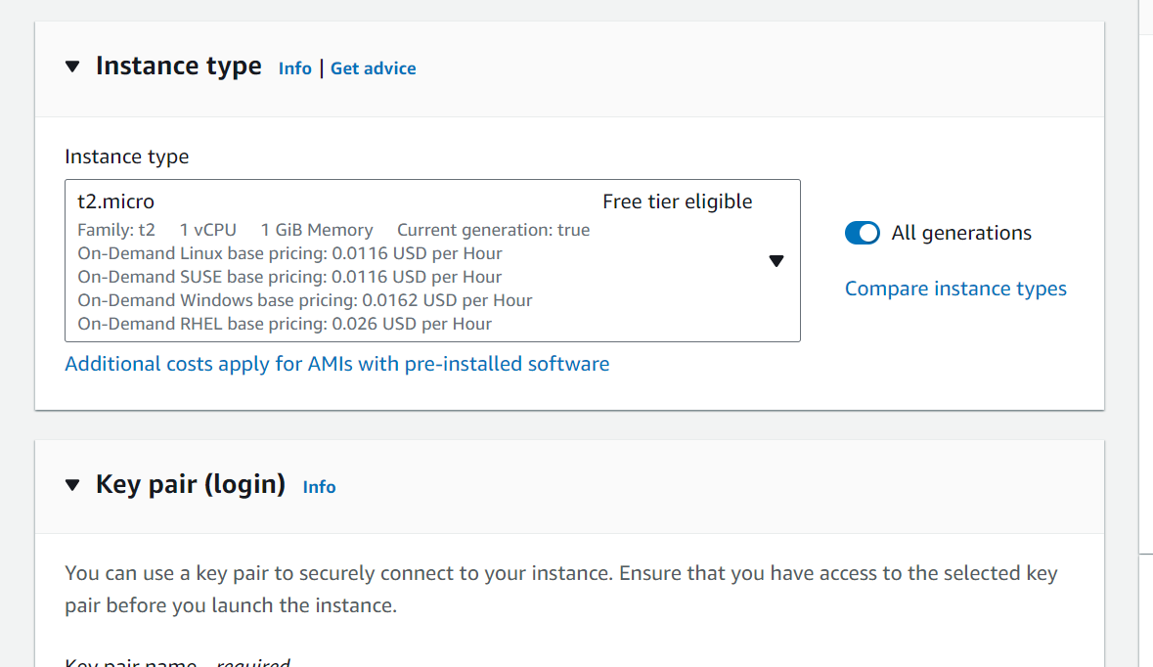

* + **Document the instance ID and public IP address.**

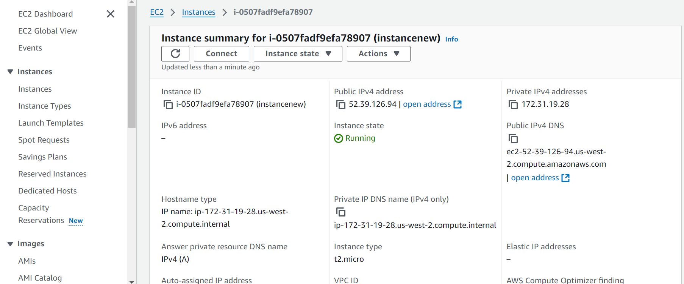

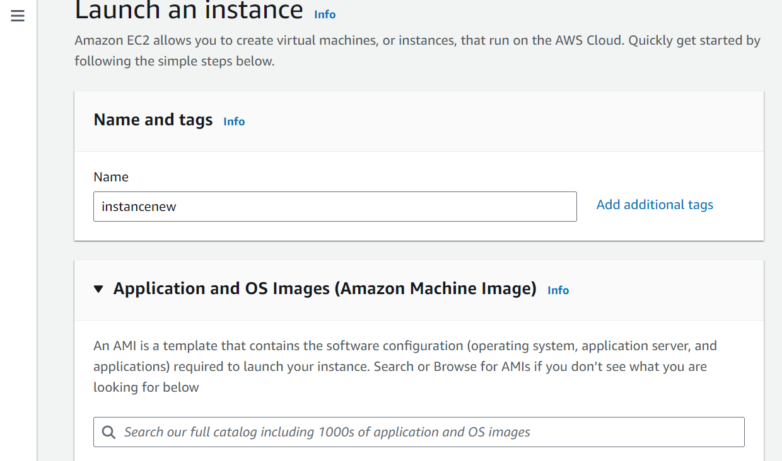

1. **Configure Security Group**:

**Create a security group that allows SSH (port 22) and HTTP (port 80).**

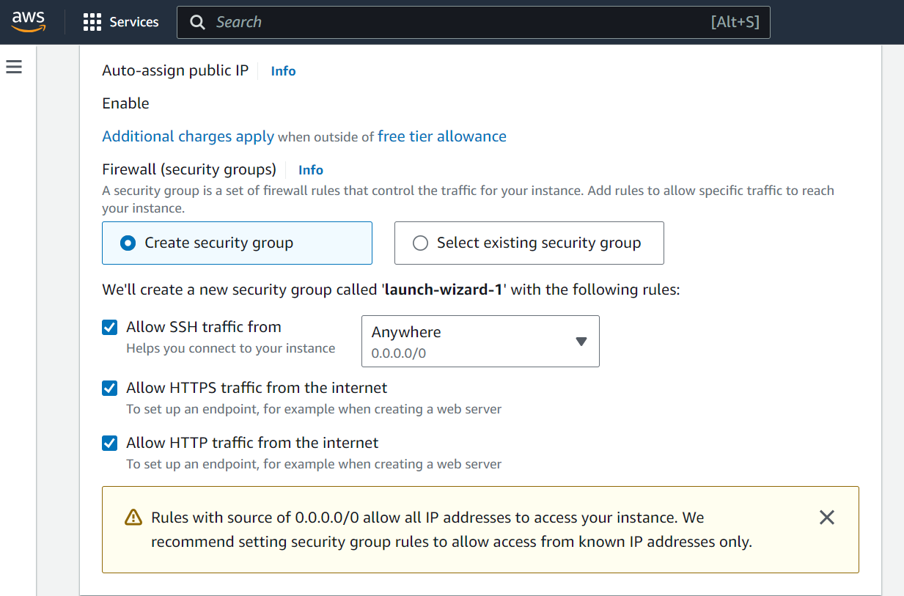

Attach the security group to your EC2 instance.

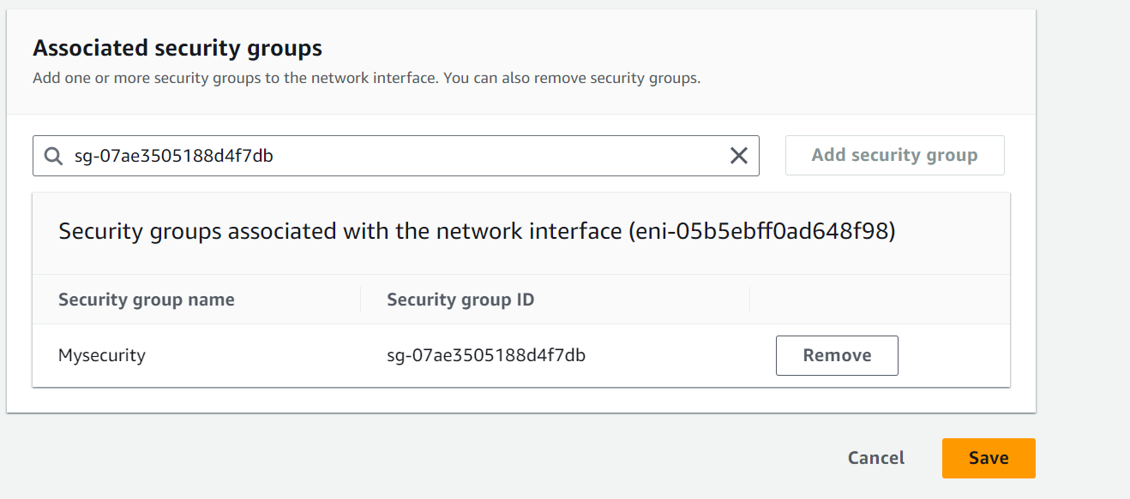

**3.Install and Configure a Web Server**:

* + Connect to your EC2 instance via SSH and install Apache or Nginx.
  + Verify that the web server is running by accessing the public IP address.

**4.Create a Bash Script**:

* + Write a script to automate the installation of the web server.
  + 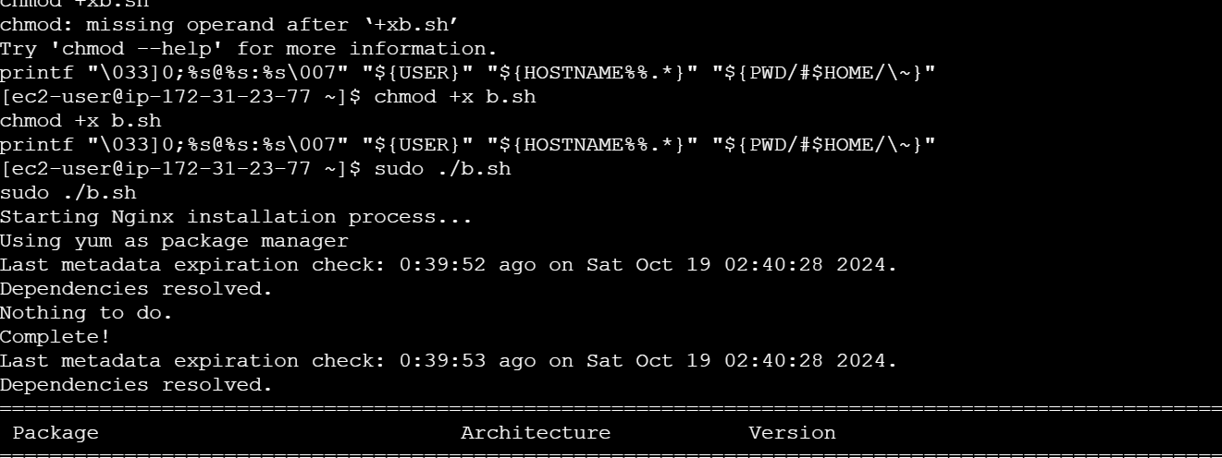
  + Document your script and its functionality.
  + 